“Equity” in higher education: what does this term mean and what are the practical implications for students in equity groups?

Nicole Crawford, National Centre for Student Equity in Higher Education

Introduction
Depending on where you work and what your role is, you may or may not hear about students in various “equity” groups, such as the “low SES” or “regional and remote” equity groups. What does this mean? Where does this term come from? What are other equity groups? What are some practical implications for students in equity groups?
The purpose of this guide is to:
- explain the equity group classifications used in higher education in Australia
- identify some practical implications and supports for students in equity groups.

Equity policy in higher education: some background information
In the 1990 Australian Government report, A Fair Chance for All, a national framework articulated the aim of achieving equity in higher education: that is, to ensure that “the benefits of higher education are within everyone’s reach” (p. 5). Six equity groups were identified with the intention of increasing their representation in higher education. These groups are still a key focus of policy today:
- Students from non-English speaking backgrounds (NESB)
- Students with disability
- Women in non-traditional areas (WINTA)
- Indigenous students (Aboriginal and Torres Strait Islander students)
- Students from low socioeconomic status (SES) locations
- Students from regional and remote locations (DESE, 2020).

What does equity mean?
In brief, “equity” is different from “equality”. Providing exactly the same assistance to each student might be considered an equal way of supporting students, but it is not equity or fairness. Equity is about providing students with the supports they need to participate — it is about removing barriers, redressing disadvantage and creating a level playing field. Depending on students’ circumstances, they may well require, and benefit from, different types of supports to access and participate in higher education.
Australia has seen a major shift in equity policy over the past decade following the 2008 Review of Australian Higher Education: Final report (“the Bradley Review”) (Bradley et al., 2008). The Bradley Review made significant recommendations to transform higher education, including two notable targets: 1) that 40 per cent of 25- to34-year-old Australians have a university degree by 2020; and 2) that 20 per cent of undergraduate enrolments in higher education should be students from low SES backgrounds by 2020 (p. xiv).
The Bradley Review led to a focus on equity group participation through initiatives such as the introduction of the demand driven funding system (DDFS), which expanded the number of higher education places in Australia, and specific equity policies such as the launch of the Higher Education Participation and Partnerships Program (HEPPP). The HEPPP funds university outreach work in schools and communities, as well as retention work at universities, with a primary focus on equity group students.
More recently, informed by a national consultation process, a NCSEHE project saw Zacharias and Brett (2019) develop a new equity policy statement: “Australia’s future depends on all its people, whoever and wherever they are, being enabled to successfully engage in beneficial lifelong learning” (p. 7). This vision underpins their policy document, The Best Chance for All: Student Equity 2030 — A long-term strategic vision for student equity in higher education, which, recently formed the basis for an equity roadmap through and beyond the pandemic (Kift, Zacharias & Brett, 2021).

Defining “regional and remote” and “low SES”
You might wonder how the “regional and remote” equity group is defined. The Australian Statistical Geography Standard (ASGS): Remoteness Structure (Australian Bureau of Statistics, 2018a) is used to classify students’ geographical location by the DESE and university data units. It divides Australia into five categories: major cities (RA1); Inner Regional (RA2); Outer Regional (RA3); Remote (RA4); and Very Remote (RA5), as illustrated in the map below. “Regional and remote” includes four categories: Inner Regional, Outer Regional, Remote, and Very Remote.
Students are designated as either regional or remote students based on their permanent home address being located in such an area. This status is now reported by two measures: Commencing Address, which defines students’ locational status given their home address at the commencement of their studies, and Current Address, which defines it according to the location of their current home address (Koshy, 2020).

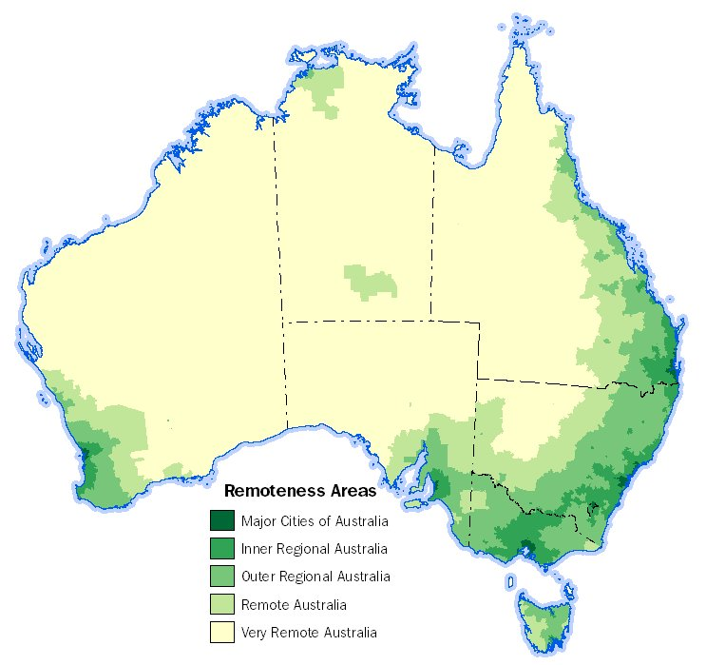

ABS Map of the 2016 remoteness areas of Australia (ABS, 2018a)
SES is defined using the Australian Bureau of Statistics (2018b) Socio-Economic Indexes for Areas (SEIFA) Index of Education and Occupation (IEO) scores, with areas scoring from one to 25 per cent being considered low SES.

Compounding challenges: multiple equity and/or “equity-like” groups
A student might have the demographic or personal characteristics of more than one equity group. They may also have characteristics of “equity-like” groups — that is, groups that are not a formally-designated equity group (i.e. not designated by the DESE), but are, nevertheless, associated with experiencing educational disadvantage. Such groups include, but are not limited to, the following: students who are the first in their family to attend university; students who are carers; mature-aged students; students from refugee backgrounds; students who identify as LGBTQI+; and students who are veterans.
Students in equity groups often experience multiple, compounding factors, as noted by Nelson et al. (2017):
[They] face a number of structural challenges in accessing, participating and completing higher education, including geographical location, financial constraints, emotional factors and sociocultural incongruity. The impact of belonging to multiple equity groups exacerbates the challenges, which include travel constraints, a lack of access to resources such as high speed internet, affordability of living expenses, the necessity to work whilst studying, challenges to wellbeing including financial stress, isolation from support networks, and challenges to navigating sociocultural incongruities (p. 2).

Practical implications for students: what can you do?
So, what does membership of these equity groups mean in a practical sense for students? Students in designated equity groups may be eligible for specific supports and/or for scholarships to assist with their participation in higher education. You may be able to connect students to the relevant supports. Here are some suggestions:

* Top tip: raise awareness of supports for students from/in regional and remote locations
The DESE (2021) website, Study in a regional area, has links to information for students about studying at a Regional University Centre, and accessing higher education and financial support, such as the Higher Education Loan Program (HELP).

* Top tip: raise awareness of supports for Aboriginal and Torres Strait Islander students
The DESE programs and policies for Aboriginal and Torres Strait Islander students are listed on their website. Many universities have Indigenous centres/units. They provide personal, academic and cultural support, and foster connections, community and belonging for Aboriginal and Torres Strait Islander students (Fredericks et al., 2022; Nakata et al., 2019). The Riawunna Centre for Aboriginal Education at the University of Tasmania is one such example. The Indigenous centres/units tend to be based on campus, but it is well worth encouraging Aboriginal and Torres Strait Islander students to get in touch with staff at the Indigenous centres — it may be that some supports have moved online.

* Top tip: raise awareness of Disability/Accessibility Services and staff
Funded by the Higher Education Disability Support Program, universities provide supports for students with disability. For instance, students with disability can access university Disability Services (also called Accessibility Services) to formally have adjustments made in their courses. They can then progress through their studies without being disadvantaged (for instance, in undertaking an assessment task) because of their disability. In consultation with an individual student, Disability/Accessibility Advisors make recommendations regarding reasonable accommodations and adjustments, such as alternative forms of assessment, which they document in a Learning Access Plan (or similar). Disability/Accessibility advisors can arrange access to assistive technologies, procurement of course materials, specialised equipment and more. A range of information for students and staff can be found on the ADCET website, and NDCOs are another source of support for students with disability.
If a student has disclosed to you that they have a disability, do let them know that they are eligible to access their university’s Disability/Accessibility Services. They might not be aware of the services. Students who are eligible often do not know – this is especially the case for students with a mental health condition who might not equate it with “disability”, and, therefore, might not think to access the services (Crawford, 2021a, p. 64). Referring students with disability to these services could make a big difference!

* Top tip: explore university scholarship programs
Most universities have scholarship programs. It is worth assisting students in exploring them; there are hundreds of programs with an enormous range, including scholarships for students experiencing educational disadvantage. As a starting point, in the search box on the student’s institution’s website, try searching terms such as: “scholarships”, “bursaries” or “prizes”.

* Top tip: take an inclusive approach to teaching and support
Implement inclusive practices in teaching, learning and support, and offer ways of catering for the needs and strengths of all students. In designing a course, teaching and learning materials, assessment tasks or support provision, it is worth considering who you might be including or excluding. It is important to apply an equity lens and think about the diverse needs of students in your course (Crawford, 2021b, p. 6). While the OLT project by Devlin et al. (2012) focused on supporting students from low SES backgrounds, their advice for teachers is applicable for teaching all students, regardless of the students’ background or equity group classification. Their advice includes: 1) Know and respect your students; 2) Offer your students flexibility, variety and choice; 3) Make expectations clear, using accessible language; 4) Scaffold your students’ learning; 5) Be available and approachable to guide student learning; and 6) Be a reflective practitioner (p. 3).
Take an inclusive approach to teaching and learning, and support by implementing principles of inclusive education and/or universal design for learning, and universal design in assessment. These approaches will help you to cater for all your students (Crawford, 2021b, p. 6).

Acknowledgements
Thank you to my colleagues: Dr Paul Koshy, NCSEHE, Curtin University; Dr Judy Skene, Independent Consultant (formerly Associate Director, Student Services, UWA); and Allen Baird (formerly Student Coordinator/Lecturer/Tutor, Pre-degree Programs, UTAS), for excellent feedback on this guide. The beautiful illustration on the cover is by Morag Porteous.

References
Australian Bureau of Statistics. (2018a). 1270.0.55.005 - Australian Statistical Geography Standard (ASGS): Volume 5 - Remoteness Structure, July 2016. https://www.abs.gov.au/ausstats/abs@.nsf/mf/1270.0.55.005
Australian Bureau of Statistics. (2018b). 2033.0.55.001 - Census of population and housing: Socio-economic indexes for areas (SEIFA), Australia, 2016. https://www.abs.gov.au/AUSSTATS/abs@.nsf/Lookup/2033.0.55.001Main+Features12016?OpenDocument
Australian Bureau of Statistics. (2018c). 2033.0.55.001 - SEIFA 2016 Technical Paper. https://www.abs.gov.au/AUSSTATS/abs@.nsf/DetailsPage/2033.0.55.0012016?OpenDocument
Bradley, D., Noonan, P., Nugent, H., & Scales, B. (2008). Review of Australian Higher Education: Final Report. Canberra: Department of Education, Employment and
Workplace Relations. https://apo.org.au/sites/default/files/resource-files/2008-12/apo-nid15776.pdf
Burnheim, C., & Harvey, A. (2016). Far from the studying crowd? Regional and remote students in higher education. In A. Harvey, C. Burnheim, & M. Brett. (eds) Student Equity in Australian Higher Education (pp. 143-162). Springer.
Crawford, N. (2021a). “On the radar”: Supporting the mental wellbeing of mature-aged students in regional and remote Australia. Perth: National Centre for Student Equity in Higher Education, Curtin University. https://www.ncsehe.edu.au/wp-content/uploads/2021/04/Crawford-Equity-Fellowship-Report_FINAL.pdf
Crawford, N. (2021b). “On the radar”: Supporting the mental wellbeing of mature-aged students in regional and remote Australia – Guidelines and Recommendations. Perth: National Centre for Student Equity in Higher Education, Curtin University. https://www.ncsehe.edu.au/wp-content/uploads/2021/11/NicoleCrawford_Guidelines_final-bound_Digital.pdf
DEET. (1990). A fair chance for all: national and institutional planning for equity in higher education: a discussion paper. Australian Government Department of Employment, Education and Training. https://www.voced.edu.au/content/ngv%3A2270
DESE (2020). 2019 Section 11 Equity groups. Higher Education Statistics. Australian Government Department of Education, Skills and Employment. https://www.dese.gov.au/higher-education-statistics/resources/2019-section-11-equity-groups
Devlin, M., Kift, S., Nelson, K., Smith, L., & McKay, J. (2012). Effective teaching and support of students from low socioeconomic status backgrounds: Practical advice for teaching staff. Australian Government Office for Learning and Teaching. https://lowses.edu.au/assets/Practical%20Advice%20for%20Teaching%20Staff.pdf
Fredericks, B., Barney, K., Bunda, T., Hausia, K., Martin, A., Elston, J., Bernardino, B., &
Griffiths, D. (2022). Building the evidence to improve completion rates for Indigenous
students. Perth: National Centre for Student Equity in Higher Education, Curtin University https://www.ncsehe.edu.au/wp-content/uploads/2022/02/Fredericks_UQ_Final.pdf
Kift, S., Zacharias, N., & Brett, M. (2021). The Best Chance For All: A Policy Roadmap for Post-Pandemic Panic. Student Success, 12(2). https://doi.org/10.5204/ssj.1782
Koshy, P. (2020). Equity Student Participation in Australian Higher Education: 2014 – 2019. Perth: National Centre for Student Equity in Higher Education, Curtin University. https://www.ncsehe.edu.au/publications/ncsehe-briefing-note-equity-student-participation-australian-higher-education-2014-2019/
Nakata, M., Nakata, V., Day, A., & Peachey, M. (2019). Closing gaps in Indigenous undergraduate higher education outcomes: Repositioning the role of student support services to improve retention and completion rates. The Australian Journal of Indigenous Education, 48(1), 1-11. https://doi.org/10.1017/jie.2017.36
Nelson, K., Picton, C., McMillan, J., Edwards, D., Devlin, M., & Martin, K. (2017). Understanding the completion patterns of equity students in regional universities. University of the Sunshine Coast and Federation University. https://www.ncsehe.edu.au/publications/completion-patterns-of-equity-students-in-regional-universities/
Tomaszewski, W., Kubler, M., Perales, F., Clague, D., Xiang, N., Johnstone, M. (2020). Investigating the effects of cumulative factors of disadvantage: Final report. Institute for Social Science Research, The University of Queensland. https://espace.library.uq.edu.au/view/UQ:2a76ba9
Zacharias, N., & Brett, M. (2019). The best chance for all. Perth: National Centre for Student Equity in Higher Education, Curtin University. https://www.ncsehe.edu.au/publications/the-best-chance-for-all/

This guide was updated and edited for a general audience of academic and professional staff in May 2022; at that time, the links in this document were accurate, but please note that links to university webpages often change.
According to Koshy, around 50 per cent of domestic undergraduate students can be classified into at least one of the six equity categories with many falling into two or more groups. This percentage was calculated in an analysis of data, of multiple equity groups, from a data request to the Department of Education, Skills and Employment (email communication with Paul Koshy, 30 May 2022). Refer also to the report by Tomaszewski et al. (2020); in their analysis of the 2016 student data, 29.7 per cent of undergraduate students were classified in at least one of the following four equity groups: low SES; regional and remote; Indigenous; and students with disability, and 8.5 per cent were classified in two of the four equity groups (Tomaszewski et al., 2020, Table 24, p. 93).
For a visual representation and a brief description of inequality, equality, equity and justice, refer to: https://onlinepublichealth.gwu.edu/resources/equity-vs-equality/
As described in the SEIFA Technical paper (Australian Bureau of Statistics, 2018c, p. 7), “The IEO summarises variables relating to the educational and occupational aspects of relative socio-economic advantage and disadvantage. This index focuses on the skills of the people in an area, both formal qualifications and the skills required to perform different occupations. A low score indicates that an area has a high proportion of people without qualifications, without jobs, and/or with low skilled jobs. A high score indicates many people with high qualifications and/or highly skilled jobs”.

