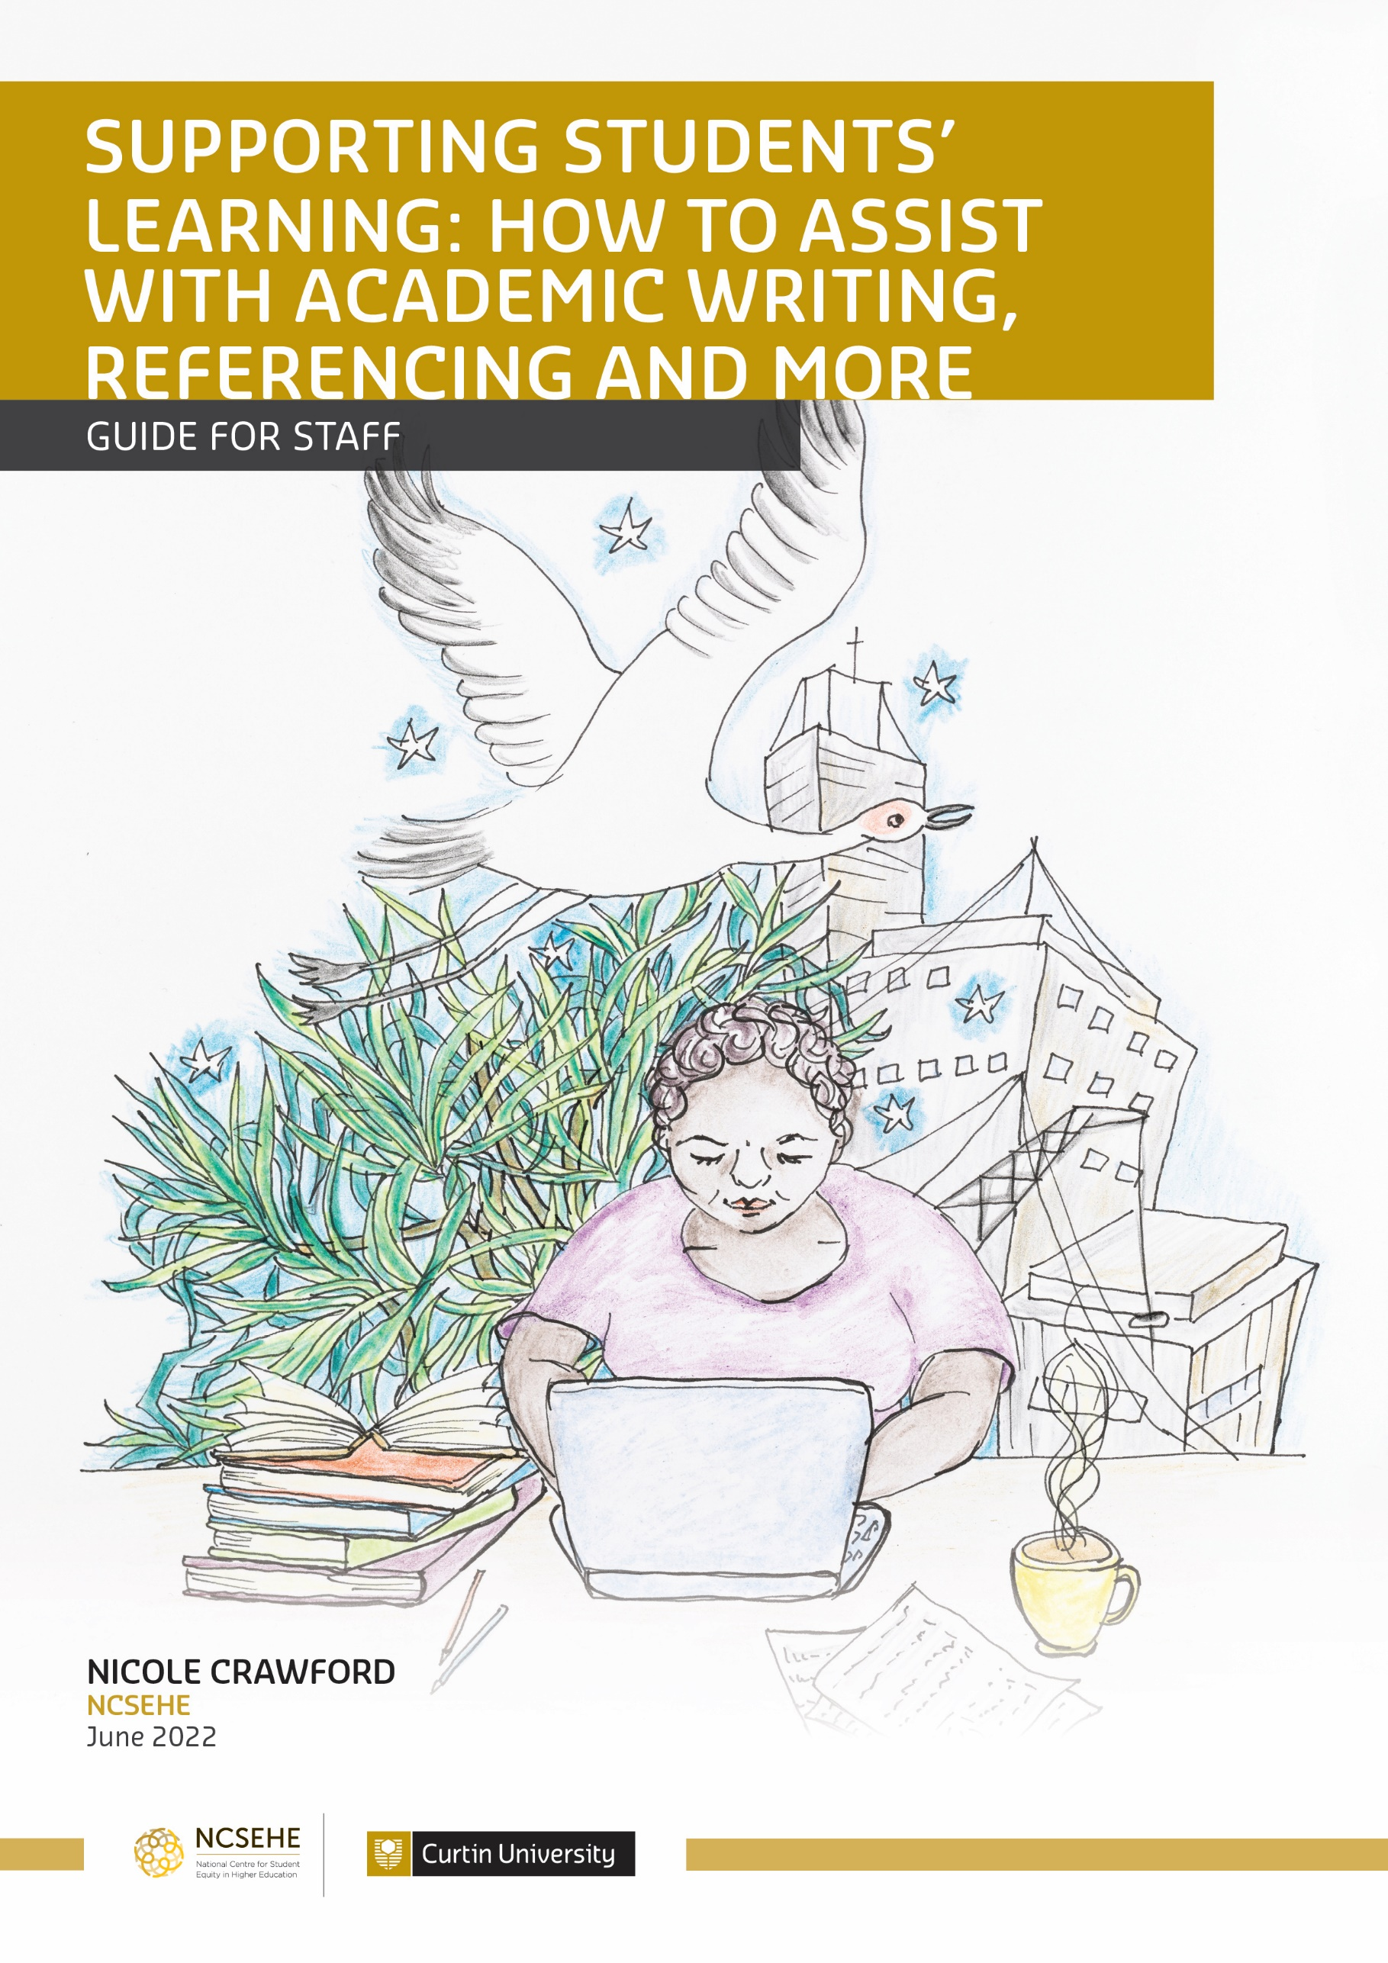

Supporting students’ learning: how to assist with academic writing, referencing and more

Nicole Crawford, National Centre for Student Equity in Higher Education

Introduction
Are you a tutor or lecturer? Or perhaps you work in a local library, a Regional University Centre or in a residential college? Whatever your role, you may find that students are looking for guidance on essay and report writing, referencing, oral presentations and lots more. Working “on the ground”, you are not expected to be an expert on the range of academic skills and literacies required of university students. There is great diversity between subject areas, so even if you know a lot about how a report needs to be written in a particular course, and which referencing style to follow, the expectations in another subject are likely to be quite different. In most cases, however, universities have “Academic Skills” units within Student Support Services, which offer one-to-one sessions and workshops and provide online resources. So, what you can do is direct students to the relevant information and supports.
The purpose of this guide is to:
- raise awareness of the academic learning support services provided by universities
- assist staff in helping students find the relevant information for their discipline/subject area and/or for their assessment tasks
- share some useful sites on academic learning.

Academic skills and literacies: some background info
It is often assumed that students arrive at university knowing how to write academic essays and reports, and how to follow the numerous referencing styles. Such skills and literacies are required to undertake many assessment tasks. In reality, students develop academic skills and literacies over time and throughout a degree.
Academic literacy and learning staff have expertise in assisting students to develop the required skills and literacies, and in how to approach assessment tasks, for instance, analysing the assignment question and planning the task to undertake it in manageable parts. Where can students find these academic learning skills advisors? Many Academic Skills units are centrally located in Student Support Services. Some staff are based within faculties and others are in libraries. These services are free and are usually available for students in undergraduate and postgraduate courses.
The shift to online provision due to COVID-19 has seen many Student Support Services that were formerly only provided on campus now being provided online as well. These include, for example, one-to-one services and workshops. In addition, a range of other online supports are increasingly being used, such as: online drop-ins; live chat; message boards and forums; recorded sessions; quick guides; after hours assignment feedback (e.g. from external providers); and online learning modules and units.
If it has been a while since students were in an educational context—which is often the case for mature-aged students—they may benefit from undertaking a transition course prior to commencing an undergraduate degree. Some universities offer short transition courses before or during their Orientation periods. Many Australian universities offer enabling programs (also called university preparation programs or access courses) that run over one or two semesters. These courses focus on study skills, such as time management; academic writing; numeracy; how to find information; critical thinking; and much more. Some focus on specific disciplines in the sciences and humanities. At the same time as developing skills and confidence, learning “how to be a student”, individuals in enabling programs become more familiar with the university environment, its expectations and culture (Crawford, 2014). For your information, a few examples of enabling programs include courses at Edith Cowan University, CQUniversity, James Cook University, The University of Newcastle (UON) and the University of South Australia.

How can you help students find the relevant supports and guides?
A lot of handy “Academic Skills” guides are provided on university websites, so you don’t need to reinvent the wheel! You could raise awareness among staff and students in your team that such services exist. In particular, students commencing their studies may not know about these services or realise that they can access them from afar. It is also worth reminding students about these services throughout their degree. At the beginning of their studies, students might experience information overload, so timely reminders at different points of a semester and beyond the first year of their course are recommended.

* Top tip: encourage students to use the “academic learning” resources provided by their institution
You can assist students with finding and using the resources and services provided by their institution. That way, they will become familiar with the staff, services and expectations of their institution, as well as gain confidence with navigating their institution’s website and/or physical environment.
Note that “Academic Skills” units go by different names at different universities, such as “Academic Skills Support” and “Learning Support.”

* Top tip: explore the fantastic resources at other institutions
You might like to look beyond your institution’s website and see what resources are publicly available elsewhere.
Here are a few of my favourites:
- The Academic Skills Toolkit at the University of New South Wales has guides to referencing, writing, critical thinking, reading and note-taking, oral presentations, time management and lots more! Their Writing Skills Support, for example, includes guides on grammar and how to write in specific disciplines, such as in science and engineering. I’m fan of encouraging students to unpack their assignment question.
- The University of Western Australia (UWA)'s Academic Skills Centre (also known as STUDYSmarter) has loads of resources and YouTube clips. “Featured resources” includes assignment and semester planners; online etiquette tips; and an agreement template for students involved in group or team work. In addition to guidance on essays, grammar and time management in their “A-Z of online resources”, you’ll find “Maths and Stats” and “Skills for Science”.
- The University of New England’s Academic Skills Office has a lot of useful resources on developing study skills, writing assignments (including self-paced tutorials), referencing and plagiarism, and a long list of Fact Sheets on writing essays, reviews and reports (including lots on grammar) and more!

Here are a few more excellent resources to add to the list:
- RMIT University’s Learning Lab: online study resources
- Curtin University’s UniSkills including Digital skills
- University of Wollongong (UOW)’s Online study resources

The websites mentioned above cover referencing in terms of what, why and how. When actually referencing and needing to follow a specific style guide, university library guides are helpful, such as the UTAS library’s “libguides”. Another favourite is QUT’s referencing site.

* Top tip: Remind students of the range of learning support services
Encourage students to look out for one-to-one services and workshops–delivered face-to-face and/or online–as well as the online resources mentioned above. If you are not sure where to find your local academic skills support team, the Association for Academic Language and Learning (AALL) provides a Table of ALL Centres and Units across Australian institutions.

Acknowledgements
Thank you to my colleagues: Siri Barrett-Lennard, Manager STUDYSmarter, UWA; Amelia Dowe, Online Learning Support Officer, University of Tasmania (UTAS); Dr Judy Skene, Independent Consultant (formerly Associate Director, Student Services, UWA); and Allen Baird (formerly Student Coordinator/Lecturer/Tutor, Pre-degree Programs, UTAS), for excellent feedback and suggestions on this guide.
The beautiful illustration on the cover is by Morag Porteous. This illustration–Two worlds–was inspired by the experiences of one research participant in my NCSEHE Equity Fellowship research, Jessica (pseudonym). Furthermore, Jessica provided invaluable suggestions and feedback on the early drawings and approved of the final drawing and title. She also sought feedback and ideas from an Aboriginal and Torres Strait Islander Elder in her community. I am most grateful for Jessica’s interest, time and suggestions, as well as the generosity and time of Jessica’s Elder in providing suggestions and feedback.

References
Crawford, N. (2014). Practical and profound: multi-layered benefits of a university enabling program and implications for higher education. International Studies in Widening Participation, 1(2), 15-30. https://novaojs.newcastle.edu.au/ceehe/index.php/iswp/article/view/11

This guide was updated and edited for a general audience of academic and professional staff in May 2022; at that time, the links in this document were accurate, but please note that links to university webpages often change.

