Supporting students’ mental wellbeing: what can we do “on the ground”?

Nicole Crawford, National Centre for Student Equity in Higher Education

Introduction
University students’ mental health and wellbeing has been increasingly “on the radar” in recent years with studies highlighting the prevalence of mental ill-health (Caleb & Barden, 2019; Larcombe et al., 2016), and reports and charters calling for institution-wide, holistic approaches to address this emerging issue (Baik et al., 2016a; Hughes & Spanner, 2019; Okanagan Charter, 2015; Orygen, 2020). Working as a tutor, lecturer, librarian or learning skills advisor, you might notice that some students appear stressed out and overwhelmed at times, particularly when juggling their studies with work, parenting and other commitments. You are not expected to be a counsellor or psychologist; however, there might be some little actions you can take that impact positively on students’ mental wellbeing, lessen their stress and help them manage their studies. In this guide, I’ll draw on my NCSEHE Equity Fellowship research (Crawford, 2021a) to provide some context, findings and strategies.
The purpose of this guide is to:
- briefly define mental wellbeing
- consider what impacts on students’ mental wellbeing
- share some tips on how academic and professional staff who work “on the ground” can support students’ mental wellbeing
- raise awareness of the Student Support Services provided by universities, including Counselling Services and Disability/Accessibility Services
- provide some links to useful resources and further reading.

Defining mental wellbeing
Terms such as “mental health” and “mental wellbeing” are difficult to define and, to add to the confusion, they get used differently in different disciplines and contexts. In brief, adapting the World Health Organisation (WHO)’s (2014) definition, I understand “mental wellbeing” to be about managing the “normal” stresses of university and life in order to thrive and reach one’s academic goals and potential (Crawford, 2021a, pp. 1, 12). When considering mental wellbeing, I’m including all students, whether they have a diagnosed mental health condition or not.

What impacts on students’ mental wellbeing?
In the Fellowship research, which focused on mature-aged students in, and from, regional and remote Australia, a variety of factors were found to impact on students’ mental wellbeing (Crawford, 2021a). Some were within the context of students’ daily learning and interactions with their university course, curriculum, peers and staff. Others were outside of the university environment, such as practical issues (for example, unreliable internet) and financial challenges. Mature-aged students in certain sub-groups within the regional and remote cohort—such as students who studied online and part-time, and students with children—experienced compounding challenges and impacts (pp. 2, 41, 42, 48-50, 59-60).
Almost half of the survey respondents (47.7%, n=883) considered deferring/withdrawing from their university course. The top two reasons were: 1) stress (65.6%, n=579); and 2) feeling overwhelmed by their university study load (55.4%, n=489). Stress was found to have a temporal nature with some periods of time within a semester being more stressful than others. Unsurprisingly, the most stressful periods were the time just before assignments were due and during the final weeks of semester. School holiday periods were a stressful time for a large minority of students, as were the pre-semester/orientation periods and the first week of semester (Crawford, 2021a, pp. 42-43).

How can you support students’ mental wellbeing?
So, what can you do as a staff member who works “on the ground” to support students’ mental wellbeing? You might not realise it, but you are probably already doing a lot of things that contribute to supporting and enhancing students’ mental wellbeing, as outlined in the following guidelines.

Guidelines for proactively supporting student mental wellbeing (Crawford, 2021b)
- Know your students: understand their diverse challenges, commitments and strengths.
- Check in with students: be approachable, supportive and caring.
- Implement principles of inclusive education and/or universal design in the curriculum.
- Consider students’ online environment in course and curriculum design, and delivery.
- Facilitate student interactions and connections.
- Inform students about pre-university transition or preparation courses and specific orientation events (see the guide, Supporting students’ learning for information about enabling programs).
- Consider students’ practical challenges: assessment deadlines, timetabling, placements, internet access and natural disasters.
- Raise awareness of the full range of university services that support students.

* Top tips for supporting students’ psychological needs
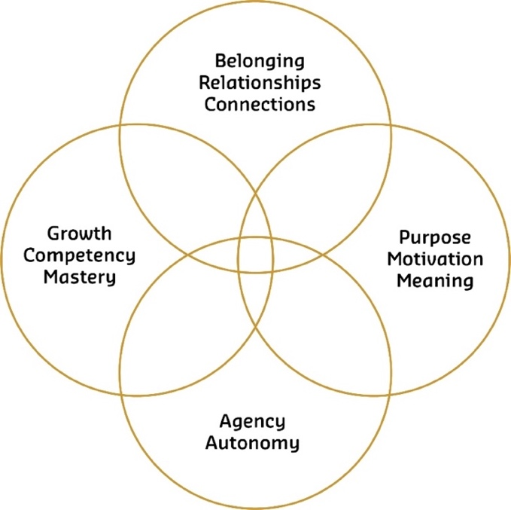
We all have a range of psychological needs – you can see them in Figure 1.

Figure 1. Combination model: psychological needs for student mental wellbeing (Crawford, 2021a, p. 12).
In the context of your role (and the teaching, learning and support environment) and regarding the elements in Figure 1, you might like to think about what you and/or your team can do to:
- foster students’ sense of belonging and connections with staff and other students
- assist students with having a purpose, finding meaning in their studies and helping them with motivation for study
- provide students with some agency
- enable students to experience growth/competency/mastery.
You may already be doing a lot that meets students’ psychological needs. If so, great! Keep it up! Please know that your actions really do make a difference.
In the teaching and learning context, a lot of the elements in Figure 1 are impacted by the curriculum that teaching staff design, and the face-to-face and online learning environments that students encounter as they go about their daily learning. Depending on your role, you may or may not have input into course content and the curriculum, or control over other factors, such as assignment deadlines, and university rules and regulations. So, in your role, what can you do? Where do you have some control? Some agency? Some influence?
Here are a few thoughts about the four elements in Figure 1 for academic and professional staff who work “on the ground” and who might not have oversight over course content and curriculum:
- Creating a friendly and caring culture and atmosphere in your on-campus or online learning environment helps students to feel connected and develop a sense of belonging to a community of learners.
- At stressful times, reminding students of time management strategies (such as breaking tasks down into small parts) and their longer-term goals can help to give them a purpose.
- Guiding students with accessing university resources helps them gain some independence and autonomy, rather than relying on others.
- Reminding students of the progress they have made (e.g. pointing out improvements in their writing in assessment tasks) assists them with realising that they are competent and experiencing growth.
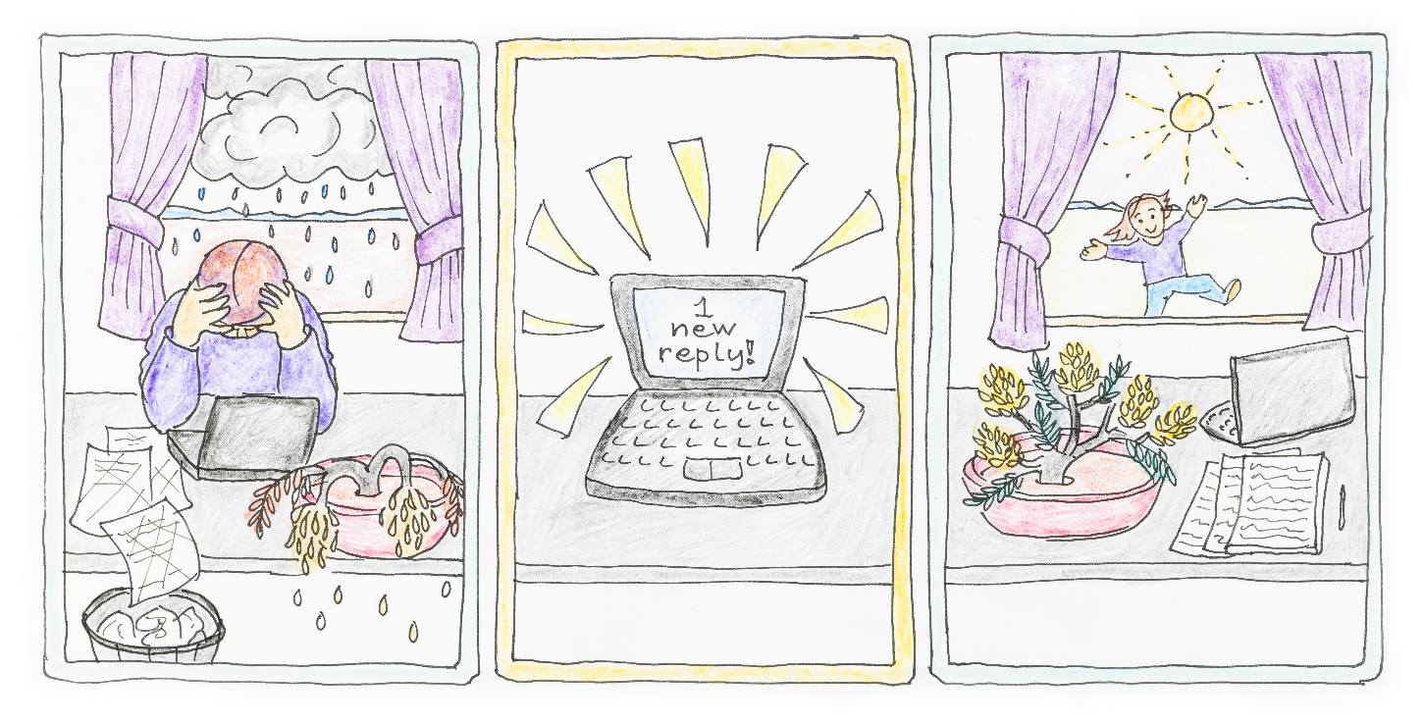

Small Actions, Morag Porteous
In the Fellowship research, students noticed and appreciated the relatively small actions made by staff. So, do know that small actions help students to feel known, connected, valued, and a sense of belonging (Crawford, 2021a, p. 91). Furthermore, “small actions by university staff can have a positive impact on students’ mental wellbeing” and “the simple act of checking in with a student and asking if they are okay [for instance, if they seem “out of sorts”] opens students to the possibility of seeking help” (p. 51).

What services do universities provide for students with mental health challenges?
In your teaching or support role, you are not expected to be an expert on mental health conditions, but you could become familiar with the types of services available and refer students to them. Most universities in Australia have Student Support Services, and one of the units within these services provides Counselling Services. University Counselling Services are usually free, and students can access them whether or not they have a diagnosed mental health condition. Since COVID-19, a lot more of these services are being provided online or over the phone, which makes them more accessible for students who work or have parenting responsibilities during office hours and/or are located in regional and remote areas.
If a student has a diagnosed mental health condition, they can access university Disability Services (also called Accessibility Services) to formally have adjustments made in their courses, so they can progress through their studies without being discriminated against or disadvantaged. In consultation with the student, Disability/Accessibility Advisors make recommendations regarding reasonable accommodations and adjustments, such as alternative forms of assessment (ADCET, 2021).

* Top tip: refer students to relevant support services
If you know a student in your unit/course has a diagnosed mental health condition (i.e. they may have disclosed this information to you), you could tell them about the Disability Advisors and direct them to the relevant information on their university’s website. They may not equate “mental health condition” with “disability” and, as a result, might not know that they are eligible to access the Disability/Accessibility Services.
Whether a student has a diagnosed mental health condition or not, if it seems they are overwhelmed and struggling, you could guide them to the Counselling Services at their university. These days, students can often book an appointment online and have the counselling session online or over the phone. You could also direct them to mental health services in your local community (or wherever the closest services are located). For immediate support around Australia, there are services such as Beyond Blue that can be contacted via phone or online.

What about staff mental wellbeing?
When thinking about supporting students’ mental wellbeing, it’s also important to consider your mental wellbeing — the mental wellbeing of academic and professional staff. It needs to be considered alongside the important role you play in supporting students’ mental wellbeing. Regardless of how equipped teaching staff feel they are to support students, they are often the first port of call for students experiencing academic and non-academic challenges (Crawford & Johns, 2018; Hughes et al., 2018). Providing support and pastoral care can carry an emotional load and impact negatively on staff mental wellbeing (Crawford et al., 2018; Olds et al., 2018). You might benefit from checking in, chatting to and debriefing with your colleagues. You’ll probably have some understanding of each other’s experiences.
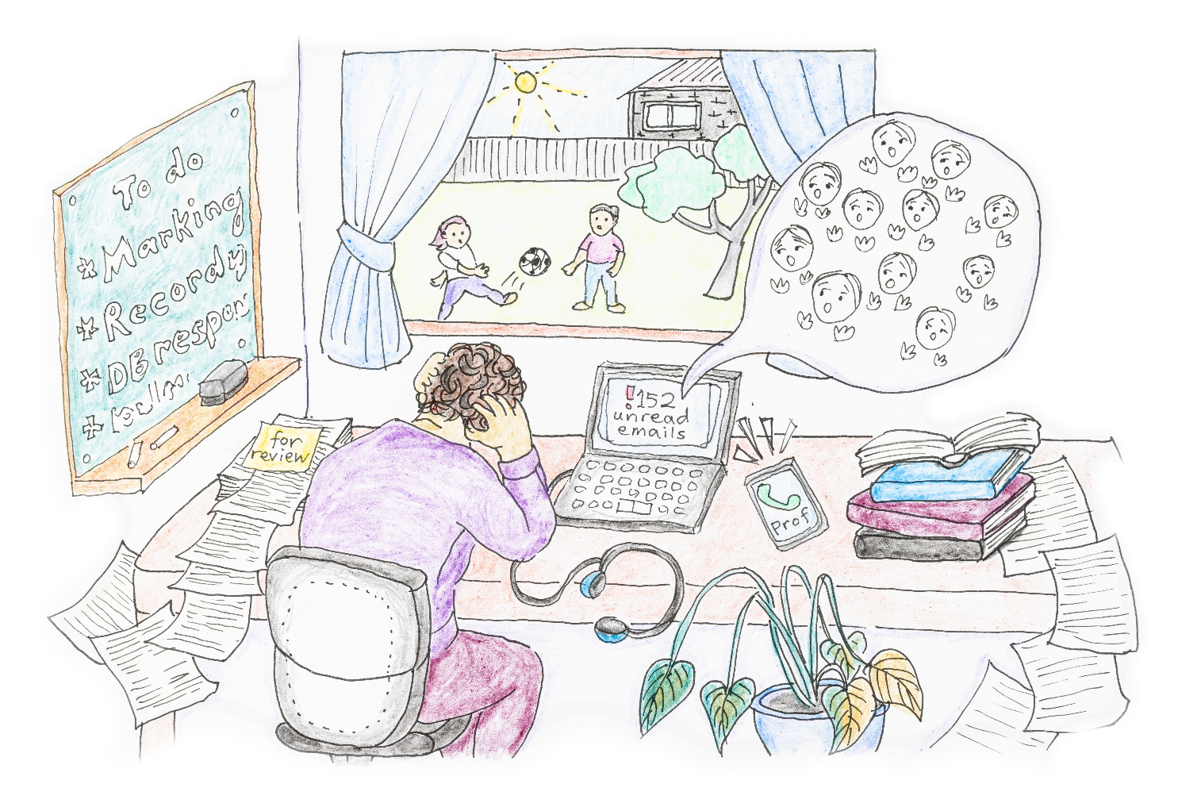

Staff Mental Wellbeing, Morag Porteous

Useful links

Online resources
As with learning skills support (see the guide, Supporting students’ learning), most universities have online resources related to student mental health and wellbeing. You might like to also look beyond your institution’s website and see what resources are publicly available at other universities.
Here are a few suggestions:
- Baik et al.’s (2016) Enhancing Student Wellbeing website has a suite of online resources for university educators. Although it’s written with university teaching staff in mind, some of the tips in Section 3.4. Lifehacks for teaching might be useful for academic and professional staff.
- The University of Newcastle’s Counselling unit has some great Study and Wellbeing online resources for students, including Stress Management and Managing Burnout.
- Flinders University has a Student Health and Wellbeing blog, by Dr Gareth Furber, with great information and tips for students.
- The Fridge is an evidenced-based online resource for university students. It covers managing time, goals, motivation and wellbeing. The project was led by Professor Jacquelyn Cranney (University of New South Wales).
- The project Promoting academic success and wellbeing, led by Associate Professor Sharron King, involved the development of a suite or resources for regional students.
- More links to resources can be found on the 2021 Needed Now conference website, specifically, the Student mental health and wellbeing session, organised and facilitated by Professor Sally Kift.

Policy, research and practice in the UK
Impressive policy work, research and resource development is being undertaken in the United Kingdom (UK). Check out the following fantastic documents and resources:
- Universities UK’s Stepchange: Mentally health universities
- The University Mental Health Charter by Hughes & Spanner (2019)
- Student Minds includes resources and more
- Student Mental Health Research Network (SMaRteN)
- The Wellbeing Thesis is an online resource for postgraduate students.
- The recently released Education for Mental Health Toolkit is a comprehensive resource developed by Hughes et al. (2022) and Wilson et al. (2022), funded by the Office for Students in the UK.

Acknowledgements
Thank you to my colleagues: Professor Sally Kift, President, Australian Learning & Teaching Fellows; Dr Judy Skene, Independent Consultant (formerly Associate Director, Student Services, The University of Western Australia); and Allen Baird (formerly Student Coordinator/Lecturer/Tutor, Pre-degree Programs, University of Tasmania), for excellent feedback and suggestions on this guide. The beautiful illustrations on the cover and in this document are by Morag Porteous.

References
ADCET (2022). Disability Practitioners. https://www.adcet.edu.au/disability-practitioner/your-role
Baik, C., Larcombe, W., Brooker, A., Wyn, J., Allen, L., Brett, M., Field, R., & James, R. (2016a). A framework for promoting student mental wellbeing in universities. Australian Government Office for Learning and Teaching. http://unistudentwellbeing.edu.au/framework/
Baik, C., Larcombe, W., Brooker, A., Wyn, J., Allen, L., Brett, M., Field, R., & James, R. (2016b). Mental health essentials: M-BRAC. Enhancing Student Wellbeing. Australian Government Office for Learning and Teaching. http://unistudentwellbeing.edu.au/wp-content/uploads/2016/08/MCSHE-Student-Wellbeing-MBRAC.pdf
Caleb, R., & Barden, N. (2019). Higher Education in the Twenty-first Century: Changes and Challenges for Mental Wellbeing. In N. Barden & R. Caleb (Eds.), Student Mental Health and Wellbeing in Higher Education: A practical guide (pp. 3-17). SAGE Publications Limited.
Crawford, N. (2021a). “On the radar”: Supporting the mental wellbeing of mature-aged students in regional and remote Australia. Perth: National Centre for Student Equity in Higher Education, Curtin University. https://www.ncsehe.edu.au/wp-content/uploads/2021/04/Crawford-Equity-Fellowship-Report_FINAL.pdf
Crawford, N. (2021b). “On the radar”: Supporting the mental wellbeing of mature-aged students in regional and remote Australia – Guidelines and Recommendations. Perth: National Centre for Student Equity in Higher Education, Curtin University. https://www.ncsehe.edu.au/wp-content/uploads/2021/11/NicoleCrawford_Guidelines_final-bound_Digital.pdf
Crawford, N., & Johns, S. (2018). An academic’s role? Supporting student wellbeing in pre-university enabling programs. Journal of University Teaching & Learning Practice, 15(3), 1-21. https://ro.uow.edu.au/jutlp/vol15/iss3/2/
Crawford, N., Olds, A., Lisciandro, J., Jaceglav, M., Westacott, M., & Osenieks, L. (2018). Emotional labour demands in enabling education: A qualitative exploration of the unique challenges and protective factors. Student Success, 9(1), 23-33. https://doi.org/10.5204/ssj.v9i1.430
Hughes, G., Panjawni, M., Tulcidas, P., & Byrom, N. (2018). Student mental health: The role and experiences of academics. Student Minds. https://derby.openrepository.com/handle/10545/622114
Hughes, G., & Spanner, L. (2019). The University Mental Health Charter. Student Minds. https://www.studentminds.org.uk/charter.html
Hughes, G., Upsher, R., Nobili, A., Kirkman, A., Wilson, C., Bowers-Brown, T., Foster, J., Bradley, S., & Byrom, N. (2022). Education for Mental Health: Enhancing Student Mental Health through Curriculum and Pedagogy. AdvanceHE. https://www.advance-he.ac.uk/teaching-and-learning/curricula-development/education-mental-health-toolkit#ToolkitOverview
Larcombe, W., Finch, S., Sore, R., Murray, C. M., Kentish, S., Mulder, R. A., Lee-Stecum, P., Baik, C., Tokatlidis, O., & Williams, D. A. (2016). Prevalence and socio-demographic correlates of psychological distress among students at an Australian university. Studies in Higher Education, 41(6), 1074-1091. https://doi.org/10.1080/03075079.2014.966072
Olds, A., Jones, A., Crawford, N., & Osenieks, L. (2018). Reflective encounters for enabling educators: The role of debriefing in building psychological capital. Proceedings of the 2018 Foundation and Bridging Educators New Zealand Conference (FABENZ), Wellington, New Zealand. https://fabenz.org.nz/proceedings-of-the-fabenz-conference-2018/
Okanagan Charter. (2015). Okanagan Charter: an international charter for health promoting universities and colleges. http://www.healthpromotingcampuses.ca/okanagancharter/
Orygen. (2020). Australian university mental health framework. Orygen. https://www.orygen.org.au/Policy/University-Mental-Health-Framework/Framework/
Ryan, R. M., & Deci, E. L. (2000). Self-determination theory and the facilitation of intrinsic motivation, social development, and well-being. American Psychologist, 55(1), 68-78. https://doi.org/10.1037/0003-066X.55.1.68
Wilson, C., Knight, G., Leadbeater, W., Shephard, N., Shokr, H., Taylor, J., Vettraino, E., Warren, A., & Higson, H. (2022). Curriculum design for mental health and wellbeing: guidance and resources for learning and teaching development programmes in higher education. AdvanceHE. https://www.advance-he.ac.uk/knowledge-hub/education-mental-health-toolkit
Woodyatt, L. (2019, July 10). “Psychological Wellbeing Network” session. Students Transitions Achievement Retention and Success (STARS) conference, Melbourne.
World Health Organization. (2014). Mental health: a state of well-being. http://origin.who.int/features/factfiles/mental_health/en/

This guide was updated and edited for a general audience of academic and professional staff in May 2022; at that time, the links in this document were accurate, but please note that links to university webpages often change.
See Section 2.2.1 in Crawford (2021a, pp. 10-12) for detailed definitions and conceptualisations of mental wellbeing.
Refer to the full set of guidelines for suggested approaches for each Guideline.
This combination model in Figure 1 draws on the work of Baik et al. (2016b) and Woodyatt (2019) in higher education, which is underpinned by self-determination theory (Ryan & Deci, 2000).
Refer to Section 7.7. “The impact on staff mental wellbeing” in Crawford (2021, p. 78) for a discussion of systemic issues that impact on staff mental wellbeing.

