Student equity in higher education: research, policy, practice and data

Nicole Crawford, National Centre for Student Equity in Higher Education

Introduction
Working in higher education, you may be interested in research, policy, practice and data about equity students to get a sense, for instance, of the bigger picture or to learn about equity initiatives. Where do you begin?
The purpose of this guide is to provide some suggestions for where to find:
- research, policy and practice about student equity in higher education
- Department of Education, Skills and Employment (DESE) data about students in equity groups in higher education, as well as how to create graphs and comparisons using the National Centre for Student Equity in Higher Education (NCSEHE)’s interactive site.

Equity research, policy and practice: some background information
Research, policy and practice in regard to student equity in higher education typically focuses on the six designated equity groups, as well as equity-like groups (see the Guide, Equity in higher education, for definitions). Equity programs, interventions and initiatives are often explored through the student life cycle stages identified in the Equity Initiatives Framework (Bennett et al., 2015). The stages of the student life cycle are: Pre-access; Access; Participation; Attainment and Transition Out. Other related topics such as student engagement, and student mental health and wellbeing are also explored in relation to equity.

Student equity: research, policy and practice
There is a lot of information out there in the world of research, policy and practice in regard to student equity. Where and how can you find it? University students and staff have access to their institutions’ libraries and the invaluable research databases and journals that their universities subscribe to. If you don’t have an affiliation with a university, unless the journal is an “Open Access Journal”, research (in the form of peer-reviewed journal articles) can be difficult to access. However, research and practice reports, and policy documents are often publicly available. Here are some places to explore:
- The NCSEHE website houses NCSEHE-funded research by equity researchers and practitioners across Australia; it also has links to other equity-related reports, journal articles and news:
  - In the menu bar, hover over “Publications” then select “Research Reports”, “Journal Articles” and more from the drop-down menu.
  - Alternatively, go directly to the NCSEHE Research Database where you can use filters to narrow your search.
  - The NCSEHE Building Legacy and Capacity reports include summaries of numerous research projects on student equity topics.
- The University of Newcastle’s Centre of Excellence for Equity in Higher Education (CEEHE) team has publications available on their website.
- QILT’s national annual Student Experience Survey includes breakdowns by demographic groups including location (e.g. regional/remote), socioeconomic status, study mode and more.
- Victoria University’s Mitchell Institute has an education focus, as does the Grattan Institute within its broader scope.

In terms of advocacy, check out– the Equity Practitioners in Higher Education Australasia (EPHEA) professional body. The Centre for Social Justice at UTS holds excellent panels on equity-related topics. – The Society for the Provision of Education in Rural Australia (SPERA) focuses on educational opportunities for rural communities in Australia.
You could join the NCSEHE mailing list and/or become a member of EPHEA to keep up to date with student equity-related news, practice, research and professional learning opportunities.

Student equity data
As far as data are concerned, the main area of interest for you is probably the students enrolled in your unit, course, faculty or centre. However, if you’d like to get a national picture—for example, “regional and remote” or “low socioeconomic status (SES)” students’ participation in higher education across the country—here are a couple of suggestions:
The DESE Analysis and Data Division collect and disseminate statistics about higher education. In particular, the DESE Student Statistics webpage is worth visiting: DESE’s data team can also assist with the provision of student data for specialised requests.
Since 2014, Paul Koshy (NCSEHE) has prepared annual Briefing Notes about the DESE Student Data. These publications provide an overview of student participation, such as identifying growth (or not) in equity group participation over six-year periods, and a snapshot of how well represented equity group students are in Australian higher education. In more recent years, the NCSEHE has provided this equity data in an interactive format as well, which allows us to look at specific equity groups and compare institutions.
Let’s have a look at the national data on this interactive site!
Step 1: Go to the interactive site for “National Data”.
Step 2: Let’s select the following options:
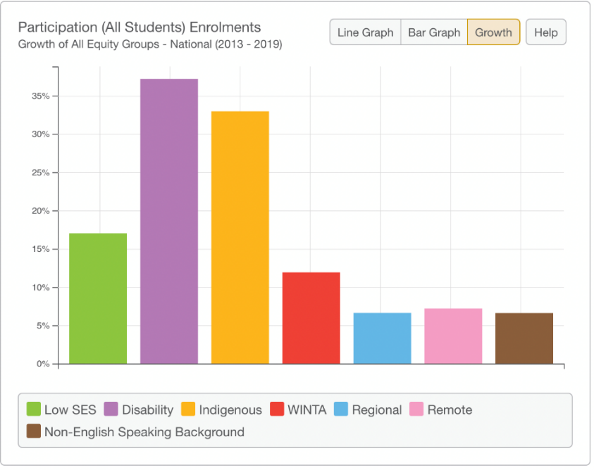
- Domain: Participation
- Indicator: Enrolments
- Equity Group: All Groups
- Focus: National Dashboard
- In the chart: select Growth
Figure 1 shows what appears as a result of this combination.

Figure 1: Participation (All Students) Enrolments: Growth of All Equity Groups (2013-2019)
Let’s try a different combination this time and select the following:
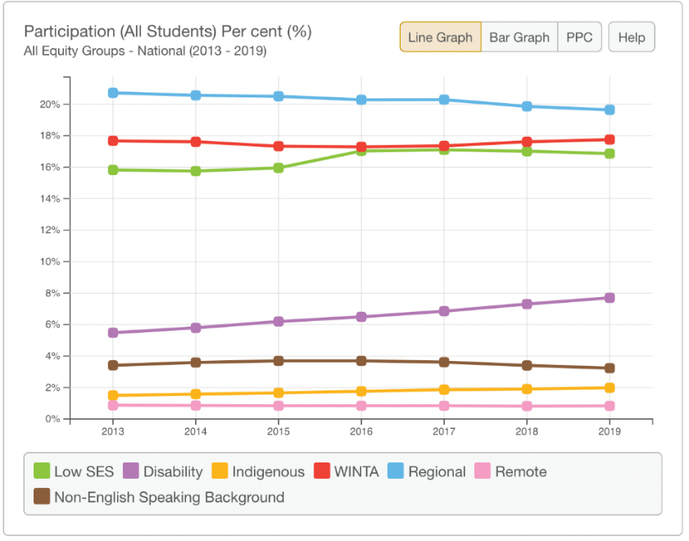
- Domain: Participation
- Indicator: Share/Rate
- Equity Group: All Groups
- Focus: National Dashboard
- In the chart: let’s select Line Graph.
Figure 2 shows what appears.

Figure 2: Participation (All Students) Enrolments: Percentage (%) (2013-2019)

You might like to choose some other combinations and also check out the Institutional Data.
Enjoy!

Acknowledgements
Thank you to my colleagues: Dr Paul Koshy, NCSEHE, Curtin University; Dr Judy Skene, Independent Consultant (formerly Associate Director, Student Services, UWA); and Allen Baird (formerly Student Coordinator/Lecturer/Tutor, Pre-degree Programs, UTAS), for excellent feedback and suggestions on this guide. The beautiful illustration on the cover is by Morag Porteous.

References
Bennett, A., Naylor, R., Mellor, K., Bridges, E., Brett, M., Gore, J., Harvey, A., Munn, B., James, R., Smith, M., and Whitty, G. (2015). The Critical Interventions Framework Part 2: Featured Initiatives. https://www.ncsehe.edu.au/wp-content/uploads/2018/06/23_UoN_AnnaBennett_Supplied_Part2.pdf

This guide was updated and edited for a general audience of academic and professional staff in May 2022; at that time, the links in this document were accurate, but please note that links to university webpages often change.

