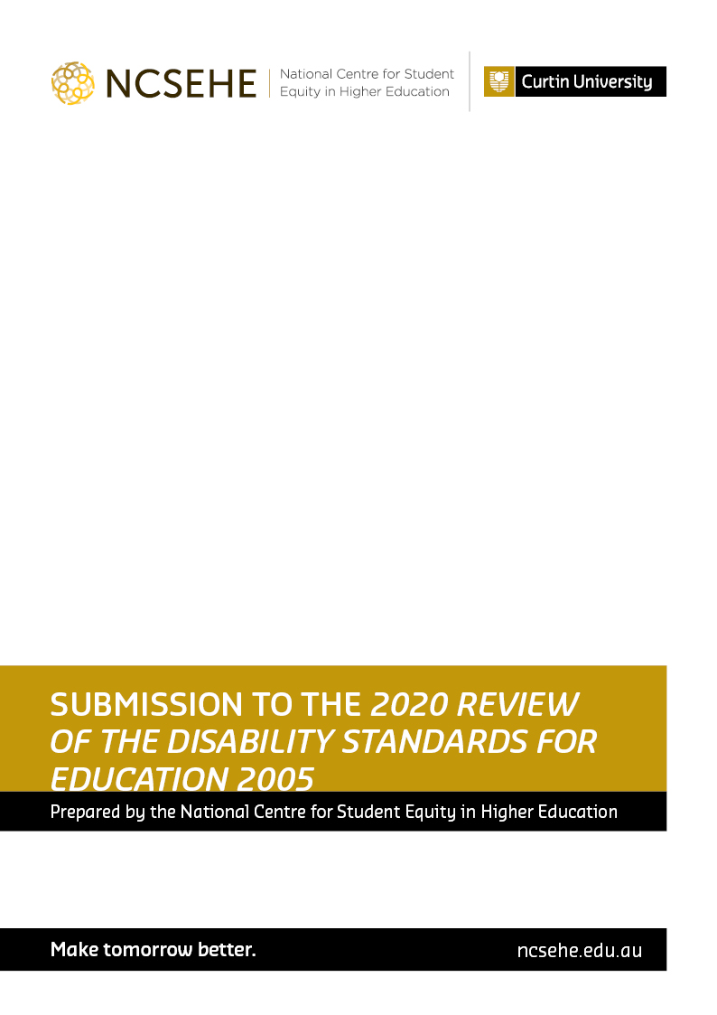

Submission to the 2020 Review of the Disability Standards for Education 2005

September 2020

Submission prepared by:

The National Centre for Student Equity in Higher Education (NCSEHE)

This submission has been prepared by Dr Paul Koshy, Dr Catherine Drane, Dr Nicole Crawford and Mr Matt Brett on behalf of the NCSEHE.

National Centre for Student Equity in Higher Education
ncsehe.edu.au
Tel: +61 8 9266 1573
Email: ncsehe@curtin.edu.au
Technology Park, Enterprise Unit 4 (Building 602)
9 De Laeter Way Bentley WA 6102
GPO Box U1987 Perth WA 6845

DISCLAIMER
Information in this publication is correct at the time of release but may be subject to change. This material does not purport to constitute legal or professional advice.

Curtin accepts no responsibility for and makes no representations, whether express or implied, as to the accuracy or reliability in any respect of any material in this publication. Except to the extent mandated otherwise by legislation, Curtin University does not accept responsibility for the consequences of any reliance which may be placed on this material by any person. Curtin will not be liable to you or to any other person for any loss or damage (including direct, consequential or economic loss or damage) however caused and whether by negligence or otherwise which may
result directly or indirectly from the use of this publication.

Contents
Introduction 4
Disability in Australian Higher Education 5
Defining Disability 5
Identification of Disability 6
Key Issues in Creating and Enforcing Standards in Higher Education 7
References 12

Introduction

The National Centre for Student Equity in Higher Education (NCSEHE) is a research and policy centre funded by the Australian Government Department of Education, Skills and Employment (DESE), and based at Curtin University. It provides national leadership in student equity in higher education, connecting research, policy, and practice, to improve higher education participation and success for marginalised and disadvantaged people.
The NCSEHE would like to thank the DESE for this opportunity to provide a submission to the 2020 Review of the Disability Standards for Education 2005.
This submission draws on the NCSEHE’s Discussion Paper on the 2020 Review of the Disability Standards for Education 2005 (National Centre for Student Equity in Higher Education, 2020a). The discussion paper should be consulted for an expanded briefing of the issues addressed here in relation to the Disability Standards for Education (“the Standards”).
The NCSEHE endorses an approach to higher education policy that is grounded in inclusive participation. In February 2019, it released a report outlining a series of principles for equity policy over the next decade, The Best Chance for All: Student Equity 2030 (Zacharias & Brett, 2019). This vision is underpinned by an understanding that all people in Australia, whomever and wherever they are, are provided with the opportunity to successfully engage in beneficial and lifelong learning in a higher education system that is responsive to its community, inclusive, and accountable.
Based on NCSEHE research and policy work, and in consultation with equity stakeholders in Australian higher education, the NCSEHE proposes 10 recommendations to increase the relevance and impact of the Standards.

Disability in Australian Higher Education

The NCSEHE contends that responsibility for complying with the Standards should lie with institutions. Compliance with the Standards should be proactive rather than reactive and include a whole-of-institution approach to disability that considers an institution’s culture and environment.
However, while institutional responses can be induced through structural approaches, there is presently no mechanism to ensure that higher education providers comply with the Standards. In a recent NCSEHE-funded study, Naylor and Mifsud (2019) examined institutional cultural responses to structural inequality and identified Structurally Enabling approaches as critical. These approaches involve an institution recognising that processes which inhibit the ability of students to navigate the institution can be changed, ensuring that institutional engagement with students is as flexible and responsive as possible. They found that “structurally enabling approaches were most widespread and developed in the disability space” and noted that the expectation around performance that flows from a structural approach to disability helped foster institutional adoption (Naylor & Mifsud, 2019, p. 42).
This reflects the influence of the Standards, yet it is also noticeable from the evidence proffered below and in our accompanying Discussion Paper that the Standards are not wholly integrated into the administrative processes of Australian higher education providers. For this reason, the NCSEHE’s first recommendation is that the Review consider options for establishing the position of Disability Education Commissioner, with responsibility for the development, implementation, and evaluation of the Standards, in conjunction with an assessment of other disability policy initiatives in Australian education.
Recommendation 1: That the position of Disability Education Commissioner be established through the Standards, to have responsibility for the implementation of the Standards and other disability policy initiatives, across all settings in Australian education.

Defining Disability

The disability classifications utilised in higher education are somewhat simplistic and based on a medical model of disability, which fails to capture the complexities and diversity of disability (Brett, 2016). The medical model also tends to place impairment at the core of the problem — requiring a “fix or cure” for the individual.
The NCSEHE advocates for a social model of disability, where a broader understanding of disability shifts the emphasis to making social structures more equitable and removing systemic barriers to participation, rather than a single focus on “impairment”. This places policy at the centre of interventions to mitigate disadvantage, with inclusion being the responsibility of institutions, and reflecting principles of universal design (Brett, 2016). While the identification of medicalised disability offers some useful information for universities, the underlying purpose of collecting this information should be to inform institutional policy and interventions that facilitate greater inclusion and support of students with disability. Categorical identification, therefore, must be supplemented with information that allows for a more complex understanding of student needs, beyond the mere presence or absence of disability. The development of an appropriate and sensitive mechanism (Kilpatrick et al., 2016) to supplement high-level identification of disability, which allows for a more nuanced and meaningful understanding of student need, is required.
Recommendation 2: That the Standards require the identification of disability be complemented with contextual information that allows for a more nuanced and meaningful understanding of student experience and need.
Recommendation 3: That the Standards impose a stronger requirement on institutions to adopt a universal design approach to disability, whereby the presence of students with disability is assumed, regardless of disclosure, with available data used to inform the development of inclusive policy and practice.

Identification of Disability

Australia has 30 years’ experience in the collection, analysis and reporting of higher education equity data, including reporting on disability. However, there is considerable room for improvement. Disability, along with Indigenous status, is the only equity indicator generated from self-reporting. This form of collection has no reference to external data sources such as the Nationally Consistent Collection of Data on School Students with Disability (NCCD) or the National Disability Insurance Scheme (NDIS). The use of self-reporting, with limited external verification, has led to gaps in reporting, such as the current limited reporting on mental health conditions.
Australian universities currently report information on student disability via the Higher Education Information Management System (HEIMS). Students are asked to indicate a “disability, impairment or long-term medical condition” in relation to the broad categories of disability: “hearing”; “learning”; “mobility”; “visual”; “medical” or “other disability”. In addition, they are also asked if they “would like to receive advice on support services, equipment and facilities” (Element No. 386 “Disability”, in: Higher Education Information Management System, 2020).
The new student collection system in higher education, the Tertiary Collection of Student Information (TCSI), will address some of these issues as part of its rollout in 2020–21. This will occur through the inclusion of a new disability variable: “Disability” (E615). A key change with the new collection is the expansion of disability definitions to include standardised categories, specifically the creation of new categories from “Other disability” — including “Mental health condition” (Commonwealth of Australia, 2020). However, TCSI will not collect data on students’ nomination for support services.
A welcome outcome from the current Review would be the initiation of a new project looking at higher levels of data integration between the education, health, and social service sectors. One prospective source of data on disability and support requirements is the Council of Australian Governments’ (COAG) proposed National Disability Data Asset (Department of Social Services, 2020). A potential starting point for utilising NDDA data in education is the recommendation from the Review of Senior Secondary Pathways into Work, Further Education and Training (“Review of Senior Secondary Pathways”), which called for the establishment of a unique student identifier (USI) for (Education Services Australia, 2020, p. 22).
Recommendation 4: That the Standards encourage the consistent identification of disability in Australian education, both within and outside higher education and in view of the proposed development of a Unique Student Identifier for Australian education.

Key Issues in Creating and Enforcing Standards in Higher Education

Pre-Access
Establishing a pathway to higher education participation and post-graduation outcomes is critical to increasing participation by people with disability. The Review of Senior Secondary Pathways emphasised the importance of pathways for senior secondary students. In its recommendations to government it called for all senior secondary students with disability to have access to work exploration in school (Education Services Australia, 2020, p. 22).
Attention to this issue has become critical since the emergence of COVID-19, which has exacerbated the disadvantages faced by students with disability in accessing information about post-compulsory educational options. As part of its submission on the Job-ready Graduates Package and its draft legislation, the NCSEHE observed that there was a requirement to examine how the new funding arrangements would explicitly impact on institutional performance in relation to disability access and enrolment (National Centre for Student Equity in Higher Education, 2020b, p. 8).
Recommendation 5: That the Standards require that outreach activities in secondary education be accessible to students with disability.
Access and Enrolment
A consistent approach to both recognising and addressing disability is essential in making access to higher education equitable. Beyond the identification of students with disability, an issue which in great part would be dealt with in addressing issues around pre-access, is the complexity of current enrolment procedures in higher education. In a submission to the Higher Education Standards Panel (HESP) Review of Transparency of Higher Education Admissions Processes, the NCSEHE (2016) highlighted the challenges equity students faced in navigating university. In relation to disability, this includes the discussion of, and response to, inherent requirements to also address pre-access and enrolment.
Recommendation 6: That the Standards articulate clearer guidance about formulation of statements of inherent requirements and their communication to students at the pre-access and enrolment stages in higher education.
Participation
The 2015 Review of the Standards identified impediments to instituting the Standards in post-compulsory education (Urbis, 2015). It observed that the “the scale of universities means that only a selected few people in university administration and support roles thoroughly understood their obligation for compliance to the Standards” (Urbis, 2015, p. 27). In large part, this is a function of the overall lack of enforceability of the Standards, whereby, in practice, institutions only have to undertake reasonable adjustments to ensure access for students, often motivated by individual cases, with limited attempts to create general guidelines in relation to inherent requirements for courses. It is anticipated that Recommendation 1 in this submission, should it be adopted, will provide a suitable framework for strengthening compliance around the Standards, and additionally improving the responsiveness of institutions.
Curriculum Development, Accreditation and Delivery
Urbis (2015) identified the inconsistent adoption of the Standards across courses, institutions, and professional settings, as a key issue in curriculum development and delivery. Brett et al. (2016), in a series of recommendations on inherent requirement statements in Australian higher education, called for the exploration of options for achieving “greater consistency, clarity and transparency of inherent requirement statements across institutions and disciplines” (p. 3), combined with research into the impacts of such statements on student access and participation.
In addition to these issues, inclusive curriculum development and practice is vital to ensuring positive outcomes for students with disability. The recent changes to the Higher Education Disability Support Program (DSP), which included additional funding for the Australian Disability Clearinghouse on Education and Training (ADCET) to promote inclusive learning and teaching, are a welcome development in this context (Department of Education, Skills and Employment, 2020).
Recommendation 7: That the Standards provide clearer guidance on the design and implementation of inherent requirements. That this is coupled with guidance on inclusive teaching practice and structures that will make the Standards integral to course and qualification design and operation.
Student Support Services
In 2020, the Commonwealth created more flexibility for institutions in providing support services to students with disability, primarily through changes to the DSP, including the creation of the new Disability Support Fund (DSF) and an expansion in the list of eligible activities on which funding can be spent. In addition, under the DSF, higher education institutions will be able to claim reimbursement for students whose needs require funding in excess of $10,000 in a calendar year (Department of Education, Skills and Employment, 2020).
The NCSEHE anticipates that further desirable changes to student support services will emerge from recommendations in this submission, in conjunction with further, appropriate, adjustments to the DSP as part of their implementation.
Elimination of Harassment and Victimisation
People with disability are commonly subjected to harassment and victimisation. The ABS’s 2014 General Social Survey (GSS) found that 22.7 per cent of people with disability had experienced discrimination, compared with 16.9 per cent of people without disability (Australian Bureau of Statistics, 2014).
This issue is compounded by poor response mechanisms. When students do experience discrimination, the onus is placed on them to submit a complaint, in the context of a power differential between an individual student and the institution. In turn, the true extent of harassment and victimisation is not recognised in higher education, except through anecdotal evidence. Higher education would benefit from a national system of data collection and reporting on harassment and victimisation in all education settings.
Recommendation 8: That the Standards introduce a requirement for the consistent collection and reporting of data on harassment and victimisation in education.
Mental Health and Disability
A particular consideration in higher education is the reporting of, and institutional response to, student mental health issues. Many students choose not to disclose or seek help for their mental ill-health due to a perceived lack of understanding among university staff about the seriousness of their condition (Orygen, 2017). A lack of disclosure can also be due to the episodic nature of mental ill-health, with some students experiencing periods of acute illness, as well as periods of stability and success.
For many students, their mental ill-health is invisible, may be undocumented, or considered “under control”. Importantly, mental health issues are not always present at the time of enrolment, but rather emerge during a student’s educational journey. As the onset of mental ill-health peaks in adolescence and early adulthood, and given the prevalence of high or very high levels of psychological distress reported by university students (Orygen, 2020), a lack of disclosure means that many students’ psychological needs are not being met by current support services.
Recommendation 9: That the Standards ensure the classification of mental health conditions under the term “disability” is sufficiently broad to include temporary, chronic and/or episodic conditions, and that institutional responses to student support service requirements or allegations of harassment and victimisation reflect this complexity.

Post-Graduation Outcomes
The labour force outcomes for higher education students with disability in Australia are substantially lower than those of students without disability. The 2020 Graduate Outcomes Survey longitudinal collection shows new graduates with disability experienced lower levels of full-time employment compared with others — 63.9 per cent versus 73.6 per cent, with commensurately lower levels of overall employment and labour force participation (Quality Indicators for Learning and Teaching, 2020).
While progress has been made in improving labour force outcomes for students with disability, the gap in outcomes with the general population, most notably in full-time participation, but also in earnings after three years in the workforce, indicates that more attention is required. The general guidance and training of students in relation to employability skills and work options needs to take into specific consideration the needs of students with disability. For this reason, the Review of Senior Secondary Pathways’ recommendation on providing both a policy impetus and resourcing in schools to prepare students with disability for post-school transition is welcome. Importantly, a similar need exists at the higher education level, and so the NCSEHE recommends that the current Review consider ways in which employability skills and work options programs can be extended across the educational life cycle.
Recommendation 10: That the Standards provide clearer guidance on the transition to employment, ensuring students with disability are provided with consistent and relevant guidance on employability skills and work options.

References

Australian Bureau of Statistics. (2014). General Social Survey: Summary Results, Australia, 2014. Catalogue No. 4159.0. Table 11. Disability. https://www.abs.gov.au/AUSSTATS/abs@.nsf/DetailsPage/4159.02014?OpenDocument
Brett, M. (2016). Disability and Australian Higher Education. In A. Harvey, C. Burnheim, & M. Brett (Eds.), Student Equity in Australian Higher Education: Twenty-five years of A Fair Chance for All, (pp. 87–108). Springer.
Brett, M., Harvey, A., Funston, A., Spicer, R. & Wood, A. (2016). The Role of Inherent Requirement Statements in Australian Universities. Report submitted to the National Centre for Student Equity in Higher Education (NCSEHE), Curtin University. https://www.ncsehe.edu.au/publications/the-role-of-inherent-requirement-statements-in-australian-universities/
Commonwealth of Australia (2020). Disability Code. TCSI: Tertiary Collection of Student Information website. https://www.tcsisupport.gov.au/element/615
Department of Education, Skills and Employment. (2020). Higher Education Disability Support Program. https://www.education.gov.au/higher-education-disability-support-programme
Department of Education and Training. (2015). Australian Government Initial Response to the 2015 Review of the Disability Standards 2005. https://docs.education.gov.au/documents/australian-government-initial-response-2015-review-disability-standards-education-2005
Department of Social Services. (2020). National Disability Strategy: Position Paper. https://engage.dss.gov.au/nds-stage2-consultation/national-disability-strategy-position-paper/
Education Services Australia. (2020). Looking to the Future: Report of the Review of Senior Secondary Pathways into Work, Further Education and Training. Education Services Australia (Education Council). https://uploadstorage.blob.core.windows.net/public-assets/education-au/pathways/Final%20report%20-%2018%20June.pdf
Higher Education Information Management System. (2020). 2020 Higher Education Data Collection. Element Dictionary. Element No. 386 (Disability). https://heimshelp.education.gov.au/sites/default/files/2020-he-data-element-dictionary.pdf?v=1593405978
National Centre for Student Equity in Higher Education. (2016). Submission to Higher Education Standards Panel Review of Transparency of Higher Education Admissions Processes.
National Centre for Student Equity in Higher Education (NCSEHE), Curtin University.
National Centre for Student Equity in Higher Education. (2020a). Discussion Paper on the 2020 Review of the Disability Standards for Education 2005. National Centre for Student Equity in Higher Education (NCSEHE), Curtin University.
National Centre for Student Equity in Higher Education. (2020b). Submission to the Job-ready Graduates Package draft legislation consultation. National Centre for Student Equity in Higher Education (NCSEHE), Curtin University.
Naylor, R., & Mifsud, N. (2019). Structural inequality in higher education: Creating institutional cultures that enable all students. National Centre for Student Equity in Higher Education (NCSEHE), Curtin University.
https://www.ncsehe.edu.au/wp-content/uploads/2019/09/NaylorMifsud-FINAL.pdf
Orygen. (2020). Australian University Mental Health Framework. www.orygen.org.au.
Quality Indicators for Learning and Teaching. (2020). QILT 2020 GOS-L National Tables, https://www.qilt.edu.au/qilt-surveys/graduate-employment.
Urbis. (2015). Review of the Disability Standards for Education 2005.
https://docs.education.gov.au/system/files/doc/other/final-report-2015-dse-review.pdf
Zacharias, N., & Brett, M. (2019). The Best Chance for All. Student Equity 2030 – A long-term strategic vision for student equity in higher education. https://www.ncsehe.edu.au/wp-content/uploads/2019/03/Equity2030_FINAL.pdf

