Power of Perceptions

3 January 2017 to 31 March 2018

Ann Jardine

The project that resulted in the production of this report was funded under a National Priorities Pool (Higher Education Participation and Partnerships Program) grant from the Commonwealth. The recipient of the grant has granted the Commonwealth the right to sub-licence the material in this report. Copyright in the report remains with the original copyright owners.
Except where otherwise indicated, and save for any material protected by a trade mark, the Department of Education and Training, acting on behalf of the Commonwealth, has applied the Creative Commons Attribution 4.0 International Licence.

Modifications: Changed to meet WCAG 2.0 accessibility requirements.
Alternate text inserted for all images. Minor typographical errors corrected.

Higher Education Participation and Partnerships Programme (HEPPP)

2016 National Priorities Pool FINAL REPORT
Power of Perceptions
3 January 2017 to 31 March 2018
Name of university University of New South Wales, Sydney
Name of contact officer Dr Ann Jardine
Position title Director, AimHigh
Email address a.jardine@unsw.edu.au
Telephone number 02 9385 6360
In accordance with the Conditions of Grant, you must submit to the Department a Final Report (Clause 6.1 of Part A) and an Acquittal Report (clause 6.4 of Part A).
To meet this obligation, please submit:
- the completed Final Report template, in Word and PDF
- the completed and signed Declaration form, in PDF
- the completed Acquittal Report template, in Excel and PDF.
All documents must be submitted to equity@education.gov.au by 31 December 2017.
If you require additional guidance or clarification, please contact us at equity@education.gov.au.

Contents
List of Tables 3
1. PROJECT SUMMARY (Conditions of Grant, clause 2.2 of Part A) 4
Objectives 4
Project Activities, Milestones and Key Performance Indicators 4
Highlights and Issues 8
2. OTHER PROJECT MATERIAL (Conditions of Grant, clause 2.2 (b)-(e) of Part A) 10
Appendix: EPHEA 2017 PowerPoint Presentation 11

List of Tables
Table 1: Project objectives 4
Table 2: Project activities, milestones and KPIs 4
Table 3: Additional materials produced over the course of the project 10

1. PROJECT SUMMARY (Conditions of Grant, clause 2.2 of Part A)

Objectives

Table 1: Project objectives
IDENTIFIED OBJECTIVE | EXTENT TO WHICH THE OBJECTIVE WAS MET
To identify key elements that shape regional and remote low status students' aspirations to access university and then measure their perceptions about these elements, and to quantify their impact on student progression. | A number of the elements that shape regional and remote students’ aspirations to progress to university were identified through a complete literature review. This was complemented by input from UNSW-ASPIRE’s outreach staff, both practitioners and researchers.  The theory of planned behaviour was employed to categorise the elements found, shaping a research model. These categories are students’ attitudes towards university, their perceptions of control towards the decision of progressing towards university, and the way significants’ others’ opinions and support were perceived by these students.  A sample of 620 students in Year 12 from regional and remote areas of NSW was surveyed and asked to assess these elements according to their perceived importance.  The results of this survey allowed quantifying the impact of the elements/obstacles previously identified. The data collected was modelled using statistical techniques, particularly structural equation modelling.  The findings show that students’ attitudes towards progressing to university is the most important predictor of regional and remote students’ intention to progress to university. There are consequences to practitioners which are explained in the academic article prepared.  Therefore, this objective was completely met.

Project Activities, Milestones and Key Performance Indicators

Table 2: Project activities, milestones and KPIs
TIME FRAME | PLANNED ACTIVITIES & MILESTONES | PROJECT ACTIVITIES & MILESTONES COMPLETED | IDENTIFIED KEY PERFORMANCE INDICATORS | KEY PERFORMANCE INDICATORS OUTCOME
Nov 2016 – Dec 2016 | 1.1 Project Officer recruitment. | Project Officer with PhD and research skills in quantitative methodologies recruited | 1.1 A Project Officer with the knowledge, skills and experience to successfully deliver the Project is appointed. | Completed  Project officer recruited and commenced initial work on the project in late November 2016.
 | 1.2 Evaluation framework development | A scan of relevant international research undertaken | 1.2 An evaluation framework that will allow a determination to be made of whether or not the Project has successfully delivered all outcomes is devised. | Completed  Evaluation framework developed and implemented.
Dec 2016 – Feb 2017 | 2.1 Submission of application for ethics approval to the University of New South Wales. | Ethics approval sought from both UNSW and due to the involvement of school students, subsequently the appropriate area of NSW Department of Education (DET) | 2.2 Application for ethics approval  submitted in sufficient time for approval to be granted by the end of February 2017. | Completed  UNSW ethics approved (HC16959) and NSW DET SERAP approved (2017003)
Jan 2017 – Apr 2017 | 3.1 Literature review to develop a comprehensive understanding of the factors which can affect students' perceptions of their capacity to participate in higher education. | A comprehensive review of international research undertaken | 3.1 Literature review is completed. | Completed  Literature review undertaken and completed. Literature review was constantly updated through the project life and used to write an article for journal publication.
 | 3.2 Research model formulation. | A research model was developed and tested with relevant and experienced outreach practitioners. The developed research model illustrates the different variables found during literature review and the relationships between them. | 3.2.1 Draft research model, which includes identification of relevant variables, measuring scales and theoretical framework, formulated by the end of March 2017.  3.2.2 Final research model formulated by the end of April 2017 | Completed  Final research model was completed.  The project survey instrument was then based on the research model.
 | 3.3 Identification and confirmation of the schools which will participate in data collection. | ASPIRE schools were included in the list of schools invited to participate. In addition similar non ASPIRE regional and remote schools in NSW were identified and invited to take part.  After discussion with both schools and practitioners it was decided to confine the research to Year 12 students | 3.3 Confirmation of agreements with  up to 15 ASPIRE partner schools with senior high school cohort (Years 10, 11 and 12) | Completed  The final total number of participant schools was 33, from which 15 were ASPIRE partner schools. The total number of students who took part in the study was 695.
Mar 2017 – Apr 2017 | 4.1 Survey development based on extant literature to identify the key elements relating to aspirations and designed to test perceptions of university education | A survey instrument was developed based on the literature review process and on the research model. | 4.1.1 Draft survey developed by 2017.  4.1.2 Survey finalised and piloted in two ASPIRE schools by the end of April 2017. | Completed.  The veracity of the survey was tested with UNSW-ASPIRE staff and also with a group of volunteer UNSW students who are mentors for the targeted students.
May 2017 – Jun 2017 | 5.1 Data collection. | A process was developed to collect data in situ in schools in order to maximise participation and minimise incomplete responses. | 5.1 All 15 ASPIRE Schools with a high school component invited to participate with the aim for an 80% take up rate.  5.1.1 All participating schools visited by  ASPIRE team members and the researcher in early May 2017 to administer the survey and maximise the return rate.  5.1.2 Surveys distributed via the  ASPIRE schools with a collection method either via school or pre−paid envelope.  5.2 All data collected by the end of May 2017 | Completed  Visits were organised and discussed independently with the participant schools. Authorisation to perform the study was requested from all principals and/or careers teacher.  Two researchers visited every participant school, and students at these schools asked to complete the surveys at that time. Surveys were then collected.
Jul 2017 – Aug 2017 | 6.1 Data input and analysis. | Appropriate quantitative techniques for data analysis were identified | 6.1.1 Input of all survey data collected is completed by the end of July 2017.  6.1.2 Preliminary data analysis is completed by mid−August 2017.  6.1. Final data analysis is completed by the end of August 2017. | Completed  All the collected responses were uploaded to a data base, and further analysed through SPSS (statistical software) and AMOS (structural equation modelling) was conducted.
Sept 2017 – Dec 2017 | 7.1 Findings and conclusions | Data were fully analysed, findings and conclusions drawn | 7.1 Research findings and conclusions  are finalised, including:  a. the identification of factors influencing aspiration towards and access to higher education for low  socio−economic status, regional/ remote students  b. categorisation of the importance and impact of these factors, and  c. recommendations on feasible strategies to improve aspiration  towards and access to higher education for low socio−economic  status, regional/ remote students. | Completed  The research explored three critical factors in the determining of regional and remote school students’ intentions to progress to university: attitudes, the opinions of significant others and students’ perceptions of control.  Results show that students’ attitudes towards university and the influence of social capital were found to be the most important predictors of students’ intentions to progress to university.  Research findings, conclusions and recommendations for practitioners were first presented at the EPHEA 2017. Subsequently a journal article has been written with the intent of submission to the  Studies in Higher Education Journal.
Nov 2017 – Dec 2017 | 8.1 Publication and dissemination  of results. | Draft of a journal article written. Potential Journals identified. | 8.1 A conference paper or journal  article presenting the Project outcomes is prepared and targeted for submission to an appropriate conference or peer−reviewed journal. | Completed  Journal article has been readied and ready for submission for review to Studies in Higher Education journal.
 | 8.2 Delivery of the Final Report and  Acquittal Report. | Final report prepared | 8.2 Final Report and Acquittal Report  submitted to the Department of  Education and Training by 31 December  2017. | Complete  Final report and acquittal written for submission to the Federal Government.

Highlights and Issues
Provide a summary of highlights and achievements arising from your project (maximum half page).
- The research enabled a comprehensive list of elements and obstacles perceived by students as capable of shaping their perceptions about university and progression to further studies to be fully developed.
- This then enabled a research model to be built and tested.
- A survey instrument was developed to measure the impact of each of the variables in the research model among students in Year 12 in remote and regional settings. This survey instrument could be applied to further research.
- Findings show that students’ knowledge about university is positively related to their attitudes towards progressing to university and their perceptions of control about this decision.
- In addition, the results of this study show that regional and remote student’s attitudes are the most important predictor of their intentions to progress to university.
- As a consequence, practitioners interested in improving students’ intentions to progress to university could find the results and recommendations of this study able to inform their practice.

Outcomes
The outcomes of this study will assist in providing widening participation practitioners with empirical research upon which to base decisions on program design. In turn it is hoped this will assist in addressing the underrepresentation of low SES rural students in Australian university populations.
For further details, please examine the section “Implications for practitioners” in the accompanying research article.
Did you undertake an evaluation of your project?
Yes No X (not applicable)

Summary
Results of this research showed that:
- Students’ attitudes towards university and the influence of social capital were found to be the most important predictors of students’ intentions to progress to university.
- Students’ perceptions of control, this is perceived ownership of skills required to succeed in university (among others), were not found to be relevant when simultaneously analysed with attitudes and influence of social capital. An explanation to this could be given by the possibility that perceptions of control have already influenced and contributed in the shaping of students’ attitudes (which is in turn the stronger predictor of students’ intentions to progress to university) during previous years. Therefore, perceptions of control might be considered as a secondary factor by students in Year 12, once attitudes towards university have been already shaped.
- Students’ knowledge about university (study programs, university life, careers) proved to be a very relevant predictor of attitudes towards university and perceptions of control. This is, students with more knowledge about university tend to have more positive attitudes towards university and better perceptions of control over the decision of progressing to it.
- It is relevant to mention that these results are relevant for the sample analysed, this is, regional and remote students in Year 12 of school in NSW.
Project outcomes are presented and explored in detail within the accompanying research article. A confidential draft of the research article has been attached in compliance with section 6.1 C in Part A of the Conditions of Grant.

Student contacts | 695
Journal (or other publication) submissions | 1 – Studies in Higher Education is proposed
Conference Presentations | 1 – 2017 EPHEA Conference
Websites developed | N/A
Educational or marketing campaigns | N/A
Community organisations engaged | N/A
Schools engaged | 33
Parental/family contacts | N/A

Issues
Although initially 15 schools were contemplated to be part of the study, it was later decided that more schools were required to increase the number of students in Year 12 in the sample. In this way, 33 schools were finally part of the project, which was achieved after acquiring ethics allowance from both UNSW and SERAP.
Original times scheduled for data analysis and article writing were slightly underestimated in part due to the increase in schools and the travel involved in visiting all schools, and in part due to the time taken to obtain SERAP approval. However, the project has been completed within the timeframe.

2. OTHER PROJECT MATERIAL (Conditions of Grant, clause 2.2 (b)-(e) of Part A)

Table 3: Additional materials produced over the course of the project
TYPE | AUTHOR | DATE OF PUBLICATION | PUBLICATION DETAILS
EPHEA 2017 PowerPoint presentation | Dr Franz Carrillo | November 2017 | Unpublished conference slides

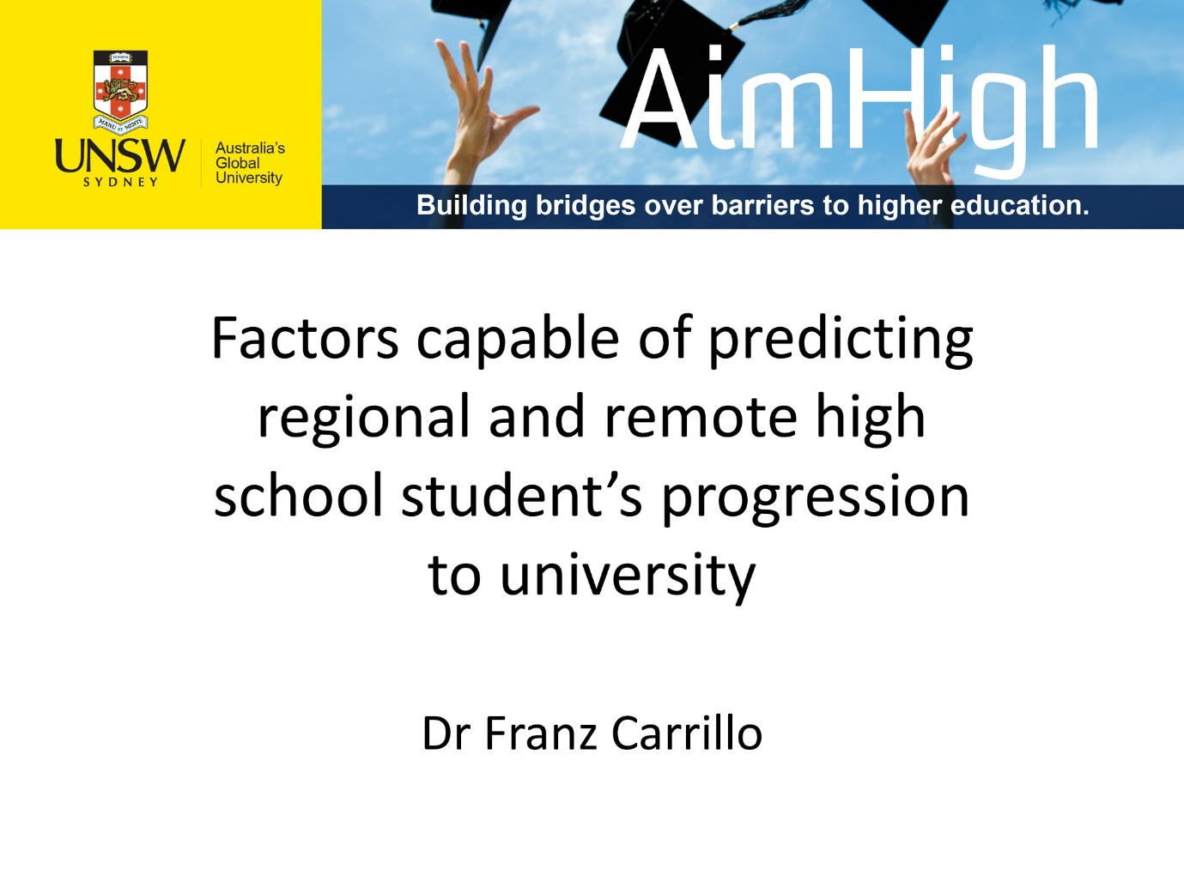
Appendix: EPHEA 2017 PowerPoint Presentation
