Supported Pathways to Education & Employment: Building the Capacity of the Illawarra and South East Region
1 December 2014 to 31 December 2015

Anne Snowball, University of Wollongong

The project that resulted in the production of this report was funded under a National Priorities Pool (Higher Education Participation and Partnerships Program) grant from the Commonwealth. The recipient of the grant has granted the Commonwealth the right to sub-licence the material in this report. Copyright in the report remains with the original copyright owners.
Except where otherwise indicated, and save for any material protected by a trade mark, the Department of Education and Training, acting on behalf of the Commonwealth, has applied the Creative Commons Attribution 4.0 International Licence.

Modifications: Changed to meet WCAG 2.0 accessibility requirements.
Alternate text inserted for all images. Minor typographical errors corrected.

Higher Education Participation and Partnerships Programme (HEPPP)

2014 National Priorities Pool FINAL REPORT
Supported Pathways to Education & Employment: Building the Capacity of the Illawarra
and South East Region
1 December 2014 to 31 December 2015
Name of university University of Wollongong
Name of contact officer Anne Snowball
Position title Director of Regional Campuses and Student Diversity
Email address annem@uow.edu.au
Telephone number (02) 4221 5668
In accordance with the Conditions of Grant, you must submit to the Department a Final Report (Clause 6.1 of Part A) and an Acquittal Report (clause 6.4 of Part A).
To meet this obligation, please submit:
- the completed Final Report template, in Word and PDF
- the completed and signed Declaration form, in PDF
- the completed Acquittal Report template, in Excel and PDF.
All documents must be submitted to equity@education.gov.au by 31 March 2016.
If you require additional guidance or clarification please contact equity@education.gov.au.

Contents
List of Tables 3
1. PROJECT SUMMARY (Conditions of Grant, clause 2.2(a)-(e) of Part A) 4
Objectives 4
Project Activities, Milestones and Key Performance Indicators 4
Highlights and Issues 5
Project Outcomes and 2016 6
Issues 6
2. OTHER PROJECT MATERIAL (Conditions of Grant, clause 2.2 (b)-(e) of Part A) 8
3. ACQUITTAL REPORT (Conditions of Grant, clause 6.4(e), clause 6.7-8 of Part A) 9
DECLARATION 10
Appendix 1: Pathways Stakeholder Survey 2015 11
Appendix 2: Collaborative Pathways to Education and Employment: An Emerging
Initiative at the University of Wollongong 16

List of Tables
Table 1: Project objectives 4
Table 2: Project activities, milestones and KPIs 4
Table 3: Additional materials produced over the course of the project 8

1. PROJECT SUMMARY (Conditions of Grant, clause 2.2(a)-(e) of Part A)

Objectives

Table 1: Project objectives
IDENTIFIED OBJECTIVE | EXTENT TO WHICH THE OBJECTIVE WAS MET
Improve the participation of Low SES, rural and remote and Indigenous people in higher education and employment. | Ongoing- UOW’s Regional campuses and Student diversity unit is committed to improving the participation of Low SES, rural and remote and Indigenous people in higher education and employment in line with unit and institutional objectives.
Provide 250-350 individuals from underrepresented backgrounds with opportunities to enhance their academic capacity and options post –schooling to access higher education and employment through a supported pathways program. | Met- over 350 students across five campuses and regions participated in the Pathways program in 2015 which included the Bridging and Transition program and careers planning.
Clearly articulate and streamline pathways and progression between vocational education providers, higher education providers and employers. | Met-Streamlining pathways, together with providing exit points with employment outcomes proved to be particularly important in building the capacity of this cohort of students. Students who participate in a supported pathways program will have had the opportunity to complete Certificate III, Certificate IV and Diploma level courses which have specific employment outcomes.
Strengthen partnerships and creating linkages with the University of Wollongong, government agencies and vocational education providers. | Met -The Pathways Program has continued to strengthen the working partnerships and linkages between the University of Wollongong and our vocational and government partners. The program was so successful in 2015 that new partners have been added for 2016 with several new types of vocational qualification being added. Opportunities for collaboration have also arisen at relevant industry forums.

Project Activities, Milestones and Key Performance Indicators

Table 2: Project activities, milestones and KPIs
TIME FRAME | PLANNED ACTIVITIES AND MILESTONES | PROJECT ACTIVITIES AND MILESTONES COMPLETED | IDENTIFIED KEY PERFORMANCE INDICATORS | KEY PERFORMANCE INDICATORS OUTCOME
Feb 2015 | Students recruited to participate in the Supported pathways program. | YES | 150 students recruited to participate in the supported pathways program. | Students recruited to participate in the Supported pathways program.
Jul-Aug 2015 | Additional Students recruited to participate in the supported pathways program. | YES | An additional 150 students recruited to participate in the supported pathways program. | Additional Students recruited to participate in the supported pathways program.
Oct 2015 | Transition Programs Delivered. | YES | 300 students participating in the supported pathways program in 2015. | Over 350 students participated in the Bridging and Transition Program across our five campuses.
Nov 2015 | Vocational Qualifications conclude.  Graduation ceremonies and applications to higher education or employment completed. | YES | 100% growth of partners involved in delivering supported pathways programs from 2014. | Vocational Qualifications were completed and graduations held across our five locations.
Nov 2015 | Quantitative/ Qualitative partnership survey conducted with partners. | YES | Positive responses from survey that demonstrate clear messaging and communication to students AND All partners sign back onto the program for 2016. | As per our attached Stakeholder Survey (Attachment One).

Highlights and Issues
The Supported Pathways program has been very successful across a number of measures, in particular:
- Regional Engagement
- Number of students engaged with the program
- Success of the partnerships with vocational providers
- Bridging and Transition Subject co-enrolment
As reported above across our five regions over 350 students were engaged with the program in partnership with 12 vocational providers. Students have gained a meaningful qualification with their provider that will lead to better employment outcomes. In many cases the students also chose to continue their learning journey either into a Diploma qualification or on to a Bachelor’s degree. For our Regional sites in particular this has a notable effect on the broader community with students engaged in workplace learning with local businesses. Local business chambers were involved in the study and the graduation ceremonies for a number of pathways cohorts.
A significant part of what made this pathways model innovative was the co-enrolment of students in both their Certificate IV qualification and the university approved UOW Bridging and Transition Subject. The integrated nature of this Bridging subject allowed for parallel skills development: While students are acquiring generalised skills and acculturation for university within the context of the Bridging subject, they are also becoming familiar with the discipline-specific discursive language of their subject matter within a vocational training context. Feedback from Bridging and Transition students has also reflected students’ delight at “discovering another side of themselves”, and feeling, for the first time in their lives, that they actually are “smart enough” to attend university.

Project Outcomes and 2016
The project has provided the opportunity to demonstrate the possibility of this kind of pathway program both to our own institution and to our partners and the communities in which we operate. In particular 2016 will bring:
- New administrative framework
- Broader range of articulation agreements
- Bridging and Transition subject offered to all students studying with partner vocational providers
- Continued focus on regional priorities
- Expansion to include online and distance options
The scope of the pilot work done as a result of this funding has allowed us to refine and develop a flexible administrative framework to ensure that the program continues in the future. Through analysis of our stakeholders, students and institutional measures we have developed a three tier engagement model that allows partners to engage with the program at a level appropriate for their needs and outcomes. The model allows us to expand elements of the program like the Bridging and Transition subject to more students whilst focusing funding for sponsored places into key strategic areas. This is a robust and flexible model that will contribute to the viability of the program in years to come.
The new framework also allows for engagement with a broader number of vocational providers and to expand our scope of articulation. In 2016 we will engage across a scope three times the size (in terms of Certificate IV qualifications) and we will be able to engage more directly with Diploma students by offering the Bridging and Transition subject to all students of our vocational partners. This is of particular significance to our Regional Partners.
Future developments of the program are similarly focused in the regional, rural and remote space. We will further develop our Moodle program as part of the Bridging and Transition subject and seek to pilot a version that can be delivered by distance or by a combination of on campus and distance delivery.

Issues
In July 2015 the Academic staff member whom we employed to deliver the Bridging and Transition Programs and undertake resource development and support resigned. This meant that we had to employ a large number of additional casual academics to deliver the program across our locations. We also had to engage an administrative assistant and a research assistant to assist with resource development. The impact on the project was negligible.
Did you undertake an evaluation of your project?
Yes No
UNDERWAY – Currently pending final census date data
Where applicable, indicate number of the following resulting from this project:

Student contacts
Journal (or other publication) submissions | N/A
Conference Presentations | Enter number or N/A
Websites developed | 1  http://www.uow.edu.au/in2uni-myway/pathways/index.html
Educational or marketing campaigns | 2
Community organisations engaged | 15
Schools engaged | N/A

2. OTHER PROJECT MATERIAL (Conditions of Grant, clause 2.2 (b)-(e) of Part A)
[List the titles of any published reports, pamphlets or other documentation produced in the course of the Project and attach them to this Final Report.]

Table 3: Additional materials produced over the course of the project
TYPE | AUTHOR | DATE OF PUBLICATION | PUBLICATION DETAILS
Conference paper; | Anne Snowball  Keirin McCormack  Annie Werner | Submitted February 2016 | STARS Conference

3. ACQUITTAL REPORT (Conditions of Grant, clause 6.4(e), clause 6.7-8 of Part A)
Have you fully expended the Grant Funds provided under the Conditions of Grant?
Yes X No
*IMPORTANT NOTICE - Unspent 2014 HEPPP Partnership Grant Funds
- Grant recipients must fully expend these 2014 National Priorities Pool funds in the project period for which the grant is made and report on this expenditure to the Commonwealth, including the amount of any unspent funds.
- If a provider fails to spend the full amount granted it in respect of a year, the unspent funds may be recovered by the Commonwealth.

DECLARATION
I declare that:
- I am authorised by the university to sign this Declaration on its behalf, and
- to the best of my knowledge, the information that I have provided in the Final Report and Acquittal Report for the HEPPP 2014 National Priorities Pool project Supported Pathways to Education and Employment is true, correct and accurate in all particulars.
I understand that:
- The provision of false or misleading information or the making of false or misleading statements to the Commonwealth is a serious offence under the Criminal Code Act 1995 (Cth).
- If any actual or potential conflict of interest arises, I must notify the Commonwealth immediately in writing of the facts giving rise to the actual or potential conflict of interest and to take such steps as the Commonwealth may require so as to resolve or otherwise deal with any conflict of interest that may arise.

Title Professor
Name Paul Wellings CBE
Position Chief Executive Officer (Vice-Chancellor)
Signature

Appendix 1: Pathways Stakeholder Survey 2015

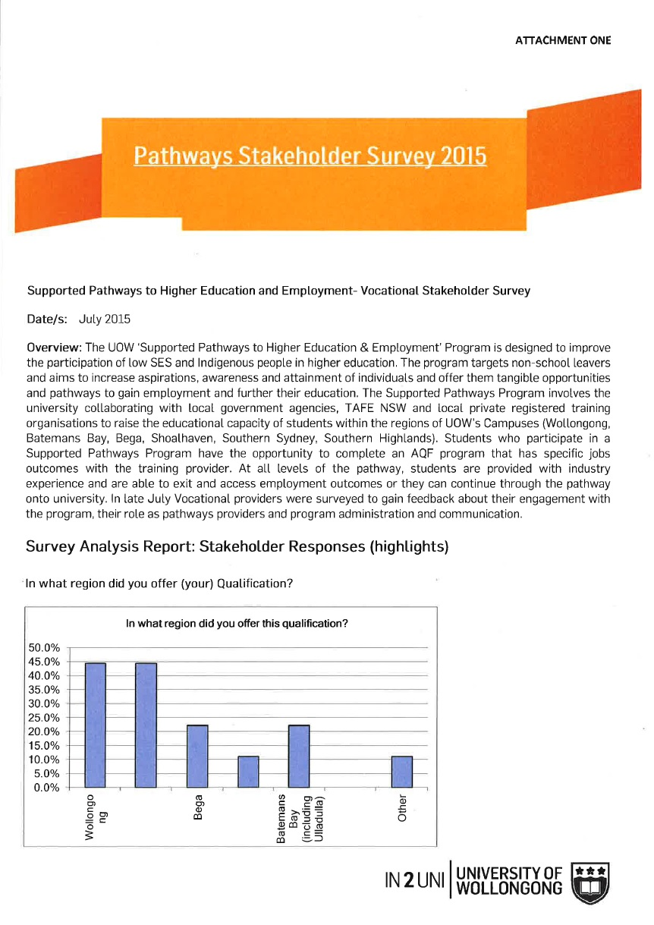
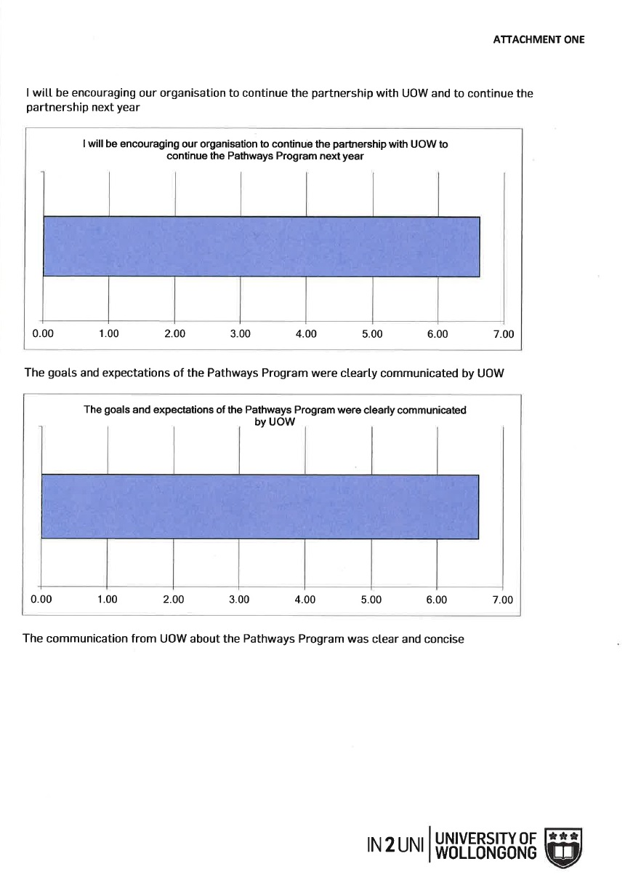

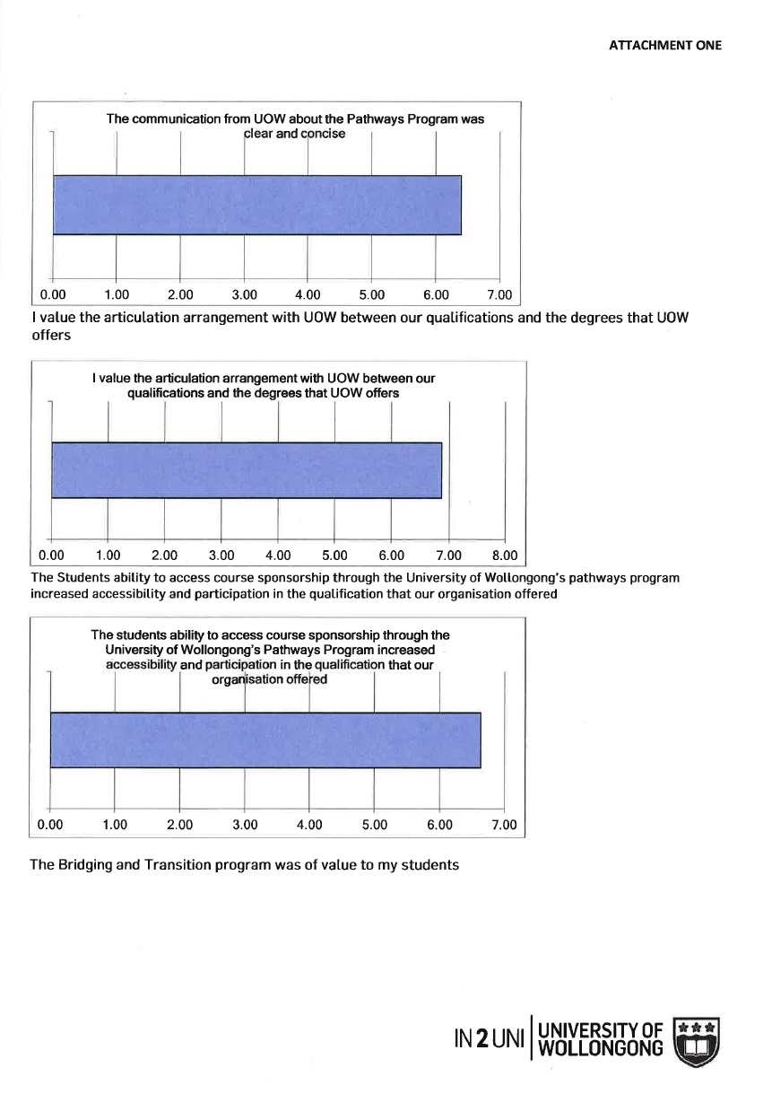

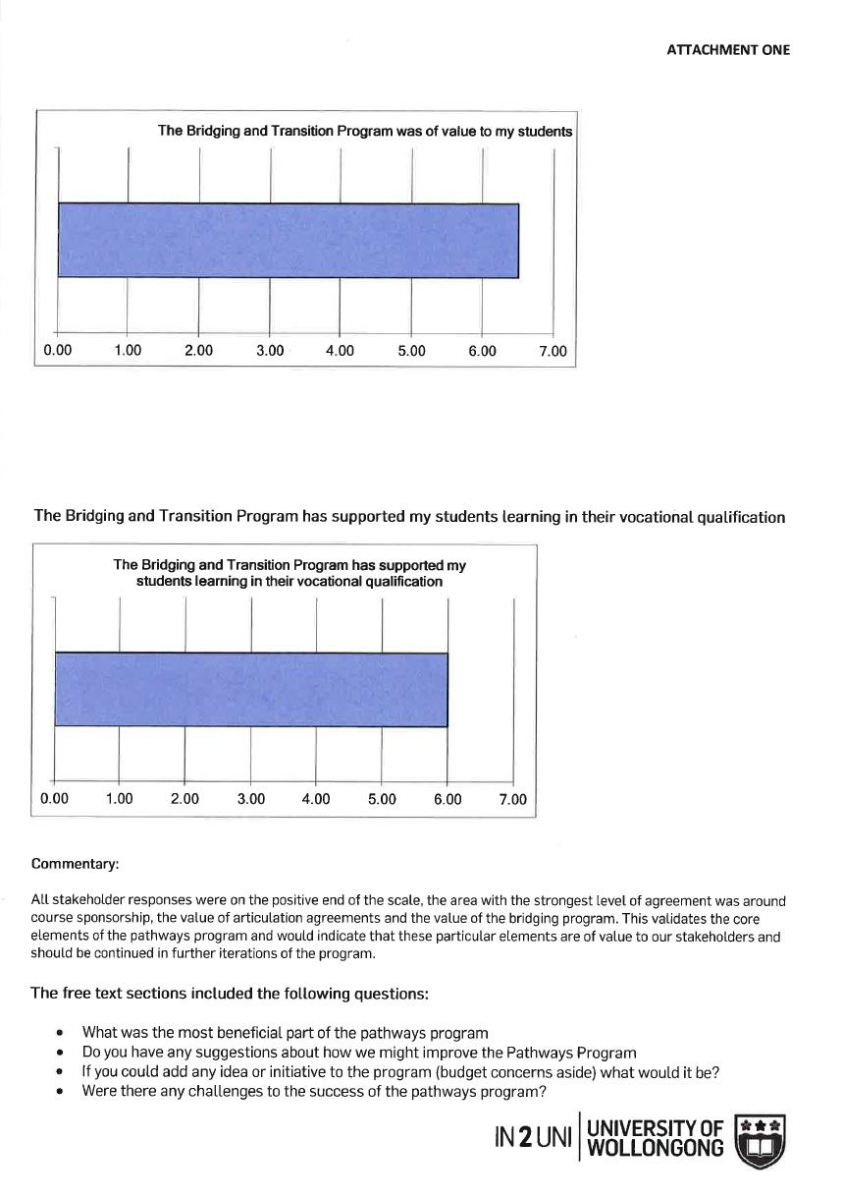

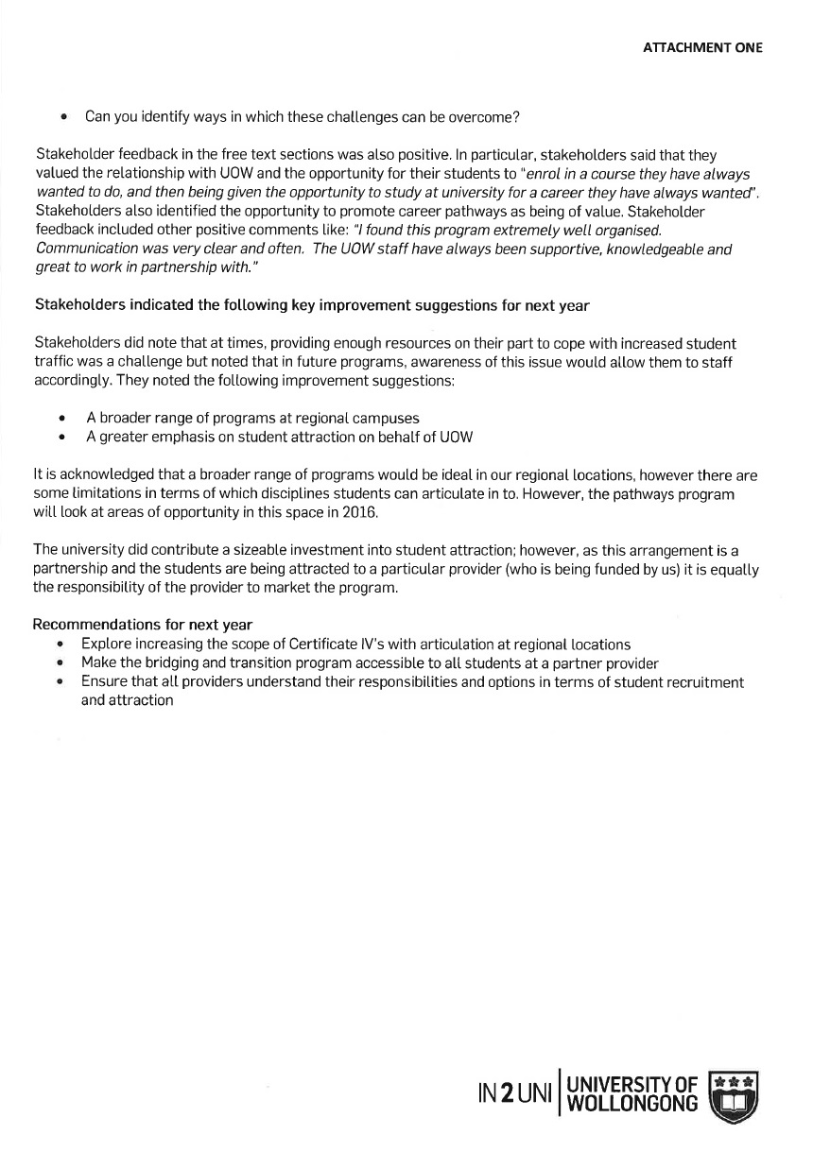

Appendix 2: Collaborative Pathways to Education and Employment: An Emerging Initiative at the University of Wollongong
