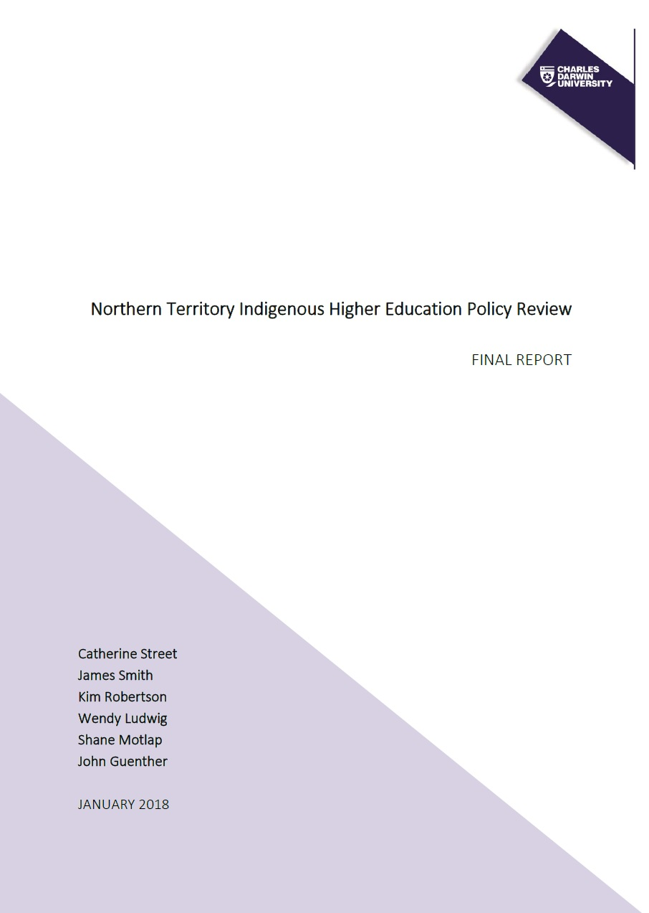

Northern Territory Indigenous Higher
Education Policy Review: Final Report

January 2018

Catherine Street
James Smith
Kim Robertson
Wendy Ludwig
Shane Motlap
John Guenther

Suggested citation
Street, C., Smith, J., Robertson, K., Ludwig, W., Motlap, S. & Guenther, J. (2018). Northern Territory Indigenous Higher Education Policy Review. Prepared for the Australian Government Department of Education and Training. Charles Darwin University: Darwin.

The project that resulted in the production of this report was funded under a National Priorities Pool (Higher Education Participation and Partnerships Program) grant from the Commonwealth. The recipient of the grant has granted the Commonwealth the right to sub-licence the material in this report. Copyright in the report remains with the original copyright owners.
Except where otherwise indicated, and save for any material protected by a trade mark, the Department of Education and Training, acting on behalf of the Commonwealth, has applied the Creative Commons Attribution 4.0 International Licence.

Modifications: Changed to meet WCAG 2.0 accessibility requirements.
Alternate text inserted for all images. Minor typographical errors corrected.

Executive summary
The Australian Government’s Developing the North agenda makes it an opportune time to consider lessons from the past about ‘what works’ in tertiary education as a means of preparing the local Indigenous workforce to support economic development within the Northern Territory (NT). Recent moves to shift a larger proportion of the costs of higher education to individuals also make it timely to consider what can be learnt about the impacts of decreasing government investment in higher education over time. The NT Indigenous Higher Education Review was implemented to develop lessons for future policy reform and development for governments and institutions as seen by Indigenous people who had lived experiences of interacting with the higher education system. This project aimed to explore how Indigenous perspectives of ‘success’ relate to definitions of success within policy, how these may have evolved over time, and identify any links with Indigenous student outcomes.
The results confirmed the evolution in national and subsequent NT government higher education policy approaches from assimilation in the 1960s; to self-determination in the 1970s and early 1980s; to access, participation and equity in the late 1980s and 1990s; and finally achieving ‘outcomes’ from 2000 onwards. Charles Darwin University (CDU) and Batchelor Institute of Indigenous Tertiary Education (BIITE) – as the two institutions primarily responsible for higher education in the NT – were initially guided by national higher education policy directions in their strategies around Indigenous higher education. In particular, they focused on Indigenous teacher training and putting in place access and support measures such as bridging courses and academic support. Changes were implemented in the 1990s within the Vocational Education and Training (VET) and higher education industries that increased competition between providers and therefore the need for accountability. The investments of both CDU and BIITE in Indigenous higher education after this time appear to have been more strongly driven by socio-economic forces, such as ensuring financial sustainability, than policy at the national level. It was also found that success in Indigenous student enrolment and completion outcomes at CDU and BIITE was influenced more by discipline-specific strategies than particular Indigenous higher education policy initiatives. Historically, there have been several attempts for collaboration between CDU and BIITE, although these have been individual- or project-based. The two institutions are well-placed to work in partnership on policy and research initiatives in an ongoing way to counteract the absence of formalised NT-specific Indigenous higher education policy structures.
Concerns were raised through this research regarding the accountability and transparency of governments and institutions in relation to reporting against Indigenous higher education student outcomes. Historical data was neither easily accessible nor comprehensive. In addition to this, we argue that recent Indigenous higher education policy now problematises being Indigenous. Within this report, we have interrogated some of the assumptions that underpin these representations – such as what the purpose of education is, what success is and how success can be measured. The focus on ‘outcomes’ and accountability since the 2000s has perpetuated a deficit view in which the Indigenous affairs discourse is now framed. Our data indicates that informants saw themselves as strong and resilient agents of change, which contradicts this picture of ‘failure’ and ‘disadvantage’ that we often hear about. Disparity was found between Australian Government higher education policy goals and Indigenous higher education motivations. The neoliberalist goals of the current government appears to be centred around increasing employment and trade opportunities. This has not always been the case; self-determination policy of the 1970s and 1980s was more closely aligned with Indigenous motivations for participating in higher education and fits within broader policy goals of civil rights at this time. The narratives of this research presented higher education as a vehicle for creating a better future for Australian Indigenous people and helping communities attain control over their own affairs, in addition to personal benefits that higher education brings.
Indigenous (higher) education consultative groups, such as the National Aboriginal Education Committee (NAEC) and Feppi, were emphasised as being highly significant in the NT Indigenous higher education policy cycle in the years they were active. Not only did they ensure that Indigenous education experts were engaged in decision-making, but they also provided ongoing capacity development opportunities. The National Aboriginal Education Policy (NAEP), developed by the NAEC in 1989, provided a national framework for all education sectors to subscribe to and implement at the State and Territory level and many current education initiatives have their foundations in this document. This research has shown that over time, a number of these groups provided stewardship for the educational needs of Indigenous groups and communities in policy, only to be disbanded by governments who generally have not recognised the pivotal role that they play in creating higher education opportunities for Indigenous people. In-part a result of this degradation of Indigenous ownership over governance and decision-making processes is the narrow focus on workforce and the economy within higher education policy, which represents only one part of why Indigenous people engage in higher education. This disparity makes holding open and honest conversations around ‘success’ difficult. Education theory supports the need for Indigenous worldviews to be integrated into policy goals – and into the articulation of success in relation to policy goals – through governance and decision-making structures. Our key findings and recommendations reflect this.
KEY FINDING 1: There is an urgent need for National and NT Indigenous education consultative bodies to be re-established.
Recommendation: The Australian Government must establish and fund an independent National Indigenous Education Consultative Group to consult and provide specialist advice to the Federal Minister for Education on matters relating to Indigenous education and training at all levels (from early childhood to tertiary education).
Recommendation: The NT Government must establish and fund an independent NT Indigenous Education Consultative Group to consult and provide specialist advice to the NT Minister for Education on matters relating to Indigenous education and training at all levels (from early childhood to tertiary education).
KEY FINDING 2: In the face of ongoing deregulation, opportunities exist for CDU and BIITE to collaborate in a more strategic manner in order to advance Indigenous higher education outcomes in the NT.
Recommendation: CDU and BIITE should explore opportunities to work in partnership to advance the higher education interests of Indigenous people, groups and communities in the NT.
The two key findings and three corresponding key recommendations outlined above, if addressed, would allow Indigenous higher education policies to more accurately reflect the needs of NT Indigenous people, groups and communities. This would enhance engagement and participation of Indigenous Australians within higher education, and bring broader social, economic and cultural benefits to Australia as a nation. We sincerely hope that the findings of this research will be utilised in future Indigenous higher education policy development with these goals in mind.

Acknowledgements
The project team would like to extend thanks to the project Reference Group who have invested much time, effort and thought throughout this project. The expert guidance of the Chair of the Reference Group, Shane Motlap, must also be acknowledged. Conducting such a project would not have been possible without the wealth of experience of those who were involved in this group, who represented the following organisations:
- Charles Darwin University (CDU)
- Batchelor Institute of Indigenous Tertiary Education (BIITE)
- Northern Territory Department of Education (NT DoE)
The Reference Group included:
- Shane Motlap (Chair – Indigenous Policies and Programs Analyst, Office of the Pro-Vice Chancellor Indigenous Leadership [OPVC-IL], CDU)
- Catherine Street (Secretariat – Project Coordinator, OPVC-IL, CDU)
- James Smith (Ex-officio)
- Kim Robertson (Ex-officio)
- Wendy Ludwig (Director of Operations, OPVC-IL, CDU)
- Tracy Woodroffe (Lecturer, Indigenous Knowledges (Education), School of Indigenous Knowledges and Public Policy, CDU)
- Elaine Lawurrpa Maypilama (Principal Research Fellow, School of Health, CDU; Galiwinku Community)
- Gabby Hill (Indigenous Student Ambassador, CDU)
- Mark Munnich (Indigenous Student Ambassador, CDU)
- John Guenther (Research Leader, Education and Training, BIITE)
- Robyn Ober (Indigenous Research Fellow, BIITE)
- Kevin Gillan (Executive Director – Education Partnerships, NT DoE)
- Joe Brown (Director – Community Engagement, NT DoE)
- Valda Shannon (Indigenous Elder and Educator, NT Aboriginal Interpreter Service, Tennant Creek)
The project team would like to thank staff at CDU and BIITE who assisted in the collation and analysis of Indigenous student higher education enrolment and completion statistics. This includes Penny Szybiak (Director – Planning and Performance, CDU), Fiona Shalley (Research Fellow, CDU), and Eike Pakeha (Director – Performance Monitoring and Review, BIITE). We are very grateful for your assistance throughout the year.
We are also grateful to Professor Adrian Miller, Pro Vice Chancellor – Indigenous Leadership at CDU, for his support of this project. Thanks to Lorraine St Clair, Indigenous Academic Support Officer at CDU Alice Springs, for providing valued input into the data analysis process.
Finally, we are grateful to the Australian Government’s Higher Education Participation and Partnerships Programme (HEPPP) for kindly providing funding for this project.

List of Acronyms
ABS Australian Bureau of Statistics
ACIKE Australian Centre for Indigenous Knowledges and Education
AECG Aboriginal Education Consultative Group
ALP Australian Labor Party
ANTA Australian National Training Authority
AQF Australian Qualifications Framework
ASGS Australian Statistical Geography Standard
ATEC Aboriginal Teacher Education College
ATF Aboriginal Task Force
ATSIC Aboriginal and Torres Strait Islander Commission
ATSIHEAC Aboriginal and Torres Strait Islander Higher Education Advisory Council
ATSIPTAC Aboriginal and Torres Strait Islander Peoples Training Advisory Council
BC Batchelor College
BIITE Batchelor Institute of Indigenous Tertiary Education
CAIS Centre for Aboriginal and Islander Studies
CDU Charles Darwin University
CGSA Certificate of General Studies for Aborigines
COAG Council of Australian Governments
DCC Darwin Community College
DI Direct Instruction
DIT Darwin Institute of Technology
GOO Growing Our Own
HECS Higher Education Contribution Scheme
HEIMS Higher Education Information Management System
HELP Higher Education Loan Repayment
HEPPP Higher Education Participation and Partnerships Programme
IHEAC Indigenous Higher Education Advisory Council
ISSP Indigenous Student Success Program
LLN Language, Literacy and Numeracy
MCEETYA Ministerial Council on Education, Employment, Training and Youth Affairs
MITI/MATSITI More Indigenous Teachers Initiative/More Aboriginal and Torres Strait
Islander Teachers Initiative
MYEFO Mid-Year Economic and Fiscal Outlook
NAEC National Aboriginal Education Committee
NAPLAN National Assessment Program – Literacy and Numeracy
NATSIHEC National Aboriginal and Torres Strait Islander Higher Education Consortium
NSW New South Wales
NT Northern Territory
NT DoE Northern Territory Department of Education
NTER Northern Territory Emergency Response
NTU Northern Territory University
OPVC-IL Office of Pro Vice Chancellor – Indigenous Leadership
PTS Preparation for Tertiary Success
PVC-IL Pro Vice Chancellor – Indigenous Leadership
SEIFA Socio-Economic Indexes for Areas
SES Socio-economic status
TAFE Technical and Further Education
VCIAC Vice Chancellors Indigenous Advisory Committee
VET Vocational Education and Training
VTC Vocational Training College
WPR ‘What is the Problem Represented to be?’

Contents
Executive summary 2
Acknowledgements 5
List of Acronyms 6
List of Figures 8
Section 1: Introduction, Background, Approach and Methods 10
1.1 Introduction 10
1.2 Background 10
1.3 Approach 13
1.4 Methods 15
Section 2: Results 21
2.1 The evolution of Indigenous higher education in the NT 21
2.2 Indigenous student higher education enrolment and completion outcomes 35
2.3 Indigenous perspectives of ‘success’ in higher education policy in the NT 42
Section 3: Discussion, Key Findings, Recommendations and Conclusion 52
3.1 Discussion 52
3.2 Key Findings and Recommendations 53
3.3 Conclusion 56
Appendix 1: Project Activities 58
Project Outputs 62
Publications 62
References 63

List of Figures
Figure 1: Visual overview of the Northern Territory Indigenous higher
education policy review project 16
Figure 2: Semi-structured interview questions 18
Figure 3: Aboriginal children at Kahlin Compound, Darwin, 1921 (Northern
Territory Library, 2017c) 21
Figure 4: National and NT Indigenous Higher Education Policy Timeline 22
Figure 5: Vincent Lingiari and Gough Whitlam, 1972 (Museum of Applied
Arts and Sciences, 2017) 26
Figure 6: Feppi, 1982 (Northern Territory Library, 2017b) 26
Figure 7: Darwin Community College, 1979 (Northern Territory Library, 2017a) 27
Figure 8: Indigenous student enrolments in various courses at Batchelor
College and Darwin Community College (Department of Education, 1981, p.36) 29
Figure 9: CDU Indigenous student higher education enrolments - by gender 35
Figure 10: BIITE Indigenous student higher education enrolments - by gender 35
Figure 11: CDU Indigenous student higher education enrolments - by course type 36
Figure 12: BIITE Indigenous student higher education enrolments - by course type 37
Figure 13: CDU Indigenous student higher education enrolments - by field of
education (Health, Education and Society and Culture) 37
Figure 14: BIITE Indigenous student higher education enrolments - by field of
education (Health, Education and Society and Culture) 38
Figure 15: CDU Indigenous student higher education completions - by gender 39
Figure 16: BIITE Indigenous student higher education completions - by gender.
* X< 5 = 4; unless X = 0 39
Figure 17: CDU Indigenous student higher education completions - by course
type. * X< 5 = 4; unless X = 0 40
Figure 18: BIITE Indigenous student higher education completions - by course
type. *X< 5 = 4; unless X = 0 40
Figure 19: CDU Indigenous student higher education completions - by field of
education (Health, Education and Society and Culture). *X< 5 = 4; unless X = 0 41
Figure 20: BIITE Indigenous higher education student completions - by field of
education (Health, Education and Society and Culture). *X< 5 = 4; unless X = 0 41
Figure 21: Enablers to success in Indigenous higher education policy implementation 44

Section 1: Introduction, Background, Approach and Methods

1.1 Introduction
Indigenous higher education policy approaches in the Northern Territory (NT) have evolved significantly over the past sixty years. They have often been heavily influenced by policy at the national level. From efforts to facilitate Indigenous self-determination during the 1970s that led to the first training of Indigenous teachers until the present time during which various multi-pronged strategies within and external to universities assist in increasing the number of Indigenous students that successfully attain a higher education qualification; the sector has undoubtedly seen ‘success’. What ‘success’ actually means within the education setting, though, is dependent upon worldview (Pidgeon, 2008), and the values that people hold (Biesta, 2009). This project aimed to examine definitions of ‘success’ within the context of a continually evolving Indigenous higher education policy space. Higher education policy development and implementation in the NT has been explored as a case study to identify enablers and constraints to ‘success’ that are contextually relevant and nationally applicable. The purpose of this report is to summarise the research process and findings, and highlight key lessons for future policy reform and development.
The objectives of the NT Indigenous Higher Education Policy Review were to:
- Explore Indigenous perspectives of underlying principles of success in Indigenous higher education policy;
- Identify cultural, socio-political and environmental factors that enable successful policy implementation from the perspectives of Indigenous ‘users’ of higher education policy; and
- Explore the relationship between Indigenous perspectives of successful Indigenous higher education policy and practice, Northern Territory and national higher education policy, and Indigenous higher education enrolment and completion outcomes, in order to inform future policy reform and development.

1.2 Background

Background to this report
This research was initiated with the recognition that decades of research, program evaluations and, most importantly, persistent calls from Indigenous advocates have reiterated the need to learn from history. Indigenous Elders, leaders, academics, educators, researchers and past students in the NT often state that important lessons about Indigenous higher education – and Indigenous education more broadly – and their successes and failures are present in past attempts to improve policies and programs. The Higher Education Participation and Partnerships Program (HEPPP), which funded this research, aims to increase opportunities for students from low socioeconomic status (SES) backgrounds to study at university (Department of Education and Training, 2017b). Approximately seventy-four per cent (74%) of Indigenous people in the NT live in the most disadvantaged quintile of the Socio-Economic Indexes for Areas (SEIFA) (ABS, 2006; Department of Prime Minister and Cabinet, 2014). We therefore know that a majority of the NT’s Indigenous population is disadvantaged by geographical location alone.
It was an explicit aim of this project to be strengths-based in nature, and to not succumb to the language of disadvantage and deficit that dominates Indigenous higher education and education policy (Guenther, 2017; Sarra, 2011; Vass, 2013). While it is recognised that remote Indigenous people in the NT are more geographically disadvantaged, many of the Indigenous experts who were consulted in this project saw the targeting of remote Indigenous communities as reminiscent of the ‘divide and conquer’ tactics that underpinned assimilation policy (Behrendt, 1994, p.59). Assimilation policy led to the classifying of Indigenous children according to how much Indigenous ‘blood’ they had. The focus on remote Indigenous communities within the recent Wilson Review (2014) and the NT Government’s response to it – A Share in the Future: Indigenous Education Strategy 2015-2024 – demonstrates the same underlying attitudes about what it means to be Indigenous. We do not argue that all Indigenous people hold the same views and perspectives - quite the contrary. The common thread is having an identity that is linked to heritage of Australia’s First Nation people, and it is maintaining strength in this identity that contributes to their emancipation (Harris, Nakata, & Carlson, 2013).
As the reader will discover, there were delays in putting in place numerous initiatives to increase access and participation for all Indigenous people in higher education in the NT that were gaining ground nationally in the 1970s, 1980s and 1990s. One example is the ongoing conservatism within Darwin Community College (DCC – CDU’s predecessor) that prevented establishment of Indigenous governance bodies and Indigenous Studies courses in the late 1970s (Berzins & Loveday, 1999). These obstructions to advancing Indigenous peoples’ interests within higher education occurred in combination with the relatively late establishment of higher education institutions at which aspiring Indigenous students in the NT could study – alongside numerous other historical factors. Higher education policy was borne relatively recently in the NT, therefore, which has constrained access and opportunity in higher education for all Indigenous people in the Territory.

Indigenous higher education in the Northern Territory
At the national level over the last fifty years, we have seen the number of Indigenous people enrolling in and completing higher education courses steadily increase (Department of Education and Training, 2015; Pechenkina, Kowal, & Paradies, 2011). Some measures emerging from higher education policies that have assisted this include financial and academic support, enabling and bridging courses, aspiration building and orientation programs, increasing the Indigenous academic and professional workforce, and strengthening Indigenous governance within universities (Behrendt, Larkin, Griew, & Kelly, 2012). As a result of this, A vast array of National and State or Territory Government policies have been developed and implemented over time to direct action within the institutions responsible for higher education delivery. However, Indigenous higher education student enrolment, success and completion figures are still well below parity with those of the non-Indigenous population (Department of Education and Training, 2015). The ongoing disparity highlights that policy success is partly dependent on the policy implementation process. We have therefore integrated policy and practice considerations into the aims of this research.
Understanding the student cohort in the NT is vital to unpacking lessons from history relating to the policy implementation process. Indigenous higher education students in the NT are largely mature aged (Charles Darwin University, 2017a). This means that, as these students are often studying part time and working in parallel, they often require a longer period of time to complete a degree. This has important ramifications when considering Indigenous student completion rates in comparison to enrolments at CDU and BIITE. This must be taken into account when interpreting the Indigenous student enrolment and completion data within Section 2.2 of this report.
In addition to the high proportion of mature-aged Indigenous students in the NT as discussed above, another factor to consider when reading this report is the significance of alternate pathways into higher education for Indigenous people in the NT. The proportion of Indigenous people in the NT aged between twenty and twenty-four years old with Year 12 or equivalent attainment sits at 29.7% (ABS, 2016), indicating that Vocational Education and Training (VET) is a more commonly accessed form of post-school education. Limited English language, literacy and numeracy (LLN) ability is known to lead to a ‘ceiling effect’ within VET courses, that is, Indigenous students sometimes do not progress past Certificate III level if they do not possess adequate English LLN skills (Stewart & Shalley, 2017). Asides from not being an accurate reflection of academic ability or potential, it is important to describe this as an explanation for why education policy more generally has often been referred to throughout this report. For students to get into a university course they must first transition through the relevant study pathways to get there, whether that be through completing high school or entering through alternate pathways.
So – what else is and what is not known in relation to higher education in the NT? Recent literature has provided much context around the current state of Indigenous higher education and higher education policy in Australia. Behrendt et al.’s (2012) Review of Access and Outcomes for Aboriginal and Torres Strait Islander People, for example, was the most recent comprehensive review of Indigenous higher education nationally. Kinnane and colleagues’ Can’t Be What You Can’t See (2014) literature review summarises a dearth of literature regarding transitions of Aboriginal and Torres Strait Islander students into higher education. These two reviews are just some of what is available within the evidence base, and each contributes in their own way to what we know about Indigenous higher education and what works. This research is unique in its historical and retrospective approach that gives Indigenous experts in the NT higher education space the chance to reflect upon and analyse why they believe particular policies were successful and what enabled or constrained their successful implementation within higher education institutions in the NT – CDU and BIITE. It is hoped that the findings of this report will be useful to those involved in Indigenous higher education policy development in the NT and nationally.

Socio-political context
This research is timely in the context of a higher education sector seeing more deregulation than ever before. In mid-2017, the Australian Government announced the Higher Education Reform Package that included lowering the mandatory Higher Education Loan Repayment (HELP) debt repayment threshold (Department of Education and Training, 2017c). Although this bill failed to pass in the Senate, the government has since announced in its Mid-Year Economic and Fiscal Outlook (MYEFO) that it would be finding other ways to save on higher education spending (Birmingham, 2017). Proposed changes include making other changes to the HELP repayment schedule to speed up student debt repayments and introducing a lifetime lending limit across HELP programs. This announcement represents the government’s third attempt to significantly reduce spending in the higher education sector (Warburton, 2017).
It is clear that the Australian Government is intent on reducing spending on Australian higher education; how this will occur remains to be seen. What we do know is that reduced investment in this space will have weighty consequences for Indigenous students in the NT. The largely mature-aged Indigenous higher education student cohort in the Territory has already been noted in this report (Charles Darwin University, 2017a). The NT Indigenous population also has a much lower life expectancy than the non-Indigenous population (Georges et al., 2017). These factors necessitate ongoing investment to support Indigenous students to be able to complete their degrees successfully. The consequences of not doing so would include those associated with lack of representation of Indigenous people in the higher education student body and workforce (see Bradley, Noonan, Nugent, & Scales, 2008) – but also long term fiscal impacts associated with unpaid student debts.
In a more positive light, there is also much opportunity offered by the current socio-political context. The past fifty years in the NT have seen significant change in terms of its demographic. The Indigenous population and the general population have grown quickly since 1960. The number of people identifying as Aboriginal or Torres Strait Islander in 1966 was 25,345, which grew to 56,875 by 2001 (Wilson & Condon, 2006). This figure continued to increase, with 74,509 people reporting having Aboriginal or Torres Strait Islander origins in the NT in the 2016 census (ABS, 2017b). Although the NT general population continued to grow at a relatively fast pace since 2000 (ABS, 2012), it has since shown signs of slowing (ABS, 2017a). Approximately thirty per cent of the NT’s populace identify as Indigenous (ABS, 2017b). The plateau in population growth, then, highlights more workforce prospects for local Indigenous people than ever before.
The push to ‘Develop the North’ has also seen the spotlight on Northern Australia as prime territory to build an economic base that is strategically located next to our neighbours in Asia (Australian Government, 2015). The Developing the North agenda is aiming to strengthen the capacity of local industry as part of the federal government’s plan to build a ‘safe, secure Australia’ (Australian Government, 2015, p. IV). Enormous opportunities exist to develop the local workforce to support these plans. Given that 30% of the population of the NT is Indigenous (ABS, 2017b), economic and social benefits will be brought about by improving the effectiveness of the higher education sector to equip Territorians with the skills they need to participate in the labour force. It is vital that the higher education sector consider the huge potential that lies with the local population for its future and learns from lessons of the past to enable this to happen.

1.3 Approach

Poststructural policy analysis
Biesta (2009) argued that values determine what one perceives to be the purpose of education, and what types of education are deemed to be desirable. Bacchi and Goodwin (2016) have since developed poststructural policy analysis, influenced by Foucault educational theory, as a vehicle for critically questioning values as an ‘endpoint’ and encourages the ‘articulation of the series of practices… that accounts for our current practices’ (Flynn, 2006, p. 40). Poststructural policy analysis views knowledges and ideas created through disciplines such as social policy as ‘contingent historical creations, human constructions, that need to be interrogated rather than enshrined as ‘truth’ (p.5). The authors introduce a tool called ‘What’s the Problem Represented to be?’, or WPR. WPR observes policy as something that produces problems rather than addressing problems, which is the more conventional view of why policies are created. We adopted WPR as a framework through which to analyse our findings as we wished to interrogate the rarely-considered assumptions that underpin Indigenous higer education policy creation, review and development.

Indigenist research and Indigenous Standpoint Theory
The consultation and design process for this research highlighted the need for the lived experiences of Indigenous people – who are often excluded from the policy development and review process (Maddison, 2012) – and their lived experiences of interacting with the higher education system, to be the focus. As a result, this research has been informed by Indigenous Standpoint Theory (Foley, 2006; Moreton-Robinson, 2013; Nakata, 2007b) and Indigenist research principles (Rigney, 1999). As a theoretical approach, Indigenous Standpoint Theory is contested (Nakata, 2007b). Standpoint accounts, however, investigate the ‘social relations within which [Indigenous people] as ‘knowers’ know’ (Pohlhaus, 2002, p.287). Thus, Indigenous standpoint is ‘not a simple reflection of experience’ nor ‘deterministic of any truth’ (Nakata, 2007b, p.214). Rather, it ‘lays open a basis from which to launch a range of possible arguments for a range of possible purposes’ (Nakata, 2007b, p.214). Consistent with this, this research was conducted paying particular attention to structures and processes within the higher education systems and structures with which Indigenous people interact (Foley, 2006; Nakata, 2007b; Rigney, 1999; Smith, 1999). It aimed to bring attention to the experiences of Indigenous people as students, teachers, researchers, and leaders in the policy implementation process, which may not be obvious to ‘knowers’ in more privileged social positions (Nakata, 2007b; Pohlhaus, 2002).
Rigney (1999) describes Indigenist research as that which aspires for ‘more progressive kinds of knowledge seeking methods that privilege the diversity of Indigenous experiences’ (p.36). Indigenist research aims to reform research methodologies to be compatible with Indigenous aspirations, interests and realities. A project Reference Group predominantly consisting of Indigenous students, educators, academics and thinkers were involved in the design and analysis process through regular formal and informal meetings. The Reference Group was also chaired by an Indigenous thinker with significant expertise in the Indigenous higher education policy setting. The involvement of the Reference Group in determining the scope and focus of this research, in addition to presiding over the analysis process, integrated principles underpinning Indigenist research. Implementing Indigenous Standpoint Theory and Indigenist research principles enabled us to develop a ‘critical understanding of the underlying assumptions, motivations and values’ that is the goal of decolonizing methodologies (Smith, 1999). We were strongly guided by Smith’s (1999) work in outlining research practices that offer alternatives to Western paradigms for Indigenous research agendas.

Strengths-based approach
It is highlighted in Section 2.1 as well as confirmed in the literature (for example - Altman, 2009; Guenther, 2017; Guenther, Disbray, & Osborne, 2016; Vass, 2013) that language used at present in Indigenous Affairs policy is dominated by terms that suggest ongoing deficit and failure. The ‘Closing the Gap’ agenda is the most recent example and is the current predominant discourse of governments in relation to Indigenous issues. There are of course practical reasons why disparities in data relating to education, health and other social outcomes are highlighted; to be able to better address the issues. Deficit discourse is pervasive, though, and problematic for multiple reasons articulated by Guenther et al. (2016, p.24). During the design phase of this project, the Reference Group stated the desire to see this policy review project framed within a way that highlights the strength, resilience and diversity of Indigenous peoples in the NT and the good things that have happened, without compromising on honesty with regards to constraints to success. We have endeavoured to find a balance of both.

1.4 Methods
This research was granted ethics approval by CDU Human Research Ethics Committee (CDU-HREC) on 1st June, 2017 (H17050).
This research took a mixed-methods approach incorporating:
- a policy review;
- semi-structured interviews with Indigenous higher education stakeholders; and
- Indigenous student higher education enrolment and completion outcomes data.
The project was overseen by a predominantly Indigenous Reference Group. Refer to Figure 1 for a visual overview of the research methods.

The Project Team
The project team consisted of four researchers from the Office of Pro Vice Chancellor – Indigenous Leadership (OPVC-IL) at CDU and one researcher from BIITE. CDU researchers were responsible for project coordination, analysis of CDU policy responses, collation and analysis of CDU Indigenous higher education student data, conducting interviews, and preliminary analysis of all research data. The BIITE researcher was responsible for collation and analysis of BIITE policy responses and collation of BIITE higher education student data. All CDU and BIITE researchers played a role in the National and NT Government policy analysis process and production of project outputs (Refer to Appendix 1).

The Reference Group
The Reference Group consisted of twelve individual members who represented CDU, BIITE and the Northern Territory Department of Education (NT DoE). Ten (83.3%) of these members identified as having Aboriginal or Torres Strait Islander heritage. Five (5) Reference Group meetings were held between March and October 2017. These meetings were chaired by the Indigenous Policies and Programs Analyst from OPVC-IL at CDU. Members of the Reference Group had significant experience within the Indigenous education or higher education sectors and were well placed to provide guidance for the research process. Two Indigenous student representatives also participated in the Reference Group. The project design and development phase occurred during the first four meetings. Activities included refining the scope of the research including research questions and design, consolidating research questions and methodology, and identifying policies to be analysed and key informants to be interviewed. The fifth meeting involved collaborative analysis in which draft findings were presented to the group and feedback sought. Reference Group members were also involved in the development of project outputs noted in this report.

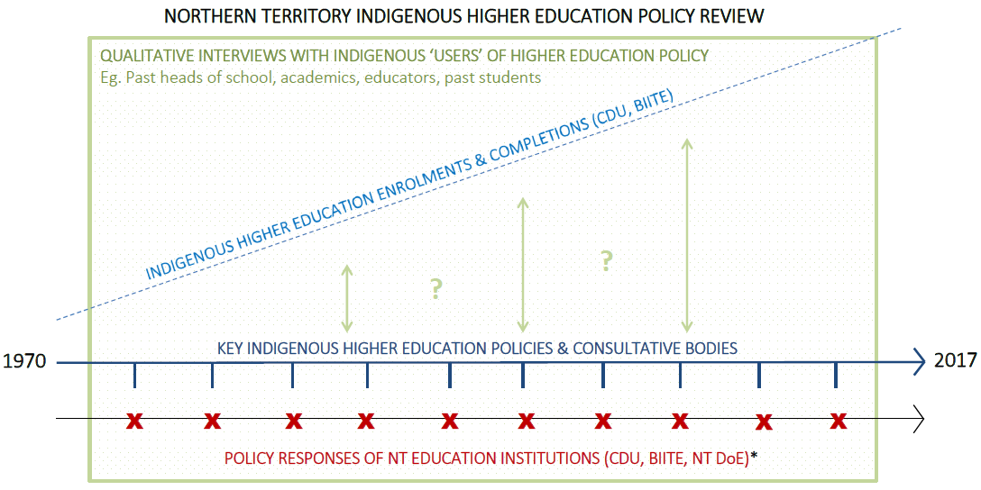
*Includes strategic plans, implementation plans, annual reports, and other relevant documentation.

Figure 1: Visual overview of the Northern Territory Indigenous higher education policy review project

Policy review
Data collection
There were two stages in the policy review process. The first stage included searching for National and Northern Territory Government policies, policy documents and other relevant literature such as journal articles. This was conducted between May and June 2017. The online search included reviewing databases such as Australian Policy Online and Google Scholar, in addition to referring to other related policy review documents and their reference lists. Terms such as ‘higher education’, ‘university’, ‘education’, ‘Indigenous’, ‘Aboriginal and Torres Strait Islander’, ‘policy’, ‘program’ and ‘evaluation’ were included. An in-person search of hard-copy documents was also conducted at the NT Education and Darwin Languages Centre Library. Key policies and events included as part of this analysis were agreed to, and in many cases put forward by the Reference Group, before the search was completed. National and NT Government policies that were included within the policy review included those considered by the Reference Group as having had significant influence on Indigenous higher education in the NT. There were no Indigenous education or higher education policies and policy documents of relevance prior to the 1960s.
The second stage, conducted between July and August 2017, involved a review of institutional policy documents such as strategic plans, annual reports and evaluation reports. Online searches through CDU and BIITE libraries were conducted using search terms above, in addition to ‘Charles Darwin University’, ‘Batchelor Institute’ and other past names of CDU and BIITE. In-person searches of hard-copy documents were also completed at CDU and BIITE libraries.
Policies were included within the review that covered a range of areas relating to Indigenous education. Some focused on Indigenous higher education specifically, while others targeted Indigenous education or education more broadly. This is will be covered in more depth in Section 2 of this report.
Data analysis
A retrospective analysis was applied to historical Indigenous higher education policies since the 1960s. Initially, a descriptive chronology of significant National and NT Government policies was developed. NVivo 11 software was then used for coding CDU and BIITE responses to National and NT Government policies according to the ‘types’ of strategy that were mentioned in the institutional document. For example, we coded strategies such as ‘Indigenous unit/centre’, ‘Indigenous governance’, ‘Indigenous specific courses’, ‘Indigenous knowledges and studies’, ‘workforce’ and ‘student support’. We also coded when there was quantitative student enrolment or completion data found within the documents. The evolution of these themes was then mapped against National and NT Government policy trajectory that was developed to elicit links between institutional strategies and National and NT Government Indigenous higher education policies.

Interviews
Recruitment, sampling & data collection
A list of potential key informants who were considered to have relevant expertise was developed in collaboration with the Reference Group. ‘Relevant expertise’ was defined as having acquired significant experience – as students, educators, academics, strategic thinkers or a combination of the above – in the implementation of Indigenous higher education policies within CDU and/or BIITE. Several key informants had experience working in higher education at the national level also. Formal invitation emails outlining the aims and methods of the study, the purpose of interviews and reasons that they had been chosen were sent to potential key informants. Follow-up emails or phone calls were attempted for those who did not respond. Some key informants declined due to having a high workload or for unspecified reasons. Once contact had been made with individual informants and individuals consented to participating, arrangements were made for interviews.
Two non-Indigenous researchers conducted semi-structured interviews with fourteen (n=14) key informants. Interviewees were asked open-ended questions about their involvement in Indigenous higher education policy implementation, definitions of ‘success’ in Indigenous higher education, and their perspectives about enablers and barriers to achieving success as per their preferred definition. Refer to Figure 2 for interview questions. Interviews were conducted either face-to-face or by phone. All interviews were recorded with written consent and subsequently transcribed for analysis.
Most interviews lasted between forty-five and ninety minutes. Follow-up (secondary) interviews were conducted with four individuals with whom the scheduled time was inadequate to discuss all interview questions. One key informant was unwell and was only interviewed for approximately twenty minutes. Interviews were conducted in a semi-structured format, with conversation flowing in a fluid manner consistent with ‘yarning’, which has been validated as a legitimate data collection tool when undertaking research with Indigenous people (Bessarab & Ng'andu, 2010; Ober, 2017). The Reference Group considered it important that key informants be given the opportunity to tell ‘stories about their lived experiences, feelings, thoughts and ideas’ in a way that ‘requires the researcher to develop and build a relationship that is accountable to Indigenous people participating in the research’ (Bessarab & Ng'andu, 2010, p.38).
All key informants were Indigenous. Two out of the four Investigators of this project, in addition, identified as Indigenous. Where possible, interviews were conducted where there were pre-existing relationships between interviewer and key informant. Interviewers questioned key informants about their past experiences of higher education policy implementation as students, teachers, community leaders, academics, and in roles on governing bodies. Specific questions were asked regarding the purpose of higher education and definitions of success. Probing questions were then asked regarding particular experiences of policy that were viewed as being successful and what led to their success. All informants were agreeable to publishing attributed quotes, except for one person who opted to remain anonymous.
SEMI-STRUCTURED INTERVIEW QUESTIONS
- Tell me about your background? How did you become involved in higher education?
- How would you define ‘success’ in Indigenous higher education?
- In your experience, was there a specific period of time/policy/program that you saw as being successful? Why was it successful?
- Keeping in mind this definition of success, what are some of the enablers to achieving success?
- What are some of the barriers to achieving success?
- What do you think is the value/purpose of higher education for Aboriginal people? Looking back over your career, have you seen progress/change?
- How does your definition of success fit with what you see happening now? What is working and why? What could be improved?

Figure 2: Semi-structured interview questions

Data analysis
Interview data was analysed using NVivo 11 software. As interviews were conversation-style and narratives often included story-telling in a manner that was not chronologically in order with interview questions, framework analysis was conducted during the familiarisation process. Framework analysis is useful method for conducting applied policy analysis (Srivastava & Thomson, 2009) and involves sifting, charting and sorting data according to key issues and themes (Ritchie & Spencer, 1994). The data was categorised according to overarching themes corresponding with interview questions – such as ‘definitions of success’, ‘purpose of higher education’, ‘enablers/barriers to success’, ‘perceptions of change’ and ‘proposed solutions’. Once a general sense of the data was obtained, thematic analysis was conducted using open coding. In searching for patterns of meaning in the data, key themes emerged that related broadly to the higher education system, institutions, and finally relating to individuals and their role within the success of policy. Emerging themes were shared with the project team and Reference Group to seek feedback. Further analysis was conducted by the Project Coordinator, to consolidate and refine themes. The findings that have been reported are not exhaustive and represent the most common or most poignant themes that emerged. The significance of the key themes reported here were confirmed by the Reference Group.

Indigenous student higher education enrolments and completion data
Data collection
Indigenous student enrolment and completion datasets extending to the earliest year available for each institution were obtained from CDU and BIITE. For CDU the dataset included enrolments from 2001 and completions from 2005 onwards. For BIITE the dataset included enrolments and completions from 2002 onwards. A student was counted as ‘Enrolled’ in a course in an Academic Year if they enrolled in a least one ‘unit’ (a sub-component of a ‘course’) and stay enrolled in that unit past the ‘Census Date’ for a ‘Teaching Period’ which falls within the Academic Year. Enrolment data therefore includes commencing and ongoing students. A student was counted as having ‘Completed’ a course if they fulfilled all of the requirements associated with completing a particular course between 1 January to 31 December of a year. The data element ‘Year’ refers to the an ‘Academic Year’ which is from January 1st of a given year to December 31st of the same year. The data provided for this project included enrolments in full Academic Years and the Academic Year 2017 as at October 2017 for BIITE and December 2017 for CDU.
The raw data were sorted according to Gender, Course Type and Field of Education. Fields of Education were defined as per the Higher Education Information Management System (HEIMS) Element E461. Course Types were defined according to the Australian Quality Framework (AQF) and the Classifications codes in the Higher Education Information Management System (HEIMS) Element E310 (Department of Education and Training, 2017a). To protect student confidentiality, enrolment and completion data that were included in graphs with an asterisk presented in Section 2.2 include values <5 which have been designated 4 (unless 0). BIITE data that has been included in graphs prior to 2002 was obtained from annual reports where available.
Data analysis
Once the data had been sorted it was graphed and analysed, initially, by the Primary Investigator and the Project Coordinator. Some inferences were made based on patterns in the data in relation to the findings of the policy review. For example, where spikes or dips were seen in enrolments or completions the political and organisational contexts were revisited to attempt to deduce reasons why these spikes and dips were present. These themes were then discussed with at the final Reference Group meeting, where some additional observations were made. The key themes presented in this report were those developed collaboratively with the Reference Group.
Limitations
Our sample size of fourteen interviewees was limited by the timeframe of the project and numerous other factors. A total of thirty-three (33) individuals were invited to participate in this study, however, we experienced difficulty contacting a number of these individuals through email or phone. This was particularly so for individuals outside of Darwin and in remote NT communities. Also, many of the individuals invited to participate were high level staff with demanding schedules and reported that they were too busy. Some individuals had personal or family commitments that resulted in them declining to participate. Because of a relatively small sample size of fourteen (14) we do not believe a point of data saturation was reached. As such, we are unable to draw conclusions or make claims that this research is representative of all Indigenous people in the NT.
As already mentioned above, the researchers who conducted interviews and conducted the majority of data analysis were non-Indigenous. This is a limitation of the research, as the intent of the research was to be underpinned by Indigenous Standpoint Theory. Organisational capacity meant that this was the only option and this was understood, and agreed to, by the Reference Group. There were, however, regular meetings both formal and informal with Indigenous members of the research team and the Reference Group to explore and discuss emerging research findings.
The Indigenous student higher education enrolment and completion data obtained prior to 2001 for CDU and prior to 2002 for BIITE has been obtained from annual reports and other available documentation. This means that we have not been able to clarify details regarding how this data has been collated and reported. Data prior to these points in time should not necessarily be considered as accurate nor comparable to the remainder of the dataset.
Finally, the student enrolment and completion data presented here should be interpreted with caution. Higher education data is confounded by the complexity of higher education study pathways and transitions, and more so in the context of a mature-age student cohort. Students can become inactive, discontinue and re-enter degree courses over time, exit with a different degree type, change their study discipline, change universities within their degree, and change their study status between full and part time. This means that enrolment and completion data reported here may have confounding or causational factors that cannot be determined. Another challenge associated with the student enrolment and completion data that has been presented here lies in the relatively small total population of the NT (ABS, 2017a), and therefore small numbers of Indigenous higher education students. These small numbers make it difficult to draw definitive conclusions that are based on numbers of statistical significance.

Section 2: Results

2.1 The evolution of Indigenous higher education in the NT
This section will outline national Indigenous higher education policy, followed by a description of NT Indigenous (higher) education policy, followed by CDU and BIITE responses to such policies. It should be noted that the NT Government is yet to develop policy measures addressing higher education specifically. As a result, discussion relating to NT Indigenous higher education policy includes NT Government school education policy and other relevant policy events. This section also examines any tangible links to Indigenous student higher education enrolment and completion outcomes. This is presented chronologically – era by era. Student outcomes data for the period 2000-2017 will be presented in Section 2.2 as the dataset was consistent, which warranted an in-depth discussion. Figure 4 provides a visual timeline of the evolution of NT Indigenous higher education policy in the NT. Each element of Figure 4 is described chronologically throughout this section of the report.
To provide some background, policy approaches before the 1960s centred around extermination from British contact in 1788 until the late 1880s, and then segregation until the 1950s (Australian Law Reform Commission, 1986; Bleakley, 1928; Cameron, 2005). Aboriginal children were forcibly removed from their families and placed in institutions, which eventually became reserves, towns and then communities (Parliament of Victoria, 1910). In the NT, education focused on training boys and girls in unskilled roles, such as domestic work and stock work, to add to the labour force to assist white settlers in the early 1900s (Parry, 1996). This approach continued until Indigenous people were finally included within Australian Government policy in the 1960s. It is only from after the 1960s that government educational strategy for Indigenous people became visible – at least from a policy point of view. From this point onwards, it is important to note that a majority of historical Indigenous education and higher education policies have targeted remote Indigenous communities. The data presented in this Section is a reflection of this and relates mostly to NT Indigenous remote communities.
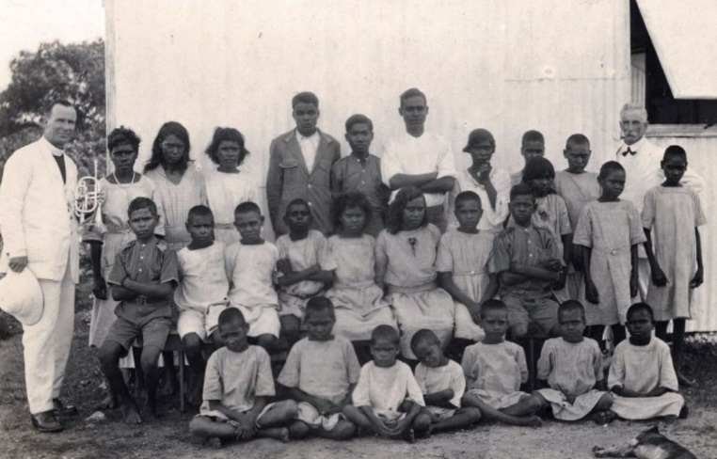

Figure 3: Aboriginal children at Kahlin Compound, Darwin, 1921 (Northern Territory Library, 2017c)
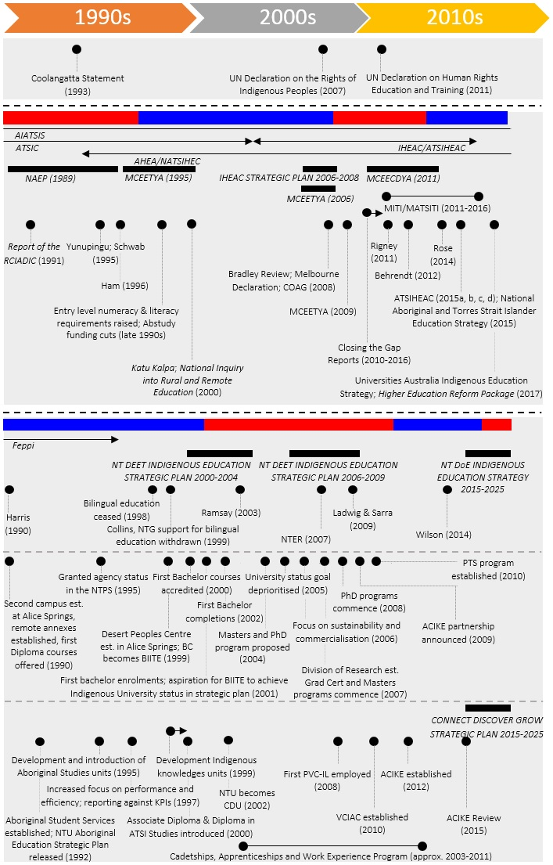
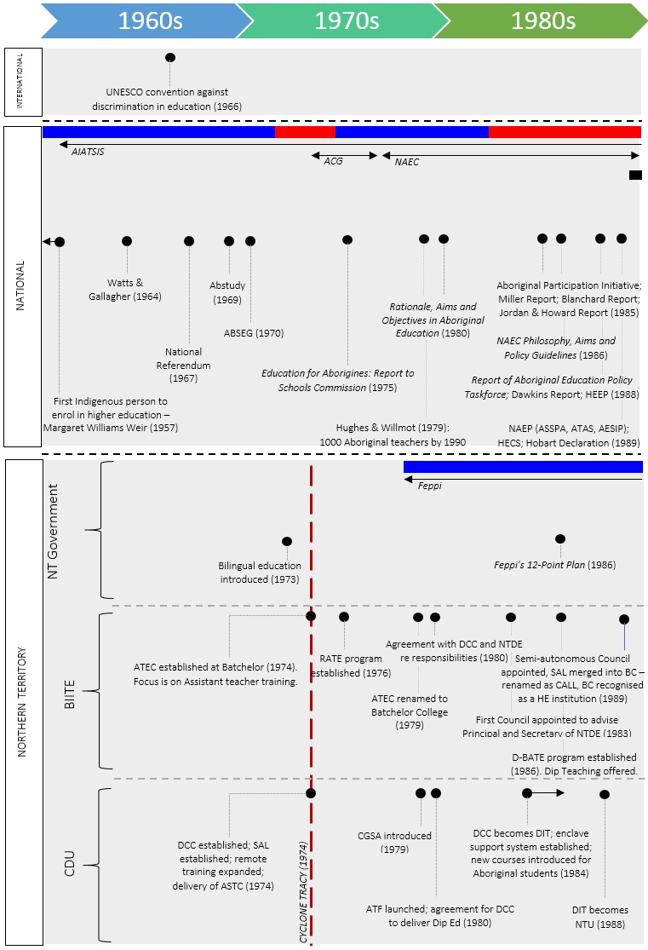

Figure 4: National and NT Indigenous Higher Education Policy Timeline
Colour | Meaning
 | Liberal Government in power
 | Labor Government in power
LEGEND
ACRONYMS
Acronym | Meaning
ABSEG | Scholarship scheme for Aboriginal secondary students
Abstudy | Financial support scheme for Aboriginal secondary, further and tertiary education students
ACG | National Aboriginal Consultative Group
ACIKE | Australian Centre for Indigenous Knowledges and Education
AESIP | Aboriginal Education Strategic Initiatives Program
AIATSIS | Australian Institute of Aboriginal and Torres Strait Islander Studies
ASSPA | Aboriginal Student Support and Parent Awareness
ASTC | Aboriginal Schools Teaching Certificate
ATAS | Aboriginal Tutorial Assistance Scheme
ATF | Aboriginal Task Force
ATSIHEAC | Aboriginal and Torres Strait Islander Higher Education Advisory Council
ATEC | Aboriginal Teacher Education College
BC/BIITE | Batchelor College/Batchelor Institute of Indigenous Tertiary Education
CALL | Centre for Australian Languages and Linguistics
CDU | Charles Darwin University
CGSA | Certificate of General Studies for Aborigines
COAG | Council of Australian Governments
D-BATE | Deakin-Batchelor Aboriginal Teacher Education Program
DCC | Darwin Community College
HE | Higher Education
HECS | Higher Education Contribution Scheme
IHEAC | Indigenous Higher Education Advisory Council
MITI/MATSITI | More Aboriginal and Torres Strait Islander Teachers Initiative
NAEC | National Aboriginal Education Committee
NAEP | National Aboriginal Education Plan
NATSIEP | National Aboriginal and Torres Strait Islander Education Plan
NATSIHEC | National Aboriginal and Torres Strait Islander Higher Education Committee
NTPS | Northern Territory Public Sector
NTU | Northern Territory University
KPI | Key Performance Indicator
NT DE/DEET | Northern Territory Department of Education/Department of Education, Employment and Training
NTER | Northern Territory Emergency Response
PhD | Doctor of Philosophy
PVC-IL | Pro Vice Chancellor – Indigenous Leadership
RATE | Remote Aboriginal Teacher Education Program
SAL | School of Australian Linguistics
UN | United Nations
VCIAC | Vice Chancellor’s Indigenous Advisory Committee

1960s
National Indigenous higher education policy
For the majority of the 1960s, Assimilationist policy dominated Indigenous affairs (Australian Law Reform Commission, 1986; Hasluck, 1961). National Indigenous rights advocacy became more prominent as Indigenous communities sought equal civil and human rights after centuries of oppression that came after European contact. Indigenous people were only counted in the census as of 1967 – being granted the right of citizenship as a result of the Commonwealth Referendum – and soon after the Assimilation Policy was formally abandoned. The Australian Government’s first inclusion of Indigenous people within higher education policy came when the Aboriginal Study Grants Scheme (Abstudy) was introduced in 1969, and then Aboriginal Secondary Grants Scheme (ABSEG), which was introduced in 1970.
Northern Territory Indigenous education and higher education policy
Although the Assimilation policy formally came to an end late in this decade, it was still clearly embedded within An investigation into the curriculum and teaching methods used in Aboriginal schools in the Northern Territory (Watts & Gallacher, 1964). This report recommended English as the language of instruction in all schools and encouraged training of Aboriginal Teaching Assistants. For most of the 1960s, however, there were no tertiary education institutions in the NT. It was only in the 1950s that the first Aboriginal Teaching Assistants had been employed, although they did not receive accredited training.
Responses to Indigenous higher education policy in the Northern Territory
Adult Education Centres
Adult education began in the Northern Territory (NT) in 1950 with the delivery of adult education classes in Alice Springs, and then in Darwin in 1951 at Adult Education Centres (Webb, 2013). Webb (2013) reports that enrolments grew quickly at these centres in the 1950s and 1960s, and momentum developed in the discussion around the need for a university in the NT as the population was continuing to grow by 1970. The population of the NT was 79,000 at the time (ABS, 2012). These Adult Education Centres were the early predecessors of CDU.
Indigenous student higher education enrolment and completions
Indigenous children were increasingly enrolling in government schools, schools on pastoral properties and mission schools across the Territory throughout the 1960s (Watts & Gallacher, 1964). No publicly available data could be found regarding enrolments or completions of Indigenous people at Darwin and Alice Springs Adult Education Centres during this period.

1970s and 1980s
National Indigenous higher education policy
In 1972 Gough Whitlam in a historically significant gesture, poured red soil into Vincent Lingiari’s hand. This represented the start of the Aboriginal civil and land rights movement in the NT and Self-Determination policy more generally. The influential Education & Employment of Aboriginal Teachers Report (Hughes & Willmot, 1979) recommended the training of 1000 Indigenous teachers by 1990 to assist self-determination efforts. The 1970s and 1980s also saw the emergence of Indigenous consultative groups who were involved in policy development - such as the National Education Committee (NAEC; established 1977) and State and Territory Aboriginal Education Consultative Groups (AECGs). The NT AECG was named ‘Feppi’ and was established in 1978. In 1989, the NAEC released the National Aboriginal Education Policy (NAEP - later the National Aboriginal and Torres Strait Islander Education Policy or NATSIEP) (Department of Employment Education and Training, 1989). The NAEP, in addition to other influential reports, led to investments into Indigenous higher education student support measures (Blanchard, 1985; Gale, 1998; Jordan & Howard, 1985; Kinnane et al., 2014; Miller, 1985). The late 1980s saw ‘educational disadvantage’ introduced into the Indigenous education policy discourse (Hughes & Australia Aboriginal Education Policy Task Force, 1988, p.16), which preceded ‘involvement’, ‘participation’ and ‘equity’ featuring in educational policy during the 1980s (Guenther, 2017). In 1988, the Higher Education: A Policy Statement (Dawkins, 1988) noted Australia’s rapidly increasing participation in higher education and the subsequent burgeoning costs to the sector. This kickstarted the first deregulatory reforms to the higher education sector in the early 1990s.

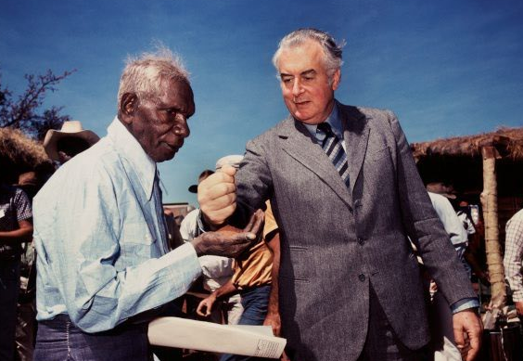

Figure 5: Vincent Lingiari and Gough Whitlam, 1972 (Museum of Applied Arts and Sciences, 2017)

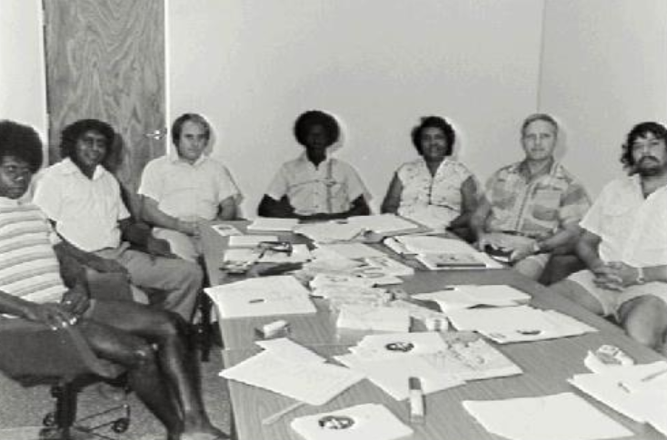

Figure 6: Feppi, 1982 (Northern Territory Library, 2017b)
Northern Territory Indigenous education and higher education policy
The NT Government first introduced bilingual education in 1973 (Northern Territory Department of Education, 1981). Formalised secondary schooling was being established around remote parts of the NT at this time for Indigenous students (Lee, Fasoli, Ford, Stephenson, & McInerney, 2014).
Responses to Indigenous higher education policy in the Northern Territory
Darwin Community College; Darwin Institute of Technology
In 1973 the Darwin Adult Education Centre became Darwin Community College (DCC). DCC eventually evolved into the Darwin Institute of Technology (DIT) (1984-1988), Northern Territory University (NTU) (1989-2002), and finally to CDU in 2003. The Alice Springs Adult Education Centre became Centralian College, which was merged with NTU in 2003 to also become part of CDU. During the early 1970s DCC set up its teacher education program for Indigenous teachers in line with national self-determination policy at the time; vocational non-award courses were also being delivered in a number of remote Indigenous communities (Darwin Community College, 1973, 1977). In 1980 the first enabling course for Indigenous students was delivered - the Certificate of General Studies for Aborigines (CGSA). The Aboriginal Task Force (ATF) was also established in 1980, which began developing additional courses specifically for Indigenous people, in addition to the CGSA (Berzins & Loveday, 1999; Calma, 1984, p.2; Darwin Community College, 1980). The 1980s also saw the establishment of various student support measures as a result of national policies aiming for equity and increased participation, such as an enclave support system for teaching Aboriginal students who were transferring from Batchelor College to complete their final year of a Diploma of Teaching at DIT (Darwin Community College, 1984). Many Indigenous education centres had already been established around Australia, but it wasn’t until 1988 that the Division of Aboriginal Education was finally established at DIT (Calma, 1984; Darwin Institute of Technology, 1988).

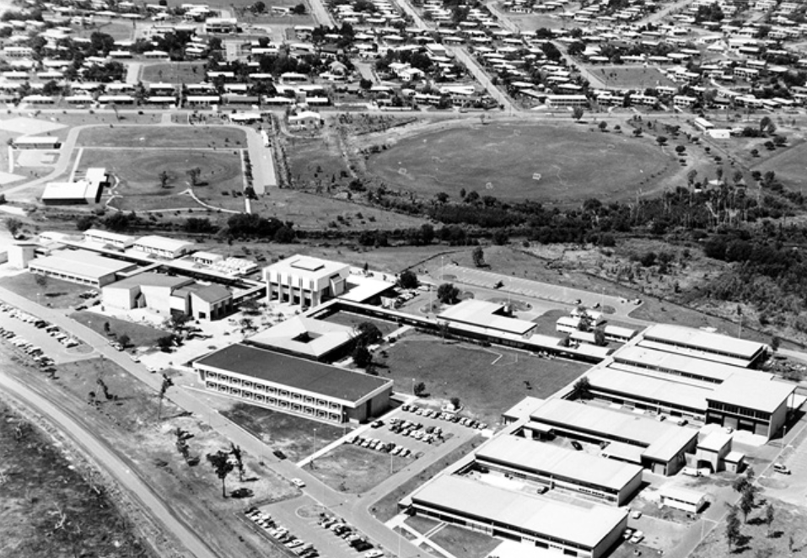

Figure 7: Darwin Community College, 1979 (Northern Territory Library, 2017a)
Aboriginal Teacher Education College; Batchelor College
In 1972 the Vocational Training College (VTC) was established at Batchelor. An assistant teacher training program run at Kormilda College was also relocated to Batchelor in 1974, which then became Aboriginal Teacher Education College (ATEC). Teacher training was the focus in Batchelor’s early years, with core business being training for first and second year Aboriginal Assistant Teachers. Third and Fourth year training was conducted at DCC - however a third year was added to the College’s teacher training program in 1983 leading to an Associate Diploma of Teaching (Aboriginal Schools). Students wishing to complete a full Diploma were then required to enrol with DIT. ATEC established its Remote Aboriginal Teacher Education (RATE) program in 1976. In 1979, the name ‘Batchelor College of Technical and Further Education (TAFE)’ replaced the previous VTC and ATEC. During this period Batchelor championed ‘Both Ways’ learning and fostered a culture of participatory action research with Aboriginal educators (White, 2005). Batchelor also endeavoured to increase the qualifications in its teacher training program, establishing a partnership with Deakin University to accredit training at the standard of a three-year higher education qualification in 1986 (The D-BATE program). This ultimately led to Batchelor being recognised as a higher education institution in 1989 (Batchelor College, 1988, 1997; Roche & White, 1990).
Indigenous student higher education enrolment and completion outcomes
Minimal data was available for this period for both Batchelor College and DCC, with Cyclone Tracy causing significant disruptions to the activities of both institutions in 1974. The earliest indications of Indigenous student enrolment figures – as at this point most students were not yet at the point of completing courses – are available in Figure 8. Figure 8 demonstrates that Batchelor’s teacher education program, since its establishment in 1976, had up to 61 students enrolled. During this time DCC was seeing a small number of Indigenous people enrolling in its range of courses, with the Associate Diploma of Social Work being the most popular. There were 28 students enrolled in the CGSA in 1980 at DCC. Calma (1984) reported that over 400 Aboriginal and Torres Strait Islander students were enrolled DCC but it is unknown which awards that this figure pertains to. Early DCC annual reports do give us an indication of how many students were enrolling in and completing the CGSA, the NT’s first enabling course. In 1981 there were 24 students enrolled in this course. In the same year, there were ten students who completed the course, which increased to fifteen in 1982 (Darwin Community College, 1981, 1982). The next year, 1983, saw 9 students complete the CGSA (Darwin Community College, 1983). After this time the indicator is no longer reported against.

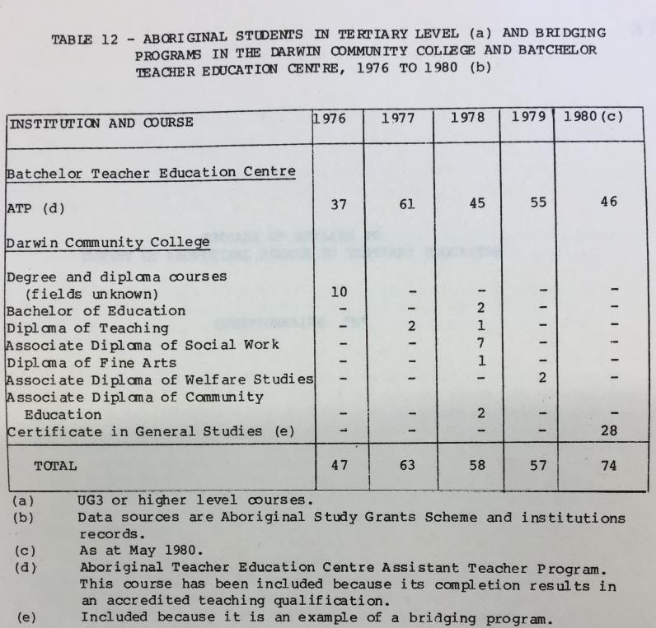
Figure 8: Indigenous student enrolments in various courses at Batchelor College and Darwin Community College (Department of Education, 1981, p.36)
The patchiness of the data at this early point in time allows us to draw a small number of conclusions. The first is that the teacher training programs run by Batchelor College and DCC and the CGSA at DCC, were the first programs that increased participation in post-school education for Indigenous people in the NT. Although the teacher training courses were not equivalent to what is now required for teacher registration due to incremental changes in industry requirements, they paved the way for a cohort of Indigenous educators to enter the workforce – in the education sector and in other sectors – and to enrol in other courses. Secondly, although education was the predominant field of study, it is apparent that at this early point in time there was interest in degrees unrelated to education and teaching – such as the Arts. The high rate of enrolments in education courses would have been influenced by the strong political push for Indigenous teachers that emerged from Hughes and Willmot’s ‘1000 teachers by 1990’ recommendation (Hughes & Willmot, 1979).

1990s
National Indigenous higher education policy
In the 1990s the first major deregulatory and standardisation reforms in the VET and higher education sector – such as increased competition between providers and reduced federal funding for higher education institutions – saw an increased need to measure ‘outcomes’. After Indigenous student access and participation had been increased through the 1970s and 1980s (Gale, 1998; Holt, 2016; Rigney, 2011), the natural next step was to focus on improving student achievement. Some reports were still talking about ‘equity’ (Schwab, 1995; Yunupingu, 1995), and others recommended closer links between funding, student outcomes and student load (Ham, 1996). Paul Keating’s historic Redfern speech introduced ‘reconciliation’ into the Indigenous affairs landscape, which was later shaped by his successor John Howard, into a ‘practical reconciliation’ approach. Howard’s focus quite explicitly focused on accountability and measurement of outcomes. The NAEC had been abolished in 1989 (Holt, 2016), however the Aboriginal Higher Education Association was formed in 1994, eventually evolving into the National Aboriginal and Torres Strait Islander Higher Education Consortium (NATSIHEC) in 2008. NATSIHEC remains in operation in 2017.
Northern Territory Indigenous education and higher education policy
Harris’s Learning Lessons: an independent review of Indigenous education in the NT Review highlighted that learning standards for Indigenous students must be on par with standards for the broader community and questioned bilingual education (Harris, 1990, p. 16). This echoed the national policy emphasis around outcomes. By the late 1990s, Collins (1999) stressed deteriorating educational ‘outcomes’ for Indigenous students ‘from an already low base’ (p.2) and recommended an overhaul in financial management and information systems. This report introduces a discourse of ‘cost-effectiveness’, adding weight to what has now developed into a strong focus on institutions demonstrating their performance against indicators. In 1998, the NT Government withdrew support for bilingual education due to its perception that it was not supporting improved language and literacy for Indigenous students (Lee et al., 2014).
Responses to Indigenous higher education policy in the Northern Territory
Northern Territory University
The influence of ‘equity’ and ‘access’ policy and policy discourse became evident at NTU during this period through, for example, the use of Australian Government equity funds to set up initiatives such as Aboriginal Liaison Positions in 1995 (Northern Territory University, 1995). Aboriginal Student Services (ASS) was also established in 1992 for the provision of academic and personal support to students (Northern Territory University, 1992). NTU finally caught on to Indigenous governance as a strategy and set up an Indigenous advisory body to advise Council. Changes to the higher education sector and reduced government funding had put added financial pressure on the university in the late 1990s; it then began to develop a stronger focus on international activity in the late 1990s to increase revenue (Northern Territory University, 1997). In line with national requirements NTU established a business model to strategically coordinate and report against outcomes, as demonstrated in various strategic plans (MCEETYA, 1995; Northern Territory University, 1998b, 1999b, 2000).
Batchelor College
The recognition of Batchelor College as a higher education institution enabled an expansion of a number of courses, which by this time included health and community studies, and the development of higher level courses. Again in line with the national policy approach, a 1995 external evaluation of the College (Baumgart, Halse, Philip, Aston, & Power, 1995) recommended that the College’s status as a ‘continuing entity’ (p. 162) be tied to development of its quality assurance processes, with a focus on outcomes. Consequently, the language of Batchelor Annual Reports subsequent to the 1995 evaluation incorporated ‘outcomes’ and ‘quality’, where previously these terms were largely missing. Batchelor became an independent higher education provider on 1 July 1999.
Indigenous student higher education enrolment and completion outcomes
Again, student data was only occasionally available in the annual reports of CDU and BC. Batchelor reported Indigenous student enrolments from 1992 onwards, which saw a sharp increase from 30 Indigenous students enrolled in Diploma courses in 1993 (Batchelor College, 1994) to 414 in Diploma and Graduate Certificates in 1994 (Batchelor College, 1995). Enrolments appeared to fluctuate but peaked in 1999 at 667 students in Diploma, Advanced Diploma and Graduate Certificate programs (Batchelor Institute of Indigenous Tertiary Education, 2000).
In 1991, it was reported that there were 108 Indigenous students enrolled in higher education courses across NTU (Northern Territory University, 1991). It was also reported in 1993 that 693 Indigenous people were enrolled in all courses across the university (Northern Territory University, 1993). From 1995 onwards NTU began reporting against access, participation, retention and success (Northern Territory University, 1995). The figures reported fluctuate considerably – most likely due to the small student numbers that were used to calculate them – and do not demonstrate any clear trends (Northern Territory University, 1995, 1997, 1998a, 1999a). NTU reported that there were 49 students enrolled in the enabling course delivered by the Centre for Aboriginal and Islander Studies (CAIS) in 1994 (Northern Territory University, 1994). The inconsistency of the data available for this period does not allow us to make any conclusions, asides from indicating that enrolments in NTU’s enabling course were increasing.

2000s
National Indigenous higher education policy
The higher education sector saw some momentum created in Indigenous involvement in policy development with the Indigenous Higher Education Advisory Council (IHEAC – later renamed as the Aboriginal and Torres Strait Islander Higher Education Advisory Council or ATSIHEAC) established in 2004 to provide strategic ministerial advice. It was abolished, however, by the Australian Government in late 2015. Extreme differences in governmental approaches to Indigenous affairs were seen in the 2000s firstly with the Howard Government’s highly controversial Northern Territory Emergency Response (NTER) implemented in 2007, which had severe impacts on Indigenous ownership and control (Australian Indigenous Doctors' Association and Centre for Health Equity Training, 2010; Gray, 2015). Soon after, the ALP’s recently elected Kevin Rudd delivered the National Apology. Around this time the ‘Closing the Gap’ discourse emerged, which has been criticised by some as underpinned by a deficit viewpoint (Altman, 2009; Guenther, 2017; Hogarth, 2017; Sarra, 2005; Vass, 2013). The emerging focus on ‘outcomes’ to measure this ‘gap’ began to shift the onus for education towards individuals. Bradley’s Review of Australian Higher Education (Bradley et al., 2008) and the Melbourne Declaration on Educational Goals for Young Australians (2008) were two key reports that encouraged reporting against targets in the pursuit of improved student outcomes and increased accountability measures were applied across the sector around this time (MCEETYA, 2006). The Bradley Review emphasised Indigenous Australian people as a priority in the higher education policy agenda. Over the next few years a nationalised curriculum, the National Assessment Program (NAPLAN), and professional teaching standards were put in place. The National Education Agreement was also developed in 2008 (COAG, 2008), in addition to a series of other National Partnerships and ‘Closing the Gap’ priorities, specific to Indigenous Australian people.
Northern Territory Indigenous education and higher education policy
In line with what was happening nationally, the NT Government’s educational strategy began to focus on school attendance, learning outcomes and performance (Northern Territory Department of Employment Education and Training, 2000). The ‘Secondary Education Review’ (Ramsay, 2003) recommended systems to monitor the quality of education providers and services. It also became apparent that efficiency and effectiveness of educational service delivery was an increasing priority, for example, demonstrated in recommendations made by the Structural Review of the NT Department of Education & Training: Delivering the Goods (Ladwig & Sarra, 2009). A significant change that emerged from COAG’s set of agreements in 2009 included designation of approximately 20 ‘Growth Towns’ in the NT as part of the government’s Working Future Strategy (Northern Territory Government, 2009). These growth towns were designated as hubs for which services and infrastructure would be centralised – including the provision of education (Macklin, 2009).
Responses to Indigenous higher education policy in the Northern Territory
Charles Darwin University
From the 2000s onwards it becomes more difficult to draw links between national Indigenous higher education policy and CDU’s strategy for Indigenous education. There was a time lag after corporatisation and standardisation processes of the 1990s and then the institution appears to be more driven by financial sustainability than national Indigenous higher education policy. CDU decreased its remote education and training delivery and invested into the online learning space to increase access to a wider range of students from interstate and internationally. Some Indigenous student support measures were put in place or supported to continue (Charles Darwin University, 2004). New initiatives were introduced that included cadetships, apprenticeships, a work experience program and the Growing Our Own (GOO) program (Charles Darwin University, 2009). CDU also aimed to strengthen Indigenous leadership, with the Pro Vice Chancellor - Indigenous Leadership (PVC-IL) being established at CDU in 2008. Once appointed, the PVC-IL was the most senior Indigenous academic in the country at that point in time (Charles Darwin University, 2008).
Batchelor Institute of Indigenous Tertiary Education
During this period Batchelor also appeared to be driven by economic forces, particularly in the late 2000s. The institute began the decade in a positive light, establishing its Bachelor course in 2000. This was coupled with a desire to see post-graduate courses established (Batchelor Institute of Indigenous Tertiary Education, 2005), and in 2007 a Division of Research was established with Graduate Certificate and Masters Courses commencing. In 2008, PhD courses commenced. By 2008, though, it was clear that the Institute was about to undergo significant change. In August 2009, Brian McMaster, ‘a senior partner at KordaMentha, a consulting firm specialising in corporate reconstruction and reorganisation was appointed by the Council of the Institute as Acting Director’ (Batchelor Institute of Indigenous Tertiary Education, 2010, p.10 Vol.2). This ultimately led to a revision of the BIITE Act in 2012, the partnership with CDU and the establishment of the Australian Centre for Indigenous Knowledges and Education (ACIKE) partnership.
Indigenous student higher education enrolment and completion outcomes
A consistent dataset of Indigenous student higher education data was available from the early 2000s until 2017. Therefore, we have included Indigenous student higher education data for this period in a separate section – refer to Section 2.2.

2010s
National Indigenous higher education policy
This period was highly tumultuous in the Australian Government, with several leadership spills and election defeats. The most recent Abbott and Turnbull governments have emphasised ‘lifestyle choices’ (Bourke, 2015), which has further shifted responsibility for learning on to individuals. Since the Closing the Gap targets were established, annual Closing the Gap reports have been published to report on progress in achieving these targets, however these do not contain any targets for higher education (COAG, 2010, 2011, 2012, 2013, 2014, 2015, 2016, 2017). The Behrendt Review of Higher Education Access and Outcomes for Aboriginal and Torres Strait Islander People (2012) recommended parity targets for access and participation be set to match those of non-Indigenous students. As a result of the Behrendt Review, the revised funding formula for the Indigenous Student Success Program (ISSP) placed increased weight on progression and completion outcomes (Department of the Prime Minister and Cabinet, 2016). The current national Indigenous higher education strategy is the 2017-2020 Universities Australia Indigenous Strategy, developed in consultation with NATSIHEC (Universities Australia, 2017). In 2017, the Australian Government’s Department of Education and Training announced that it aimed to cut funding to the higher education sector. The Higher Education Reform Package (Department of Education and Training, 2017c) did not pass in the Senate, however, other cost saving measures have since been announced (Birmingham, 2017).
Northern Territory Indigenous education and higher education policy
NT Government policy during this time takes an increasingly ‘one-size-fits-all’ approach. The Review of Indigenous Education in the NT (2014), led by Bruce Wilson, was criticised for its lack of consultation with Indigenous communities and is seen by many as paternalistic (ABC, 2015). Wilson recommended defunding remote secondary schools, and was against bilingual education. The NT Government’s 2015-2024 NT Indigenous Education Strategy (Department of Education, 2015) was built on the Wilson Review and initially included strategies around transitioning remote Indigenous secondary students into boarding schools in urban centres. It also led to the trialling of Direct Instruction (DI) – a teaching method developed in the United States in the 1960s. DI has been described by distinguished Aboriginal educator Chris Sarra as a long lasting and expensive mistake (Sarra, C cited in Terzon, 2015) but, on the other hand, has been supported by Indigenous commentator Noel Pearson.
Responses to Indigenous higher education policy in the Northern Territory
Charles Darwin University
CDU’s efforts to follow national policies encouraging Indigenous governance came in the form of the Vice Chancellor’s Indigenous Advisory Committee (VCIAC), established in 2010 (Charles Darwin University, 2010). It was during this period that the OPVC-IL began to increase its focus on research with the securing of a number of research grants (for example, Frawley, Larkin, & Smith, 2017; Shalley & Stewart, 2017; Street, Smith, Stewart, & Girard, 2017). The mid-2010s onwards saw a significant withdrawal of regional and remote service delivery as a cost-saving and efficiency measure, especially in the VET space (Charles Darwin University, 2016). This was also partly attributed to changes to Abstudy that required students to enrol in whole courses before being eligible for student allowances, for example, Away From Base (AFB) allowances. By 2010, three-quarters of all CDU students studied partially or fully online; highlighting the university’s efforts in expanding access to interstate and international students (Charles Darwin University, 2010). The new Connect Discover Grow Strategic Plan intends to prioritise ‘growth and sustainability’ of the university (Charles Darwin University, 2015b). The ACIKE partnership is currently under review.
Batchelor Institute of Indigenous Tertiary Education
For the major part of the 2010s BIITE delivered Bachelor programs under the ACIKE partnership agreement. BIITE also maintained its higher education focus on its enabling programs through its Preparation for Tertiary Success (PTS) program under the ACIKE banner; and through the development of its post-graduate programs. BIITE continues to explore commercial and international course delivery contracts that build on the growing expertise being developed around customisation of accredited training to Indigenous peoples nationally and internationally. BIITE was also granted cultural standards accreditation by the World Indigenous Higher Education Consortium in 2017. It is only the second higher education institution in Australia that has been granted this accreditation.
Indigenous student higher education enrolment and completion outcomes
Refer to Section 2.2.

2.2 Indigenous student higher education enrolment and completion outcomes

Enrolments
By Gender
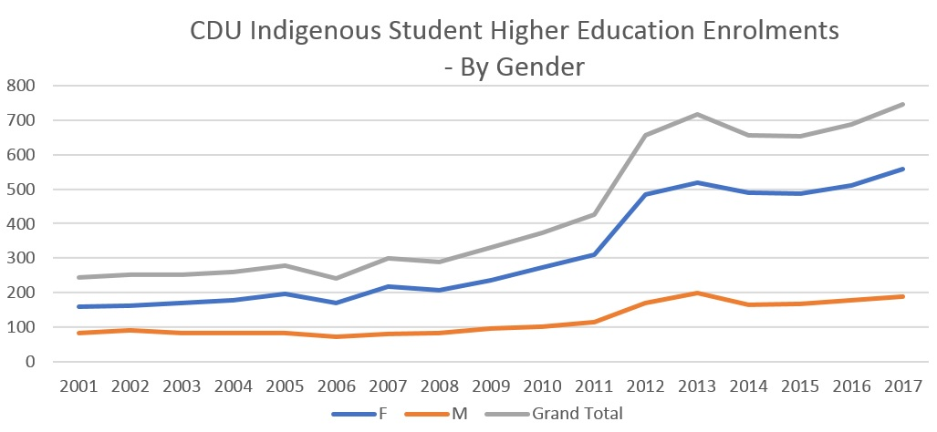

Figure 9: CDU Indigenous student higher education enrolments - by gender

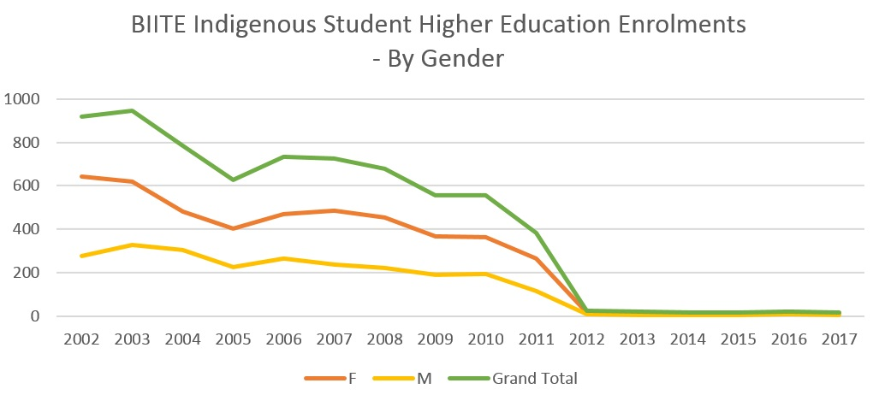

Figure 10: BIITE Indigenous student higher education enrolments - by gender
The most obvious event that manifests in the data in Figures 8 and 9, and the remainder of graphs included in this report, is the establishment of the ACIKE partnership. There is a clear increase in student enrolments at CDU in 2012 and a sudden decrease in 2012 at BIITE at the same time, brought about by enrolments at BIITE transferring to CDU. After it was announced that the ACIKE partnership would be established in 2009, students deciding to enrol in higher education courses would have enrolled at CDU, which is why BIITE enrolments trend downwards after 2009. We can see that CDU’s Indigenous student higher education enrolments continue to steadily grow from 2012 onwards, with a small part of this growth attributed to enrolments in courses other than those that transferred from BIITE. BIITE was only delivering higher degree by research courses after this time and therefore the numbers are small. BIITE from this point onwards of course continued to play an important role in delivery of VET programs for Indigenous students also.
The other observation we can see in these graphs is the differences between male and female enrolments for both institutions. BIITE had approximately two females enrolling for every one male for the period represented in Figure 9. CDU was enrolling the same proportion of females to males (2:1), but this increased to approximately 3:1 by 2017. This demonstrates that the gender gap between Indigenous male and female students at CDU is widening.
By Course Type
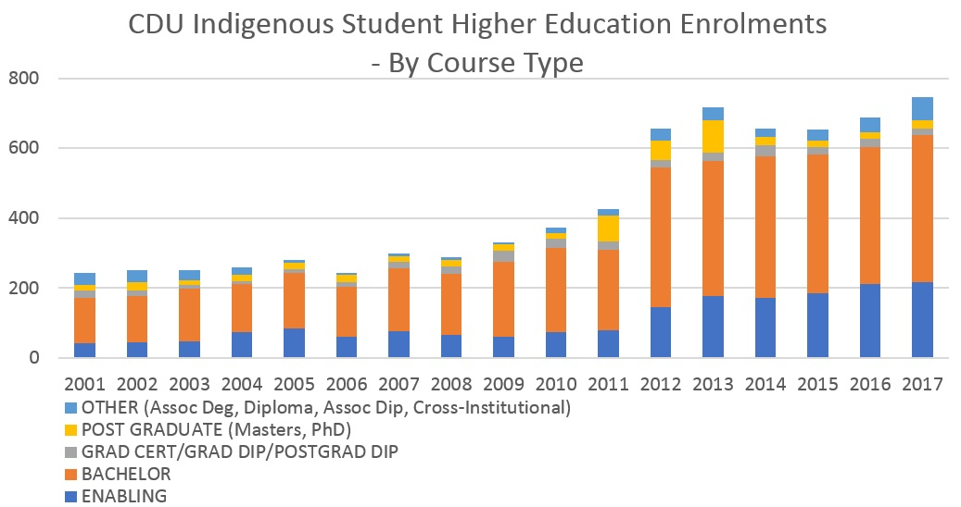

Figure 11: CDU Indigenous student higher education enrolments - by course type
Figure 10 highlights the many students studying Bachelor degrees who were transferred over to CDU from BIITE once the ACIKE partnership was established (i.e. 2012 onwards). Since this time there is also a steady increase in enrolments in enabling courses at CDU. At CDU there was also an increase in enrolments in Masters and Doctorate programs from 2011, which again decreased after 2013. A number of these were attributed to the Mawul
Rom Master of Indigenous Knowledges program, which has been in abeyance since 2013 (Dinning, 2017).
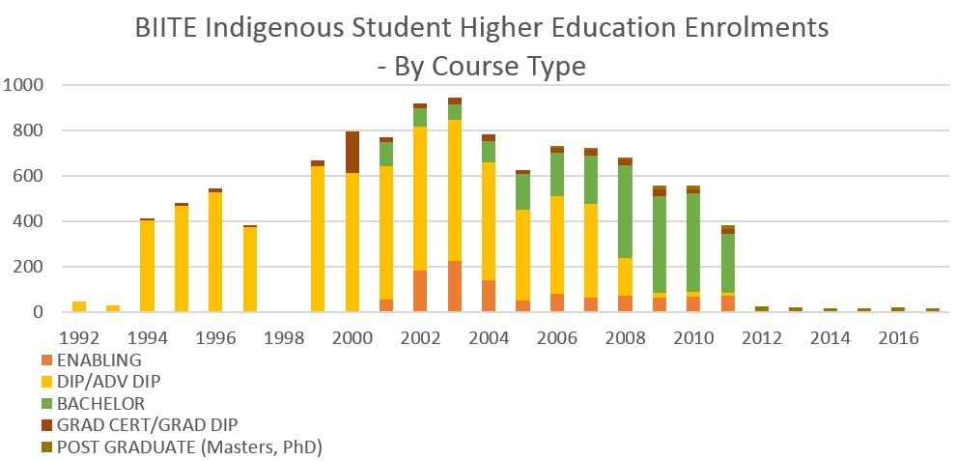

Figure 12: BIITE Indigenous student higher education enrolments - by course type
It is clear in Figure 11 that Diploma courses were the majority of BIITE’s higher education program delivery until the mid-2000s. From approximately 2005 onwards their relatively new Bachelor program grew its higher education enrolments until it became the most popular course type for Indigenous students to enrol in at BIITE from 2008 onwards. After the ACIKE partnership was established BIITE’s only higher education program delivery was Masters and Doctorate degrees by research.
By Field of Education
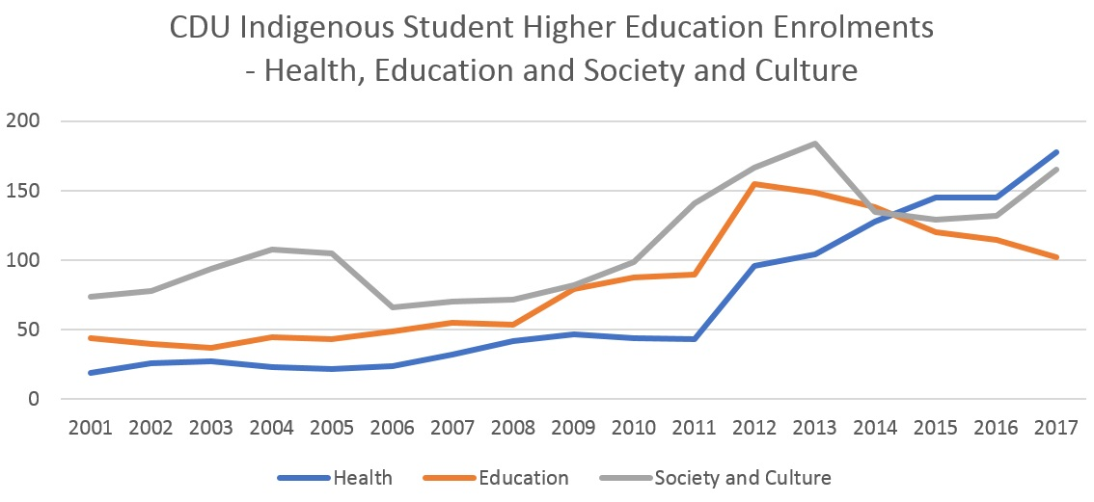

Figure 13: CDU Indigenous student higher education enrolments - by field of education (Health, Education and Society and Culture)
The three most common fields of education in which Indigenous students enrol are displayed in Figures 12 and 13. The impacts of the ACIKE partnership are again evident; enrolments increased across all three areas in 2012. It is noteworthy that after Indigenous higher education students transferred across from BIITE to CDU, enrolments in health courses continued to grow whereas education enrolments have steadily declined.
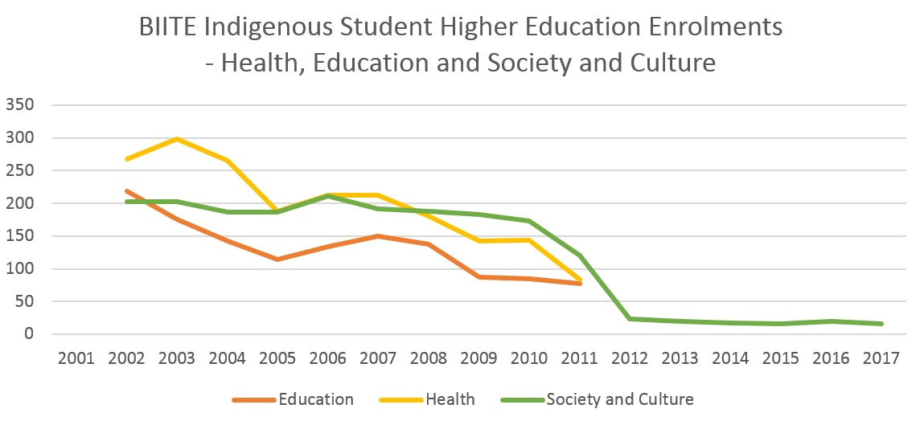

Figure 14: BIITE Indigenous student higher education enrolments - by field of education (Health, Education and Society and Culture)
Indigenous student enrolments in health courses at BIITE, displayed in Figure 13, saw a gradual decline since 2003. Enrolments in education courses at BIITE were declining from 2002. They then increased in 2005 and this continued until 2007 when they again began to decline until they were transferred to CDU through the ACIKE partnership. Enrolments in Society and Culture courses remained relatively steady until the ACIKE partnership was established. The Doctor of Philosophy (Indigenous Knowledges) and the Master of Indigenous Knowledges – which are classified under Society and Culture – were BIITE’s only remaining courses after this time.

Completions
Relatively small numbers of students completing courses are included in this data. To protect student confidentiality, where the number of students was less than 5, the figure has been changed to 4, unless the figure was 0. Graphs that include figures that have been changed are marked with an asterisk (*).

By Gender
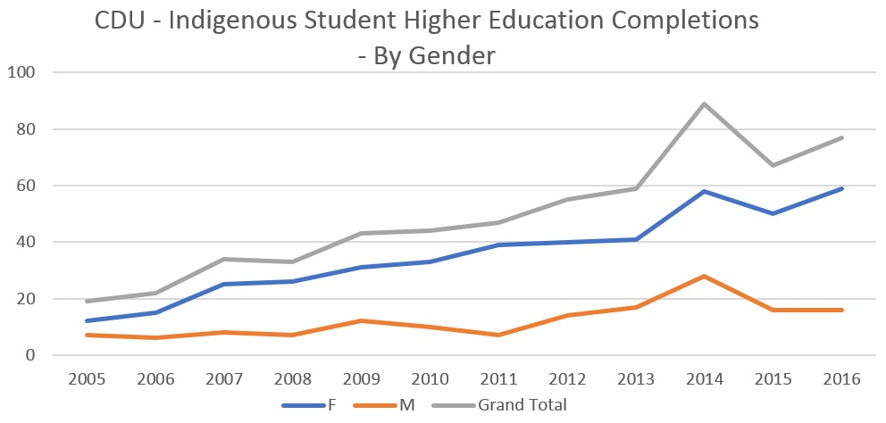

Figure 15: CDU Indigenous student higher education completions - by gender
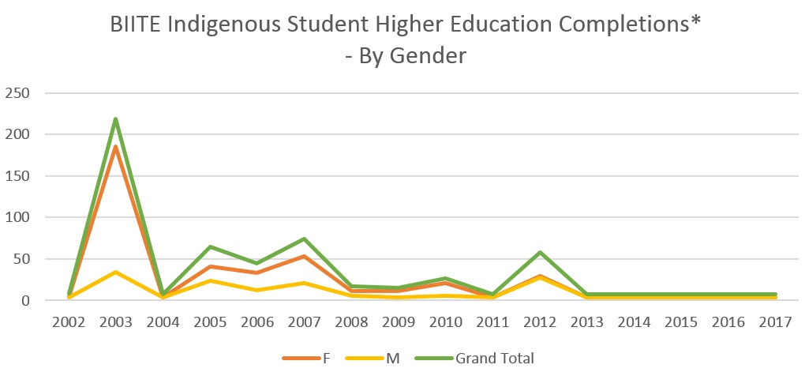

Figure 16: BIITE Indigenous student higher education completions - by gender. * X< 5 = 4; unless X = 0
We again see a widening gap between females and males in Indigenous student completions at CDU as displayed in Figure 14. In Figure 15, there is an obvious peak in BIITE Indigenous student higher education completions in 2003. This skews the graph and can be in fact attributed to a changeover in student administration systems when students had to be classified as having completed an award. This meant many students at this time were awarded with Diploma degrees in nested award arrangements when they may have in fact been studying for an Advanced Diploma, or awarded an Advanced Diploma when they were progressing towards a Bachelor degree. The spike in 2012 would have been caused by similar circumstances in which students transferring over to CDU were awarded degrees based on their attainment of competencies up until that date.
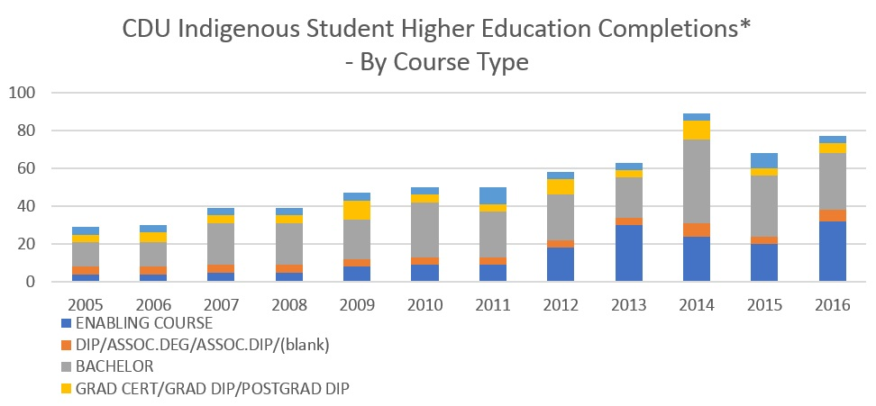

Figure 17: CDU Indigenous student higher education completions - by course type. * X< 5 = 4; unless X = 0
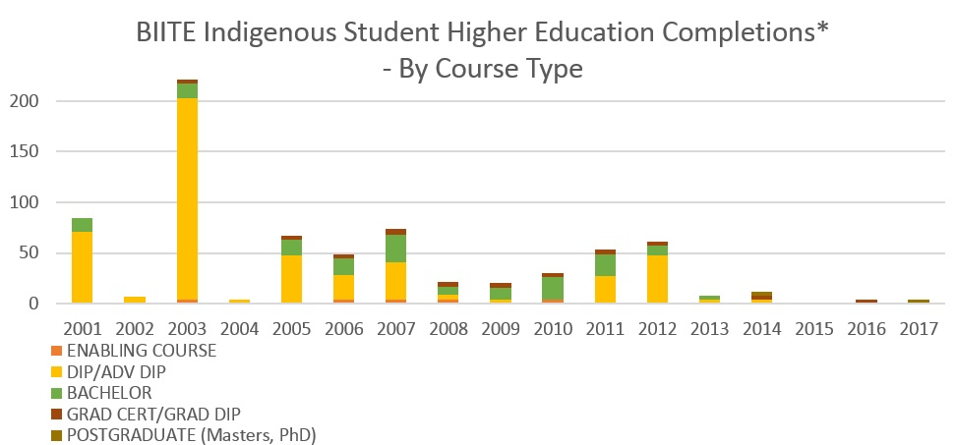

Figure 18: BIITE Indigenous student higher education completions - by course type. *X< 5 = 4; unless X = 0
Figure 16 demonstrates that course completions for Bachelor degrees and enabling courses have both slowly increased at CDU since 2005. Actual numbers are relatively small, with 28 students being awarded Bachelor degrees and 32 students completing enabling courses in 2017. The spike in 2003 is again visible in Figure 17 demonstrating the many Diplomas and Advanced Diplomas that were awarded by BIITE in this year partly for administrative purposes. Other than that, Figure 17 shows that Diplomas were the most common degree awarded for much of BIITE’s recent history, with Bachelor degrees beginning to be more prominent in the 2000s.

By Field of Education
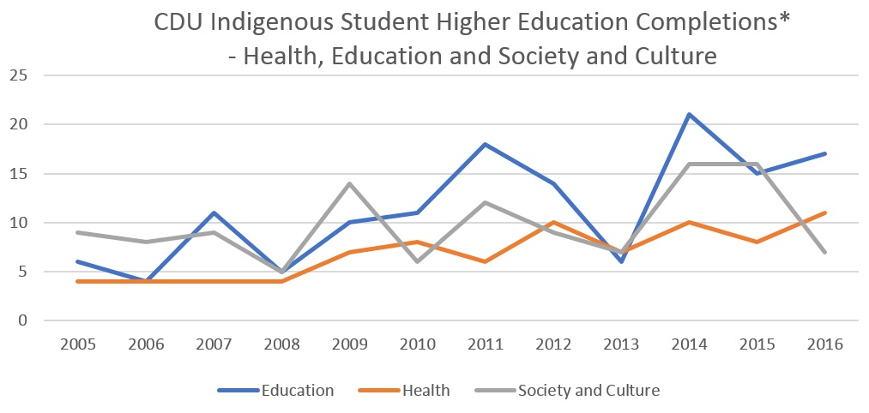

Figure 19: CDU Indigenous student higher education completions - by field of education (Health, Education and Society and Culture). *X< 5 = 4; unless X = 0
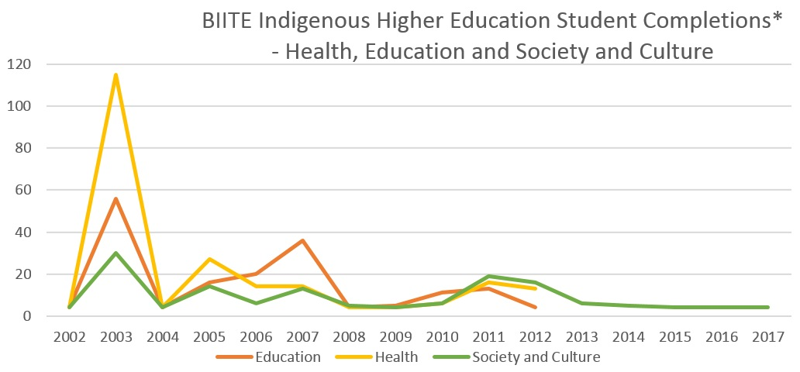

Figure 20: BIITE Indigenous higher education student completions - by field of education (Health, Education and Society and Culture). *X< 5 = 4; unless X = 0
CDU’s Indigenous student completions in health courses have increased steadily since 2008 as demonstrated by Figure 18. The number of Indigenous students completing education courses, on the other hand, decreased after the ACIKE partnership was established. There was then a spike in 2014 – potentially attributed to the GOO program. Society and Culture completions have fluctuated since 2005. Asides from the spike in 2003, Figure 19 shows us a small increase in students completing health and education courses at BIITE before these areas plateaued. They both declined around 2008 – when BIITE was experiencing financial challenges but then increased again prior to the establishment of ACIKE.
The statistics reported here highlight some important points. The first is that CDU and BIITE both play an important role in the higher education of Indigenous people nationally. Using the Higher Education Information Management System (HEIMS) data to obtain a comparable dataset, we can deduce the proportion of Indigenous students nationally that study with these two institutions. In 2016 there was a total of 676 Indigenous students enrolled in higher education courses at CDU and BIITE, and 17,800 Indigenous students enrolled in higher education courses nationally (Department of Education and Training, 2016). CDU and BIITE’s higher education programs, therefore, account for 3.8% of Indigenous higher education students in Australia. That is, CDU and BIITE are disproportionately supporting Indigenous student enrolments in Australia on a per capita basis. At present, there is no national policy or funding incentive to adequately recognise or remunerate this situation.
The other noteworthy points in the data presented here include the steady increase in enrolments in enabling courses at CDU; the much greater representation of Indigenous females in higher education at both CDU and BIITE when compared to Indigenous males; and the impacts of ACIKE partnership on BIITE’s student profile. Patterns in enrolments and completions do not appear to clearly align with particular Indigenous higher education policy investments. It appears that institutional strategy development responding to contextual circumstances may be a stronger influence on Indigenous student enrolment and completion outcomes. This includes factors such as available external financial support, internal financial management, student support services and institutional (or Indigenous) leadership. It also appears that discipline specific policies and strategies may be influential in enrolment and completion outcomes – for example, the introduction of health courses to align with particular health policies.
Although our dataset is patchy, we can make some inferences about institutional responses to national policy since the 1970s together with what we know based on our policy review. The 1970s saw a focus of both institutions on Indigenous teacher training in line with national self-determination policy. Despite not having a complete dataset it appears that a majority of Indigenous students were enrolled in teacher training courses during this period. As more students began showing interest in higher education, DIT in particular during this 1980s strategised around increasing access to other courses through establishing bridging courses specifically for Indigenous people such as the CGSA. We also know that BIITE provided a range higher education courses to a significant number of Indigenous higher education students in the 1990s. This decade saw NTU reporting against access, participation, retention and success – which demonstrate the national emphasis on equity around this time. Finally, our observation that since around 2000 institutional strategy does not appear to be guided by national Indigenous higher education policy, aligns with what we see in Indigenous student higher education enrolment and completion data.

2.3 Indigenous perspectives of ‘success’ in higher education policy in the NT
We have now explored changes in national Indigenous higher education policy over time, the responses of CDU and BIITE to various national policies, and related them to available Indigenous higher education student enrolment and completion statistics. We will now use poststructural analysis (Bacchi & Goodwin, 2016) to unpack definitions of success of our Indigenous key informants as ‘users’ of policy in Indigenous higher education policy and outline enablers and constraints to effective policy implementation that emerged from the data.

Defining success
The purpose of education
Success is defined by the Oxford Dictionary as ‘the accomplishment of an aim or purpose’. Within the context of Indigenous education, a number of authors have posited that assumptions around the purpose of education, and therefore what ‘success’ refers to, generally reflect Western ways of looking at the world and are exclusionary (Guenther & Bat, 2013; Osborne & Guenther, 2013; Zipin, Sellar, Brennan, & Gale, 2015). Definitions of success of our key informants, therefore, related to successfully achieving the perceived aims of higher education which were often embedded within community interests (Bunda, Zipin, & Brennan, 2012) – although individual benefits such as employment and intellectual stimulation were also mentioned. Higher education, and more broadly education, was seen as a vehicle to ‘open ways forward for our [Indigenous] community people’ (Valda Shannon). The reason for undertaking tertiary study is greater than just individual aspirations or needs, because, ‘you're doing it for yourself, but you're also doing it for your family and for your community’ (Gary Fry).
It was also highlighted that improved access to higher education for Indigenous people is largely the result of ongoing advocacy of Indigenous groups and individuals. Several key informants emphasised that improved access to higher education for Indigenous people is largely the result of longstanding advocacy efforts of Indigenous individuals and bodies:
‘[Recent successes are] on the basis of all of the struggles, and the successes that we've had over the last 40 years. So, it's impossible to actually extract out one period of time and say, ‘Yeah, this was the really successful time,’ because it's all built on this foundation, and continues to be built on a foundation that goes back to the beginning of time really.’
— Wendy Ludwig
How should success be measured?
Definitions of success revolved around two predominant fields – as well as others that have been described in relation to the policy implementation process later in this section. Firstly, ‘completing’ higher education units or courses, ‘to get to the other side and complete’, and to ‘gain a degree’ were terms used in relation to this form of success. The second theme was around representation; some interviewees believed that success should be measured through representation of Indigenous people as students and staff in higher education and other sectors. It was important to Gary Fry that ‘Aboriginal people [are] up there reflecting the demography of the NT [as students in higher education]’. This supports Behrendt’s recommendation that parity targets for Aboriginal and Torres Strait Islander students and staff should be based on the total proportion of the national population that are Aboriginal and Torres Strait Islander (Behrendt et al., 2012). For this to be achieved though, the Indigenous higher education student and staff body in each of the States and Territories must reflect the jurisdictional population. Similarly, Steven Larkin identified that ‘increased numbers of people [staff]’ in the higher education sector is one way of measuring success. Within the education sector, parity in the workforce was seen as vital because ‘once we get more representation at a higher level that’s going to be really crucial in terms of how we move forward… having people in those situations then will be able to change current legislation, policy and practice’ (Yvonne Cadet-James). Our interviewees’ perceptions of how success should be measured are strongly linked to some of the commonly used measures for success in policy as has already been described.

Enablers to success in Indigenous higher education policy implementation
We have categorised themes relating to enablers to success in Indigenous higher education policy implementation as key principles that relate to 1) the higher education system; 2) higher education institutions; and 3) the role of Indigenous higher education students.This is outlined in Figure 21. Although Indigenous Standpoint Theory explicitly focuses upon interactions with education systems and structures, the interview data elicited several important themes relating to characteristics of individuals that were important to include in the analysis presented here.
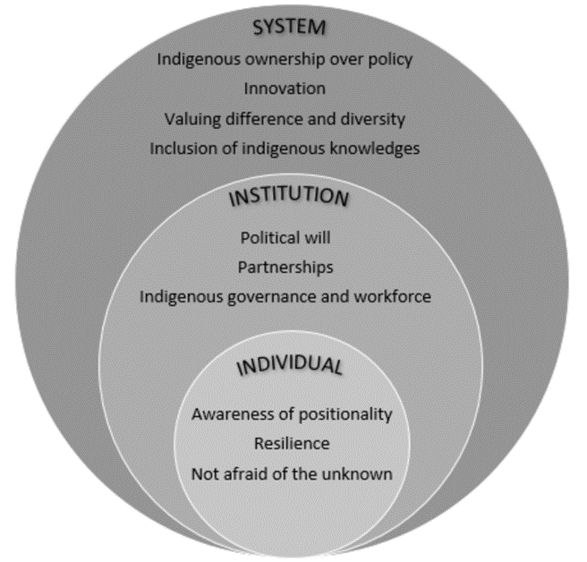

Figure 21: Enablers to success in Indigenous higher education policy implementation
Key principles of effective policy implementation: the higher education system
There were numerous strong themes that emerged relating to the higher education system in general, that is, not relating to any one government, institution, or organisation. The first poignant theme was involvement of Indigenous people in governance and decision-making, that is, the formal process of developing and reviewing government or institutional policies (Moreton-Robinson, Walter, Singh, & Kimber, 2011; Universities Australia, 2011). Ownership of policy processes, and inclusion of Indigenous perspectives within policy processes was also reported by many as an enabler to success and is described in a growing body of literature (Foley, 2006; Rigney, 1999; Smith, 1999). As evidenced by this research, there are many Indigenous higher education experts in the NT well-placed to be involved in policy development and review, however, ‘they haven't been asked, that's my feeling’ (Lawrence Webster). It was noted by a number of informants that consultative structures in place in government at present are less conducive to Indigenous advocacy than in the past such as the opportunities offered through NAEC and Feppi (Holt, 2016).
The second theme related to innovation; it was highlighted that some of the gains made in Indigenous higher education were a result of trying things that had not been tried before. The (ATEC - BIITE’s predecessor), for example, provided innovative training that integrated Indigenous worldviews into curriculum and pedagogy (Kemmis, 1988). Similarly, if CDU had not established the Pro Vice Chancellor – Indigenous Leadership position in 2008, ‘the other unis may not have followed suit’ (Steven Larkin).
A third theme related to valuing the benefits that diversity brings to the experience of students, and ultimately to Australia’s nationhood (Bradley et al., 2008). CDU and BIITE have both done well to extend access to interstate and international students (Charles Darwin University, 2017b). CDU has established a distinctive graduate quality about ‘appreciating and understanding Indigenous Australians’ and incorporated some aspects of Indigenous history into core curriculum. However, many informants felt that the higher education industry in Australia maintains ‘structural selectivity of cultural and epistemological codes embedded in mainstream… curricula and pedagogies’ (Bunda et al., 2012, p.942). As Geoffrey Shannon describes it simply, it is ‘one way’. Bob Morgan argued that ‘our kids are entitled to a world that they feel and … does value them and respects their difference and their culture’.
Key principles of effective policy implementation: higher education institutions
Altbach (1977, p.6) emphasised that resistance within academic organisations ‘has tended to oppose reforms which change the traditional patterns of university governance, curriculum or other elements that affect working conditions and privileges’. In considering enablers for creation of more positive conditions for Indigenous higher education students and staff, there were a number of qualities specific to CDU and BIITE that, historically, were seen as important. Firstly, political will was alluded to a number of times by key informants as being essential for policy success (Ahmed, 2012; Atwood, Colditz, & Kawachi, 1997; Lezine & Reed, 2007; Richmond & Kotelchuck, 1993). Relating this to the establishment of the CGSA at DCC, Wendy Ludwig described that, in addition to Indigenous advocacy and perseverance as well as some advocates within the NT Government, the importance of ‘the particular personalities that were involved in pushing the barrow… There were some people, some advocates inside Darwin Community College… that could see the value.’ Steve Larkin, in contrast, summarised frustration at observing:
‘Policy documents, strategies, plans... they’re meant to be conveying this sense of institutional commitment to something that it’s seen as important. But it seems to then go into this hiatus and so you don’t actually see any discernible effort.’
Political will is based on ‘public understanding and support’ (Richmond & Kotelchuck, 1991, p.451). Conditions for understanding and support have been shown to be created through partnerships between Indigenous communities and post-secondary institutions (Ball, 2004). Several key informants reflected on experiences with lecturers or leaders within institutions that saw the Indigenous community as partners in their efforts to improve higher education outcomes for Indigenous people. Geoffrey Shannon remembered his experience with lecturers at DIT (a past iteration of CDU): ‘They'd give the time. They'd give their wisdom. Their understanding.’ Yvonne Cadet-James, who was at one point Chancellor at BIITE, reflects on the importance of ‘making sure that you're out there talking to people [in the community], that you’re giving them feedback, that they're involved in things…’ These comments emphasise that when Indigenous communities are engaged, it leads to trust, reciprocity and sustainability (Kirkness & Barnhardt, 1991; Smith, Larkin, Yibarbuk, & Guenther, 2017).
Finally, key informants stressed the need for Indigenous people to be involved in higher education policy implementation – either through governance structures or in the workforce, or both – to feel valued and supported (Asmar & Page, 2009; Curtis, Wikaire, Stokes, & Reid, 2012; Dodson & Smith, 2003; IHEAC, 2006, 2011; Rigney, 2002). One informant remembers feeling supported in her role as an Indigenous student support officer when dealing with a difficult situation with a student: ‘I thought that was just great, you know? So, not only do they look after students. They look after staff too’ (Anonymous). It is also critical that Indigenous members of staff be supported to develop the skills and knowledge to do their job effectively and have access to career development opportunities. This is an essential element to individuals feeling valued by their employer, and an essential part of capacity building processes. Valda Shannon expressed frustration that ‘all these organisations getting our mob to work, work, work. No training, no study. This is hurting us. I believe strongly our organisation should be opening doors for our mob to study from within the organisation.’
Key principles of effective policy implementation: the role of Indigenous higher education students
Several qualities of students more likely to be successful were described. Several informants described how an understanding of one’s positionality within the Western-centric education system – the ‘politics of Indigenous tertiary education’ (Nakata, 2013) – allows students to negotiate their life as a student in a more constructive way (Battiste, 2000; Smith, 1999). Wendy Ludwig recalled her time at university and wished that she had gained an appreciation of her positionality at an earlier point in time:
‘It wasn't until I realised that what I was being taught was about how Western society constructs itself, how it reproduces its knowledge, and how it socialises its people. Once I realised that, and then thought about what opportunities I then had to say in the context of tutorials, or writing assignments, use the question, the essay - the assignment question. And, use it in such a way that allowed me to then research and write about my reality, as a way of reproducing my own knowledge to help me feel okay.’
Nakata, Nakata, Keech, and Rueben (2012) caution that decolonisation of Western knowledge and practices is too often an oversimplification of what is a very complex and contested space. What we do know is that students who are equipped with skills to engage in critical thought about how they fit within a Western education system – and to question the inherent vested interests within knowledge production (Smith, 1999) – will be more successful. Vital to persevering in this space is the need for resilience. Negotiating the challenges associated with study while coping with risk – for example, an unfamiliar environment, learning new content, completing assignments, dealing with institutional racism and other challenges – requires resilience and drive (Hunter, 2012). Valda Shannon reflected on her journey: ‘It was hard, but I was determined. I made a lot of sacrifices… But in the end I thought it’s got to be me, and I have to take control and drive myself to finish this course.’
A willingness to engage with the unknown was seen as essential to success for Indigenous higher education students. Valentine Shaw observed that: ‘Sometimes you see people get scared of [studying], scared that they think they can’t do it’. The language of ‘disadvantage’ and deficit in Indigenous affairs – such as what is implied through Closing the Gap policy agenda – positions Indigenous people within a frame of failure and inadequacy (Guenther, 2017). This discourse impacts on socialisation processes, which can be internalised by Indigenous people (Sarra, 2005; Stronger Smarter Institute, 2014). Courage and self-belief, in addition to resilience, are essential qualities that are required to take on the challenge of higher education in order to then achieve success. Finally, the role of the family was mentioned by many informants as being pivotal, as has surfaced in other scholarship (Frawley, Ober, Olcay, & Smith, 2017; Guillory & Wolverton, 2008). ‘The quicker the family understands, the better’ commented Lorraine St Clair. When families are made aware of study commitments and the reasons why their family member has undertaken study, they are more equipped to play a support role on the student journey.

Constraints to success in Indigenous higher education policy implementation
Despite the strengths-based approach taken for this research it was important to acknowledge and report on constraints to success in Indigenous higher education policy. These constraints were often generalised elements relating to the higher education system – and in many cases were relevant to sectors other than education. We have categorised these themes according to theoretical or philosophical constructs underpinning the higher education system, and more practical considerations of what is perceived to prevent effective Indigenous higher education policy implementation.
Theoretical and philosophical constraints
The education system is that which is responsible for the production of ‘knowledge’. As we have learnt already, values are the core of what one perceives to be the purpose of education, and what types of education are deemed to be desirable (Biesta, 2009). If the knowledge that is deemed to be suitable for production has originated from a narrow epistemological and ontological framework and now forms our current education system, then it is certain to be exclusionary of alternative ways of being and knowing (Bunda et al., 2012; Gray & Beresford, 2008). Gary Fry observed this: ‘When you get the same personality types gravitating around the top, and they tend to be racially the same people, they seem to be the same age cohort and most of them are the same gender… the education system has functioned to maintain that stratification.’ Elaine Lawurrpa Maypilama believed that government policy purposefully oppresses Indigenous people: ‘In this balanda way, it's different. Harder. Because they want their children to learn. They keep their nowi, law and policy, to be like that.’ Bob Morgan summarised the problem as: ‘If the education system is fundamentally flawed… then you can put all the Aboriginal people you want into that system and then they just become defeated by the process. Then they just spend their time just sort of fitting in and not being agents of change.’ His assessment reflects that of many key informants; until there is flexibility for teaching practices, curricula and the policy frameworks underpinning these, to reflect Indigenous ways of being and knowing, Indigenous people will continue to be disempowered by the Western education system. The conceiving, collection, analysis and interpretation of research and evaluation data by Indigenous experts to inform the policy review and development process (Walter, 2010), has in recent times been advocated for by Indigenous scholars as an essential mechanism for this to occur (Anderson, 2017).
Paternalism and protectionism were seen to be barriers to effective higher education policy implementation: ‘There's a certain level of paternalism… of needing to protect these innocent blacks that live in the bush and are going to get done over’ (Wendy Ludwig). Gary Fry talked about government approaches generally: ‘They come at it from an imperialist point of view and try to throw it down people’s throats.’ Wendy and Gary refer to the historically protectionist attitude in the NT and nationally that sees Indigenous people as unable to determine what is right for themselves and their communities. It can be traced back to segregation and assimilation practices in the early twentieth century during which there were attempts to separate Indigenous people based on how much ‘native blood’ a person was deemed to have (Cummings, 1990; MacDonald, 1995). Since this time, division of Indigenous communities has continued – whether that be conscious or unconscious – through much of Indigenous policy in the NT being targeted towards those in remote communities. This approach is taken as it is politically expedient to do so - given that approximately 80% of Indigenous people in the NT reside in regional or remote areas (ABS Census of Population and Housing, 2016). It also, however, reinforces mentalities that create pictures of what it means to be Indigenous (and what it doesn’t mean). This manifests itself through race relations, such as identity politics. For example, as Lawrence Webster describes, teachers returning to communities face serious challenges to their identity when returning to a community after becoming qualified:
‘They are now seen as someone who's made it so far in the wider society and come back with a qualification, as a teacher. Therefore, the community looks on them in a different light, and in that light there are other added pressures that are put on them by the community members.’
Identity politics was mentioned by some key informants as being a very real challenge for successful policy implementation. Identity politics concerns the notion that identity is defined by someone’s cultural difference – which is not accessible to the dominant culture – and in the Indigenous setting is often linked with perceived ‘authenticity’ (Harris, Carlson, & Poata-Smith, 2013; Shouls, 2003). As Sissons (2005) reminds us, identity politics are a manifestation of deep-rooted colonial struggles such as the practice of creating and imbuing racial categories with seemingly impermeable boundaries (Harris, Carlson, et al., 2013, p.1).
Political constraints
Many constraints were mentioned that relate to various characteristics of the policy cycle. Firstly, trust in governments has been gradually eroded over time in Indigenous communities due to a history of chop-and-change political agendas based on ideology of the government in power (Street et al., 2017). The current state of the government approach to Indigenous higher education, and more broadly Indigenous affairs, was also described as ‘… piecemeal. You've got little areas doing this, and little areas doing that’ (Lawrence Webster). Lorraine St Clair, an Indigenous student support staff member, reports seeing the effects of withdrawal of funding for the More Indigenous Teachers Initiative (MITI): ‘There was so many Indigenous people really excited about that, really getting on board with it too. Had their applications in when they pulled it. So, they were really disappointed.’ In addition to impacts on trust and engagement, Lawrence Webster highlighted that: ‘They [government] don't need to be commissioning more reviews into what's wrong with Indigenous education. What they should be doing is putting in place all the recommendations that have emanated from these reports, and give them a chance to take effect.’
In addition to frustration with short timeframes, frustration was expressed about the lack of transparency and accountability in the policy review cycle (Hudson, 2016; Muir & Dean, 2017). Geoffrey Shannon recalled, ‘We never got any feedback from what they were going to do [after Feppi meetings]. How is it going to be used? For what purpose? You know - a whole range of things never came back’ (Geoffrey Shannon). Yvonne Cadet-James reported that ‘people can basically say anything they want’ in their reporting to the Australian Government. We find a conflict of interest when considering institutional accountability in that it is not in the best interests of higher education providers to be transparent in their performance, as this may impact on the level of funding they receive. Bob Morgan believes this is rightly so:
‘Is it right that they [higher education institutions] should continue to receive funding if they’re not performing? My view is no. I think if those institutions can’t demonstrate that they are capable or that they are willing to, even do something different than what they’ve done historically, then perhaps they shouldn’t receive the same level of funding and support.’
This is not as simple as it sounds, however. In the NT, a majority of Indigenous students study part time and are more likely to be mature-aged and working. Thus, it would be unfair to base funding decisions solely on an institutions ability to support students to complete within a specified timeframe. This highlights that context is important, particularly within a context of performance-based funding, such as that currently adopted through the ISSP.
Accountability has, in one sense, increased over the past few decades. The Dawkins reforms kick-started a progressive process of deregulation of the Vocation Education and Training (VET) and higher education industries from the 1990s onwards (Dawkins, 1988). These sectors saw increased competition between providers, which prompted institutions to become more concerned with their own effectiveness. This has occurred in parallel with global neoliberal influences – and the current Turnbull government’s general approach to policy – that shifts responsibility for learning onto the individual. These changes have caused education providers to push themselves to utilise their finances in the most efficient way possible. The impacts of this were noted by many key informants: ‘Bums on seats is what people are after. They don't want to worry about that quality or good outcomes of students’ (Valda Shannon). The stronger emphasis on performance and efficiency measures, however, is a double-edged sword. Indigenous advocates have called for enhanced accountability for institutions in the utilisation of financial resources (Behrendt et al., 2012). It is their ethical responsibility to deliver effective and equitable education. The range of measures that are used to assess performance – such as for the ISSP, for which reporting is required on student outcomes, governance, workforce, and performance against an Indigenous Education Strategy - are narrow due to their ease of measurement:
‘It’s easy to set key performance indicators for the number of people being recruited and the number of completions. But when you think about all the other support things that need to be in place it’s more difficult to assess.’
— Yvonne Cadet-James.
They typically describe activities rather than evaluate effectiveness. This is to the detriment of Indigenous learners and the education they receive. Measuring an institutions’ ‘performance’ through the activities that they implement, rather than how well their activities support Indigenous students to succeed, does not necessarily encourage learning and improvement.

Perceptions of change
Some observations of positive change were reported. Some informants highlighted the increase in numbers of graduates emerging, and that the young people who are graduating have sophisticated thought processes and a critical world view: ‘There’s a whole generation of really sophisticated young people coming through. When you talk to them they’re very politically savvy’ (Yvonne Cadet-James). There was also an acknowledgement that there are more Indigenous people in senior level positions in universities (Malin & Maidment, 2003; Pechenkina & Anderson, 2011).
A general sense of concern, however, was expressed by most interviewees about the general direction Indigenous education and higher education are heading. Several people commented on how rigid policy frameworks have become and that they are not accommodating of alternative worldviews and knowledge systems: ‘I worry about all the kids... They're not going to learn anything in these schools; not the way the government's set up’ (Geoffrey Shannon). Steven Larkin termed current state of inclusion of Indigenous people within the higher education system as ‘an unconditional accommodation’, which is in contrast to valuing the benefits that Indigenous people bring to the higher education sector and to the nation in general (Bradley et al., 2008). There was frustration expressed about government’s tendency to ‘reinvent the wheel’: ‘It just drives you mad… It’s just more and more and more and more of the same. I think we’re better than that (Bob Morgan).’ Despite recent investments through a program led by CDU in partnership with BIITE, the people interviewed from remote Indigenous communities commented on a lack of progress in improving higher education outcomes for their fellow community members: ‘I can tell you the truth, that I don’t see anyone going up to that pathway’ (Elaine Lawurrpa Maypilama). Valda Shannon observed, ‘I don’t think there’s any change, to be honest. There should be more people like us coming up behind us.’

Proposed solutions
Proposals for improvement in policy development, implementation and review put forward by key informants emerged under two central themes. The first is ownership over the policy cycle, which was seen as being the most fundamental precursor to success in Indigenous higher education policy and has been since the NAEC developed the NAEP in 1989. This document was, at the time, considered the cornerstone of Indigenous educational policy, but successive government policy approaches have shifted significantly away from its ideals. Calls for power in decision-making in education policy are currently being echoed in the broader Indigenous social policy setting, where the federal government recently rejected the Uluru Statement from the Heart and the Referendum Council’s recommendation for an Indigenous voice to Parliament (Conifer, Brennan, Higgins, Crothers, & Wellington, 2017). If the government genuinely wants to see change – in employment outcomes or otherwise – genuine inclusion in decision-making processes as part of policy development must be a priority.
Secondly, the emerging body of literature regarding decolonised approaches to education and education policy was seen by many key informants as bringing significant opportunities to the higher education and education sectors. Bob Morgan summarises this succinctly:
‘Anything that relates to Indigenous matters should automatically have a process attached to it that empowers Indigenous thinkers. And that doesn’t detract from the other, if people are really honest about it that enhances it and it gives a new sense of we’re in this together and rather than doing evaluations and research on people, we’re actively engaged in the process so that the outcomes are going to shape our world.’
‘Our own ways of teaching and our own ways of bringing and presenting knowledge’ (Robyn Ober) should be incorporated into curriculum design, leadership and governance structures and staff training – to name a few suggestions (Andersen, Bunda, & Walter, 2008; Nakata, 2007a; Nakata et al., 2012; Sinclair, 2004). Decolonised approaches to education will also enable government, institutions and Indigenous individuals to better tackle factors such as identity politics, which have been brought about by globalisation (Harris, Nakata, et al., 2013; Rudolph, 2010).

Section 3: Discussion, Key Findings, Recommendations and Conclusion

3.1 Discussion
It would be prudent for us to now provide analysis regarding the deep-seated causes of why it is not so simple for policy-makers to simply adhere to key principles for effective policy implementation that we have outlined in this report. In doing so, we will unpack our findings using the policy analysis framework, ‘What is the Problem Represented to be?’, or WPR (Bacchi & Goodwin, 2016). Throughout this paper we have emphasised that the higher education system as it exists has been created based on dominant Western-centric perspectives around what education should be for and how policy should address identified policy ‘problems’. A lack of systematised Indigenous input into policy development processes has been created through the gradual disbandment of numerous Indigenous education consultative groups since the 1970s and 1980s. Indigenous ‘involvement’ in NT higher education and education policy has been, in recent times, more likely to involve occasional contributions from small numbers of Indigenous people. This has meant that education policy problems have increasingly been viewed from the perspective of predominantly non-Indigenous policy-makers. As a result a deficit discourse now frames Indigenous affairs, which implies that Indigenous people and communities must fit in with the rest of society; that they are the ‘problem’. The current ‘Closing the Gap’ agenda, for example, is underscored by language of failure and disadvantage. This discourse ignores the fact that Indigenous people have acted as resilient agents of change throughout the short history of Indigenous higher education policy – and long before this time too – and identify with heritage and traditional knowledges that span tens of thousands of years into history. This deficit discourse can also be internalised and make potential Indigenous students less likely to engage in tertiary study, which has flow-on implications for building Indigenous education, research and leadership capabilities. Crucially, it creates stereotypes, which nurture racism.
This research has drawn out Indigenous perspectives of key enablers and constraints to successful policy at the systemic, institutional and individual levels. Perceived enablers and constraints to effective policy implementation for the most part echo tensions that are a result of the absence of pre-conditions for effective policy development and reform at Federal and Territory levels. Current government approaches to Indigenous higher education and education policy in the NT (and nationally) involve top down policy development implemented in relatively short timeframes and monitored with a narrow range of accountability measures. Not only has this paternalistic attitude created a deficit discourse, but it has also disempowered Indigenous people and their higher education aspirations because their interests are not served in policies as they are currently created. The Australian Government’s increasing focus on the economy and trade has honed in on just one of the motivations of Indigenous people to participate in higher education. Our data demonstrates that aspirations for higher education were embedded within community interests and social justice aspirations. As the ultimate goal of higher education for government and for Indigenous groups is viewed through a different lens, this makes conversations around progress and/or achievement of success difficult to hold in an open and honest way. Although ideal indicators for success reported by our informants were consistent with those of policy, the motivations for measuring them differs.
The relative impact of various policies over time is difficult to disentangle because there have often been simultaneous policy initiatives at Territory and Australian Government levels, which affect student outcomes. In the midst of such complex policies, CDU and BIITE have endeavoured to effect change in line with relevant policies in parallel with catering to the needs of the Indigenous people and communities that they serve. Highly inconsistent historical data prevents us from making strong conclusions about the impact of Indigenous higher education policies on student outcomes over extended periods. The data that we were able to access, though, indicates that in recent times Indigenous higher education policy implementation at CDU and BIITE has been constrained by a progressively deregulated higher education sector. Our data also suggests that Indigenous student enrolment and completion outcomes may be more strongly influenced by discipline specific strategies. They do not appear to be closely linked with Indigenous higher education policy initiatives – at least since the early 2000s when a consistent dataset became available.
There also currently exists a ‘policy vacuum’. Higher education providers are attempting to streamline Indigenous higher education services to ensure they build on the work of the early childhood, schooling and VET sectors, in addition to preparing students optimally for the employment industry. There is, however, no policy framework at the national or NT levels to consolidate the efforts of the various education sectors in any strategic way. Another result of this is ongoing resourcing challenges faced by higher education institutions. CDU and BIITE are currently struggling to sustain their own business as tertiary education providers and retain competitiveness. Prioritising the needs of Indigenous higher education students will be a challenge as long as this is the case. The Universities Australia Indigenous Strategy (2017), which was developed collaboratively with NATSIHEC, is a step in the right direction. But this must be aligned with policy initiatives of the broader Indigenous education policy setting and political will must exist within institutions to implement it effectively. We are fully supportive of the continued leadership role of NATSIHEC in Indigenous higher education (and education) policy development.
The findings of this policy review have brought to light a range of challenges that the Indigenous higher education sector is facing. Amongst such a comprehensive range of data outlined in this report, we have been able to summarise our final commentary within two key findings. We outline these below in addition to outlining three recommendations that we view as practical solutions that may be implemented if progress is to be achieved.

3.2 Key Findings and Recommendations

Key Finding 1: There is an urgent need for National and NT Indigenous education consultative bodies to be re-established.
While policy itself may be seen as a driver for change, in many cases, what we have seen is that policy has in fact responded to activism and advocacy by Indigenous individuals and organisations to effect change. In addition to individuals who have been engaged in the activities of the NAEC and Feppi, there are several key Indigenous leaders who have made significant contributions to education (e.g. Moreton-Robinson, Rose, Hughes, Yunupingu, Sarra, Wilson, Buckskin, Rigney, Nakata, Bunda). These Indigenous scholars and commentators, and others, continue to contribute much to contemporary academia and their work should be used to guide future policy development.
Our data supports literature that describes the education system in Australia as being built on theoretical and philosophical constructs that do not match with those of Indigenous peoples (Bunda et al., 2012; Guenther & Bat, 2013; Guenther et al., 2016; Nakata, 2007b; Rigney, 1999). Although policy rhetoric and approaches have changed, the education system continues as a machine that reproduces the knowledge that created it, that is, Western-centric understandings of the world. Indigenous epistemologies and ontologies remain foreign and excluded. This has been highlighted as a key challenge to advancing Indigenous interests within the NT higher education system. To counteract this, decolonising education policy approaches must be adopted. Such approaches involve ensuring that empowerment of Indigenous students, staff, academics, policy makers at all levels is the immediate aim, with the knowledge that when given the opportunity to be engaged in the process, people will own the outcomes. Another key part of this is decolonising policy processes for non-Indigenous people also – in which non-Indigenous people learn to recognise where they can assist or support, but also learn to recognise when it is not their place to speak.
As a new wave of Indigenous thinkers emerge and disseminate contemporary ways of thinking, there are new possibilities opening up for ensuring Indigenous higher education policies reflect the needs of their target group within such financially constrained times. Systematised Indigenous involvement in the policy cycle, and in the conceiving, collection, analysis and interpretation of data to inform the policy review and development process (Walter, 2010), should be mandatory (Anderson, 2017). This has been advocated for by many groups since the progressive disbanding of a number of Indigenous education consultative groups, unfortunately without much serious consideration by governments. It has been highlighted that there are many experienced Indigenous higher education thinkers who are willing and able to drive positive change in this space.
Recommendation: The Australian Government must fund and re-establish a National Indigenous Education Consultative Group to provide independent, strategic advice to the Federal Minister for Education on matters relating to all levels of education.
The National Indigenous Education Consultative Group should be comprised of Indigenous education specialists who have expertise from throughout the education cycle - from early childhood through to tertiary education. It should be adequately funded and members should be supported to meet regularly in order to set priorities, strategise and share learnings. Reflecting the structure of the past NAEC, Indigenous experts from each State and Territory should be represented on this group. A medium-term goal of this group would be to develop a National Aboriginal Education and Training Policy Framework that sets out goals, objectives and strategies for Indigenous education and training nationally. The policy framework would outline governance mechanisms to ensure that Indigenous education policy investments at all levels are coordinated. It would incorporate rigorous accountability measures that have also been defined through Indigenous worldviews. The process for reporting against progress on this strategy would include publishing annual reports, which would be available to the public to ensure transparency. The National Aboriginal and Torres Strait Islander Higher Education Consortium (NATSIHEC) would be represented on the National Indigenous Education Committee, and would be involved in the development of this policy framework. We also recommend that NATSIHEC support the recommendations of this research and that they continue to play a strong advocacy role for Indigenous higher education.
Recommendation: The Northern Territory (NT) Government must fund and re-establish the NT Indigenous Education Consultative Group to provide independent, specialist advice to the NT Minister for Education on matters relating to all levels of education.
The NT Indigenous Education Consultative Group (IECG) would be modelled on the Victorian and New South Wales (NSW) Aboriginal Education Consultative Groups (AECGs) that were established in the 1970s. These AECGs receive State government funding however operate independently of the Victorian and NSW Governments. An NT Indigenous Education Consultative Group would provide independent advice to the NT Minister for Education based on the perspectives of Indigenous education experts from across the education cycle. A medium-term goal of this group would be to support the development, implementation and evaluation of a ten-year Indigenous education and training strategy for the NT. As per our recommendation for a national policy framework outlined above, the NT Indigenous education and training strategy would provide a mechanism for coordination of policy throughout the education cycle and would have an inbuilt accountability and performance framework, articulated by IECG members.

Key Finding 2: In the face of ongoing deregulation processes, opportunities exist for Charles Darwin University (CDU) and Batchelor Institute of Indigenous Tertiary Education (BIITE) to collaborate in a more strategic manner in order to advance Indigenous higher education outcomes in the NT.
In the midst of very complex political histories, CDU and BIITE have endeavoured to effect change in line with relevant policies in parallel with catering to the needs of the Indigenous people that they serve. Although we cannot make strong conclusions about the impact of Indigenous higher education policies over extended periods on Indigenous higher education students at CDU and BIITE, we can infer that in recent times CDU and BIITE institutional strategies have often revolved around financial sustainability as a result of deregulation and increased competition within the sector. In the context of these changes, and in the absence of National and NT education and training policy frameworks to formalise coordination of their activity, these two institutions could seek opportunities to collaborate in a manner that supports a common goal of both organisations – improving Indigenous higher education outcomes. The ACIKE partnership was an ambitious attempt to work in partnership for the delivery of higher education courses for Indigenous students. The circumstances in which it began though, were not ideal and – asides from this partnership – the two organisations have not collaborated on policy and research projects in any strategic way. Past collaborations, always well-intentioned and often productive, have been individual- or project-based. Considering that the two institutions have shared interests, it would be both timely and wise for them to consider other options for working in partnership as outlined in the below recommendation.
Recommendation: CDU and BIITE should explore opportunities to work in partnership to advance research and advocacy in the higher education interests of Indigenous people, groups and communities in the NT.
CDU and BIITE share a common goal – that is, improving Indigenous higher education participation and outcomes in the NT – thus it would be in both institutions’ best interest to collaborate in a more effective way. Opportunities exist to apply for joint grants, conduct research and play a stronger advocacy role in the NT higher education policy setting. It goes without saying that this process must be Indigenous led. BIITE, being recently awarded International First Nations Accreditation by the World Indigenous Higher Education Consortium (WINHEC), would ideally be the driver of these initiatives. Key research priorities, identified through the NT Indigenous Higher Education Policy Review, should include:
- Exploring the benefits of higher education for Indigenous students, families and communities.
- Evaluating the real costs associated with effective Indigenous higher education services and delivery platforms.
- Exploring the impacts of age on Indigenous higher education student outcomes.
- Exploring the impact of Indigenous higher education policy on urban Indigenous higher education student outcomes.
- Tracking enablers and constraints to Indigenous student success (in its various forms) longitudinally, from early childhood to tertiary education.
- Developing a clearinghouse for research regarding ‘what works’ in improving Indigenous higher education outcomes.
- Exploring the success of past effective Indigenous higher education policies such as the ‘1000 teachers by 1990’ recommendation in the Hughes Report (1979).
- Exploring the gender gap between Indigenous male and female participation in higher education, and exploring ways to increase Indigenous male participation.
- Exploring ways to foster Indigenous leadership and advocacy.
There are many higher education experts – Indigenous and non-Indigenous – in the NT who could be involved in these initiatives. Any such collaborations should capitalise on the knowledge and expertise within both organisations. The two organisations in partnership could play a key role in providing policy commentary in the Indigenous higher education policy sphere in the NT and nationally, as together they would have a more powerful voice. BIITE’s revised leadership could make the present time opportune to nurture stronger research relationships for strategic interests. Such initiatives would also support the Indigenous leadership pillar of CDU’s Connect Discover Grow Strategy (Charles Darwin University, 2015).

3.3 Conclusion
This project has successfully explored Indigenous perspectives of success in higher education in the NT, and how higher education policy can most effectively cater to their needs. It is well documented that for policies to be effective, they must be guided by the needs and priorities of those who are served by the actions of governments and organisations and underpinned by long-term financial investment. The design, data collection, analysis and reporting processes of this research project were informed by the perspectives of Indigenous people who have extensive experience in both the NT and National higher education settings. They have seen various policy approaches develop and evolve over many years. It is these experts – with their lived experiences of implementing and using Indigenous higher education policies – as Indigenous people, whose perspectives matter. Although these policy lessons have been developed through exploring the history of Indigenous higher education policy in the NT, the underpinning themes of control and ownership are highly relevant to the national setting. Learnings from this project are particularly urgent for policy-makers to consider given current proposed reforms to the higher education sector. If deregulatory measures continue, we posit that this will have profound impacts on the engagement and participation of Indigenous people within higher education across the NT and nationally. Implementation of higher education policy goals – economic, social, cultural or otherwise – will continue to be constrained, and so too the achievement of ‘success’ no matter how it is defined. To our knowledge, this research is the most up-to-date and comprehensive review of Indigenous higher education in the NT. It is urgent that the lessons of this research be taken on board if Australia’s higher education industry is to continue contributing to a ‘robust democracy and a civil and just society’ (Bradley et al., 2008, p. xi).

Appendix 1: Project Activities

Activities and Milestones
TIME FRAME | MILESTONES AND ACTIVITIES | KEY PERFORMANCE INDICATORS | OUTCOME
April-May 2017  (8 weeks) | 1.1 Identify and invite remote Indigenous education stakeholders to become members of the project Reference Group.  1.2 Document processes for identifying, inviting and engaging with remote Indigenous education stakeholders.  1.3 Document Reference Group Terms of Reference. | 1.1 Reference Group members identified and first meeting held.  1.2 Documented process for building this Reference Group.  1.3 Reference Group Terms of Reference documented. | 1.1 The first Reference Group meeting was held on 4 April, 2017, and was attended by 6 representatives from CDU and BIITE. Agenda items included scope of the project, research questions and the process for building the Reference Group.  1.2 The process for building this Reference Group has been recorded in notes and meeting minutes. Consultations to consolidate research questions and methodology occurred through snowball method, ie. Individuals were suggested by Reference Group members as having expertise in the Indigenous higher education sector were then asked who else would be appropriate to consult.  In the period until the second Reference Group meeting (29 May 2017), 24 consultations were held with 19 individuals representing various faculties within CDU (including Office of the Pro Vice Chancellor – Indigenous Leadership, School of Indigenous Knowledges and Public Policy, and The Northern Institute), BIITE (Centre for Collaborative First Nations Research, Graduate School, and the Division of Higher Education and Research), NT DoE (Community Engagement and Education Partnerships), the Industry Skills Advisory Council and the Australian Council for Private Education and Training.  Reference Group members were people who were suggested by those consulted as being experts in the area and who expressed interest in being involved. Reference Group consisted of 15 individuals from CDU, BIITE and NT DoE.  1.3 Reference Group Terms of Reference were drafted and presented to the Reference Group at the second Reference Group meeting on 29 May 2017. The Terms of Reference were amended as per the Reference Group’s suggestions, and finalised. Other agenda items included reviewing research questions and methodology.
June 2017  (4 weeks) | 2.1 Draft and document research questions and methodology, list of policies to review and key informants to interview in consultation with Reference Group members.  2.2 Convene meeting of Reference Group to finalise research questions and methodology, list of policies to review and key informants to interview. | 2.1 Summary record of consultations.  2.2 Research questions and methodology, list of policy documents to review and key informants to interview documented. | 2.1 A further 7 consultations occurred during this period with individuals from CDU and BIITE. This assisted to refine research questions and methodology, and to begin to collate the list of policies for review and determine key informants to be interviewed.  2.2 The third Reference Group meeting was held on 19 June 2017. During this meeting research questions and methodology were finalised. A final draft list of policies to review and key informants was presented to the group, which was amended and finalised according to feedback received.
June-August 2017  (14 weeks) | 3.1 Complete research and as directed by the Reference Group:  brief review of relevant education policies in the NT;  analysis of interview data and enrolment data | 3.1 Research evidence is used to draft a report to that summarises key findings  3.2 Summary report of analysis of interviews, policy documents and enrolment and completion data documented.  3.3 Process for data analysis documented. | 3.1 The fourth Reference Group meeting was held on 14 August 2017. By this time, collection of research evidence was not completed. However, a draft contents page for the final report was presented to the Reference Group. The group also discussed and agreed on the process for dissemination of project findings. It was agreed that three publications would be co-authored by interested members of the Reference Group. Two manuscripts have been submitted for review in peer-reviewed journals. A third manuscript is in preparation for submission to a peer-reviewed journal.  3.2 At this point in time policy analysis and interviews were still underway. Student enrolment and completion data had been obtained from BIITE, however it had not yet been obtained from CDU. This prevented analysis at this point in time.  3.3 At the fourth Reference Group meeting (14/8/2017) the group agreed to meet in October, by which point all data was to be collected. It was agreed that preliminary data analysis would be conducted by the project team, which would then be collaboratively analysed by the Reference Group.
August 2017  (4 weeks) | 4.1 Use the Report to consult with Reference Group regarding emerging findings. | 4.1 Summary report provided to the Reference Group.  4.2 Feedback is used to refine the Report in consultation with the Reference Group. | 4.1 A summary report was not provided by this time as data collection and analysis was still underway.  4.2 A summary report was not provided by this time as data collection and analysis was still underway.
September-October 2017  (8 weeks) | 5.1 Final reporting of findings as directed by Reference Group. | 5.1 Completion of final report and other communication products as directed by the Reference Group. | 5.1 Two resources, to assist in collaborative analysis, were produced and presented to the Reference Group at the fifth Reference Group meeting on 31 October 2017. The first resource was an A3 poster depicting a timeline of events relevant to NT Indigenous higher education policy. The second resource was an online presentation developed through ‘Prezi’, which included draft project findings. The Reference Group put forth feedback to refine these resources, which have been integrated into the final resources. These resources will be available at:  http://www.cdu.edu.au/indigenous-leadership
October-December 2017  (13 weeks) | 6.1 Final dissemination of key findings to government, NT higher education institutions, other stakeholders and broader community development and Indigenous leadership sectors as directed by Reference Group. | 6.1 Dissemination outcomes and process documented. | 6.1 On 3 November 2017, a manuscript titled, ‘The evolution of Indigenous higher education in the Northern Territory: A review of policy influence and impact’ was submitted to the International Studies for Widening Participation journal. This paper is a summary of the review of national and NT government Indigenous higher education policies. It outlines the evolution of Indigenous higher education policy approaches since the 1960s. Reviews were received on 5 December 2018 and the article was resubmitted on 13 December 2018. This paper was accepted on 9 January 2018 and is due to be published by the end of January 2018 in Volume 4 Issue 2.  On 3 November 2017, an abstract titled ‘Understanding ‘success’ in the context of Indigenous higher education policy: An historical overview of changing discourses in the Northern Territory’ for a book chapter in a book that is yet to be titled was submitted. The book will focus on policy and practice for Australia’s First Nations people and will be published through Springer. If accepted, this book chapter will contain an integrated summary of this project’s findings. It will outline how definitions of ‘success’ in Indigenous higher education policy have evolved, reflect on the responses of the NT’s two higher education institutions to the ever-changing higher education policy space, and describe how Indigenous perspectives of success fit within this changing policy landscape. The project team is still awaiting feedback regarding this submission.  On 21 November 2017, a manuscript titled, ‘A historical overview of responses to Indigenous higher education policy in the Northern Territory: Progress or procrastination?’ was submitted to the Australian Universities’ Review journal. This paper details the responses to national and NT government policy of CDU and BIITE, and analyses other economic and socio-political forces that also impact on policy. The project team is still awaiting feedback regarding this submission.  A third manuscript titled ‘Defining success from an Indigenous standpoint: Connecting Northern Territory Indigenous higher education policy to purpose’ is in preparation and is likely to be submitted to the Studies in Higher Education journal. This paper contains a summary of the thematic analysis of the interviews conducted through this project. It reflects on how Indigenous perspectives of success may be consistent with those of governments, however, that perspectives of the purpose of higher education of policy-makers and policy-users have diverged.  A presentation was delivered by the Project Coordinator at the Northern Institute on Tuesday 23 January 2018. Approximately 40 people attended this presentation. The presentation was recorded and will soon be uploaded to the website:  https://www.cdu.edu.au/northern-institute/events/ppp-seminars  A summary of the findings that are detailed in project outputs is included within Section 2.3 of this report.
31 March 2018  (13 weeks) | 7.1 Final Report and Acquittal Report. | 7.1 Final Report and Acquittal Report submitted to the Department of Education and Training by 25 January 2018. | The Final Report was submitted to the Department of Education on 25 January 2018. The requested variation to the original deadline for submission of the Final Report and the Acquittal Report (31 December 2018) was approved by the Department of Education on 10 January 2018.  An additional variation was requested by the project team for the Acquittal Report on 22 January 2018 due to an error in finance processing. This was approved on the 23 January 2018 by the Department of Education. This will be submitted by James Smith (Primary Investigator) on 2 February 2018.

Project Outputs
The following outputs have been, or are being, finalised.

Publications

Manuscripts submitted for peer review
Street, C., Guenther, J., Smith, J., Robertson, K., Motlap, S., Ludwig, W., Gillan, K., Woodroffe, T. & Ober, R. [unpublished]. The evolution of Indigenous higher education in the Northern Territory: A review of policy influence and impact. International Studies for Widening Participation.
Street, C., Guenther, J., Smith, J., Robertson, K., Motlap, S., Ludwig, W. & Gillan, K [unpublished]. A historical overview of responses to Indigenous higher education policy in the Northern Territory: Progress or procrastination? Australian Universities’ Review.

Abstracts submitted to book editors
Street, C., Guenther, J., Smith, J., Robertson, K., Ludwig, W., Woodroffe, T., Ober, R. & Gillan, K. [unpublished]. Understanding ‘success’ in the context of Indigenous higher education policy: A historical overview of a changing discourse in the Northern Territory (book chapter). Indigenous education policy in Australia. Springer.

In preparation
Street, C., Smith, J., Robertson, K., Maypilama, L., Shannon, V. et.al. [unpublished]. Defining success from an Indigenous standpoint: Connecting Northern Territory Indigenous higher education policy to purpose.

Resources
Street, C., Guenther, J., Smith, J., Robertson, K., Motlap, S., Ludwig, W., Gillan, K., Brown, J., Woodroffe, T. & Ober, R. (2017). Northern Territory Indigenous Higher Education Timeline [Prezi presentation]. Darwin: Charles Darwin University.
Street, C., Guenther, J., Smith, J., Robertson, K., Motlap, S., Ludwig, W., Gillan, K., Brown, J., Woodroffe, T. & Ober, R. (2017). Northern Territory Indigenous Higher Education Timeline [Poster]. Darwin: Charles Darwin University.

References
ABC. (2015). Australian Education Union slams Wilson Review of Northern Territory Indigenous education [3rd May, 2015]. Darwin: ABC Online, retrieved http://www.abc.net.au/news/2015-05-03/australian-education-union-slams-review-of-indigenous-schooling/6440026.
ABS. (2006). 2006 Census of Population and Housing - Product Brief Socio-Economic Indexes for Areas (SEIFA 2006) cat. no. 2033.0.55.001. Canberra: ABS. Retrieved http://www.abs.gov.au/websitedbs/D3310114.nsf/4a256353001af3ed4b2562bb00121564/cbc195deddc8d84eca25740f0010e378!OpenDocument.
ABS. (2012). 1301.0 - Year Book Australia. Canberra: ABS. Retrieved http://www.abs.gov.au/ausstats/abs@.nsf/Lookup/by%20Subject/1301.0~2012~Main%20Features~Population%20size%20and%20growth~47.
ABS. (2016). National Aboriginal and Torres Strait Islander Social Survey 2014-15. Canberra: ABS.
ABS. (2017a). 3101.0 - Australian Demographic Statistics, Mar 2017. Canberra: ABS. Retrieved http://www.abs.gov.au/ausstats/abs@.nsf/mf/3101.0.
ABS. (2017b). 3101.1 Aboriginal and Torres Strait Islander Population Estimates, 2016 - Preliminary. Canberra: ABS. Retrieved from http://www.abs.gov.au/ausstats/abs@.nsf/Latestproducts/3101.0Feature%20Article1Mar%202017?opendocument&tabname=Summary&prodno=3101.0&issue=Mar%202017&num=&view.
ABS Census of Population and Housing. (2016). 2071.0 Stories from the Census, 2016 Aboriginal and Torres Strait Islander Population 2016 Census Data Summary. Canberra: ABS. Retrieved http://www.abs.gov.au/ausstats/abs@.nsf/Lookup/2071.0main+features102016.
Ahmed, S. (2012). On Being Included: Racism and Diversity in Institutional Life. Durham, North Carolina: Duke University Press.
Altbach, P. (1977). Comparitive Perspective on the Academic Profession. New York: Praeger.
Altman, J. (2009). Beyond Closing the Gap: Valuing Diversity in Indigenous Australia CAEPR WORKING PAPER No. 54/2009. Canberra: Centre for Aboriginal Economic Policy Research.
Andersen, C., Bunda, T., & Walter, M. (2008). Indigenous Higher Education: The Role of Universities in Releasing the Potential. The Australian Journal of Indigenous Education, 37(1), 1-8. Retrieved https://www.cambridge.org/core/journals/australian-journal-of-indigenous-education/article/indigenous-higher-education-the-role-of-universities-in-releasing-the-potential/376CB378C399BB978DE354C330FA374B378F306.
Anderson, I. (2017). Menzies Oration: Democratising Indigenous Data. Menzies School of Health Research, Darwin: Department of Prime Minister and Cabinet. Retrieved https://www.pmc.gov.au/news-centre/indigenous-affairs/2017-menzies-oration-democratising-indigenous-data.
Asmar, C., & Page, S. (2009). Sources of satisfaction and stress among Indigenous academic teachers: findings from a national Australian study. Asia Pacific Journal of Education, 29(3), 387-401. doi:10.1080/02188790903097505
Atwood, K., Colditz, G., & Kawachi, I. (1997). From public health science to prevention policy: placing science in social and political contexts. American Journal of Public Health, 87, 1603-1606.
Australian Government. (2015). Our North, Our Future: White Paper on Developing Northern Australia. Canberra: Department of Industry, Innovation and Science.
Australian Indigenous Doctors' Association and Centre for Health Equity Training, Research and Evaluation,. (2010). Health Impact Assessment of the Northern Territory Emergency Response. Canberra: Australian Indigenous Doctors' Association.
Australian Institute of Criminology, Australian Institute of Health and Welfare, Australian Institute of Family Studies, Australian Council for Educational Research, Allen Consulting Group, Colmar Brunton Social Research, . . . Putt, J. (2011). Northern Territory Emergency Response Evaluation Report 2011. Retrieved from http://web.archive.org/web/20120317140037/http://www.facs.gov.au/sa/indigenous/pubs/nter_reports/Documents/nter_evaluation_report_2011.PDF
Australian Law Reform Commission. (1986). The Recognition of Aboriginal Customary Laws (ALRC Report 31). Canberra: Australian Government.
Bacchi, C., & Goodwin, S. (2016). Poststructural Policy Analysis: A Guide to Practice. New York: Springer Nature.
Ball, J. (2004). As if Indigenous Knowledge and Communities Mattered: Transformative Education in First Nations Communities in Canada. The American Indian Quarterly, 28(3&4), 454-479.
Batchelor College. (1988). A Proposal to Develop Batchelor College as an Institute of Aboriginal Tertiary Education. A response to the Commonwealth Government's Green Paper on Higher Education. . Batchelor: Batchelor College.
Batchelor College. (1994). 1993 Annual Report. Batchelor: Batchelor College.
Batchelor College. (1995). 1994 Annual Report. Batchelor: Batchelor College.
Batchelor College. (1997). 1996 Annual Report. Batchelor: Batchelor College.
Batchelor Institute of Indigenous Tertiary Education. (2000). Batchelor College 1 January-30 June 1999, Batchelor Institute of Indigenous Tertiary Education, 1 July - 31 December 1999 Annual Report. Batchelor: Batchelor Institute of Indigenous Tertiary Education. Retrieved from http://www.territorystories.nt.gov.au/jspui/bitstream/10070/259218/1/1999%20Annual%20Report_Web.pdf.
Batchelor Institute of Indigenous Tertiary Education. (2005). Batchelor Institute of Indigenous Tertiary Education Annual Report 2004. Batchelor: Batchelor Institute of Indigenous Tertiary Education.
Batchelor Institute of Indigenous Tertiary Education. (2010). Batchelor Institute of Indigenous Tertiary Education Annual Report 2009. Batchelor: Batchelor Institute of Indigenous Tertiary Education. Retrieved from http://www.territorystories.nt.gov.au/jspui/bitstream/10070/259271/1/2009%20Annual%20Report%20Vol1_Web.pdf.
Battiste, M. (2000). Reclaiming Indigenous Voice and Vision. Vancouver: UBC.
Baumgart, N., Halse, C., Philip, H., Aston, J., & Power, A. (1995). Meeting the Needs of Indigenous Communities: Evaluation of Batchelor College. Canberra: Australian Government Publishing Service.
Behrendt, L. (1994). Aboriginal Urban Identity: Preserving the Spirit, Protecting the Traditional in Non-Traditional Settings. The Australian Feminist Law Journal, 4, 55-61.
Behrendt, L., Larkin, S., Griew, R., & Kelly, P. (2012). Review of Higher Education Access and Outcomes for Aboriginal and Torres Strait Islander People: Final Report. Retrieved from https://docs.education.gov.au/system/files/doc/other/review_final_report_2012.pdf
Berzins, B., & Loveday, P. (1999). A University for the Territory: The Northern Territory University and Preceding Institutions 1949-1999. Darwin: Northern Territory University.
Bessarab, D., & Ng'andu, B. (2010). Yarning about Yarning as a Legitimate Method in Indigenous Research. International Journal of Critical Indigenous Studies, 3(1), 37-50.
Biesta, G. (2009). Good education in an age of measurement: on the need to reconnect with the question of purpose in education. Educational Assessment, Evaluation and Accountability(formerly: Journal of Personnel Evaluation in Education), 21(1), 33-46. doi:10.1007/s11092-008-9064-9
Birmingham, S. (2017). Sustainability and excellence in higher education [Media Release, 18th December 2017]. Canberra: Department of Education and Training.
Blanchard, M. (1985). Report to the House of Representatives Select Committee on Aboriginal Education. Canberra: Australian Government.
Bleakley, J. (1928). The Aboriginals and Half-Castes of Central Australia and North Australia. Melbourne: Government Printer.
Bourke, L. (2015). 'Lifestyle choice': Tony Abbott stands by controversial comments despite indigenous leader backlash [Sydney Morning Herald]. Retrieved http://www.smh.com.au/federal-politics/political-news/lifestyle-choice-tony-abbott-stands-by-controversial-comments-despite-indigenous-leader-backlash-20150310-140mn5.html on 23 November, 2017.
Bradley, D., Noonan, P., Nugent, H., & Scales, B. (2008). Review of Australian Higher Education: Final Report. Canberra: Australian Government.
Bunda, T., Zipin, L., & Brennan, M. (2012). Negotiating university 'equity'from Indigenous standpoints: a shaky bridge. International Journal of Inclusive Education, 16, 941-957.
Bureau of Meteorology. (2017). Severe Tropical Cyclone Tracy. Canberra: Australian Government. Retrieved http://www.bom.gov.au/cyclone/history/tracy.shtml.
Calma, T. (1984). Aboriginal Education 1985 - 1990. Darwin: Darwin Institute of Technology.
Cameron, C. (2005). Public Policy on Formal Education for Indigenous Australians in the Northern Territory. (Doctor of Philosophy), NTU, Darwin.
Charles Darwin University. (2004). Annual Report. Darwin: Charles Darwin University.
Charles Darwin University. (2008). Annual Report. Darwin: Charles Darwin University.
Charles Darwin University. (2009). Annual Report. Darwin: Charles Darwin University.
Charles Darwin University. (2010). Annual Report. Darwin: Charles Darwin University.
Charles Darwin University. (2015). Connect Discover Grow: Charles Darwin University Strategic Plan 2015-2025. Darwin: Charles Darwin University.
Charles Darwin University. (2016). Annual Report. Darwin: Charles Darwin University.
Charles Darwin University. (2017a). Higher Education Indigenous Student Enrolment and Completion Data: by Age. Darwin: Office of Planning & Performance, Charles Darwin University.
Charles Darwin University. (2017b). Higher Education Indigenous Student Enrolment and Completion Data: by Gender, Location, Award Type and Field of Education. Darwin: Office of Planning & Performance, Charles Darwin University.
COAG. (2008). National Education Agreement. Canberra: COAG.
COAG. (2010). Closing the Gap: Prime Minister's Report. Canberra: COAG.
COAG. (2011). Closing the Gap: Prime Minister's Report. Canberra: COAG.
COAG. (2012). Closing the Gap: Prime Minister's Report. Canberra: COAG.
COAG. (2013). Closing the Gap: Prime Minister's Report. Canberra: COAG.
COAG. (2014). Closing the Gap: Prime Minister's Report. Canberra: COAG.
COAG. (2015). Closing the Gap: Prime Minister's Report. Canberra: COAG.
COAG. (2016). Closing the Gap: Prime Minister's Report. Canberra: COAG.
COAG. (2017). Closing the Gap: Prime Minister's Report. Canberra: COAG.
Collins, B. (1999). Learning Lessons: An independent review of Indigenous education in the Northern Territory. Darwin: Northern Territory Department of Education.
Conifer, D., Brennan, B., Higgins, I., Crothers, J., & Wellington, S. (2017). Indigenous advisory body rejected by PM in 'kick in the guts' for advocates [28th October, 2017]. Darwin: ABC News. Retrieved http://www.abc.net.au/news/2017-10-26/indigenous-advisory-body-proposal-rejected-by-cabinet/9087856.
Cummings, B. (1990). Take this child: from Kahlin Compound to the Retta Dixon Children's Home. Canberra: Aboriginal Studies Press.
Curtis, E., Wikaire, E., Stokes, K., & Reid, P. (2012). Addressing indigenous health workforce inequities: A literature review exploring 'best' practice for recruitment into tertiary health programmes. International Journal for Equity in Health, 11(1), 13. doi:10.1186/1475-9276-11-13
Darwin Community College. (1973). Annual Report. Darwin: Darwin Community College.
Darwin Community College. (1977). Annual Report. Darwin: Darwin Community College.
Darwin Community College. (1980). Annual Report. Darwin: Darwin Community College.
Darwin Community College. (1981). Annual Report. Darwin: Darwin Community College.
Darwin Community College. (1982). Annual Report. Darwin: Darwin Community College.
Darwin Community College. (1983). Annual Report. Darwin: Darwin Community College.
Darwin Community College. (1984). Annual Report. Darwin: Darwin Community College.
Darwin Institute of Technology. (1988). Annual Report 1987/88. Darwin: Darwin Institute of Technology.
Dawkins, J. (1988). Higher education: a policy statement. Canberra: Australian Government Publishing Service.
Department of Education. (1981). Survey on Aboriginal Access to Tertiary Education. Canberra: Australian Government.
Department of Education. (2015) A share in the future: Indigenous Education Strategy 2015-2024. Darwin: Northern Territory Government.
Department of Education and Training. (2016). Higher Education Student Data. Appendix 2 - Equity Groups [Excel Spreadsheet]. Canberra: Australian Government. Retrieved from: https://docs.education.gov.au/node/45206.
Department of Education and Training. (2017a). HEIMS HELP. Canberra: Australian Government. Retrieved http://heimshelp.education.gov.au/sites/heimshelp/2017_data_requirements/2017dataelements/pages/310.
Department of Education and Training. (2017b). Higher Education Participation and Partnerships Program (HEPPP). Canberra: Australian Government.
Department of Education and Training. (2017c). Higher Education Reform Package. Canberra: Australian Government. Available https://docs.education.gov.au/system/files/doc/other/ed17-0138_-_he_-_glossy_budget_report_acc.pdf.
Department of Employment Education and Training. (1989). National Aboriginal and Torres Strait Islander Education Policy: Joint policy statement. Canberra: Department of Employment, Education and Training.
Department of Prime Minister and Cabinet. (2014). Health Performance Framework 2014 Report. AIHW analysis of ABS 2011 Census of population and housing. Canberra: Australian Government. Retrieved https://www.pmc.gov.au/sites/default/files/publications/indigenous/Health-Performance-Framework-2014/tier-2-determinants-health/209-index-disadvantage.html.
Department of Social Services. (2016). ABSTUDY Policy Manual. Canberra: Australian Government.
Department of the Prime Minister and Cabinet. (2016). 2016 - 17 Budget: Indigenous Student Success in Higher Education. Retrieved from https://www.pmc.gov.au/news-centre/indigenous-affairs/2016-17-budget-indigenous-student-success-higher-education
Dinning, I. (2017). Personal communication with Street, C on 1 December, 2017. Darwin.
Dodson, M., & Smith, D. (2003). Governance for sustainable development: Strategic issues and principles for Indigenous Australian communities. Canberra: Centre for Aboriginal Economic Policy Research. Retrieved https://openresearch-repository.anu.edu.au/bitstream/1885/41862/3/Dodson_GovernanceSustainable2003.pdf.
Flynn, T. (2006). Foucault's mapping of history. In G. Gutting (Ed.), The Cambridge companion to Foucault (2nd ed.). Cambridge: Cambridge University Press.
Foley, G. (2006). Indigenous epistemology and Indigenous standpoint theory. Social Alternatives, 22(1), 44-52.
Frawley, J., Larkin, S., & Smith, J. (2017). (Eds). Indigenous Pathways and Transitions into Higher Education: From Policy to Practice. Singapore: Springer.
Frawley, J., Ober, R., Olcay, M., & Smith, J. (2017). Indigenous Achievement in Higher Education and the Role of Self-Efficacy: Rippling Stories of Success. Curtin University, Perth: National Centre for Student Equity in Higher Education (NCSEHE). Retrieved https://www.ncsehe.edu.au/publications/indigenous-achievement-in-higher-education-and-the-role-of-self-efficacy-rippling-stories-of-success/.
Gale, P. (1998). Indigenous rights and tertiary education in Australia. Paper presented at the Australian Association for Research in Education Conference: Research in education: does it count?, Adelaide, SA. http://www.aare.edu.au/98pap/cro98340.htm
Georges, N., Guthridge, S., Qin Li, S., Condon, J., Barnes, T., & Zhao, Y. (2017). Progress in closing the gap in life expectancy at birth for Aboriginal people in the Northern Territory, 1967–2012. Medical Journal of Australia, 207(1), 25-30.
Gray, J., & Beresford, Q. (2008). A ‘Formidable Challenge’: Australia's Quest for Equity in Indigenous Education. Australian Journal of Education, 52(2), 197-223. doi:10.1177/000494410805200207
Gray, S. (2015). The Northern Territory Intervention: An evaluation. Melbourne: Castan Centre for Human Rights Law, Monash University.
Guenther, J. (2017). Same Words, Different Story: unpacking nine years of NAPLAN data for very remote Australia. Paper presented at the AIATSIS National Indigenous Research Conference, Canberra. Retrieved 20th October 2017 from https://www.academia.edu/31887749/Same_words_different_story_unpacking_nine_years_of_NAPLAN_data_for_very_remote_Australia.
Guenther, J., & Bat, M. (2013). Towards a Good Education in Very Remote Australia: Is it Just a Case of Moving the Desks Around? The Australian Journal of Indigenous Education, 42(Special Issue 02), 145-156.
Guenther, J., Disbray, S., & Osborne, S. (2016). Red Dirt Education: A compilation of learnings from the Remote Education Systems project. Alice Springs: Ninti One Limited. Available: https://nintione.com.au/resource/RedDirtEducation_CompilationLearningsRES_EBook.pdf.
Guillory, R., & Wolverton, M. (2008). It’s about family: Native American student persistence in higher education. The Journal of Higher Education, 79(1), 58-87.
Ham, D. (1996). A review of support funding for Indigenous Australian students in higher education. WA: Curtin University.
Harris, M., Carlson, B., & Poata-Smith, E. (2013). Indigenous identities and the politics of authenticity. In M. Harris, M. Nakata, & B. Carlson (Eds.), The Politics of Identity: Emerging Indigeneity (pp. 1-9). Sydney: University of Technology Sydney E-Press.
Harris, M., Nakata, M., & Carlson, B. (2013). The Politics of Identity: Emerging Indigeneity. Sydney: UTS Publishing.
Harris, T. (1990). A review of the traditionally oriented Aboriginal people in the Northern Territory. Darwin: Office of the Minister for Education, the Arts and Cultural Affairs.
Hasluck, P. (1961). The Policy of Assimilation. Decisions of Commonwealth and State Ministers at the Native Welfare Conference, January 26th and 27th, 1961. Canberra.
Hogarth, M. (2017). Speaking back to the deficit discourses: a theoretical and methodological approach. Australian Educational Researcher, 44, 21-34.
Holt, L. (2016). The Development of Aboriginal Education Policy in Australia – Voices of the National Aboriginal Education Committee (NAEC). (PhD PhD), University of Newcastle, Newcastle.
Hudson, S. (2016). Mapping the Indigenous program and funding maze. Retrieved from Sydney:
Hughes, P., & Australia Aboriginal Education Policy Task Force. (1988). Report of the Aboriginal Education Policy Task Force. Canberra: Australian Government.
Hughes, P., & Willmot, E. (1979). The education and employment of Aboriginal and Torres Strait Islander Teachers: report to the NAEC of the investigation into the education, training and employment of Aboriginal and Torres Strait Islander teachers / the NAEC Steering Committee. Canberra: NAEC.
Hunter, C. (2012). Is resilience still a useful concept when working with children and young people? [CFCA Paper No. 2]. Canberra: Australian Institute of Family Studies.
IHEAC. (2006). Improving Indigenous outcomes and enhancing Indigenous culture and knowledge in Australian higher education. Canberra: Department of Education, Science and Training.
IHEAC. (2011). National Indigenous Higher Education Workforce Strategy. Canberra: Department of Education.
Jordan, D., & Howard, S. (1985). Support systems for Aboriginal students in higher education institutions. Adelaide: Tertiary Education Authority of South Australia.
Kemmis, S. (1988). A study of the Batchelor College Remote Area Teacher Education Program 1976-1988: final report. Geelong, Vic: Deakin Institute for Studies in Education.
Kinnane, S., Wilks, J., Wilson, K., Hughes, T., Thomas, S., Drew, N., . . . Watson, K. (2014). Can't be what you can't see: The Transition of Aboriginal and Torres Strait Islander Students into higher education - Literature review. Broome: The University of Notre Dame.
Kirkness, V., & Barnhardt, R. (1991). First Nations and higher education: The four R's - respect, relevance, reciprocity, responsibility. Journal of American Indian Education, 30(3), 1-15.
Ladwig, J., & Sarra, C. (2009). Structural Review of the Northern Territory Department of Education and Training. Darwin: Northern Territory Department of Education.
Lee, P., Fasoli, L., Ford, L., Stephenson, P., & McInerney, D. (2014). Indigenous Kids and Schooling in the Northern Territory: An introductory overview and brief history of Aboriginal Education in the Northern Territory. Batchelor: Batchelor Institute of Indigenous Tertiary Education.
Lezine, D., & Reed, G. (2007). Political Will: A Bridge Between Public Health Knowledge and Action. American Journal of Public Health, 97(11), 2011-2013.
MacDonald, R. (1995). Between two worlds: the Commonwealth government and the removal of Aboriginal children of part descent in the Northern Territory. Alice Springs: IAD Press.
Macklin, J. (2009). NT Government's framework for reform in remote areas [Media Release 20th May, 2009] [Press release]
Maddison, S. (2012). Evidence and Contestation in the Indigenous Policy Domain: Voice, Ideology and Institutional Inequality. Australian Journal of Public Administration, 71(3), 269-277. doi:10.1111/j.1467-8500.2012.00775.x
Malin, M., & Maidment, D. (2003). Education, Indigenous Survival and Wellbeing: Emerging Ideas and Programs. The Australian Journal of Indigenous Education, 32, 85-100. Retrieved http://www.atsis.uq.edu.au/ajie/docs/20033285100.pdf.
MCEETYA. (1995). A National Strategy for the Education of Aboriginal and Torres Strait Islander Peoples 1996-2002. Canberra: MCEETYA.
MCEETYA. (2006). Australian Directions in Indigenous Education. Canberra: Australian Government.
MCEETYA. (2008). Melbourne Declaration on Educational Goals for Young Australians. Melbourne: MCEETYA.
Miller, M. (1985). Aboriginal employment and training programs: report of the Committee of Review. Canberra: Australian Government.
Moreton-Robinson, A. (2013). Towards an Australian Indigenous Women's Standpoint Theory. Australian Feminist Studies, 28(78), 331-347.
Moreton-Robinson, A., Walter, M., Singh, D., & Kimber, M. (2011). On stony ground: governance and Aboriginal and Torres Strait Islander participation in Australian universities Queensland University of Technology & University of Tasmania, unpublished report to the Review of Higher Education Access and Outcomes for Aboriginal and Torres Strait Islander People. Canberra: Department of Education, Employment and Workplace Relations.
Muir, S., & Dean, A. (2017). Evaluating outcomes of programs for Indigenous families and communities. Child Family Community Australia (CFCA) Practice Resource. . Melbourne: Australian Institute of Family Studies.
Museum of Applied Arts and Sciences. (2017). Gough Whitlam and Vincent Lingiari. Northern Territory: Mervyn Bishop.
Nakata, M. (2007a). The Cultural Interface. The Australian Journal of Indigenous Education, 36(1), 7-14.
Nakata, M. (2007b). An Indigenous Standpoint Theory. In M. Nakata (Ed.), Disciplining the savages, savaging the disciplines. Canberra: Aboriginal Studies Press.
Nakata, M. (2013). The Rights and Blights of the Politics in Indigenous Higher Education. Anthropological Forum, 23(3), 289-303.
Nakata, M., Nakata, V., Keech, S., & Rueben, B. (2012). Decolonial goals and pedagogies for Indigenous studies. Decolonization: Indigeneity, Education & Society, 1(1), 120-140. Retrieved http://www.decolonization.org/index.php/des/article/view/18628/15551.
Northern Territory Department of Education. (1981). Submission to the Standing Committee on Aboriginal Affairs [unendorsed]. Darwin: Northern Territory Government.
Northern Territory Department of Employment Education and Training. (2000). Indigenous Education Strategic Plan 2000-2004. Darwin: Northern Territory Department of Employment, Education and Training.
Northern Territory Government. (2009). Budget 2010-2011. Darwin: Northern Territory Government.
Northern Territory Library. (2017a). Darwin Community College looking towards Alawa, April 1979. Darwin: Creator unknown.
Northern Territory Library. (2017b). Feppi Consultant Group, 1982. Darwin: Tschirner Collection.
Northern Territory Library. (2017c). Stolen Generation Children Kahlin Compound. Darwin: Peter Spillett Collection.
Northern Territory University. (1991). Annual Report. Darwin: Northern Territory University.
Northern Territory University. (1992). Annual Report. Darwin: Northern Territory University.
Northern Territory University. (1993). Annual Report. Darwin: Northern Territory University.
Northern Territory University. (1994). Annual Report. Darwin: Northern Territory University.
Northern Territory University. (1995). Annual Report. Darwin: Northern Territory University.
Northern Territory University. (1997). Annual Report. Darwin: Northern Territory University.
Northern Territory University. (1998a). Annual Report. Darwin: Northern Territory University.
Northern Territory University. (1998b). Strategic Directions. Darwin: Northern Territory University.
Northern Territory University. (1999a). Annual Report. Darwin: Northern Territory University.
Northern Territory University. (1999b). Strategic Directions. Darwin: Northern Territory University.
Northern Territory University. (2000). Strategic Directions. Darwin: Northern Territory University.
Ober, R. (2017). Kapati Time: Storytelling as a Data Collection Method in Indigenous Research. Learning Communities: International Journal of Learning in Social Contexts [Special Issue: Decolonising Research Practices], 22(December), 8-15.
Ober, R., & Bat, M. (2007). Both-ways: the philosophy. Ngoonjook, 31, 64.
Osborne, S., & Guenther, J. (2013). Red Dirt Thinking on Power, Pedagogy and Paradigms: Reframing the Dialogue in Remote Education. The Australian Journal of Indigenous Education, 42(Special Issue 02), 111-122. doi:10.1017/jie.2013.19
Parliament of Victoria. (1910). Aboriginals Act 1910. Victoria: Parliament House Victoria.
Parry, S. (1996). A question of identity: 'halfcaste' children and their schooling. Journal of the Northern Territory History, 7, 25-39.
Pechenkina, E., & Anderson, I. (2011). Background paper on Indigenous Australian Higher Education: Trends, Initiatives and Policy Implications. Canberra: Commonwealth Government.
Pidgeon, M. (2008). Pushing against the margins: Indigenous theorizing of "success" and retention in higher education. Journal of College Student Retention, 10(3), 339-360.
Pohlhaus, G. (2002). Knowing communities: An investigation of Harding's standpoint epistemology. Social Epistemology, 16(3), 283 – 293.
Ramsay, G. (2003). Report on Future Directions for Secondary Education in the Northern Territory. Darwin: Charles Darwin University & Northern Territory Department of Employment, Education and Training.
Richmond, J., & Kotelchuck, M. (1991). Co-ordination and development of strategies and policy for public health promotion in the United States. In V. Holland, R. Detels, & G. Knox (Eds.), Oxford Textbook of Public Health (pp. 441-454). San Francisco: Jossey-Bass Publishers.
Richmond, J., & Kotelchuck, M. (1993). Political influences: rethinking national health policy. In C. Mcquire, R. Foley, A. Gorr, & R. Richards (Eds.), Handbook of Health Professions Education (pp. 386-404). San Francisco: Jossey-Bass Publishers.
Rigney, L. (1999). Indigenist Research and Aboriginal Australia. In J. G. Kunnie, I (Ed.), Indigenous Peoples' Wisdom and Power: Affirming Our knowledge through narratives. UK: Ashgate Pub Co.
Rigney, L. (2002). Indigenous education and treaty: building Indigenous management capacity. [Paper in: Treaty - Let's Get It Right] [online]. Balayi: Culture, Law and Colonialism, 4, 73-82. Retrieved http://search.informit.com.au/documentSummary;dn=200305558;res=IELAPA.
Rigney, L. (2011). Indigenous Higher Education Reform and Indigenous Knowledges Review Canberra: Department of Education.
Ritchie, J., & Spencer, L. (1994). Qualitative data analysis for applied policy research. In A. Bryman & R. Burgess (Eds.), Analyzing qualitative data (pp. 173-194). London: Routledge.
Roche, V., & White, L. (1990). Evaluation Report on the Remote Area Teacher Education Program Implementation of Stage Two of the Batchelor College Associate Diploma of Teaching (Aboriginal Schools) in 1989. Batchelor: Batchelor College Educational Media Unit.
Rudolph. (2010). Rethinking Indigenous Educational Disadvantage: A Critical Analysis of Race and Whiteness in Austrailan Education Policy. (Masters of Education), University of Melbourne, Unpublished.
Sarra, C. (2005). Strong and Smart: Reinforcing Aboriginal Perspectives of Being Aboriginal at Cherbourg State School. Murdoch University, Perth.
Sarra, C. (2011). Strong and Smart - Towards a Pedagogy for Emancipation. Education for First Peoples.: Routledge.
Schwab, R. (1995). Twenty years of policy recommendations for Indigenous education: overview and research implications. Centre for Aboriginal Economic Policy Research: Australian National University.
Shalley, F., & Stewart, A. (2017). Aboriginal English language literacy and numeracy in the NT: A statistical overview. Darwin: Charles Darwin University.
Shouls, T. (2003). Shifting Boundaries: Aboriginal Identity, Pluralist Theory, and the Politics of Self Government. Canada: UBC Press.
Sinclair, R. (2004). Aboriginal Social Work Education in Canada: Decolonizing Pedagogy for the Seventh Generation. First Peoples Child & Family Review, 1(1), 49-61. Retrieved http://journals.sfu.ca/fpcfr/index.php/FPCFR/article/view/10/41.
Sissons, J. (2005). Indigenous Cultures and Their Futures. London, UK: Reaktion Books Ltd.
Smith, J. A., Larkin, S., Yibarbuk, D., & Guenther, J. (2017). What Do We Know About Community Engagement in Indigenous Education Contexts and How Might This Impact on Pathways into Higher Education? In J. Frawley, S. Larkin, & J. A. Smith (Eds.), Indigenous Pathways, Transitions and Participation in Higher Education: From Policy to Practice (pp. 31-44). Singapore: Springer Singapore.
Smith, L. (1999). Decolonising methodologies: Research and Indigenous Peoples. Dunedin: Zed Books Ltd. University of Otago Press.
Srivastava, A., & Thomson, S. (2009). Framework Analysis: A Qualitative Methodology for Applied Policy Research. Journal of Administration and Governance, 4(2), 72-79.
Stewart, A., & Shalley, F. (2017). A statistical overview: Aboriginal adult LLN in the Northern Territory, . Darwin: Office of the Pro Vice Chancellor - Indigenous Leadership, Charles Darwin University.
Street, C., Smith, J., Stewart, A., & Girard, A. (2017). Whole of Community Engagement Initiative: Final Evaluation Report. Prepared for the Australian Government Department of Education and Training. Darwin: Charles Darwin University.
Stronger Smarter Institute. (2014). High Expectations Relationships: A Foundation for Quality Learning Environments in all Australian Schools. Caboolture, QLD: Stronger Smarter Institute Position Paper. Retrieved http://strongersmarter.com.au/resources/high-expectations-relationships/.
Terzon, E. (2015). Remote Peppimenarti Indigenous school looks to Direct Instruction trial to solve literacy gap. [ABC News]. Retrieved http://www.abc.net.au/news/2015-05-13/peppimenarti-school-new-teaching-model/6466036 on 23 November, 2017.
Universities Australia. (2011). National best practice framework for Indigenous cultural competency in Australian Universities. Canberra: Universities Australia.
Universities Australia. (2017). Indigenous Strategy 2017-2020. Canberra: Universities Australia.
Vass, G. (2013). So, What is Wrong with Indigenous Education?' Perspective, Position and Power Beyond a Deficit Discourse. The Australian Journal of Indigenous Education, 41(2), 85-96.
Walter, M. (2010). The Politics of the Data: How the Australian Statistical Indigene in Constructed. International Journal of Critical Indigenous Studies, 3(2), 45-56.
Warburton, M. (2017). Universities get an unsustainable policy for Christmas [21 December, 2017]: The Conversation. Retrieved https://theconversation.com/universities-get-an-unsustainable-policy-for-christmas-89307.
Watts, B., & Gallacher, J. (1964). An investigation into the curriculum and teaching methods used in Aboriginal schools in the Northern Territory. Darwin: Australian Government.
Webb, C. (2013). An Eventful Journey: The evolution of Charles Darwin University. Darwin: Charles Darwin University.
White, L. (2005). Batchelor Institute's 'both-ways' journey: 1968-1985 [online]. Ngoonjook, 27, 6-17. Retrieved https://search.informit.com.au/documentSummary;dn=895589058483608;res=IELIND.
Wilson, B. (2014). A share in the future: Review of Indigenous Education in the Northern Territory. Retrieved from https://education.nt.gov.au/__data/assets/pdf_file/0020/229016/A-Share-in-the-Future-The-Review-of-Indigenous-Education-in-the-Northern-Territory.pdf
Wilson, T., & Condon, J. (2006). Indigenous population change in the Northern Territory 1966 to 2031. People and Place, 14(4), 65-79.
Yunupingu, M. (1995). Final report of the national review of education for Aboriginal and Torres Strait Islander peoples. Canberra: Australian Government Publishing Service.
Zipin, L., Sellar, S., Brennan, M., & Gale, T. (2015). Educating for Futures in Marginalized Regions: A sociological framework for rethinking and researching aspirations. Educational Philosophy and Theory, 47(3), 227-246. doi:10.080/00131857.2013.839376

For the purposes of this report, Indigenous refers to Aboriginal and/or Torres Strait Islander people and/or Australian First Nations people. The terms have been used interchangeably in this report.
Catherine Street, James Smith, Kim Robertson and Wendy Ludwig.
John Guenther.
NVivo is a Computer Assisted Qualitative Data Analysis software program.
The data presented in this section refers to higher education data only, unless otherwise stated. VET data is not included.
Abstudy provides financial assistance for study costs and housing relating to higher education to Indigenous students.
ABSEG provided financial support for Indigenous students to complete high school. It was amalgamated with Abstudy in 1988 (Department of Social Services, 2016).
Gough Whitlam was Prime Minister from 1972-1975 and represented the Australian Labor Party (ALP).
The NAEC was a full time operational body that advised the Australian Government on matters relating to Indigenous education at all levels. It consulted widely with Indigenous people nationally throughout its lifespan (Holt, 2016).
‘Feppi’ means ‘rock’ or foundation’ in Nganmarriyanga language of the Palumpa region of the NT (Collins, 1999). Feppi underwent numerous restructures and now ceases to exist. The Indigenous Education Consultative Group, the most recent iteration of a peak body for Indigenous education in the NT, was dissolved in 2014.
Both-Ways is a philosophy of education that ‘brings together Indigenous Australian traditions of knowledge and Western academic disciplinary positions and cultural contexts, and embraces values of respect, tolerance and diversity’ (Ober & Bat, 2007, p.69)
Cyclone Tracy was the most severe tropical cyclone in Australia’s history. It was responsible for 65 deaths, completely destroyed or damaged a majority of buildings in Darwin and led to a damage bill worth hundreds of millions of dollars (Bureau of Meteorology, 2017).
Paul Keating was Prime Minister from 1991 until 1996 and represented the ALP.
John Howard was Prime Minister from 1996 until 2007 and represented the Liberal Party.
The NAEC was abolished due to perceptions of non-Indigenous people within the Australian Government that there had been an increase in Indigenous people in positions of responsibility within government, and therefore it was not needed anymore (Holt, 2016).
The NTER is informally known as ‘the Intervention’. It has been highly controversial and involved initiation of several rapidly-designed and implemented measures to reduce sexual abuse and neglect in Aboriginal communities in the NT. Several evaluation reports have demonstrated that the NTER has failed to improve outcomes, including educational outcomes, and indeed has had detrimental impacts on Indigenous communities in the NT (Australian Institute of Criminology et al., 2011; Gray, 2015).
Kevin Rudd was Prime Minister from 2007 until 2010, and then again for a brief period in 2013. He represented the ALP.
On the 13th February 2008, Prime Minister Kevin Rudd formally apologised to the Stolen Generation and its descendants for the damage caused by colonisation. This is formally known as ‘the National Apology’.
The Growing Our Own Program is a partnership between CDU and Catholic Education NT that aims to increase the number of Indigenous students in the NT.
The ACIKE was a partnership between CDU and BIITE for the delivery of further and higher education for Indigenous students. Courses delivered in partnership included an enabling program, eight undergraduate courses, five postgraduate courses and three postgraduate research courses. BIITE continued to deliver VET and higher degree by research programs, but other higher education courses were delivered through ACIKE and qualifications awarded through CDU.
Wollotuka Institute at the University of Newcastle in New South Wales was awarded WINHEC accreditation in 2015.
A word in Yolŋu Matha language translating approximately to ‘umm’.
Although we advocate against use of the term ‘problems’ due to its role in creating a deficit discourse around Indigenous affairs policy, we use it in this instance for consistency with the title of our policy analysis framework – ‘What is the Problem Represented to be’ (Bacchi & Goodwin, 2016).

