2017 Rural In2Uni Program:
Findings and Evaluation Report

The project that resulted in the production of this report was funded under a National Priorities Pool (Higher Education Participation and Partnerships Program) grant from the Commonwealth. The recipient of the grant has granted the Commonwealth the right to sub-licence the material in this report. Copyright in the report remains with the original copyright owners.
Except where otherwise indicated, and save for any material protected by a trade mark, the Department of Education and Training, acting on behalf of the Commonwealth, has applied the Creative Commons Attribution 4.0 International Licence.

Modifications: Changed to meet WCAG 2.0 accessibility requirements.
Alternate text inserted for all images. Minor typographical errors corrected.

Table of Contents
List of Figures 3
List of Tables 5
Program Overview 7
Background 7
Program Specifics 7
Findings and Evaluation 7
Executive Summary 7
2017 Rural Kids In2Uni: Findings and Evaluation 10
Program Overview 10
Outcomes 10
Evaluation 11
Quantitative Data 11
Participant Demographics 14
Quantitative Data 14
Qualitative Feedback 22
Evaluation: Teacher Feedback 23
Qualitative Feedback 23
Quantitative Data 24
Recommendations 27
2017 Rural In2Uni Year 7 & 8 Mini Bootcamp: Findings and Evaluation 29
Program Overview 29
Evaluation 30
Quantitative Data 30
Qualitative Feedback 36
Evaluation 37
Parent Responses to Post Survey Questions 37
Qualitative Data 37
Evaluation 38
2017 Rural In2Uni Future Finder Day: Findings and Evaluation 39
Program Overview 39
Student Engagement 39
Evaluation 40
Quantitative Data 40
Qualitative Feedback 49
Teacher Evaluation 49
Qualitative Feedback 50
Quantitative Data 50
Recommendations 56
Rural In2Uni University Preparation Program: Findings and Evaluation 57
Program Overview 57
Student Engagement 57
Evaluation 58
Qualitative Data 58
Student Responses to Post Survey Questions 65
Qualitative Feedback 74
Recommendations 75
Rural In2Uni Focus Group Evaluation 77
Background 77
Participating Schools 77
Qualitative Feedback 77
Mentor Focus Groups 82
Qualitative Feedback 82

List of Figures
Figure 1: Q.1. I want to go to university after I finish school 11
Figure 2: Q.2. I know what the university experience would be like 12
Figure 3: Q.3. I know that there are different ways to get into university 12
Figure 4: Q.4. There are things that would stop me going to university 13
Figure 5: Q.5. I think I will do well enough at school to go to university 13
Figure 6: Q.6. I know what I need to do to get the job that I want when I finish school 14
Figure 7: Q.1. I want to go to university after I finish school 15
Figure 8: Q.2. I know what the university experience would be like 15
Figure 9: Q.3. I know that there are different ways to get into university 16
Figure 10: Q.4. There are things that would stop me going to university 16
Figure 11: Q.5. I think I will do well enough at school to go to university 17
Figure 12: Q.6. I know what I need to do to get the job that I want when I finish school 17
Figure 13: Q.7. I am comfortable talking to my mentor 18
Figure 14: Q.8. The In2Uni program was not useful in talking about my career goals 18
Figure 15: Q.9. I learnt something in the program that I didn’t know before 19
Figure 16: Q.10. I found the program beneficial 19
Figure 17: Q.11. I have spoken to my parent/caregiver about university since
attending the program 20
Figure 18: Q.12. I enjoyed the program 20
Figure 19: Q.13. I look forward to attending future In2Uni Programs 21
Figure 20: Q.14. I understand that education is important 21
Figure 21: Q.15. I feel comfortable on the University of Wollongong campus 22
Figure 22: Q.1. This university visit has encouraged me to further discuss
career options with my students 24
Figure 23: Q.2. This university visit has helped familiarise students with the university 24
Figure 24: Q.8. The information regarding logistics was adequate 25
Figure 25: Q.9. The students’ perceptions of university were changed in a positive way 26
Figure 26: Q.10. The ‘taster sessions’ were engaging for the students 26
Figure 27: Q.11. The activities that allowed students to explore the campus
were not useful 27
Figure 28: Q.12. This visit has allowed students to imagine themselves at university 27
Figure 29: Q.1. After attending this program, I feel confident that I want to
attend university after I finish school 30
Figure 30: Q.2. After attending this program, I have a better sense of what the university
experience would be like (e.g. finance, lectures, tutorials, time commitment) 31
Figure 31: Q.3. I know there is more than one way to get into university as a
result of this program. 31
Figure 32: Q.4. I feel more confident that I can overcome any barriers of going
to university after attending this program. 32
Figure 33: Q.5. I am familiar with the steps I need to take to achieve my career goals 32
Figure 34: Q.6. I am comfortable talking to my In2Uni Mentor 33
Figure 35: Q.7. The In2Uni program was not useful in talking about my career goals 33
Figure 36: Q.8. The program introduced me to the language of higher education 34
Figure 37: Q.10. I recognise the links between my school curriculum, higher
education and my career 34
Figure 38: Q.11. I have developed short and long term goals for my future as a
result of participating in the Mini Bootcamp 35
Figure 39: Q.1. After attending this program, I feel confident that I want to attend
university after I finish school 40
Figure 40: Q.2. After attending this program, I have a better sense of what the university
experience would be like (e.g. finance, lectures, tutorials, time commitment) 41
Figure 41: Q.3. I know there is more than one way to get into university as a
result of this program. 41
Figure 42: Q.4. I feel more confident that I can overcome any barriers of going
to university after attending this program. 42
Figure 43: Q.5. I am familiar with the steps I need to take to achieve my career goals 42
Figure 44: Q.6. I am comfortable talking to my In2Uni Mentor 43
Figure 45: Q.7. The Year 10 Future Finder Days was not useful in talking
about my career goals 43
Figure 46: Q.8. I learnt something in the program that I didn’t know before 44
Figure 47: Q.9. I found the program beneficial 44
Figure 48: Q.10. I enjoyed the program 45
Figure 49: Q.11. After attending this program, I feel comfortable on the University
of Wollongong campus 45
Figure 50: Q.12. I have more confidence making decisions about my senior subject
selections, as a result of the program 46
Figure 51: Q.13. I better understand how my subject selections for Year 11 & 12 can
influence my post-school options as a result of In2Uni 46
Figure 52: Q.1. The university visit has encouraged me to further discuss career
options with my students 51
Figure 53: Q.2. This university visit has helped familiarise students with the university 51
Figure 54: Q.3. This university visit has the potential to encourage students
to consider university 52
Figure 55: Q.4. Participation in the In2Uni program has provided students with
positive role models 52
Figure 56: Q.5. The communication from the In2Uni program staff was clear and concise 53
Figure 57: Figure 57: Q.6. The activities were pitched at an appropriate age level 53
Figure 58: Q.7. My students were engaged in the activities 54
Figure 59: Q.8. The information regarding logistics was adequate 54
Figure 60: Q.9. The students perceptions of university were changed in a positive way 55
Figure 61: Q.10. The taster sessions were engaging for students 55
Figure 62: Q.11. The activities that allowed students to explore the campus
were not useful 56
Figure 63: Q1. I want to go to uni when I finish school 59
Figure 64: Q2. I have a good sense of what the university experience would be like
(e.g. finance, lectures, tutorials, time commitment) 59
Figure 65: Q3. I know there is more than one way to get into university 60
Figure 66: Q4. There are factors that would prevent me from going to university 60
Figure 67: Q.5. I think I will do well enough at school to go to Uni 61
Figure 68: Q.6. I am familiar with the steps I need to take to achieve my career goals 61
Figure 69: Q.10. How confident are you that you can find the information you need? 64
Figure 70: Q.11. How confident are you in using university/TAFE/Other
training provider websites? 64
Figure 71: Q.12. How confident are you that you know who to contact for
the information you need? 65
Figure 72: Q.13. How confident are you in receiving good career advice and pathway
planning assistance 65
Figure 73: Q.1. I want to go to uni when I finish school 66
Figure 74: Q.2. I have a good sense of what the university experience would
be like (e.g. finance, lectures, tutorials, time commitment) 67
Figure 75: Q.3. I know there is more than one way to get into university 67
Figure 76: Q.4. There are factors that would prevent me from going to university 68
Figure 77: Q.5. I think I will do well enough at school to go to Uni 68
Figure 78: Q.6. I am familiar with the steps I need to take to achieve my career goals 69
Figure 79: Q.10. How confident are you that you can find the information you need? 71
Figure 80: Q.11. How confident are you in using university/TAFE/Other
training provider websites? 72
Figure 81: Q.12. How confident are you that you know who to contact for
the information you need? 72
Figure 82: Q.13. How confident are you in receiving good career advice and
pathway planning assistance 73
Figure 83: Q.14. To what extent has the program influenced your decision
about going to university 73

List of Tables
Table 1: Pre-survey participant numbers 10
Table 2: Post-survey participant numbers 14
Table 3: Participation by region 29
Table 4: Q.12. Where do you imagine yourself studying in the future? 35
Table 5: Q.13. Where do you imagine yourself working in the future? 36
Table 6: Participation by region 39
Table 7: Q.14. My first taster session was: ____________
And I found it interesting: ____________ 47
Table 8: Q.15. My second taster session was: ___________
And I found it interesting: ___________ 48
Table 9: Face-to-face session breakdown 57
Table 10: Participation by region 58
Table 11: Q.7. What are your plans for when you leave school?
(Multiple response question) 61
Table 12: Q.8. Where do you imagine yourself studying in the future? 62
Table 13: Q.9. Where do you imagine yourself working in the future? 63
Table 14: Q.7. What are your plans for when you leave school?
(Multiple response question) 69
Table 15: Q.8. Where do you imagine yourself studying in the future? 70
Table 16: Q.9. Where do you imagine yourself working in the future? 70
Table 17: Q.15. How useful have the individual parts of the program been
to your decision about whether to go to university? 74
Table 18: Participating schools 77

Program Overview

Background
In 2017, The University of Wollongong piloted the regional and remote outreach program “Rural In2Uni” with Braidwood Central School (NSW), Bombala High School (NSW), Cann River P-12 College (VIC) and Mallacoota P12 College (VIC). Funded by the 2016 Federal Government National Priority Pool, the Rural In2Uni program aimed to address the social and educational disadvantages experienced by schools located in regional and remote areas, commonly recognised as low socio-economic status (low-SES) coupled with a lack of proximity that restricts students from being strongly supported by university outreach programs. To address this gap, the Rural In2Uni program developed resources to allow schools outreach programs to be delivered locally and at minimal cost to the school.

Program Specifics
The Rural In2Uni program offers university outreach workshops delivered in both the targeted schools’ environment and on-campus at the University of Wollongong’s Batemans Bay and Bega Campuses. The outreach workshops are delivered by current university students from rural backgrounds. Specifically, the workshops involve in-school university preparation and career development sessions for senior high school students, including faculty and pathways advice; online enrolment at university, enabling remote high school students’ access to tertiary student resources; early admission application support for year 12 students; pathway contacts, career development and scholarship opportunities. The Rural In2Uni program further includes Year 7 & 8 workshops that offer students and their parents an insight into the language of higher education and recognition of the links between their own curriculum and higher education, which leads to potential careers in both rural and metropolitan environments. Additionally, the outreach model includes an on-campus Future Finder day held at the Batemans Bay and Bega campuses where senior high school students have the chance to experience university taster sessions. The Primary cohort is also engaged with a Kids In2Uni day held at both the Batemans Bay and Bega Campuses for Year 6 students to participate in various university faculty taster sessions, as well as teacher resources packages being available for all programs.

Findings and Evaluation
This document provides a summary of the findings and evaluations carried out for each individual program undertaken as part of the Rural In2Uni model.

Executive Summary
Rural and remote schools outreach programs that achieve long term, positive outcomes incorporate all three aspects of aspiration, awareness and attainment. The combination of these three factors requires sustained engagement between universities and schools to meet the educational and career progression needs of students living in these isolated environments. Despite this, many schools in regional and remote locations experience high social and educational disadvantage as a result of low socio-economic status (low-SES) and due to lack of proximity, are not in a position to take part in the traditional schools outreach programs delivered by universities. This highlights the importance of developing a model for delivering university outreach to rural and remote schools that overcomes the barrier of distance and positively impacts on student progression to higher education.
The Rural In2Uni Program aims to change the focus of university outreach in the target areas, providing schools with the opportunity to lead the program in partnership with a university. By identifying the various progression requirements of the students from the perspectives of the targeted schools, university outreach delivery options have been designed that are capable of being transferred to other regional and remote schools with high numbers of low-SES students. Rather than a “one size fits all” approach, the Rural In2Uni program will be tailored to the local school context and will be developed according to a model that does not depend on close proximity to a university. The model achieves this whilst keeping the highly necessary quality of sustained and long engagement, and local contextualisation by:
- Developing a university outreach model for low SES students attending regional and remote schools, tailored to meeting the needs of the targeted schools;
- Engaging individuals from underrepresented backgrounds and providing tangible bridges to access higher education;
- Connecting positively with individuals from underrepresented backgrounds to support their aspirations and capacity towards higher education; and
- Encouraging collaborative partnerships between universities and schools to support school alumni in delivering university outreach modules designed to cater to the needs of the different school contexts.
The Rural In2Uni program produced important findings for rural and remote students’ level of aspirations, awareness and attainment of higher education. These positive outcomes are evident within the different program stages of the Rural In2Uni model. After attending the Kids In2Uni, 83% of students agreed that they learnt something that they didn’t know previously, 83% of students agreed that they know what they need to do to get the job they want after finishing school and 100% of teachers strongly agreed that the Kids In2Uni visit has the potential to encourage students to consider university. After attending the Future Finder Day, 73% of students agreed that they felt more confident in overcoming barriers to higher education, 75% of students agreed that they are familiar with the steps to achieving their career goals and 76% of students agreed that they found the program beneficial. These results are a reflection of the positive impact the program had on supporting student aspirations, awareness and attainment of higher education. 100% of teachers agree that the Future Finder Day allowed students to imagine themselves at university, while 80% of teachers agree that after attending the Future Finder Day, student perceptions of university were changed in a positive way. After attending the University Preparation Program, 84% of students agreed they are familiar with the steps for achieving their career goals, 91% of students agreed that they have a level of confidence towards using university/TAFE and other training provider websites , 93% of students agreed to having a level of confidence towards knowing who to contact for the information they need and 81% of students indicated that the University Preparation Program has had a level of influence on their decision about going to university. This data indicates the positive impact that the University Preparation Program had in supporting students’ aspirations, awareness and attainment of university participation post-school.
One of the major findings of the Rural In2Uni program was the important role of university-school partnerships for delivering higher education participation programs. While schools outreach can successfully improve students’ progression, the rapidly changing nature of the higher education environment requires increased university presence to work with schools to provide up-to-date information that supports student aspirations, awareness and attainment of higher education participation. The Rural In2Uni program found that universities are required to play a sizeable role in schools outreach programs, evident by the following principal comment made in a focus group session:
“…We’re not the experts (the rules keep changing) that’s your world, we’re experts in this world we can tell you… about the new stage 6 syllabus, we can tell you about the change of board of studies… that’s our world, our area of expertise… we can’t communicate what is foreign to us… I think that’s really, really important. It’s also the people who you have coming out are young people… who … ‘this is where I was and so I can speak better’… I mean in any classroom we know that some people will understand the teacher and others will understand their peers much better. I think that one of the positives is that this is peer communication” (Principal, 2017).
The partnership between the University of Wollongong and the target schools enabled the development of an online resource package that allows any school, Australia wide, to work with any university to improve higher education access for their students. This online toolkit provides schools with the resources to co-deliver university transition programs that have previously been unavailable due to remoteness, while further offering skills acquisition opportunities to teachers, careers advisors, primary, secondary and tertiary students located in rural and remote environments.
The Rural In2Uni program has resulted in the continuation of working relationships between the University of Wollongong and the target schools, resulting in the sustained delivery of schools outreach to these locations and increased engagement with low-SES students located in regional and remote locations. Due to the ongoing relationships, activities included in the Rural In2Uni program will be delivered to the target schools in 2018. Key touch points will continue with students from Years 6-12.
The findings of the 2017 Rural In2Uni program highlight that supporting the aspirations, awareness and attainment of higher education for rural and remote students is a collaborative process that involves strong partnerships between universities and target schools. The outcomes of the Rural In2Uni program will inform the continuous improvement of the University of Wollongong’s outreach model across the various Regional Campuses and the identification of new regions to pilot rural outreach activities that are not currently being engaged by other universities.

2017 Rural Kids In2Uni: Findings and Evaluation

Program Overview

Background
The Rural Kids In2Uni Program is for stage 3 students and aims to start the conversation with students about higher education. It gives students the opportunity to experience university, interact with university students and staff and think about why they might like to consider study beyond school.
What does the program look like?
Rural Kids In2Uni is a five-week teacher delivered module that links to the NSW Curriculum. The program involves:
- A unit of work delivered by trained primary school teaching staff
- A visit to the University of Wollongong campuses by students, parents and teachers
This model is designed to provide students, parents and teachers with a positive connection to UOW and to 'taste' university life

Objectives
The objectives of the Rural Kids In2Uni Program are to:
- Build aspirations for higher education;
- Create discussion about future possible higher education pathways;
- Create positive connections to the University of Wollongong within local school communities

Event Dates
Students, parents and teachers visited University of Wollongong campuses across the Illawarra and South East Region on the following dates:
- Batemans Bay: Friday 24th November 2017
- Bega: Wednesday 22nd November 2017

Outcomes

Pre-Survey Participant Numbers

Table 1: Pre-survey participant numbers
School | Students
Mallacoota P-12 College | 7
Braidwood Central School | 23
Total | 30

Evaluation

Pre-Survey Participant Data
Rural Kids In2Uni participants were Stage 3 students from Mallacoota P-12 College and Braidwood Central School. Cann River P-12 College was also invited but due to prior commitments was unable to attend.
The following student demographics were collected via the pre-event survey in-school.
- Gender Identification
- Aboriginal or Torres Strait Islander identification
- Whether or not student was potentially First In Family (did not have family members who attended university)
Results from the quantitative data are as per below:
- 15 (50%) of students identified as male
- 15 (50%) of students identified as female
- 5 (16.67%) of students identified as Aboriginal or Torres Strait Islander
- 1 (3.33%) of students did not identify
- 10 (33.33%) of students identified as First in Family (did not have family members who attended university)
- 3 (10%) of students did not respond

Quantitative Data
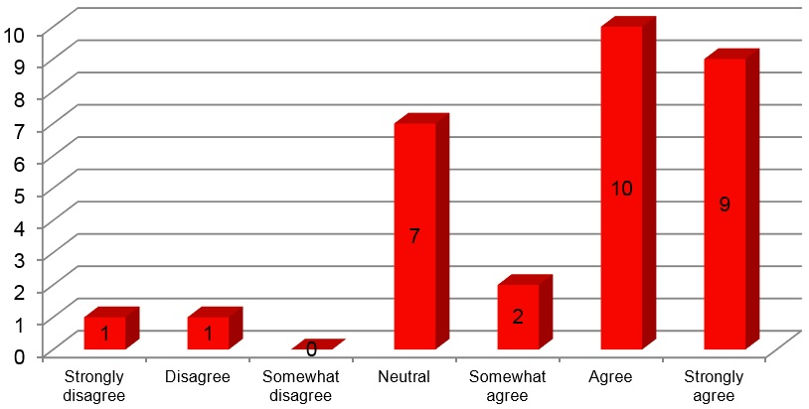

Figure 1: Q.1. I want to go to university after I finish school
- Prior to completing the Kids In2Uni program 70% of students agreed that they wanted to go to university after completing school.

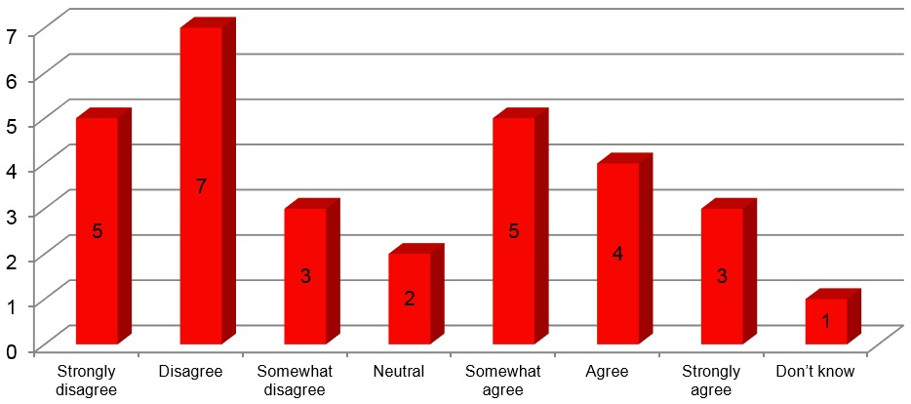
Figure 2: Q.2. I know what the university experience would be like
- Before participating in Kids In2Uni 50% of students disagreed that they know what the university experience would be like.

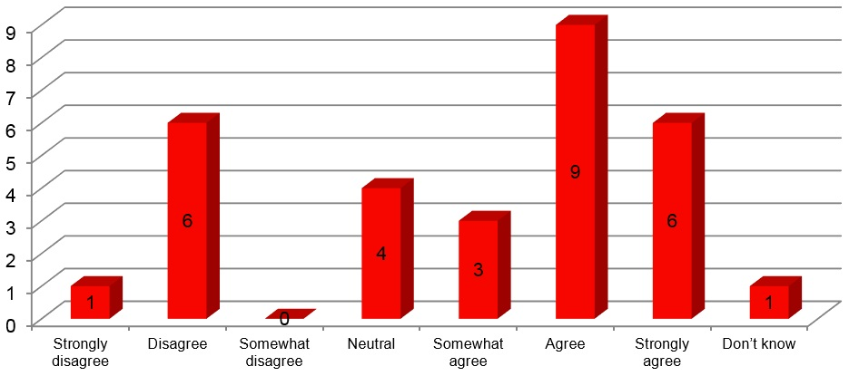

Figure 3: Q.3. I know that there are different ways to get into university
- Prior to the Kids In2Uni event 60% of students agreed that they knew of different pathways for getting into university.
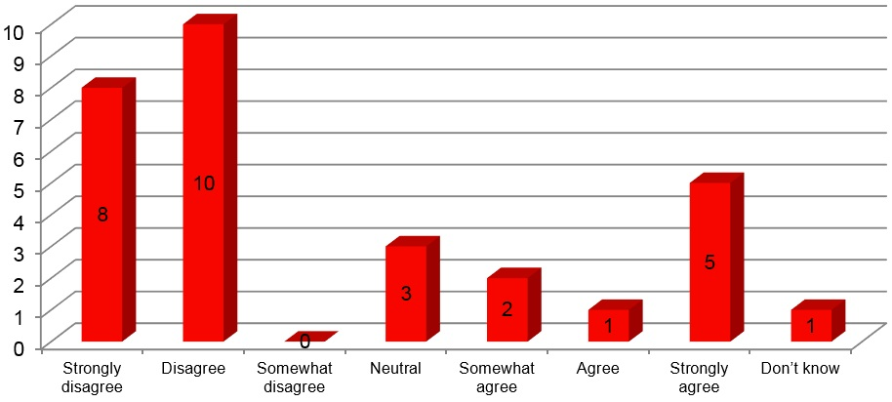

Figure 4: Q.4. There are things that would stop me going to university
- 26.67% of student agree that there are barriers preventing them from going to university before partaking in the Kids In2Uni event.

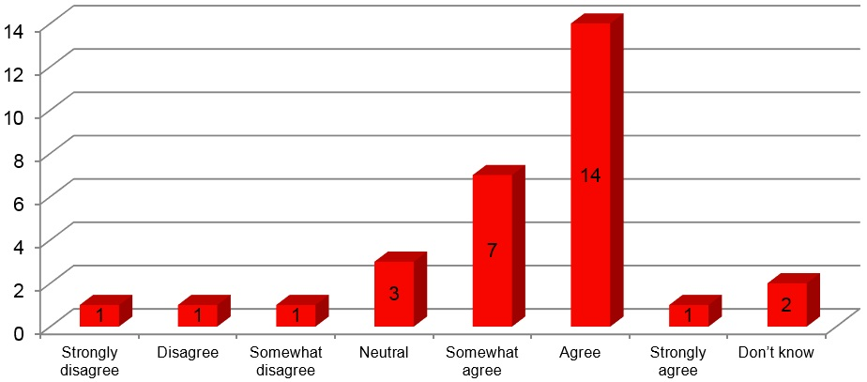

Figure 5: Q.5. I think I will do well enough at school to go to university
- 73.33% of students believe that they will do well enough at school to go to university.
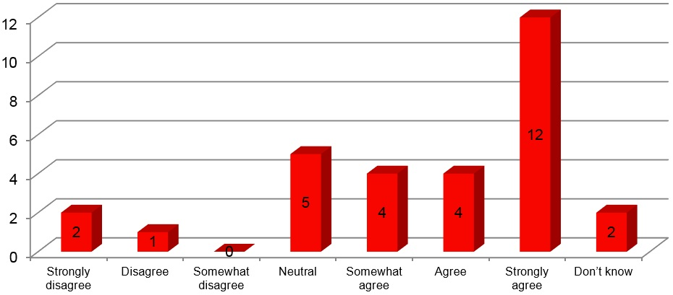

Figure 6: Q.6. I know what I need to do to get the job that I want when I finish school
- Prior to completing the Kids In2Uni program, 66.66% of students knew what they needed to do to get their desired job when they finish school.

Participant Demographics

Post-Survey Participant Numbers

Table 2: Post-survey participant numbers
School | Students | Parents | Teachers
Mallacoota P-12 College | 7 | 0 | 1
Braidwood Central School | 29 | 0 | 2
Total | 36 | 0 | 3

Post-Survey Participant Data
The following student demographics were collected via the post-event survey on-campus.
Results from the quantitative data are as per below:
- 15 (41.67%) of students identified as male
- 21 (58.33%) of students identified as female
- 9 (25%) of students identified as Aboriginal or Torres Strait Islander
- 17 (47.22%) of students identified as First in Family (did not have family members who attended university)
- 2 (5.56%) of students did not respond

Quantitative Data

Summary of Post-Survey Quantitative Questions

Students were asked to complete a post- program hard copy survey. All 36 attendees completed the survey.
A summary of students responses to post-survey questions are provided below:

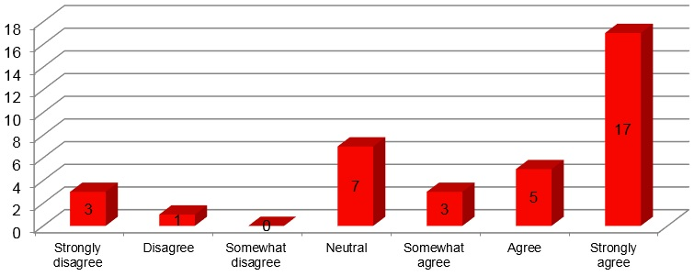

Figure 7: Q.1. I want to go to university after I finish school
- 69.44% of students agreed that they want to go to university after finishing school.

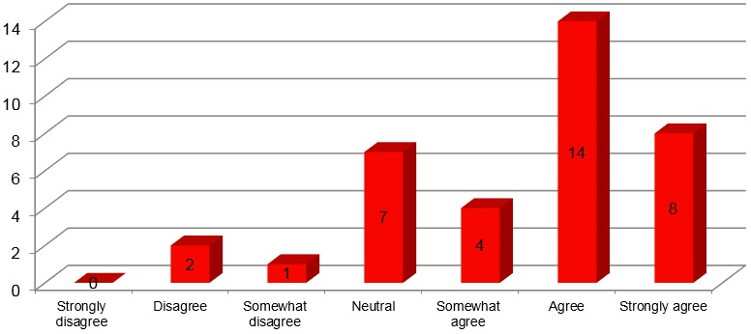

Figure 8: Q.2. I know what the university experience would be like
- 72.22% of students agreed that they know what the university experience would be like after participating in the Kids In2Uni on-campus days. This figure has increased by 22.22% from the same pre-survey question, indicating a positive impact on student awareness of university.
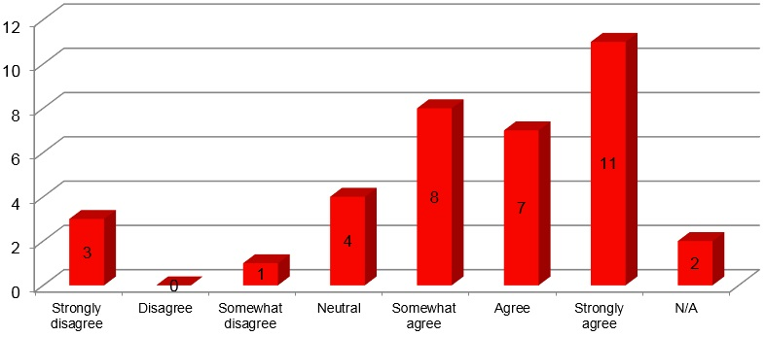

Figure 9: Q.3. I know that there are different ways to get into university
- 72.22% of students agreed that as a result of the Kids In2Uni program they were more aware of options for entering university. This is an increase of 12.22% from the same pre-survey question and indicates an increased awareness of the various pathways into university.

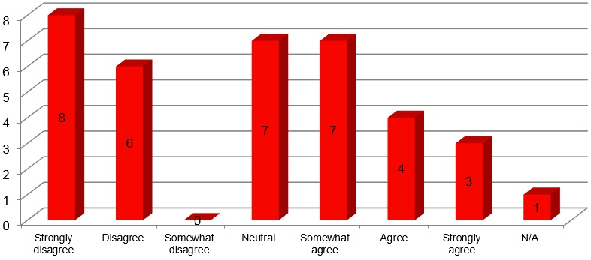

Figure 10: Q.4. There are things that would stop me going to university
- After attending this program, 38.88% of students agreed that they are aware of the things that would stop them from going to university. This figure indicates students’ awareness of the barriers to participating in higher education and how to overcome them, therefore positively impacting student perceptions surrounding attainment of higher education in their future.
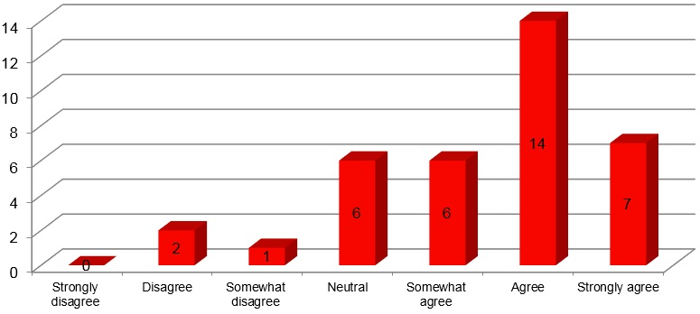

Figure 11: Q.5. I think I will do well enough at school to go to university
- After attending this program, 75% of students agree that they think they will do well enough at school to go to university. This is a slight increase of 1.67% compared to the 73.33% of students who agreed to the same pre-survey question.

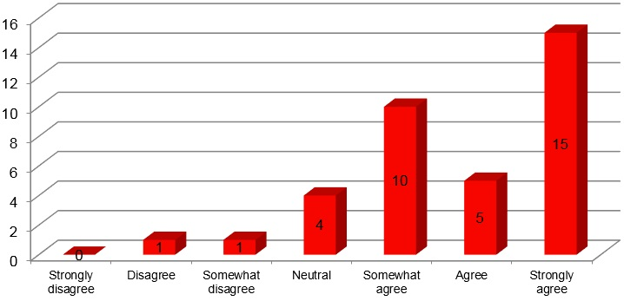

Figure 12: Q.6. I know what I need to do to get the job that I want when I finish school
- After attending the Kids In2Uni event, 83.34% of students agree that they know what they need to do to get the job they want after finishing school. This result is an increase of 16.68% compared to the same pre-survey question where 66.66% of students were aware of what was required to obtain their career goal. This increase offers an insight into the ability of the Kids In2Uni program to not only support student aspirations for higher education and employment but also the programs ability to increase levels of awareness surrounding career expectations and pathways to achieving career goals.
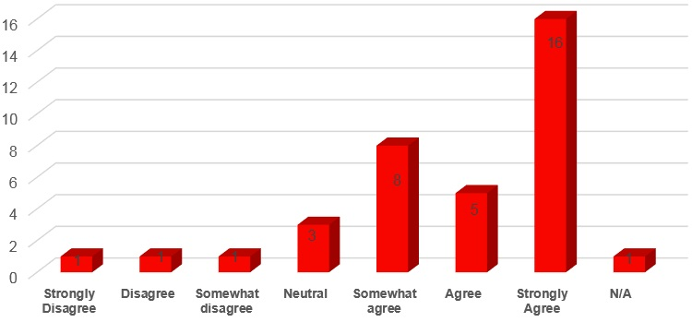

Figure 13: Q.7. I am comfortable talking to my mentor
- 80.55% of students agreed that they were comfortable talking to their mentor at the Kids In2Uni event

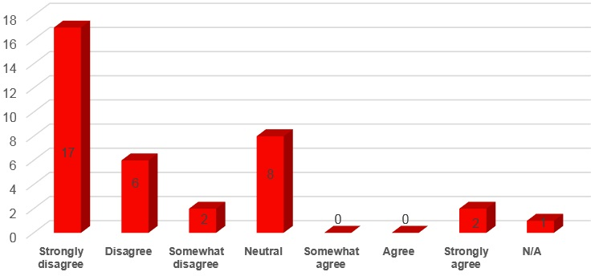

Figure 14: Q.8. The In2Uni program was not useful in talking about my career goals
- Only 5.56% of students agree that the Kids In2Uni program was not useful in talking about their career goals.
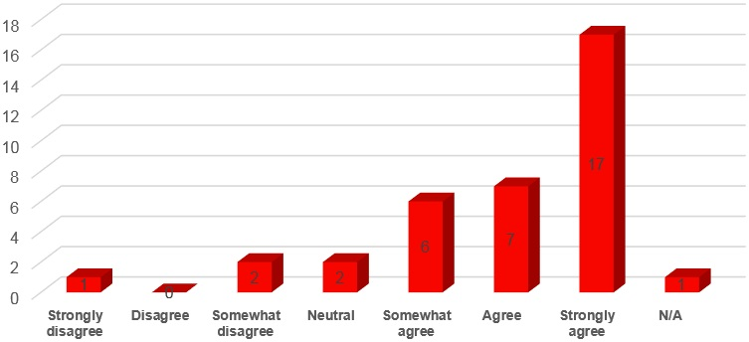

Figure 15: Q.9. I learnt something in the program that I didn’t know before
- After attending the Kids In2Uni event, 83.33% of students agreed that they learnt something that they didn’t know previously.

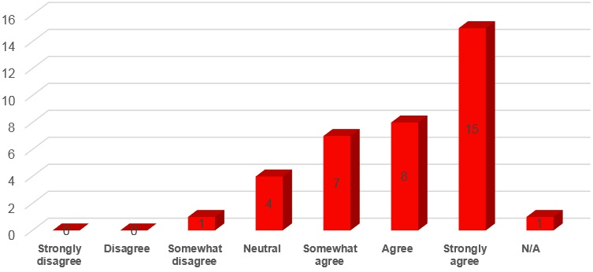

Figure 16: Q.10. I found the program beneficial
- 83.33% of students found the Kids In2Uni program to be beneficial to future career planning.
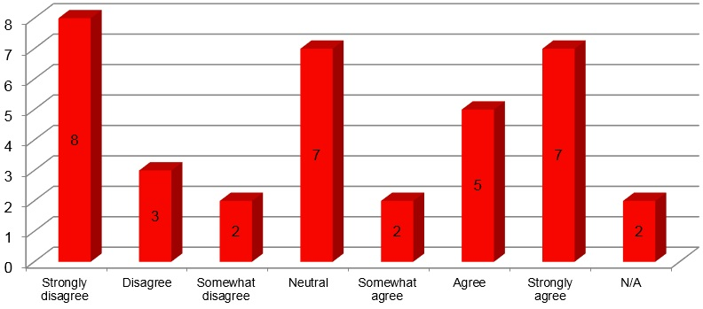

Figure 17: Q.11. I have spoken to my parent/caregiver about university since attending the program
- 38.89% of students indicated that they have spoken to their parent/caregiver about university since attending the program. This question was asked prior to students returning home and increased parent-student engagement is predicted as a result of student attendance at the on-campus days.

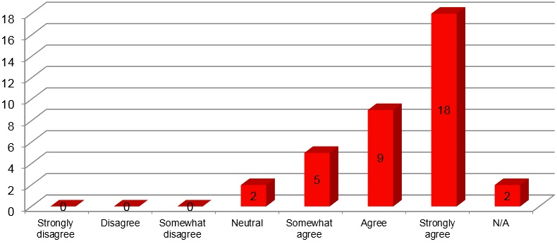

Figure 18: Q.12. I enjoyed the program
- 80.56% of students agreed that they enjoyed the Kids In2Uni program.
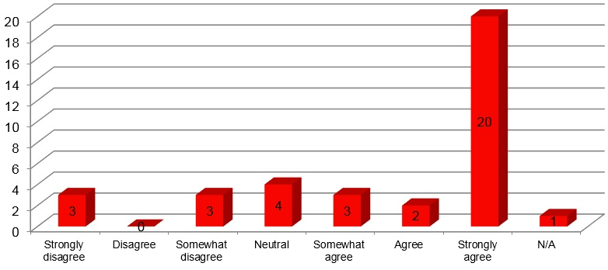

Figure 19: Q.13. I look forward to attending future In2Uni Programs

- After attending the event, 69.45% of students agreed that they look forward to attending future In2Uni programs.

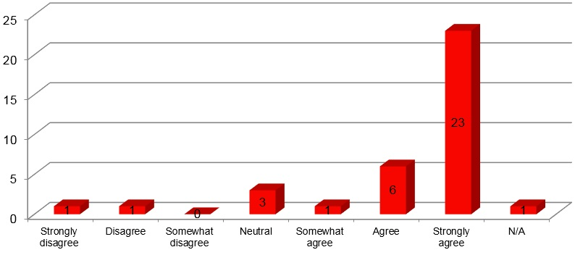

Figure 20: Q.14. I understand that education is important

- The post-event survey revealed that 83.34% of participating students agreed that education is important.
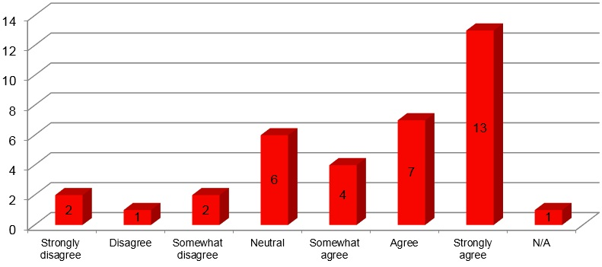

Figure 21: Q.15. I feel comfortable on the University of Wollongong campus

- 66.66% of students agreed that they feel comfortable attending the University of Wollongong’s Campus (Batemans Bay and Bega).

Qualitative Feedback

Summary of Post-Survey Qualitative Questions
A summary of student responses and key quotes included in post-survey qualitative questions are provided below:
- What was your favourite part of the program?
- “Learning different things and having fun” (Student, 2017)
- “Everything” (Student, 2017)
- “All of it – it was awesome!” (Student, 2017)
- Faculty Taster Sessions (Business, Humanities, Health, PDHPE, Engineering, Exercise Science)
- “The craft because I have strong feelings about art” (Student, 2017)
- “My favourite part of the day was learning how to be a nurse, I really liked all the different activities that we participated in” (Student, 2017)
- “The Nursing part because my dream job is to be a doctor” (Student, 2017)
- “I loved the Nursing programme. My mum is a nurse and I liked seeing things she does at work” (Student, 2017)
- “I want to be a Nurse, Paramedic or a Midwife – so I enjoyed the Nursing one” (Student, 2017)
- “Nursing because you learn heaps out of it” (Student, 2017)
- Do you think there are any improvements that need to be made to the program? If yes, what are these improvements?
- “No, not really – this place is amazing” (Student, 2017)
- “No, it’s amazing!” (Student, 2017)
- “No not really, because I love everything” (Student, 2017)
- “No I think everything is great” (Student, 2017)
- “No, everything was perfect” (Student, 2017)
- “It was brilliant” (Student, 2017)
- “No, I tried my best” (Student, 2017)
- “No, I think it’s perfect just like it is” (Student, 2017)
- “It’s perfect” (Student, 2017)
- “..Maybe more courses to do” (Student, 2017)
- “The physical activities” (Student, 2017)
- “Less lunch time” (Student, 2017)
- “In some activities people need to speak louder and clearer otherwise it was awesome” (Student, 2017)
- Please provide any other comments and feedback you have about the program
- “It was very useful and it was awesome!” (Student, 2017)
- “Legendary!” (Student, 2017)
- “Amazing and hopefully I get to come back” (Student, 2017)
- “I had a lot of fun and can’t wait to start uni” (Student, 2017)
- “It was really fun and I enjoyed it. I can’t wait to go to uni or come back to an In2Uni day” (Student, 2017)
- “I really want to go to uni, so I really enjoyed today” (Student, 2017)
- “It was amazing” (Student, 2017)
- “It was amazing and the people that go here are lucky” (Student, 2017)
- “I had a great day and a really good experience in the taster” (Student, 2017)

Evaluation: Teacher Feedback

Teacher Demographics
The following demographics were collected as part of the post-program survey:
- 3 teachers were present across Bega and Batemans Bay’s Future Finder Day
- 1 (33.33%) of teachers identified as being from Mallacoota P-12 College
- 2 (66.67%) of teachers identified as being from Braidwood Central School
- 3 (100%) of teachers identified as female

Qualitative Feedback

Teacher Qualitative Feedback
A summary of teacher responses and key quotes included in post-survey qualitative questions are provided below:
Q.1 What was the most beneficial part of the day?
- “Hands-on activities” (Teacher, 2017)
- “Nursing” (Teacher, 2017)
- “Nursing” (Teacher, 2017)
Q.2. Why was it the most beneficial activity?
- “Students were engaged” (Teacher, 2017)
- “Engaging and hands on activities –realistic” (Teacher, 2017)
- “Because the theme was lots of hands on activities for the kids to engage in. More realistic representation of university” (Teacher, 2017)
Q.3. Are there any improvements for next time?
- No suggestions for improvement were made.

Quantitative Data
The following student demographics were collected via the post-event survey on-campus.
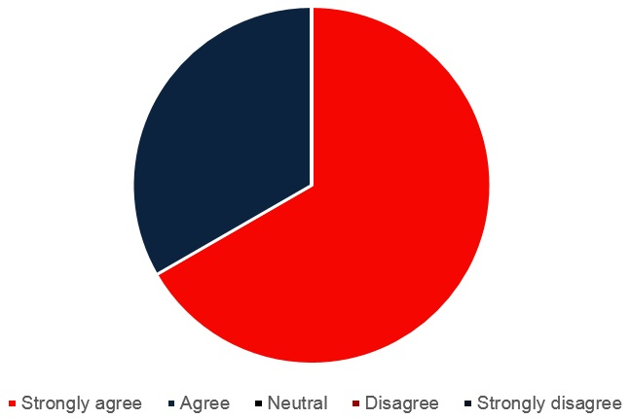

Figure 22: Q.1. This university visit has encouraged me to further discuss career options with my students

- After attending the Kids In2Uni Day 66.67% of teachers strongly agreed and 33.33% of teachers agreed that the visit has encouraged them to further discuss career options with their students.
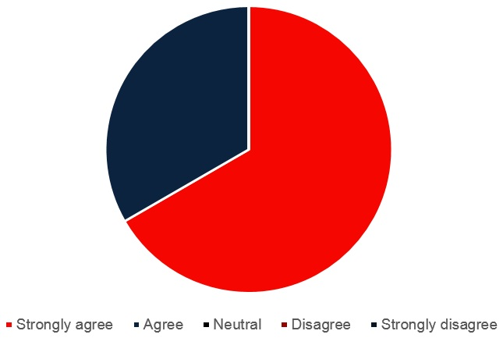

Figure 23: Q.2. This university visit has helped familiarise students with the university
- After attending the Kids In2Uni Day 66.67% of teachers strongly agreed and 33.33% of teachers agreed that the university visit has helped familiarise students with the university
Q.3. This university visit has the potential to encourage students to consider university
- 100% of teachers strongly agreed that the university visit has the potential to encourage students to consider university.
Q.4. Participating in the In2Uni Program has provided students with positive role models
- 100% of teachers strongly agreed that participating in the In2Uni program has provided students with positive role models.
Q.5. The communication from the In2Uni Program staff was clear and concise
- 100% of teachers strongly agreed that the communication they received from In2Uni Program Staff was clear and concise.
Q.6. The activities were pitched at an appropriate age level
- 100% of teachers agree that the Kids In2Uni activities were pitched at an appropriate age level.
Q.7. My students were engaged in the activities
- 100% of teachers strongly agreed that their students were engaged in the event activities.
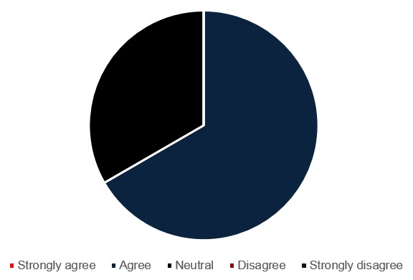

Figure 24: Q.8. The information regarding logistics was adequate

- 66.67% of teachers agreed and 33.33% of teachers remained neutral when answering whether the information regarding logistics was adequate.

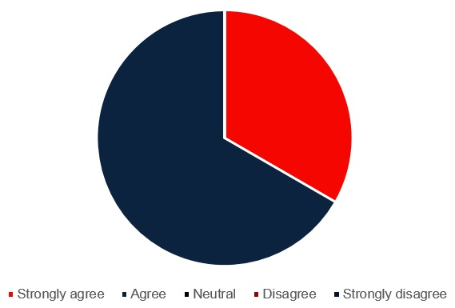

Figure 25: Q.9. The students’ perceptions of university were changed in a positive way

- 66.67% of teachers agreed and 33.33% of teachers strongly agreed that after attending the Kids In2Uni Program, student perceptions of university were changed in a positive way.
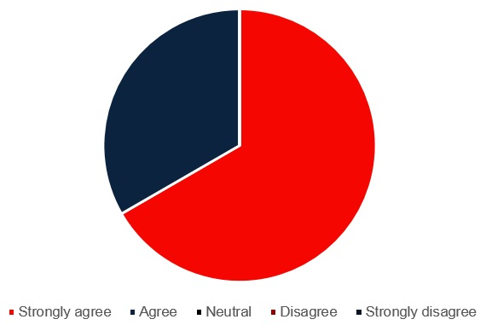

Figure 26: Q.10. The ‘taster sessions’ were engaging for the students

- After attending the taster sessions, 66.67% of teachers strongly agreed and 33.33% of teachers agreed that the taster sessions were engaging for students.
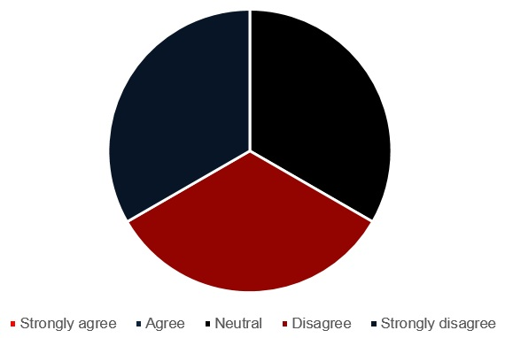

Figure 27: Q.11. The activities that allowed students to explore the campus were not useful

- 33.33% of teachers strongly disagreed, 33.33% of teachers disagreed and 33.33% of teachers remained neutral when answering whether the activities that allowed the students to explore the campus were not useful.
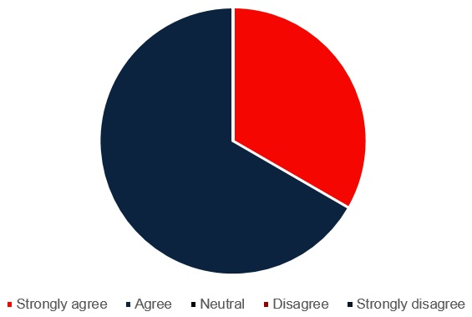

Figure 28: Q.12. This visit has allowed students to imagine themselves at university

- 66.67 of teachers agreed and 33.33% of teachers strongly agreed that the Kids In2Uni on-campus event allowed students to imagine themselves at university.

Recommendations
The following recommendations are suggested following a review of the program and event, in conjunction with In2Uni program staff:

Pre-Event
- Encourage mentors to share personal stories during in-school sessions
- Confirm Teacher contact details and total class numbers during Term 3 (phone call most effective)

Event
- Students wanted less lunch time
- More hands-on taster sessions
- More course options
- Mentors and teachers to speak louder/clearer in taster sessions
- Teachers reported learning more about their students, their family’s educational background and their attitudes about further education and as a result the program development will focus on an increased amount of these sharing activities.
- Increased information about Campus logistics required
- Some taster sessions not geared towards younger students - – delivery style deeply affected student engagement

For Schools:
- Upon initial registration encourage contact/s to notify In2Uni with any change in contact details

For Mentors:
- Provide campus tour prior to event day to establish location of delivery rooms, disabled access points and proximal toilets
- Encourage mentors to share their own stories with event school group
- Continue with briefing session prior to event to ensure all mentors are across delivery

2017 Rural In2Uni Year 7 & 8 Mini Bootcamp: Findings and Evaluation

Program Overview
The Rural In2Uni Year 7 & 8 Mini-Boot camps engage Year 7 and 8 students, their parents and teachers in a three hour workshop. The workshop covers topics such as the concept of a progression journey, an introduction to higher education, introducing the language of higher education and recognising the links between their own curriculum and study at a higher education level that will lead to potential careers. The workshops culminate in students developing short term and long term goals for the academic study.

Objectives
The objectives of the Rural In2Uni Year 7 & 8 Rural Mini Bootcamp are to:
- Understand the concept of a progression journey;
- Be introduced to the concept of higher education and raise aspirations and motivation towards post-school options;
- Be introduced to the language of higher education; and
- Recognise the link between own curriculum and study at a higher education level and have an increased interest in continuing to study
The following schools participated in the 2017 Rural In2Uni Year 7/8 Mini Bootcamp:
- Bombala High School
- Braidwood Central School
- Mallacoota P-12 College

Participation by Region

Table 3: Participation by region
School Name | Participating Students
Bombala High School | 20 (Year 7)
Braidwood Central School | 24
Mallacoota P12 College | 24 (Year 7 & 8)
Total | 68

Participant Demographics
The following demographics were collected as part of the post-program survey
- 32 (47.06%) students identified as Male
- 32 (47.06%) students identified as Female
- 4 (5.88%) students identified as other
- 16 (23.53%) students identified as first in family (did not have family members who attended university)
- 4 (5.88%) of students did not identify or were unsure about first in family status.
- 16 (23.59%) students identified as Aboriginal or Torres Strait Islander
- 2 (2.94%) students did not identify

Evaluation

Quantitative Data

Student Responses to Post-Survey Questions
The graphs and information below reflect data captured in the post survey.

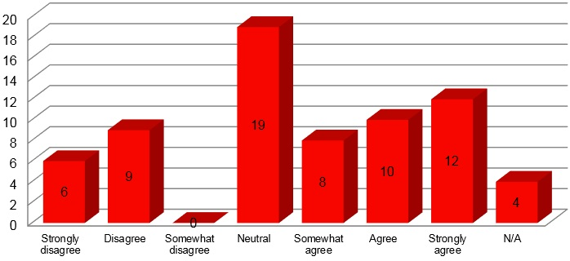

Figure 29: Q.1. After attending this program, I feel confident that I want to attend
university after I finish school

- 44.12% of students agreed that after completing this program they feel confident that they want to attend university, while 27.94 % of students remained neutral on this question.
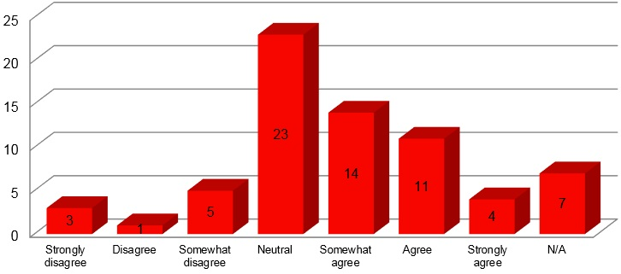

Figure 30: Q.2. After attending this program, I have a better sense of what the university experience would be like (e.g. finance, lectures, tutorials, time commitment)

- 42.65% of students agreed that after attending the program they have a better sense of what the university experience would be like.

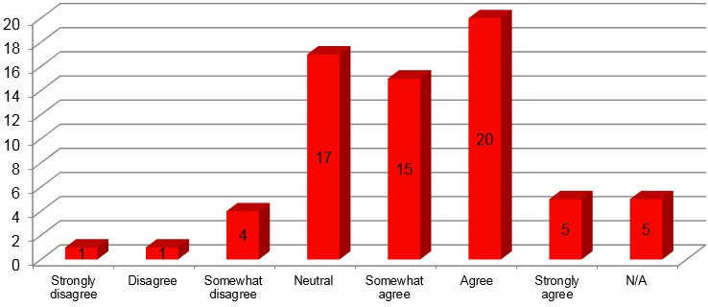

Figure 31: Q.3. I know there is more than one way to get into university as a result of this program.

- After attending this program, 58.82% of students agreed that they know of more than one way to get into university. This figure reflects the positive impact that the Mini Bootcamp has in raising students’ awareness towards the multiple pathways that lead to higher education participation.
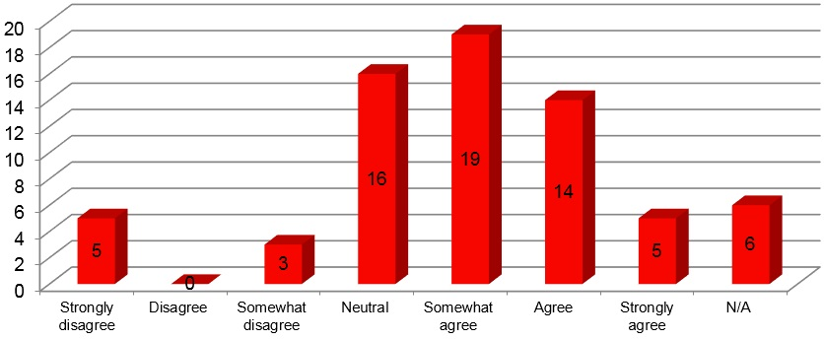

Figure 32: Q.4. I feel more confident that I can overcome any barriers of going to university
after attending this program.

- After attending the Mini Bootcamp sessions, 55.88% of students agreed that they feel more confident in overcoming barriers that prevent them from participating in higher education. This result indicates the positive influence such programs have on building student aspirations towards higher education by increasing an awareness of how to overcome the obstacles that prevent university participation.

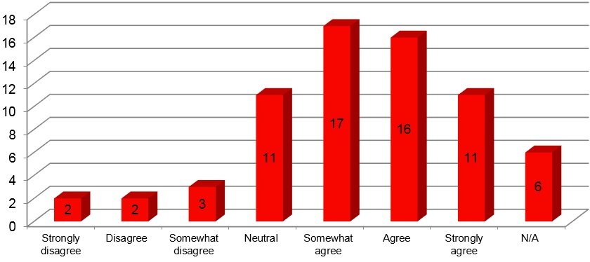

Figure 33: Q.5. I am familiar with the steps I need to take to achieve my career goals

- After attending the Mini Bootcamp session, 64.71% of students agreed that they are familiar with the steps they need to take to achieve their career goals, indicating that the content in the program assists with career pathway planning for students.
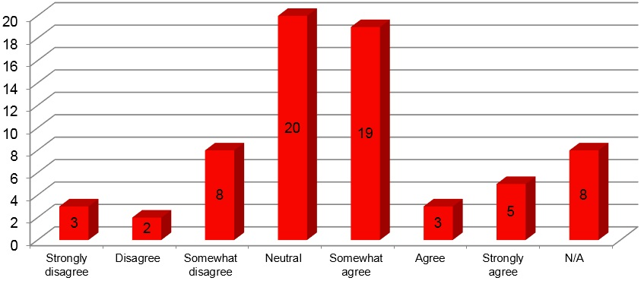

Figure 34: Q.6. I am comfortable talking to my In2Uni Mentor

- 39.7% of students agreed that they are comfortable talking to their In2Uni Mentor, while 32.35% of students remained neutral on this question.

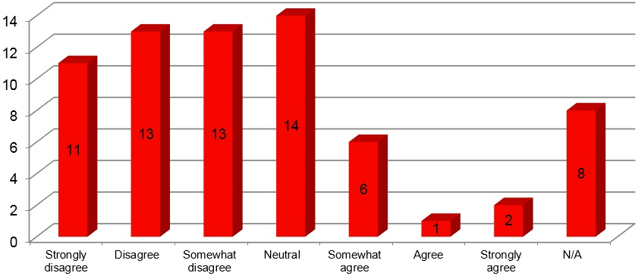

Figure 35: Q.7. The In2Uni program was not useful in talking about my career goals

- 54.42% of students disagreed that the In2Uni program was not useful in talking about their career goals, indicating that the program did support the aspirations, awareness and attainment towards higher education for more than half of the participating student body.
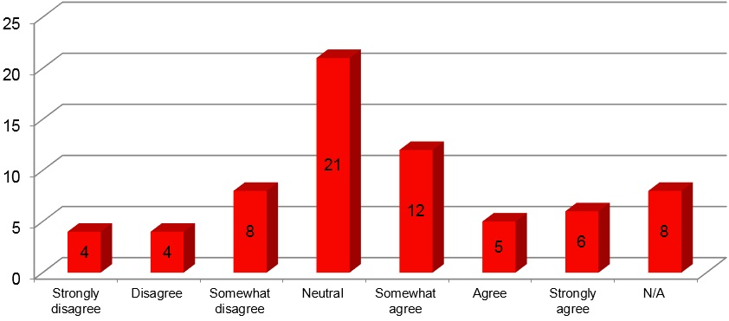

Figure 36: Q.8. The program introduced me to the language of higher education

- 33.82% of students agreed that the program introduced them to the language of higher education, while 30.88% students remained neutral on this question.

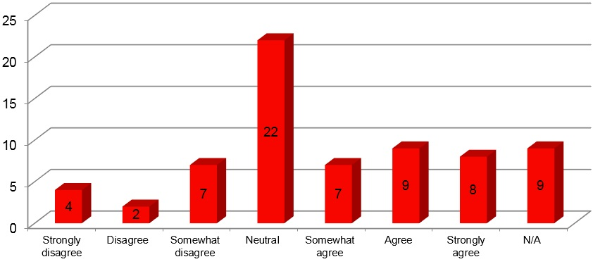

Figure 37: Q.10. I recognise the links between my school curriculum, higher education and my career

- 33.83% of students agreed that they recognise the links between their school education, university participation and career, while 35.29% students remained neutral on this question.
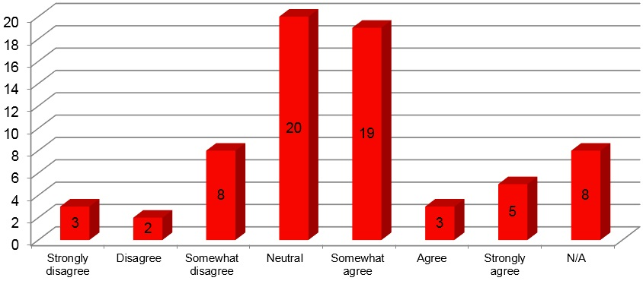

Figure 38: Q.11. I have developed short and long term goals for my future as a result of
participating in the Mini Bootcamp

- 39.7% of students agreed that they have developed short and long term goals for their future as a result of participating in the Mini Bootcamp, while 29.41% students remained neutral on this question.

Table 4: Q.12. Where do you imagine yourself studying in the future?
Variables | Number | Percentage
1. Regional (like) | 10 | 15%
2. Urban (Like) | 2 | 3%
3. Regional (Expect) | 1 | 1.5%
4. Regional (Like and Expect) | 9 | 13%
5. Urban (Like and Expect) | 17 | 25%
6. Regional and urban (like) | 2 | 3%
7. Regional (like) urban (expect) | 4 | 6%
8. Regional and Urban (like) Urban (expect) | 1 | 1.5%
9. Regional (like) urban (expect) | 4 | 6%
10. No response | 18 | 26%
Total | 68 | 100%

- The previous table reveals that a regional environment is the most popular choice for students to imagine themselves studying in the future. This is evident by a total of 29.5% of students selecting a regional environment as a place that they would either ‘like’, ‘expect’ or ‘like and expect’ to study in. This outcome contrasts to the results of the same question asked of senior students participating in In2Uni programs, where an urban environment was recorded as the most popular response and therefore reflects the perceptions of students in the early stages of career planning.

Table 5: Q.13. Where do you imagine yourself working in the future?
Variables | Number | Percentage
Regional (like) | 8 | 12%
Regional (Expect) | 1 | 1.5%
Urban (Expect) | 1 | 1.5%
Regional (Like and Expect) | 10 | 15%
Urban (Like and Expect) | 14 | 21%
Regional and urban (like) | 1 | 1.5%
Urban (like) regional (expect) | 2 | 3%
Regional and Urban (like and expect) | 7 | 10%
Regional and Urban (like) Urban (expect) | 1 | 1.5%
Regional (like) urban (expect) | 3 | 4%
No response | 20 | 29%
Total | 68 | 100%

- The above table reveals that a regional environment is the most popular choice for students to imagine themselves working in the future. This is evident by a total of 28.5% of students selecting a regional environment as a place that they would either ‘like’, ‘expect’ or ‘like and expect’ to work in. This outcome contrasts to the results of the same question asked of senior students participating in In2Uni programs, where an urban environment was recorded as the most popular response and reflects the perceptions of students in the early stages of career planning.

Qualitative Feedback
A summary of student responses and key quotes included in post-survey qualitative questions are provided below:
Q.1. What was your favourite part of the program?
- “Talking about my future” (Student, 2017)
- “Listening to the In2Uni mentors talk about uni” (Student, 2017)
- “It’s fun with the uni, their really good” (Student, 2017)
- “Discovering ways to get to where I want to be” (Student, 2017)
- “The painting a pathway to my dream career” (Student, 2017)
- “Writing out the attributes needed for a particular job”(Student, 2017)
- “Learning about the steps to achieving my goal” (Student, 2017)
- “The career plan” (Student, 2017)
- “Everything” (Student, 2017)
- “The fact that we weren’t expected to know what we wanted to do after school” (Student, 2017)
Q.2. Do you think there are any improvements that need to be made to the program? If yes, what are these improvements?
- “Talk about a wider variety of jobs” (Student, 2017)
- “…More about the resources and scholarships” (Student, 2017)
- “More practical” (Student, 2017)
- “What you actually do in uni” (Student, 2017)
- “A bit more engaging” (Student, 2017)
- “More information” (Student, 2017)
Q.3. Please provide any other comments and feedback you have about the program
- “Really good” (Student, 2017)
- “It was good to get an understanding of university degrees and personal attributes that are needed” (Student, 2017)
- “It was very fun” (Student, 2017)
- “Good job” (Student, 2017)

Evaluation

Parent Responses to Post Survey Questions

Participant Demographics
- 2 (100%) parents identified as female
- 2 (100%) parents identified as non-first in family (did not have family members who had attended university)

Qualitative Data
A summary of parent responses and key quotes included in post-survey qualitative questions are provided below:
Q.1. What was the most beneficial activity that you/your child participated in?
- Worksheet
- Worksheet
Q.2. Why was it the most beneficial activity?
- Only one
- Clarified post school focus + opportunities
Q.3. Are there any improvements that you think need to be made for next time?
- NA
- Joint parent-student session
Q.4. Attending this program was enjoyable
- 100% of parents strongly agreed that the In2Uni program was enjoyable.
Q.5. Talking to university staff has increased my understanding about university studies
- After talking to university staff, 100 % of parents strongly agreed that their understanding about university studies had increased.
Q.6. My child’s perceptions of university were changed in a positive way following the program
- After attending the program, 50% of parents agreed and 50% of parents strongly agreed that their child’s perceptions of university were changed in a positive manner.
Q.7. I don’t feel comfortable undertaking further workshops with the university
- After attending the program 50% of parents strongly disagreed and 50% of parents strongly agreed (potential survey response mistake) that they didn’t feel comfortable in undertaking further workshops with the university.

Evaluation

What Worked Well?
- Expansion of program to entire cohort and year groups, rather than single classes
- General content of program with focus on more generalised skills, subject and career information than subject specific information was well received by teaching staff
- Inclusion of the following points in presentation:
  - Concept of a progression journey
  - Intro to higher education and Australian education levels
  - Continuation of language of higher education
  - Linking curriculum content, higher education study options and potential careers
  - Development of short and long term study goals and development of a career pathway plan
- Initial stage career planning with students
- Activities run within the program worked well
- 1 hour delivery timeframe was successful for student engagement levels

What Didn’t Work So Well?
- Engagement of parents attending the workshop proved difficult (despite different times and engagement methods across schools) only 1 school had parent representatives attend

Recommendations for 2018
- Timing of the program – could be moved to earlier term in school year
- Revise parent session component. Instead of parent workshop consider presenting a similar session at high school transition nights (subject selection)
- Development of a resource that can be sent out to parents for review

2017 Rural In2Uni Future Finder Day: Findings and Evaluation

Program Overview

Background
The Rural In2Uni Future Finder Day is an opportunity for students to find out what university study is really like. This day is held prior to the student’s subject selection decisions, to help better inform students during this process. Students have the opportunity to undertake activities in the faculties of their choice, explore the University's facilities, participate in goal setting activities for their senior studies and build their pathway to higher education.

Objectives
During this program students will gain an understanding of the different types of courses, institutions and progression routes, as well as an understanding of preferred learning styles and the improvement of skills to raise attainment (study, revision and exam skills etc.), the ability to make information decisions about the future, the development of a positive learner identity and prepare for transition into senior studies and higher education.
Students will have the opportunity to speak in small groups with University mentors to build a career planner and discuss their subject selection, and how they can maximise their opportunities after school.

Student Engagement

Participating Schools
The following schools participated in the 2017 Rural In2Uni Future Finder Program:
- Bombala High School
- Braidwood Central School
- Cann River P-12 College
- Mallacoota P-12 College

Participation by Region

Table 6: Participation by region
School Name | Participating Students
Bombala High School | 8
Braidwood Central School | 25
Cann River P12 College | 2
Mallacoota P12 College | 16
Total | 51

Participant Demographics
The following demographics were collected as part of the post-program survey
- 51 students participated in the Future Finder event at Batemans Bay and Bega Campuses
- 26 (50.98%) students identified as male
- 23 (45.10%) students identified as female
- 2 (3.92%) students identified as other
- 18 (35.29%) students identified as first in family (did not have family members who had attended university)
- 4 (7.84%) self-identified as Aboriginal or Torres Strait Islander

Evaluation

Quantitative Data

Post-Survey Results

Students were asked to complete a post- program hard copy survey. All 51 attendees completed the survey.
A summary of students responses to post-survey questions are provided below:

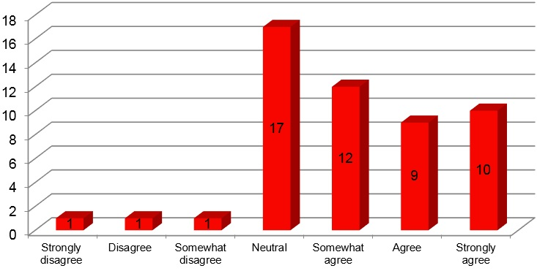

Figure 39: Q.1. After attending this program, I feel confident that I want to attend
university after I finish school

- After attending the Future Finder Day 62.79% of students agreed that they feel confident that they want to attend university after completing school, indicating a positive outcome for the Future Finder Day supporting student aspirations towards and attainment of higher education.
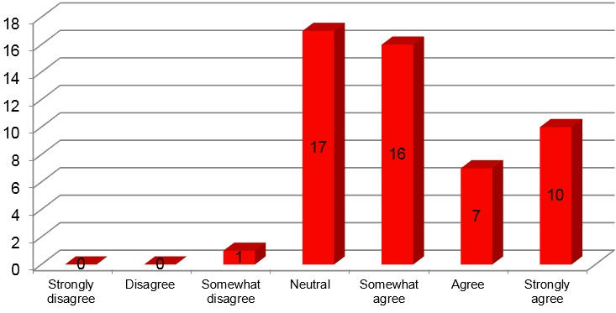

Figure 40: Q.2. After attending this program, I have a better sense of what the university experience would be like (e.g. finance, lectures, tutorials, time commitment)

- 64.71% of students agreed that participating in the Future Finder Day has increased their level of awareness about what the university experience would be like.

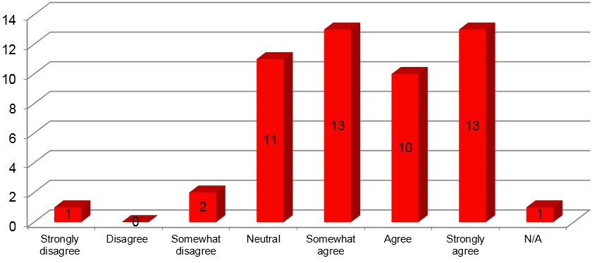

Figure 41: Q.3. I know there is more than one way to get into university as a result of this program.

- After participating in the Future Finder Day, 70.59% of students agree that they are aware of the ways to get into university, allowing the Future Finder Day to positively influence student awareness surrounding pathways to higher education.
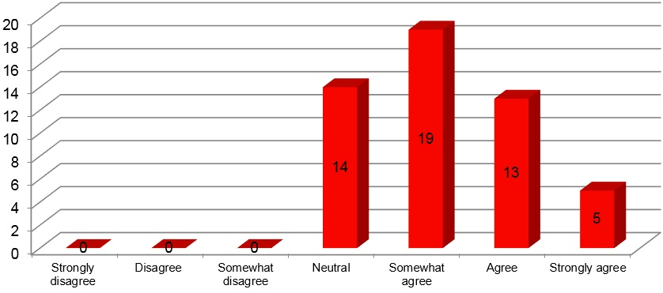

Figure 42: Q.4. I feel more confident that I can overcome any barriers of going to university
after attending this program.

- 72.54% of students agreed that they felt more confident in overcoming barriers to higher education after attending the Future Finder Day, a reflection of the positive influence the event has on supporting student aspirations towards higher education.

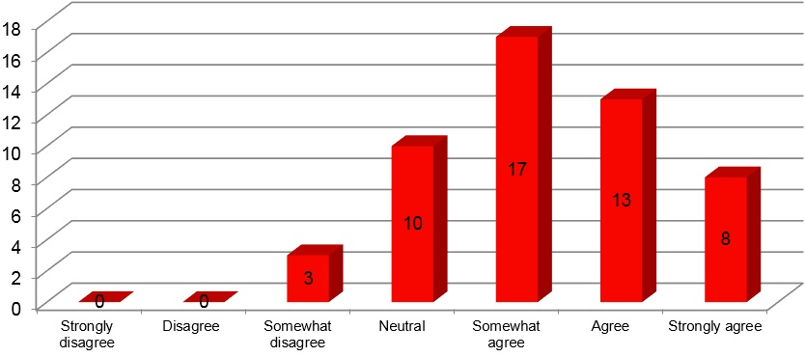

Figure 43: Q.5. I am familiar with the steps I need to take to achieve my career goals

- 74.51% of students agree that they are familiar with the steps they need to take to achieve their career goals. This figure indicates the positive impact the Future Finder event has on increasing students’ awareness towards higher education and employment opportunities and the resources required to achieve these.
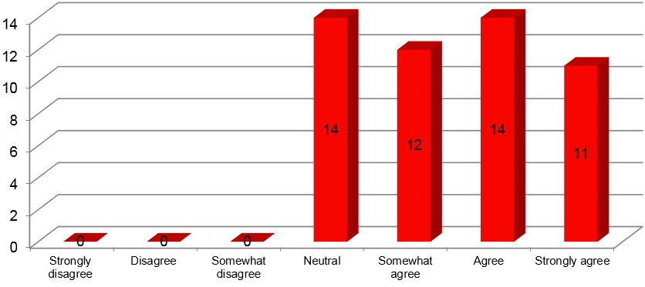

Figure 44: Q.6. I am comfortable talking to my In2Uni Mentor

- 72.55 % of students agreed that they are comfortable talking to their In2Uni mentor. This figure gives an insight into the success of utilising university students as approachable individuals who successfully support and foster the career development of high school students.

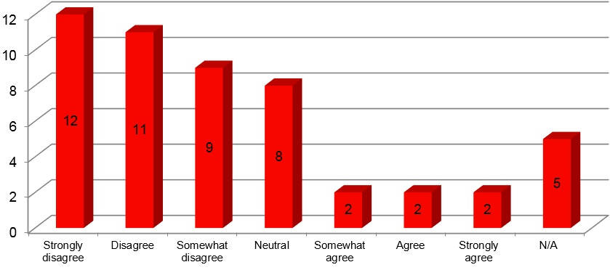

Figure 45: Q.7. The Year 10 Future Finder Days was not useful in talking about my career goals

- 62.75% of students disagreed that the Future Finder Day was not useful in talking about their career goals, indicating that over half thought the event supported the development of their career aspirations, awareness and attainment.
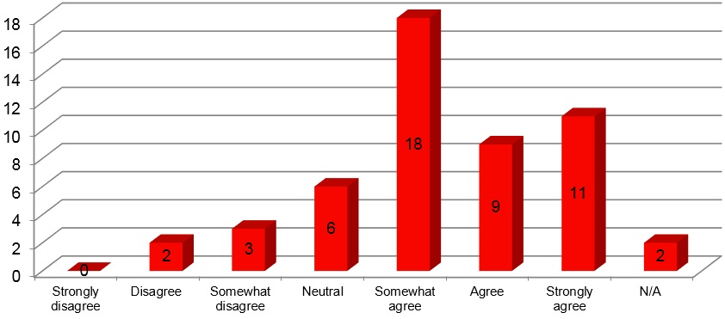

Figure 46: Q.8. I learnt something in the program that I didn’t know before

- 74.51% of students agreed that they learnt something at the Future Finder day that they didn’t know before.

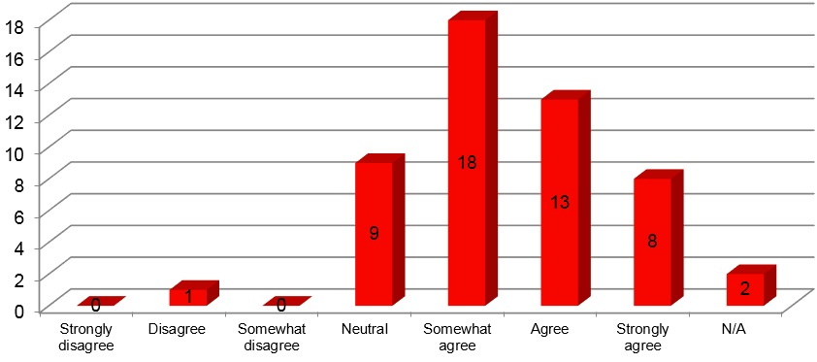

Figure 47: Q.9. I found the program beneficial

- After attending the Future Finder Day, 76.47% of students agreed that they found the program beneficial. This offers an insight into the positive impact that on-campus university experience days have in regards to de-mystifying post-school career and education options.
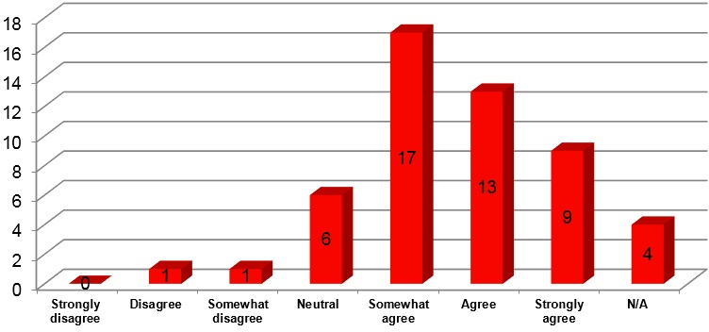

Figure 48: Q.10. I enjoyed the program

- 76.47% of students agreed that they enjoyed participating in the Future Finder Day.

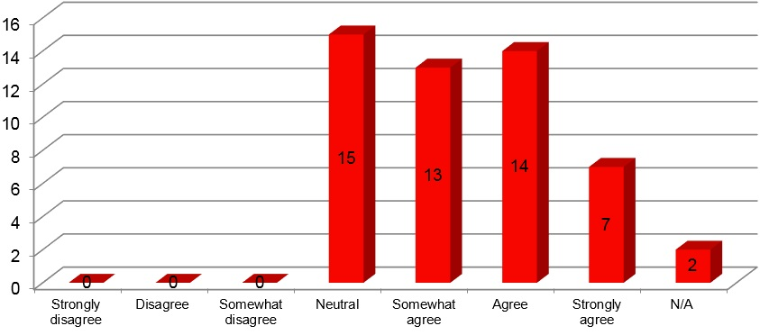

Figure 49: Q.11. After attending this program, I feel comfortable on the University of Wollongong campus

- After attending the Future Finder Day, 66.67% of students agree that they feel comfortable attending the University of Wollongong Campus. This figure indicates the success of on-campus experience days in raising students’ awareness towards what it is like to be a university student and supports students’ motivation towards higher education participation in the future.
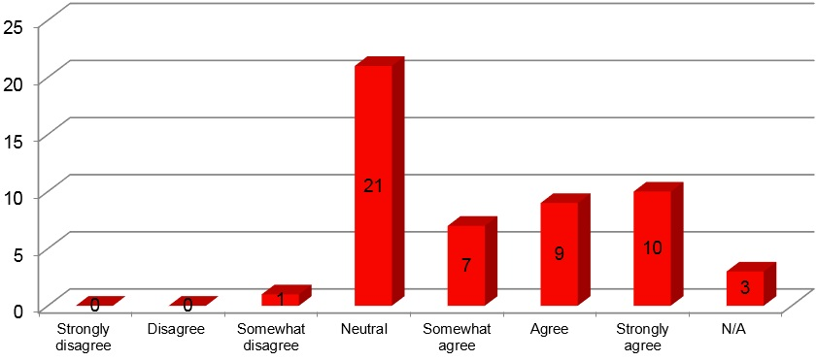

Figure 50: Q.12. I have more confidence making decisions about my senior subject selections,
as a result of the program

- 50.99% of students agreed that they have more confidence making decisions about their senior subject selections as a result of the program (N.B. Year 11 & 12 students who have already made subject selection choices were also included in the survey data).

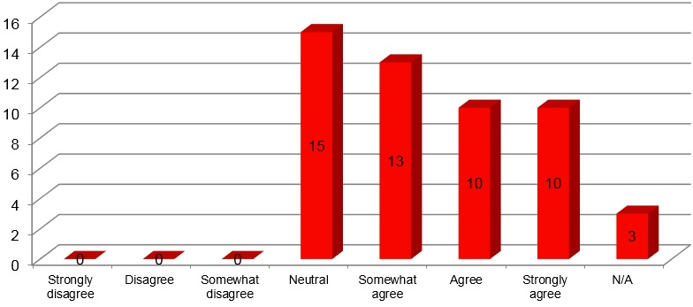

Figure 51: Q.13. I better understand how my subject selections for Year 11 & 12 can influence
my post-school options as a result of In2Uni

- After attending the Future Finder Day, 64.71% of students agreed that they had a better understanding of the relationship between subject selection for Year 11 and 12 and post-school options.

Table 7: Q.14. My first taster session was: ____________
And I found it interesting: ____________
Taster Session | Participants | Number | Percentage
Business | 8 | 3 x agree  2 x strongly agree  2 x neutral  1 x somewhat agree | 37.5%  25%  25%  12.5%
Engineering | 12 | 3 x agree  3 x strongly agree  5 x somewhat agree  1 x NA | 25 %  25 %  42%  8%
Future Finder/Careers | 5 | 3 x neutral  2 x strongly agree | 60%  40%
Nursing/Health | 6 | 1 x agree  1 x strongly agree  3 x neutral  1 x Disagree | 16.7%  16.7 %  50%  16.7%
Teaching | 1 | 1 x somewhat agree | 100%
IT | 3 | 1 x neutral  1 x somewhat disagree  1 x disagree | 33.3%  33.3%  33.3%
Social Science | 6 | 4 x somewhat agree  1 x neutral  1 x strongly agree | 66.7%  16.7%  16.7%
Arts | 1 | 1 x strongly disagree | 100%
No taster name  stipulated | 5 | 2 x agree  2 x neutral  1 x somewhat agree | 40 %  40 %  20 %
NA | 4
Total | 51

The above table reveals that:
- Engineering was the most attended taster session, with 12 participants and 92% of students agreeing that they found it interesting.
- Business was the second highest attendance (8 participants) and 75% of students agree that they found it interesting.
- Nursing and Social Science were the third highest in attendance (6 participants). 33.4% of students found nursing interesting, while 83.4% of students found Social Science to be interesting.
- 5 students recorded attending the Future Finder session and 40% of the student body found the workshop to be interesting/
- 5 students did not identify which taster session they participated in first however, 60% of students agree that it was interesting.
- IT was attended by 3 students in their first taster session and 33.3% of students remained neutral on their level of interest towards the workshop while 66.6% of students disagreed that they found the workshop interesting.
- Arts and Teaching were attended by 1 student each as their first taster session. The student in the teaching session agreed that it was interesting while the student in the Arts workshop disagreed.
- 4 students did not respond to this question.

Table 8: Q.15. My second taster session was: ___________
And I found it interesting: ___________
Taster Session | Participants | Number | Percentage
Engineering | 10 | 1 x neutral  3 x somewhat agree  3 x agree  3 x strongly agree | 10 %  30%  30 %  30 %
Business | 10 | 2 x neutral  3 x somewhat agree  3 x agree  2 x strongly agree | 20%  30%  30%  20%
Nursing/Health | 11 | 4 x neutral  2 x somewhat agree  2 x agree  2 x strongly agree  1 x NA | 36.4%  18.2%  18.2%  18.2 %  9.1%
Future Finder/Careers | 3 | 2 x agree  1 x strongly agree | 66. 7 %  33.4%
Arts | 5 | 1 x disagree  3 x neutral  1 x somewhat agree | 20%  60%  20%
IT | 3 | 2 x agree  1 x strongly agree | 66. 7%  33.4%
No Taster Name  stipulated | 4 | 4 x neutral | 100% neutral
NA | 5
Total | 51

The above table reveals that:
- Nursing/Health was the most attended session (11 participants) and 54.6% of students found it interesting.
- Engineering and Business were the second most attended sessions (10 participants each) with 90% of students finding the Engineering session interesting and 80% finding the Business session engaging.
- The Arts session was the third highest in attendance (5) with 20% of students agreeing it was an interesting session.
- The Future Finder and IT sessions were attended by 3 people each. 100% of students in each session found the workshop interesting.
- 4 students did not identify their second taster session and all attendees remained neutral regarding their level of interest.
- 5 students did not respond to the question.

Qualitative Feedback
A summary of student responses and key quotes included in post-survey qualitative questions are provided below:
Q.16. What was your favourite part of the program?
- “Nursing taster session – lots of different sections and learnt a lot about it” (Student, 2017)
- “All was good, enjoyed Nursing and Business” (Student, 2017)
- “Health- learning about job roles of GPs” (Student, 2017)
- “Marketing, as originally I was not at all interested in marketing...however I like how creative you could be and make a difference” (Student, 2017)
- “The engagement” (Student, 2017)
- “Activities for first and second taster subjects” (Student, 2017)
- “Learning about my options for the future” (Student, 2017)
- “Probably looking into careers that are involved with what your subject selections for Year 11 and 12” (Student, 2017)
- “Finding the different jobs you can do in a particular area” (Student, 2017)
- “All of it!” (Student, 2017)
- “Seeing what it’s all like” (Student, 2017)
Q.17. Do you think there are any improvements that need to be made to the program? If yes, what are these improvements?
- More variety and information about courses
- Not really sure, it was a very informative and hands on program which was good. I found the hands on activities the most successful and helpful
- More options for year 12
- School mates being in the same activity at the same time
- More information on taster session subject at university level
- More subjects
- No improvements were suggested by 11 students
- No response by 27
Q.17. Please provide any other comments and feedback you have about the program:
- “It was great keep up the great work” (Student, 2017)
- “The hands on activities were beneficial, definitely keep them maybe add more for different subjects” (Student, 2017).
- “The mentors were very interesting” (Student, 2017)
- “Was fun and engaging” (Student, 2017)
- “It was a great day” (Student, 2017)

Teacher Evaluation

Teacher Demographics
The following demographics were collected as part of the post- program survey:
- 5 teachers were present across Bega and Bateman Bay’s Future Finder Day (3 at Bega & 2 at Batemans Bay)
- 2 (40%) teachers identified as being from Mallacoota P-12 College
- 1 (20%) teachers identified as being from Bombala High School
- 2 (40%) teachers identified as being from Braidwood Central School
- 3 (60%) identified as female
- 2 (40 %) identified as male

Qualitative Feedback
Teachers were also asked to complete a post- program hard copy survey.
A summary of teacher responses to post-survey questions are provided below:
Q.1. What was the most beneficial part of the day?
- The arts degree presentation
- In2Uni Activity
- Subject specific workshops
- Future Finder session
- All (marketing, engineering and nursing)
Q.2. Why was it the most beneficial activity?
- It cleared up the most areas of confusion
- Enabled kids to focus on their pathway
- Students were buzzing
- Relevant, showed how subjects influence choices and options – vice versa
- Engaging, enjoyable activities, great tutors
Q.3. Are there any improvements for next time?
- The intro was skipped which was a shame
- No, great job more orientation?
- No – great day
- No it was great
- N/A

Quantitative Data
Teachers were asked to complete a post- program survey. A summary of teacher responses to post-survey questions are provided below:
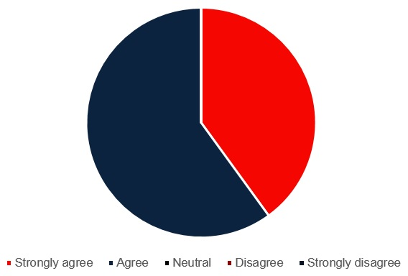

Figure 52: Q.1. The university visit has encouraged me to further discuss career options with my students

- 60% of teachers agree and 40% of teachers strongly agree that the Future Finder day encouraged them to discuss career options with their students.
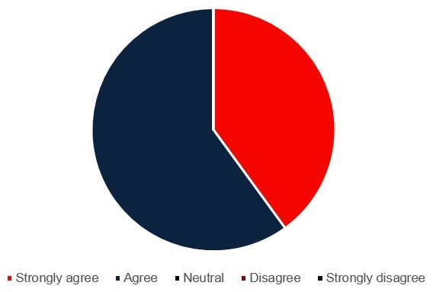

Figure 53: Q.2. This university visit has helped familiarise students with the university

- 60% of teachers agree and 40% of teachers strongly agree that the on-campus experience day has helped familiarise students with the university.

Figure 54: Q.3. This university visit has the potential to encourage students to consider university

- 60% of teachers agree and 40% of teachers strongly agree that the Future Finder day has the potential to support student aspirations and awareness towards considering university as a post-school option.
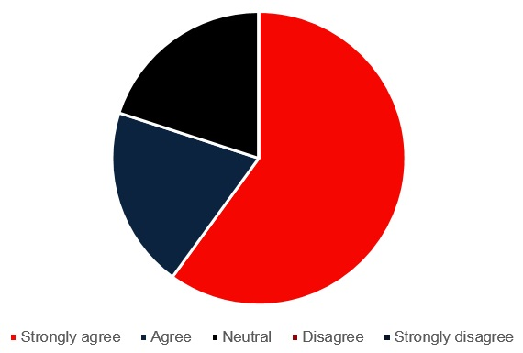

Figure 55: Q.4. Participation in the In2Uni program has provided students with positive role models

- 80% of teachers agree that the Future Finder Day has provided students with positive role models

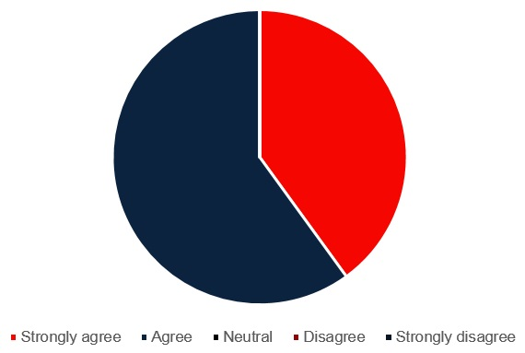

Figure 56: Q.5. The communication from the In2Uni program staff was clear and concise

- 60% of teachers agree and 40% of teachers strongly agree that staff communication surrounding the Future Finder Day/In2Uni program was clear and concise.
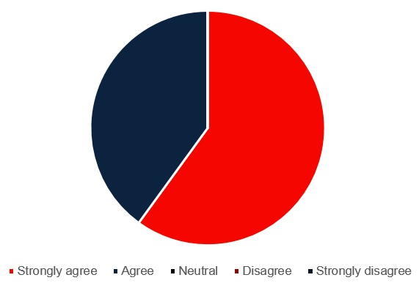

Figure 57: Figure 57: Q.6. The activities were pitched at an appropriate age level

- 60% of teachers strongly agree and 40% of teachers agree that the Future Finder activities were pitched at an appropriate age level.
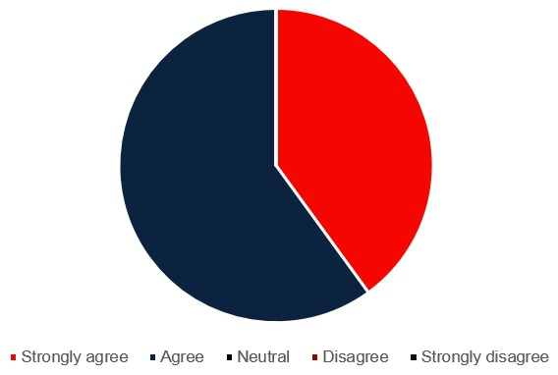

Figure 58: Q.7. My students were engaged in the activities

- 60% of teachers agree and 40% of teachers strongly agree that their students were engaged in the Future Finder activities.
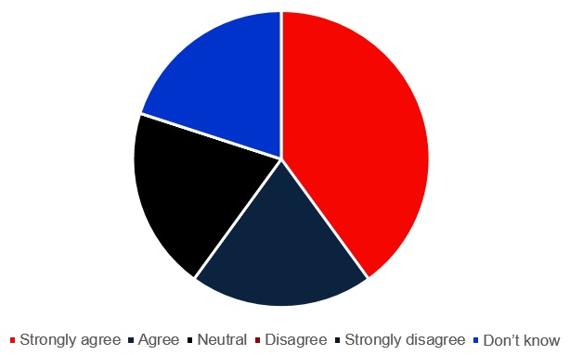

Figure 59: Q.8. The information regarding logistics was adequate
- 60% of teachers agree that the information regarding logistics was adequate
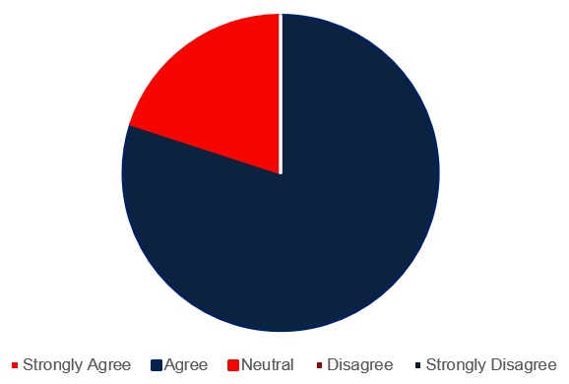

Figure 60: Q.9. The students perceptions of university were changed in a positive way
- 80% of teachers agree that after attending the Future Finder Day, student perceptions of university were changed in a positive way.
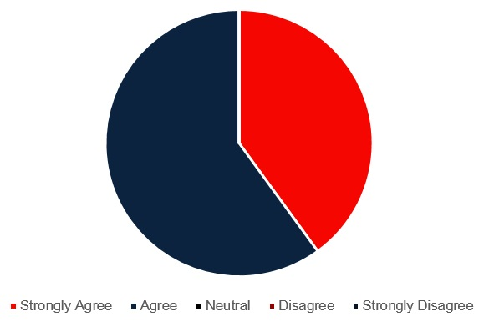

Figure 61: Q.10. The taster sessions were engaging for students
- 60% of teachers agree and 40% of teachers strongly agree that the taster sessions were engaging for students.
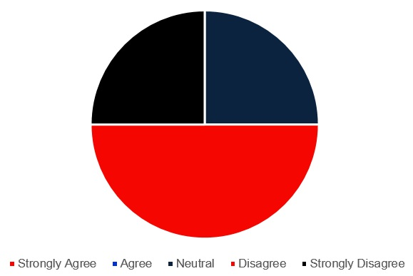

Figure 62: Q.11. The activities that allowed students to explore the campus were not useful
- 60% of teachers disagree that the activities that allowed students to explore the campus were not useful
Q.15. This visit has allowed students to imagine themselves at university
- All 5 participating teachers agreed that the Future Finder Day allowed students to imagine themselves at university.

Recommendations
- Review communications to schools and students to ensure that expectations around taster session allocations are well managed
- Explore introducing non-university focussed taster sessions if maintaining full cohort attendance.
- Deeper level of introduction to taster sessions
- Increased orientation prior to on-campus event
- Increased variety of taster session options for senior students (if continuing to invite Year 10, 11 & 12)
- Further information provided surrounding subject/course options available to study at university

Rural In2Uni University Preparation Program: Findings and Evaluation

Program Overview
The Rural In2Uni University Preparation Program (UPP) is designed to support students to improve their study skills and experience a taste of UOW student life.
Students receive tailored study sessions with trained In2Uni Mentors. This includes receiving advice on study skills, discussions about your options post-high school and support in applying for your UOW Early Admissions interview*.
The UPP offers:
- Five tailored tutoring sessions with In2Uni Mentors within the school environment
- Face-to-face and online study skills development
- Mentoring to explore post-high school options including course options
- Assistance completing an Early Admission interview* and UAC online applications*
- An Early Admissions interview* to UOW
- Participation in an on-campus Future Finder day
- Participation in ‘mock interviews’ for all students
* Interview for Year 12 students only

Student Engagement
The University Preparation Program was offered to students at the following schools in 2017:
- Bombala High School
- Braidwood Central School
- Cann River P-12 College
- Mallacoota P-12 College
Each campus offered 5x2hr face-to-face sessions at times to suit their student cohorts, please see a break down below:

Table 9: Face-to-face session breakdown
School | Session 1 | Session 2 | Session 3 | Session 4 | Session 5
Braidwood Central School | Friday, 19 May, 8:52am-10:38am | Friday, 30 June, 1:24pm-3:10pm | Friday, 18 August, 10:58am-12:50pm | Friday 8 September, 10:58-12:50pm | Wednesday 13 September, 1:24pm-3:10pm
Bombala High School | Tuesday, 16 May, 9am-11am | Tuesday, 27 June, 9am-11am | Tuesday, 1st August, 9am-11am | Tuesday, 15 August, 9am-11am | Friday 25 August, 9am-11am
Cann River P12 College | Tuesday, 9 May, 9am-11am | Tuesday, 20 June, 1:30pm-3:30pm | Tuesday, 25 July, 1:30pm-3:30pm | Tuesday 8 August, 9am-11am | NA
Mallacoota P12 College | Tuesday, 9 May, 1:30pm-3:30pm | Tuesday, 20 June, 9am-11am | Tuesday, 25 July, 9am-11am | Tuesday 8 August, 1:30pm-3:30pm | Friday, 8 September, 9am-11am

In addition to the above face-to-face sessions, students were also encouraged to complete twenty online skills modules, focussed on generic study and higher education preparation

Participation by Region

Table 10: Participation by region
 | Commencing students | Completing students | Student contact hours
Bombala High School | 22 | 10 | 10
Braidwood Central School | 16 | 18 | 10
Cann River P12 College | 5 | 3 | 10
Mallacoota P12 College | 23 | 12 | 10
Total | 66 | 43 | 10

Participant Demographics
The University Preparation Program participants completed 5x 2 hour tutoring and skills based workshops aimed at improving their higher education literacy and supporting career aspirations, awareness and attainment.
The following demographics were collected as part of the program application process.

Pre-Survey
- 66 students commenced the University Preparation Program
- 34 (51.52%) students identified as male
- 28 (42.42%) students identified as female
- 3 (4.55%) students identified as other
- 1 (1.52%) students did not identify
- 37 (56.06%) students identified as first in family (did not have family members who had attended university)
- 4 (6.06%) self-identified as Aboriginal or Torres Strait Islander
- 1 (1.52%) students did not identify

Evaluation

Qualitative Data

Student Responses to Pre-Survey Quantitative Questions
The graphs and information below reflect data captured in the post survey only.
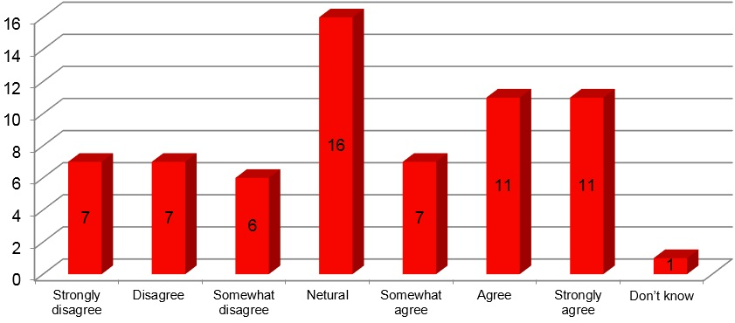

Figure 63: Q1. I want to go to uni when I finish school

- Prior to starting the University Preparation Program, 43.95% of students agreed that they want to go to university when they finish school.

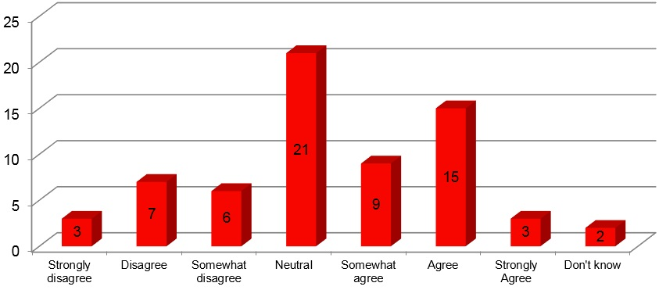

Figure 64: Q2. I have a good sense of what the university experience would be like (e.g. finance,
lectures, tutorials, time commitment)

- Prior to participating in the University Preparation Program, 40.92% of students agreed that they knew what the university experience would be like.
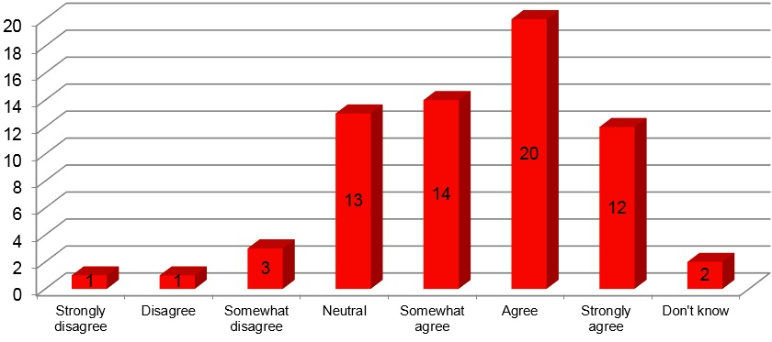

Figure 65: Q3. I know there is more than one way to get into university

- 69.71% of students agree that they know there is more than one way to get into university.

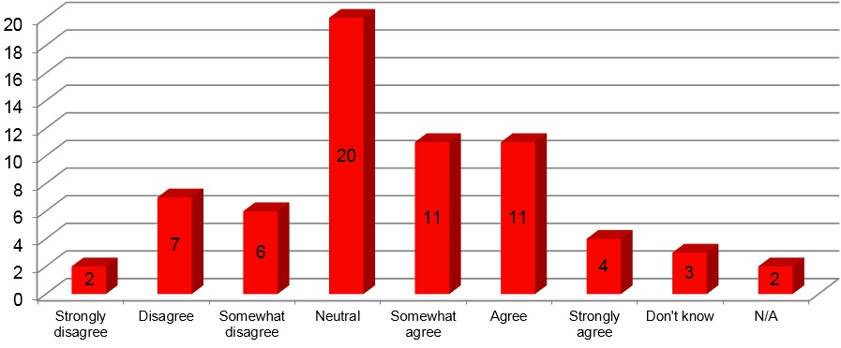

Figure 66: Q4. There are factors that would prevent me from going to university

- 39.40% of students agreed that there were barriers preventing them from attending university, while 30.40 % of students remained neutral on this question.
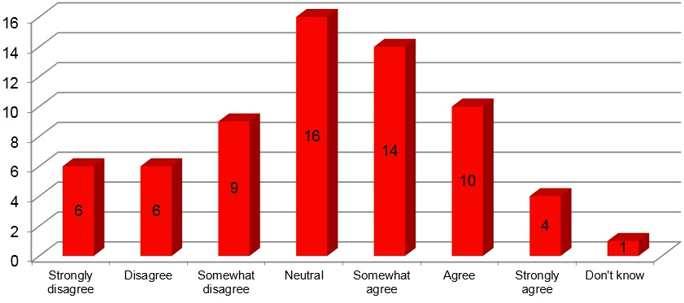

Figure 67: Q.5. I think I will do well enough at school to go to Uni

- 42.42% of students agree that they think they will do well enough at school to go to university.

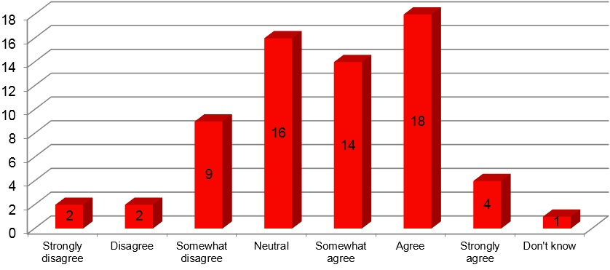

Figure 68: Q.6. I am familiar with the steps I need to take to achieve my career goals

- 50.54% of students agree that they are familiar with the steps needed to achieve their career goals.

Table 11: Q.7. What are your plans for when you leave school?
(Multiple response question)
Choice | What would I like to do | What I expect to do | Like and expect to do
Apply to go to university | 15 | 2 | 20
Apply to do an apprenticeship/ traineeship | 7 | 1 | 6
Apply for a certified VET course with TAFE or another training organisation | 7 | 0 | 4
Look for a job | 10 | 12 | 16
Other (please specify) | 1 x Join the police force  1 x Gap year  1 x Move away and travel  1 x Work  1 x Don’t know  3 x non specified |  | 1 non specified
No response | 5

The above table reveals that:
- The ‘liked to do’ plan for when students leave school is ranked as follows:
- Apply to go to university
- Look for a job
- Apply to do an apprenticeship/traineeship & Apply for a certified VET course with TAFE or another training organisation
- Other (as indicated on table)
- The ‘expected to do’ plan for when students leave school is ranked as follows:
- Look for a job
- Apply to go to university
- Apply to do an apprenticeship/traineeship
- The plan in which students would ‘like and expect to do’ is ranked as follows:
- Apply to go to university
- Look for a job
- Apply to do an apprenticeship/traineeship
- Apply for a certified VET course with TAFE or another training organisation
- Other (as indicated on table)

Table 12: Q.8. Where do you imagine yourself studying in the future?
Variables | Number | Percentage
1. Regional (like) | 5 | 7.6%
2. Urban (Like) | 7 | 10.6%
3. Regional (Expect) | 2 | 3%
4. Urban (Expect) | 5 | 7.6%
5. Regional (Like and Expect) | 9 | 13.6%
6. Urban (Like and Expect) | 17 | 26 %
7. Regional and urban (like) | 4 | 6%
8. Regional (like) urban (expect) | 4 | 6 %
9. Regional and urban (like and expect) | 4 | 6%
10. No response | 9 | 13.6%
Total | 66 | 100%

- The above table reveals that an urban environment is where many students imagine themselves studying in the future. This is evident by a total of 44.2% of students selecting an urban environment as a place that they would either ‘like’, ‘expect’ or ‘like and expect’ to study in.

Table 13: Q.9. Where do you imagine yourself working in the future?
Variables | Raw number count | Percentage
1. Regional (like) | 6 | 9 %
2. Urban (Like) | 9 | 13.6 %
3. Regional (Expect) | 2 | 3 %
4. Urban (Expect) | 4 | 6%
5. Regional (Like and Expect) | 11 | 16.7%
6. Urban (Like and Expect) | 13 | 19.7 %
7. Regional and urban (like) | 2 | 3 %
8. Regional (like) urban (expect) | 2 | 3 %
9. Regional (like and expect) urban (expect) | 1 | 1.5 %
10. Urban area (like and expect) Regional area (like) | 2 | 3%
11. Regional and urban (like and expect) | 5 | 7.6%
12. Other | 1 | 2%
13. No response | 8 | 12%
Total | 66 | 100%

- The above table reveals that an urban environment is where many students imagine they will work in the future. This is evident by a total of 39.30 % of students selecting an urban environment as a place that they would either ‘like’, ‘expect’ or ‘like and expect’ to study in.
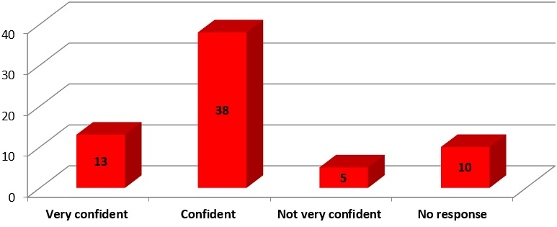

Figure 69: Q.10. How confident are you that you can find the information you need?

- 77.28% of students agree they have the confidence to find the information they need

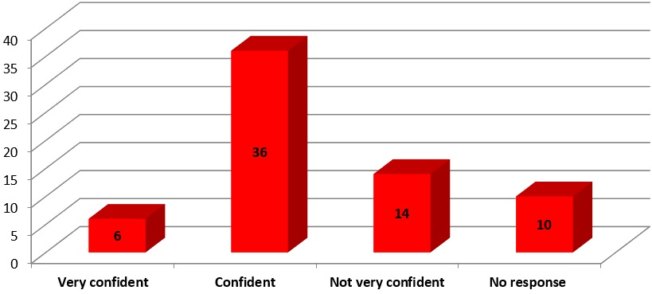

Figure 70: Q.11. How confident are you in using university/TAFE/Other training provider websites?

- 63.64% of students feel a level of confidence in using university/TAFE and other training provider websites
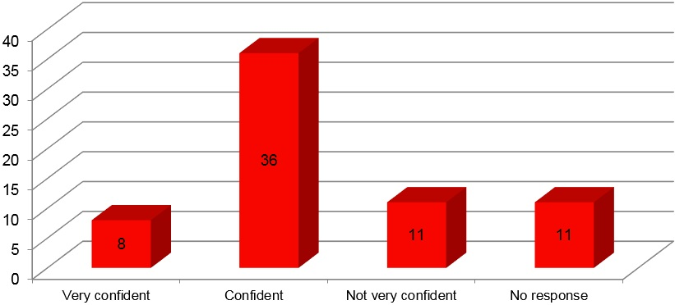

Figure 71: Q.12. How confident are you that you know who to contact for the information you need?

- 66.67% of students feel a level of confidence that they know who to contact for the information they need.

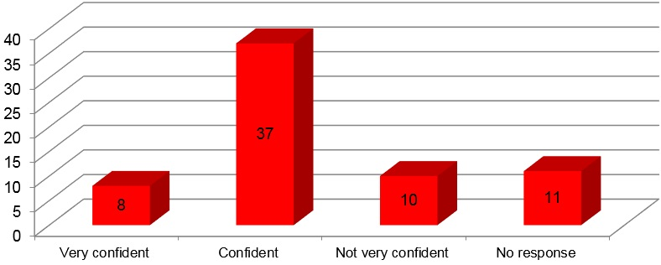

Figure 72: Q.13. How confident are you in receiving good career advice and pathway planning assistance

- 68.18% of students feel a level of confidence that they are receiving good career advice and pathway planning assistance

Student Responses to Post Survey Questions

Participant Demographics
The following demographics were collected post-program:
- 43 completed the University Preparation Program
- 21 (48.84%) students identified as male
- 21 (48.84%) students identified as female
- 1 (2.33%) students identified as other
- 20 (47.619%) students identified as first in family (did not have family members who had attended university)
- 1 (2.33%) students did not identify
- 3 students (6.98 %) self- identified as Aboriginal or Torres Strait Islander
The graphs and information on following pages reflect data captured in the post survey only.

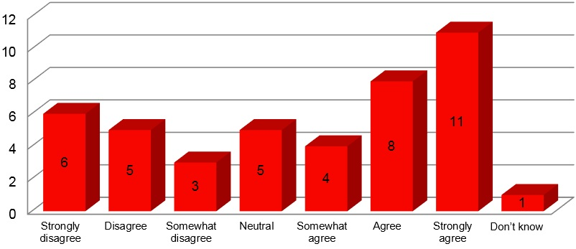

Figure 73: Q.1. I want to go to uni when I finish school

- After completing the University Preparation Program, 53.47% of students agreed that they want to go to university when they finish school. This is a 9.52% increase from the same pre-survey question. This response indicates a positive outcome on the program’s ability to support student aspirations, awareness and attainment towards higher education in their future.

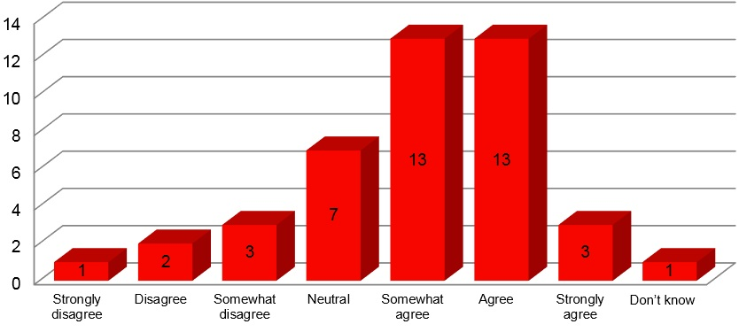

Figure 74: Q.2. I have a good sense of what the university experience would be like (e.g. finance, lectures, tutorials, time commitment)

- 67.44% of students agreed that after attending the University Preparation Program they have a good sense of what the university experience would be like. This is a 26.52% increase from the same pre-survey question. This response indicates an increased awareness towards higher education for students after completing the University Preparation Program.

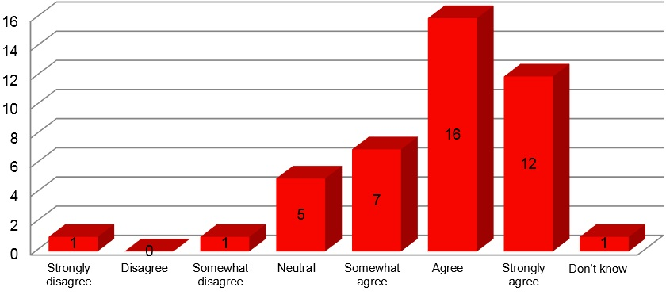

Figure 75: Q.3. I know there is more than one way to get into university

- 81.40% of students agreed that they are aware of more than one way of getting in to university after attending this program. This is an increase of 11.69% compared to the same pre-survey question, suggesting that the University Preparation Program has made a positive impact on student awareness surrounding the various pathways to obtaining a place in higher education.
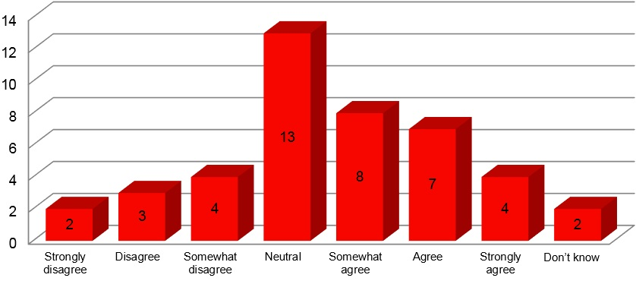

Figure 76: Q.4. There are factors that would prevent me from going to university

- 44.18% of students agreed that there are factors that would prevent them from going to university after completing the program, while 30.23% remained neutral on this question.

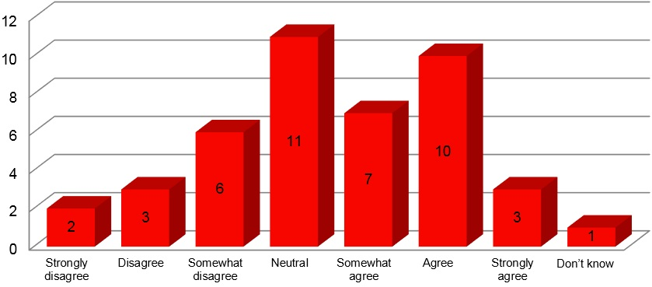

Figure 77: Q.5. I think I will do well enough at school to go to Uni

- 46.52% of students agreed that they think they will do well enough at school to go to university. This is an increase of 4.1% compared to the same pre-survey question.
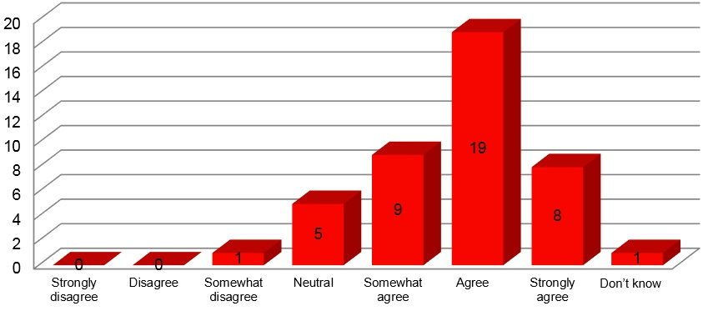

Figure 78: Q.6. I am familiar with the steps I need to take to achieve my career goals

- 83.72% of students agreed that they are familiar with the steps they need to take to achieve their career goals. This is an increase of 33.18% compared to the same pre-survey question. This increase indicates the positive impact the University Preparation Program had on raising student awareness and levels of attainment towards post-school education and employment.

Table 14: Q.7. What are your plans for when you leave school?
(Multiple response question)
Choice | What I would like to do | What I expect  to do | Like and Expect to do
Apply to go to university | 13 | 5 | 9
Apply to do an apprenticeship/traineeship | 11 | 1 | 4
Apply for a certified VET course with TAFE or another training organisation | 11 | 2 | 5
Look for a job | 14 | 2 | 11
Other (please specify) | 5 (no specifications) | 1 (not specified)
No response | NA

The above table reveals that:
- The ‘liked’ plan for when students leave school is ranked as follows:
- Look for a job
- Apply to go to university
- Apply to do an apprenticeship/traineeship & Apply for a certified VET course with TAFE or another training organisation
- 4Other (as indicated above)
- The ‘expected’ plan for when students leave school is ranked as follows:
- Apply to go to university
- Apply for a certified VET course with TAFE or another training organisation/Look for a job
- Apply to do an apprenticeship/traineeship & Other (not specified)
- The plan in which students would ‘like and expect to do’ is ranked as follows:
- Look for a job
- Apply to go to university
- Apply for a certified VET course with TAFE or another training organisation
- Apply to do an apprenticeship/traineeship

Table 15: Q.8. Where do you imagine yourself studying in the future?
Variables | Number | Percentage
1. Regional (like) | 5 | 11.6 %
2. Urban (Like) | 4 | 9.3 %
3. Urban (Expect) | 5 | 11.6 %
4. Regional (Like and Expect) | 5 | 11.6 %
5. Urban (Like and Expect) | 10 | 23.3 %
6. Regional and urban (like) | 5 | 11.6 %
7. Urban (like) regional (expect) | 1 | 2 %
8. Regional (like) urban (expect) | 3 | 7 %
9. Regional and urban (like) regional (expect) | 1 | 2%
10. Regional and urban (like and expect) | 2 | 5 %
11. No response | 2 | 5 %
Total | 43 | 100%

- The above table reveals that an urban environment is still the most popular choice for students to imagine themselves studying in the future. This is evident by a total of 44.2% of students selecting an urban environment as a place that they would either ‘like’, ‘expect’ or ‘like and expect’ to study in.

Table 16: Q.9. Where do you imagine yourself working in the future?
Variables | Raw Number Count | Percentage
1. Regional (like) | 6 | 14%
2. Urban (Like) | 4 | 9%
3. Regional (Expect) | 2 | 5 %
4. Urban (Expect) | 2 | 5 %
5. Regional (Like and Expect) | 5 | 12 %
6. Urban (Like and Expect) | 7 | 16%
7. Regional and urban (like) | 7 | 16 %
8. Urban (like) regional (expect) | 3 | 7 %
9. Regional (like and expect) urban (expect) | 1 | 2%
10. Urban and regional (like) Urban (expect) | 1 | 2%
11. Regional and urban (like and expect) | 3 | 7 %
12. No response | 2 | 5 %
Total | 43 | 100%

- The above table reveals that a regional environment is the most popular choice for students when imagining where they will work in the future. This is evident by a total of 31% of students selecting a regional environment as a place they would either ‘like’, ‘expect’ or ‘like and expect’ to study in. This result is closely followed by an urban environment with 30% of students selecting this as a place they would ‘like’, ‘expect’ or ‘like and expect’ to study in. In addition, these preferences are by a further 23% of students selecting the variable of ‘regional and urban’ as equal environments they would ‘like’ or ‘like and expect’ to work within. When comparing these results with Q.8 (study options), these results give an insight into students’ level of desire to return to a regional environment to work upon completing their studies and further reflect the value placed upon regional areas by the students participating in the program.

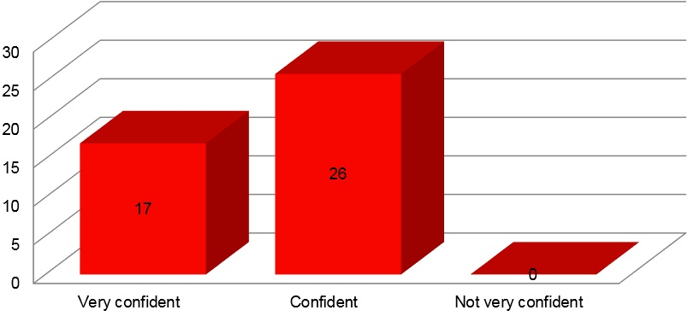

Figure 79: Q.10. How confident are you that you can find the information you need?

- 60.47% of students agree they are confident and 39.53% of students very confident, to find the information they need after completing the University Preparation Program. This equates to 100% of students having a level of confidence towards sourcing information for career and educational development. This is an increase of 22.72% compared to the same pre-survey question.
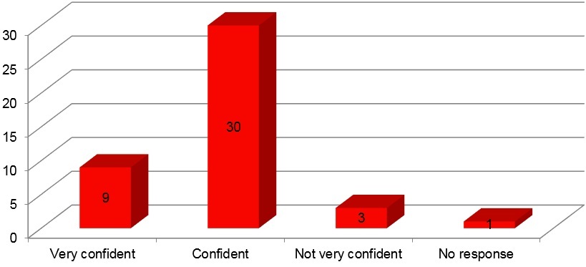

Figure 80: Q.11. How confident are you in using university/TAFE/Other training provider websites?

- 90.70% of students agree that they have a level of confidence towards using university/TAFE and other training provider websites after completing the University Preparation Program. This is an increase of 27.06% compared to the same pre-survey question.

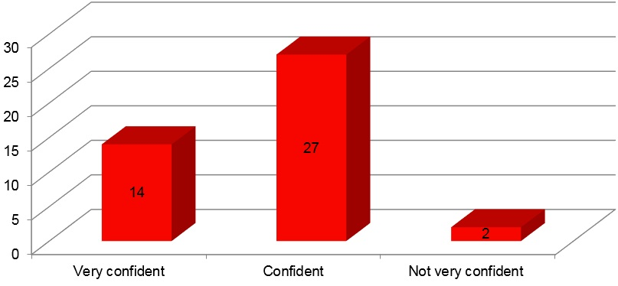

Figure 81: Q.12. How confident are you that you know who to contact for the information you need?

- 93.35% of students agree to having a level of confidence towards knowing who to contact for the information they need. This is an increase of 28.68% compared to the same pre-survey question and indicates the positive influence the University Preparation Program has on raising students’ awareness towards key contacts and resources for receiving information about post-school options.
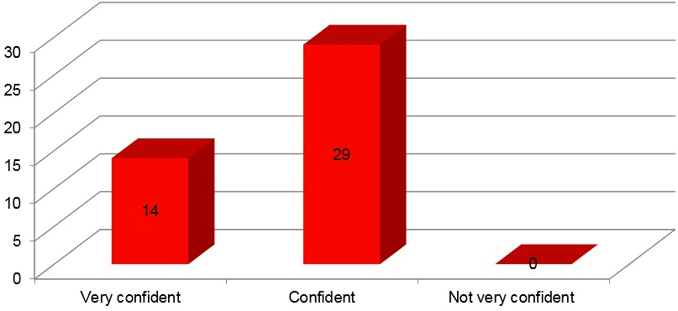

Figure 82: Q.13. How confident are you in receiving good career advice and pathway planning assistance

- 32.56% of students agree they feel very confident and 67.44% of students agree they feel confident that they have received good career advice and pathway planning assistance after completing the university preparation program. This equates to 100% of students feeling a level of confidence towards the pathways and career planning advice received throughout the program and is a 31.82% increase compared to the same pre-survey question.

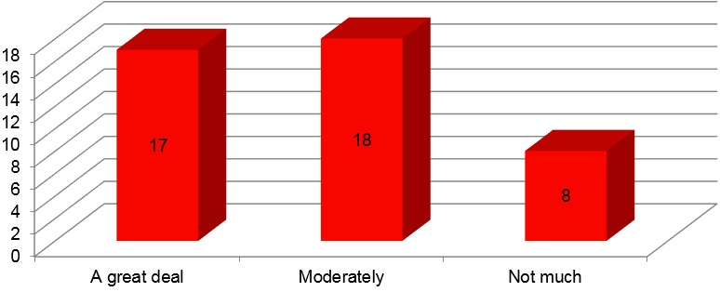

Figure 83: Q.14. To what extent has the program influenced your decision about going to university

- 81.39% of students have indicated that the University Preparation Program has had a level of influence on their decision about going to university. This data indicates the positive impact that the University Preparation Program had in supporting students aspirations, awareness and attainment towards university participation post-school.

Table 17: Q.15. How useful have the individual parts of the program been to your decision about whether to go to university?
Activity | Useful | Some impact | Not useful | N/A | Total
Meeting staff from the university | 28 | 11 | 2 | 0 | 41
Meeting university students | 23 | 17 | 1 | 0 | 41
Face-to-face workshops | 27 | 13 | 1 | 0 | 41
Video-conferenced workshops | 21 | 10 | 5 | 5 | 41
Study skills modules | 27 | 10 | 2 | 2 | 41
Mentoring | 26 | 10 | 4 | 1
Campus visits | 24 | 9 | 4 | 4 | 41
Non response to all questions |  |  |  |  | 2

The above table indicates that ‘Useful’ was the highest selected option by students for all individual parts of the University Preparation program.
The percentage breakdown for the ‘Useful’ option is as follows:
- 65.12% - Meeting university staff
- 53.49% - Meeting university students
- 62.79% - Face-to-face workshops
- 48.84% - Video-conferenced workshops
- 62.79% - Study skills modules
- 60.47% - Mentoring
- 55.81% - Campus visits
Comment: The results indicate that the individual components of the University Preparation Program have had a positive influence on student decisions about whether to go to university. The data reveals that each individual component is beneficial to supporting student decisions about higher education participation post-school, allowing each component to be recognised as a key resource for building student aspirations, awareness and attainment towards university study.

Qualitative Feedback
A summary of student responses and key quotes included in post-survey qualitative questions are provided below:
Q.1. What was your favourite part of the program
- Campus Visit
- “Meeting new people, getting information about different options” (Student, 2017)
- “The people/mentors” (Student, 2017)
- “The interview – Gave me more self-belief and confidence” (Student, 2017)
- Feedback from the mock-interviews
- “The interviews were a really helpful experience, it was a comfortable environment to practice interview skills” (Student, 2017)
- “Meeting the mentors and doing the interactive activities” (Student, 2017)
- “Gaining knowledge about university” (Student, 2017)
- “I think my favourite part of the program was actually visiting the campus and learning one on one about the campus and studying” (Student, 2017)
- “The presenters were very friendly and were happy to answer any questions, it was good to get some knowledge of what university will be like” (Student, 2017)
- “The people were great, a lot of advice” (Student, 2017)
- “Learning interesting topics” (Student, 2017)
Q.2. Do you think there are any improvements that need to be made to the program?
- “Not so much time out of class”(Student, 2017)
- “More fun activities” (Student, 2017)
- “I think the program is very good already” (Student, 2017)
- “I think there aren’t many improvements that need to be made but maybe just more hands on activities” (Student, 2017)
- “Nope pretty straight forward and useful” (Students, 2017)
Q3. Please provide any other comments and feedback you have about the program:
- “It is fun and interesting” (Student, 2017)
- “Keep doing what you’re doing” (Student, 2017)
- “This program was really helpful for me personally and has made me more confident with the idea of going to uni” (Student, 2017)
- “I think all in all the program was helpful for me in general guiding me through university options and advice” (Student, 2017)
- “Really useful - thank you” (Student, 2017)

Recommendations
The following recommendations are suggested following a review of the program, in conjunction with In2Uni program staff and key stakeholders:

Timing and Structure of Program
The program will be restructured following feedback from schools and students and to reduce travel cots. This will include:
- 1 x face-to-face session
  - x in-school Mock interview session with Year 12
  - 1 x Q&A session with university representative via video conference
  - Opportunity to complete 20 online Moodle Modules
  - New structure to be delivered over School terms 2 and 3
- Participation in all sessions, completion of modules and meeting of subject criteria for chosen degree guarantees Year 12 students an Early Admissions interview with UOW.
- Program delivery led by Outreach Coordinators at closest campus to target rural and remote schools

Mentor Numbers
- There are an adequate number of mentors to cover the requirements of the program
- Mentors from closest regional campus to rural and remote schools will deliver program content

Rural In2Uni Focus Group Evaluation

Background
The teachers and outreach staff involved in the Rural In2Uni Program participated in a one-hour focus group which was used as an open space to analyse the current Rural In2Uni model and shape the design of future programs that accommodate a diverse range of student needs, approaches to learning and future educational aspirations. The in-depth reflections found in the focus group responses aids in informing a future Rural In2Uni model and associated resources based upon sustainable delivery options that are transferrable to other schools with high numbers of low-SES students in regional and remote communities.

Participating Schools

Table 18: Participating schools
School | Teachers | Principal
Bombala High School | 1 | 0
Braidwood Central School | 1 | 1
Cann River P-12 College | 0 | 1
Mallacoota P-12 College | 1 | 0
Total | 3 | 2

Qualitative Feedback
A summary of teacher responses and key quotes related to each focus group question is found below.

Questions
- How would you define the term ‘University Outreach’?
- “I would understand that to be an office outside of the university in a rural area I guess or not necessary rural which delivers programs and from the main university and enables students in outlying regions to complete those programs without having to attend the main university” (Teacher, 2017)
- “To me it’s the university coming in to schools to work with the students so that they can feel that they can go to university, that it is doable. So just sort of reaching out to them… that there is the possibility for them” (Teacher, 2017)
- “Universities linking with partner schools in order to connect and show kids that there is a path for education beyond school – whatever that looks like. That what I think your program has delivered. So for us, you’ve come here, we have spoken about how important that is. Speaking about the general mass so let’s talk on mass about there is more to education then school, it’s a lifelong opportunity for everyone no matter where you want to go and then that individualised help as we progress across different parts of your program to specifically helping individual students with specific university entrance” (Principal, 2017)
- “I would think a university outreach program is any program where the university initiates, links within other organisations, especially schools… to try and improve the aspirations of students and, obviously leading to pathways usually into university if they can” (Principal, 2017)
- Can you describe the aspirations towards higher education that the students of <Insert School> had prior to engaging in the university outreach model?
- “…We have a really high correlation with kids saying that they would like to go to tertiary education. What they actually don’t have is perceptions of what that actually… means, and so it’s not a consolidated view. Ah, so the idea of running a program just helps people to ideate that sense of what that might mean and what they might do, and actually maybe starting to lead towards some of the thinking about what they will need to do to get there” (Principal, 2017)
- “…Really our experience towards doing open days, to doing tertiary things, ah, programs such as your own, ah, that sparks are lit, and connections are made sometimes that are actually life changing” (Principal, 2017)
- “…With the higher education of our Year 12’s …they were aspiring to go to uni but a lot of the times they were not sure of how to get there and where to go from there…” (Teacher, 2017)
- “I think they (our kids) self- select out between year 5 and Year 9 and that is usually based on the academic achievement at school. So if they have failed a test along the way… they still want to go to uni, but they don’t think they are capable of doing it… they have put up a barrier. I think even the start of this cohort, I think many of them aspired, but they are not going to say that out loud…there’s a real tenaciousness in a person to actually say I’m going to uni because you are putting yourself out there and if you don’t meet that expectation you believe that the entire of the community and particular in a rural, small environment, you’re a ‘loser’ or ‘you didn’t make it to uni and you said you wanted to do that’ where as if I (the students) don’t say I want to go there then it’s okay that I didn’t get in cause I never wanted to go there…I think they aspire to go to uni but they self-select out so they aren’t seen as failures’ (Principal, 2017)
- “That fact that I’m a failure if I can’t get in on the first shot, and it’s not that they can’t get in on the second, third or the fourth shot or any of that, if I don’t get in on that first shot then the community will think I am a failure” (Teacher, 2017).
- “I think that prior to the program we wouldn’t of certainly have had as many apply to go to university definitely…there is always going to be one or two in each cohort that has university written all over them and will apply regardless but there was also some that didn’t think it was for them but then after doing the program through yeah I can do this” (Teacher, 2017)
- “Many students would have had low aspirations towards higher education, they would of not been that motivated to actually do any tertiary education rather they would be looking to leave school and find a job of some kind. Other students however have always tended towards a university degree” (Teacher, 2017)
- Can you describe the level of awareness that students of < Insert school > had towards higher education prior to engaging with the university outreach model?
- “That’s a really good question I think. Ah, one of the things, because of the socio-economic group, because of essentially that most of the families haven’t experienced tertiary education, there’s no ah, what Allen Luke would call, ‘folk knowledge’… about it so it’s either, something that’s seen as something strange and beyond, or the pathways are entirely unknown…” (Principal, 2017)
- “…Surface level is the way to say it, it’s yeah know I know a uni exists, actually I don’t even think our kids know that that uni excels at that, that uni excels at that, I don’t think they have that knowledge at all. They know uni and that’s it, it’s actually quite foreign” (Principal, 2017)
- “Probably not that high I tend to work on a student-to-student basis and unless they identify that uni is an option I won’t go through the (process)….if they come to me and say TAFE I just haven’t got the time to say oh well you can go to university or let me look at that for you…” (Teacher, 2017)
- “I would say a medium level of awareness” (Teacher, 2017)
- From your perspective, did the university outreach model have any influence on the aspirations or level of awareness towards higher education for students of <Insert school>?
- “Yes, I think what it did was confirm for the kids who wanted to go that this was the right path it unpacked it for them it showed them that France wasn’t just the Eiffel tower, that there are a couple of other things they might need to be experiencing” (Principal, 2017)
- “I think we’ve had some immediate response in regards to a couple of our students…, that it may have helped them even maintain their involvement at school- to actually finish their exams…” (Principal, 2017)
- “Definitely, again it’s the number of students that you reach and there’s a number of students in the low socioeconomic here that just don’t have the resources or the nous to find stuff for themselves so that really, really focused them as well, participating in the model and I can think of two students prior to doing this that certainly would not be at summer school” (Teacher, 2017)
- “Yeah definitely, it raised their level of awareness and It possibly gave them aspirations which ...in fact definitely gave them aspirations, which they had not thought of previously…it gave them pathways and real trajectories to follow in order to achieve their goals” (Teacher, 2017).
- Was the University Outreach model delivered at <Insert School> effective in supporting student progression needs?
- “I do think that it bought it (post-school education) from the back of the head to the front of the head that we can actually do something that actually we might be able to be you know the engineer that was on the poster… or you know going to TAFE and things like that so um yeah I do believe it went from the back to the front” (Teacher, 2017).
- “I think it does… even the students that came up and visited on the day, is that one of their sets of aspirations has changed completely, and they’re going to turn out to be a very academic student. Now that’s one part of the ingredients. We understand that it’s family… we understand that it’s the successful approach of a couple of teachers in the school… these are the elements that fit together, but certainly, in my experience, is that the actual going to the place can be the start of actually making the perception “I can imagine myself here.” (Principal, 2017).
- “I think starting with year 7 is amazing… I like the different focuses on the different year groups so that it’s like a progression and students don’t think ‘oh I’ve got to do that again’ because it’s something completely new” (Teacher, 2017).
- “Yes, definitely because these students are building a relationship with you guys as well” (Teacher, 2017).
- “… I think from what I observed… the touch points as you call them, were effective, yes” (Teacher, 2017).
- Discuss the effectiveness of the resource package in enabling schools like <Insert School> to self-deliver outreach programs:
- “I think we could deliver those sorts of programs, but the uni presence is defiantly a huge bonus just to have ...I mean ...the kids in XXXX we don’t get to see a whole lot of other people from outside on a regular basis so having you come down from XXXX with your colleagues has been tremendous” (Teacher, 2017)
- “I think getting these things into schools is really valuable, I think there’s a lot of that stuff that we do already… but , look, slightly different versions of it can really enrich the sense of what it might look like…so you know, I think that’s really important too. You know part of it is actually highlighting, which is, you know, somebody external… somebody external brings an entirely different sense of narrative, and, and, to the situation, rather than the teachers that they know… it’s thinking other” (Principal, 2017)
- Response to the effective components of program: “I also think it’s, les have a look at the average timetable, here’s when I’m supposed to turn up to uni, here’s where I technically should be in that group session, here’s where actually they’ve left me alone for a reason, I need to put my timetable that this is the time I will logon to the online resources because no one actually tells you to do that and unless you put it in there’s no one there unlike school where we ring a bell and you will move and we will tell you when you will turn u… there’s no one to tell you that” (Principal, 2017)
- “I have to work with them with a resume but that program comes in and shows them a completely different way that might be more suitable for them… just a completely different perspective on things I think would benefit any of our isolated students here…(Teacher, 2017).
- Do you think the resource package offers regional and remote schools with a long-term and sustainable option for delivering university outreach?
- “Yeah, if you’re going to keep coming out yes! I think it’s worthwhile” (Principal, 2017)
- “I think what your offering is that opportunity to demystify what is something that is an aspiration into an expectation and that is a difference. You are turning something like ‘oh that would be really cool but I won’t say it out loud cause I could never really do it into oh yeah I can do that’ … (Principal, 2017)
- “ …If the package involves people coming, I think it could be a very sustainable program… the connection of university outreach is…giving us the latest and the nearest of what’s going on… and, you know, with the change of pathways and curriculums, that, that idea of, you know genuinely being able to see a nursing course” (Principal, 2017).
- “Because I am so familiar with these students they take sometimes what I say with a grain of salt and I just think them being challenged with new resources… is really powerful certainly coming from, don’t get me wrong you’ve (the teacher) built up a relationship with the students over the years, but it’s not coming from us” (Teacher, 2017)
- “I think it doesn’t do them any harm to have a look at different ways to do things because the way I do it mightn’t be the way they that do it, because I’m so concrete, they might be the creative and pick up on a different way of doing things as well. So no, we definitely need your presence in the school” (Teacher, 2017)
- “Absolutely… the kids now have the ability to access tertiary education at a centre that is not more than 2hrs away so I mean that is fantastic for us and it would be over the long term…” (Teacher, 2017).
- Following from the previous question, do you think the outreach model and resource package is a suitable approach for improving access to higher education for students in regional and remote locations? Can you make any other suggestions?
- “I think it works and I think we break down that rural because if you can change a kid in a town that’s going to break down that whole town ‘oh yeah so and so went to there and that then becomes a rite of passage for others to follow that path I think it’s worthwhile doing…keep the freshness, keep the aliveness” (Principal, 2017).
- “It’s gotta be… it’s always an ongoing negotiation which is the reality of schools…our whole focus is that we’re dealing with evidence-based practice…trial and run, and there’s a really good chance that- and we understand in a small school- that what works really well one year, doesn’t work really well the next year…” (Principal, 2017).
- “Definitely, I guess working… I think this program, its drives students to see that there is something in the HSC that is in it for them” (Teacher, 2017)
- “Well I think it has been very suitable…and as I said it has been great to improve the access and I think it does really do that” (Teacher, 2017).
- “So far as suggestions, maybe you could consider delivering some of the content of the actual uni courses from XXXX down to us just to give kids an idea that you know… what you do at university is not out of their conception…” (Teacher, 2017)
- From your perspective, what size role should a university play in outreach programs that are driven by schools in regional and remote locations?
- “It’s hugely important, you making those connections, are really, really important in a rural environment it works really differently…” (Principal, 2017).
- “…We’re not the experts the rules keep changing that’s your world, we’re experts in this world we can tell you… about the new stage 6 syllabus, we can tell you about the change of board of studies… that’s our world, our area of expertise… we can’t communicate what is foreign to us… I think that’s really, really important. It’s also the people who you have coming out are young people… who … ‘this is where I was and so I can speak better’… I mean in any classroom we know that some people will understand the teacher and others will understand their peers much better. I think that one of the positives is that this is peer communication” (Principal, 2017).
- “…I think, ah, especially from small schools, the notion of getting people inside, because you know, we don’t have a full time careers person… so, I couldn’t give a percentage size- it varies. But, you know, I mean, I think that whatever it is … every school will be negotiable over time…” (Principal, 2017).
- “It’s absolutely… you know… there is the whole sense that even- if the content was exactly the same that having mentors down, it provides a different world view…”(Principal, 2017)
- “I think we have found a really good balance, spaced out across the entire year, different focus groups at different times of the year when its strategically important” (Teacher, 2017)
- “I think a very sizable role because these days it seems that getting your VCE or HSC isn’t quite enough and many of the rural kids are not getting the advantage of a tertiary education which would greatly help their future aspirations” (Teacher, 2017).
- Finally, is there anything related to the Rural In2Uni model and associated resource package provided to <Insert school > which has not been discussed and you would like to draw attention to now?
- “Keep going, do it well, sign us up” (Principal, 2017)
- “If you didn’t exist, we’d still find some way to do it… but we’re incredibly grateful that is does exist” (Principal, 2017)
- “Look I think we could do better at our end just you know providing you guys with better classrooms, better resources and hopefully when we are better set up to do that we can do that better …otherwise I think it has been a really good program” (Teacher, 2017)
- “No , as you know we’ve been massive supporters and I think its invaluable for all of our students” (Teacher, 2017)

Mentor Focus Groups

Participating Mentors
- 3 University Outreach Staff (Mentors) who delivered across the locations of Cann River P-12 College, Mallacoota P-12 College, Bombala High School and Braidwood Central School.
- Mentors based at The University of Wollongong’s Batemans Bay and Bega Campuses.

Qualitative Feedback
A summary of University Outreach Staff (Mentors) responses and key quotes related to each focus group question is found below.
- How would you define the term ‘University Outreach’?
- “Getting the basic knowledge of what university is like and just trying to get an understanding of how university is different to high school and what sort of differences is going to be if they go do to university as opposed to TAFE or just getting a job or something like that” (Mentor, 2017).
- How do you interpret the notions of aspirations and awareness as they relate to higher education?
- “…Some students just don’t have an interest in tertiary education and they would prefer to get hands on work rather than continue studying and that’s quite evident in a small town… so I think getting a practical hands on job was much more appealing then continuing to study especially when … like having grown up in a very remote place, their experience of what study was like…I don’t think they could get their head around with what it would be like with a lot more people around them and doing something that is focused and what they would be interested in doing as well.
- “I think quite mixed. I think the aspirations, some students have really strong aspirations to go to university and then other students… they know where they would like to be the following year, I’m talking specifically about the year 12 students but the aspirations for higher education in a sense were quite mixed. There were students that had really strong aspirations to go to university and were willing to try extremely hard and then some other students that weren’t interested in higher education at all and were wanting to go straight into a job after school” (Mentor, 2017).
- From your perspective, did the university outreach model have any influence on the aspirations or level of awareness towards higher education for students of <Insert school>?
- “I certainly think that the awareness increased… I think that there were more students at XXXX that already had pre-existing aspirations to go to university and that just sort of confirmed what they would like to do after Year 12 a bit more, whereas with XXXX I don’t think there really was much of an increase in aspirations to go to university compared to XXXX , but it certainly did increase awareness and maybe to just begin thinking about the path to go to university where as before I don’t think they had even considered it” (Mentor, 2017).
- “I think for some students it was positive in the fact that they realised, when we talk about the ATARS and things like that, they are able to achieve it” (Mentor, 2017).
- “I think of in terms of awareness, a significant increase for students just by the amount of questions that have been asked and some of the things that were mentioned before things like pathways in to university...In terms of aspirations whether we increased them I think that is more complex and we will get that feedback through the surveys as it is quite hard to understand, I know that some of the students that I spoke with earlier in the UPP program were unsure and towards the end they were 100% sure on what they wanted to do so …the aspiration was still there but it was sort of made more obtainable...” (Mentor, 2017).
- “Even simply just the presence in the schools is a really positive thing” (Mentor, 2017).
- Were the resources utilised in the Rural In2Uni programs suited to the needs of the targeted schools?
- “I think the structure fitted the school quite well… so it sort of had that differentiation for the students in terms of whether they were 100 percent sure of going to university or not it had that nice level of that worked for most students and kept all of the students engaged” (Mentor, 2017).
- Were the resources utilised at <Insert School> effective in supporting individual student progression needs?
- “I think they were stacked like as a building block really quite well, the more interactive parts of the workshop are always really well received and engaged with by the students so yeah I think they (the lessons) build upon each other quite well” (Mentor, 2017).
- “I think that having more hands on activities… that was much more engaged with rather than us talking or sort of trying to explain a concept (would work better)…” (Mentor, 2017).
- “The icebreakers are good when they got to stand up and we done the speed interviewing, that was quite good I think maybe a few of them throughout” (Mentor, 2017).
- From your perspective, do you feel the resources are designed to allow for an easy transition to a teacher-led delivery in the absence of a student mentor?
- “I think knowing teachers, they can usually pick things up and deliver them quite easily, it’s one of the great skills they have. It would just be more of the little things that we can add on that we might need to make, like a bit of a master list or something or potential questions you may get with potential answers for the teachers as well because this is where we want to make sure that the teachers aren’t giving answers back to the students that aren’t necessarily 100% correct or the little insights that we have that are really important like the different pathways in to university and all those kinds of things …” (Mentor, 2017).
- Do you think the resource package offers regional and remote schools with a long-term and sustainable option for delivering university outreach?
- “I think the model would work, the content and what is involved may have to differ every now and then just so that it’s a bit more engaging but I think the model is set up quite well to work sustainably because it’s got a very strong foundation for what its goal is” (Mentor, 2017)
- “I think the model would work although it still requires touch points with university so a lot of the feedback that after the program coming on to campus or even the mock interviews I think there still needs to be involvement by the university, it doesn’t have to be the full involved that we have had but it can’t be a program simply run by the teacher without us being involved as well” (Mentor, 2017).
- “It would have to be a partnership as opposed to going here’s a whole load of resources we’re out because the students are, you know when they come on to campus we can say you have been doing this with the teachers and now we are going to build upon that here or even with the mock interviews and things like that they are not taken as seriously with a teacher I don’t think as opposed to someone coming from the uni and can sit down for a mock interview with myself it’s going to seem a little bit more… I feel that they would take it a little bit more seriously” (Mentor, 2017).
- Following from the previous question, do you think the outreach model and resource package is a suitable approach for improving access to higher education for students in regional and remote locations? Can you make any other suggestions?
- “Yes, definitely for XXXX cause for them the closest is, other than XXXX, is Canberra, and that is where all of the tertiary education trips were before… because there is much more engagement throughout the year rather than just once… would be much more effective to opening pathways to university rather than the methods they have got at the moment” (Mentor, 2017).
- “…Maybe more days on campus I think just the physical exposure of being outside of the school would be beneficial to understanding what is out there… just seeing what the place is like and just having an understanding of where they would be studying that is not their own school” (Mentor, 2017).
- “In the cases where that wouldn’t be possible, like really remote schools, even utilising some online tech like skype or adobe connect or something linking a student up with a mentor not to answer all the questions but maybe to potentially ask some questions …I feel like there is such power in sharing stories so even just explaining their story into higher education and what their studying and what university is like and something like that could potentially work” (Mentor, 2017)
- “I think so, there were a few students who went ‘Bega has a uni?!’ (Mentor, 2017).
- “I think a lot of them also didn’t know that you could do it online so I think that’s a big thing and a lot of people forget that …but maybe just some more education on what is actually available to them and I think that the programs encompasses that a lot more” (Mentor, 2017).
- From your perspective, what size role should a university play in outreach programs that are driven by schools in regional and remote locations?
- “Yeah and that’s coming back to sort of what I was saying before that we still need to have those touch points cause I think it’s important that the university plays a key role in these sort of activities or events or whatever they might be because we need to ensure that the message is being sent correctly. We don’t want to hand it over for incorrect information and to be spread …A university definitely has to play a key role and I understand that this become harder in rural and remote settings so it is about figuring out, testing and seeing how things go and building upon what you’ve delivered the previous year and a lot of reflection and those kind of things” (Mentor, 2017).
- “For a lot of the kids who knew who I was I think it made a lot more relatable, so like ‘oh she came to this school so obviously it’s possible that I can do that as well” (Mentor, 2017).
- “Yes, certainly beneficial and I think if it’s ever possible it’s probably one of the tools that should be most utilised. There is obviously going to be circumstances where there aren’t students from XXXX or XXXX that are studying at the campuses where programs are being delivered from but yeah if possible it is certainly something that should be utilised as much as possible” (Mentor, 2017).
- Finally, is there anything related to the Rural In2Uni model and associated resource package provided to <Insert school > which has not been discussed and you would like to draw attention to now?
- “A few minor improvements reflecting back on how things can work a bit better…like with the reminder to mentors to provide more time for surveys…in the future finder day we had the year 10, 11 and 12 …The year 10 students really enjoyed it but I think for some of the year 12 students it wasn’t as enjoyable…” (Mentor, 2017).
- “I also think that the interviews for the students is very, very well received by the students they all really enjoyed that its where they get a bit of time to ask you (the mentor) personally one on one some questions and get some clarification. All students really, really enjoyed it (Mentor, 2017).

