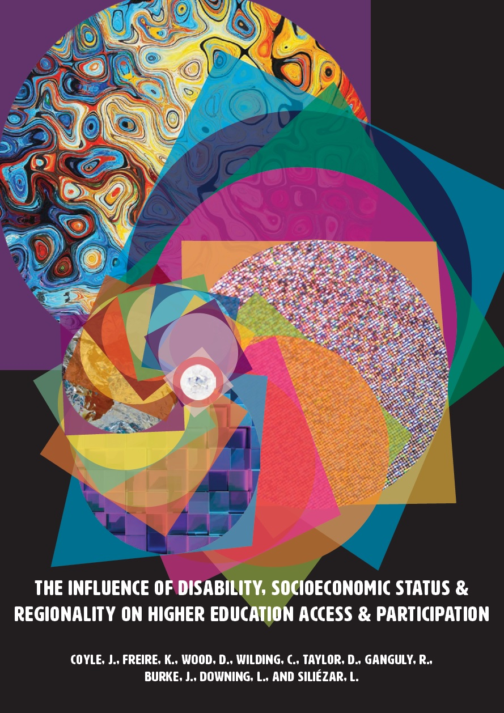

The Influence of Disability, Socioeconomic
Status and Regionality on Higher Education Access and Participation

This report was funded by the Australian Government through the Higher Education Participation and Partnerships Program National Priorities Pool.

Professor Julia Coyle (Lead), University of Wollongong
formerly Charles Sturt University (Lead Institution)
Dr Kate Freire (Project coordinator) Charles Sturt University
Professor Denise Wood, Central Queensland University
Dr Clare Wilding, Knowledge Moves
Ms Davina Taylor, Central Queensland University
Dr Rahul Ganguly, University of Southern Queensland
Associate Professor Jenene Burke, Federation University Australia
Mr Liam Downing, Charles Sturt University
Ms Larissa Siliézar, James Cook University

April 2018
Cover and Back Cover design by Georgie Demertzis© 2018

The project that resulted in the production of this report was funded under a National Priorities Pool (Higher Education Participation and Partnerships Program) grant from the Commonwealth. The recipient of the grant has granted the Commonwealth the right to sub-licence the material in this report. Copyright in the report remains with the original copyright owners.
Except where otherwise indicated, and save for any material protected by a trade mark, the Department of Education and Training, acting on behalf of the Commonwealth, has applied the Creative Commons Attribution 4.0 International Licence.

Modifications: Changed to meet WCAG 2.0 accessibility requirements.
Alternate text inserted for all images. Minor typographical errors corrected.

Acknowledgements
The research team express their sincere thanks to all participants who took part in the study and generously shared their experiences and perspectives.
The research team would also like to specifically thank the following people:
- Mr Simon MacDonald and Ms Justine Parer for their assistance with the survey analysis.
- Ms Gail Fuller: for her assistance in conducting the survey and her expertise in Survey Monkey.
- Mr Mitchell Hibbens: for his advice and guidance related to survey design to address the Indigenous student perspective.
Additional thanks go to those who worked as research assistants, conducting interviews and initial qualitative analysis:
- Dr Danika Galvin, Ms Robyn Bailey, Dr Pennie White, Ms Bernadette Dimla, Ms Jacqueline McNamara and Ms Sonya Winterbotham.

Table of Contents
Executive Summary 6
Key Findings 6
Key Recommendations 7
Key advice to higher education sector leaders and policy makers 7
1. Introduction 10
Project Brief 10
Project Team and Governance 10
Background 11
Literature Review 13
2. Research Approach and Methodologies 17
Research Approach 17
Study One: Survey Methodology 17
Study Two: Hermeneutic Methodology 20
3. Survey Findings of University Students with Disability 26
Demographic Profiles of Respondents 26
Disability Profiles of Respondents 29
Academic Profiles of Respondents 31
Making Decisions for Higher Education Study 33
Impact of Disability on Current Course of Study 37
Concerns about Completion of Current Course of Study 40
Resilience 41
Career Optimism 42
Self-advocacy Characteristics of Respondents 43
Usefulness of Adjustments 47
4. Qualitative Findings from Interviews 49
Influences on Decision Making 49
The Complexity of it all: “It’s a Juggling Act” 58
Managing Complexity and Achieving Success 67
The University’s Response to My Complex Space 78
5. Discussion 86
Discard the deficit model 86
Staff ought to work in partnership with students with disability 89
The case for universal design 91
Facilitating students to develop agency 92
Poverty and disability: the cumulative impact 93
Disability experience does not differ with regionality 94
All stakeholders need to proactively address the gap in participation 95
Strengths and limitations of the program of research 96
Summary 96
Key Recommendations: 97
Key advice to higher education sector leaders and policy makers 97
References 100
Appendices 106
Appendix A. Biographies of researchers 106
Appendix B1. Scopus database search Date of search: 24 October 2017 109
Appendix B2. Decision flow chart for exclusion or retention of identified
papers based on title or abstract 112
Appendix B3. Study inclusion and exclusion criteria 113
Appendix B4. Flow diagram based on PRISMA flow diagram depicting literature
search, screening and selection processes (Moher et al., 2009) 114
Appendix B5. Papers that examined the levers and barrier, or experiences
of university students with disability in Australia 116
Appendix B6. Papers that examined the levers and barriers, or experiences of
university students with disability at a regional university in Australia 119
Appendix C1. Questionnaire 120
Appendix C2. Disability Categories 154
Appendix C3. Interview guide 157
Appendix D1. Demographic profiles of respondents 159
Appendix D2. Age and disability of respondents 161
Appendix D3. Secondary disability 162
Appendix D4. People who influenced respondents’ decisions to enrol in
their current courses of study 163
Appendix D5. The importance of a range of factors on respondents’ decisions
to enrol in a particular university 164
Appendix D6. Impact of disability on current course of study 165
Appendix E1. Demographics of the five universities engaged in the research in 2017 167

Executive Summary
Little is known about the cumulative impact of disability, low socioeconomic status and regionality on students in Australia and the barriers, levers and influences that impact their higher education decisions making. The overarching objectives of the program of research were to determine the factors that influence the decisions of people from low SES background with a disability from regional and remote areas to attend university and to provide strategies that might be effective in reducing barriers to higher education among young people with a disability.
Study One involved a survey of university students with disability (respondents = 540) from five regional universities across three states of Australia to investigate: making decisions to study at university; resilience and career optimism; self-advocacy; and student demographics (such as employment status, age, gender). In Study Two, semi-structured interviews were conducted with 48 university students with disability, 15 community members with disability and 9 school students with disability. Study Two sought to explore experiences and perceptions of university study by people with disability and how these influenced aspiration, participation and success in university study. Human research Ethics approval was provided by all participating universities (NB: pseudonyms have been used to replace participants’ names throughout the report).

Key Findings
The findings from this program of research demonstrate the diversity of students with disability at university and show that whilst it was possible to allocate each student research participant to a designated disability category, these categories did not define their learning needs.
The most common primary disability reported by respondents was mental health disability with qualitative findings highlighting the difficulties and complexities students experienced in managing mental health disability whilst studying at University.
Poverty and disability were found to impact cumulatively on students with disability. The prospect of gaining employment as a solution to financial stress is not a clear or easy option for students with disability.
Disability experience was not found to differ with regionality. However, participants reported difficult transition experiences from high school to university settings. When this finding is coupled with lower participation rates among regional students with disability it indicates that barriers to entry and participation still remain.
Managing and negotiating access to education was a challenge students with disability experienced above the existing challenges students face with University study. This additional challenge was compounded by a predominantly reactive model to their learning needs adopted by the universities. It is important to note that the program of research found that students with disability spent considerable time negotiating with multiple university stakeholders for adjustments that would be covered if universities adopted a universal design approach.
Meeting challenges associated with accessing education required high levels of agency that some students did not yet possess. Students with disability recognised the importance of developing their skills in this respect alongside other skills and expertise gained through University study. Some sought guides or facilitators to assist them in their planning and to develop a greater sense of agency.
Overall the findings highlight the precarious existence of a student with disability at university. They also highlight how through careful planning and high levels of tenacity many of these students overcome significant barriers to succeed.

Key Recommendations
Key recommendations have been developed as they relate to overarching advice for all stakeholders, including higher education sector leaders and policy makers. The aim in providing this advice is to inform access and successful participation in university study by people with disability. Please note that these recommendations apply across regional and metropolitan settings.

For Students (their Families and support networks)
- Be confident in your right to participate in university study and experience the benefits and opportunities that this provides to all citizens
- Actively seek out expert advice regarding participation in university study, including the range of services available to you and universities’ responsibilities with respect to working with students with disability
- Challenge schools and universities to effectively support your study needs including the development of study skills and personal development that enhances your sense of agency
- Assert your right to access and use quality disability services and to have reasonable adjustments that are tailored to your needs and implemented with empathy

Key advice to higher education sector leaders and policy makers

1. Discard the deficit model
First and foremost, think about students with disability as students who have a variety of needs, which when met make it possible for them to undertake learning.
1.1. Establish strategies that develop stakeholders’ capacity to act in a person centred rather than disability focussed way
1.2. Establish strategies to ensure access to social and cultural aspects of participation (in schools and) at university
1.3. Celebrate the success of students with disability in ways that enhance awareness, and understanding and to provide role models for future students

2. Work in partnership with students with disability
All staff in schools and in universities ought to work in collaborative partnerships with students with disability, and universities need to adopt an approach that minimises the need for students with disability to negotiate on multiple levels with multiple different stakeholders.
2.1. Use data analytics to expand understanding of barriers experienced by individual students to inform curriculum design and evidence based practice of staff
2.2. Work with students to adjust practices and streamline processes to minimise additional effort required by students, including ensuring that practices adopted are proactive, rather than just reactive, to student needs
2.3. Provide professional development opportunities and resourcing to ensure that university staff receive adequate training and have sufficient time to support students with disability and understand the cumulative impacts of studying with a disability, in particular, levels of tiredness experienced
2.4. Ensure that policies and procedures are in place to support the implementation as required of reasonable adjustments and that these are tailored to the individual needs of students and applied empathically
2.5. Partner with students with disability and institutional and community based disability services to provide and promote staff development opportunities that raise awareness and understanding of the aspirations and experiences of students with disability
2.6. Universities should review practices associated with timetables and the pace of study from an accessibility perspective to systemically minimise blocks to education

3. Adopt universal design
To be more inclusive, universities need to adopt an approach to learning and teaching that is more flexible and adaptable and that acknowledges the diversity of student experiences. Although there are resourcing implications required to adopt a more inclusive mode based on the principles of universal design, the benefits extend to all students regardless of their backgrounds and experiences.
3.1 Adopt the principles of UDL and the flexible learning model advocated by Edwards (2000) provide a blueprint for universities to implement the benefits of inclusive education for all students, while minimising the cost associated with applying custom solutions
3.2 Sector leaders work collaboratively with stakeholders to develop guidelines across the student lifecycle that support the adoption of the principles of UDL, improve the experience, retention levels and success of students with disability

4. Facilitate students to develop agency
For all students, success in navigating the academic and social demands in school and in higher education requires the ability and propensity to take self-determined actions. In other words, it requires agency. Schools and universities need to provide more explicit instruction in self-advocacy and time management skills, since mastering these skills is critical for success in meeting the academic and social rigours of university as well as for life after university.
4.1. Develop a comprehensive and systematic approach with coherent communication lines to increase the capacity for students with disability (and students without disability) to control stress, and successfully study.
4.2. Adopt a formative learning environment that facilitates students’ development of agency dependent upon individual circumstances.

5. Recognise the cumulative impact of poverty and disability
Poverty and disability impact cumulatively on students with disability and require targeted strategies, as finding work (as a solution to financial stress) is not a clear or easy option for students with disability.
5.1 Review government and institutional financial assistance for students with a disability that addresses the need for some students with disability to study with lower loads and recognises that for many students with disability working on top of study and managing their disability is not possible
5.2 Ensure that material is developed that clearly advises students with disabilities of their rights with respect to financial assistance
5.3 Develop grants and scholarships targeted at reducing financial stress for students with disabilities
5.4 Work closely with industry to identify appropriate paid work integrated learning opportunities aligned with courses to facilitate students with disability career prospects and reduce financial stress during study

6. Proactively address the gap in participation
Universities need to act in partnership with students, families, schools and community disability services to address the gap in university participation rates between students with disability and students without disability.
6.1. Develop material and strategies (including through open days) that enable students with disabilities to make informed choices about study at your institution
6.2. Sector leaders work collaboratively with schools, health professionals and communities to develop a series of guidelines that support aspiration and successful transition into university by students with disability
6.3. Develop clear guidelines for school students with disabilities and their families that highlight their rights with respect to education at a tertiary level
6.4. Develop strategies that link school students with disability to university role models and mentors to support aspiration and participation in university study

1. Introduction

Project Brief
Charles Sturt University received funding through the Department of Education and Training National Priorities Pool for this program of research. The brief was to:
- Build an evidence base through research on the decisions of people with disability from low socio-economic status (SES) backgrounds associated with access to and participation in higher education, including the decision to delay university study until later in life;
- Disseminate research findings on barriers, levers and influences regarding higher education; and
- Provide recommendations on ways in which the higher education sector can improve low current levels of higher education access and participation for regional people with disability.
The key research questions driving the program of research were:
- What factors influence the decisions of people from low SES background with a disability from regional and remote areas to attend university?
- What strategies might be effective in reducing barriers to higher education among young people with low SES background with a disability from regional and remote areas?
The program of research included:
- a survey of university students with disability; and
- interviews with university students with disability, Year 10 and 11 school students with disabilities and community members with disability.

Project Team and Governance
The research project team included researchers from the following universities:
- Charles Sturt University (lead)
- CQUniversity
- Federation University Australia
- James Cook University
- University of Southern Queensland.
The core research team comprised eight researchers from the five universities:
- Professor Julia Coyle
- Professor Denise Wood
- Associate Professor Jenene Burke
- Dr Rahul Ganguly
- Ms Davina Taylor
- Ms Larissa Siliézar
- Dr Kate Freire
- Mr Liam Downing
Appendix A contains the biographies of the researchers.
The study was led by Professor Julia Coyle and managed by Charles Sturt University. Regular guidance from an advisory group was received throughout the program of research through bimonthly meetings. The Reference Group members were as follows:
- Professor Marcia Devlin, former Deputy Vice-Chancellor (Learning and Quality), Federation University Australia, now Adjunct Professor RMIT University;
- Professor Sally Kift, former Deputy Vice-Chancellor (Academic), James Cook University;
- Mr. Craig Petersen, Board member of NSW Education Standards Authority and College Principal of Denison College of Secondary Education;
- Professor Denise Wood, Reference Group Liaison; CQUniversity; and
- Professor Julia Coyle, Project Lead; Charles Sturt University (chair).

Background
The Bradley Review of Australian Higher Education documented the low participation rates in higher education from a number of student populations including: from low socioeconomic status (SES) backgrounds, from regional and remote areas; Indigenous students, and those with disability (Bradley, Noonan, Nugent & Scales, 2008). The review recommended action to widen access, participation and retention within these populations (Bradley et al., 2008). Increasing rates of participation within these populations is considered important at both a societal and individual level as higher education participation is associated with enhanced employment opportunities, better health and higher levels of well-being (Australian Bureau of Statistics [ABS], 2015). Thus, higher education is critical to social inclusion and it acts as a strong protective factor against feeling, or actually being, excluded from society. People with disability face many barriers to accessing and participating in higher education. For example, in Australia, people with disability are more likely to have lower levels of educational attainment. The Australian Bureau of Statistics Survey of Disability, Ageing and Carers found that 41% of Australians with disability (aged 15-64 years) had completed Year 12 or equivalent compared to 63% of those without a disability (ABS, 2015). People with disability are also less likely to be in employment, with 53.4% of working age people with disability in employment in 2015 in Australia compared to 83.4% of people with no disability (ABS, 2015).
In this report, ‘university students with disability’ refers to those university students who have either a disability or long-term (chronic) medical condition. The Australian Government, Department of Education and Training currently uses six categories of disability to classify university students with disability: ‘hearing’, ‘learning’, ‘mobility’, ‘vision’, ‘medical’ and ‘other’. Universities currently use this terminology to collect data on this population and report to government.
Challenges faced by university students with disability at university include: lack of knowledge of the disability support available, problems in obtaining documentary evidence of disability, fear of disclosure of disability due to stigma, access to reasonable adjustments and the additional administrative burden of repeated liaison about adjustments (Fossey et al., 2015; Kilpatrick et al., 2017). Australian university students with disability typically have retention rates that are approximately three percentage points lower than other student populations (Australian Government, Department of Education and Training, 2014). However, retention and completion rates of university students who identify to their Higher Education institution as having a disability and seek support, are similar to overall student populations (Kilpatrick et al, 2016; Owen et al, 2016). Thus, it is of concern that in one recent report, over a third of students who self-identified with a disability during the university enrolment process did not progress their disability registration once at university (Ganguly, Brownlow, Du Preez & Graham, 2015).
A person-centred, strength-based approach to enabling participation of university students with disability in higher education has been recommended, as the individual characteristics of a person with disability will influence their participation and success at university. For example, Ganguly et al. (2015) found that resilience, engagement with university study and a good personal social network were higher amongst those students with disability who had a grade point average of greater than 5.5. Successful collaboration between multiple parties, including the student, disability support staff and teaching staff and between different units of the university (for example: Disability Support Units, Faculties and Indigenous Education or Support Units) have been identified as crucial to identify and provide the support required for successful participation for university students with disability (Fossey et al., 2015; Fleming & Grace, 2016). Yet, there is a sense that not all teaching staff fully appreciate the ethos or importance of the provision of reasonable adjustments, indeed some staff may perceive the accommodations provide unjustifiable advantage, rather than equitable access, for university students with disability (Ganguly et al., 2015).
Recent reports have highlighted that support for students with non-physical disabilities requires urgent consideration and further investment by universities (Owen et al., 2016; Orygen, The National Centre of Excellence in Youth Mental Health (2017). The report: Supporting students with Autism Spectrum Disorder (ASD), highlighted that students with autism encounter significant barriers both online and in the built environment through sensory overload (Owen et al., 2015). Owen et al. (2016) recommended that teaching staff ought to gain further knowledge about working with students with ASD so that students with ASD are supported in their “individual preferences in location within learning spaces” (Owen et al., 2016, p. 6). Orygen’s (2017) report found that students in higher education experience high levels of stress and mental health disability. Both of these reports advocated that learning materials, learning contexts and technology should endeavour to follow the principles of universal design and that a range of learning content and spaces should be provided, to allow a greater diversity of disability to be accommodated without disclosure or explicit disability service provision (Orygen, 2017; Owen et al., 2016). The authors of the Orygen report concluded that the Australian Government should provide clear guidance to the higher education sector about the level of support that should be provided to students with a mental health disability, but they acknowledged there was a limited number of studies that have investigated the experience of university students with disability within the Australian context and therefore it was challenging for policy makers to make informed recommendations (Orygen, The National Centre of Excellence in Youth Mental Health, 2017).
Proponents of inclusive education stress that impairment-specific teaching and learning approaches, where some students are treated substantively differently to their peers on the basis of their disability, do not represent a useful way forward for learning institutions. Rather institutions must act to ensure that they meet the “full participation of all students in all aspects of schooling” (Loreman, Deppeler & Harvey, 2011) and apply approaches and strategies towards achieving this end. Although Loreman, Deppeler and Harvey were referring to school students, the philosophy of inclusive education can be applied to all learning environments (Goodley, 2017).

Low socio-economic status students and regional and remote students
The combined impact of low SES with regionality has been explored in a number of reports (Harvey et al., 2016; National Centre for Student Equity in Higher Education [NCSEHE], 2017). Importantly, a parent’s educational background and SES has been found to shape their approach and aspirations for their child’s education (NCSEHE, 2017). Thus, the relevance of sociocultural influences are particularly significant for regional higher education in Australia, where higher education attainment levels are much lower when compared to metropolitan areas (NCSEHE, 2017).
Belonging to multiple equity groups compounds a student’s risk of non-completion of their study (Edwards, & McMillan, 2015; Tertiary Education Quality and Standards Agency, 2017). The reasons that students in equity groups leave university before completing their degree have been found to differ between students in both equity (low SES, regional or Indigenous) and non-equity groups, with equity-group students citing reasons such as “finance, family obligations and core issues relating to ‘getting by’” (Edwards, & McMillan, 2015, p.vi). Devlin and McKay (2017) identified eight factors, drawn from a student’s personal, socio-cultural, financial, institutional and technological contexts that contribute to success in low SES background students at regional universities, which makes evident the complex and coordinated approach required to support these groups of students. Universities have found that programs which support and prepare students for university study, such as pre-commencement interviews, show positive outcomes (Wood, Gray-Ganter & Bailey, 2016).
The cumulative impact of a third element or equity group, disability, presents a further gap in knowledge and understanding of the experience of university students and how to best support them. Presently, little evidence exists around the barriers, levers and influences that impact on the Higher Education study decisions of people from low SES background with disability and residing in regional areas of Australia. ABS data on 15-64 year olds shows that there is a higher proportion of people with disability living in regional areas than in major cities (18% to 13%) (ABS, 2012). These statistics suggest that there should be a higher proportion of students with disability from regional areas attending university when viewed as a proportion of the student population. However, 2% of people with disability living in a regional or remote area are currently studying in higher education, compared with 4% of people with disability living in a major city (ABS, 2012). This suggests an immediate problem with university access among people with disability, or with registering as having a disability at University, which is exacerbated by regionality.

Literature Review
A comprehensive literature review was completed and a summary of the findings is provided in this section. Further detailed information may be found in Appendix B1.

Summary of method
A comprehensive literature search was conducted in October 2017 using EBSCO, Ovid, Proquest, Scopus and Google Scholar databases (Appendix B1). Following identification of all potentially relevant studies, titles and abstracts of the identified papers were screened to select those papers that investigated students with disability in Higher Education in Australia (Appendix B2). All potentially relevant papers were obtained in full text. The reference lists of articles selected were also scrutinised for any articles that may have been missed during database searching. Inclusion and exclusion criteria were employed to identify the final list of papers to be included in the review (Appendix B3).

Results
A large number of papers were excluded because they did not explore the Australian context of Higher Education for people with disability. Papers that explored psychological distress, rather than disability in student populations (e.g. Mulder & Cashin, 2015; Ryan, Shochet & Stallman, 2010) and papers that investigated university students’ attitudes or perceptions towards disability without distinguishing the responses of university students with disability (e.g. Ryan & Struhs, 2004), were also excluded. The results of the systematic search, screening and selection processes are further documented in the PRISMA flow diagram (Appendix B4).
Eleven of the 13 papers involved research into university students with disability in Australia (Appendix B5). Two of the 13 papers, that appeared to describe the same research study, examined the experiences of eight regional university students who self-identified as having “a range of difficulties with learning” (Ryan, 2005, p. 49, Ryan & Brown, 2005) (Appendix B6).

Summary of the findings
A number of common themes were identified from the papers including: disclosure of disability, additional time investment, accessing support and adjustments, equitable access, and providing a person centred approach.
Disclosure of disability
The complexity and consequences of decision making in regards to disclosure of disability were highlighted in three papers (Ryan & Brown, 2005; Martin, 2010; Couzens et al., 2015). Embarrassment, fear of stigma and a wish to maintain their privacy, can lead to university students with disability choosing to not to disclose their disability to university staff (Martin, 2010). Previous negative past experiences at university after disclosing their learning difficulties resulted in students with disability regretting their disclosure (Ryan & Brown, 2005). As well, negative past experiences were found to result in subsequent non-disclosure of disability (Martin, 2010). The assumptions or beliefs a student holds about their eligibility for support was also found to affect the rate of disability disclosure at university. For example, Couzens et al. (2015) found that some students with disability based their assumed ineligibility for support upon secondary school experience. In addition, Martin (2010) found that some students with mental health conditions believed that disability support units could only be accessed for acute support

Additional time investment
Students with disability were found to invest additional time into both their study at university and liaising with disability staff in order to gain support.
The additional time that university students with disability invest in their study was highlighted by the findings of three studies where interviews were conducted with students with learning disabilities (MacCullagh, Bosanquet & Badcock, 2017; Couzens et al., 2015) and students with autism spectrum disorder (ASD) (Cai & Richdale, 2016). MacCullagh et al. (2017) compared the experiences of students with dyslexia to their peers who are not dyslexic and found that despite both cohorts using the strategy of downloading the slides prior to lecture, students with dyslexia might not be able to perform the dual task of taking notes and listening during the lecture. Thus, many of the students with dyslexia tended to just listen during the lecture and then take notes afterwards from a recording, thereby adding to their study time (MacCullagh et al., 2017). The extra time engaged in learning was noted to impact on other aspects of the students’ life, in particular the time available to socialize (Couzens et al., 2015).
The time taken by university students with disability to liaise with disability staff and issues in gaining timely support from disability staff was also found to negatively impact upon their experience and engagement at university (Cai & Richdale, 2016; MacCullagh et al., 2017), and caused students with ASD additional anxiety (Cai & Richdale, 2016). Time extensions for assignments and exams, were found to be the most frequently requested adjustment or support measure in an online survey of students with disability (Hughes, Corcoran & Slee, 2016).
Accessing support and adjustments
There was a consensus that many of the university disability support units did not provide the type of support that university students with disability wanted (Martin, 2010; Couzens et al., 2015; Cai & Richdale, 2016). In addition, the quality and type of support provided by formal support networks within the university, such as disability support units, was found to vary widely (Fossey et al., 2017; Couzens et al., 2015). As a result, university students with disability were found to rely on organizing and planning support from informal networks such as family members, friends and informal student study groups (Martin, 2010; Couzens et al., 2015; Cai & Richdale, 2016). Fossey et al. (2017) found university students with disability wanted help and support in their self-advocacy skills and knowledge of their disability rights. The authors recommended that disability support workers’ roles should change from support to empowerment by developing and supporting the self-advocacy skills of university students with disability including informing students about their disability rights (Fossey et al., 2017).
Equitable access to the curriculum
University students with disability reported having to frequently remind university staff about their learning needs and also reported occasions when their adjustments had been refused (Ryan & Brown, 2005; Hyde et al, 2009). Studies noted that gaining an adjustment did not always guarantee equal access when compared to other student populations. For example, Napier & Barker (2004) found when examining the preferences of sign language interpretation in university students with a hearing disability, that some students might not receive full access to information in university lectures due to the quality of the interpreter. This finding was echoed in another population of university students with hearing disability (Hyde et al., 2009) and for vision impaired students accessing graphic material in university courses (Butler, 2017). The students’ experiences, coupled with the lack of choice provided in learning formats and assessments, left some authors with the sense that academic staff lacked both an understanding of students’ disability and the capabilities required to accommodate students with learning disability in their course (Ryan & Brown, 2005).
Whilst many of the papers focused upon issues with the accessibility of material and a student’s subsequent ability to engage in courses, Komesaroff’s (2005) qualitative study challenged the curriculum as well. Komesaroff described the experiences of an education student with a hearing disability who was keen to teach deaf students when she qualified. However, the university made the student follow the “hearing curriculum” and she was not allowed to either do a placement in a deaf school or write about hearing disability learning issues in assignments. The author challenged universities to restructure their courses with a greater awareness of “curricula justice” for students with disability (Komesaroff, 2005, p. 402).
Person centred approach
The lack of a person centred approach to enabling participation for university students with disability was noted by a number of authors. For example, the use of inappropriate adjustments was highlighted by MacCullagh et al. (2017) who provided the example of extra time in an exam to a student who suffered from fatigue. Authors recommended a flexibility in lecture format and choice in assessments to accommodate university students with disability’s preferred method of learning and communication (MacCullagh et al., 2017; Cai & Richdale, 2016). Finally, the importance of a person centred approach was highlighted in the recommendations of the only paper that investigated the impact of a peer mentoring program for university students with ASD (Siew, Mazzucchelli, Rooney & Girdler, 2017). The program led to improved social support scores and general apprehension in students with ASD but no significant change was found in overall anxiety scores or perceived communication competence (Siew et al., 2017).

2. Research Approach and Methodologies

Research Approach
An exploratory mixed-method approach was used; two studies, one quantitative and the other qualitative, were performed sequentially. The researchers reasoned that these two approaches would provide a comprehensive picture and a deeper understanding of access to and participation in higher education by regional low SES students with disability than could be obtained by a singular approach (Table 1).

Table 1: Methodology and methods
STUDY ONE | STUDY TWO
Survey | Hermeneutic study
Anonymous questionnaire of university students with disability | Semi-structured interviews of:  - University students with disability  - Year 10 and 11 students with disability  - Community persons with disability

As can be seen in Table 1, Study One involved a survey that was administered primarily online, to regional university students with disability. Results from the survey informed Study Two. The second study was a hermeneutic investigation of semi-structured interviews of university students with disability, school students with disability, and community members with disability. The respective Human Research Ethics Committees of each partner university granted permission for each study.

Study One: Survey Methodology

Introduction
A cross-sectional survey was administered across the five partner universities. The survey was completed online between April and May 2017. The survey was designed to explore the experiences of regional university students with disability. Specifically, it aimed to: a) identify the socio-demographics, educational, and disability characteristics of university students with disability; b) explore relationships between the characteristics identified (see Appendix C1 for the survey tool).
The following research questions guided Study One:
- What are the profiles of regional and low SES university students with disability?
- What factors influence the decisions of regional and low SES university students with disability to attend university?

Participants
A convenience sampling approach was used. Potential participants were identified from each university’s existing student database. Participants who had previously self-identified as having disability and who had registered with the university’s disability department (either at enrolment or subsequently registered) were invited via email to complete the survey. Additionally, social media platforms at the universities were used to promote the research and encourage participation by students with disability who may not have registered with their university’s disability department.

Survey – development and description
The survey, which incorporated elements of a previous survey used with university students with disability in recently published research by Ganguly, Brownlow, Du Preez and Graham (2015), was designed using the Delphi technique of an advisory panel of experts (Hsu & Sandford, 2007). The advisory panel consisted of nine experts: four academics with expertise in education, equity access, and disability; three academics and health professionals with experience of working in the disability sector; and from CSU, the Student Liaison Officer (Equity) and a Student Liaison Officer (Indigenous). The advisory panel also critiqued the survey prior to piloting and provided feedback about relevance of items, gaps, ambiguity and clarity of the questions, cultural appropriateness, and questionnaire format. All recommendations from the advisory panel were incorporated into the final survey.
To increase the reliability of surveys, Fink (2005) recommended that a pilot be conducted prior to the survey’s implementation. Therefore, the survey was piloted across the five partner universities, with recently graduated students with disability and university disability support workers. Feedback about the format, the wording of the questions, readability, the length of the questionnaire, and the relevance of the items was given. In addition, the survey was tested using different accessibility software programs to ensure its easy accessibility for participants. After this piloting process, several formatting issues were identified and resolved, including making the survey accessible when using Survey Monkey Pro (n.d.) and JAWS software with older versions of web browsers.

The final survey instrument
The survey was designed to contain a mix of open- and closed-ended questions, including multiple choice and rating scales (Appendix C1). The survey was composed of five sections.
Section one: background information.
This section included questions about the respondent’s university, degree, mode of study and enrolment at university.
Section two: making decisions for higher education study.
This section included questions about the decisions the respondents made for higher education study including the impact of their disability upon those decisions and identifying other factors of importance upon their decision to enrol in higher education.
Section three: resilience, career optimism.
This section consisted of a shortened version of the Connor-Davidson Resilience Scale (CDRISC-10), a commonly used instrument to assess resilience across 10 items using a 5 point likert scale (minimum score zero, maximum score 4) (Connor & Davidson, 2003), as used by Ganguly, Brownlow, Du Preez and Graham (2015). The sum of all scores is used to calculate total score, with higher scores (i.e., closer to 40), indicating higher resilience. In addition, career optimism was measured using a subscale of the Career Futures Inventory (Rottinghaus, Day & Borgen, 2005).
Section four: self-advocacy information.
This section began with questions about the respondent’s disability including: What is your most significant disability? And there were questions about the number, permanence and duration of the disability. Questions were asked about the impact of the disability on study, the respondent’s relationship with the university’s disability services, and the respondent’s experience with adjustments.
Section five: demographic information.
This section included questions about the respondent’s age, gender, ethnic background, marital status, their care giver’s (where relevant) highest level of education, employment status, and household income. The section finished with an open-ended “further comment” section to allow respondents to add anything they considered important but which had not been previously discussed.
After completing the survey, respondents were provided with information about interviews that were scheduled to be held later in the year. Respondents were invited to provide their contact information if they were willing to take part in an interview.

Data collection
Charles Sturt University’s Spatial Data Analysis Network created and administered the online survey using Survey Monkey Pro (n.d.). Respondents accessing the survey on their own device were able to save their responses and complete the survey at a later time within the data collection timeframe. The ability to return to the survey if using a university computer varied between universities depending upon the duration that the university information technology systems retained the user’s folder on that particular computer; duration varied between two days and one month. Thus, each university personalised the information they provided to their students. A paper survey was provided as an alternative for any students who did not have access to the internet. However, this option was only taken up by one student.
One week prior to the survey being available, potential participants were sent an emailed information sheet telling them about the research and inviting them to take part. The survey was available for eight weeks between April and May 2017. During the data collection period, additional email alerts were sent to all potential participants to encourage their participation in the survey. The number of alerts sent varied between universities (between three and five reminders were sent by individual universities).

Data analysis
The raw data was extracted from Survey Monkey Pro and coded prior to data analysis. Questionnaire response rates were calculated based on the methods recommended by the Institute for Social and Economic Research (Lynn, Beerten, Laiho, & Martin, 2001). Response rates were defined as the percentage of respondents invited to participate in the questionnaire who met the criterion of having completed the questionnaire. A decision rule was established, a priori, in which questionnaires of respondents who had completed less than 51% of questions would be omitted from data analysis. Twenty respondents completed less than 50% of the questionnaire and these were omitted from the final analysis. In addition, no analysis was performed upon the respondents’ enrolment pattern (e.g. enrolled within 2 years of completing Year 12) due to a poor completion rate to this question with 380 respondents (74%) not providing an answer.
Disability type was reported according to eight categories (Appendix C2). Six of the categories, hearing, learning, medical, mobility, visual and other, are the broad categories that the Department of Education and Training (2014) used to categorise disability. Two more categories were added to facilitate a more detailed analysis: communication, including autism spectrum disorder and speech disorders; and mental health, including depression, anxiety, and post-traumatic stress disorder). The categorisation of these disability types have been found to be problematic in previous literature as it is not obvious whether these disabilities should be identified in the ‘medical’ or ‘other’ category (Kilpatrick et al, 2017).
Descriptive statistics and measures of variability were used to describe the respondents. Most of the data in the quantitative component of this study were discrete in nature, thus, nonparametric methods were preferred for comparative statistics including the Chi-Square Test, the Kruskall Wallis, and Spearman’s Correlation. In some circumstances a test result was found significant but ignored because of predicted and therefore inconsequential relationship (for example, Index of Relative Socio-economic Advantage and Disadvantage with postcode). The resilience scale manual (Davidson & Connor, 2017) was followed and cases with any missing values in any comparison were removed rather than employing imputation.
Content analysis
Content analysis was used to analyse responses to open-ended questions. The raw data was coded inductively, to generate an orderly catalogue with central themes identified by combining related concepts or sub-themes (Bos & Tarnai, 1999). Pairs of researchers analysed the open-ended questions together, coming to a consensus about the coding. In addition, two other researchers reviewed the analysis of the six open-ended questions to check for consistency of language.
Response rate
A total of 2,667 invitations were distributed via email to university students with disability at the five participating universities. Of these, 540 respondents returned the online questionnaire and one respondent returned the paper version. Thus, the response rate was 20%.

Study Two: Hermeneutic Methodology

Introduction
Study Two was completed within the same geographical locations of the five partner universities as for Study One. Study Two was qualitative, and informed by the work of Hermeneutic scholars. Participants were drawn from three sub-populations (university students with disability, school students with disability, and community members with disability) and each completed a semi-structured interview.
The following research questions guided Study Two:
- What are the experiences and perceptions of university for people with disability?
- What informs the aspirations for university of people with disability?
- In what ways do the aspirations of people with disability for attending university align with or differ from the reality of their experiences at university?
- What impacts upon people with disability accessing university?
- What impacts upon the successful participation at university of people with disability?

Participant recruitment
Congruent with Hermeneutics methods, a purposeful sample was used to recruit participants across the three groups: university students with disability; year 10 and 11 school students with disability; and community members with a disability who were post school age with aspiration for university study.
Recruitment of university students with disability was achieved by inviting those students who had expressed an interest in further engagement in the research at the end of Study One. Maximum variation sampling, based on disability category, was used to ensure that participants with a broad range of perspectives and experiences were recruited.
Year 10 and 11 school students with disability and community members with disability were recruited via disability support groups and the professional networks of the researchers from each of the five partner universities. As this strategy did not yield sufficient numbers of school students with disability, School Principals of Catholic schools within each university’s regional footprint were asked to invite school students with disability in their school to participate. Human research ethics approval for this variation in recruitment strategy was achieved by amending the original application for each university’s Human Research Ethics Committee. As well, permission to proceed was gained from the Catholic Schools Office of each local Diocese. School students with disability gave voluntary consent to participate and also provided parental consent.

Participants
Forty-eight university students with disability, 9 school students with disability and 15 community members with disability participated in Study Two. The disability characteristics of each sub-population of participants are shown in Table 2.

Table 2: Overview of participants for Study Two
Primary disability | University students with disability | Community members with disability | School students with disability
Hearing disability | 2 | 0 | 0
Learning disability | 3 | 3 | 1
Mobility disability | 6 | 3 | 1
Visual disability | 3 | 2 | 1
Medical disability | 11 | 2 | 0
Mental health disability | 19 | 1 | 0
Communication disability | 4 | 4 | 6
Other disability | 0 | 0 | 0
Total | 48 | 15 | 9

Data collection
Data was collected between July and December 2017. The semi-structured interviews provided an opportunity for the researchers to explore each participant’s personal experience and perception of attending university with a disability. As recommended by Minichello et al. (1995), interviews were conducted as “purposeful conversations”.
Semi-structured interview guides were developed from the themes identified by Study One and the gaps identified in the literature review. Researchers asked questions using the guide but, congruent with the semi-structured approach were not obliged to follow the guide exactly. Rather, researchers used prompting to obtain more detailed and in-depth answers from participants, followed up on new knowledge emerging during an interview, and adapted questions to suit each participant’s situation. Researchers used paraphrasing to clarify meaning and to assist participants to reflect upon their experiences. A copy of the interview guide is located in Appendix C3.
Participants were given the opportunity to select the mode of being interviewed that suited them best, including face-to-face (where available), telephone, online videoconferencing, or by written correspondence. Most interviews were conducted by telephone (n=70). Two interviews were completed by email correspondence.
The telephone interviews were audio-recorded and then transcribed verbatim. The email interviews were transferred verbatim to a Word document. For each text, pseudonyms for participants were assigned using a random name generator. The texts were initially stored by each university within an NVivo project. Later, NVivo projects were shared between researchers using Cloudstor (https://support.aarnet.edu.au/hc/en-us/categories/200217608-CloudStor) to facilitate joint analysis of the texts.

Research team
Ten researchers with qualitative research expertise from the five partner universities were involved in data collection and the initial phases of analysis. To facilitate communication and teamwork, regular researcher meetings were conducted. These meetings were held by videoconference.
The meetings held prior to data collection also included discussion of researchers’ preunderstandings, strategies to maintain a naïve perspective during data collection, and strategies to ensure consistency across the universities in the topics covered in the semi-structured interviews. Strategies included:
- detailed discussions of the topic guides;
- use of CSU Blackboard site to discuss relevant topic threads; and
- regular minuted and recorded meetings of the qualitative researchers.

Data analysis
The data were qualitatively analysed within a hermeneutic framework using three iterative phases (Figure 1).
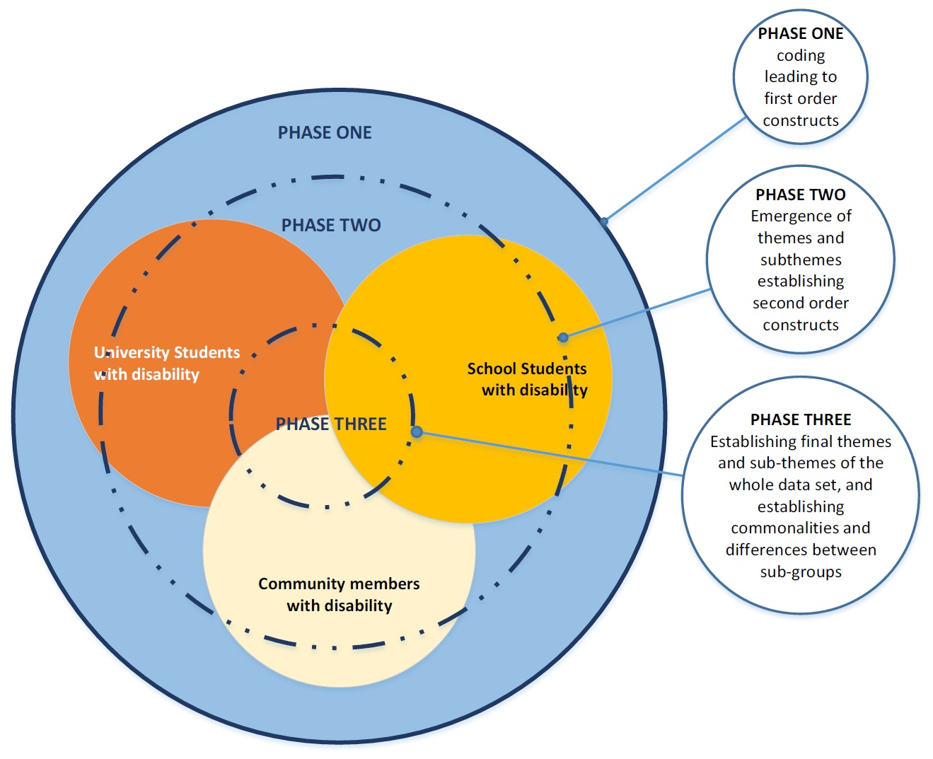

Figure 1: Three phases of analysis
Table 3 provides an overview of the data analysis that is described in detail below.

Table 3: Phases of data analysis
Phase of data analysis | Data set | Researchers | Strategy
One: initial coding of each interview text | 48 USWD texts  15 CPWD texts  9 SSWD texts | Five researchers, one researcher from each partner university completed initial coding for their university’s data | - Code according to research questions  - Broad nodes and example provided by lead researcher
Two: analysis of each subpopulation data set | USWD data set  CPWD data set  SSWD data set | Two researchers analysed each subpopulation data set (i.e. three pairs of researchers) | - Refine categories by searching for similarities and duplicates  - Group categories to form emerging themes for each set
Three: analysis of the entire data set | Entire data set | The lead qualitative researcher combined all data sets and created a condensed thematic analysis. Three researchers progressed the analysis through further discussion, writing, and re-writing. | - Refine themes and subthemes  - Identify commonalities and differences across groups
Note: USWD: university students with disability; CMWD: community members with disability; SSWD: school students with disability.

Phase One – Analysis of individual interview texts.
Each university partner performed an initial coding of the interviews conducted by their university. In Phase One, each interview was entered into an NVivo project and coded. The lead qualitative researcher developed broad nodes which were related to each of the qualitative research questions. The lead qualitative researcher shared the coding of the interviews conducted by CSU with the other researchers. Thus, the lead qualitative researcher’s coding provided an example and initial coding structure. Researchers from the partner universities used the lead qualitative researcher’s nodes and also added additional nodes for previously uncoded material found from within their interviews.
Phase Two – Analysis by sub-population.
Two researchers analysed the combined NVivo projects for each sub-population. That is, a pair of researchers analysed the university students with disability project, another pair analysed community members with disability data, and a third pair analysed school students with disability data. During this analysis, the two researchers met regularly and discussed analysis, combining and collapsing nodes to attain a shared understanding of the categories and subcategories that related to each sub-population.
Phase three – Analysis of whole data set.
In phase three the lead qualitative researcher analysed the whole data set by combining the analyses from Phase Two. In this final phase, codes and categories from the previous phases were combined and collapsed to form a more condensed and focused thematic analysis. Congruent with qualitative approaches writing informed the final analysis. During this final phase, three researchers finalised analysis through writing and discussion about the themes and subthemes. This approach enhanced rigour and facilitated the researchers to further test and illuminate the interpretation.

Rigour and Trustworthiness
Study Two employed a number of strategies to enhance rigour and trustworthiness of the research, including triangulation. Data source triangulation (e.g. collection of data from multiple sources) was used to gain multiple perspectives and thus a better understanding of the phenomenon (Patton, 2002). Researcher triangulation (e.g. participation of multiple researchers) was used to enhance researchers’ reflexivity by facilitating consideration of the text from alternative perspectives and scrutiny of researchers’ decision-making and rationale (Liamputtong, 2013). Attempts were also made to incorporate variation and diversity into the sample of research participants by purposefully sampling within each university across a range of disability categories. Finally, a rich and thick description of the experiences of people with disability is incorporated into the qualitative findings chapter, with themes and sub-themes supported by participant’s excerpts. These strategies also enhance credibility and transferability and allow understanding gained from research findings to be relevant to a broader context and group of readers (Merriam, 2002).

3. Survey Findings of University Students with Disability
This section details the findings arising from the survey. First, the demographic, disability and academic profiles of the respondents are detailed to provide readers with an understanding of the participants in Study One. The second part of this section details findings associated with student decision making for higher education study, the impact of disability on students’ current course of study and concerns about completion of their current course of study. The final part of this section reports findings on student resilience, career optimism, self-advocacy characteristics of respondents, and the usefulness of adjustments.

Demographic Profiles of Respondents
Nearly three quarters of respondents were female (N = 470: 73% female, 26% male, 1% other). According to the Australian Statistical Geography Standard (ABS, 2012), 61% of the students lived in either inner regional or outer regional areas. Figure 2 shows the respondents’ geographic location by postcode.
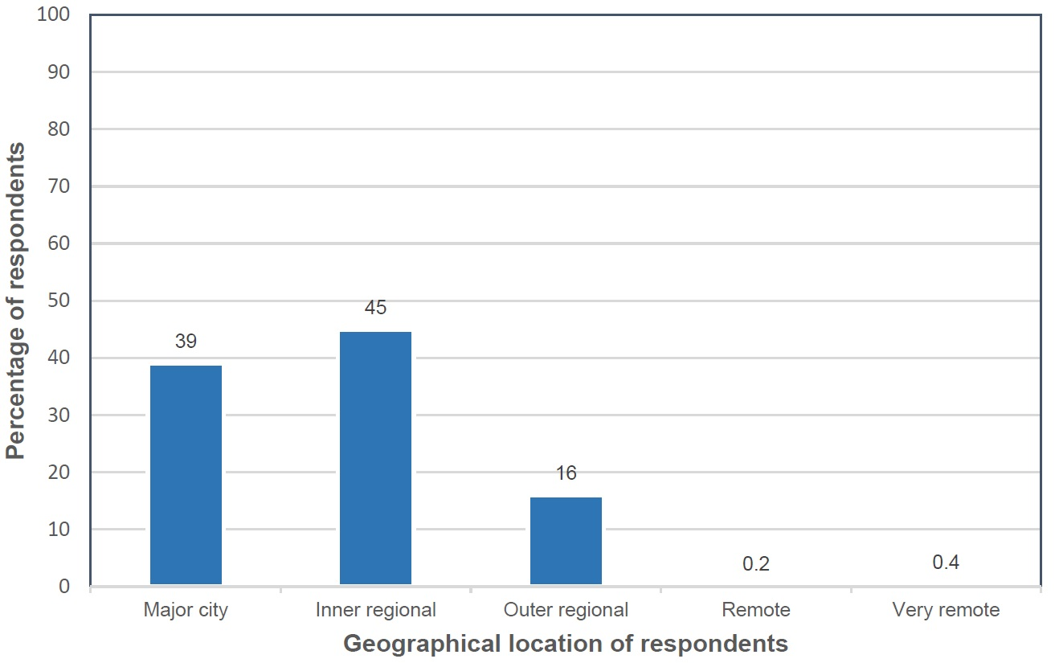

Figure 2: Geographical location of respondents by postcode (N = 460)

The majority of students (74%) were mature (i.e., over 24 years), with the mean age of the student sample being 36 years (S.D. = 13.4) (Figure 3).
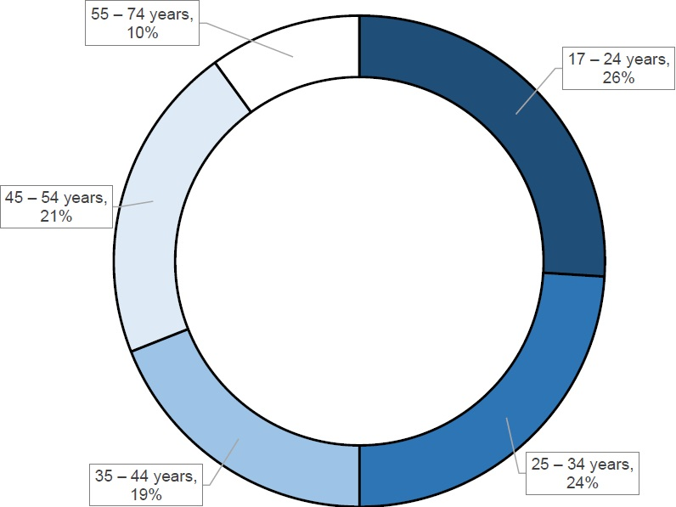

Figure 3: Age of respondents (N = 454)

Three percent of the students were from Aboriginal or Torres Strait Islander background (n = 15). Fifty-two percent of students were not employed (N = 470). Appendix D1 provides a summary of the respondents’ age, ethnicity, employment status, highest level of education of primary carer and income.
More than half of recent school leavers (17-21 year olds) indicated that their primary carer had completed post-secondary school university level study, with more than a third (34%) having completed university courses and 23% with a Trade or TAFE qualification. (Figure 4).
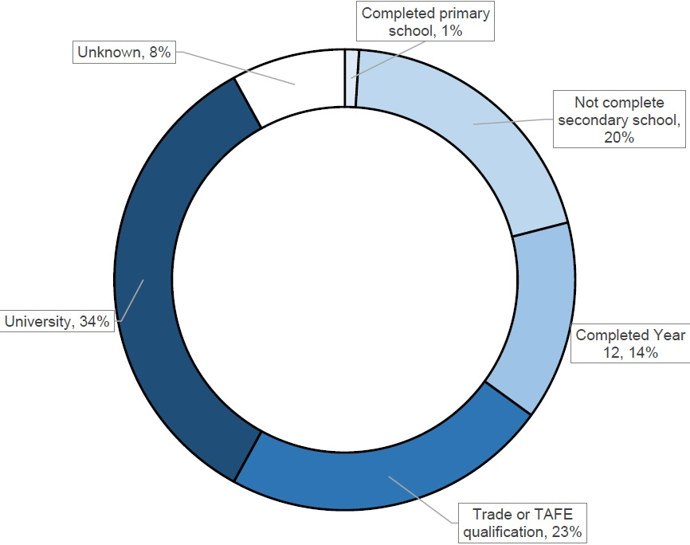

Figure 4: Highest level of education of primary carer of recent school leavers (N = 74)

Socio-economic advantage and disadvantage
The Index of Relative Socio-economic Advantage and Disadvantage (IRSAD) provides a broad general measure of advantage and disadvantage based upon a respondent’s postcode as defined by the ABS (2013) “relative socio-economic advantage and disadvantage in terms of people’s access to material and social resources, and their ability to participate in society”. A low score indicates greater disadvantage and a lack of advantage. The ABS has categorised Australia into ten deciles of relative socio-economic advantage and disadvantage. Figure 5 shows the respondents IRSAD score by ABS defined decile.
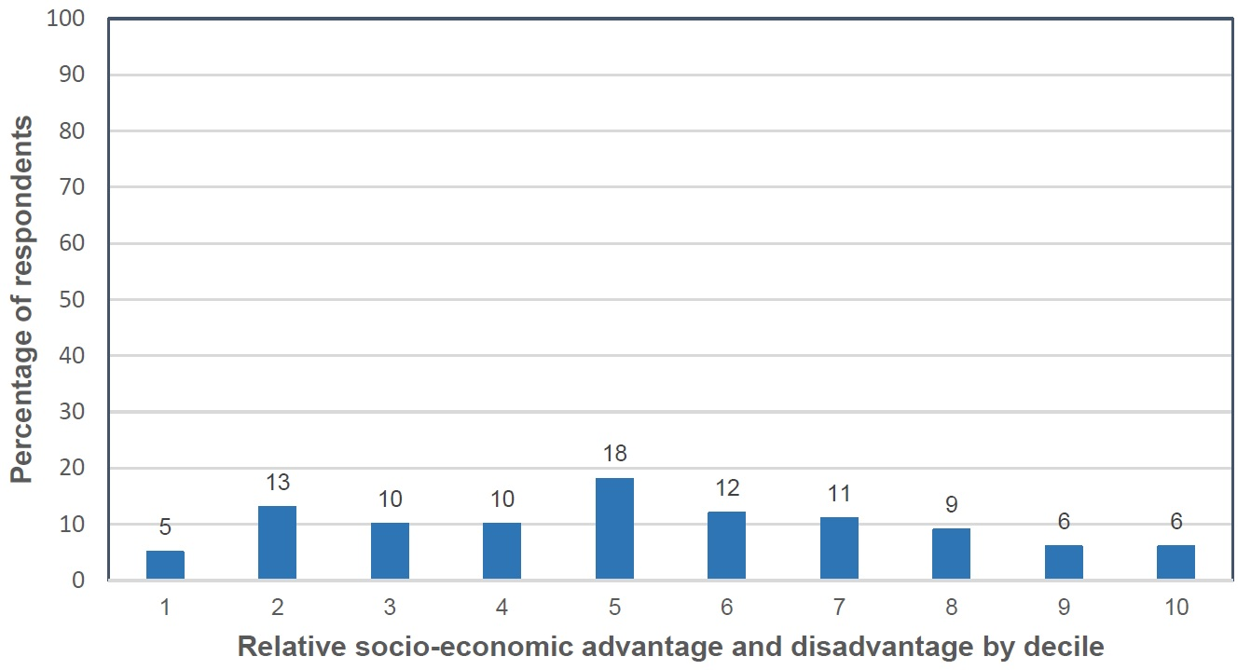

Figure 5: IRSAD score of respondents by ABS defined decile (N = 460)

Geographical location and socio-economic advantage and disadvantage
A difference in mean IRSAD scores (and deciles) was found between respondents from major cities and from combined regional areas with major cities scoring higher with a decile of 7 compared with combined regional areas scoring a decile of 4 (Table 4).

Table 4: Respondent geographical location and mean IRSAD scores (N = 460)
Regionality | Mean IRSAD score | IRSAD decile
Major cities | 1017.0646 | 7
Combined regional areas | 963.0296 | 4

Pairwise tests were performed and no relationship was found between disability, IRSAD and regionality. Therefore, no modelling was performed.

Disability Profiles of Respondents
The most common primary disability was a mental health condition (39%) and the second most frequently reported primary disability was a medical condition (20.5%) (Figure 6).
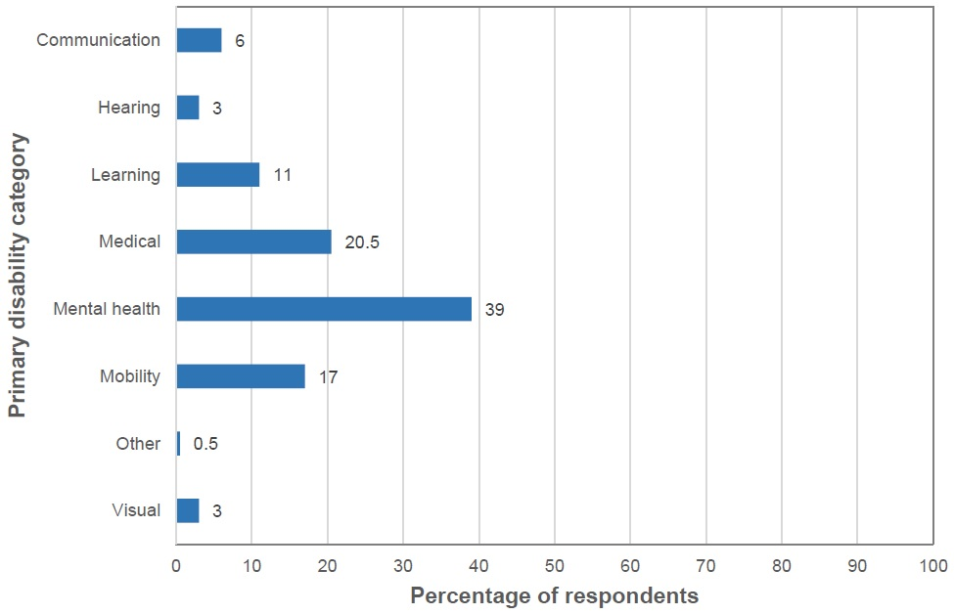

Figure 6: Category of respondent’s primary disability (N = 469)

Participants with a communication disability were younger on average than students with another category of disability and this was a statistically significant difference (H = 33.7, df = 6, p < 0.01). Students with a communication disability were on average between 22 to 24 years old, compared to students with another type of disability, who were on average 36 years old (Appendix D2).
Seventy-eight percent of participants reported their disability was permanent (N = 478), 3% reported experiencing a temporary disability and 19% were unsure about the permanency of their disability. Most respondents (74.5%) had experienced disability for more than five years (Figure 7).
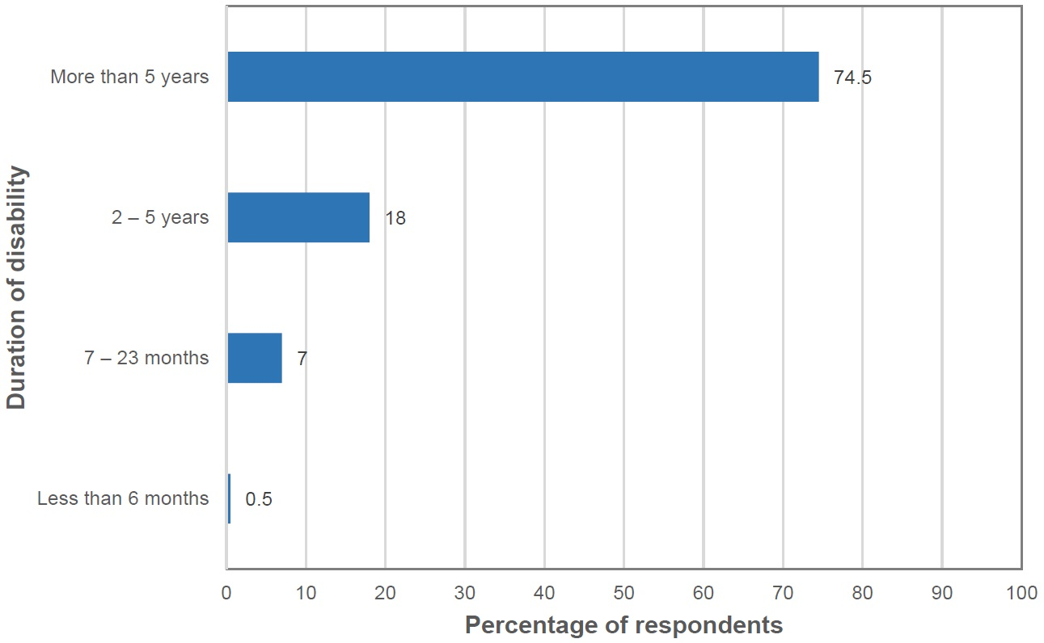

Figure 7: Duration of disability (N = 478)

Eighty-seven percent of respondents (N = 521) reported that the onset of their disability occurred prior to enrolment in their current course of study. Figure 8 shows the percentages of respondents in each disability category whose disability began after their enrolment in their current course of study. No significant difference was found between disability categories.
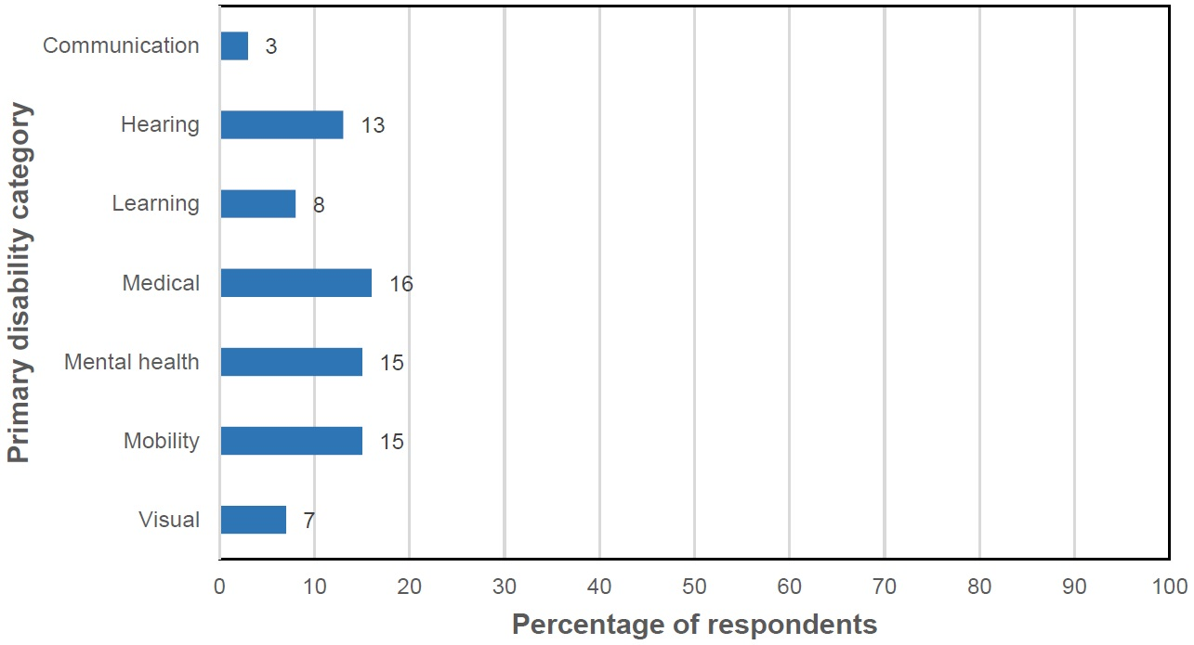

Figure 8: Onset of disability after enrolment in current course of study by disability category (N = 521)

Prevalence of secondary disabilities
Forty-one percent of respondents (n = 197) reported that they had more than one disability (N = 479). Figure 9 shows the percentage of respondents in each of the primary disability categories who reported a second disability. Higher proportions of students with primary medical disability, mental health conditions, and mobility disability reported having a secondary disability compared to students with communication, visual, hearing, or learning disability (χ² = 14.875, df = 6, p< 0.05). The most common secondary disabilities were: mental health disability (36%), medical disability (30%), mobility (15%) and learning (9%) (Appendix D3).

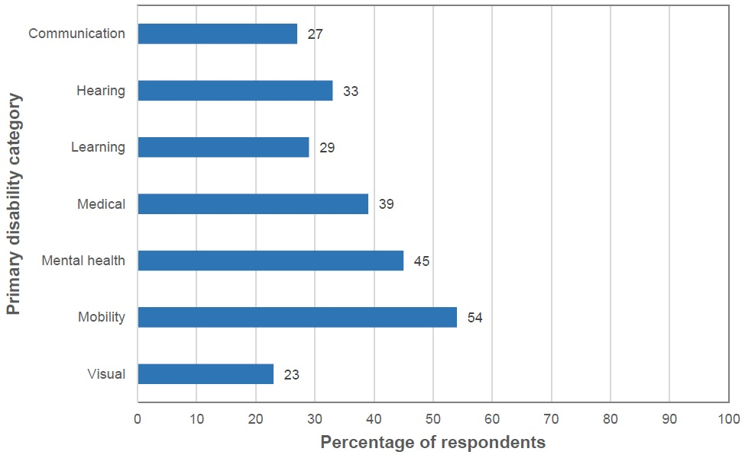

Figure 9: Proportions of respondents who reported a secondary disability by primary disability
category (N = 194)

Academic Profiles of Respondents
Respondents’ broad areas of study were categorised using the Australian Standard Classification of Education (ABS, 2001). Where students indicated a joint degree, these were categorised as a ‘mixed field’ program. Nearly a third of respondents (32%) were undertaking study under the category of Society and Culture (Figure 10). Other popular fields of study included Creative Arts (13%), Education (13%), Management and Commerce (12%), and Health (11%).
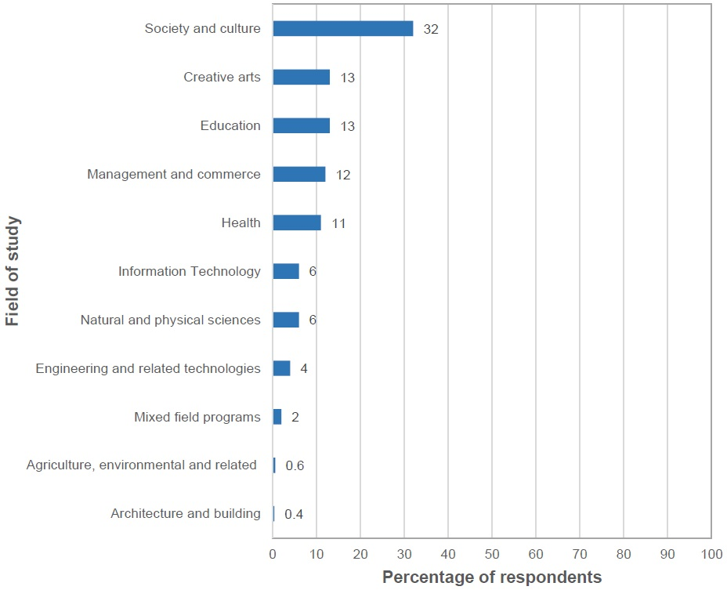

Figure 10: Broad study areas of respondents (N = 477)

Respondents (N = 517) were almost evenly divided between full time (51%) and part-time (49%) enrolment. Forty-five percent of respondents were completing their study online (Figure 11).
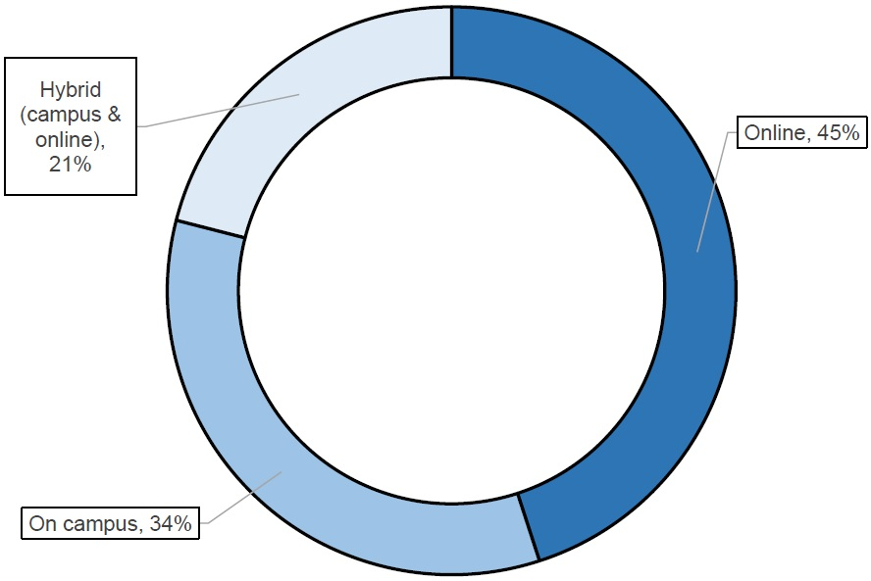

Figure 11: Mode of study (N = 520)
Figure 12 shows the pre-entry qualifications of respondents.

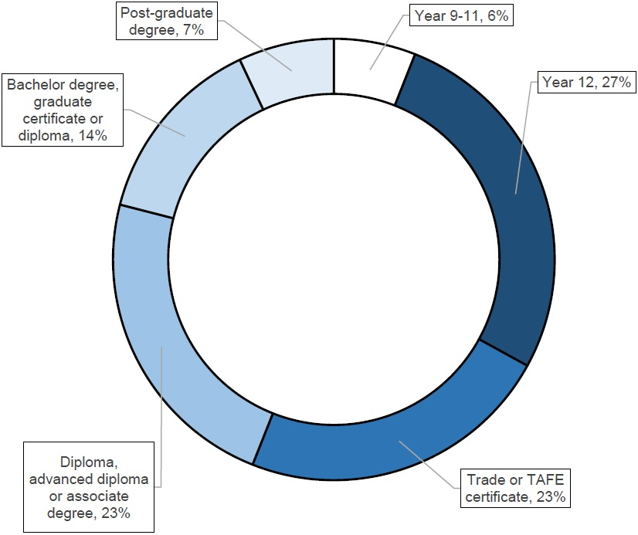

Figure 12: Pre-entry qualifications of respondents (N = 519)

Making Decisions for Higher Education Study
There was a lack of consensus about whether the presence of disability impacted a respondents’ decision to attend university (Figure 13).

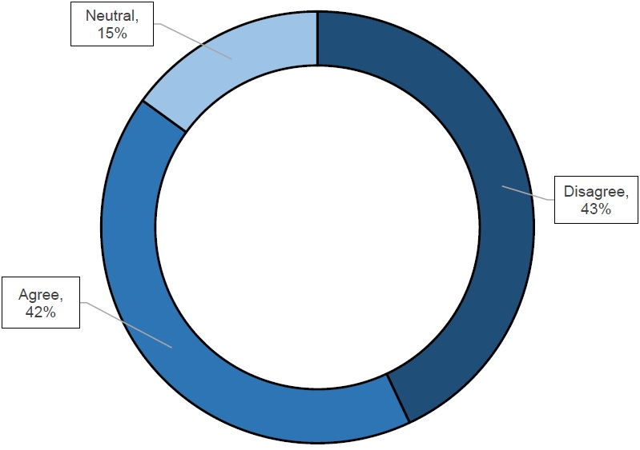

Figure 13: Impact of disability upon respondents’ decisions to attend university (N = 437)

The respondents ranked the ability of the university to appropriately address students' learning needs and accommodate disability as important. A high level of importance was recorded by students in every disability category (Figure 14). In Figure 14 the grey line denotes the mean (3.9) of all respondents (N = 430).
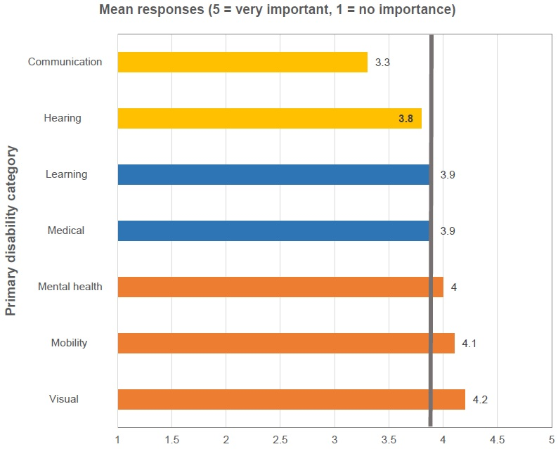

Figure 14: Influence on decision-making to attend university according to the university ability to appropriately address students' learning needs and accommodate disability (N = 430)

Parents (44%) and partners (40%) were rated the most influential people to affect a respondent’s decision to enrol in their current course of study. In contrast, only 6% of respondents rated high school staff as influential upon a decision to attend university (Figure 15 and Appendix D4).
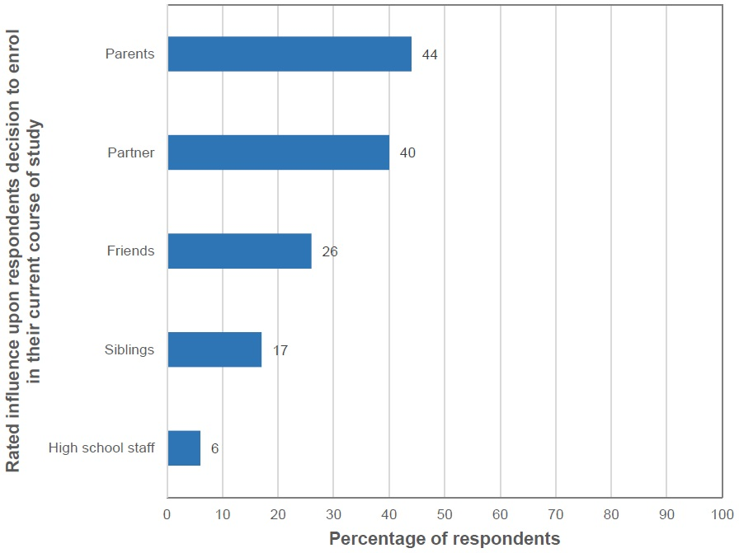
Parent (s)/ primary caregiver (N = 307); Partner (N = 248); Siblings (N = 299); High School staff (N = 243); Friends (N = 335).

Figure 15: Influences on respondents’ decisions to enrol in their current course of study
according to social relationships

The majority of school leavers (17- 21 year olds) disagreed or were ambivalent about the influence of high school upon decision-making to attend university (Figure 16). In particular, only 29% of school leavers agreed that staff actively encouraged them to pursue their current course of study.
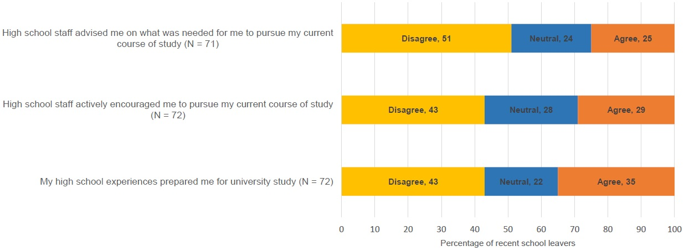

Figure 16: School leaver responses (17 – 21 year olds) to statements regarding the influence of high
school upon decision-making to attend university

The importance of a range of university factors on respondents’ decisions to enrol in university are reported in Figure 17 and Appendix D5. The majority of respondents agreed that the following were important factors in their decision-making: the course aligned with their career choices (82%); flexible study options were available (74%); location of the course (70%); high quality of teaching (68%); and, the ability of the university to appropriately address their learning and disability needs (67%).
Few students identified the following as important to their decision to enrol at university: contact with students currently studying; lower academic entry requirements (in comparison to other universities); high school staff recommended the university; friends were studying at the university; and the quality of the sports and recreational facilities.
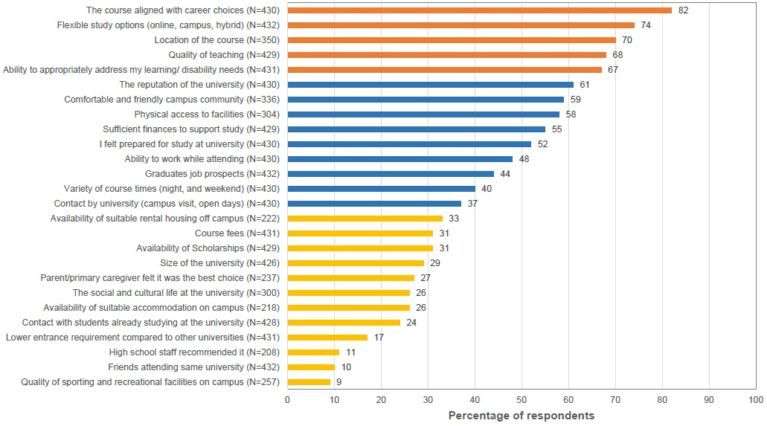

Figure 17: The importance of a range of factors on respondents’ decisions to enrol in a particular university

Impact of Disability on Current Course of Study
Students were asked to indicate how much their disability impacted upon five major areas of university participation: their program of study, their ability to learn, their ability to remember, their ability to concentrate and the physical environment. As can be seen in Figure 18 the majority of respondents considered that their disability impacted their levels of concentration, program of study, and ability to learn and remember, however less consensus was found about the impact of their disability on the physical environment. Please note that to aid clarity the scores of strongly disagree and disagree were combined for Figure 18.

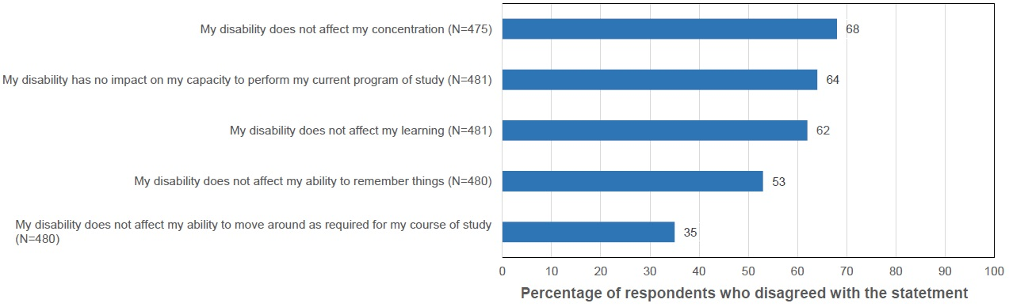

Figure 18: Level of respondent disagreement with statements about the impact of their
disability upon academic study

Further analysis by disability category was performed to assess differences between disability categories. These are provided below.

‘My disability does not affect my concentration’
There were statistically significant differences between disability groups in their ratings of how much their disability affected concentration (H= 47.018, df = 6, p<0.01) in a two-sided test. Respondents with learning disability and mental health disability reported being most adversely affected by difficulty concentrating, with mean Likert ratings of 1.8 and 1.9, respectively. Loss of concentration was reported as being least affected by student with hearing and visual disability with means of 3.1 and 3.4, respectively (Figure 19, Appendix D6). In Figure 19 the grey line denotes the mean (2.2) of all respondents (N = 475).
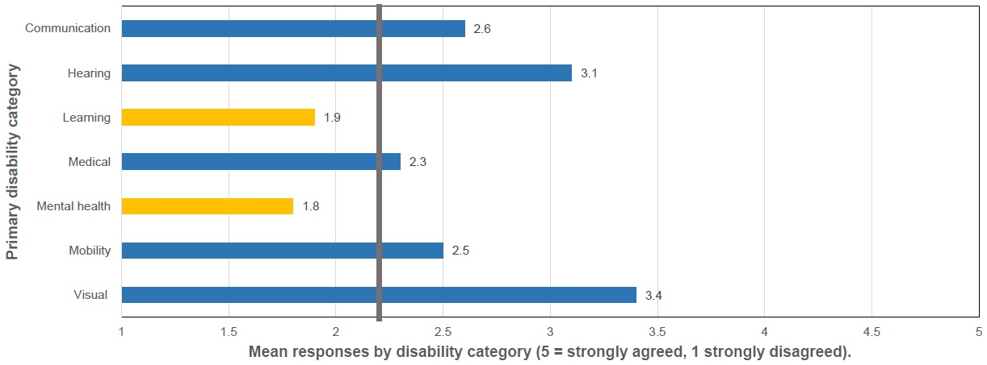

Figure 19: Impact of disability upon concentration (N = 475)

‘My disability has no impact on my capacity to perform my current program of study’
All students with disability indicated that their disability impacted on their capacity to study, as indicated by low agreement with this item (Figure 20). Respondents with mental health disability and learning disability were least likely to agree that there was no impact of their disability on their performance. That is, these students considered their performance was significantly affected by mental health disability or learning disability. The difference between those most impacted and least impacted was statistically significant in a two-sided test (H = 22.123, df = 6, p< 0.01). In Figure 20 the grey line denotes the mean (2.2) of all respondents (N = 481).

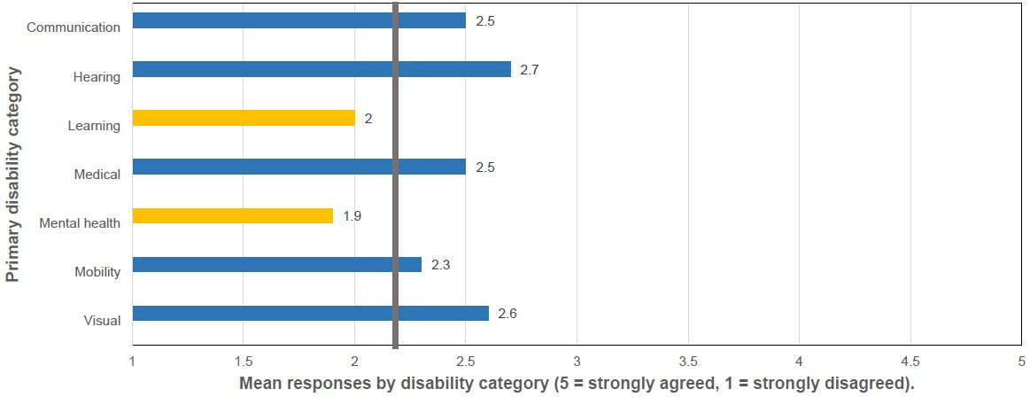

Figure 20: Impact of disability upon current program of study (N = 481)

‘My disability does not affect my learning’
Respondents with learning disability and mental health disability agreed that their disability affected their learning more than respondents with other types of disability. Respondents with learning disability and mental health disability had mean Likert scores of 1.8 and 2, respectively (Figure 21). Respondents with visual disability reported the least effect on their learning, with a mean Likert score of 3.4. The difference between groups was statistically significant in a two-sided test (H= 42.304, df = 6, p<0.01). In Figure 21 the grey line denotes the mean (2.4) of all respondents (N = 481).

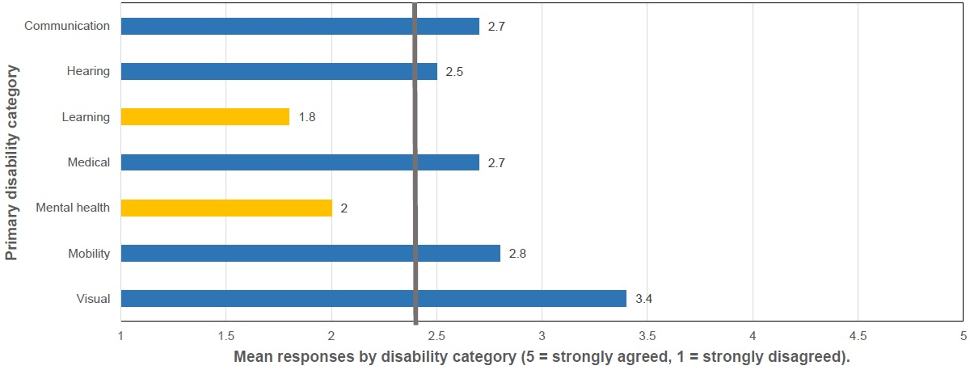

Figure 21: Impact of disability upon learning (N = 481)

‘My disability does not affect my ability to remember things’
A high Likert rating on this item means strong agreement that a respondents’ disability does not affect memory. Respondents with learning and mental health disability rated this item lowest compared to other disability categories, with 2.1 and 2.2 means respectively (Figure 22). Thus, people with learning disability and mental health disability reported finding difficulty with their ability to remember. In contrast, those with a visual disability did not report having difficulty remembering (H= 53.679, df = 6, p<0.01). In Figure 22 the grey line denotes the mean (2.6) of all respondents (N = 480).

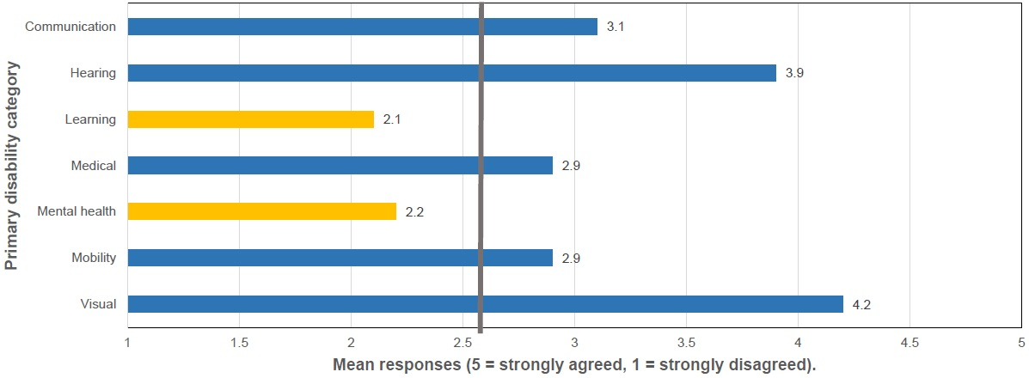

Figure 22: Impact of disability upon memory (N = 480)

‘My disability does not affect my ability to move around as required for my course of study’
There was a statistically significant difference between students with a mobility disability and students with other types of disability related to ability to move around on campus (H= 50.954, df = 6, p<0.01) in a two-sided test. Respondents with a mobility disability had the lowest agreement with this item, with a mean of 2.4 (Figure 23). That is, students with mobility disability found it difficult to move around as required for their course of study. The only respondents to report strong agreement (that is, no difficulty moving around) were respondents with learning disability, with a mean of 4.1. In Figure 23 the grey line denotes the mean (3.3) of all respondents (N = 480).

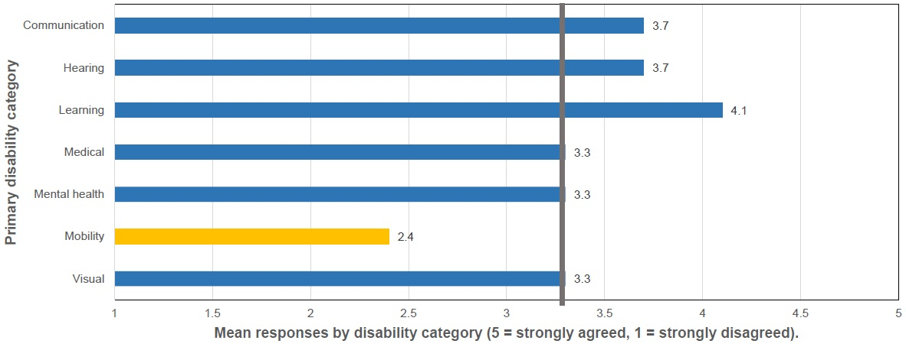

Figure 23: Impact of disability upon ability to move around as required for current
program of study (N = 480)

Concerns about Completion of Current Course of Study
Students with disability were concerned about their ability to complete their study. The majority, 73% of respondents stated that they had concerns about not being able to complete their current course of study (N = 477). Students’ concerns about completion of their course of study were not statistically significantly different by IRSAD, or across broad categories of study. That is, apprehension about completion was universal, there were no differences in disquiet about completion at different levels of social advantage, or among courses.
Examination by category of disability revealed that concerns about completion were not distributed evenly across the sample and there was a statistically significant difference (χ² = 45.433, df = 6, p<0.01). The disability categories with the highest proportion of fearful respondents were mental health disability (87%) and learning disability (80%). In contrast, 31% of people with visual disability and 40% of those people with hearing disability were worried (Figure 24).
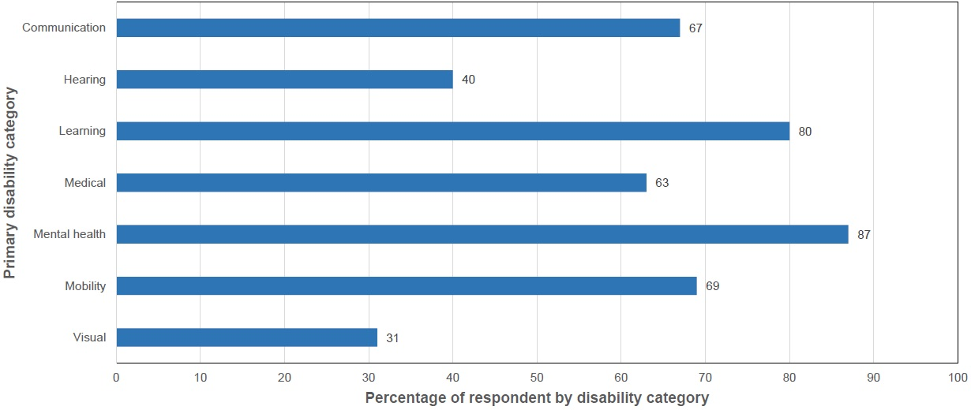

Figure 24: Concerns about completion of current course of study by disability category

Extended leave from current course of study
A quarter of respondents (n = 130) reported that they had left their current course of study for an extended period of six months or more. The reasons, reported in open ended responses, for taking extended leave from their current studies were found to be due to ill health and impairment, difficulty managing competing priorities, personal reasons, and problems with university contexts (Table 5). It is important to note that some students identified more than one reason why they took leave from studies.

Table 5: Reasons for extended leave from current studies: Ranked order for an extended period of leave from study
Rank | Reason
1 | Health and impairment (n = 87)  It was not possible to separate additional health issues and those related to a respondent’s current disability or impairment
2 | Difficulty managing competing priorities (n = 41)  e.g. family commitments, academic workload, employment & other personal commitments
3 | Personal reasons (n = 17)  e.g. multiple personal issues, unprepared for study, lack of finances, lack of confidence in academic ability, homelessness, domestic violence
4 | Issues experienced at university (n = 5)  e.g. accessibility barriers, negative experiences at university, poor support from university, low enjoyment of student life
N. B. some respondents gave more than one reason

Resilience
Resilience was measured using the shortened Connor-Davidson Resilience Scale (CD-RISC-10) and was scored according to the authors’ advice (Connor & Davidson, 2003). The mean score for the student cohort was 22 (N = 473). Resilience was not associated with statistically significant differences according to IRSAD (S = 14629, rho 0.03679071, p = 0.4362). Similarly, there was no significant relationship between resilience and regional-remoteness (H= 4.1, df=4, p=0.386), level of education (H= 3.39, df = 5, p = 0.63), study mode (H= 1.45, df = 2, p = 0.48), or course of study (H= 10.6, df = 7, p = 0.16). There was also no difference in resilience between students who were registered with a disability liaison officer or not (H = 1.3564, df = 1, p = 0.24), or whether students had an additional disability (H= 1.9932, df = 1, p = 0.15).
Mean scores of the CD-RISC-10 were calculated for respondents’ primary disability category (Figure 25). The grey line denotes the mean (22) of all respondents.

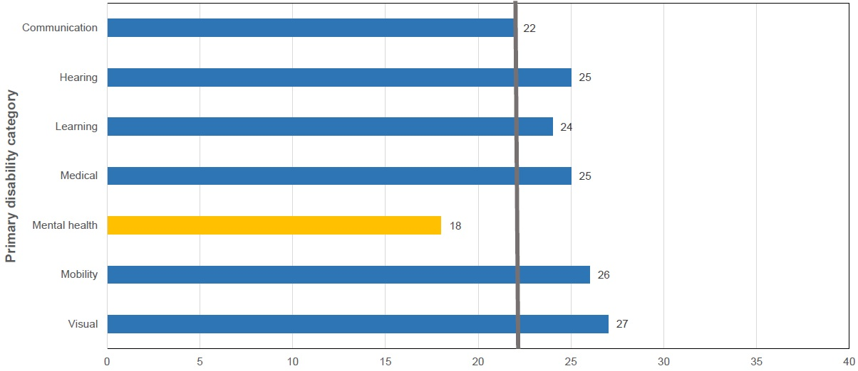

Figure 25: Connor-Davidson Resilience Scale: Means of disability categories

There were statistically significant differences between students with mental health disability and all other categories of disability (H = 76.95, df = 6, p<0.01) in a two-tailed test. Self-reported resilience of students with a mental health disability as measured using the CD-RISC-10 was lower than for students with communication, hearing, learning, medical, mobility and visual disability. Students with communication disability also had significantly lower self-reported resilience as measured by the CD-RISC-10 when compared to students with medical, mobility and visual disability.

Career Optimism
Career optimism was measured using a subscale of the Career Futures Inventory (Rottinghaus, Day & Borgen, 2005). Career optimism total scores could range from 11 to 55. The mean score for the student cohort was 37.1 (N = 445).
Mean scores of the Career Futures Inventory were calculated for respondents’ primary disability category (Table 6). Self-reported career optimism of students with communication disability as measured using a subscale of the Career Futures Inventory, was lower than for students with mental health, hearing, learning, medical, mobility, and visual disability. Students with a communication disability also had significantly lower career optimism when compared to students with hearing, medical, mobility and visual disability.

Table 6: Career optimism: means of primary disability categories
Primary disability category | Mean score of career futures inventory
Communication | 34.0
Hearing | 39.5
Learning | 36.6
Medical | 38.4
Mental health | 35.5
Mobility | 38.4
Visual | 40.3

Self-advocacy Characteristics of Respondents
Ninety-three percent of respondents were registered with their university’s disability service (Figure 26). However, it is important to note that every university primarily used their disability service to inform students with disability about the survey and to issue survey invites. Although this strategy was augmented by university social media channels, this level of registration may not be a typical representation of the student with disability population.

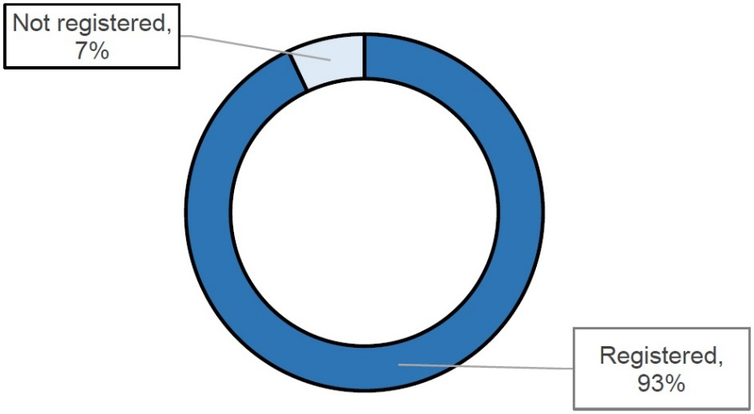

Figure 26: Percentage of students registered with their university’s disability service (N = 427)

Seventy-three percent of respondents had registered with their university’s disability service within the first year of their current course of study (Figure 27).

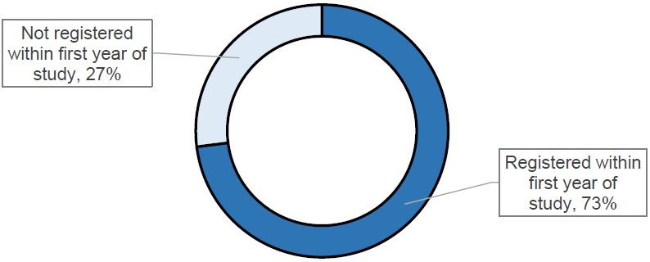

Figure 27: Percentage of students who registered within their first year of study (N = 422)

Of the 50 participants who had not registered with their university’s disability services, 47 participants provided additional information about why they were not registered. Three themes were identified by content analysis and are summarised in Table 7.

Table 7: Reasons respondents were not registered with their university disability service: Why aren't you registered with your universitiy's disability service? (N = 47)
Reason | Example

In the process of registering (n = 4)
Personal reasons  (n = 23) | e.g. not required, keep missing the appointments, dislike of acknowledging disability, hadn’t thought about it
University based reasons  (n = 26) | e.g. lack of information/knowledge about the service, too much paperwork, negative experiences with service, too hard/stressful, complexity of the process
N. B. Some respondents gave more than one reason, thus numbers do not add up to 47.

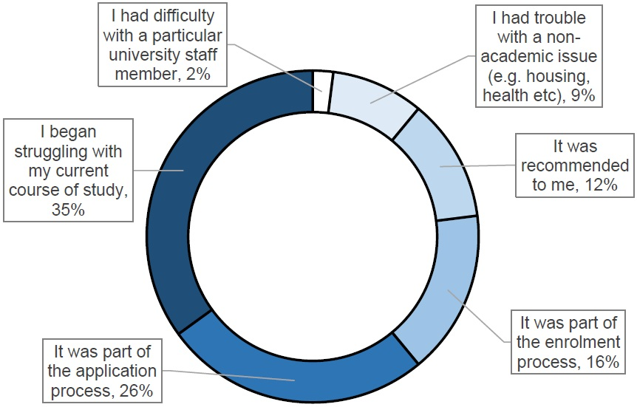

Figure 28: Factors that prompted the respondents to register with their university’s
disability service (N = 490)

On average, respondents contacted their university’s disability service four times per year. Seventy-eight percent of respondents felt that they had sufficient contact with their university’s disability service and 28% indicated they had insufficient contact (Figure 29).

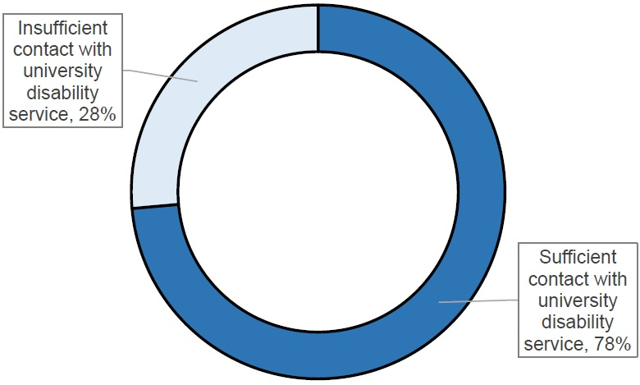

Figure 29: Sufficiency of contact with university disability service (N = 420)

Notification to other university staff members of the need for adjustments due to disability
The majority of respondents had notified both academic support services staff (57%) and teaching staff (54%) of the need for adjustments due to their disability. In contrast, one fifth of respondents had notified administrative staff (20%) and support staff (20%) about the need for adjustments due to their disability.

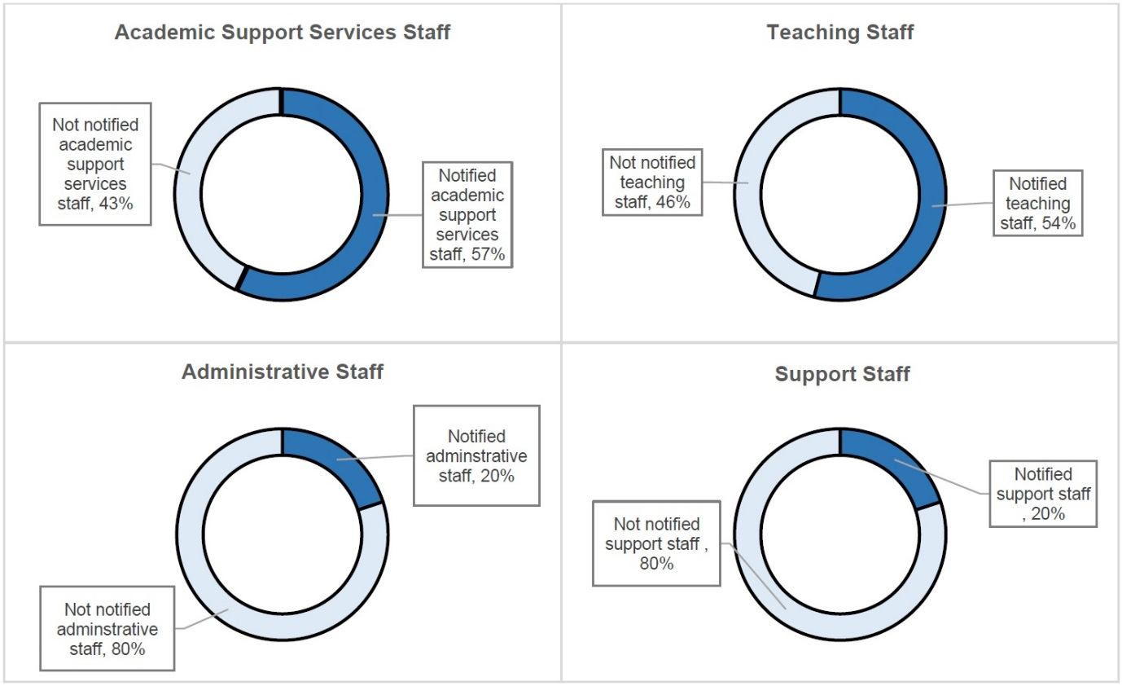

Figure 30: Notification of need for adjustments to university staff (N = 521)

Nearly one fifth of respondents reported that a university staff member had refused to provide them with reasonable adjustments for their disability (Figure 31).

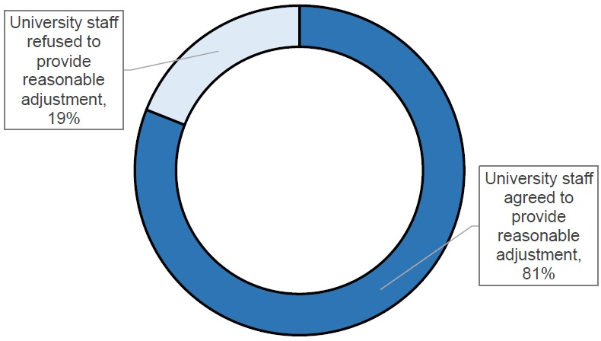

Figure 31: Provision of reasonable adjustment by university staff members (N = 417)

Usefulness of Adjustments
Respondents were asked to rate the usefulness of the adjustments they had received in the previous year. The only types of adjustments that were rated by more than 200 respondents were extensions of assignment due dates and alternative exam arrangements. The majority of students rated these adjustments as useful: 91% rated alternative exam arrangements as useful and 88% rated extension of assignment due dates as useful. Table 8 displays further detail of the usefulness of these two adjustments by disability categories.

Table 8: Usefulness of alternative exam arrangements and extensions of assignment due dates by disability category
Disability category | n | % rated as useful

Alternative exam arrangements (N = 289)
Communication | 15 | 93
Hearing | 8 | 62
Learning | 33 | 85
Medical | 51 | 92
Mental health | 108 | 93
Mobility | 51 | 94

Extensions of assignment due dates (N = 282)
Communication | 17 | 94
Hearing | 6 | 50
Learning | 31 | 84
Medical | 50 | 88
Mental health | 121 | 95
Mobility | 48 | 79

Usefulness of adjustments for students with communication disability
There was consensus among students with communication disability who used note takers (n = 4) and participation assistants (n = 2) with all respondents to this question stating that these adjustments were useful. In addition, three of four students who used library assistance found it useful. Small numbers of respondents with communication disability used other adjustments (e.g. loan of assistive technology equipment n = 5, transcription of subject material n = 3, assistance required at residential school n = 3, and access to buildings n = 3)) but there inconsistency about the usefulness of these adjustments.

Usefulness of adjustments for students with hearing disability
All students with hearing disability who used adjustments in the past year rated them as useful, including: note takers (n = 4), other services (n = 3) and Auslan interpreters (n = 2) found them useful. In addition, five of six students who used transcription of subject material, three of four students who used library assistance, and two of three students who used live captioning, found these adjustments useful.

Usefulness of adjustments for students with learning disability
Eight out of ten students with a learning disability who used loaned assistive technology equipment and software found this adjustment useful. Six of ten students found referral to other services useful and six of eleven students found library assistance useful. Three of five students did not find assistance with workplace learning to be useful. There was inconsistency in rating of usefulness of other adjustment including: transcription of subject materials (n = 11), participation assistant (n = 6), access to buildings (n = 5), note taker (n = 5), live captioning (n = 4) and priority for on-campus accommodation (n = 4).

Usefulness of adjustments for students with medical disability
Six out of eight students with medical disability reported that assistance at residential schools was a useful adjustment. However, no consensus was found in the usefulness of other adjustments including: library assistance (n = 19), assistance for workplace learning (n = 13), referral to other services (n = 12), access to buildings (n = 12), transcription of subject materials (n = 11), loan of assistive technology equipment and software (n = 10), participation assistant (n = 8), note taker (n = 6) and priority for on-campus accommodation (n = 6).

Usefulness of adjustments for students with mental health disability
Half of those respondents with mental health disability found referral to other services (n = 58), library assistance (n = 29), access to buildings (n = 18), assistance with workplace learning (n = 16), transcription of subject materials (n = 12); and loan of assistive technology equipment and software (n = 12) useful.

Usefulness of adjustments for students with mobility disability
The majority of students with mobility disability found the following useful: assistance at residential school (n = 13), access to buildings (n = 23), referral to other services (n = 17), loan of assistive technology equipment and software (n = 13), assistance with workplace learning (n = 10) and participation assistant (n = 5). However, no consensus was found in the usefulness of other adjustments including: library assistance (n = 14), transcription of subject materials (n = 8), note taker (n = 6), assistive technology room access (n = 5) and priority for on-campus accommodation (n = 6).

4. Qualitative Findings from Interviews
This section reports findings from Study two. Congruent with the reporting of qualitative research, these findings are presented with excerpts from the data. Decision making and the influences on people with disability’s decisions regarding university study is the focus of the first part of this section. Following this is material that describes the complex environment experienced by students with disability and the multiple interdependent elements they juggle in order to participate. The final part explores the Universities response to these students needs through the experiences of students with disability.

Influences on Decision Making
Commonly, the participants who were university students reported that they would encourage other people with disability to try attending university. For example, Charles (university student) said he would advise others to “just give university a go”. Brigit (university student) similarly recommended that attending university provided a sense of achievement and enabled social connections: “Do it! It is amazing how good you feel when you get through an exam or assignment. And you will improve your health just by learning more and mixing with others.” However, even though university is clearly a valuable experience for many people, decision-making about attending university was a complex and individualised process.
There appeared to be two broad areas of influence that interacted to sway a person with disability to engage in university study: a perception that the experience of attending university could contribute to personal development; and the right conglomeration of circumstances to support a decision to enrol at university. There was one broad category that generally dissuaded a decision to attend university, which was doubt in one’s capacity to meet the challenge of academic work or to endure the experience of attending university. It also appeared that previous educational experiences were influential upon decision-making. However, there was no orthodoxy or common relationship about how prior experiences affected future behaviour.

It’s About My Personal Development
So it’s just been like a success spiral. Everything is escalating, but it’s getting better and better and better. I’ve been able to work, to improve my anxiety disorders, and now they’ve made me a meet up leader, and I’m working on a project. It’s really incredible. I don’t want it to stop, it’s incredible. It’s the most amazing thing. I can actually stand up in front of a whole classroom full of people now, and I never could do that, ever. It’s amazing. It has been very good, and it’s really helped me to manage my disorders very, very well, and to lower my social anxiety. Everything is improving very well, and so it’s just the best thing I ever did. (Susan, university student)
The participants were motivated to make a decision to enrol at university according to four key reasons: 1) they enjoyed and valued the process of learning; 2) they wanted to meet new people; 3) they wanted to advance their career opportunities; and 4) attending university provided the opportunity for them to meet a challenge and develop personal characteristics. Thus, these perceived benefits of attending university persuaded participants to take the step of applying for university entry.
Learning is enjoyable and important
Participants felt inspired to attend university because they appreciated learning as an activity in its own right. For many, the study aspect of university was greatly appealing. “I’ve always wanted to attend university. I have a passion for learning. I love to learn stuff. I love to learn new things. I love the experience of learning, and I like teaching people the things that I learn” (Mark, university student). Deborah (university student) valued the sense of authentication through successfully completing university work: “It’s incredibly validating for me because I’m doing very well. I’m sitting on a GPA [grade point average] of six so I’m happy with that. Yeah, it’s incredibly validating for me.”
Some participants enjoyed learning in general and others derived pleasure from their enthusiasm for their subject areas. Connor (university student) was inspired by his favourite subject: “history is my passion, and I love the fact I learn something new every day. I love the fact that I can learn from my teachers, my class mates, and they can learn from me.” Although not every topic was captivating, participants’ motivation for study was increased by choosing a course of study that they felt a zeal for.
If I find something that’s really interesting to me, I can just soak into that, and absorb into that. Just really soak it up. So that would be one of the things as well, I guess, finding those things that you’re interested in, and not everything in every unit is going to be of equal interest to you, but finding those things that you can really be absorbed in. (Megan, university student)
When thinking about whether to attend university, community people and school students reflected on their previous experiences of learning at school, TAFE, or university. For people who had previous enjoyable experiences of study, they anticipated that attending university would be agreeable. For example, Jeffery (community person) was keen to return to university and learn a new profession after having experienced a stroke because his previous experience of study had been that “I loved everything, I loved everything about studying. I loved school and I loved going to art school”.
I want to meet new and interesting people
The participants were inspired to attend university because they valued the opportunity that university provided to build new social relationships. For example, when asked what he would be looking forward to at university, Joel (school student) replied: “meeting new people”. School students, Ben and Xaviour, enjoyed the social aspects of school, and they anticipated that this sense of being with friends would be reproduced at university: “I like being able to sort of be with my friends, you know in a, in an environment where I'm, where I feel safe” (Ben, school student).
The social support provided by other students made attending university pleasurable. Enjoyment of an activity can increase motivation for ongoing and future engagement in the activity (Kielhofner, 2008).
Relationships with my colleagues. I find that really enjoyable. We’re there together, we’ve got similar things and focus in mind, and we just banter, and relationship talk about why we’re there and what things have frustrated us for the day, and what things have made us nervous. We get there at lunch time. We’ll bounce off each other in our conversations about what we’re doing… if we can all get together at the end of the day as well and talk about what’s going on. That’s helpful. (Evan, university student)
Enduring friendships may be formed at university. This is an attractive benefit for people with disability who are deciding if they will attend university: “we founded bonds out of convenience and necessity, and some of them are still my friends even now” (Patrick, university student).
Advancing my career
Participants saw the value in attending university to advance their career and future employment options. For example, Amy (university student) said, “I like doing psychology because it is helping me get into the field I want and am interested in, in the future”. Teresa’s motivation for future study arose from her desire to move into a new area of work: “I plan to return to full time studies in the near future as I am no longer satisfied with working in the administrative field. I haven’t decided what course to take yet however” (Teresa, community person).
For some participants, the limitations due to their disability meant that they needed to change career direction. For example, Gerard (university student) reported that “I had to medically retire from my former profession. And it’s not portable, I cannot use it anymore. So as I said, I’m requalifying so I can get back into the workforce and doing something else.”
Participants purposefully chose their university study to fit with their dreams of their imagined futures. For example, Evan (university student) enrolled in nursing because he could envision that this profession would give him a variety of career options and longevity that would be able to accommodate limitations due to his disability.
I don’t see myself in a hands-on role in the future, because it will be too tough on my body. I’d like to be in some sort of administration nursing type role where it’s not as hard on my body as more direct [nursing practice] would be - leadership, management nursing type role in the future. And that’s why I’ve chosen the Registered Nurse Division 1 course, because there’s career pathways, multiple options I can go down. (Evan, university student)
Mel (community person) was inspired to go to university to try and obtain employment. Ultimately she was unsuccessful in finding work. However, she did not regret undertaking university study:
I will always use the skills. I mean, yes, I'm sad that I didn't get a job in a lot of ways. I think I could have been a great employee, I honestly believe that. But, uni teaches you so much more than just you, what your degree teaches you. Had I known it was going to be impossible to get a, well pretty much impossible to get a job, I may have chosen a different field… but no I don't think I regret going, it was a great experience. (Mel, community person)
Enhancing and challenging personal traits
Participants thought about their strengths when considering potential areas for future study. For example, Nathan (community person) said “Yeah, I want to study more technology…with computers, because in Year 11, I was really good at it, I was really good at Maths and English”.
Mel (community person) had a longstanding interest in accounting and business and is a wheelchair user. When she was at school Mel was unsure that she would be clever enough to undertake university studies. In primary school she struggled to do mathematics because her disability meant that she had difficulty with handwriting and at the time she was at school there were no computer programs that supported students to do mathematics using typing. However, in high school she was given the assistance of having a helper to scribe for her, which meant that she began to excel at mathematics and she attained high grades. Mel realised that she had sufficient ability to continue with study and therefore she sought entrance to university.
I thought well, you know, I've always wanted to work, right from the age of 8, I always wanted to do something. And I thought well, accountants sit at a desk all day, so they're sitting, that deals with that side of it. I'm doing the work, I'm getting the results, I'm capable of the theoretical side of it, I might, I might look into going to uni. (Mel, community person)
Families were also influential in helping participants to identify appropriate future study options. For example, David (university student) chose a study topic and future career direction based on his and his mother’s assessment of David’s fit with the field.
I was encouraged by Mum, because we basically went together and see what best suits my personality and traits, and what we think I’m good at. And we actually figured out that surveying is good, because for an ADHD person they can move around constantly, because it’s all different locations, and so we found it more interesting. (David, university student)
Many of the participants were influenced by positive personal experiences with professionals they had encountered; these people inspired them when they chose their future careers.
I wanted to be a teacher because when I had my stroke, my teacher at that time would come down every weekend to help me. I couldn’t speak, I couldn’t do anything. This was when I was seven years old …We had to write out sums, we had to do English, and she would teach me on the weekends, everything she’d taught. I wanted to replicate that. So that’s why I chose teaching as my first degree (Robert, university student).
Some participants were motivated by the sense of challenge they perceived was inherent in the experience of attending university. Alice acquired a disability later in life, after she had been to school and completed a Bachelor’s degree. Alice returned to university after she became blind because the loss of her eyesight meant that she needed to develop new skills and a new direction from her previous career. She said “I did some arts, and mostly sociology. I didn’t complete the degree. I really think I went back to prove to myself, and maybe others, that I hadn’t lost my brains when I lost my eyesight” (Alice, community person).
Robyn (university student) was unwavering in her desire to finish her university studies because she wanted to inspire her children and she desired the satisfaction attained through completing a goal.
I’m stubborn. I kind of knew that there was a goal at the end, and I just had to, I set a commitment to myself. I’d given up a job to be able to study. And I really wanted to succeed. Nobody in my family has got a degree, but they’re all successful in their own way… So I’m the very first person to get a degree. And I wanted my boys to see that if you put your mind to it, you can achieve. (Robyn, university student)
Clearly, participants were encouraged to consider attending university due to internal motivations and perceived benefits of study. The next section describes the external factors that needed to be in place for participants to think positively about attending university.

The Right Circumstances
Having made a personal decision to attend university, the conditions that support that decision and enable it to be acted upon must also be present. If the context is not supportive, then a person with disability may not be able to action his or her decision to attend university, or the person may be forced to withdraw from university prior to completing the course of study. Circumstances that were identified as influential upon a decision to enrol in university included ability to meet the financial obligations of study, a sense that the timing of study was appropriate in the context of a person’s life, and that the university was able to provide the support needed by the person with disability.
Ability to meet financial obligations of study
The cost of university study was a consideration for participants.
I don't know all the details about what the government pays for and what the government doesn't pay for… Money would come more into it if I was living, you know, off-campus I suppose because that, that's different, you know you've got bills and stuff like that, other than just fees. (Ben, school student)
A person might desire to attend university but this dream can only become a reality if they have the means to pay the costs associated with study. Lincoln (community person) was interested to go to university but noted that he would struggle financially if this occurred.
I’m on the disability support pension so I don’t have as much access to Centrelink-based resources as someone on Austudy or Abstudy may have, such as the loan for example. And also, you know, living as an adult, so I’ve got living expenses. The other thing that comes out of that, because I can’t – well I have issues working, and therefore not working, it can get very expensive. And when you’re spending $500 on textbooks, it’s like do I pay rent or do I get textbooks? (Lincoln, community person)
Katherine’s mother provided practical support in the form of funding her daughter at university. Katherine found that this pragmatic help enabled her to experience university study as less stressful.
After discussions with my Mum, she decided that she would support me as much as she could financially, so that I could do it without working. That definitely made the first two years a lot more manageable. All I had to focus on was university. (Katherine, university student)
As illustrated in the previous excerpt, for some participants, even though there are many elements that contribute to achieving “the right circumstances”, alleviating or eliminating the pressure on one component may be enough to enable successful engagement at university.
The right timing
There was a sense that the timing of study had to be appropriate for the context of that person’s life. Sometimes even though a person had decided to attend university they were not in a position to be able to put this desire into action.
I’ve been looking at university for a while. It was a timing issue, where I was at university, just a single unit before I fell pregnant. We started a family, I was getting a bit older and so I had my baby four years ago. And it was a timing issue where I did want to go back to uni again, but just when I had the time for it. (Megan, university student)
In contrast to Megan’s (university student) experience of needing to wait until the timing was right, Mia (university student) made an opportunistic decision to attend university because her life’s happenstances created an easy entry into university for her.
I got a job straight away, and I actually ended up at the [name of a university]… and because I was working here, I thought, oh, I wouldn’t mind seeing whether I could go to university, because I was working in a university and it was all very exciting… So in effect, I kind of ended up doing university because I wanted to do it, and the opportunity came (Mia, university student).
Anticipation of support
Participants wanted support from universities because they recognised that this assistance would be important if they were to be successful at university. Therefore, universities that appeared to offer this needed help were much more attractive than universities in which backing did not seem to be available.
And then they had the tertiary studies expo in Brisbane not long after that and [name of a university] by far offered the best supports and the best environment. They were the most welcoming. I stopped at a few of the other stalls, and said you know “do you offer supports for people with a disability?” and the response I got was, “oh I'm not sure, we might do, I don't really know”. Whereas at [name of a university], the second you even looked in their direction they came over; they were welcoming; there were providing information; they were supportive. So I came to both the open day when I was in grade 11 and then again in grade 12. And I guess it snowballed from there, I spoke to the disability support student services and got the ball rolling. (Mel, community person)
Once at university, students with disability underscored that university support and assistance was indispensable for assisting students with disability to be successful and complete university study.
Support, it’s got to be support, definitely. I don’t think my friend or my wife or I would still be studying at university without a place like accessibility. And access to counsellors, and other support services. I think that’s probably the priority. (Paul, university student)
If a person with disability anticipated receiving social support from other students, family, and friends, then this quality also helped people with disability to consider attending university more favourably. Paige (community person) foresaw that university would be fun rather than scary because “I think I’ll get a lot of help from my carers and my family and my friends”. University students with disability thought that a supportive social network increased the likelihood that they would thrive at university.
If a person has a good support base, they can do really well. My sister’s been to university, so she’s helped me out a lot. I think that’s mainly what it comes down to. A person with a disability just to have a support base at home, and at university have good support there from either friends and so forth and whatever other support groups are there can do quite well. (Kevin, university student)
The participants were motivated to consider attending university because of the benefits they thought the experience would yield and also if the right circumstances were present to support their successful participation. However, there were also factors that could reduce the likelihood of a participant deciding to attend university, and chiefly this was misgiving about their ability to cope at university.

Self-doubt and sabotage
For some participants, confidence in their own ability was a significant challenge they had to overcome to access university study. For example, Ben (school student) worried about “not getting overwhelmed by everything and then you know having a breakdown”. Lack of self-confidence was an element that caused some school students to dismiss university as an option. Xaviour (school student) felt that university would be “a bit hard” and that he “wouldn’t be able to handle it”.
Lincoln experienced others’ doubt in his ability to handle university study with his disability.
It’s like you shouldn’t be studying, it’s like, well you’re no good at it. Don’t bother. Like that kind of thing, or, “No, you won’t be able to survive uni with your anxiety issues”, for example. (…) So it’s not only self-sabotage. It’s also external sabotage (Lincoln, community member)
As can be seen other’s opinions fed Lincoln’s own doubts about his capacity to succeed at university.
Sometimes self-belief could be improved if others demonstrated confidence in the person.
If I find that I’ve done really good work, I kind of think “yes, OK, alright”. And I got my first HD [High Distinction] and it was just like, “oh my God, it was a HD”. And I thanked the lecturer profusely, and he’s going, “you did it. You did it”. So it’s really quite funny that sometimes you don’t recognise it in yourself. You’ve got to have it pointed out to you… Yes, if they do that, and make constructive comments, you just want to go, you know what? I’ll give it a shot. (Robyn, university student)
Participants were concerned about their ability to manage social challenges. School students discussed that sometimes there could be challenges in dealing with other people and also in managing their feelings about interactions with others. For example, Brittany (school student) noted that some people would more than likely be more difficult for her to get along with: “well, the only difficulties I can think of is probably like, well university's almost more like a workplace, so I might have a few people that I'll clash with, that'd be a difficulty” (Brittany, school student).
In considering the influential factors upon decision-making thus far, the direction of the prompt has been clearly positive or negative. However, the way in which previous educational experiences provoke decision-making appears to be far less certain, as is discussed in the next section.

Influence of Previous Educational Experiences
It is unclear how previous positive or negative experiences of education might influence a person’s future desire to attend university. Positive experiences of previous study did not always lead to an interest in further study at university but neither did negative experiences automatically lead to distaste for university study. For example, Calum (community person) enjoyed school but was not interested in going to university. Calum believed there would be significant differences between the type of support he received at school and the support he could expect at university:
They don't like have teacher aides coming in and helping students… I could go to a consult. Like, but they don't come into classrooms and help students, but you just like go over to a teacher aide and ask them about what your task is… Yeah, it's going to be different to school. (Calum, community person)
Sarah (community person) lost her vision as a child and so all her educational experiences were impacted by the effect of her disability. She had an interrupted school experience, she attended TAFE, and she also went to university. Sarah’s key message was that study experiences were more enjoyable and more likely to be successful if relevant individually-tailored support was provided. Sarah attended a mainstream school and received extensive support from teachers who had received training in supporting students with vision loss. These specialist teachers also assisted the regular teachers in working with Sarah.
They supported the teachers as well as me. They did all the work of actually turning the material into accessible, they did all the brailling, and I would just be basically presented with the same material as the other students, in an accessible format. And explaining braille as we went along. I basically just learnt it as we went along. They put all my stuff in braille, so that the aid teacher wasn’t always in the class, she had her own little office, and she would translate all my braille back into print for the teachers. (Sarah, community person)
Sarah did not complete her secondary schooling in her youth; instead, she went to TAFE as a mature aged student to finish high school level studies. Sarah found staff sometimes lacked awareness of the individualised nature of challenges between students with the same classification of disability.
There was other vision impaired students there, who had some vision, and I used to get, “but Stuart can do it. How come you can’t do this, if he can do it?” I would say “Look, because he has some vision and I’ve got no vision”. So he could read print material. It was a struggle for him, but it appeared he could actually do it. So after three, four years of all that, I just got so sick of it. I never had textbooks, they were never available. (Sarah, community person)
Sarah also described that a subsequent university experience was similarly difficult because she did not receive the accommodations she needed as a blind person. She found the experience very “stressful and too hard to perform”. Although Sarah did not have a good university experience, she remains interested in study and would like to do more. However, she stressed that she needed support to be able to be successful at university.
Doing well at school and having those efforts recognised by teaching staff could change a person’s perception of themselves and their abilities, and hence their suitability for further study. For example, initially Mel (community person) reported that she did not think “I was intelligent enough”. Later, the feedback Mel received caused her to review her previous assessment of her abilities:
But the real moment when I realised that maybe I was smart enough for uni was we came back from holidays and we had like a year assembly and they gave out these awards to like the top performers, the middle performers, and then, you know like an encouragement, I guess, award. And there were three people that got the top award, and I was in that three. (Mel, community person)
Participants were also influenced by what they had observed and heard from family members’ and friends’ experiences of university. For example, Xaviour (school student) heard his mother describe university as “stressful, tedious, and sometimes a bit, like hard”. Xaviour thought that university might be too difficult for him.
It's mainly all theory work and theory is just not what I like. I myself have always been one of those people who learns better from, from learning it first-hand. Like you know, like, if I'm trying to, if I'm learning about food I will actually like to go into a kitchen and learn food while preparing it and learn ways to cook with it…. And it's a bit hard. Like, as I've said like friends have found it really hard and like, as they say it's worth it, for doing it. But I myself just wouldn't be able to handle it. (Xaviour, school student)
In summary, when thinking about the factors that influence people with disability to enrol at university, it seems that it is difficult to predict how previous educational experiences will influence decision-making. However, people with disability are likely to be persuaded to attend university because of personal values such as seeing learning as a priority activity, noting that there are social and career advancement benefits in attending university, and realising that university provides an opportunity to achieve one’s personal goals. People with disability may be dissuaded from attending university due to feelings of self-doubt about their ability to be successful at university. In addition, if certain supports are available, including financial support, disability support services at university, and the right timing in a person’s life, then people with disability are more likely to be able to action a decision to attend university.

The Complexity of it all: “It’s a Juggling Act”
I’m passing, and passing with HDs [High Distinctions], so it must be working. But I’m possibly sad about uni, and it’s a constant pain in my backside with all the worry and the stress that I go through. So yes, it’s working in an academic sense. But on a personal level, it’s kind of destroying my soul. It’s not ideal. It’s not how I wanted uni to be. (Jodie, university student)
The presence of disability added a layer of additional complexity to the experience of being a university student. In addition, some students indicated that they had more than one disability. Clearly, dealing with more than one disability increased the level of challenge in coping with university studies. For students with disability, it was challenging just to study. However, if a student became unwell or there was an exacerbation of loss of function as a consequence of disability, this situation could create an immediate complication and resulting spike in level difficulty of coping.
Arguably, the university environment is complicated, and therefore, when a student has disability, the personal, environmental, and social elements that must be managed heighten the experience of complexity. In order to manage study at university students with disability required more time to complete study requirements. Some students experienced very high levels of anxiety and stress, and students with disability also experienced deep tiredness and at times felt overwhelmed. Commonly, participants found life at university tough as they juggled the effects of studying with disability and poverty; students with disability were frequently unable to work as well as study, which is how the majority of students manage fiscally in current times (Bexley, Daroesman, Arkoudis, & James, 2013). Despite these multitudinous challenges, students with disability could also see the benefit of completing university study and their desire to achieve their goals drove them forward in their studies and enabled them to persist against the odds.

Studying with disability
How is it different for someone with a disability? - More challenges! What may not even faze other students, and they can flippantly discuss it, can have my heart rate elevated, and get me in all sorts of hidden panic. (Gerard, university student)
The participants found university to be a challenging environment, which was made more difficult by the impact their disability had on their capacity to participate. For some participants, like Oscar (university student) and Tyler (university student), the whole experience was just “very challenging”. Similarly, Jodie (university student) could not identify any aspect of university that was easy: “none of it [is easy]. It’s all a lot of talk to myself to make myself to get going. Not really any is easy at all”.
Discriminatory attitudes held by other people (including staff and students) contributed to making the experience of attending university gruelling: “I didn’t expect it would be as difficult as it has been. But then again, nobody expects to encounter difficulty… It’s a lot harder. And the attitudes towards people with disability sometimes frustrate the living daylights out of me” (Ashton, university student). Alice (community person) felt that because of her disability others shunned her and this reduced her ability to participate in group work and other types of interactive learning.
One of the key barriers I think, because I find this in the community, too, it’s an attitudinal thing. It’s the attitude of other people towards disabilities. It’s quite interesting. With the different community groups that I do belong to, I find it quite rife in there. People are very, it’s a dreadful generalisation, but some people are very hesitant to approach or have any sort of contact with someone if they’re different. (Alice, community person)
As for all students, students with disability also experience challenges of intellectual struggle and development. However, students with disability concurrently must manage a range of functional losses that impact on their ability to study. For example, students with hearing or vision loss need to find other ways to listen to lectures and read text books; students with movement difficulty need to have classrooms that are accessible to them; students with learning disability may need to have learning materials presented in an altered format, such as having summary information presented first and detailed information presented later (and perhaps in visual forms as well as written and aural forms). The level of difficulty of study for students with disability is increased if students experience disability that affects many different functions, if they experience more than one type of disability, and if the effects of their disability are not immediately apparent to their teachers and colleagues. In addition, illness or an exacerbation of loss of function can quickly create catastrophic consequences for being successful at university.
More than one type of disability
Many students were dealing with more than one type of disability, and a mental health disorder was frequently present alongside other types of disability. Clearly, more disability increases the amount of obstacles.
The whole bloody thing is stressful. I was giving a presentation at a research conference a couple of weeks ago and they had a lectern there for me to give my presentation. But I couldn’t get my wheelchair behind the lectern. They had a clicker that I had to click the slide over, but I had to keep on turning my wheelchair around, and that stuffed up my timing, and because I have an anxiety disorder, I actually had a panic attack during my presentation. So I had to deal with the presentation and also deal with the panic attack at the same time. (Ashton, university student)
Some types of disability created multiple impacts across a range of a person’s functional abilities. For example, Claire experiences multiple sclerosis, which is a disorder characterised by exacerbations and remissions and variations in its presentation in the same individual (Hauser & Goodwin, 2008). She also experiences rheumatoid arthritis. The combination of these two medical conditions made studying difficult and at times hazardous.
I have MS [multiple sclerosis] which affects mobility, dexterity, can affect vision, hearing, word fixations, balance. I can sometimes look like I don’t have any incapacity at all, whereas other times I may need to use walking stick, wheelie walker. I explain that I’ve got hearing aids and that I might need to sit facing them so that if necessary I can lip read. One of the lecturers, if they’re doing a residential or whatever, if he doesn’t believe I’m well enough, has got permission to take my keys off me, and organise transport back to my accommodation. I asked them, if possible do not come up behind me and call my name, because if I turn around too quick, I’m likely to end up on the floor. I then explain I also have rheumatoid arthritis, which can lead to stiffness, joint and pain problems, and although MS gets worse over the day, the rheumatoid can actually start off worse at the beginning of the day, but once I get moving, that part of me gets better. Please be aware of these things, and just consider them when organising things. And I usually get a good response back. (Claire, university student)
Claire actively engaged with staff to help her address the hazards she encountered and to take account of the ways in which her disability impacted upon her participation.
Less “visible” disability
Katherine’s disability created episodes of intense pain for her, and although her pain could not be observed by others, it significantly reduced Katherine’s ability to concentrate.
I think some days when I’ve been physically challenged, struggling to drive or struggling to walk, have been really difficult to kind of make myself get to university, and to try and concentrate when you’re in pain was really difficult (Katherine, university student).
In this respect, the outward manifestation of Katherine’s disability was of a physical type with impacts upon her mobility. However, a more critical impact of Katherine’s disability was on her cognitive processes. Thus, Katherine needed a range of accommodations that might not have been immediately obvious.
In similar fashion to Katherine’s experience, Robert experienced feelings of anger linked to his performance as a learner with disability and this made study more challenging for him.
Oh I suppose I get angrier quickly in class. Or I, yeah, especially when I muck up something. Yeah it's just really annoying. I find it much more annoying than other people. Like people can accept it, and I'm just like, I get, yeah pretty mad like inside of me. (Robert, school student)
Robert thought that his capacity to regulate his emotions was not the same as other students, and although this impact on his studies was less tangible and was perhaps hidden by Robert from others, it nevertheless is likely to make studying much more burdensome for Robert.
Rapid escalation of effects of disability
A common issue that added complexity was when participants experienced a sudden deterioration in their health as a result of their disability. For example, Katherine’s ability to participate in study was tenuous because she could quickly and unexpectedly plunge into illness. This would then impact upon her ability to keep up with her study workload.
I think it’s challenging, because when you’ve got illnesses that can debilitate you really quickly and very suddenly, you find that you’ve got subjects, three or four subjects, and the workload is really heavy. And one minute you’re fumbling along, you’re getting through it, and next thing you wake up, oh, yeah. That’s a bit sore. Oh dear. And before you know it, you’re really ill. All of a sudden it comes crashing down. (Katherine, university student)
Essentially, there were times when illness and disability stripped away Katherine’s capacity to control her study workload.
Dealing with the complexities of managing study and the effects of disability impacted upon participants’ mental wellbeing.
I was constantly tired, and I was, I think at one stage, I was recovering from chemo, and because I had peripheral neuropathy in my hands, I’d spilt a whole cup of hot tea on my hands and across my computer, and it died. I panicked and it was just like, “oh God!” It was frustrating because of those things, because you don’t have full sensation in your fingers. It was just being mindful of that. And of course, I had to get my computer fixed up, and then they brought me the wrong computer back, and it was just a nightmare. One of those situations that went from bad to worse. But once I had recovered, I guess that was the first six months to twelve months, then you’re also trying to grapple with being a university student again, and trying to go back to work, and all the appointments and the scans and all sorts of things. So there’s still that really recovery process, so it was draining, and it was tiring, and it was challenging. (Mia, university student)
When a complex system is in balance, its stability can still be precarious: as in Mia’s situation, one small slip can create ruinous effects. In addition, the tension of keeping the complicated arrangement aligned is exhausting.
Clearly, studying with disability adds an additional layer of effort to the already demanding experience of university study. This struggle is further compounded if a student has more than one type of disability and if the disability is not immediately apparent to others (because other people can make incorrect assumptions about a student’s ability to cope with university study and the supports that student might need or not need). In addition, the complexity of studying with disability is perilous because a small change in circumstances can mean a rapid descent into disaster.

Everything takes more time
Given that studying with disability is complicated and challenging, it was not surprising that most of the participants considered that the presence of disability increased the amount of time that was needed to complete university tasks. For example, Gerard (university student) found it time-consuming to physically move around the campus; what may be experienced as a quick journey for students without disability was significantly slower for Gerard.
There wasn’t enough parking there that I could even be relatively close to where the lecture was. It was very, very painful. I would have to stop every 50 metres or so. If you’re at the other end of the university, it’s a kilometre to get to where you need to be. So then of course I’d have to make sure I arrived with plenty of time to actually get where I wanted to be. So you’re wasting more and more time. (Gerard, university student)
Time and effort spent travelling to classes meant that Gerard had less time and energy for other activities. In addition, Gerard’s disability could impact upon the timing and sequence of his classes; he may have been unable to take a class that was scheduled to occur immediately after an earlier class, if the two classrooms were not adjacent to each other.
Often participants struggled with the pace of learning. The prescribed timetable for learning activities was inconsistent with their needs and preferences
I worry about the pace of my course, as I need to spend time examining and researching each aspect of my learning as an autistic person, not because I am slow to learn, but because my learning style is very involved. I need to really understand in order to retain the information. I find neuro-typical people grasp concepts at surface level before moving onto another topic. This I cannot do. I worry that my sensory sensitivities will get in the way of my classroom learning. (Michael, university student)
Lack of fit between the rate of introduction of new topics and the time that people with disability need to learn, is a significant problem, as the timetable for a university course is typically not amenable to alteration. Therefore, students struggling with the tempo of learning, like Michael, need to keep up as best they can by applying for extensions of time to complete assessment items. Although students identified that they relied upon gaining extensions in order to continue with their studies, this situation meant that students’ completion of assessment items was out of sync with the teaching topics. For students in Michael’s situation, this disconnection is likely to add to learning challenges and to the complexity of study.
Mismatched pace of learning was especially raised as problematic by students who identified as having learning disability.
I find going into class stressful, knowing that I have not covered all the material everyone else has, because I’m always behind, it takes me longer to do it. So I feel stressed because everyone else, or most of the other people seem to know what we’re talking about, and I feel like I have no idea … It’s stressful knowing that I am not at the same level as everybody else. Most of the other students have just left high school, so they have just learned all this stuff anyway at high school level. Whereas I am well past high school, and didn’t do any of this at school because I did the basic stuff just so I could pass … I have trouble learning the same way as other people and it takes me longer. Twice as long to understand and learn something and do the work. So that’s kind of really it. I can’t concentrate for long, and I don’t take information in the same way other people do. This where it gets mixed up in my head and I’ve got to go over it, work it all out, and it just makes things longer … I’m still focusing on the last topic, whereas everyone else has moved on to the next one. (Jodie, university student)
Being slower than other students was not only problematic for academic work; some students with disability felt that they needed more time for other tasks too. For example, Evan (university student) found it challenging to fit into the social life of university: “I need time to warm up and to get to know the university life, and also understand the student relationships. I take my time in getting to know the relationship aspect side of that. It took me a fair while to connect, it did.”
For some students, the challenge of meeting the assigned pattern and rhythm of study was too great. Some students with disability were unable to complete their course of study.
I loved the study side of university, and the research side. I would be one of those geeks that would sit down and read every word of the textbook. I loved studying. I actually enjoy that side of it. So I really actually enjoyed the university experience. I think the tutors and the whole university experience, and I wish I could have stayed and actually finished my degree.
Interviewer: But you didn’t? You ended up making a choice?
Yes. It was getting too stressful and too hard to perform and to finish the subjects, to hand in the material. (Sarah, university student)
For students with disability, university tasks took longer to complete than for students without disability. Some students needed more time to traverse physical distances between classrooms. Some students found it difficult to cope with the standard pace of the presentation of learning materials and assessment items and they had few options to maintain the required tempo of study. Consequently, students with disability are at risk of falling behind in their studies or they face the hazard of burnout and development of illness (which further compromises their ability to successfully manage university studies).

I just get so damn tired
As a consequence of juggling the impacts of disability, along with the additional time and effort required to access study, many of the participants experienced tiredness and this fatigue limited their ability to participate in university activities.
The amount of reading that has to be done is for me, difficult. Because of having MS [multiple sclerosis] which makes my eyesight tired, and stuff like that, and makes it difficult to read for long periods of time. So the amount of work that I’ve been doing more lately is limited. And of course, doing your own research reading, books that may not be part of the set reading, can be a bit difficult. (Claire, university student)
As discussed in the previous section, students with disability considered that it took them longer than other students to prepare for and attend to university tasks, and this additional workload added to high levels of fatigue.
People like myself with cognitive and learning difficulties, learning at a higher education institution means that you really have to put your brains into gear, and it’s difficult when you have cognitive difficulties in understanding processing, and memory prompts and understanding material in classes. It’s tough. You’re mentally exhausted at the end of the day, for people with learning difficulties and cognitive difficulties [and for] students with mental illness who study at university as well. It’s mentally exhausting, it really is. It’s tough on the mind. (Evan, university student)
Tiredness also impacted the core university task of learning, because being weary made thinking, understanding and remembering more difficult. Tyler (university student) noted that “the more tired I get, the worse the memory gets.” Likewise, Caroline (university student) observed that “I just get so damn tired, and then I can’t think, and then I’m reading, and I’m not listening to what I’m reading.” Feeling tired can also reduce one’s motivation to be active, as James experienced.
Because I had a heart problem, I was tired all the time, so I just had no motivation to do work. And I’d just lose interest in subjects. Like start off really well, and at the end of semester I’d be just not handing stuff in, not going to exams. (James, university student)
Poppy managed her fatigue and meeting her study demands by sacrificing her participation in other activities so that she could have the energy needed to study.
Maybe students without any disability, they are more able to do things, like take part in events and life at school rather than me. Yeah, like go to class every day, face to face, and all that. And do more. Because when I get tired, I have to just stop studying and just lie down for a while and then start again. (Poppy, university student)
A symptom of mental illness can be lack of motivation to attend one’s usual activities. Poppy was influenced by this symptom.
I then had a lot of problems after my back injury, anxiety, depression and all that. I forgot things easily. I was really afraid. I sometimes blank out and also, I learn nothing. It completely changed my life, because I was a workaholic. I never idled around doing nothing … Sometimes I don’t feel like studying. Yeah, I feel down. I just don’t feel like doing anything at all. (Poppy, university student)
Students with disability face the peril of becoming engaged in a cycle of struggle to complete university tasks that demand additional effort and time, which leads to burdensome tiredness, which then further reduces the student’s ability to study effectively thus increasing the student’s level of difficulty in completing university tasks. This self-perpetuating circle of difficulty, toil, and fatigue is a significant and ongoing barrier to university study for people with disability.

Dealing with poverty
The complexity of the participants’ experiences of attending university was further exacerbated by the need to find sufficient income to study and to support themselves. Many students with disability may experience financial burden. Sometimes the presence of disability can make it more difficult to procure employment and thus potential to earn an income may be reduced. In addition, living with disability may incur extra expenses (for example costs of ongoing medical fees and prescriptions, the cost of procuring specialist adaptive equipment, or costs of employing support staff).
I think it’s just the fact of financing, the fact that you just don’t have the finances and stuff like that. I haven’t been able to hold, I had to give away my permanent job that I had due to my health, and my disability per se. So that hasn’t helped, that’s been added to the stress of university … I’ve got a disability support pension, so that helps. But even that gets pretty - that gets stretched pretty thin between all the medical bills and everything else. There’s only so much that can provide. So that’s the other reason I do distance education, is that fact that I don’t have a car or anything like that, because I can’t afford one. It puts a damper on things that way. (Anna, university student)
I was frequently not possible for students with disability to augment their income with work. Some students with disability are unable to find employment and others are unable to meet the demands of studying while also working.
For some students with disability, the number of courses they studied per semester was not based upon their individual capacity for study, but rather by the need to maintain a minimum number of courses to be eligible for funding from Centrelink4.
And I can’t get part time studying due to Centrelink, because of constraints, because I have to be studying three subjects to be classified as a full time student. And then I don’t get the education supplement or the mobility pension if I don’t. (Robert, university student)
Thus, students’ decisions about their study were impacted by their financial circumstances. Sometimes the decisions they made to suit their financial situation did not accord well with meeting their requirements for academic success or even for maintaining health and wellbeing.
School students with disability were aware that there would be financial challenges associated with attending university. Ben, Xaviour and Robert were planning for this situation.
I don't know all the details about what the government pays for and what the government doesn't pay for. Money would come more into it if I was living, you know, off-campus I suppose because that, that's different, you know you've got bills and stuff like that, other than just fees. (Ben, school student)
Robert was making efforts to save money in preparation for attending university.
Since I'm a musician and I can, I'm allowed to busk. Me and my friend, well depends who wants to busk with me, we usually busk for like an hour or two. So, I'm thinking of just like from now, I'm going to put like 90 percent of the money I gain into like funds for the future. And like the other 10 per cent for stuff I want. So, and I'm just going to try and get a job, I don't care if it's going to be terrible, I just need a source of money so I can really strive for that. (Robert, school student)
Olivia struggled financially, but experienced emotional distress in completing the process of accessing monetary support.
With my job that I was in, it was just over $1000 a week: a good income. Now I’m on the pension, disability pension … I know that uni does have the scholarships and supports for those things. I have got through the process. Not all of it though, I had to send in some documents. I just thought, this is just taking too much out of me, because I think it was reminding me of my needs, in terms of how I was once, and how I am now, on a stupid pension … I didn’t even know that I could get an education support [from Centrelink]. I only found out the other week. I went there, and I said I’m finding it really difficult buying my books and things like that. And they said, you can get a pensioner education supplement. And that was the first time in four years that anyone’s said that to me. (Olivia, university student)
As Olivia’s story highlights, some students with disability experienced shame by having to ask for help. In addition, ready information about available support is sometimes lacking.
Problems in procuring sufficient financial resources to enable a person with disability to study, add to the list of factors that need to be juggled and managed when a person with disability attends university. People with disability are often financially disadvantaged because of their disability and it is also not easy for them to engage in employment as a means of reducing financial hardship because working adds its own stressors upon their health and wellbeing, and their ability to complete university tasks.

It’s tough, but I can see the upside
Although it is clearly burdensome to study at university when one has disability, some students were able to manage the intricacy of the multitudinous challenges and persist in their studies. Some aspects of participating at university were easier than they expected.
It’s actually easier than I thought it would be. Not necessarily the content, or the course material, but the whole online process. Being an older, mature student, I thought “oh gosh, I’m not very good with technology, and this is going to be really hard, and I don’t know if I can do this online stuff.” But as soon as I learned how to do it, it was really, really straightforward, and that was surprising. (Mia, university student)
Some students with disability derived comfort and strength to continue through realising that all students at university felt challenged by the experience of study. Initially, David (university student) feared that he would be the only student who was challenged by university work: “I more or less had more of an expectation through school experiences, more of an expectation of people knew more constantly and you were the person that, you know, had to go through it harder.” However, once he arrived at university, David discovered that “everyone struggles just as much as me.”
For some students with disability, although studying was challenging, it could also provide other types of benefits. For example, being at university could allow an opportunity for escape from routine concerns. For example, Peter (university student) noted that attending university “helped me mentally to look beyond any day to day negatives” and similarly for Lara (university student): “it gets me away from my personal problems for eight hours”. For Jodie, attending university enabled her to try out a new role:
I enjoy the fact that I’ve got somewhere to go to, to get out of my house. That’s really good, and when I’m at uni, I’m not Mum, I’m not anyone else but a uni student. Although I am still thinking about what have to do when I get home, I get to just be a student. And it’s kind of a nice break in a way, even though it’s a different stress, because I’m at uni. So that’s kind of what I enjoy about it. (Jodie, university student)
Likewise, Olivia valued attending residential schools because it provided her with a break from everyday worries.
Residential school I like. I have to get away, and that’s some respite for me, because up until the last eight months, my son, who’s disabled, he has had a problem with drugs, so he’s been living with me the last eight months, but he’s had to go to [name of city], because his Dad had a stroke
Interviewer: So when you go to residential school, it gives you a bit of a break from that does it?
It does. It’s actually, I can find my mind, it’s just clear. It seems almost like being free. (Olivia, university student)
Olivia also found that absorbing herself intensely in her university work enabled her to put aside worry and anxiety.
The other thing I get from it is that when you are fixed on your study, you are in another world. So you don’t have, particularly with mental health, you don’t have different thoughts coming in, because you’re really focused. For me it is, it is definitely therapeutic. (Olivia, university student)
In summary, the experience of studying at university with disability is clearly an enormous challenge. There are many factors that interdependently act upon each other, including effects of disability, the extra time required to complete study for people with disability, the additional fatigue that studying with disability adds, and the strain of trying to support oneself financially while also juggling disability effects, study demands, and other work and family responsibilities. Plainly, it is a multidimensional undertaking to try and manage these various factors, avoid pitfalls, and somehow manage to be successful in completing university studies. In the next section, some of the ways that people with disability overcome these trials will be discussed.

Managing Complexity and Achieving Success
As discussed in the previous section, attending university can be colossally stressful for people with disability. However, there are actions that people with disability can take to ameliorate challenges. Prior to arriving at university, people with disability can research available options and ensure that they chose the university, course, mode, and pace of completion that best suits them, taking account of their needs, wants, abilities, and disability. People with disability can also prepare for university by making study plans, developing study skills, and learning to manage stress. Many people with disability have developed a tenacious attitude to life through constant exposure to struggle, set-backs, prejudice, and difficulty; students with disability drew upon their resilience developed through these harsh trials to cultivate an attitude of determination and fortitude. This mind-set of resolve to achieve was very helpful to succeeding. Although students with disability do have doggedness, it is also important that they recognise that they have a right to ask for help and support and that they can accept the help and support of family, friends, and peers.

Attaining the right fit
The right university and course
University students encouraged others to try studying for themselves, but cautioned that universities ought to be investigated first. Bailey (university student) underscored the value of choosing the right course for the right career.
Talk to other people. Do the preparation, do your homework. Check out the different universities. Talk to as many people as you can who have studied at those universities. … I think often what happens is that people have ideas about stuff they’d like to study, but haven’t really thought through what’s that going to mean to me as a blind person? … I think often careers advisors both at schools and universities have very little understanding of what jobs blind people can do, realistically, given that we live in a society where disability is that socially constructed concept, and there are so many barriers that prevent you doing what you want to be doing. If you do a Bachelor in Social Work, are you going to be able to practice as a social worker? And what might the barriers be? And are you prepared to work at overcoming them? I think to be honest, you have to be resilient. I think it’s hard. (Bailey, university student)
The need to check universities thoroughly was echoed by Heidi, who also advised that promises may not match the reality of experience.
Question the disability support a lot before you enrol, I think is a big one. Make sure that the support is going to be there, which I didn’t do this time around. And I think I regret that. But make sure that the support you require is going to be provided and the staff are willing to do it. It’s no good saying yes, we can do this, this and this, but then when you get there, they go no, no, no, do it yourself. Question, question. (Heidi, university student)
When selecting a university, Anna (university student) highlighted the need to personally engage with key staff to assess their approach and what supports they might provide.
I would say maybe look around, really. I’d say consult, I’d say look and see what offers are, see what kind of supports the university offers first, before you apply to the university. Maybe speak to the department, and see how you feel about the department before you actually apply to the university. And see what you can get out of that department. I think that’s the best way to judge. I think that’s the way you judge the university, is on that department and what they provide. (Anna, university student)
In making a decision about which university to attend, the participants recommended that one ought to take into account one’s own passions, needs, and interests. Being a university student is challenging and therefore the participants recommended choosing a course and subjects that one felt inspired by; being interested in the subject matter makes it easier to find the motivation to overcome difficulties.
I would say choose something you know you like, because that will make it easier to study when you don’t feel like studying. If it’s something you like, then you’re going to do it. Whereas if you’re doing a course that you’ve been told to do, or your parents want you to do, you’re not going to do well in it. You won’t have any motivation. (James, university student)
A strategy that assisted in making the right choice was to undertake a preparatory program. For people with disability, these courses not only provided an opportunity to refresh study skills, they also helped to establish what supports were needed and to test expectations against reality without the burden of large financial costs.
Give [a free tertiary preparation program] a bash, it doesn’t cost you anything. If I hadn’t have been studying before I got sick that would have been the best way to get back. It’s got to be a perfect way to relearn your study habits, because I had to change my study habits so much, that if I was doing it in a free program, rather than paying through the teeth to not get great marks, in a real program, it would have been great. (Caroline, university student)
The right location
To set oneself up for success at university, choosing the right university and the right course is a great first step. Another action is to consider a study location that is supportive and conducive to having a positive experience. Ben (school student) was concerned about leaving home in order to study at university.
My biggest concern probably is being away from home, even though it's only an hour’s drive really, it's just, you know I've had this sort of support, my whole life, and that won't be as easy to access. Living away from family, you know it's, it's sort of, not frightening, but seems like something looming at the end of a long journey that I'm not really too sure about. (Ben, school student)
Although Ben needed to move away from home to attend university, he chose a university that was not too far from home; he could still return home in a relatively short time if he needed or wanted to. This strategy of choosing a geographical location for study that suited his needs helped Ben feel more comfortable and less stressed about attending university.
I just like the fact that it's close to home…. I don't want to go to the city or anything like that, that feels a bit overwhelming you know. (Ben, school student)
The right mode of study
Having made a decision based on the right university, the right course, and in the right geographical location, another aspect of study that was ameliorable to being a good fit to the student with disability was choosing the right study mode. For example, Grace (university student) valued studying online because she could “access it wherever you are and it doesn’t matter what you’re doing. Sign on for five or ten minutes and then toddle off and do something else, and come back to it” (Grace, university student). Megan (university student), who had a young child, also valued the control over study time afforded by online learning: “so just the flexibility of time that I could devote to study, without having to adapt to the university’s on campus schedule.” Peter (university student) appreciated being able to study online because it meant he did not have to expend extra time and effort in leaving his home: “I mean the attraction to me was doing uni online, distance, mainly because I would have difficulty going to uni every day sort of thing.”
Although Poppy (university student) preferred to learn by attending face-to-face classes, she acknowledged that online learning enabled her to better manage the effects of her disability.
Poppy had a back injury that meant that sitting for a long time was painful and tiring; she liked the freedom afforded by online learning to take a break and move when she needed to.
I get sort of embarrassed when I have to get up in the middle of class when I’m face to face. But it’s okay when I’m at home. I can even lie down and listen to the lectures and online classes and interact online, because they won't be able to see what I’m doing, really. (Poppy, university student)
Milla (university student), who experienced anxiety, also appreciated the anonymity provided by online learning. She could interact with the teacher and other students but she experienced less social phobia in the online environment.
I haven’t felt this pressure to engage, especially with having such bad anxiety. There was a period of time when I was experiencing PTSD [posttraumatic stress disorder] and I found it very difficult when I was in an anxious state to have to deal with people around me. So I think that being in the comfort of my own environment, just a safe space, a comfortable space where I can still engage, if I want to log on to the online tutorial, I can hear my tutor, but I don’t have to engage verbally, or even physically in the sense of people seeing me and seeing my posture, if I want to be in my pyjamas, because that’s how I feel more comfortable. I still participate, and I’m still able to type or still able to engage in the class, but I don’t have to feel the anxious feelings of who’s watching me? Who’s looking at me? What am I wearing? What are they thinking about me? All those sorts of feelings that come with having anxiety, that’s removed, because it’s all digital. Noone can see anyone. (Milla, university student)
The right rhythm
In some instances, students experienced protracted, and sometimes severe, bouts of ill health. Students with disability were able to manage periods of health and periods of illness by altering their subject and course progression. For example, they took time out from study by taking leave and they reduced the demands of study during illness by reducing their subject load.
I’ve got craniocerebral vasculitis, so it’s just an autoimmune thing. My blood vessels started being stupid and getting inflamed and causing strokes. And so I had to withdraw from study for I think it was six months, and I’ve just gone back, very gradually, one subject at a time for about six months. And now I’m up to two, and I’m sticking with that. (Caroline, university student)
Georgia (university student) reduced her study load so that she could manage her disability:
There is absolutely no way I could do it full time, or even a proper part time, which is two subjects per semester, I couldn’t even do that. I did try, I did do it the first year, I did the full two subjects per semester, and I just thought no, I can’t do this, I’ve got to pull back. I’ve had to actually pull out for a semester. Twice I’ve had to pull out, because I’ve got a mental health illness. I think the times that I have actually had to pull out, are times I’ve been in hospital. Because mentally I just can’t, I’ve had an episode of illness, and I’ve just got to accept that’s the way the cookie crumbles. I’ve got the following semester to make up for it. (Georgia, university student)

Being super-prepared and skilled at studying
The participants recognised that they could take steps to improve their chances of success by planning, being prepared, and setting up a structure for study. Alice (community person) for example, described what was important: “being able to focus, prioritising things. I write down dates that tasks have to be due by, my assignments and my tasks and homework.” Similarly, Xavier (school student) planned a study schedule to ensure that he managed study, work, and social activities: “pretty much start up a schedule to work with, work with the uni and also outside of uni. So you're not over, you're not completely crashing yourself with too much work.”
Planning ahead for issues that had potential to disrupt capacity to submit assessment items on time or to participate in study was advocated as a vital strategy.
Be prepared, a lot more prepared than you think you would be. Way overexaggerate of how much you think you need to do. Not in a work burden way, but try and think of every possible outcome, and just all the little things. I never thought of all the little things like the schedule, putting into place of how I can sleep better. Or what are the days you can slack off, or what are the days you really need to do something? And then just make sure you keep everything in line. Like you make sure, ‘cos obviously you can slack off, but make sure you know when you can. And that’s some things that didn’t go well the first year. (David, university student)
Sandra (university student), who experienced chronic pain, reported that she had to plan carefully to ensure that she managed her pain and her attendance at university.
So for me it’s choosing a seat, to looking at the time, to trying to time my breaks so I’m not missing out on too much work. Or time when I stand up. And sometimes even having the pain is distracting in class. It’s hard to manage that and not be distracted. When you’re in pain, you can’t really focus, it’s hard. And it builds up, sometimes slowly, and I just kind of lose focus gradually. And sometimes it’s quicker and I take painkillers and I can manage it faster. But other times, it wears you down… Getting to and from place A to place B, so sometimes my ankle will play up, or my hip will play up, and even walking can be an extra pain that I have to consider. So I’ll have to make sure I wear the right shoes as well, to make sure I have painkillers before and have some during. I used to use a walking stick. I’d have to make sure I have that. It affects all parts of my life. Being at university and trying to have your mind process all these different things that you have to think about is just an extra stressor when you have all these other things you have to think about in your life. (Sandra, university student)
Several university students had strategies for planning out the work they needed to complete for university.
Put up big charts of just stuff I need to do, and due dates, and make sure I don’t have any sneaky assignments sneaking up on the next one that’s due, because that’s what got me last year. I was hyper-focused on just one thing, and then I realised, I only have two days to do this one I haven’t started. So it’s getting all that up so it evenly spreads out everything for me. It really helps. (David, university student)
Starting assignments well before the due date was a common strategy.
Starting everything early is very important as well, for a disabled person. Because you don’t know what’s going to happen down the track. You can’t afford to leave things until the last minute, because if you do, and then you find that you’re sick for those last three days, then you won’t get it done anyway… I’ll probably have to get a few extensions here and there. But I do find that I need to get a little bit more prepared earlier, at times nowadays. It just comes down to, with a disability, it just comes down to having good time management. (Steve, university student)
Adopting effective study habits
University students with disability developed study habits to be successful in their study. For example, Rachel (university student) created standard procedures to ensure she completed her university work.
So my university is actually my bedroom. I have a desk, and I have a library, and I have the computer all set up. So as an online learner, I actually create the environment, and I actually approach my study exactly like it’s my job. I get up, I do my shower, do my cup of coffee, I make sure I set myself up. Right, I’m ready to go. I’m committed to the amount of time. Whenever they write it will take 15.5 hours to do this unit per week. Righto, I’m putting in 15.5 hours per week. I kind of, and I can be a bit flexible around that too, because I do have family commitments and things like that. Where I deficit one place, I always add somewhere else. So if I haven’t done my 15 there, I add that extra five hours onto the weekend or whatever. (Rachel, university student)
Claire (university student) emphasised the value of working consistently on small steps rather than being overwhelmed by a task that was too big.
You know, making sure that breaking it down into smaller components rather than, and that’s the same with all assignments… Break assignments down, and concentrate on one small amount of it. Get that done, and then go onto the next bit, until you’ve done the whole lot, rather than trying to do it all in one hit, and tie yourself up in knots over it. (Claire, university student)
Learning to manage stress
The participants noticed that there were actions they could take to care for themselves and to reduce personal stress levels. For example, being able to relax was important to Robert:
Try to find a way to relax, definitely would work. As for me I use music to relax. Everybody has something different to relax them. That's something that you have to do if you have a disability, you have to try finding a way to relax yourself. (Robert, school student)
Deborah (university student) advocated the use of taking a break to manage stress. Well, I have pretty good stress management. I mean, I take, I do regular exercise. I walk the dogs morning and night. I do a bit of yoga where I can and sometimes I meditate depending on the situation. So, yeah, that’s how I manage things. (Deborah, university student)
Steve (university student) was gentle with himself and realistic about what he could and could not achieve. He prioritised his health and sought to ensure that he was as well as he could be for the long term.
Some mornings I may actually sleep in. Because if I’ve had a really late night on dialysis, I might have had problems, I may not get home until 2:00 or 3:00 in the morning, in which case, I don’t force myself to get up at the same time. I will just go, okay, if my body feels I need to sleep in until 10:00, well I’ll sleep in until 10:00. That will then throw me back, because then I’ll be like, okay, now I’ve got less time to get these assignments done, and less time to do this, and things like that. But I’ve come to the point nowadays where I realise that it’s okay if you don’t get it done today, that’s fine, I’ll just see how I go tomorrow. Every day is a new day, to me, and I just start afresh each day, going okay, what can I achieve today? (Steve, university student)

Developing a mind-set that will help me to succeed
Another factor that can increase success is having a resolutely optimistic outlook that accomplishment is achievable. “That’s what everybody says, that I’ve got a positive approach. No use being negative, it won’t get you anywhere” (Lara, university student). Brittany (school student) developed a robust sense of self-belief: “I'm a strong believer that if you put your mind to something, you'll do it, you can get it done. So, I suppose if they put their mind to whatever they want to do, they'll achieve it.”
Although developing confidence and self-belief can be challenging, it was a characteristic that university students thought was important for being successful. “I’ve been more confident this semester. I was a bit nervous, I was a lot more nervous last semester. [I am] making an effort this semester” (Charles, university student)). Initially Mia (university student) struggled with feeling confident: “really doubtful that you can do the course and finish it. You think should I give up? Should I not? And you kind of think, I’ve just got to do it.”
Having a pragmatic approach and learning to cope with frustration can increase a person’s resilience to adversity and engender an attitude of achievement.
When I was younger I used to get really mad or like really emotionally quickly. And they used to say “just cop it on the chin”. I've kind of learnt a way of just learning how to just cop it, really easily. So I just got to deal, just kind of deal with it. Like I still don't like it, and I find it tedious, but I just have to deal with it and get it done. (Robert, school student)
Using my tenacity sticker
The experience of living with disability presents challenges in all aspects of life; participants drew upon the tenaciousness they developed through living with disability and applied this determination to assist them to complete their university studies.
If you think about it, if you’ve got a disability already you’ve got the tenacity sticker, because you’ve had to deal with this, whether it’s prejudice from people, or stigma, whether it’s frustration of not being able to get into a building because there’s no lifts or stairs. (Kate, university student)
Robert (university student) also drew upon a steadfast sense of resolve: “I want to graduate if it takes me ten years, if it takes me twenty years.” Likewise Jodie (university student) asserted, “I think you have to have grit and you have to have determination to get there, and to finish your degree, and to do whatever you have to do to get your degree.”
University students with disability developed an attitude of not letting setbacks defeat them and to keep trying even though university study could be difficult: “Being willing to work hard and not play the victim. Just get in there and do it. I’m not a victim. I’m not a stroke victim, I’m a stroke survivor, so I have to make sure I never let that go in my head” (Caroline, university student). They also recognised the need to “bounce back” from an obstacle. For example, Mark (university student) noted the importance of “being persistent and being willing to accept that sometimes things just don’t work. It’s just not going to happen. And being able to accept that and to move on, I suppose, so tenacity.”
University students cultivated a mindset of dogged determination:
People without disabilities have their own struggles as well and they need to persist, but I think especially for me, it’s like an everyday challenge for me to get up and to get out of bed and look at the books, and think okay, so study equals pain [but] I’m going to try and do it today. I think persistence and resilience is important. I’ve had a few knockbacks and just keep going forward. Focus on the outcome, really. (Sandra, university student)
Developing internal drive
Being internally driven helped the university students keep going.
You have to be very self-motivated. I think you have to be a very strong person to do study. It’s very easy to give up, really easy to give up. You have to be just so motivated to continue, because you don’t get a lot of motivation from anyone else except yourself. That’s the only motivation that you get and the fact that you’re getting a qualification at the end. (Georgia, university student)
Having a clear sense of one’s goals and desires helped university students to develop the strong motivation they needed to persevere when they encountered challenges and blocks.
Being open to, wanting to be there, I suppose that’s a big plus for me, is I’m there by choice. I suppose everybody is, but I’ve decided to go back. It’s not just been finish school, go to uni, because Mum and Dad wants me to go. So I think that, and the fact that you’re paying for this out of your own, I pay at the end of each financial year, so I know how much university is costing me. So it’s a matter of motivation. (Joseph, university student)

Asking for help
Clearly, there are times that university students with disability will benefit from receiving assistance. However, the participants reported that they needed to be proactive in seeking help. Although university students with disability may require help, they ought not to be worried about asking for support; Sarah (community person) asserted that students with disability have a right to ask for aid.
Make sure you do tick that box that you’ve got a disability, because you won’t get any help otherwise. Right from the start, and make sure the university is aware that it is actually something they have to do. I think that was one of my problems at the start. It was almost like they were doing me a favour. I had to basically say, “no, just back up here, this is actually something you have to do, is to make reasonable adjustments. You’re not doing it out of the kindness of your heart”. The people that are working in this area need to know that it is actually a requirement. (Sarah, community person)
Similarly, Nancy (university student) was keen to reassure prospective students with disability that is was perfectly reasonable to seek help.
Ring disability services. I think take advantage of, make use of what the uni offers, I think, because it’s there for you. You’re not getting advantages you shouldn’t have, I think. It’s not putting you ahead. You should ask for help. You actually are starting from a little bit behind. (Nancy, university student)
Students with disability are entitled to receive support and therefore they ought not to feel uncomfortable or reticent to ask for what they need.
Not being embarrassed about asking for help. Not being embarrassed about saying I just can’t do this, or I need an extension. Instead of just struggling and hoping you get there, to be successful I know that I’ve had to put my hand up and say I need help. I’m going to need extra help to get through this, otherwise I’m either going to get through it and have a complete nervous breakdown, and my family are going to lose out, or I just won’t get there. So I have to use the facilities and the support that is offered to me. (Jodie, university student)
The participants considered that it was valuable to communicate with staff to let them know about the challenges and issues that they faced, and to ask for the assistance they needed.
I’ve made a habit of introducing myself to each of my lecturers at the start of the session, and just give them a brief rundown of the situation. And I don’t think I’ve really had any … that haven’t been willing to try and help. So I think introducing yourself at the start, and just saying this is my situation, and providing some background information and generally the disability team will also contact them. So I think that’s helped. (Joseph, university student)
However, different people had different strategies about when to let others know help was needed. Joseph (university student) developed a habit to speak to staff about his disability. However, Lisa (university student), who experienced mental illness, preferred to speak only about her disability if she thought it was likely to impact immediately on her studies.
I only bring it up to lecturers if there’s an issue. Like one subject … we had to do a field trip and I really wanted to do the field trip, but I was scared that if I went on the field trip, which went right out of town into the bush, what if I had a major panic attack in front of everybody, what would I do? There would be nowhere to withdraw to. But they were very good. I brought it up to them, I said this is the situation, I get panic attacks, I need to sit down and take the medication, I need a little bit of time to get it together again, and they were excellent. They said that was fine and they did ask me throughout the field trip, would you like a break, would you like to sit down for a while, how are you? So, they were very good. (Lisa, university student)
Students have a right to seek help, but pragmatically, Claire (university student) encouraged that students sought help early on in their studies, as university disability services may need time to provide the necessary adjustments.
Make sure that they do have a disability support unit. As soon as you’re offered a place, contact them, and register, so that they can start helping from as soon as they can. Because if you leave it until the last minute, they obviously if you need special help, they’re not going to have the materials or the things in place by the beginning of the session, which can put you behind the eight ball. (Claire, university student)
The participants recommended that students with disability should plan to ask for help.
Don’t be afraid to ask for help. Don’t be afraid to think in advance what you might need if the wheels fall off, because you might be just fine now, but life has a way of having moments on you. It’s much better to pump your tyres up before you get on the road than to be cruising along the road at 100km an hour, and all of a sudden the wheels fall off. So look out for yourself. I think you have to think about it a lot more when you’ve got a disability. What do you need to do, worst case scenario? So you’ll be fine if you put in a bit of prior planning, and then you’ll just be fine. (Rachel, university student)

Having a good support base
In addition to receiving help from university services and staff, the participants considered that social support from other students, family, and friends contributed to assisting people with disability to be successful at university. Xavier (school student) valued “being able to have friends and people that you can rely on to help you out if you need it”. Kevin (university student) appreciated support from others and considered that this contributed to his success at university.
If a person has a good support base, they can do really well. My sister’s been to university, so she’s helped me out a lot. I think that’s mainly what it comes down to. A person with a disability just to have a support base at home, and at university, have good support there from either friends and so forth and whatever other support groups are there can do quite well. (Kevin, university student)
There is value in having peer support, having another student to talk to, and finding others who can assist a person to meet his or her learning goals.
A full capacity buddy, who, who was wanting to do that, not just assigned to it. A person who volunteers as a buddy, whether they be in that same unit, or whether they be, a study buddy or a person just to show them you know mentoring them, ok this is where the library is, that might be a better way to get into it with a wheelchair and you know things like that. Somebody who knows the university. (Sandra, community person)
So it’s sort of like not only can I contact someone and say…“Look I’ve been off for about a week. I just need someone to help me catch up,” and I can make an appointment and sit with them for an hour or so…and maybe they’ve been in the same course and down the same unit and they’re third year, for example, and I can sit down with them and say, “Okay, this is what you missed. This is how it works.” “Oh, thank you,” kind of thing. (Lincoln, community person)
Forming bonds with the students in there did significantly assist me in my university experience. Just having someone I knew I could count on, who knew what I was going through at the time, it was helpful. I guess having at least a connection that goes to your classes with you. Someone that you can hide in the back of the room with, no matter how bad things get, and just sit in the back of the room and listen to the lecture with, without any judgement, it becomes a different world. It’s like a world alone compared to a world with a companion. It’s a completely different experience, being able to share something… making a bond with someone in your classes is important. That bond can support you in more than one way. In my case, not only did it provide me with a friend, or several friends, but when I had my issue at home, it actually provided me with a house to stay at for a time when I needed it. (Patrick, university student)
Having a social connection with peers helped students with disability to feel a sense of belonging and acceptance.
It’s nice that you go and people are “hey, how you going?” and you sit and have a chat and catch up with them. And we’ll have lunch. You’ll meet up with people outside of university for drinks or coffee. That’s just made me feel more accepted, in that space. And it’s made it nice to go there. I don’t feel uncomfortable going there. (Katherine, university student)
Sarah (community person), who felt that she was not receiving sufficient support in her studies, traded skills with other students to attain the help she needed: she helped them and in turn received their help in accessing study materials.
I resorted to getting as much help from other students as I could in the end. I did a bit of bartering of typing essays and stuff to get other students to read stuff for me… They’d read their messy handwriting out and I’d type up, because I can touch type at a fair few words a minute. So a bit of help with editing, and helping other people with their essays. I think I am fairly good with language and words. So I’d barter a bit of that sort of editing help for them to read, and sometimes share an article, if they had an article that was useful to me as well, they’d share it with me. We were allowed to use the same article sometimes. You weren’t allowed to copy but you’re still allowed to use the same references as other students. (Sarah, community person)
University offered participants studying at university the opportunity to make friendships that continued outside of their engagement with formal learning experiences. These friendships were important because they helped students with disability to succeed at university and even after leaving university.
In every semester I’ve been at uni, I’ve always made at least one friend in the semester and I’ve stuck with them, and it’s just, there was always somewhere for us to go to do some study of some description. The ability to find a quiet space to sit and have a chat with almost no-one around in that sort of setting was incredible. It was far beyond what I expected. We founded bonds out of convenience and necessity, and some of them are still my friends even now. It assisted both of us to get through the uni semester in every case. (Patrick, university student)
In some instances participants made connections that benefitted their careers.
I really appreciate it when we have collaborations in sessions so that you can actually be engaged in a process across Australia. It’s fabulous. Last semester I was talking to people in WA [Western Australia], Northern Territory - fantastic networking, especially when you’ve got a unit that you’re sharing the same with people from multidisciplinary areas. So some people are doing social work, environmental studies, and then we’ve had psychologists, all sorts of different people in units I’ve done over the last three years. And hearing the different perspectives is always really a value add. It’s been immediately applicable into almost every stage of my working career over the last three years. So it’s wonderful to create a fellowship, a student body of like-minded people. (Rachel, university student)
University students with disability are able to offset some of the difficulty of coping at university by choosing a university, course, and mode of study that accords well with their personal character and circumstances. They can also be agents of their own success by preparing for study, developing effective study and self-management skills, and developing self-belief and determination that they can be successful. Students with disability will also need help from universities and from others. In the next section, the actions that universities can take to better support students with disability will be discussed.

The University’s Response to My Complex Space
There are several actions that universities could take to increase support for students with disability and enhance the likelihood of their success at university. Ensuring that physical and digital learning spaces comply with universal access design principles is a good starting point for enabling inclusion for all types of students. Universities could also be more proactive in providing information and support to students with disability, and they could take a lead in advocating for students with disability. Academic staff could develop greater awareness of the experience of students with disability and work to develop more empathy for these students. Staff who provide specialist disability support services ought to be highly educated and have comprehensive skills, including understanding of the effects of disability, understanding of university learning and teaching, and creativity and talent in designing and adapting environments and processes to support individual students with a wide range of different types of disability.

Improve universal accessibility
Students noted that there were actions that universities could take to make learning environments more universally accessible to all students, for example, ensuring buildings are designed to be accessible to people using wheelchairs. Ironically, sometimes even the support services were physically inaccessible:
I would like to be appropriately catered for as a student with a mobility disability; but given that many of the support services on both campuses are located on upper levels, without any lifts nearby to access, I don’t believe this would be possible. Perhaps if I could articulate my inabilities more effectively I would be more confident in approaching others for assistance. (Teresa, community person)
Universal access was lacking in other contexts as well. For example, Teresa noted “I am partially deaf, which made attending lectures in large theatres difficult if the acoustics weren’t adequate”.

Staff ought to be more proactive in providing support, information, and advocacy
Universities are able to assist students with disability to be successful when they provide sufficient information, which enables students to know what to expect and where to go to receive help. When asked what helped her be successful at university, Alice (community person) responded: “Support and guidance, I suppose, guidance in the form of just having information, and knowing what’s required. And I really believe that if you’ve got that at your fingertips, then it does make life a lot easier, rather than being thrown into a situation without any guidelines”. Students with disability argued that they would benefit from a more proactive approach from universities in providing information and support. For example, Oscar (university student) recommended that universities “should be telling distance disability students how and where to get services to help their learning. They should be putting things in place to make sure students have access to everything they need”. Sandra (community person) was concerned that students with disability could get easily overlooked and therefore that universities should “do a sort of like a check of some form between registration and tutors and the lecturers you know, sort of have feedback going back, 'hey listen I've got this person here' and have it really marked ‘disabled’.”
The participants considered that more communication about expectations and supports available would enable students with disability to be more effective in planning for academic success.
I think at the start of every year, they should hold a seminar for each subject, for each discipline, and just explain what you can expect that year, what happens if you are ill or can’t take the exam, who you can go to if you’re having problems … I would also like a bit more communication and a bit more access to people who can explain things … They need to hold seminars at the start of each semester on where you’re at, what you can expect, how things are done, what they mean. They need to explain things a lot more. (Lisa, university student)
A more pre-emptive approach to supporting students with disability would not only ensure that students with disability were more likely to access the assistance they required to study under equitable conditions, but also that universities would be perceived as demonstrating a higher level of pastoral care towards students with disability.
I think it’s just people knowing what’s available to them, or maybe being successful and having someone check in now and again can be really beneficial. Even if it’s just a: “hey, it’s been 12 months, I just want to check that your study access plan is going well? Do we need to continue it? Do we need to extend it? How are you going with the year? What’s working? Is it all working? Is it not working?” I don’t know. That could be beneficial to make people feel cared, they’re still checking in and they’re making sure you’re getting the support you need to be able to complete your studies. Because I think sometimes they can be the biggest things that will really aid in people dropping out of uni. Because they think, no-one’s really checking in, no-one really cares. It’s all getting a bit too hard for me. I might just give it a bit of a break for a while. (Milla, university student)
Sometimes students with disability may not realise that they have a right to receive accommodations and support from universities. Universities have an ethical obligation to proactively advise students of the supports that are available.
You know, sort of, ask that question to the students because a disabled person mightn't realise that they can have their assessment criteria adjusted to be able to meet around their, their disability… And also, a lot more information in connection with rights. You know I, I was persistent because I knew my rights. They don't, most of them may not know their rights. (Sandra, community person)
Students with mental health disability appeared to sometimes feel reluctant to acknowledge and seek help and there may also be staff who are unclear about the needs of students with mental health disability. However, it is clear that students with mental health disability need others to acknowledge that this disability is legitimate and that there is help available from the university for students experiencing this type of disability.
So I think also, particularly with people that have mental health concerns, a lot of them don’t want to identify that as being a disability, but it can be really impacting on themselves. I think even just people recognising that that also can be seen as a disability, and it is, they are within their right to get assistance. I just think that awareness is key. People knowing what’s available to them, having those extra little supports in place, the access plans, but also the disability support team that you can contact. (Milla, university student)
Another issue that may affect students with disability when seeking support is discomfort in having to ask for assistance: “contacting people is hard to do, but it needs to be done. Okay, I’ve got an issue, I’m sorry, I’m not going to be able to get my assignment in. Or I can’t return this, or I can’t do that” (Mark, university student). In another example, Oscar (university student) felt that he needed more support but he experienced difficulty asking for and finding this help.
I didn’t think it was going to be as hard as it was. I thought it would be a lot more communication… between the lecturer and the online students. A lot more support, and a lot more extra tuition… I’m not very computer savvy. I’m timid, didn’t want to ask for help. It’s part of the condition as well. I felt embarrassed asking for help. (Oscar, university student)
Plainly, the issue of trying to support students with disability who are shy or self-conscious about seeking support is a predicament for both students and universities. However, there may be actions that both parties can take to ease the quandary. For example, universities can promote that students with disability have a right to seek assistance, and that such aid is not about receiving special dispensations but rather that it is enabling more equitable conditions.

Staff need more understanding about the impacts of disability
University students with disability described a range of experiences with academic staff: sometimes staff members were compassionate and caring and sometimes the participants found staff to be “ignorant” and “disinterested”. Georgia (university student) had positive interactions with academic staff:
I have to be careful, and I have to pace myself. And if I’m finding I am getting a little bit stressed or behind, I have to say something. You have to. You have to communicate. I have found that in most instances, the lecturers and subject coordinators have all been very understanding about the situation. (Georgia, university student)
On the other hand, Teresa (community person), who experiences hearing loss, had distressing experiences with academic staff. In Teresa’s situation, lack of understanding of the staff resulted in Teresa experiencing significant disadvantage and discrimination in learning opportunities.
I have also unfortunately had to deal with ignorance from facilitators who didn’t understand the need for social inclusion, and refused to reorient desks during class interaction activities to allow me to read classmates’ lips when there was a need to whisper! My raising such issues only caused tension and ironically excluded me from “the pack”, so I gave in instead of advocating for myself or asking more senior staff for assistance. (Teresa, community person)
Sarah (community person) experiences blindness. It appeared that the staff did not understand how her loss of vision impeded her ability to access university systems:
I’d go and complain and say I can’t do this. And she’d say, it’s all online, you should be able to do it. It’s all online. And I’d say “yes, it’s all online, but I can’t access it. It’s in PDF image format that I can’t read, all this stuff that’s online. You need to get someone to print it out, scan it”. (Sarah, community person)
It seems that staff are sometimes reluctant to make changes to their practices to accommodate students with disability. For example Trent’s (community person) lecturer appeared unwilling to consider students with disability because it took a considerable amount of time and effort to make accommodations for them:
They have so many students and they don't want to have to then stop and try to figure a different way to do it for one when they've got another hundred odd that they have to do it and that'd just make it easier for them to do it the one way ‘cos then they just do it all the same. And like I can understand it why some teachers just go “oh people with disabilities are just nothing but a nuisance and an inconvenience” because they change everything to do it for one student. (Trent, community person)
Lisa (university student) reported another example of lack of willingness of staff to change their usual practices: “and some of them, you just cannot hear, and I have told them that we can’t hear them, and I’ve asked them to use a microphone and they have said to me, ‘oh no, I don’t like the feedback of a microphone’. So basically, no one can hear a word they say.”
There were instances in which staff appeared to have blatantly ignored a student’s sanctioned accommodations. Amy (university student) reported that lecturers had refused to give extensions that were approved on her disability support plan:
I have teachers telling me that they won’t give me extensions that were required on the plan …I’ve had a staff member not actually listen to the full extent, when they’re meant to give an extension, because I said I hadn’t started this assignment, because I was working on another one. And she punished me. I felt like she punished me for not starting her assignment. (Amy, university student)
Universities are faced with a challenging task of leading cultural and attitudinal change for staff and students, which needs to commence with increased understanding about how disability can add to adversity for students with disability and move to agreement that students with disability have a right to accommodations in order to ensure equity and justice. If students with disability are to be successful at university, then all staff should understand the additional burden that disability can place on students and they need to agree that it is equitable to provide students with disability with assistance and support to overcome disadvantages wrought by disability. Most importantly, staff ought to be prepared to act on this knowledge and effectively and efficiently provide information, implement supports, and proclaim the rights of students with disability.

Provide me with experts who know their stuff
As discussed previously, it is vital that all staff understand that the presence of disability creates additional challenges for students and therefore they require information, support, and advocacy. However, students with disability also need the support of experts in disability to assist them to attain appropriate and individualised help. Students with disability rely on disability support services to assist them. Well managed disability support services can ease the additional difficulties that students with disability face.
Even having access to accessibility services at university has just been fantastic, because I can go to someone when I’m feeling particularly disconnected or stressed, I can talk to someone about it, and they can help me develop strategies. And I’ve got a teaching and learning plan, so that if I’m unable to complete an assessment piece on time, I myself can email the lecturer and say, can I get an extension? And I don’t have to go through the whole process of going and getting a doctor’s opinion on that issue. I’ve already got my doctor and my specialist’s opinion there, registered, and that makes it a lot easier. (Matthew, university student)
Students with disability expected disability support staff to have an understanding of disability and knowledge of the kinds of support that are available. In order to be successful at university, students with disability need access to disability support staff who are informed and knowledgeable. For example, Lisa (university student) remarked: “I think the accessibilities will actually make or break whether a student continues or not. If I hadn’t had help from [names of staff] at [disability support unit], I would have quit uni in first year, I wouldn’t have gone on.”
Students endorsed the critical role that accommodations played in their success at university.
I wouldn’t have got through uni without some of the adjustments. No way on earth. I would have failed all the exams, I reckon. I couldn’t have written for two hours. It would have been an incredible strain, and the fatigue would have been unbearable and I wouldn’t have finished the exams. I wouldn’t have gotten through. I wouldn’t have gotten through the exams without it. (Nancy, university student)
A wide variety of adjustments were appreciated, from additional time to complete assignments and examinations, to having a personal assistant and support in group work contexts.
I often require extension to work due to my unpredictable health. I need ample time between classes so that I can process what I have learned. There are times where I have seizures and my memory is very poor for about a week. I need teachers and support workers to understand that while I may appear to be regular, this is not the case and I do need extra support. (Michael, community person)
Participants also reported needing adjustments that were individually-tailored.
Well it would depend on the student; it would depend on the disability, and depend on the support. Like I kind of gave you an idea of how it would work for me, but it might not necessarily work for every other person. Like even people with the same disability as me it would work completely different. Like they might be completely fine with the social aspect…They could be completely fine and not need support at all. Or they might be like and need, you know the audio and the one on one and stuff. It's really varied and depends on what, it's, your aiming for, for that certain student. (Trent, community person)
Although it takes more resources to customise learning to suit individual students, Liam (community person) was adamant that this level of personalisation was crucial: “assess the student to see how they learn first. Don't push the student to learn the way that the university wants them to learn. I know the Dean is gonna say 'we don't have funding to special, special needs' that sort of shit, well that's crap, that is crap.”
The kinds of adaptations that students with disability wanted may not be immediately apparent to staff who are designing supports for students. For example Michael (community person) thought that students with disability should be given the opportunity to select their timetables first, before the “first in, first served” system was implemented. Having the opportunity to create an individualised timetable meant that Michael could be proactive in scheduling his learning times according to his most productive hours.
I believe the priority should be given to students with certain conditions in terms of what time slots they are able to choose for their studies. I would work best in the afternoon or evening, but if the only lessons available are in the morning I am then compromising multiple facets of my health and wellbeing. Those students who choose afternoon classes simply because they do not like getting up early should not be given the upper hand this way because they do not have conditions which impede on their functioning and health. To ensure fairness both students with disabilities and other health conditions should be given time slot request forms ahead of time so that they can design class schedules that fit with their specific needs. (Michael, community person)
Ben (school student) suggested that having a mentor at university would be beneficial: “Well I guess it's just, well that will come back to who I know, who could, you know who I can talk to. That kind of stuff, support, would definitely help me be successful from others”.
Although help of disability support staff was clearly essential, some students with disability had experiences that illustrated that disability support staff lacked sufficient knowledge and understanding about how to make the right accommodations. For example, Sarah (community person) had to educate disability support staff about her needs: “I’m sure they were very well qualified, but to know the equipment that I needed, and what I needed. I’d try to explain to them, this is what I need”.
Students with disability also reported that they experienced problems attaining access to the right support person.
There seemed to be a lot of double handling, and a lot of people that didn’t really know what they were talking about, but they’re on the phones to give you the information… You’re supposed to come to them to start with and then it’s up to them to answer the question or refer you on. I found a lot of times, I’ve gotten an answer back, and gone, really? That doesn’t quite sound right. I’ve asked it again, and it’s gotten to somebody that it probably should have gotten to in the first place. And you get a sensible answer. So that’s been a concern. (Robyn, university student)
Robyn had to be tenacious as she sought to obtain the information and support she needed.
Students with disability suggested that disability staff should provide more backup support if teaching staff were unsupportive or indifferent to their experiences. Students desired the backing of disability staff to facilitate and moderate negotiation with university lecturers.
People who have disabilities need [staff] to be really there to support them throughout the course, and not just be like I’m here for you to provide a plan, and then you have to go forwards and speak to your lecturers. It’s your duty to go and speak to your lecturers. I think there should be somebody there who will be there as a mediator throughout the semester that kind of thing. There needs to be somebody there throughout that kind of role, throughout the semester. (Anna, university student)
The demands upon disability staff are high and therefore they ought to have excellent credentials of relevant knowledge and experience. The role of disability support staff is challenging because there is a very wide variety of different types of effects on study created by a wide range of different types of disability.
People that are working in the disability support, really have to have a passion and an interest in it, I think … It is very difficult for one person to know what to do for, it could be 100 students or so with their varying disabilities within an institution. (Sarah, community person)
As has been discussed in this section, there are actions that universities can and perhaps should take to better support students with disability. These activities include designing learning processes and spaces for universal access, anticipating the needs of students for information, support, and advocacy, and providing these services proactively rather than waiting for students to request them. Universities ought to educate all staff about the challenges that students with disability can face and encourage staff to show empathy and take action to create inclusive learning opportunities for all students. When designing disability support services and appointing specialist disability service staff, universities should ensure that personnel are highly knowledgeable and experienced and therefore able to manage the significant diversity and complexity that comprises the landscape of supporting students with disability at university.

5. Discussion
This chapter will discuss the overarching themes that emerged from a synthesis of the findings from both studies, making links to literature where relevant. The chapter also presents strengths and limitations of the program of research and closes with recommendations to four key groups: students, stakeholders around students, university staff and policy, and government.

Discard the deficit model
The current framework that universities adopt to provide support for students with disability does not appear to be working effectively. Universities are required to provide an inclusive learning environment, that is, one that is supportive and accommodates the needs of a range of students, including those who identify as having disability. However, the universities involved in this research tended to focus on reacting to the individual needs of students rather than addressing more broadly how they can be providers of education that include a diversity of learners. Allan (2004, p. 420) criticised the implementation of inclusive practices in education, arguing that universities have ‘reterritorialized difference’ leading to a focus on management of, rather than engagement with, difference. One of the ways in which this is manifested in universities’ practice is by requiring students to identify that they have a diagnosed disability in order to receive “reasonable accommodations” based on their specific needs (Wood, 2015). Such an approach is based on a deficit view of disability rather than challenging the ideologies that underpin the view that disability is a “problem in need of a solution” (Titchkosky and Michalko, 2012). This practice also means that rather than universities embracing diversity through the use of universal design they are locked into a reactive model based upon disability being perceived as a deficit.
The adjustment support model draws upon a deficit perspective in which the student with disability is positioned as “the problem”. Locating the problem within the student and requiring students to seek support rather than addressing systemic challenges leads to inflexible, reactive and backward looking methods of instructional services. For example, universities depend upon the student with disability registering with the university support unit, the student with disability speaking up and telling them what they need, and the student with disability following up if something is not working. The qualitative data from Study Two illustrates these issues. Some students described their embarrassment and lack of confidence in seeking assistance by using terms such as “demeaning”, “insulting”, “diminishing” and “degrading” as descriptors of the gatekeeping processes they encountered in order to receive accommodations. In particular, the requirement to obtain medical proof for a particular accommodation (sometimes repeatedly) demonstrated that universities employed deficit and reactive approaches.
The adjustment support model is not inclusive as it does not respond to the needs of students who choose not to disclose disability. Some participants in the current program of research elected not to apply for recognition as having disability because they did not associate their condition with disability (for example, a mental health condition), they were oblivious to their eligibility for disability services, or they had previous negative reactions from others. Some participants disclosed only certain disability but not other types of disability (often mental health disability was not divulged). Some participants had encountered university staff who lacked understanding or empathy of their difficulties in engaging in study, or staff who lacked knowledge of their disability. Thus, there may be many students who are not served by the current adjustment support model.
Other authors have also maintained that the adjustment support model is inadequate, inflexible, and does not address issues of making university more broadly accessible. For example, there is growing evidence that the adjustment support model is not effective, with several studies reporting that despite receiving accommodations, students with disability experience difficulty in completing coursework and have poor academic achievement (Fuller, Healey, Bradley & Hall, 2004; Mamiseishvili & Koch, 2011; Ryan, 2007). Edwards (2000) argued that the model adopted by Australian universities to manage the needs of students with disability is “inherently discriminatory, inefficient and inadequate” (p. 1). Ghersierquiere, Maes and Vandenberghe (2004) illustrated that the adjustment support model situates the learning or social-emotional problem “within” the student, and consequently views students with disability as “defective”. Under this model, the presence of an underlying condition in the student with disability is the primary cause of his or her success or failure (Dudley-Marling, 2004). Students with disability are left “to conform to the institutional habitus, assume responsibility for attaining higher education skills and access services on the margins of the mainstream curriculum” (O'Shea, Lysaght, Roberts, & Harwood, 2016, p. 6). The use of the adjustment support model does not address institutional policies or teaching practices that might also impede learning, thus leading to issues of inflexibility or non-accessibility.
The findings from the current program of research demonstrated wide diversity among students with disability at university and that stereotyped adjustments classified by disability type are insufficient for accommodating students’ learning needs. Although it was usually possible to allocate each student research participant to a designated disability category, these categories did not strictly or exclusively define their learning needs. Added complexity arises from the fact that significant numbers of participants (41%) in this research identified more than one disability. Essentially there are significant problems with implementing a set of impairment-specific responses accompanying a particular disability label. The uniqueness of each participant’s experience helps explain the lack of consensus about the usefulness of particular adjustments according to disability category that was observed in Study One.
When emphasis is placed on the “the impairment as it resides within the individual”, the impairment becomes a person’s “dominant characteristic” (Ginsberg & Schulte, 2012) and such a response fails to acknowledge each student’s personal strengths and attributes as a learner and their goals for undertaking study. As well, this type of response neglects to address the unique complexities of individual needs, and contexts, which may explain why at times staff did not adopt a particular adjustment because another student identified as being within the same disability ‘category’ had not required it. We propose that it is more useful to first and foremost think about students with disability as students, who have a variety of needs, which when met, make it possible for them to undertake learning.
In this program of research, student participants identified barriers to learning that were experienced by all student populations, in addition to impediments that were unique due to the impacts of their disability. Obstructions to learning that are common, point to the need for more broadly inclusive education practices. The primary aim of inclusive education is to ensure access to and full participation in education for all. Inclusion requires an institution-based response to providing access to the basic human right to educational opportunity (Loreman, Deppeler & Harvey, 2011). A fundamental element of inclusion is that the education institution must adopt a set of practices that meet the needs of the learner, rather than requiring the learner to adapt to fit the institution. In this way, factors that serve as barriers to learning are reduced and facilitators for learning are increased (Loreman et al., 2011). Within an inclusive framework, difference due to disability difference is acknowledged, accepted and respected within a diverse student cohort. Inclusive education should be seen “not as an additive process of stacking up different ways to attend to all student diversities, but in the possibility of deconstructing barriers common to all” (Baglieri & Shapiro, 2017, p. 141). In this respect, effective teaching strategies for students with disability will also be effective strategies for all students.
If universities adopt a more generally inclusive approach they are more likely to attain a more favourable reputation as a university of choice for students with disability. A finding in the current program of research was that students with disability chose a university to attend based upon those universities that made them feel welcome at open days by demonstrating knowledge of the needs of students with disability. In addition, if universities adopt inclusive design principles in all courses, they can reduce the need for individual students to identify as having disability and this would aid students who do not wish to disclose their disability because of embarrassment, fear of stigma, or to maintain their privacy, such as some students who participated in the current research and in research by Martin (2010).
Nearly two decades ago, Edwards (2000) provided recommendations for universities wishing to adopt an inclusive approach based on research with students with disability. Edwards’ endorsements included: ensuring delivery of all educational material was accessible; implementing solutions to barriers systemically and pro-actively; seeking solutions that provided long-term effects; and, moving to more flexible delivery modes. It is disheartening to note that findings from the current program of research still echo the call to action advocated by Edwards.
The consequences of the universities’ lack of inclusive approach are costly for students with disability. When students with disability are faced with inflexible university services, they need to develop idiosyncratic “workarounds” to overcome blockages, and these require significant additional effort for students. Furthermore, the steps needed to resolve impasses may be experienced as “embarrassing” and “humiliating”. As discussed in the findings, student participants described extreme fatigue arising from the extra effort needed to access and participate in university learning, and in a self-reinforcing cycle, this tiredness and negative emotional experience destructively impacted upon their cognitive processes and their capacity to persist with university study. Cumulatively the lack of an inclusive approach depleted participants’ self-confidence so significantly in some cases that some participants made the decision to withdraw from study.
The detrimental impact of lack of an inclusive model upon a person’s confidence to succeed at university reinforces failing mental health, which is already fragile in many students with disability. In the current program of research, students frequently experienced mental health problems. As described in the results for Study One, mental health disability was the most common primary disability reported by respondents (39%, N = 469) and the most common secondary disability (36%, n = 197) amongst those who reported they had more than one disability. The widespread nature of mental health disability among university students has also been illustrated in recent reports (Reavley, McCann & Jorm, 2011; Larcomb et al., 2016; Orygen, 2017). For example, Larcomb et al. (2016) used the Depression, Anxiety and Stress Scales to investigate prevalence of severe levels of psychological distress and found that out of the 1,246 Australian university students who participated in their research, 20% recorded severe level scores on all three of the scales, 50% recorded severe level scores for distress only, and 25% recorded severe level scores for anxiety only. Given the evidence for an association between participation in university study and mental health disorders, global and systemic solutions are undoubtedly required.
The findings from Study Two highlighted that it is gruelling to manage mental health disability in a higher education environment, in part due to experiences of stigma and discrimination, and also due to the unpredictability of the impact of mental illness, which could vary in presentation by the hour, day or month. The following vignette (drawn from data captured in Study Two) illustrates challenges experienced by students with mental health disability at university.
The hardest thing for me is not being able to go, you know in four weeks’ time I’m going to have a problem. I can’t schedule my illness, if I could schedule it, I’d go okay, I know that I’ve got a break for four weeks coming up here, so I can have my manic phase then, that’s great, that will work well. It doesn’t work that way. So, I have to rely on waiting for illness to strike unexpectedly and then beg for an extension. But when I’m in the midst of being unwell, it’s hard to feel motivated or well enough to take action and sometimes, by the time you would be able to access the lecturer to ask for an extension, it’s after the due date anyway, because unfortunately, anxiety doesn’t have a timetable. So of course that creates even more anxiety and stress. It’s tricky trying to coordinate it all and sometimes I get too far behind. I’ve had to actually pull out for a semester. Twice I’ve had to pull out, because I’ve got a mental health illness, and the times that I have actually had to pull out, are times I’ve been in hospital. Because mentally I just can’t cope. I’ve had an episode of illness and I cannot complete my university study and I’ve just got to accept that’s the way the cookie crumbles.
Patently, the adjustment support model is failing students with disability at university highlighting the need to adopt a more inclusive model as a mode of operation. The adoption of an inclusive model is likely to be less personally taxing for students with disability and facilitate their capacity to succeed. There are also further benefits to universities that adopt a truly inclusive approach: students are more likely to prefer universities that have a good reputation for providing a no-fuss, low-stress, and welcoming attitude for all learners, including students with disability.

Staff ought to work in partnership with students with disability
There is no doubt that studying at university stretches all students. Indeed, a primary purpose of attaining a university qualification is about achieving growth in knowledge and skills through struggle and effort. Clearly, this research has shown that the level of challenge for students with disability is considerably increased by the presence of disability. In particular, the variable and fluctuating nature of disability caused consternation for students by leading to added complexity for their participation in university study. Students with disability have to manage and organise their participation and performance at university without knowing if or when their capacity to participate and to perform may change. For example, in Study Two, students with disability spoke about fluctuations in health as a result of disability that made it difficult to meet schedules and complete tasks, and at times derailed well thought out plans. These hurdles were considerably more frequent and more difficult to overcome than those generally experienced by students without disability. The following vignette (drawn from data captured in Study Two) illustrates some of the challenges experienced by students with disability at university.
You have to think about it a lot more when you’ve got a disability: for me it’s choosing a seat, to looking at the time, to trying to time my breaks so I’m not missing out on too much work, or timing when I should stand up to stretch. And sometimes having pain distracts me in class. It’s hard to manage that and not be distracted. When you’re in pain, you can’t really focus, it’s hard. And it builds up, sometimes slowly, and I just kind of lose focus gradually. And sometimes it’s quicker and I take painkillers and I can manage it faster. But other times, it wears you down. It’s hard just getting to and from place A to place B, so sometimes my ankle will play up, or my hip will play up, and even walking can be an extra pain that I have to consider. So I’ll have to make sure I wear the right shoes as well, to make sure I have painkillers before and have some during. I used to use a walking stick. I’d have to make sure I have that. It affects all parts of my life. Being at university and trying to have your mind process all these different things that you have to think about is just an extra stressor when you have all these other things you have to think about in your life.
Universities’ current reactive and inflexible response to students with disability fails to take account of the fluid and complex worlds of students with disability. Thus, currently it is extremely hard for students with disability to gain an equitable university experience.
Both the current research and previous research (Fossey et al, 2015; Kilpatrick et al, 2016) identified that collaboration between multiple parties is crucial for successful participation for university students with disability. However, such partnerships rarely occur. Study Two findings show how hard it was for students to ask for help, and the day-to-day struggle they experienced in negotiating access to their education across multiple subjects and with multiple staff concurrently. This study also found that students with disability needed to repeatedly follow up with staff to see that items had been implemented. That is, students had to be vigilant in ensuring requirements for their access needs were met as well as diligently adhering to study timetables and assessment submission schedules. This finding aligns with findings from a UK study conducted by Coventry and Warwickshire called Aim Higher (2011), which concluded that students with disability have to assign considerable time and energy into liaison with university staff. In addition, the finding supports other research that established that the time taken by university students with disability to liaise with university staff negatively impacted upon their experience and engagement at university (Cai & Richdale, 2016; MacCullagh et al., 2017). Findings from the current research emphasises that all staff at universities ought to work in collaborative partnerships with students with disability, and that universities need to adopt an approach that minimises the need for students with disability to negotiate on multiple levels with multiple different stakeholders. It is evident that universal design would be a crucial key in this approach.

The case for universal design
Universal Design is defined as the design and development of an inclusive environment that can be accessed, understood and used to the greatest extent possible by all people regardless of their abilities, race, age, gender, nationality or any other factor (National Disability Authority, 2014). Despite common misconceptions, according to the principles of universal design there is no “one size fits all” solution, but rather, by following the principles, the need for and cost of custom solutions is minimised. Applying the principles of universal design for learning (UDL) (CAST, 2011) can enable a more flexible learning approach that minimises the need for adjustments (Edwards, 2000). However such an approach requires a change in “educational philosophy, teaching strategies, delivery modes and administrative structures which allows maximum choice for differences in student learning needs, styles and circumstances” (Edwards, 2000, p. 4).
The principles of UDL focus on developing flexible goals, methods, materials, and assessments that are designed to meet the needs of all learners, and thereby reduce the need for expensive and time-consuming retrofitting of curricula to meet the needs of specific learners (Wood et al., 2017). There are three principles underpinning the UDL framework: 1) Provide multiple means of representation; 2) Provide multiple means of action and expression; and 3) Provide multiple means of engagement. According to the first principle, providing a range of options for the representation of instructional materials (for example audio, visual and text) enables students from diverse backgrounds, including those with sensory and cognitive impairments and those who have differing cultural backgrounds and languages, to comprehend information more easily. Moreover, conveying information in multiple forms of representation can facilitate learning transfer for all students. The second principle recognises that the optimal means for action and expression will differ between students, particularly those with disability, and those of differing cultural backgrounds and languages. Providing students with the option to interact and express themselves in a variety of ways that best meet their needs (for example, the option to complete an assessment item via audio, text or visuals) is more likely to lead to optimal learning outcomes for those students. The third UDL principle is based on the understanding that students differ in the ways they respond emotionally to differing approaches to teaching. Accordingly, the third principle of UDL advocates for teachers to provide a range of teaching approaches to accommodate the diversity of their students, thereby maximising the likelihood that students will be engaged in the learning process and motivated to learn.
Critically, the current program of research found that the pace of the typical university schedule of study is not working for many students with disability. The usual schedule, of about 12 weeks of study followed by an exam period, does not address the needs of students who may experience exacerbations of medical conditions or periods in which they simply cannot study. Neither does it allow for students with a disability that restricts them from moving from a topic until they have studied it in depth. There is an assumption implicit with current scheduling of study that assumes that all students can maintain a specific pace. An assumption proved in this research to be invalid for many students.
To be more inclusive, universities need to adopt an approach to learning and teaching that is more flexible and adaptable and that acknowledges the diversity of student experiences. Although there are resourcing implications required to adopt a more inclusive mode based on the principles of universal design, the benefits extend to all students regardless of their backgrounds and experiences. The principles of UDL and the flexible learning model advocated by Edwards (2000) provide a blueprint for universities to implement the benefits of inclusive education for all students, while minimising the cost associated with applying custom solutions. Most importantly, this approach shifts the focus from deficit discourses that view disability as a problem to be managed, to a more affirming approach: one that embraces diversity and promotes a more accepting learning environment for all students.
As discussed previously, the adjustment support model is reactive and inadequate. The participants in the current research suggested that universities ought to make a change to be more proactive, for example in making systems and environments more universally accessible, promoting that there are available support systems for students with disability, and advocating that students with disability have a right to receive support in order to achieve equity. However, from the evidence extracted from Study Two, it appears that some university staff lack knowledge of and understanding about disability. Thus, we recommend that all university staff should receive adequate training and have sufficient time to support students with disability.
The current research supports recommendations by Kilpatrick et al. (2016) for the development of a series of guidelines for Higher Education providers to engage with students with disability across the entire student lifecycle, engage specialist disability support staff, and provide regular training for all staff who are responsible for supporting and advising students with disability.

Facilitating students to develop agency
In the current program of research, the universities’ structural conditions inhibited the development of agency among students with disability. For all university students, success in navigating the academic and social demands in higher education requires the ability and propensity to take self-determined actions. In other words, it requires agency. However, Study Two found that some staff, other students, and even students with disability perceived that students with disability lacked the necessary skills and cultural capital to cope with the academic rigors at university. Additionally, most universities viewed the identity of students with disability in terms of their impairment or disability and consequently, the universities’ administrations regarded students with disability as a separate category of student. As an alternative, we recommend that rather than considering students with disability as “different” or “lacking”, they ought to be deemed as being on a continuum of human diversity. That is, all students present with a range of challenges and needs, and universities ought to develop models of operation that enable more choice and flexibility.
Some of the university students with disability who participated in the current program of research, struggled with demonstrating self-advocacy skills and time management skills. In addition, they also acknowledged that a lack of confidence and self-sabotage could limit their academic progress. As a means of overcoming these barriers, students with disability requested guides or facilitators to assist them in learning university processes and to support them as they developed confidence and more self-sufficiency. Thus universities may need to provide more explicit instruction in self-advocacy and time management skills, since mastering these skills is critical for success in meeting the academic and social rigours of university as well as for life after university. Also, services that focus on enhancing resilience skills of students with disability should be considered, since it is unlikely that all potential stressors that might cause adverse university outcomes can be avoided (for example, financial debt).
The students in the current program of research were navigating a multi-layered complex life where they, at times, maintained a precarious existence trying to keep study, health and wellbeing, and other life roles in balance. Their ability to maintain equilibrium was not only influenced, as discussed before, by the fluctuating state of their disability, but by complex university organisational structures in which communication between staff was lacking. Therefore, it seems reasonable to assume that were universities to develop a comprehensive and systematic approach with coherent communication lines, it would increase the capacity for students with disability (and students without disability) to control stress, and successfully study. Essentially, universities need to operate as formative learning environments that facilitate students to develop agency dependent upon individual circumstances.

Poverty and disability: the cumulative impact
This research identified that poverty and disability impacted cumulatively on students with disability. That is, high numbers of the university student with disability participants were also identified as being of low socioeconomic status. The poverty line for an Australian single adult equates to a weekly income of $426, or an annual income of around $22,000. The Australian Council of Social Service (ACOSS) (2016) determined that below the poverty line income is insufficient to enable an acceptable standard of living. Study One found that 37.5% of university students with disability had an annual income below $21,000 and in Study Two participants described experiencing financial stress, such as difficulty covering the associated costs of university study. Participants were faced with the dilemma of making a choice between purchasing textbooks or paying rent or medical bills.
Many Australians with disability experience financial stress. ACOSS (2016) reported that 16% of adults with disability are living below the poverty line and for those with a core activity limitation this is increased to 18%. Some of the extra costs for people with disability include “adjustments to the home or workplace, costs of care, additional transportation costs such as taxis and medical and pharmaceutical costs” (ACOSS, 2016, p.35). It is also common for students to experience poverty; Bexley, Daroesman, Arkoudis & Games (2013) found that two-thirds of university students were living below the poverty line and that 17% of students “regularly go without food or other necessities because they cannot afford them” (p. 7). Thus, university students who have disability are even more likely to experience financial difficulty. Bexley et al., (2013) noted that students who were worried about their financial situation were “twice as likely to have a disability … and more likely to have had a recent a mental health condition” (p.58).
The option to work may be proposed as a solution to financial stress. However, this is not a clear or easy option for students with disability. Study One found that only 48% of students with disability were working, which is similar to labour force participation rates for people with disability (reported in 2012 as 52.8% for people with disability, in comparison to 82.5% of people without disability [ABS, 2012]). However, these rates are lower than those of Australian students in general, which was reported to be 76% in 2017 (Anglicare Australia, National Union of Students, 2017). Findings from Study Two provide more context for these statistics and showed that participants felt compelled to give up work because they could not manage the exhaustion they experienced when they combined work and study with the effects of disability.
Another potential solution for financial distress is to seek government support such as benefits. However, this option was also problematic. If students requested assistance from Centrelink, they were required to be actively seeking work if studying part-time and yet students with disability were so overwhelmed by fatigue due to studying with disability that adding the extra activity of job-seeking was too burdensome.

Disability experience does not differ with regionality
The current study found that there was no relationship between responses on disability and geographic location for students. That is, there was no difference in students’ experiences according to whether the student resided in a metropolitan, regional, or remote area. Although the five universities that took part in the research were regional universities located in eastern Australia, each university offered online study modes providing opportunity to compare responses from metropolitan based and regionally based students. A significant proportion of students with disability who were surveyed resided in metropolitan areas and this allowed for analysis by geographic location. The themes identified in the current research concur with existing literature that explored the experiences of students with disability studying at regional universities (Ryan & Brown, 2005; Ryan, 2005) and the findings for students with disability in metropolitan universities (Fossey et al., 2017; Hughes et al., 2016).
Edwards and McMillan (2015) reported that belonging to multiple equity groups, including attending university in regional and remote regions, compounds risks to student success. However, the findings from the current research suggest that rather than location, there are other factors that impact engagement in higher education for students with disability. It is the ways in which universities work with students with disability and the impact of poverty that form the key levers and barriers to students’ success. Therefore, recommendations from this report can be taken to apply to students with disability across all Australian universities.
Although the current study found there was no difference according to location for students with disability who were already attending university, there appears to be a difference corresponding to location regarding entry to university. Analysis of enrolment numbers across the research partner universities shows that among students in regional and remote areas, 4% of students registered as having disability, as compared with 6% in metropolitan areas (Appendix E). These percentages reflect the population level higher education participation data, which also shows lower participation rates for regional students with disability (ABS, 2012). This difference in participation for students with disability according to metropolitan or regional location indicates that whereas issues are similar across locations for enrolled students with disability, barriers to entry to university for students with disability in regional areas may still remain. Thus attention should be paid to mitigate barriers to entry for potential students who have disability, in regional and remote areas.

All stakeholders need to proactively address the gap in participation
The gap in participation rates between students with disability and students without disability and findings from this research indicate a need for universities to act in partnership with students, families, schools and community disability services. With respect to recent school leavers, Study One, found low numbers of respondents (6%) rated high school staff as influential upon their decision to attend university, in contrast to the higher levels of influence of parents (44%) and partners (40%). In addition, a key finding from Study Two was that participants reported a lack of encouragement and misinformation about transition from high school to university settings. At times well-intended health professionals and high school staff misrepresented students’ capacities and the availability of university support. That is, those who were experts in higher education were absent. These transgressions sapped school students’ confidence in their own judgement and abilities, perhaps contributing to lower participation rates.
Findings also inform understanding of mature student decision making about studying at university, and perhaps why there is a delay in participation. For example, the majority of respondents in Study One reported that the onset of their disability occurred prior to enrolment in their current course of study. This is important, as although the survey found a lack of consensus about whether the presence of disability impacted a respondents’ decision to attend university, in Study Two students described engaging with university study to retrain after acquiring a disability. At times participation appeared to be to meet a challenge, to prove that they retained capacity to be successful in education post onset of a disability. As Alice so eloquently put it “to prove to myself, and maybe others, that I hadn’t lost my brains.” An additional element that may be influencing the timing of study is that Study Two found that it was critical that the circumstances were right. That is, perceived lack of assistance and support would lead a person with disability to withdraw or delay action on his or her decision to attend university.
Finally, a key element that generally dissuaded or delayed a decision to attend university was doubt in one’s capacity to meet the challenge of academic work or to endure the experience of attending university. In this respect previous educational experiences did have the potential to influence decision-making. However, there was no orthodoxy or common relationship about how prior experiences affected future behaviour
Universities ought to adapt aspirational programs to more effectively encourage school students with disability to consider attending university. These programs would benefit from partnerships that enhance understanding by school staff, community services, and health professionals of studying at university as well as the unique impact of the disability experienced by an individual school student considering it. In particular we recommend that a truly student centred approach is required to ensure that school students with disability are able to make an informed decision about university study. Greater collaboration between students and their families, schools, and universities may assist students with disability in identifying university and community resources that will assist them during university study and after graduation. As well, it is incumbent upon universities to work closely with disability service providers to establish ways to inform decision making by mature people contemplating participation in university study post onset of disability. The National Disability Insurance Scheme may provide a valuable opportunity for attaining resources and support to assist students with disability to consider attending university.

Strengths and limitations of the program of research
The strength of this research arose from successful completion of the complex design used to address the research questions. Two studies were conducted with participants from three populations, who were drawn from five regionally-based universities in Australia. The use of mixed methods was essential to exploring in depth the experiences of people with a disability in higher education. As well, the approach to qualitative data analysis enabled in-depth understanding of the experiences and perceptions of students with disability and their contexts. The program of research has revealed understanding that can valuably inform practice related to aspiration programs as well as university approaches to effectively meeting the needs of students with disability. Readers should appraise the transferability of the findings to their own settings based upon the detailed descriptions of the settings, participants, and research methods. Another strength of the program of research is that it sought and considered three populations of participants with disability: university students, school students and community members.
It should be acknowledged that those who chose to participate were a select group of participants and that difficulties were encountered in recruiting school students with disability and participants with disability who also identified as Aboriginal and Torres Strait Islander. This limits the generalisability of the results. Future research is needed to explore aspiration and transition of school students to university. We recommend that further research on factors identified in this research is warranted to further inform aspiration programs for students with disability, and in particular ways in which understanding of key stakeholders may be enhanced. It is also important to note that when data on Indigenous students across the five universities was scrutinised it was revealed that 9% of Indigenous students (253 of 2,527 – Appendix E) identified as having disability. This is compared to 6% of non-Indigenous students (4,270 of 64,515) identifying as having disability. In this research only 15 Indigenous students were participants. This low participation rate, coupled with the fact that significant numbers of Indigenous students at these universities identified as having a disability indicates that a carefully constructed and focussed research program designed in partnership with Indigenous student services and Indigenous communities is required.
Finally, further research is needed to explore organisational barriers and levers in adopting Universal Design Learning to better understand why recommendations regarding its use continue to fail to be adopted.

Summary
In this chapter, we argued that the current adjustment support model that is utilised by universities is reactive, inflexible, and inadequate, and does not take account of individual student difference even though there is wide diversity among students. Thus, universities ought to work toward being more broadly inclusive; principles of universal design could be applied to achieve this aim. Students with disability experience many challenges and they would benefit from more cooperative relationships with university staff. Universities can help students with disability to develop agency by normalising diversity, providing mentors to help students with disability develop skills and self-confidence, and increase communication with students with disability. Students with disability are likely to also experience poverty and these two situations interact to compound both difficulties with studying and increased financial disadvantage. No effects were found for students with disability according to whether the student’s university was in a metropolitan or regional area, however, there appears to be barriers for students with disability to entering universities that are regionally-based. Consequently universities ought to be more proactive in educating staff about being inclusive of all types of students, and they should be more encouraging of students with disability to pursue a degree at university.

Key Recommendations:
Key recommendations have been developed as they relate to overarching advice for all stakeholders, including higher education sector leaders and policy makers. The aim in providing this advice is to inform access and successful participation in university study by people with disability. Please note that these recommendations should apply across regional and metropolitan settings.

For Students (their families and support networks)
- Be confident in your right to participate in university study and experience the benefits and opportunities that this provides to all citizens
- Actively seek out expert advice regarding participation in university study, including the range of services available to you and universities’ responsibilities with respect to working with students with disability
- Challenge schools and universities to effectively support your study needs including the development of study skills and personal development that enhances your sense of agency
- Assert your right to access and use quality disability services and to have reasonable adjustments that are tailored to your needs and implemented with empathy

Key advice to higher education sector leaders and policy makers

1. Discard the deficit model
First and foremost, think about students with disability as students who have a variety of needs, which when met make it possible for them to undertake learning.
1.1. Establish strategies that develop stakeholders’ capacity to act in a person centred rather than disability focussed way
1.2. Establish strategies to ensure access to social and cultural aspects of participation (in schools and) at university
1.3. Celebrate the success of students with disability in ways that enhance awareness, and understanding and to provide role models for future students

2. Work in partnership with students with disability
All staff in schools and in universities ought to work in collaborative partnerships with students with disability, and universities need to adopt an approach that minimises the need for students with disability to negotiate on multiple levels with multiple different stakeholders.
2.1. Use data analytics to expand understanding of barriers experienced by individual students to inform curriculum design and evidence based practice of staff
2.2. Work with students to adjust practices and streamline processes to minimise additional effort required by students, including ensuring that practices adopted are proactive, rather than just reactive, to student needs
2.3. Provide professional development opportunities and resourcing to ensure that university staff receive adequate training and have sufficient time to support students with disability and understand the cumulative impacts of studying with a disability, in particular, levels of tiredness experienced
2.4. Ensure that policies and procedures are in place to support the implementation as required of reasonable adjustments and that these are tailored to the individual needs of students and applied empathically
2.5. Partner with students with disability and institutional and community based disability services to provide and promote staff development opportunities that raise awareness and understanding of the aspirations and experiences of students with disability
2.6. Universities should review practices associated with timetables and the pace of study from an accessibility perspective to systemically minimise blocks to education

3. Adopt universal design
To be more inclusive, universities need to adopt an approach to learning and teaching that is more flexible and adaptable and that acknowledges the diversity of student experiences. Although there are resourcing implications required to adopt a more inclusive mode based on the principles of universal design, the benefits extend to all students regardless of their backgrounds and experiences.
3.3 Adopt the principles of UDL and the flexible learning model advocated by Edwards (2000) provide a blueprint for universities to implement the benefits of inclusive education for all students, while minimising the cost associated with applying custom solutions
3.4 Sector leaders work collaboratively with stakeholders to develop guidelines across the student lifecycle that support the adoption of the principles of UDL, improve the experience, retention levels and success of students with disability

4. Facilitate students to develop agency
For all students, success in navigating the academic and social demands in school and in higher education requires the ability and propensity to take self-determined actions. In other words, it requires agency. Schools and universities need to provide more explicit instruction in self-advocacy and time management skills, since mastering these skills is critical for success in meeting the academic and social rigours of university as well as for life after university.
4.1. Develop a comprehensive and systematic approach with coherent communication lines to increase the capacity for students with disability (and students without disability) to control stress, and successfully study.
4.2. Adopt a formative learning environment that facilitates students’ development of agency dependent upon individual circumstances.

5. Recognise the cumulative impact of poverty and disability
Poverty and disability impact cumulatively on students with disability and require targeted strategies, as finding work (as a solution to financial stress) is not a clear or easy option for students with disability.
5.5 Review government and institutional financial assistance for students with a disability that addresses the need for some students with disability to study with lower loads and recognises that for many students with disability working on top of study and managing their disability is not possible
5.6 Ensure that material is developed that clearly advises students with disabilities of their rights with respect to financial assistance
5.7 Develop grants and scholarships targeted at reducing financial stress for students with disabilities
5.8 Work closely with industry to identify appropriate paid work integrated learning opportunities aligned with courses to facilitate students with disability career prospects and reduce financial stress during study

6. Proactively address the gap in participation
Universities need to act in partnership with students, families, schools and community disability services to address the gap in university participation rates between students with disability and students without disability.
6.1. Develop material and strategies (including through open days) that enable people with disabilities to make informed choices about study at your institution
6.2. Sector leaders work collaboratively with schools, health professionals and communities to develop a series of guidelines that support aspiration and successful transition into university by school students with disability
6.3. Develop clear guidelines for school students with disabilities and their families that highlight their rights with respect to education at a tertiary level
6.4. Develop strategies that link school students with disability to university role models and mentors to support aspiration and participation in university study
6.5. Develop in partnership with community disability services material and strategies that enhance community member’s understanding of contemporary university study

References
Allan, J. (2004). Deterritorializations: Putting postmodernism to work on teacher education and inclusion. Educational Philosophy and Theory, 36(4), pp. 417–432. Doi. 10.1111/j.1469-5812.2004.00078.x.
Anglicare Australia, National Union of Students (2017). Student Housing Survey: Joint Survey Report 2017. Anglicare Australia: Canberra.
Australian Bureau of Statistics (2012). Australian standard classification of education (ASCED), 2001 (No. 1272.0). Canberra: Author.
Australian Bureau of Statistics (2012). Disability, ageing and carers, Australia: Summary of findings, 2012 (No. 4430.0). Canberra: Author.
Australian Bureau of Statistics (2015). Disability, ageing and carers, Australia: Summary of findings, 2015 (No. 4430.0). Canberra: Author.
Australian Council of Social Service (2016). Poverty in Australia. Australian Council of Social Services, Strawberry Hills, Author.
Australian Government, Department of Education and Training. (2014). Appendix 5: Equity performance data for 2013. http://docs.education.gov.au/documents/2013‐appendix‐5‐equity‐performancedata
Baglieri, S., & Shapiro, A. (2017). Disability studies and the inclusive classroom: Critical practices for embracing diversity in education. (2nd ed.). New York: Routledge.
Bexley, E., Daroesman, S., Arkoudis, S., & James, R. (2013). University student finances in 2012: a study of the financial circumstances of domestic and international students in Australia’s Universities. Centre for the Study for Higher Education, The University of Melbourne.
Bos, W., & Tarnai, C. (1999). Content analysis in empirical social research. International Journal of Educational Research, 31, 659-671. Doi. 10.1016/S0883-0355(99)00032-4
Bradley, D., Noonan, P., Nugent, H., & Scales, B. (2008). Review of Australian higher education: final report [Bradley review]. Canberra: Review of Australian Higher Education.
Butler, M., Holloway, L., Marriott, K., & Goncu, C. (2017). Understanding the graphical challenges faced by vision-impaired students in Australian universities. Higher Education Research & Development, 36, 59-72. Doi. 10.1080/07294360.2016.1177001
Cai, R., & Richdale, A. (2016). Educational experiences and needs of Higher Education students with Autism Spectrum Disorder. Journal of Autism & Developmental Disorders, 46, 31-41. Doi. 10.1007/s10803-015-2535-1
CAST (2011). Universal Design for Learning Guidelines version 2.0. Wakefield, MA.
National Disability Authority (2014). What is universal design? Centre for Excellence in Universal Design. http://universaldesign.ie/What-is-Universal-Design/
Connor, K. M., & Davidson, J. R. (2003). Development of a new resilience scale: The Connor Davidson Resilience Scale (CD-RISC). Depression and Anxiety, 18(2), 76-70. Doi. 10.1002/da.10113
Couzens, D., Poed, S., Kataoka, M., Brandon, A., Hartley, J., & Keen, D. (2015). Support for students with hidden disabilities in universities: A Case Study. International Journal of Disability, Development & Education 62, 24-41. Doi. 10.1080/1034912X.2014.984592
Devlin, M., & McKay, J. (2017). Facilitating success for students from low socioeconomic status backgrounds at regional universities. Ballarat: Federation University Australia.
Doyle, M., & Griffin, M. (2012). Raised aspirations and attainment? A review of the impact of Aim Higher (2004-2011) on widening participation in higher education in England London Review of Education, 10(1), 75-88. Doi. 0.1080/14748460.2012.659060
Dudley-Marling, C. (2004). The social construction of learning disabilities. Journal of Learning Disabilities, 37(6), 482-489.
Edwards, M. (2000). Wising up: strategies for moving towards an inclusive model of service provision for higher education students with disabilities. In Pathways 5 Conference Proceedings. Canberra, Australia.
Edwards, D., & McMillan, J. (2015). Completing university in a growing sector: is equity an issue? Australian Council for Educational Research.
Fink, A. (2005). How to conduct surveys: a step-by-step guide. (3rd Ed.) Thousand Oaks, CA: Sage Publications Inc.
Fleming, M., & Grace, D. (2016). Best practice in supporting Indigenous students with disability in higher education. Canberra: University of Canberra.
Fossey, E., Chaffey, L., Venville, A., Ennals, P., Douglas, J., & Bigby, C. (2015). Supporting tertiary students with disabilities: individualised and institution-level approaches in practice. National Centre for Vocational Education Research. Adelaide.
Fossey, E., Chaffey, L., Venville, A., Ennals, P., Douglas, J., & Bigby, C. (2017). Navigating the complexity of disability support in tertiary education: perspectives of students and disability service staff. International Journal of Inclusive Education, 21(8), 822-832. Doi. 10.1080/13603116.2017.1278798
Fuller, M., Healey, M., Bradley, A., & Hall, T. (2004). Barriers to learning: A systematic study of the experience of disabled students in one university. Studies in Higher Education, 29(3), 303-318. Doi. 10.1080/03075070410001682592
Ganguly, R., Brownlow, C., Du Preez, J., & Graham, C. (2015). Resilience/thriving in postsecondary students with disabilities. An exploratory study. Curtin University, Perth: National Centre for Student Equity in Higher Education.
Ghersiequiere, P., Maes, B., and Vandenberghe, R. (2004). The usefulness of qualitative case studies in research on special needs education. International Journal of Disability, Development and Education, 51(2), 171-184. Doi. 10.1080/10349120410001687382
Ginsberg, S., & Schulte, K. (2012). Instructional accommodations: Impact of conventional vs. social constructivist view of disability. Journal of the Scholarship of Teaching and Learning, 8(2), 84-91.
Goodley, D. (2017). Disability studies: An interdisciplinary introduction. (2nd ed.). Thousand Oaks: SAGE Publications.
Harvey, A., Brett, M., Cardak, B., Sheridan, A., Stratford, J., Tootell, N., McAllister, R., & Spicer, R. (2016). The Adaptation of Tertiary Admissions Practices to Growth and Diversity. Melbourne, Access and Achievement Research Unit, La Trobe University.
Hauser, S., & Goodwin, D. (2008). Multiple sclerosis and other demyelinating diseases. In: A. Fauci, E. Braunwald, D. Kasper & S. Hauser (Eds.), Harrison’s Principles of Internal Medicine. (17th ed., p. 2611–2621). New York: McGraw-Hill Medical.
Hughes, K., Corcoran, T., & Slee, R. (2016). Health-Inclusive Higher Education: listening to students with disabilities or chronic illnesses. Higher Education Research and Development, 35, 488-501. Doi. 10.1080/07294360.2015.1107885
Hsu, C., & Sandford, B. A. (2007). The Delphi Technique: making sense of consensus. Practical Assessment, Research & Evaluation, 12(10), 1-8.
Hyde, M., Punch, R., Power, D., Hartley, J., Neale, J., & Brennan, L. (2009). The experiences of deaf and hard of hearing students at a Queensland University: 1985-2005. Higher Education Research & Development, 28, 85-98. Doi. 10.1080/07294360802444388
Kahu, E. (2014). Increasing the emotional engagement of first year mature‐aged distance students: Interest and belonging. The International Journal of the First Year in Higher Education, 5(2), 45‐55. Doi: 10.5204/intjfyhe.v5i2.231
Kielhofner, G. (2008). Model of Human Occupation. 4th Ed. Lippincott Williams & Wilkins, Balimore, MD
Kilpatrick, S., Johns, S., Barnes, R., McLennan, D., Fischer, S., & Magnussen, K. (2016). Exploring the retention and success of students with disability. Perth: National Centre for Student Equity in Higher Education.
Kilpatrick, S., Johns, S., Barnes, R., Fisher, S., McLennan, D., & Magnussen, K. (2017). Exploring the retention and success of students with disability in Australian higher education. International Journal of Inclusive Education, 21, 747-762. Doi. 10.1080/13603116.2016.1251980
Komesaroff, L. (2005). Category politics: deaf students’ inclusion in the ‘hearing university’. International Journal of Inclusive Education, 9, 389-403. Doi. 10.1080/13603110500138301
Larcombe W., Finch S., Sore R., Murray C. M., Kentish S., Mulder R. A., … Williams, D. (2016). Prevalence and socio-demographic correlates of psychological distress among students at an Australian university. Stud. Higher Educ. 41, 1074–1091. Doi. 10.1080/03075079.2014.966072
Liamputtong, P. (2013). Qualitative research methods (4th Ed.). Melbourne: Oxford University Press.
Loreman, T., Deppeler, J., & Harvey, D. (2011). Inclusive education: Supporting diversity in the classroom. (2nd ed.). Crow’s Nest, N.S.W. Allen & Unwin.
Lynn, P., Beerten, R., Laiho, J., & Martin, J. (2001). Recommended standard final outcome categories and standard definitions of response rate for social surveys. Working Papers of the Institute for Social and Economic Research, paper 2001-23. Colchester: University of Essex.
MacCullagh, L., Bosanquet, A., & Badcock, N.A. (2017). University students with Dyslexia: a qualitative exploratory study of learning practices, challenges and strategies, Dyslexia, 23, 3-23. Doi. 10.1002/dys.1544
Mamiseishvili, K., & Koch, L. (2011). First-to-second-year persistence of students with disabilities in postsecondary institutions in the United States. Rehabilitation Counselling, Bulletin, 54(2), 93-105. Doi. 10.1177/0034355210382580
Martin, J.M. (2010). Stigma and student mental health in Higher Education. Higher Education Research and Development, 29, 259-274. Doi. 10.1080/07294360903470969
Merriam, S. B. (2002). Qualitative Research in Practice (1st ed.). San Francisco: Jossey- Bass.
Minichello, V., Aroni, R., Timewell, E., & Alexander, L. (1996). In-depth interviewing (2nd ed.). Melbourne: Addison Wesley Longman.
Mulder, A.M., & Cashin, A. (2015). Health and wellbeing in students with very high psychological distress from a regional Australian university. Advances in Mental Health, 13, 72-83. Doi. 10.1080/18374905.2015.1035618
Napier, J., & Barker, R. (2004). Accessing university education: perceptions, preferences, and expectations for interpreting by deaf students. Journal of Deaf Studies & Deaf Education, 9, 228-238. Doi. 10.1093/deafed/enh024
National Centre for Student Equity in Higher Education. (2017). NCSEHE Focus: Successful outcomes for regional and remote students in Australian higher education. Perth: Author.
O'Shea, S., Lysaght, P., Roberts, J., & Harwood, V. (2016). Shifting the blame in higher education - social inclusion and deficit discourses. Higher Education Research and Development, 35 (2), 322-336.
Owen, C., McCann, D., Rayner, C., Devereaux, C., Sheehan, F., & Quarmby, L. (2016). Supporting Students with Autism Spectrum Disorder in Higher Education. National Centre for Student Equity in Higher Education, Curtin University, Perth.
Orygen. The National Centre of Excellence in Youth Mental Health. (2017). Under the radar. The mental health of Australian university students. Melbourne: Author.
Patton, M. Q. (2002). Qualitative Research and Evaluation Methods (3rd Ed.). California: Sage.
Reavley, N., McCann, T., & Jorm, A. (2012). Actions taken to deal with mental health problems in Australian higher education students. Early Intervention in Psychiatry, 6,159-165. Doi. 10.1111/j.1751-7893.2011.00294.x
Rottinghaus, P., Day, S., & Borgen, F. (2005). The career futures inventory: a measure of career-related adaptability and optimism. Journal of Career Assessment, 13(1), 3-24. Doi. 10.1177/1069072704270271
Ryan, J., & Struhs, J. (2004). University education for all? Barriers to full inclusion of students with disabilities in Australian universities. International Journal of Inclusive Education, 8, 73-90. Doi. 10.1080/1360311032000139421
Ryan, J. (2005). ‘Uni is a serious thing, why are you here if you’ve got learning difficulties?’ Access and exclusion in higher education. Melbourne Studies in Education, 46(1), 45-62. Doi. 10.1080/17508480509556415
Ryan, J., & Brown, M. (2005). Just for them to understand better: the impact of learning difficulties at university. Australian Journal of Learning Disabilities, 10(1), 19-24. Doi. 10.1080/19404150509546782
Ryan, J. (2007). Learning disabilities in Australian Universities: Hidden, ignored, and unwelcome. Journal of Learning Disabilities, 40(5), 436-442.
Ryan, M.L., Shochet, I.M., & Stallman, H.M. (2010). Universal online interventions engage psychologically distressed university students who are unlikely to seek formal help. Advances in Mental Health, 9, 73-83. Doi. 10.5172/jamh.9.1.73
Siew, C, Mazzucchelli, T, Rooney, R., & Girdler, S. (2017). A specialist peer mentoring program for university students on the autism spectrum: A pilot study, PloS ONE, 12, (7). Doi. org/10.1371/journal. pone.0180854
Survey Monkey Pro [Computer software]. (n.d.). Retrieved from http://www.surveymonkey.com. Palo Alto, California, USA.
Titchkosky, T., & Michalko, R. (2012). The body as the problem of individuality: A phenomenological disability studies approach. In D. Goodley, B. Hughes & L. Davis (Eds.), Disability and social theory: New developments and directions (pp. 127–142). Hampshire, U.K.: Palgrave Macmillan.
Tertiary Education Quality and Standards Agency. (2017). Characteristics of Australian higher education providers and their relation to first-year student attrition – June 2017. Melbourne: Author.
Bexley, E., Daroesman, s., Arkoudis, S., & Games, R. (2013). University student finances in 2012: A study of the financial circumstances of domestic and international students in Australia’s universities. Center for the Study of Higher Education, The University of Melbourne.
Wood, D. (2015). Problematizing the inclusion agenda in higher education: Towards a more inclusive technology enhanced learning model. Disability and the Internet: Special issue of First Monday Journal, 20(9) - 7 September 2015. Doi. http://dx.doi.org/10.5210/fm.v20i9.6168
Wood, D., Gray-Ganter, G., & Bailey, R. (2016). Pre-commencement interviews to support transition and retention of first year undergraduate students. Student Success, 7(2), 21-31. Doi. 10.5204/ssj.v7i2.338
Wood, D., Scutter, S., & Viljoen, J. (2017). Evidenced-based approach to the design and redevelopment of inclusive technology enhanced learning environments (ID13-2658): Final report. Department of Education and Training, Office for Learning and Teaching, Sydney, Australia.

Appendices

Appendix A. Biographies of researchers

Professor Julia Coyle
Professor Coyle is the Pro Vice-Chancellor (Students) at the University of Wollongong and an Adjunct Professor at Charles Sturt University where she was previously the Dean of Students with responsibility for the Division of Student Services, including equity programs. Her qualifications include a PhD (on team practice); Master of Manipulative Physiotherapy, Graduate Certificate of University Teaching and Learning, and a Diploma of the Australian Institute of Company Directors. Professor Coyle is a Board Director on the Boards of Albury Wodonga Health and the Rural Locum Access Program, and an invited member of the Queensland Health Department’s Peer Review Panel for the Queensland Health Practitioners Research Scheme.
Professor Coyle has experience of Higher Education and health practice, research and governance across three states (Queensland, New South Wales and Victoria). She brings significant clinical experience from 20 years practice as a physiotherapist in regional and remote Australia. This is complemented by subsequent experience as an academic that includes: leading major student service innovations and projects; successful supervision of 15 research higher degree students; leading major research projects on rural health workforce and organisational change; leading a series of Federally funded Higher Education projects (total $6.3million). Professor Coyle also has significant experience in mixed method research methodology, qualitative research approaches; ethics processes; and the successful management of complex budgets and programs across multiple sites and with multiple stakeholders.

Dr Kate Freire
Kate is the project co-ordinator for the program of research. She is a physiotherapist with over twenty years’ experience working in the health, education and occupational sectors. Her recent mixed method PhD investigated the child-parent physical activity partnership.

Professor Denise Wood
Professor Wood is Professor of Learning, Equity, Access and Participation at CQUniversity. She also held an adjunct Professorial position in the Faculty of Education at the University of the Western Cape, South Africa from 2012-2015 and is an adjunct at the University of South Australia.
Professor Wood's qualifications include a PhD (Education), Master of Educational Technology, Master of Design, Graduate Certificate in Flexible Learning, Graduate Diploma in Social Sciences and a Bachelor of Arts in Social Work. Denise’s research focuses on strategies for improving social and educational participation of people from underrepresented groups including people from Aboriginal and Torres Strait Islander backgrounds, people from regional and remote locations and people who identify as having a disability. She has been awarded more than $6 million in research income over the last five years including a $2.974 million research project funded by the Australian Government, Department of Education, which focused on improving educational and employment outcomes of young people with disabilities and a current $870,000 project aimed at improving educational and vocational opportunities of young people with disabilities from regional and remote locations. She has been project leader of four Australian Government, Office for Learning and Teaching funded projects focusing on technology enhanced learning, including a recently completed project focusing on the inclusive design of technology enhanced learning. She was also a chief investigator with the Young and Well Cooperative Research Centre focusing on participatory research involving people from special equity groups, especially young people with disabilities and young people from Indigenous communities.

Dr Clare Wilding
Dr Wilding is an Adjunct Senior Lecturer in the School of Community Health at Charles Sturt University. She is also Director of Knowledge Moves, a microbusiness that provides research consultancy, academic writing, and professional development services. Dr Wilding is an experienced researcher, occupational therapist and academic.
Previously, Dr Wilding worked for Charles Sturt University for 17 years, across multiple roles, including as Courses Director for the School of Community Health, Course Coordinator, and a Lecturer in Occupational Therapy. Dr Wilding has completed several studies for Charles Sturt University related to higher education including: Sustainability in Assessment (2015-2016), Sustainability in the Professions (2015), and Evaluation of Higher Education Participation and Partnerships Programs (2013-2014). Dr Wilding has completed research that focused on people with disability (for example, Adult Transition Project for people with disability in NSW, 2012-2014).

Ms Davina Taylor
Ms Taylor is the Course Coordinator and Lead Lecturer for Social Work and Allied Health within the School of Human, Health and Social Sciences. Currently completing a PhD that is relevant to the disability field and has completed a Master of Arts (Research) in the area of disability and Bachelor of Arts (Welfare Studies) and Bachelor of Business (HRM). Research Assistant in several funded research projects (from 2009 to present). Over 15 years’ experience working in the disability industry.

Dr Rahul Ganguly
Dr Ganguly is a Senior Lecturer in Special Education and Mathematics at University of Southern Queensland. For the past 20 years, he has forged relationships with individuals with disabilities and their families in Australia, USA and South East Asia. Primarily his research and project work focuses on creating desirable postsecondary education options and employment opportunities for individuals with emotional and behavioural disabilities in regional and rural areas. Dr. Ganguly has received grants from both Australian Government and international foundations. At USQ, he teaches postgraduate courses in Autism, Research design, and Managing emotional health challenges in school settings.

Associate Professor Jenene Burke
Associate Professor Jenene Burke is the Associate Dean of Learning and Teaching at Federation University Australia. Jenene is a mid-career researcher in the Faculty of Education and Arts at Federation University Australia. She is a teacher educator and has a track record as a researcher that demonstrates her particular expertise in qualitative research with children and adult learners in educational settings. She has conducted and completed several research projects in State and Independent schools which have involved conducting interviews and focus group discussions with children and young people. Her PhD dissertation, completed in 2009, examined socio-cultural aspects of inclusive play spaces from the perspectives of a variety of stakeholders, including children with impairments and their parents and teachers. Associate Professor Burke is also actively involved in researching learning and teaching in higher education where students' and teachers' perspectives of their pedagogical learning and intersects with the field of inclusive education. Jenene has an array of peer-reviewed publications and numerous conference seminars and presentations, particularly in the broad field of education.

Mr Liam Downing
Liam is Equity Programs Evaluation Coordinator at CSU. He has previously worked in the social research field with multiple Commonwealth Government clients on evaluation and research projects involving diverse audiences including parliamentarians, people experiencing homelessness and health professionals responsible for blood product prescription. He has delivered presentations and professional workshops at a range of conferences on the topic of evaluation in higher education, won the 2015 Rosalind Hurworth Award for Best Paper at the Australasian Evaluation Society International Conference, and has multiple published articles and papers in the evaluation space.

Ms Larissa Siliézar
Ms Siliézar is the Manager of Student Equity and Wellbeing Unit at James Cook University. The Unit provides Counselling, Chaplaincy, Disability Equity and Wellbeing services to enrolled students. Larissa has thirteen years’ experience in Higher Education working in various roles including student and staff equity, AusAID sponsored scholarships and international student support. Larissa has a Bachelor of Arts, Bachelor of Journalism and a Master of Conflict and Dispute Resolution. Larissa’s research interests focus on access and equity in higher education including improving access and participation for people with a disability or health condition, humanitarian visas as well as cross-cultural conflict resolution.

Appendix B1. Scopus database search Date of search: 24 October 2017

Search | Terms | Result: no of articles
1. | student* AND disabilit* | 116,212
 | student* AND disabilit*  AND higher education OR tertiary education OR college education OR degree education OR university | 100,413
 | Limit to article title, abstract, keywords | 3,003
 | Limit year from 1st Jan 2000 | 2,630
 | Limit to peer reviewed journal articles and conference papers | 1,859
 | Limit to English language | 1,730
 | Exclude key words: United Kingdom, child – preschool, Canada, Great Britain, United States, Preschool child, | 567
2. | student* AND impairment* | 82,626
 | student* AND impairment*  AND higher education OR tertiary education OR college education OR degree education OR university | 23,689
 | Limit to article title, abstract, keywords | 1,195
 | Limit year from 1st Jan 2000 | 1,025
 | Limit to peer reviewed journal articles and conference papers | 919
 | Limit to English language | 857
 | Exclude key words: child, preschool child, United States, child – preschool, school child, | 420
3. | student* AND dyslex* | 12,846
 | student* AND dyslex*  AND higher education OR tertiary education OR college education OR degree education OR university | 2,445
 | Limit to article title, abstract, keywords | 326
 | Limit year from 1st Jan 2000 | 294
 | Limit to peer reviewed journal articles and conference papers | 262
 | Limit to English language | 255
 | Exclude key words: United Kingdom, child, Canada, Child – preschool, Great  Britain | 119
4. | student* AND “mental health” | 145,278
 | student* AND “mental health”  AND higher education OR tertiary education OR college education OR degree education OR university | 127,909
 | Limit to article title, abstract, keywords | 4,189
 | Limit year from 1st Jan 2000 | 3,441
 | Limit to peer reviewed journal articles and conference papers | 2,956
 | Limit to English language | 2,639
 | Exclude key words: China, United States, child, United Kingdom, | 873
5. | student* AND ‘vis* impair*’ OR ‘vis* disabilit*’ | 7,148
 | student* AND ‘vis* impair*’ OR ‘vis* disabilit*’ AND higher education OR  tertiary education OR college education OR degree education OR university | 5,702
 | Limit to article title, abstract, keywords | 202
 | Limit year from 1st Jan 2000 | 178
 | Limit to peer reviewed journal articles and conference papers | 161
 | Limit to English language | 151
 | Exclude key words: child, school child, child – preschool, Brazil, children,  disabled children, United States, preschool child, Nigeria, primary school,  handicapped child | 77
6. | student* AND ‘hearing loss’ OR ‘hearing disabilit*’ OR deaf* OR ‘hearing  impair*’ | 17,898
 | student* AND ‘hearing loss’ OR ‘hearing disabilit*’ OR deaf* OR ‘hearing  impairment’  AND higher education OR tertiary education OR college education OR degree education OR university | 14,695
 | Limit to article title, abstract, keywords | 872
 | Limit year from 1st Jan 2000 | 748
 | Limit to peer reviewed journal articles and conference papers | 508
 | Limit to English language | 482
 | Exclude key words: child, child – preschool, preschool child, parent, United States, school child, China, Canada | 150
7. | student* AND ‘mobility disabilit*’OR ‘mobility impairment’ | 616
 | student* AND ‘mobility disabilit*’OR ‘mobility impairment’  AND higher education OR tertiary education OR college education OR degree education OR university | 562
 | Limit to article title, abstract, keywords | 20
 | Limit year from 1st Jan 2000 | 16
 | Limit to peer reviewed journal articles and conference papers | 15
 | Limit to English language | 14
 | Exclude key words: Cyprus, United States of America, Americans with Disabilities Act, Canada, | 11
8. | student* AND ‘learning disabilit*’ | 41,556
 | student* AND ‘learning disabilit*’  AND higher education OR tertiary education OR college education OR degree education OR university | 35,962
 | Limit to article title, abstract, keywords | 424
 | Limit year from 1st Jan 2000 | 320
 | Limit to peer reviewed journal articles and conference papers | 261
 | Limit to English language | 250
 | Exclude key words: Israel, child, Great Britain, Canada, England, United  Kingdom, United States | 43
9. | student* AND autism OR Asperger’s | 23,729
 | student* AND autism OR Asperger’s  AND higher education OR tertiary education OR college education OR degree education OR university | 20,727
 | Limit to article title, abstract, keywords | 353
 | Limit year from 1st Jan 2000 | 345
 | Limit to peer reviewed journal articles and conference papers | 284
 | Limit to English language | 276
 | Exclude key words: child, preschool child, parents, United States, school child, Canada, child – preschool, | 85

Appendix B2. Decision flow chart for exclusion or retention of identified papers based on title or abstract

# | Question | Yes | No | Unknown
1 | Does the study consider students with disability? | Yes – 2 | No – Exclude | Unknown – Obtain full paper
2 | Does the study investigate students with disability in Higher Education? | Yes – 3 | No – Exclude | Unknown – Obtain full paper
3 | Does the study describe an Australian context? | Yes – Obtain full paper | No – Exclude | Unknown – Obtain full paper

Appendix B3. Study inclusion and exclusion criteria

Inclusion criteria | Exclusion criteria
Involved students with disability in Higher Education | Involved students with disability in primary or secondary education
Samples of students with disability were drawn from populations in Australia | Samples of students with disability were drawn from populations in countries other than Australia
Published between 1st January 2000 and October 2017 | Published prior to 2000
Peer reviewed research paper (quantitative, qualitative or mixed methods) | Not peer reviewed research
Written in English | Not written in English

Appendix B4. Flow diagram based on PRISMA flow diagram depicting literature search, screening and selection processes (Moher et al., 2009)
The text below describes the figure on the following page.
Five databases were searched (EBSCO, Ovid, Proquest, Scopus and Google Scholar) which yielded a potential 1,130 papers. 301 duplicates were removed and 556 papers were excluded based upon screening of title or abstract. Thus 273 papers were retrieved in full text.
257 papers were then excluded based upon the inclusion and exclusion criteria in Table B3 which left 13 papers that examined the Australian content.
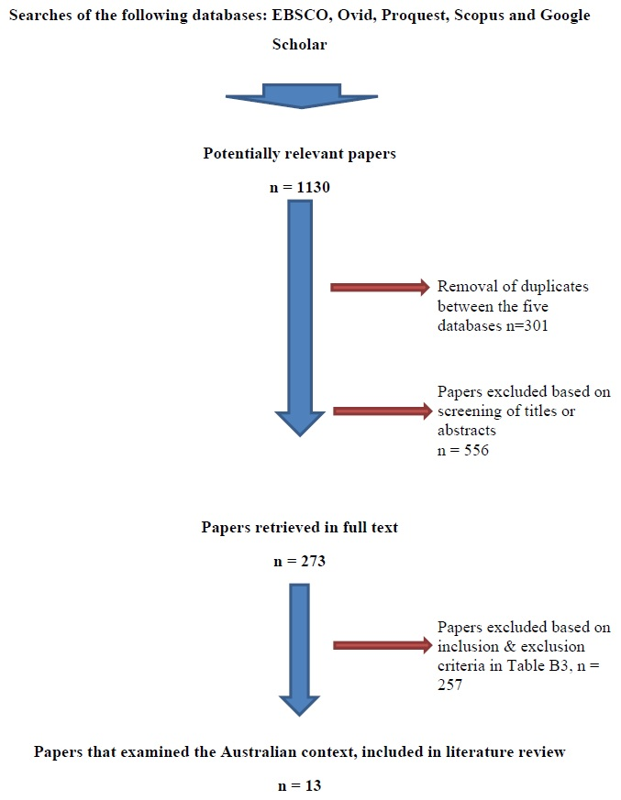

Appendix B5. Papers that examined the levers and barrier, or experiences of university students with disability in Australia

Table B5.1. Papers that examined the levers and barriers, or experiences of university students with disability (in general) in Australia
Year | Authors | Research focus/question | Design | Sample | Results
2017 | Fossey et al. | Disability service staff and USWD perspectives on the implementation of reasonable adjustments at two metropolitan universities. | Overarching methodology not stated.  Method: semi-structured interviews. | 15 students with an ongoing health condition and 10 students with impairment that was physical, sensory or cognitive. All students enrolled full or part-time at VET or university course. And 7 disability support staff. | The variable nature of negotiating and implementing reasonable adjustments was noted. Students experiences of negotiating reasonable adjustment contingent upon the relationship that they develop with the teaching staff.  Negotiating adjustments was noted to add another stressor to many participants.
2016 | Hughes, Corcoran & Slee | Investigated the ways in which a metropolitan university supported USWD. | Online survey. | 83 students who had registered as having a disability at enrollment or through the Disability Support Unit. | 86% of participants identified a low to medium level of assistance: time flexibility, organizational assistance and support.  20% of participants reported general fatigue from their disability impacting their ability to study. Fatigue and time issues were the two main issues identified as barriers to study.

Table B5.2. Papers that examined the levers and barriers, or experiences of university students with specified types of disability in Australia
Year | Authors | Research focus/question | Design | Sample | Results
2017 | Butler, Holloway, Marriott & Goncu | Investigate the current state of accessible graphic provision in Higher Education. | Online survey followed by semi-structured interviews of students, disability support staff and academics with experience of teaching a vision impaired student. | Survey: 71 vision-impaired students.  Interviews: 13 students, 12 disability support staff, 10 academics. | Accessing graphical materials at university was a barrier for many vision impaired students. 76 % of vision impaired students reported having used tactile graphics outside university but only 26% had access to tactile graphics at university.
2017 | MacCullagh, Bosanquet & Badcock | Comparing the learning experiences of students with dyslexia compared to their non-dyslexic peers. | Overarching methodology not stated.  Method: semi-structured qualitative interviews. | 13 students with dyslexia and 20 non-dyslexic peers. | Students with dyslexia reported challenges to studying including: difficulty with notetaking, reading, and technology. They appreciated short face-to-face lectures and tutorials backed up by recordings.
2017 | Siew, Mazzucchelli, Rooney & Girdler | Effect of a peer mentoring program on students with autism spectrum disorder (ASD). | Single group: pre-test, post-test design. Survey and thematic analysis of interviews after peer mentoring program for one hour per week for five months. | 10 young adults with ASD enrolled at university in Western Australia. | Significant improvement in social support scores & general communication apprehension. No significant change in overall anxiety scores, state communication apprehension or perceived communication competence.
2016 | Cai & Richdale | Investigating the experiences and support for students at university with ASD. | Overarching methodology not stated.  9 student focus groups & 6 family member focus groups. | 23 Victorian students with ASD, 14 parents and 1 sister. | Students with ASD felt that they received support educationally but not socially, but families’ impression was that support was poor in both areas.
2015 | Couzens et al. | Examining the support for students with learning disabilities and difficulties (learning, planning, organisation and or social communication) at one metropolitan university. | Overarching methodology not stated.  Method: semi-structured qualitative interviews. | 7 students with learning disabilities and difficulties & 8 staff. | Informal support networks were found by students to be the most effective followed by knowledgeable and caring academic staff. Support provided by University Disability Staff was reported to be variable in nature, difficult to access and often not targeted towards the individual’s need.
2010 | Martin | Investigate the mental health of university students. | Online survey to all university students enrolled within one school in a university. | 54 students from one school at a metropolitan university | 34 students had not disclosed their mental health condition to university staff despite negative impact on study due to: fear of stigma, wanting to maintain their privacy, embarrassment or negative past experiences.
2009 | Hyde et al. | Investigate the experiences of students with hearing disability at one Australian university from 1985-2005. | Examination of the university records of 257 students who identified as being deaf or hard of hearing on enrolment were examined, followed by survey sent out to the identified students. | 72 former and current students with hearing loss from one university which has an extensive support program of those with hearing disability. | Students reported that not all academic staff made adjustments to accommodate their learning needs and hard of hearing students, who used their residual hearing encountered many contexts that inhibited their hearing and therefore learning, such as poor lighting and room acoustics.
2005 | Komesaroff | Investigate the experiences of two students with hearing disability in Higher Education. | Overarching methodology: interpretative framework of category or identity politics and constructions of difference.  Method: 3 semi-structured qualitative interviews conducted in Auslan. | 1 interview with a student in 2nd year of study, 2 interviews with a student in 3rd year of study. Participants at two different Victorian universities. | Academic staff were found to lack of awareness of needs of students with hearing disability.  Author recommended that curricula justice required to enable engaged participation of students with hearing disability.
2004 | Napier & Barker | Preferences of sign language interpreting provision in university lectures. | Overarching methodology not stated.  Method: panel discussion of two videotaped segments of signing: 1 free interpretation, 1 literal interpretation. | 8 current and just finished university students who use interpreters of Auslan for their study. | Approaches preferred dependent on the context but there was a general consensus that the more literal approach would be more suitable for university lectures.

Appendix B6. Papers that examined the levers and barriers, or experiences of university students with disability at a regional university in Australia

Year | Authors | Research focus/question | Design | Sample | Results
2005 | Ryan & Brown | Investigated the nature of USWD learning difficulties & the ways in which lecturers responded to their learning needs. | Overarching methodology not stated.  Method: semi-structured interviews. | 8 students that identified that they had ‘a range of difficulties with learning’. | Students reported a perceived lack of understanding and support from lecturers and difficulty in receiving adjustments.  Many regretted disclosing their difficulties after experiencing negative attitudes from staff and students.
2005 | Ryan | Investigated students with learning difficulties learning experiences. | Overarching methodology not stated.  Method: semi-structured interviews. | 8 students that identified that they had ‘a range of difficulties with learning’. | Students desired understanding from lecturers as they attempted to navigate the barriers of an educational system that questions their legitimacy of being there.

Appendix C1. Questionnaire
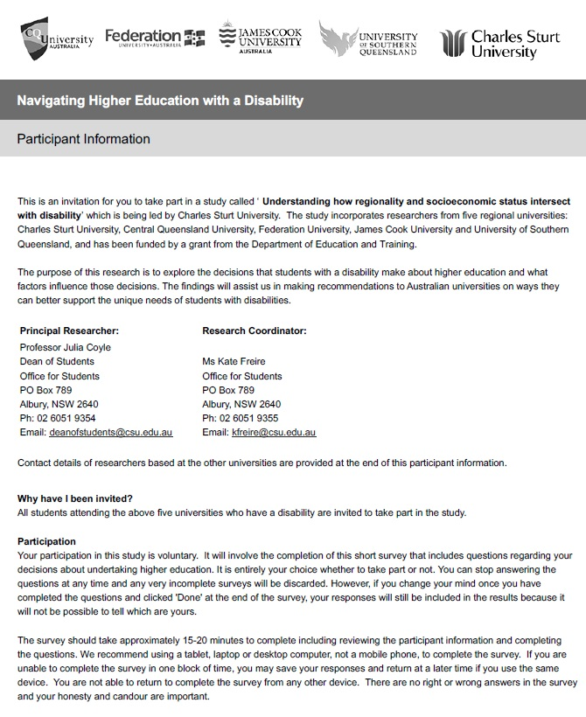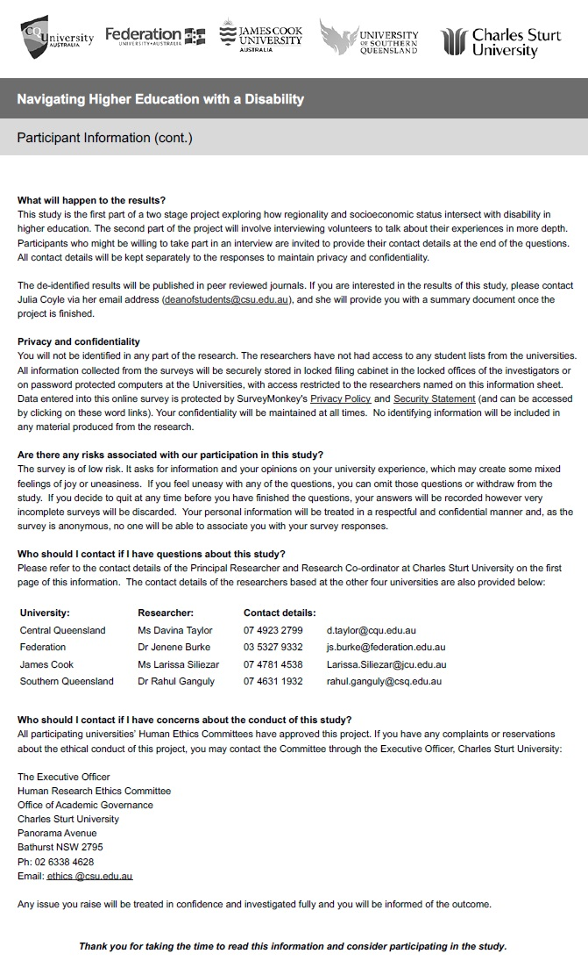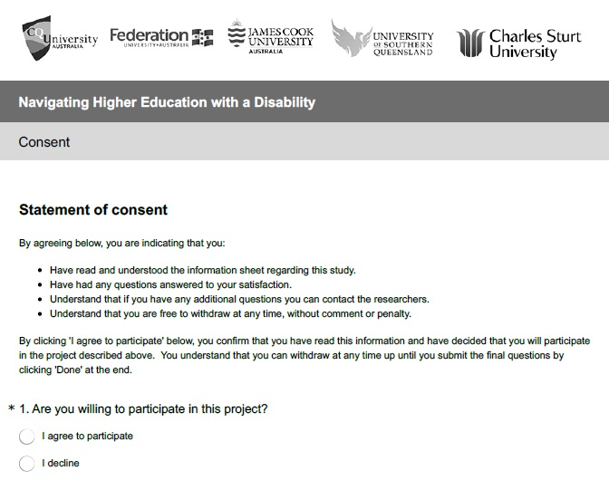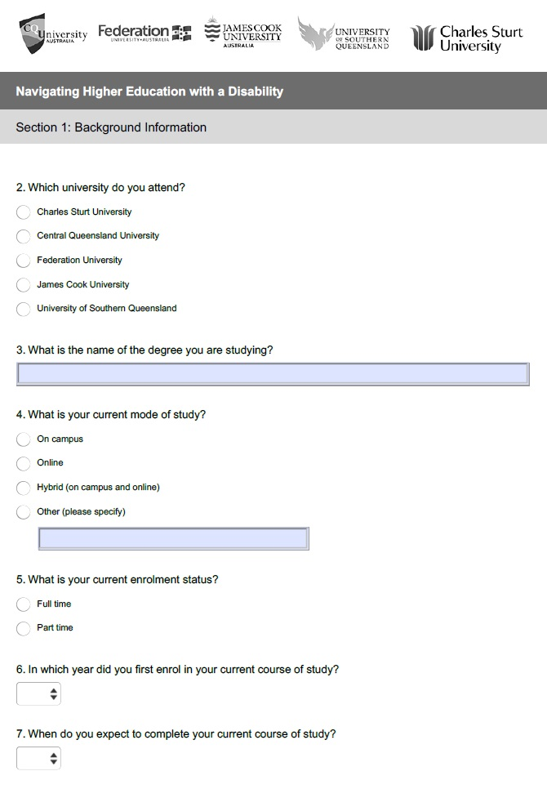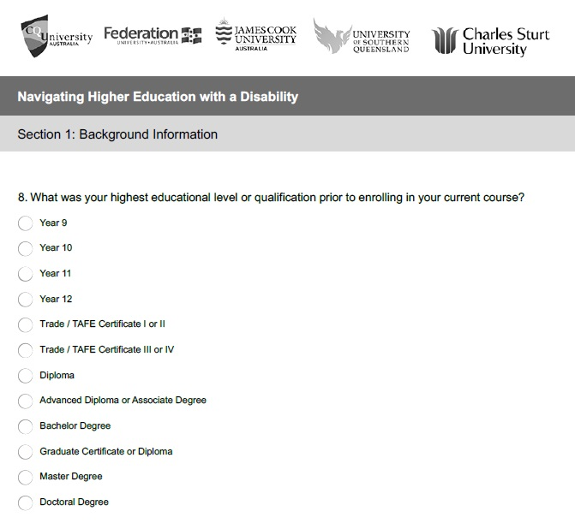

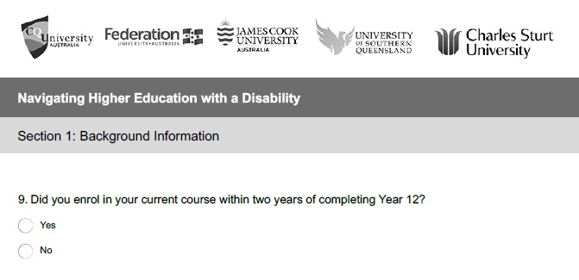

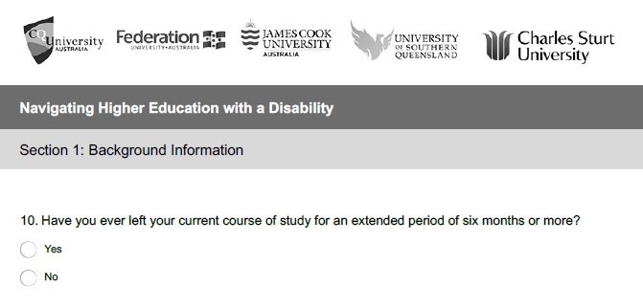
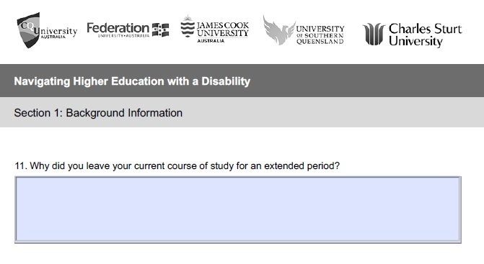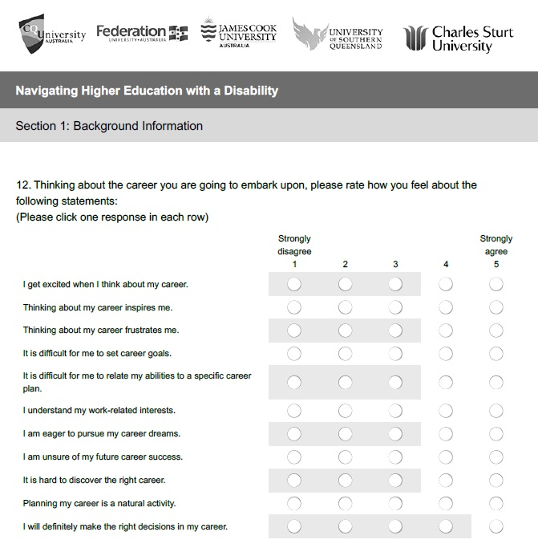
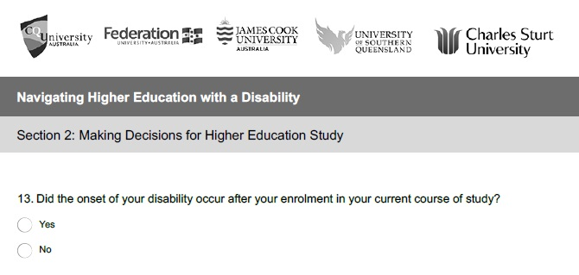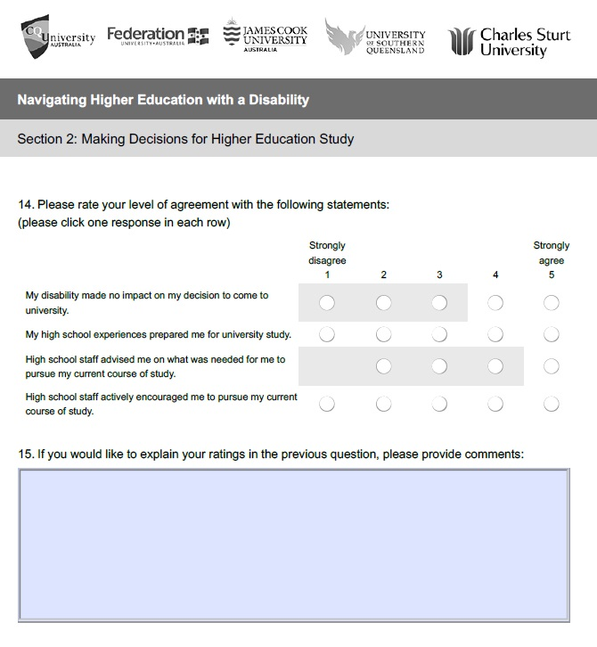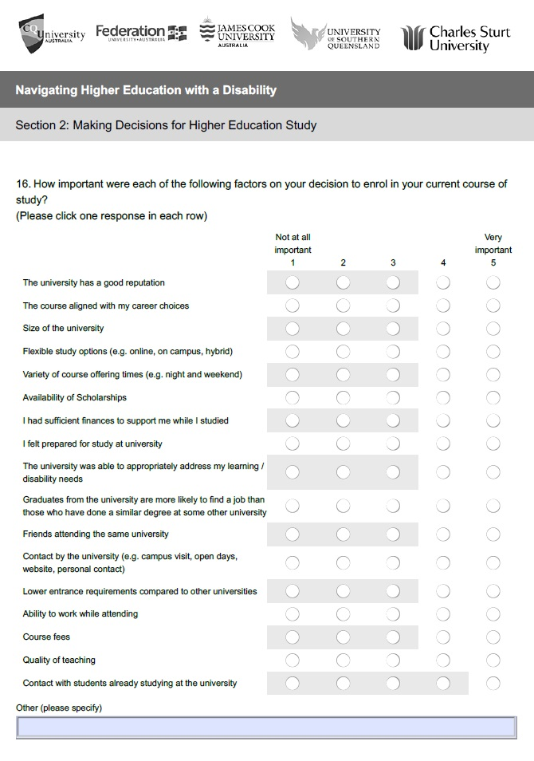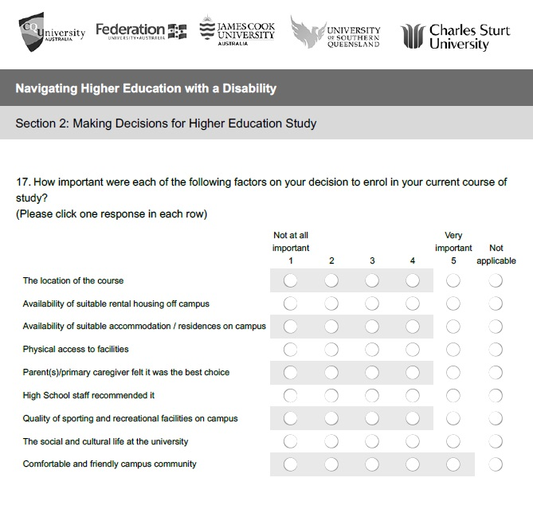
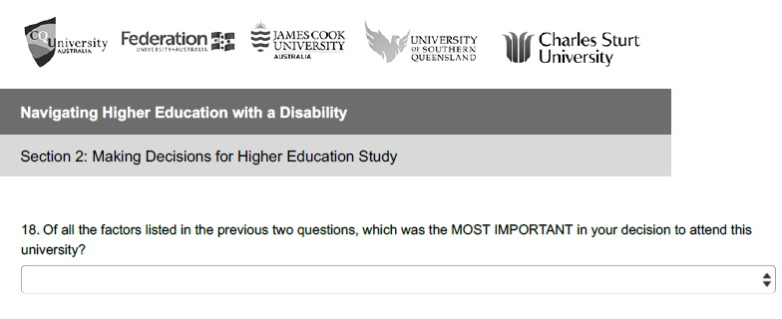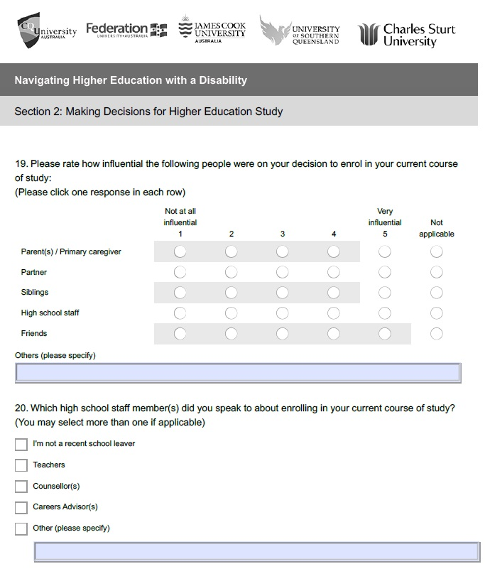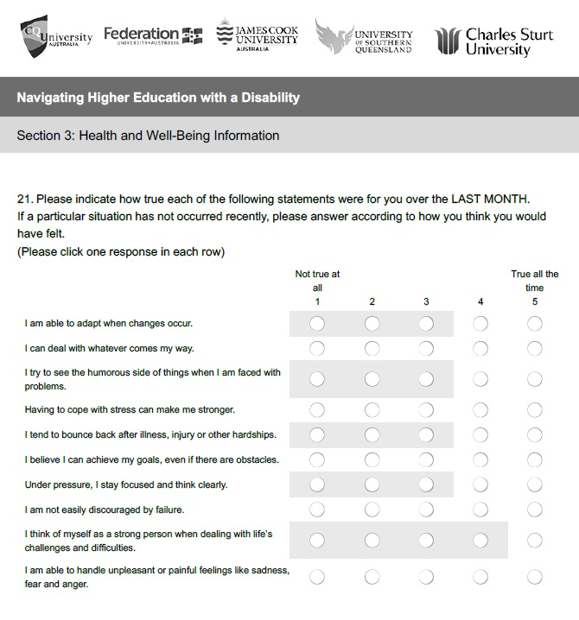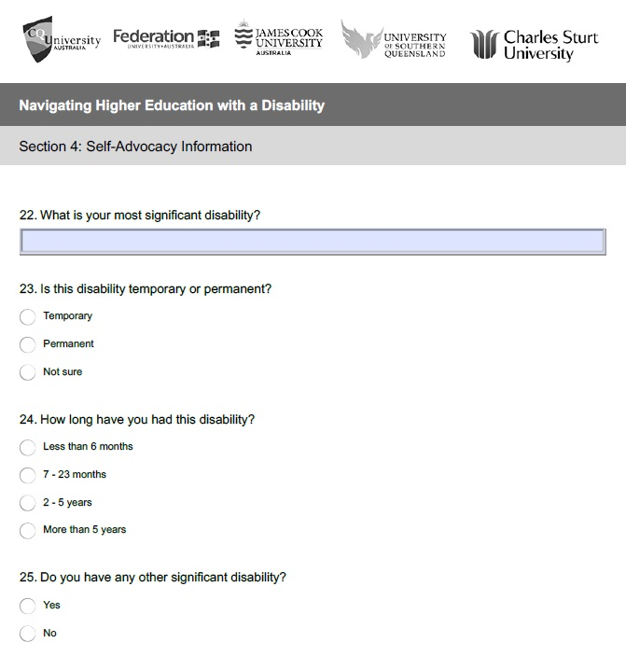
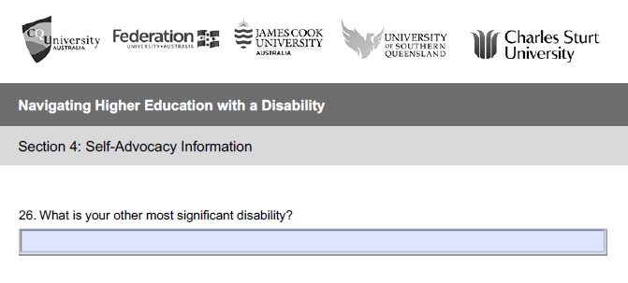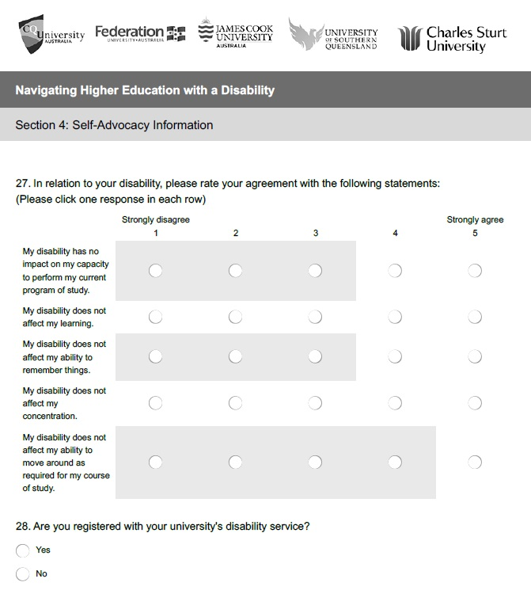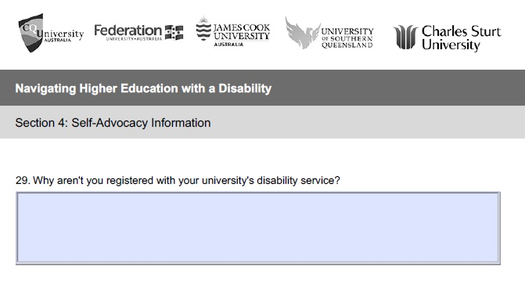

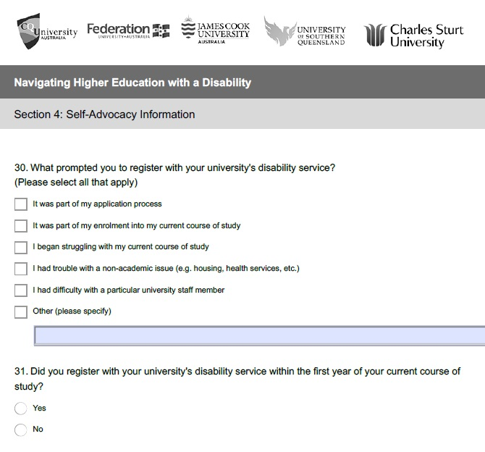
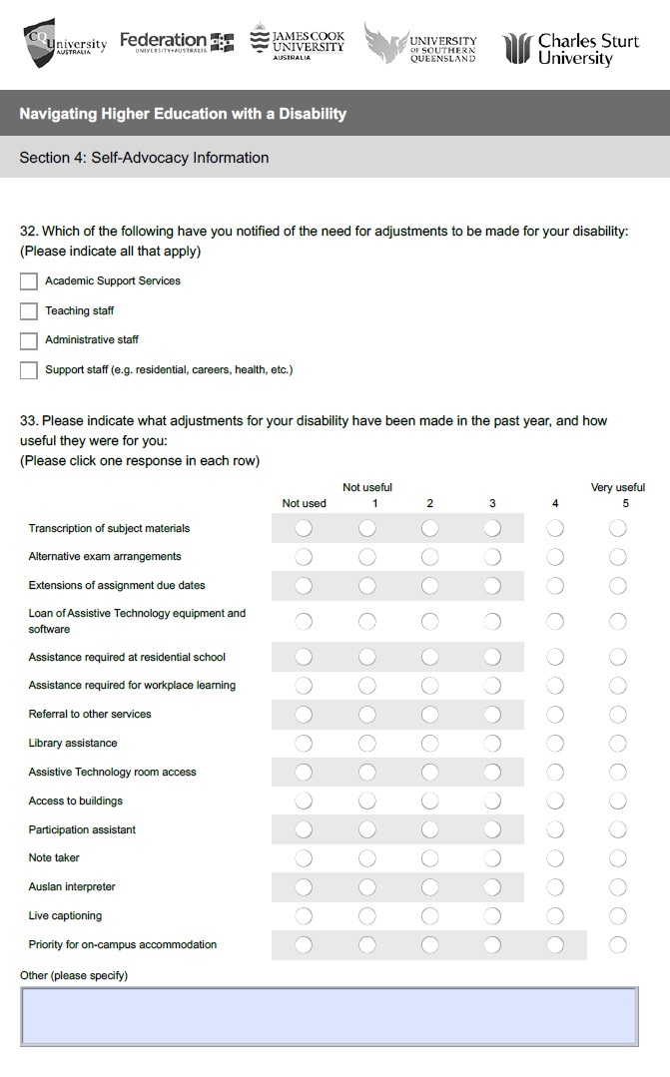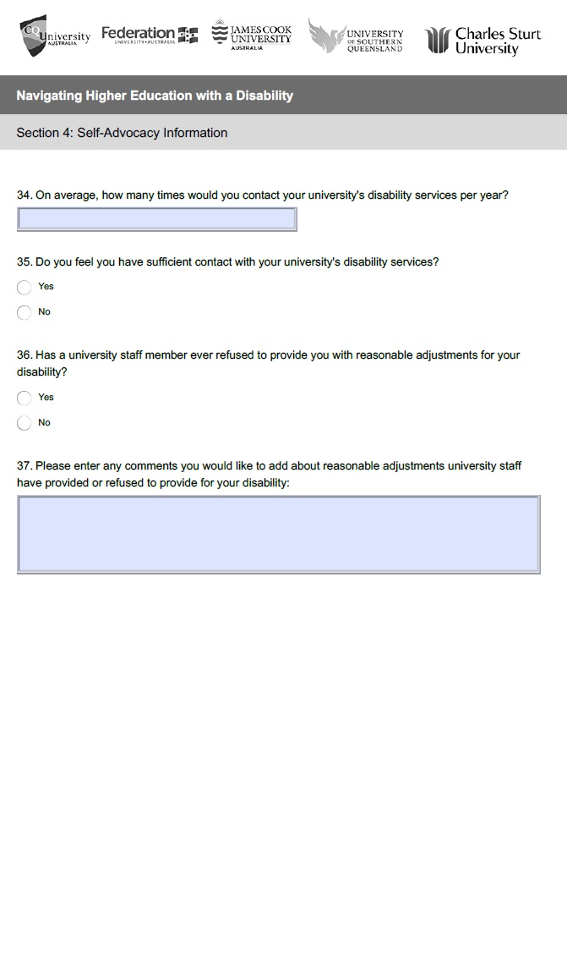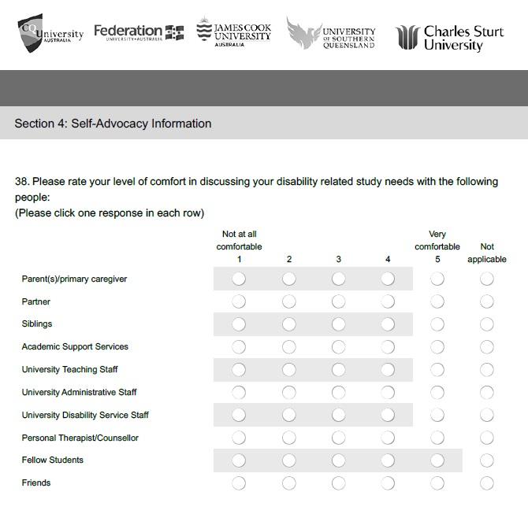

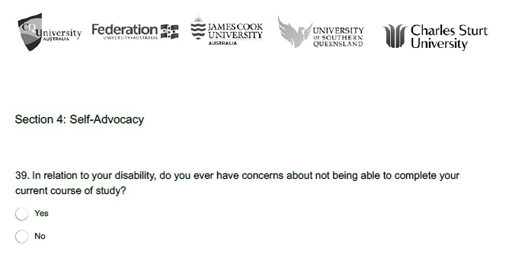
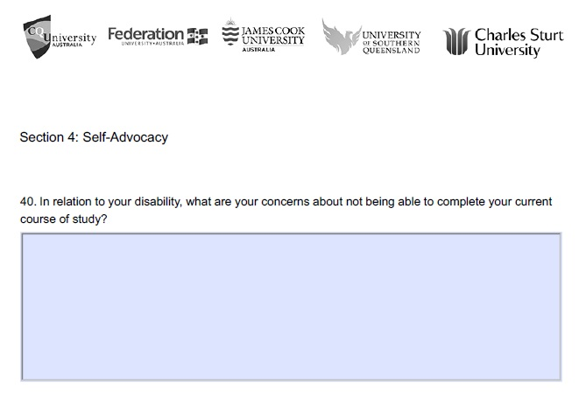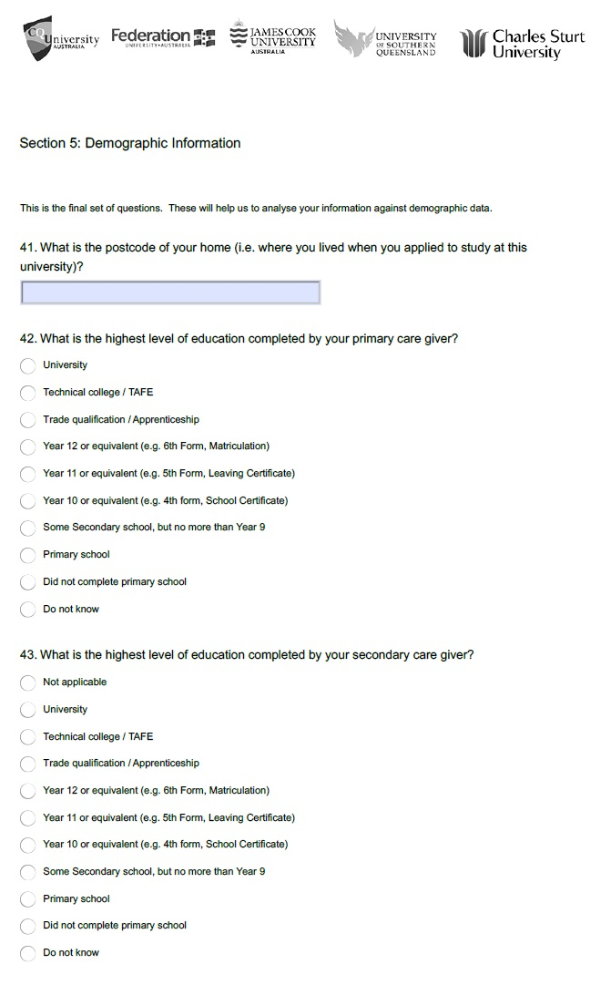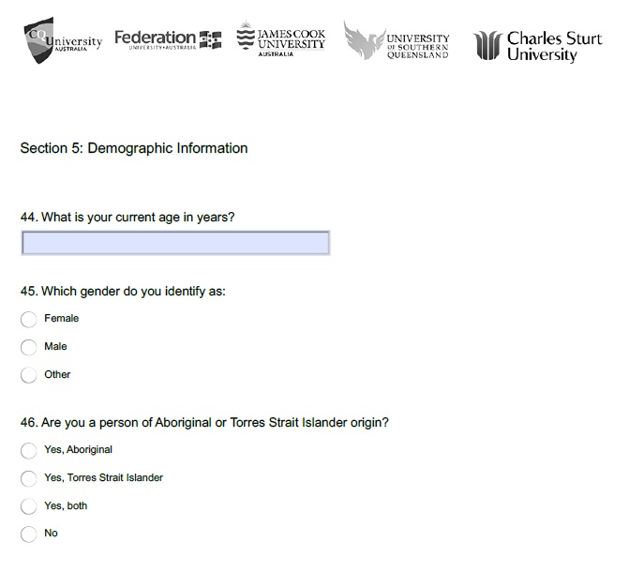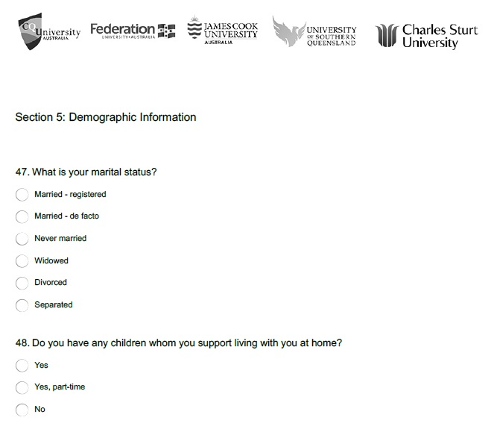
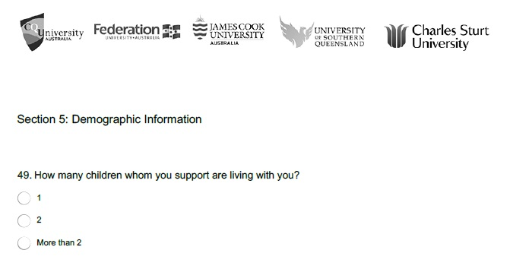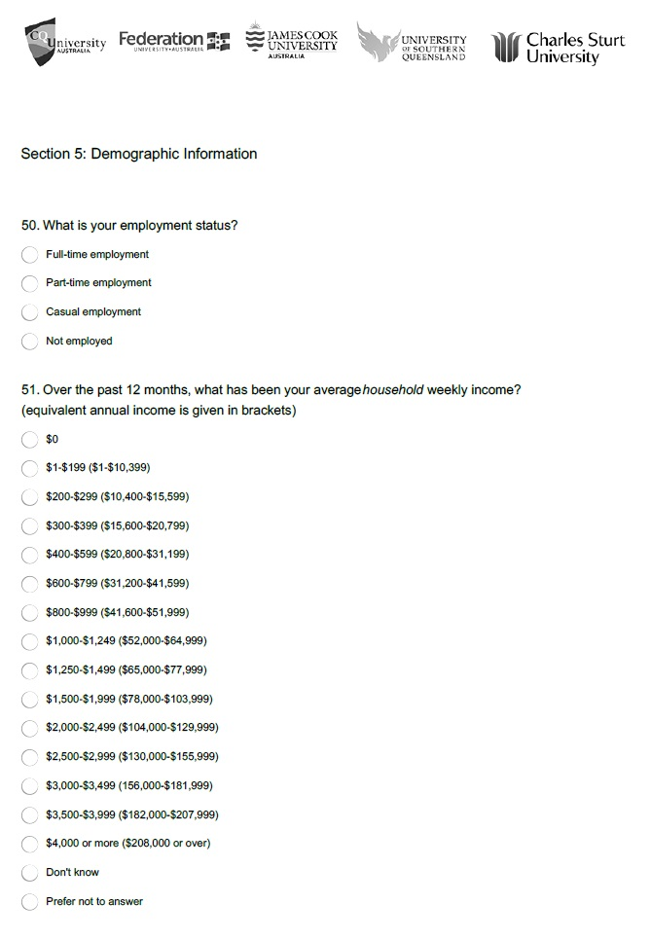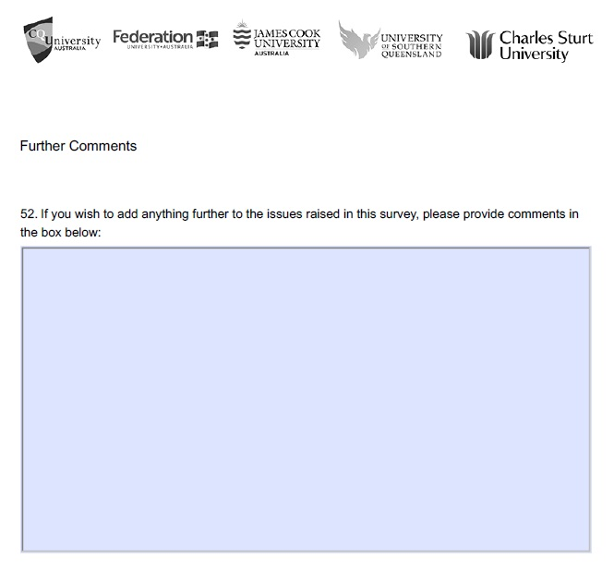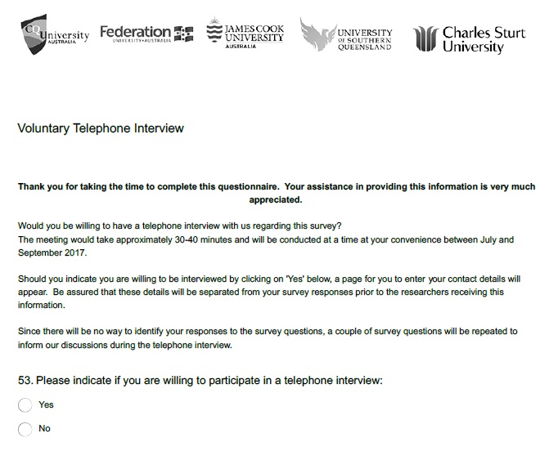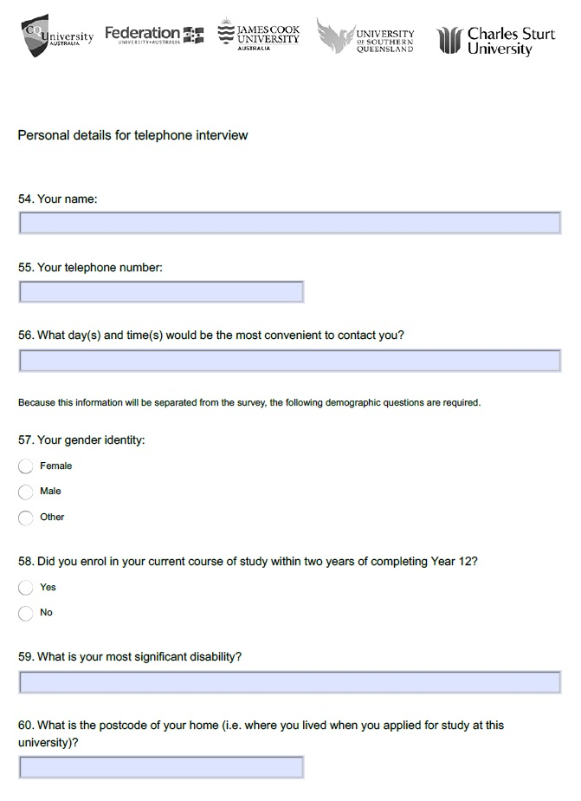

Appendix C2. Disability Categories

Disability category hierarchy

1. Hearing disability n=15

2. Learning disability n=53

1.1 ADHD 13

2.2 Concentration issues 1

2.3 Dysgraphia 1

2.4 Dyslexia 31

2.5 Learning difficulties 3

2.6 Memory loss 3

2.7 Mild intellectual disability 1

3. Mobility disability n=75

3.1 Chronic synovitis 1

3.2 Arthrogryposis 1

3.4 Cerebral Palsy 7
3.5 Musculoskeletal conditions (18) total 27 | Carpel tunnel syndrome 4
 | Spinal Conditions 5 | Chronic back pain 1
 |  | Chronic back injury 1
 |  | Congenital spinal defect 1
 |  | Scoliosis 1
 |  | Spondylitis 1
3.6 Other mobility specified 8 | 3.6.1 Paralysis 1
 | 3.6.2 Post polio 1
 | 3.6.3 Spinal cord injury 1
 | 3.6.4 Hemiplegia 1
 | 3.6.5 Hypermobility 1
 | 3.6.6 Spina bifida 1
 | 3.6.7 Chronic pain 2
3.7 Other/unspecified (24)  total 31 | 3.7.1 Difficulty standing/sitting 1
 | 3.7.2. Mobility impairment 6

4. Visual disability n=12

5. Medical disability n=87
5.1 Neurological conditions 20 | 5.1.1 Acquired brain injury (1) total 2 | (CVA could come here) 5.1.1.1 Cerebral trauma 1
 | 5.1.2 Epilepsy 7
 | 5.1.3 Multiple sclerosis 2
 | 5.1.4 Other 9 | Dystonia 1 (Hemi-facial spasms)
 |  | Nerve pain 1
 |  | Tourette 2
 |  | Unspecified neurological condition 5
5.2 Chronic medical conditions 66 | 5.2.1 Arthritis 3 total (2) | 5.2.1.1 Osteoarthritis 1
 | 5.2.2 Cancer 3

5.2.3 Chronic Kidney Disease 2

(AKA Chronic Renal Failure)
 | 5.2.4 Inflammatory Gastrointestinal Conditions 6 | 5.2.4.1 Crohn’s Disease 3
 |  | 5.2.4.2 Ulcerative Colitis 1
 |  | 5.2.4.3 Gastrointestinal dysfunction 1
 |  | 5.2.4.4 Irritable Bowel Syndrome 1
 | 5.2.5 Metabolic Diseases 8 | 5.2.5.1 Diabetes 7
 |  | 5.2.5.2 Hypoglycaemia 1
 | 5.2.6 Autoimmune diseases 7 | 5.2.6.1 Autoimmune arthritis 1 (including juvenile arthritis 1, rheumatoid arthritis 4)
 |  | 5.2.6.2 Lupus 1 (AKA systemic lupus erythematosus SLE)
 | 5.2.7 Infectious diseases 1 | 5.2.7.1 AIDS 1
 | 5.2.8 Cardiovascular disease (1) total 4 | 5.2.8.1 Coronary Heart Disease (CHD) 1
 |  | 5.2.8.2 Cerebrovascular Accident (CVA) 1
 |  | 5.2.8.3 Congestive Heart Failure 1 (heart failure)
 | 5.2.9 Connective tissue disorders 1 | 5.2.9.1 Ehlers-Danlos Syndrome 1
 | 5.2.10 Other (3)- total 32 | Dercum Disease 1
 |  | Allergic conditions 2 (Eczema 1, anaphylaxis 1)
 |  | Fibromyalgia 12
 |  | Chronic Fatigue Syndrome 1
 |  | Fatigue 1
 |  | Migraines 5
 |  | Organ Failure 1
 |  | Postural Hypertension 1
 |  | Multiple chronic health conditions 1
 |  | Sleep disturbance 2
 |  | Other 2

5.3 Genetic 1

6. Mental health disability 183

6.1 Anxiety disorders 58
6.2. Depressive Disorders 40 | 6.2.1. Depression 40

6.3. Bi-polar disorders 17

6.4. Obsessive-compulsive disorder 2

6.5. Post-traumatic stress disorder 26
6.6. Psychotic disorders 5 | 6.5.1. Schizophrenia 5
6.7. Personality Disorders (2) total 4 | 6.5.1. Borderline Personality Disorder 1
 | 6.5.2. Avoidant Personality Disorder 1

6.8. Other/undefined Mental Health 31

7. Communication difficulties n=32
7.1. Autism Spectrum Disorder (11) total 30 | (7.1.1. Asperger’s 19)

7.2. Dyspraxia 1

7.2. Speech Impairment 1

Multiple unspecified 1

Not defined 8

Appendix C3. Interview guide

Introduction
- Researcher introduction - Hello, thank you for your interest in our research, which is about understanding how the experience of disability impacts upon students studying at a regional university. We are interested to find out about what assists students with disability and what the challenges are. There are no right or wrong answers. I am interested in your perspectives and experiences.
- Review consent to participate – Have you received the information sheet? Do you have any questions about the research or your participation? You are free to say as much or as little as you want. If there are questions you don’t want to answer just let me know. The interview will take about an hour but if you need to take a break please let me know. You are free to stop and withdraw from the interview at any time without any problems or any questions asked.
- Confirm consent to participate - Are you happy to go ahead?

General structure for interviews
Start with very broad open-ended questions so that the participant’s perspectives are gained without influence from your expectations.
Two questions to ask during each interview (You may like to wait till the end of the interview to ask these)
- In what way does your disability impact upon your participation at university? (Additional prompts: How do you describe your disability to others? What would be a useful way for staff in higher education to describe the disability you experience?)
- What is your postcode?

University Students with Disability
- Tell me a bit about what university life is like for you?
- Tell me a bit about your course or study?
- What aspects of your study/going to university do you find easy? What aspects of your study/going to university do you find challenging?
  - Do you have to go on any placements? How do you find that?
  - Do you have to do any group work? How do you find that?
- What is it like to be a university student from your perspective?
  - Do you think university life is different for students with a disability?
- Is being at university different to what you thought it would be?
- Tell me about any elements at university that are difficult?
  - Is there anything about going to university that you find stressful?
    - How do you manage/cope with that?
- Tell me about any elements at university that you enjoy?
  - Is this what you expected when you decided to go to university? In what way is it different to what you expected?
  - What do you think makes a student with disability at university successful?
- Tell me about your school experiences in relation to university.
- Do you have any advice for people with disability who are thinking of studying at university?
- Do you have any advice for universities?

Year 10 and 11 School Students with Disability
- Tell me a bit about what school is like for you. What do you enjoy about school? What is difficult about school?
- What are you thinking of doing once you finish school?
- Do you have any plans for future study? Tell me a bit about your plans.
- What do you think university will be like? What worries do you have about going to university? What are you looking forward to about going to university?
- What barriers or difficulties do you think you might face in going to university?
  - How do you think you will manage them?
- What do you think will help you be successful at university?
  - What do you think makes a student with disability at university successful?

Community members with Disability
- Tell me a bit about your previous experiences of going to school and studying?
  - What year did you get to at school?
  - Did you do any study or apply to do any study after school? What was that experience like?
- What did you enjoy about previous study?
- What was challenging for you about previous study?
- Do you have any plans to study in the future?
- What do you think it would be like for you to study at university? What worries might you have about going to university? What would you look forward to about going to university?
- What barriers or difficulties do you think you might face if you went to university?
  - How do you think you could manage these types of challenges?
- What do you think would help you be successful at university?
  - What do you think makes a student with disability at university successful?

Appendix D1. Demographic profiles of respondents

 | Frequency | %
Age | (N=454)
17 – 24 years | 120 | 26
25 – 34 years | 109 | 24
35 – 44 years | 87 | 19
45 – 54 years | 93 | 21
55 – 74 years | 45 | 10
Missing cases | 37
Ethnicity | (N=468)
Aboriginal | 13 | 3
Torres Strait Islander (TSI) | 1 | 0.2
Aboriginal & TSI | 1 | 0.2
Other | 459 | 96
Missing cases | 53
Employment | (N=470)
Full time | 68 | 14.5
Part time | 64 | 14
Casual | 92 | 19.5
Not employed | 246 | 52
Missing cases | 51
Highest level of education of primary carer | (N=442)
Not complete primary school | 7 | 2
Completed primary school | 6 | 1.5
Not complete secondary school | 91 | 25.5
Completed Year 12 | 46 | 13
Trade or TAFE qualification | 78 | 22
University | 129 | 36
Did not know | 85
Missing cases | 79
Income | (N=469)
Less than $10,399 | 38 | 11
$10,400 – 15,999 | 53 | 15
$15,600 – 20,799 | 41 | 11.5
$20,800 – 31,199 | 66 | 18
$31,200 – 41, 599 | 41 | 11.5
$41,600 – 51,999 | 21 | 6
$52,000 - 64,9999 | 26 | 7
$65,000 - $77,999 | 26 | 7
Over $78,000 | 47 | 13
Don’t know | 58
Prefer not to answer | 52
Missing cases | 52

Appendix D2. Age and disability of respondents

Primary disability category | Mean age - years | Median age - years
Communication | 24.7 | 22
Hearing | 35.6 | 36
Learning | 32.3 | 31
Medical | 38.0 | 39
Mental Health | 36.6 | 34
Mobility | 38.4 | 40
Visual | 36.9 | 37

Appendix D3. Secondary disability

Table D3.1. Prevalence of secondary disability by primary disability category
Primary disability category | No - n | Yes - n | Yes - %
Communication | 22 | 8 | 27
Hearing | 10 | 5 | 33
Learning | 37 | 15 | 29
Medical | 58 | 37 | 39
Mental Health | 100 | 81 | 45
Mobility | 36 | 43 | 54
Visual | 10 | 3 | 23

Table D3.2. Categories of secondary disability
Secondary disability category | n | %
Communication | 9 | 5
Hearing | 7 | 4
Learning | 17 | 9
Medical | 59 | 30
Mental Health | 70 | 36
Mobility | 30 | 15
Visual | 2 | 1

Appendix D4. People who influenced respondents’ decisions to enrol in their current courses of study

People | Non influential % | Neutral % | Influential %
Parent(s)/primary caregiver (N=307) | 46 | 10 | 44
Partner (N=248) | 46 | 14 | 40
Siblings (N=299) | 69 | 13 | 17
High School staff (N=243) | 84 | 10 | 6
Friends (N=335) | 55 | 19 | 26

Appendix D5. The importance of a range of factors on respondents’ decisions to enrol in a particular university

Factors | Not important % | Neutral % | Important %
The course aligned with career choices (N = 430) | 5 | 13 | 82
Flexible study options (online, campus, hybrid) (N = 432) | 12 | 14 | 74
Location of the course (N = 350) | 18 | 11 | 70
Quality of teaching (N = 429) | 13 | 19 | 68
The university was able to appropriately address my learning/ disability needs (N = 431) | 10 | 23 | 67
The reputation of the university (N = 430) | 13 | 26 | 61
Comfortable and friendly campus community (N = 336) | 23 | 18 | 59
Physical access to facilities (N = 304) | 29 | 13 | 58
Sufficient finances to support study (N = 429) | 17 | 28 | 55
I felt prepared for study at university (N = 430) | 17 | 31 | 52
Ability to work while attending (N = 430) | 32 | 20 | 48
Graduates job prospects (N = 432) | 27 | 29 | 44
Variety of course times (night, and weekend) (N = 430) | 33 | 27 | 40
Contact by university (campus visit, open days) (N = 430) | 40 | 23 | 37
Availability of suitable rental housing off campus (N = 222) | 58 | 9 | 33
Course fees (N = 431) | 38 | 31 | 31
Availability of Scholarships (N = 429) | 43 | 26 | 31
Size of the university (N = 426) | 47 | 24 | 29
Parent/primary caregiver felt it was the best choice (N = 237) | 60 | 13 | 27
The social and cultural life at the university (N = 300) | 56 | 18 | 26
Availability of suitable accommodation on campus (N = 218) | 63 | 11 | 26
Contact with students already studying at the university (N = 428) | 55 | 21 | 24
Lower entrance requirement compared to other universities (N = 431) | 56 | 27 | 17
High school staff recommended it (N = 208) | 82 | 7 | 11
Friends attending same university (N = 432) | 76 | 14 | 10
Quality of sporting and recreational facilities on campus (N = 257) | 81 | 9 | 9

Appendix D6. Impact of disability on current course of study

Table D6.1. Impact of disability upon concentration (N = 475)
Secondary disability category | Mean | Median
Communication | 2.6 | 2
Hearing | 3.1 | 3
Learning | 1.9 | 2
Medical | 2.3 | 2
Mental health | 1.8 | 1
Mobility | 2.5 | 2
Visual | 3.4 | 3

Table D6.2. Impact of disability upon current program of study (N = 481)
Secondary disability category | Mean | Median
Communication | 2.5 | 2
Hearing | 2.7 | 2
Learning | 2.0 | 2
Medical | 2.5 | 2
Mental health | 1.9 | 2
Mobility | 2.3 | 2
Visual | 2.6 | 3

Table D6.3. Impact of disability upon learning (N = 481)
Secondary disability category | Mean | Median
Communication | 2.7 | 2.5
Hearing | 2.5 | 2
Learning | 1.8 | 2
Medical | 2.7 | 2
Mental health | 2.0 | 2
Mobility | 2.8 | 3
Visual | 3.5 | 3

Table D6.4. Impact of disability upon memory (N = 480)
Secondary disability category | Mean | Median
Communication | 3.1 | 3
Hearing | 3.9 | 4
Learning | 2.1 | 2
Medical | 2.9 | 3
Mental health | 2.2 | 2
Mobility | 2.9 | 3
Visual | 4.2 | 5

Table D6.5. Impact of disability upon ability to move around as required (N = 480)
Secondary disability category | Mean | Median
Communication | 3.7 | 4
Hearing | 3.7 | 4
Learning | 4.1 | 5
Medical | 3.3 | 3
Mental health | 3.3 | 3.5
Mobility | 2.4 | 2
Visual | 3.3 | 3

Appendix E1. Demographics of the five universities engaged in the research in 2017

Table E1. Area remoteness of students at five universities engaged in the research in 2017
 | Major city | Inner regional | Outer regional | Remote | Very remote
Disability | 1,636 | 1,731 | 1,124 | 50 | 23
No disability | 25,642 | 22,911 | 17,315 | 949 | 410

Table E2. Gender of students at five universities engaged in the research in 2017
 | Male | Female | Other
Disability | 1,484 | 3,098 | 10
No disability | 25,292 | 43,817 | 36

Table E3. Study mode of students at five universities engaged in the research in 2017
 | Internal | Mixed | Online
Disability | 1,918 | 697 | 1,977
No disability | 26,471 | 9,286 | 33,387

Table E4. Ethnicity of students at five universities engaged in the research in 2017
 | Indigenous | Not Indigenous | No information
Disability | 253 | 4,270 | 69
No disability | 2,527 | 64,515 | 2,103

Job Access With Speech is a computer screen reader program for Microsoft Windows.
As stated in the methodology, the category of ‘other’ has been omitted from further data analysis due to the small number of respondents in the category.
pseudonym

