Equipping Parents to Support their Children's Aspiration: What Works?

Sue Kilpatrick, University of Tasmania

The project that resulted in the production of this report was funded under a National Priorities Pool (Higher Education Participation and Partnerships Program) grant from the Commonwealth. The recipient of the grant has granted the Commonwealth the right to sub-licence the material in this report. Copyright in the report remains with the original copyright owners.
Except where otherwise indicated, and save for any material protected by a trade mark, the Department of Education and Training, acting on behalf of the Commonwealth, has applied the Creative Commons Attribution 4.0 International Licence.

Modifications: Changed to meet WCAG 2.0 accessibility requirements.
Alternate text inserted for all images. Minor typographical errors corrected.

Contents
List of Tables 2
PART A: Equipping Parents to Support their Children’s Aspiration: What Works? 3
Australian Higher Education and Equity Policy Framework 4
What is parent involvement? 6
Misaligned Parental Aspirations 10
Criticisms of parent involvement 10
Strategies for engaging parents 11
Successful programs 15
Key factors contributing to successful programs 17
References 17
Bibliography 23
PART B: UTAS Parent Engagement Workshop Modified DEMO Term Explanations 31
Assembling resources 31
Engaging Parents 32
Working together 32
Building confidence 32
PART C: Equipping Parents to Support their Children’s Aspiration:
What Works? Slideshow Presentation 33
PART D: Equipping Parents to Support their Children’s Aspiration:
What Works? Slideshow Presentation 43

List of Tables
Table 1: Key dimensions of parent involvement from Family-School
Partnerships Framework (2008) 8
Table 2: Academic Socialisation from Emerson et al 2012 9
Table 3: Strategies and characteristics 31

PART A: Equipping Parents to Support their Children’s Aspiration: What Works?
Parents from low SES backgrounds, in common with other parents, report that they want ‘the best’ for their children’s future. Getting a good education is a part of the aspiration of most parents, regardless of SES status. Parents from mid and high SES backgrounds usually have ‘educational cultural capital’ to support their children’s educational aspiration. This means they can confidently access information they need about possible education pathways within and beyond school, and know where to find out about financial and other support resources available to facilitate access to higher education.
There is a strong theoretical basis for the effectiveness of early outreach to children and families. However, evidence as to the nature and features of programs that are most effective in engaging low SES parents in building their children’s educational aspirations is limited. This project addresses that evidence gap. It builds on partners’ combined experience and international literature to identify features of parent engagement and information programs and resources that are cost efficient and effective in informing and supporting low SES parents’ aspirations for their children’s participation in higher education; produce a web resource for institutions’ use in design of parent engagement and information programs and resources that are effective in informing and supporting low SES parents’ aspirations for their children’s participation in higher education.
There is a strong theoretical basis for the effectiveness of early outreach to primary and early secondary school age children and families, particularly if sustained over several years and if outreach targets all students and parents (Naylor et al 2013). However, evidence as to the nature and features of programs and resources that are most effective in engaging low SES parents, carers and families (hereafter referred to simply as parents) in building their children’s educational aspirations is limited. This project addresses that evidence gap.
The project builds on a substantial body of research from the University of Tasmania (e.g. Kilpatrick and Abbott-Chapman 2002) and elsewhere (e.g. James et al 1999, James 2002, James et al 2008, Bok 2010, Gemici et al 2014) that has established the key role of family and parents in particular in shaping the career and educational aspirations of children and young people in low SES communities. Longitudinal research has established a strong relationship between education and career aspiration by the age of 15 and completion of Year 12 in Australia (Khoo & Ainley 2005). Parents in low SES communities want to assist their children, but are less likely to be aware of the full range career and educational options available for their children, and supports to available to assist them achieve these aspirations (Craven et al 2005, James and Devlin 2006, James et al 2008, Bok 2010). Interventions that target the attitudes and aspirations of these parents are likely to have a positive influence on the educational aspirations and subsequent participation of children from low SES families (Gemici et al 2014).
The Universities of Tasmania and Wollongong both service low SES regional areas where the need for parent engagement programs is clear. Over time they have developed a variety of models of parent engagement, some standalone such as Tasmania’s Parents Matter program in rural schools, and some as incorporated into other programs, such as Wollongong’s Parent Seminars run as part of the Learning Labs Program and the Parent Seminars run as part of the year 6 program, Kids In2Uni.
The University of Tasmania has established the Children’s University program that engages parents with their children aged 7 to 14 in learning activities outside school. This project will give the partner Universities and others evidence to modify their programs to best target resources for parent engagement in an increasingly resource constrained environment.

Australian Higher Education and Equity Policy Framework
To understand the current state of thought surrounding best practices for low SES parent engagement, it is necessary to understand the policy framework under which decisions are being made about when and how to engage parents in an educational context. Over the last two decades, Australia has put forward numerous policy documents that recognise the importance of increasing low SES student enrolments in universities. While none of these documents has a direct focus on parent engagement, the documents do indicate government support for increasing low SES student enrolments and more recently, begin to incorporate parents into action planning.
In 1988, a white paper titled Higher Education: A Policy Statement was released by the Minister for Employment, Education, and Training, the Honourable John Dawkins, MP. This document set forward national equity goals and provided see funding for programs aimed at increasing equity. The government reiterates its commitment to developing a more equitable higher education system and states that it believes that higher education should be acknowledged as a legitimate aspiration for those who can demonstrate capacity (Dawkins, 1988).
Following that, in 1990, a discussion paper, A fair chance for all: higher education that’s within everyone’s reach, was published by the Department of Employment, Education and Training (DEET) that once again confirmed the government’s support for higher education and this time, identified six specific equity groups of interest, including people from low socioeconomic backgrounds (low SES). In 1996, the progress towards the equity objectives outlined in A fair chance for all were assessed in the National Board of Employment, Education and Training Higher Education Council’s report Equality, diversity and excellence: advancing the national higher education equity framework. This report found that while the situation had improved for a number of equity groups, people from low SES backgrounds were still under-represented in higher education. This report set out 26 recommendations and identified people from low SES backgrounds and rural and isolated students as two priority areas for action, with $4 million in additional funding recommended to address the needs of these two groups. Because of a change of government, implementation of these recommendations was impacted. While the report never became formal policy, it did influence institutional planning and programs (Gale and Tranter 2011).
Next, Backing Australia’s Future (Nelson 2003), which introduced higher educational reforms and a range of new funding streams and programs, shifted focus from the two priority equity groups identified previously to indigenous and disability equity groups. In this report, parents, whom the academic literature widely identifies as key in students’ success, are mentioned just twice. First, the government recognises the financial stress that can be caused to parents by higher education in its proposal of the Commonwealth Accommodation Scholarships and next in its recommendation for enhancements to the Graduate Destination Survey and Course Experience Questionnaire. In this case, the government mentions that along with students, parents will likely be wanting information about institutional and course performance. In 2004, the Family-School & Community Partnerships Bureau, an organisation dedicated to greater parental engagement and community involvement in schools, was created and funded by the Australian government and following that in 2008, the Department of Education Employment and Workplace Relations released the Australian National Action Framework for Family-School Partnerships. This indicates a shift in thinking and recognition that parent engagement is a key to success in higher education.
Most recently, the Review of Australian higher education discussion paper (Bradley 2008), or ‘Bradley Review’, was initiated in March 2008 and released in December 2008. The purpose of this review was to examine the future directions for higher education sector, determine its capacity for meeting the needs of Australians and suggest options for future reforms. The Bradley Review acknowledged the level of participation in higher education for people from low SES backgrounds had remained virtually unchanged for the past two decades and that there were a number of factors, including costs and geographic locations, that were possibly contributing to this. It was also pointed out at that this was the case not just in Australia, but in the United States and the United Kingdom, as well. In 2009 budget, the Australian government responded comprehensively to the Bradley Review with $5.4 billion and released Transforming Australia’s Higher Education System, which set a target for 20% of higher education enrolments at the undergraduate level to be comprised of people from low SES backgrounds by 2020. The next liberal government, however, did not adopt these targets and instead created a scholarship scheme. Noonan (2015) points out that “the extent to which that [scholarship scheme] would change the socioeconomic composition of the universities with the most significant scholarship programs is questionable” (p.35).
Despite equity policies being in place, low SES students are still ‘significantly and persistently underrepresented in Australian higher education’ (James 2008, Gale and Parker 2013). One quarter of the Australian population lives in low SES postcodes, yet year after year, students from low SES backgrounds comprise only approximately 15% of the domestic student population in Australian universities (James 2008).
Simultaneously over these two decades there has been an abundance of research focused on understanding why, despite government support and funding, people from low SES backgrounds continue to be under-represented and how this can be changed. One body of research examines the barriers to accessing and succeeding in higher education. Various factors have been examined in great detail, however, two studies from the early 1980’s summarise barriers to higher education quite succinctly and describe four conditions must be met for a student to enter university (Anderson and Vervoon 1983, Anderson et al 1980). These studies explain that an adequate number of places must be available, the institution must be accessible to the student, both geographically and financially, the student must have the necessary preparation and capability to succeed and the student must want to enter. Although all four conditions are closely interrelated and must be met for a student to succeed at university, the focus of this literature review will be on the fourth condition, student aspirations and specifically, parent involvement and support for their student’s educational aspirations.

What is parent involvement?

Definition and Terminology
In the literature, two phrases are often used to described the partnerships between parents and others that constitute their participation in the academic realm of their children’s lives: parent engagement and parent involvement. The definitions of the two are quite similar and are often used interchangeably, but more recently there appears to be a shift from parent involvement to parent engagement because engagement implies a broader conception of the role of parents in learning. Drawing on several diverse lines of theory and research, Grolnick and Slowiaczek (1994) defined parents’ involvement in children’s schooling as parents’ commitment of resources to the academic arena of children’s lives. Expanding on this, Emerson et al (2012) state that “parental engagement consists of partnerships between families, schools and communities, raising parental awareness of the benefits of engaging in their children’s education, and providing them with the skills to do so” (p.7).

Importance
The importance of parent involvement or engagement in relation to educational aspirations is widely understood. Bergensen (2009) explains that parental involvement, across all race/ethnicities and socioeconomic groups is a better predictor of students’ education expectations than parents’ educational level and student academic achievement and Muller (2009) states in Emerson et al (2012): “Family-school and community partnerships are re-defining the boundaries and functions of education. They enlarge parental and community capacity; they create conditions in which children learn more effectively. In these ways they take education beyond the school gates. (p.7)”
Bordua (1960) was one of the first to investigate the impact of various factors that influence students to attend college and reconfirmed that gender, religious affiliation and socioeconomic status were related to the decision. He also found for the first time that parental emphasis on college also played a role. This opened the door for expanded research on the topic of the influence of parent engagement on the children’s higher education aspirations.
Moving forward to more recent times, in the past two decades, researchers have repeatedly confirmed the link between parent engagement and students’ higher education aspirations. There is widespread acknowledgement of the benefits of parental involvement for effective education (Grolnick and Slowiaczek 1994, Ceja 2004, Hong and Ho 2005, Jeynes 2005, Bakker and Denessen 2007, Auerbach 2007, Charles, Roscigno and Torres 2007, Cunningham et al 2007, Gonida and Urdan 2007, Jeynes 2007, Fann, Jarsky and McDonough 2009, Hill and Tyson 2009, Cheung and Pomerantz 2011, Kirk et al 2011, and Martinez and Ulanoff 2013, Gerard and Booth 2015, Education Endowment Foundation 2016). Finally, most recently, in addition to the academic literature highlighting the importance of involving parents in their children’s education, the Organization for Economic Co-operation and Development (OECD), an international organisation of 34 countries, released a report in 2016, Teaching Excellence through Professional Learning and Policy Reform: Lessons from Around the World that emphasised the importance of parental engagement. This report indicates that in order for students to be able to achieve, parents need to be engaged and in order for parents to be engaged, teachers need to be able trained to know how and when to communicate with parents. The report also states that schools should specifically reach out to immigrant parents because “students do better when their parents understand the importance of schooling, how the school system works, and how best to support their child’s progress through school” (Schleicher 2016, p.30).

Broad issues influencing parent involvement
The research reviewed above strongly suggests that, in order to increase the representation of students from low SES background in higher education, it is advantageous to increase the engagement of their parents. Several researchers have identified factors influencing the engagement of parents from low SES backgrounds. Hornby and Lafaele (2011) present a model developed to help clarify and elaborate on the wide spectrum of barriers to parental engagement. They divide the barriers into four areas: individual parent and family, child, parent-teacher and societal. Individual parent and family factors focus on parents’ beliefs about parent involvement, perceptions of invitations for parent involvement, current life contexts and class, ethnicity and gender. Child factors focus on age, learning difficulties and disabilities, gifts and talents and behavioural problems. Parent-teacher factors include differing goals and agendas, differing attitudes and differing language used and societal factors focus on historical and demographic, political and economic aspects. For each factor an example is given to clarify, but solutions are not discussed. The authors suggest that the model will provide insight for teachers and offer ideas for areas of future research.
In contrast to providing an overview as did Hornby and Lafaele (2011), other studies examine one specific factor that can negatively impact parent involvement. Ludicke and Kortman (2012) examined the parent-teacher relationship for children with learning barriers. They found that there were often tensions in the home-school partnership, and disagreements or differences in perceptions about solutions to overcoming learning barriers and communications. Likewise, Hill and Wang (2015) examined another specific factor, parenting practices. In a longitudinal study they examined “practices related to the emotional (monitoring and warmth) and cognitive (autonomy support and warmth) engagement” (p.224) for African American and European American parents of children in 7th grade affect success and aspirations of those children in the following years through enrolment in higher education.

Types of parent involvement
A wide range of types of parent engagement with their children’s education is described in the literature. However, three models are often used when describing the various types of parent involvement: Epstein’s six types (Epstein et al 2002), the Australian Government’s ‘Family-School Partnerships Framework’ (DEEWR 2008) and Emerson et al’s (2012) Parental engagement in learning and schooling: Lessons from research.
Epstein et al (2002) describe six types of parent involvement as listed below, along with ways of fostering each type of engagement.
- Parenting
Assist families with parenting and child-rearing skills, understanding child and adolescent development, and setting home conditions that support children as students at each age and grade level. Assist schools in understanding families.
- Communication
Communicate with families about school programs and student progress through effective school-to-home and home-to-school communications.
- Volunteering
Improve recruitment, training, work, and schedules to involve families as volunteers and audiences at the school or in other locations to support students and school programs.
- Learning at home
Involve families with their children in learning activities at home, including homework and other curriculum-linked activities and decisions.
- Decision-making
Include families as participants in school decisions, governance, and advocacy through school councils, committees and parent organisations.
- Collaborating with the community
Coordinate resources and services for families, students, and the school with businesses, agencies, and other groups, and provide services to the community.
The Australian Government’s Family-School Partnerships Framework (DEEWR 2008) outlines seven dimensions of family-school partnerships. These are quite similar to Epstien’s six types of parental involvement and are list in the table below. This framework was prepared collaboratively by the Australian Council of State School Organisations (ACSSO), the Australian Parents Council (APC), the Australian Government, and other key stakeholders including State and territory government and non-government school authorities, and school principals’ associations.

Table 1: Key dimensions of parent involvement from
Family-School Partnerships Framework (2008)
Key dimension | Key dimension emphasises:
A. Communicating | This key dimension emphasises that effective communication:  - is active, personal, frequent, culturally appropriate and multi-dimensional; is open to families' needs and attitudes  - is a two-way exchange between families and schools that involves not only an exchange of information, but also opportunities for schools and families to learn from each other  - makes clear that families are genuine partners and can help solve big problems.
B. Connecting learning at home and at school | This key dimension emphasises families and schools understanding:  - the overlap between the home and school environments  - the connection between successful partnerships and children's learning, including the importance of high expectations from both teachers and parents to children's success at school  - the importance of families and schools working together to create positive attitudes to learning, and of parents working with teachers in the educational decision-making process for their children  - the benefits of schools being venues and agents to parental self-growth, learning and the development of new skills.
C. Building community and identity | This key dimension emphasises:  - activities that improve the quality of life in a community while honouring the culture, traditions, values and relationships in that community  - that the work of schools includes aspects of the social, emotional, moral and spiritual development of young people  - that schools can act as a focal point for communities to come together and engage in capacity building.
D. Recognising the role of the family | This key dimension emphasises that as primary educators of their children, parents and families have a lasting influence on their children's attitudes and achievements at school. They can encourage their children's learning in and out of school and are also in a position to support school goals, directions and ethos. Parents look to schools to provide secure and caring environments for their children.
E. Consultative decision-making | This key dimension emphasises that parents are entitled to be consulted and to participate in decisions concerning their children. An inclusive approach to school decision-making and parental involvement/ engagement creates a shared responsibility among parents, community members, teachers and school leaders.
F. Collaborating beyond the school | This key dimension emphasises identifying, locating and integrating community resources which can strengthen and support schools, students and their families, and opportunities for schools, students and families to assist the community in return.
G. Participating | This key dimension emphasises that families' time, energy and expertise can support learning and school programs in multiple ways and that all contributions are valuable. This may involve:  - working with students on learning activities in classrooms  - participating in other school activities outside the classroom  - participating in activities outside the school itself  - supporting and valuing teachers  - ensuring that parental involvement/engagement is a recognised topic of staff meetings, professional development and in the induction of new staff.

Finally, most recently and drawing on Epstein’s six parenting types and the seven dimensions of the Family-School Partnerships Framework, Emerson et al (2012) have proposed a matrix that shows the various types of parent involvement for home-based involvement, school-based involvement and academic socialisation and illustrates the difference between the focal points of each type.

Table 2: Academic Socialisation from Emerson et al 2012
 | School-based involvement | Home-based involvement | Academic socialisation
Communication | Between parents and school personnel | Between parents and children about school | Between parents and children about parental expectations for education and about the value and enjoyment of learning
Engagement | Visiting school for school events, participating in school governance and volunteering at school activities | Helping with school work | Discussing learning strategies with children
Learning | Creating opportunities for parents to become involved in academic and learning activities in the school | Creating an environment at home which is conducive to learning | Linking school work to current events and other topics
Parenting | Building relationships between the school and parents | Taking children to events and places that encourage learning (e.g. museums, libraries) | Fostering educational aspirations and making preparations and plans for the future

Misaligned Parental Aspirations
Another section of the literature examines the effect of misaligned parental aspirations on their children’s higher education aspirations, or what happens when the parents have either much higher or much lower aspirations than their children’s abilities and achievements. While previous studies have found that there is a correlation between high parental aspirations and high student academic achievement and low parental aspirations and lower achievement levels (Schoon, Parsons, and Sacker 2004, Creed et al. 2007), De Boer & van der Werf (2015) found that there is a small to medium positive correlation between parental aspirations and student achievement. They also found that there is no relationship between parent involvement and misaligned parental aspirations.

Criticisms of parent involvement
It is worth mentioning that researchers have pointed out that indeed the involvement of parents can have a negative effect on their students’ achievements and higher education aspirations. Pomerantz, Moorman and Litwack (2007) argue that how parents become involved and the context of that involvement need to be considered and may, in fact, result in a negative effect on the student’s achievements. They considered “controlling” involvement versus “autonomy- supportive” involvement and found that children were more likely to be successful when parent involvement, both home-based and school-based, was of the autonomy-supportive variety rather than controlling. They also considered “process-focused” versus “person-focused” involvement and found that when parental involvement focused on the learning process rather than the student’s achievements, the involvement had a more positive effect. Likewise, when they examined involvement characterized by “positive beliefs about children’s potential” versus “negative beliefs about children’s potential” they found that when parents were involved and had positive beliefs about their children’s potential, then the child actually did do well in school. Finally, they looked at parent involvement with positive affect versus parent involvement with negative affect and found then when parent involvement was an enjoyable experience for the child, it was likely to have a positive influence on the child’s academic success and when the involvement involved negative feelings, it was likely to have a negative effect on the child’s academic experience.

Strategies for engaging parents
Best practices for engaging parents in their children’s education have been widely studied with numerous peer-reviewed papers as well as handbooks and guides published on the topic. In the last decade, several literature reviews of best practices and meta-analysis of suites of parent engagement programs have been released. Overall finding from these large studies include a focus on incorporating culture into strategies (Gorinski and Fraser 2006), a need for evaluation of parental engagement programs (Agronick et al 2009), and academic socialization as a key characteristic of parental engagement for academic success (Jeynes 2007, Hill and Tyson 2009).
In 2003, Deforges and Abouchaar conducted a literature review for the United Kingdom’s Department for Education and Skills that examined spontaneous involvement, which they describe as self-motivated and self-sustained versus induced parent involvement, which are intervention programmes, initiated by a non-parental source and usually aimed at increasing parent involvement. Consistent with other studies (Jeynes 2007, Hill and Tyson 2009), Deforges and Abouchaar (2003, p10) found “that a form of parental involvement, specifically ‘at-home’ good parenting, has a major impact on school outcomes even after all other forces (e.g. the effect of prior attainment or of social class) have been factored out.” Also consistent with other studies (Agronick et al 2009), Deforges and Abouchaar found that the evaluation of parent involvement programs is weak. Finally, with regard to ethnic differences, this review found that while different ethnic groups express their support in different ways, parent involvement consistently has a positive relationship with academic achievement across ethnic groups.
A meta-analysis conducted by Jeynes (2005) used 41 studies to examine the relation between parent involvement and urban elementary school students. Their research found that parent involvement is indeed positively related to academic achievement regardless of race, gender or urban setting. They also examined the level of effectiveness of several common parent engagement strategies including general parent involvement, specific parent involvement, communication between parents and their children about school activities, checking homework prior to it being turned in, parents holding high expectations for their students’ academic achievement, parents regularly reading to their children, and whether and how often parents attend and participate in school functions and finally, whether there was a loving and supportive parenting style. The study (Jeynes 2005, p.262) found that general parent support “may create an educationally oriented ambience, which establishes an understanding of a certain level of support and standards in the child’s mind” and the individual strategies such attending school functions and checking homework are less important. This is echoed in the findings Hill and Tyson (2009) that parent academic socialisation is the most important factor affecting student achievement. Jeynes (2007) also found that programs designed to increase parent involvement are positively related to urban students’ academic achievement.
In 2006, Gorinski and Fraser published a literature review focused on the effective engagement of Pasifika parents and communities in education in New Zealand. The review included not only literature specific to Pasifika communities, but also relevant international literature about engaging parents on education from low SES backgrounds from 1985 to 2005. Overall, the authors found the literature to be lacking in studies with a micropolitical perspective, or studies that look at how power influences relationships between people and also found that most research was conducted in a ‘deficit-theorising’ paradigm, which, placed the blame for lack of achievement on parents’ lack of interest or involvement rather than on schools’ attempts to engage parents. They also discussed barriers to parent involvement including “barriers associated with notions of culture and acculturation; language needs and deficiencies; strained economic resources (both those of families and those of government); parents’ uncertainties, and schools’ preconceptions.”(p.2) Finally, similar to other reviews, the authors identify commonly used parental engagement strategies such as the use of parents as tutors, workshops for parents to learn new skills and information, literacy programs both for children and families, collaborative projects between the school and families, reporting to parents about academic and social aspects of their children’s education and other communication and support strategies such as bilingual community support liaisons.
Agronick et al (2009) conducted a literature review on parent involvement and student success as well as reviewed policies, programs and practices at American middle and high schools in the Northeast and Island regions. This literature review yielded a typology of parent involvement practices which included the following categories: general information exchange, information exchange on individual student performance, special events, volunteer opportunities, parent education, professional development for faculty and staff, parent centres, dedicated staff to promote home and school coordination and outreach to traditionally hard to reach parents. Using this typology, Agronick et al (2009) then examined programs from nine urban districts across four states. Their study found that only a few programs had at least one of the characteristics highlighted by the literature review. The authors note a lack of evaluation for the parental engagement programs studied and highlight this as an area to focus in the future.
A meta-analysis conduction by Hill and Tyson (2009) identifies ‘academic socialization’, which ‘includes communicating parental expectations for education and its value or utility, linking schoolwork to current events, fostering educational and occupational aspirations, discussing learning strategies with children, and making preparations and plans for the future’, as the type of parent involvement that has the strongest positive relation with achievement in middle school. They also found that the type of parent involvement with the second strongest positive relation with achievement was school-based parent involvement and that home-based parent involvement had mixed results, with some forms not consistently associated with achievement, while other forms of involvement were positively related to achievement. This analysis was synthesised the results of 50 studies published between 1985 and 2006.
Hooker and Brand (2009) examined 23 programs that work to prepare middle and high school students for college/university and had quality program evaluations available. The study looked at Programmatic Elements of Success such as rigor and academic support, relationships, college knowledge and access, relevance, youth-centred programs and effective instruction, as well as structural elements of success such as partnerships and cross-systems collaboration, strategic use of time, leadership and autonomy and effective assessment and use of data. While the focus of these programs was not parent engagement, the programs that were successful often rated high on ‘relationships’, which included parent involvement.
Gale et al (2010) reviewed Australian and international literature to examine interventions early in school as a means to improve higher education outcomes for disadvantaged (particularly low SES) students. While not looking specifically at the role parent involvement plays in improving higher education outcomes for disadvantaged students, parent involvement is mentioned as a key aspect in many of the studies reviewed. Overall, the successful programs are collaborative, start early and are long‐term and sustained, people‐rich, cohort‐based, use a variety communication and information sharing methods, including digital media, provide familiarisation/site experiences, recognise and value differences, enhance academic curriculum, and provide financial supports and/or incentives.
In 2010, the UK Department of Education released a commissioned report (Goodall and Voorhaus 2010) that reviewed over 50 studies of interventions from 2000 to 2010, along with a few earlier, frequently cited studies. This report found that evidence of the impact of literacy interventions, interventions to support home-school links and trainings for parents to support their children’s learning was robust. The report identifies that there is a gap in the literature regarding “many academic and learning related outcomes, and on many of the specific activities schools and services should undertake in pursuit of the general features of an effective parental engagement strategy” (p.9). Additionally, the authors point out that there is not yet enough evidence to evaluate the effectiveness of the various interventions for different key stages of children’s development. Despite this, the authors point out that much of the literature is in agreement on what is effective. Key features of successful parent engagement programs identified by Goodall and Voohaus include planning, leadership, collaboration and engagement, and sustained improvement and support.
Emerson et al (2012) provide a comprehensive overview of the literature on parental engagement in a report by the Australian Research Alliance for Children & Youth for the Family-School and Community Partnerships Bureau. The authors of this report identify strategies for promoting parental engagement including communication strategies such as parent-teacher meetings, internet/new media, community liaison officers, homework centres and ongoing work to support learning. Strategies are also broken out by intervention focus including parents and families, teachers, whole of community and school plans, processes and reforms. Strategies for early childhood, primary school and high school are also described. The last group of strategies explained are for different cultural groups including culturally and linguistically diverse families, parents of Aboriginal and Torres Strait Islander students and refugee groups. Emerson et al (2012) emphasise the importance of academic socialisation as a type of parent engagement.
In addition to the large meta-analysis studies and literature reviews, researchers have conducted various studies examine strategies for engaging the parents in a specific cultural group and note ethnic variations in parent involvement patterns and strategies. For example, Kim (2013) explains how despite lower parental involvement of Korean and Chinese parents in the American school system, Korean American and Chinese American students still are likely to attend highly selective universities and colleges. Kim attributes this to parental aspirations consistent with homeland cultural values and practices. Raihani and Gurr (2010) describe the strategies an Islamic Australian school has used to engage parents in their children’s education. This study found that although important aspects of Muslim culture were present at the school, parent involvement was limited at the school studied with most communication flowing in one direction, from the school to the parents. Smith (2009) seeks to understand the involvement of low SES African-American parents in their children’s college choice and found that parental aspirations were for a completion of high school and academic socialisation focused on a narrative of struggle. A study based in the Netherlands by Smit et al (2007) compared Dutch parents’ involvement to minority parent involvement. It also looked identified specific types of parents and proposed strategies for schools to use to engage each type of parent. The study found that at minority schools, parents did not perceive themselves as qualified to be involved in their students’ education. And in 2014 (p.11), Alfaro at al, emphasise that educational institutions “must acknowledge and value the positive influence that Latino parental involvement has on Latino students throughout the P20 educational pipeline”.
Other studies still focus on how to engage families with specific situations such parents who have not attended university (Eckland 2013) or children with same-sex parents (Fedewa and Clark 2009). In the case of first generation college students, Eckland (2013) discusses that while occasionally parent involvement can be challenging, overall, and with the proper support, it is important for universities to engage students’ parents. Fedewa and Clark (2009) found that in the case of same-sex parents, their parenting practices did not differ from heterosexual parents nor did the effective strategies for engaging same-sex parents.
In addition to mentioning successful tools and methods for engaging parents as a part of a larger study, some researchers look specifically at a single tool or method or a suite of tools and methods and attempt to determine their effectiveness. For example, Lewin and Luckin (2010) investigated how technology can support parent engagement efforts. They found that there are benefits to using technology to support parent engagement, but projects that do so must be flexible in order to accommodate parents’ needs, which are complex. This study also looked at whether or not transporting technology between the school and home would have a positive impact on parent engagement and found that overall, it did not.
In any case, it is important that parents have explicit opportunities and reasons to engage. Other key factors are identified in recent research by Dotterer and Wehrspann (2016) include developing policy that instead of vaguely encouraging parent involvement, clearly justifies the importance of parental engagement as well as identifies specific pathways for engaging parents. The same study suggests that programs that are aimed at increasing parent involvement communicate the results to the parents, thus developing a deeper understanding for the parents of how their efforts impact their children. McFarlane (2008) examines Queensland parental engagement policies for schools and questions the true intentions of those policies. Parents are seemingly invited to engage, but it is pointed out that this invitation is often qualified and restricted. McFarlane adds that if parents do not engage ‘properly’, they may be disciplined and future opportunities for engaging in their children’s education may be limited.
More recently, a Canadian study by Leithwood and Patrician (2015) examines several tools used to engage parents in relation to three sets of parent engagement goals related to family educational culture: 1. fostering high expectations among parents for their children’s success at school, 2. creating effective communication between parents and their children in the home and 3. building family’s social and intellectual capital related to schooling. For each of these goals, the methods. This study used data collected from seven school districts and found that while parent engagement has a positive impact on their children’s educational aspirations, some interventions work better than others. Among the eight lessons learned from this study are, regardless of the intervention method, engaging parents can be difficult, trust must be built between school staff and parents, if meetings are used to engage parents, ample time should be allowed during these meetings for trust building, a handful of meetings is not likely to have much impact on student related goals for parent engagement, effective implementation strategies are likely to be those that are dynamic, engaging secondary school parents is different than engaging elementary school parents, First Nation parents may be from low SES backgrounds, but are highly motivated to increase social and intellectual capital in order to improve their children’s academic success, communications between parents and schools are key to parent engagement, but no one form works well in all circumstances with all parents.

Successful programs
While many programs exist that successfully engage parents from low SES backgrounds with the goal of creating a ‘college culture’ or increasing higher education enrolment for their children, only a few are described in the academic literature. These programs, described below, are often aimed at a very specific groups of parents, but the methods and key features may be transferrable to programs aimed at different groups of parents in different locations. The four programs described here are all parent engagement programs specifically aimed at increasing enrolment of students with low SES backgrounds in colleges and universities.

School, College and University Partnership’s Parent and Student Success (PASS) Program
Gilbert (1996) describes the School, College and University Partnership (SCUP) program at northern Arizona University, a program that successfully promoted academic success for Hopi and Navajo students. The program targeted seven rural high schools on or near Navajo and Hopi reservations. Many of the students in the program came from low SES backgrounds. The SCUP program was made up of several smaller components, each with its own goal. The goals of PASS were three-fold: 1. to help parents feel confident and effective about helping with their students’ academic performance and success, 2. To facilitate communication between community members, “specifically regarding educational goals and school administration” (Gilbert 1996, p.12) and 3., to encourage communication between parents and their students about “academic performance, homework, school-related attitudes, discipline and family issues” (Gilbert 1996, p.12). Based on evaluations, the most successful of these components was the bilingual and culturally relevant parent involvement program, Parent and Student Success (PASS) program. Communication was key to this program, with bilingual letters, flyers and workshops used. In addition to this, success is attributed to adapting the model the program was based on to fit the needs of the Native American parents’ culture. This gave the parents a better understanding of how the American education system is similar to, for example, the Navajo Philosophy.

UCLA’s Futures and Families Program
Auerbach (2004) shows how the Futures and Families (F&F) program, a bilingual outreach program at a large, diverse high school that was part of a small, experimental college access program that was part of an ongoing University of California, Los Angeles (UCLA)-school partnership, successfully created a “college-going” culture. This program started with parents of year 10 students and focused on “building parents’ basic knowledge in general, college planning and specific colleges” (p.131) and creating opportunities and a safe space for marginalised parents to dialogue with educators and engage around educational issues (Auerbach 2004). The method of parent engagement used included 25 monthly bilingual meetings organised largely around parent concerns and college planning deadlines formed the core of the program. These meetings combined guest speakers of colour with small group discussions (in a choice of language), handouts, panel discussions and hands-on workshop activities. The meetings were held at high school’s Parent Center and were facilitated by a respected Latina who could provide a cultural and linguistic bridge among the students, staff and parents. In this case, many of the parents wanted to be supportive of their students, but lacked access to information that would allow them to be supportive in a system that was new to them. In addition to building college knowledge, F&F successfully built social capital by facilitating three types of relationships that support college pathways: between parents and educators, between parents and fellow parents and between parents and their children. This, in turn, resulted in the construction of critical capital (and advocacy for some parents, creating strong allies for the students. By acknowledging the barriers to college access that their students face, parents were able to develop strategies for overcoming them and build social capital in the process (Auerbach 2004). It should be noted that a similar program for the students was run simultaneously.

The Puente Project
The Puente Project, started in 1981 and co-sponsored by the University of California and the California Community College Chancellor's Office, works with students who are struggling in high school and community colleges throughout California and their parents. While not all of these students are from low SES backgrounds, many of them are. The aim of this program is to “increase number of students who enroll in four-year colleges and universities, earn college degrees, and can then serve as mentors and leaders within the community” (Agronick et al 2009, p.42). The highly successful Puente Project has been described by several researchers (Cooper 2002, Gandara 2002, Gandara and Moreno 2002 and Grubb, Lara, and Valdez 2002). In the Puente program, parents sign contracts agreeing to participate in the program and provide support to their students, the teachers and the program counsellors. Parents also participate in workshops to learn about the college admissions process and attend activities such as campus visits. Gandara (2002) found Puente students reported going on to four-year colleges at nearly double the rate of non-Puente students with the same grades and test scores. Grubb, Lara, and Valdez (2002) also found the program to be successful and highlight the returning of participants as mentors as a key to success. Moreno (2002) reports that Puente students have higher levels of college preparation, college persistence, and college preparedness than non-Puente students. Cooper (2002) identifies parent involvement as one of the key ‘bridges’ in the Puente Program. Finally, Grubb, Lara, and Valdez (2002) examine the role counsellors play in the Puente Program. It is their job not only to help the parents understand the college admissions process, but also “to change parental attitudes toward their children’s leaving home for college, getting them to let go of their children—especially their daughters.” (p.560) Because of its successes, in 1998 the Puente Program won the Innovations in American Government Award.

Latino Parents-Learning About College (LaP-LAC) Program
Another successful program focusing on Latino parents, The Latino Parents-Learning About College (LaP-LAC) Program is described by Villalba et al (2014, p.47) as “a psychoeducational group work experience wherein Latina/o parents with high school-aged children learn to understand the high school curriculum and become more familiar with post-secondary options (including financial aid), in an effort to empower themselves and their family.” Unlike the other programs described here, this program has not been implemented formally in the field. Instead, it was developed/planned and a shorter, modified version was successfully trialled. The program proposed suggests offering six closed weekly sessions to Latino parents that both provide information about navigating the pathway to college as well as psychological support for dealing with frustration and anxiety regarding tasks required to provide support for their students and processing the information provided. The sessions focus on parents identifying their student’s values, skills and aptitudes to help set goals and plans, how to get the most out of their students’ high school experience, understand post-secondary options, how to prepare and help their students’ with the college application and admission process, financial aid options and how to plan for the transition into college life. As other previous studies, it was found that sessions should be offered in the preferred language of participants and more “personal” and “informal” sessions were preferred.

Key factors contributing to successful programs
The four programs reflect what is described in the literature as key factors that contribute to successful engagement for parents from low SES backgrounds.
- Start early
- Present information in a variety of culturally appropriate ways, including multiple languages
- Adapt to be culturally relevant and address specialised/personal information needs (safety, loans, visa status)
- Facilitate social capital building
- Build critical capital to empower parents by encouraging them to learn about educational inequality and take action to rectify
- Provide explicit reasons for parents to engage, and specific opportunities for them to do so.

References
Agronick, G., Clark, A., O’Donnell, L., & Steuve, A. (2009). Parent involvement strategies in urban middle and high schools in the Northeast and Islands Region (Issues and Answers Report, REL 2009–No. 069). Washington, DC: U.S. Department of Education, Institute of Education Sciences, National Center for Education Evaluation and Regional Assistance, Regional Educational Laboratory Northeast and Islands.
Alfaro, D. D., O’Reilly-Díaz, K., & López, G. R. (2014). Operationalizing “Consejos” in the P-20 Educational Pipeline: Interrogating the Nuances of Latino Parent Involvement. Multicultural Education, 21(3-4), 11–16.
Anderson, D.S. & Vervoon, A.E. (1983) Access to privilege: patterns of participation in Australian post-secondary education. Canberra: Australian National University Press.
Anderson, D.S., R. Boven, P.J. Fensham & J.P. Powell (1980). Students in Australian higher education: a study of their social composition since the abolition of fees. Canberra: Australian Government Publishing Service.
Auerbach, S. (2004). Engaging Latino Parents in Supporting College Pathways: Lessons from a College Access Program. Journal of Hispanic Higher Education, 3(2), 125–145.
Auerbach, S. (2007). From Moral Supporters to Struggling Advocates: Reconceptualizing Parent Roles in Education through the Experience of Working-Class Families of Color. Urban Education, 42(3), 250–283.
Bakker, J., & Denessen, E. (2007a). The concept of parent involvement. Some theoretical and empirical considerations. International Journal about Parents in Education, 1(0), 188–199.
Bergerson, A. A. (2009). College choice and access to college: Moving policy, research, and practice to the 21st century. ASHE Higher Education Report, 35(4), 1–141.
Bok, J. (2010). The capacity to aspire to higher education: “It’s like making them do a play without a script’. Critical Studies in Education, 51(2), 163–178. http://doi.org/10.1080/17508481003731042
Bordua, D. J. (1960). Educational Aspirations and Parental Stress on College. Social Forces, 38(3), 262.
Bradley, D., Noonan, P., Nugent, H., & Scales, B. (2008). Review of Australian higher education: discussion paper. Canberra City, A.C.T.: Dept. of Education, Employment and Workplace Relations.
Ceja, M. (2004). Chicana College Aspirations and the Role of Parents: Developing Educational Resiliency. Journal of Hispanic Higher Education, 3(4), 338.
Charles, C. Z., Roscigno, V. J., & Torres, K. C. (2007). Racial inequality and college attendance: The mediating role of parental investments. Social Science Research, 36, 329–352. http://doi.org/10.1016/j.ssresearch.2006.02.004
Cheung, C. S.-S., & Pomerantz, E. M. (2011). Parents’ Involvement in Children’s Learning in the United States and China: Implications for Children’s Academic and Emotional Adjustment. Child Development, 82(3), 932.
Cooper, C. R. (2002). Five Bridges Along Students’ Pathways to College: A Developmental Blueprint of Families, Teachers, Counselors, Mentors, and Peers in the Puente Project. Educational Policy, 16(4), 607.
Craven, R. (2005). Indigenous students’ aspirations, dreams, perceptions and realities. Canberra, A.C.T.: Dept. of Education, Science and Training. Retrieved from http://hdl.voced.edu.au/10707/82002
Creed, P. A., Conlon, E. G., & Zimmer-Gembeck, M. J. (2007). Career barriers and reading ability as correlates of career aspirations and expectations of parents and their children. Journal of Vocational Behavior, 70, 242–258. doi:10.1016/j.jvb.2006.11.001
Cunningham, A. F., Erisman, W., Looney, S. M., & Institute for Higher Education Policy. (2007). From Aspirations to Action: The Role of Middle School Parents in Making the Dream of College a Reality. Institute for Higher Education Policy.
Dawkins, J.S. (1988). Higher education: a policy statement. Canberra: Australian Government Publishing Service.
Department of Employment, Education and Training (1990). A fair chance for all: higher education that’s within everyone’s reach. Canberra: Australian Government Publishing Service.
Department of Education Employment and Workplace Relations (2008). Family-School Partnership Framework: A guide for schools and families. Canberra: Australian Government Publishing Service.
de Boer, H., & van der Werf, M. P. C. (2015). Influence of Misaligned Parents’ Aspirations on Long-Term Student Academic Performance. Educational Research and Evaluation, 21(3), 232–257.
Desforges, C., Abouchaar, A., Great Britain, & Department for Education and Skills. (2003). The impact of parental involvement, parental support and family education on pupil achievement and adjustment: a literature review.
Dotterer, A. M., & Wehrspann, E. (2016). Parent involvement and academic outcomes among urban adolescents: examining the role of school engagement. Educational Psychology, 19p. http://doi.org/10.1080/01443410.2015.1099617
Ecklund, K. (2013). First-Generation Social and Ethnic Minority Students in Christian Universities: Student Recommendations for Successful Support of Diverse Students. Christian Higher Education, 12(3), 159–180.
Education Endowment Foundation. (2016) Parental Involvement. England: Education Endowment Foundation. Retrieved from https://educationendowmentfoundation.org.uk/evidence/teaching-learning-toolkit/parental-involvement/
Emerson, L., Fear. J., Fox, S., & Sanders, E. (2012). Parental engagement in learning and schooling: Lessons from research. A report by the Australian Research Alliance for Children and Youth (ARACY) for the Family-School and Community Partnerships Bureau: Canberra.
Epstein, J. L. (Ed.). (2002). School, family, and community partnerships: your handbook for action (2nd ed). Thousand Oaks, Ca: Corwin Press.
Fann, A., Jarsky, K. M., & McDonough, P. M. Parent Involvement in the College Planning Process: A Case Study of P-20 Collaboration. (October 2009).
Fedewa, A. L., & Clark, T. P. (2009). Parent Practices and Home-School Partnerships: A Differential Effect for Children with Same-Sex Coupled Parents? Journal of GLBT Family Studies, 5(4), 312.
Gale, T., Hattam, R., Comber, B., Tranter, D., Bills, D., Sellar, S., & Parker, S. (2010). Interventions early in school as a means to improve higher education outcomes for disadvantaged students. National Centre for Student Equity in Higher Education. Retrieved from http://dro.deakin.edu.au/view/DU:30064931
Gale, T. & Tranter, D. (2011) Social justice in Australian higher education policy: an historical and conceptual account of student participation, Critical Studies in Education, 52(1), 29-46, DOI: 10.1080/17508487.2011.536511
Gale, T. & Parker, S. (2013). Widening Participation in Australian Higher Education. Report to the Higher Education Funding Council for England (HEFCE) and the Office of Fair Access (OFF), England. CFE (Research and Consulting) Ltd, Leicester, UK and Edge Hill University, Lancashire, UK.
Gandara, P. (2002). A study of high school Puente: what we have learned about preparing Latino youth for postsecondary education. Educational Policy, 16(4), 474–96.
Gandara, P., and Moreno, J. F. (2002). Introduction: The Puente project: issues and perspectives in preparing Latino youth for higher education. Educational Policy, 16(4): 463–73.
Gemici, S., Longitudinal Surveys of Australian Youth (Program), & National Centre for Vocational Education Research (Australia). (2014). The factors affecting the educational and occupational aspirations of young Australians.
Gerard, J. M., & Booth, M. Z. (2015). Family and school influences on adolescents’ adjustment: The moderating role of youth hopefulness and aspirations for the future. Journal of Adolescence, 44, 1–16. http://doi.org/10.1016/j.adolescence.2015.06.003
Gilbert, W. S. (1996). Bridging the Gap between High School and College: A Successful Program That Promotes Academic Success for Hopi and Navajo Students. Retention in Education for Today’s American Indian Nations: A National Conference Presenting Unique Strategies for Native American Students Retention in Higher Education, Tuscon: Northern Arizona University.
Gonida, E. N., & Urdan, T. (2007). Parental influences on student motivation, affect and academic behaviour: Introduction to the Special Issue. European Journal of Psychology of Education, (1), 3.
Goodall, J., & Vorhaus, J. (2011). Review of best practice in parental engagement. Retrieved from http://dera.ioe.ac.uk/11926/1/DFE-RR156.pdf
Gorinski, R., Fraser, C., New Zealand, Ministry of Education, New Zealand, Ministry of Education, … Pacific Coast Applied Research Centre. (2006). Literature review on the effective engagement of Pasifika parents and communities in education. [Wellington, N.Z.]: Research Division, Ministry of Education.
Grolnick, W. S., & Slowiaczek, M. L. (1994). Parents’ Involvement in Children’s Schooling: A Multidimensional Conceptualization and Motivational Model. Child Development, (1), 237.
Grubb, W. N., Lara, C. M., & Valdez, S. (2002). Counselor, coordinator, monitor, mom: the roles of counselors in the Puente program. Educational Policy, 16(4), 547–72.
Hill, N. E., & Tyson, D. F. (2009). Parental Involvement in Middle School: A Meta-Analytic Assessment of the Strategies that Promote Achievement. Developmental Psychology, 45(3), 740–763.
Hill, N. E., & Wang, M.-T. (2015). From middle school to college: developing aspirations, promoting engagement, and indirect pathways from parenting to post high school enrollment. Developmental Psychology, 51(2), 224–235. http://doi.org/10.1037/a0038367
Hong, S., & Ho, H.-Z. (2005). Direct and Indirect Longitudinal Effects of Parental Involvement on Student Achievement: Second-Order Latent Growth Modeling Across Ethnic Groups. Journal of Educational Psychology, 97(1), 32–42.
Hooker, S., & Brand, B. (2009). Success at Every Step: How 23 Programs Support Youth on the Path to College and beyond. In American Youth Policy Forum. ERIC. Retrieved from http://eric.ed.gov/?id=ED507792
Hornby, G., & Lafaele, R. (2011). Barriers to parental involvement in education: an explanatory model. Educational Review, 63(1), 37.
James, R. & Devlin, M. (2006). Partnerships, Pathways and Policies - Improving Indigenous Education Outcomes. Conference Report of the Second Annual Indigenous Higher Education Conference. Commonwealth of Australia.
James, R. (2008) Participation and Equity: A review of the participation in higher education of people from low socioeconomic. Centre for the Study of Higher Education, University of Melbourne. Retrieved from https://www.universitiesaustralia.edu.au/.../Participation%20and%20equity.pdf.aspx.backgrounds and Indigenous people
James, R., (2002). Socioeconomic background and higher education participation: an analysis of school students’ aspirations and expectations. Canberra: Dept. of Education, Science and Training.
Jeynes, W. H. (2007). The relationship between parental involvement and urban secondary school student academic achievement: A meta-analysis. Urban Education, 42(1), 82–110. http://doi.org/10.1177/0042085906293818
Jeynes, W. H. (2005). A meta-analysis of the relation of parental involvement to urban elementary school student academic achievement. Urban Education, 40(3), 237–269. http://doi.org/10.1177/0042085905274540
Khoo, S. T., Ainley, J. G., Australian Council for Educational Research, Australia, & Department of Education, S. and Training. (2005). Attitudes, intentions and participation. Camberwell, Vic.: Australian Council for Educational Research.
Kilpatrick, S., & Abbott-Chapman, J. (2002). Rural young people’s work/study priorities and aspirations: The influence of family social capital. The Australian Educational Researcher, 29(1), 43–67.
Kim, E (2014). When Social Class Meets Ethnicity: College-Going Experiences of Chinese and Korean Immigrant Students. Review of Higher Education, 37(3), 321.
Kirk, C. M., Lewis-Moss, R. K., Nilsen, C., & Colvin, D. Q. (2011). The role of parent expectations on adolescent educational aspirations. Educational Studies (03055698), 37(1), 89.
Kutty, F. M. (2014). Mapping Their Road to University: First-Generation Students’ Choice and Decision of University. International Education Studies, 7(13), 49–60.
Leithwood, K., & Patrician, P. (2015). Changing the Educational Culture of the Home to Increase Student Success at School. Societies (2075-4698), 5(3), 664.
Lewin, C., & Luckin, R. (2010). Technology to support parental engagement in elementary education: Lessons learned from the UK. Computers & Education, 54, 749–758. http://doi.org/10.1016/j.compedu.2009.08.010
Ludicke, P., & Kortman, W. (2012). Tensions in Home–School Partnerships: The Different Perspectives of Teachers and Parents of Students with Learning Barriers. Australasian Journal of Special Education, 36(2), 155.
MacFarlane, K. (2008). Playing the game: Examining parental engagement in schooling in post-millennial Queensland. Journal of Education Policy, 23(6), 701–713. http://doi.org/10.1080/02680930802065913
Martinez, E., & Ulanoff, S. H. (2013). Latino Parents and Teachers: Key Players Building Neighborhood Social Capital. Teaching Education, 24(2), 195–208.
Moreno, J. F. (2002). The long-term outcomes of Puente. Educational Policy, 16(4), 572–88.
Morrell, E. and Rogers, J. (2002). Toward a grounded theory of critical capital. Paper presented at the annual meeting of the Sociology of Education Association, Asilomar, CA.
Muller, D (2009). Parental engagement: Social and economic effects. Prepared for the Australian Parents Council, Retrieved from http://www.austparents.edu.au.
Naylor, R., Baik, C., James, R., & others. (2013). Developing a critical interventions framework for advancing equity in Australian higher education. Retrieved July, 25, 2014.
Nelson, B. (2003). Our universities: backing Australia’s future. Canberra: Commonwealth of Australia.
Noonan, P. (2015). Building a sustainable funding model for higher education in Australia – a way forward. Mitchell Institute for Health and Education Policy, Retrieved from http://www.mitchellinstitute.org.au/wp-content/uploads/2015/02/Building-a-sustainable-funding-model-for-higher-education-in-Australia1.pdf.
Pomerantz, E., Moorman, E., & Litwack, S. (2007). The How, Whom, and Why of Parents’ Involvement in Children’s Academic Lives: More Is Not Always Better. Review of Educational Research, (3), 373.
Raihani, R., & Gurr, D. (2010). Parental Involvement in an Islamic School in Australia: An Exploratory Study. Leading and Managing, 16(2), 62.
Schleicher, A. (2016). Teaching Excellence through Professional Learning and Policy Reform. OECD Publishing. Retrieved from http://www.oecd-ilibrary.org/education/teaching-excellence-through-professional-learning-and-policy-reform_9789264252059-en
Schoon, I., Parsons, S., & Sacker, A. (2004). Socioeconomic adversity, educational resilience, and subsequent levels of adult adaptation. Journal of Adolescent Research, 19, 383–404. doi:10. 1177/0743558403258856
Smit, F., Sluiter, R., Driessen, G., & Sleegers, P. (2007). Types of parents and school strategies aimed at the creation of effective partnerships. International Journal About Parents in Education, 1(0), 45.
Smith, M. J. (2009). Right Directions, Wrong Maps: Understanding the Involvement of Low-SES African American Parents to Enlist Them as Partners in College Choice. Education & Urban Society, 41(2), 171.
Villalba, J. A., Gonzalez, L. M., Hines, E. M., & Borders, L. D. (2014). The Latino Parents-Learning About College (LaP-LAC) Program: Educational Empowerment of Latino Families Through Psychoeducational Group Work. Journal for Specialists in Group Work, 39(1), 47–70 24p. http://doi.org/10.1080/01933922.2013.859192

Bibliography
Al-Yousef, H. (2009). “They Know Nothing about University--Neither of Them Went”: The Effect of Parents’ Level of Education on Their Involvement in Their Daughters’ Higher Education Choices. Compare: A Journal of Comparative and International Education, 39(6), 783–798.
An, B. P. (2010). The relations between race, family characteristics, and where students apply to college. Social Science Research, 39, 310–323. http://doi.org/10.1016/j.ssresearch.2009.08.003
Anderson, K. J., & Minke, K. M. (2007). Parent Involvement in Education: toward an Understanding of Parents’ Decision Making. The Journal of Educational Research, (5), 311.
Areepattamannil, S. (2010). Parenting Practices, Parenting Style, and Children’s School Achievement. Psychological Studies, 55(4), 283.
Berzin SC. (2010). Educational aspirations among low-income youths: examining multiple conceptual models. Children & Schools, 32(2), 112–124 13p.
Black, R. (2008). Beyond the Classroom: Building New School Networks. ACER Press.
Boon, H. J. (2007). Low- and high-achieving Australian secondary school students: Their parenting, motivations and academic achievement. Australian Psychologist, 42(3), 212–225. http://doi.org/10.1080/00050060701405584
Booth, A., & Dunn, J. F. (1996). Family-School Links: How Do They Affect Educational Outcomes? Lawrence Erlbaum Associates, Inc., 10 Industrial Avenue, Mahwah, NJ 07430-2262 ($29.95). Retrieved from http://eric.ed.gov/?id=ED411048
Bosch, C., Family-School and Community Partnerships Bureau, & Australia. Dept of Education, E. and W. R. (DEEWR). (2011). Survey of Australian parents: parent perspectives on their children’s secondary schooling context.
Boulanger, D., Larose, F., Grenier, N., Saussez, F., & Couturier, Y. (2014). Making the Unfamiliar Familiar: Social Representations of Teachers about Parental Engagement in an Intervention Program in Quebec. Procedia - Social and Behavioral Sciences, 116, 106–112. http://doi.org/10.1016/j.sbspro.2014.01.176
Bowers-Brown, T. (2006). Widening Participation in Higher Education amongst Students from Disadvantaged Socio-Economic Groups. Tertiary Education and Management, 12(1), 59–74.
Bryan, J., & Henry, L. (2012). A Model for Building School-Family-Community Partnerships: Principles and Process. Journal of Counseling & Development, 90(4), 408–420. http://doi.org/10.1002/j.1556-6676.2012.00052.x
Bull, A., Brooking, K., Campbell, R., New Zealand, Ministry of Education, & New Zealand Council for Educational Research. (2008). Successful home-school partnerships. Wellington, N.Z.: Ministry of Education.
Byun, S., Meece, J. L., Irvin, M. J., & Hutchins, B. C. (2012). The Role of Social Capital in Educational Aspirations of Rural Youth* The Role of Social Capital in Educational Aspirations of Rural Youth. Rural Sociology, 77(3), 355.
Carpenter, P. G., & Fleishman, J. A. (1987). Linking Intentions and Behavior: Australian Students’ College Plans and College Attendance. American Educational Research Journal, 24(1), 79.
Carranza FD, You S, Chhuon V, & Hudley C. (2009). Mexican American adolescents’ academic achievement and aspirations: the role of perceived parental educational involvement, acculturation, and self-esteem. Adolescence, 44(174), 313–333 21p.
Cheng, E. (2012). Knowledge strategies for enhancing school learning capacity. International Journal of Educational Management, 26(6), 577.
Chiang, Y.-L., & Park, H. (2015). Do grandparents matter? A multigenerational perspective on educational attainment in Taiwan. Social Science Research, 51, 163–173. http://doi.org/10.1016/j.ssresearch.2014.09.013
Chrispeels, J. (1996). Effective Schools and Home- School-Community Partnership Roles: A Framework for Parent Involvement. School Effectiveness & School Improvement, 7(4), 297.
Churaman, C. V. (1992). Financing of college education by minority and white families. Journal of Consumer Affairs, 26(2), 324.
Conrad, D., & Sinner, A. (2015). Creating Together : Participatory, Community-Based, and Collaborative Arts Practices and Scholarship Across Canada. Waterloo, Ontario: Wilfrid Laurier University Press. Retrieved from https://login.ezproxy.utas.edu.au/login?url=http://search.ebscohost.com/login.aspx?direct=true&db=nlebk&AN=1066726&site=eds-live
Cooper, C. R., Chavira, G., & Mena, D. D. (2005). From Pipelines to Partnerships: A Synthesis of Research On How Diverse Families, Schools, and Communities Support Children’s Pathways Through School. Journal of Education for Students Placed at Risk, 10(4), 407.
Cooper, C. W. (2007). School choice as “motherwork”: valuing African-American women’s educational advocacy and resistance. International Journal of Qualitative Studies in Education (QSE), 20(5), 491.
Cooper S, & Smalls C. (2010). Culturally distinctive and academic socialization: direct and interactive relationships with African American adolescents’ academic adjustment. Journal of Youth & Adolescence, 39(2), 199–212 14p. http://doi.org/10.1007/s10964-009-9404-1
Crosnoe, R. (2001). Academic Orientation and Parental Involvement in Education During High School. Sociology of Education, 74(3), 210.
De La Rosa, M. L. (2006). Is Opportunity Knocking? Low-Income Students’ Perceptions of College and Financial Aid. American Behavioral Scientist, 49(12), 1670.
Department of Education Employment and Workplace Relations (2008). Strengthening family and community engagement in student learning School Assessment Tool (Reflection Matrix) Canberra: Australian Government Publishing Service. Retrieved from http://www.familyschool.org.au/files/2713/8811/6325/School_Assessment_Tool.pdf
Denessen, E., Bakker, J., & Gierveld, M. (2007). Multi-Ethnic Schools’ Parental Involvement Policies and Practices. School Community Journal, 17(2), 27–44.
Duckworth, K., Akerman, R., Gutman, L., & Vorhaus, J. (2009). Influences and leverages on low levels of attainment: a review of literature and policy initiatives [Wider Benefits of Learning Research Report No. 31]. Retrieved from http://eprints.ioe.ac.uk/2040/1/Duckworth2009Influence.pdf
Ekpe, I., Adelaiye, M., Adubasim, E., & Adim, V. (2014). The moderating effect of self-motivation on the relationship between parent’s socio-economic background and children’s academic performance at Nigerian universities. Asian Social Science, 10(21), 73–79. http://doi.org/10.5539/ass.v10n21p73
Epstein, J. L. (2011). School, Family, and Community Partnerships: Preparing Educators and Improving Schools. Boulder, CO: Westview Press.
Epstein, J. L., & Jansorn, N. R. (2004). School, Family and Community Partnerships Link the Plan. Education Digest: Essential Readings Condensed for Quick Review, 69(6), 19–23.
Espinoza, G., Gillen-O’Neel, C., Gonzales, N., & Fuligni, A. (2014). Friend Affiliations and School Adjustment Among Mexican-American Adolescents: The Moderating Role of Peer and Parent Support. Journal of Youth & Adolescence, 43(12), 1969–1981 13p. http://doi.org/10.1007/s10964-013-0023-5
Frederico, M., & Whiteside, M. (2015). Building School, Family, and Community Partnerships: Developing a Theoretical Framework. Australian Social Work, 16p. http://doi.org/10.1080/0312407X.2015.1042488
Gayle, V., Berridge, D., & Davies, R. (2002). Young People’s Entry into Higher Education: Quantifying Influential Factors. Oxford Review of Education, (1), 5.
Gibson, M. A. (2005). Promoting Academic Engagement among Minority Youth: Implications from John Ogbu’s Shaker Heights Ethnography. International Journal of Qualitative Studies in Education, 18(5), 581–603.
Gonzalez, A., Greenwood, G., & Wen Hsu, J. (2001). Undergraduate Students’ Goal Orientations and Their Relationship to Perceived Parenting Styles. College Student Journal, 35(2), 182.
Gonzalez-DeHass, A. R., Willems, P. P., & Holbein, M. F. D. (2005). Examining the Relationship Between Parental Involvement and Student Motivation. Educational Psychology Review, (2), 99.
Gorard, S. (2008). Who is missing from higher education? Cambridge Journal of Education, 38(3), 421–437. http://doi.org/10.1080/03057640802286863
Gordon, M., & Cui, M. (2014). School-Related Parental Involvement and Adolescent Academic Achievement: The Role of Community Poverty. Family Relations, 63(5), 616.
Graham-Clay, S. (1999). Enhancing Home-School Partnerships: How School Psychologists Can Help. Canadian Journal of School Psychology, 14(2), 31.
Grodsky, E., & Jones, M. T. (2007). Real and imagined barriers to college entry: Perceptions of cost. Social Science Research, 36, 745–766. http://doi.org/10.1016/j.ssresearch.2006.05.001
Guenther, J., Disbray, S., & Osborne, S. (2015). Building on “Red Dirt” Perspectives: What Counts as Important for Remote Education? Australian Journal of Indigenous Education, 44(2), 194–206.
Gutman, L., & Midgley, C. (2000). The role of protective factors in supporting the academic achievement of poor African American students during the middle school transition. Journal of Youth and Adolescence, 29(2), 223–248.
Hoover-Dempsey, K. V., & Sandler, H. M. (1997). Why do parents become involved in their children’s education? Review of Educational Research, 67(1), 3.
Hornby, G. (2011). Engaging “hard to reach” parents: teacher–parent collaboration to promote children’s learning. Educational Review, 63(3), 387–388. http://doi.org/10.1080/00131911.2011.596017
Houtenville, A. J., & Conway, K. S. (2008). Parental Effort, School Resources, and Student Achievement. The Journal of Human Resources, (2), 437.
Johnson, P. (1998). 10 Steps to Help the Planning-Impaired Pay for College. Journal of Financial Planning, 11(2), 96–99.
Kane, J., & Spizman, L. M. (1994). Race, Financial Aid Awards and College Attendance: Parents and Geography Matter. American Journal of Economics & Sociology, 53(1), 85.
Lea, T., Thompson, H., Wegner, A., & McRae-Williams, E. (2011). Policy fuzz and fuzzy logic: Researching contemporary Indigenous education and parent-school engagement in north Australia. Journal of Education Policy, 26(3), 321–339. http://doi.org/10.1080/02680939.2010.509813
Lee, J.-S., & Bowen, N. K. (2006). Parent Involvement, Cultural Capital, and the Achievement Gap among Elementary School Children. American Educational Research Journal, (2), 193.
LeFevre, A. l., & Shaw, T. v. (2012). Latino Parent Involvement and School Success: Longitudinal Effects of Formal and Informal Support. Education and Urban Society, 44(6), 707–723. http://doi.org/10.1177/0013124511406719
Macgregor, R. (2005a). Exploring the dynamics of effective and innovative family-school and community partnerships across Australia. Family-School-Community Partnerships Merging into Social Development. Oviedo: Grupo. Retrieved from http://www.familyschool.org.au/files/8513/7955/4736/exploringdynamics.pdf
Macgregor, R. (2005b). “FAMILIES MATTER”: WORKING AS PARTNERS. Retrieved from http://www.familyschool.org.au/files/4613/7955/4852/Working_as_Partners.pdf
Macgregor, R. (n.d.). Engaging with Parents, Families and Community. Retrieved from http://familyschool.org.au/files/4813/7955/4735/engagingwithparents.pdf
Maras, P. (2007). “But No One in My Family Has Been to University.” Aiming Higher: School Students’ Attitudes to Higher Education. Australian Educational Researcher, 34(3), 69–90.
Martinez, D. C., Conroy, J. W., & Cerreto, M. C. (2012). Parent Involvement in the Transition Process of Children with Intellectual Disabilities: The Influence of Inclusion on Parent Desires and Expectations for Postsecondary Education. Journal of Policy & Practice in Intellectual Disabilities, 9(4), 279.
Maruyama, G., Burke, M., & Mariani, C. (2005). The Role of Pre-Collegiate Partnership Programs in Environments Ambivalent about Affirmative Action: Reflections and Outcomes from an Early Implementation. Journal of Social Issues, 61(3), 427.
Mattingly, D. J., Prislin, R., McKenzie, T. L., Rodriguez, J. L., & Kayzar, B. (2002). Evaluating Evaluations: The Case of Parent Involvement Programs. Review of Educational Research, (4), 549.
Myers, S. M., & Myers, C. B. (2012). Are Discussions about College between Parents and Their High School Children a College-Planning Activity? Making the Case and Testing the Predictors. American Journal of Education, 118(3), 281.
Noel, A., Stark, P., Redford, J., National Center for Education Statistics (ED), & American Institutes for Research. (2015). Parent and Family Involvement in Education, from the National Household Education Surveys Program of 2012. First Look. NCES 2013-028. Rev. National Center for Education Statistics.
Obeidat, O. M., & Al-Hassan, S. M. (2009). School-parent-community partnerships: The experience of teachers who received the queen Rania award for excellence in education in the Hashemite Kingdom of Jordan. School Community Journal, 19(1), 119.
Okeke, C. I. (2014). Effective home-school partnership: Some strategies to help strengthen parental involvement. South African Journal Of Education, 34(3), 1.
Oostdam, R., & Hooge, E. (2013). Making the difference with active parenting; forming educational partnerships between parents and schools. European Journal of Psychology of Education - EJPE (Springer Science & Business Media B.V.), 28(2), 337.
Ovink, S. M., & Kalogrides, D. (2015). No place like home? Familism and Latino/a–white differences in college pathways. Social Science Research, 52, 219–235. http://doi.org/10.1016/j.ssresearch.2014.12.018
Oxley, D. (2013). Connecting Secondary Schools to Parents and Community. Principal’s Research Review, 8(1), 1.
Paat, Y.-F. (2015). The Roles of Life Course Resources on Social Work Minority Students’ Educational Aspirations. International Journal of Lifelong Education, 34(2), 121–138.
Pagliarulo McCarron, G., & Kurotsuchi Inkelas, K. (2006). The Gap between Educational Aspirations and Attainment for First-Generation College Students and the Role of Parental Involvement. Journal of College Student Development, 47(5), 534.
Park, S., & Holloway, S. D. (2013). No Parent Left Behind: Predicting Parental Involvement in Adolescents’ Education Within a Sociodemographically Diverse Population. Journal of Educational Research, 106(2), 105.
Patrikakou, E. n., & Weissberg, R. p. (2000). Parents’ perceptions of teacher outreach and parent involvement in children’s education. Journal of Prevention and Intervention in the Community, 20(1-2), 103–119.
Pavalache-Ilie, M., & Ţîrdia, F.-A. (2015). Parental Involvement and Intrinsic Motivation with Primary School Students. Procedia - Social and Behavioral Sciences, 187, 607–612. http://doi.org/10.1016/j.sbspro.2015.03.113
Porumbu, D., & Necşoi, D. V. (2013). Relationship between Parental Involvement/Attitude and Children’s School Achievements. Procedia - Social and Behavioral Sciences, 76, 706–710. http://doi.org/10.1016/j.sbspro.2013.04.191
Ricard, N. C., & Pelletier, L. G. (2016). Dropping out of high school: The role of parent and teacher self-determination support, reciprocal friendships and academic motivation. Contemporary Educational Psychology, 44-45, 32–40. http://doi.org/10.1016/j.cedpsych.2015.12.003
Ricco, R., Sabet, S., & Clough, C. (2009). College Mothers in the Dual Roles of Student and Parent: Implications for Their Children’s Attitudes toward School. Merrill-Palmer Quarterly: Journal of Developmental Psychology, 55(1), 79–110.
Rivard, M.-C., & Deslandes, R. (2013). Engagement of educators and parents in students’ health education in a low socioeconomic school in Quebec: A case study. Health Education Journal, 72(5), 537–544 8p. http://doi.org/10.1177/0017896912450903
Rivers, J., Mullis, A. K., Fortner, L. A., & Mullis, R. L. (2012). Relationships Between Parenting Styles and the Academic Performance of Adolescents. Journal of Family Social Work, 15(3), 202.
Salazar, L. P., Schludermann, S. M., Schludermann, E. H., & Huynh, C.-L. (2000). Filipino Adolescents’ Parental Socialization for Academic Achievement in the United States. Journal of Adolescent Research, 15(5), 564–86.
Saulwick Muller Social Research, & Australia. Dept of Education, S. and T. (DEST). (2006). Family-school partnerships project: a qualitative and quantitative study.
Schumacher, R., & Institute for Women’s Policy Research (IWPR). (2013). Prepping Colleges for Parents: Strategies for Supporting Student Parent Success in Postsecondary Education. Working Paper. Institute for Women’s Policy Research.
Shen, Y.-L., & Peterson, G. (1999). Effect of Chinese Parental Practices on Their Adolescent Children’s School Performance, Moderated by Student’s Conformity to Parents, Self-Esteem, and Self-Efficacy.
Silva, M., Dorso, E., Azhar, A., & Renk, K. (2008). The Relationship among Parenting Styles Experienced during Childhood, Anxiety, Motivation, and Academic Success in College Students. Journal of College Student Retention: Research, Theory & Practice, 9(2), 149–167.
Smit, F., Wolf, J. C. van der, Sleegers, P., & European Research Network About Parents in Education (ERNAPE). (2001). A bridge to the future: collaboration between parents, schools and communities. Nijmegen, Netherlands: Institute for Applied Social Sciences, University Nijmegen.
Suizzo, M.-A., & Soon, K. (2006). Parental Academic Socialization: Effects of home‐based parental involvement on locus of control across U.S. ethnic groups. Educational Psychology, 26(6), 827-846.
Sung Seek Moon, Suk-Young Kang, & Soonok An. (2009). Predictors of Immigrant Children’s School Achievement: A Comparative Study. Journal of Research in Childhood Education, 23(3), 278.
Swart, E., Engelbrecht, P., Eloff, I., Pettipher, R., & Oswald, M. (2004). Developing inclusive school communities: voices of parents of children with disabilities. Education as Change, 8(1), 80.
Syed, M., Azmitia, M., & Cooper, C. R. (2011). Identity and Academic Success among Underrepresented Ethnic Minorities: An Interdisciplinary Review and Integration. Journal of Social Issues, 67(3), 442.
Taylor, L. K., Bernhard, J. K., Garg, S., & Cummins, J. (2008). Affirming plural belonging: Building on students’ family-based cultural and linguistic capital through multi-literacies pedagogy. Journal of Early Childhood Literacy, 8(3), 269.
Trent, J., & Lim, J. (2010). Teacher identity construction in school–university partnerships: Discourse and practice. Teaching and Teacher Education, 26, 1609–1618. http://doi.org/10.1016/j.tate.2010.06.012
Turner, E., Heffer, R., & Chandler, M. (2009). The influence of parenting styles, achievement motivation, and self-efficacy on academic performance in college students. Journal of College Student Development, 50(3), 337–346.
Van Voorhis, F., & Sheldon, S. (2004). Chapter 4: Principals’ roles in the development of US programs of school, family, and community partnerships. International Journal of Educational Research, 41, 55–70. http://doi.org/10.1016/j.ijer.2005.04.005
Visher, M. G., Stern, D. (2015). New Pathways to Careers and College: Examples, Evidence, and Prospects. MDRC.
Watson, T. N., & Bogotch, I. (2015). Reframing Parent Involvement: What Should Urban School Leaders Do Differently? Leadership and Policy in Schools, 14(3), 257–278.
Westmoreland, H., Rosenberg, H. M., Lopez, M. E., & Weiss, H. (2009). Seeing is Believing: Promising Practices for How School Districts Promote Family Engagement. Harvard Family Research Project Issue Brief July 2009. Retrieved from http://www.hfrp.org/content/download/3420/98238/file/SeeingIsBelieving.pdf
Wohn, D. Y., Ellison, N. B., Khan, M. L., Fewins-Bliss, R., & Gray, R. (2013). The role of social media in shaping first-generation high school students’ college aspirations: A social capital lens. Computers & Education, 63, 424–436. http://doi.org/10.1016/j.compedu.2013.01.004

PART B: UTAS Parent Engagement Workshop Modified DEMO Term Explanations
This matrix is based on the Design and Evaluation Matrix for Outreach (DEMO) (Gale, 2010). It has been modified based on our research to facilitate reflection and evaluation/modification of parent engagement programs aimed at low SES families. To use this matrix, a program manager should rate each characteristic 1 (not addressed), 2 (present/developing) or 3 (present/well-addressed) for their program Like the original DEMO, programs should strive to have breadth and depth, striving to rate highly in both characteristics and strategies. For any characteristics that did not receive a score of 3, an opportunity for reflection and modification is presented.

Table 3: Strategies and characteristics
Strategies | Characteristics
Assembling resources | - People rich  - Financial support  - Early, long-term and sustained
Engaging parents | - Recognition of difference  - Enhanced academic curriculum  - Research-driven interventions
Working together | - Collaboration  - Cohort based
Building confidence | - Communication and information  - Familiarisation/site experiences for parents  - Familiarisation/site experiences for parents and students

Assembling resources
- People‐rich: an approach that requires the development of ongoing relationships between parents, their children and those in a position to offer them ongoing guidance which relates to their situation and capacities (James et al 1999, James 2002, James et al 2008, Bok 2010, Gemici et al 2014) and provides a clear reason to engage. Parent peer networks are included (Auerbach 2004, Cooper 2002, Agronick et al 2009)
- Financial support and/or incentives: addressed to particular economic constraints of different cohorts of parents and their students, and which combine with other support strategies (Anderson 1983, 1980).
- Early, long‐term, sustained: an approach to intervention that is designed to work with parents of students in earlier phases of schooling, ideally the primary years, and to continue as their students make the transition through the middle years into senior secondary schooling (Gale et al 2010, Naylor et al. 2013).

Engaging Parents
- Recognition of difference: premised on the perspective that parents of disadvantaged students bring a range of knowledge and learning capacities to supporting their children in formal education that should be recognised and valued as assets. Some have high aspiration but lack relevant contextual experience (Auerbach 2004, Craven et al 2005, James and Devlin 2006, James et al 2008, Bok 2010) while others have limited relevant assets (Auerbach 2004, Gorinski and Fraser 2006). Ensure messages and approaches are culturally appropriate. (Gilbrt 1996, Auerbach 2004)
- Enhanced academic curriculum: develop parents’ understanding of the schooling required to prepare students for further or higher education and developing a culture of academic socialisation (Emmerson et al., 2012)
- Research‐driven interventions: that engage the research capacities of the university to inform program design, implementation and evaluation, and to support the production and dissemination of knowledge about effective intervention strategies.

Working together
- Collaboration: between stakeholders across different sectors and agencies, including industry and government, at all stages of program development and enactment. (Emerson et al 2012)
- Cohort‐based: an approach that engages with cohorts of parents within a school, workplace, community or region, to create ‘college-going’ cultures (Auerbach 2004) as well as supporting individuals. (Emerson et al 2012, Gilbert 1996, Agronick 2009)

Building confidence
- Communication and information: about university life and how to get there, using a variety of digital media technologies as well as more traditional means such as parent information sessions, brochures or school visits for parents and their children (Agronick, 2009).
- Familiarisation/site experiences for parents: through a schedule of university visits designed to both inspire and familiarise parents with higher education and what it means to be a student in that context. (Gale et al 2010)
- Familiarisation/site experiences: for parents and their children through a schedule of university visits designed to both inspire and familiarise parents and their children with higher education and what it means to be a student in that context. (Gale et al 2010)

PART C: Equipping Parents to Support their Children’s Aspiration: What Works? Slideshow Presentation
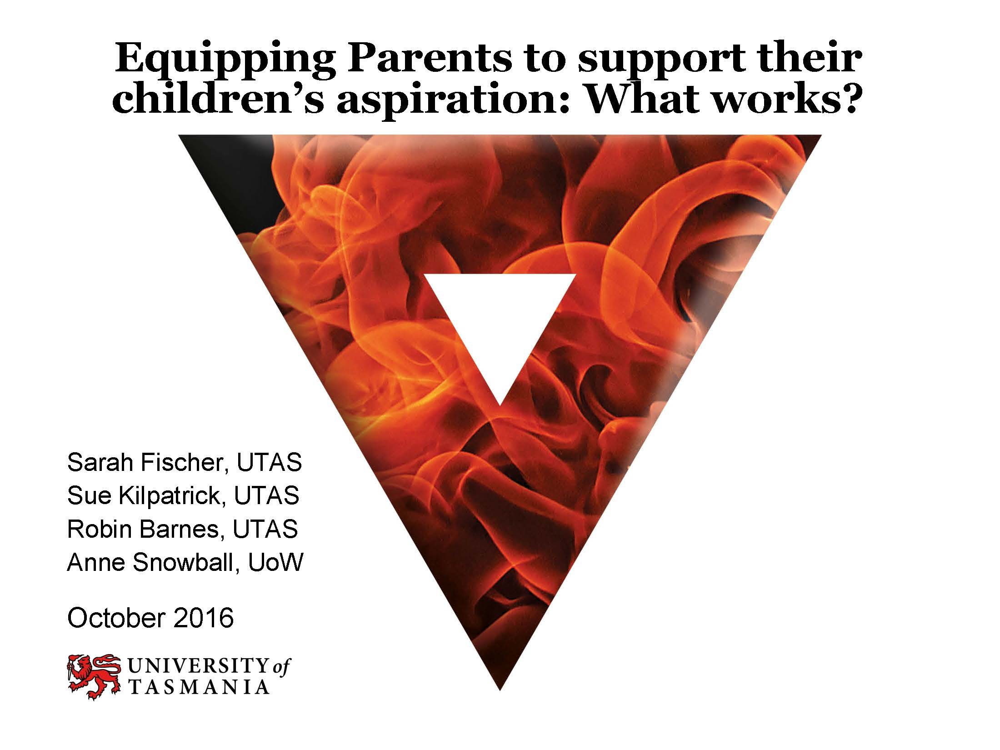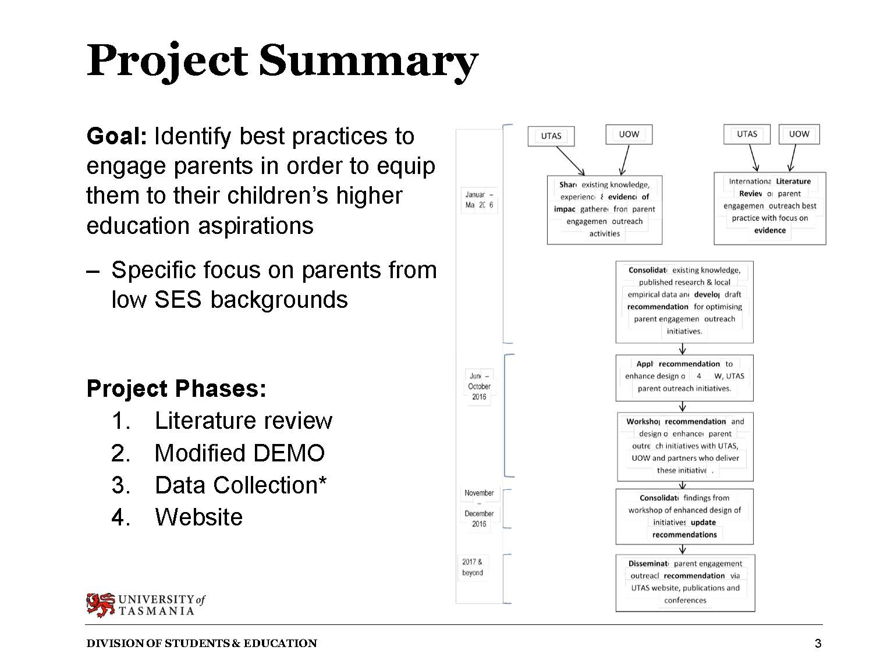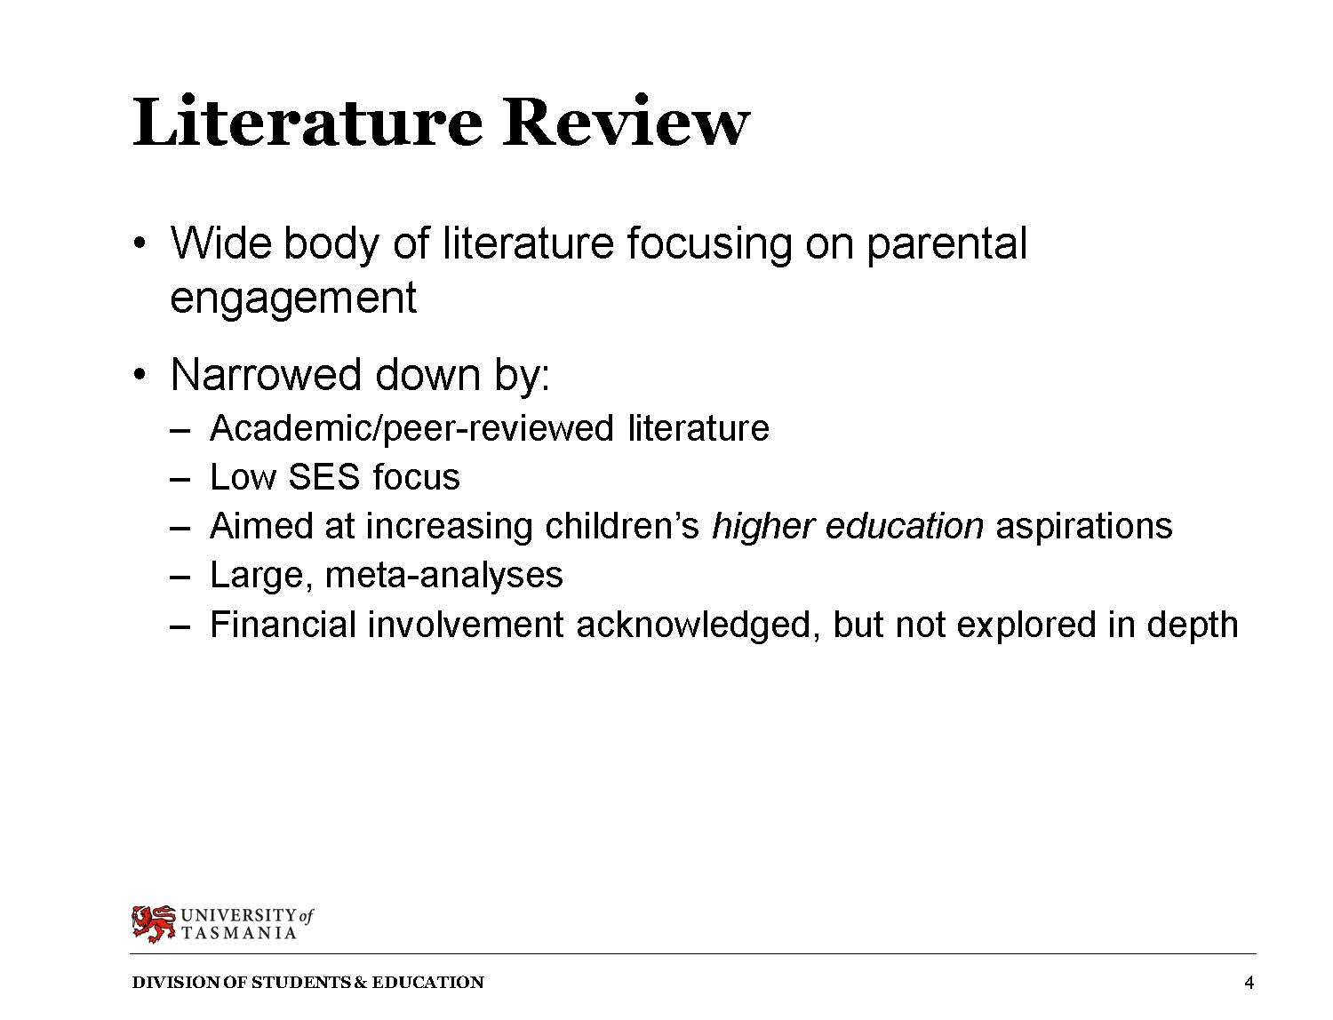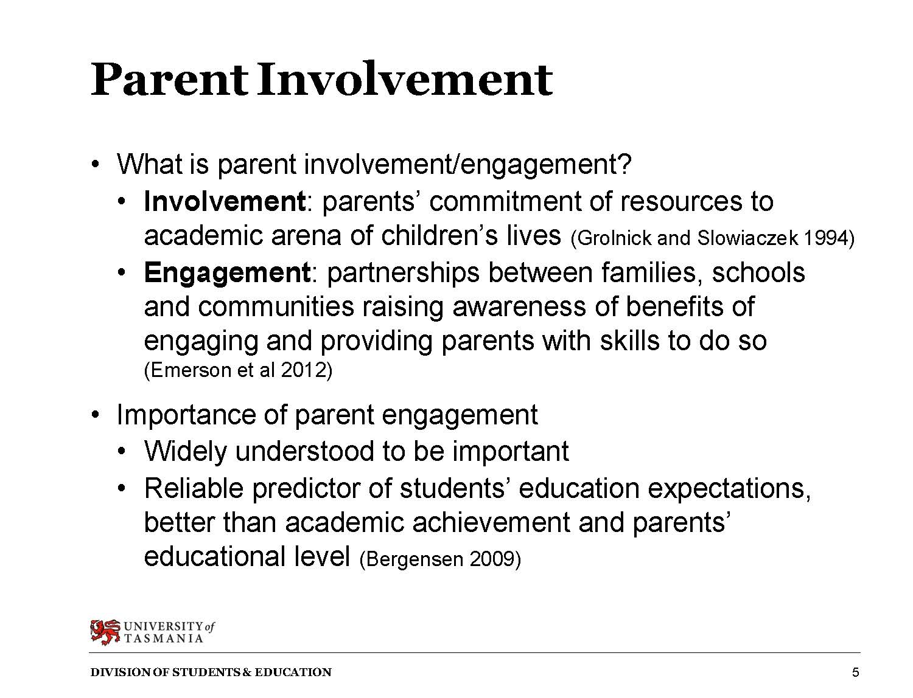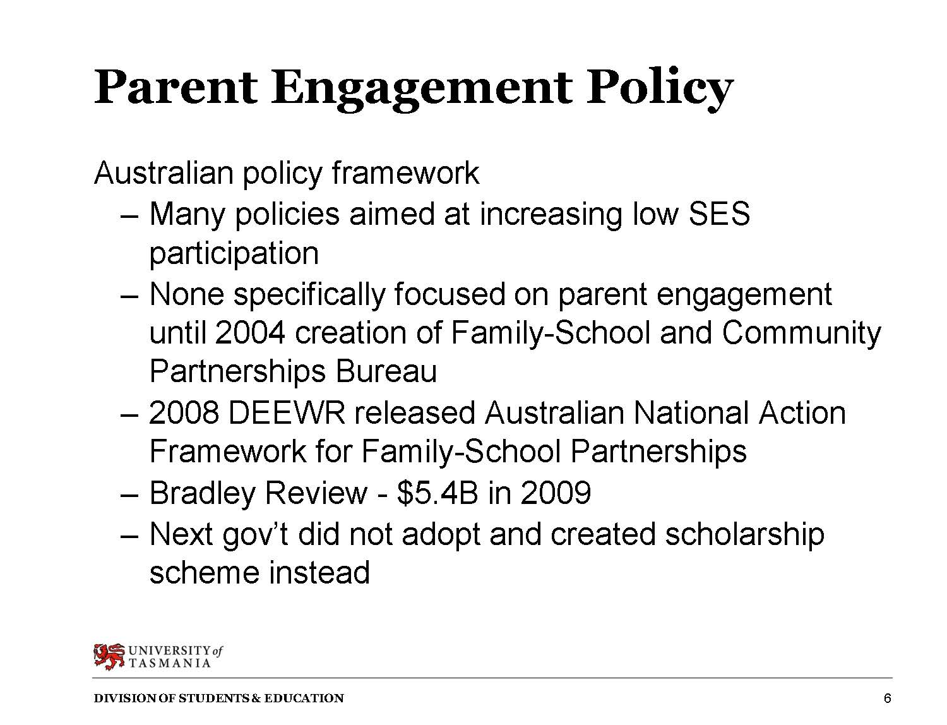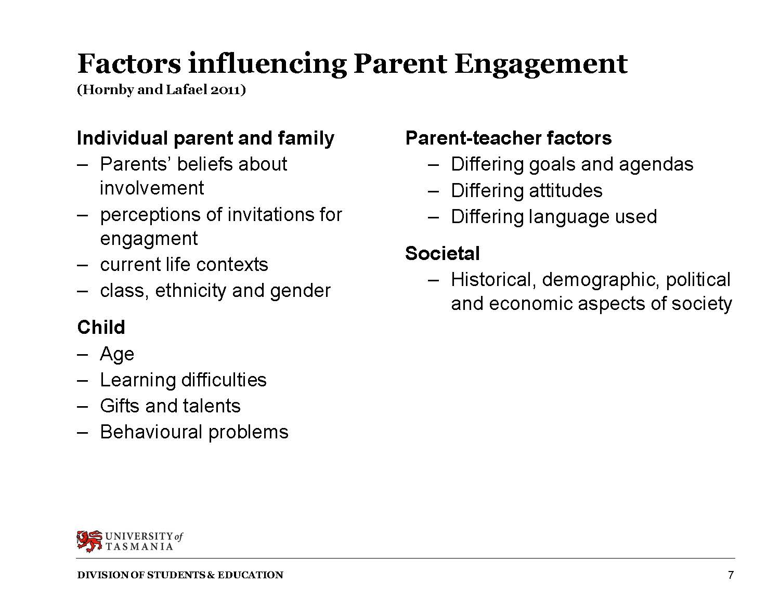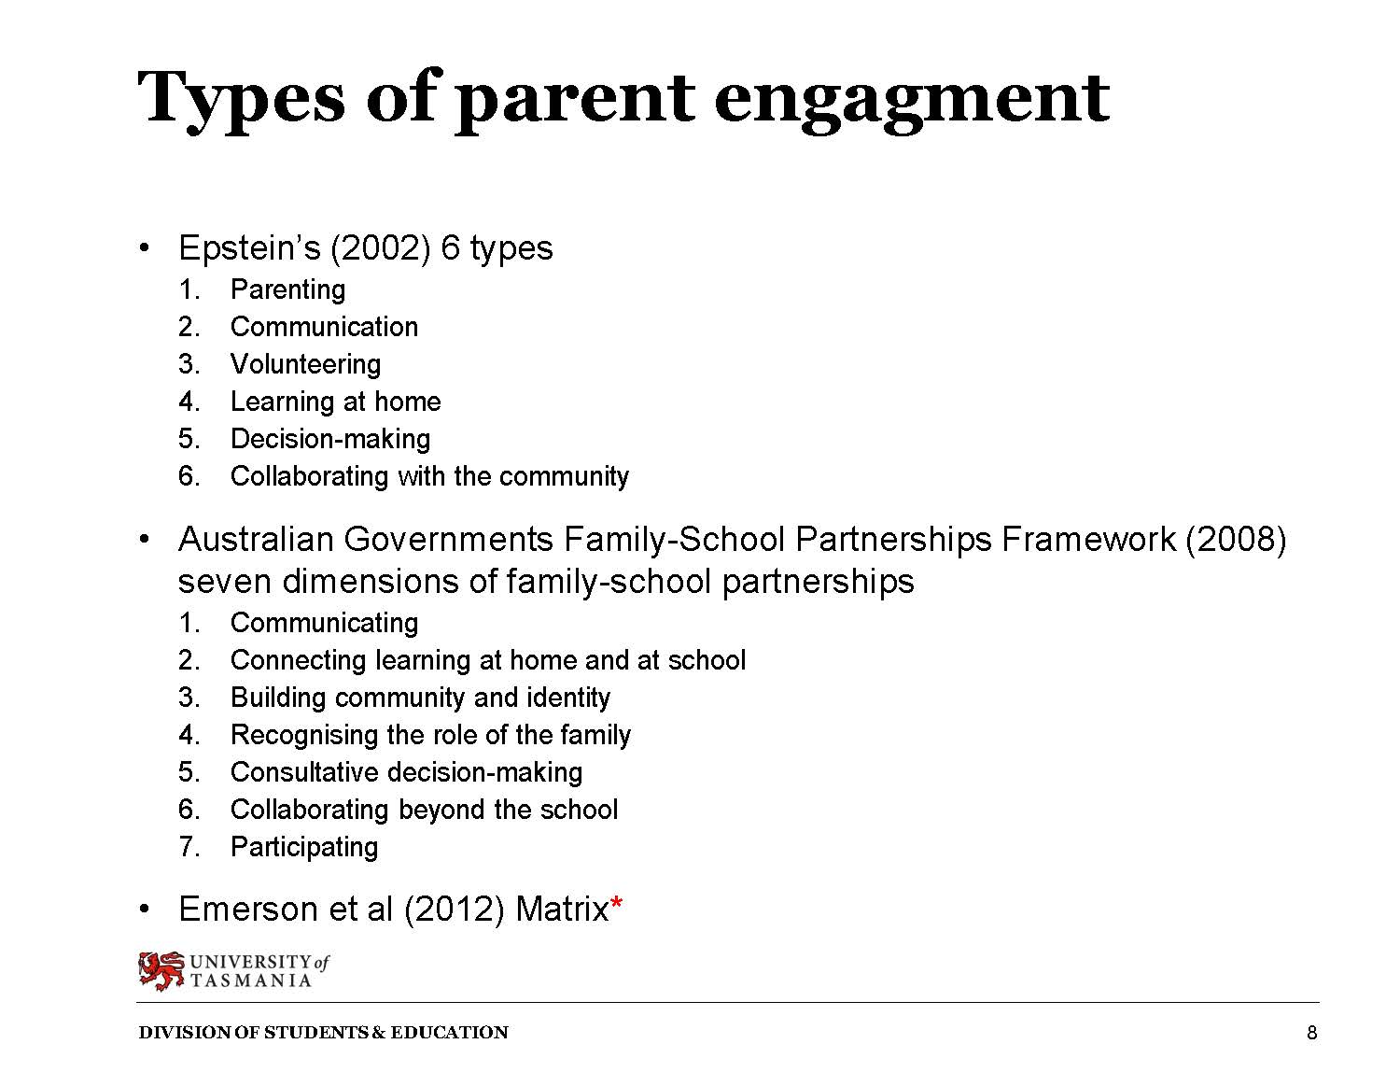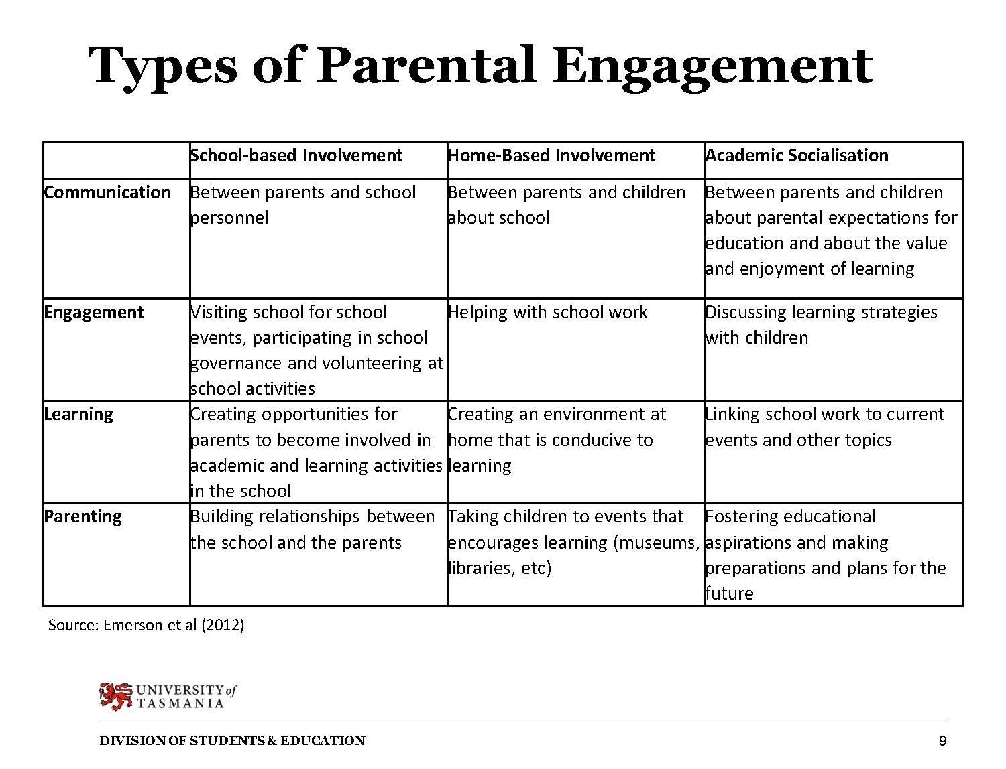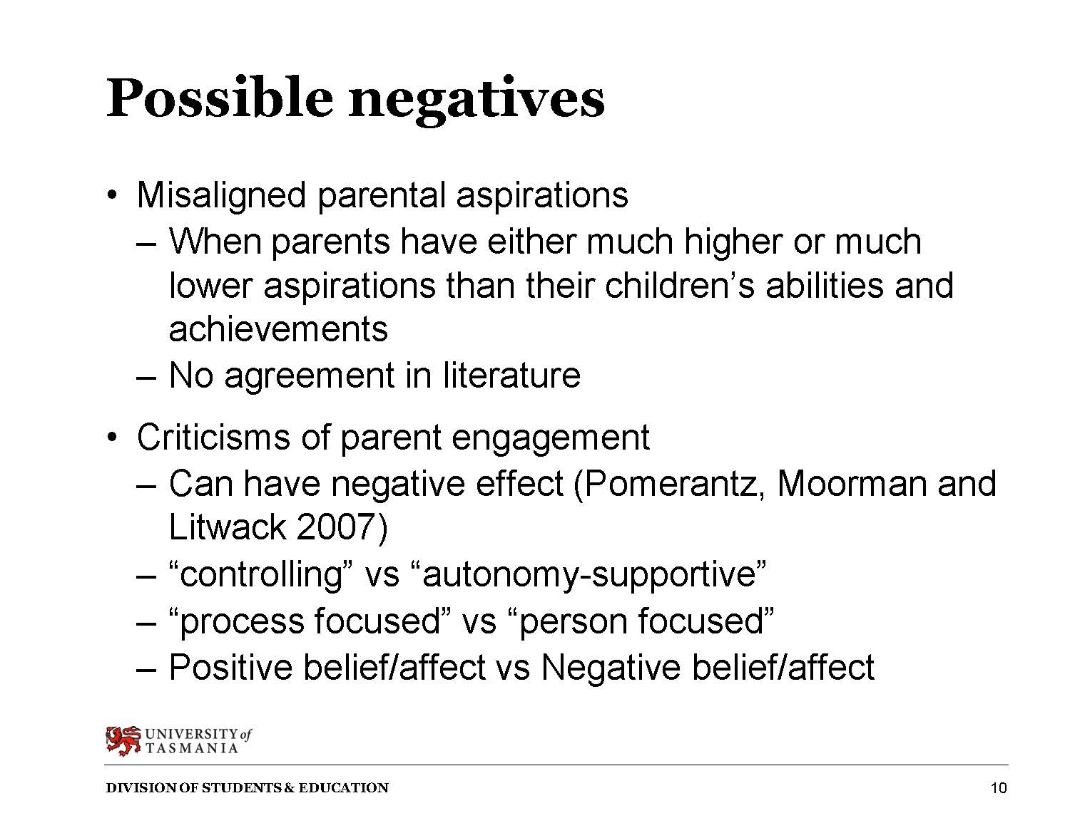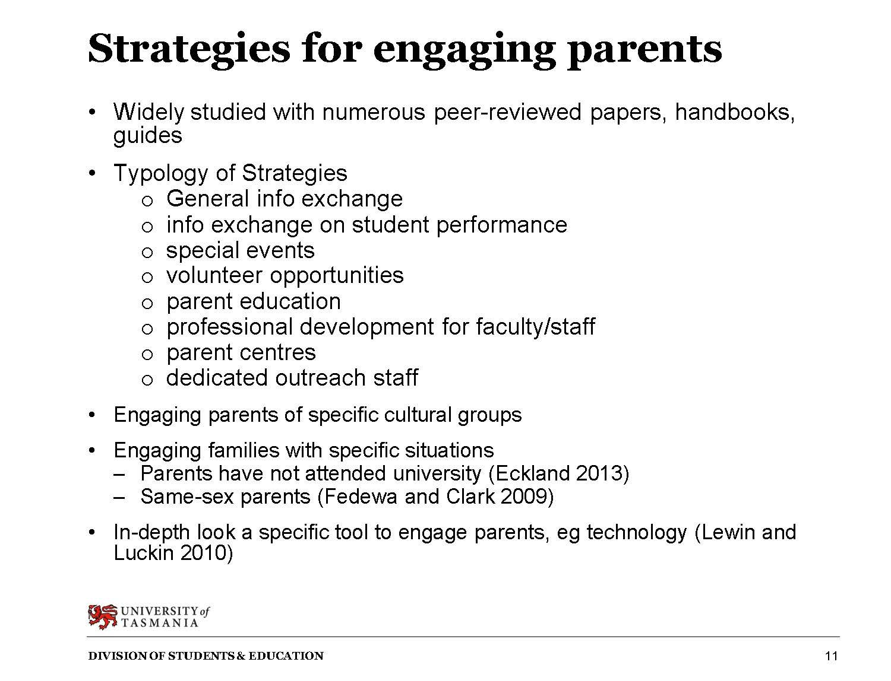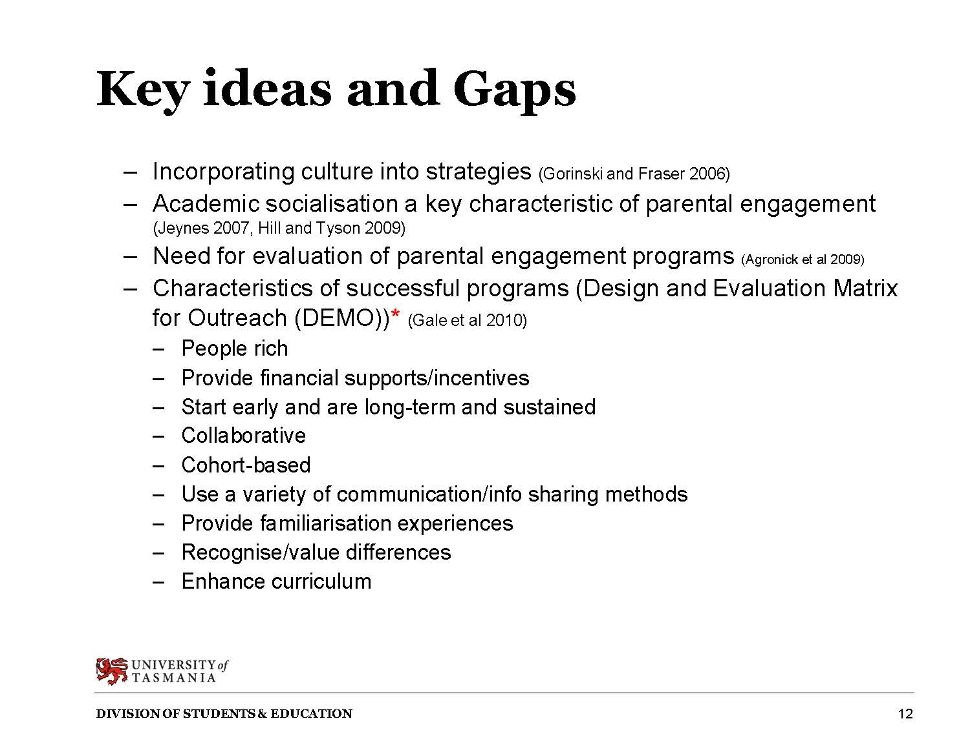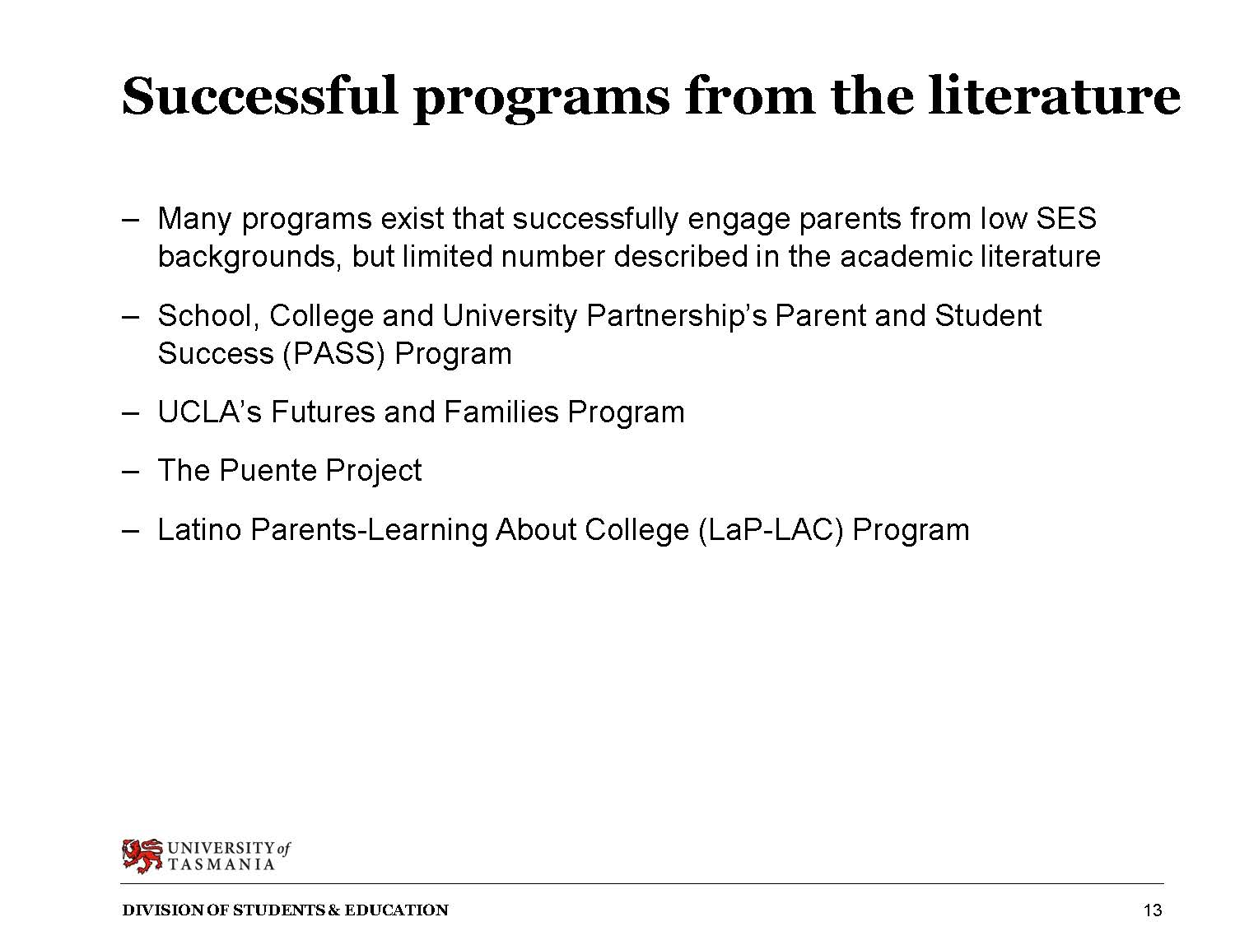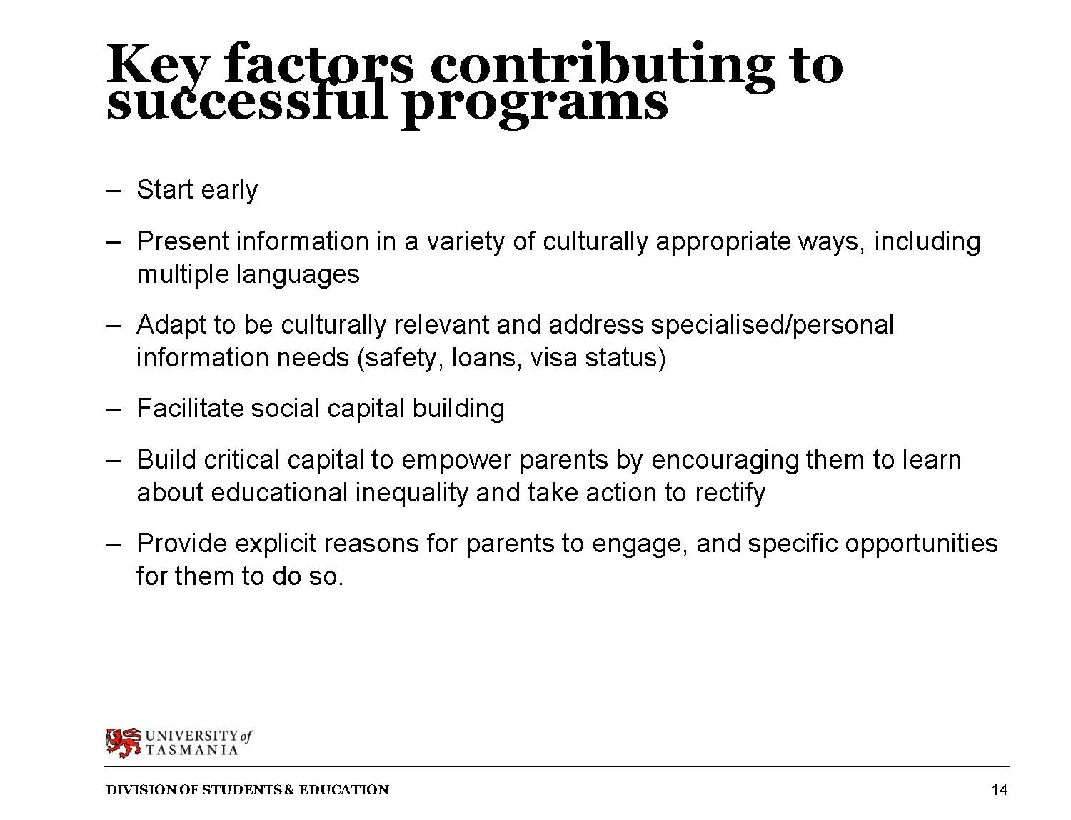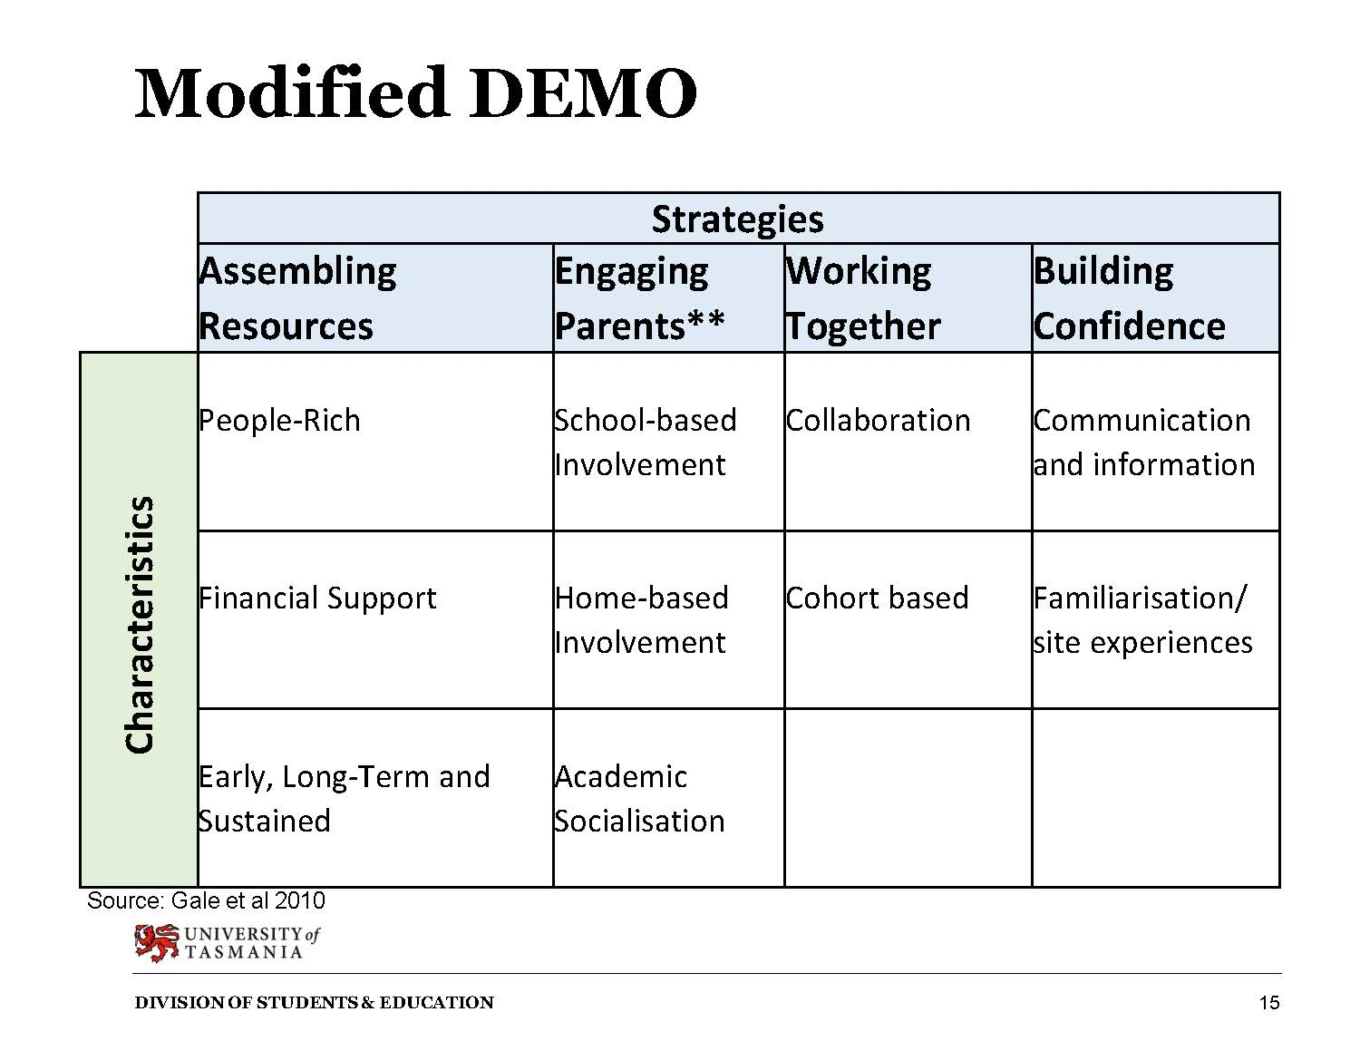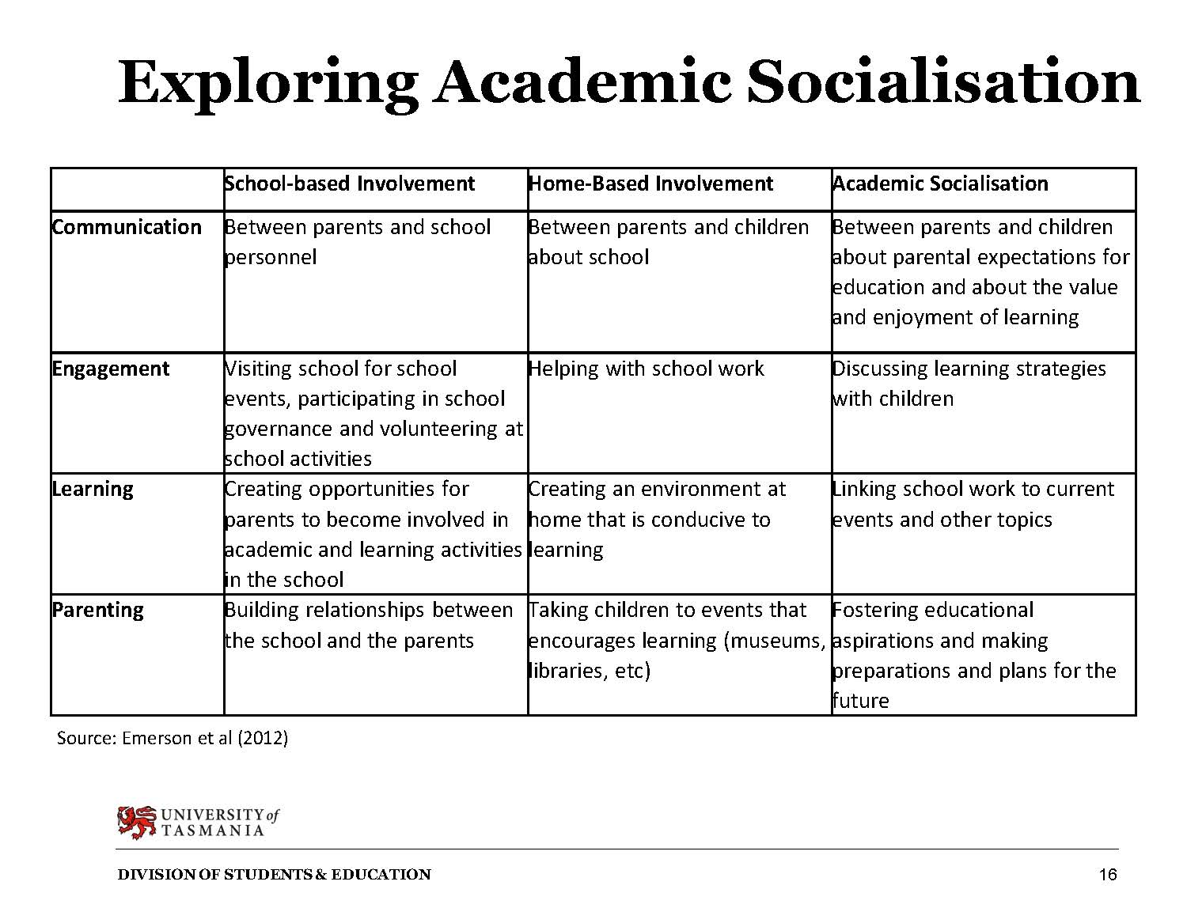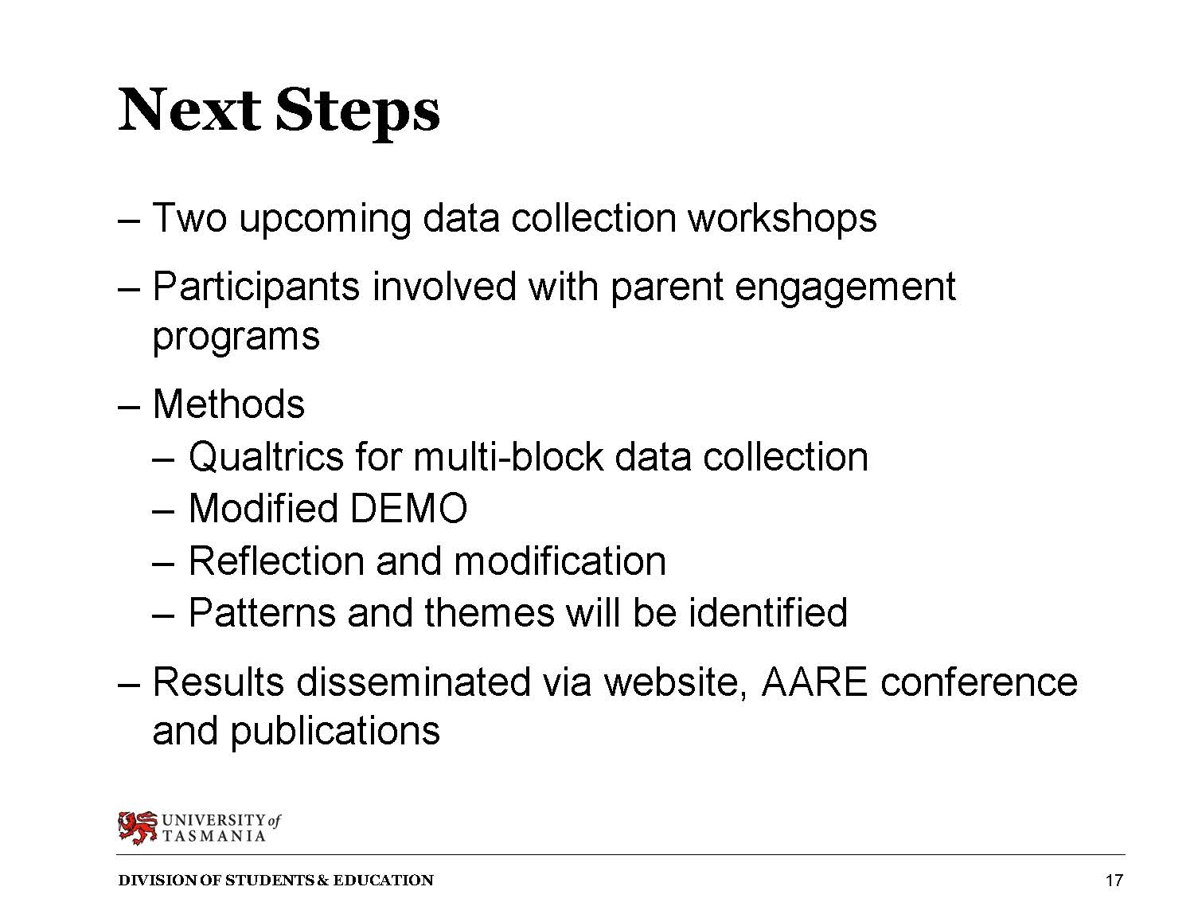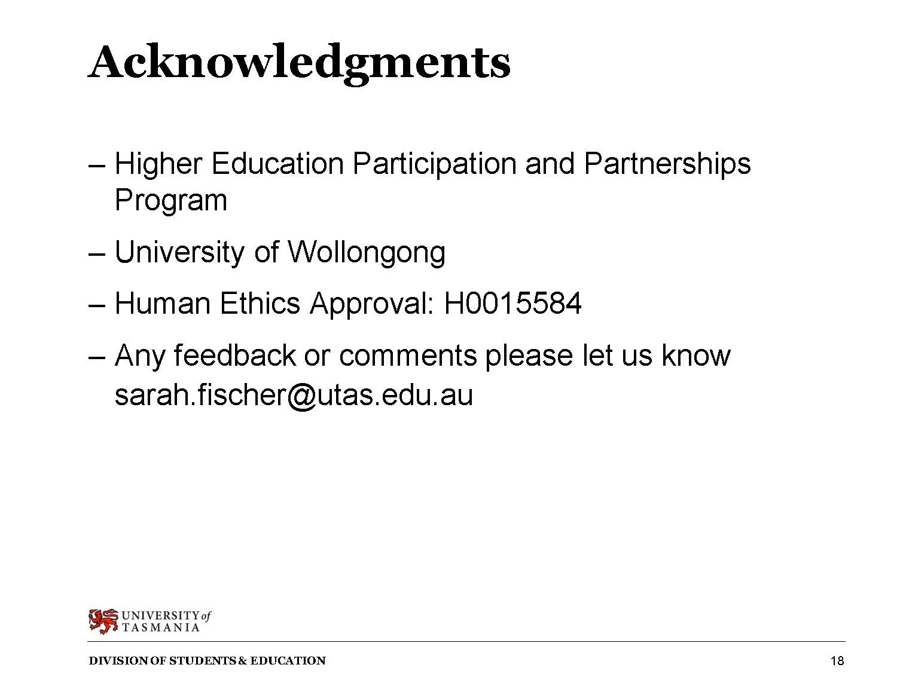

PART D: Equipping Parents to Support their Children’s Aspiration: What Works? Slideshow Presentation
