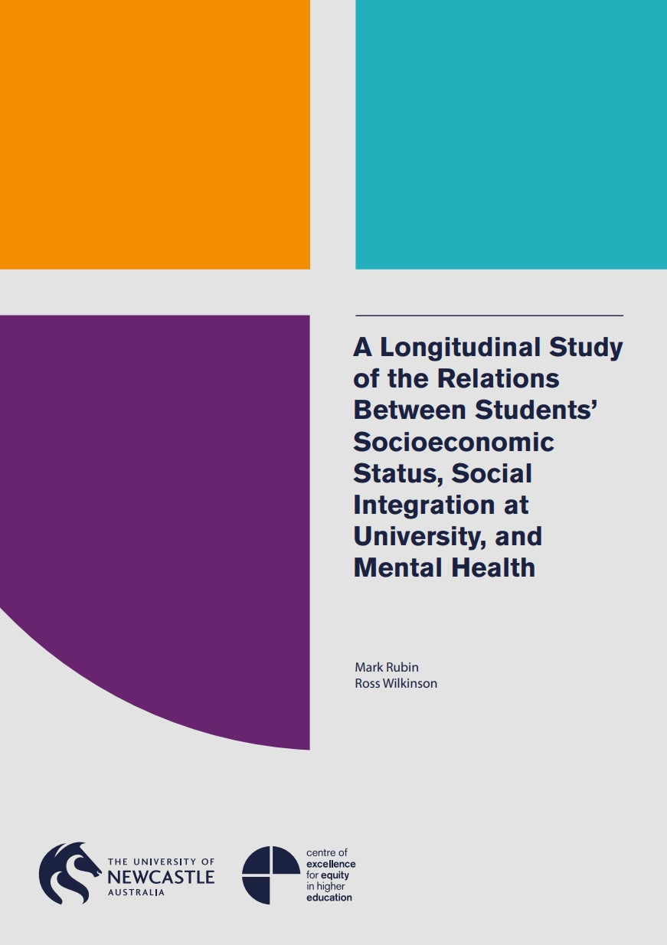

A Longitudinal Study of the Relations Between Students’ Socioeconomic Status, Social Integration at University, and Mental Health

December 2014 – December 2015

Associate Professor Mark Rubin, University of Newcastle
Dr Ross Wilkinson, University of Newcastle

The project that resulted in the production of this report was funded under a National Priorities Pool (Higher Education Participation and Partnerships Program) grant from the Commonwealth. The recipient of the grant has granted the Commonwealth the right to sub-licence the material in this report. Copyright in the report remains with the original copyright owners.
Except where otherwise indicated, and save for any material protected by a trade mark, the Department of Education and Training, acting on behalf of the Commonwealth, has applied the Creative Commons Attribution 4.0 International Licence.

Modifications: Changed to meet WCAG 2.0 accessibility requirements.
Alternate text inserted for all images. Minor typographical errors corrected.

Higher Education Participation and Partnerships Programme (HEPPP)

2014 National Priorities Pool FINAL REPORT
A Longitudinal Study of the Relations Between Students’ Socioeconomic Status, Social Integration at University, and Mental Health
17th December 2014 to 30 December 2015
Name of university The University of Newcastle, Australia
Name of contact officer Dr Mark Rubin*
Position title Senior Lecturer
Email address mark.rubin@newcastle.edu.au
Telephone number (02) 4921 6706
In accordance with the Conditions of Grant, you must submit to the Department a Final Report (Clause 6.1 of Part A) and an Acquittal Report (clause 6.4 of Part A).
To meet this obligation, please submit:
- the completed Final Report template, in Word and PDF
- the completed and signed Declaration form, in PDF
- the completed Acquittal Report template, in Excel and PDF.
All documents must be submitted to equity@education.gov.au by 31 March 2016.
If you require additional guidance or clarification please contact equity@education.gov.au.
*Please send a copy of any correspondence regarding this project to:
Ms Belinda Munn
Associate Director
Centre of Excellence for Equity in Higher Education
University of Newcastle
belinda.munn@newcastle.edu.au

Contents
List of Tables 4
1. PROJECT SUMMARY (Conditions of Grant, clause 2.2(a)-(e) of Part A) 5
Objectives 5
Project Activities, Milestones and Key Performance Indicators 5
Highlights and Issues 7
2. OTHER PROJECT MATERIAL (Conditions of Grant, clause 2.2 (b)-(e) of Part A) 9
3. ACQUITTAL REPORT (Conditions of Grant, clause 6.4(e), clause 6.7-8 of Part A) 10
DECLARATION 11
Appendix 1 12
Project Summary 12

List of Tables
Table 1: Project objectives 5
Table 2: Project activities, milestones and KPIs 6
Table 3: Additional materials produced over the course of the project 9

1. PROJECT SUMMARY (Conditions of Grant, clause 2.2(a)-(e) of Part A)

Objectives
Indicate the extent to which the Project Objectives specified in clause 3 of Part A of the Conditions of Grant were met. Where obligations established in the Conditions of Grant were not met, please identify these and provide an explanation of circumstances and consequences.

Table 1: Project objectives
IDENTIFIED OBJECTIVE | EXTENT TO WHICH THE OBJECTIVE WAS MET
- To provide a better understanding of the empirical links between university students' SES, their social integration at university, and their mental health and well-being. | Objective met. We have arrived at a better understanding of the empirical links between university students’ SES, social integration, and mental health and well-being. We have submitted a manuscript that reports our research results to an international peer-reviewed journal: The Journal of Social and Clinical Psychology.
- To inform policies and approaches that  promote the social inclusion of two key minority groups: low SES students and students with mental health problems. | Objective partially met. We have not yet published our research results in a peer-reviewed journal article, and it would be inappropriate to make policy recommendations on the basis of unpublished research. We commit to achieve this objective following the publication of our research results.
- To inform policies and approaches that reduce mental health problems among university students, increase their satisfaction at university, and reduce their attrition rates. | Objective partially met. As explained above, we have not yet published our research results in a peer-reviewed journal article, and it would be inappropriate to make policy recommendations on the basis of unpublished research. However, we commit to achieve this objective following the publication of our research results.

Project Activities, Milestones and Key Performance Indicators
Below, please specify whether:
- all project Activities specified in Schedule 1 of the Conditions of Grant
were completed
- all Project Milestones specified in Schedule 1 of the Conditions of Grant
were completed
- all Key Performance Indicators specified in Schedule 1 of the Conditions of
Grant were met.
Where obligations established in the Conditions of Grant were not met, identify these and provide an explanation of circumstances and consequences.

Table 2: Project activities, milestones and KPIs
TIMEFRAME | PLANNED ACTIVITIES AND MILESTONES | PROJECT ACTIVITIES AND MILESTONES COMPLETED | IDENTIFIED KEY PERFORMANCE INDICATORS | KEY PERFORMANCE INDICATORS OUTCOME
January - February | Develop online survey  Obtain ethical approval for the research | YES  YES (Ethics approval number: H-2012-0382) | N/A | N/A
March - June | Wave 1 data collection during Semester 1 | YES. Data collected from 749 students. | N/A | N/A
August - September | Wave 2 data collection during Semester 2 | YES. Data collected from 314 students. | N/A | N/A
October - December | Analyse research data  Present results at Social Inclusion in Education conference  Write journal article and submit to top tier journal  Contact stakeholders with recommendations for policies and strategies | YES  The Social Inclusion in Education conference was not held in 2015. Instead, results were presented at (1) the Australian Association for Research in Education Conference 2015, Freemantle, Western Australia, and (2) 14th Australian Psychological Society Psychology of Relationships Interest Group Conference, Melbourne, Australia  In progress  Not yet completed. We will contact stakeholders via email following the publication of our research results. Key stakeholders include the Department of Education, the Australian Council for Educational Research, the National Centre for Student Equity in Higher Education, Universities Australia, the Go8 Social Inclusion Strategy Group, Innovative Research Universities, and the Australian Technology Network of Universities. | N/A | N/A

Highlights and Issues
Provide a summary of highlights and achievements arising from your project (maximum
half page).
- We collected usable data from 749 students in Wave 1 and 314 students in Wave 2. The Wave 2 sample included 202 women (64.33%) and 112 men (35.67%). Participants ranged in age from 17 to 62 years with a mean age of 23.4 (SD = 7.86). The majority of participants self-identified as Caucasian (89.5%), with the remainder identifying as “other” (4.8%), Aboriginal or Torres Strait Islander (3.5%), Asian (1.6%), or African (.6%). Based on a measure of self-reported social class identity, 11.8% of participants described themselves as working class, 13.7% as lower middle class, 40.8% as middle class, 22.6% as upper middle class, 1.9% as upper class, and 2.88% selected “don’t know.” Finally, 34.1% of our sample was enrolled in degrees in the Faculty of Education and Arts, 23.9% were from the Faculty of Health and Medicine, 15.0% were from the Faculty of Business and Law, 12.4% were from the Faculty of Engineering and the Built Environment, 12.1% were from the Faculty of Science and Information Technology, and 2.5% did not identify a specific faculty.
- Consistent with previous work, our findings indicated that students’ subjective social class (i.e., their own appraisal of their social status in society) was negatively related to their levels of depression and positively related to their satisfaction with life. These relationships were mediated by social contact at university. This means that subjective social class predicted the amount of social contact that students had with other students at university which in turn predicted their levels of depression and satisfaction with life. These relations were tested longitudinally meaning that we can infer that social contact is the mechanism through which social class and mental health are linked: Social class determines the level of social contact that students have at university, and social contact, or lack thereof, determines the level of mental health that students experience.
- We will make the following research materials available via a public data repositories called Figshare: the research survey, deidentified data set, associated SPSS syntax file, and variable naming information.
Did the project lead to implementable outcomes?
We believe that our results will lead to implementable outcomes. For example, developing targeted programs to increase the social contact that low SES student have at university may help to buffer the effects of SES on mental health. Hence, universities may pay greater attention to integrating low SES students into the social life in order to protect them from poor mental health. Potential integration strategies include subsidising the financial costs of (a) travel to university campuses, (b) on-campus and close-to-campus accommodation, (c) campus childcare, and (d) university-based social events. Online social networking may also serve as an effective form of social contact for time- and money-poor low SES students.
What changes will result at your institution/nationally?
It is too early to indicate concrete changes as a result of the current research results. However, likely recommendations will involve Universities developing targeted programs to enhance social contact at University for low SES students.
Are there activities resulting from this project that will be continued?
Yes.
- We are in the process of collecting a third wave of data. This third wave will allow us to provide a more comprehensive analysis of the relations between SES, social integration, and mental health.
- One of the research assistants that was associated with this project (Olivia Evans) has now commenced a PhD in the area. Her PhD research is titled: “Socioeconomic Status Differences in University Students' Mental Health.” She will be including the results from Wave 3 of our data collection in her thesis.
- We have submitted the following grant application to follow up on the current research project: Rubin, M., Wilkinson, R., Evans, O., & Sanatkar, S. (2016). Socioeconomic status, social integration, and mental health in tertiary students: A longitudinal and comparative study. Submitted to the Student Equity in Higher Education Research Grants Program, National Centre for Student Equity in Higher Education.
Did you undertake an evaluation of your project?
Yes No X
Please summarise the findings and attach the evaluation report
N/A
Where applicable, indicate number of the following resulting from this project:
Student contacts | 2 (1 Hons student; 1 PhD student)
Journal (or other publication) submissions | 0 (1 in preparation)
Conference Presentations | 2, with a 3rd in preparation
Websites developed | 1 (Website address/es: https://figshare.com/s/eec643aa7ded27d0ef82)
Educational or marketing campaigns | N/A
Community organisations engaged | N/A
Schools engaged | N/A

Optional - If you included transformational/behavioural change KPIs in your EOI please summarise outcomes here:
E.g. Percentage increase in enrolment | N/A
E.g. Percentage increase in aspiration | N/A

Describe any issues that occurred during the year and any mitigation strategies you implemented.

2. OTHER PROJECT MATERIAL (Conditions of Grant, clause 2.2 (b)-(e) of Part A)
[List the titles of any published reports, pamphlets or other documentation produced in the course of the Project and attach them to this Final Report.]

Table 3: Additional materials produced over the course of the project
TYPE | AUTHOR | DATE OF PUBLICATION | PUBLICATION DETAILS
E.g. Journal article; conference paper; website; pamphlet, etc. | N/A | N/A | Name of Journal, Conference title and date; website URL, etc.

3. ACQUITTAL REPORT (Conditions of Grant, clause 6.4(e), clause 6.7-8 of Part A)
Have you fully expended the Grant Funds provided under the Conditions of Grant?
Yes X No
[If the answer is No, you must state:
- the amount of the underspend, and
- the reason for the underspend.]
[Complete the Acquittal Report template and attach it to this Final Report.]
*IMPORTANT NOTICE - Unspent 2014 HEPPP Partnership Grant Funds
- Grant recipients must fully expend these 2014 National Priorities Pool funds in the project period for which the grant is made and report on this expenditure to the Commonwealth, including the amount of any unspent funds.
- If a provider fails to spend the full amount granted it in respect of a year, the unspent funds may be recovered by the Commonwealth.

DECLARATION
I declare that:
- I am authorised by the university to sign this Declaration on its behalf, and
- to the best of my knowledge, the information that I have provided in the Final Report and Acquittal Report for the HEPPP 2014 National Priorities Pool project A Longitudinal Study of the Relations Between Students’ Socioeconomic Status, Social Integration at University, and Mental Health is true, correct and accurate in all particulars.
I understand that:
- The provision of false or misleading information or the making of false or misleading statements to the Commonwealth is a serious offence under the Criminal Code Act 1995 (Cth).
- If any actual or potential conflict of interest arises, I must notify the Commonwealth immediately in writing of the facts giving rise to the actual or potential conflict of interest and to take such steps as the Commonwealth may require so as to resolve or otherwise deal with any conflict of interest that may arise.

Title Professor
Name Andrew Parfitt
Position Deputy Vice-Chancellor (Academic)
Signature

Appendix 1

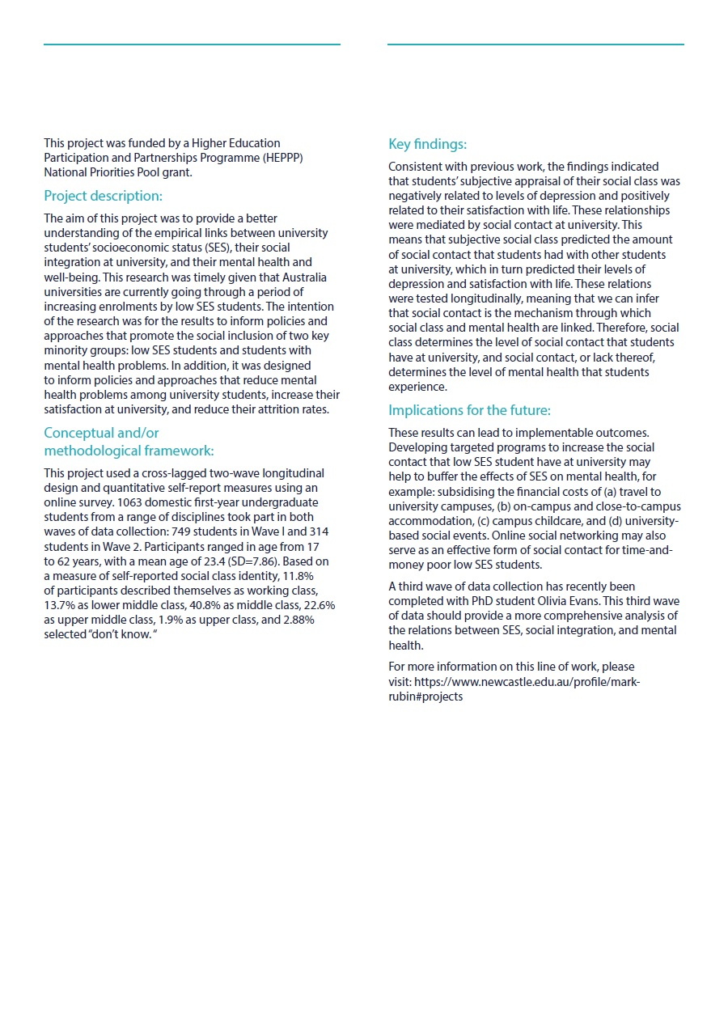
Project Summary

