Click-on Mentoring
Jan 2017 to March 2018

Ann Jardine, University of New South Wales

The project that resulted in the production of this report was funded under a National Priorities Pool (Higher Education Participation and Partnerships Program) grant from the Commonwealth. The recipient of the grant has granted the Commonwealth the right to sub-licence the material in this report. Copyright in the report remains with the original copyright owners.
Except where otherwise indicated, and save for any material protected by a trade mark, the Department of Education and Training, acting on behalf of the Commonwealth, has applied the Creative Commons Attribution 4.0 International Licence.

Modifications: Changed to meet WCAG 2.0 accessibility requirements.
Alternate text inserted for all images. Minor typographical errors corrected.

Higher Education Participation and Partnerships Programme (HEPPP)

2017 National Priorities Pool FINAL REPORT
Click-on Mentoring
Jan 2017 to March 2017
Name of university University of New South Wales, Sydney
Name of contact officer Dr Ann Jardine
Position title Director, AimHigh UNSW
Email address a.jardine@unsw.edu.au
Telephone number (02) 9385 6360
In accordance with the Conditions of Grant, you must submit to the Department a Final Report (Clause 6.1 of Part A) and an Acquittal Report (clause 6.4 of Part A).
To meet this obligation, please submit:
- the completed Final Report template, in Word and PDF
- the completed and signed Declaration form, in PDF
- the completed Acquittal Report template, in Excel and PDF.
All documents must be submitted to equity@education.gov.au by 31 December 2017.
If you require additional guidance or clarification, please contact us at equity@education.gov.au.

Contents
List of Tables 4
List of Figures 4
1. PROJECT SUMMARY (Conditions of Grant, clause 2.2 of Part A) 5
Objectives 5
Project Activities, Milestones and Key Performance Indicators 5
Highlights and Issues 8
Outcomes 9
Summary 9
Issues 9
2. OTHER PROJECT MATERIAL (Conditions of Grant, clause 2.2 of Part A) 11
3. ACQUITTAL REPORT (Conditions of Grant, clause 6.4 (a)-(d), clause 6.5
(a)-(b) of Part A) 12
DECLARATION 13
Appendix 1: ASPIRE Click-on Mentoring Evaluation Report 14
A. Introduction 14
B. Implementation 14
C. Program Structure 17
D. Program Launch Day 18
E. Online Sessions 19
F. Program Close Day 19
Evaluation 19
Recommendations for improvement 25
Strategy for Click-on Mentoring to be incorporated into the core ASPIRE program 27
References 28
Evaluation Report Appendix 1: Click-on Mentoring Partnership Agreement 28
Evaluation Report Appendix 2: Mentor Training Topics 29
Appendix 2: Information for Schools Flyer 31
Appendix 3: Information for Students Flyer 33

List of Tables
Table 1: Project objectives 5
Table 2: Project activities, milestones and KPIs 5
Table 3: Pre program and post program survey results 8
Table 4: Additional materials produced over the course of the project 11
Table 5: Year 9 students participating in the program 15
Table 6: Program structure 17

List of Figures
Figure 1: shows mentors were recruited from a variety of Faculties 16
Figure 2: shows mentors recruited were from a range of year levels 16
Figure 3: shows Mentees’ attitude shift towards having a clear understanding
of the job they would like to do in the future 21
Figure 4: shows mentees’ attitude shift towards having a clear understanding
of the training and qualification they would like to do after school 21
Figure 5: shows mentee’s belief that it was beneficial to talk to another adult 22
Figure 6: shows that the mentoring program has increased mentee’s motivation
to pursue in further education after high school 22
Figure 7: shows the mentor’s experience of the program 23
Figure 8: shows unexpected gains in mentor skills 23
Figure 9: shows mentee preference of technology 24
Figure 10: shows the percentage of participants completing online sessions. 26
Figure 11: how to incorporate mentoring with other ASPIRE events 27

1. PROJECT SUMMARY (Conditions of Grant, clause 2.2 of Part A)

Objectives

Table 1: Project objectives
IDENTIFIED OBJECTIVE | EXTENT TO WHICH THE OBJECTIVE WAS MET
Run a pilot e-mentoring scheme with two regional/remote partner schools in the UNSW ASPIRE program; | Completed – pilot program at two ASPIRE partner schools has concluded.
Evaluate the effectiveness of the scheme | Completed – a number of evaluations were completed with multiple stakeholders. The pilot program was highly received; further details of this can be found in the evaluation report.

Project Activities, Milestones and Key Performance Indicators

Table 2: Project activities, milestones and KPIs
TIME FRAME | PLANNED ACTIVITIES AND MILESTONES | PROJECT ACTIVITIES AND MILESTONES COMPLETED | IDENTIFIED KEY PERFORMANCE INDICATORS | KEY PERFORMANCE INDICATORS OUTCOME
Jan 2017 – Apr 2017 | 1.1 Project Officer recruitment | Project Officer appointed on 7 March 2017. | 1.1 Appointment of a Project Officer with knowledge, skills and experience to successfully deliver the pilot e-mentoring scheme | Completed  Project Officer appointed with experience in coordination of online mentoring program.
 | 1.2 Recruitment of pilot schools | Two existing ASPIRE schools were identified as suitable to implement e-mentoring. Both schools located in Regional NSW:  - Condobolin High School  - Ungarie Central School | 1.2 Agreement reached with two ASPIRE schools to participate in the e-mentoring scheme | Completed  Both schools agreed to participate.
Jan 2017 – Apr 2017 | 2.1 Development of training, training materials and guidelines for the scheme |  | 2.1.1 Scheme and training materials developed to discuss with schools on their return in February.  2.1.2 Supporting technology is identified and trialled. | Completed  Training materials and guidelines completed and documented. A number of technological platforms were trialled and a suitable one was identified.
May 2017 | 3.1 Visits to pilot schools to discuss:  - recruitment of mentees  - scheme scope  - technologies for delivery of scheme | A total of 26 students were identified by schools as mentees to participate in the program. | 3.1 Pilot schools are visited.  Agreement is reached on:  - logistics of delivering the scheme  - key milestones (start and finish timeframes, development of toolkit, timeframe and process for feedback) | Completed  Schools were visited in early May. Agreement reached on delivery and milestones of scheme. Both schools signed Mentoring Partnership Agreement.
May 2017 – Jun 2017 | 4.1 Recruitment and training of mentors from UNSW staff and students | UNSW students recruited as mentors | 4.1 Recruitment and training of up to 15 mentors | Completed  26 mentors were recruited and trained to allow for 1-1 mentor-mentee relationships
Jun 2017 | 5.1 Recruitment of Year 8 and 9 students to be mentored through the scheme | Schools identified Year 9 students to be more suitable for the mentoring scheme. | 5.1 Up to 30 students chosen from Years 8 and 9 in the pilot schools | Completed  26 students in total were chosen from both schools  - Ungarie Central School: 6 students  - Condobolin High School: 20 students
Jul 2017 | 6.1 Pre-scheme training event in regional centre (Dubbo) | Pre-Scheme Training was renamed as Program Launch. It was in agreement with schools that UNSW campus in Sydney was a more suitable location to hold this. | 6.1 Mentors (up to 15) and mentees (up to 30) brought together for two days for ice breaker and joint training sessions for scheme, including guidelines and technologies to be used | Completed  This was held at UNSW Sydney at the end of August.
Jul 2017 – Dec 2017 | 7.1 Delivery of pilot e-mentoring scheme | 6 online sessions were scheduled in agreement with schools.  Mentors completed a mid-program debrief to replace feedback sessions due to time constraints. Teachers provided informal feedback at the start of each online session due to time constraints. | 7.1.1 Delivery of up to 5 mentoring sessions of one hour to each mentee across the scheme  7.1.2 Up to 5 feedback sessions with mentors and schools, facilitated by Project Officer via a short survey instrument | Completed  Online session completed. Mid program debrief and informal feedback from teachers gathered.
 | 7.2 Ongoing development of web-based toolkit designed to inform others when setting up an e-mentoring scheme |  | 7.2 Toolkit to be completed by end of Project | Completed  Toolkit to be published on the ASPIRE website.
Dec 2017 – Feb 2018 | 8.1 Evaluation of pilot e-mentoring scheme in order to identify strengths and weaknesses of scheme, identify technological challenges and obtain feedback for improvement | In agreement with teachers, the two semi-structured interviews were counted as stakeholder meetings. | 8.1.1 Up to 3 key stakeholder meetings conducted with teaching staff in each pilot school  8.1.2 All mentees and mentors surveyed on the successes of the scheme  8.1.3 A minimum of 2 semi-structured interviews held with staff in pilot schools  8.1.4 Focus groups held with students from all schools | Completed  Three stakeholder meetings with teachers conducted in each school.  Two semi-structured interviews were also held at each school.  Mentors and mentees completed a pre-program and post program survey.  Mentees participated in a focus group study at the completion of the program.  Details of the findings can be found in the evaluation report.
Jan/Feb 2018 | 9.1 Post-scheme event in regional centre (Dubbo) | Event was held at regional school (Condobolin High) in agreement with teachers. | 9.1 One-day event bringing mentors and mentees together to celebrate successful completion of the scheme | Completed  Event held at the end of November
Feb 2018 – Mar 2018 | 10.1 Strategy for making the e-mentoring scheme available to other ASPIRE partner schools |  | 10.1 Development of a strategy for incorporating the e-mentoring scheme into the core ASPIRE program | Completed  Strategy developed to expand the program to 160 students across ASPIRE metro and regional partner schools in 2018
Mar 2018 | 11.1 Dissemination of Project outcomes |  | 11.1.1 Evaluation Report is finalised and disseminated to key stakeholders  11.1.2 Toolkit is finalised and placed on website | Completed  Report attached and sent to participating schools  Toolkit completed on ASPIRE website www.aspire.unsw.edu.au
 | 11.2 Final Report and Acquittal Report |  | 11.2 Final Report and Acquittal Report submitted to the Department of Education and Training by 31 March 2018 | Completed  Reports attached

Highlights and Issues
One of the highlights was how well mentors and mentees kicked off their relationship with a great start at the Program Launch Day. Teacher commented that the students came back to the school “raving about their mentors and couldn’t wait to start the online sessions”. Teachers also commented that all mentors and mentees were very well matched.
Teachers, mentors and mentees’ satisfaction of the program was a big achievement:
“The kids really enjoyed it, it opened up their eyes. Having someone younger to talk to is good, someone going through what they might possibly go through in the future.” Teacher at regional school
There was a significant increase between the pre-program and post-program survey results in the percentage of mentees’ knowledge of post school options after high school:

Table 3: Pre program and post program survey results
 | PRE PROGRAM RESULTS | POST PROGRAM RESULTS
Percentage of students who had a clear understanding of the job they would like to do in the future | 42% | 65%
Percentage of students who had a clear understanding of the training and qualifications they would like to do after school | 35% | 53%

- 90% of mentees agree that it was beneficial to talk to someone other than a teacher or parent about career related topics.
- Over 90% of mentees agree that the mentoring program has motivated them to pursue higher education after school.
- Over 90% of our past mentors feel that mentoring has been able to increase their interpersonal skills.
- Over 70% of our past mentors feel that mentoring has been able to increase their leadership skills.
- Over 80% of our past mentors feel that they have made a difference in a young person’s life.
One of the big achievements of the project was that it helped students make informed choices of post school options after talking to a mentor. Conversations with a mentor helped students have a clearer understanding of the job or educational/training qualifications they would like to do in the future. All students enjoyed talking to a young adult, who was not their parent or teacher, about career options. This shows the importance of mentoring to increase social capital in a geographically isolated town.

Outcomes
The project will be expanded to more schools and will be incorporated in core ASPIRE programs. Further details can be found in the evaluation report.
Did you undertake an evaluation of your project?
Yes X No

Summary
Overall, Click-on Mentoring was well received by mentors, mentees and teachers. Mentors and mentees engaged in career related topics over 6 online sessions. By talking to a mentor who is a current university student, mentees were able to find out what it is like to study at university, the type of university courses which exists, the type of jobs which a university degree can lead to and the social environment of a university campus. All this knowledge helps a mentee decide and have motivation to study at university.

Student contacts | 26
Journal (or other publication) submissions | N/A
Conference Presentations | 1
Website materials developed | 1  www.aspire.unsw.edu.au
Educational or marketing campaigns | N/A
Community organisations engaged | N/A
Schools engaged | 2
Parental/family contacts | N/A

Issues
Firstly, mentors were recruited from various Faculties across UNSW. A mentor flyer was designed and developed which contains the relevant information. The flyer was a pdf document and it was sent around to various key contact people across the university to promote the program. However, it was soon realised the application process was not straightforward. There was no application form linked to the flyer. Additionally, some faculties used Facebook to promote the program, however the pdf flyer was not compatible. A webpage was then created to resolve this problem. The link to the webpage was sent to key contacts and it was a better way for university students to access the information.
Secondly, it was planned that the mentor coordinator would be the host of one meeting room, but mentoring pairs would be able to have private conversations in the breakout rooms. The mentor coordinator would be the administrator to initiate and end the breakout rooms. However, Adobe Connect breakout rooms did not function at optimal level. Once everyone logged into Adobe Connect within the same meeting room, it was difficult to drag and drop the relevant pairs into breakout rooms. As this difficulty was encountered in the training, it was decided that the breakout rooms should not be used for the actual online sessions. Instead, mentors were asked to host the Adobe Connect meetings so that the meeting room only consisted of themselves and their own mentee.

2. OTHER PROJECT MATERIAL (Conditions of Grant, clause 2.2 of Part A)

Table 4: Additional materials produced over the course of the project
TYPE | AUTHOR | DATE OF PUBLICATION | PUBLICATION DETAILS

N/A

3. ACQUITTAL REPORT (Conditions of Grant, clause 6.4 (a)-(d), clause 6.5 (a)-(b) of Part A)
Have you fully expended the Grant Funds provided under the Conditions of Grant?
Yes No X
If the answer is No, please specify:
- the amount of funds remaining: $18,345.94
- the reason for this underspend: Savings were made in staffing costs due to efficiencies being able to be made through the help of staff in other mentoring programs within the overall ASPIRE program.
Ensure that the completed Acquittal Report template is signed by an appropriate university officer and attached to this Final Report.
*IMPORTANT NOTICE - Unspent 2016 National Priorities Pool Grant Funds
- Grant recipients must fully expend these 2016 National Priorities Pool funds in the project period for which the grant is made and report on this expenditure to the Commonwealth, including the amount of any unspent funds.
- If a provider fails to spend the full amount granted it in respect of a year, the unspent funds may be recovered by the Commonwealth.

DECLARATION
I declare that:
- I am authorised by the university to sign this Declaration on its behalf, and
- to the best of my knowledge, the information that I have provided in the Final Report and Acquittal Report for the HEPPP 2016 National Priorities Pool project: Click-On Mentoring is true, correct and accurate in all particulars.
I understand that:
- The provision of false or misleading information or the making of false or misleading statements to the Commonwealth is a serious offence under the Criminal Code Act 1995 (Cth).
- If any actual or potential conflict of interest arises, I must notify the Commonwealth immediately in writing of the facts giving rise to the actual or potential conflict of interest and to take such steps as the Commonwealth may require so as to resolve or otherwise deal with any conflict of interest that may arise.
I agree to publication of the Final Report on the Department of Education and Training website, once accepted by the department.

Title Professor
Name Ian Jacobs
Position Chief Executive Officer (Vice-Chancellor)
Signature

Appendix 1: ASPIRE Click-on Mentoring Evaluation Report

A. Introduction
The UNSW ASPIRE Click-on Mentoring pilot program ran in two schools over Term 3 and Term 4 of 2017. An online mentoring program was developed to meet the identified objectives:
- Run a pilot e-mentoring scheme with two regional remote partner schools in the UNSW ASPIRE program
- Evaluate the effectiveness of the program

Contextual Information
The project examines whether technologies can be successfully utilised to provide remote mentoring to regional schools in low socio-economic communities. Geographically isolated students are linked up via technology with the university community to overcome challenges of distance, time and cost. It has been found that mentoring has been an important strategy internationally in addressing the lack of relevant social capital (Reay 2001). The use of university students has been a common feature of widening participation initiatives internationally which has led to evidence on successful approaches (Storey, 2005, Rogers 2010). While face to face mentoring is prevalent in metropolitan schools, regional schools often miss out because of geographical isolation. This pilot project examines e-mentoring as a scheme to address the difficulties of a sustainable widening participation strategy over vast distances.
Several platforms were trialled. For example, Google Hangout, Skype, Click-Meeting, Go-To-Meeting and Adobe Connect. Due to the strict firewall settings from the schools, extended consultations were conducted with the Department of Education to find a suitable platform. Although the Department of Education advised they will expand their platforms to Google Hangout, Adobe Connect was the only platform which was able to pass through the firewall at the time of the project commencement. As a result, it was decided the pilot e-mentoring program would use Adobe Connect as the platform for communication.
Adobe Connect’s breakout room feature was another reason for the pilot project to settle on this platform. It was planned that the mentor coordinator would be the host of one meeting room, but mentoring pairs would be able to have private conversations in the breakout rooms. The mentor coordinator would be the administrator to initiate and end the breakout rooms. Where required, the mentor coordinator would be able to jump in and out of each breakout room during the session to provide monitor and support.

B. Implementation

School Recruitment
The Principal was the first point of contact ASPIRE made with the school to gain permission to implement the program. Both schools were existing ASPIRE partner schools for a number of years. A key contact teacher was identified by the Principal to work with the ASPIRE mentor coordinator to deliver the program.

In discussion with the school, it was decided that a one-on-one mentoring relationship would be suitable for implementation if the total number of students was under 30. A pre-program planning meeting was held at each school in early May to discuss logistics, student recruitment and program structure. The one hour online session was to be held during school hours and it was up to the school to elect the session time. After the meeting, a Mentoring Partnership Agreement was signed to formalise the implementation of the program. Refer to Appendix 1 for a sample of the Mentoring Partnership Agreement.

Student Recruitment
It should be noted that there were only six Year 9 students in total at Ungarie Central School. The Year 9 Advisor at Ungarie Central School decided all six students would be given the opportunity to participate in the program. The Career Advisor at Condobolin High decided the mentoring program would be best suited to the “self-select class” in which there were 20 students in total. The self-selected class consists of students who choose to be in the class and choose certain subjects to study. The Career Advisor and the school perceive these students to be more driven than the rest of the cohort and will benefit the most from the program.
A student information session was delivered over the internet using Adobe Connect. The session served two purposes:
- A virtual training session to allow students to familiarise themselves to use Adobe Connect
- To inform students about the e-mentoring program aims, objectives and how the program works.

Table 5: Year 9 students participating in the program
SCHOOL | CONTACT TEACHER | YEAR GROUP | NUMBER OF STUDENTS
Condobolin High School | Career Advisor | Year 9 | 20
Ungarie Central School | - Year 9 Advisor  - Head Teacher | Year 9 | 6
Total number of students |  |  | 26

Mentor Recruitment
Mentors were recruited from seven faculties across the University. A mentor flyer was designed and developed which contains the relevant information. The flyer was a pdf document and it was sent to various key contact people across the university to promote the program. However, it was realised it was not a straightforward process for people to apply. There was no application form linked to the flyer. Additionally, some faculties used Facebook to promote the program, however the pdf flyer was not compatible. A webpage was then created to resolve this problem. The link to the webpage was sent to the key contact and it was found to be a better way for university students to access the information.
Mentors were individually interviewed to assess their suitability for the program. Successful candidates received a three hour training session to ensure they had the relevant skills to become an effective mentor. Refer to Appendix 2 for information on mentor training topics. Additionally, a demonstration of Adobe Connect was shown to mentors so they could see how the platform works.
Number of mentors: 26
Gender distribution: Male (50%), Female (50%)
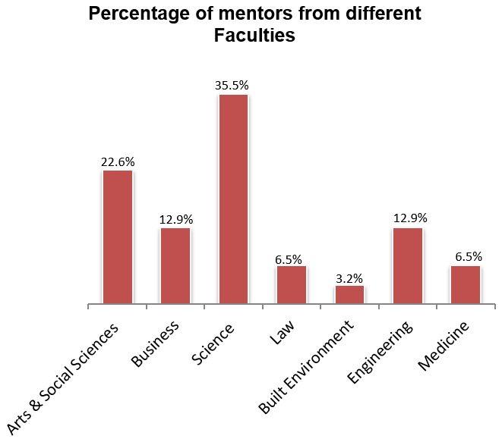

Figure 1: shows mentors were recruited from a variety of Faculties

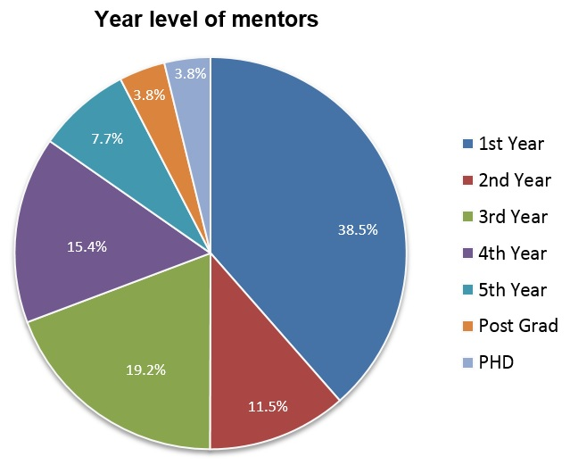

Figure 2: shows mentors recruited were from a range of year levels
Figure 1 shows the wide range of faculties from which mentors were recruited. Figure 2 shows the range of year levels of mentors.

Matching
It should be noted that mentors and mentees were pre-matched before they met each other in person. Matching was based on information gathered from mentor and mentee application forms, with a basis for the pairs to have similar hobbies and interest. Where possible, the mentor coordinator tried to match based on alignment in field of study of mentors and intended field of study from the mentee. Teachers were consulted for more information on students which might not be covered in the application form. Once matching was completed, mentor and mentee profiles were created. Profiles were exchanged before the Program Launch day to allow the mentoring pairs to have some information about one another before their first interaction.

C. Program Structure
The following program structure was agreed with the schools:

Table 6: Program structure
ACTIVITIES | PROPOSED DAYS | VENUE
Program Launch Days | Wednesday 23rd & Thursday 24th August | UNSW Sydney campus, Kensington
Session 1 | Week beginning 28th August | Online
Session 2 | Week beginning 4th September | Online
Session 3 | Week beginning 11th September | Online

School holidays 23 Sept – 8th Oct

No online sessions
Session 4 | Week beginning 9th October | Online
Session 5 | Week beginning 16th October | Online
Session 6 | Week beginning 23rd October | Online
Program Close Day | Wednesday 1st November | Condobolin High School

The Conditions of Grant stipulated that:
- Mentors and mentees be brought together for a one-day ice breaker and joint training day at Dubbo for a Pre-Scheme Event.
Reason for slight variation: It was decided that this first event would be renamed Program Launch Day. After discussion with the school, it was agreed that the Program Launch Day venue would be better held at UNSW Sydney as it would create excitement from the mentees about going to university and allow mentors to answer follow-up questions in subsequent online sessions.
- Delivery of up to 5 mentoring sessions
Reason for slight variation: It was agreed with schools that six online sessions were better than five. An extra session accommodated for any mentor or mentee absences which caused a session to be missed.
- Mentors and mentees to be brought together to celebrate the successful completion of the program at Dubbo for a Post-Scheme event.
Reason for slight variation: In agreement with the schools, it was decided that it would be much more relatable for mentors and mentees to have the celebration event at one of the regional schools instead of Dubbo. Therefore, this event was renamed Program Closing Day and was hosted by Condobolin High School which 20 mentees attended.

D. Program Launch Day
The Program Launch Days were held on Wednesday 23rd and Thursday 24th August. The purpose of the Launch was to allow mentors and mentees to meet face to face and develop a rapport before the online sessions. It also provided an opportunity for mentees to explore UNSW Sydney.
Initially it was intended to have a one-day Launch. However, the schools advised that they had to travel a full day to arrive to Sydney and the time spent on the road travelling will be more than the time they spent at the university. It was agreed with the schools that the Launch would be across two days to allow the mentees more time to get to know the mentors and explore the university campus.
During the Program Launch Days, the following activities were undertaken:
- Ice Breaker Activities
- Mentoring 1-1 Conversations
- Personal Branding
- Speed Mentoring
- Technology Training
- Completion of Mentoring Partnership Agreement
The technology training session was more difficult to facilitate than expected, mainly due to Adobe Connect breakout rooms not functioning at optimal level. Once everyone logged into Adobe Connect, it was not easy to drag and drop the relevant pairs into breakout rooms.
As this difficulty was encountered in the training, it was decided that the breakout rooms should not be used for the online sessions. Instead, mentors were asked to host the Adobe Connect meetings so that the meeting room only consisted of themselves and their own mentee.
In future, two staff are required to facilitate the technology training session. One staff member would demonstrate the technology on the computer and another staff member would walk around the room to address questions. Another suggestion is to ask mentors and mentees to log into Adobe Connect in a staggered way; for example, one pair at a time. This is because the platform interface becomes very confusing when there are a lot people logged in at the same time.

E. Online Sessions
Online sessions were held one hour a week at a set time suitable for the school. The mentor coordinator was the conduit between the mentors and the school. At the beginning of each session, the mentor coordinator would call the teacher to find out if there are any student absences. A text message was sent to mentors if their mentees were absent. The mentor coordinator would stay on the phone with the teacher for nearly 20 minutes each session. This is because there were a few challenges:
- The amount of time which each student takes to log on varies. The mentor coordinator would find out which student was having trouble logging on and would then communicate that delay to the mentor.
- Some challenges that mentees receive include the online meeting room not loading, microphone or webcam not working.
- Adobe Connect relies on Internet Explorer to be used, however students forget about this each week and open Chrome to use. This causes unnecessary delays each session.
A mentoring folder with suggested activities was given to each mentor and mentee. It is believed that a mentoring relationship will flourish through organic conversations rather than prescriptive activities. Therefore mentors were advised that the activities are optional, and they can suggest to the mentee to work on an activity if they need help in starting conversations.

F. Program Close Day
The Program Close Day was held on Wednesday 1st November. This day not only provides an opportunity for mentors and mentees to see each other one last time before the program ends, it also allows the mentors to see and have a better understanding of regional towns and schools.
It was a very enjoyable day and a great opportunity to allow pairs to have a good closure. Certificates were presented to mentors and mentees to celebrate their achievements and each person also received a small gift from ASPIRE. The Senior Executive team at the School of Business was there to observe the event to have a better understanding of regional students. It was great to involve other faculty members into the event as it allows more exposure to ASPIRE programs.

Evaluation
To evaluate the success of the program, the following were conducted:
- Up to three stakeholder meetings were conducted with teaching staff with each pilot school
- A minimum of 2 semi-structured interviews were held with staff in pilot schools
- All mentees and mentors were surveyed on the successes of the scheme
- Focus groups were held with students in each school

1. Stakeholder meetings with teaching staff
Three stakeholder meetings with teaching staff were held at different points during the program:

- The first meeting was held prior to the program being launched. The purpose of this initial meeting is to understand the school’s needs and ensure the program is a good fit.
“It will be a great opportunity to have someone else talk to the students, someone that was not a parent or a teacher. The students really need to expand their knowledge of what career options are out there.”
- The second meeting was held at the end of the Program Launch Days, before the commencement of the online sessions. The purpose of the meeting was to check in with the teachers, to evaluate teachers’ impression of mentors and to gauge whether the Launch was a success.
“The kids really enjoyed it, it opened up their eye. Having someone younger to talk to is good, someone going through what they might possibly go through in the future.”
- The third stakeholder meeting was held after the program ended, to evaluate the whole program.
“It opened up their world… because we are a very insular place at Ungarie…a lot of people think this is the world…this is the bigger part of it, it opened their world …which is fantastic.”
The stakeholder meetings were valuable and essential. It allowed information to be gathered and provided a touch point with teachers. From the quotes above, teachers found the program to be a positive experience and very valuable for their students.
2. A minimum of 2 semi-structured interviews held with staff in pilot schools
The two semi-structured interviews were combined with the stakeholder meetings. For reporting purposes, the first semi-structured interview was conducted with teachers prior to the start of the program. The second semi-structured interview was conducted at the end of the program.
“It’s (Click-on Mentoring) been great…They (students) are more aware of what happens if they go to university.”
“Kids have come away with life-long learning.”
Teachers expressed that Click-on Mentoring adds value as it provides their students with something they cannot offer – perspective from outside of their town. By engaging in conversation with a young adult who is not from their town, it offers a chance for students to see and hear what opportunities awaits outside.

3. All mentees and mentors are surveyed on the successes of the scheme
Mentee Outcomes
To measure the success of the program, mentees and mentors completed a pre-program and post program survey. The same questions were asked in the pre-program and post program surveys to measure if there were any shifts in attitudes. For example:
- I have a clear understanding about the job I would like to do in the future.
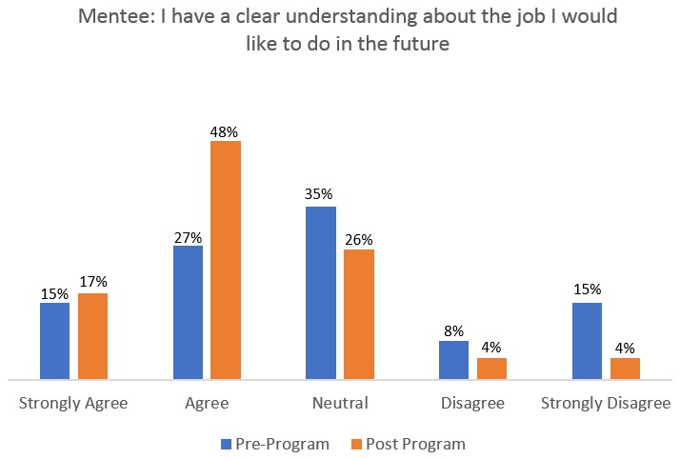
- I have a clear understanding of the training and qualifications I would like to do after school.

Figure 3: shows Mentees’ attitude shift towards having a clear understanding of the job they
would like to do in the future
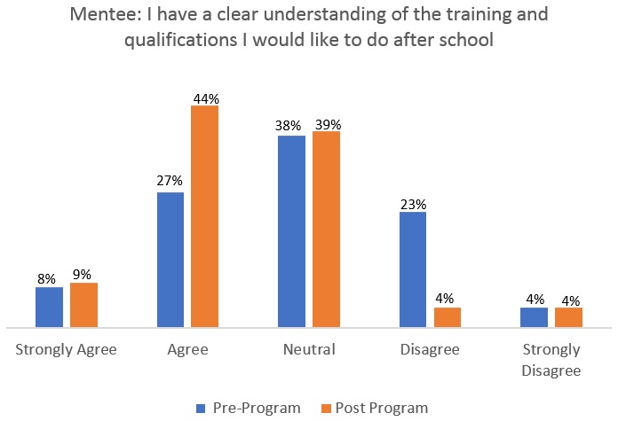

Figure 4: shows mentees’ attitude shift towards having a clear understanding of the training and qualification they would like to do after school
From Figures 3 and 4, it can be seen there is a significant increase between the pre-program and post-program survey results in the percentage of mentees’ knowledge of post school options after high school. Over 65% of mentees had a clear understanding of the job they would like to do after completion of the program. Additionally, 53% of the mentees had a clear understanding of the training qualifications they would like to do after high school. This means the program has been successful in increasing mentees’ knowledge in making informed choices about post school options.

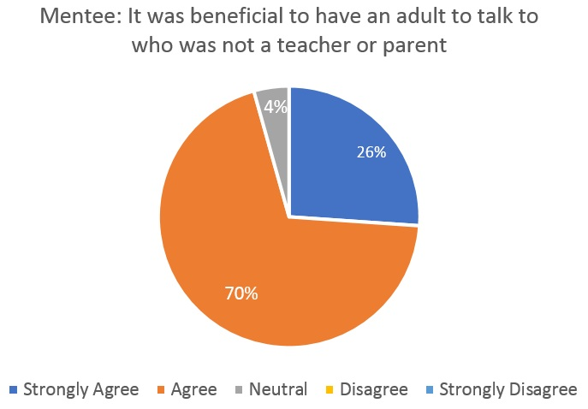
Figure 5: shows mentee’s belief that it was beneficial to talk to another adult
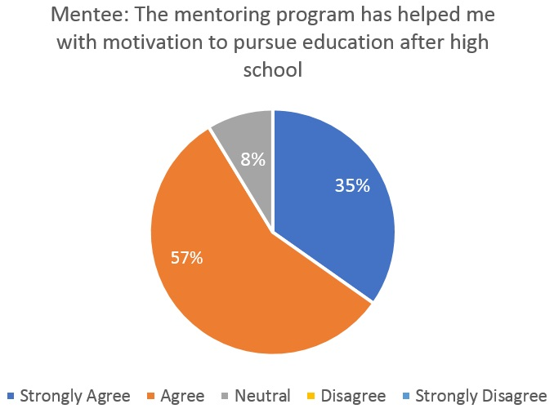

Figure 6: shows that the mentoring program has increased mentee’s motivation to pursue in further education after high school
Figures 5 and 6 shows that over 90% of mentees agree that it was beneficial to talk to someone other than a teacher or parent about career related topics. This proves social capital is extremely beneficial to mentees, especially those in geographically isolated areas. Additionally, over 90% of mentees believe the mentoring program has improved their motivation to pursue further education after high school.
Mentor Outcomes
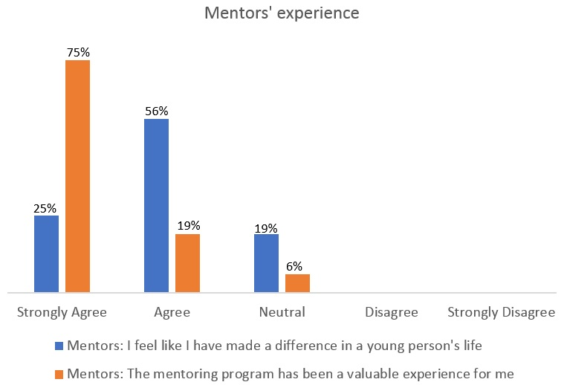

Figure 7: shows the mentor’s experience of the program

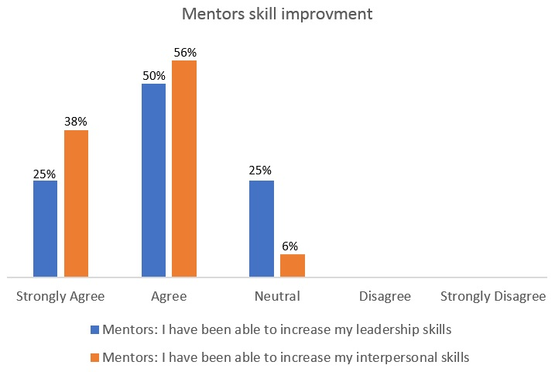

Figure 8: shows unexpected gains in mentor skills
Figure 7 and 8 shows the mentors had a positive experience of the program. Over half of the mentors felt that they have made a difference in a young person’s life and that the mentoring program has been a valuable experience for them. The mentoring program has also resulted in skill improvement in the mentors’ leadership and interpersonal skills.
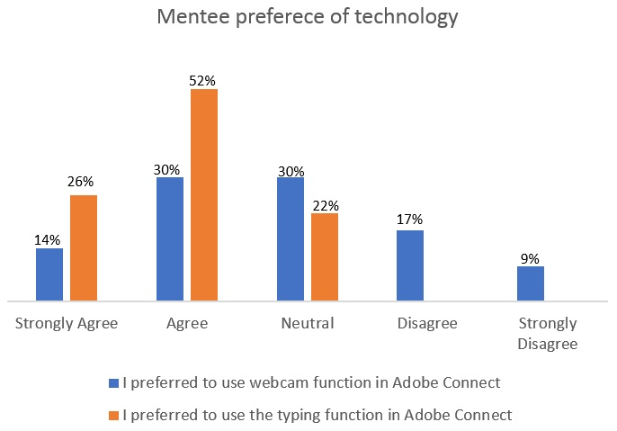

Figure 9: shows mentee preference of technology
During the online sessions, mentors and mentees had the choice to either use a webcam and microphone to talk to each other or use the typing function. Figure 9 shows that mentees preferred to use the typing function over the webcam and microphone option. Some mentors found their mentees to be uncomfortable in the use of the webcam. Mentees would either turn the webcam away from their face or refuse to use it altogether.

4. Focus groups held with students in each school
Focus groups was held at the students’ schools at the end of the program to evaluate its success. All students expressed that they enjoyed the program. Below are some quotes extracted from the mentee focus groups.
“I like talking to someone other than family, so you can share things that you normally won’t.”
“I told the mentor about my interests and he advised me on possible career paths.”
“Good to talk to someone who is a successful young person who was an inspiration.”
“I had a feeling I never ever wanted to go uni, but now that I know that it will be better for my future, I think I should go for it.”
“My mentor helped me with studying, procrastinating, we worked out a study guide.”
“I thought I didn’t want to go uni, but now I think I might go to uni.”
From the evaluation outcomes, the program was found to be a success. All mentors and mentees enjoyed the program. Mentees could make informed choices about post school options and had a better understanding about university. Mentors also benefited from an increased skill in leadership and communication.

Recommendations for improvement

Communication strategy
ASPIRE has a strong and existing relationship with the schools, with various ASPIRE programs already running in the schools and an ASPIRE Project Officer as the primary contact person. In future, it would be recommended that the school communication for Click-on Mentoring be the responsibility of an ASPIRE Project Officer instead of the Mentor Coordinator. This will provide a more streamlined approach to communicate with teachers. During Click-on Mentoring, teachers have expressed that communication with more than one ASPIRE worker is confusing “There are so many of you (ASPIRE workers), I don’t know who to contact”. Additionally, Project Officers have more knowledge of the schools and will be able to add more value to enrich the program.
As 2017 was a pilot year for Click-on Mentoring, there was not enough time to develop a communications strategy. Moving forward, it would be recommended to map out the different types of communication and who is the best person to be responsible for it.

Student recruitment
Student recruitment was left with the schools to choose which students to participate in the program. However, ASPIRE was not aware of how much the students wanted to participate, and whether they could opt out before the program started without any consequences. Although at the end all students reported that they thoroughly enjoyed the program, they did not know what the program was about before the program started. Although the Mentor Coordinator conducted a virtual information session with students regarding what Click-on Mentoring is about, it would be recommended in future that the Project Officer follows up with teachers to see if further explanation is required.

Online sessions
It is recommended that schools do not have online sessions in the first period. In the first period, teachers often find it difficult to notify ASPIRE of student absences as roll call has not been finalised. Additionally, students who arrive late will most likely miss the whole session. In 2017, one school held their online session in the first period and another school held their online session in the second period. The school which held the session in the first period did not know which students were at school until the session started. There were times where mentors had to wait more than 15 minutes before they were advised that their mentee was absent from school. Comparatively, the school which held their session in the second period would advise of student absences before the session started.
Although the Conditions of Grant stated to have five online sessions, ASPIRE, together with the schools, decided that five sessions were not enough. Therefore it was agreed that there would be six online sessions instead. At the end of the program, mentees expressed that more sessions would be better. This was because most of them did not participate in all six sessions due to absences. On average, most of the mentoring pairs participated in four sessions. It is recommended in future that there should be a minimum of eight online sessions.
In the evaluation, it was found that mentees preferred to use the typing function over the webcam and microphone option. Some commented that the microphone would lag, which resulted in mentees and mentors talking over each other. Other mentees were not comfortable using the webcam. It is recommended that future online sessions use the typing function only, without the use of a webcam and microphone.

Noticeboard for absences
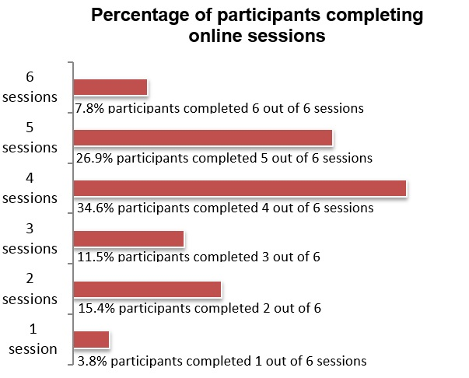
A noticeboard in Google Classroom or Moodle can be created where mentors can post or leave messages if they are to be absent. Mentees would be able to see if their mentor is absent without the Mentor Coordinator having to call the school. A separate noticeboard can be created for teachers to post student absences. However, this will need to be discussed with the teachers to see if they have capacity to do so.

Figure 10: shows the percentage of participants completing online sessions.

Mentoring folder
In 2017, a hardcopy mentoring folder was created and distributed to participants. The folder consisted of suggested activities for mentors and mentees to complete. Activities were optional and served as a guide to build conversations. However, most mentors would ask the mentee to complete the worksheet on their own instead of incorporating the questions on the worksheets into the conversations. It is recommended that an e-mentoring folder is to be created in place of the hard copy folder. The e-mentoring folder should contain resources such as mentoring activities, and guide the mentor to incorporate related topics of the activities into the conversation.

Strategy for Click-on Mentoring to be incorporated into the core
ASPIRE program
The lessons learnt has allowed ASPIRE to develop a strategy for Click-on Mentoring to be incorporated into the core ASPIRE program.

Incorporate mentoring with other ASPIRE events
In 2017, Click-on Mentoring was a stand-alone program, independent of other ASPIRE programs. Whilst mentors and mentees had meaningful conversations, it was recognised with teachers that mentoring would have the most impact if it follows on from other ASPIRE events. Moving forward, ASPIRE will increase the interaction with students in years 10 to 12 through the new ASPIRE Advantage program. ASPIRE Advantage incorporates learnings from both the HEPPP funded Focus on Success project and Click-On Mentoring project, as well as knowledge from across the team. ASPIRE Advantage will incorporate sustained engagement with senior students, paired with mentoring support, and will provide students with an increased number of high quality interactions over their final secondary school years.
Students will have a mentor to engage in 8-10 online sessions after the Year 11 Focus on Success and Year 10 Connect events. This strategy not only allows the online mentoring sessions to have more focus, it also provides a follow-up to ASPIRE events which previously did not occur.
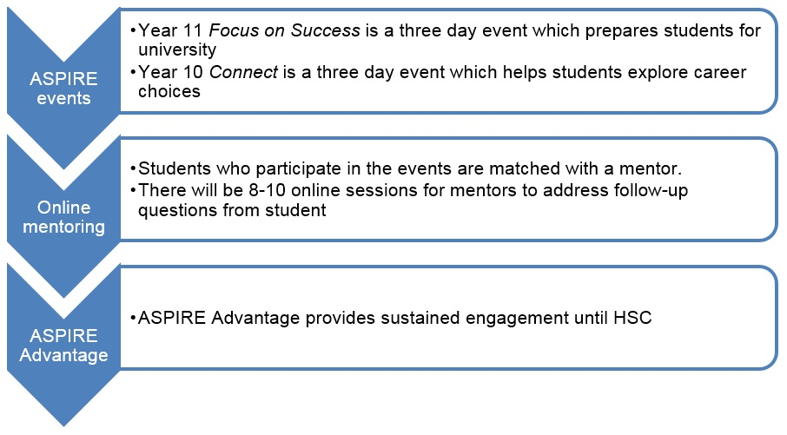

Figure 11: how to incorporate mentoring with other ASPIRE events

Expansion to more schools
The strategy to incorporate online mentoring with ASPIRE events will naturally mean there will be an expansion to more schools. Schools will be consulted about this new strategy and they have an option to opt out of mentoring if it does not suit their school operations. Schools will need to commit a teacher to supervise the online sessions and commit to lock in online sessions in their timetable.
As there will be more schools involved, it will not be feasible for one Mentor Coordinator to liaise with all the different schools. Therefore, Project Officers will be the main contact person with schools and will be relied heavily upon to ensure this strategy is a success.

The use of university students as mentors
The success of the program proves how valuable university students are as mentors. University students can connect and relate to high school students, including uncertainty of future pathways, closeness in age and a range of other factors. In 2018, ASPIRE will continue to use university students as mentors. However, if the student mentor numbers are low, ASPIRE may tap into the pool of university staff.

References
Reay, D. (2001). Finding or losing yourself? Working class relationships to education. Journal of Education Policy
Storey, P. (2005). Mentoring and Aimhigher/Widening participation: A Literature Review
Rogers, R. (2010). Student perceptions of Aimhigher learning mentors and post-16 pastoral support

Evaluation Report Appendix 1: Click-on Mentoring Partnership Agreement

School Details:
Name of School:
School Facilitator Name(s):
Year level to be targeted:
Number of total students to participate in program:

To contribute to the success of the Click-on Mentoring program the following arrangements are agreed:
School Responsibilities
- Identify and recruitment of students
- Distribution and collection of student media consent forms and alerting Mentor Coordinator if any students are uncomfortable with having their photo taken
- Participate in the Click-on Mentoring Launch event day at UNSW Kensington campus
- Allocate one hour over six weeks in school timetable for students to conduct the online session during school hours
- Secure a space within school for mentoring sessions to occur for the duration of the program
- Ensure each student has a computer or laptop that is connected via an Ethernet cable (wifi connection may be unstable) to conduct the online mentoring sessions
- Alert Mentor Coordinator as early as possible if students are absent from school on a mentoring day
- Assist and ensure students arrive on time to conduct online mentoring sessions. Please keep in mind it may take a few minutes to log in
- Monitor students during the sessions and ensure they are fully focused to converse with minimal distractions (eg ensure they are not surfing the net while chatting to the mentor)
- Provide support to students during the sessions if required
- Ensure the students complete any pre-work and encourage them to think of questions to ask mentors before each session
- Host the Click-on Mentoring Close/Celebratory event day at the school
- Participate and cooperate in the evaluation process. Mentor Coordinator will conduct online surveys and focus groups with students and a semi-structured interview with School Facilitator
ASPIRE Responsibilities
- Coordinate recruitment and training of mentors
- Implement appropriate risk measures to ensure the online safety of students
- Match mentors and mentees
- Collaborate with the School Facilitator to schedule mentoring sessions
- Communicate session details to mentors
- Notify mentors of any student absence on mentoring session days
- Arrange the online resources to facilitate mentoring sessions
- Offer support with technology if any issues or problems arise, including loan of webcams and headphones if required
- Offer ongoing support and guidance to mentors and the School Facilitator throughout the mentoring period
- Organise and finance travel, accommodation and meals for mentoring launch event at UNSW
- Provide program evaluation summaries to participating schools
School Principal Name and Signature:
Date:
School Facilitator Name and Signature:
Date:
ASPIRE Director Name and Signature:
Date:
Click-on Mentoring Coordinator Name and Signature:
Date:

Evaluation Report Appendix 2: Mentor Training Topics
- About ASPIRE
- What is Mentoring?
- Mentoring with ASPIRE
- Mentor roles, responsibilities and boundaries
- The Mentoring Cycle
- Understanding ASPIRE students
- Cultural Sensitivity
- Interpersonal Skills
- Privacy and Confidentiality
- Duty of Care
- Support for Mentors

Appendix 2: Information for Schools Flyer
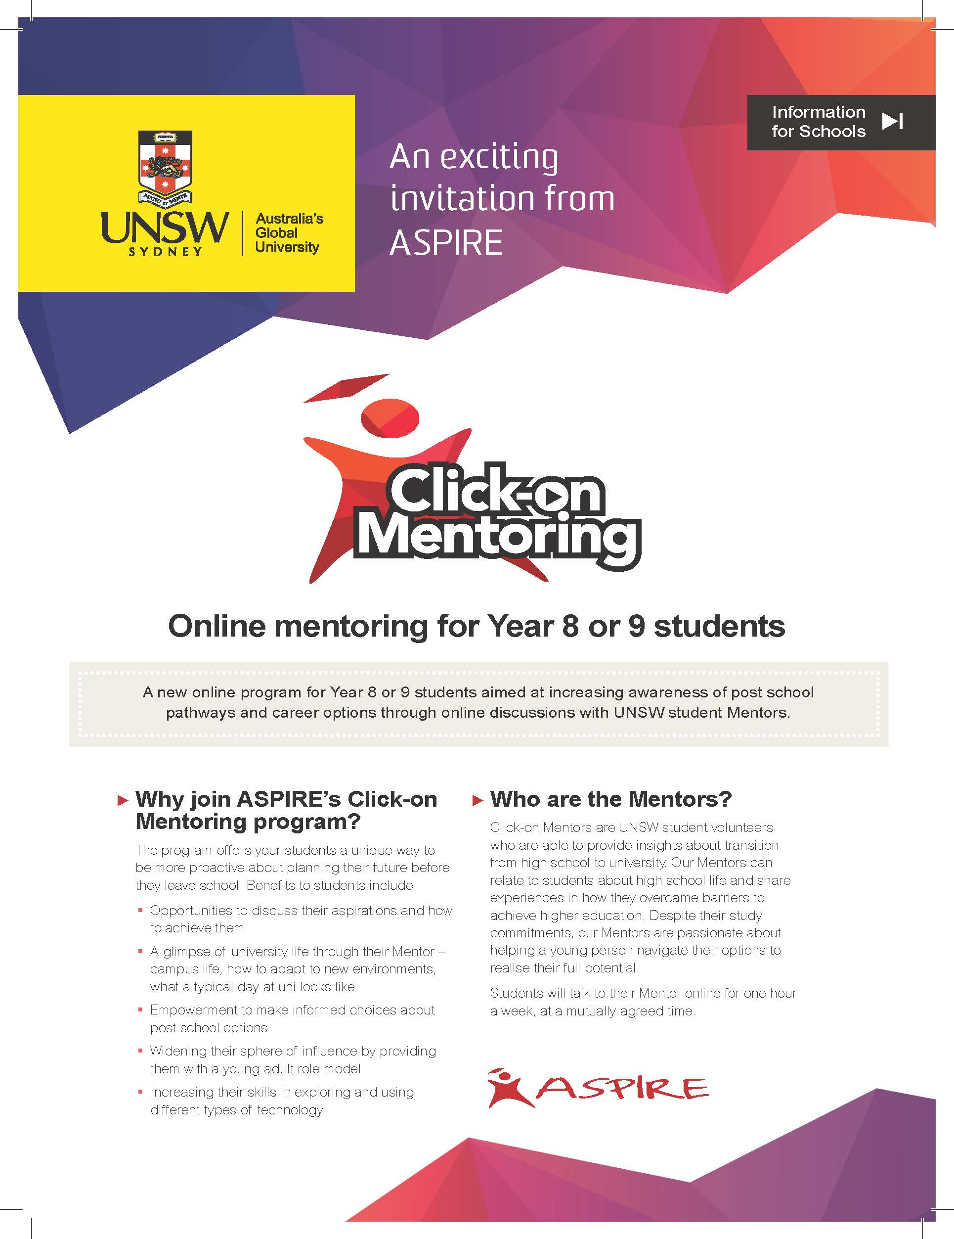

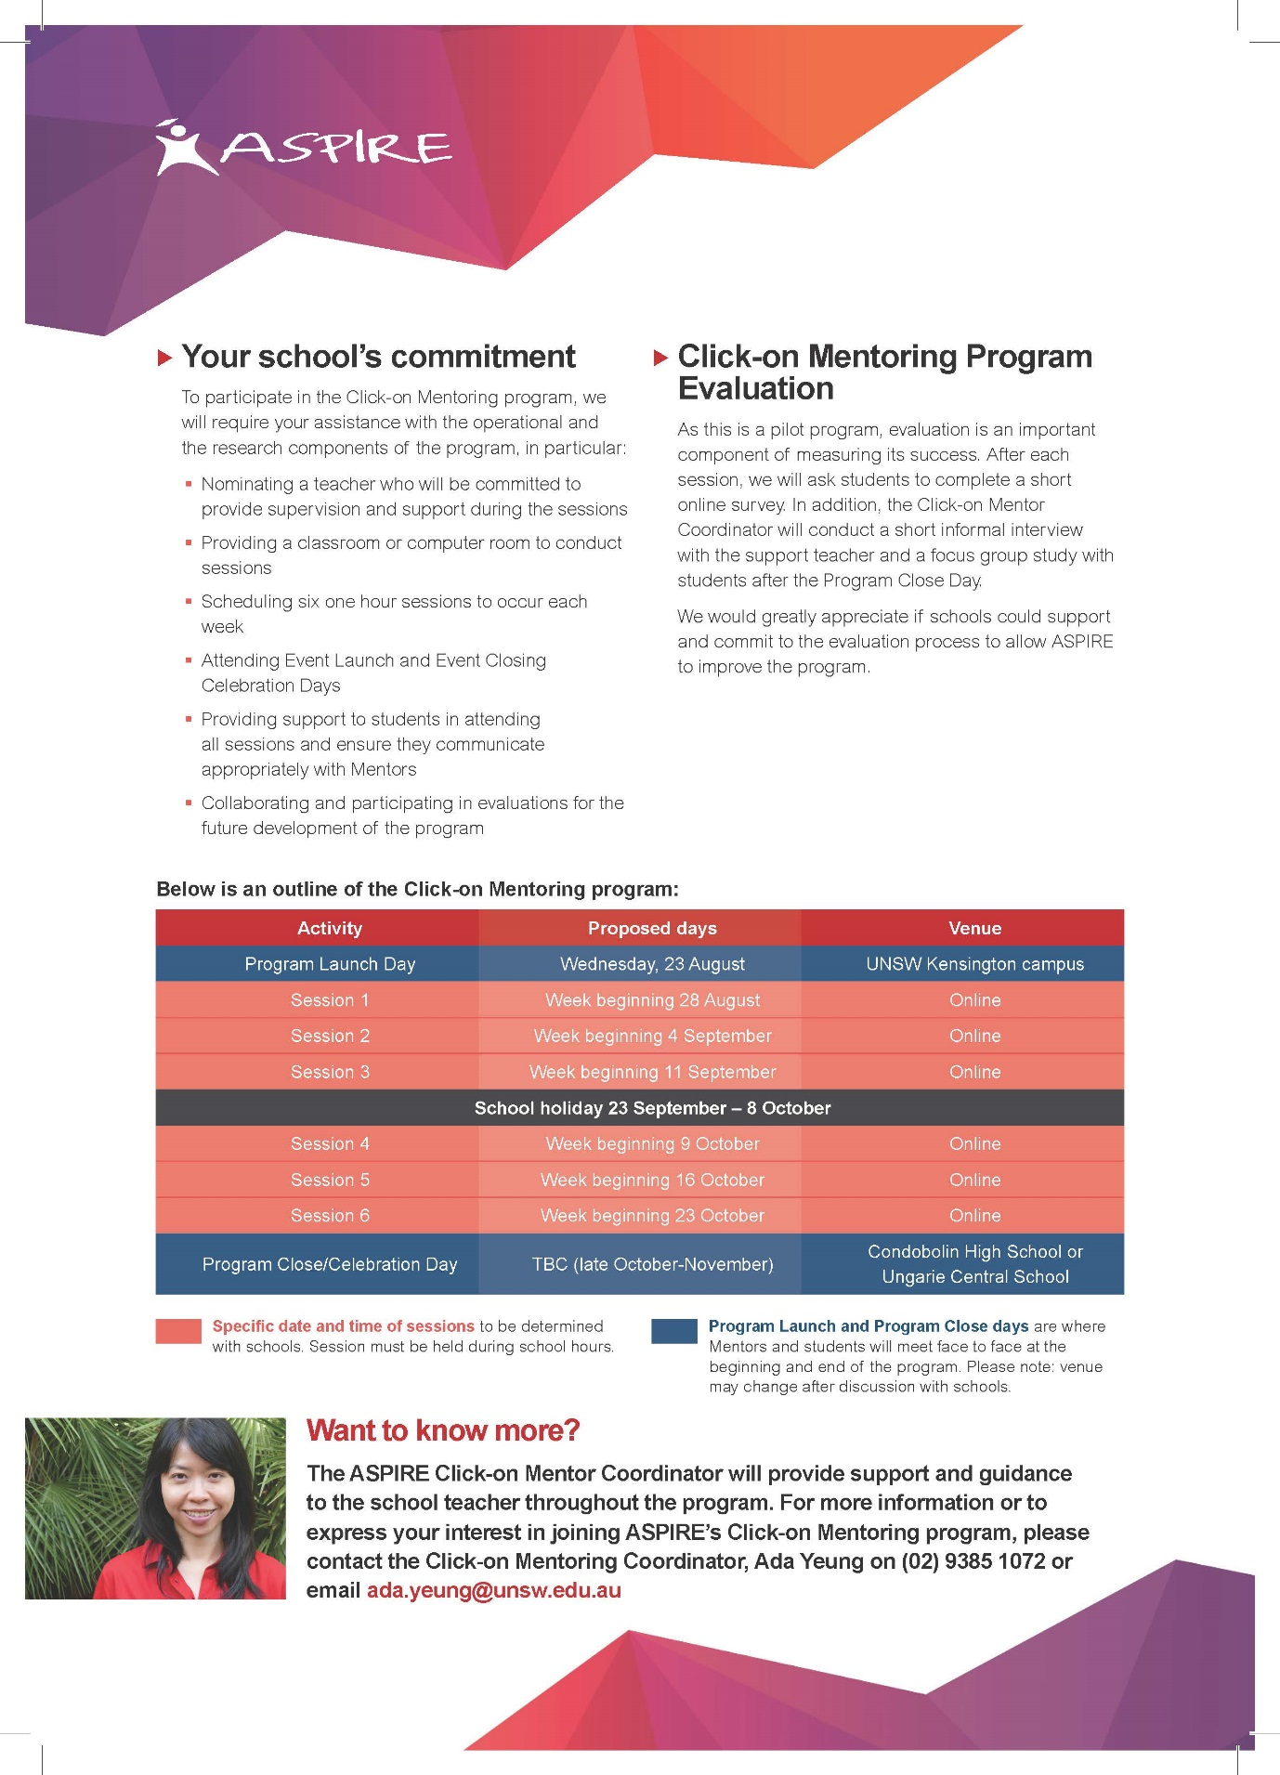

Appendix 3: Information for Students Flyer
