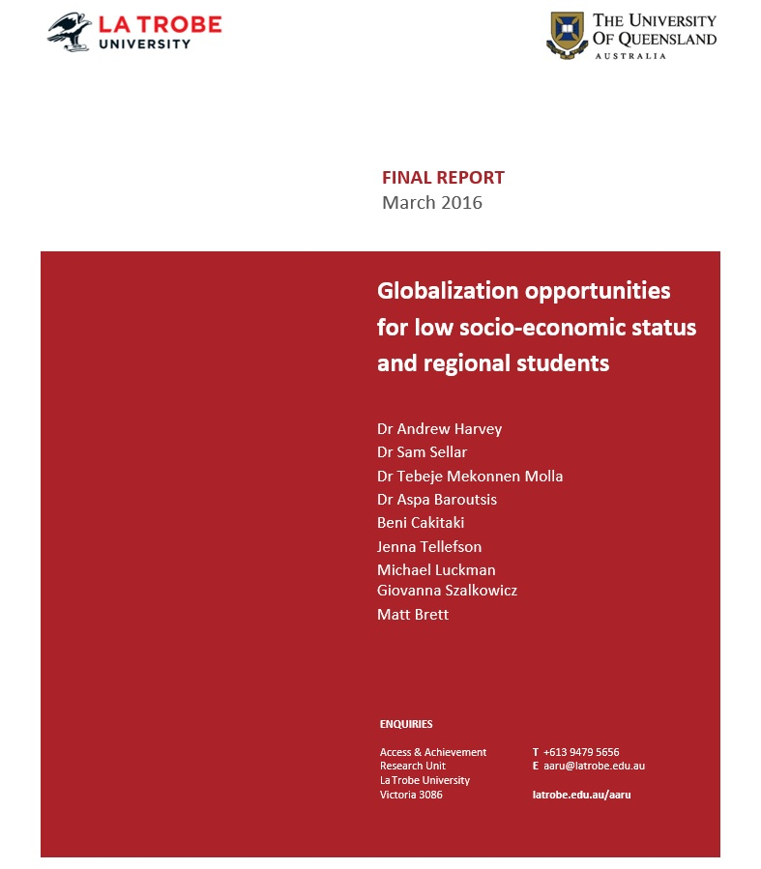

Globalization Opportunities for Low
Socio-Economic Status and Regional Students
March 2016

Dr Andrew Harvey
Dr Sam Sellar
Dr Tebeje Mekonnen Molla
Dr Aspa Baroutsis
Mr Beni Cakitaki
Ms Jenna Tellefson
Mr Michael Luckman
Ms Giovanna Szalkowicz
Mr Matt Brett

The project that resulted in the production of this report was funded under a National Priorities Pool (Higher Education Participation and Partnerships Program) grant from the Commonwealth. The recipient of the grant has granted the Commonwealth the right to sub-licence the material in this report. Copyright in the report remains with the original copyright owners.
Except where otherwise indicated, and save for any material protected by a trade mark, the Department of Education and Training, acting on behalf of the Commonwealth, has applied the Creative Commons Attribution 4.0 International Licence.

Modifications: Changed to meet WCAG 2.0 accessibility requirements.
Alternate text inserted for all images. Minor typographical errors corrected.

Acknowledgements
The authors acknowledge the funding of the Australian Government Department of Education and Training.
We are grateful for the advice provided by Lyndal Groom, Steve Nerlich and staff members at the Australian Government Department of Education and Training.
The authors are thankful for the data provided by:
- Dr Barbara Sidwell, Australian Government Department of Education and Training
- Mr Tony O’Sullivan, Australian Passport Office.
We acknowledge David Peacock for his important contributions to the project scope, design and research.

Globalization opportunities for low socio-economic status and regional students is published by the Access and Achievement Research Unit, La Trobe University
Access & Achievement
Research Unit
La Trobe University
Melbourne Victoria 3086
Australia
Tel: +61 3 9479 5656
Email: aaru@latrobe.edu.au
Web: latrobe.edu.au/aaru
March 2016
ISBN 978-0-9946100-1-0
© Access and Achievement Research Unit, La Trobe University 2016
Written by Dr Andrew Harvey, Dr Sam Sellar, Dr Tebeje Mekonnen Molla, Dr Aspa Baroutsis, Beni Cakitaki, Jenna Tellefson, Michael Luckman, Giovanna Szalkowicz and Matt Brett.
To cite this report: Harvey, A., Sellar, S., Molla, T. M., Baroutsis, A., Cakitaki, B., Tellefson, J., Luckman, M., Szalkowicz, G. & Brett, M. (2016). Globalization opportunities for low socio-economic status and regional students. Report for the Australian Government Department of Education and Training, Melbourne, Access and Achievement Research Unit, La Trobe University.

Contents
Acknowledgements 3
List of Figures 5
List of Tables 5
List of Abbreviations 6
Executive Summary 7
Recommendations 10
Background and Report Structure 12
Background 12
Definition of Key Terms 12
Report Structure 13
Section 1. Literature Review 14
Introduction 14
Globalization in International Higher Education 15
Globalization in Australian Higher Education 17
The Benefits of Outbound Mobility and Language Study 18
Equity Groups, Foreign Language Study and Outbound Mobility Programs 21
Conclusion 27
Recommendations 28
Section 2. National Data Analysis 29
Findings from Undergraduate Foreign Language Study National Data 29
Undergraduate OS-HELP Data 35
Recommendations 40
Section 3. University Policies and Strategies 41
Globalization Plans 41
Foreign Language Study 43
Outbound Mobility 47
Global Citizenship 54
Conclusion 58
Recommendations 58
Section 4. Student Interviews 60
Foreign Language 60
Outbound Mobility 70
Conclusion 86
Recommendations 87
Section 5. Conclusion 88
References 90
Appendices 99
Annex A: University Online Surveys 99
Annex B: Student Interview Guide 101
Annex C: Methodology 102

List of Figures
Figure 2. 1: 2014 foreign language study participation rates by institutional grouping. 29
Figure 2.2: University of Western Australia language enrolments by language
grouping, 2009-2014 (Headcount). 30
Figure 2.3: 2014 Foreign language and overall participation rates by basis of admission. 31
Figure 2.4: 2014 Foreign language and overall participation rates by ATAR band. 32
Figure 2.5: Remoteness of school and number of languages provided. 33
Figure 2.6: Average ICSEA score and average parent contribution per student, by
number of languages provided. 33
Figure 2.7: Low SES foreign language study participation rate compared to the
overall Low SES participation rate at university. 34
Figure 2. 8: 2014 Foreign language study and overall participation rates by
remoteness area category. 35
Figure 2.9: 2014 OS-HELP and overall participation rates by SES. 37
Figure 2.10: 2014 OS-HELP and overall participation rates by regional status. 38
Figure 2.11: Proportion of adult passport ownership by SES. 39
Figure 2.12: Proportion of adult passport ownership by remoteness area. 40
Figure 3.1: Languages offered by respondents’ universities (n=21). 44
Figure 3.2: Equity language scholarships or bursaries. 45
Figure 3.3: Universities achieving the highest proportion of undergraduate
completions with OS-HELP loans. 2011-2013. 48
Figure 3.4: Equity travel grants examples. 51
Figure 3.5: Global citizenship programs. 56
Figure 3.6: Indigenous graduate attribute. 57

List of Tables
Table 4. 1: Distribution of language study participants for University A and
University B by gender, regional and socio-economic category, broad field
of education and major languages (n=15) 61
Table 4.2: Distribution of outbound mobility participants for University A
and University B by gender, regional and socio-economic category, broad field
of education and program duration (n=24) 71

List of Abbreviations
ABS Australian Bureau of Statistics
ASGS Australian Statistical Geography Standard
ATAR Australian Tertiary Admission Rank
ATN Australian Technology Network of Universities
ATSI Aboriginal and Torres Strait Islander
AUIDF Australian Universities International Directors’ Forum
DET Victorian Department of Education and Training
EU European Union
GCSE General Certificate of Secondary Education
Go8 Group of Eight universities
GPA Grade Point Average
HECS Higher Education Contribution Scheme
HELP The Higher Education Loan Programme
HEPP Higher Education Participation Programme
ICSEA Index of Community Socio-Educational Advantage
IEO Index of Education and Occupation
IRU Innovative Research Universities
LOTE Languages Other Than English
NCP New Colombo Plan
NESB Non-English Speaking Background
OS-HELP Overseas Higher Education Loan Programme
RUN Regional Universities Network
SEIFA Socio Economic Indexes for Areas
SES Socio-economic status
STEM Science, Technology, Engineering and Mathematics
UK United Kingdom
US United States of America
VET Vocational Education and Training

Executive Summary
Globalization is now central to the mission of most Australian universities. The nature of institutional commitment to globalization takes many forms, including the establishment of off-shore campuses and the development of tailored interdisciplinary courses and subjects. Central to many university strategies are also the provision of languages other than English and the promotion of outbound mobility programs, in which students travel for offshore study that is typically tied to their course, or for internships or other experiential learning opportunities that may or may not receive academic credit. Language study and outbound mobility thus form twin pillars of globalization strategies, and are reflected in Australian Government policies such as the New Colombo Plan, the establishment of a target for 40 per cent of Year 12 students to study a foreign language, and the restriction on universities closing any course seen to involve a strategic language (Department of Foreign Affairs and Trade, 2014).
Questions of student equity arise as globalization becomes integral to the university experience. For example, to what extent are all Australian students being afforded opportunities to access outbound mobility and language learning experiences? In particular, what barriers do students from regional and low socio-economic status (SES) backgrounds face, and how might these barriers be overcome? To address these questions of the relationship between student equity and globalization in universities, we conducted a mixed methods study that included: an analysis of relevant international and national literature; a national geo-demographic map of students enrolled in foreign languages and accessing outbound mobility experiences; a survey of university leaders; and a series of interviews with students across two universities.
Several findings emerge from our research. Internationally, we found mixed policy messages regarding globalization. In many Anglophone countries, there is growing policy interest but declining student participation in foreign language learning. Broad international consensus acknowledges the insufficiency of monolingualism, but many nations face challenges to encourage student interest in foreign languages, and to balance the promotion of heritage (ancestry) languages with widening access to ‘strategically important’ languages. Outbound mobility is also the subject of growing policy interest and program development but, unlike foreign language learning, it is also a consistent area of student growth. However, despite overall growth, under-representation of minority groups is an issue, particularly along ethnic, racial, and socio-economic lines. There are multiple causes of under-representation, and barriers to participation in language and mobility programs are closely related. For example, a lack of foreign language proficiency often acts as a deterrent to mobility and a limiting factor in choice of study country. Equally, institutional approaches may reflect unhelpful beliefs, such as that outbound mobility is primarily a reward for academic excellence, that students will have previous experience in travelling and independent living, and that cultural integration is largely unproblematic. Adapting to a new, broader and more diverse student cohort requires fundamental interrogation of many of the assumptions that have historically underpinned institutional globalization programs.
Within Australia, recent policy documents promote increased enrolments in language subjects. The 2015 Draft National Strategy for International Education consultation paper emphasises the importance of ‘preparing our students to engage globally through languages study in all stages of the education cycle from early childhood through to higher education’ (Australian Government, 2015, p. 9). The Australia in the Asian Century White Paper (Australian Government, 2012) signals a further stimulus to languages education policy. Nevertheless, the proportion of domestic undergraduate students studying a foreign language remains extremely low (approximately 4 per cent). By contrast, outbound mobility in higher education is rising in line with international trends, with high recent growth in the take-up of Commonwealth Overseas Higher Education Loan Programme (OS-HELP) student loans.
Further analysis of national data reveals that both languages education and outbound mobility within Australian universities are marked by unequal participation. Foreign languages are most prominently studied within the most selective Group of Eight (Go8) universities, often reflecting school participation patterns in which students from medium and high SES backgrounds and urban areas dominate enrolments. Similarly, students from regional and low SES backgrounds are under-represented in outbound mobility, as evidenced through the student loans that are accessed by a majority of outbound students. In 2014, for example, only 11.4 per cent of students within the OS-HELP scheme were from a low SES background, despite this group comprising 17.6 per cent of the overall undergraduate student population and 25 per cent of the overall Australian population.
Many university leaders are aware of differential participation rates in language learning and outbound mobility, and our surveys revealed a range of views on the causes of this inequity. Several universities offer minimal or no foreign languages, and for regional students the choice of language offerings can be extremely limited (or non-existent). Institutional type affects the languages offered and the countries visited by students. Similarly, small and regional university representatives reported resource constraints in supporting large outbound mobility programs. Representatives also highlighted the unique challenge of making such mobility visible and accessible to their students, who are more often mature aged, from low SES backgrounds, and first in their family to attend university. Understanding the effects of institutional diversity and stratification on globalization experiences is therefore central to understanding unequal participation across the sector.
While acknowledging the difficulties in promoting equitable participation, many university representatives described potential strategies for progress. Most institutions already include globalization as a central part of their strategic plan, and our desktop review found that fourteen institutions have specific ‘Internationalisation’ or ‘Global Engagement’ strategic documents to complement their strategic plans. Several universities have set targets for outbound mobility participation, though fewer have established equivalent targets relating to foreign language learning. Apart from setting targets, university representatives highlighted the need for better data, including matching geo-demographic data with participation and academic achievement outcomes. As incentives for participation, the inclusion of languages and outbound mobility within credentialed global citizenship programs was seen as important. Finally, representatives highlighted the need for greater financial support, and for better communication of information about support.
Financial need was highlighted as an issue by students in our interviews. Many students were unaware that an income-contingent loan was available to support their overseas study, or that their institution provided bursaries to eligible students. The connection between language offerings at secondary school and university was underlined, with many students pursuing a language they first undertook at school. A clear pipeline effect is thus evident from the limited range of language offerings within regional schools. Happenstance was also a common theme in the interviews, with many students encountering information by chance, through friends, family and university resources. As a result, students who are first in their family to attend university may be less likely to discover options for outbound mobility. Nevertheless, despite barriers to participation faced by low SES and regional students, respondents who did undertake language study or outbound mobility overwhelmingly found the experience rewarding and it did not prejudice the satisfactory and timely completion of their studies.
Several policy developments provide cause for optimism and opportunity. Australian Government investment in the New Colombo Plan, and ongoing financial support through OS-HELP loans, provide a platform for more low SES and regional students to access outbound mobility experiences. The challenge for universities is to communicate these opportunities to all students and to extend that support at an institutional level. Some universities have already made progress here, such as the University of Melbourne, RMIT University, Monash University, and La Trobe University, which all provide additional specific bursaries for low SES students to undertake outbound mobility experiences. Similarly, Sydney University has set a clear target around foreign language enrolments, and both the University of Western Australia and University of Melbourne have seen dramatic increases in language enrolments since moving to generalist undergraduate degree models. Recent collaboration among the Regional Universities Network (RUN) to share language offerings, including through online provision, reflects another innovative strategy that may drive increased participation among under-represented cohorts. What is clear from our study is that languages and outbound mobility are closely connected, and universities require globalization strategies that address student equity across both experiences.
Further research and policy action is required in other areas of student equity and globalization. While this project focused on regional and low SES students, it is particularly notable that students with a disability remain dramatically under-represented within outbound mobility experiences. This cohort is the fastest growing student equity group nationally, and ensuring that students with a disability are able to access globalization opportunities is critical. The positioning of Indigenous students and culture within the globalization agenda is also important. Some universities, such as the University of Western Australia and RMIT, have specific programs connecting Indigenous students to globalization experiences. However, while many university respondents cited Indigenous students as a specific equity group to target for participation in outbound mobility programs, there was a more general absence of Indigenous students within both the outbound mobility and languages programs discourse. While some universities are developing Indigenous graduate attributes and re-focussing on local languages, the potential role of Indigenous languages and culture within the globalization agenda remains under-researched.

Recommendations

That the Australian Government:
- Commission further research on the under-representation of student equity groups in foreign language learning and outbound mobility programs.
- Promote the availability of Overseas Higher Education Loan Programme (OS-HELP) funding, and investigate expansion of the maximum loan amount and the financial motivations of loan students.
- Require universities to track the participation and achievement of equity groups in outbound mobility experiences, and publish the outcomes.
- Support and promote foreign language learning across the student lifecycle, from early childhood to higher education, in partnership with state and territory governments.

That universities:
- Collaborate within the sector, including through digital technologies, to ensure that students at all public universities have access to multiple foreign languages.
- Establish dedicated, full-time language teaching positions where possible and offer professional development in pedagogy for language teachers.
- Develop greater support during outbound mobility programs, including a mentor/buddy program at the host destination, opportunities to study abroad in small peer groups and post-program workshops and debriefings.
- Promote the mobility of under-represented students within institutions, by harnessing offshore campuses where applicable and integrating outbound mobility within employability strategies.
- Promote and market both outbound mobility and foreign language study to prospective students, including through school outreach and Higher Education Participation Programme (HEPP) activities.
- Voluntarily track the participation, achievement and outcomes of student equity groups in outbound mobility experiences, until such tracking is mandated.
- Establish participation targets for outbound mobility and foreign language study, particularly for under-represented groups.
- Promote languages and outbound mobility programs to low socio-economic status (SES) background and other equity students, including through bursaries, need-based scholarships, and student ambassadors.
- Refocus financial support for outbound mobility from ‘merit’ to need, and reconsider academic requirements for outbound students to widen participation.
- Involve the state-based Tertiary Admission Centres in determining ‘need’ for outbound scholarships.
- Offer Australian Tertiary Admissions Rank (ATAR) bonus points to students from equity groups who are studying a foreign language.
- Ensure course structures are flexible and are designed to accommodate outbound mobility and foreign language study.
- Work with Indigenous offices, disability services, and student support areas to ensure promotion and take-up of outbound mobility experiences among specific under-represented groups.
- Promote under-represented student success stories in online material and appoint student ambassadors from under-represented groups to encourage participation.
- Provide information widely and early to all students regarding outbound mobility programs to maximise possibilities for integrating these opportunities in students’ degree structures.
- Ensure that the promotion of outbound mobility programs reflects potential benefits and challenges of the experience to inform decision making and improve preparedness.
- Diversify outbound mobility experiences, including lengths of placement, and promote the representation of equity students both in long-term placements and in highly selective overseas universities.
- Ensure that the promotion of outbound mobility programs reflects potential positive and negative aspects of the experience in order to inform decision making and improve preparedness.

That state and territory governments:
- Prioritise the teaching of foreign languages in regional and low SES schools, and encourage collaboration among schools to ensure broad language availability, including through digital technologies.
- Collaborate with the Australian Government to support and promote foreign language learning across the student lifecycle, from early childhood to higher education.
- Promote the value of foreign languages within careers education.

Background and Report Structure

Background
This study was conducted by La Trobe University and The University of Queensland. The study was funded through an external research grant provided by the Australian Government Department of Education and Training (DET) through the 2014 National Priorities Pool. There were three core study objectives: (1) map the geo-demographics of outbound mobility and foreign language domestic student cohorts; (2) identify barriers to participation for low socio-economic status (SES) and regional domestic students; and (3) identify institutional programs that facilitate global experiences for these students.
For the purposes of this study, globalization opportunities in higher education are confined to two activities: (1) engagement in foreign language study, and (2) participation in outbound mobility programs. Our study explored how structural factors such as remote or regional geographical localities and low SES backgrounds affect access to globalization opportunities in higher education. These factors were investigated because there was initial evidence that students from both demographic groups are systematically under-represented in languages study and outbound mobility participation.
Our project adopted a mixed methods approach involving: (1) the quantitative analysis of national data sets relating to foreign language enrolments, outbound mobility statistics, OS-HELP loans, and passport applications; and (2) qualitative analysis including interviews and surveys with university students and surveys of university leaders and administrators.

Definition of Key Terms
Globalization: Definitions of globalization differ according to what aspect of this complex phenomenon is emphasised. In this report, globalization is understood in terms of the diminution of physical and territorial social spaces and the rapid emergence of transnational social spaces. We draw from Held and McGrew’s (2007) definition of globalization as ‘a process (or set of processes) which embodies a transformation in the spatial organization of social relations and transactions’ particularly as ‘assessed in terms of their extensity, intensity, velocity and impact-generating transcontinental or interregional flows of networks of activity, interaction and the exercise of power’ (p. 55). Most accounts of globalization emphasise a major change in social and economic relations on a global scale that have come about as a result of technologies that have compressed time and space. Scholte (2005) explains: ‘Globalization involves reductions of barriers to trans-world social contacts’ such that ‘with globalization people become more able – physically, legally, linguistically, culturally and psychologically – to engage with each other wherever on earth they might be’ (p. 59).
Globalization Opportunities: Globalization has profound implications for graduate attributes that higher education institutions seek to promote. At an individual level, benefiting from global economic systems and labour markets (for example international employment opportunities) requires adaptability, intercultural competence, and multilingualism. Globalization opportunities allow participation in the economic and cultural dimensions of globalization, including international learning experiences and foreign language study.
Global Citizenship: In the context of higher education, global citizenship is an attribute of the ‘ideal global graduate’ (Lilley, 2014). This graduate has ‘an attitude or disposition towards others and the world underpinned by moral and transformative cosmopolitanism and liberal values (openness, tolerance, respect and responsibility for self, others and the planet)’, as well as a ‘mindset for mature, critical, ethical and interconnected thinking’ (Lilley, 2014, p. 4).
Global Competence: As an inherent quality of global citizenship, global competence underscores the importance of global mobility and exposure to foreign cultures and languages. Global competence is defined as ‘having an open mind while actively seeking to understand cultural norms and expectations of others, leveraging this gained knowledge to interact, communicate and work effectively outside one’s environment’ (Hunter, 2004, p. 1).
Internationalisation: In the context of higher education, internationalization refers to ‘the process of integrating an international, intercultural, or global dimension into the purpose, functions or delivery of postsecondary education’ (Knight, 2003, p. 2). Internationalisation involves efforts to ensure that curricular materials, pedagogic practices, student learning and accreditation frameworks reflect changes, continuities and expectations in other national systems. As Jackson (2008) suggests, internationalisation can be seen as policy-based responses to the demands of globalization. The term can also refer specifically to initiatives designed to assist international students to adapt to new academic settings.
Low socio-economic status (SES) background: The SES status of students was determined by matching Index of Occupation and Education (IEO) data from the Australian Bureau of Statistics’ 2011 Socioeconomic Indexes for Areas (SEIFA) to the postcode of the student’s home residence. Postcodes classified as being in the lowest 25 percentile of the population according to the IEO were classified as low SES, while postcodes in the highest 25 percentile of the population were classified as high SES. Postcodes between the 25th and 75th percentile were classified as medium SES.
Regional background: The regional status of students was determined by matching Remoteness Area data from the Australian Bureau of Statistics’ 2011 Australian Statistical Geography Standard (ASGS) to the postcode of the student’s home residence.

Report Structure
The first substantive section of this report reviews international and national research on language study and outbound mobility, including pre-university factors that affect participation in both.
The second section of the report examines the geo‐demographics of: (1) students enrolled in higher education foreign language courses nationally, and (2) students who participated in outbound mobility programs, with a focus on students from low SES backgrounds and regional students.
In the third section of this report we examine university policies and strategies for supporting under-represented students to study a foreign language and/or participate in outbound mobility programs.
Finally, we examine and compare the experiences of domestic students at two universities who either studied a foreign language or participated in an outbound mobility program.

Section 1. Literature Review

Introduction
Higher education institutions in Australia and around the world are increasingly integrating globalization into their missions. The strategic response to globalization is often described as internationalisation in higher education and takes many forms, including: competing for position in global higher education ranking systems; establishing off-shore campuses and international franchising; developing research collaborations across borders; and increasing global movements of faculty (Marginson & van der Wende, 2007). Another important part of this process is the internationalisation of the curriculum, which provides direct benefits to students and includes: the development of tailored interdisciplinary courses and subjects; an emphasis on language study; short-term and longer-term mobility programs; intercultural education programs; and a focus on ‘global citizenship’ as a graduate attribute (Altbach & Knight, 2007).
In this report we focus explicitly on two major elements of institutional responses to globalization: outbound mobility programs and foreign language study. Both of these areas are currently under-researched, despite the availability of institutional and national data and growing attention to internationalisation in higher education. Outbound mobility and language study are closely related, and student enrolments in both are quantifiable, accessible, and internationally comparable. Moreover, existing evidence suggests that student equity is an issue in both areas (Salisbury, Paulsen & Pascarella, 2011). Thus, while curriculum, research, staffing and other issues are clearly also important to the broader globalization agenda, we have chosen to focus here on two specific areas that are comparable, inter-related, quantifiable, marked by unequal participation, and prominent in national and international policy debates.
Between 2000 and 2011, the number of students who were internationally mobile more than doubled to approximately 4.5 million (Organisation for Economic Co-operation and Development [OECD], 2014, p. 342). Most of this growth came from Asian countries, with Asian students accounting for 53 per cent of all students studying abroad in 2011 (OECD, 2014, p. 342). At the same time, more people than ever around the world now speak English, but in Anglophone countries foreign language study has been either stagnant or declining (Cha & Ham, 2008). As the global proliferation of language skills and outbound mobility experiences continues, graduates without these skills and experiences may be placed at a disadvantage. Anglophone higher education policy makers and institutions thus face increasing pressure to incorporate language study and outbound mobility programs into the curriculum to ensure graduates are ‘globally competent’.
For institutions, international appeal through outbound mobility can be an indicator of prestige. High numbers of students participating in outbound mobility is often seen as an indicator of university quality (Stroud, 2010; Sutton & Rubin, 2010). Recently, international university rankings such as the Times Higher Education ranking and Quarelli Symonds have included an indicator of internationalisation (for example, QS Top Universities, 2015). However, the proliferation of globalization opportunities in higher education gives rise to further challenges relating to participation rates among equity groups. While covering all six identified equity groups to some degree (Department of Employment Education and Training, 1990), this report focusses specifically on students from low socio-economic status (SES) backgrounds and students from regional areas. There is international evidence that students from more advantaged socio-economic backgrounds and from metropolitan areas are more likely to participate in an outbound mobility program (Brooks & Waters, 2009; Nerlich, 2015; Stroud, 2010; Waters & Brooks, 2010; Salisbury, Umbach, Paulsen & Pascarella, 2009). Participation in foreign language study is also skewed towards students from socio-economically advantaged backgrounds (Tinsley, 2013).
Globalization presents unique challenges to Australian higher education. Since the 1970s, Australian foreign policy has shifted significantly towards Asia. This strategic re-orientation in trade and foreign policy includes strategies for encouraging Asian languages and study abroad in Asian countries. For example, a number of Asian languages have been deemed ‘strategic’ in official government policy, and the New Colombo Plan offers students grants for study abroad in the Indo-Pacific region. However, there is no robust evidence base in Australia to assess the level of participation and access (or lack thereof) that students from equity groups have to such globalization opportunities. Based on what we know from the international literature, it is likely that significant barriers impede regional and low SES students from full participation in foreign language study and outbound mobility programs in Australia.

Globalization in International Higher Education
The European Union (EU) has widely promoted the internationalisation of higher education. The 2013 European Commission paper, European Higher Education in the World, argues that globalization has radically changed the landscape of higher education. The paper clearly states the need to promote outbound mobility as part of a broader EU internationalisation strategy, including mobility to countries outside of the EU (EC, 2013, p. 6). Part of the EU strategy is the Erasmus+ (2015) program, which funds study and work placements in higher education, and also includes a new pilot Erasmus Student Loan Guarantee Facility to provide loans for students pursuing Masters-level study in another European country. Multilingualism is seen as instrumental in consolidating the EU and ensuring transnational employability of citizens from member countries. The EU has established a ‘2+1’ model of language competence that requires member states to promote their students to learn two languages other than their mother tongue (European Commission, 2012), including at the level of higher education.
In the United States (US), there has been specific recent promotion of outbound mobility. The Generation Study Abroad campaign was launched in 2015 and aims to double the number of US students studying abroad by the end of the decade (Institute of International Education, 2015). In addition, the campaign encourages and tracks campus activities that expand diversity in race and ethnicity, academic disciplines, and destinations of those who study abroad (Institute of International Education, 2015). In the US, outbound mobility has more than tripled since 1995, reaching 304,467 students in 2015, although still only 10 per cent of US students participate in an outbound mobility program (Institute of International Education, 2014). Assistant Secretary of State for Educational and Cultural Affairs at the US Department of State, Evan Ryan, in a 2015 speech declared, ‘By increasing accessibility to study abroad, we are investing in our future and providing a forum to solve global challenges’ (Institute of International Education, 2014, p. 1). In the area of foreign language study, Spanish is the most spoken non-English language and also the fastest growing foreign language in the US – by 2020 the number of Spanish speakers is projected to be around 40 million (Lopez & Gonzalez-Barrera, 2013; Ortman & Shin, 2011). The US has also recently emphasised the strategic importance of Chinese and Arabic and this is reflected in the growth in student enrolments from 2.4 per cent (34,153) and 0.8 per cent (10,584) in 2002, respectively, to 3.9 per cent (61,055) and 2.1 per cent (32,286) in 2013 (Goldberg, Looney & Lusin, 2015).
Canada recognises both English and French as official languages, as well as incorporating around 200 Indigenous languages. Second language provision in Canadian universities is seen as an internationalization strategy (Association of Universities and Colleges of Canada [AUCC], 2014). A 2014 study by the AUCC shows that nearly 69 per cent of the 97 Canadian universities and ‘university degree-level colleges’ that participated in a survey had sought to internationalise their curricula (AUCC, 2014). The survey indicated that 31 per cent of universities that internationalised their curricula also integrated language learning as part of some non-language courses (ACCU, 2014).
Similarly, the importance of outbound mobility has been recognized in the United Kingdom (UK), as outlined in the 2013 paper, UK Strategy for Outbound Mobility (International Unit, 2013). The paper adumbrates a number of strategic objectives to improve participation in outbound mobility programs, including: promoting the benefits of study and work abroad; building capacity in UK higher education to facilitate outbound mobility; addressing financial and institutional barriers to outbound mobility; and ensuring that more flexible forms of study abroad are available (International Unit, 2013). This strategy is designed to align with developments in Wales, Scotland, and Northern Ireland.
There is no unifying foreign language policy for the UK. In England, in response to the report on low participation in foreign languages study (the Nuffield Language Inquiry in 2000), the Government introduced a range of new initiatives and strategies. In 2006, the Higher Education Funding Council for England (HEFCE) launched the Route into Languages project (2006/07-2012/13) to promote the provision of language studies in higher education institutions. The project focused on ‘demand-raising’ activities across schools, colleges and universities.
The Welsh Government, through Routes Cymru (the Welsh regional arm of England’s Routes into Languages project), has provided financial support for programs that aim to inspire young people to study languages in schools, colleges and universities (Welsh Assembly Government, 2013). In 2014, the ownership of the program was passed on to universities, and was administered by the Higher Education Funding Council for Wales (HEFCW) and the Welsh Joint Education Committee (WJEC). The Scottish Government leaves the selection of specific languages to be offered as a second language (L2) and a third language (L3) to local authorities and schools. However, the Government suggests that priority should be given to languages of nearest European countries such as French, German, Italian and Spanish (Scottish Government, 2012). In Northern Ireland there is no specific foreign language education strategy, nor is language learning a statutory entitlement for all children in primary schools (Purdy, Siberry & Beale, 2010). Nevertheless, the Government promotes the EU’s 2+1 model, and encourages ‘all higher education providers to offer extended training in language competence’ (Department for Employment and Learning, 2012, p. 18). It has also been proposed that Irish be afforded equal status with English (Gillespie, Johnston & Ó Corráin, 2012).

Globalization in Australian Higher Education
Australian universities have embraced the language of globalization. For example, 95 per cent of Australian universities now include ‘global citizenship’ in their graduate attribute statements (Bosanquet, Winchester-Seeto, & Rowe, 2014). The 2008 Melbourne Declaration on Educational Goals for Young Australians states that providing a high quality of life for all depends on ‘the ability to compete in the global economy on knowledge and innovation’ (Barr et al., 2008, p. 6). This focus on maximising the economic benefits of globalization through education has occurred alongside a national foreign policy shift towards the Asian region.
Rhetoric surrounding globalization has not necessarily translated into effective higher education policy. While there are large numbers of international students studying in Australia, there are relatively few Australian domestic students studying abroad as part of their degrees (Dall'Alba & Sidhu, 2013, p. 723). Nevertheless, outbound mobility is increasing significantly for Australian university students. A recent report conducted by the Australian Universities International Directors’ Forum (AUIDF) found that:
In 37 Australian universities in 2013, 29,487 students at all levels undertook international study experiences, from 24,763 in 38 universities in 2012, 20,906 in 36 universities in 2011, 18,340 in 37 in 2010, 15,058 in 36 in 2009, 10,718 in 37 in 2007. (Olsen, 2014, p. 13)
Olsen (2014) found, specifically in relation to domestic undergraduate students, that ‘17,812 Australian undergraduate students undertook international study experiences in 2013’ (Olsen, 2014, p. 13).
In relation to foreign languages, a 2007 policy note from the Group of Eight universities warned that a trend towards monolingualism in Australia had culminated in a ‘crisis’ in languages education (Group of Eight, 2007). Other scholars have lamented that Australia is beset by a ‘monolingual mindset’ (Pauwels, 2007). Language provision in universities did marginally improve after the Group of Eight declared a crisis in language education (Dunne & Pavlyshyn, 2012). However, Kemp and Norton (2014) have found that the effort to increase and widen higher education participation in Australia through the introduction of the demand driven system ‘has had little effect to date on low foreign language enrolments’ (p. xiii).
Three government reports written since 2012 provide an indication of the impact of globalization in Australian education policy: the Australia in the Asian Century white paper; the 2013 report of the International Advisory Council, Australia: Educating Globally (Chaney, 2013); and the 2015 Draft National Strategy for International Education consultation paper.
The Asian Century white paper signalled a further stimulus in languages education policy at both the Federal and State levels of government (Australian Government, 2012). The Australian Government has declared a number of nationally strategic languages, which universities are discouraged from defunding: Arabic, Chinese (Mandarin), Hindi, Indonesian, Japanese, and Korean. New Commonwealth supported places have also been allocated for students undertaking a diploma of language to encourage higher education students to undertake foreign language study.
The Chaney (2013) report, Australia: Educating Globally, addressed the need to ‘expand the internationalisation of our education sector through outgoing student flows and through online and offshore provision’. The report advised that Australian policy makers should focus on stimulating an ‘increase in foreign languages at matriculation level’ through subject bonus points and other incentives (Chaney, 2013, p. 6). This would be part of a broader national strategy to develop international partnerships ‘that encourage exchange, capacity building and collaboration’ (Chaney, 2013, p. 6). The report also acknowledged that language was a barrier to Australian students choosing to study overseas.
The Draft National Strategy specified that a major part of the international education strategy included ‘preparing our students to engage globally through languages study in all stages of the education cycle from early childhood through to higher education’ (Australian Government, 2015, p. 9). Here, the Australian Government has outlined a plan to rejuvenate language study over the next five to ten years at all stages of the education cycle. At the early childhood level, the government is rolling out a trial of online interactive games-based learning of Chinese, Japanese, Indonesian, French and Arabic (Australian Government, 2015). Other recent schemes include language training for students studying abroad in strategic Asian countries, as well as language training for New Colombo Plan scholars (Australian Government, 2015).

The Benefits of Outbound Mobility and Language Study
Outbound mobility and foreign language study are defining features of globalization strategies and may yield significant benefits, including the development of intercultural understanding and economic benefits for individuals, countries and regions. Countries and supranational organisations looking to leverage global connections are very aware of the role of language and cultural understanding as enablers that can promote labour mobility and trade relations.

Regional and National Benefits
One clear benefit of outbound mobility and foreign language study accrues at the level of nations and regions in terms of increased opportunities for trade and economic development. Successful participation in the global economy requires competence in globally and regionally dominant languages, and low rates of multilingual capacity within nations can harm potential trade relations (Foreman-Peck & Wang, 2014). Since the 1970s, Australian language policy has followed trade flows and has shifted emphasis from European languages towards Asian languages. In this time, Australian trade relations have drastically shifted towards the Asia-Pacific region, with 70 per cent of transactions taking place with the economies that are party to the Asia-Pacific Economic Cooperation forum (Coghlan & Holcz, 2014, p. 27).
The European Commission underscores the economic value of language education, arguing that, ‘language learning outcomes must be geared to support employability, mobility and growth’ (European Commission, 2012, p. 2). In a landmark report, the Nuffield Language Inquiry (2000) revealed that young people in the UK lacked functional foreign language skills to benefit from the global labour market. The report argued that the ‘exclusive reliance on English is leaving the UK vulnerable and dependent on the linguistic competence and goodwill of others’ (Nuffield Languages Inquiry, 2000, p. 6). Accordingly, the report recommended that languages should be designated a ‘key skill’ (Nuffield Languages Inquiry, 2000), with a range of policies subsequently adopted to this end.

Student Benefits
Students derive both intrinsic and extrinsic benefits from participation in outbound mobility programs and foreign language study. These benefits can be significant and include: gaining new life experiences; attaining academic course credit; increasing future career benefits; and the development of intercultural competency and global awareness (Cuthbert, Smith & Boey, 2008; Dall'Alba & Sidhu, 2013; Daly & Barker, 2005; Doyle et al., 2010; Luo & Jamieson-Drake, 2015). In the case of languages, there is further broad literature outlining the cognitive benefits of second language learning (for example, Choi & Clark, 2006; Mitchell, Myles & Marsden, 2013).
Language study and outbound mobility are often symbiotically related. Students who study abroad tend to develop second language proficiency, and conversely students engaged in language study tend to aspire to participate in outbound mobility programs (Forsey et al., 2012; Ingraham & Peterson, 2004; Luo & Jamieson-Drake, 2015; Raby et al., 2014; Salisbury, Paulsen & Pascarella, 2010; Twombly et al., 2012). Dwyer (2004) shows that students who spent at least a year studying abroad were more likely to speak that foreign language in the course of their chosen work and careers later in life. Outbound mobility can also help students determine if they enjoy life and work overseas, and whether they would consider it as part of their future career plans (Doyle et al., 2010).
There are significant career benefits to participating in overseas study (Doyle et al., 2010). Norris and Gillespie (2009) found that 63 per cent of respondents in their US study agreed that study abroad assisted or influenced their career choices and career paths. These benefits included developing academic resources and professional connections while abroad (Dolby, 2008; Doyle et al., 2010). Attendance at a prestigious overseas university is also considered a valued listing on a student’s curriculum vitae (Doyle et al., 2010; Van Der Meid, 2003). However, Brooks and Waters (2009) found that some UK employers were unaware of the quality of overseas institutions, and therefore did not attribute appropriate value to overseas degrees or courses.
Tillman (2011) confirms that many employers are now seeking graduates who have developed cross-cultural sensitivity and a global perspective. Students in the UK, and elsewhere, are increasingly more aware of the ‘global market for skills’ and the advantage associated with the possession of these skills (Brooks & Waters, 2009, p. 195). Consequently, students’ subject choices are often aligned with career and employment goals (Waters & Brooks, 2010). Wage premiums for language skills provide empirical evidence of individual benefits to learning a second language. Hu and McKay (2012) have shown that people with English language skills in East Asian countries earn a wage premium due to the perceived importance of the English language. A study using a representative sample of graduates from the US calculated a 2 per cent wage premium attributed to graduates with second language skills (Saiz & Zoido, 2002). Another study from the UK using longitudinal cohort analysis found that students who had undertaken outbound mobility programs did better academically, were less likely to be unemployed after they graduated, and earned higher salaries (Gone International, 2015). Research underlines the need to integrate outbound mobility and foreign language study within university employability strategies.
There is mixed evidence as to whether students who are outwardly mobile take longer to graduate. Brooks and Waters (2009) found that UK graduates who were involved in outbound study programs felt disadvantaged compared to their peers who studied in the UK, because their degrees often took longer to complete overseas and upon their return. This perceived disadvantage of overseas educational experiences contrasts with other studies, which have found that while students undertaking study abroad may enrol in more terms of study, it takes them less time to graduate (Ingraham & Peterson, 2004; Twombly et al., 2012), with one study finding these groups had significantly higher rates of graduation (Sutton & Rubin, 2010). Further comparative cases studies are needed to examine differences in graduation time and employability.
Outbound mobility experiences are valuable to many students, regardless of the length of time abroad. Chieffo and Griffiths (2004) concluded that ‘short-term programs, even as short as one month, are worthwhile educational endeavours that have significant self-perceived impacts on students’ intellectual and personal lives’ (p. 174). Dwyer (2004) argues that while longer programs tend to produce better success in achieving ‘academic, personal, career and intercultural development outcomes’, programs of at least six weeks duration can also be effective (p. 162). However, Daly and Barker (2005) suggest that programs under three months are less likely to show changes in a student’s development of ‘international skills and global awareness’ (p. 28).
Earning academic credit is a significant motivator for participating in outbound mobility programs (Allen, 2010; Nguyen, 2014; Souto-Otero et al., 2013). Olsen (2014) found that 87.5 per cent of outbound mobility programs at Australian universities were undertaken for credit. Similarly, other studies have indicated that course credit was an important motivator for participation in outbound mobility programs, with 72 per cent of the participants in one study indicating they had received credit for courses they had studied abroad (Dall'Alba & Sidhu, 2013, p. 736; Nerlich, 2015). Course credit is also linked to university credentials and career benefits.
National identity and global awareness are also associated with participation in language education and outbound mobility programs. A prominent benefit that features in the literature is the function of outbound mobility programs as an opportunity for students to gain life experiences and engage in ‘social learning’ (Allen, 2010). Social learning describes the development of social intelligence through meeting new people and experiencing foreign cultures (Dall'Alba & Sidhu, 2013; Daly, 2011; Nguyen, 2014; Norris & Steinberg, 2008; Van Der Meid, 2003). Alongside this experience, students may develop critical ‘self-awareness’ in relation to their national identity and better understanding of their global citizenship (Dolby, 2008). According to Dolby (2008, p. 57), returning students often note that, ‘understanding their own nation and its place in the world was a significant part of the study abroad experience’.

Equity Groups, Foreign Language Study and Outbound Mobility Programs
Language study and outbound mobility benefit students greatly, yet some groups are systematically under-represented and face major barriers to participation. There are six student equity groups formally recognized in Australian higher education: women, especially in non-traditional areas of study; people from low socio-economic status (SES) backgrounds; people with a disability; people from regional and remote areas; people from non-English speaking backgrounds (NESB); and Aboriginal or Torres Strait Islander (ATSI) people (Department of Employment Education and Training, 1990). This report is primarily concerned with the participation in language study and outbound mobility of regional students and students from low SES backgrounds, who comprise the largest two identified equity groups.

Equity Groups and Outbound Mobility
Higher education often disproportionately benefits young people from the privileged middle and high SES backgrounds (Marcucci & Johnstone, 2007). Perhaps unsurprisingly, outbound mobility programs also primarily benefit students from these advantaged backgrounds. Salisbury, Paulsen and Pascarella (2011) found that students with higher SES were more likely to participate in outbound mobility. Brooks and Waters (2009) found that typically in the UK, the families of young people who study abroad are from middle-class backgrounds. Similarly, in Australia, outbound mobility appears to be more common among students from middle-class backgrounds (Dall'Alba & Sidhu, 2013). As Skrbis (2014) notes, there is an expectation amongst certain groups that they will be globally mobile: ‘for young, middle class people in developed countries, mobility is a given not a privilege’ (p. 3). Various studies (Brooks & Waters, 2009; Nerlich, 2015; Stroud, 2010; Waters & Brooks, 2010) indicate that outbound mobility programs are undertaken by the more privileged and socially advantaged groups in society and those countries with stronger economies (Waters & Leung, 2013).
Geo-demographic differences in outbound mobility participation extend beyond the issue of socio-economic status. For example, participants in outbound mobility are often disproportionately female (Daly, 2011; Stroud, 2010), which may reflect studies showing that students from female dominated disciplines such as humanities, social science and languages are more likely to participate in outbound mobility than those with a major in science, technology, engineering and mathematics (STEM) (Dessoff, 2006; Nerlich, 2015; Paus & Robinson, 2008). Members of racial and ethnic minority groups do not appear to participate in outbound mobility programs in substantial numbers (Sutton & Rubin, 2010). People with physical or mental disabilities are vastly under-represented in outbound mobility programs (Dessoff, 2006; Twombly et al., 2012). Age is also relevant, with Daly and Barker (2005) finding that, typically, just under 70 per cent of participants in Australian and New Zealand international exchange programs were between the ages of 20 and 21.
In addition to geo-demographic differences, academic achievement and institutional type are factors that affect likelihood of participation. US research, for example, highlights that students who participated in outbound mobility programs had a relatively high grade point average (GPA) (Chieffo & Griffiths, 2004; Paus & Robinson, 2008; Sutton & Rubin, 2010). Students from elite universities, identified as ‘sandstone’ in Australia, Ivy League in the US and Oxbridge/Russell Group in the UK, are also ‘more likely to have proportionately greater numbers of students participating in exchange programs’ than other universities (Daly, 2011). Very few participants in mobility programs in the US attend community colleges (Dessoff, 2006; Luo & Jamieson-Drake, 2015; Nerlich, 2015; Salisbury, Umbach, Paulsen & Pascarella, 2009). This is important because ‘half of all minority undergraduate students in the US attend a community college’ and this was identified as a reason for the underrepresentation of these institutions in student mobility programs (Dessoff, 2006, p. 24). Similarly, students at regional universities were less likely to study abroad than their metropolitan counterparts (Salisbury, Umbach, Paulsen & Pascarella, 2009).

Barriers to Outbound Mobility
The decision to study overseas often involves parents, partners, and friends and includes factors such as country and institution (Brooks & Waters, 2011; Daly, 2011; Nguyen, 2014; Paus & Robinson, 2008; Van Der Meid, 2003). In the US, Paus and Robinson (2008) suggest that while encouragement from academic staff is also significant, it was parents and friends who had the most influence on these decisions.
Van Der Meid (2003) found that family and social beliefs of minority groups played an important role in decision making about participation in outbound mobility programs. Brux and Fry (2010) suggest that family attitudes and concerns may discourage some young people from participating in outbound mobility programs. Lowe et al. (2014) noted that in the US, students of ‘colour’ (racial and ethnic minorities such as African American, Asian American, Latino/a, and Native American) were notably under-represented in mobility programs. Moreover, ethnic and racial minorities perceived a lack of representation of minority groups in university promotional material which acted as a deterrent for participation (Van Der Meid, 2003). Overt racism may also be an issue for some students when studying overseas (Dessoff, 2006).
Doyle et al. (2010) found that all students who participated in the research study believed that they had access to good advice regarding the availability of loans, scholarships, and overseas allowances while studying abroad, as well as fees at the home university. However, in other studies, students indicated that they were not given sufficient time between notification of a successful application to study abroad and departure time, which resulted in additional difficulties including problems and delays in obtaining visas (Dall'Alba & Sidhu, 2013). Students may find that they are personally responsible for organising many of the elements of the exchange process and in some cases this can lead to difficulties resulting from lack of information about secure accommodation in the foreign country (Doyle et al., 2010) and problems with arranging travel (Dall'Alba & Sidhu, 2013; Doyle et al., 2010). Additionally, students may encounter challenges in adapting to the requirements of a new university system, including course selection, enrolment and timetabling, and not being admitted into host university courses that had been approved for credit by their home university (Dall'Alba & Sidhu, 2013, p. 737). Many Australian universities operate campuses offshore, and the greater promotion of intra-institutional outbound mobility may be one way of reducing these imposts on students.
Stroud (2010) found that positional marketing and media information about outbound mobility programs increased their appeal to students. However, promotion must be matched with accurate information. Dall'Alba and Sidhu (2013) reviewed one university’s marketing and promotional materials for the outbound mobility programs. These materials constructed their mobility programs as having ‘undisputed … positive effects’, including ‘academic gain’ by ‘broadening the scope of their degree’, ‘discovering career opportunities and improving their foreign language skills’, and ‘gaining employment overseas’ (Dall'Alba & Sidhu, 2013, p. 730), but very little detail was provided about how this would be achieved. Forsey et al. (2012) suggest that university websites often provide ‘opaque’ understandings of student learning while engaged in mobility programs. One way of increasing the quality of outbound mobility programs would be to ensure alignment between promotional material and actual travel abroad experiences.
Doyle et al. (2010) suggest that outbound mobility programs are ‘overly reliant on individual placements’ (p. 486). Instead, there is the suggestion that student mobility programs could be better organised to provide social and emotional support networks.
Being a member of a group of just two or three students could make study abroad a less intimidating prospect for many students. The social support provided in a group may reduce the psychological barriers of isolation and separation from family and friends, hence reinforcing the decision to study overseas … Another social support initiative that might make overseas exchange more attractive to students is providing an academic and personal mentor while overseas. (Doyle et al., 2010, p. 486)
Another suggestion was the inclusion of academic mentors or student buddies in the host country (Doyle et al., 2010).
Monolingualism can be a further barrier to mobility. Australian students without a second language are limited in choice of overseas location to study in an English-speaking country, or at institutions that teach in English (Daly, 2011; Souto-Otero, Huisman, Beerkens, de Wit, & Vujic, 2013; Van Der Meid, 2003). Forsey et al. (2012) found that, in 2009, Australian students favoured ‘Europe and the United Kingdom as the most desirable areas for study abroad’ with New Zealand being identified as the least favourable destination because it was too similar to Australia (p. 132). More recently, Olsen (2014) found a change has occurred, with 34.8 per cent of students preferring Asia, 33.8 per cent Europe, and 21.7 per cent selecting the Americas (p. 13).
A number of studies report that, for Australian students, the costs of studying abroad are the greatest impediment to student mobility (Forsey et al., 2012; Guest et al., 2006). As well as the up-front costs of tuition fees, other considerations include the costs associated with living overseas, including travel costs and daily expenses (Daly, 2011). There is also an opportunity cost that includes loss of earnings through an inability to work while overseas (Daly, 2011; Guest et al., 2006). To minimise the impact of rising costs on students’ international study experiences, governments can establish targeted financial support systems. Scholarship eligibility has been found to be an important facilitator of participation in mobility programs (Doyle et al., 2010). Similarly, Salisbury et al. (2011) found that increased financial support through government or institutional scholarships and grants increased the likelihood of studying abroad.
Studies have also revealed strong associations between opportunities to travel as a child or young adult and the tendency to participate in outbound mobility programs (Brooks & Waters, 2009; Forsey et al., 2012; Nerlich, 2015; Pedersen, 2010). The research found that this association was maintained regardless of specific socio-economic background (Brooks & Waters, 2009). Additionally, Salisbury et al. (2011) found that students with more educated parents were far more likely to study abroad.
Building government capacity may be helpful in improving the equity and efficiency of outbound mobility programs. In the US, a specific Study Abroad Office was set up in 2015. The office oversees a range of higher education outbound mobility scholarships, as well as the ‘Capacity Building Program for US Undergraduate Study’ – a program that allocates institutional grants to US colleges and universities that plan to create or expand their outbound mobility programs, particularly for students from equity groups or for non-traditional study abroad destinations (Bureau of Educational and Cultural Affairs, 2015). The office states that, ‘[i]t is important that those who engage in study abroad represent who we are as a nation and that the opportunity is available to all students regardless of their race, ethnicity, national origin, sex, age, religion, sexual orientation or socio-economic status’ (Bureau of Educational and Cultural Affairs, 2015).

Equity Groups and Foreign Language Study
Access to foreign language study is also mediated by geo-demographic factors such as remoteness and socio-economic status. Students often learn a foreign language at university that they first studied at school. The availability of language offerings within schools is thus critical to university enrolments, and this availability often depends on geo-demographic factors. Unlike students who attend independent schools in urban centres, students from regional areas and from low SES backgrounds often have limited access to language study opportunities (Liddicoat et al., 2007). Regional schools, for example, are less likely to offer foreign language options and this limitation in turn influences student subject choices at university level. Similarly, evidence from Scotland, Germany and France indicates that socio-economic status and geographical location influence language learning motivation primarily through effects on student mobility and access to schools with language subject options (Gayton, 2010). A large scale cross-sectional study on foreign language learning in Hungary also showed that geographical location played a key role in choices of foreign language in schools (Dörnyei, Csizér & Németh, 2006).
Stratification at school level continues into higher education. Recent empirical work (Dunne & Pavlyshyn, 2012) on language provision in Australian universities has shown that, while the range of languages being taught at Australian universities has grown (from 32 in 2006, to 45 in 2011), there are large gaps in provision between universities. Metropolitan universities were more likely to offer languages than regional universities, and a number of regional universities offered no languages at all (Dunne & Pavlyshyn, 2012). Accordingly, equity of access to languages is important, ‘if regional students are to enjoy equality in educational opportunities and be enabled to compete in a globalised economy on the same footing as their metropolitan counterparts’ (Dunne & Pavlyshyn, 2012, pp. 12-13). Unequal access to university languages is an international problem. A 2013 UK Language Trends Survey shows a marked social imbalance in foreign language admission rates in the English higher education system. The report reveals that there exists ‘very strong evidence which shows that language learning is associated with privilege and higher socio-economic status, and that language courses tend to be concentrated in the older universities’ (Tinsley, 2013, p. 132).

Barriers to Participation in Foreign Language Study
The curriculum is a reflection of social structure in the sense that students from socially advantaged families tend to have a monopoly of access to top ranked subjects in the curriculum hierarchy, including modern foreign languages (Teese, 2006; 2003). The 2012 report of the UK Language Trends Survey stated:
Schools with lower levels of social deprivation, measured by proportions of pupils eligible for free school meals, are more likely to have languages as a compulsory subject in KS4 [Key Stage 4, i.e. Year 10-11] than schools with higher levels of social deprivation. (Tinsley & Han, 2012, p. 15)
For example, in 2010, about 79 per cent of students in Independent Schools took a foreign language towards the General Certificate of Secondary Education (GCSE), while the figure dropped to 40 per cent for Comprehensive schools (Tinsley & Han, 2012). In England, a Cambridge Assessment survey revealed that students from Grammar and Independent (i.e. high socio-economic background) schools ‘were generally at least twice as likely to have chosen a foreign language as one of their AS (Advanced Subsidiary) or A2 (Advanced Year Two) level subjects than pupils in any other type of school in the survey’ (Cambridge Assessment, 2009). Similarly, in Wales, the overall proportion of students who took a GCSE in a foreign language dropped from 55 per cent in 1995 to 22 per cent in 2013, and the participation rate further declined into single figures in socio-economically disadvantaged schools (Board & Tinsley, 2015). In Scotland, a review report cautioned: ‘The reduction of language teaching in state schools also has the potential for language teaching to be seen as a marker of privilege rather than an entitlement’ (Grove, 2011, p. 1).
In England, since the introduction in 2010 of the English Baccalaureate (EBacc) as a ‘new award’ for any student who achieves a good GCSE in English, maths, science, history or geography, and a foreign language, the take-up of languages has improved – about 50 per cent of state-funded schools reported a considerable increase in the number of students taking language classes at Key Stage 4 (Board & Tinsley, 2014). In Scotland, the 1+2 language policy aims to ensure that the opportunity of foreign language learning is available ‘to all schools, regardless of social circumstances’ (Scottish Government, 2012).
A 2009 study by the Australian Academy of the Humanities surveyed a broad range of language students across selected universities, in order to gauge the extent of retention and attrition in language study at university (Nettelbeck et al, 2009). The study found a number of barriers faced by students, including: course rigidity; students only coming to languages later in their degree; and expectation gaps between students who undertook a language in high school and those who did not.
Teacher supply and retention in languages are ongoing problems at all levels of education in Australia, and are often cited as the reason for cutting language programs (Liddicoat et al., 2007). Pauwels (2014) analysed a range of interviews undertaken between 2008 and 2011 with 62 university language teachers in Australia (42) and the UK (20). While the group is not statistically representative of university language teachers, Pauwels (2014) argues that their views are typical of many language teachers in Australia and the UK and concludes that, ‘[t]his study reveals a teaching corps that seems ill-prepared to tackle the challenges of globalization and super-diversity…’.
The more senior academics in this sample often commented, sometimes apologetically, that they were neither qualified nor interested in language pedagogical matters but had ‘ended up’ teaching some language classes because of personnel shortages or because they were native speakers of the language. (Pauwels, 2014, p. 316)
Part of the reason for this lack of interest was the low status afforded to language teaching in the university, and this had negative implications for maintaining language education capacity:
… the absence of mandatory training for individual language teaching at university and the fact that language teaching can be a peripheral activity for individual language teachers, may limit the impact such teachers can have on the next generation. (Pauwels, 2014, p. 311)
Much of the literature points to collaboration between universities as the most effective way to improve the level of language education provision.
A 2009 project funded by the Collaborative and Structural Reform Fund, titled Collaborative Models and Languages in Australian Higher Education, investigated ‘the conditions under which collaborations or collaborative activities around the provision of languages education in Australian universities best meet the interests and planning needs of various audiences; the academy of language scholars, Deans/ Pro-Vice Chancellors, university managers and administrators, graduates, policy makers’ (Winter, 2009, p. v). Part of the project involved the design, trial and evaluation of different Collaborative Models that could deliver language programs through inter-institutional partnerships and arrangements.
Online provision of languages, and digital technology enhanced language education may alleviate some problems that have led to an undersupply of languages at universities. The 2009 Collaborative Models project involved trialling a range of collaborative models in language provision in higher education. The blended model of provision trialled in the project involved online and face to face learning designed to offer flexible and effective method of teaching languages, particularly less commonly provided languages (Winter, 2009, p. 25). Significantly, in 2015 the Regional Universities Network (RUN) has joined in a language and creative and performing arts collaboration between member universities (RUN, 2015). Within this arrangement, students in these universities can access languages from other universities via online provision, where they otherwise would have not had access at all. In the regions, languages are especially marginalised because regional universities generally have fewer resources than their metropolitan counterparts.
A survey of collaborative practices in universities was undertaken by White and Baldauf (2006). The study examined survey data between 2001 and 2005 and found a number of barriers to collaboration between universities in language provision. First, while enrolments were stable, staffing had diminished in language offerings. There had also been a notable shift towards casual staffing. While more than half of Australian universities during this period were part of collaborative arrangements, these were based on fragile connections that may have not lasted.
The survey also revealed a distrust between universities and private providers. A strong concern was that control of the language curriculum needed to rest with universities (White & Baldauf, 2006). Indeed, many respondents were opposed to using private providers for language provision. This attitude is summarised as follows:
Universities are more inclined to work with each other in terms of developing collaborative language teaching arrangements…They are basically averse to working with other organizations, private or otherwise, who they see as lower quality competition to their already beleaguered language programs. (White & Baldauf, 2006, p. 32)
The main issues that were cited as problematic for increased collaboration between universities are: aligning timetables between institutions; different credit points; inadequate support from the partner University; and inadequate flexibility in delivery (White & Baldauf, 2006).
Lo Bianco and Gvozdenko (2006) lament the ‘wheel reinvention’ and ‘the constant chopping and changing’ apparent in language provision in Australian higher education over time. Also apparent in their analysis of languages education collaboration in the higher education sector are particular flashes of innovation in language teaching in Australian universities. For example, the University of Central Queensland ran a Japanese tertiary immersion scheme that was one of the first full university degree programs in the world to be taught using immersion pedagogical methods at the tertiary level (Lo Bianco & Gvozdenko, 2006). Unfortunately, many innovative and collaborative schemes for university language provision do not endure over time (Lo Bianco & Gvozdenko, 2006; Winter, 2009). As Lo Bianco and Gvozdenko (2006) explain: ‘36 years of Australian public policy for languages education shows commendable aspiration, experimentation, and innovation but far too little constancy’ (p. 11).

Conclusion
The contemporary proliferation of globalization opportunities in higher education is creating challenges relating to the participation of students from equity groups. In this report we focus explicitly on two major elements of policies and programs that are designed to internationalise higher education as a response to globalization: outbound mobility programs and foreign language study. Specifically, the review addresses issues that contribute to comparatively low participation rates in these programs among students from low SES backgrounds and students from regional areas.
The review has surveyed policies relating to outbound mobility and foreign language study in the EU, US, Canada, the UK and Australia, paying particular attention to the latter. This was followed by a discussion of how globalization opportunities in higher education offer potential economic and trade benefits for nations and regions, as well as specific benefits for individual students. Importantly, the benefits of language study and outbound mobility are often symbiotically related.
While foreign language study and outbound mobility can benefit students greatly, some groups are systematically under-represented and face major barriers to participation. This has consequences for individuals and nations. Barriers to outbound mobility for students from low SES backgrounds and regional areas include lack of familiarity with international travel, lack of information about opportunities, monolinguism and financial issues. Barriers to foreign language study for students from low SES backgrounds and regional areas include comparatively poor access to foreign language learning opportunities in school and challenges associated with providing consistent policy settings that promote and enable equal access to language programs for all higher education students.
It is important to note that alongside the outward gaze encouraged by globalization, which has been the focus of this review, lies another challenge for many Anglophone countries: maintaining community and Indigenous languages. Indigenous languages have declined significantly in Australia since non-Aboriginal settlement, from approximately 270 languages before non-Aboriginal settlement to only 18 languages in 2011 that are spoken by a significant number of people across all generations (Disbray, 2015). As well as promoting strategically important globalization opportunities, there is also an imperative to revive and maintain Australian cultural diversity and intercultural competence in Indigenous practices and languages, and the practices and languages of other minority communities. While this issue falls beyond the scope of the present study, it is important to recognise that the internationalisation of higher education should not overshadow the development of intercultural competence between cultural groups within nations.
Overall, this review of literature finds that equity initiatives designed to address low participation rates in globalization opportunities among students from low SES backgrounds and from regional areas are relatively rare. There is little international research on strategies to broaden participation towards students from low SES backgrounds and regional areas. Indeed, both of these areas are currently under-researched, despite the availability of institutional and national data and growing attention to internationalisation in higher education. The present study begins to address this gap in the literature.

Recommendations

Section 1. Literature Review
- That the Australian Government commission further research on the under-representation of student equity groups in foreign language learning and outbound mobility programs.
- That universities collaborate within the sector, including through digital technologies, to ensure that students at all public universities have access to multiple foreign languages.
- That universities establish dedicated, full time language teaching positions where possible and offer professional development in pedagogy for language teachers.
- That universities develop greater support during outbound mobility programs, including a mentor/buddy program at the host destination, opportunities to study abroad in small peer groups and post-program workshops and debriefings.
- That universities promote the mobility of under-represented students within institutions, by harnessing offshore campuses where applicable and integrating outbound mobility within employability strategies.

Section 2. National Data Analysis

Findings from Undergraduate Foreign Language Study National Data

Overall Pattern of Language Study in Undergraduate Courses
Based on the customised data provided by the Australian Government Department of Education and Training, we found that a total of 28,809 undergraduate students had studied at least one foreign language unit in 2014, which was up slightly from 27,156 in 2011. When compared to the total number of domestic undergraduate enrolments across the sector, we found that comparatively few domestic undergraduates participated in foreign language study. The proportion of domestic undergraduates studying a foreign language declined 0.4 of a percentage point from 4.2 per cent in 2011 to 3.8 per cent in 2014.
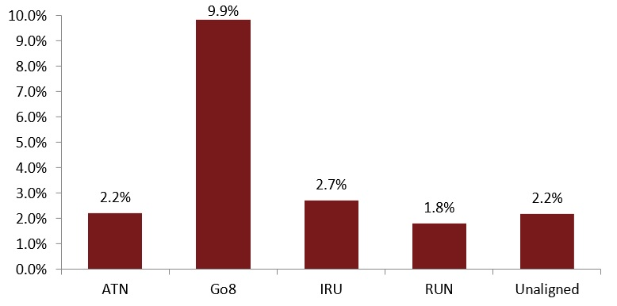
We also found distinct patterns in foreign language study by institution grouping. Over 58 per cent of all foreign language study is conducted at Go8 institutions, with unaligned institutions coming a distant second with 17 per cent of all foreign language enrolments. Calculated as a proportion of overall undergraduate enrolments, we were able to estimate the foreign language participation rate for each grouping, the results of which are displayed in Figure 2.1. We found that almost 10 per cent of all students at Go8 institutions were studying a foreign language, which is more than three times higher than the participation rates reported by the Innovative Research Universities (IRU) grouping, which reported the second highest foreign language study participation rate. The Regional Universities Network (RUN) grouping reported the lowest foreign language participation rate with 1.8 per cent of undergraduate domestic enrolments.

Figure 2. 1: 2014 foreign language study participation rates by institutional grouping.
Source: Commonwealth Department of Education and Training customised data request. Overall enrolment numbers by institutional grouping sourced from the National Centre for Student Equity in Higher Education (NCSEHE) (Koshy, 2014).
Analysis of language offerings by institutional grouping helps to explain the participation differences in foreign language study by region and socio-economic status. Language provision across the institutional groupings is extremely variable, with Go8 universities on average offering eight more language options than the next group, the IRU. The prestigious Go8 universities, which are based in large cities and typically enrol the highest SES cohorts, have relatively high levels of language provision. This provision both reflects student demand and reinforces it. Conversely, the relative lack of supply options provided by RUN institutions is reflected in low enrolments. Students from a regional background are less likely to have studied a foreign language at school, and school subject choices influence subsequent university language enrolments. Supply and demand limitations can be mutually reinforcing, and it is necessary to address both factors to increase regional and low SES participation.
We were also able to examine the broad field of education (FoE) of students who were studying a foreign language. We found a clear trend, with the Society and Culture field - which typically covers generalist qualifications such as the Bachelor of Arts and the Diploma of Languages – being the largest field of education and significantly over-represented within foreign language study by comparison to its overall proportion of enrolments. Interestingly, we also found that students from the Natural and Physical sciences were comparatively over-represented. Students from the Health Sciences were the most under-represented cohort within foreign language study, but students from the Education and Engineering fields also have comparatively low foreign language study rates.
Given the over-representation of foreign language students within fields of education that are more often associated with generalist degrees such as the Bachelor of Arts and the Bachelor of Science, we further examined foreign language participation rates within two Australian institutions, the University of Western Australia and the University of Melbourne, which have moved to a model of generalist undergraduate education that emphasises breadth of study rather than specialisation. Our analysis of data from both institutions shows the rate of foreign language study dramatically increased with the introduction of the generalist undergraduate model. Figure 2.2 shows the increase in the number of foreign language enrolments within the University of Western Australia after the generalist model was introduced in 2012.
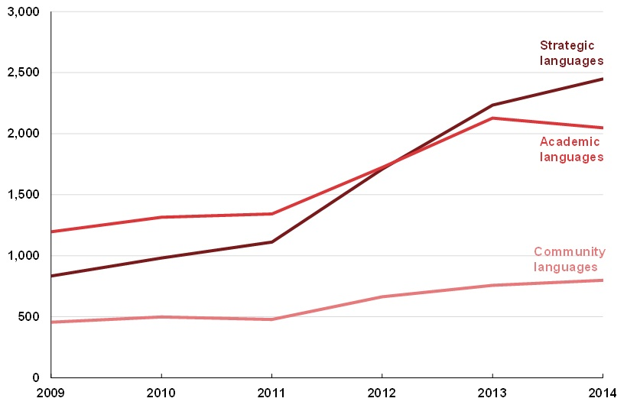

Figure 2.2: University of Western Australia language enrolments by language grouping,
2009-2014 (Headcount).
Source: publicly available subject enrolment data from http://www.planning.uwa.edu.au/statistics/unistats
The increase in so-called strategic languages (Chinese, Japanese, Indonesian, Korean and Arabic) was particularly strong, with the number of enrolments increasing in 2014 to almost three times the number of foreign language enrolments in 2009. The proportion of academic (Latin, Ancient Greek, French and Spanish) and community (Italian, Modern Greek, Vietnamese, Cantonese, Auslan) foreign languages also increased significantly over this period.
The University of Melbourne reported similar results. Despite a temporary decline in enrolments within the Diploma of Languages in 2008 (the year the Melbourne Model was introduced), enrolment levels have recovered and are now at unprecedented levels. Foreign language enrolments generally have also increased, and roughly 11 per cent of all students are now studying a foreign language (University of Melbourne, 2015).
The aforementioned field of education data shows that for some disciplines, particularly those in which professional registration is an issue, there is probably little flexibility in course structure to enable students to study foreign languages. By contrast, the experiences of the University of Western Australia and the University of Melbourne suggest that encouraging breadth of study can dramatically increase the number of students studying a foreign language.
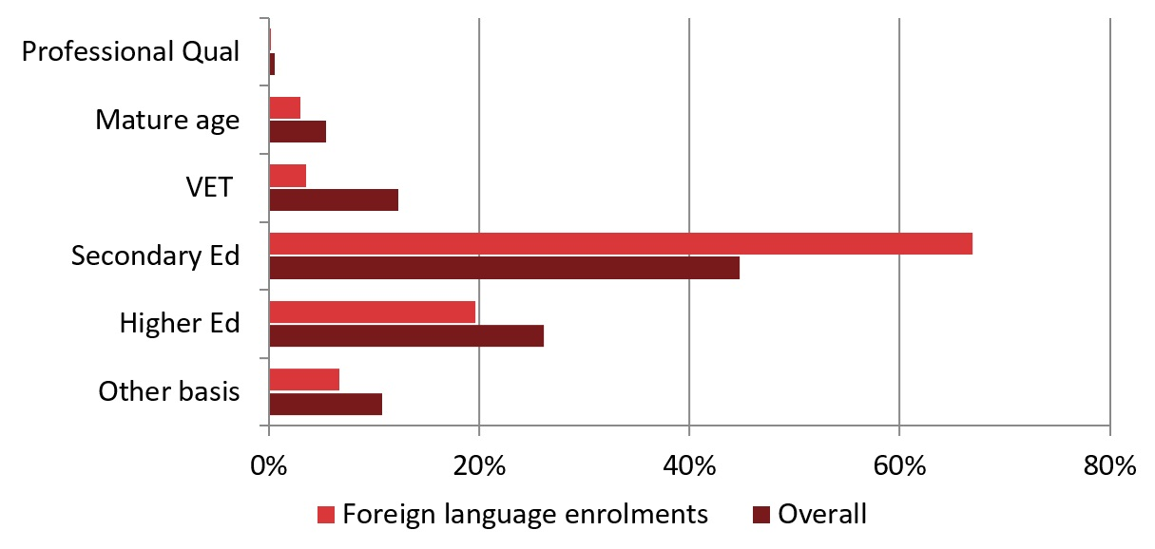
Using the foreign language study data it was also possible to examine patterns relating to the basis of admission and Australian Tertiary Admission Ranks (ATARs) of commencing undergraduate domestic students. Figure 2.3 shows that 67 per cent of commencing foreign language students come directly from secondary school, compared to 45 per cent of overall undergraduate enrolments. Other bases of admission—Mature age, Vocational Education and Training (VET), Higher Education and Other Basis—are all comparatively under-represented within foreign language study. In addition to the comparative over-representation of school leavers within foreign language study, we also found that the age profile of these students was dramatically skewed toward those aged 19 and under.

Figure 2.3: 2014 Foreign language and overall participation rates by basis of admission.
Source: Commonwealth Department of Education and Training customised data request.
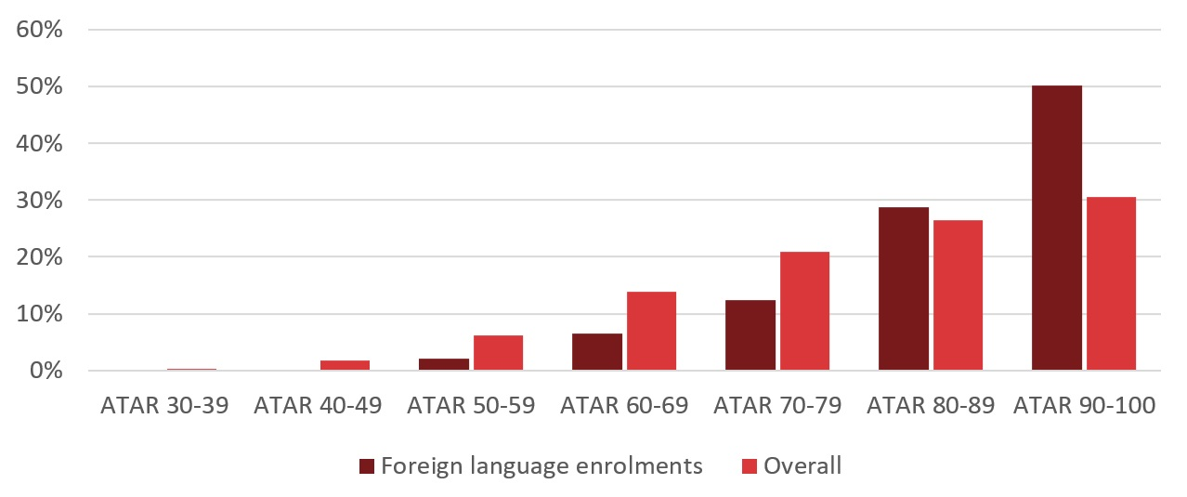
In addition to the basis of admission, we were able to access data on the ATARs of commencing students admitted through secondary education on the basis of their ATAR (excluding students for which no ATAR data was available). Figure 2.4 shows that over 50 per cent of foreign language students admitted on the basis of their ATAR had achieved an ATAR above 90, which is well above the 30.5 per cent of students who had achieved an ATAR above 90 across the sector generally. Students with an ATAR between 80 and 90 were also slightly overrepresented, while all ATAR bands below 80 were under-represented within language study.

Figure 2.4: 2014 Foreign language and overall participation rates by ATAR band.
Source: Commonwealth Department of Education and Training customised data request. Only includes commencing students admitted on the basis of secondary education who were admitted on the basis of their ATAR.
Given the majority of foreign language students within higher education are admitted directly from high school and the fact that high ATAR students are also dramatically over-represented, it is clear that patterns within secondary education are inextricably linked to the poor equity outcomes in relation to foreign language study at university.
Data from the Victorian secondary school sector confirms that language provision is correlated with socio-economic and regional status. Figure 2.5 shows that over 70 per cent of the schools which did not provide any foreign language study were from regional areas, while fewer than 10 per cent of those schools which provided access to four languages were from regional areas.
Figure 2.6 shows a clear link between the Index of Community Socio-Economic Advantage (ICSEA) score of schools and the number of languages schools offered. While the overall average ICSEA is 1,000, the average ICSEA of schools that did not teach a language at all was approximately 963, compared to an average ICSEA of 1025 for schools that provided access to four or more foreign languages.

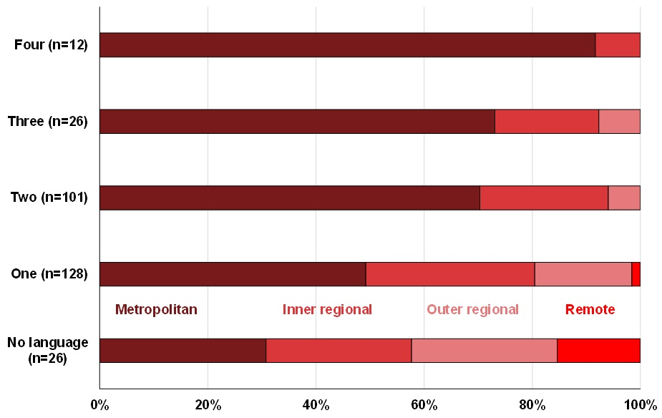

Figure 2.5: Remoteness of school and number of languages provided.
Source: Customised data based on Victorian Department of Education and Training (2015)
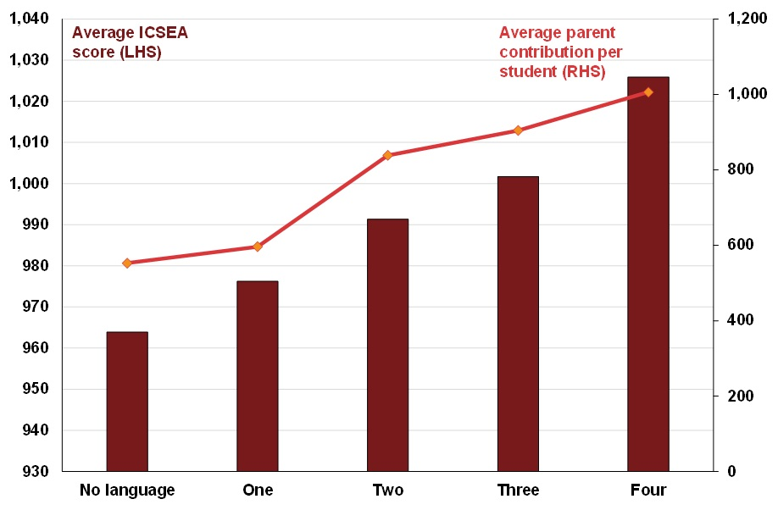

Figure 2.6: Average ICSEA score and average parent contribution per student, by number of
languages provided.
Source: Customised data based on Victorian Department of Education and Training (2015)

Equity Participation Rates within Foreign Language Study
Low SES
University participation data confirms the extent to which language enrolments are mediated by socio-economic and regional status. Overall, we found evidence to suggest that low SES students are considerably under-represented within language study, while students from high SES backgrounds were considerably over-represented. The high SES category represents 46.4 per cent of the foreign language study cohort, well above their overall university participation rate of 32.1 per cent and their overall representation within the general population of 25 per cent. By contrast, both the medium and low SES categories are under-represented in comparison to their overall participation within undergraduate university study. In 2014, 41.6 per cent of students studying a foreign language were from the medium SES cohort, compared to their overall university participation rate of 49.3 per cent and their representation of 50 per cent of the Australian population. In 2014, medium SES students had a foreign language to overall participation ratio of 0.84.
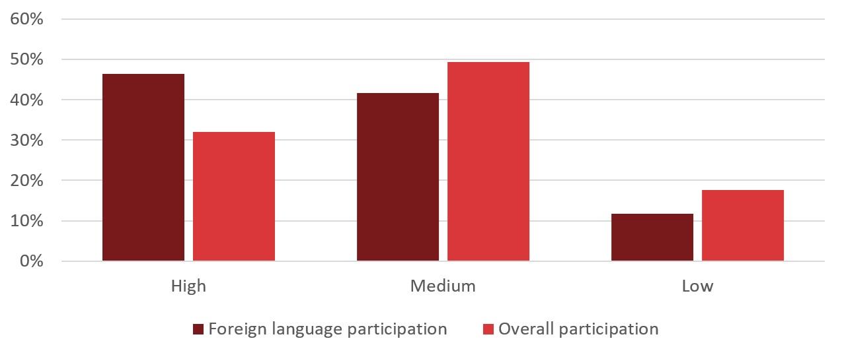
However, underrepresentation is particularly acute for students from low SES backgrounds, who had a foreign language study to overall participation ratio of 0.66. This is despite a small improvement in their participation rate between 2011 and 2014. Figure 2.7 compares the low SES foreign language study participation rate to the national overall undergraduate participation rate and shows that low SES students studying a foreign language constituted 11.7 per cent of all foreign language enrolments in 2014. This compares to low SES students comprising 17.6 per cent of all undergraduate enrolments and 25 per cent of the overall Australian population. Based on this data, a high SES student is almost 5 times more likely to be studying a foreign language subject at university than a student from a low SES background.

Figure 2.7: Low SES foreign language study participation rate compared to the overall Low SES
participation rate at university.
Source: Commonwealth Department of Education and Training customised data request

Students from Regional Backgrounds
We also found that students from regional and remote backgrounds were under-represented both in comparison to their general participation rates in undergraduate study, and their proportion of the Australian population. In 2014, 14.1 per cent of students studying a foreign language were from a regional background, and the overall regional student foreign language participation rate has declined slightly over the preceding four years. The 2014 participation rate compares to the overall national regional participation rate of 20.6 per cent in the same year and the 30.8 per cent of the Australian population who live in regional or remote areas (Australian Bureau of Statistics, 2012).
Students from remote areas experienced even higher levels of underrepresentation. In 2014, remote students consisted of 0.4 per cent of language enrolments, compared to their overall enrolment participation rate of 0.8 per cent. However, as a result of the very low numbers in this group we focus instead on regional students in this report. Figure 2.8 shows a comparison of foreign language and overall participation rates by remoteness area, with a regional student foreign language study participation ratio of 0.68.
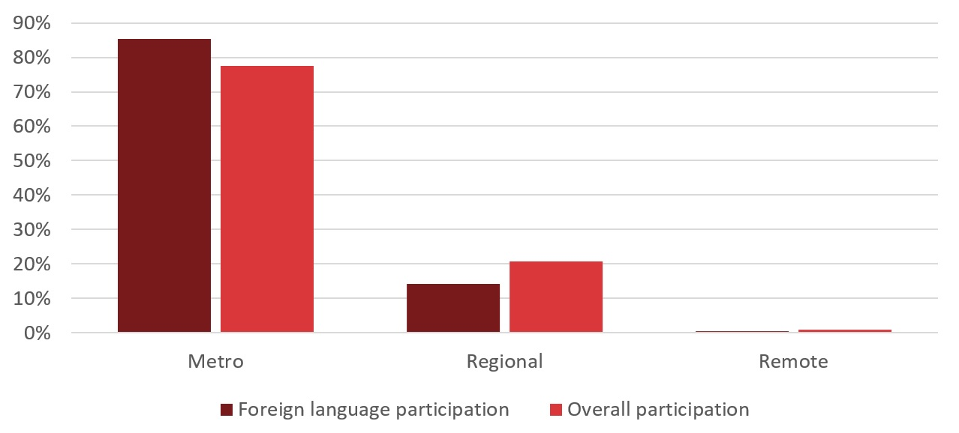

Figure 2. 8: 2014 Foreign language study and overall participation rates by remoteness area category.
Source: Commonwealth Department of Education and Training customised data request
We also found that regional students are well represented within Southeast Asian Languages (believed to be predominantly Indonesian), with 26.3 per cent of students within the Southeast Asian field of education coming from regional backgrounds. This is almost twice the average for all languages and above the overall undergraduate regional student participation rate. While these categories only reflect a relatively small number of enrolments generally, regional students are not at all represented within Southwest Asian and North African languages or Southern Asian Languages. These patterns may partly reflect provision models, with many languages not offered on regional university campuses.

Undergraduate OS-HELP Data
The Australian Government extends financial support for outbound mobility programs to students enrolled in a Commonwealth supported place through the Overseas Higher Education Loan Programme (OS-HELP) loan scheme. Under OS-HELP, students can take out an additional loan for overseas study related travel repayable through their Higher Education Contribution Scheme (HECS) debt. In 2015, the maximum amount students could borrow for a six-month study period was $6,362. Students studying in Asia could borrow $7,635, as well as an additional $1,018 if they undertook Asian language study at their home university in preparation for their overseas study. Students can receive one loan per six month study period and can access two OS-HELP loans over their lifetime.
While it is difficult to quantify exactly what proportion of students who participate in outbound mobility programs take out an OS-HELP loan, it is clear that there is a fairly large minority who do not. Quantifying the size of the group who do not take out OS-HELP loans when they travel on student exchange is difficult. Alan Olsen, in his annual survey of Directors of International Education in Australian Universities, estimates that roughly 63 per cent of international study experiences received funding, or had access to OS-HELP, covering as many as 80 per cent of students who participated within an official student exchange, while around 50 per cent of students undertaking other long term experiences take out a loan (Olsen, 2014). Using the data provided in Olsen’s report, we estimate that around 75 per cent of students undertaking a long term (semester length) exchange take out an OS-HELP loan. However, it must be stressed that this survey is based on the impressions provided by Directors of International Education and is not based on a count of actual numbers.

Overall OS-HELP Statistics
Overall, 9,998 domestic undergraduate students took out an OS-HELP loan in 2014 for the purposes of travelling overseas for a long term student exchange. This figure dramatically increased by 60 per cent from the 6,241 students reported in 2013. Furthermore, expressed as the proportion of all domestic undergraduate students, the proportion of students taking an OS-HELP loan increased by 44 per cent between 2013 and 2014 to represent 1.3 per cent of all domestic undergraduate students.
The amount loaned through the OS-HELP scheme has also increased. According to the Higher Education Report 2011-2013, published by the Commonwealth Department of Education, over $38.9 million of OS-HELP loans were issued in 2013, compared to $31.9 million in 2012 and $28.2 million in 2011 (Commonwealth Department of Education, 2015). While figures for 2014 are yet to be released, we have been able to calculate an estimate of the total amount of OS-HELP funding using the number of loans and the average size of the loan. We estimate that over $64 million will be provided to students participating within the scheme, which is a 66 per cent increase from 2013. Most of this money will be recouped through income contingent repayments, with the Australian Government Actuary estimating that 17 per cent of loan payments will not be repaid (Norton & Cherastidtham, 2014).

Equity within the OS-HELP Loan Scheme
Low SES
Using the data provided by the Australian Government Department of Education, we were able to examine the proportion of students obtaining OS-HELP loans who were from low SES and regional backgrounds. The proportion of low SES students participating in the scheme increased marginally between 2011 and 2014, but they still remain significantly under-represented when compared with both their overall participation rate within university and the overall proportion.
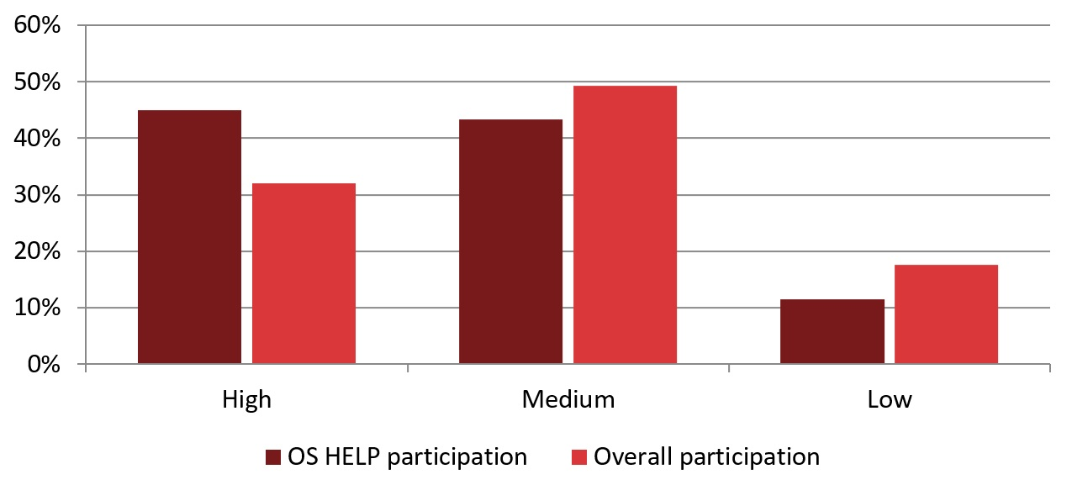
The medium SES category, which consisted of over 49 per cent of all domestic undergraduate enrolments in 2014, was also under-represented. The degree to which low SES and medium SES categories are under-represented is shown in Figure 2.9. Students from high SES backgrounds consisted of 45 per cent of students with OS-HELP loans, compared to an overall undergraduate participation rate of 32.1 per cent and 25 per cent of the Australian population in 2011 (last available census data). Students from medium SES cohorts had an OS-HELP access rate of 43.4 per cent, compared to an overall undergraduate participation rate of 49.3 per cent and 50 per cent of the Australian population in 2011 (last available census data). Medium SES students had a participation rate ratio of 0.88 in 2014. Low SES students were significantly under-represented, reporting an OS-HELP participation rate of 11.4 per cent in 2014, compared to an overall undergraduate participation rate of 17.6 per cent and 25 per cent of the Australian population in 2011 (last available census data). Low SES students recorded a participation ratio of 0.64, suggesting they are considerably under-represented within OS-HELP loans.

Figure 2.9: 2014 OS-HELP and overall participation rates by SES.
Source: Commonwealth Department of Education and Training customised data request
Split by the region of the destination country of the student exchange, we found differences between the low SES and non-low SES cohorts. Students from low SES backgrounds were slightly less likely to travel to Northern America and the United Kingdom, Northern Europe and Southern Europe. On the other hand, low SES cohorts were comparatively more likely to travel to mainland South East Asia, Southern Asia, Japan and the Koreas.
There were some interesting differences between the destinations to which there were relatively small numbers of student exchanges. Low SES students were more likely to travel to many of these smaller regions including Southern and East Africa, Central America, Eastern Europe, New Zealand and Polynesia. In the case of Polynesia, low SES students were almost three times more likely than non-low SES students to visit, but the relatively small numbers mean this figure should be treated with caution.
Regional Students
The proportion of regional students taking out an OS-HELP loan has remained relatively steady over the past four years, with 17.4 per cent of OS-HELP loans being awarded to students from regional areas in 2014, compared to their overall representation of 20.6 per cent within undergraduate higher education and 30.3 per cent within the general Australian population (Australian Bureau of Statistics, 2012).
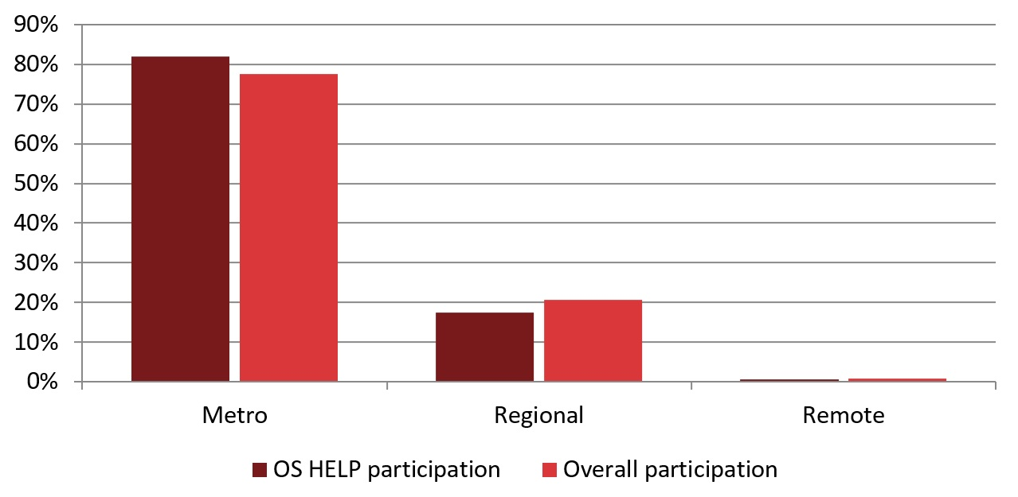
Overall, we found regional student under-representation within the OS-HELP loan scheme was less than that observed within foreign language study. Figure 2.10 shows a comparison of metropolitan, regional and remote student participation rates within the OS-HELP scheme, compared to overall participation rates within university. The results show that students from metropolitan areas are comparatively over-represented, with metropolitan students having a participation ratio of 1.06, while both regional and remote students where under-represented with participation ratios of 0.84 and 0.67 respectively.

Figure 2.10: 2014 OS-HELP and overall participation rates by regional status.
Source: Commonwealth Department of Education and Training customised data request
There are also some interesting patterns by the region of the destination of the student exchange. While regional students only visited a relatively small number of international regions as part of their student exchange, there were significant differences in destinations between regional and metropolitan students. Regional students were less likely to travel to the UK and Western Europe and were slightly more likely to travel to mainland South-East Asia (Vietnam, Thailand, Laos, Cambodia), Central America and Chinese Asia.
In addition to examining OS-HELP scheme access rates, we were also able to examine average OS-HELP loan size. Contrary to expectations, we found very little evidence of any significant variations in the average amount loaned to students across a number of categories, including socio-economic status, regional status, non-English speaking background (NESB), Indigenous status, disability status, gender, course, field of education and age. The only trend detectable from the data provided by the Australian Government Department of Education and Training appears to be that students participating in the OS-HELP scheme, on average, take out the maximum amount possible. Further research into the adequacy of the grant and motivations of loan students would be helpful.
Overall Access to Passports
In addition to an under-representation in access to OS-HELP loans, we found strong evidence that Australians living in disadvantaged areas generally are less likely to travel overseas. Using data sourced from the Australian Passports Office, we calculated an estimate of what proportion of those above the age of 18 had a passport by geographic area as a proxy measure for those who were likely to travel overseas. Figure 2.11 shows the proportion of the adult population who owned a passport by SES background. We found that an estimated 47.7 per cent of adults living in low SES postcodes had a passport, compared to 73.7 per cent of high SES residents owning a passport.

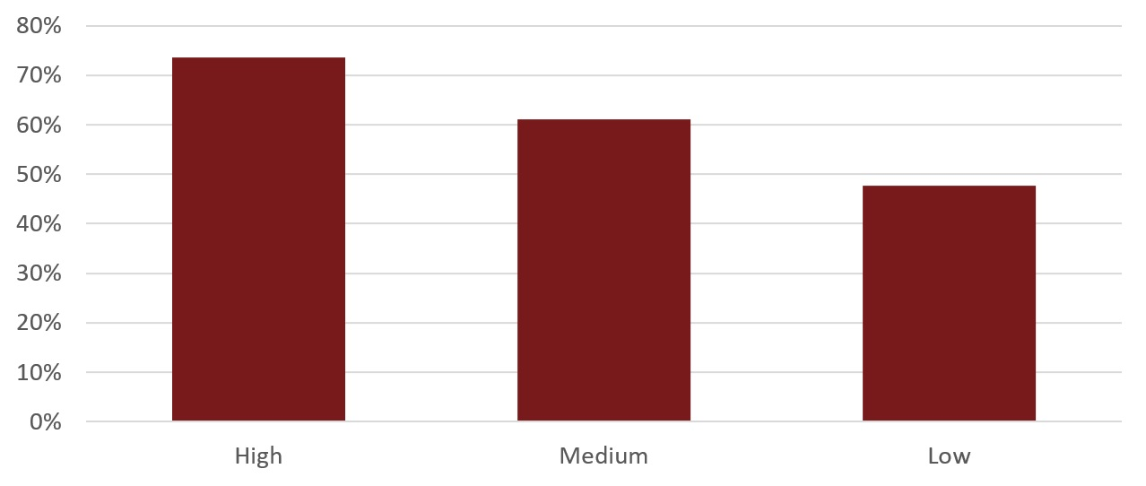
Figure 2.11: Proportion of adult passport ownership by SES.
Source: Customised data provided by passport ownership data provided by the Commonwealth Department
of Foreign Affairs.
Figure 2.12 shows a similar relationship by remoteness area. Overall, Australian residents living in remote areas reported 37.8 per cent passport ownership, while those living in regional areas reported an ownership rate of 48.8 per cent. Residents in metropolitan areas reported an estimated ownership rate of 53.7 per cent.

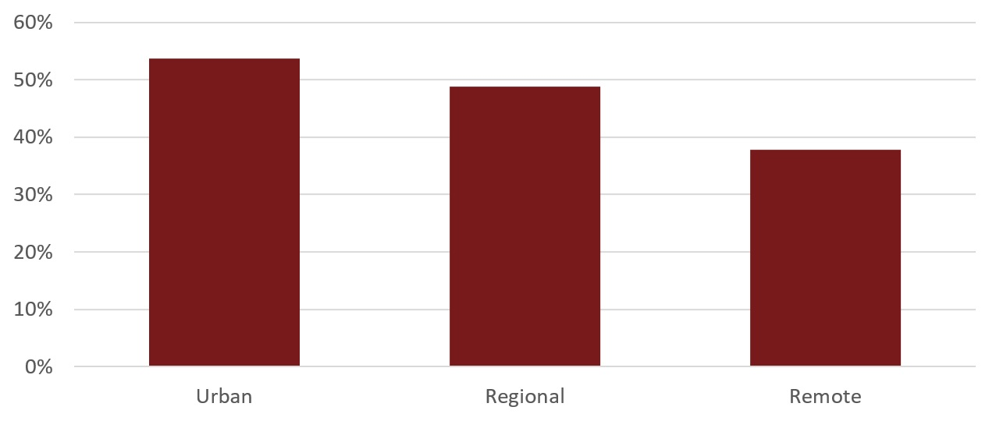
Figure 2.12: Proportion of adult passport ownership by remoteness area.
Source: Customised data provided by passport ownership data provided by the Commonwealth Department
of Foreign Affairs.
Passport ownership is another metric suggesting that regional and low SES people are less likely to travel, and that there are structural, geographic and cultural barriers to mobility that universities need to address to develop more equitable mobility outcomes.

Recommendations

Section 2. National Data Analysis
- That the Australia Government promote the availability of Overseas Higher Education Loan Programme (OS-HELP) funding, and investigate expansion of the maximum loan amount and the financial motivations of loan students.
- That the Australian Government require universities to track the participation and achievement of equity groups in outbound mobility experiences, and publish the outcomes.
- That universities promote and market both outbound mobility and foreign language study to prospective students, including through school outreach and Higher Education Participation Programme (HEPP) activities.
- That state and territory governments prioritise the teaching of foreign languages in regional and low SES schools, and encourage collaboration among schools to ensure broad language availability, including through digital technologies.

Section 3. University Policies and Strategies
As part of our study we conducted two surveys of staff within Australian public universities. The surveys were designed to determine the policies and strategies universities currently have in place to support under-represented students, particularly low SES and regional students, to: (1) study a foreign language, and; (2) participate in outbound mobility programs. Invitations to complete the online survey were emailed to senior staff with responsibility for language and outbound mobility programs at all 37 Australian public universities. A total of 21 universities responded to the language survey. Removing the four universities who do not offer language study, this represents a 64 per cent response rate. A total of 24 universities responded to the outbound mobility survey, representing a 65 per cent response rate. A desktop review of the strategic plans, graduate attribute statements and scholarships and bursaries programs at all Australian public universities was also conducted to complement these surveys.

Globalization Plans
Respondents to the outbound mobility survey overwhelmingly identified globalization as an important strategic direction for universities. However, the desktop review found that while many universities make specific reference to globalization or internationalisation in their strategic plans, the extent to which these concepts feature varies substantially.
Most universities described aspirations to be ‘globally engaged’, ‘globally networked’ or an ‘international institution’. Universities often included references to the public good in their descriptions of globalization; for example, one university’s vision is, ‘to strengthen and extend strategic partnerships with professional and broader communities to reflect both our academic ambitions and our civic responsibility’.
For universities that offer a significant number of programs delivered via distance education, either through their own platforms, or external platforms such as Open Universities Australia, globalization can have a different meaning. Due to online delivery modes, students at these universities may be drawn from a wide geographic area and may not experience the constraints of more traditional face-to-face delivery. As such, globalization can take a more pragmatic form. For example, one university with a large proportion of online enrolments defines globalization as ‘having greater international connectivity in terms of course delivery, course content, pedagogical practice, benchmarking and human capital’.
‘Internationalisation of the curriculum’ was another common initiative and featured in nearly three quarters of the strategic documents. ‘Internationalisation of the curriculum’ arose out of growing concerns that university curricula inadequately accommodate the needs of international students (Callan, 2000) and was initially introduced to assist international students to adapt to new academic settings (Sawir, 2013, p. 361). Some universities have since retained this narrow scope, for example, by defining internationalising the curriculum as ‘integrating global perspectives and ensuring course design and content to meet the needs of international students’.

Other universities have expanded the concept to acknowledge the wider benefits of delivering a global education to all students: ‘[internationalisation of the curriculum] build[s] learning environments that enhance the global skills and intercultural capabilities of our students and maximise the opportunities for international students to participate and feel valued in the classroom’.
Of the 37 universities, 14 had specific ‘Internationalisation’ or ‘Global Engagement’ strategic documents to complement their strategic plans. Most universities focus on the narrower policy-based concept of internationalisation, rather than globalization. A brief analysis of the internationalisation or global engagement plans revealed many commonalities between the globalization experiences offered by universities. Mostly, internationalisation was understood as contributing to the global profile and international reputation of the institution and commonly compromised the following actions:
- internationalise the curriculum;
- offer outbound mobility/international experiences for students;
- establish/strengthen strategic partnerships with international institutions; and
- increase and/or diversify international student recruitment.
When asked to comment on challenges and benefits of implementing globalization plans, many respondents confined their response to the provision of outbound mobility opportunities. This limitation was expected given the targeting of the survey to staff responsible for outbound mobility policy and programs.

Challenges of Implementing Globalization Plans
One respondent noted the increasingly competitive environment of international learning opportunities: ‘students have a “smorgasbord of choice”, and in response universities are expected to compete on the full suite of international learning opportunities ... Leveraging resources to provide sustainable, integrated and scalable programming solutions is the biggest challenge’.
Smaller universities in particular reported resource constraints in supporting large global mobility programs. They also highlighted the unique challenge of making global mobility visible and accessible to their students, who are more often mature aged, low SES and first in their family to attend university. One respondent from a small university commented:
We have to work quite hard to promote the opportunities to students. Many of our students are drawn from low SES areas and do not inevitably see themselves as global citizens. They also have work/life commitments that mean travel (albeit brief) may not be an option.
When speaking about the implementation of globalization plans more broadly, a common challenge was the alignment of the strategy across the whole university and generating support, or ‘buy in’, for the concept throughout departments and faculties. As one respondent commented, ‘aligning all areas to be equally engaged, and finding adequate resources to implement the strategy, is challenging’.

Benefits of Implementing Globalization Plans
The most commonly identified benefit of implementing globalization plans was delivering opportunities for international experiences that enable the ‘enrichment of [student] learning experiences’, instil ‘global perspectives’ and create better ‘engagement with international students on-campus in Australia’.
For low SES students, while it was acknowledged that encouraging participation can be challenging, one respondent explained that ‘for the students who do participate in these opportunities, the benefits are immeasurable… they report very positive outcomes’.
There were also university wide benefits reported, including ‘the development of innovative partnerships and programs’, ‘better global profiling of the institution’, and maintaining or establishing the university as an ‘international institution, [opening] future revenue flows through research grants and international student fees’.

Foreign Language Study

Opportunities for Domestic Students
The Foreign Language survey and desktop review found that the study of languages was not commonly recognised as a globalization opportunity for students. Only four universities recognised language study in their strategic documents as an element of globalization or internationalisation strategies. Furthermore, these references were often minimal, with little reference to specific policies. For example, a common action was to ‘promote linguistic diversity’.
The University of Sydney was one of the only Australian universities to link the learning of languages explicitly to globalization opportunities in its strategic plan. Under the ‘expand and diversify opportunities for students to develop as global citizens’ strategy, the plan cites the implementation of the Second Language Acquisition Project, which involves promotion of the Diploma of Language Studies. The Diploma is designed to facilitate language study opportunities for all students regardless of degree. It is open to all undergraduate or combined degree students at the University of Sydney, as well as students wishing to undertake cross institutional study. Completion requires eight units of study, usually undertaken part time over three years.
The most common languages offered at the 21 respondents’ universities were French, Japanese and Chinese (Mandarin), with 71 per cent of universities offering these languages. Italian was offered at 68 per cent of universities. German, Spanish and Indonesian were offered at roughly half of the universities. The most common ‘other’ language listed was Modern Greek, which was offered by 23 per cent of the universities (see Figure 3.1).
The University of New England, which has a substantial number of online courses, offers Chinese [Mandarin], French, German, Italian, Indonesian, Japanese, and Spanish language study. Open Universities Australia (OUA), another major online higher education provider, which facilitates enrolments through its shareholder universities, offers Ancient Greek, Chinese [Mandarin], Indonesian, Italian, Japanese, Latin, Spanish and Yolngu languages. These are similar to the standard offerings of many face-to-face universities, with the exception of Yolngu languages. Although out of scope of this project, the offering of Indigenous languages through OUA provides an important example of the capacity of technology to increase language provision.

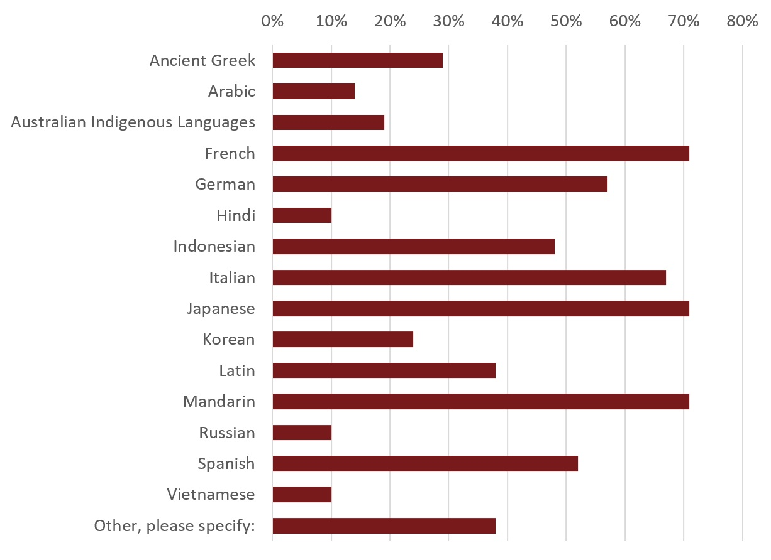
Figure 3.1: Languages offered by respondents’ universities (n=21).
Language professionals reported many barriers and constraints to the provision of foreign language education. These barriers included: low demand from students for particular languages; high cost of delivery; insufficient funding; and inflexible course structures. In response to these barriers and constraints, just over half of the respondents indicated that they co-ordinate with feeder schools in the language offerings they provide, as well as offer bonus points for secondary school students studying a LOTE. In Western Australian, there is a state-wide agreement that all LOTE students receive a 10 point bonus (TISC, 2016). Many respondents also stated that their universities have considered cross-institutional collaboration as a means to expand language provision. Knowledge of the proportion of the total domestic student population studying a language in 2014 was poor amongst respondents, with only one respondent reporting that their university tracked the total proportion of domestic students studying a language in 2014.
Data were not available from any university detailing the proportion of under-represented students studying a language. However, as one respondent warned, the relationship between under-represented students and language study are complex:
There is an assumption in this study about the relationship between languages and disadvantage that needs to be made very clear. The pattern for languages in this space is much more complex as it differs for different students and for different languages. This level of sensitivity must come into play if we are to understand the phenomenon and we can’t proceed without this understanding.
The survey results also found that seven of the universities offered some form of financial support for domestic students to study languages. Of these seven universities, five allocated funding according to academic merit, while three allocated funding for need and/or equity considerations. Examples of two language bursary/scholarship programs that include equity considerations are summarised in Figure 3.2.

Australian National University - The Ethel Tory Languages Scholarships
The Ethel Tory Language Scholarship provides a one-off payment of $2,500 to assist students undertaking full-time study outside Australia in the following categories:
- language courses conducted off shore by ANU and recognised for credit towards an ANU degree;
- language courses offered by an approved international education provider and recognised for credit towards an ANU degree; or
- a program of study, offered by an approved international education provider, delivered in a foreign language and recognised for credit towards an ANU degree.
To be eligible, students must be currently studying language at an intermediate/advanced level within their ANU program. Selection criteria include:
- academic merit, as evidenced in grades achieved in prior language study at ANU;
- student motivation and need for financial support, as detailed in a one-page personal statement outlining the student's reasons for participating in the international language study experience;
- whether the applicant has been awarded any other funding, grants or scholarships for language study; and
- access and equity considerations, including financial circumstances, Indigenous Australians, difficult family circumstances, rural or isolated area applicants and students with a disability or medical condition.
University of Sydney – Badham Bursaries
The Badham Bursaries are for students enrolled in the Departments of Latin and/or Ancient Greek at the University of Sydney. Bursaries are valued up to $2,000 and awarded on the basis of financial need and academic merit attained in Latin and/or Ancient Greek. Preference is given to a student who is taking both Latin and Ancient Greek for the degree of Bachelor of Arts.

Figure 3.2: Equity language scholarships or bursaries.

Suggested Improvements
Language survey participants were asked to provide broad suggestions for how to encourage and support more domestic students to study languages, and particularly under-represented students. However, most responses related to the uptake of languages by all students, reflecting an overall concern for the language disciplines more generally. Suggestions offered by respondents related to the following themes: flexible course structures; outbound mobility opportunities; incentives; and the promotion and marketing of languages.
Flexible Course Structures
A common suggestion raised by respondents was the need for faculties to design more flexible course structures and embed an interdisciplinary approach. As one respondent explained, ‘we need to open up course structures that have become far too tight because of disciplinary protectionism’. Another respondent commented, ‘ultimately it is making the connection with other disciplines that matters. Languages are too often seen as a study in their own right rather than a pathway’. Further, one respondent strongly advocated for a pedagogy change:
we need to re-conceptualise the nature of [language] courses and the pedagogies for teaching languages … we need whole of institution approaches, research into actual provision, consideration of types of courses [offered], [and to] look at the outcomes of learning.
To embed this flexibility, two respondents cited the University of Melbourne and University of Western Australia ‘breadth’ model, identifying ‘languages [as] one of the major beneficiaries of [these] policies’. Respondents suggested that their universities should follow the model and similarly ‘provide an opportunity for language learning to students in all undergraduate programs’.
Other respondents commented that faculties need to allow and encourage their students to study languages: ‘more flexibility in allowing students from other degree programs (that is, non-humanities) to take language, either as electives or via certificate or diploma studies would be helpful’.
Some respondents identified specific degrees that they felt should incorporate a compulsory language component, such as Bachelor of Arts, Bachelor of International Studies and Business courses. One respondent cited the success of the introduction of a language minor requirement (four subjects) for the Bachelor of International Studies on language enrolments. Other suggestions included the recommendation that some form of language study be a requirement of all undergraduate degrees.
Outbound Mobility Opportunities
Expanding, promoting and providing scholarships for exchange programs was a common suggestion made by many respondents to increase the uptake of language study. Creating further incentives for language study, one respondent suggested ‘giv[ing] priority funding for exchange places to students who are studying in a non-English speaking country and who have studied some language beforehand’.
To increase participation of under-represented domestic students, many respondents suggested ‘financial support for immersion programmes overseas, targeted at low SES domestic students’. However, a more nuanced response suggested the allure of outbound mobility programs may be not be sufficient to increasing participation:
Local domestic students who've engaged with (and excelled at) foreign language learning have reported to us the transformational nature of study abroad, and suggested a focus on making students aware of the various enablers of [outbound mobility programs] ... However, purely anecdotally, that cohort seems to skew to people who had already travelled abroad in childhood, or before coming to university. I'm not sure that awareness of enablers [provides] motivation to those of our students who haven't travelled abroad before, or had close family who've done so.
The implication, as the discussion of the outbound mobility survey responses also reveals, is that the provision of funding may not adequately address the suite of constraints faced by under-represented students when deciding whether to participate in outbound mobility programs. Beyond financial constraints, there are also geographic, cultural and structural barriers to participation.
Incentives
Incentives were frequently suggested as a means of enticing students to study languages. Suggested incentives included: offering bonus entry points for secondary students studying languages; advanced standing credit; and providing scholarships for language study.
Promotion and Marketing of Languages
Other common suggestions included the need to promote the value of language study better. One respondent commented that there is a need to, ‘make [languages] as much a part of the [university] culture as valuing engineering or business programs’. Others recommended emphasising ‘the importance of a global education’, recognising ‘the crucial relationship between language and intercultural understanding’ and emphasising ‘the career advantages in studying a language, particularly one relevant to our region’. A handful of respondents also suggested working closely with secondary schools to encourage language learning from an earlier age.

Outbound Mobility

Opportunities for Domestic Students
The outbound mobility survey and desktop analysis found that, in comparison to the study of foreign languages, outbound mobility opportunities were much more clearly recognised for students. While only four universities recognised language study in their strategic documents, 26 of 37 universities specified outbound mobility and international experiences as an initiative in their strategic plan.
A handful of universities outlined specific targets for participation, including:
- the University of Canberra, which aims to have at least a third of its graduates undertake an international experience by 2018;
- the University of Western Australia, which aims to increase student participation in outbound mobility and student exchange from its current 20 per cent level;
- Queensland University of Technology, which aims to ensure at least 15 per cent of all graduating students have had an international study experience by 2016; and
- the University of Adelaide, which commits to every student completing either graduate work experience/career mentoring, an outbound mobility program, or an international student host program.
While many of the targets above involve a commitment to increasing international experiences, including short term program, and practical or clinical placements, analysis of OS-HELP data provides a clearer picture of participation in long term programs. Since the OS-HELP loan scheme is only available for semester or year exchange programs, and was accessed by 72.2 per cent of all domestic students in Australian universities participating in a semester or year exchange program in 2013 (Olsen 2014), access to OS-HELP is a good proxy for long term outbound mobility program participation.
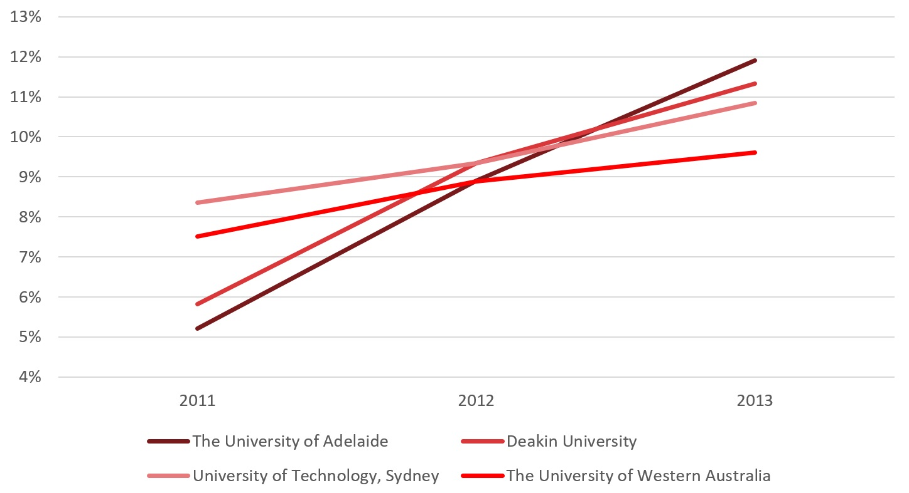
The University of Adelaide and Deakin University are the two universities who have recorded the most significant growth in proportion of undergraduate completions with an OS-HELP loan (see Figure 3.3). The University of Technology Sydney and the University of Western Australia have also experienced considerable growth in graduates who have accessed an OS-HELP loan.

Figure 3.3: Universities achieving the highest proportion of undergraduate completions with
OS-HELP loans. 2011-2013.
Source: Commonwealth Department of Education and Training (2015) and the Higher Education Data Cube
Despite this growth in participation in long term outbound mobility programs, it is unclear whether growth has improved representation across particular equity groups. Returning to the survey, half of the respondents stated that their universities have a specific strategy or plan to support under-represented students to consider globalization opportunities. However, in all instances no further details on these plans could be found.
Only two universities indicated that they specifically monitored under-represented students’ participation in outbound mobility programs, with only one university going to the level of low SES background. As several respondents explained, many universities do not collect this data. Instead, they rely on the annual survey of Australian universities undertaken by the Australian Universities International Directors Forum (AUIDF). This survey provides a national picture of outbound mobility activity. The AUIDF data de-identifies students and provides a range of demographic information; however, it does not identify students’ home institutions. As a result, patterns of participation against key demographic indicators can only be obtained from aggregated data compiled from the diverse range of Australian universities.
Eligibility requirements for outbound mobility programs varied across the surveyed universities. Most universities required at a minimum that the student was currently enrolled - usually on a full time basis - and had completed a minimum number of credit points towards their degree. In addition, many universities required students to achieve a minimum Grade Point Average (GPA). Most commonly, the minimum GPA was between 4.0 and 5.0, although one institution cited a GPA of 2.0. Additional requirements included having enough subjects left to complete your degree at the home institution, proving financial self-sufficiency for the exchange period, and minimum GPA requirements at the destination institution.
The New Colombo Plan (NCP) includes a Scholarship Program and a Mobility Program. The NCP Scholarship Program provides scholarships for Australian undergraduates to undertake semester-based study and internships or mentorships in participating Indo-Pacific locations. The NCP Mobility Program provides funding for Australian universities and consortia to support Australian undergraduate students to participate in semester based or short term study, internships, mentorships, practicums and research in 38 host locations across the Indo-Pacific region. Both programs are open to Australian undergraduates aged 18-28 at Australian universities, though there is some capacity to include students over 28 years of age in the program.
Ninety-two per cent of the surveyed universities reported providing some form of financial support for domestic students to participate in outbound mobility programs. However, the degree of support varied substantially across the universities. The largest number of travel grants awarded in 2014 was reported at 2,000, while the smallest was 10. The average number of grants across all universities was 455.
Some universities allocated funding for outbound mobility programs on the basis of merit, while others provided funding based on demonstrated need and/or equity considerations, and several universities considered both. Of the responding universities, 73 per cent reported allocating their funding on the basis of academic merit and 64 per cent allocated on the basis of need and/or equity considerations. In addition, a number of universities guaranteed a travel grant to every student undertaking an outbound mobility experience. For the universities that allocated funding on the basis of need and/or equity considerations, the following groups were considered, in order of descending frequency: low SES; Aboriginal and Torres Strait Islanders; regional/remote students; students with a disability; and NESB students.
Exploring the provision of financial assistance to under-represented students further, the desktop study found that while many universities offered some form of financial assistance to under-represented students, the amount and extent of support varied substantially across the institutions. In an analysis of 11 universities identified as providing financial support for under-represented students, four universities were found to offer only minimal support. For example, at two universities, only a small number of equity travel grants were offered by individual faculties. Of the universities who did provide equity travel grants, many were Go8 universities, which have the smallest proportions of under-represented students (James et al., 2008).
Of the two university to have recorded the most significant growth in proportion of undergraduate completions with an OS-HELP loan (see Figure 3.3), the University of Adelaide has a travel access grant program and the University of Western Australia offers an Indigenous outbound mobility scholarship. However, without disaggregated data by equity categories and trend data, it is hard to comment on the success of these programs.
Examples of large equity travel grant programs include: the Monash Global Equity Bursary; the University of Melbourne Lin Martin Melbourne Travelling Scholarship; and the RMIT Equity Travel Grant. The details of these grants are summarised below in Figure 3.4.

Monash University - Monash Global Equity Bursary
The Monash Global Equity Bursary is a $2500 bursary awarded on the basis of need. To be eligible, students must experience financial disadvantage, defined as currently receiving a Centrelink payment, or be experiencing exceptional financial disadvantage but not receiving any Centrelink payments.
In addition, consideration is given to students who experience other forms of disadvantage such as:
- difficult circumstances;
- Indigenous Australian background;
- recent refugee;
- disability or medical condition; and/or
- from a regional and remote area of Australia.
A $4000 bursary is also available, awarded based on academic achievement and need. Students must have a weighted average mark of 80 per cent to be eligible.
Thirty-three bursaries are available each year for any Monash Abroad program including: exchange programs; intercampus exchange (Monash South Africa or Monash University Malaysia campus); and short term international study programs. Occasionally, consideration is given to other intercultural programs within Australia.
The University of Melbourne - Lin Martin Melbourne Travelling Global Scholarship
The Lin Martin Melbourne Global Scholarship is a travelling scholarship established for students who have experienced social, educational or financial disadvantage and who wish to study overseas on a short term program for credit to their degree. The scholarship provides a one-off payment of up to $5,000. There are approximately 26 scholarships available each year.
To be eligible, students must be enrolled in an undergraduate degree at The University of Melbourne, have completed at least 75 credit points and achieved a Weighted Course Average (WCA) of at least 65. They also must have received approval to study overseas and not have studied overseas previously.
In addition, students must be in a position of social, educational or financial disadvantage, such as:
- having a disadvantaged financial background;
- coming from a rural area or under-represented school;
- having a disability or medical condition; and/or
- identifying as an Indigenous Australian; and/or
- experiencing other difficult circumstances
Candidates are required to submit supporting evidence of their financial disadvantage including a current means-tested Centrelink payment, or a brief statement regarding their financial circumstances if not in receipt of a means tested Centrelink benefit.
RMIT University – RMIT Equity Travel Grant
The RMIT Equity Travel Grant provides a one-off payment of up to $4000, with a maximum of $3000 for short term programs. Students must be an Australian citizen, permanent resident or permanent humanitarian visa holder and be enrolled at RMIT in a vocational education diploma, associate or bachelor degree, or postgraduate coursework program.
In addition, students must be able to demonstrate financial disadvantage/s, such as receiving a Government tested low income benefit or having a Centrelink Health Care Card. Students must also be able to demonstrate educational disadvantage/s such as:
- having a long term medical or disability which impacting their study;
- having difficult family circumstances;
- having relocated from interstate or from a Victorian rural location;
- being born overseas and from a non-English speaking background;
- having a refugee background; and/or
- having completed secondary school at one of the RMIT School Network Access Program secondary schools.

Figure 3.4: Equity travel grants examples.
In addition to financial support, most universities provided additional support for domestic students to participate in outbound mobility programs, including: pre-departure information sessions; application support and assistance with booking flights/obtaining visas; providing university insurance; and returning home events.
In providing specific support for under-represented students, several universities cited partnerships with disability services and Indigenous centres on campus. While many described the benefits of these relationships as enhancing the visibility of global mobility programs, some universities have used these relationships to increase their accessibility. For example, at RMIT University, the Global Mobility office and the Ngarara Willim Centre for Aboriginal and Torres Strait Islander Peoples are working in collaboration to develop mobility programs centred on Indigenous learning.
While many respondents cited Indigenous students as a specific equity group to target for participation in outbound programs, there was a more general absence of discussion about Indigenous students within the outbound mobility area. For example:
- How do Indigenous students think about outbound mobility programs, and where do they want to go?
- Do outbound mobility programs encompass intercultural programs within Australia, and should they?
- Is there a role for intercultural programs within Australia to deliver similarly transformative experiences as overseas study reportedly does, for both Indigenous and non-Indigenous students’ knowledge and appreciation of contemporary and traditional Indigenous culture?
While many of these questions are beyond the scope of this project, the increasingly global agenda of universities presents an opportunity to interrogate what globalization, intercultural competence and outbound mobility mean, or should mean, in the context of Indigenous Australia and for both Indigenous and non-Indigenous Australian students.

Suggested Improvements
Outbound mobility survey participants were asked to provide broad suggestions for how to encourage and support more domestic students to participate in outbound mobility programs, in particular under-represented students. Suggestions offered by respondents are summarised below.
Offer Diverse Programs
Recognising that financial constraints are not the only factors affecting a student’s choice to participate in an outbound mobility program, many respondents emphasised the importance of offering a diverse range of programs. In particular, short term programs were identified as being more accessible for many under-represented students, who may have family or work commitments. For example, one respondent commented:
faculty led short term mobility programs are often the most accessible for students from under-represented groups. This is because the reasons for lack of participation may not be just financial, given support available through OS-HELP, but could be to do with family commitments, lack of confidence in travelling overseas independently or lack of confidence in being able to operate in a new academic environment. [These] can contribute to a reticence to participate.
Related suggestions included providing greater on-program support, including a mentor/buddy program at the host destination, and compiling a list of partners with specific support programs in place for under-represented students, which could assist students in choosing their destination institution.
Provide Adequate Funding Recognising the Additional Financial Constraints Facing Some of These Cohorts
Many respondents recommended that ‘sufficient’ funding should be allocated to a wide range of under-represented students. As one respondent commented:
We need to provide guaranteed, on-going funding for under-represented domestic students. The funding needs to be substantial enough ($5000) that it will enable a student from an under-represented group to participate in an international program. Smaller amounts would probably not help students in this cohort.
Ensure Course Structures Accommodate, or Encourage, Outbound Mobility Programs
Several respondents highlighted the rigidity of course structures as a significant limitation to students’ participation in outbound mobility programs:
The biggest issue that all students face when participating in an outbound international experience is the limitation of their degree program. Therefore, to encourage more under-represented students, the university should first of all make the programs more flexible to allow an international experience.
Target Promotion to Under-Represented Cohorts
Increasing promotion, including targeted marketing and information dissemination to under-represented students, was also frequently raised. In reaching these students, some respondents emphasised building stronger partnerships with student support and equity areas of the university to ensure a wider range of students are aware of the opportunities available. To broaden the image of global mobility, one respondent suggested revamping ‘web design with some of the focus on under-represented student success stories and the use of student ambassadors from under-represented student groups to encourage participation’.
Improve Data Collection to Better Understand Enablers and Inhibitors to Participation in Outbound Mobility Programs
While many respondents suggested targeted promotion and scholarships, a handful of respondents highlighted a larger issue: the inherent difficulties of identification of under-represented students. Identification has a large implication for how opportunities are made available and funding is allocated. One respondent stressed the need for their university to determine a ‘fair and equitable way of determining “need” as opposed to “merit” for funding’.
One means to improve this process, currently used at La Trobe University, is to utilise the Victorian Tertiary Admissions Centres (VTAC). Tertiary Admissions Centres assist in administering need and/or equity based scholarships by taking the information and evidence provided by the student about their circumstances and ranking the applications according to ‘need’. Greater use of this system by International Offices may provide a simple solution for identifying under-represented students and making funding available to them.
Another respondent commented on the necessity of:
improved reporting mechanisms and research on under-represented cohorts in an Australian setting, and increased knowledge and awareness of barriers for student cohorts that are under-represented. Improved information will enable better strategies and encourage outcomes moving forward, and may, for example, move the conversation away from finance and funding and into other domains.

Global Citizenship
Global citizenship education is in additional way in which universities offer globalization opportunities to students.

Educating Global Citizens: Examples from Australian Universities
An increasing number of Australian universities are developing their approach to global citizenship, with many embedding the concept in their graduate attribute statements. As with global mobility and language study opportunities, global citizenship offerings vary substantially across Australia universities and usually manifest in two ways: through specific for-credit or extra-curriculum programs or as embedded within the curriculum. A selection of global citizenship programs are provided as examples in Figure 3.5.

Deakin University - ‘Global Citizenship Program’
The Deakin University Global Citizenship Program is a voluntary non-credit bearing program designed to supplement studies at Deakin University. It aims to instil the values of global citizenship and prepare students for success in an increasingly global society by offering a range of international activities such as:
- international study experiences;
- participation in internationally-focused units;
- seminars on international topics;
- international internships;
- international-centred volunteering;
- foreign language studies;
- peer mentoring; and
- professional development programs.
To become a global citizen, students are required to participate in a number of internationally-related activities categorised as volunteering, internships, leadership, international study and language study. Each activity is awarded points based on its associated skills and the extent to which each skill has been developed by the student. A student is required to accumulate a minimum of 100 points and 17 of 20 skills to complete the program. In addition, reflective pieces may be prepared that explore how these activities have contributed the student’s development as a global citizen.
The Global Citizenship Program understands global citizens to have:
- an appreciation for diversity and multiple perspectives;
- active engagement in the community, both locally and globally;
- personal responsibility for one's actions, and any consequences;
- recognition that all people have rights, and a commitment towards global equality;
- understanding of the economic, social, cultural, political, and environmental relationship that exists among all people and countries
- critical thinking about personal beliefs, actions, communication, global issues and relationships; and
- a capacity for effective intercultural communication and personal adaptability.
Of particular note, Deakin University also recognises foreign language study as a significant, or large points awarding, activity towards becoming a global citizen. While some graduate attributes statements articulate the appreciation of ‘linguistic diversity’, most statements do not explicitly link foreign language study to global citizenship.
The University of Newcastle – International Leadership Experience and Development Program (iLEAD)
The International Leadership Experience and Development (iLEAD) Program is an extra-curricular Leadership Program that gives students the opportunity to gain experience and skills in the areas of leadership and international awareness. iLEAD is also a points-based program where students are required to participate in a range of activities to accumulate iLEAD points.
Activities include:
- Skill Building Lectures, where academics from the University of Newcastle and external experts present on the three iLEAD program themes (Leadership in an International Context, International Awareness; and Community, Diversity and Pluralism);
- International Leaders Series events where high-profile speakers with distinguished leadership and international experience address the iLEAD program participants; and
- Activities such as volunteering, study abroad, and participation in short programs are awarded iLEAD points.
Two programs are offered: the iLEAD program and the iLEAD short program.
The iLEAD Program
Students in the iLEAD program are required to participate in nine Skill Building Lectures, four International Leaders Series events and accumulate 100 iLEAD points. It is intended that students complete the program throughout the duration of their undergraduate degree.
The iLEAD Short Program
The short program has been designed for inbound Study Abroad and Exchange students who have come to study at the University of Newcastle, as well as postgraduate coursework students. Short program participants are required to participate in three Skill Building Lectures, one International Leaders Series events and accumulate 50 iLEAD points.
Macquarie University - People, Planet and PACE
While Macquarie University has an extra-curricular a Global Leadership Program, the university has also decided to embed global citizenship learning as a compulsory component of their undergraduate degrees.
Currently all Macquarie students undertake a People and Planet unit as part of their degree. People units help students to become engaged local and global citizens through learning about the challenges of contemporary society. Planet units help students develop scientific literacy and understanding of what it means to live in the physical world.
More recently Macquarie University has introduced the PACE unit, which over time every Macquarie undergraduate will be required to take. The PACE unit seeks to facilitate ‘real world’ experiences by integrating professional and community engagement opportunities into the degree structure. Through activities such as community development projects, internships or field trips with a range of partner organisations in the community, business and government sectors in Australia and overseas, it aims to deepen knowledge and broaden practical experience.
A PACE Student Travel Grant Scheme is available to help provide financial assistance to students undertaking a PACE activity in regional and remote Australia, interstate and/or overseas. Specific funding is allocated to students experiencing financial hardship under the PACE Equity Grant Scheme.

Figure 3.5: Global citizenship programs.
Global citizenship is often criticised for its limited view of global mobility experiences (Killick, 2012; Tarrant, 2010; Morais and Ogden, 2011), but a common feature of the global citizenship programs above is the recognition of a broader range of activities, including volunteering, short programs, community engagement and internships. Addressing concerns identified by global mobility survey respondents, the inclusion of a diverse range of programs may assist participation by under-represented groups who face particular barriers to participating in more traditional global mobility programs. As global citizenship programs develop, these may help to overcome the challenges present in language study and global mobility programs and to achieve better representation from a wider range of equity groups.
While the above programs are representative of current initiatives in global citizenship education in Australian universities, it is worth noting the difficulties inherent in attempting to quantify such a concept. Lilley (2014) explains that there is a considerable challenge in attempting to capture the notion of global citizenship through individual validated scales of measurement. In this context, there are concerns regarding the extent to which points based activity model can adequately determine the global citizen qualities and learnings of their students.
Other universities instead choose to incorporate global citizenship education into the curriculum, often through initiatives to internationalise the curriculum. For example, one university understands global citizenship as having a ‘cross cultural and international outlook’, defined as the ability to:
Contribute effectively to our multi-cultural, interdependent and global society. Students who have a cross-cultural and international outlook demonstrate respect for different cultures and are able to interpret issues of international consequence. They can communicate sensitively and effectively in cross-cultural and international contexts.
Another small university outlines their mission to ‘equip students to live a life they value and to be effective global citizens’. Here, global citizenships is articulated through ‘cultural competency’ and defined as: ‘The ability to engage with diverse cultural and Indigenous perspectives in both global and local settings’.
In both instances a ‘cross cultural and international outlook’ and ‘cultural competency’ are neither incorporated as a specific learning strategy nor an explicit curriculum approach. Rather, staff are directed to a list of principles or ideas to consider when teaching. While embedding global citizenship into formal learning might lend to a more nuanced understanding of the concepts of global citizenship, Lilley (2014, p. 12) argues that this ‘lack of organisational structure for translating social aims into teaching and learning practice stands apart as the greatest obstacle for educating global citizens’.
Drawing from criticisms of global citizenship education in prioritising the global over the local, many universities acknowledge Indigenous cultural competency, understanding and knowledge as key attributes of their graduates. Yet, despite several universities citing the aim to develop the Indigenous cultural competency of their graduates, very little information was available outlining how universities are achieving this goal. One university that has implemented a university-wide Indigenous graduate attribute is the University of Western Sydney (see Figure 3.6).

The University of Western Sydney – Indigenous Graduate Attribute
The University of Western Sydney was the first in Australia to introduce an institution-wide Indigenous Graduate Attribute. The rationale for its development, that:
UWS acknowledges that due to past educational practices many non-Indigenous Australians know very little about Indigenous Australia. In recognition of this and in seeking to encourage an inclusive Australian identity as well as raise the standard of professional service delivery to Indigenous Australians, UWS is committed to the inclusion of Indigenous content within its courses. Similarly, UWS is committed to the development of Indigenous cultural competency amongst its staff. (Badanami Centre for Indigenous Education, 2012)
The Indigenous graduate attribute is known as Indigenous Australian Knowledge. Students acquire this knowledge by taking units specifically developed for every undergraduate and postgraduate course.
Knowledge of Indigenous Australia is demonstrated through cultural competency and professional capacity, understood as the following:
- an appreciation of the culture, experiences and achievements of Indigenous Australians, thereby encouraging an Australian identity inclusive of Indigenous Australians;
- ethical and effective communication within Indigenous Australian contexts;
- an understanding of, and effective engagement with, the culturally and socially diverse world in which they live and will work; and
- understanding the circumstances and needs of Indigenous Australians, thereby encouraging responsibility in raising the standard of professional service delivery to Indigenous Australians; graduates possess a capacity to engage and partner with Indigenous Australians.

Figure 3.6: Indigenous graduate attribute.
Again, although out of project scope, recognition of Indigenous cultural competency in globalization strategies (or not) is critical, and impacts upon student equity in myriad ways.

Conclusion
The surveys and desktop analysis found that for representatives at Australian universities, globalization opportunities are most frequently understood to involve participation in outbound mobility programs. Global mobility has a strong presence in the strategic plans of most universities, and nearly all universities provide some form of financial and/or non-financial support for students to participate. The desktop analysis found that several universities do offer equity travel grants, indicating an awareness in the sector that certain cohorts may be financially excluded from these opportunities. Nevertheless, these grants are predominately, though not exclusively, made available at Go8 universities, which have the smallest proportions of under-represented students.
The outbound mobility survey indicated that there is recognition of the additional barriers and constraints that under-represented groups can face when considering participation in outbound mobility programs. Many universities cited a shift in focus, or signalled an intention to shift, from traditional semester or year-long exchange programs to offer a more diverse range of programs. In particular, short programs were seen as more accessible to many under-represented students who may have additional work or family commitments. Other suggestions to support participation from under-represented groups included: ensuring course structures accommodate, or even encourage, outbound mobility programs; better targeted promotion; and improved data collection to better understand the enablers and inhibitors to participation in outbound mobility programs.
Foreign language study, on the other hand, was much less frequently linked to globalization strategies. To increase opportunities for under-represented students to study a language, most respondents suggested increasing languages study across all student groups, reflecting an overall concern for this field more generally. Suggestions included: more flexible course structures; outbound mobility opportunities; incentives such as bonus points; and better promotion of the value and importance of languages.
The concept of global citizenship education is also prominent in university strategies, though this approach has also been criticised for focusing too strongly on outbound mobility. More recently, many global citizenship programs have sought to diversify the activities recognised as contributing to global citizenship, including engagement with local and global communities and language study. More research is needed to understand whether and how these programs can prove more effective at overcoming the challenges present in both language study and global mobility programs and improving participation across a wider range of equity groups.

Recommendations

Section 3. University Policies and Strategies
- That universities voluntarily track the participation, achievement and outcomes of student equity groups in outbound mobility experiences, until such tracking is mandated.
- That universities establish participation targets for outbound mobility and foreign language study, particularly for under-represented groups.
- That universities promote languages and outbound mobility programs to low socio-economic status (SES) background and other equity students, including through bursaries, need-based scholarships, and student ambassadors.
- That universities refocus financial support for outbound mobility from ‘merit’ to need, and reconsider academic requirements for outbound students to widen participation.
- That universities involve the state-based Tertiary Admission Centres in determining ‘need’ for outbound scholarships.
- That universities offer Australian Tertiary Admissions Rank (ATAR) bonus points to students from equity groups who are studying a foreign language.
- That universities ensure course structures are flexible and are designed to accommodate outbound mobility and foreign language study.
- That universities work with Indigenous offices, disability services, and student support areas to ensure promotion and take-up of outbound mobility experiences among specific under-represented groups.
- That universities promote under-represented student success stories in online material and appoint student ambassadors from under-represented groups to encourage participation.

Section 4. Student Interviews
The fourth section of this project identifies factors that enable and inhibit domestic student participation in foreign language study and/or outbound mobility programs. The rationale for this component of the study was to explore more deeply the experiences of students participating in these programs. The analysis details the findings of interviews conducted with students from an Innovative Research University (IRU) multi-campus university, referred to as University A, and a university from the Group of Eight universities (Go8), referred to as University B.
Participants were selected to reflect a mix of socio-economic status, geographical location, and gender. All interview data has been de-identified. However, a naming system has been used to identify participant responses. The university the student attends (University A or University B) is combined with a number that denotes the interview sequence (01) and a letter to identify gender (F for female, and M for male). For example, UB08F is a female student who was the eighth participant from University B.

Foreign Language

Introduction
The aim of this component of the study was to explore in greater depth the experiences and motivations of the students who studied a foreign language and, where possible, to make comparisons between each university. This section is divided into four areas that provide: (1) background information about each university; (2) a summary of demographic information about participants; (3) an analysis of themes; and (4) conclusions and recommendations.

Background
University A
University A offers four Asian (Chinese, Indonesian, Hindi and Japanese) and four European (French, Greek, Italian, and Spanish) languages. Students have the option to study foreign languages as elective courses in their Bachelor of Arts degree, or by completing a Diploma in Languages, studying a language as an additional major or enrolling in a single language subject. To receive a Diploma in Languages, a student needs to undertake a minimum of 120 credit points in three years.
University B
At University B, students can study four Asian (Chinese, Indonesian, Japanese, and Korean) and five European (French, German, Italian, Russian, and Spanish) languages as part of the Bachelor of Arts degree. Additionally, students can add a Diploma in Languages to any Bachelor degree, and this option is described as a form of ‘value-adding’. Language majors include four Asian (Chinese, Indonesian, Japanese, and Korean), four European (French, German, Russian, and Spanish), and two classical languages (Ancient Greek and Latin). Outside of the Bachelor degree, students can also study languages at the Institute of Modern Languages (IML), a provider of over 80 different courses offering learning in over 30 languages.

Participant Characteristics
A total of 15 interviews were conducted across the two universities: seven at University A and eight at University B. Students who participated in these interviews were from low and middle SES backgrounds, and were enrolled in an undergraduate degree.
Summary of participant characteristics (see also Table 4.1):
- A larger number of female students participated in the interviews.
- The majority of participants of LOTE courses were from the ‘Society and Culture’ field of study.
- At University A, six out of seven participates reported that the language they studied at university level was the one they learned at school.
- A majority of the participants were from metropolitan areas.

Table 4. 1: Distribution of language study participants for University A and
University B by gender, regional and socio-economic category, broad field of
education and major languages (n=15)
 |  | UNI A | UNI B | TOTAL
Gender | Male | 1 | 1 | 2
 | Female | 6 | 7 | 13
Regional category | Metropolitan | 4 | 6 | 10
 | Regional | 3 | 2 | 5
SES category | Medium | 4 | 2 | 6
 | Low | 3 | 6 | 9
Broad field of education | Natural and physical sciences | 1 | 1 | 2
 | Creative arts | 0 | 1 | 1
 | Society and culture | 6 | 6 | 12
Major LOTE | French | 1 | 2 | 3
 | Italian | 1 | 0 | 1
 | Chinese | 1 | 0 | 1
 | Indonesian | 3 | 0 | 3
 | Latin | 1 | 0 | 1
 | Japanese | 0 | 1 | 1
 | Mandarin | 0 | 1 | 1
 | German | 0 | 1 | 1
 | Unknown | 0 | 3 | 3

Key Themes
Three key themes were identified by the participants from both universities: motivations for foreign language learning; financial considerations; and experiences (both positive and negative) specifically associated with language learning.

Theme 1: Motivation for Foreign Language Learning
A range of factors interact in influencing people’s motivation to study a foreign language. Those factors can broadly be categorised as intrinsic and instrumental values (Dörnyei, 1990; Gardner, 1982). People learn foreign language because either it is inherently interesting for them (intrinsic motivation) or because it results in material benefits (instrumental values). Intrinsic factors such as cultural heritage, a curiosity about other people’s language and culture, and a desire to integrate into a language were key areas of motivation. Foreign language study was linked to students’ career aspirations at both universities, with students identifying language as a significant factor in attaining their career and research goals.
Intrinsic Motivation
In our study, intrinsic motivation for foreign language learning was expressed in three ways:
- a disposition toward one’s heritage language;
- a curiosity about other people’s language and culture; and
- the desire to integrate into the target language.
Some participants emphasised the importance of intrinsic motives in their decisions to learn foreign languages at both universities. For one student, heritage was a key factor for selecting Italian as a foreign language at University A. For this student, learning Italian as a foreign language was a form of reconnecting with her Italian family background (UA02F). Another student at University B (UB10F) asked her parents, ‘Why didn’t you teach me Hungarian?’ This student lamented the lost opportunity to learn another language and later studied German. These are similar findings to those of Noel (2005), who showed that a strong sense of connection with culture and community was a key driver of learning a foreign language.
Curiosity about other peoples’ language and culture, as well as the enjoyment of learning, are also key drivers of studying a foreign language. One participant in our study (UA04F) highlighted her intrinsic interest in foreign language by stating that she learned Indonesian for ‘just the love of it’. Asked why she studies a foreign language, she highlighted her personal interest in understanding other cultures through foreign language learning:
I love learning about the culture along with it [language] which was one of the benefits of the classes at University A, they did offer the opportunity to go and meet people of the culture rather than just saying okay here’s the language but there’s no context around it. (UA04F)
Another student was quite explicit in her motivation for foreign language learning, suggesting that:
I don’t actually believe you can properly understand another culture without understanding and speaking that language. Because I’m so interested in travel and culture, and I know people say that all the time, but I do like to think I genuinely am, I really just love – I relish the opportunity to use German any time I can. (UB10F)
For this student, language and culture are intertwined and understanding one without the other is not possible. Another participant highlighted the value of language learning to understand and socialise with other cultures and people: ‘When I talk to the people of the country, the language they speak and the way they greet me … encourages me to learn more’ (UA01F).
As Gardner (1982) and Dörnyei (1990) show, motivated people learn foreign languages as a means of connecting with the people who speak the language and honouring cultures associated with the language. For a motivated person, foreign language learning is a goal in itself and it can be a tool for building relationships and meaningful communication.
Career Aspirations
People may study foreign languages for the instrumental value of speaking another language, for example gaining academic credit, traveling overseas or widening employability opportunities. Some interviewees reported that they chose foreign languages mainly on the grounds of their career aspirations.
At University A, six out of seven interviewees reported that the foreign language they studied had direct relevance to their career goals. Accordingly, students majoring in International Development, International Relations, Journalism, Medieval European History and Literature selected foreign languages that they thought were aligned with their professional aspirations. For example, one participant studied French with a plan to work in the field of International Development in the West African region. One participant justified her decision to study Indonesian in terms of her career plan: ‘Basically because I wanted to become an Indonesian teacher’ (UA03F). Another student at University B (UB07F) was also able to obtain a job with Education Queensland due to her advanced knowledge of the French language.
Students also indicated that language studies facilitated their academic studies (UA07F, UB05F) and research and higher degree options (UB02F, UB05F, UB07F, UB09M).
One student chose foreign language with the aim of better understanding their major subject; a strategic decision that she saw as instrumental in deepening her understanding of the subject:
I also want to try to learn French because I want to go to Europe for a PhD and further studies. So since a lot of the physics over there is very French based, it would really help. … And I’d like to work at CERN, if possible, because I actually got to visit there. (UB09M)
At both universities, foreign language study was linked to students’ career aspirations, with students identifying language as a significant factor in attaining their career goals. While people might choose foreign languages on the basis of status, respondents did not describe decisions to study a foreign language on this basis.

Language Policy and Funding Cuts: University B
Language-learning motivation is also aligned with availability of opportunities. It can be guided by government policies that allocate resources toward specific languages which are of special importance to national socio-economic and political interests (Dörnyei, Csizér & Németh, 2006). For example, on 25 September 2015, President Obama launched the ‘1 Million Strong’ initiative to increase the number of American students learning Chinese (Mandarin) from 200,000 to one million by 2020. In a joint press conference with his Chinese counterpart, President Obama stated, ‘If our countries are going to do more together around the world, then speaking each other’s language, truly understanding each other, is a good place to start’ (The White House, 2015, p. 1). In the UK, in light of its trade partners and geographical position, foreign language education predominantly focuses on European languages. In Australia, recent foreign language education policy initiatives, informed by talk of the ‘Asian century’, have paid special attention to Asian languages. A number of students at University B (UB02F, UB05F, UB10F) were cognisant of these policy initiatives. For example, one student indicated:
… all the funding is getting cut, cut, cut. The only area that it doesn’t seem to be getting cut is in Chinese studies because there’s this whole China boom at the moment. So they seem to be funnelling a lot of that into the China programs. … I have even noticed with my undergraduate degree that a lot of the classes I was interested in taking just weren’t available. So, you know, they did a class four or five years ago and then it just hasn’t been done since. So that was kind of sad. (UB02F)
In this example, awareness of policies designed to increase the number of students studying particular foreign languages is set against perceived cut backs to language study in other areas.
Theme 2: Financial Considerations
Financial factors are often a consideration in the decision to participate in programs where tuition fees apply. While foreign language study can often be undertaken as an elective within a standard undergraduate degree, many Australian students undertake a Diploma of Languages that may add a year of study to their degree. Apart from one participant with health issues, our interview participants generally reported that the costs associated with language study were not prohibitive. However, the additional time and money required to undertake a Diploma is likely to be a limiting factor in undergraduate participation.
Financial Considerations and Participation
Although separate diploma requirements add cost and time, foreign language learning opportunities at higher education level typically come with no immediate financial implications for the individual learner, as accessibility to deferred, income-contingent loans (HECS-HELP) is widespread. However, completing a Diploma in Languages with undergraduate degree may require an additional year of study. One student suggested, ‘I always intended to study language at Uni, so not getting a scholarship was not a factor’ (UB07F). In one case a student discussed the financial implications of her medical condition:
I have a chronic illness. … So that costs a lot of money. And, as such, I don’t have enough of an income to buy. Because I’ve got to buy the textbooks. I need the textbooks. There’s no way around that. So that it becomes a habit of, “Do I get this textbook or do I eat lunch?” (UB05F)
In this instance, medical expense were costly and the absence of a scholarship meant difficulty in meeting the financial requirements associated with studying a foreign language.
Opportunity to Study Abroad
Students enrolled in foreign language study as a diploma subject can benefit from scholarships and grants for short term outbound mobility programs. For example, one participant studying Indonesian was presented with an opportunity to study at the University of Yogyakarta in Indonesia, and another student studying Chinese did his outbound mobility program in a Chinese university in Shanghai though the Confucius Institute at University A. For students of low SES background, the grant was crucial. One student explained:
I don’t think I would’ve been able to go to Shanghai without the money, because money was very tight in my family at the time, since I was able to get that scholarship well then it meant that I could go and I didn’t have to ask for any money to do it. I didn’t feel degraded or anything asking for money, because I couldn’t just put it on my HECS. (UA06F)
A number of students who had the opportunity to travel abroad as part of their foreign language studies also praised the benefits of immersion programs:
I came back and I was sort of fresh out of Germany and just loving everything German. I was really surprised that I was taking advanced classes with people who – that was kind of when I realised that my German was actually pretty good... It’s a hard language and it’s way easier to learn when you’re immersed. (UB10F)
Theme 3: Experiences
As previous sections have highlighted, foreign language competence is increasingly important and can provide graduates with a competitive edge. Improved communication skills and in-depth cultural understanding enable people: to be competitive in the labour market both nationally and internationally; to better understand other cultures; and to communicate effectively with people of diverse backgrounds.
Among our respondents, the positive experiences of foreign language studies that were identified focused on interactions with competent teachers and access to the cultural dimension of the target language. Less favourable experiences related to language learning difficulties such as the language of instruction, the differences between teaching native and non-native speakers and class composition, the step-increase approach to language difficulty, administrative constraints such as course availability, and cultural stereotypes including talk of the Asian Century. Improved availability of information, especially early in a student’s candidature, and regular communication during candidature, would improve the foreign language experiences of students according to our respondents.

Inequality in Early Language Learning Experiences
Consistent with national data patterns, interviews with participants revealed that early and direct experiences with foreign language and associated cultural practices have a positive impact on students’ tendency to study that language. For example, six out of seven participants at University A reported that the language they studied at university level was the one they learned at school. One participant reported that she attended an independent school where foreign language study was compulsory from year 7 to year 9. The school offered five languages (Spanish, French, Greek, Italian and Japanese). She picked Italian for heritage reasons and at university level she continued learning the language. This participant noted: ‘I already knew a sufficient level before university, so … I have an attachment to it [Italian] so I keep doing it’ (UA02F). Another participant who studied Indonesian at University A argued that her decision to study Indonesian was based on her previous experience with the language:
When I was in secondary school, when I chose it, my practical reason behind it was because I’d already studied it in primary school so it made sense to continue it. (UA03F)
There was a strong relationship between travel experiences and foreign language studies. Most participants reported that their foreign language competence had influenced their decision to travel as well as their destinations. Most of them frequently travelled to countries where the foreign language they studied is spoken as a first language before and during their language studies. Students who learn a foreign language at school level often travel overseas and this mobility in turn reinforces their interest in language study and the decision to continue learning foreign language at university level, which in turn further strengthens their possibilities for mobility. This association can be seen in a story from one participant:
I started studying Italian when I was really little, I’ve always wanted to travel and I guess having learnt a little bit of Italian, Italy was always somewhere that fascinated me. (UA05M)
Positive Learning Experiences: University A
Most of the foreign language students interviewed for these case studies at University A had a positive evaluation of their learning experiences. They highlighted their experiences in terms of the learning process, including their interaction with competent teachers and access to cultural aspects of the target language. One student commented:
I think it’s pretty good. The tutors are pretty good and pretty experienced, they have doctorate level studies and some of them are natives … from Italy so they bring their knowledge and accents and culture, so it helps a lot. (UA02F)
Another student, who studies Indonesian as a foreign language, had a similar view about the foreign language study programs:
I have really enjoyed [my language course], I think the classes are run really well at the university. I know my lecturer, she would speak to us in Indonesian and just sort of gauge our understanding - if we didn’t understand she might swap back to English or just clarify some words so I think that’s really well done too. I know I’ve grown a lot since I started Indonesian at university compared to what I was like at secondary school, so I think both of those are done really well. (UA03F)
Limited Course Availability: University A
A concern expressed by some participants at University A was limited course availability. In some cases, in line with their heritage and cultural background or career aspirations, universities did not always offer students the wide range of languages they expected. For example, a student with an Afghani background wanted to learn Arabic at University A so that she could travel to Middle Eastern countries for her outbound mobility or exchange program. However, Arabic was not on offer and she had to choose Indonesian. Similarly, according to the account of one regional student, not only were the options limited, but they also are not well advertised. Another student reported:
… I only studied languages because I went and sorted it out, there was no advertising or anything at [the regional campus] or, really for anything else in any other department, it was just basically do what's in your degree and that’s all you can do. They didn’t say no but they haven’t really gone out and encouraged me either. (UA06F)
Administrative Constraints: University A
When it comes to administrative constraints, the experience of a science student at University A who wanted to study Chinese as a foreign language is illustrative. This student referred to the notion of ‘faculty animosity’ and found it a disincentive to participate in language studies:
… as far as the university’s handled, it's been pretty fine, there's no problems with it. There's been a couple of bumps along the road with studying Chinese along with my degree, but the science department, the science technology and engineering department didn’t like that at all. … That’s the same for other people as well, I had to physically do the paperwork every single semester just because the computer wouldn’t let me do it and I had to get 5 signatures every semester, but I did it. … there was a bit of faculty animosity going on, some really petty stuff, but I would just be physically running back and forth between buildings and they just couldn’t call each other. (UA06F)
Cultural Stereotypes: University A
Despite the policy initiatives outlined previously in this report, some commentators such as Bense (2015) argue that, ‘Language proficiency and multilingualism are simply not regarded as significant in Australia’ (p. 8). This position is reflected by one student at University A who highlighted what she saw as a ‘stigma’ regarding the learning of Asian languages:
I think it’s the stigma of learning another language …, especially the Asian languages. I think generally within Australian society these cultures aren’t necessarily respected, and so people don’t appreciate the language or feel that there’s a benefit in learning them. (UA03F)
Peer Learning and Support: University B
Foreign language students at University B often indicated the importance of peer learning and support as a means of improving the foreign language experience. Most gave the example of ‘conversation classes’, in which peer learning was encouraged but often thwarted by differences in proficiency levels and a lack of structure. For example, one student mentioned:
They’re supposed to be a way for native speakers to get in touch with non-natives and vice versa. But I’ve only ever been to two because … they weren’t … structured in any way. So you just had the native speakers huddled in a corner rapid-fire and then you had the non-natives going, “Hi. I have this dialogue. Can you practise with me?” (UB05F)
Participants at University B suggested that these classes need to have greater structure in order to provide effective opportunities for language learning. This student developed her own networks and methods:
I have several Chinese friends. I have some friends that are both from mainland China and Taiwan. I speak Chinese with them in just a conversational setting. And then if I have a Chinese assignment, they’ll look over mine and see what I’ve done wrong and things like that. (UB05F)
Peer networking became a strategy that was mutually beneficial to native and non-native speakers of the foreign language and provided a forum for practicing and developing speaking skills.
Language Learning Difficulties: University B
Some students at University B outlined their experiences with language learning difficulties, including: the language of instruction, the step-increase in language difficulty levels, and class composition. Most of the students indicated that English was used too frequently in foreign language classes as the language of instruction. For example, one student noted:
But I found it a bit difficult because I was kind of a bit frustrated that there wasn’t being enough German spoken by the teachers. And I was like, “This is advanced. What are people doing here if they don’t speak it? Like, this is the only opportunity in the week that you have to speak German. Why aren’t we all speaking German?” (UB10F)
This was of particular concern in classes that were identified as ‘advanced’ language classes.
Conversely, some students struggled with the level of difficulty. In particular, non-native speakers or students who had neither studied language abroad nor participated in other immersion programs, often struggled. In another example, one student found the progression of learning difficult beyond the early stages that were predominantly scaffolded:
The first year and second year courses are really good. They follow a set unit of textbooks and they were really good. You had 20 to 40 new words of vocab a week and you memorised that. You had a dialogue, and that was really good. And that was easy to follow. It progressed; quite straightforward. But then once you got past, like, the 2,000 into the 3,000s, it got quite, not ambiguous, but it was very - this is hard to explain - it was very difficult to follow because you went from 20 words a week to over 100 and you had - there was suddenly no English and you were suddenly given two pages of full text with no Romanisation, no English. And it was just expected. And that was really hard. And then we stopped having separate speaking and written courses, and that was hard. (UB05F)
Class composition may help to address this issue if it brings together learners at the same level. Otherwise, as suggested by the example below, class composition can be counter-productive and lead to an unnecessarily stressful situation and drop-outs:
I had a friend who was learning Japanese … And she just found that environment really stressful. She found that there were people in it that … there were people who obviously had because their learning skills were just way too advanced to actually be a beginner. So she said she found that really, like, confronting. And she was, like, “I’m not in amongst peers …She had to drop that subject altogether, which was quite sad because she really was interested in doing it. (UB02F)
These experiences of language learning difficulties highlight the need for effective pedagogy, including asynchronous learning methods, and the potential difficulties where learners at very different levels of proficiency are studying together.
Information and Communication: University B
Some students at University B mentioned the importance of providing students with information about their courses and opportunities for further study. Most of these students suggested that information was provided to them at a point where it was not possible to take advantage of course and further student opportunities. For example:
But I think coming in … there was stuff that I wasn’t aware of until I’d gotten right to the end and people started talking about postgraduate opportunities or, “Oh, you’ve done really well in your course. You should look into other stuff.” “Oh, what have you got available?” “Oh, all of that. Oh, but you can’t do it.” So I think it would have been good if some of that was more openly advertised or something, because I definitely would have jumped on board with some of that. But I just didn’t know about it until it was too late. (UB02F)
The importance of effective and frequent communication practices within faculties and schools was identified as a way in which goal-oriented learning pathways could be established.

Conclusion
Promoting equity in globalization opportunities necessitates widening foreign language learning opportunities in the school system. In this respect, with unequal distribution of foreign language subjects in Australian school system, access to globalization opportunities is mediated by geo-demographic factors. Consistent with the national data, our qualitative data suggest that early school experience in foreign language and associated overseas travel opportunities have considerable impact on people’s decision to continue foreign language learning at university level.
Participants recounted how intrinsic values such as heritage, personal rewards and enjoyment, and instrumental motivation such as widening one’s employment opportunities, influenced their decision to learn foreign languages. Higher education institutions can draw on both types of motivation when recruiting students. The value of cultural appreciation involved in studying a foreign language was also expressed, among other things, in the close link between foreign language competence and curiosity about other cultures and subsequent outbound mobility experiences.
Less favourable experiences related to language learning difficulties such as the language of instruction, the differences between teaching native and non-native speakers and class composition, the step-increase approach to language difficulty, administrative constraints such as course availability, and cultural stereotypes. Additionally, improved availability of information, especially early in a student’s candidature, and regular communication during candidature would improve the foreign language experiences of students.

Outbound Mobility

Introduction
As part of our study, interviews were conducted with 24 students across two universities to explore in greater depth the experiences and motivations of outbound mobility participants. Where possible, comparisons in our analysis are made between each university. The following four sections provide: (1) background information about each university; (2) a summary of demographic information about participants; (3) analysis of themes; and (4) conclusions and recommendations.

Background
University A
University A’s strategic plan (2013-2017) outlines three required features of all coursework degrees. Key attributes of future ready graduates include: global citizenship; innovation and entrepreneurship; and sustainability thinking. University A aims to build global citizenship by exposing students to globalization opportunities such as outbound student mobility and foreign language study programs.
Outbound student mobility programs at University A include the Student Exchange Program and Short Term/Study Tour Program. Through the Student Exchange Program, students can participate in faculty approved, credit bearing overseas courses for one or two semesters in one of over 150 partner universities. Students must be enrolled in a relevant University A degree award program at the time of application, have completed at least one year full-time study (equivalent to 120 credit points), have a minimum of 65 per cent weighted average mark (WAM), have enough subjects left in their degree to be studied during the exchange program and have the approval of the relevant body in the university.
The Short Term Programs at University A consist of a range of short-term courses lasting from two to eight weeks. These include study tours, clinical placements, internships and volunteering. Participants in these short-term programs can claim credit toward their degrees.
University B
University B’s strategic plan (2014-2017) aims to ‘provide opportunities for students to gain global competencies through internationalisation experiences’ and to ‘promote intercultural and linguistic diversity through our student profile, mobility opportunities and internationalised curriculum’.
University B’s study exchange program allows students with a Grade Point Average (GPA) of 4.5 (out of 7) and over to study overseas for up to one year in one of 175 partner universities while gaining credit towards their degrees. Students can participate in either elective courses or non-elective courses; however, if applying for non-elective courses, students must select courses at their host university that align with their course at University B. Short-term programs are also available during semester breaks, but University B’s interview participants were only engaged in long-term outbound mobility programs.

Participant Characteristics
A total of 24 interviews were conducted across the two universities: 13 at University A and 11 at University B. Students who participated in these interviews were from low and middle SES backgrounds, and were enrolled in a Bachelor degree course, with a number also completing Honours programs.
Summary of participant characteristics (see also Table 4.2):
- More female than male students participated in the interviews.
- There were more metropolitan students than regional students interviewed and the majority of regional students were at University A.
- Approximately equal numbers of participants were selected from the low and medium SES categories.
- Participants were predominantly studying in the area of Society and Culture, followed by Natural and Physical Sciences and Engineering and Related Technologies.
- At University A, most interviewees were involved in short-term programs, while University B interviewees were predominantly involved in long-term outbound mobility programs.
- The United Kingdom was by far the most selected destination, followed by the United States and then Canada. Other countries included Sri Lanka, Finland, Italy, Indonesia, China, Vietnam, Germany, and the Netherlands.

Table 4.2: Distribution of outbound mobility participants for University A
and University B by gender, regional and socio-economic category, broad field
of education and program duration (n=24)
 |  | UNI A | UNI B | TOTAL
Gender | Male | 2 | 4 | 6
 | Female | 11 | 7 | 18
Regional category | Metropolitan | 6 | 8 | 14
 | Regional | 7 | 3 | 10
SES category | Medium | 9 | 2 | 11
 | Low | 4 | 9 | 13
Broad field of education | Natural and physical sciences | 3 | 2 | 5
 | Creative arts | 1 | 2 | 3
 | Engineering and related technologies | 2 | 3 | 5
 | Society and culture | 7 | 4 | 11
Duration of program | Long term (two semesters) | 0 | 1 | 1
 | Long term (one semester) | 4 | 9 | 13
 | Short term | 9 | 1 | 10

Key Themes
Seven key themes were identified by the participants from both universities: motivation for participation; financial considerations; academic considerations; availability of information; support from home and host universities; perceived benefits; and challenges.
Theme 1: Motivation for participating in outbound mobility programs
Students’ participation in outbound mobility programs was influenced by a combination of personal, social and institutional factors, including:
- gaining life experience and the opportunity to travel abroad;
- prior travel and language experiences; and
- a personal invitation from the university to participate in outbound mobility programs, as evidenced by practices at University A.
Life Experiences
Decisions to participate in outbound mobility programs were often informed by motivational factors related to life experiences, such as seeking adventure. Many students enthusiastically expressed their satisfaction with their outbound mobility programs: ‘I loved it. It was the best thing I ever did’ (UB04F) and, ‘That was amazing, probably the best experience I’ve had in my life’ (UB09M). This was especially the case for students who had no previous travel experiences: ‘[I’ve] never been anywhere … I didn’t even have a passport … [if] I do nothing else with my life, at least I’ve been to England…’ (UA08F).
Others cited curiosity and desire to learn about other cultures and lifestyles. As one student stated, ‘the main reason why I wanted to do it is I want to experience as many things as possible in different places’ (UB03M). Students who had no prior overseas travel experience valued the opportunity to experience life in another culture for the first time. For example, one student explained:
I’d hardly ever left the Hunter Valley until after year 12, like we never had money to travel or anything. So it was such a massive shock going to Hong Kong, seeing poverty for the first time, even in Hong Kong you'd still see heaps of poverty, and just the way of life was just intense … (UA10F)
For another student, interest in different educational systems was a motivator: ‘I was really interested to explore what was being done in these other countries in terms of my own study’ (UA01F). The motivation to participate in order to further careers was also a common factor:
I feel like going overseas and seeing different ways of learning and different ways of how curriculums are run lets you have a more open mind … if you do get a job after university overseas … it can be completely different ... I think it is also [beneficial in] helping you get out there into the real world. (UB12F)
Students also indicated that another strong motivating factor was to challenge themselves personally, for example:
I just kind of wanted to get out of [a regional town] and go out and do something … Just getting out, meeting a bunch of different people from all over the world, and kind of also testing yourself, like you're capable of going to the other side of the world and not knowing anybody. (UA07M)
A clear finding from the interviews was that the desire to broaden one’s horizons and to experience new challenges and opportunities for personal growth is a strong motivator of participation in outbound mobility programs.
Prior Travel Experiences
Many students described how their decision to participate in outbound mobility programs was positively affected by their proficiency in foreign languages and previous overseas travel experiences. Many students (UB01F, UB03M, UB08F, UB12F, UB13F, UB14M, and UA07M) indicated that their families had extensive travel experience when they were growing up. One student explained: ‘Mum had travelled quite a lot back in her heyday. My older brother did university exchange before I did, so I was like…I may do one as well’. (UA07M). In some cases, students at both universities decided their destination based on their prior travel experiences, preferring the familiarity of these locations. A handful of students (UB03M, UB11M, and UB12F) indicated they also had attended a secondary school while overseas, which encouraged them to consider participation in outbound mobility programs.
Opportunity: University A
Notably, most participants at University A reported that they became interested in an outbound mobility program only after receiving an invitation from the University. As one student explained:
I never really looked into doing overseas things until I just got an email one day saying there was a programme in Italy, so I was like, ‘Oh, that sounds okay’. So I didn’t necessarily choose Italy, it was just that my course was there. (UA12F)
For some of the students, the offer was even more attractive because it provided opportunities to travel to countries they would not have previously considered visiting:
… if I was to go travelling on my own now I don’t think I would’ve considered [visiting] Finland– but because it was an opportunity to go over there as part of a study program I thought it was a good chance to select a place that I wouldn’t have gone [to] otherwise. (UA05F)
While this practice was identified as a motivational factor at University A, it was not a factor that was identified by any of the participants at University B, where invitations to participate in outbound mobility programs are not typically sent.
Theme 2: Financial Considerations
At University A, all full time students are entitled to mobility grants, including Semester Exchange ($1,500), Short Term Programs ($500; previously $1,000); and approved Clinical Placements ($750). To apply for those mobility grants, eligible students must secure acceptance into a recognised university program. There are also a range of competitive scholarship opportunities for high achieving applicants. These include Strategic Mobility Scholarships ($7,000) and Student Mobility Assistance Scholarships ($1,500).
University B offers Student Exchange Scholarships ($3,000) and Abroad Travel Grants ($1,000) to support exchange students on the basis of academic merit or to students attending strategic partner institutions. There are also other faculty specific and alumni awards. When a student at University B submits an application to study abroad they are automatically considered for all grants and scholarships.
In addition to university-based mobility grants, students at both universities who apply for semester exchange programs can access other sources of funding. Full-time students who are Australian citizens or permanent humanitarian visa holders can apply for OS-HELP loans. There are also Australian Government subsidised grants such as the semester-based New Colombo Plan Mobility ($5,000) funding for students visiting partners in the Indo-Pacific region. Students also accessed private funding sources and received funding from host countries
Previous studies conducted in Australia have highlighted the importance of study costs to participation in student mobility (Forsey et al., 2012; Guest et al., 2006), in particular for low SES groups. While some students interviewed indicated that costs affected their decision to participate, others indicated that this was not a contributing factor. However, in all cases our interviewees indicated that the availability of grants, scholarships and loans were critical to their outbound mobility experience. Financial insecurity may also restrict access to outbound mobility programs of longer duration, with some students tending towards short term outbound mobility programs.
Costs Affecting the Decision to Participate
For many participants, the availability of funding to help cover the costs associated with outbound mobility was a critical factor that shaped their decision making. Asked if she would still enrol in outbound mobility programs without financial support from the university, one participant replied:
No, I couldn’t possibly. … I’m a mature age student and there was a group of us going, we all accessed the overseas help loan and none of us would have been able to go without it. (UA01F)
Another commented:
If I hadn’t been able to get those [grants], then I wouldn’t have been able to afford to go. I was also getting Centrelink payments as well - youth allowance - while I was overseas. (UB04F)
Several students (UB04F, UB06F, UB08F, and UB12F) also made reference to their Centrelink payments as a source of income while on exchange. In many cases, students took OS-HELP loans in conjunction with mobility grants and other scholarships. Students indicated that OS-HELP payments were particularly useful in providing them with the money to make up-front payments associated with travel. As one student explained:
I took out OS-HELP. … That was definitely useful because there was a big chunk that I had to pay upfront a month before I left. OS-HELP definitely helps you organise [things] like flights and that, although you use a bit more savings after that as well. (UB03M)
While costs did affect student decisions to participate in outbound mobility programs at both universities, for a large number of students at University B, the costs of travel and accessibility of funding were not factors that ultimately determined their decision to participate. Rather, this group of students were determined to participate regardless of financial issues. As one student explained: ‘For me personally, because of the financial situation I’m in now, it wouldn’t have made any difference of whether I decided to go or not. It was a bonus if I had [funding]’ (UB01F).
Some of the University B students (UB04F, UB12F, and UB14M) also indicated that their parents were able to provide them with loans, should they get into financial difficulty whilst overseas, for example:
I always knew that if I got into a financial debt – I didn’t – but mum and dad were like, “Anything financial. Just let us know. You can pay us back later. It’s not like we don’t have money to give you if there is, like, a situation that you are stuck in.” (UB12F)
The capacity of this group of students at University B to rely on parental support or their own savings contrasts with the reliance of other students on scholarships and loans to make participation in outbound mobility experiences possible.
Financial Insecurity and Short-Term Outbound Mobility Programs: University A
Financial insecurity can restrict access to outbound mobility programs of longer duration. Students from low SES backgrounds interviewed at University A stressed that cost was a significant factor in the choice of their length of program. Almost all University A students from a low SES background interviewed participated in short term outbound mobility programs, whereas University A students of medium SES backgrounds tended to dominate the long term programs. One student highlighted how her economic situation factored in her decision to take a short-term rather than semester exchange program:
If you're in my situation where you can’t afford to work while you're studying, it makes it even more difficult to be able to jump on those [longer term] opportunities. (UA05F)
Reflecting on her determination to have global experiences, another student stressed how she managed her short term study trip to England with a minimal budget:
[It] was the first time ever in an aeroplane … I never thought I’d ever make it…. I went over with about 400 pounds, whereas the other students were going over with thousands of pounds, and 400 pounds just did me. I was willing to starve. (UA11F)
The greater representation of low SES students in short term programs at University A suggests that students are navigating options to overcome some of the financial and other constraints. However, our findings have also shown that even for short term outbound mobility programs, some students have limited financial resources at their disposal. Moreover, broader evidence revealing the greater benefit of longer placements shows a particular need to address unequal participation in long-term programs.
Theme 3: Academic Considerations
For interviewees, the choice of host university was affected by the availability of placement positions, course alignment and the language of instruction. Students’ decisions often became quite pragmatic based on the available information about the host university.
Students at University B referred to academic considerations when making the decision to participate in outbound mobility programs. In particular, they referenced course selection and GPA requirements associated with semester-long outbound mobility programs. This theme was not prevalent in data from University A.
Students with electives in their degree were better able to align their study and choose from numerous destination options. Students with less flexibility in their programs were more limited in their options and found the process more stressful. Students were also generally appreciative of a pass or fail grade being awarded for their overseas studies, although this may impact upon final GPAs.
Language of Instruction
At both University A and University B, the spoken language and language of instruction affected decision making in relation to the choice of host university. For some students (UA08F, UA12F, and UB03M), choice of destination was limited to English-speaking countries.
If the course wasn’t in English I definitely wouldn’t have done it, but because I knew it was in English, then I was quite excited. (UA12F)
Basically the criteria for me when I was choosing a university was: Can I still speak to everyone properly without having major trouble? (UB03M)
Additionally, language of instruction interacted with academic requirements affecting the opportunities available to students. For example, one student explained how admission to certain US universities was more rigorous than universities in non-English speaking countries:
Some of the universities, [for example some in California] … a lot of people want to go there because it’s California. So they only take the highest GPAs that apply because it’s so popular. But if you wanted to go to South America or somewhere like that, they would be a lot more lenient, as long as you speak the language. (UB09M)
These findings show that inequity continues beyond participation rates in outbound mobility to include differences in the institutions and regions that are perceived to be desirable and/or accessible.

Academic Factors: University B
Students at University B also considered academic issues when making decisions about destination universities. In conjunction with decision-making about location, students also indicated that they needed to address the issue of course alignment (UB03M, UB04F, UB09M, UB10F, UB11M, UB12F, and UB14M). This was particularly the case for those students who did not have any electives available in their program:
[Sheffield University] wasn’t my first choice. I wanted to go somewhere in the UK, but I preferred a couple of other universities. But I couldn’t find courses that would line up with what subjects I had left. Then University B Abroad suggested I talk to the school of geography head about it. They had sent a lot of students studying geography in the past to Sheffield and they recommended it … So I looked into it and that’s how I chose Sheffield. (UB04F)
In conjunction with academic concerns, many of the students took a pragmatic approach to the selection of their host university, enquiring about the availability of placements and their chances of being offered a position at particular universities. For example, one student explained:
Honestly, the reason why I went is because I walked into the University B Abroad and was sort of like, “Okay, please tell me where I have the greatest chance of being accepted. I’ve already changed around and been at Uni for plenty of time and I don’t want to go on exchange if I’m not going to get course approved.” They basically told me two options, which were Stony Brook, which is in New York state an hour out of the city, and North Carolina. I looked up the weather and it was warmer in North Carolina. So North Carolina it was. (UB10F)
Destination decisions are often random or ill-informed. More could be done to inform all students about decisions regarding potential host universities and particularly low SES students and others who are unfamiliar with university systems around the world. Some students indicated it was fortunate that their grade was a pass or a fail as their results were, at times, affected by the challenges arising from the mobility experience.
… I did not get good grades because I was starting five weeks in [due to difficulties with course alignment]. And their assessment is actually spread out over the semester. So I had already missed like 20 per cent of the assessment before I even started. (UB14M)
Theme 4: Availability of Information
This section explores students’ access to information. Research suggests that a range of information needs to be provided to the students participating in these programs to make clear the implications and academic outcomes of the program (Forsey et al., 2012; McPherson & Heisel, 2010).
According to interviewees, email, word-of-mouth and university websites were considered to be the most useful and effective means of informing students of the opportunities for outbound mobility programs. Participants argued that the provision of information to students and the level of advertising about outbound mobility programs needs to be improved and provided early in a student’s candidature. Some students at smaller regional campuses indicated that they had inadequate access to support and information relating to outbound mobility programs.
While many of the students were aware of outbound mobility programs at each university, there was some dissatisfaction that this information was not available early in a student’s program of study, which would facilitate better planning and goal setting. Similarly, a number of other studies (Doyle et al., 2010; Nerlich, 2015; Souto-Otero et al., 2013; Van Der Meid, 2003) have also suggested that more could be done to improve the availability of information about mobility programs.
Sources of Information
Students at both universities became aware of overseas travel opportunities in a variety of ways including emails, flyers, posters, open days, information meetings, testimonials, social media and phone calls. For example:
I guess there were flyers and things around. You’d get emails and see posters. I used to walk past the building every time I came up from the University B links bus stop. So I don’t think there was a specific time. I just knew that it was an option that existed. (UB08F)
I think there was just a flyer on the noticeboard advertising they were having an information session and I went along to that and I really liked what I was hearing, and what they were offering, and then yeah I applied. (UA09F)
Friends and lecturers also provided a valuable source of information across both universities:
I think it was more of a word of mouth thing, because I heard people talking about it. I was like, “Oh, that sounds interesting”, so I basically looked up University B Abroad. (UB03M)
Some students also noted the importance of peer-to-peer information sharing in relation to outbound mobility programs. Open day events and information sessions identified possibilities for outbound mobility and assisted many students in clarifying their expectations of the programs. For example, one student described the value of listening to the experience of past students:
I think the talks [from] previous students who had been on it were really good, because people can hear from [students] and not the teachers, and yeah realise that… it can be hard to do, but it’s not as bad as it seems, and yeah it's not too big of a deal. (UA04M)
University B’s website was also identified as a useful information tool. For example one student mentioned:
I think definitely University B [Abroad] has a great website… it tells you every detail that you need. For example, for it to be approved, it tells you the credit that you need and it helps you give a general overview of each university. (UB03M)
Social media was also identified by students at University B as useful means of providing information and communication, as well as means of support and connection overseas. For example one student explained:
[University B Abroad] have a Facebook page where you can ask any questions, like, even when you’re overseas, or before [you go] overseas. They also have people that answer that have been previously overseas. (UB14M)
The use of personalised phone calls and emails to students was only evident at University A. University A students reported receiving phone calls and letters to apply for the program and scholarships (UA07M, UA13F). One student explained, ‘I had three lecturers contact me personally because they wanted me to go’ (UA11F). In particular, the university directly contacted high achieving students and recommended that they apply for Strategic Mobility Scholarship.
Improved Communication and Advertising
Some students at University B suggested that communication and advertising in relation to outbound mobility programs needs to be improved. One student indicated that a lack of communication about the support services available to students was a potential deterrent:
I think [there] needs to [be a greater effort to] communicate that you can do it and it is easy to do. And [that there are] people, that if you are struggling, will sit down with you and help you out. … it is not as hard as what people make it out to be. (UB12F)
Similarly, there was concern about the limited level of advertising of the opportunity to study abroad, which can act as an awareness-raising mechanism and assist students in planning their course structure:
What I would say is probably increase the advertisement so that people might be aware. … If I had known in first year or second year that I was thinking of going on exchange, that there exists such a thing as going on exchange, I would probably not have done my electives. So I would find less trouble finding subjects. … I wasn’t aware of that. I had completed all of my electives by second year. (UB11M)
Students from University A’s regional campuses expressed they experienced inadequate access to information about outbound mobility opportunities and the associated financial support options. Responding to whether she received encouragement from her school/department toward the outbound mobility program, a regional interviewee noted:
The lecturers in [University A’s Urban Campus] seemed to promote it, whereas the lecturers in [the regional campus] don’t. … I was the only [regional] student, so I’d sort of asked a couple of people and most didn’t know much about it. And I decided to explore it a little bit further myself. If I didn’t do that I wouldn’t have gone probably. … I had to go to [the urban campus] for an information session. (UA02F)
Another student’s comments similarly illustrated the lack of knowledge of outbound mobility opportunities at their campus:
It's something you just find out on your own. When I told a lot of people that I was going they were like oh I didn’t know you could do that. (UA09F)
These experiences suggest that university offices responsible for promoting outbound student mobility need to promote opportunities across campuses, and to commencing students as well as continuing students.
Theme 5: Benefits Associated with Outbound Mobility
Mobility is often identified as an ‘added value’ to the university experience (Sellar & Gale, 2011). Participants identified benefits of outbound mobility programs that were personal, social, cultural, academic, and career related. The opportunity to develop friendships and social networks was identified as a significant benefit. The opportunity to experience other cultures raised students’ intercultural awareness and developed a sense of appreciation of their own, perhaps more privileged, lifestyle.
Many students who were interviewed perceived their outbound mobility experience to be beneficial to their careers and future study aspirations. Dall'Alba and Sidhu (2013) suggest that choices regarding destination universities are often influenced by ‘positionings of chosen countries … and universities within a global hierarchy of knowledge and cultural capital’ (p. 735). At times, some interviewees noted the prestige of their host university, their school or faculty, or their lecturers, noting the competitive nature of these institutions would provide them with a competitive advantage in pursuing their career goals. Differences in the learning and teaching cultures were identified by students, including the benefits of experiencing different educational systems, teaching approaches and assessment cultures. While some previous studies (Hadis, 2005) have found that academic focus was not a high priority for students, who instead were centred on the overseas travel rather than learning, this finding was not the case in our study where concern for new academic experiences was a major perceived benefit to students, in particular at University B.
Developing Social Networks
Many students emphasised the social networking aspect of their experience as one of the key benefits of outbound mobility programs (UA09F, UB10F, UB06F, UB04F, UB03M). As one student commented:
The thing I really hoped to get out of it was just networking with different people and experiencing their culture I guess … I’ve made a lot of lifelong friends over there that I still regularly keep in contact with, not just in America but from other countries that also studied abroad. (UA09F)
Similar to other studies (Dall'Alba & Sidhu, 2013; Daly, 2011; Doyle et al., 2010), participants suggested that meeting new people and making friendships was a very important part of the outbound mobility experience.
Increasing Intercultural Awareness
Many students in our study suggested that their participation in outbound mobility helped them develop intercultural awareness. For instance, many participants acknowledged that their experiences gave them a lens to understand other cultures. One interviewee noted:
I think the benefits would definitely be that you get to go overseas and see a different world, basically, a different culture and work within that. Living there for even such a short time like I did, you definitely get to see a side of whatever other culture you are in that other people don’t get to see. (UB13F)
Intercultural awareness as a learning outcome of outbound mobility was especially evident in regional student responses. For example one student explained:
I think it’s a great opportunity for country people like us to do something so far from our own reality, and have that experience and broaden our minds. I think it’s good because our future, well I hope that our country becomes much more multicultural and as the population increases it’s important for people to have that view; that understanding of what life is like in a different country like Sri Lanka. (UA01F)
Similar to other studies (Dall'Alba & Sidhu, 2013; Doyle et al., 2010; Forsey et al., 2012) we found that developing intercultural awareness and gaining perspectives and better insights into their own culture were important benefits of outbound mobility programs.
Career and Employment Advantage
Many students commented that their decision to participate in mobility programs was linked with their career aspirations. For some, this meant working overseas: ‘Yes, absolutely, that’s why I started doing study in community development because I wanted to work internationally’ (UA01F). Similarly, another student secured a job offer as a direct result of her studies overseas (UB03M). Other students also felt that outbound mobility improved their employability. The notion that this would be advantageous on their resume was a recurrent perception (UA12F, UA07M, UB04F). As one student commented:
It look[s] really good on your transcript and on your CV to have studied abroad. I think it shows that you’re willing to put yourself out there to [pursue] new experiences and deal with a range of people. (UB04F)
At University B, the students tended towards identifying their experiences as giving them the competitive edge. For example, one student noted:
The other reason [I decided to participate] was because I’m studying in a really competitive degree and having any kind of experience that is outside the norm of your Australian university experience gives you quite an advantage. (UB08F)
However, reflecting on their experiences searching for employment, a University A student questioned the competitive advantage it provides:
I don't know whether or not [employers] really look at it … from the numerous interviews I go to, not many people really ask me about that trip or why I’ve taken it or what I’ve done. (UA05F)
Experiencing Different Learning and Teaching Cultures
Participants indicated that their involvement in overseas study programs enabled them to learn about different education systems and experience different teaching and learning cultures. As one participant explained, her overseas study experiences broadened her perspectives on different education systems:
I think it was just a really good opportunity just to kind of see how other education systems work, like in the same course, how the students learned
over there. (UA05F)
For these students, a deeper understanding of other education systems was instrumental in reflecting on their own learning experiences and learning styles. In particular, students at University B highlighted some of the differences between their home and host education systems. These included their class load and the level of difficulty, class sizes and the role of the lecturer.
A number of students also highlighted the differences in assessment culture between home and host universities. Some students found the lecturer had greater autonomy in deciding content and assessment, compared with tighter instruction by faculties in Australia (UB11M). By identifying these differences, many of the students were able to better appreciate or understand their own education system and identify their preferred learning styles.
Competition and Prestige of Overseas Universities
A number of students noted the international ranking and prestige of their host university. For example, a level of prestige was derived from the lecturers, as one student explained: ‘although the lecturers here are amazing, the lecturers over there had a lot of experience. They had come from Cambridge, Oxford and [places] like that’ (UB09M).
Other students identified the international success of the school or faculty, or emphasised the prestige of the university itself with comments such as, ‘the university [I attended] is the fifth highest rank at the moment’ (UB09M); and ‘the university that I attended has a pretty high international presence’ (UB08F).
Similar to some other studies (Doyle et al., 2010; Van Der Meid, 2003), we found that students considered attending a top prestigious overseas university for a period of time to be a valued experience. Students with greater awareness of other university systems may be advantaged when making decisions about host universities. Australian universities need to ensure that equity students are not inhibited or prevented from attending a wide range of overseas universities, including highly selective institutions.
Theme 6: Institutional Support
Students had mixed experiences regarding the level of support they received from their home universities and host universities when planning and applying for their outbound mobility program, as well as their experiences whilst overseas.
Most students interviewed felt supported by their respective universities during the planning and application process. However, a few students indicated they did not feel supported during their exchange, which was of particular relevance to those who experienced difficulties with their host university in areas such as availability of courses.
Consistent with other studies (Doyle et al., 2010), interviewees were personally responsible for organising many of the elements of the exchange process and this proved a challenging aspect of the program. In particular, reported challenges included course selection, enrolment and timetabling, and the host university not admitting students into courses that had been approved for credit by their home university.
Support from Home Universities
Students from both University A and University B indicated that their level of support prior to travelling abroad was adequate, with many students appreciative of support with the application. For example, one student mentioned:
I think [the support] they offer is really amazing, and especially with their partnership universities, they're quite helpful in getting you to fill out the application and submitting it on time, and then they followed up with information sessions, [which] were great. (UA09F)
Some students also indicated that their experiences liaising with the outbound mobility office were positive, suggesting that staff were helpful and patient. In particular, students indicated that the outbound mobility office continued to be supportive whilst they were studying abroad:
They were continuously communicating with us, like, “What’s going on?”, checking up on us and things like that. So it was very nice. And there was an event in Ottawa where there was a shooting or something. Not that anyone went there, but University B asked if you had heard about and they contacted us in case we were on holiday there because it’s quite close. (UB03M)
Ongoing communication and support was also valued when students encountered problems with courses. For example, one student was not admitted into the courses he selected prior to travel and needed immediate assistance from the outbound mobility office to resolve the problem of course alignment and course selection:
I think the advisers were the biggest help … I had been emailing them constantly with, “Is this course good enough with this profile?” They would say yes or no. But they were always very quick at replying and quite good. (UB14M)
Organising the Outbound Mobility Program
The students at University B often mentioned the challenges involved in organising the various aspects of their outbound mobility program. The most difficult and intensive part of the organisation was selecting courses, particularly when courses needed to align with the student’s degree program. A number of students indicated they would have appreciated additional assistance with this task. For example, one student noted:
I think it would have been good to have more support finding the right courses. … I know that you have to be independent, but there are so many different opportunities. That was probably the most exhausting part of it all - trying to find courses that will align with yours. (UB06F)
Doyle et al. (2010) also found that students experienced difficulties with the lack of information that obliged them to do a lot of their own research. When preparing for travel, other areas that students needed to organise included decisions about scholarships, loans, flights, accommodation, visas, travel insurance, banking, and mobile phones. The second area that most students indicated they required assistance with was visa applications.

Unsupportive Experiences with the Home University: University B
While most students indicated that they felt supported in the application process and whilst overseas, some students from University B also indicated that there were occasions where they felt unsupported. Several students indicated that greater support was needed in relation to holding meetings and information sessions prior to departure, with one student suggesting that the format of the meetings could be better structured to facilitate social connections. One student commented:
Maybe more sessions where you actually get to meet the other people going over there. They did hold one, but it was very unorganised. It was very casual, kind of thing. So people just kind of stuck with their friends instead of meeting each other. (UB09M)
To counter this lack of peer support, some students suggested that outbound mobility experience might be improved by a ‘buddy’ or ‘mentor’ system before, during, and after the program.
The other area of concern that arose related to a miscommunication between the home and the host universities. While the issue was only experienced by one student, it is still a valuable illustration of an area where the support offered to students studying abroad could be improved:
I think students need to be given a bit more information about what they are signing on for in that I left Australia being told I could go [to my host university] and study English … and I arrived to discover only their master’s courses were in English. … [instead of] just walking into a totally different structure and curriculum; I would have preferred to have had the heads-up. (UB08F)
Some participants also complained about the lengthy process from completing outbound mobility application forms to the transfer of grants. They particularly mentioned delays in the transfer of OS-HELP loans. Refining these aspects of the outbound mobility program is likely to improve the overall student experience.
Theme 7: Personal Challenges
Inevitably, as part of an outbound mobility program, students will face personal challenges. Typical challenges faced by interview participants included feeling out of their comfort zone, homesickness, re-integrating on arrival back home, and dealing with unexpected difficulties.
Whilst overseas, students faced many personal challenges without the support of their family and friends. Dall'Alba and Sidhu (2013) suggest that many everyday practices such as finding suitable accommodation, transport, language barriers and cultural misunderstandings, unfamiliar weather and food, and homesickness present a challenge to students when overseas. Similarly, our study found many of these elements, on occasion, presented challenges to students. Forsey et al. (2012) caution against marketing rhetoric that promises much, but delivers little. When a balanced explanation of outbound mobility experiences is not provided prior to travel, this can affect the students’ overall experience when they encounter challenges. This is especially the case when they encounter social or emotional problems whilst abroad.

Personal Challenges
At a personal level, as much as moving out of one’s comfort zone served as an intrinsic motivational factor for some participants (as highlighted above), for others it was a barrier that prevented them from taking outbound mobility opportunities. Especially for students of low SES backgrounds who had little or no prior travel experiences, the fear of being out of one’s comfort zone was noted as a potential impediment. Asked to reflect on this issue, an interviewee commented:
I think for a lot of people, [travel] is just out of their comfort zone, especially if they haven’t travelled as much in their life. … I think there [were] only two people on our trip who had never been overseas before, whereas most of us had already been overseas. (UA04M)
Moving outside one’s comfort zone entails a determination to overcome perceived risks and self-doubt. As such, especially for students who had no prior international travel experiences, the mobility programs represent beneficial opportunities to move from a ‘comfort zone’ to a ‘learning zone’ (Brown, 2008) where they confront their fears and doubts and exercise their agency. Of course, support is required if this is to be a positive experience.
When overseas, some students indicated that they experienced homesickness. (UB04F). Another student summarised the link between being out of his comfort zone and without the support of family and friends:
… [Student exchange] provided me with a different perspective of how life is outside Australia, how life is outside of my comfort zone. It gave me an opportunity to see how people are on the other side of the world, because it’s literally the other side of the world. And that was a really good experience in terms of how to deal with pressure when you don’t have your friends or family there, how to deal with a university that has a different university culture as well, staying in a dorm, not having mum’s cooked food and so on …. Even the littlest of things would matter over the long term. (UB11M)
Additionally, one student suggested that there were personal challenges upon her return from exchange:
… Coming back to Australia, that was really difficult as well. People kind of sugar-coat that as well. Essentially, you go away, you have all these amazing experiences, positive and negative. … It’s a bit confronting coming home and trying to get back into what your life was before. (UB06F)
While acknowledging that these were issues for the participants, we found that there was a tendency among interviewees not to dwell on these negative aspects of the experience.
Positive Representations
One student suggested that representations of outbound mobility experiences can be unbalanced at times, with greater emphasis on positive aspects of the experience:
People don’t go and post things on their Facebook of them actually sitting at home on a Friday night not doing anything because they just don’t know what to do. … It is pretty confronting. Sometimes it was really hard because you didn’t have anyone. People see it as this amazing opportunity. And it is an amazing opportunity and you do learn a lot about yourself. But I think the hard times, when you are just so far away from home and you are so far away from what you know, that’s [the] time when you do learn a lot about yourself. (UB06F)
This finding in reflected in other studies, which observe that ‘universities do not appear to help students grasp broader implications of their activities overseas … in explicit, concrete terms’ (Forsey et al. 2012, p. 136). As Forsey et al. (2012) suggest, university websites often provide ‘opaque’ understandings of student learnings while engaged in mobility programs, indicating that this is an area that requires significant attention. One way of increasing outbound mobility programs would be to ensure alignment between promotional material and the actual travel abroad experience.

Conclusion
The data presented in this section of the report suggest that motivation toward outbound mobility is guided by prior experiences, financial capacity, foreign language proficiency, availability of opportunity, career aspirations, and curiosity toward other peoples, cultures and education systems.
While metropolitan students at University A have significantly benefited from the university’s proactive communication about outbound mobility programs and funding options, students at regional campuses and some students at University B were less satisfied with both the amount of information they received about the program and the level of support from their home and host universities.
In addition to credit points toward their degrees, participants of outbound mobility programs saw the international experiences as a means of advancing their employability and giving them a competitive edge.
The findings also suggest that not all students are equally positioned to navigate opportunities and make sound decisions regarding outbound mobility. The implication for higher education institutions, if they are to widen participation in ‘globalization opportunities’ such as outbound mobility programs, is the need to take into account differential capacities of aspiration and navigation among students of different social origins. This change involves more than promoting existing structures and approaches to under-represented students. Institutions themselves will need to adapt some of their assumptions and policies to reflect a more diverse student cohort. For example, prevalent assumptions include that outbound mobility is primarily a reward for academic excellence, that students will have previous experience in travelling and independent living, and that cultural integration is largely unproblematic. At some institutions, these assumptions are reflected in the maintenance of high GPA requirements, a dearth of pre-mobility mentoring and ‘on-program’ support, and a paucity of cross-cultural training and education. Adapting to a new, broader and more diverse student cohort requires fundamental interrogation of many of the assumptions that have historically underpinned institutional mobility programs.

Recommendations

Section 4. Student Interviews
- That the Australian Government support and promote foreign language learning across the student lifecycle, from early childhood to higher education, in partnership with state and territory governments.
- That universities provide information widely and early to all students regarding outbound mobility programs to maximise possibilities for integrating these opportunities in students’ degree structures.
- That universities ensure that the promotion of outbound mobility programs reflects potential benefits and challenges of the experience to inform decision making and improve preparedness.
- That universities diversify outbound mobility experiences, including lengths of placement, and promote the representation of equity students both in long-term placements and in highly selective overseas universities.
- That universities ensure that the promotion of outbound mobility programs reflects potential positive and negative aspects of the experience in order to inform decision making and improve preparedness.
- That state and territory governments collaborate with the Australian Government to support and promote foreign language learning across the student lifecycle, from early childhood to higher education.
- That state and territory governments promote the value of foreign languages within careers education.

Section 5. Conclusion
Globalization is now an important element of the institutional strategies of most Australian universities. This commitment to globalization reflects the growing importance of global competence as a graduate attribute that may enhance the value of a degree program and provide graduates with additional cultural and economic opportunities. The study of languages other than English is another element of globalization, although it is not yet widely recognised as such in institutional strategies.
Internationally, we found mixed policy messages regarding globalization agendas in universities. In many Anglophone countries, there is growing policy interest in promoting foreign language learning but declining participation rates. There is also growing policy interest in promoting outbound mobility and there is consistent growth in participation in these programs. However, in many nations there is under-representation of minority groups in these programs, particularly along ethnic, racial, and socio-economic lines. There are multiple causes of this under-representation and the barriers to participation in language and mobility programs are closely interrelated. For example, a lack of foreign language proficiency may deter participation in outbound mobility programs.
Questions of student equity are thus arising as globalization becomes integral to the university experience and confers additional advantages beyond standard degree programs. To address these questions, this mixed methods study provided: an analysis of relevant international and national literature; a national geo-demographic map of students accessing outbound mobility experiences and enrolled in foreign language study; a survey of university leaders in the areas of outbound mobility and foreign languages; and a survey and series of in-depth interviews with students at two universities who had participated in outbound mobility and foreign language courses.
The national data show that outbound mobility programs and foreign language study in Australian universities are marked by unequal participation. Many university leaders are aware of this inequity, including the under-representation of particular groups. In this report we have identified a range of barriers and enablers to participation in outbound mobility and foreign language study for students from low SES backgrounds and regional and remote areas. We have also identified particular institutional strategies and programs that are designed to increase participation among these groups. Drawing on in-depth interviews, the study also provides insights into the student experience of outbound mobility and foreign language learning. These findings show that not all students are equally positioned to navigate opportunities and access outbound mobility and foreign language study, and this has implications for institutional strategies designed to promote globalization opportunities.
We also found that inequity exists not only in participation rates, but in the type of participation. Longer term placements are typically more beneficial, and these placements are often less accessible to low SES and regional students. Similarly, many of the highest status destination countries and universities remain inaccessible to underrepresented students because of strict GPA requirements and other criteria. As outbound mobility moves from an elite to a mainstream activity, adaptation is required to enable underrepresented groups to access universities of all kinds in all destination countries.
Further research and policy action is required to improve equitable participation in globalization opportunities. This report provides recommendations to governments and institutions for policies and strategies that may increase and widen participation among students from low SES backgrounds and regional and remote communities. While this project focused specifically on these two groups, we note that other students, such as Indigenous students and students with a disability, also remain under-represented in outbound mobility experiences. As globalization moves from the margins to the mainstream of Australian higher education, it is critical that the opportunities of global citizenship extend to all university students.
This study provides an important starting point for further discussion, research and action to address the emerging problem of student equity in university globalization opportunities.

References
Allen, H. W. (2010). What shapes short-term study abroad experiences? A comparative case study of students’ motives and goals. Journal of Studies in International Education, 14(5), 452-470. doi: 10.1177/1028315309334739
Altbach, P. G., & Knight, J. (2007). The Internationalization of Higher Education: Motivations and Realities. Journal of Studies in International Education, 11(3-4), 290-305. doi: 10.1177/1028315307303542
Association of Universities and Colleges of Canada [AUCC]. (2014). Canada’s Universities in the World: AUCC Internationalization Survey 2014. Retrieved from https://www.univcan.ca/wp-content/uploads/2015/07/internationalization-survey-2014.pdf
Australian Bureau of Statistics [ABS]. (2012). 3218.0 - Regional Population Growth, Australia, 2011, accessed 10/11/2015. Retrieved from http://www.abs.gov.au/ausstats/abs@.nsf/Previousproducts/3218.0Main%20Features42011?opendocument&tabname=Summary&prodno=3218.0&issue=2011&num=&view
Australian Government (2015). 2015 Draft National Strategy for International Education. Retrieved from https://internationaleducation.gov.au/International-network/Australia/InternationalStrategy/Documents/Draft%20National%20Strategy%20for%20International%20Education.pdf
Australian Government (2012). Australia in the Asian century White paper. Retrieved from http://www.defence.gov.au/whitepaper/2013/docs/australia_in_the_asian_century_white_paper.pdf
Badanami Centre for Indigenous Education. (2012) Embedding an Indigenous attribute. Australia: The University of Western Sydney.
Barr, A., Gillard, J., Firth, V., Scrymgour, M., Welford, R., Lomax-Smith, J. & Constable, E. (2008). Melbourne Declaration on Educational Goals for Young Australians. Ministerial Council on Education, Employment, Training and Youth Affairs. PO Box 202 Carlton South Victoria, 3053, Australia.
Bense, K. (2015). Why is Australia condemning language education to insignificance? Retrieved from http://www.aare.edu.au/blog/?p=859
Board, K., & Tinsley, T. (2015). Language Trends 2014/15: The state of language learning in primary and secondary schools in England. Retrieved from, https://www.britishcouncil.org/sites/default/files/language_trends_survey_2015.pdf
Board, K., & Tinsley, T. (2014). Language Trends 2013/14: The state of language learning in primary and secondary schools in England. Retrieved from https://www.britishcouncil.org/sites/default/files/language-trends-survey-2014.pdf
Bosanquet, A., Winchester-Seeto, T. & Rowe, A. (2014). Conceptualising global citizenship: Analysing intended curriculum in Australian universities. In A. Kwan, E. Wong, T. Kwong, P. Lau & A. Goody (Eds.), Research and Development in Higher Education: Higher Education in a Globalized World, 37, 48-60. Hong Kong, 7-10 July 2014.
Brooks, R., & Waters, J. (2009). International higher education and the mobility of UK students. Journal of Research in International Education, 8(2), 191-209.
Brown, M. (2008). Comfort zone: Model or metaphor. Australian Journal of Outdoor Education, 12(1), 3-12.
Brux, J. M., & Fry, B. (2010). Multicultural students in study abroad: Their interests, their issues, and their constraints. Journal of Studies in International Education, 14(5), 508-527. doi: 10.1177/1028315309342486
Bureau of Educational and Cultural Affairs. (2015). US Study Abroad. Retrieved from http://eca.state.gov/programs-initiatives/us-study-abroad
Callan, H. (2000). Higher education internationalization strategies: Of marginal significance or all pervasive?, Higher Education in Europe (UNESCO), 25(1), pp. 15–24.
Cambridge Assessment. (2009). Factsheet 10: AS and A Level Choice. Modern Foreign Languages are not popular choices. Retrieved from http://www.cambridgeassessment.org.uk/images/109964-as-and-a-level-choice-factsheet-10.pdf
Cha, Y.K., & Ham, S.H. (2008). The impact of English on the school curriculum. The handbook of educational linguistics, 313.
Chaney, M. (2013). Australia educating globally report. Advice from the International Education Advisory Council. Canberra: Commonwealth of Australia.
Chieffo, L., & Griffiths, L. (2004). Large-scale assessment of student attitudes after a short-term study abroad program. Frontiers: The interdisciplinary journal of study abroad, 10, 165-177.
Choi, S., & Clark, R. E. (2006). Cognitive and affective benefits of an animated pedagogical agent for learning English as a second language. Journal of Educational Computing Research, 34(4), 441-466.
Coghlan, P., & Holcz, P. (2014). The state of play: Languages education in Western Australia. Perth: School Curriculum and Standards Authority.
Commonwealth Department of Education and Training, (2015). Higher Education Report 2011-2013, accessed 10/11/2015. Retrieved from https://docs.education.gov.au/node/37869.
Cuthbert, D., Smith, W., & Boey, J. (2008). What do we really know about the outcomes of Australian international education? A critical review and prospectus for future research. Journal of Studies in International Education, 12(3), 255-275. doi: 10.1177/1028315307308134
Dall'Alba, G., & Sidhu, R. (2013). Australian undergraduate students on the move: Experiencing outbound mobility. Studies in Higher Education, 40 (4), 721-744. doi: 10.1080/03075079.2013.842212
Daly, A. (2011). Determinants of participating in Australian university student exchange programs. Journal of Research in International Education, 10(1), 58–70.
Daly, A. J., & Barker, M. C. (2005). Australian and New Zealand university students’ participation in international exchange programs. Journal of Studies in International Education, 9(1), 26-41. doi: 10.1177/1028315304271479
Department for Employment and Learning. (2012). Graduating to success: A higher education strategy for Northern Ireland. Belfast: Department for Employment and Learning.
Department of Employment, Education and Training [DEET]. (1990). A Fair Chance for All: national and institutional planning for equity in higher education. Canberra: Australian Government Publishing Service.
Department of Foreign Affairs and Trade. (2014). New Colombo Plan Fact Sheet. Retrieved from http://dfat.gov.au/people-to-people/new-colombo-plan/resources/Documents/new-colombo-plan-fact-sheet.pdf
Department for Education and Skills. (2002). Languages for All: Languages for Life. A Strategy for England. London: Department for Education.
Dessoff, A. (2006). Who's not going abroad? International Educator, 15(2), 20.
Disbray, S. (2015). Indigenous languages in education: Policy and practice in Australia. UNESCO Observatory Multi-Disciplinary Journal in the Arts, 4(1), 1-26.
Dolby, N. (2008). Global citizenship and study abroad: A comparative study of American and Australian undergraduates. Frontiers: The Interdisciplinary Journal of Study Abroad 17, 71-67.
Dörnyei, Z. (1990). Conceptualizing Motivation in Foreign‐Language Learning. Language learning, 40(1), 45-78.
Dörnyei, Z., Csizér, K., & Németh, N. (2006). Motivation, language attitudes and globalisation: A Hungarian perspective. Clevedon, England: Multilingual Matters.
Doyle, S., Gendall, P., Meyer, L. H., Hoek, J., Tait, C., McKenzie, L., & Loorparg, A. (2010). An investigation of factors associated with student participation in study abroad. Journal of Studies in International Education, 14(5), 471-490. doi: 10.1177/1028315309336032
Dunne, K. S., & Pavlyshyn, M. (2012). Swings and roundabouts: Changes in language offerings at Australian universities 2005-2011. Retrieved from, http://ro.uow.edu.au/artspapers/1990/
Dwyer, M. M. (2004). More is better: The impact of study abroad program duration. Frontiers. The interdisciplinary journal of study abroad, 10, 151-163.
Erasmus+. (2015). Erasmus+. Retrieved from http://ec.europa.eu/programmes/erasmus-plus/discover/index_en.htm
European Commission. (2012). Language competences for employability, mobility and growth. Retrieved from http://www.proalv.pt/erasmusmais/images/erasmusmais/outras-iniciativas/K-Cunningham-Lisbon-December-2014-K-Cunningham.pdf
European Commission [EU]. (2013). European higher education in the world. Retrieved from http://www.em-a.eu/fileadmin/content/Promo/Erasmus__in_the_world_layouted.pdf
Foreman-Peck J & Wang Y (2014). The Cost to the UK of Language Deficiencies as a Barrier to UK Engagement in Exporting: A Report to UK Trade & Investment, Cardiff Business School. Retrieved from https://www.gov.uk/government/uploads/system/uploads/attachment_data/file/309899/Costs_to_UK_of_ language_deficiencies_as_barrier_to_UK_engagement_in_exporting.pdf
Forsey, M. G., Broomhall, S., & Davis, J. (2011). Broadening the mind? Australian student reflections on the experience of overseas study. Journal of Studies in International Education, doi: 1028315311407511.
Gardner, R. C. (1982). Language attitudes and language learning. Attitudes towards language variation, 132-147.
Gayton, A. (2010). Socioeconomic Status and Language-Learning Motivation: To what extent does the former influence the latter?, Scottish Languages Review, 22, 17-28.
http://www.scilt.org.uk/portals/24/library/slr/issues/22/3_gayton_-_socioeconomic_status_ml.pdf
Gillespie, J. H., Johnston, D., & Ó Corráin, A. (2012). Languages for the future. Ireland: Northern Ireland Languages Strategy.
Goldberg, D., Looney, D., & Lusin, N. (2015). Enrolments in Languages Other Than English in United States institutions of higher education. Fall 2013. US: Modern Language Association.
Gone International. (2015). Gone international: Mobile students and their outcomes: Report on the 2012/13 graduating cohort. Retrieved from http://www.international.ac.uk/media/3207989/Gone-International-mobile-students-and-their-outcomes.pdf
Group of Eight. (2007). Languages in Crisis: A Rescue Plan for Australia. Retrieved from https://go8.edu.au/sites/default/files/agreements/go8-languages-in-crisis-discussion-paper.pdf
Grove, D. (2011). Talking the talk, so that Scotland can walk the walk. The economic case for improving language skills in the Scottish workforce. Edinburgh: Scottish Government.
Guest, D., Livett, M., & Stone, N. (2006). Fostering international student exchanges for science students. Journal of Studies in International Education, 10(4), 378-395.
Hadis, B. F. (2005). Why are they better students when they come back? Determinants of academic focusing gains in the study abroad experience. Frontiers: The interdisciplinary journal of study abroad, 11, 57-70.
Held, D., & McGrew, A. (2007). Globalization/anti-globalization: Beyond the great divide. Cambridge Polity.
Hu, G., & McKay, S. L. (2012). English language education in East Asia: Some recent developments. Journal of Multilingual and Multicultural Development, 33(4), 345-362.
Hunter, W. D. (2004). Knowledge, skills, attitudes, and experiences necessary to become globally competent. US: Lehigh University.
Ingraham, E. C., & Peterson, D. L. (2004). Assessing the impact of study abroad on student learning at Michigan State University. Frontiers: The interdisciplinary journal of study abroad, 10, 83-100.
Institute of International Education [IEE]. (2015). Generation study abroad. Retrieved from http://www.iie.org/Programs/Generation-Study-Abroad
Institute of International Education [IEE]. (2014). Open Doors data. Retrieved from http://www.iie.org/Research-and-Publications/Open-Doors/Data
International Education Advisory Council. (2013). Australia – Educating globally advice from the International Education Advisory Council. Canberra: Commonwealth of Australia.
International Unit. (2013). UK Higher Education International Unit: UK strategy for outward mobility. Retrieved from http://www.international.ac.uk/media/2468186/uk-he-international-unit-uk-strategy-for-outward-mobility.pdf
Jackson, J. (2008). Globalization, internationalization, and short-term stays abroad. International Journal of Intercultural Relations, 32(4), 349-358.
James, Richard, Bexley, E., Anderson, A., Devlin, Marcia, Garnett, R., Marginson, S. & Maxwell, L. (2008). Participation and equity: A review of the participation in higher education of people from low socioeconomic backgrounds and Indigenous people, Centre for the Study of Higher Education, Melbourne, Vic.
Kemp, D. & Norton, A. (2014). Review of the demand driven funding system. Canberra: Commonwealth of Australia.
Killick, D. (2012). Seeing-ourselves-in-the-world: Developing global citizenship through international mobility and campus community. Journal of Studies in International Education, 16(4), 372-389. doi: 10.1177/1028315311431893
Knight, J. (2003). Updating the definition of internationalization. International higher education, 33(6), 2-3.
Koshy, P. (2014). Student Equity Performance in Australian Higher Education: 2007 to 2012. National Centre for Student Equity in Higher Education (NCSEHE), Perth: Curtin University.
Liddicoat, A., Scarino, A., Curnow, T., Kohler, M., Scrimgeour, A., & Morgan, A. (2007). An investigation of the state and nature of languages in Australian schools. Australia: Department of Education, Employment and Workplace Relations.
Lilley, K. (2014). Educating global citizens: Translating the 'idea' into university organisational practice. Paper presented at the IEAA National Symposium: Fostering global citizenship and global competence, Melbourne.
Lo Bianco, L. J., & Gvozdenko, I. (2006). Collaboration and innovation in the provision of languages other than English in Australian universities. Melbourne Faculty of Education, University of Melbourne.
Lopez, M. H., & Gonzalez-Barrera, A. (2013). What is the future of Spanish in the United States? Retrieved from http://www.pewresearch.org/fact-tank/2013/09/05/what-is-the-future-of-spanish-in-the-united-states/
Lowe, M. R., Byron, R. A., & Mennicke, S. (2014). The Racialized Impact of Study Abroad on US Students’ Subsequent Interracial Interactions. Education Research International, Volume 2014. Retrieved from, http://dx.doi.org/10.1155/2014/232687
Luo, J., & Jamieson-Drake, D. (2015). Predictors of study abroad intent, participation, and college outcomes. Research in Higher Education, 56(1), 29-56. doi: 10.1007/s11162-014-9338-7
Marcucci, P. N., & Johnstone, D. B. (2007). Tuition fee policies in a comparative perspective: Theoretical and political rationales. Journal of Higher Education Policy and Management, 29(1), 25-40.
Marginson, S., & Van Der Wende, M. (2007). Globalisation and higher education. OECD Education Working Papers, No. 8. OECD Publishing (NJ1).
McPherson, M. P., Heisel, M., Johnstone, B., d'Ambrosio, M., & Yakoboski, P. (2010). Creating successful study abroad experiences. In B. Johnstone, M. B. d’Ambrosio, & P. Yakoboski (Eds.), Higher Education in a global society (pp. 109-123). Abingdon: Edward Elgar.
Mitchell, R., Myles, F., & Marsden, E. (2013). Second language learning theories. New York: Routledge.
Morais, D. B., & Ogden, A. C. (2011). Initial development and validation of the global citizenship scale. Journal of Studies in International Education, 15(5), 445-466.
Nerlich, S. (2015). Students from Australian universities studying abroad. Australian Universities Review, 57(1), 52-57.
Nettelbeck, C., Byron, J., Clyne, M., Dunne, K., Hajek, J., Levy, M., & Wigglesworth, G. (2009). An analysis of retention strategies and technology enhanced learning in beginners’ languages other than English (LOTE) at Australian universities. Canberra: Australian Academy of the Humanities. Retrieved October, 25.
Nguyen, S. V. (2014). 'F' is for family, friend and faculty influence: Examining the communicated messages about study abroad at a Hispanic-Serving Institution (HSI). International Education, 43(2), 77-93, 100.
Norris, E. M., & Gillespie, J. (2009). How study abroad shapes global careers evidence from the United States. Journal of Studies in International Education, 13(3), 382-397.
Norris, E. M., & Steinberg, M. (2008). Does language matter? The impact of language of instruction on study abroad outcomes. Frontiers: The interdisciplinary journal of study abroad, 17, 107-131.
Norton, A., & Cherastidtham, I., (2014). Mapping Australian higher education, 2014-15, Grattan Institute.
Nuffield Languages Inquiry. (2000). Languages: The next generation. London: The Nuffield Foundation.
Organisation for Economic Co-operation and Development [OECD], (2014). Education at a glance 2014 OECD indicators. Retrieved from http://dx.doi.org/10.1787/eag-2014-en
Olsen, A. (2014). 2014 Research agenda: Australian Universities International Directors’ Forum. Paper presented at the Australian International Education Conference 9th October 2014. http://www.spre.com.au/download/AIEC2014AUIDFResearchPaper.pdf
Ortman, J. M., & Shin, H. B. (2011). Language projections: 2010 to 2020. US: Social, Economic, and Housing Statistics Division U.S. Census Bureau.
Paus, E., & Robinson, M. (2008). Increasing study abroad participation: The faculty makes the difference. Frontiers: The interdisciplinary journal of study abroad, 17, 33-49.
Pauwels, A. (2014). The teaching of languages at university in the context of super-diversity. International Journal of Multilingualism, 11(3), 307-319.
Pauwels, A. (2007). Maintaining a language other than English through higher education in Australia. In: Pauwels, A. and Winter, J. and Lo Bianco, J., (eds.), Maintaining minority languages in transnational contexts (107-123). London: Palgrave Macmillan.
Pedersen, P. J. (2010). Assessing intercultural effectiveness outcomes in a year-long study abroad program. International Journal of Intercultural Relations, 34(1), 70-80.
Purdy, N., Siberry, L., & Beale, G. (2010). Primary languages in Northern Ireland: Too little, too late? Language Learning Journal, 38(2), 149-158.
QS Top Universities. (2015). QS stars university ratings. Retrieved from http://www.topuniversities.com/qs-stars#sorting=internationalization+country=+rating=+order=desc+orderby=uni+search=
Raby, R. L., Rhodes, G. M., & Biscarra, A. (2014). Community College study abroad: Implications for student success. Community College Journal of Research and Practice, 38(2-3), 174-183. doi: 10.1080/10668926.2014.851961
Regional Universities Network [RUN]. (2015). RUN launches collaboration in languages and creative and performing arts. Retrieved from http://www.run.edu.au/resources/17June2015.pdf
Saiz, A., & Zoido, E. (2002). The returns to speaking a second language (No. 02-16). Federal Reserve Bank of Philadelphia.
Salisbury, M. H., Paulsen, M. B., & Pascarella, E. T. (2011). Why do all the study abroad students look alike? Applying an integrated student choice model to explore differences in the factors that influence white and minority students’ intent to study abroad. Research in Higher Education, 52(2), 123–150. doi: 10.1007/s11162-010-9191-2
Salisbury, M. H., Paulsen, M. B., & Pascarella, E. T. (2010). To see the world or stay at home: Applying an integrated student choice model to explore the gender gap in the intent to study abroad. Research in Higher Education, 51(7), 615-640.
Salisbury, M. H., Umbach, P. D., Paulsen, M. B., & Pascarella, E. T. (2009). Going global: Understanding the choice process of the intent to study abroad. Research in Higher Education, 50(2), 119-143.
Sawir, E. (2013). Internationalisation of higher education curriculum: The contribution of international students. Globalisation, Societies and Education, 11(3), 359-378.
Scholte, J. A. (2005). Globalization: A critical introduction. Hampshire: Palgrave Macmillan.
Scottish Government. (2012). Language learning in Scotland A 1+2 approach. Scotland: Scottish Government Languages Working Group: Report and Recommendations.
Sellar, S., & Gale, T. (2011). Mobility, aspiration, voice: A new structure of feeling for student equity in higher education. Critical Studies in Education, 52(2), 115-134.
Skrbis, Z. (2014). Coming to terms with cosmopolitanism, global citizenship & global competence. Paper presented at the IEAA National Symposium: Fostering global citizenship and global competence, Melbourne.
Souto-Otero, M., Huisman, J., Beerkens, M., de Wit, H., & Vujic S. (2013). Barriers to international student mobility: Evidence from the Erasmus Program. Educational Researcher, 42(2), 70-77. doi: 10.3102/0013189x12466696
Stroud, A. H. (2010). Who plans (not) to study abroad? An examination of U.S. student sntent. Journal of Studies in International Education, 14(5), 491-507. doi: 10.1177/1028315309357942
Sutton, R. C., & Rubin, D. L. (2010). Documenting the academic impact of study abroad: Final report of the GLOSSARI project. Paper presented at the annual conference of NAFSA: Association of International Educators, Kansas City, MO.
Tarrant, M. A. (2010). A conceptual framework for exploring the role of studies abroad in nurturing global citizenship. Journal of Studies in International Education, 14(5), 433-451.
Teese, R. (2006). Condemned to innovate. In J. Schultz (Ed.), Griffith Review Edition 11 – Getting Smart: The battle for ideas in education. Queensland: Griffith University
Teese, R., & Polesel, J. (2003). Undemocratic schooling: Equity and quality in mass secondary education in Australia. Melbourne: Melbourne University Press.
The Colombo Plan. (2015). Colombo Plan for cooperative economic and social development in Asia and the Pacific. Retrieved from http://www.colombo-plan.org/
The White House. (2005). Remarks by President Obama and President Xi of the People's Republic of China in Joint Press Conference. Office of the Press Secretary. Retrieved from https://www.whitehouse.gov/the-press-office/2015/09/25/remarks-president-obama-and-president-xi-peoples-republic-china-joint
Tillman, M. (2011). AIFS student guide to study abroad and career development. AIFS Abroad. Retrieved from http://www.aifsabroad.com/advisors/pdf/Tillman_AIFS_Student_Guide_Career.pdf
Tinsley, T. (2013). Languages: The state of the nation: demand and supply of language skills in the UK. UK: British Academy.
Tinsley, T., & Han, Y. (2012). Language learning in secondary schools in England. Findings from the 2011 Language Trends Survey. UK: CfBT Education Trust.
TISC. (2016). Australian Tertiary Admission Rank. Retrieved from http://www.tisc.edu.au/static/guide/atar-about.tisc
Twombly, S. B., Salisbury, M. H., Tumanut, S. D., & Klute, P. (2012). Study abroad in a new global century: Renewing the promise, refining the purpose. Association for the Study of Higher Education, 38(4), 1-152. doi:10.1002/aehe.20004
University of Melbourne. (2015). Student enrolments within Diploma of Languages, unpublished custom data request.
Van Der Meid, J. S. (2003). Asian Americans: Factors influencing the decision to study abroad. Frontiers: The interdisciplinary journal of study abroad, 9(4), 71-110.
Victorian Department of Education and Training. (2015). Languages Provision in Victorian Government Schools 2014. Victorian Department of Education and Training, Melbourne. Retrieved from http://www.education.vic.gov.au/Documents/school/teachers/teachingresources/discipline/languages/2014_Languages_Report.pdf
Waters, J., & Brooks, R. (2010). Accidental achievers? International higher education, class reproduction and privilege in the experiences of UK students overseas. British Journal of Sociology of Education, 31(2), 217-228.
Waters, J., & Leung, M. (2013). Immobile transnationalisms? Young people and their in situ experiences of ‘international’ education in Hong Kong. Urban studies, 50(3), 606-620.
Welsh Assembly Government. (2013). Policy statement on higher education. Cardiff: Welsh Assembly Government.
White, P., & Baldauf, R. B., Jr. (2006). Re-examining Australia’s tertiary language programs. Brisbane: Arts/ Social and Behavioural Sciences, University of Queensland. Retrieved from http://www.murdoch.edu.au/ALTC-Fellowship/_document/whitebauldaufreport2006.pdf
Winter, J. (2009). Collaborative models for the provision of languages in Australian Universities: Australasian Council of Deans of Arts, Social Sciences and Humanities (DASSH).

Appendices

Annex A: University Online Surveys

Foreign Language
QUESTION | RESPONSE TYPE
What languages are currently taught at your university? | Ancient Greek, Arabic, Australian Indigenous Languages, French, German, Hindi, Indonesian, Italian, Japanese, Korean, Latin, Mandarin, Russian, Spanish, Vietnamese, Other (free text)
Can you list any barriers or constraints your university has faced in providing Languages Other Than English (LOTE) education? | Yes (free text), No, Unsure
Has your university considered cross-institutional collaboration as a means to expand language provision? | Yes, No, Unsure
Does your university co-ordinate with feeder secondary schools in the Languages Other Than English (LOTE) offerings you choose to provide? | Yes, No, Unsure
Does your university offer bonus points for secondary school students studying a Language Other Than English (LOTE)? | Yes, No, Unsure
From your point of view, what could universities do to encourage and support more domestic students to study a foreign language? | Free text
Does your university provide financial support for domestic students to study a foreign language? | Yes, No, Unsure
If yes, on what basis does your university allocate financial support for domestic students to study a foreign language? | Academic merit (i.e. high achieving students), Need / Equity (i.e. financial hardship; students from disadvantaged backgrounds), Other (free text)
If need / equity, does your university specifically allocate financial support for any of the following equity groups to study a foreign language? | Low socio-economic status, Regional / remote students, Non-English speaking background, Aboriginal and Torres Straight Islanders, Students with a disability, Other (free text)
Does your university offer any other types of support for under-represented domestic students to study a foreign language (e.g. non-financial support)? | Yes, No, Unsure
If yes, Please describe the support offered for under-represented domestic students to study a foreign language | Free text
Does your university monitor specifically how many under-represented domestic students study a foreign language? | Yes, No, Unsure
If yes, Did your university monitor specifically how many domestic students from low socio-economic status studied a foreign language in 2014?  If the answer is ‘Yes’, please provide the exact proportion or your best estimate. | Yes (free text), No, Unsure
Did your university monitor what proportion of the total domestic student population at your university studied a foreign language in 2014?  If the answer is ‘Yes’, please provide the exact proportion or your best estimate | Yes (free text), No, Unsure
From your point of view, what could universities do to encourage and support more under-represented domestic students to study a foreign language? | Free text
Please make any further comments here. | Free text

Outbound Mobility
QUESTION | RESPONSE TYPE
Is globalization an important element of your university’s current strategic plan? | Yes, No, Unsure
Please describe any challenges and benefits associated with implementing a globalization strategy at your university. | Free text
Does your university have a strategy or plan to support under-represented domestic students to consider globalization opportunities? | Yes, No, Unsure
Do students need to meet a specific criteria to participate in an outbound mobility program at your university (e.g. minimum academic standards)? | Yes (free text), No
Does your university provide financial support for domestic students to participate in outbound mobility programs? | Free text
On what basis does your university allocate financial support for domestic students to participate in outbound mobility programs? | Academic merit (i.e. high achieving students), Need/Equity (i.e. financial hardship; students from disadvantaged backgrounds), Other (free text)
If need / equity, does your university specifically allocate financial support for any of the following equity groups to participate in outbound mobility programs? | Low socio-economic status, Regional/remote students, Non-English speaking background, Aboriginal and Torres Straight Islanders, Students with a disability, Other (free text)
How many bursaries/scholarships were given out more generally for outbound mobility programs in 2014? If unsure, please give us your best estimate. | Free text
What was the average spend on outbound mobility bursaries/scholarships in 2014 (in Australian dollars)? If unsure, please give us your best estimate. | Free text
Does your university offer any other types of support for domestic students to participate in outbound mobility programs (e.g. non-financial support)? | Yes, No, Unsure
If yes, please describe the types of support offered for domestic students to participate in outbound mobility programs. | Free text
Does your university offer any other types of support for under-represented domestic students to participate in outbound mobility programs (e.g. non-financial support)? | Yes, No, Unsure
If yes, please describe the types of support offered for under-represented domestic students to participate in outbound mobility programs. | Free text
Did your university monitor what proportion of the total domestic student population at your university participated in an outbound mobility program in 2014?  If the answer is ‘Yes’, please provide the exact proportion or your best estimate. | Yes (free text), No, Unsure
Does your university monitor specifically how many under-represented domestic students participate in outbound mobility programs? | Yes, No, Unsure
If yes, did your university monitor specifically how many domestic students from low socio-economic status participated in outbound mobility programs in 2014? If the answer is ‘Yes’, please provide the exact proportion or your best estimate. | Yes (free text), No, Unsure
From your point of view, what could universities do to encourage and support more under-represented domestic students to participate in outbound mobility programs? | Free text
Please make any further comments here. | Free text

Annex B: Student Interview Guide

Foreign Language

QUESTION
Backgrounds of participants | Can you tell us a little bit about yourself? (Location, family background etc.)
Experience with languages | Did you study a foreign language before?; did you have the option to study a foreign language at school?; did you learn a foreign language at school?/which one?; did you learn a foreign language at home?; do your parents/grandparents speak a foreign language?/which one?; how many foreign languages do you speak?
Motivation to study a language | Why did you choose to study a foreign language?; why did you choose that particular language?
Experience/perceptions of assistance/support received to study a foreign language | Bursaries/scholarships: did you receive bursaries/scholarships to study a foreign language?; did the provision of bursaries/scholarships influence your decision to studying a foreign language?)/ Timing: Did you think of traveling before you decided to study a foreign language?/ Costs and benefits: What did you hope to get out of this program?; what did participation in foreign language study cost you?
Closing statement | From your experiences, what is your opinion of the University’s foreign language study opportunities?

Outbound Mobility

QUESTION
Backgrounds of participants | Can you tell us a little bit about yourself? (Location, family background etc.)
Experience with overseas travel and study program | Did you travel abroad before the mobility program?; did you have the option to travel overseas at school?; which foreign countries did you visit before you participated in the Study Abroad/Student Exchange program?
Participants’ motivations to undertake the Study Abroad or Student Exchange Program | What motivated you to travel overseas?; is that something you always wanted to do?
Experience/perceptions of assistance/support received to participate in a Study Abroad or Student Exchange program | Bursaries/scholarships: did you receive bursaries/scholarships for Study Abroad/Student Exchange?; what type of financial support did you receive?; did the provision of bursaries/scholarships influence your decision to participating in Study Abroad/Student Exchange? ; how did you find out about it?; did you get other non-monetary support at the University regarding mobility opportunities?/ Timing: at what point did you decide to participate in a Study Abroad or Student Exchange Program?; had you learned a foreign language before you made the decision to participate in a Study Abroad or Student Exchange Program?/ Costs and benefits: what did you hope to get out of this program?; what did participation in Student Exchange/Study Abroad cost you?
Closing statement | From your experiences, what is your opinion of the University’s mobility programs?

Annex C: Methodology
The project was led by La Trobe University and included The University of Queensland as a formal partner.
This project sought to: map the geo-demographics of foreign language and outbound mobility student cohorts; identify barriers to participation for low socio-economic status and regional students; and identify institutional programs that facilitate global experiences for these students. Ethics approval for this research project was granted by the La Trobe University College Human Ethics Sub-Committee (ref: E15/38) on 22 June 2015 and The University of Queensland Behavioural and Social Science Ethical Review Committee (ref:2015001012) on 29 June 2015.
The project adopted a mixed methods approach involving: 1) the quantitative analysis of national data sets around foreign language enrolments, outbound mobility statistics, OS-HELP loans, and passport applications; 2) qualitative analysis including interviews with university students and surveys of university leaders and administrators.
The first stage of the project was a review of international and national research on outbound mobility, language study and pre-university issues.
The second stage of the project examined the geo‐demographics of higher education foreign language course enrolments nationally, and of students who participated in outbound mobility programs, with a focus on low socio-economic status backgrounds and regional students. Data on language study and international student exchange was requested from the Commonwealth Department of Education and Training. OS-HELP records were used to identify students who had taken out an OS-HELP loan for the purpose of going on an international student exchange. Data on the rate of passport ownership by postcode was requested from the Australian Passports Office to identify the proportion of the Australian population who hold passports.
Data on foreign language study was collected by identifying students who had studied at least one unit or subject which had a detailed field of education related to foreign language study in the last four years. These fields of education included: Northern European Languages, Southern European Languages, Eastern European Languages, Southwest Asian and North African Languages, Southern Asian Languages, Southeast Asian Languages and Eastern Asian Languages. It was not possible to disaggregate these detailed fields of education into individual languages.
Identifying students who participated within a student exchange was more difficult, as the Commonwealth Department of Education and Training does not capture data on all students who go on exchange. However, the Department of Education and Training collects data on students who participated in the OS-HELP scheme. While we were unable to collect data on all students participating in a student exchange using OS-HELP data, we were able to collect some useful extra data from OS-HELP participants based on the average size of the OS-HELP loan and the region of their destination country.
Once students participating within these activities had been identified, we were able to match this data to enrolment records and conduct cross sectional analysis of language study and OS-HELP participation within the OS-HELP scheme against a range of socio-demographic variables. These variables included: socio-economic status, gender, regional status, broad field of education of the student’s course, ATSI status, NESB status, disability status, age, commencing students, basis of admission and ATAR.
The data collected for globalization programs was also compared to overall university participation rates to measure the extent of underrepresentation. To quantify the degree of underrepresentation of low socio-economic status and regional students, within both language study and the OS-HELP scheme, we calculated a participation ratio. The participation ratio was calculated by dividing the proportion of students from a disadvantaged background participating in a globalization activity by the overall participation rate for that cohort. A ratio above one indicated that the equity category was comparatively overrepresented within the globalization activity relative to their overall participation rate within higher education. While a ratio below one indicates the equity cohort was comparatively under-represented.
We also analysed a variety of supplementary primary and secondary datasets. These datasets provide useful supporting evidence of various trends in globalization activities and included data on: passport ownership in disadvantaged locations, data on language provision in higher education institutions, language study in generalist undergraduate programs offered at the University of Western Australia and the University of Melbourne, as well as patterns in language study within Victorian education institutions.
The third stage of the project involved surveying Australian universities about institutional polices and strategies for supporting under-represented students to study a foreign language and/or to participate in outbound mobility programs. Two surveys were designed using the Qualtrics online survey tool and administered to senior contacts at Australian public universities. Invitations to complete the language survey were emailed to senior language representatives at all 37 Australian public universities. A total of 21 universities responded to the language survey. After the four universities who do not offer language study were removed, the response rate was 64 per cent. Invitations to complete the outbound mobility survey were emailed to senior outbound mobility representatives at all 37 Australian public universities. A total of 24 universities responded to the outbound mobility survey, representing a 65 per cent response rate. A desktop review of the strategic plans, graduate attribute statements and scholarships and bursaries programs at all Australian public universities was conducted to complement the language and outbound mobility surveys.
Finally, stage four involved interviewing 39 domestic students at from a RUN multi-campus university, referred to as University A in this study, and a university from the Group of Eight universities (Go8), referred to as University B in this study, who studied a foreign language and/or participated in an outbound mobility program. Students at both universities were invited to participate in a 30 minute interview, conducted either in person or over the telephone. These students had previously completed an online survey about their attitudes regarding language study and outbound mobility programs, and indicated their interest in participating in the interview. Participants were selected based on three criteria, socio-economic status, geographical location and gender.
All interview data was de-identified. A naming system was used to identify the participants. The university the student attends (University A or University B) was combined with a number that denotes the interview sequence (01) and a letter to identify gender (F for female, and M for male). For example, UB08F is a female student who was the eighth participant from University B. A total of 15 semi-structured interviews were conducted across the two institutions with students who studied a foreign language, seven at University A and eight at University B.
The language interviews covered: backgrounds of participants, experience with languages, motivation to study a language, experience and perceptions of assistance and support received to study a foreign language (i.e. bursaries and scholarships, timing, costs and benefits). A total of 15 semi-structured interviews were conducted across the two institutions with students who studied a foreign language, seven at University A and eight at University B.
The outbound mobility interviews covered: backgrounds of participants, experience with overseas travel and study program, participants’ motivations to undertake the outbound mobility or student exchange program, experience and perceptions of assistance and support received to participate in a outbound mobility or student exchange program (i.e. bursaries and scholarships, timing, costs and benefits). A total of 24 semi-structured interviews were conducted across the two institutions with students who participated in an outbound mobility program, 13 at University A and 11 at University B. University A interviewed students who participated in short term and long term programs, while University B interviewed students who participated in long term programs.
Interviews were digitally recorded, transcribed and analysed for content and themes using NVivo 10 software (QSR International, 2012).

There has never been a UK-wide foreign language learning policy. The extent of modern foreign language provision, and focuses and scales of policy initiatives, vary across the four UK regions. In England, at primary school level, the major languages to be taught are Mandarin, Latin and Greek, as well as French, German and Spanish (Department for Education and Skills [DfES], 2002).
The second phase of Route into Languages project (2013-2016) is run by a consortium of universities and focuses on promoting language learning and student mobility. See https://www.routesintolanguages.ac.uk/about
At the end of Key Stage 4 (age 16, or Year 11), students take school leaving examinations called General Certificate of Secondary Education (GCSE). After completing GCSEs, based on their scores, students can take A Level (Advanced Level) examinations (Key Stage 5). An A level qualification is one of the main routes into higher education, and consists of AS (Advanced Subsidiary) and A2 (Advanced Year Two) level courses and examinations, which are taken in Year 12 and Year 13 respectively.
Here foreign language learners include what in the Australian Curriculum for Languages are categorised as ‘second language learners’ and ‘background language learners’ to refer respectively to people who study additional new language and heritage language in a formal educational setting.

