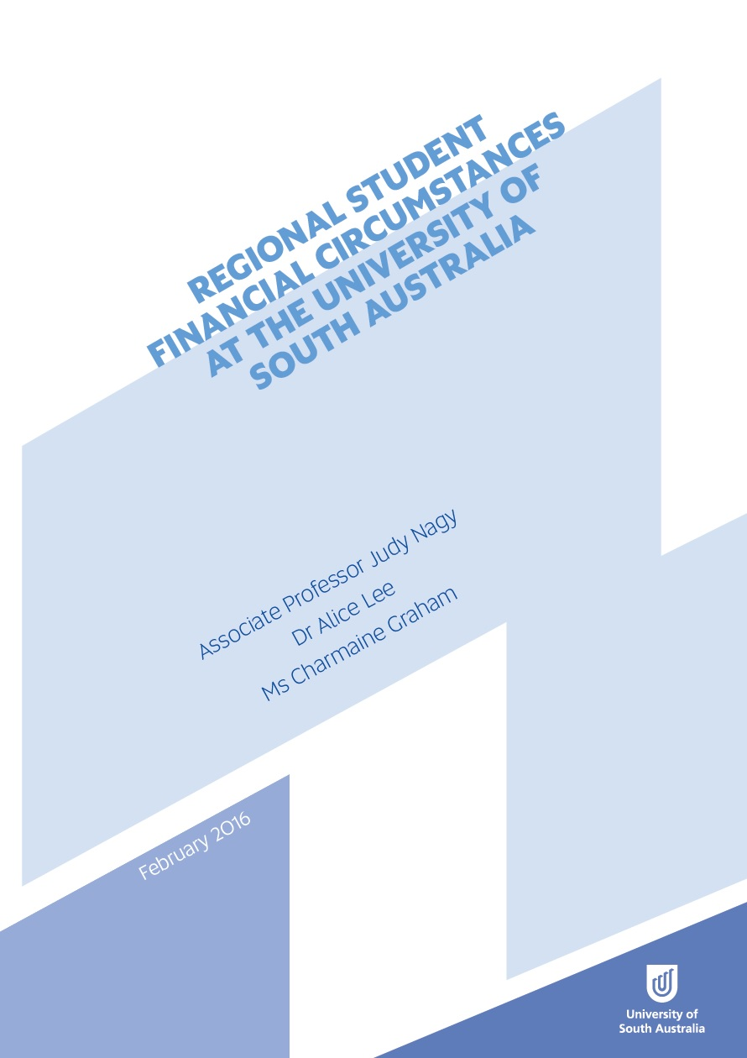

Regional Student Financial Circumstances
at the University of South Australia

February 2016

Associate Professor Judy Nagy
Dr Alice Lee
Ms Charmaine Graham

The project that resulted in the production of this report was funded under a National Priorities Pool (Higher Education Participation and Partnerships Program) grant from the Commonwealth. The recipient of the grant has granted the Commonwealth the right to sub-licence the material in this report. Copyright in the report remains with the original copyright owners.
Except where otherwise indicated, and save for any material protected by a trade mark, the Department of Education and Training, acting on behalf of the Commonwealth, has applied the Creative Commons Attribution 4.0 International Licence.

Modifications: Changed to meet WCAG 2.0 accessibility requirements.
Alternate text inserted for all images. Minor typographical errors corrected.

Contents
List of Tables 4
List of Figures 4
Acknowledgements 6
1. Executive Summary 7
2. Background and Context 11
2.1 Background 11
2.2 Project Aims 13
2.3 Research Site 14
2.4 Research Methodology 15
2.5 Defining Rurality 16
2.6 Student Demographics 18
2.7 Study Details 20
3. Income and Expenditure 23
3.1 Government Support 24
3.2 Additional Government Support 27
3.3 Employment 29
3.4 Scholarships 31
3.5 Expenditure 33
3.6 Living Arrangements 37
3.7 Transport 40
3.8 Financial Stress 42
4. Becoming and being a Student 47
4.1 Pathways 47
4.2 Motivation 48
4.3 Preparation 49
4.4 Study Load and Mode 51
4.5 Campus Location 53
4.6 Course Placements 55
4.7 Deferrals/Withdrawals 57
4.8 Adjustment 58
5. Study Limitations 62
6. Conclusions 63
7. References 66
Appendix A 69
Appendix B 71
Appendix C 73

List of Tables
Table 1: Proportion of respondents based on demographic subgroups 19
Table 2: Proportion of participants based on course and study details 20
Table 3: Proportion of respondents based on field of study 21
Table 4: Weekly mean and median income sources ($) for all respondents 23
Table 5: Proportion of students on government allowances 26
Table 6: Weekly mean and median expenses ($) for all respondents 34
Table 7: Overall mean income and expenditure of receiving Youth
Allowance per week ($) 35
Table 8: Semester study-related costs for all respondents 36
Table 9: Set up costs for commencing higher education – percentage of
expenditure for students aged under 25 39
Table 10: Set up costs for commencing higher education – percentage of
expenditure for students aged 25 years and over 39
Table 11: Financial stress by age group and relocation status 43

List of Figures
Figure 1: Conceptual framework of factors impacting rural and regional students 14
Figure 2: ASGS rural classifications of South Australia 17
Figure 3: Reasons for not receiving government allowances for students aged
under 25 years 26
Figure 4: Reasons for not receiving government allowances for students aged
25 years and over 27
Figure 5: Percentage of students aged under 25 receiving additional
government allowances 28
Figure 6: Percentage of students aged 25 and over receiving additional
government allowances 28
Figure 7: Study/work patterns of students aged under 25 29
Figure 8: Study/work patterns of students aged 25 and over 31
Figure 9: Types of scholarships received by students aged under 25 32
Figure 10: Types of scholarships received by students aged 25 years and over 33
Figure 11: Current living arrangements of students aged under 25 years 37
Figure 12: Current living arrangements of students aged 25 years and over 38
Figure 13: Primary method of travel to and from university for students aged under 25 40
Figure 14: Primary method of travel to and from university for students aged 25 and over 41
Figure 15: Number of return visits rural students make to their rural homes per annum 41
Figure 16: Barriers that prevent rural students from visiting their rural homes 42
Figure 17: Indicators of financial stress for regional students 44
Figure 18: Financial impact on university studies for students aged under 25 years of age 45
Figure 19: Financial impact on university studies for students 25 years and over 46
Figure 20: Primary motivations to attend university 48
Figure 21: Level of support for student decision to attend university 49
Figure 22: Level of preparedness of associated costs of attending university 50
Figure 23: Sources of information about the cost of attending university 50
Figure 24: Reasons why regional and remote students study part-time 51
Figure 25: Reasons students elect to study at a metropolitan campus 54
Figure 26: Reasons students elect to study at a regional campus 55
Figure 27: Challenges associated with relocating to complete professional placement 56
Figure 28: Reasons for taking a gap year 57

Acknowledgements
This project was funded by the Australian Government under the Higher Education Participation and Partnerships Program (HEPPP) in 2015.
We wish to acknowledge the support of various internal and external stakeholders who have assisted with the progression and completion of the project. Firstly we would like to acknowledge and thank Education Consultant Dr Dianne Bills for her personal support, assistance in the data collection process and valuable input into the project. We also acknowledge the contributions of the stakeholder reference group members comprising Lalita McHenry, Scott Jones, Chris Crabbe, Lorraine Overton, Sue Brogden and Helen Johnston, who provided feedback to assist with ongoing development and evaluation of the project. We would also like to thank Country Education Foundation of Australia CEO Sarah Taylor for her assistance with reviewing the survey document and promoting the survey to her students and the University of South Australia Student Association, and the student ambassadors who also assisted with the promotion of the survey.
Finally, we appreciate the time given by the students at the University of South Australia to complete the survey and to those who also participated in interviews. The willingness to share personal information and to share often emotional stories of their journeys in higher education significantly enriched the qualitative data available for analysis.

Project Team
- Associate Professor Judy Nagy (Project Leader)
- Dr Alice Lee (Research Fellow)
- Ms Charmaine Graham (Research Assistant)

1. Executive Summary
It’s a lot harder for rural students than for people who grew up in the city. A lot of people I know still live with their parents, their parents are buying them textbooks and they’re not stressed about rent and buying their own food ... and finding a part-time job. Just the cost of moving here in the first place is difficult ... so, the more you can do to help us out the better. (Regional student interviewee)
Higher education qualifications and an educated populace are symbolic tools for economic prosperity and for social equity for both individuals and society in Australia. Widening participation in such prosperity through education has long been an Australian Government objective, with the Whitlam Government policies of the mid 1970s instigating the pathway for progressive reforms in higher education aspiring to greater equity in access and participation. In particular, a group identified as socioeconomically disadvantaged, representing 25% of the nation’s population (the lowest quartile of the population based on Australian Bureau of Statistics Index of Education and Occupation), is the target for widening participation. This broad group includes Indigenous Australians, those from low socioeconomic status (SES) backgrounds, from non-English speaking backgrounds, those with a disability, people from regional and remote areas and, since 1990, women in non-traditional fields of education. This report, however, is concerned only with one of these sub groups, regional and remote students, where despite government efforts the percentage of such students participating in higher education has not changed significantly over time, hovering around 19-20%, with the participation rate in higher education by the overall population standing at 35% in 2013.
To date there has been a paucity of detailed evidence about the financial circumstances of regional students in Australian higher education. As noted by Geoffrey Blainey in his classic study of Australian history, The Tyranny of Distance (1967), distance and isolation are significant challenges for regional populations, with the ability to access education generally and higher education specifically, still being impacted by these same variables many years later, despite significant developments in technology. While there have been national studies examining the challenges faced generally by tertiary students, any research on participation in higher education by regional students and the factors that influence and contribute to their financial circumstances, has been limited. This report in part addresses this evidence gap through a methodology that captures the whole regional student population for a particular university, the University of South Australia, through a survey instrument and personal in-depth interviews. The survey design was informed by a stakeholder consultation process that included regional students and was refined using feedback from a small pilot study. Findings and recommendations provide some valuable institutional insights that may be used for policy planning.
One of the key contributions of this research has been the provision of data that is multi-layered and allows for the breakdown of regional students into clearer demographic groups, with income and expenses linked to the groupings. Previous studies with a subsection for regional students implied that regional students were one homogenous group and provided little clarity about student demographics or specific circumstances impacting student financial wellbeing. Findings include commencing and continuing students and are presented using the general boundaries that are present within current government policy and student support frameworks to provide clear pathways for implementation of new policy initiatives that may emerge. Policies that are specific to a target group can be more effectively constructed and are more likely to achieve desired outcomes. The most significant support mechanisms provided by government for students are Youth Allowance (YA) and Austudy, and these are delineated by age. The focus of this study, therefore, is on regional students aged under 25 and those aged 25 years and over, using relocation and non-relocation to pursue higher education, as income and expense drivers for data analysis.
The approach taken has highlighted that, particularly for relocating students, the interplay between family, personal, community and locational factors has direct and indirect impacts on finances that are complex. There is also an underlying presumption that newly independent students have the skills and capabilities to manage the interplay between factors and to effectively prioritise competing demands of daily living, recreating support networks and study obligations. Expenditure evidence suggests that choices may not always reflect a balanced approach and this is reflected in higher stress levels. While all students commencing higher education undergo a significant adjustment process, as previously reported by Baik et al (2014, p. 5) in their study of first year students, ‘for a large proportion of students from regional and remote backgrounds financial consideration were frequently a source of stress’. For students in any age group that relocate for higher education stress levels are higher than those who do not relocate and this study suggests that stress levels are rising.

Students Under 25 – 60% of Respondents
The demographic profile of respondents to the survey instrument shows that 82% of students aged under 25 have relocated to undertake higher education. These students are mostly single with no children and 46.7 % of these students receive Youth Allowance. The process of leaving rural towns to study in a city with a different cultural milieu, and the need to learn new life skills, results in relocating regional students being ‘independent’ regardless of their Youth Allowance status. There are layers of tensions that come into play as a consequence of being disconnected from family support structures and the need to build new networks for sporting, social and learning activities. The emergence of travel time and expense on financial circumstances is both significant and difficult to quantify as students need time and funds to participate in social, sporting and work commitments in addition to study obligations.
Relocating students aged under 25 also report that they have difficulty finding employment that is flexible enough for them to rebuild networks, and that employers prefer less expensive teenage labour. For those relocating students on dependent Youth Allowance (where parental income and assets are assessed for qualification) the relationship between income and expenditure suggests they are living beyond their means. The role of scholarships in bridging that gap is considered very important, with approximately one quarter of students receiving some form of scholarship. Students also report stressful relationships with government support mechanisms where timelines for applying and subsequently receiving support payments added to transitional challenges.

Students 25 Years and Over – 38% of Respondents
In this age group only 10.8% of students have relocated for study purposes with the same percentage receiving Austudy or Abstudy. This older demographic reported that 64.5% had carer responsibilities, 73.2% cohabited with income levels that precluded qualification for government support and 46.1% of students studied part time. Income and expenses figures are somewhat clouded by partner/family income and expenditures influences.
Those in the 25 years and over age group generally reported being more stressed than younger counterparts with interview data providing insights about stress influences. One contributing factor highlighted is the travel associated with the use of blended learning options. While blended learning options often mean students don’t need to relocate to participate in higher education, obligations to travel and attend compulsory professional practice workshops involve significant financial outlays. For each compulsory workshop the costs of travel and living for stays of up to a week add to normal living expenses with child care and lost casual employment hours bringing additional expenses. These costs are in addition to any placement commitments that are required for professional accreditation. Blended learning reflects a positive paradigm change in learning and as this phenomena is likely to continue to increase over time and alleviating cost burdens for regional students is an area where universities can provide additional student support.

Findings and Recommendations
This project has utilised the Australian Statistical Geographical Standard (ASGS) to determine which students would be included in the sample populations. However, mapping regionality over time is complicated due to inconsistencies in data, with changing classifications and new areas being added to classifications. These changes impede the comparability of data across time and between research studies. Current determinations of rurality can also generate outcomes that may be inequitable and would benefit from contextual refinement.
Recommendation 1 (section 2.5)
It is suggested that a new higher education rural mapping system be established to enable rural student home addresses to be mapped to their applicable university campus, thereby providing a more consistent method at the national level that will determine eligibility for various government and university financial support mechanisms.
Recommendation 2 (section 2.5)
Should the system suggested in recommendation 1 be developed the definition of ‘inner regional’ should preclude distances of 50km or less between the proximity of a student’s rural home address and their primary university campus.
Students reported that they had difficulties understanding government requirements concerning eligibility, special allowances and timing for receiving government allowances and this contributed significantly to transitional stress.
Recommendation 3 (section 3.1)
A gap currently exists in relation to the communication of information in relation to the documentary process and the timing for applications for government allowance. Centrelink and the sector to consider revising the communication flow to students.
Student survey results show that transport costs represent a significant cost burden on a daily basis with relocating students visiting home a number of times each year adding to transportation costs. Students have identified they would like to visit their home based support networks more often and cannot afford to do so.
Recommendation 4 (section 3.7)
In the situations where transport costs represent a significant cost burden on a daily basis - to further explore - what provisions and mechanisms could be identified and easily implemented.
Technology mediated blended learning study options often mean that regional student do not need to relocate to participate in higher education. However, this study has highlighted the emergence of short term relocation expenses to attend compulsory professional practice workshops as a source of financial pressure. Expensive short term accommodation, lost income from casual employment and the need to pay for child care can add significantly to financial pressures.
Recommendation 5 (section 4.4)
Universities to consider the most efficient process for regional students attending professional practice workshops.
Relocating regional students undergo the greatest transitional challenges when they move away from established support networks. To assist the process of adaptation, there is a need to create a means for regional students to connect, form new friendships and share resources.
Recommendation 6 (section 4.8)
Universities to consider how best to assist regional students’ transition to university and sense of connection with university life.

2. Background and Context

2.1 Background
Life as a university student is often synonymous with ‘surviving’ on minimal income and having to ‘make ends meet’. Yet findings from the Universities Australia 2012 national study of domestic and international students indicate a ‘polarization between the “haves” and “have-nots”’ (Bexley et al. 2013, p. 7) with the financial situations of university students being far from homogenous (Bexley et al. 2013; Halliday-Wynes & Nguyen 2014). Evidence from this study confirms that rural, regional and remote (‘regional’) students also lack homogeneity, with relocating and non-relocating students dealing with financial pressures whether they receive government support allowances or not.
The aspiration of widening higher education participation has been an Australian Government policy agenda for the last few decades, with the Australian Government’s 2008 review of the Australian higher education sector (Bradley et al. 2008) (known as the Bradley Review) arguably a significant catalyst in more recent years. In response to the Bradley Review, a number of equity based initiatives have been introduced (for example, Higher Education Participation and Partnerships Programs, Higher Education Disability Support Program, Indigenous Support Program, Commonwealth Scholarships Program and Regional Loading) that have either sought to understand the broad range of barriers and enablers to participation, or have provided specific interventions. In addition, government support through Centrelink, Austudy, Abstudy and Youth Allowance have attempted to address financial issues through the provision of monetary support. The Grattan Institute has identified the costs of supporting financially disadvantaged students through student support policies in 2013–14. In particular, Youth Allowance in 2013–14 cost $2.1 billion for 170,900 students, $479 million for 31,800 students receiving Austudy and an estimated $47 million for 4200 Abstudy students (Norton & Cherastidtham 2014, p. 48). While these government programs represent significant costs, they are needs-based schemes, with additional support available through merit-based institutional scholarships and other university support mechanisms.
While government higher education student support policies are open to all students in financial need, this study focuses on regional student participation where, despite concerted effort, participation rates of regional students in higher education remains lower than for their metropolitan peers (Pagnini et al. 2014). The Australian Institute of Health and Welfare (AIHW) in Towards a performance measurement framework for equity in higher education (2014), provides the most recent evidence of regional student access and participation in higher education. The report shows that participation rates have marginally declined over the time period 2001–11 (p. 16) with further evidence indicating an even greater rate of decline in remote regions (Pagnini et al. 2014). Evidence suggests that participation rates are influenced by a complex mix of variables that include the lack of an aspirational culture perpetuated through communities and low parental educational attainment (Wilks & Wilson 2012). It has also been reported that some regional communities believe that higher education generates no value to regional populations (Richardson & Friedman 2010). The propensity for graduates to move away from regional communities for study and after graduation for employment would no doubt contribute to such viewpoints as the pursuit of employment often means moving away from regional communities.
At a national level there have been numerous reports that have referred to financial matters as a major barrier to rural student access and participation rates for higher education. These include: Department of Industry, Innovation, Climate Change, Science, Research and Tertiary Education (2013), Moving to an Enhanced Indicator of Higher Education Students’ Socio-economic Status (discussion paper); Dow K.L. (2011), Review of Student Income Support Reforms (the Dow Report); Richardson, S. and Friedman, T. (2010), Australian Regional Higher Education: Student characteristics and experiences. Senate Rural and Regional Affairs and Transport References Committee (2009) Rural and regional access to secondary and tertiary education opportunities. The Dow Report contributed to changes in government support mechanisms, including increases in Student Start-up Scholarships and the implementation of student Relocation Scholarships for students on income support. However, these initiatives are for those who qualify for support and there is an implied assumption that students who are not eligible for income support payments do not have challenging financial circumstances.
One of the difficulties associated with ascertaining how government and institutional financial incentives impact regional student participation rates over time are the changes made to various grant and income support mechanisms in relatively short time frames. As various reports and studies identify issues that could address particular participation challenges, changes made to, for example, Youth Allowance and Austudy qualifying criteria, relocation incentives, scholarships and other support mechanisms over relatively short time frames, make data analysis and comparison with earlier research a challenge.
A comprehensive study conducted by Godden (2007) provides insight into the situation of regional university students, reporting that it is ‘all the little things’ that affect participation, including distance, isolation, culture, identity, and family attitudes, combined with the biggest challenge: the high cost associated with studying away from home (p. 10). Godden’s (2007) study focused on university students aged 18 to 25 years, resulting in a gap of evidence surrounding the financial circumstances of older regional university students. With research indicating that regional students are more likely to be mature age (Baik, Naylor et al. 2015) and therefore more likely to enter university with pre-existing and competing demands associated with family commitments and work constraints, this adds a further layer of complexity to life as a student (Townsend 2010). Furthermore regional students are more likely to belong to other equity groups, with studies indicating that they are more likely to be Indigenous, be first in their family to attend university, and have a low socioeconomic status (Baik et al. 2015; Polesel 2009). This cumulative disadvantage provides partial explanation of the low participation rates in higher education; it is difficult, though, to isolate the factors that relate to each disadvantage.
Whilst financial circumstances present a significant prohibitive factor in regional and remote students pursuing higher education (Wilks & Wilson 2012), once at university, research indicates that financial pressures continue to influence and shape student experiences, impacting significantly on engagement with their studies (Halliday-Wynes & Nguyen 2014). Although financial circumstances are not reported as a primary driver for regional and remote students deferring or withdrawing from university, closer analysis shows that the interwoven relationship between a lack of social support and the demands of juggling study and paid employment result in financial reasons playing an indirect but significant role in regional student attrition from university (Halliday-Wynes & Nguyen 2014).

2.2 Project Aims
The aim of this study is to address the evidence gap described above, by providing a representative data set of the financial circumstances for commencing, continuing, deferred and postgraduate regional and remote students studying at the University of South Australia. In response to recommendations made in an evaluative institutional study that surveyed a limited number of financially disadvantaged students qualifying for University Relocation Scholarships known as the Rural Reconnect Project (Bills 2012), this project is a larger institutional study that seeks to provide greater detail and clarity about the financial circumstances of all rural students. This broader study provides evidence across one institution and allows for comparison between the experiences of regional students who move away from home with those who study at regional campuses or online and who have not relocated. The focus is on student-sourced data rather than institutional data, thus providing a different perspective about regional student participation.
Evidence obtained through a survey instrument and follow up interview data has produced a rich data set that allows for personal voices to supplement survey findings. The data set has been de- aggregated to reflect existing government support structures with further dissections focussing on student relocation status to increase data usability and allow for any planned responses to be more effectively targeted to particular sub groups.
In order to effectively explore the full extent of those financial factors, there is a need to recognise that psychosocial elements are intrinsically linked to financial factors. While the causal links are difficult to isolate, literature identifies that the blend of personal, family, community, locational and other environmental factors in regional contexts impact financial circumstances in ways that make generalisation challenging. Through the recognition that cost goes beyond basic economics, this study also investigates a range of monetary and non-monetary factors, thereby gaining a greater understanding of the financial consequences that engaging in university studies has for rural and regional students.
Figure 1 provides a conceptual framework applicable to both the quantitative and qualitative components of the study. The framework demonstrates the interaction between multiple factors, with each cluster of factors being unique to individual students. Importantly, the modification of one cluster may impact other clusters, thereby changing both the magnitude and direction of influence.
Interview data has provided a layer of potency to survey results identifying that finances are impacted by a range of ‘push’ and ‘pull’ factors that act together to shape an individual students circumstances. In addressing the nominated evidence gap we acknowledge the complexities of generalising within this conceptual framework.

Figure 1: Conceptual framework of factors impacting rural and regional students

2.3 Research Site
The University of South Australia (UniSA) is South Australia’s largest university, comprising four metropolitan campuses and two regional campuses at Whyalla and Mount Gambier. The University is committed to providing equitable access to higher education for all sectors of the community and this commitment is incorporated in the University’s Act (the University of South Australia Act 1990).
Students at metropolitan campuses have the choice of studying on campus using blended modes of delivery for a comprehensive range of programs. There is an increasing range of online programs allowing students to study from any location; however, such programs may require attendance on campus for professional practice workshops.
The two UniSA regional campuses are located in regional cities with populations of approximately 25,000–28,000 in the immediate city boundaries and students are also drawn from a broader hinterland, often necessitating significant travel. While the combined student numbers at these regional locations are approximately 500 students in programs that include Nursing, Social Work, Education (Early Childhood), Education (Primary) Mechanical Engineering and Foundation Studies, the number of programs being offered at these locations is growing. Students at regional campuses have traditionally studied on campus, with blended delivery modes, and the campuses are increasingly providing support for online students and intensive study options.
UniSA has a clear strategic priority for fostering ‘Education beyond the City’, highlighted in the University’s Crossing the Horizon 2013–2018 Strategic Plan with a commitment to three new regional learning hubs. In regions, there has been a tertiary institution in Whyalla since 1965 and this became part of UniSA 25 years ago. The more recent Mount Gambier campus commenced in 2005 and has benefitted from two allocations of federal government tertiary infrastructure funding, with new technology-driven facilities opening early in 2016 to enrich the student learning experience.
The University has a long history of engagement with programs that engage with communities in South Australia, with high concentrations of families from low SES backgrounds. Key strategies have encouraged greater participation in higher education from these areas. Strategies have included:
- In 2002 federal government funding was received for The University Northern Adelaide Project (UNAP), where there are high proportions of low SES families, to promote education, skills development and improved relationships between schools, businesses, and the community encouraging participation in higher education.
- More recently the creation of UniSA College (established in 2011) has provided new pathways to higher education, again targeting low SES and Indigenous families, through a combination of academic and community engagement programs.
- The University’s Rural Reconnect project is a five-year pilot project designed to encourage greater participation, retention and achievement of rural and remote students in higher education, established in 2009. The project provides assistance for rural students through five initiatives as outlined in Bills (2012): scholarships for students in the first year at university; professional placement grants for rural students undertaking experiential learning in a rural district; implementation of communication strategies to ‘stay in touch’ with deferring rural students; a mentoring program for first year rural students; and an orientation to university program for Year 10 rural students.
- In addition, UniSA, and other universities employ a number of strategies to encourage regional student participation. Examples include equity scholarships; bonus ATAR points for students from underrepresented, regional or remote schools; school outreach programs; employment and accommodation services; and various financial grants.

2.4 Research Methodology
The methodological approach deployed by this study was a mixed method design, incorporating qualitative and quantitative data gathered through survey and interview techniques. The survey design was informed by a stakeholder consultation process that included regional students and was refined using feedback from a small pilot study. The survey collected demographic data from which relocation status was used to drive the statistical analysis for the income and expense data provided. Survey evidence also informed the process of determining interview questions for in-depth interviews.
Quantitative data was collected using an online survey, and consisted of a combination of 5-point Likert scale, multiple choice and open-ended questions. The online survey was open for a four-week period between 21 July 2015 and 20 August 2015. Consideration was given to survey timing to ensure that participation was maximised by avoiding semester break and exam periods. All students attending UniSA who had either: relocated from a rural, regional or remote location for the purposes of study; were currently studying at a regional campus; who had deferred or were studying online and lived in a rural, regional or remote location; or commuted from a regional location, were invited to participate in the survey. A total of 759 respondents (17% of regional and remote students studying at UniSA) commenced the survey, however the analysis process identified a number of respondents who were ineligible or failed to complete a large proportion of the survey, so were subsequently removed from the data sample. The result was a total of 607 responses (14% of regional and remote students studying at UniSA) included in the data analysis, including those respondents who partially completed at least half of the survey questions. This compares favourably with the most recent survey of the finances of all Australian university students in the Australian University Student Finances Survey 2012, which also had a response rate of 14%.
Qualitative data was collected through 30 minute semi-structured face-to-face interviews with interview questions informed by preliminary survey findings. A total of 258 survey participants volunteered to be involved in the interview process, of which a representative sample of 37 interviewees was selected based on participant age, gender, field of study, level of study, campus location and study mode. The diversity of the participants reflects that of their rural communities, personal circumstances and the broader student population base. Interviews were conducted over a four-week period across September and October 2015, incorporating a two-week semester break.
Interviews were tape recorded, transcribed and thematically analysed to determine emergent patterns. The result is a discourse of personal experiences that adds a rich dimension to the quantitative data.

2.5 Defining Rurality
There is a broad consensus within literature that sweeping policies and/or statements pertaining to ‘rurality’ fail to recognise the extraordinary diversity amongst rural localities, including differences between population size, accessibility to services, natural surrounds, human capital and economic resources (Alston & Kent 2009). Defining ‘rurality’ is thus a complex issue with significant implications for comparability of outcomes between research studies. Kemp and Norton (2014, p. 41) came up against such challenges, noting that ‘Calculating trends in regional and remote student numbers is complicated by changing classifications of areas. New classifications introduced by the Australian Bureau of Statistics in 2011 give higher numbers than the previously used definition. This analysis uses the earlier definition to see longer-term trends.’ The importance of trend data to the review meant usage of an older classification system for their report.
Remoteness is a common measurement of rurality used in Australian research (Alston & Kent 2009; Baik et al. 2015) and provides the rationalisation and legal foundation for a number of government policies, including payment of government allowances such as the Relocation Scholarship. The Australian Statistical Geographical Standard (ASGS) classifies localities based on remoteness into the following five categories (displayed in Figure 2) (ABS 2011):
- Major Cities of Australia
- Inner Regional Australia
- Outer Regional Australia
- Remote Australia
- Very Remote Australia

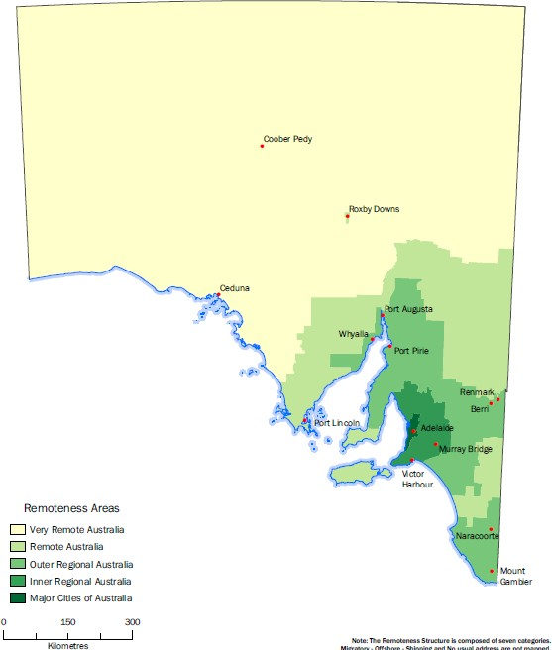
Figure 2: ASGS rural classifications of South Australia

Whilst this study was aligned with the ASGS classifications, incongruities exist between the standard use of ASGS in research and the institutional definition applied by UniSA. The ASGS assesses remoteness on the basis of location to the closest capital city; in contrast UniSA takes a more restricted approach to defining rural students, excluding those students with rural home address postcodes below 5200. The result of this more restrictive definition of rurality results in a proportion (3%) of students defined by the University as being metropolitan, in comparison to government policy and research which defines the same student population as Inner Regional.
These different definitions of rurality highlight the complexities surrounding the concept of physical location, though it is clear that proximity to a metropolitan university campus providing a strong indication of an individual’s educational and financial disadvantage. This study provides a case study for one institution, however it is anticipated that further research would identify a number of incongruities across multiple university sites. By maximising use of current technology, it is possible for a more targeted approach to be applied when determining rural student eligibility for financial support, as opposed to the broad general grouping that is currently used under the ASGS classification structure.
The following two scenarios illustrate the incongruities.
Natalie lives in Gawler, a town situated 51 km away from her university campus. Due to time constraints and the financial impact of the regular commute to campus, Natalie is planning on relocating closer to the city. As Gawler is classified under the ASGS as being within a major city, Natalie is not entitled to the Relocation Scholarship.
Brian lives in Hahndorf, a town situated 26 km away from his university campus. Access to the campus is via a freeway, with public transport options. On relocating to the city Brian was eligible for the Relocation Scholarship on the basis that he met all of the eligibility criteria, which included relocating from Hahndorf as it is classified under the ASGS as Inner Regional.
Recommendation 1:
It is suggested that a new higher education rural mapping system be established to enable rural student home addresses to be mapped to their applicable university campus, thereby providing a more consistent method at the national level that will determine eligibility for various government and university financial support mechanisms.
Recommendation 2:
Should the system suggested in recommendation 1 be developed the definition of ‘inner regional’ should preclude distances of 50km or less between the proximity of a student’s rural home address and their primary university campus.

2.6 Student Demographics
The demographic data in Table 1 and Table 2 shows that 60% of respondents were under 25 years of age and 38% were aged 25 years or over with 46% of both groups being the first in their family to attend higher education. The profile of an under 25 year old regional UniSA student responding to the survey was most likely to be female, have relocated to study, and be studying full time on campus. The profile of a UniSA regional student aged 25 and over responding to the survey was most likely to be female, have not relocated, with half of such students studying part time and half studying primarily in off-campus mode. A broad overview of the sample demographics is provided in Table 1.

Table 1: Proportion of respondents based on demographic subgroups
Demographic subgroups | Under 25 |  | 25+ |  | Age not provided |  | Row Total
 | n | % | n | % | n | %

Age group
 | 364 | 60.0 | 231 | 38.1 | 12 | 1.9 | 607

Gender
Female | 300 | 82.4 | 187 | 81.0 | 10 | 83.3 | 497
Male | 63 | 17.3 | 43 | 18.6 | 2 | 16.7 | 108
Unspecified | 1 | 0.3 | 1 | 0.4 | - | - | 2

Equity Groups
ATSI | 4 | 1.1 | 8 | 3.5 | 0 | 0.0 | 12
FiF | 166 | 45.6 | 106 | 45.9 | 7 | 58.3 | 279
Disability | 20 | 5.5 | 37 | 16.0 | - | - | 57

Carer responsibilities
Children | 6 | 1.6 | 124 | 53.7 | 7 | 58.3 | 130
Other | 14 | 3.8 | 25 | 10.8 | 1 | 8.3 | 39

Relationship status
Single | 287 | 78.8 | 39 | 16.9 | 5 | 41.7 | 331
Cohabitating | 33 | 9.1 | 13 | 5.6 | - | - | 46
Civil union | 37 | 10.2 | 42 | 18.2 | 1 | 8.3 | 80
Married | 4 | 1.1 | 114 | 49.4 | 4 | 33.3 | 122
Div/sep/widow | 2 | 0.6 | 23 | 10 | 2 | 16.7 | 26

Location status
Relocated | 299 | 82.1 | 25 | 10.8 | 4 | 33.3 | 328
Non-relocated | 65 | 17.9 | 206 | 89.2 | 8 | 66.7 | 279

Government allowances
Dependent YA | 71 | 19.5 | - | - | - | - | 71
Independent YA | 99 | 27.2 | - | - | - | - | 99
Austudy | - | - | 24 | 10.4 | - | - | 24
Abstudy | - | - | 1 | 0.4 | - | - | 1
Newstart | 8 | 2.2 | 5 | 2.2 | - | - | 13
Families | 3 | 0.8 | 38 | 16.5 | - | - | 41
Carer | 1 | 0.3 | 5 | 2.2 | - | - | 6
Disability | - | - | 4 | 1.7 | - | - | 4

Scholarship recipient
 | 120 | 33.0 | 64 | 27.7 | 1 | 8.3 | 185

ASGS Classification
Inner Regional | 80 | 22.0 | 85 | 36.8 | 2 | 16.7 | 167
Outer Regional | 208 | 57.1 | 122 | 52.8 | 7 | 58.3 | 337
Remote | 51 | 14.0 | 18 | 7.8 | 1 | 8.3 | 70
Very Remote | 16 | 4.4 | 5 | 2.2 | 2 | 16.7 | 23
Unspecified | 9 | 2.5 | 1 | 0.4 | 0 | 0.0 | 10
Reference has been made in higher education research (Baik et al. 2015) about the overlap that exists for regional students with other equity subgroups. The demographics and background of regional students within this sample confirms this high proportion of overlap, demonstrating the multiple barriers required to be overcome by regional and remote students in order to pursue higher education.

2.7 Study Details

Table 2: Proportion of participants based on course and study details
Course and study details | Under 25 |  | 25+ |  | Age not provided |  | Row Total
 | n | % | n | % | n | %

Study load
Full time | 330 | 90.7 | 118 | 51.2 | 4 | 33.3 | 452
Part time | 24 | 6.6 | 102 | 44.3 | 8 | 66.7 | 134
Block release | 2 | 0.5 | 4 | 1.8 | 0 | 0.0 | 6
No response | 8 | 2.2 | 7 | 3.0 | 0 | 0.0 | 15

Study mode
Primarily on campus | 300 | 82.4 | 54 | 23.4 | 4 | 33.3 | 358
Primarily off campus | 24 | 6.6 | 134 | 58.0 | 6 | 50.0 | 164
Mixed mode | 30 | 8.2 | 38 | 16.5 | 0 | 0.0 | 68
No response | 10 | 2.7 | 5 | 2.2 | 2 | 16.7 | 17

Campus
Metropolitan | 297 | 81.6 | 51 | 22.1 | 3 | 25.0 | 351
Regional5 | 33 | 9.1 | 41 | 17.7 | 1 | 8.3 | 75
Online only | 24 | 6.6 | 134 | 58.0 | 6 | 50.0 | 164
No response | 10 | 2.7 | 5 | 2.2 | 2 | 16.7 | 17

Program level
Undergraduate | 343 | 94.3 | 174 | 75.3 | 9 | 75.0 | 526
Postgraduate coursework | 8 | 2.1 | 35 | 15.2 | 1 | 8.3 | 44
Postgraduate research | 0 | 0.0 | 7 | 3.1 | 0 | 0.0 | 7
Other award | 11 | 3.0 | 10 | 4.3 | 0 | 0.0 | 21
No response | 2 | 0.5 | 5 | 2.2 | 2 | 16.7 | 9

Undergraduate stage
Due to commence | 4 | 1.2 | 0 | 0.0 | 0 | 0.0 | 4
Commenced | 138 | 40.2 | 57 | 32.8 | 4 | 44.4 | 199
Continuing | 201 | 58.6 | 117 | 67.2 | 5 | 55.6 | 323

Consistent with earlier findings (Harvey & Andrewartha 2013; Heagney 2010), regional and remote students continue to be under-represented at the postgraduate level with 8% of respondents engaged in further degrees. Of the 35 undergraduates interviewed, five (14%) indicated their intention to continue on to postgraduate studies. Despite these indicated intentions, the number of regional students that actually go on to pursue postgraduate studies appears to drop once undergraduate qualifications are completed.

Table 3: Proportion of respondents based on field of study
Field of study | Under 25 |  | 25+ |  | Age not provided |  | Row Total
 | n | % | n | % | n | %
Health Science | 70 | 17.2 | 5 | 2.2 | 0 | 0.0 | 75
Education | 51 | 14.0 | 16 | 6.9 | 2 | 16.6 | 69
Nursing & Midwifery | 46 | 12.6 | 62 | 26.8 | 0 | 0.0 | 108
Management & Commerce | 32 | 8.7 | 64 | 27.7 | 3 | 25.0 | 99
Pharmacy & Medical Science | 26 | 7.1 | 4 | 1.7 | 1 | 8.3 | 31
Psychology & Social Work | 24 | 6.6 | 39 | 16.9 | 1 | 8.3 | 64
Art, Architecture & Design | 22 | 6.0 | 1 | 0.4 | 0 | 0.0 | 23
Communication, International Studies &  Language | 18 | 4.9 | 3 | 1.3 | 0 | 0.0 | 21
Tourism & Events | 14 | 3.8 | 3 | 1.3 | 1 | 8.3 | 18
Medical Radiation Science | 13 | 3.6 | 12 | 5.2 | 0 | 0.0 | 25
Engineering | 9 | 2.5 | 2 | 0.9 | 1 | 8.3 | 12
Marketing | 9 | 2.5 | 0 | 0.0 | 1 | 8.3 | 10
Law & Legal Studies | 6 | 1.6 | 2 | 0.9 | 0 | 0.0 | 8
Urban & Regional  Planning | 4 | 1.1 | 0 | 0.0 | 0 | 0.0 | 4
Information Technology | 3 | 0.8 | 7 | 3.0 | 0 | 0.0 | 10
Aboriginal & Australian  Studies | 3 | 0.8 | 3 | 1.3 | 0 | 0.0 | 6
Environmental & Spatial Science | 3 | 0.8 | 0 | 0.0 | 0 | 0.0 | 3
Aviation | 2 | 0.8 | 0 | 0.0 | 0 | 0.0 | 2
Population Health | 2 | 0.5 | 0 | 0.0 | 0 | 0.0 | 2
Construction  Management | 1 | 0.3 | 1 | 0.4 | 0 | 0.0 | 2
Science & Mathematics | 1 | 0.3 | 1 | 0.4 | 0 | 0.0 | 2
Other | 3 | 0.8 | 1 | 0.4 | 0 | 0.0 | 4
No response | 2 | 0.5 | 5 | 2.2 | 2 | 16.7 | 9

Student respondents under the age of 25 were found to be predominantly enrolled in the disciplines of Health Science, Education, and Nursing & Midwifery. Students 25 and over displayed different discipline preferences, with the areas of Management & Commerce, Nursing & Midwifery and Psychology & Social Work being the most popular. The majority of respondents (87%) indicated that they were studying their first preference program. For
those who were not studying their first preference, reasons included: having to relocate; pre-requisite subjects not offered in Year 12; lack of available information during Year 12; expectation of family; and not attaining the required ATAR/STAT test score.

3. Income and Expenditure
Income and expenditure statistics derived from survey data has generally confirmed that those aged under 25 are more dependent on government, work and family support mechanisms. Statistics also show that those who have not relocated in both the under 25 and 25 and over categories have a higher mean and median income than those responding students who have relocated. It is reasonable to expect that a relocated student aged under 25 will face some challenges managing a budget and be less experienced in juggling the needs of study, work, domestic duties and the need to travel to and from university and for sport and social activities. This significant time-management adjustment, as well as difficulties finding employment in a city where there is a far more competitive job market, and where community contacts are no longer useful in securing employment, will mean finding a job with hours that are practicable is likely to be a challenge. It is clear however, that for those students of both age groups who have not relocated there appears to be more time to work, as the issue of competing challenges is avoided. Table 7 confirms that more hours are spent in paid employment by those who have not relocated.
For those respondents aged 25 and over, evidence shows that generally students did not relocate and rely on their own earnings and that of a partner rather than forms of government support. For respondents aged 25 years and over patterns of paid employment are discussed further in Section 4.2, and indicate that nearly half (48.7%) of students aged 25 years and over study part time and work more than 32 hours per week, resulting in a higher average weekly income in comparison to students aged under 25 years. Table 4 details weekly mean and median income sources for all respondents. Six outliers were removed from the below data set prior to analysis due to obvious data error, and a further 121 respondents had missing income data. Scholarships have not been included in the below weekly income table. Refer section 3.4 for scholarship income details.

Table 4: Weekly mean and median income sources ($) for all respondents
 | Under 25 |  |  | 25+
 | All  N=296 | Relocated  n=247 | Non-  relocated n=49 | All  N=184 | Relocated  n=24 | Non-  relocated n=160

Total income
$Mean | 359 | 338 | 461 | 1035 | 708 | 1084
Median | 300 | 300 | 350 | 995 | 556 | 1000

Government allowances
$Mean |  | 239 | 200 |  | 309 | 313
% |  | 63.9 | 40.8 |  | 45.8 | 38.8

Own wages
$Mean |  | 227 | 322 |  | 414 | 774
% |  | 57.5 | 97.9 |  | 79.2 | 71.3

Partner’s wages
$Mean |  | 479 | 567 |  | 562 | 899
% |  | 3.6 | 26.5 |  | 33.3 | 55.0

Allowance from parents
$Mean |  | 144 | 185 |  | 0 | 233
% |  | 33.6 | 10.2 |  | 0.0 | 1.9

Other family support
$Mean |  | 90 | 94 |  | 158 | 205
% |  | 5.7 | 8.1 |  | 12.5 | 4.4

Other
$Mean |  | 20 | 90 |  | 375 | 258
% |  | 0.8 | 2.0 |  | 8.3 | 3.8

3.1 Government Support
The most significant income support mechanisms available to students in higher education remains the Youth Allowance (YA) for those aged under 25 and Austudy for those aged 25 and over. These forms of support have evolved over time with eligibility criteria being redefined and various additional incentives introduced in response to government policy initiatives. YA began in 1998 as the main income support system for young students replacing Youth Training Allowance, Newstart Allowance and Student Allowance for those who were unemployed and aged 15–20 years. YA also replaced Austudy for those students aged 16–24 years and older students starting a course before turning 25 years of age. To obtain YA, students could qualify as either ‘dependent’, where eligibility was determined in relation to a parental income and assets test, or ‘independent’ where assessment was then made in relation to their personal income and assets.
Survey data shows that of those aged under 25, 170 students (46.7%) received YA and for students aged 25 and over 24 received Austudy (10.8%). This means that approximately one third of respondents received some form of study allowance that can vary between $283.80 per week for those who are single with children (both Austudy and YA have the same rate) to $142.60 for those who receive a dependent YA allowance and are living at home with no children. Another 60 respondents nominated that they received ‘other’ government allowances that included disability, parenting, Newstart Allowance and Carer Allowance, and come with a range of ‘add on’ factors for various hardship circumstances.
Concentrating on study support, reasons for ineligibility is a complex issue, with students needing to navigate and disclose parental and personal income and assets and determine which pathway may be best to secure government support. However, it is clear that the process and timing for applications can be quite a challenge and contribute to significant student stress. In a previous study on regional students and Youth Allowance, Godden (2007) found participant attitudes towards the government income support system to be overwhelmingly negative as a result of the processes involved and the strict eligibility requirements. It was reported that the income support system created additional barriers for regional students’ access to higher education, as opposed to a support mechanism that assisted widening participation policies (Godden 2007). While there may have been some streamlining of the system between the time of the Godden study and this report, evidence from interviews in 2015 suggest that procedural issues continue.
Comments made by interviewees echo these earlier views, indicating that the application process for income support continues to be a confusing process, with students finding it difficult to obtain assistance and guidance in navigating the system.
Centrelink is not easy, and I understand that it’s not meant to be easy ... but it’s really difficult. There’s letters that you have to write and forms that have to be signed by your parents who are in a different town (three hours away) and you’ve got to mail it to them and they mail it back. Mia
It took me a good six to eight months to first initially get my Centrelink payments ... honestly I think that was crap. We did all the correct application processes and that sort of stuff, and then they stuffed us around a bit saying, ‘you need this extra document ... you need this statement ... you need this and that’, and it took six to eight months to actually get it, and then I got nearly $10, 000 back pay because they took so long. And then apparently they were paying me too much, so they cut that ... and then they increased it and then they cut it again ... Lily
Recommendation 3:
A gap currently exists in relation to the communication of information in relation to the documentary process and the timing for applications for government allowance. Centrelink and the sector to consider revising the communication flow to students
Subsequent to Godden’s (2007) study, a number of reports including the ‘Bradley Review’ (2008) and ‘Dow Report’ (2011) have highlighted the need for Australia’s income support system to better address the financial needs of low SES, Indigenous and regional and remote students. Following a review of income support programs in 2011, income support changes were made by the government in 2012. The changes were intended particularly to benefit students from low SES backgrounds and regional students who move away from home for study, and formed part of the package of reforms to support the target of 40% participation in higher education by 25–34 year olds. Some of the reforms included: increasing the value of Relocation Scholarships; providing support for those relocating from regional Australia for study; raising parental income test thresholds; lowering the age of independence for support eligibility; and raising the personal income threshold. Despite these changes many regional students find themselves ineligible for income support and other associated government assistance, including scholarships.
While the above mentioned changes may have improved access to higher education for some, interviewees indicated that there were gaps in processes, with some students receiving no income support to enable the pursuit of further education.
I didn’t get Youth Allowance because my parents earned just over (so I didn’t quality for it), and that means I couldn’t get any scholarships because all the scholarships needed Youth Allowance to demonstrate financial disadvantage. Isla
We did look into whether I drop my hours back to see if I would be entitled to some sort of Austudy, but no. They won’t give us a cent because I’ve got a
0.6 contract and they said that as far as they’re concerned I should maintain that contract ... if I drop it that’s my choice, so they won’t give me anything if I drop it. Emily
Table 5 details the number of regional students that receive government study allowances by income support type, age group and whether the student had relocated for the purpose of attending university.

Table 5: Proportion of students on government allowances
 | Under 25 |  |  |  | 25+
 | Relocated n=246 |  | Non-relocated  n=65 |  | Relocated  N=25 |  | Non-relocated  n=206
 | n | % | n | % | n | % | n | %
Dependent YA | 62 | 25.2 | 9 | 13.8 | - | - | - | -
Independent YA | 89 | 36.2 | 10 | 15.3 | - | - | - | -
Austudy | - | - | - | - | 7 | 25.9 | 17 | 8.3
Abstudy | - | - | - | - | - | - | 1 | 100
Newstart Allowance | 7 | 2.8 | - | - | - | - | 3 | 1.4
Family Allowance | 2 | 0.8 | 1 | 1.5 | 1 | 4 | 37 | 18
Carer Allowance | 1 | 0.4 | 1 | 1.5 | - | - | 5 | 2.4
Disability Support Pension | 0 | 0 | - | - | 1 | 4 | 3 | 1.5

Figure 3 outlines the various reasons for YA ineligibility for respondents aged under 25 years. Irrespective of relocated status, the major reason for not receiving government allowances was due to parental income being too high, followed by parental assets being too high. Despite not receiving income support, evidence indicates that regional students still choose to relocate to further their education, with qualitative evidence suggesting this choice has negative impacts on their emotional and physical wellbeing and their studies.

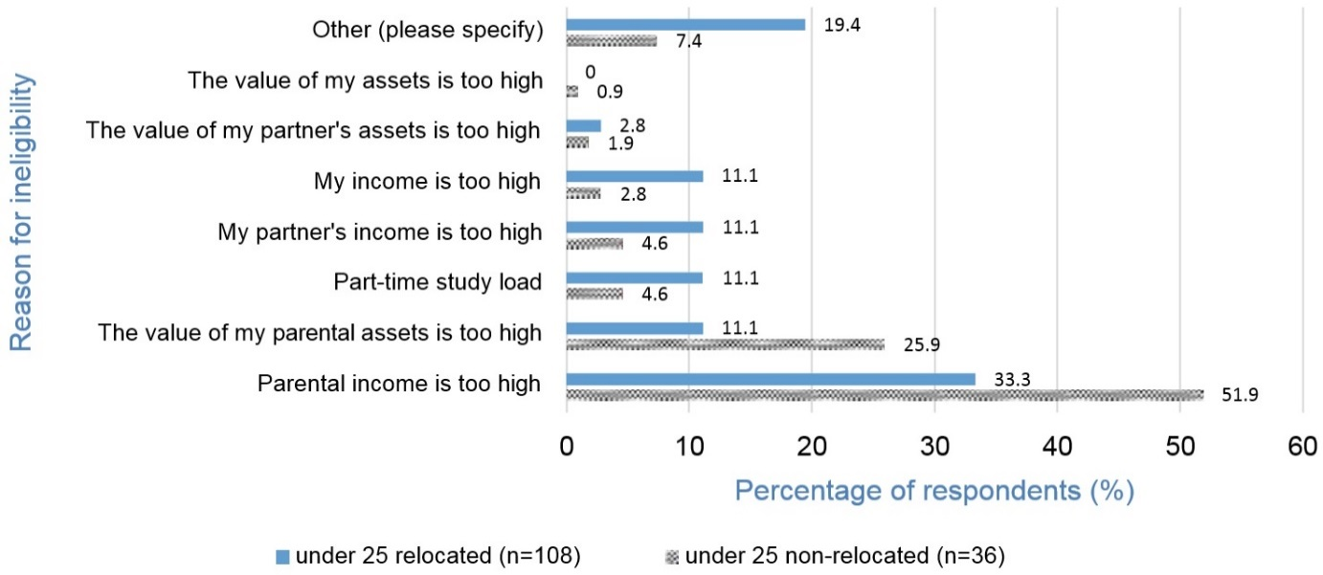
Figure 3: Reasons for not receiving government allowances for students aged under 25 years
The current system factors in both income and assets as part of the means test to determine eligibility for a range of government allowances for dependent students aged under 22 years. Recent legislative change that commenced on 1 January 2016 has seen the removal of parent assets from the Youth Allowance means test resulting in an increased number of dependent students aged under 22 years who will now be eligible for government support.
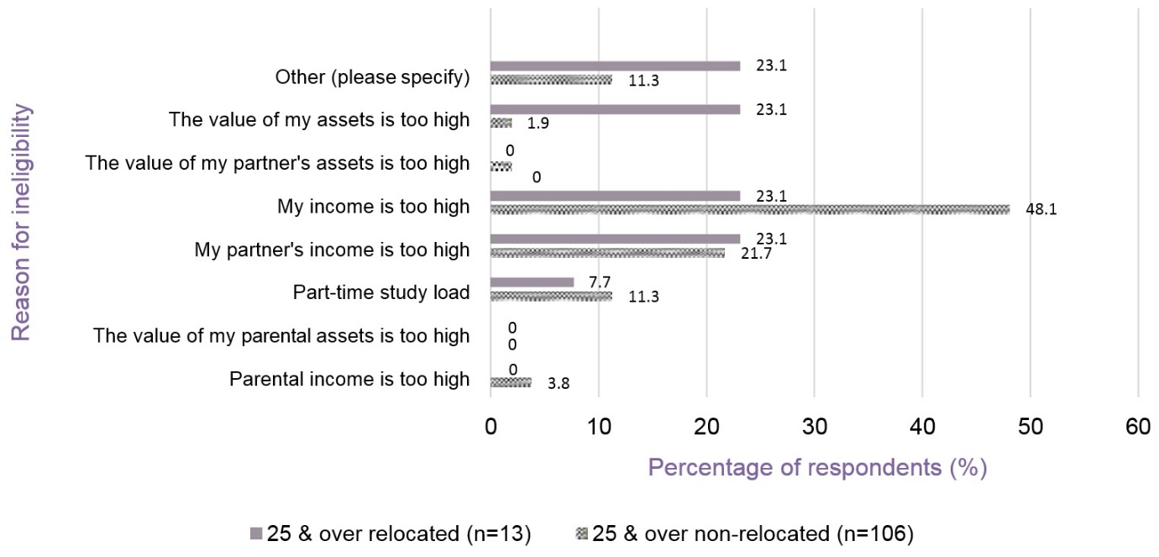
In comparison, for students aged 25 years and over, the major reason for ineligibility for government allowance is an individual’s income being too high.

Figure 4: Reasons for not receiving government allowances for students aged 25 years and over

3.2 Additional Government Support
In addition to income support, the Australian Government also provides a number of additional allowances and financial support mechanisms that include rent assistance, healthcare benefits and fares assistance. Figure 5 outlines the proportion of respondents aged under 25 years in receipt of additional government support.
Of the students aged under 25 who have relocated, 46% indicate they receive rent assistance, 22% receive healthcare benefits and 37% receive no additional support. For those students who have not relocated, 12% receive rent assistance, 14% receive healthcare benefits and 66% have indicated that they receive no additional support.
Rent assistance was the most common additional support received by all respondents, and whilst there is an apparent range in value amount, with one student receiving as little as $7 per week, the majority of students indicated that it provided essential money for day-to-day living, providing some relief of the financial burden placed on parents.

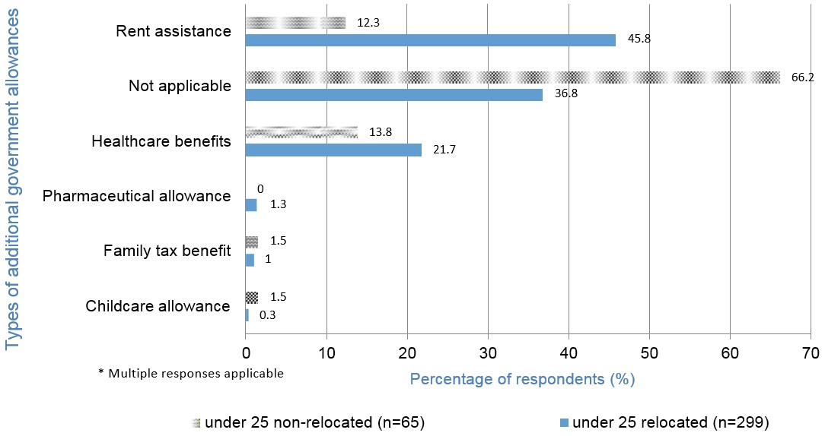
Figure 5: Percentage of students aged under 25 receiving additional government allowances

I now get some rent assistance which covers that, and also some electricity... there’s a small amount that goes towards electricity payments, and there is also another allotment for food shopping or anything that needs to go to the house ... and so that’s been really good because my parents don’t then have to pay for that, and so there’s less financial stress on them and myself. Lucy
Whilst there appeared to be a strong awareness of the existence of rent assistance, fewer students appeared to be aware of fares assistance.
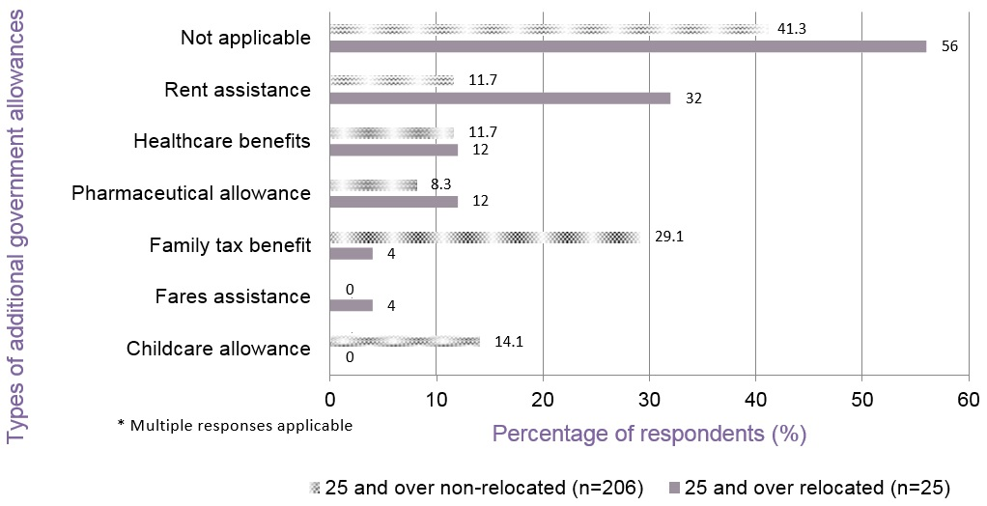

Figure 6: Percentage of students aged 25 and over receiving additional government allowances
To assist students returning to their rural homes to visit family, the government offers fares assistance for those students receiving ‘living away from home’ dependent Youth Allowance, which consists of payment for the ‘least-expensive practical form of public transport’ at the commencement and completion of the academic year plus one annual return trip during the year. Despite the availability of this type of financial support, of the 71 respondents in receipt of dependent YA, only one respondent indicated receiving fares assistance, suggesting that either regional students are unaware of the available financial support or that public transport options are impractical.
Of the students aged 25 years and over that have relocated, 32% receive rent assistance. With the exception of Family Tax Benefit there are no significant differences between those who have relocated or not relocated.

3.3 Employment
Findings by Baik et al. (2015) indicate that there is an increasing trend towards combining work and study, with this study confirming that 75% of respondents are engaged in paid employment. Figure 7 shows the various combinations of paid employment and study by respondents. 26% of the undergraduate students study full time and work up to 16 hours per week with most students studying bachelor degree and foundation studies. A further 13.2% of undergraduates study full time and work up to 24 hours per week. Research suggests that an increased number of hours spent working can have adverse effects on academic achievement. Previous studies have found that students who work more than 16 hours per week are more likely to achieve only an average mark of 60% or less and that longer working hours contribute to higher education attrition rates (Halliday- Wynes & Nguyen 2014; van Reyk 2012).

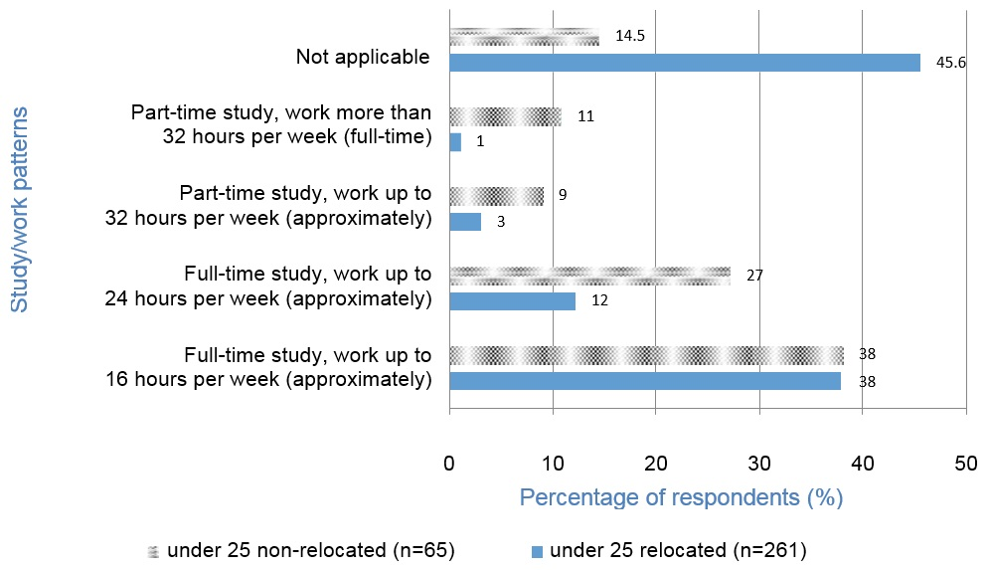
Figure 7: Study/work patterns of students aged under 25
Of the students aged under 25 who relocated, 45% (n=136) indicated that they were not currently employed on a regular basis. Polesel and Klatt (2014) noted that there are ‘large differences between students from metropolitan and non-metropolitan regions in their likelihood of working and in the number of hours worked. Non-metropolitan students are much more likely not to be working at all.’ (p. 187) For students that have relocated our findings support this outcome.
During interviews a number of students commented about the unexpected challenge associated with finding employment in the city, suggesting that age becomes a barrier as well as the requirement to return home during semester break.
I’ve recently got a job. I’ve been looking since the start of the year and I’ve only just gotten a job. I found when I was looking for a job it was stressing me out more than ... because I thought, ‘urgh ... I’ve gotta get a job, I’ve gotta help Mum and Dad’, and that just stressed me out way too much ... so then I wouldn’t focus on my studies. Jasmine
It’s so hard, because a lot of the fast food people want young people to pay less ... but because my shifts at McDonald’s are overnight and over the weekend, you have to be over 18 to do the night shifts. So, I’m only getting those shifts because I’m over 18. Jasmine
In the last two semesters I’ve struggled a lot. It has been quite hard. I’ve
had to be a hermit and not really do anything. At [name of employer] I’m one
of the oldest staff members ... I’m 21 and I’m full wages so they wanna give
the shifts to the younger people, so that’s been hard ... they don’t give me weekend work. Zoe
Because I go home every term it’s hard to get work and keep work if they know that you’re only going to be here for eight weeks or so at a time. Regina
Comments in interviews highlight a reluctant reliance on family support when students find it difficult to find employment. A common theme was the anguish and concern that this reliance on family creates, with a keen awareness of the burden placed on their families. This is discussed further in Section 3.8, below. The forced dependence despite living away from home at the same time as having to acquire independence skills contributed to another layer of stress.
My Dad has been out of my life for close on six years now, so it’s pretty much just my Mum taking care of everything. She’s 61 and a retired teacher so it’s a bit unfair on her to have this burden that I’m supposed to be her dependant. She obviously can’t afford to financially take care of me. Harry
I have a lot of medication so my parents help with that, but I’ve recently got a job. I’ve been looking since the start of the year and I’ve only just gotten a job. So, that’ll be a bit better ... they won’t need to put so much money towards me (because I can then pay for my own medication), because although I know that they will help me when I need it ... I don’t want to continuously be, ‘Mum ... I need money for this’. Jasmine
It’s to the point where my parents can’t actually give me any more money. For that first six to eight months they were paying for everything … making sure that I had enough money to pay rent and that sort of thing. But that placed financial stress on them. Lily
So I turned 22 in April ... but up until then I received nothing ... and it was impossible. My parents were having to completely support me which obviously puts financial stress on them that they don’t need, and it made it hard because it was ... you sort of are juggling, ‘can I eat today’ and there were no social outings ... that was just completely off the radar because there’s also all of the university costs (travel to placements ... any textbooks required), and so not having any financial support was very difficult. Lucy
Whilst lack of employment opportunities provide a partial explanation of the number of students not engaged in regular paid work, 16% (n=98) of survey respondents indicated that they engage in seasonal work patterns, returning to regional areas during semester break to work and save money for the upcoming study year.
I don’t work while I’m down here. I try to just keep my focus on my studies. I work so hard during the summer so that I can just do uni and study and stuff like that. At the moment I’m doing placement which cuts into my time again. Daniel
Figure 8 displays the study and work patterns for students aged 25 years and over, indicating that whilst the majority (33%) of students that relocate study full time and work up to 16 hours per week, those that don’t relocate tend to study part time and work more than 32 hours per week. This suggests that having valued existing employment may deter regional students from relocating.

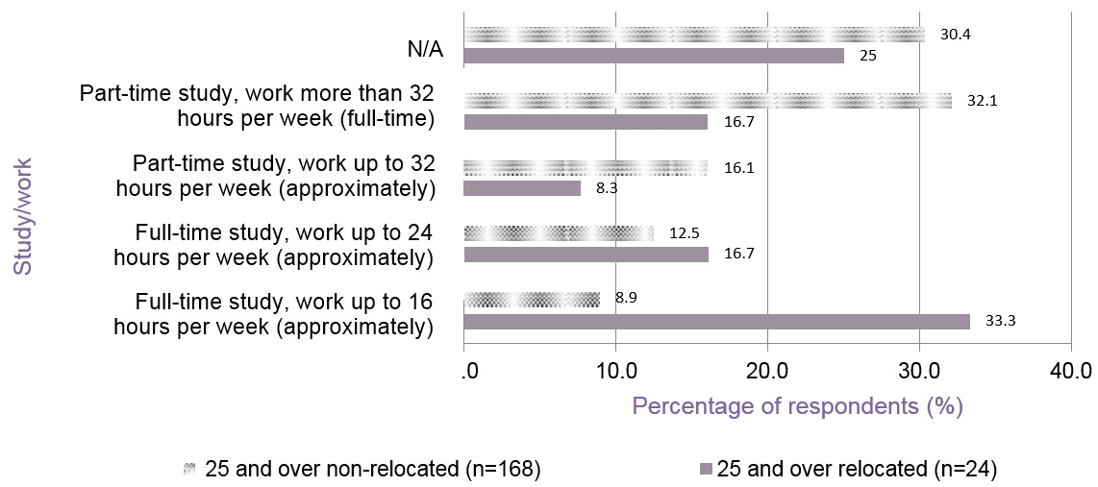
Figure 8: Study/work patterns of students aged 25 and over

3.4 Scholarships
A significant number (n=185) of respondents indicated that they receive scholarship income that has made relocation for study a more manageable process. Scholarship income contributes financial relief towards the initial cost of relocating to attend university, as well meeting ongoing living expenses and costs associated with studying (Bills 2012b; Halliday-Wynes & Nguyen 2014). Scholarships have been treated as unanticipated gains and not included in weekly income figures in the above data, to prevent mean income distortions.
Scholarships are available from a number of sources including the government, universities, bequeaths through universities, and community-based agencies. The Country Education Foundation of Australia (CEF) has partnered with a number of higher education institutions to provide funding to students moving from rural or remote areas of Australia for study. The amount of funding ranges from book vouchers to help make textbooks more affordable to grants of several thousand dollars.
I had to apply for scholarships because with my family I don’t think we would’ve been able to afford it straight out, and also getting help from Centrelink so I could afford to move over and pay board ... so that I could live here, but I was fortunate in that I did get a couple of scholarships. Regina
Financially the scholarships really do help ... Harper
I get the Relocation Scholarship at the beginning of the year and the Start-up Scholarship at the beginning of the year and then the beginning of second semester which does help a lot. It helps me in being able to afford textbooks and stuff like that ... Lily
In response to the Bradley Review, the federal government introduced the Relocation Scholarship in 2010, providing $4000 in the first year and $1000 in later years. In addition, students receiving a Relocation Scholarship were also entitled to a Student Start-up Scholarship valued at $1300 in 2010, increasing to over $2128 in 2011, indexed annually. The scholarship most frequently received by survey respondents was a government scholarship. Interestingly, though the University provides numerous scholarships and grant opportunities for regional students, respondents seemed to not be as well informed about University scholarships available.

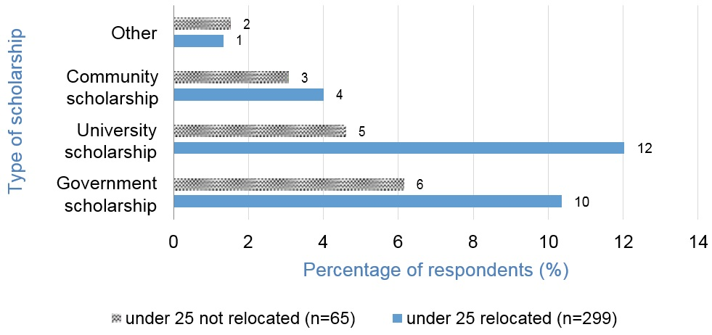
Figure 9: Types of scholarships received by students aged under 25
I was eligible for a placement scholarship, but I didn’t know about that until someone told me about it. It wasn’t much it’s going to help … it won’t cover the fuel that I’ll spend going there and from but it’s ... it helps. I don’t know where I would’ve found it otherwise. If I’d tried to do that out of my own pocket I would’ve been in strife. Daniel
I luckily applied for a scholarship with uni, and I got one of those ... and I didn’t even know about it until somebody told me about it in my class. Willow
Respondents indicated that government scholarships provided an estimated annual average value of $3500, University scholarships $2700 and community scholarships $2100. Figure 9 shows that relocating students are more likely to have some form of scholarship than those who did not relocate however the values for scholarships were correspondingly less. For the non-relocating students government scholarships provided an estimated annual average value of $1800, University scholarships $1300 and community scholarship $1250 per annum.

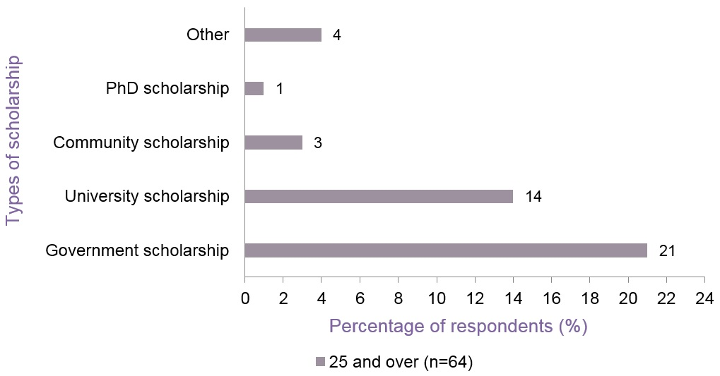
Figure 10: Types of scholarships received by students aged 25 years and over

For students aged 25 years and over the value of scholarships is higher. Of the students who are aged 25 years and over, 21% receive a government scholarship of approximately $8800, 14% receive a University scholarship of approximately $2300, 3% receive a community scholarship of $4500, and 1% receive a PhD scholarship, valued at an average of $30,000 per annum.

3.5 Expenditure
As identified in previous studies, accommodation, followed by transport costs, comprise the two largest expenses incurred by university students, with day-to-day expenses being the third largest cost (Halliday-Wynes & Nguyen 2014). The Regional Young People and Youth Allowance: Access to Tertiary Education report (Godden 2007) estimated the annual cost for regional students to attend university to be between $15,000 and $20,000, excluding the cost of a privately owned vehicle, with the data in Table 6 for students aged under 25 falling within this same band almost eight years later.
This study indicates similar findings to Godden (2007), with weekly student expenditure unrelated to study predominantly divided into rent/mortgage payments, utilities, internet bills, telephone bills, groceries, petrol costs, public transport costs, childcare, insurance and others. Table 6 shows the weekly mean and median expenses for all respondents after removing six outliers from the above data set prior to analysis due to obvious data error; a further 86 respondents had missing expenditure data.
Table 6 shows that although overall expenditure between students aged under 25, both relocated and non-relocated, is similar, closer analysis shows that individual costs vary. For relocated students, rent is approximately $50 per week higher than non-relocated, accounting for 57% of their weekly income. In contrast non-relocated students pay lower rent; however the majority of other costs such as groceries, utilities and internet are higher in regional locations. These figures align with competitive economic pressures and costs of living, where generally rental costs are lower in regional locations (ABS 2011b, Median Weekly Rental Payment) and energy costs are higher (National Rural Health Alliance and ACOSS, 2013). However, as noted above, those who do not relocate tend to work longer hours and thus have more disposable income.
Relocated students aged 25 years and over spent an average of $532 per week, in comparison with non-relocated students in that age group, who spent an average of $704 per week. The higher expenditure for non-relocating students reflects the additional costs of dependants or carer responsibilities, with 69% of the non-relocating students having such responsibilities, compared with only 32% of the relocating respondents.

Table 6: Weekly mean and median expenses ($) for all respondents
 | Under 25 |  |  | 25+
 | All  N=314 | Relocated  n=260 | Non-  relocated n=54 | All  N=191 | Relocated  n=24 | Non-  relocated n=167

Total expenses
$Mean | 353 | 355 | 346 | 638 | 532 | 704
Median | 325 | 325 | 323 | 660 | 500 | 670

Rent/mortgage
$Mean |  | 194 | 158 |  | 249 | 301
% |  | 77.7 | 61.1 |  | 95.8 | 91.6

Groceries
$Mean |  | 66 | 88 |  | 99 | 170
% |  | 77.1 | 87 |  | 95.8 | 100

Utilities
$Mean |  | 42 | 82 |  | 56 | 93
% |  | 59.2 | 64.8 |  | 91.7 | 92.2

Internet
$Mean |  | 18 | 30 |  | 26 | 28
% |  | 60.8 | 66.7 |  | 79.1 | 96.4

Phone
$Mean |  | 25 | 30 |  | 29 | 27
% |  | 73.2 | 90.7 |  | 100 | 94.6

Petrol
$Mean |  | 43 | 52 |  | 42 | 65
% |  | 61.8 | 92.6 |  | 91.7 | 97.6

Public transport tickets
$Mean |  | 14 | 15 |  | 13 | 15
% |  | 59.9 | 31.4 |  | 58.3 | 6.6

Insurance
$Mean |  | 33 | 30 |  | 64 | 68
% |  | 17.2 | 59.3 |  | 62.5 | 80.2

Childcare
$Mean |  | 43 | 100 |  | 200 | 126
% |  | 1 | 1.8 |  | 4.2 | 21

Table 7: Overall mean income and expenditure of receiving Youth Allowance per week ($)
 | RELOCATED | DEFICIT/ SURPLUS | NON-RELOCATED | DEFICIT/ SURPLUS
Dependent Youth Allowance  recipients: Total income $ | (n=62)  311 |  | (n=9)  435
Dependent Youth Allowance  recipients: Total expenses $ | 347 | -36 | 314 | 121
Independent Youth Allowance  recipients: Total income $ | (n=89)  415 |  | (n=10)  453
Independent Youth Allowance  recipients: Total expenses $ | 363 | 52 | 362 | 91

In Table 7 it is interesting to note that for those respondents receiving a dependent Youth Allowance who have relocated, the students appear to be living beyond their means, with overall expenses exceeding their income. It is more probable that this group of respondents will be without a partner or children and the data reflects individual circumstances. It is also likely that scholarships (excluded from weekly income data) contribute substantially to this shortfall as those who relocate are more likely to receive scholarships than those who do not relocate. In comparison, students who have relocated but received independent Youth Allowance have higher employment income to offset expenses.
For students aged 25 years and over it is difficult to interpret whether students are living beyond their means as 68% of respondents have partners, and any household expenditure reflected in the survey would reflect a mixture of individual and shared circumstances, particularly for utilities, consumables and elective expenditures. Partner personal expenditures were not part of the survey.
Regarding costs associated with attending university, course fees represent the largest expense. The majority of respondents (84%) indicated that they are currently deferring course fees through the HECS-HELP loan system, with a minority (16%) of students paying part or all of their course fees upfront.
For other study expenses, relocated and non-relocated students spent similar amounts of money on textbooks and stationery per semester; however non-relocated students spent a significantly larger portion of their money on ‘other’ things related to study. A major contributor to these additional expenses relates to the need for non-relocated students to attend workshops and assessments in the city, as well as the lack of available competitive services, resulting in increased costs for services such as printing.
I have to prepare for the workshops … the travel down and accommodation. Lisa
You don’t have Officeworks here ... and because you’re online I need a lot of printing but we can’t get cartridges up here, so you have to prepare in advance and cartridges aren’t cheap. The internet isn’t as good or as fast and always cuts out … I also need books and postage on top is sometimes $20 for a book and you need four a semester. Willow

Table 8: Semester study-related costs for all respondents
 | Under 25 |  |  | 25+
 | All  N=364 | Relocated  n=299 | Non-  relocated n=65 | All  N=231 | Relocated  n=25 | Non-  relocated n=206

Textbooks
$ | 317 | 325 | 355 | 296 | 430 | 278
% | 86.5 | 86.9 | 84.6 |  | 92 | 83.1

Stationery, course materials, photocopying
$ | 88 | 89 | 90 | 116 | 132 | 112
% | 24.1 | 85.2 | 83 |  | 92 | 75.7

Other
$ | 87 | 98 | 267 | 334 | 270 | 349
% | 23.9 | 27.7 | 40 |  | 68 | 36.4

The pattern of expenditure is similar for relocated and non-relocated students aged 25 and over. However, relocated students spent an average of $140 or more on textbooks while non-relocated students spent an average of $80 extra in other study-related expenses.

3.6 Living Arrangements
The costs of living away from home are substantial and have a significant impact on any family’s or individual’s finances. In a recent report on first year experience at university, Baik et al. (2015) report that 57% of regional and remote students are required to relocate to attend university, in comparison to 27% of metropolitan students. The impact of relocating to attend university not only results in significant financial costs incurred, but also results in regional students experiencing emotional stress due to the loss of their support networks (Baik et al. 2015).
Whilst cost of accommodation is a major concern and is discussed below, Bills (2012) identifies that additional stress is experienced for both regional students and their families due to issues relating to finding appropriate accommodation. Results from this study indicates that 55% of regional students aged under 25 begin planning for living arrangements around four months before university study started, 18% started almost one year before the start of university study. Accommodation was generally found through word of mouth (34%), via various websites (27%) or through a real estate agent (15%), or other means (17%). It is interesting to note that the majority of students in the other category found accommodation through friends and family friends.
Unsurprisingly, there are very different styles of living arrangements for those aged under 25 and those aged 25 years and over. Those under 25 are more likely to be living with family or in shared accommodation whereas the main type of living arrangements for students 25 and over are renting alone or buying their own homes.
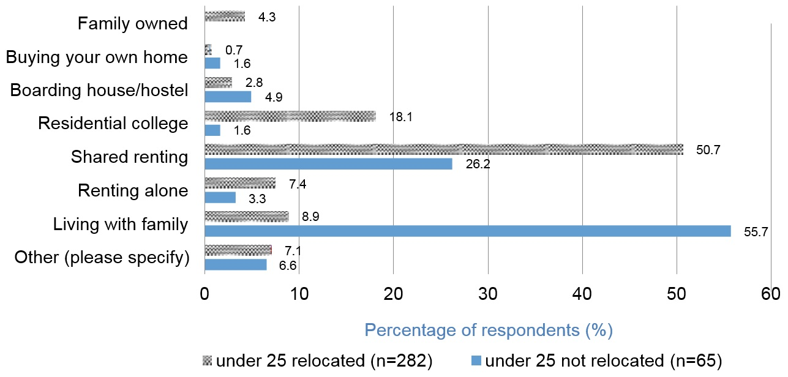

Figure 11: Current living arrangements of students aged under 25 years

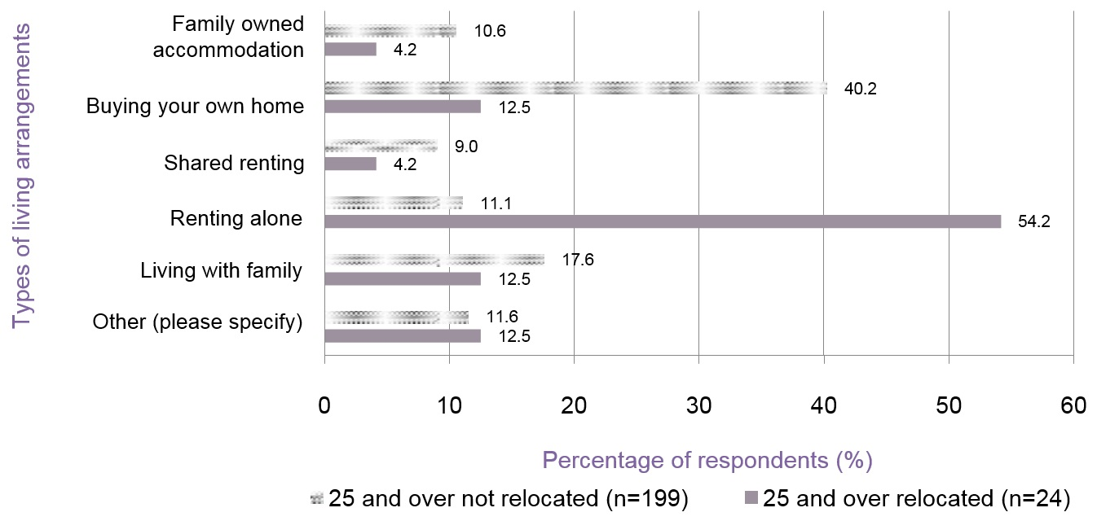
Figure 12: Current living arrangements of students aged 25 years and over
For the majority of regional students living in rental accommodation, there are significant set-up costs associated with moving into private rental accommodation, including four weeks rent as bonds and two weeks’ rent in advance, furniture, basic food items, and linen. Lack of flexibility surrounding eligibility for Centrelink was raised throughout interviews, including the inability to save money in preparation of meeting these start-up costs.
Some people need the money straight away, but the thing is that they can’t apply for Centrelink any earlier because you can’t apply for it until you’ve left, but when you need the money you can’t get it … you move in at the end of January and then I think it was mid-March before I got anything, so that’s like a month and a half ... which for some people that’s just six weeks without any income ... without anything at all. Mia
There needs to be a bit more consideration around the earnings limits and the casual nature of that, as a lot of rural students will go back on their Christmas break and work really hard in their job that they had before they moved over and then come back and they won’t work for three or four months. I’m not sure the current system is the best way to handle that. There needs to be a bit more flexibility and understanding. Emm

Table 9: Set up costs for commencing higher education – percentage of expenditure for students aged under 25
 | Bond $ - Cost |  | Stocking the pantry |  | Cleaning products |  | Linen inc. towels |  | Electrical items |  | Furniture  $ - Cost |  | Insurance $ - Cost |  | Electronic equipment |  | Other - Cost
 | Relocated | Non-relocated | Relocated | Non-relocated | Relocated | Non-relocated | Relocated | Non-relocated | Relocated | Non-relocated | Relocated | Non-relocated | Relocated | Non-relocated | Relocated | Non-relocated | Relocated | Non-relocated
$0-$124 | 2.7 | 3.8 | 32.3 | 17.3 | 51.0 | 25.0 | 41.2 | 19.2 | 27.1 | 13.5 | 12.1 | 3.8 | 12.1 | 16.7 | 9.7 | 5.7 | 5.9 | 5.6
$125-$250 | 4.7 | 1.9 | 36.5 | 17.3 | 19.5 | 7.7 | 29.6 | 5.8 | 22.9 | 7.7 | 10.2 | 9.6 | 6.1 | 8.3 | 7.8 | 1.9 | 10.2 | 5.6
$251-$500 | 12.8 | 3.8 | 10.4 | 3.8 | 5.7 | 5.8 | 10.4 | 11.5 | 15.5 | 11.5 | 13.3 | 7.7 | 8.2 | 4.2 | 7.8 | 7.5 | 10.2 | 2.8
$501-$750 | 14.3 | 7.5 | 2.7 | 5.8 | 1.1 | 1.9 | 3.1 | N/A | 6.2 | 1.9 | 7.0 | 1.9 | 5.6 | 4.2 | 5.4 | 3.8 | 2.5 | 5.6
$751-$1000 | 12.8 | 9.4 | 1.2 | N/A | 0.8 | N/A | 1.2 | N/A | 3.1 | N/A | 9.0 |  | 2.2 | 2.1 | 12.5 | 9.4 | 2.5 | N/A
$1001-$1250 | 10.1 | 3.8 | N/A | N/A | N/A | N/A | N/A | N/A | 0.4 | N/A | 5.5 | 1.9 | 0.4 | N/A | 13.2 | 11.3 | 0.8 | N/A
$1251-$1500 | 4.7 | 1.9 | N/A | N/A | N/A | N/A | 0.4 | N/A | N/A | 1.9 | 2.7 | 1.9 | 0.4 | N/A | 9.3 | 11.3 | N/A | N/A
$1501-$1750 | 3.5 | 1.9 | N/A | N/A | N/A | N/A | N/A | N/A | N/A | N/A | 3.1 | N/A | 0.4 | N/A | 8.2 | 5.7 | N/A | 2.8
$1751-$2000 | 2.7 | 1.9 | N/A | N/A | N/A | N/A | N/A | N/A | 0.4 | N/A | 3.1 | N/A | N/A | 2.1 | 4.3 | N/A | N/A | N/A
$2,000 | 2.7 | N/A | N/A | N/A | N/A | N/A | N/A | N/A | 0.4 | N/A | 5.5 | 11.5 | N/A | N/A | 8.6 | 11.3 | 3.4 | 5.6
Not Applicable | 29.1 | 66.0 | 16.9 | 55.8 | 21.8 | 59.6 | 14.2 | 63.5 | 24.0 | 63.5 | 28.5 | 49.2 | 64.5 | 62.5 | 32.1 | 32.1 | 64.4 | 72.2

 | Bond $ - Cost |  | Stocking the pantry |  | Cleaning products |  | Linen inc. towels |  | Electrical items |  | Furniture $ - Cost |  | Insurance $ - Cost |  | Electronic equipment |  | Other - Cost
 | Relocated | Non-relocated | Relocated | Non-relocated | Relocated | Non-relocated | Relocated | Non-relocated | Relocated | Non-relocated | Relocated | Non-relocated | Relocated | Non-relocated | Relocated | Non-relocated | Relocated | Non-relocated
$0-$124 | N/A | 1.3 | 20.8 | 5.3 | 30.4 | 8.7 | 18.2 | 6.1 | 18.2 | 4.8 | 4.3 | 4.7 | 9.5 | 4.1 | 4.2 | 1.2 | 13.3 | 3.8
$125-$250 | N/A | N/A | 29.2 | 9.9 | 26.1 | 6.0 | 9.1 | 2.0 | 9.1 | 4.1 |  | 2.0 | 14.3 | 6.8 | 4.2 | 2.4 | 6.7 | 3.8
$251-$500 | 13.6 | .7 | 29.2 | 3.3 | 4.3 | 2.7 | 13.6 | 4.8 | 13.6 | 3.4 | 4.3 | 6.7 | 19.0 |  | 20.8 | 6.1 | 6.7 | 3.8
$501-$750 | 9.1 | 2.6 | N/A | .7 | 8.7 | N/A | 13.6 | .7 | 13.6 | .7 | 13.0 | 1.3 | 14.3 | 1.4 |  | 5.5 | N/A | 3.8
$751-$1000 | 9.1 | 1.3 | N/A | N/A | N/A | N/A | N/A | N/A | N/A | N/A | 8.7 | 2.7 | 4.8 | .7 | 8.3 | 11.0 | N/A | .8
$1001-$1250 | 22.7 | N/A | N/A | N/A | N/A | N/A | 4.5 | N/A | 4.5 | .7 | 13.0 | 2.0 | N/A | 1.4 | 8.3 | 7.3 | N/A | .8
$1251-$1500 | N/A | 2.0 | N/A | N/A | N/A | N/A | N/A | N/A | N/A | N/A | 4.3 | 2.7 | N/A | N/A | N/A | 7.9 | N/A | N/A
$1501-$1750 | 9.1 | .7 | N/A | N/A | N/A | N/A | N/A | N/A | N/A | N/A | 4.3 | .7 | N/A | N/A | 12.5 | 2.4 | 6.7 | N/A
$1751-$2000 | 9.1 | N/A | N/A | N/A | N/A | N/A | N/A | N/A | N/A | N/A | 4.3 | .7 | N/A | N/A | 12.5 | 3.0 | N/A | N/A
$2,000 | 4.5 | N/A | N/A | N/A | N/A | N/A | N/A | N/A | N/A | N/A | 13.0 | .7 | N/A | .7 | N/A | 5.5 | N/A | 1.5
Not Applicable | 22.7 | 91.5 | 20.8 | 80.9 | 26.1 | 82.7 | 30.4 | 86.4 | 40.9 | 86.4 | 30.4 | 75.8 | 38.1 | 84.9 | 29.2 | 47.6 | 66.7 | 81.7

Table 10: Set up costs for commencing higher education – percentage of expenditure for students aged 25 years and over

Most of the set-up costs for students aged under 25 years who have relocated is on electronic equipment ($500–$1000) as well as rental bond ($250–$750), while the set-up costs for non- relocated students involved electronic equipment ($500–$750), furniture ($0–$250) and bond ($0–$250). For aged 25 and over relocated students, most of the set-up costs involved electronic items ($500–$1000), bond ($500–$1000), and furniture ($500–$1000), which is vastly greater than those that have not relocated.

3.7 Transport
As highlighted in the 2014 Longitudinal Survey of Australian Youth, transport or lack of transport is identified by university students as being a source of financial stress. Owning a vehicle, with associated maintenance, insurance, registration and parking issues, together with the time taken for travel in city locations may mean that students will trade not having a car for the lower cost and duration of time spent commuting on public transport. In a city environment both the use of a car and public transport travel options involve an opportunity cost with less time available for paid employment. In many regional locations public transport options are few if any (as reflected in the results of Figure 13 and Figure 14 for non- relocated students) and reliance on a car involves little traffic or parking expenses and limited distances mean less time commuting. Transport costs was identified as one of the three major expenses, along with rent and day-to-day expenses, for students (Halliday-Wynes & Nguyen 2014).
I had to get a car because I like to go home because I miss my family. With purchasing a car there’s maintaining a car, petrol ... so that adds pressure. Ruby
Results from this study indicate that 50% of respondents who have relocated utilised public transport to travel to university, whilst 24% of respondents use their own vehicle. Of those students who have not relocated, 65% travel to the university with their own vehicle and 24% travel via other means.
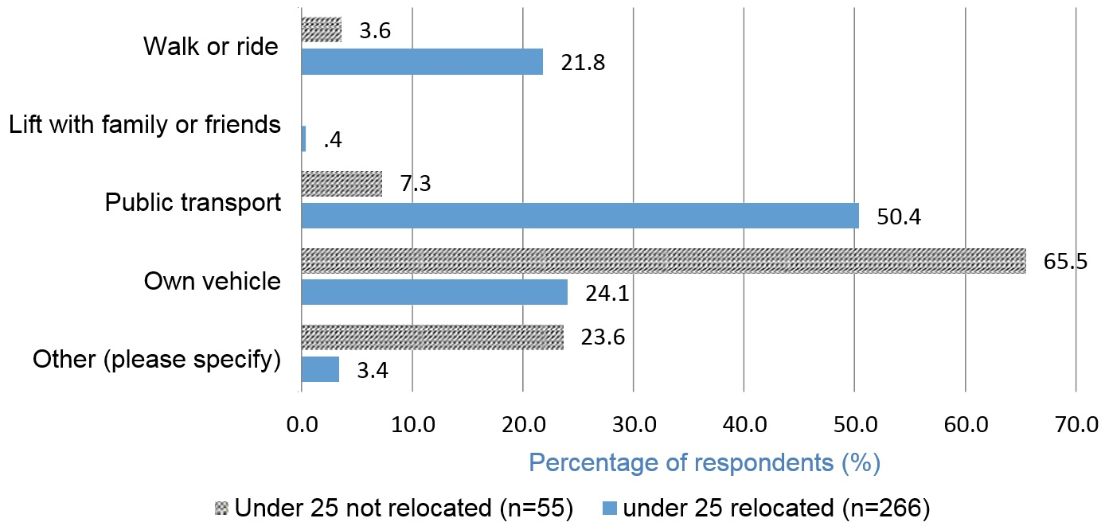

Figure 13: Primary method of travel to and from university for students aged under 25

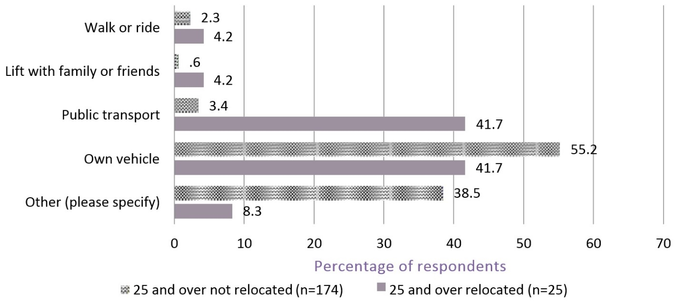
Figure 14: Primary method of travel to and from university for students aged 25 and over
Similarly, for those respondents aged 25 years and over who have not relocated, 55% utilise their own vehicle to travel to the university while 38.5% travel by other means. Students who have relocated use both public transport (42%) and their own vehicle (42%) as the main method of travel to the university.
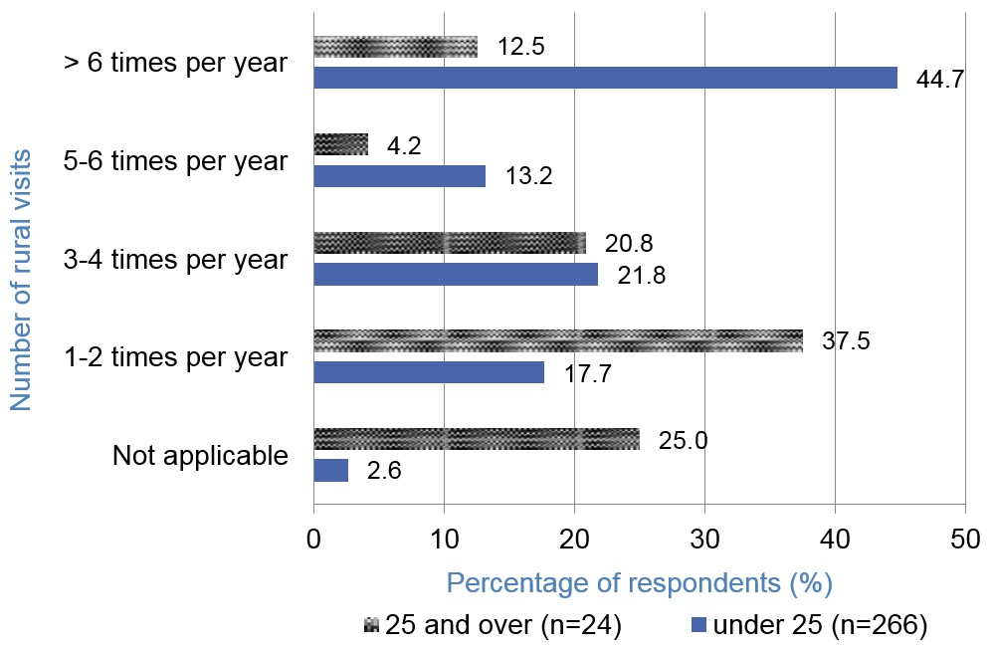
In addition to the associated cost of travelling to and from university, students aged under 25 also indicated that associated costs of travelling to visit their regional homes was important, with 45% of regional students returning home more than six times per year. However, 37.5% of students aged 25 and over only visit home one or two times a year or not at all.

Figure 15: Number of return visits rural students make to their rural homes per annum
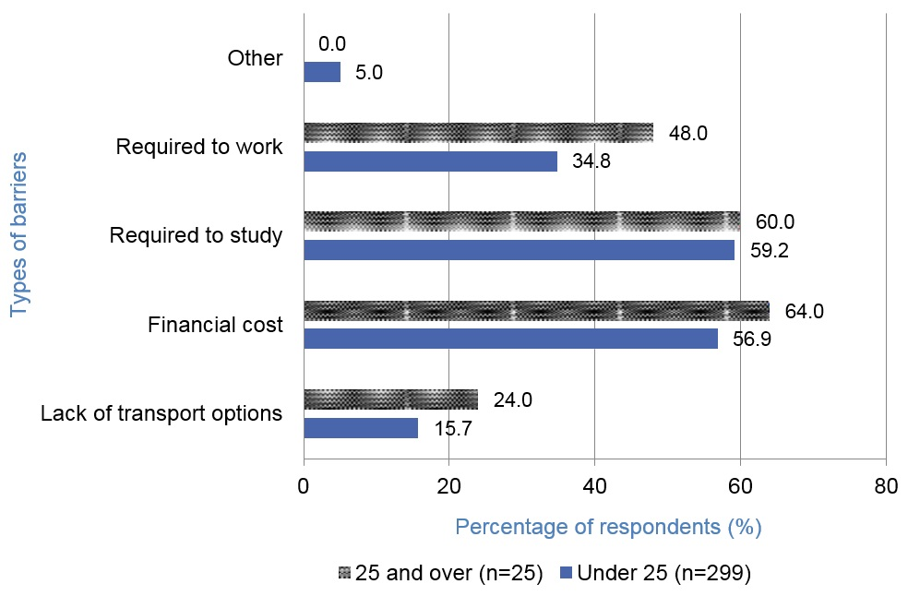
When asked about visiting rural homes, 75% of the students aged 25 and over, and 79% of students aged under 25 indicated that they would like to visit their regional homes more, but financial cost and the requirement to study were identified as two major barriers.

Figure 16: Barriers that prevent rural students from visiting their rural homes
Recommendation 4
In the situations where transport costs represent a significant cost burden on a daily basis - to further explore - what provisions and mechanisms could be identified and easily implemented.

3.8 Financial Stress
For the purposes of this study, the definition of financial stress has been adapted from the established scale applied by the Australian Bureau of Statistics (ABS 2002) which assesses household financial stress across 15 indicators. Where just one indicator is reported, financial stress is deemed not to be present, while where two to four indicators are present, moderate financial stress applies, and where five or more indicators are present there is deemed to be a higher exposure to financial stress. The 15 indicators applied within this study were modified to reflect student circumstances, but continue to reflect cash flow problems. Table 11 indicates the category of financial stress for students in each age group and relocation status. Figure 17 details the specific indicators experienced by regional students.

Table 11: Financial stress by age group and relocation status
 | Under 25 relocated %  (n=276) | Under 25 non- relocated %  (n=55) | 25 & over relocated %  (n=24) | 25 & over  non- relocated  % (n=176) | Total (n=531)
No stress | 15.4 | 23.6 | 12.5 | 22.2 | 18.4
Moderate  stress | 32.5 | 30.9 | 20.8 | 25.0 | 27.3
Higher stress | 52.1 | 45.5 | 66.7 | 52.8 | 54.3

A Pearson correlation provides further support for the validity of this data, indicating that the financial stress categories detailed above (Table 11) have a strong correlation (r=.546, n=531, p<.001) with the level of personal financial stress that individual respondents indicated that they were experiencing on a 5-point Likert scale.
Analysis shows that respondents who have not relocated (for both age groupings) are the least stressed, and those aged 25 years and over who have relocated appear to be the most stressed. Stress can apply to all students whether they are regional, have relocated or have remained in the same city. Juggling different aspects of life when there are many competing demands and where young adults have limited time management experience can compound stress. The proportion of regional students that are highly stressed is significant with regional students across all categories feeling moderately to highly stressed. Baik et al. (2015) in their survey of first year students reported that:
Forty-four per cent of students from regional and remote backgrounds reported that their financial situations were frequently a source of stress for them, compared to 24 per cent of their peers. (p. 79)
While the Baik et al. (2015) study did not include continuing or postgraduate students, this report shows that stress levels for both those aged under 25 and those aged 25 years and over are higher than previously reported for regional students. Polesel and Klatt (2014) in their recent study of deferring students, also concluded that financial stress and travel costs seem to be the biggest barrier for students taking up university places.
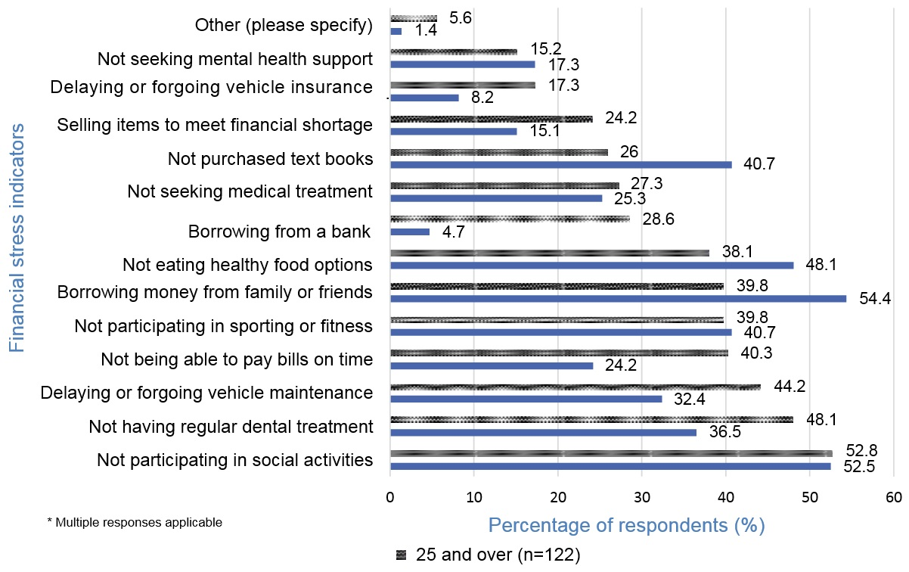

Figure 17: Indicators of financial stress for regional students
Overall, a lack of financial means suggests that respondents engage in unhealthy lifestyle choices such as making unhealthy food choices, or forgoing essential services such as seeking medical assistance.
Not receiving any income support means that I cut back on a lot of things … one time I got sick and then I got really sick because I didn’t go the doctor ... I couldn’t afford to go to the doctor. I’ve also been late in some bill payments which isn’t really good for my credit. But you just have to deal with it. It’s an emotional part. Lisa
Whilst Lewis et al. (2007) reported that nearly half of their respondents indicated that financial hardship prevented them from eating healthily, our results found the same proportion of students aged under 25 (48%) and 38% of students aged 25 and over, reported that financial hardship contributed towards unhealthy eating habits.
I lived on about $200 for a whole year. $200 a fortnight for a whole year. So, that was about $50 ... it was around $200 a fortnight, and I have to pay board to my uncle (which is $140 a fortnight), and then whatever money towards bills. So ... it was a struggle. I became really unhealthy and I got sick a lot. I literally just ate box food. It was not great. I put on a lot of weight and nothing was fitting me. I couldn’t look at myself in the mirror ... it got to that point. Harper
Around 50% of all students aged under 25 had to borrow money from family or friends, whilst 40% of students aged 25 years and older were required to borrow money from family and friends as a result of financial difficulties. The Halliday-Wynes and Nguyen (2014) study reported on financial stress for all students under 25 years of age (not only regional) using Longitudinal Surveys of Australian Youth (LSAY) data and 51 interviews, and used the same stress indicator models as this study. They reported that ‘(t)he most common financial stress indicator reported by respondents was the need to ask family or friends for money. The findings also suggest that amongst young people informal debt, such as debt incurred through loans from parents or relatives, appears to be more usual than formal debt.’(p. 7)
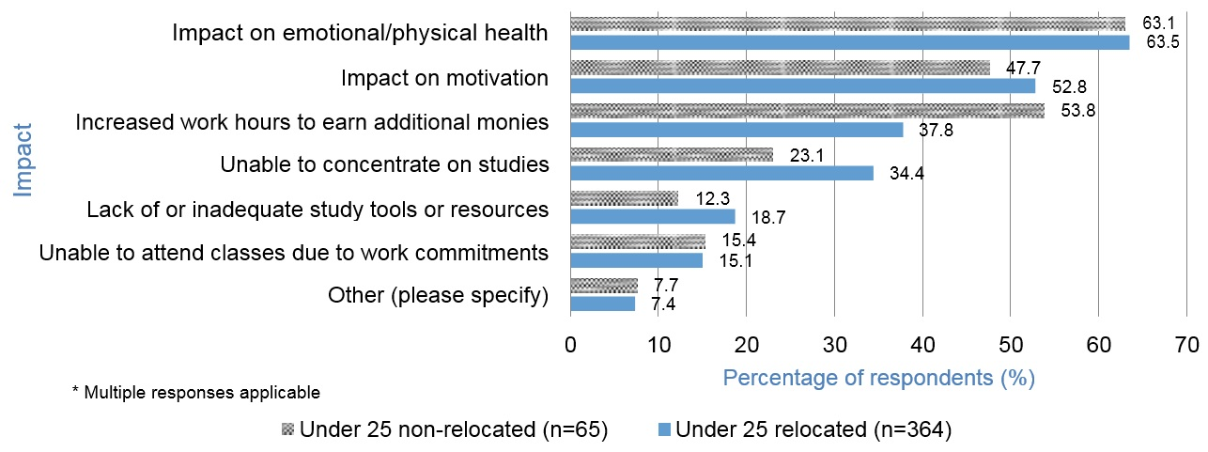
I work in hospitality which is seasonal. Over winter I was earning $30 a week which doesn’t even pay food, water, rent, fuel ... so I would be taking money from my parents (which I hate doing), from my aunty and uncle (who I’m currently boarding with), from my boyfriend ... from my friends. Grace

Figure 18: Financial impact on university studies for students aged under 25 years of age
Figure 18 shows that the majority of respondents aged under 25 in this study indicated that financial stress had a negative impact on university studies. Comments made in interviews also support the findings of James, Krause and Jennings (2010) who noted that regional students were more likely than other students to experience financial stress and to believe that this impacted their academic progress.
Certainly in the first year I really struggled to settle, and I think my grades probably looking back at my transcript reflect that. At the time I was also going through some personal issues but not having the family support there and being able to fall back on that really did cost me, and I think I ended up having to go back and get ... an appeal to get a couple of fails off my grade because of the personal stuff that I had going on. I guess there I just didn’t have any idea of the support network that I now know of that is available. Emma
When I first came over I was still really settling into the whole lifestyle and everything, so you can see all my transcripts where my grades were horrible in the first semester compared to the rest. Sophie
While stress is a significant factor that can lead to regional students withdrawing from their university studies, research indicates that financial stress also contributes to day-to-day feelings of being stressed, tired and rundown (Halliday-Wynes & Nguyen 2014). Figures 18 and 19 indicate the negative impact financial stress had on study, with 63% indicating that financial stress affected their emotional and physical health, and 50% indicating that financial stress impacted their motivation to study. Students aged 25 and, over regardless of relocation, seem to be the most stressed, with many in this group having carer responsibilities (64%). Evidence of the cumulative effect of financial stress, family and study was articulated by one interviewee:
My husband is casual so if he doesn’t work then we don’t have any income, so I’ve had to keep working and keep a 0.6 nursing contract (so I work six days a fortnight in shift work). I’m in Adelaide for the whole week and there’s an exam at the end of it, knowing that I can’t take days off this week to study ahead of time because financially I need to keep working and keep as many as my Annual Leave days sitting there for placements. It just ... there are weeks where I just think, ‘I’m going to explode ... I can’t do this’. Emily
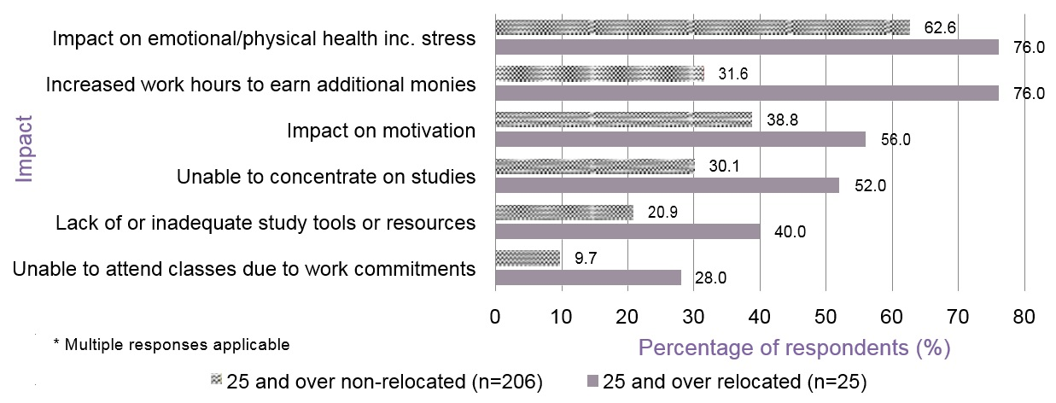

Figure 19: Financial impact on university studies for students 25 years and over
Regardless of age, over 50% of participants indicated that their financial difficulties meant that they were not able to participate in social activities. This lack of social interaction is of particular concern for regional and remote students who are required to leave behind familiar family and friend support networks and are required to establish new friendships (Baik et al. 2015). This establishment of new friendship groups, who potentially provide support in the absence of family, is difficult to achieve without the financial means and time to participate in social or sporting activities.
Rent adds huge pressure, and I usually can only work a day out of my week because for me studying is a first priority and I really want do well, which means that there’s only money for rent and the necessities. So, that dampens your social life … disposable income doesn’t really exist. Ruby

4. Becoming and being a Student

4.1 Pathways
The majority of respondents report having made the decision to attend university prior to Year 12 (51%), with only a small proportion deciding during Year 12 (13%) and the balance of respondents (36%) deciding after a period of having left school. A number of interviewees indicated that the reason for not deciding to go to university whilst at high school related to being uncertain of what they wanted to study and concern regarding making the wrong decision.
For William, concern surrounding how his family was going to afford to send him to Adelaide to complete a teaching degree was an underlying cause regarding his last minute application to university.
There was a lot of speculation (but not a lot of action) about how exactly I would get into university. There wasn’t a lot of concern about grades or anything like that, but particularly in relation to financial circumstance … so it was really perhaps (partly through dumb luck and a little bit of inaction) that I ended up here. I ... uh, I really sort of hit the end of the admission date and thought, ‘oh, what do I do?’, and it just turned out that they’d started a teaching program in Mount Gambier, and I jumped right into that. William
Through the qualitative analysis process two opposing attitudes towards university emerged, with some regional communities and schools described as being very proactive in encouraging local students to pursue higher education, whereas in contrast other regional communities and schools were described as actively discouraging students from continuing their education. Charlotte recalls that the teachers at her regional high school knew very little about university, stating:
University wasn’t necessarily encouraged, I suppose. I mean it was something that was scrambled together once we were in Year 12, and at the start of the year they asked us what we wanted to do ... and that was about the extent of it, and then they tried to help us find a place to go. They didn’t really say, ‘oh, you should do this because of this and this’ ... they just sort of asked us what we wanted to do and for most people it wasn’t uni. Charlotte
For Grace, not only did the school discourage university; she also found that her Mum ‘pushed’ her not to go.
She (Mum) said, ‘if you could get a job without it why would you bother? The only reason you go to university is to get a job’, and if I look around at my peers there are only six of us that went on to university which is quite a big number for our school ... we had one last year and none before that that went onto university. So, a lot of it is people just think, ‘you go to university to get a job ... you can get a job here ... why would you bother going?’ Grace
In contrast Ella commented that her school ‘sort of pushed the university aspect’. An experience also described by Isla:
It was a country school and the teachers were great ... don’t get me wrong, but most ... I’d say the majority of school the pressure is to go to uni. If you have the ability ... if you have the knowledge or ability or academic then you go to uni. Isla
For Sienna and Jasmine who both commenced at boarding school during their high school years, there was an obvious cultural shift in attitudes towards university, with the boarding schools having an expectation that students would continue on to university. Jasmine described the culture as ‘it’s university or it’s nothing’.

4.2 Motivation
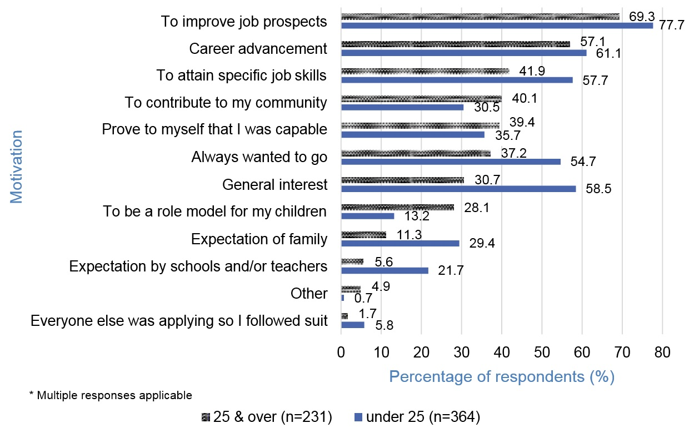
The primary motivations to attend university for all rural and regional students focused on employment aspirations, including the desire to improve job prospects and career advancement. Those aged under 25 were somewhat more influenced by others, and wished to attain specific job skills.

Figure 20: Primary motivations to attend university
In partial contrast to Fleming and Grace (2014), where it was suggested that regional parents have lower expectations than urban parents for their children to continue on with higher education, these results indicate that parental expectation for a number of remote communities is for the children to complete university. On closer analysis these remote communities can be clustered into groups that either have a major industry, such as Port Lincoln, or have relatively close proximity to a major industry hub. This data provides additional evidence to the previous suggestion that there appears to be an emerging emphasis on the role of higher education in some rural communities.

4.3 Preparation
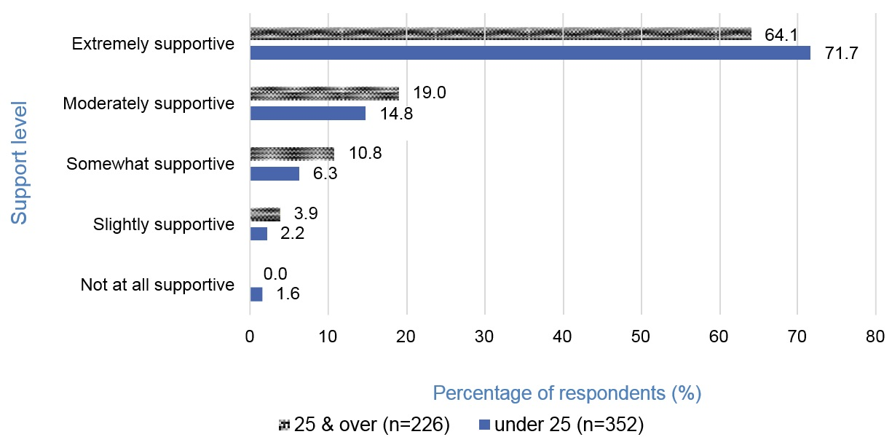
In contrast with previous studies that have found that regional students feel a lack of encouragement in their aspirations of attending university (Fleming & Grace 2014), the majority of participants (68%) in this study indicated that they felt extremely supported by their families. This was also confirmed by Bills (2014) and the data in Figure 6, which details the different levels of support experienced by regional students with regard to their decision to attend university.

Figure 21: Level of support for student decision to attend university
Of the 4% of respondents who indicated that they did not feel supported at all or only felt slightly supported, 78% were the first in their family to attend university, 95% were female and 39% were mature age students.
With regard to preparing for university, respondents indicated varying levels of preparedness concerning the financial costs of going to university. While the majority indicated they were relatively well prepared, those aged under 25 were less well informed about the expenses that may be incurred for university study (see Figure 22).

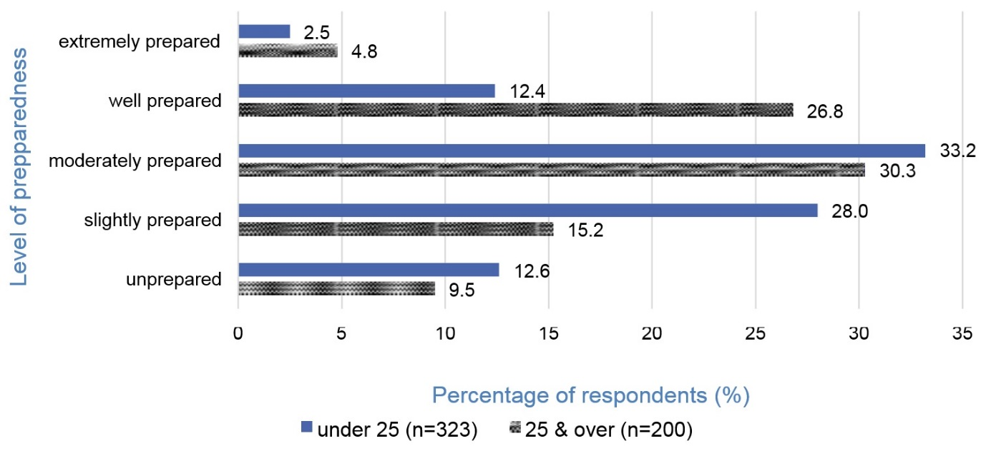
Figure 22: Level of preparedness of associated costs of attending university
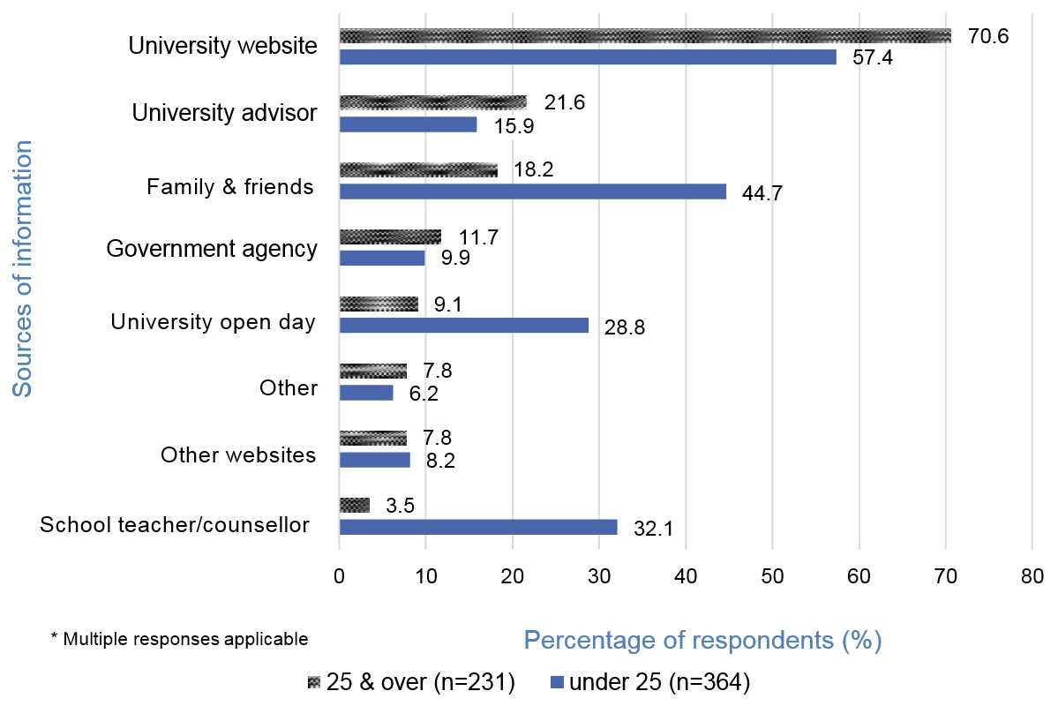
The sources of information used by students aged under 25 and those aged 25 and over regarding the costs of attending university were quite different (see Figure 23). The data reflects a natural reduction of the influence of school-based sources where a school would promote open days, host visits from university marketing personnel, and teachers would be able to advise those intending to go to university about the various expenses that may need to be considered. However, the importance of university websites for both groups was clearly highlighted.

Figure 23: Sources of information about the cost of attending university
Approximately one-third (36%) of regional students report that they gathered information by visiting a campus prior to enrolling at the university. This additional expense incurred by regional students averaged $1303 per visit, with the average costs being, for accommodation $758, travel $166, and $379 on other associated expenses. These additional expenses add further financial disadvantage to regional and remote students not experienced by their urban counterparts.

4.4 Study Load and Mode
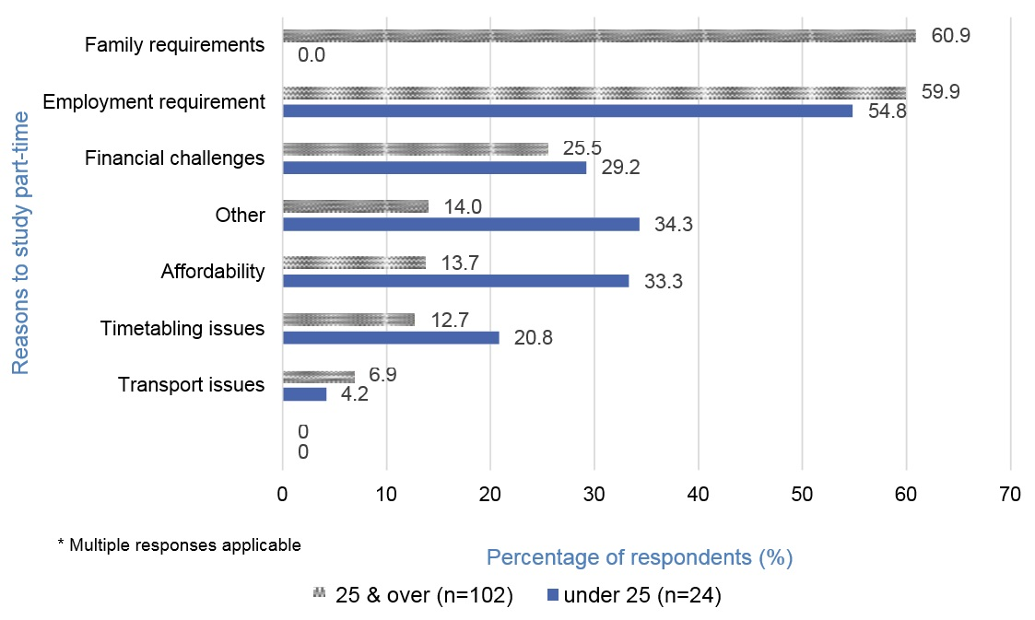
A previous study has reported that students from regional and remote areas are more likely to study part time, in comparison to metropolitan students (Baik et al. 2015). However, findings from this study are broken down to more nuanced levels and make it clear that while this is generally true of those students aged over 25 who have mostly not relocated, it is not true of those aged under 25. Receiving Youth Allowance requires that students carry a full-time study load. Figure 24 outlines the range of financial and non-financial reasons why respondents choose to study part time.

Figure 24: Reasons why regional and remote students study part-time
Over half of the respondents who are currently studying part time and indicated they were previously enrolled full time, reduced their load due to: employment requirements (30%); family requirements (22%); financial challenges (14%); timetabling issues (9%); or mental/physical health issues (6%).
With regard to study mode, previous research indicates that mature age regional and remote students are more likely to complete external university studies (Richardson & Friedman 2010). Results from this study indicate that 27% of respondents were completing their studies online, with the majority being aged over 25 years. Furthermore, 15% of regional students were completing their courses through mixed mode, including the necessity to regularly attend workshops held at a metropolitan campus. This represents a noticeably higher proportion of students travelling to attend compulsory classes, when compared with 7% of the overall university population previously reported as completing university through mixed mode (Bexley et al. 2013). This result suggests there is a subgroup of students required to deal with the financial burden of travel and accommodation to attend prerequisite face-to-face workshops at metropolitan campuses. Such costs are a hidden short-term financial cost that has not previously been identified in other research.
As universities and students continue to embrace technology-mediated learning options, the need to attend intensive workshops and seminars to engage in professional practice experiences is likely to increase in the future. Kemp and Norton (2014) in their Review of the Demand Driven Funding System made the following observations.
Despite improved student numbers at regional campuses, it is unlikely that the demand driven system will transform the economics of higher education in smaller regional centres. … Regional campuses can rarely match the range of courses and subjects or the campus life of major city universities. Smaller regional centre campuses compete on convenience and lower total study costs, by removing the need to move or travel long distances. However, in this convenience market, they face competition from improved and growing online provision. (p. 41)
Digital learning options may mean that students can study their preferred courses online, but the need to meet professional accreditation experiential learning requirements is likely to generate short-term rather than long-term relocation challenges. These challenges would be for periods of days each semester, rather than weeks (as required for placement activities) with the need for childcare, accommodation, transport and meals away from home. Income from employment may also be forfeited during these short stays away from home, exacerbating the financial burden.
Recommendation 5
Universities to consider the most efficient process for regional students attending professional practice workshops.
For Olivia, the decision to commence her Midwifery course was based on the convenience of the course being offered as mixed mode, as relocating to Adelaide was not a viable option, for various personal and emotional reasons.
I had other preferences, but they involved moving to Adelaide ... so Midwifery was my first preference studying from external studies (doing it from home), emotionally I wasn’t ready to move to Adelaide ... the commitments with my family and my partner, I wasn’t ready to move to Adelaide. Olivia
Despite not being required to relocate to Adelaide, studying mixed mode can contribute its own unique set of financial difficulties associated with attending metropolitan workshops.
I find that when they say, ‘can you be in the city on this state’ that it’s a massive drive for you to get there. It’s not a simple task to just pack up the car and go to the city for a week. I mean it’s going to cost me $1000 in accommodation next week plus the fact that I have to allow for a day to get there and a day to get home. It’s things like that ... like this last workshop that I did said, ‘oh yeah, but it’s only an hour by plane’, and it is to other major cities but when you live out here in the country ... no matter which way I’d gone ... if I’d flown then it’s an hour’s drive to Mount Gambier then an hour on the plane, and then I’d have to find a way to get from the airport to the uni. If I’d chosen to fly out of Melbourne it’s four to five hours to Melbourne and then fly. I think they need to factor that into their workshops. The next one we don’t finish until one o’clock in the afternoon, so I’ve gotta either stay an extra night in Adelaide or drive back here which is roo country. So, the chances of me hitting a roo coming home are quite high. I dunno, I just think it needs to be factored in that we are a long way ... and I’m not just looking at this area. I know some of the other girls had three to four hour drives because they live on the other side of Adelaide. Emily
Discussions in the interviews identified one possible solution that would assist overcoming some of the challenges associated with campus visits.
… organise deals with local hotels or caravan parks so that students can stay there at a discounted rate ... I rang the uni and said, ‘where’s the best place to stay?’ thinking that they might have, and she said, ‘wherever you want’… I was quite surprised that they hadn’t factored that in. That okay we’ve got three weeks of students coming so let’s go approach this motel and say, ‘what deal can you offer the students?’ Emily

4.5 Campus Location
The underrepresentation of regional and rural students in higher education continues to exist despite participation initiatives. Kemp and Norton (2014) report that the regional plus remote student enrolment share of total undergraduate student enrolments across Australia has been around 19% and 20% for the last 10 years. ‘Since the demand driven system was announced, annual enrolment growth rates for students from regional and remote areas have increased. This suggests that the participation rate is also increasing. However, there is no clear improvement in their enrolment share. This is because enrolments from students in the major metropolitan areas are increasing at a similar rate.’ (Kemp & Norton 2014, p. 41)
Data shows that 82% of respondents aged under 25 relocated and only 10.8% of students aged 25 and over relocated. This demonstrates data collection that generalises across these age groups for regional students, thus reducing the opportunity to understand the specific influences and challenges that may apply to the two distinct groups.
For regional students who relocated to study at a metropolitan campus, 86% of respondents indicated that course availability was a predominant factor. Employment opportunities (8%), social reasons (3%) and family reasons (4%) played a less significant role in student decisions to relocate (Figure 25).
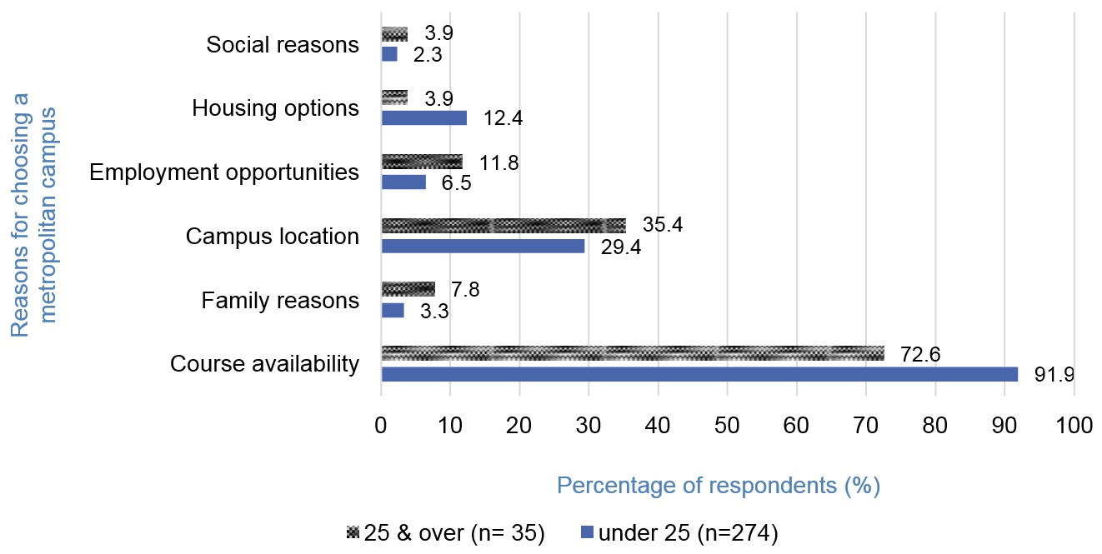

Figure 25: Reasons students elect to study at a metropolitan campus
Whilst Karen relocated to the city to study, had the course been available at a regional campus her preference would have been to remain in her hometown.
Yeah, even if it was [regional campus] I would’ve preferred that than move all the way here ... because I know they have a campus there. I would rather just go up there for a few days because it’s only a two to three hour drive and living at home and having financial support there rather than all the way over in Adelaide. Karen
The proportion of respondents studying at regional campuses (n=74) who were aged under 25 was 47% compared with 53% of respondents who were aged 25 and over. This generally reflects the standard student demographic at both UniSA regional campuses of an older student population. The gender of survey respondents studying at regional campuses is also in general alignment with regional demographic data, that is, predominately female (80–85%, n=61). Interestingly, of those studying at regional campuses only 6% indicated they were studying locally because they could not afford to relocate, with 80% indicating that the availability of their desired course locally contributed to their choice of studying locally. This is somewhat misleading, as those who could not afford to relocate and did not have a program of choice locally available would not have been surveyed.
Evidence from Polesel and Klatt (2014) suggests that for deferring students that were not captured within this survey
non-metropolitan deferrers were twice as likely to nominate the lack of courses in their local area and three times more likley to nominate the burden of leaving home as reasons for not attending university. (p. 190)
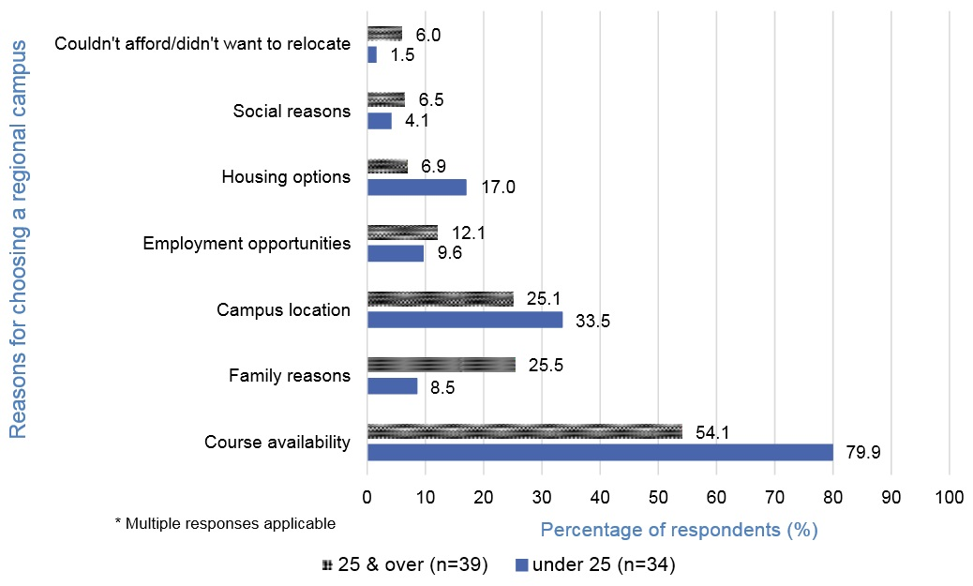
The program options available on regional campuses at UniSA are currently not extensive, with Nursing, Social Work, Education (Early Childhood), Education (Primary), Mechanical Enginering and Foundation Studies being offered, programs which tend to attract female students. The reasons why students elect to study at a regional campus are detailed in Figure 26.

Figure 26: Reasons students elect to study at a regional campus

4.6 Course Placements
In addition to the other financial impacts of university study, 35% of respondents indicated being required to temporarily relocate for the purposes of completing professional placements. In findings similar to those of Bills (2012), respondents indicated that they felt disadvantaged as a result of having to relocate for a placement, as a result of the associated financial outlay and increased stress. Figure 27 identifies different factors that present the most challenges associated with placements.
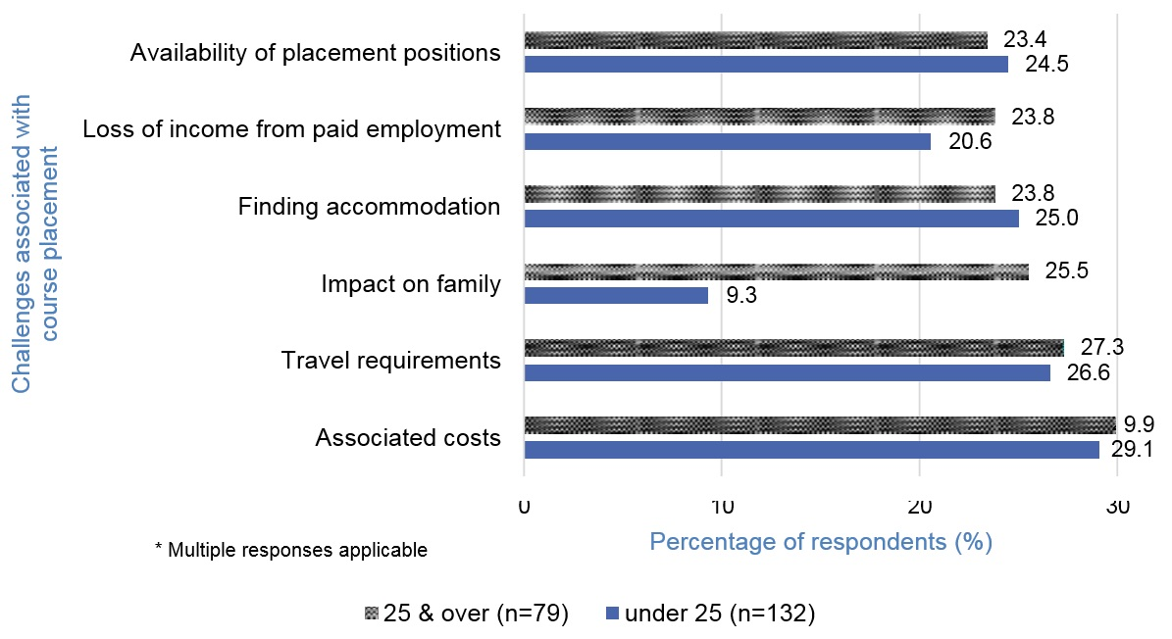

Figure 27: Challenges associated with relocating to complete professional placement
Of the most concern to regional students is the requirement to meet the associated costs of placement, which may include paying rent for two separate homes. The issue of accommodation appears to affect both regional students who have relocated to Adelaide, as well as those studying externally and who may be required to complete placement in a metropolitan location.
I’m becoming increasingly concerned because I can’t possibly afford to do 14 weeks in Adelaide ... I can’t afford that accommodation when I have four weeks at a time. Olivia
I’ve made special arrangements to cater me being a country student ... otherwise there’s no point me trying to rent two places, but I was lucky enough to be able to do two days a week and then that’ll slowly eat into my days required … Some of them couldn’t be flexible and I had to decline ... I just couldn’t do it because I needed the financial backing [from working] for when I come back to Adelaide. Daniel
A repeated theme discussed by students who were either studying at a regional campus or online, was the lack of available financial support to relocate for the purposes of completing placement.
When they have students that live a distance away from where they have to travel to placement then they should be thinking about financial grants or financial assistance, and it shouldn’t be about whether or not you’re the highest scoring student or you meet a specific criteria. It should be ... if you have to go that far then they will help us do that for that period of time. Ava
Furthermore, students recognised that information regarding available scholarships such as placement grants was provided at some stage; however, students suggested that this type of information needs to be repeated and provided in more relevant time frames to ensure students actually receive and can action these types of messages in a timely manner.
In terms of the University, they sort of mentioned about scholarships but didn’t really go much into depth. I think for rural and regional students then they need to make it more concise and clear. I understand that the information is out there ... it’s just a matter of going out and looking for it, but if you’re a first year student moving from the country to the city then you definitely need it in your face. Lily

4.7 Deferrals/Withdrawals
Whilst the decision to pursue higher education is a significant decision for a majority of regional and remote students, when to commence the journey and whether to stay once studies have commenced represent additional decisions confronting students. Taking a ‘gap year’, a one to two year break between finishing school and commencing university, is becoming increasingly popular with students (van Reyk 2012). A number of studies indicate that the reason regional and rural students take a gap year differs from those of their metropolitan counter parts, and is predominantly focused on financial reasons including saving in preparation of university or for Youth Allowance eligibility (Harvey et al. 2012; Polesel & Klatt 2014; van Reyk 2012).
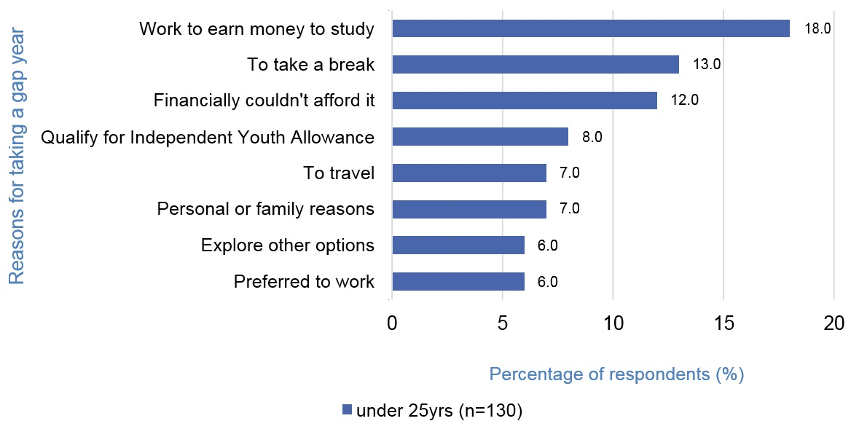
Consistent with findings reported earlier by Richardson and Friedman (2010), the results from this study indicate that 35% of respondents had taken a gap year before commencing university. The predominant reasons for them taking a gap year are financial, with a total of 38% of respondents indicating a financial reason (18% working to earn money, 12% financially could not afford university, and 8% to qualify for YA) as described in Figure 28.

Figure 28: Reasons for taking a gap year

Despite the apparent necessity to take a gap year, those students interviewed indicated that it was a positive experience and recommended that all rural students do the same.
I saved up quite a lot of money in my gap year, and it did stress me out a bit after I purchased all the necessities like furniture and the other things required. I have been managing with work and Youth Allowance ... it’s stable and I’m actually able to reduce my work hours now that I’ve earned so much, so it has been good that way. So, for anyone I would definitely recommend having a gap year ... for any rural student ... I think it’s needed. Karen
I am a big fan of gap years. I think you should try and save money if you can’t afford to pay for your child going (which most people can’t). Harry
Even for those who continued their education straight from school, indicated that in hindsight they would take a gap year not only for the purposes of earning money and qualifying for Youth Allowance, but to also provide the space and time to fully consider their career options.
Because I’d come straight from school, and in hindsight I wish I’d had the gap year to start with because I didn’t really know what I wanted to be doing anyway. So, I sort of wish I did have a gap year, because I could’ve earned money and then I could’ve got Youth Allowance ... and then it would’ve been all fine. But it didn’t work that way. Yeah, so ... in hindsight I wish I’d done that ... but I didn’t. Isla
Whilst financial reasons were a major contributing factor to regional students taking a gap year, once at university the majority of students identified personal reasons, including stress and mental health, as the predominant reason for deferring their studies. A total of 17% of respondents had deferred their university studies, with 54% citing personal reason and stress as reasons for deferring compared with 12% citing work or financial issues and 34% citing a combination of personal and financial reasons. This emphasis on personal wellbeing reflects similar findings reported by Baik et al. (2015) that indicate emotional health can significantly impact student progression and retention.
Financial stress can have significant impacts on progression of studies with 36% of respondents indicating that they had considered withdrawing from their university course, with 62% citing the combination of financial and personal reasons. A further 38% cited personal reasons only, including mental health, as a contributing factor for withdrawing. The high proportion of students indicating that financial and personal factors are combined pressures, highlights the interwoven effect that financial circumstances has with a number of other life circumstances.

4.8 Adjustment
Whilst sources such as the University website and visits to the campus provide regional students with some awareness of what relocating to university may be like, it is not until they are engaged in that transition process that the reality of the challenges associated with relocating become fully apparent. Whilst first year at university is a significant transition period for all first year university students, for regional students this period is magnified as a result of the significant cultural change of relocating to a metropolitan city. There are some similarities in the processes of adjustment that are experienced by regional students moving to cities and by international students moving to Australia for higher education. Marginson (2014) reports that international students studying in Australia expressed similar ‘cultural’ displacement issues, with students feeling isolated and having to ‘acclimatise’ to different ways of doing things. Wang (2012) also refers to the culture shock of international students, suggesting that newness to a context and loss of previous social interactions are an additional form of stress.
The following quotations from the qualitative data highlight the cultural displacement of regional students.
Big culture shock. I remember coming to O-Week and someone says just casually (you know how you do the tours around), and they’re like, ‘we’ve got 25,000 to 30,000 students on this campus’, and you sit there and think, ‘that’s like double the amount of people that is in my home town ... in the entire thing, let alone my school only had 400 students’. So, it was a shock ... it was a big shock. Emma
[Hometown] has 200 people and about 70% of them are family. It’s very busy and different ... I’m still getting used to the fact that you don’t say, ‘hello’ to every single person that you walk past, and the waving in the car ... I wave to every single person I drive past, and you get a sore wrist by the end of it ... so, there’s definitely a difference in atmosphere. Grace
The lifestyle that I used to have just completely changed. I would say it fell to pieces almost … I think the change in lifestyle is the trickiest part. Jack
Very hard (laughs). I sort of felt that in a rural community you’ve got support everywhere ... you can talk to anyone and get support. Here it’s more that you’ve gotta go out and look for it a bit harder ... it’s not immediately there for you. I also sort of felt that coming from home where you’ve got your bills and food looked after, and then you come down and you’ve got all these things that you’ve gotta sort out ... and then you’ve got uni., and so that was a really big thing. Lucy
Very hard in a lot of senses ... because everybody up there is very friendly and you know everybody ... you go into the supermarket and you’re not just there for five minutes ... you’re there for half an hour talking. A lot of people went through retrenchment as well so they understood. It’s a different culture. Willow
Isolation …
I felt quite isolated to begin with. I had no friends ... there was a new house (because I moved into a share house) so I had new house mates ... without my parents, you know. It was just ... yeah, it was very I didn’t really feel like I belonged or anything. Lily
Yeah. It was also hard because coming to uni ... people who have lived in Adelaide, it felt like they already had established networks ... there’s always someone that you know in your course, whereas for me I ... and still to this day I don’t have heaps of friends compared to what some of the other people have because they have this little network which leads onto this different network. Sophie
It’s hard to get to know people because everyone seems to already have their friendship groups because it’s not a big deal for them going to uni. They went to school two blocks over and they’re just moving over to a bigger school, so you find there’s already a lot of friendship groups established, and it’s hard to get to know people. O-Week was particularly difficult. It’s a bit difficult if you’re living in a college, but if you’re living on your own then you don’t know where you’re going or what you’re doing. Grace
I haven’t been able to meet a lot of people because I haven’t been able to make the time. I would participate in sport but I have to work to be able to survive. And the times that you have your training I have to work. Isla
In O-Week I got ridiculously lost. I could not figure out the public transport. In Year 10 we have a careers trip where they bring all the country kids over and teach us how to use busses ... it’s great. But even that ... I just got so ridiculously lost and was running late, it was boiling late ... and I just got home and collapsed ... exhausted and in tears. Grace
Driving ... because in [hometown] it’s really easy, and there’s only one two lane road ... which you don’t go down very often, so coming to Adelaide ... I still don’t feel super comfortable because there’s so much traffic, and I’ve found the lane changing heaps hard, so I catch the bus every day to uni. Sophie
I would like to be playing netball but that’s a little bit too big and scary and hard for this year, so ... I’m actually living a fair way away from uni at the moment, so hopefully next year I will live closer to uni and I can start looking into a netball club. I’ve played for the same netball club since I was five years old. Every single season without fail ... I hardly missed any games, I’ve played over 100 games. So, it was really tough ... I didn’t expect it to be so hard not playing netball for my home team. Every single one of my siblings ... my nieces and nephew have played for that team, and to be able to be sitting on Facebook and looking at photos of everyone at the footy and on the netball trip ... it is tougher than I thought it would be missing out on all that. Grace
Sometimes it’s tough when you’re in a class and everyone seems to know each other from high school and you know literally no one. Finding sporting clubs is something that I’ve found difficult. In my home town it’s very sports orientated ... if you want to play sport you can do it so easily. Whereas I moved here and I don’t really know how to go about it. Harry
Since I’ve moved to Adelaide I haven’t been involved in sport, and I haven’t really known which club to play for or anything like that. Isla
Learning to be independent …
I think just moving out of home ... and I feel like I’m still quite young to be moved out of home because a lot of my friends who live in Adelaide haven’t moved out ... because they haven’t needed to, so I think just being able to budget your money and make sure that you’re paying your rent on time, and making sure you have enough money to see you through the week ... and then knowing what activities you can do. I think that’s just a bit stressful, and because with the Centrelink money is not quite enough to put you through for the week, so you have to somehow make sure that you’re getting that little bit extra so you can pay for your board. Regina
You have to do all the cooking and everything on your own which is sometimes hard to find the time to do when you’re at uni ... and even doing washing and stuff like that ... I never did that at home. I never changed my sheets or anything like that ... I always had someone to do it for me. Sophie
Despite the challenges, though, a number of interviewees identified that it was a process that helped them to develop and grow.
It’s challenging because everything is so different once you move to a city. It was definitely a challenge, but it was also eye opening ... so it was challenging in a good way. It helped me to grow into a person, but you do lose ... I guess there’s really a big sense of community at home where everyone knows everyone, and you all help each other out ... and in Adelaide that’s a little bit different because you don’t just know everyone as soon as you get here ... you have to expand your own networks. But then when you do go home everyone questions how you’re going with uni, and it’s really positive for you because you’ve gone out and done something away from home ... and then you can come back and they’re all proud of you. Regina
Recommendation 6
Universities to consider how best to assist regional students’ transition to university and sense of connection with university life.

5. Study Limitations
Limitations of this project can be associated with the timing of data collection that occurred during mid-year, and the level of financial stress and mean income may have varied from earlier in the year due to problems associated with applying and receiving government income support.
Whilst this study targeted both undergraduate and postgraduate regional students, the limited number of postgraduate respondents is acknowledged as a limitation of this study. The low postgraduate response rate may be attributed to a number of factors, including: the number of regional students that continue on to postgraduate studies; and the length of time spent away from their rural home completing undergraduate studies may result in a number of postgraduate students, originally from regional areas, no longer identifying themselves as regional students.
There is also a hidden data set for students whom have not enrolled in higher education. For the potential learners where higher education financial commitments was perhaps a ‘bridge too far’ or whom have withdrawn from studies because the complexities were too stressful to manage, no data has been captured.

6. Conclusions
This study addresses a gap in knowledge about the financial circumstances of regional students studying in higher education by collecting evidence across a whole institution, the University of South Australia, for commencing, continuing and postgraduate students. However, determining and defining regionality can be challenging, with government departments and universities having variable interpretations based on evolving criteria, making comparisons difficult over time. We suggest that the creation of a higher education rural mapping system that allows a regional student’s home address to be mapped to their applicable university campus, can provide a more equitable mechanism for determining eligibility for various government and university financial support mechanisms.
Evidence gathered via survey and individual student interviews demonstrates that regional students are not a homogenous group and presentation of data across two categories, under 25 years of age and 25 years of age, with both categories further disaggregated by relocation status, has proved to be an informative mechanism for presenting evidence. The most significant demographic data that this approach has clarified is that 82% of regional students aged under 25 relocated for study purposes and only 10.8% of student aged 25 years and over relocated for study purposes. Also of significance is that 46.7% (almost half) of the under 25 grouping of students received Youth Allowance (YA), which means that more than half did not. This seems to support findings from the Universities Australia 2012 national study of domestic and international students that indicate a ‘polarization between the “haves” and “have-nots”’ (Bexley et al. 2013, p. 7), with the financial situations of university students being far from homogenous (Bexley et al. 2013; Halliday-Wynes & Nguyen 2014). Qualitative data from student interviews reflected similar extremes, with some students obviously distressed as they emotionally recalled transition issues and others who found the journey less stressful but still a challenge.
With 46.7% of regional students under aged 25 receiving YA, achieving eligibility for YA will have significant impacts on participation in higher education. However the process of achieving eligibility may work in conflict with government aims of increasing participation amongst regional students. Students may delay tertiary study for up to 18 months in order to meet the full-time work criterion for independence. This could prove to be a difficult task in what is a highly competitive job market for unskilled workers. Our evidence show 35% of respondents took a gap year for a variety of reasons and the findings of Polesel and Klatt (2014) conclude that regional school completers are twice as likely to defer as city-based school completers, with regional students who are able to qualify for YA much more likely to take up their university place.
In addition to YA, scholarships are a significant enabler for regional students attending university, particularly for those aged under 25 who have relocated. Government and university scholarships can bridge the significant ‘start-up’ costs of going to university and this form of supplement to income will continue to be an important form of support that allows for strategically targeting those regional students in most need.
There were a number of emerging areas of concern highlighted by findings in this study. The first relates to the high levels of financial stress being experienced by all regional students and more significantly by relocating students. While all students who commence higher education undergo some form of transition the additional layers of transitioning influences that come from moving away from established networks add to the challenges of that transition. Being disconnected from family, social, employment and sporting contacts combined with a city-based culture with a high degree of anonymity is likely to be a very different experience for regional students. Another layer of complexity comes from learning to be independent, with the need to manage living environments (that are often more expensive than anticipated) while also allowing for time to rebuild networks.
There are subtle connections between each of the layers that often have indirect financial consequences and require a young adult to become very efficient in time management and in recognising the opportunity cost of not being able to effectively address all needs at once. Managing choices about how to spend time will also have implications on study, and potentially on study outcomes. The expectation (real or imagined) of having the capability to efficiently and effectively manage the layers of complexity is perhaps another contributor to stress. Stress levels in mature age students is also significant with those relocating and balancing, carer responsibilities, with work, study and living demands being the most stressed of all respondents 66.7% of students relocating students 25 years and over are highly stressed and another 20.8% being moderately stressed.
Generally one third of mature age students are receiving some form of government benefits with clarity about reported income and expense levels being somewhat clouded because of the difficulty of isolating the impacts of shared living costs with partner income and expenses.
The stress levels identified in this study reflect broad student groups that includes commencing continuing and postgraduate regional students. Stress levels reported in this study are not directly comparable with other studies as the student profile of those being surveyed in previous studies are varied. However, data suggests that stress levels are rising. An avenue for further research is to survey alumni to determine ex-post how stress levels impact regional student performance, and retention.
A second emerging area of concern for students who are studying at regional locations, online or in mixed modes, is the cost of attending metropolitan workshops and compulsory professional practice classes. The need to find and afford short stay accommodation, together with the associated stresses of needing to travel and be away from home and jobs can be challenging. This type of short stay can mean that students are paying rent on their home and another layer of accommodation, both at the same time. As technology-mediated learning opportunities increase, there is likely to be a corresponding increase in the need for professionally accredited programs to have such practice based workshops. Developing creative solutions to assist students with such challenges may be a useful emerging support initiative however research to understand the extent of the issue is another avenue for further research. Universities can proactively recognise and assist with logistical issues to ensure that the costs of regional student participation in such workshops is as efficient and effective as possible. This could form part of a regional student website or Facebook page to assist with regional student transition and assimilation issues.
This study has confirmed that for regional students participating in higher education there are significant transitional challenges. It is also clear that the journey to higher education for relocating regional students involves a significant cultural shift from a way of life that is quite different form living in a metropolitan location. However, interviews also revealed a strong degree of resilience for those who are continuing their studies and have passed through the transition stage. The personal journeys that were shared demonstrated a strong commitment to learning and also that regional student support structures are very much appreciated and needed.

7. References
Alston, M & Kent, J 2009, ‘Generation X-pendable The social exclusion of rural and remote young people’, Journal of Sociology, vol. 45, no. 1, pp. 89–107.
Australian Bureau of Statistics (ABS) 2002, Year Book Australia: Household Income, Living Standards and Financial Stress, cat. no. 1301.0, ABS, Canberra.
Australian Bureau of Statistics (ABS) 2011a, Australian statistical geography standard (ASGS): Volume 5 Remoteness structure, cat. no. 1270.0, ABS, Canberra.
Australian Bureau of Statistics (ABS) 2011b, Perspectives on Regional Australia: Housing Arrangements – Rental Rates in Local Government Areas, Cat. no. 1380.0.55.013, ABS Canberra.
Baik, C, Naylor, R & Arkoudis, S 2015, The first year experience in Australian universities: Findings from two decades 1994–2014, Melbourne Centre for the Study of Higher Education, Melbourne.
Bexley, E, Daroesman, S, Arkoudis, S & James, R 2013, University student finances in 2012: A study of the financial circumstances of domestic and international students in Australia’s universities, Universities Australia, Canberra.
Bills, D 2012, Raising the participation and success of rural students in higher education: A longitudinal impact study of the Rural Connect Project at the University of South Australia, University of South Australia, Adelaide.
Blainey, G 1967, The tyranny of distance: How distance shaped Australia’s history, Macmillan, Melbourne.
Bradley, D, Noonan, P, Nugent, H & Scales, B 2008, Review of Australian higher education: Final report, Department of Education, Employment and Workplace Relations, Canberra.
Dow, K 2011, Review of student income support reforms, Department of Education, Employment and Workplace Relations, Canberra.
Fleming, M & Grace, D 2014, ‘Increasing participation of rural and regional students in higher education’, Journal of Higher Education Policy and Management, vol. 36, no. 5, pp. 483–495.
Godden, N 2007, Regional young people and youth allowance: Access to tertiary education, Centre for Rural Social Research, Wagga Wagga.
Halliday-Wynes, S & Nguyen, N 2014, Does financial stress impact on young people in tertiary study?, LSAY Research Report 68, National Centre for Vocational Education Research, Adelaide.
Harvey, A & Andrewartha, L 2013, ‘Dr Who? Equity and diversity among university postgraduate and higher degree cohorts’, Journal of Higher Education Policy and Management, vol. 35, no. 2, pp. 112– 123.

Heagney, M 2010, Beyond Bradley: Equity for postgraduates, Australasian Association for Institutional Research Conference, Geelong, 10 November, viewed July 2015 http://www.aair.org.au/app/webroot/media/pdf/AAIR%20Fora/ Forum%202010/ 21Heagney.pdf.
James, R, Krause, KL & Jennings, C, 2010, The First Year Experience in Australian Universities: Findings from 1994 to 2009, Centre for the Study of Higher Education, the University of Melbourne and Griffith Institute for Higher Education, Griffith University.
Kemp, D & Norton, A 2014, Review of the demand driven funding system: Final report, Department of Education and Training, Canberra.
Krause, K, Hartley, R, James, R & McInnis, C 2005, The first year experience in Australian universities: Findings from a decade of national studies, Centre for the Study of Higher Education, University of Melbourne, Melbourne.
Lewis, C, Dickson-Swift, V, Talbot, L & Snow, P 2007, ‘Regional tertiary students and living away from home: A priceless experience that costs too much?’, Australian Journal of Social Issues, vol. 42, no. 4, pp. 531–547.
Marginson, S 2014, ‘Student Self-Formation in International Education’, Journal of Studies in International Education, vol. 18, no. 1, pp. 6–22.
National Rural Health Alliance and ACOSS 2013, 'A snapshot of poverty in rural and regional Australia', accessed 3 February 2016 http://ruralhealth.org.au/documents/publicseminars/2013_Sep/Joint-report.pdf.
Norton, A & Cherastidtham, I 2014, Mapping Australian higher education 2014–15, Grattan Institute, Melbourne.
Pagnini, D, Stylianou, M, Kok, B & Johnson, D 2014, Towards a performance measurement framework for equity in higher education, Australian Institute of Health and Wellbeing, Canberra.
Polesel, J 2009, ‘Deferring a university offer in rural Australia’, Australian Journal of Education, vol. 53, no. 1, pp. 87–103.
Polesel, J & Klatt, M 2014, ‘University deferrers in metropolitan and non-metropolitan Victoria: A longitudinal study’, Australian Journal of Education, vol. 58, no. 2, pp. 182–194.
Richardson, S & Friedman, T 2010, Australian regional higher education: Student characteristics and experiences, Australian Council of Educational Research, Melbourne
Senate Rural and Regional Affairs and Transport References Committee 2009, Rural and regional access to secondary and tertiary education opportunities, Government Printer, Canberra.
Townsend, R 2010, ‘Developing 21st century diverse adult learning: Rural and regional student sccess, progression and success in higher education’, The International Journal of Learning, vol. 17, no. 2, pp. 329–341.
van Reyk, P 2012, Under the radar: The impact of housing on the access of regional students to higher education in Sydney, Shelter NSW and Yfoundations, Sydney.
Wang, J 2012, ‘A journey of intercultural and learning adaptation: International students learning experiences at one Australian university’, International Journal of Asian Social Science, vol. 2, no. 7, pp. 1140–1150.
Wilks, J & Wilson, K 2012, ‘Going on to uni? Access and participation in university for students from backgrounds of disadvantage’ Journal of Higher Education Policy and Management, vol. 34, no. 1, pp. 79–90.

Appendix A

Summary or Originating Rural and Remote Locations of Participants
ASGS Classification | Town | Postcode

Inner Regional
 | Victor Harbor | 5211
 | Goolwa | 5214
 | Kersbrook | 5231
 | Gumeracha | 5233
 | Younghusband | 5238
 | Lobethal | 5241
 | Woodside | 5244
 | Verdun | 5245
 | Mount Barker | 5251
 | Murray Bridge | 5254
 | Strathalbyn | 5255
 | Lyndoch | 5351
 | Tanunda | 5352
 | Cambrai | 5353
 | Nuriootpa | 5355
 | Truro | 5356
 | Greennock | 5360
 | Eudunda | 5374
 | Woolsheds | 5400
 | Tarlee | 5411
 | Rhynie | 5412
 | Balaklava | 5461
 | Dublin | 5501
 | Mallalla | 5502
 | Port Wakefield | 5550

Outer Regional
 | Coonawarra | 5263
 | Bordertown | 5268
 | Naracoorte | 5271
 | Millicent | 5280
 | Mount Gambier | 5290
 | Loxton | 5333
 | Renmark | 5341
 | Monash | 5342
 | Berri | 5343
 | Barmera | 5345
 | Burra | 5417
 | Peterborough | 5422
 | Orroroo | 5431
 | Quorn | 5433
 | Spalding | 5454
 | Blyth | 5462
 | Gladstone | 5473
 | Laura | 5480
 | Bangor | 5481
 | Wepowie | 5482
 | Jamestown | 5491
 | Snowtown | 5520
 | Port Broughton | 5522
 | Crystal Brook | 5523
 | Port Pirie | 5540
 | Kadina | 5554
 | Wallaroo | 5556
 | Moonta Bay | 5558
 | Bute | 5560
 | Ardrossan | 5571
 | Maitland | 5573
 | Point Turton | 5575
 | Curramulka | 5580
 | Whyalla | 5600/08
 | Port Augusta | 5700

Remote
 | Kangaroo Island | 5223
 | Lameroo | 5302
 | Yorketown | 5576
 | Stansbury | 5582
 | Cowell | 5602
 | Arno Bay | 5603
 | Port Lincoln | 5606
 | Cummins | 5631
 | Cleve | 5640
 | Kimba | 5641
 | Murlong | 5642
 | Roxby Downs | 5725

Very Remote
 | Wudinna | 5652
 | Mount Damper | 5654
 | Wallala | 5661
 | Elliston | 5670
 | Streaky Bay | 5680
 | Ceduna | 5690
 | Leigh Creek | 5731

Appendix B

Interview Questions and Prompts
1. Do you recall what prompted you to volunteer to be interviewed?
- Indicative prompt:
  - Was there a question or section in the survey that you may have wanted to expand on?
2. Can you tell me tell me about your ‘journey’ to university?
- Indicative prompts:
  - Why did you initially want to go to university?
    - Can you recall what types of preparations you and your family had to make and when you made those?
    - What was your family’s response to your decision to go to university?
    - How was the experience of leaving your rural community to go to university?
3. I understand that you’re currently completing [program] and this was your [first/other] choice, when did you decide to pursue study in that area?
- Had other courses been available and offered, do you think you may have chosen a different program?
- If applicable – you’ve indicated that your study involves doing placement activities; do you anticipate any challenges associated with completing this placement?
4. Can you think of any particular challenges that you may have had at the university that resulted from you being a regional student?
- Indicative prompts:
  - Engagement in sporting and/or social activities?
  - Sense of belonging (are comfortable) in your new environment?
  - Social support?
5. In your responses to the survey you indicated that you were [applicable level] financially stressed and I want to explore that a little further, what factors contribute towards that rating?
- Indicative prompts:
  - What are your concerns? What impact does that have on your mental and physical health?
  - How do you and your family deal with the financial cost?
  - Reference to specific comments and responses within the survey and any apparent incongruities.
  - If applicable – you indicated that you receive/don’t receive government income support (e.g. Youth Allowance, ABSTUDY). How has receiving (or not receiving) income support affected your capacity to cope financially?

6. We are interested in understanding how rural students balance work, both paid and unpaid, with study.
- If applicable – how does (did) your employer respond to your decision to go to university?
- Did you need to find another job?
- Does your paid job impact on your study and how?
- If applicable – you indicated that you also do [unpaid work for family and friends/seasonal work]; are you able to tell me a little bit more about that?
7. If you were to offer any advice or implement different support systems for rural university students what would be your advice for:
- A rural student starting university?
- Family/parents/carers of a rural student contemplating/starting university?
- Centrelink or associated government agencies responsible for providing assistance to rural students?
- University policymakers or academic staff?
- In hindsight to yourself? Things that you would do differently?
8. What are your plans after you have completed your current degree?
- Do you have any plans to return to a rural location after university?
9. Is there anything else you would like to add about the financial circumstances of rural students?

Appendix C

Interviewee Demographics
Pseudonym | Gender | Age group | Rural classification | Field of study | Location status
Charlotte | F | Under 25 | Outer regional | Law and Legal Studies | Relocated
Olivia | F | Under 25 | Outer regional | Nursing and Midwifery | Non-relocated
Jasmine | F | Under 25 | Remote | Psychology, Social Work and Human Services | Relocated
Grace | F | Under 25 | Remote | Psychology, Social Work and Human Services | Relocated
Sophie | F | Under 25 | Remote | Psychology, Social Work and Human Services | Relocated
Mia | F | Under 25 | Inner regional | Communication, International Studies and Language | Relocated
William | M | Under 25 | Outer regional | Education | Non-relocated
Lily | F | Under 25 | Outer regional | Communication, International Studies and Language | Relocated
Zoe | F | Under 25 | Remote | Media Arts, Digital Design and Marketing | Relocated
Ruby | F | Under 25 | Outer regional | Law and Legal Studies | Relocated
Isla | F | Under 25 | Outer regional | Psychology, Social Work and Human Services | Relocated
Harper | F | Under 25 | Inner regional | Communication, International Studies and Language | Relocated
Isabella | F | 25 & over | Outer regional | Psychology, Social Work and Human Services | Relocated
Violet | F | 25 & over | Outer regional | Nursing and Midwifery | Non-relocated
Willow | F | 25 & over | Remote | Psychology, Social Work and Human Services | Relocated
Ella | F | 25 & over | Outer regional | Accounting, Finance and Economics | Non-relocated
Anna | F | 25 & over | Outer regional | Psychology, Social Work and Human Services | Non-relocated
Sam | M | 25 & over | Outer regional | Education | Relocated
Jack | M | 25 & over | Inner regional | Art, Architecture and Design | Relocated
Ava | F | 25 & over | Outer regional | Psychology, Social Work and Human Services | Non-relocated
Adam | M | 25 & over | Inner regional | Information Technology | Relocated
Katarina | F | 25 & over | Inner regional | Psychology, Social Work and Human Services | Non-relocated
Emma | F | 25 & over | Remote | Rehabilitation, Health and Sports Science | Relocated
Emily | F | 25 & over | Outer regional | Nursing and Midwifery | Non-relocated
Lisa | F | 25 & over | Remote | Nursing and Midwifery | Non-relocated
Zara | F | Under 25 | Inner regional | Nursing and Midwifery | Relocated
Sienna | F | Under 25 | Outer regional | Rehabilitation, Health and Sports Science | Relocated
Lucy | F | Under 25 | Inner regional | Rehabilitation, Health and Sports Science | Relocated
Ben | M | Under 25 | Outer regional | Construction Management | Relocated
Harry | M | Under 25 | Remote | Tourism, Sports and Events | Relocated
Regina | F | Under 25 | Remote | Rehabilitation, Health and Sports Sciences | Relocated
Matt | M | Under 25 | Very remote | Accounting, Finance and Economics | Non-relocated
Karen | F | Under 25 | Remote | Art, Architecture and Design | Relocated
Daniel | M | Under 25 | Outer regional | Engineering | Relocated
Megan | F | Under 25 | Outer regional | Education | Relocated
Thomas | M | Under 25 | Outer regional | Psychology, Social Work and Human Services | Non-relocated
Jenna | F | Under 25 | Outer regional | Nursing and Midwifery | Relocated

Using DIISRTE analysis of 2011 census data using the MCEETYA definition of regionality in the Kemp & Norton Review 2014, Table 18.
Previously the Australian Vice Chancellors’ Committee (AVCC).
Social Security Act 2015 (Commonwealth).
Where respondents did not provide their regional postcode to enable their ASGS classification to be determined, students were able to be confirmed as regional based on survey responses and comments.
Includes respondents doing mixed mode.
Social Services Legislation Amendment (More Generous Means Testing for Youth Payments) Bill 2015.
Previously the Australian Vice Chancellors’ Committee (AVCC)

