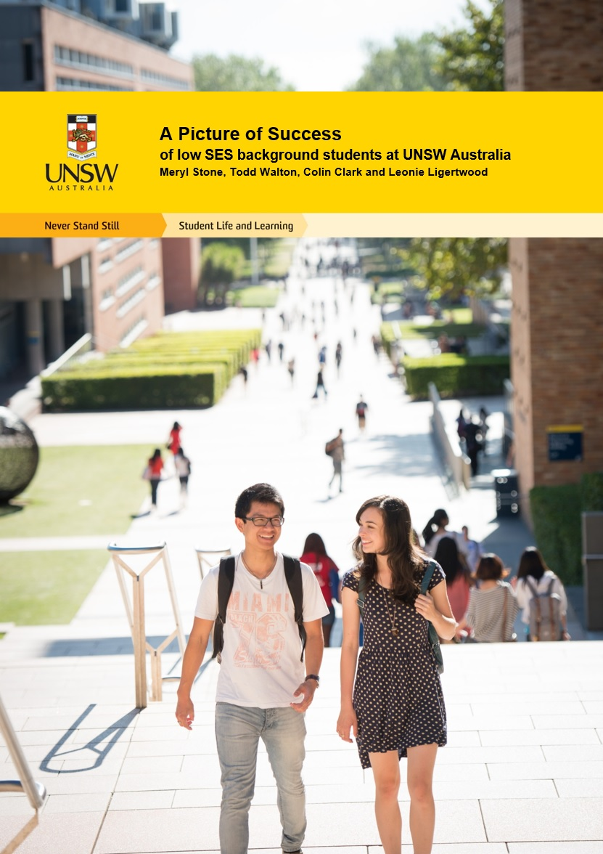

A Picture of Success

Of Low SES Background Students at UNSW Australia

Ms Meryl Stone
Dr Todd Walton
Dr Colin Clark
Ms Leonie Ligertwood

The project that resulted in the production of this report was funded under a National Priorities Pool (Higher Education Participation and Partnerships Program) grant from the Commonwealth. The recipient of the grant has granted the Commonwealth the right to sub-licence the material in this report. Copyright in the report remains with the original copyright owners.
Except where otherwise indicated, and save for any material protected by a trade mark, the Department of Education and Training, acting on behalf of the Commonwealth, has applied the Creative Commons Attribution 4.0 International Licence.

Modifications: Changed to meet WCAG 2.0 accessibility requirements.
Alternate text inserted for all images. Minor typographical errors corrected.

Acknowledgements
The research team would like to thank the Australian Government Department of Education and Training for providing the funding for this project via the Higher Education Participation and Partnerships Program 2014 National Priorities Pool. Many thanks also go to the staff across the division of UNSW Student Life and Learning who not only provided the data which proved critical to the project, but their time, interest and encouragement. We also acknowledge UNSW Business Reporting and Intelligence for granting access to the Student Information Management System and David Waters for his vital assistance in getting the project off the ground.

Contents
Acknowledgements 3
List of Figures 6
Executive Summary 8
Project Objectives 10
Project Background and Context 11
Low SES Students as an Equity Group 11
Low SES Student Engagement with Support Initiatives 12
Evidence for the Efficacy of Support Initiatives for Low SES Students 13
The UNSW Australia Context 14
The Learning Centre 15
Disabilities Services 15
UNSW Advantage 15
Careers and Employment 15
Counselling and Psychological Services (CAPS) 16
Educational Support Service 16
Methods 17
Database 17
Data Sources 17
Defining Student Success Indicators 19
Data Confidentiality 21
Data Manipulation 21
Data Analysis 23
Multilevel Modelling 23
Data Reporting 25
Questionnaire 25
Design 25
Participants 27
Data Collection and Analysis 27
Interview 28
Design 28
Participants 28
Data Collection and Analysis 28
Results 30
Building a Picture of Success 30
Demographics and Academic Success 30
Issues Impacting Success 33
Investigating the Relationship Between Success and Interaction 36
The Learning Centre 37
Disability Services 42
UNSW Advantage 45
Careers and Employment 50
UNSW Counselling and Psychological Services 54
Educational Support Service 60
Creating a Resource for Future Research 64
Discussion 69
Project Limitations, Implications and Future Research 75
References 77
Appendices 85
Appendix 1: Syntax for Coding Multilevel Models in SAS 85
Appendix 2: Multilevel Model Results 86
Appendix 3: Student Questionnaire 90
Appendix 4: Questionnaire Participant Information Statement 97
Appendix 5: Interview Schedule 99
Appendix 6. Interview Participant Information Sheet and Consent Form 101
Appendix 7: Database Results for Low SES Students and All Students 106

List of Figures
Figure 1: Conjecture in literature surrounding measures of SES 19
Figure 2: Join query for academic, demographic and interaction data. 21
Figure 3: Splitter procedure with final output table on the far right. 22
Figure 4: A comparison of demographic and academic indicators for low
and high SES students. 31
Figure 5: Low SES access, participation and completion rates by year. 32
Figure 6: Retention ratios by year (retention ratio = low SES retention rate/high
SES retention rate). 32
Figure 7: Breakdown of high and low SES students by faculty. 32
Figure 8: Severity of issues by SES. 33
Figure 9: Participation rates of low SES students at TLC consultations and workshops. 37
Figure 10: Mean WAM before and after initial interaction with a Peer Writing Assistant. 38
Figure 11: Comparison of ATAR and WAM at completion for students interacting
with a Peer Writing Assistant. 38
Figure 12: Mean WAM before and after initial interaction with a TLC workshop. 40
Figure 13: Comparison of ATAR and WAM at completion for students interacting
with a TLC workshop. 41
Figure 14: Participation rate of low SES students at Disability Services. 42
Figure 15: Comparison of ATAR and WAM at completion for students registering
with Disability Services. 43
Figure 16: Discontinuation rates comparing students who registered with Disability
Services and students who did not register. 44
Figure 17: Participation rate of low SES students in Advantage programs. 46
Figure 18: Mean WAM before and after completing an Advantage program. 47
Figure 19: Comparison of ATAR and WAM at completion for students completing
an Advantage program. 47
Figure 20: Participation rates of low SES students at Careers consultations
and workshops. 50
Figure 21: Mean WAM/academic standing before and after initial interaction
with a Careers consultation. 51
Figure 22: Comparison of ATAR and WAM at completion for students interacting
with a Careers consultation. 51
Figure 23: Mean WAM/academic standing before and after initial interaction
with a Careers workshop. 53
Figure 24: Comparison of ATAR and WAM at completion for students interacting
with a Careers workshop. 53
Figure 25: Participation rates of low SES students at CAPS consultations and workshops. 54
Figure 26: Comparison of ATAR and WAM at completion for students interacting
with a CAPS consultation. 55
Figure 27: Discontinuation rates of students who interacted with a CAPS
consultation and students who did not interact. 56
Figure 28: Mean WAM before and after initial interaction with a CAPS workshop. 58
Figure 29: Mean academic standing before and after initial interaction with a
CAPS workshop. 59
Figure 30: Comparison of ATAR and WAM at completion for students interacting
with a CAPS workshop. 59
Figure 31: Discontinuation rates comparing students who interacted with CAPS
workshop and students who did not interact. 60
Figure 32: Participation rates of low SES students at ESA consultations. 61
Figure 33: Comparison of ATAR and WAM at completion for students interacting
with an ESA. 62
Figure 34: Mean WAM/ academic standing before and after initial interaction
with an ESA. 62
Figure 35: Preparation of demographic (left) and academic (right) variables
for data source construction. 66
Figure 36: Screenshot indicating database locations in splitter process flow
within data source project. 68

Executive Summary
This project engaged a mixed-method approach to present a more complete picture of the success of low socioeconomic status background (low SES) students at UNSW Australia. Specifically, it explored how the success of low SES students was impacted by their interaction with support initiatives offered by the division of Student Life and Learning (SLL). Findings show that SLL support initiatives contribute in multiple and diverse ways to low SES student success and that this diversity is a function of the distinct service missions of each provider.
The Learning Centre and Disability Services are primarily operated to help students succeed academically and results from the study showed that low SES students who had interacted with these services demonstrated improved academic success. This was evidenced by students who had attended a consultation at The Learning Centre achieving significantly improved grades after interaction and significantly higher average grades at graduation. Low SES students who registered with Disability Services also graduated with significantly higher grades than those that did not, despite their lower ATARs at entry.
UNSW Advantage programs offer students the opportunity to broaden their skills through professional development and volunteering opportunities. The low SES students who had completed an Advantage program showed significantly improved grades after interaction and significantly better grades at graduation. Narrative analysis of student interview data linked improved social engagement via development opportunities to improved academic performance.
A Careers consultation served to significantly increase low SES student grades at program completion. Student testimony identified improved career clarity after interaction, which has been shown in previous studies (Dennis et al., 2005; Evans et al., 2011) to improve academic performance. Results from the questionnaire demonstrated that low SES groups found Careers consultations significantly more helpful than their high SES peers and interview findings provided further evidence for this, with testimony linking enhanced benefit from the Careers service to low socioeconomic status.
Low SES students seeking assistance from a Counsellor had significantly lower grades after interaction. These results may be a function of the severity of mental health issues in the low SES group, rather than an indication of the effectiveness of the intervention, with previous studies (for example Ng et al., 2014) describing an established link between SES and mental health. However, low SES students who interacted with a counsellor were no more likely to discontinue and did not graduate with grades significantly lower than their peers.
Academic success indicators for low SES students interacting with Educational Support Advisors suggest that these are the most ‘at risk’ cohort in the study – they had the lowest grades at completion and lowest ATAR at entry of any interacting group. Regardless, there was a significant improvement in their academic standing after interaction, suggesting that this intervention was effective in improving academic success for this cohort.
A further outcome of the study was the creation of a flexible and updateable source of demographic and academic student data. This data source can be used for future studies, research and evaluation across the Division.
These outcomes provide evidence on the effectiveness of higher education support initiatives for low SES students. It is envisaged that these findings be shared across the sector to inform future decision making and policy development, and to encourage further research, discussion and collaboration.

Project Objectives
The purpose of this project was to examine the success of low SES background students at UNSW Australia and investigate the impact that student interactions with support initiatives had on this success. From this broad research objective, three key thematic aims were identified:
- Present a more complete picture of the academic success of students from low SES backgrounds at UNSW
- Determine any correlation between, or patterns in, low SES student success and interaction with support initiatives
- Create a robust source of data and evidence for future research, evaluation and policy development.
An integrative qualitative and quantitative methodological framework was designed in order to address these aims. This approach combined student information from service providers and from the UNSW Student Information Management System (SIMS) with questionnaire and interview data. The combined data were used to map the profile of students from low SES backgrounds, their demographic variables, academic outcomes and interactions with student support initiatives. Inter-relationships between socioeconomic status, academic success, and interaction with support initiatives were then investigated.
A database incorporating the information gathered throughout the life of the project was established for future use, as explicated by the third project aim. The database contains student academic and demographic data in a reportable and ready-to-update format. Details on the development of the database can be viewed in the final results chapter (p.45).

Project Background and Context
This section frames the project in the context of recent and relevant literature within the field. A case is put forward for the significance of the current research, describing gaps in current knowledge and the subsequent need for this study.

Low SES Students as an Equity Group
In 1990, the Australian Government released a discussion paper titled A Fair Chance for All (Dawkins, 1990, p2), which defined the overall national equity objective for higher education “to ensure that Australians from all groups in society have the opportunity to participate successfully in higher education.” Dawkins (1990, p2) proposed that “this will be achieved by changing the balance of the student population to reflect more closely the composition of society as a whole.”
A Fair Chance for All identified six target equity groups including “people from socio-economically disadvantaged backgrounds” – now referred to as low-socioeconomic status (low SES). This paper also set out objectives, targets and strategies for achieving equity that were embedded in higher education policy over the next two decades. Following this, in 2008 the Australian Government commissioned The Bradley Review (Bradley et al., 2008) into higher education, which had a strong focus on investigating equity group participation and performance in Australian universities. The Bradley Review found that students from low SES backgrounds were still under represented in higher education, and the response paper Transforming Australia’s Higher Education System set a target of 20 per cent undergraduate enrolment of low SES students by 2020. Despite the low participation rates, Bradley et al. (2008) found that the success rates of students from low SES backgrounds were high – 97 per cent of those of their higher SES peers. This has since been confirmed in separate research by Gale and Parker (2013); and Naylor et al. (2013).
However, “low SES students face particular challenges in undertaking university study”, regardless of their success (Devlin and O’Shea, 2012, p385). James et al. (2010) found that first-year students from low SES backgrounds were more likely than their higher SES peers to admit difficulty comprehending material and adjusting to teaching styles within the university environment. Citing Lawrence (2005), Devlin (2013a) explains that low SES students may lack certain cultural capital or familial experiences (with universities) that can be drawn upon to help decode newly encountered university-specific discourses. McIntyre et al. (2012, p110) comment that “for some [low SES] students, engagement with the university experience resembles travelling to another country”. The culture of the institution can be foreign, alienating and uninviting (Krause, 2006), and low SES students may fear they lack the social and cultural capital required to navigate university (Forsyth and Furlong, 2003; McIntyre et al., 2012). If low SES students do not experience a sense of belonging, they are less likely to engage and, as a corollary, less likely to succeed (Kift and Nelson, 2005; Devlin et al., 2012).
McIntyre et al. (2012, p110) explain that the difficulties low SES students can encounter extend to the social networks that provide avenues for participating in “casual out-of-class conversations and the appropriate literary skills necessary to navigate their way through the complex university terrain”. Devlin et al., (2012, p7) add “the tacit expectations inherent in university practices are within a sociocultural subset that is peculiar to the upper socioeconomic levels”. Unless these implicit expectations are made explicit, they may operate to exclude low SES students who are not familiar with the norms and discourses of higher education (Devlin et al., 2012; Devlin, 2013a). Furthermore, Devlin and McKay (2014, p97) debate the notion of the low SES student as ‘the problem’, contesting “that a deficit conception of the institutions into which these students transition is equally limited”.
Regardless of the contributing factors to the difficulties faced in higher education, access without support does not constitute real opportunity for low SES students. (cf Tinto, 2008; White, 2011; Devlin, 2013b; French et al., 2014)

Low SES Student Engagement with Support Initiatives
The importance of providing support initiatives for all students is echoed in both national (Glaser et al., 2006; Harvey and Luckman, 2014) and international contexts (Belot et al., 2007; Crosier et al., 2007; Lesik, 2007; Biktimirov and Klassen 2008; Denny et al., 2014). Crosier et al. (2007, p47) write:
“Student services such as academic guidance, career services, accommodation, psychological counselling and welfare services, play an increasingly important role…they provide students with the infrastructure to navigate through higher education in the best possible way”.
In addition, the significance of these support initiatives in assisting low SES students has been well documented (Seftor et al., 2009; Tones et al., 2009; Stone, 2011; White, 2011; Boumelha, 2012; Devlin et al., 2012; Karimshah et al., 2013; Naylor et al., 2013; Denny et al., 2014).
However, not all studies agree on the role of support initiatives in facilitating low SES student success. Benson et al. (2009) point to other sources of support, such as academic staff, family and friends, as having more of an impact on success than formal support services, and Karimshah et al. (2013, p5) reported that while the majority of the low SES student respondents to their survey study were aware of support services, “these did not appear to be a major influencing factor on students’ reported decisions to stay at university”. Of note, Karimshah et al. (2013, p10) argue that “policy and institutional focus on enhancing student services as a support to enhance retention [among low SES students] may be misdirected” – this despite providing a table illustrating that low SES students sought out and accessed support services in greater proportions than non-low SES students, and 80 per cent of their low SES student respondents found support services helpful.
Karabenick (2006, p1) write that help-seeking has been listed among the most important activities that contribute to university student success, however, “such reliance on others [is often] considered of little value and even stigmatized”. Hoyne and McNaught (2013) found that a commonly reported issue among higher education students was reluctance to access learning support, and Reavley et al. (2012) identified a disconnect between belief in the likely helpfulness of support services and intentions to seek help from these sources.
There are also conflicting reports in the literature on the rate at which low SES students access support. Gale and Parker (2013, p38) state that “evidence from some institutions suggests that students from low SES backgrounds access academic support, mentoring and counselling services in higher rates than their mid and high SES peers”. However, Naylor et al. (2013) suggest that engagement with university services may be a function of the mature age status – and the increased need for family and financial support – applicable to many low SES students. It has also been suggested that low SES students are less likely to make use of support services than their peers (Tones et al., 2009; Naylor et al., 2013).

Evidence for the Efficacy of Support Initiatives for Low SES Students
Millions of dollars are spent on intervention and support strategies in Australia (Devlin et al., 2012) and around the world (Robbins et al., 2009). “The problem facing Student Services units is the difficulty in finding empirical evidence of a demonstrable link between the services they provide for students and positive academic outcomes” (White, 2011, p4). Robbins et al. (2009, p1166) outline that “despite the popularity of college interventions, our current knowledge about their effectiveness is very limited”. A common limitation with support service studies is “they do not assess whether developmental programs have a causal effect on student retention” (Lesik 2007, p585).
There are some examples of investigative reports into support initiative efficacy, such as the overseas based studies of Burk and Bender, (2005) Penalber (2005), Scrivener et al. (2008), Robbins et al. (2009) and Seftor et al. (2009). Locally, Nelson et al. (2014, p12) utilised and promote “Maturity Models” to assess institutional capabilities for student success, including support and interaction services. Devlin et al. (2012) used interview evidence to herald the success of mentoring programs, sociability-enabling spaces and support networks for low SES students. Tones et al. (2009, p507) explored the significance of support for mature-age low SES students through similar qualitative approaches, while highlighting that “it is surprising that research on support services to assist and promote retention among this demographic is virtually non-existent”. McNaught and Beal (2012, p200) sought to gain a better understanding of student needs and the efficacy of support services through a survey questionnaire design, concluding “This survey did not capture demographic data specific to low SES student backgrounds” adding “the collation of data could be useful”.
Most of these studies into the effectiveness or influence of student support are largely qualitative in design, employing survey and interview techniques to source data. Lesik (2007) expresses the opinion that similar studies are limited by a reliance on cross-sectional, retrospective designs despite the longitudinal nature of the research. In contrast, Lesik (2007) uses a discrete-time survival analysis using logistic regression to map the causal impact of a developmental mathematics program at a university in the US. Lesik (2007, p606) was able to identify quantitatively a positive relationship between student engagement with the support program and course retention, hypothesising that “the regression-discontinuity design can be used to investigate the causal effect that developmental programs have” on student success. In another example of a quantitative-focused research project, Denny et al. (2014) evaluated the success of a university access program for low SES students from admission to exit. Denny et al. (2014) employ ordered probit models to correlate student success dependent on their involvement in an access program, while modelling the impact of varying levels of support (in terms of financial aid) over time. Denny et al. (2014, p181) note the majority of studies in this area focus on one support program and are almost exclusively North American in focus, “thus it is important to consider the likely effects of [support] programs in countries with different social and cultural contexts”. French et al. (2014) utilised multiple linear regression analyses in an Australian context to determine relationships between variables of SES, degree preference, GPA (grade point average), course load and support initiative engagement (including number of consults and number of workshops attended). Many of the statistical analyses by French et al. (2014, p8) returned a non-significant result because of small sample sizes, which lead to the authors positing, “This study is effectively a pilot study for a larger analysis”.
Tinto (2010, p51) writes “we have not yet been able to develop a model of institutional action that would help institutions make progress in helping students continue and complete their degrees”. Gale and Parker (2014, p734) remark that “future research [into the effectiveness of support services] needs to foreground students’ lived realities and to broaden its theoretical and empirical base”. Naylor et al. (2013) lament that, “for many initiatives, there are too many variables to control in any rigorously methodological way, which makes establishing causal relationships between initiatives and effects extremely difficult”. Belot et al. (2007, p274) write that quantitative data in the form of statistics do not provide information on changes in student performance admitting “we cannot rule out the impact of other factors”. Wimshurst and Allard (2008, p694) discuss the possibility that “some finer-grained qualitative study might identify other factors not adequately captured in a largely quantitative study”.
What these authors highlight is that single-method approaches to investigating the influence of support services on low SES students, either quantitative or qualitative, often fall short of elucidating the whole story. Multi-method approaches cover a spectrum of otherwise overlooked or elided sources of data, and their application is increasingly popular within social science academic literature (see for example Hesse-Biber and Leavy, 2008, 2011; Mertens, 2011 and Shaw et al., 2014). In particular, a mixed-method design, which combines quantitative and qualitative methods, may be used to help establish cause and effect (Winchester and Rofe, 2010). Remaining academically relevant in turbulent social environments requires the integration and synthesis of a range of different yet interrelated know-how that deal with the research issues traditional methods may not adequately address (Pile, 1991; Hesse-Biber and Leavy, 2011).
Engaging a mixed-methods approach to explore the relationship between student success and support service engagement may yield many of the desired outcomes proposed in the literature (such as Devlin et al., 2012; Naylor et al., 2013; Gale and Parker, 2014), and extend much of the existing knowledge (Denny et al., 2014; French et al., 2014), albeit in a localised context.

The UNSW Australia Context
This study takes place at UNSW Australia – a research-intensive university and member of the Group of Eight. UNSW has an undergraduate population of approximately 40,000 students across eight faculties, with two main campuses in Sydney, and one in Canberra (the Australian Defence Force Academy (ADFA), which specialises in undergraduate programs tailored to the defence force).
The participation rate for low SES students at UNSW is low – significantly below the national average. However, the success rates of this cohort are consistently high – above the national, state and Group of Eight averages despite the contextually low participation rate.
Considerable efforts are made at UNSW to support students from low SES backgrounds, particularly via the suite of support and development services, programs and initiatives offered by the division of Student Life and Learning (SLL). However, a comprehensive study into the effect of these initiatives on the academic performance of students has not previously been undertaken. This study addresses this by exploring how the success of low SES students was impacted by their interactions with SLL support and development services and programs – these are referred to as ‘support initiatives’ throughout this report. Initiatives offered by faculty were out of scope for this investigation. The initiatives under investigation are described below – these are available to all undergraduate UNSW students free of charge.

The Learning Centre
TLC at UNSW helps students to improve academic writing skills by offering one-on-one consultations with Peer Writing Assistants. TLC also offers workshops focusing on improving a range of academic skills such as essay writing, oral presentations, critical thinking and referencing. These workshops run throughout semester.

Disabilities Services
Disability Services (known as the Student Equity and Disabilities Unit prior to 2016) offers help and support to students with a disability or difficult personal circumstances. Students who register with Disability Services can make an appointment with a Disability Advisor to have an assessment of their disability and the impact this may have on their study. ‘Educational adjustments’ may be put in place to ensure those with a disability have equal opportunity based on this assessment. Adjustments could include one or more of the following: exam adjustments, alternative formatting, notetaking, assistive technology or classwork support.

UNSW Advantage
UNSW Advantage accredits professional development and volunteering opportunities at UNSW for inclusion on the Australian Higher Education Graduation Statement (AHEGS). These programs aim to broaden the student experience through developing skills, contributing to the community and improving confidence. Only the UNSW Advantage programs offered by SLL were included in this study.
Several of these programs (including: the UNSW Leadership Program and Skills Development Program, and various volunteering opportunities) were established under Higher Education Participation and Partnerships Program (HEPPP) funding to facilitate engagement with low SES background students and provide opportunities to develop social capital. These opportunities are made available to all UNSW students and are not restricted to the low SES cohort.

Careers and Employment
Careers and Employment offer students individual appointments with careers consultants. Appointments cover topics such as career planning, job applications and interviews. The service also offers several programs, workshops and seminars aimed at building skills to make students more employable.

Counselling and Psychological Services (CAPS)
UNSW CAPS offers students a confidential counselling service via one-on-one consultations with qualified a psychologist. CAPS also run a number of workshops for students including: Mindfulness Mediation; Sleep Smart – which highlights the benefits of healthy sleep patterns; Student Minds@UNSW – a mental health awareness initiative; the Phoenix Rising Workshop – which supports the academic goals of underachieving students and assists them back on the path to success; and a variety of wellbeing seminars during orientation and throughout semester.

Educational Support Service
The Educational Support Service provides one-on-one appointments to students with Educational Support Advisors (ESAs) (known as Student Participation Advisors prior to 2015) who offer personal and study support. Issues addressed by the service include: academic performance; goal setting; time management; support with settling-in; and navigating UNSW processes such as special consideration, grade appeals and course withdrawal.
The Educational Support Service was established under HEPPP funding to provide targeted support to students from low SES backgrounds, students entering UNSW through alternative entry schemes and students identified as being at risk of attrition. However, the one-on-one appointments and workshops offered are open to all students.

Methods
An integrative methodology was utilised to address the aims of the project. This involved drawing from multiple methods in an iterative process of design, implementation and analysis in order to satisfy the project aims. The methods used in this project can be grouped into three main applications: a database study, a questionnaire, and an in-depth interview. These are discussed in the following sections.

Database
A quantitative-based research project with sufficient statistical power is identified in the literature as necessary to informing the role of support initiatives in contributing to student success, where small sample size has been referenced as an issue for a number of previous studies (for example McNaught and Beal, 2012; Denny et al., 2014; French et al., 2014). The use of large datasets to analyse student engagement with multiple university support initiatives has not yet been approached in this context at UNSW.

Data Sources
UNSW Student Information Management System
A major source of information for this study was the UNSW Student Information Management System (SIMS). SIMS contains the demographic and academic information for all students to have ever enrolled at UNSW from 1960 through to the present day. Manipulating SIMS for use in the study effectively enabled population-level conclusions to be drawn, in contrast to those from a representative sample (as is usually the case with questionnaire or interview data).
Support Initiative Interaction Data
Each of the SLL units provided available data on individual consultations and workshop attendance until the end of semester two 2014. These records tended to not date back further than the last ten years, with some units only having data for the past few years either due to the (young) age of the unit or program itself, or due to the age of the record keeping software in place. The support initiatives included in the study were: TLC individual consultations (dating from semester one, 2010) and workshops (from semester two, 2008); Disability Services (from semester one, 2005); UNSW Advantage programs (from semester one, 2007); Careers and Employment individual consultations (from semester one, 2009) and workshops (from semester one, 2009); CAPS individual consultations (from semester one, 2009) and workshops (from semester one, 2009); and ESA individual consultations (from summer semester, 2012).
Defining the Target Cohort
The data were first drawn on to establish the target cohort of students as outlined in the project aims (i.e. low SES students). This target group was further refined during the iterative process of elucidating their existence within SIMS. The final group was established as having the following attributes:
- Local – consisting of students with Australian citizenship, Australian permanent residency, New Zealand permanent residency or of refugee /humanitarian status.
- Undergraduate – students who were enrolled in an undergraduate program for at least one semester during the period of 2005 to 2014.
- Low socioeconomic status – as determined by SA1 (see definition below).
Defining Low-Socioeconomic Status
The Australian Bureau of Statistics (ABS) defines socioeconomic status (SES) in terms of people’s access to material and social resources as well as their ability to participate in society (ABS, 2006). The Socioeconomic Index for Areas (SEIFA) Index of Education and Occupation is used to identify areas nationally as low (the bottom 25% of the population), medium (the middle 50%) or high (the top 25%) SES. The measure of area used in this study was Statistical Area Level 1 (SA1), which was deemed the most consistent and reliable measure available, commensurate with the available student information (see Figure 1). An SA1 code was calculated for each local undergraduate student based on their first home address provided in SIMS. This calculation was performed using the IQ Standardiser V.5.8 software, which provided both the SA1 code and corresponding SES. Addresses that were not accepted initially were manually inspected and corrected by the project team and re-entered into the software in order to maximise the amount of useable data.
The Socio-Economic Indexes for Areas (SEIFA) was developed by the Australian Bureau of Statistics (ABS) to rank geographic areas in Australia according to relative socio-economic advantage and disadvantage. In 2011, the measure of area used in the index changed from Census Collection District (CD), to Statistical Area Level 1 (SA1) – smaller geographic areas designed specifically for analysis (ABS, 2011).
Prior to the availability of SA1 data, the CD index, while lacking precision, was regarded an inexpensive, non-intrusive method of SES measurement (James et al., 2008). However, use of the more accurate SA1 area measure alone is still based on the underlying assumption that location is the best signifier of SES. According to Dockery et al., (2015) classification of SES based solely on location is only adopted when data availability at the individual or family level are inadequate. Other variables commonly used in classifying SES typically include occupational and educational status, income or wealth, as well as parental, peer and neighbourhood measures (Dockery et al., 2015). Much of the literature surrounding the classification of student SES utilise or promote a combination of measures. A discussion paper released by the Australian Government (Department of Education, Employment and Workplace Relations, 2009, p13) (following Bradley et al., 2008) encouraging the development of new measures of SES states that “combining some of the dimensions into one measure of SES would provide a balanced and possibly more robust measure over time which reflects the numerous factors associated with educational disadvantage”. However, Ensminger and Fothergill (2012, p17) explain there is no one best SES measure, “the consensus seems to be that multiple components should be measured, but that these should be used in analyses separately rather than combined into one scale”. For example, Baik et al. (2015) investigated SES differences between high and low ATAR scoring students using the parental education method, the first-in-family method, and the postcode method, and then compared the results of all three individually.
An underlying issue with SES measurements relates to the fact that SES backgrounds cannot describe in full someone’s particular social, cultural, economic and political background (Gale, 2012), and there is no complete consensus on precisely what it represents (Bradley and Corwyn, 2002). Gale (2012, p244) warns that “increasing the participation of people from low SES backgrounds is now being articulated as both a target for the sector and a ‘catch-all’ for all under-represented groups”. “Approaches that align access and equity measures more directly with the sources of disadvantage are called for” (Dockery et al., 2015, p16). In other words, equity groups are often conflated and wrongly assigned low SES.
Ensminger and Fothergill (2012) express the need to regard comparability with other studies when selecting SES measures. Comparability is achievable within the Australian literature as most studies have utilised the SEIFA classification of SES. However, James (2007, p8) highlights the problem of comparing Australian findings internationally as “an artefact of a classification that uses a geographical postcode index rather than, say, parental occupation or educational attainment on which other national data are based”. Jerrim et al. (2012) attempted to overcome the issue of global comparability by utilising an aggregate that groups SES by the International Standard Classification of Education with regard to the highest level of parental achievement. Notwithstanding incompatibility with international studies, socioeconomic disadvantage in Australia incorporates far more than low income and tends to be concentrated in particular locations (Gale and Tranter, 2011). This is described by Vinson (2007, xi) as “a marked degree of geographic concentration of disadvantage” where there exists “a substantial inequality in higher education participation, determined very much by where one lives” (Gale and Tranter, 2011, p32).

Figure 1: Conjecture in literature surrounding measures of SES

Defining Student Success Indicators
The ‘Equity Performance Indicators’ used to record the performance of equity groups in higher education were defined by Martin (1994) and are still used for institutional reporting to Government. The five key indicators are:
- Access rate – the proportion of commencing students in the equity group compared to all commencing domestic students
- Participation rate – the proportion of students in the equity group compared to all domestic students
- Completion rate - the proportion of students in the equity group successfully completing all program requirements compared to all domestic students completing
- Retention rate - the proportion of students who continue their studies from the previous year compared to the total enrolled the previous year minus completions
- Success rate - the proportion of units passed in a year compared to the total number of units enrolled.
UNSW’s performance against these indicators for low SES students is presented in the results section (p.19).
Additional student grade indicators were introduced to provide more information on academic success for the investigation into the influence of service interaction. The academic indicators used in this study were:
Weighted Average Mark (WAM) Before and After Interaction
WAM is the average of a student’s grades for all courses enrolled in a particular semester. The average WAM for all semesters enrolled before a student’s initial interaction was compared with the average WAM for all semesters enrolled after a student’s initial interaction.
Academic Standing Before and After Interaction
A student’s academic standing is based on courses attempted and passed in a particular semester and is used at UNSW as an indicator of academic performance. There are seven levels of academic standing ranging from ‘good standing’ to ‘exclusion’ that are allocated to a student after each semester. An academic standing of ‘good’ was assigned ‘1’ and ‘non-good’ assigned ‘0’ to compare success before and after interaction. The average standing (between 1 and 0) for all semesters enrolled before a student’s initial interaction was compared with the average standing for all semesters enrolled after a student’s initial interaction.
WAM at Completion
WAM at completion was calculated by averaging a student’s grades over all semesters of enrolment up to completion of the program. WAM at completion was compared for: students who did not interact with a support initiative; students who did interact with a support initiative; and students who interacted with a support initiative in their first semester of enrolment.
Discontinuation Rate
A student is assigned a ‘discontinuation count’ in SIMS if they indicate to UNSW that they are no longer continuing with their program. Discontinuation rate was calculated as the number of students who enrolled for at least one semester and then discontinued, compared to the total number of students enrolled over the same time period. Discontinuation rate was compared for students who did interact and those who did not interact with a support initiative. The main difference between this and a retention rate is that discontinuation rate does not take into account those students who do not return nor inform UNSW of their intention to discontinue (instead these students are ‘administratively withdrawn’).

Data Confidentiality
All data relating to the potential identification of individual students have been removed in accordance with the requirements of UNSW Human Research Ethics (project number HC15047). Student IDs were re-identified using a reversible anonymisation code known only to the project team. Data on student interactions with CAPS were fully de-identified before leaving the service due to the particularly sensitive nature of the information. All data on student interactions were fully de-identified at the conclusion of the project.

Data Manipulation
The data management software SAS Enterprise Guide 7.1 (SAS EG) was used to manipulate the data tables within SIMS. The project team was granted access to student data in SIMS (following ethics approval) via the SAS EG interface. Data access was achieved through the assistance of a consultant working with the university’s Business Reporting and Intelligence and Data Governance unit (BRIDG). The consultant provided a specific data mart of project-related files to be leveraged by the project team using SAS EG. The objective of the data mart was to enable the project team to perform the necessary analytics with maximum efficiency.
SAS EG enables the joining and filtering of large datasets for the purposes of manipulating, streamlining and reporting data, output tabling, and statistical analyses. Its ability to run large datasets and then combine and filter them down was particularly salient for the requirements of this study. As an indicator of this importance, one of the datasets contained over three million rows across 46 columns, which required joining with multiple tables of similarly large sizes in the process of obtaining a final output. This is a common-use task for SAS EG.
Service interaction data were imported into SAS EG from their MS Excel source files following formatting. The combining of academic, demographic and interaction variables in the process of creating a final database can be viewed in Figure 2, which illustrates a complex system of links and joins determined through the building process.

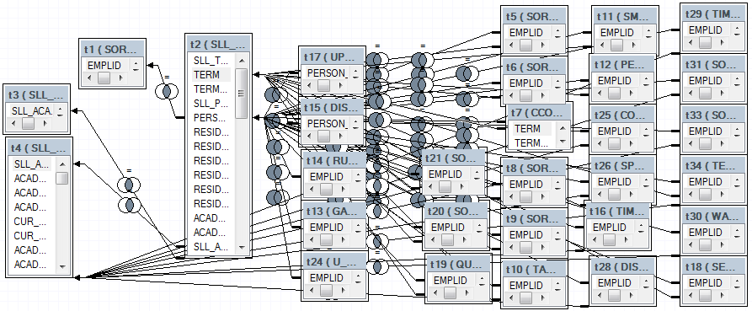
Figure 2: Join query for academic, demographic and interaction data.

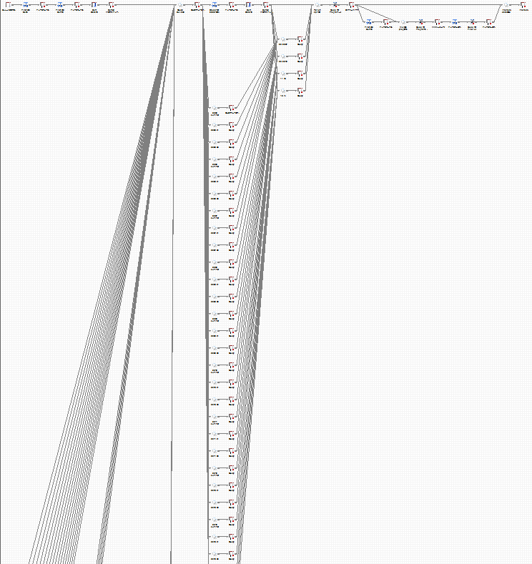
Figure 3: Splitter procedure with final output table on the far right.
The database resulting from the query pictured in Figure 2 consisted of almost 600,000 rows and 90 columns. This ‘long’ format was suitable for many of the statistical analyses that needed to be run on the data, but not all. The database needed to be re-formatted into a ‘wide’ format (eventually consisting of approximately 90,000 rows and 400 columns). This was done using a method called ‘splitting’, whereby academic, demographic and interaction variables along a single row relate to a single student within a single program. Splitting the database involved returning student and column variables (i.e. semester and then reuniting the outputs, which created columns for each semester and interactions within those semesters. Figure 3 provides an image of the splitting and re-joining procedure in the creation of the final database.
The build process for this database has since become the management system identified in the project aims as forming the legacy of the study – “Create a robust source of data and evidence for future research, evaluation and policy development”. Use of this database as a tool for future research and record-keeping is discussed in the final results chapter (p.45).

Data Analysis
Statistical modelling and data analyses were run following the completion of the final ‘long’ and ‘wide’ databases. A number of descriptive statistics were employed on the demographic and academic variable data to draw a broad picture of low SES students at UNSW between 2005 and 2014 (p.20). Determining the influence of support initiative interaction on academic success necessitated additional higher level statistical modelling incorporating the hierarchical structure and non-independent nature of the data. Multilevel modelling (MLM) was selected as the most appropriate statistical test for this purpose. A detailed description of the MLM method and how it was applied in this project is given in the following section.

Multilevel Modelling
MLMs are employed when observations in a data sample are not independent, such as a student within a faculty being more closely related to others in the same faculty than to students in another faculty. More commonly used statistical techniques such as regression models do not take this clustering of data into account, and as such were inferior in their analysis of project data. MLMs tend to be used most commonly in educational data modelling, where data tend to be nested within levels (Raudenbush and Bryk, 2002; Twisk, 2006; van de Vijver et al., 2008). They have been used frequently in research relevant to the current study (for example, Allen et al., 2008; Pan et al., 2008; Stewart, 2008), but seem somewhat absent from Australian higher education support initiative contexts. This could be due the dependence of other support studies on smaller samples and qualitative approaches.
The literature on MLMs recommends they be built in stages, with variables and effects added to each stage (Raudenbush and Bryk, 2002; Twisk, 2006; Field, 2012; Garson, 2013; Tabachnick and Fidell, 2013). Output from the statistical software can inform the analyst whether or not the latest model is a better fit than the last. The best fitting model is selected as the final model. All models were built in the same logic order (described further in this section).
One of two types of MLM was used to analyse the success indicators depending on the nature of the dependent variable. WAM at completion and WAM before and after interaction were analysed using a linear MLM. In other general linear models, such as Ordinary Least Squares regression or ANCOVA, scores before and after need to be averaged to prevent violating the independent sampling assumption, whereas a MLM allows clustering of semester WAMs at the student-level. This makes for a more powerful and complete test. Linear MLMs were run in IBM SPSS Statistics 22 and SAS EG. Syntax for the performing of a linear MLM in SAS is provided in Appendix 1.
A hierarchical generalised linear model was needed to analyse the categorical binary outcome variables of academic standing before and after interaction and discontinuation count. This was done using a logistic MLM. Logistic MLMs are mathematically more complicated than linear MLMs, and SPSS is currently unable to perform them (Twisk, 2006; Field, 2012). Logistic MLMs were run using SAS EG (syntax in Appendix 1). They are built in the same way as linear MLMs in that variables and effects are added to subsequent models to find the best fit.
Although the MLMs differed in the scale of outcome variables, i.e. continuous (for the linear MLM) and categorical (for the logistic MLM), the number of levels and model ordering were consistent. The number of levels refers to the nested or hierarchical nature of the model, where level-1 units (e.g. students) are nested within level-2 units (e.g. faculties). For the WAM and academic standing investigations, level-2 units consisted of students and level-1 units were the WAMs or academic standings for each semester before and after initial interaction. The discontinuation and WAM at completion investigations used faculty as the level-2 variable and students as a level-1. Faculty was included as the level-2 variable for analyses due to the previously reported influence of faculty on student variables (see for example Porter and Umbach, 2001).
Independent variables that are thought to confound results can be placed in the model at any level, these are called covariates. Statistical modelling of support initiative interactions showed that some variables had a greater influence on the model than others. ATAR, faculty, Stage and ID were consistently significantly impacting the p-values being produced by MLMs, and were subsequently included in all relevant analyses. The variables of age, gender, birth country, home language, ATSI status, disability count and rurality were also considered. However, statistical outputs generated with these as covariates returned no meaningful difference in p-value compared to models that only included ATAR, faculty, Stage or ID. Therefore, the extraneous variables were elided from the models. Modelling of success indicators included the following variables:
WAM Before and After Interaction
Dependent variable: semester WAMs.
Independent variable: initiative interaction.
Covariates: academic stage, student ID.
Academic Standing Before and After Interaction
Dependent variable: academic standing.
Independent variable: initiative interaction.
Covariates: academic stage, student ID.

WAM at Completion
Dependent variable: completion WAM.
Independent variable: initiative interaction.
Covariates: ATAR, faculty.
Discontinuation Rate
Dependent variable: discontinue.
Independent variable: initiative interaction.
Covariates: ATAR, faculty, first semester enrolled, last recorded stage.
Models were built in the following logic order (as outlined in Field, 2012):
- Model 1 – level-1 DV with IV (dependent variable and independent variable)
- Model 2 – level-1 DV, IV and cov (Model 1 plus covariates)
- Model 3 – level-1 and 2 predictors and random intercept (Model 2 plus level-2 predictor and random intercept)
- Model 4 – level-1 and 2 predictors, level-2 effect and random intercept with Variance Components covariance structure (Model 3 plus IV as random effect with VC)
- Model 5 - level-1 and 2 predictors, level-2 effect and random intercept with Unstructured covariance structure (Model 4 with UN)

Data Reporting
MLMs have a rather detailed output, where much of the information they supply can be somewhat turgid. In response, results have been reported with a view to making them as clear and easily interpretable as possible. Test significance has been reported in the main text along with mean scores and sample sizes. More detailed and descriptive statistics generated from the MLMs can be viewed in Appendix 2.

Questionnaire

Design
The database study used academic indicators to investigate how low-SES student success was influenced by interactions with support initiatives. The MLM method permits the variables of faculty, stage and ATAR to be accounted for in the statistical analysis of interaction versus success, but does not take into account the multitude of other influences that may impact a student over the course of their academic career. A questionnaire was used to provide more detailed insights into these influences and the agents – internal and
external to UNSW –students look to for support, how helpful they found these, and how these factors vary with socioeconomic status. Secor (2010) states that a questionnaire provides a good supplement for interview-based research – as was the case in this project.
The final questionnaire was developed and validated through use of a pilot survey and through feedback from key staff members within the division. A student focus group was asked to review the terminology, layout and content to ensure the questionnaire was clear, explicit and easy to navigate. Student suggestions were incorporated into the final draft, which was then formatted for the SurveyMonkey online tool and a paper hard copy.
The final questionnaire consisted of Likert rating scales and closed-ended questions to optimise the completion time and encourage a high-response rate – no open-ended questions were used. McLafferty (2010) suggests that it is best to use an odd number of responses on a Likert scale so respondents are able to give a neutral opinion when they do not have a strong response to offer on a topic.
The questionnaire consisted of two parts. Part A asked students to consider the following: the extent to which five different issues had impacted them during their time at UNSW; where they had sought support with these issues; and how helpful they found the support. Part B elicited information on the student’s socioeconomic status. The questionnaire is provided in full in Appendix 3.
The five issues explored in Part A were:
- Academic Demands (issues or difficulty with the university style of teaching, assessments, assignments, time management, academic writing, group work, presentations, exam preparation, etc.)
- Social Engagement (issues or difficulty with: settling in at uni, engaging with campus life, fitting in with your peers, making uni friends)
- Emotional Matters (issues with stress or anxiety, self-esteem, mental wellbeing, relationships, etc.)
- Professional Development (developing graduate skills and capabilities and improving your career prospects)
- Finance
The descriptions in brackets provided above were also provided on the questionnaire to ensure the meaning of each issue was clear to the student. This was particularly important for the areas of ‘Social Engagement’ and ‘Emotional Matters’, which may be easily conflated without this additional information. No description was provided for ‘Finance’ as it was deemed to be self-evident.
Students were asked to rate on a Likert scale how severe an issue had been for them – a rating of one being ‘has not a problem for me at all’, and five being ‘has been a severe problem for me’. Students were then asked where they had sought help with these issues, and how helpful they found the support – again on a Likert scale with a rating of one being ‘not at all helpful’ and five being ‘extremely helpful’. This question was modified for ‘Finance’ to identify major and minor sources of income.
Students were asked how important ‘Professional Development’ was to them to explore the impact of methods used at UNSW that aim to develop professional skills and improve career prospects. Students were asked which programs and services they used, and to rate how helpful they found these.
Part B asked students to provide additional information on their SES. This was somewhat of a pseudo-study brought about by the debate in the literature surrounding the defining of SES (see Figure 1). The following closed-ended questions were asked:
- Are you first in family?
- What are your parent’s/carer’s highest levels of education?
- What is the approximate income of your family household?
Four categories were defined for family household income. These were derived from the Australian Bureau of Statistics, Household Income and Income Distribution, 2013-2014 gross income quintiles: less than $40,000; $40,000-$80,000; $80,000-$120,000; and more than $120,000.

Participants
A purposive sampling technique was used to target students that had interacted with SLL support initiatives. An email was drafted describing the purpose of the study and inviting students to participate by completing a questionnaire via a link to the SurveyMonkey online tool. This email was distributed to the mailing lists of each of the service providers. Hard copies of the questionnaire were also made available at the reception areas of the units, and a link to the online questionnaire was promoted via social media.
A participant information sheet was drafted using the template provided by UNSW Research Ethics and Compliance Support (RECS) (Appendix 4). This described the research, how student information would be used and provided contact details for the research team. A link to this information online was provided in the promotion email. Alternatively, a sheet was attached to the hard copies of the questionnaire.
Respondents were given the opportunity to go into a draw to win one of five $100 vouchers as an incentive to complete the questionnaire. This methodology was based on previous research indicating that offering incentives for respondents to self-recruit can increase response-rates (Robinson, 2014).

Data Collection and Analysis
The questionnaire was available to students for four weeks in hard copy at the units and open for four weeks online after the email distribution. All hard copy responses were entered into SurveyMonkey after the closing date, and then all responses were downloaded into MS Excel.
There were 789 responses to the questionnaire. The IDs provided in the questionnaires were re-identified using the same anonymisation code used for the database study, and respondent SES data were determined using the database. There were 331 responses from students with a valid SES (following the removal of incomplete responses and duplications).
The response data were analysed to look for relationships between:
- ‘Severity of issue’ and SES
- ‘Helpfulness of service provider’ and SES
- ‘Severity of issue’ and ‘helpfulness of service provider’
Statistical significance was investigated using the Mann-Whitney U and Spearman rank-order correlation tests - these tests being selected as the most appropriate based on the data. Statistical analysis was performed in IBM SPSS Statistics 22.

Interview

Design
The in-depth interview was used to gain access to, and understanding of, activities and events that could not be observed from the database or expressed in the questionnaire. An interview is a “conversation that is directed more or less towards the researcher’s need for data” (Green and Thorogood, 2004, p87). According to Minichiello et al. (2008, p46) “Interviewing is the most commonly used form of qualitative research”. The purpose of the interview is to explore and understand actions within a specific setting (the influence of support initiatives on low SES student success), to examine human and environmental relationships and unpack why people feel or act in the ways they do (McDowell, 2010). The narrative required for this amount of detail is beyond the scope of a questionnaire or a database. This is because written responses and longitudinal information are not the only determinants of the student’s ‘story’. An interview considers language and narrative to help paint a fuller picture of interaction and success.
A list of semi-structured interview questions were developed to uncover the issues experienced by students at UNSW, the on and off-campus support services and development programs they had accessed, and their experiences with these. Students were also asked about ‘success’ – what this meant to them, what had influenced their success at UNSW, and whether SES had any impact on their success. The interview questions are provided in full in Appendix 5.

Participants
A sample of 20 or more interviews was identified as a sufficient size for attaining “saturation” (Guest et al., 2006, p59). Participants were recruited via the questionnaire, which invited respondents to provide a telephone number or email address if they agreed to be interviewed. Participants were then contacted by the project team to arrange an interview – 22 participants were interviewed. Interview participants were given a $20 voucher as compensation for their time.

Data Collection and Analysis
A total of 22 interviews were conducted over a period of three weeks by the project team. One telephone and 21 in-person interviews took place on the UNSW Kensington campus, with interviews lasting between 16 and 48 minutes. All participants were given an information sheet and were required to sign a consent form (Appendix 6) as per UNSW ethics requirement.
Interviews were tape recorded and transcribed, and after transcription the recordings were deleted. Names and any identifying information were removed from the transcripts immediately following analyses.
A thematic analysis of the interview data was undertaken using the NVivo 10 software package. NVivo software does not replace the analytical thinking process of qualitative research, as it does not develop propositions from the data. However, it does facilitate the retrieval of unsystematised text material in a fast, flexible way, using structured nodes of topics, themes or categories (Minichiello et al., 2008). Creation of nodes in NVivo first requires the import of the transcribed text document from MS Word into NVivo where it can then be accessed for coding. Nodes in NVivo are an indexing system created by the user by extracting snippets or chunks of text. These text chunks are coded as a specific theme or topic, and represented as a node. A hierarchy of nodes and sub-nodes create a tree like structure organised into meaningful categories by the researcher that can be modified, extended or deleted as coding progresses.

Results

Building a Picture of Success
The results presented in this section address the first aim of the project, namely to:
Present a more complete picture of the academic success of students from low SES backgrounds at UNSW.
This section draws on demographic and academic indicators derived from the database study to provide a detailed description of the low SES cohort and how they compare to their higher SES peers. Questionnaire and interview data were also drawn on to gain a better understanding of the issues facing low SES students, the severity of these issues, and the impact they have on academic success.
These insights present a backdrop for the factors that impact low SES students at UNSW and provide context for the circumstances in which this cohort interact with support initiatives. Results from the investigation into the influence of service interactions on low SES student academic success are presented in the next chapter.

Demographics and Academic Success
Figure 4 presents a snapshot of academic and demographic data for the target cohort and a comparison profile for high SES students (‘high SES’ refers to any student who is not low SES – i.e. the medium and high SES cohorts have been grouped together). Figure 5 and 6 provide performance indicator data by year to highlight any variance over the study period. Data have been averaged over the period of study (2005-2014) to produce the results. The following findings were of interest:
- Low SES students were three times more likely to come from a rural background, with participation rates of students from isolated backgrounds at less than 1% for both cohorts (Figure 4)
- Students from low SES backgrounds were around 20% less likely to be born overseas, but 44% more likely to come from a non-English speaking home (Figure 4)
- The percentage of students identifying as ATSI was almost three times higher for the low SES cohort (Figure 4)
- Low SES students had a significantly lower average WAM at completion and ATAR than their high SES peers (Figure 4)
- Participation and access rates for low SES students are generally increasing over time (Figure 5)
- Retention ratios were between 0.98 and 1.02 – indicating a similar rate of retention for high and low SES students across the study period (Figure 6)
- The distribution of low SES students across faculties was not even, with ADFA, Engineering and Science having a higher proportion of low SES students, and all other faculties a lower proportion – Law and Art & Design had particularly disproportionately low numbers (Figure 7).
Results indicate that the low SES cohort at UNSW appear over represented by students from other equity groups, including students from rural areas and non-English speaking backgrounds, as well as ATSI students. Research has found that equity students face amplified challenges in Australian higher education, which become compounded for students with multiple equity group membership (Willems, 2010; Edwards and McMillan, 2015). “The gradient of disadvantage further increases when an individual is a member of multiple equity (under-represented) groups” (Willems, 2010, p618).
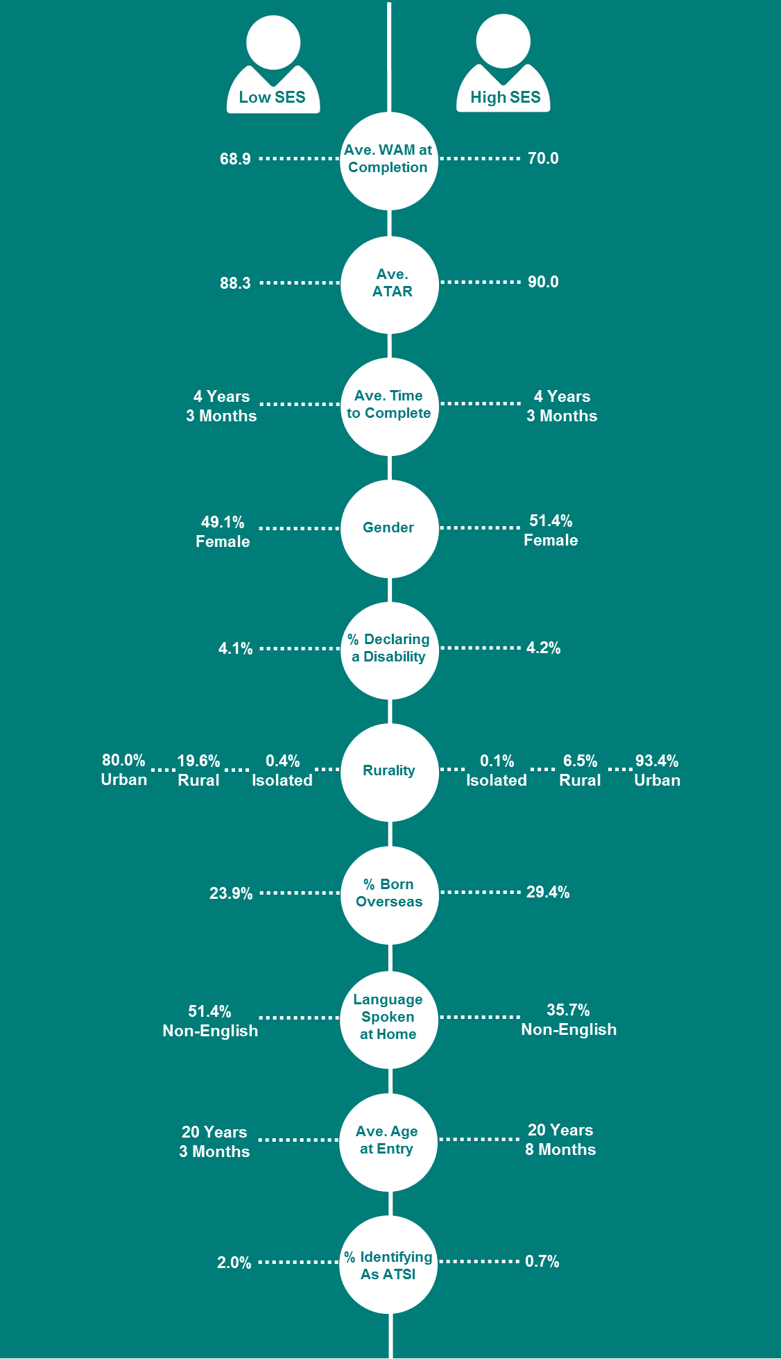

Figure 4: A comparison of demographic and academic indicators for low and high SES students.

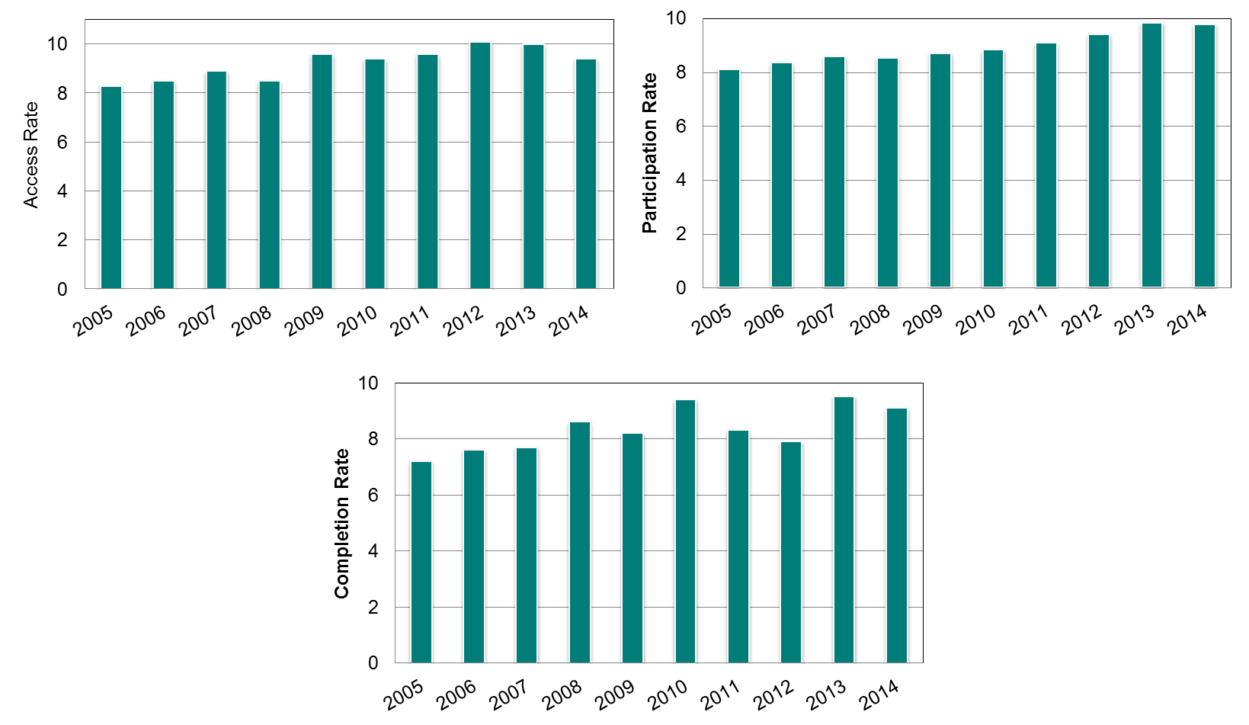
Figure 5: Low SES access, participation and completion rates by year.

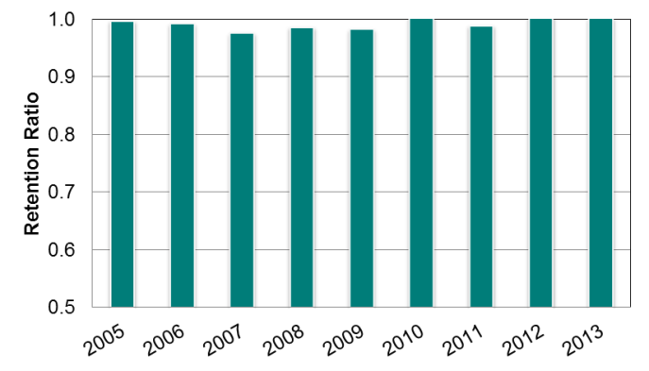

Figure 6: Retention ratios by year (retention ratio = low SES retention rate/high SES retention rate).
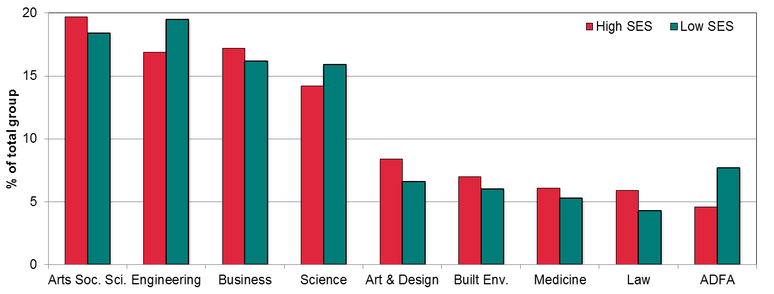

Figure 7: Breakdown of high and low SES students by faculty.

Issues Impacting Success
SA1-SES database information and self-reported SES data from the questionnaire were drawn on to compare differences between the high and low SES cohorts that completed the survey. Students were asked to rate, on a scale of one to five, the extent to which certain issues had impacted them during their time at UNSW. Figure 8 shows responses broken down by three indicators of SES. For all of the indicators, SA1, family income and parental education, results showed that the lower socioeconomic cohort rated every one of the issues as more severe.
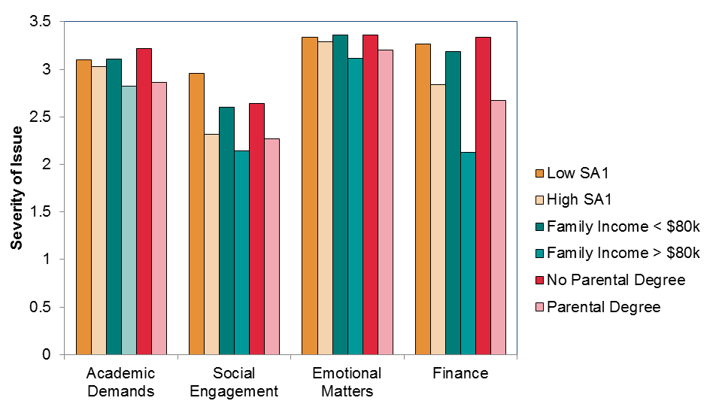
This disparity was particularly apparent for financial and social issues with significant differences reported between the high and low SES cohorts. The questionnaire also identified that emotional matters rated as the most severe problem for all cohorts of students, with no significant differences between SES groups.

Figure 8: Severity of issues by SES.
Students were asked in the interviews about difficulties that they had faced during their time at UNSW. The most frequently cited difficulties were: finance and work (cited by 73% of interviewees); mental health related (64%); social (41%); course related (32%); family (32%); time management (32%); and travel (32%).
It is perhaps not surprising that finances were the most cited issue for this cohort – many students gave lengthy examples of the financial hardships they were facing. For instance:
“Say I don’t understand an assignment, some of my friends can just pay for a tutor to figure out what’s wrong with their assessment. But unfortunately university tutors are $75 an hour; it’s not accessible [for me]. Also, just the stress of working out of necessity impacts my ability to focus on upcoming assessments as well… I feel like [my] financial situation is a constant ongoing stressor.”
“My mum is a bit ill so I have to work as well. So between work and household responsibilities it’s really pushed me back on my studies…. It’s just got worse because you need more money. When I got the full-time job, that’s when I think it became worst.”
“I’ve been flat broke. That’s why I now live in the western suburbs instead of the eastern suburbs... Sometimes you’ll skip uni to do an extra shift or something because you need the extra hundred bucks.”
“Even having access to internet is difficult cos I know that the university is moving to [having] everything online, and you have to have fast internet as well, and I think most people use the unlimited internet but I’m still using the one which has off-peak and on-peak, which I know is a bit outdated, but it’s the one we can afford.”
Students seemed willing to talk openly about the financial hardships they had encountered. In contrast, few of the 16 students who identified as having mental health related difficulties discussed in any detail how it had impacted their study or success. Students tended to instead touch on the fact that they had experienced mental health issues, evident in the delivery of their responses, which included a number of pauses and hesitations:
“Um, well personally, the main thing has been I’ve got chronic depression and anxiety issues. Sometimes the stress has gotten to me.”
“Yeah definitely so I do struggle with a lot of mental health issues…”
“When you’re not feeling well - and I’ll be quite honest here, it’s mental health related- navigating the bureaucracy of the university is really difficult.”
“And mental health issues, so that really impacts a lot of things at uni and in other areas of my life, and it makes it really difficult to complete things, and even just to get to classes - like my attendance this semester has been terrible.”
Reluctance to discuss these issues could be attributable to the stigma attached to mental health problems (Eisenberg et al., 2009; Yamaguchi et al., 2013; Wynaden et al., 2014). It did not emerge from the interviews that difficulties with mental health were in any way unique to or even related to socioeconomic status. However, this was not the case for students who stated that they had experienced difficulty with social issues. Direct, often negative, comparisons were made between participants and their higher socioeconomic peers, with these differences cited as a reason for some of the social difficulties faced:
“I’ve had difficulties socialising. That’s something that gets you down and puts the motivation on the backburner…From first year I just didn’t really fit in properly, perhaps because I’m from a regional background and didn’t identify with the Sydney thing… Perhaps this is not the best way to put it, but there are plenty of crappy North Shore people with absolutely no perspective or idea on how normal people live. It’s kind of hard to identify with these kinds of people. It’s just a completely different world… The barrier, rather than being financial, is more of a social thing - different cultures almost across high and lower socioeconomic backgrounds.”
“If people don’t know where you come from they’re pretty open, and when they ask where you’re from and you go ‘Campbelltown’ it changes things a little bit. Sometimes they become a bit more casual, and when I come to university I’m looking for the intellectual conversation that I don’t always get from family members because they don’t have that experience. I want to be able to have that kind of conversation, but as soon as people go ‘oh you come from Campbelltown’, the conversation drops a couple of knowledge points, it’s always interesting.”
“It’s good to have people who do understand what uni is like and who are in the same boat, like a lot of people at Nura Gili come from near where I lived, and they’re really easy to get along with and to relate to… They do relate a lot more than some people in my course, especially the Law degree… During pre-programs I sort of isolated myself, didn’t really talk to many people, but when I got to uni I was like ‘wow, I should really not be like isolating myself’, it makes it just way more difficult than it needs to be.”
Another frequently cited issue among interview participants was difficulty with courses. No students directly related this to socioeconomic status, although one who bemoaned the high course load noted that, for financial reasons, going part-time was not an option:
“The coursework itself I think is far too much; it’s far too much to be expected of students to be able to do that much work. You speak to so many people, they’re just trying to scrape through, to pass the assessments and pass these tests… They’re not actually really enjoying and learning the content because the load is just way too much… If you go part-time then you can’t get financial support from the government and then you have to work, that kind of defeats the purpose because then your work will be taking up study time.”
Several students cited issues related to being first in family, and the theme of family ‘not understanding’ arose on several occasions. For example:
“My family is not that supportive, my parents didn’t go to uni so they don’t understand the kind of support that would be helpful.”
“I’m the first person in my family to go to university. [My family] don’t understand and they get angry at me for not seeing them. So that was a bit upsetting, to feel like they were blaming me”
“[My family] struggle with how to support me, and they sort of don’t understand why I’m struggling with it I think. They don’t understand how different it is from high school. I was a good student in high school, and they’re like ‘you’ll be fine, you’ll blitz it’ and I’m like ‘no, not correct’. They also didn’t realise how expensive it would be either. Their expectations for uni are different to how it is; I don’t know how to address that. So it sort of makes it difficult for them and me to relate over it I think.”
“I feel like there’s a bit of a weight on my shoulders [being first in family]… I feel like at one end there’s a lot of expectation to do well, and on the other end there’s like ‘oh you’re going to “university”’, it’s like ‘yes, yes I am, I’m planning to do something with life, thank you’, so yeah, they’re all looking to me to see if I can change the way the family’s been for future generations and be like ‘oh she went to university, why don’t you think about going to university? You should talk to her about university’. So I have to be good.”
Students also raised issues relating to family that were not associated with SES:
“Parent’s expectation…. That’s the one [issue] that gets me depressed, as well as sometimes getting me stressed.”
“My Dad isn’t around so I have to take all of the responsibility for my younger siblings - brother and sister, and also for my mum.”
“I guess I had problems at home with the family… I think the problems at home impacted on my confidence.”
This section has introduced a picture of low SES students at UNSW. The target cohort has been discussed in the context of their success and experiences as an equity group. The following section adds to what has been presented here by introducing the influence of support initiatives.

Investigating the Relationship Between Success and Interaction
This section presents the findings of the investigation into the influence of support initiatives on low SES student success. The following results are a direct response to the second project aim, which was to:
Determine any correlation between, or patterns in, low SES student success and interaction with support initiatives.
The results are presented separately for each of the support initiatives. This approach was taken as each unit offers a unique service and they are operated to target different aspects of student success. The initiatives cater for diverse cohorts with discrete needs and reasons for interaction, and consequently they are not directly comparable in their potential to contribute to student success. This point is discussed at intervals within this chapter, where applicable.
Each section presents rates of participation for low SES students with the initiative and how interactions are impacting on their success. The effect of the initiative is then compared for low SES students and students from all SES backgrounds to determine whether the effect is influenced by SES. Finally, interview data are elicited to corroborate student support experiences with success.
Tables 1-3 of Appendix 7 present the full database findings for the low SES cohort and the corresponding results for all students.

The Learning Centre
The Learning Centre (TLC) at UNSW helps students to improve their academic writing skills by offering one-on-one consultations with Peer Writing Assistants (PWA). TLC also offers workshops focusing on improving a range of academic skills such as essay writing, oral presentations, critical thinking and referencing. These workshops run throughout the semester. As TLC’s primary role is to improve students’ academic performance, the effect of an interaction can be assessed as a function of a student’s academic results.

TLC – Participation Rates
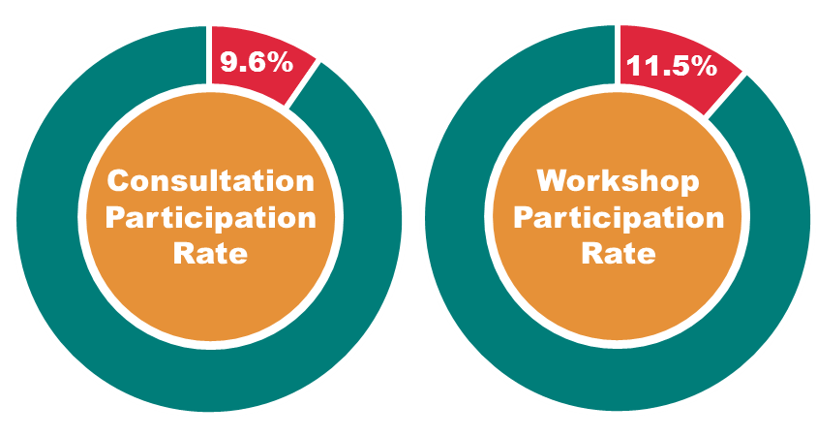

Figure 9: Participation rates of low SES students at TLC consultations and workshops.
Low SES student participation at TLC consultations was in line with their participation in the total UNSW population (local, undergraduates between 2010 and 2014) – 9.6% of students attending TLC consultations were low SES, compared to the low SES participation rate of 9.3%. In contrast, attendance at workshops was over-represented by low SES students – 11.5% compared to 9.1% between 2008 and 2014 (Figure 9).

Peer Writing Assistant Consultations – Effect on Academic Success for Low SES Students
Results indicated that low SES student WAM after consultation with a PWA was significantly higher than before interaction (Figure 10). Academic standing was also improved after interaction (0.93) compared with before (0.87), but this difference was not statistically significant.

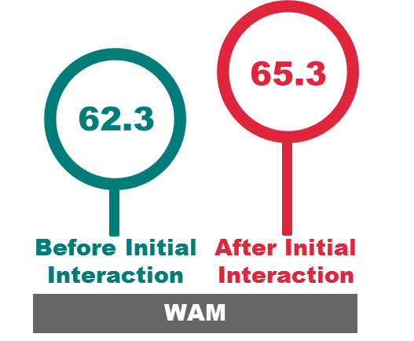

Figure 10: Mean WAM before and after initial interaction with a Peer Writing Assistant.
Low SES students who had attended consultations and completed their program graduated with a significantly better mean WAM than those who did not attend (Figure 11). Students who attended a consultation in their first semester had an even higher WAM at completion – though this improvement was not significant.
Results show that low SES students who attended consultations with a PWA had a considerably lower mean ATAR than those who did not attend (Figure 11). Only students interacting with ESAs had lower average ATARs.
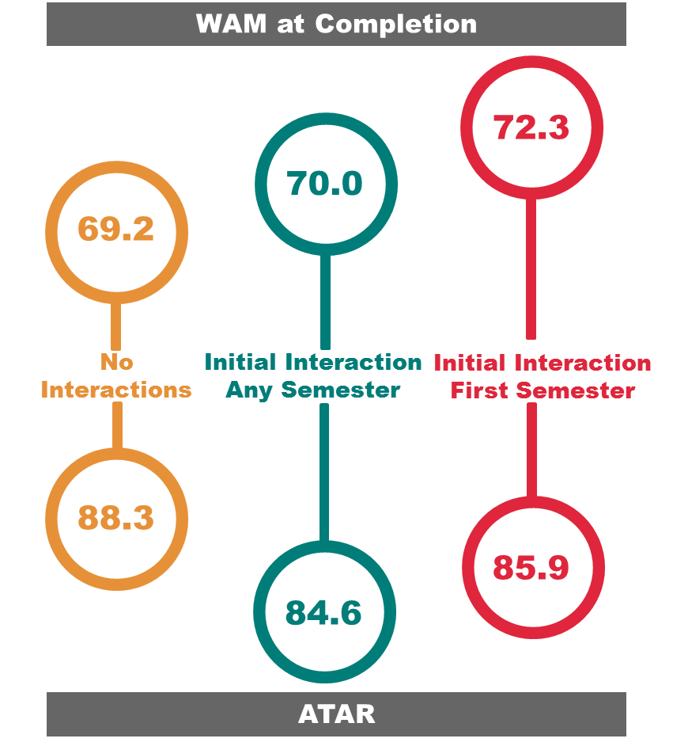

Figure 11: Comparison of ATAR and WAM at completion for students interacting with a
Peer Writing Assistant.
This suggests that these students are behind their peers on entry, but are effectively overtaking them after interaction with a PWA.
The discontinuation rate of low SES students attending PWA consultations (5.2%) was lower than those that did not attend (6.8%). This result was not significant.

All Students vs Low SES Students – Comparison of Effect on Academic Success
Low SES students had a lower average WAM both before and after interaction than the corresponding averages for all students (see Appendix 7 for database findings for all students). This gap did close slightly after interaction.
On average, academic standing improved after interaction across the whole group, though this improvement was larger for the low SES cohort (these results were not significant for either group). Though the mean WAM at completion across all students who interacted with PWA consultations was higher than for those that did not interact, unlike the low SES group, this increase was not significant.
These results suggest that interaction with a PWA had more benefit for the low SES group. There is some support for this theory in the questionnaire results, which show that the students for whom neither parent had a degree and students whose annual family household income was less than $80,000, rated TLC consultations the most helpful (as indicated in the questionnaire section ‘academic demands’) – albeit without significant difference between SES groups.

Interview Insights – Peer Writing Assistant Consultations
A number of student responses to the in-depth interview questions attested to the influence of TLC consultations on their academic performance. For instance, the following students explain how a PWA consultation assisted them:
“it was very effective, my needs were met. I don’t know how it is now, but when I went through, someone would sit down with you one-on-one, they’d go through your essay and then you’d come away and in two or three weeks they’d follow up on that same essay and give you feedback and assistance, and I guess a bit of critique. I found that exceptionally helpful… in terms of learning grammatical lessons, and what some of the words actually meant and how to go about writing an essay, it was really helpful for that.”
“[After my consultation] I went on to the [TLC] website and they’ve got pdfs that have just got everything. If you want to reference a personal conversation they tell you how to do it. Yeah so you just find the appropriate thing and they’ve got a list…That has been really useful.”
Some improvement suggestions were also made by interviewed students, for example:
“they just clearly had resourcing issues. It took 3 to 4 weeks to get in and I remember once I waited 6 weeks, it just used to book out really quickly and there used to be about 3 or 4 people there to help and they were just really under resourced.”
“a lot of people commute to university so maybe if there were a few more web based options it might help. A lot of times I wanted to get involved or ask for help but just coming to uni is quite tedious, and it (Auburn) is not even that far. I know a lot of people come further.”
This participant highlights a travel issue that is relevant for many low SES students. The student goes on to explain:
“A lot of time my first point of contact is Googling and seeing what the university offers. So if there are already some resources that are up, and a lot of places already do, then I’ll just access that place and then see if I still need help making an appointment.”

TLC Workshops ‒ Effect on Academic Success for Low SES Students
The investigation into the academic performance of low SES students who interacted with TLC workshops relied on a relatively small sample size, hence power levels were low and subsequent statistical significance was somewhat elusive. Nevertheless, the average WAM after interaction was higher than before (Figure 12), and academic standing improved from 0.81 to 0.84 after interaction.
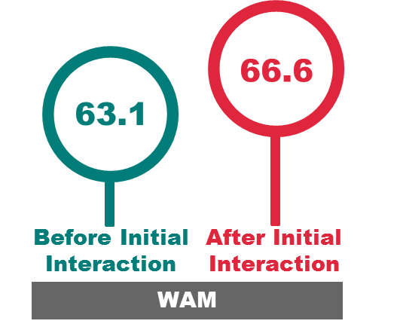

Figure 12: Mean WAM before and after initial interaction with a TLC workshop.
WAM at completion was slightly higher for low SES students that attended workshops than those that did not, and higher again for those who attended in their first semester (Figure 13). The discontinuation rate of students who attended TLC workshops (8.7%) was not significantly different to those that did not attend (7.0%).
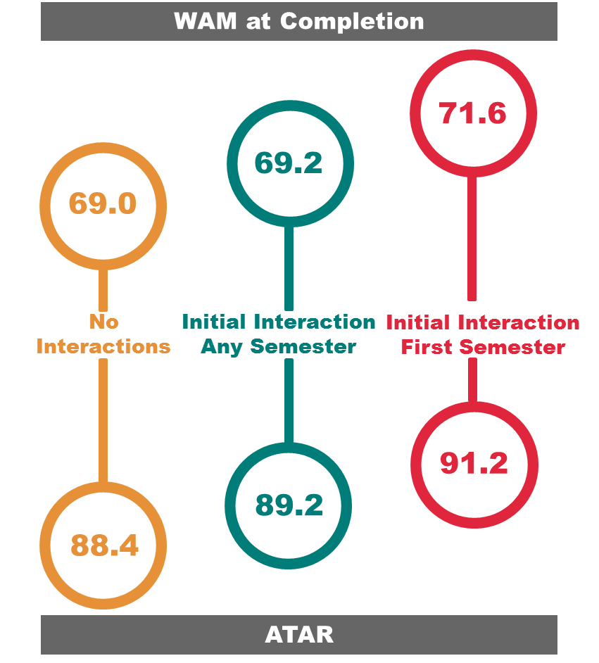

Figure 13: Comparison of ATAR and WAM at completion for students interacting with a TLC workshop.

All Students vs Low SES Students – Comparison of Effect on Academic Success
Low SES students who attended TLC workshops had marginally higher WAMs before interaction than the average for all students who attended. Results show that the increase in WAM after interaction was slightly larger for low SES students (0.7 points). This gain was not reflected in academic standing – both groups showed improved academic standing after interaction, but the improvement was less for the low SES group.
Interacting students from both groups graduated with a higher mean WAM than students who did not interact, though neither group was significantly higher. Questionnaire results showed that students for whom neither parent had a degree and whose annual family household income was less than $80,000 found the workshops most helpful (as indicated in the ‘academic demands’ section of the questionnaire) (again, testing showed no significant differences between groups).

Interview Insights – TLC Workshops
The following interview testimonies indicate that TLC workshops contributed to academic success for some students:
“it’s fantastic that this stuff (support initiatives) is there, especially things like the writing workshops where people who might be able to have a successful uni career just need a few basic skills.”
“my expectations were met in that I could essentially understand the key words that come out in essay questions like ‘analyse this’ or ‘describe this’, those sort of key words.”
“I’ve used the writing workshop and downloaded a heap of information about referencing and that has been really useful”

Disability Services
The Disability Services unit offers help and support to students with a disability or difficult personal circumstances. Students who register with Disability Services can make an appointment with a Disability Advisor to have an assessment of their disability and the impact this may have on their study. ‘Educational adjustments’ may be put in place to ensure those with a disability have equal opportunity based on this assessment. Adjustments could include one or more of the following: exam adjustments, alternative formatting, notetaking, assistive technology, and classwork support. These adjustments and the additional support provided by Disability Services are aimed at helping students to succeed academically, so the success of an interaction can be assessed as a function of a student’s academic results.
Students are given the opportunity to declare whether they have a disability at entry to UNSW. This information is recorded in SIMS. This allowed a direct comparison of students who declare they have a disability and register with Disability Services with those that declare they have a disability and do not register. It is these two groups that are compared in this study.
Disability Services were only able to provide a list of students who had registered to use the service and the year of registration, but not information on individual appointments, so it was not possible to compare student grades before and after initial interaction. However, a comparison of WAM at completion and discontinuation rates was possible using just registration information.

Disability Services – Participation Rate
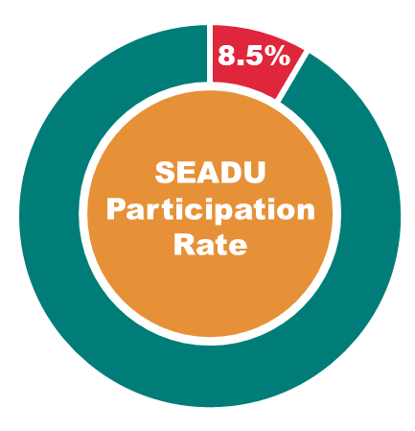

Figure 14: Participation rate of low SES students at Disability Services.
Low SES students registered with Disability Services at a slightly lower rate than their high SES peers – 8.5% of registrations were by low SES background students, compared to 8.9% of all students declaring they have a disability during the same time period (in the local, undergraduate population between 2005 and 2014) (Figure 14).

Disability Services – Effect on Academic Success for Low SES Students
Low SES students who registered with Disability Services graduated with a significantly better mean WAM than those who did not register (Figure 15). Moreover, students who registered with Disability Services in their first semester had an average WAM at completion 9.4 points higher than those that did not register. This was the highest recorded average WAM at completion for any group interacting with a support initiative in the study. This is despite students who register having considerably lower ATARs than those that don’t register.
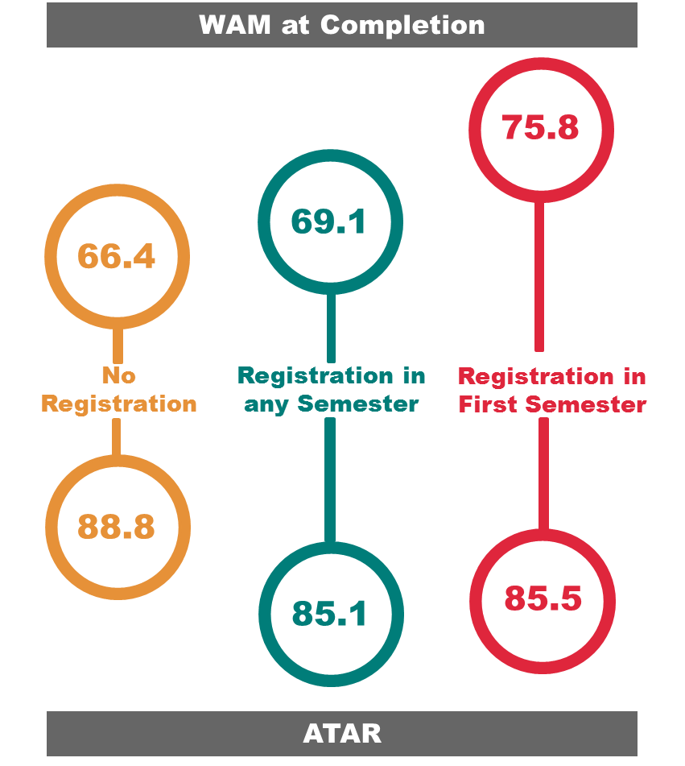

Figure 15: Comparison of ATAR and WAM at completion for students registering with Disability Services.
WAM at completion was also higher for registered students than for the full cohort – i.e. including those who did not declare that they have a disability. Students with a disability that did not register had an average WAM at completion 2.5 points lower than the full cohort. These results suggest that registration, particularly early registration with Disability Services, had a significantly positive impact on the academic results of low SES students.
Analysis showed that 7.4% of students who registered with Disability Services had discontinued. This was (non-significantly) less than the group average of 8.0% (Figure 16).
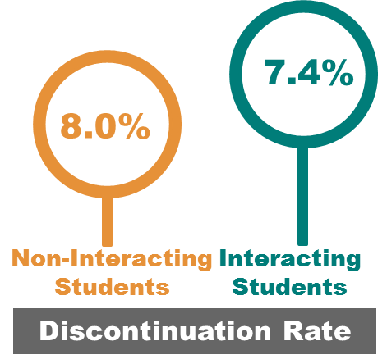

Figure 16: Discontinuation rates comparing students who registered with Disability Services and
students who did not register.

All Students vs Low SES Students – Comparison of Effect on Academic Success
Students who registered with Disability Services had a higher mean WAM at completion than non-registered students regardless of SES (despite lower ATARs for both groups), but the low SES cohort showed a greater average increase (see Appendix 7 for database findings for all students). This pattern was reflected for students who registered in first semester, where the low SES group displayed a greater improvement in mean WAM at completion compared to the average for all students. These results suggest that registration with Disability Services appeared to have more academic benefit for low SES students.
The questionnaire results showed that the SES group (as self-reported in Part B) who found interactions with a Disability Advisor most helpful were those for whom neither parent had a degree. However, the differences between SES cohorts were not significant, which was likely due to the small sample size.
Questionnaire results also showed that the helpfulness of an interaction with a Disability Advisor was significantly positively correlated with the severity of academic demands – i.e. the more severe a student’s academic issue, the more helpful they found the Disability Advisor. This significant result was not replicated for the low SES cohorts, which was similarly probably due to sample size.

Interview Insights – Disability Services
The ability of Disability Services to support students and improve their chance of success was highlighted by interview participants. Students were asked during interviews if any support or development services had impacted their success, with many students pinpointing Disability Services. For example:
“Disability Services has defiantly contributed to my success”
“Disability Services has improved my success… It has made it easier for me to succeed”
“Disability Services is the one [support initiative] that helped most”
Other students described in more detail the importance of interactions with Disability Services to their specific situations, including:
“It’s great being able to get a doctors certificate that just says ‘illness’ and that’s good enough, no questions asked. As well as just having that leniency of being able to get extensions, it’s so valuable, even just an extra week and extra time in exams. Actually the best thing is not having to go to the racecourse for exams. I mean I live here [on campus], so it’s great. I get to sit my exams here.”
“I was panicking a lot and I didn’t go to my exam, it was very bad. I was very upset just having to be in a big room with lots of people. I was very uncomfortable. So I spoke to them (Disability Services) about alternative arrangements, which are in place for this semester”.
“I’ve got chronic depression and anxiety issues. Sometimes the stress has gotten to me, but I have got procedures in place with Disability Services, and that’s been fantastic. Most of the time I’ve got a lid on it. There’s only been a couple of times I’ve had to request an extension, and that’s gone through with no dramas whatsoever.”
“Criminology is very serious about the 80% [attendance] rule. One semester I think I went to like 40% of the classes and so basically [was told] to go to Disability Services. Disability Services set up an interview and told me to go to the doctor [as well as] stuff I had to get to [show that] I’m genuinely unwell. Then I just gave that to [the lecturer] and he sort of waved the 80% attendance rule for me because he was like ‘yeh, that’s pretty legit’. So then I just got my mark based on the actual work I’d done rather than him having to fail me automatically.”
Another student contrasts the importance of having access to Disability Services with having no assistance, while also comparing Disability Services to a similar unit within another university:
“I’d come from a university that didn’t have a faculty like Disability Services to help out students with learning disabilities, and after struggling through two years there realised that it probably wasn’t the place for me. I looked at UNSW and they had the Disability Services unit and I was like, this is probably going to be the best option because they’ll be able to help me through the classes that I’m struggling in and be able to be a support for me where I haven’t had it before. It was a big part of the decision [to come to UNSW]…The unit [at the other university] was really hard to get in contact with and to talk to. I had friends come through [UNSW] who’d been involved with Disability Services as well and I [decided] it’s probably the best place for me to be, and it has been so far.”

UNSW Advantage
UNSW Advantage accredits professional development and volunteering opportunities at UNSW for inclusion on the Australian Higher Education Graduation Statement (AHEGS). These programs aim to broaden the student experience through developing professional skills, building competencies and enhancing leadership capacity. Only the programs accredited by UNSW Advantage that are offered by SLL are included in this study, and these will be referred to as ‘Advantage programs’ in the following analysis.
Several of the Advantage programs (including: the UNSW Leadership Program and Skills Development Program, and various volunteering opportunities) were established under Higher Education Participation and Partnerships Program (HEPPP) funding to facilitate engagement with low SES background students and provide opportunities to develop social capital. These opportunities are made available to all UNSW students and are not restricted to the low SES cohort.
It was not feasible to conduct an individual investigation into each of the Advantage programs due to the relatively low number of participating students, which resulted in a subsequent lack of statistical power. Instead, analyses considered all of the students interacting with these activities as one group. Only students who are recorded as having completed all requirements for a program were included in the study.

UNSW Advantage – Participation Rate
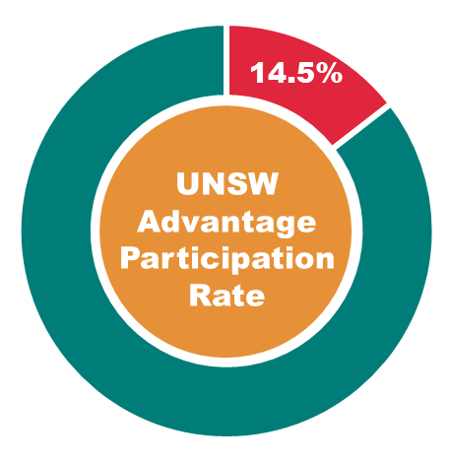

Figure 17: Participation rate of low SES students in Advantage programs.
Low SES student participation in UNSW Advantage programs was greater than their participation in the total UNSW population (local, undergraduates between 2007 and 2014) - 14.5% of students who completed an Advantage program were low SES, compared to the low SES participation rate of 9.3% (Figure 17).

UNSW Advantage – Effect on Academic Success for Low SES Students
There was no significant difference in academic standing before (0.99) and after (0.95) interaction. However, low SES students who completed an Advantage program were found to have a significantly higher mean WAM after interaction than before (Figure 18).

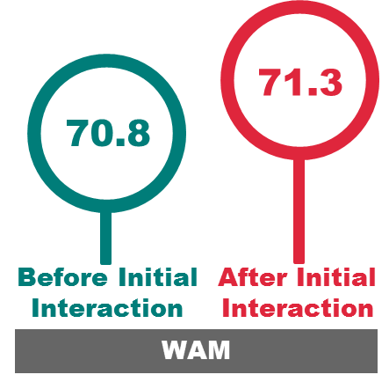

Figure 18: Mean WAM before and after completing an Advantage program.
Moreover, low SES students who completed an Advantage program had a significantly higher WAM at completion than those who did not (Figure 19). Although students who interacted in their first semester had a higher mean WAM at completion, a first semester interaction did not predict a statistically higher WAM. This was most likely due to the low number of first semester interacting students in this group (n=2).
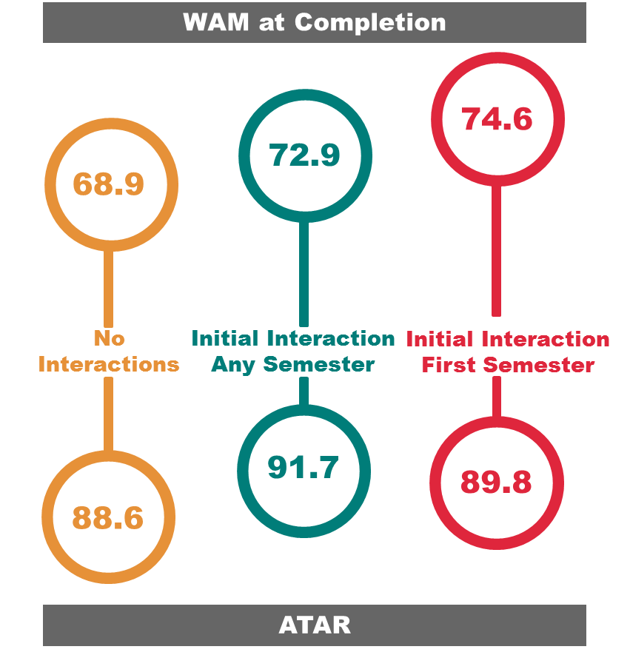

Figure 19: Comparison of ATAR and WAM at completion for students completing an Advantage program.
Only one out of 132 low SES students who had completed an Advantage program went on to discontinue. However, this did not prove to be a significantly lower discontinuation rate than for those who had not completed a program. This highlights the importance of ‘academic stage’ in the MLM calculation, i.e. most students completing Advantage programs did so in their second or third years (only two students completed a program in their first semester), after successful progression through first year when they were at most risk of dropping out (Krause, 2005).
These results also indicate that low SES students who completed an Advantage program tended to be the highest achieving cohort of any group in the study. They had the highest average WAM before and after interaction, the highest percentage of students on good standing, the highest mean WAM at completion (not including first semester interaction results), and the highest average ATAR.

All Students vs Low SES Students – Comparison of Effect on Academic Success
Results showed little difference in the academic success of students completing Advantage programs across SES cohorts (see Appendix 7 for database findings for all students). The low SES group who interacted had very similar mean WAMs before and after interaction and a similar mean WAM at completion to the averages for all students interacting. The two groups had exactly the same average academic standing after interaction (0.95) and the same percentage of students discontinuing (1.8%). The interacting group was represented by a high achieving cohort regardless of SES.
Results from the questionnaire indicate no significant differences between the SES cohorts for the helpfulness of volunteering or mentoring with either social issues or professional development.

Interview Insights – UNSW Advantage
Interview participants outlined how interactions with Advantage programs impacted their success as students. Students highlighted how involvement had assisted in specific areas, such as mental health:
“when I get to talk to people [during volunteering] I feel less stressed, and when you’re less stressed it feels like you’ve got some of the load off you so you can focus back on your work. Usually right after volunteering I get really tired so I get a good sleep. And then the next day you’re very pumped up to do your assessments.”
“For mental health [reasons], having a support network was probably the biggest [help]. Through [volunteering] I was able to overcome a lot of difficulties that I had, and I have been able to find ways to self-help and also have other people help as well.”
Two students who came to UNSW from outside Sydney spoke of the social benefits that volunteering and interacting with student societies brought:
“Through being involved in the student bodies, having a community and having friends, I’ve been able to limit the impact of being from a rural area and finding it hard to adjust or being unwell… they (volunteering programs) also gave me a way to contribute to the community that I was in, which not only helps you meet more people but it’s a lot of fun.”
“[Volunteering] was somewhere to get involved in Uni. Coming from Glenbrook/Richmond [in western Sydney] – nobody else from my school came to UNSW, so I didn’t actually really know anyone. So it (volunteering) was mainly a way to connect and make friends.”
Students also discussed how they felt that these programs had helped them with professional development:
“It (volunteering) [did] help me. Usually people do it just for their AHEGS, but I think for me it’s a bit more than that because I get to talk to students and to get the feeling of how a teacher feels when they talk to students…It’s so relatable to my degree, you can see how it’s connecting the dots to all the stuff you’ve been learning in the lectures, so the experience is probably the most important factor.”
“I feel like when you interview for jobs, you need to talk about something. I think volunteering is one of the best things. You can talk about your experience even if you haven’t had a job.”
“I’m volunteering through the Hub, through the leadership program …I think it’s important to develop your skills in ways that you might not necessarily come across in your job or in other social settings.”
Many students also mentioned Advantage participation as helping them develop new skills and as generally providing a positive experience:
“I was quite pleasantly surprised at the number of skills that I’ve learnt in the workshops [for the UNSW Leadership Program] that I wouldn’t have otherwise considered, or have thought about in paid work that I do.”
“[through] volunteering I was able to learn more about myself and develop communication skills, and also make new friends that have in the end supported me in some way.”
“It was a great way to put myself out there, talk to people, even learn more about Uni. I would definitely recommend students to volunteer for stuff.”
“[Volunteering] sort of makes you a little bit more rounded. You get to experience a bunch of things you probably wouldn’t otherwise.”
“I think it’s an important part of society in general to do some sort of volunteer work – giving back to the community, that sort of thing.”
Some of the responses also provided insight into the suggestion that those who interacted with these programs tended to be high achievers. When asked if they had accessed any of these programs, one student commented:
“No. That’s going a bit above and beyond, isn’t it? I’m a bit more of a mediocrity kind of student [laughs]. I’m barely getting through the classes I’m doing.”
Whereas another student who had interacted stated:
“I think looking back at when I was in primary school and high school, just going to school wasn’t enough for me. I definitely feel like, especially at this university where there is a really big push toward gaining more out of your university experience, I’m constantly seeking new things to get involved in. Nowadays I just find things that align with my interest or progress my career.”

Careers and Employment
Careers and Employment (Careers) offer students individual appointments with Careers consultants. Appointments cover topics such as career planning, job applications and interviews. The service also offers several programs, workshops and seminars aimed at building skills to make students more employable after graduation.

Careers - Participation Rates
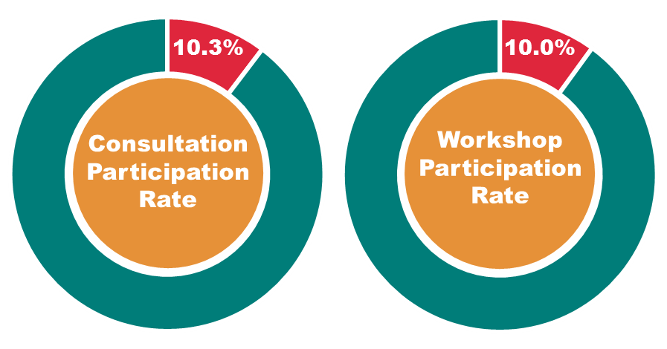

Figure 20: Participation rates of low SES students at Careers consultations and workshops.
Low SES student participation at Careers consultations was over-represented compared to low SES participation within the total UNSW population (local, undergraduates between 2009 and 2014) – 10.3% of students attending were low SES, compared to the low SES participation rate of 9.1%. Attendance at workshops was also over-represented with 10.0% attendance by low SES students (Figure 20).

Careers Consultations - Effect on Academic Success for Low SES Students
Low SES students attending appointments with Careers consultants had higher WAMs and improved academic standing after interaction (Figure 21) – though neither of these gains was significant. Interacting students also had lower discontinuation rates (3.9%) than those not attending (7.3%).
Students that interacted with Careers tended to do so at later stages in their program, which means they were at lower risk of discontinuing at the time of interaction (Krause, 2005). This has likely resulted in discontinuation rates appearing somewhat lower after a Careers interaction than was seen with other support initiatives.
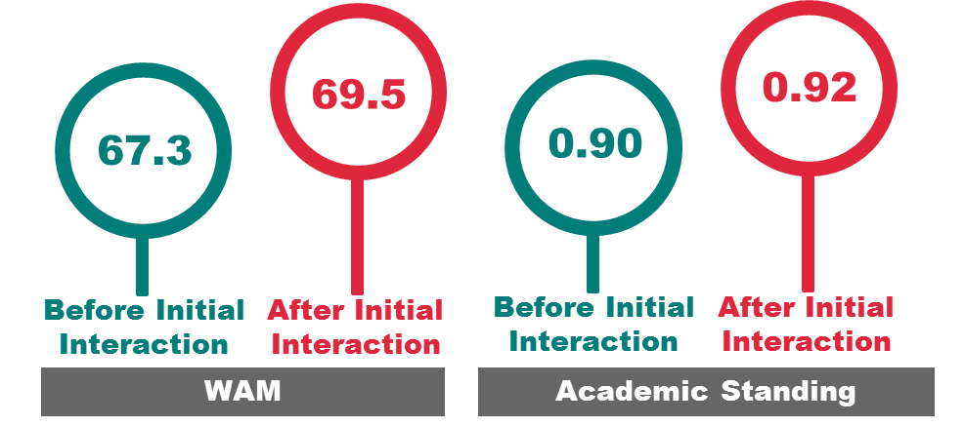

Figure 21: Mean WAM/academic standing before and after initial interaction with a Careers consultation.
Low SES students who had attended consultations and completed their program graduated with a significantly better mean WAM than those who had not interacted (Figure 22). This trend was also reflected in those who had interacted in their first semester – this group had a mean WAM at completion 5.9 points higher than those who had not interacted (though this result was not significant, perhaps due to the small sample size of first semester interacting students, n=27).
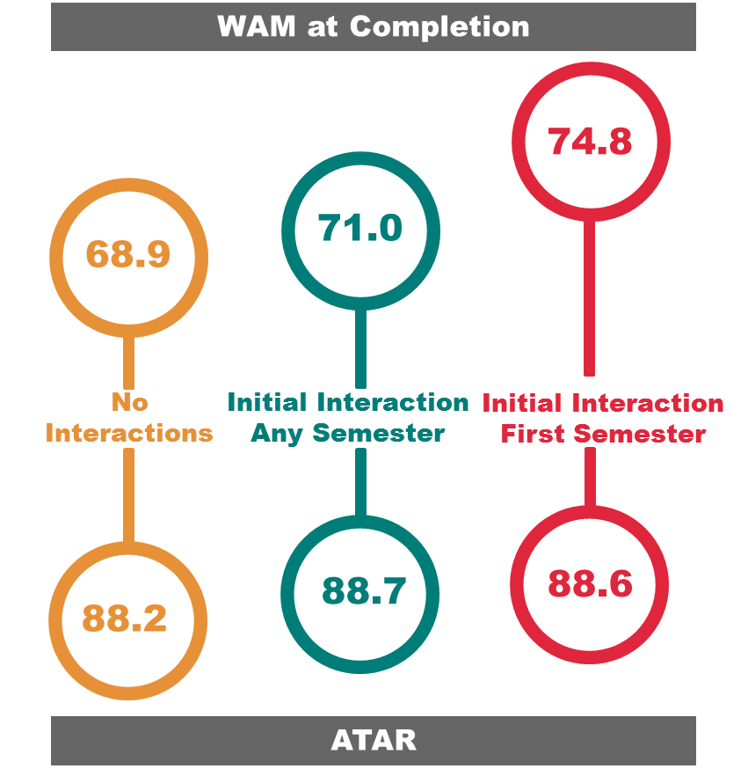

Figure 22: Comparison of ATAR and WAM at completion for students interacting with a
Careers consultation.
These results suggest that interaction with a Careers consultant had a positive impact on student success at graduation. Studies have shown that students who focus their school performance around career aspirations often perform better academically than students with less career clarity (see for example Yeung and McInerney, 2005; Ostrove et al., 2011).

All Students vs Low SES Students – Comparison of Effect on Academic Success
Across the whole cohort, those students who attended Careers consultations showed significant improvement in WAM and academic standing after interaction (see Appendix 7 for database findings for all students). They also had significantly higher mean WAMs at completion than students that did not interact. However, the average gains for the low SES cohort who interacted with Careers consultations were marginally higher across these academic indicators.
Results from the questionnaire supported this. Respondents from the low household income group (as identified in Part B of the questionnaire) found Careers consultations significantly more helpful (mean=3.59) than the high household income group (mean=2.72), as indicated on a five point Likert scale.

Interview Insights – Careers Consultants
A number of students described positive interactions with Careers consultants in the interviews. Students commented that interaction had helped them to identify career paths and develop an understanding of graduate recruiting:
“It [the Careers consultation] was nice, because… I had no idea what I wanted to do with my life and so what they helped me with was narrowing down possible fields or industries and occupations that I can get with my current degree.”
“[A Careers consultation] really helped me with honing my resume, and [my] awareness [of] how graduate recruiting works.”
One student perceived that the service had been particularly useful for them in the context of their background:
“Maybe also I found the Careers service so useful because my mum’s a teacher and my dad’s a farmer, my parents aren’t professionals so they weren’t able to teach me about the sort of graduate recruiting or networking… so maybe that’s why I found the Careers service so useful. I imagine for a lot of the Law students, their parents are lawyers so they already have access to those sorts of circles, and they already know how it works… people seemed to understand what was going on a lot better than I did.”

Careers Workshops - Effect on Academic Success for Low SES Students
Low SES students showed a significant improvement in academic standing after interaction with a Careers workshop, and these students had a higher mean WAM after interaction (Figure 23) (though this increase was not significant). Interacting students also exhibited lower rates of discontinuation (2.1%) than those who did not interact (7.9%) but again the difference was not significant.
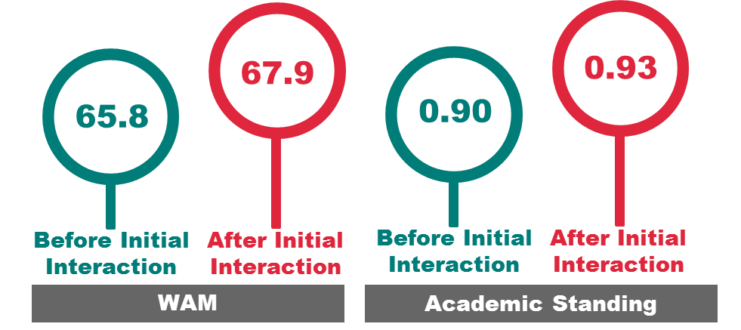

Figure 23: Mean WAM/academic standing before and after initial interaction with a Careers workshop.
There were no significant differences in WAM at completion for students who had not interacted and those who had. This was similarly the case for students who had interacted in their first semester compared to those who had not interacted (Figure 24).
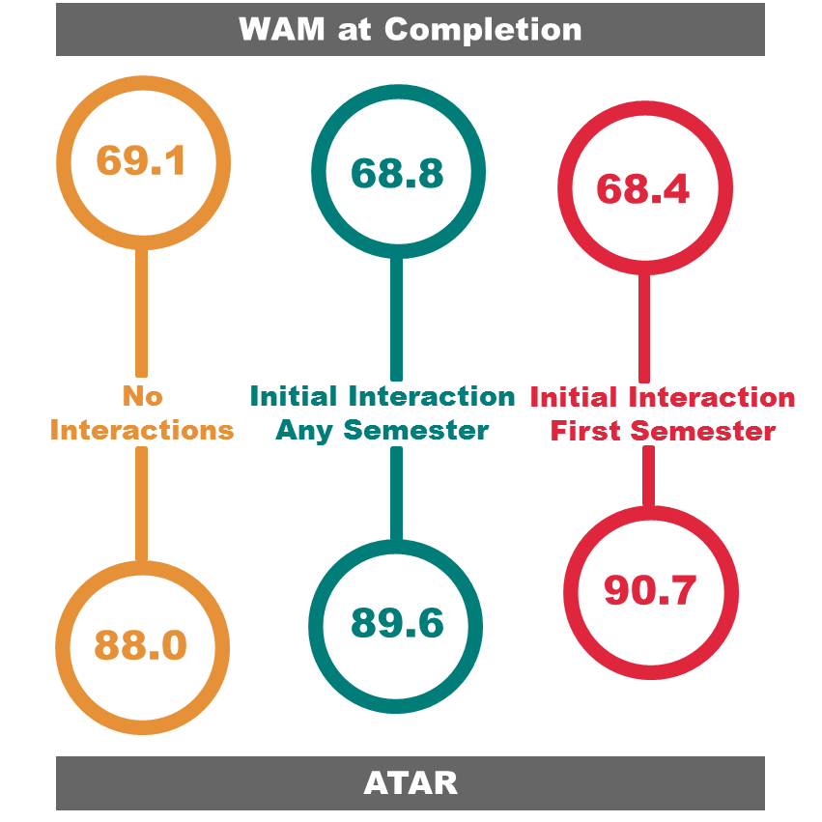

Figure 24: Comparison of ATAR and WAM at completion for students interacting with a Careers workshop.

All Students vs Low SES Students – Comparison of Effect on Academic Success
Results for the whole cohort showed significant increases in WAM before and after interaction and a significant improvement in academic standing. Interacting students also graduated with a significantly better mean WAM at completion, as did those who interacted in first semester.

Interview Insights – Careers Workshops
One participant specifically discussed attendance at a Careers workshop during interviewing. Their response indicated a positive experience:
“I’ve been to two [Careers workshops]… I found those ones useful because I’m not experienced in terms of resume writing, cover letter writing and interview skills…So I found that was helpful, I feel like I’m more knowledgeable about those things. I think without the tips that they gave me I would be a lot more clueless about job applications.”

UNSW Counselling and Psychological Services
UNSW Counselling and Psychological Services (CAPS) offer students a confidential counselling service via one-on-one consultations with a registered psychologist. CAPS consultations are usually conducted in-person by-appointment, but also occur over-the-phone, depending on the circumstances.
CAPS also run a number of programs and workshops for students including: Mindfulness Mediation; Sleep Smart – which highlights the benefits of healthy sleep patterns; Student Minds@UNSW – a mental health awareness initiative; the Phoenix Rising Workshop – which supports the academic goals of underachieving students and assists them back on the path to success. They also run a variety of wellbeing seminars during orientation and throughout semester.

CAPS – Participation Rates
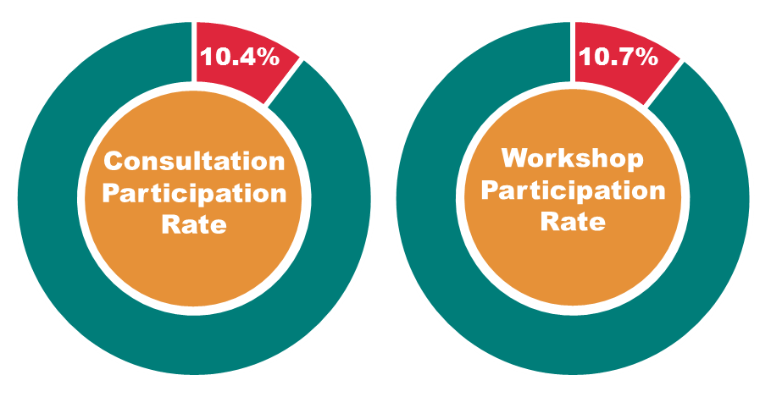

Figure 25: Participation rates of low SES students at CAPS consultations and workshops.
Low SES student participation at counselling consultations were over- represented compared to their participation in the total UNSW population (local, undergraduates between 2009 and 2014). 10.4% of students attending were low SES, compared to the low SES participation rate of 9.1%. Attendance at workshops was also over-represented with 10.7% attendance by low SES students (Figure 25).

CAPS Consultations - Effect on Academic Success for Low SES Students
Low SES students interacting with CAPS consultations had a significantly lower mean WAM after interaction (62.7) than before (63.3). The academic standing of students was also significantly worse after interaction (before = 0.84, after = 0.78). However, low SES students who interacted with CAPS consultations and then went on to complete their program did not have a significantly lower mean WAM than those who did not interact, and students who interacted in their first semester actually graduated with a WAM two points higher than those who did not interact at all. This was a significantly better result (Figure 26), despite interacting students having lower mean ATARs.
“Some students who interact with a counsellor in their first semester at UNSW are referred from a school counsellor or health professional. Students receiving support under the child and adolescent community mental health teams tend to be no longer eligible for those services due to reaching the age of 18 years and have to transfer to adult services which are not quite as ‘holding’ as the child and adolescent services. CAPS is seen as an appropriate and personalised service for these students” (personal correspondence, Andrews, 11th March 2016). This suggests that some students accessing counselling in their first semester are experienced help-seekers who may be acquainted with the potential benefits of counsellor intervention for mental health or emotional wellbeing issues.
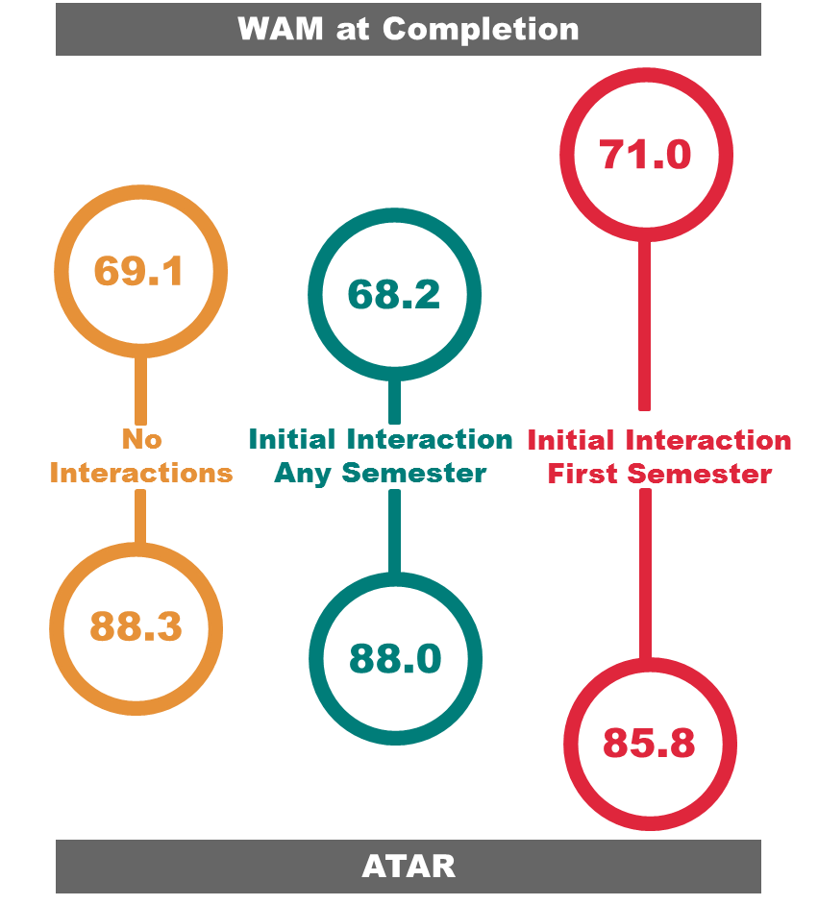

Figure 26: Comparison of ATAR and WAM at completion for students interacting with a CAPS consultation.

Low SES students who interacted with CAPS consultations were not more likely to discontinue. In fact, the discontinuation rate of those who interacted was less than average (though not significantly so) (Figure 27).
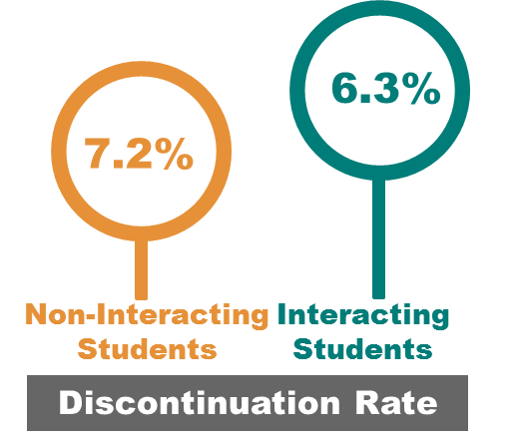

Figure 27: Discontinuation rates of students who interacted with a CAPS consultation and
students who did not interact.
Academic outcomes are not a reliable measure of success for students who interact with counselling services. Several recent studies conducted at Australian universities show that students who access university counselling services are experiencing higher levels of psychological distress than the general university student population. Andrews and Chong (2011) showed that the percentage of students exhibiting moderate to severe psychological distress attending a university counselling service was significantly higher than the general population. Vivekananda et al. (2011) found very high levels of distress among the population of students visiting the counselling service at RMIT, with 78.4% suffering significant levels of distress indicative of a number of serious mental health disorders including depression, anxiety and substance abuse. Schweitzer et al. (1995) reported a significant relationship between students’ seeking help from counselling services and an increase in suicide ideation and behaviour – with proportionally more students utilising university counselling services attempting suicide.
Andrews and Chong (2011) describe how experiences of mental health problems can have considerable impact on academic performance. Student counsellors working in the post-secondary sector are reportedly well aware of the association between anxiety/mood disorders and issues such as impaired concentration, short-term memory loss, impaired motivation, increased lethargy, and general interference with academic participation (e.g. reduced attendance, academic assessment underperformance, or delays in or failure to submit assessment) (Andrews and Chong, 2011).
Notwithstanding these issues, low SES students who interacted with CAPS were no more likely to discontinue, and did not have significantly lower WAMs at completion than those who did not interact. This highlights the importance of counselling intervention for many low SES students. It also emphasises the need for a qualitative/experiential account of service viability.

All Students vs Low SES Students – Comparison of Effect on Academic Success
When taking into account the whole cohort, those students who visited a counsellor had significantly higher WAMs after consultation than before – whereas WAM dropped after consultation for the low SES group (see Appendix 7 for database findings for all students). Additionally, although academic standing was worse after interaction, the drop was less than that for the low SES students. Furthermore, the average difference in WAM at completion for all interacting and non-interacting students was less than the difference for the low SES cohort.
These results may be a function of the severity of issues faced by low SES students, rather than an indication of the effectiveness of the intervention. It has been well established that mental health issues tend to be exacerbated in the low SES population. Ng et al. (2014, p1) highlight “generations” of research confirming the link between SES and mental health, with this relationship being one of the most firmly established patterns in psychiatric epidemiology. Ng et al. (2014) explain that the most deprived sections of society tend to experience the worst mental health outcomes. Furthermore, Andrews and Chong (2011) report that student financial circumstances exert a significant negative influence on levels of psychological distress and quality of life. This is described as “the stand out risk factor” for being significantly impacted by psychological distress, stress, anxiety and depression (Andrews and Chong, 2011, p25).

Interview Insights – CAPS Consultations
The benefits of an engagement with psychological services are better gauged via a method that captures emotional and social outcomes, as well as academic (Payton et al., 2000). Narrative analyses of interviewed students who attended a CAPS consultation were drawn on to produce a more complete account of interaction success.
Students often explained during in-depth interviewing the positive influence a counselling consultation had on their ability to perform successfully at university. For example:
“CAPS has blown my mind with how much it’s helped me keep some perspective and keep chugging along with my studies”.
“I also called them when I was thinking about dropping out of uni and they were helpful then as well.”
“They did highlight a lot of issues I didn’t realise [I had]. I didn’t realise how much anxiety affected uni for me, and I didn’t realise how much it influenced my attendance. They were pretty good at dealing with things like that.”
When asked whether any services had impacted their success at UNSW, one student commented:
“Definitely CAPS and Nura Gili, without them I would’ve just dropped out and given up, which is really horrible sounding. So I defiantly think if I didn’t access those services I wouldn’t still be studying.”
Students also explained some of the general benefits they had received through a one-on-one appointment with a counsellor:
“The counsellor was very helpful in terms of quickly working out what the situation is and supporting me.”
“I could sort of speak about my problems, and it really helped me process what was going on.”
“CAPS was most helpful. Even if it is about something that’s non-mental health related, I can still talk to them and see if they’ve got some strategies, or we can work together to figure out some strategies to cope with other things.”
“I mean, they (CAPS) are good for those times when you’re feeling low, and then you go and speak to someone and they sort of help you with your confidence to realise it’s not the end of the world – you’ve still got a chance to try your best, to do whatever you can.”
These responses highlight the issues that many students face that cannot always be modelled in statistical analyses. A successful interaction in this regard may be one where the student has received counselling to continue enrolment, or a student has been made aware of issues affecting them that were otherwise unknown, or where a referral for further assistance has been provided (cf. Nelson and Goodman, 2011). Some students highlighted positive experiences after referral:
“I started an early psychosis treatment program through Headspace…seeing CAPS led into that. Without going to CAPS I would not have gone to Headspace.”
“CAPS were good because they referred me to go and find some external [help]… which was helpful, that was what I needed.”

CAPS Workshops - Effect on Academic Success for Low SES Students
CAPS workshops cover a variety of specific programs, workshops and seminars for mental health and study skills development. They provide a self-help resource for students to uncover information and knowledge to promote personal wellbeing and adjustment to university life.
CAPS workshops provide a considerably different service than CAPS consultations. Low SES students interacting with workshops showed improvement in academic success measures.
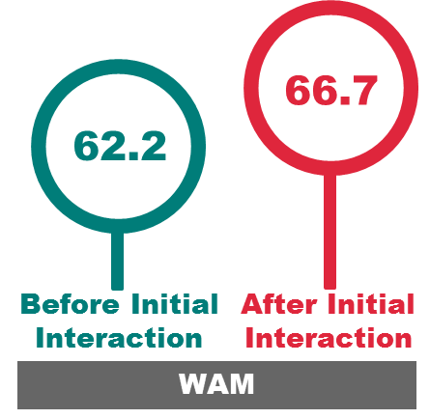

Figure 28: Mean WAM before and after initial interaction with a CAPS workshop.

Mean low SES student WAMs were 4.5 points higher after workshop interactions (Figure 28). Academic standing was similarly better after interaction, but not significantly (Figure 29).
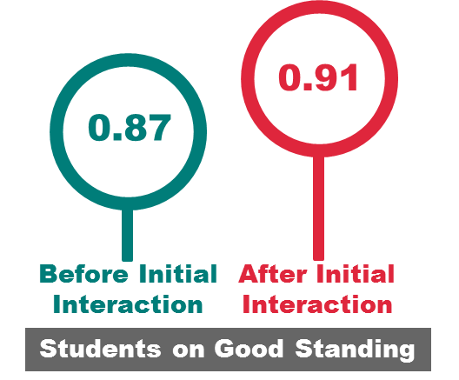

Figure 29: Mean academic standing before and after initial interaction with a CAPS workshop.
Mean WAM at completion was 1.4 points higher for those who interacted and 3.1 points higher for those who interacted in their first semester. Although, with a sample containing just one interacting student, this result is negligible (Figure 30).
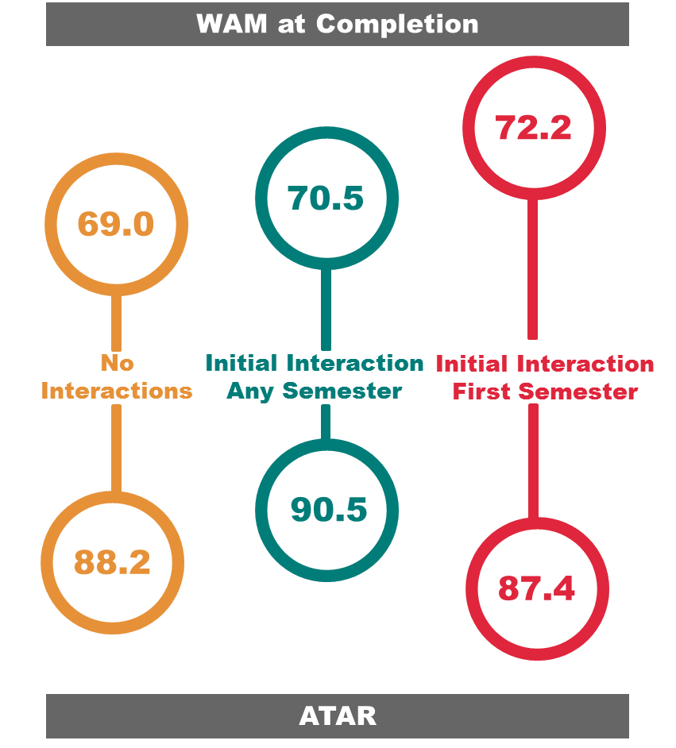

Figure 30: Comparison of ATAR and WAM at completion for students interacting with a CAPS workshop.
The discontinuation rate for interacting students was 2.8% (compared to 7.1% for non-interacting students) (Figure 31).
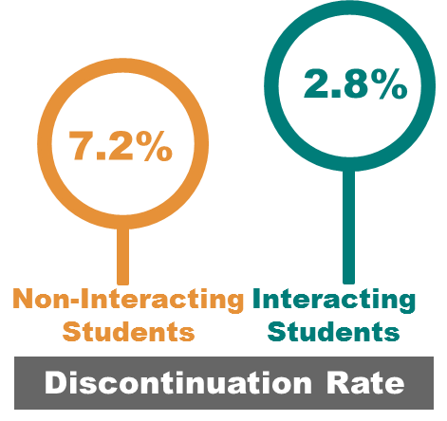

Figure 31: Discontinuation rates comparing students who interacted with CAPS workshop and
students who did not interact.

All Students vs Low SES Students – Comparison of Effect on Academic Success
The low SES cohort had a lower mean WAM before and after interaction than the corresponding averages for all students - though this gap closed by 3.8 points after interaction. Across all students academic standing did not change after interaction, whereas this improved for the low SES group. Students who interacted with CAPS workshops had a significantly higher WAM at completion compared with students who did not interact regardless of SES. However, the increase in WAM was smaller for the low SES group.

Interview Insights – CAPS Workshops
There were few mentions of attendance at CAPS workshops during in-depth interviews. Although, one student attributed the outcomes of workshop attendance to having good mental health:
“[it was an] extremely good resource because it kind of does help with your mental health having a support network and having workshops”

Educational Support Service
The Educational Support Service provides one-on-one appointments to students with Educational Support Advisors (ESAs) (known as Student Participation Advisors prior to 2015) who offer personal and study support. Issues addressed by the service include: academic performance; goal setting; time management; support with settling-in; and navigating UNSW processes such as special consideration, grade appeals and course withdrawal.
The Educational Support Service was established under HEPPP funding to provide targeted support to students from low SES backgrounds, students entering UNSW through alternative entry schemes and students identified as being at risk of attrition. However, the one-on-one appointments and workshops offered are open to all students.

ESAs – Participation Rates
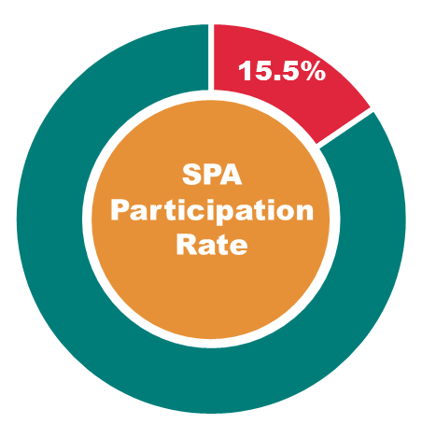

Figure 32: Participation rates of low SES students at ESA consultations.
Low SES student participation at ESA consultations was over-represented compared to their participation in the total UNSW population (local, undergraduates between 2012 and 2014) – 15.5% of students attending were low SES, compared to the low SES participation rate of 9.4% (Figure 32). This was the highest participation rate for any of the support initiatives.

ESA Interaction - Effect on Academic Results for Low SES Students
Figure 33 shows the ATAR and WAM at completion data for low SES students interacting with an ESA. These students had the lowest mean WAM at completion of any of the groups in the study – but modelling showed that this WAM was not significantly lower than those not interacting. A contributing factor to this non-significant result was the fact that this group also had the lowest mean ATAR in the study – over eight points less than the average. They also had a higher discontinuation rate (9.5%) than those not interacting (5.3%), though not significantly so.

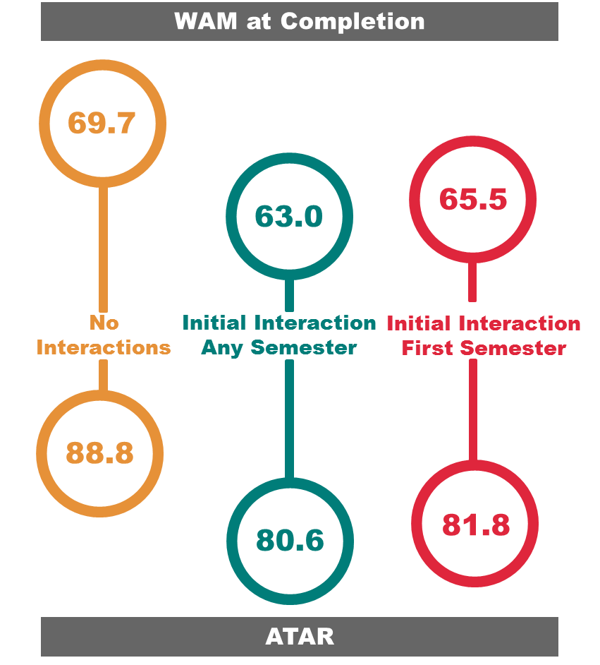

Figure 33: Comparison of ATAR and WAM at completion for students interacting with an ESA.
The results also showed that this group had a low mean WAM before and after interaction relative to their peers, and low rates of good academic standing. Again, both these indicators were the lowest of any interacting group in the study. However, low SES student WAM after interaction was higher than before, and there was a significant improvement in academic standing – the largest gain of any group in the study (Figure 34).
Results indicate that the low SES group interacting with the ESAs were the most ‘at-risk’ cohort in the study. Regardless, many benefited academically from their interaction with the service.
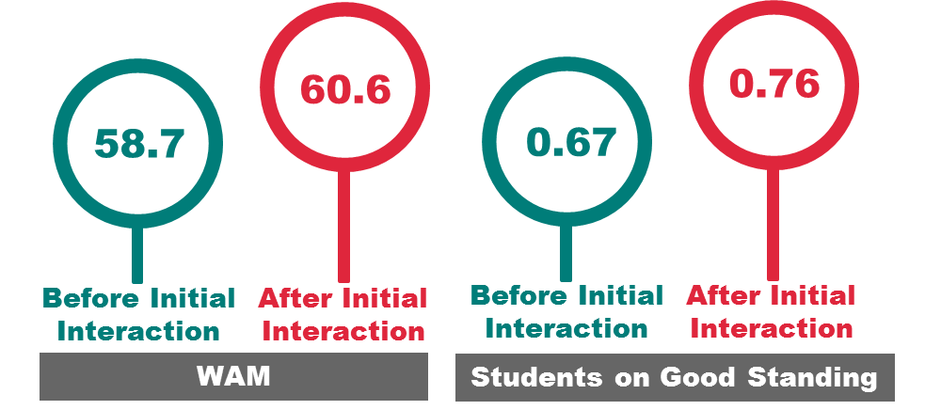

Figure 34: Mean WAM/ academic standing before and after initial interaction with an ESA.

All Students vs Low SES Students – Comparison of Effect on Academic Success
Students interacting with ESAs did not perform well academically regardless of SES (see Appendix 7 for database findings for all students). Across the whole cohort, these students had the lowest mean WAM before and after interaction, the lowest rates of good academic standing, the lowest WAM at completion; and the lowest ATAR of any group in the study.
However, those interacting did show academic gains after interaction. There was a similar increase in WAM before and after interaction, but the low SES group had a higher gain in academic standing.
WAM at completion was lower for students who interacted with ESAs than students who did not interact, but the difference was larger for low SES students.
Findings from the questionnaire show no significant differences across SES cohorts in the helpfulness of an ESA within the ‘academic demands’ section of the survey. However, for ‘emotional matters’, the three cohorts that found ESA interactions most helpful were the low SES groups. In particular, the low household income group found consultations significantly more helpful (mean=3.00) than the high household income group (mean=1.5).

Interview Insights – ESAs
Students mentioned in interviews how ESAs had contributed to their success as a student at UNSW. The following participants were grateful for the advice they received, with regard to time management for example:
“I’ve always had trouble with [time management]. In high school I never worked out how to organise my time. At uni I’ve sort of just tried to work it out myself, which didn’t really work. I ended going to see them [ESAs] and they were helpful with that.”
“[I interacted with an ESA] mainly because of [a] time management [issue]. I just wanted to get a bit more organised and have some more structure.”
“[The] ESA showed me how to do a weekly study timetable, and how to plan out assessments for the whole semester. I found that really helpful”
Another student talked of their need for special consideration and the help they received from an ESA:
“I had an assignment that was late and they sort of told me how to go about applying for special consideration, which was helpful.”
Other students spoke of the general help they received in addition to the specific instances of assistance mentioned by the above quoted students. For example:
“I saw the Educational Support Advisor once and it [helped] having the support of someone to listen to me and give some advice as well…”

“Yeah they were really helpful. It was simple information but it made a big difference.”
“I think [the] ESA was extremely helpful”

Creating a Resource for Future Research
The creation of a robust source of evidence that could be leveraged for future study and investigation was identified as a key outcome for the project. The third project aim states the intention to:
Create a robust source of data and evidence for future research, evaluation and policy development.
This aim was achieved in part through the findings presented in the preceding chapter. The outcomes from the investigation and the relationships identified provide evidence on the effectiveness of higher education support initiatives. By sharing these insights across the sector this evidence can be used as a platform for future decision making and policy development, and to encourage further discussion and collaboration.
In addition to providing evidence on the impact of support initiatives, an outcome of this study was the creation of a student data source – one specifically designed to describe student demographic and academic information. This data source can be used for future studies, research and evaluation across SLL. This chapter details the creation of the data source using SAS EG and highlights its potential for further use. The building of the data source in tandem with the other project aims is discussed, followed by a description of the data fields it contains and how these can be manipulated.
Several outcomes were identified for the data source. Features that were important in its creation included:
- Accessibility – it was made with ease of use and ease of interpretation in mind
- Flexibility – it should be flexible in its use for a range of potential research purposes
- Updateability – it should be easy to add to or improve upon
The data source consists of two databases. One was initially envisioned, however, it was observed during the project that certain analytic and reporting needs required different database formats. The methods section (page 17) touched on the need for two formats to perform the analyses necessary to the project – the long and wide database formats.
Creation of these databases involved leveraging the data mart (described on p.12). The first task involved preparing the demographic and academic variables identified for inclusion in the data source. Preparation was required due to various complexities in the information contained, particularly in regard to older data. For instance, some students graduated with a degree that they had no history of enrolment for. While this is explainable (such as a student being awarded a Bachelor of Science degree when they had been enrolled throughout their program in a Bachelor of Advanced Science), it presented issues for allocating variables to individuals (such as grades across semesters corresponding to a completed program).
Data preparation was operationalised in SAS EG via its data management and manipulation features, including query building, data sorting and data filtering. The final SAS EG project consisted of three process flows. Figure 35 displays the preparation of demographic (left process flow) and academic (right process flow) variables for inclusion in the data source. The web-like structure of the process flows visually illustrate the numerous table joins required in the querying and filtering of information from multiple information sources (i.e. the joining of data tables from the data mart).
The third process flow contains the splitter that was described on page 22 of the methods section. The long and the wide databases are housed in the splitter process flow.
The first database stores student data in long format, where each student has a row for every semester they were enrolled at UNSW. Each row contains data relevant to the student’s enrolment in that semester, such as their current program, semester WAM, and academic standing.

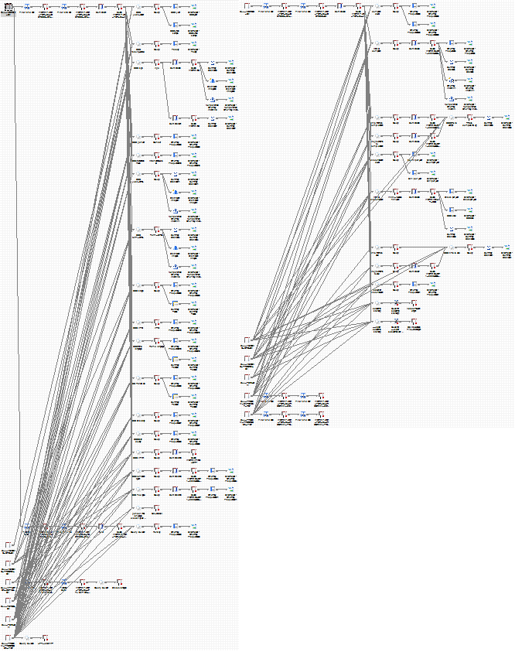
Figure 35: Preparation of demographic (left) and academic (right) variables for data source construction.
Some statistical analysis packages, as well as certain statistical methods, require data to be entered into the software in this long format. For example, the linear MLMs that were performed for this project required long format data to capture longitudinal changes in student WAMs across semesters. The long format would find most use in statistical analyses. The long database preludes the beginning of the splitting process (illustrated Figure 36).
In the wide database students still occupy their own rows as they do in the long format, however, they only have as many rows as programs they were enrolled in – e.g. two programs equals two rows. Student WAMs are populated along the row relative to the semester they were achieved – i.e. they are distributed along the columns. Each semester WAM has its own column, as do other temporal academic variables such as academic standing, study load and stage.
Manipulating the data for analysis in the project required incorporating the wide and long format data. For example, interaction data were built into a process flow for multilevel analysis via the wide format and then transposed through query and joined with long format data. This could only be achieved by having access to both data formats. Wide format data is arguably better assembled for reporting purposes. The wide database is situated at the end of the splitter (Figure 36).
Updates can be made to the data source by varying the parameters that are currently in place. Filters can be manipulated to include or remove particular data as required. Parameters placed on the data for this study included: year of enrolment (2005-2014); student residency (local students); and academic career (those enrolled in undergraduate programs). Changing of parameters is performed at the variable preparation stage of the project (process flows one and two) and at the splitter stage (process flow three), depending on the parameter.
Information from subsequent years can be included in the data source as it becomes available. These data can be added to the long database by changing the filters in process flows one and two, and at the long database join in process flow three. Adding these data to the wide database requires the same changes with the addition of new splitter re-joins for each new semester. Semesters can also be removed from the data source by restricting the years being fed through the filter and (in the case of the wide database) removing splitter re-joins (or simply removing columns from the wide database output).
For the current study, the SAS EG project also contained data files on student interactions with each of the initiatives – these were joined with the long and wide databases to investigate the impact of interaction on the academic variables. These data files are confidential. Permission for these data to be included in the project was granted by the Director of UNSW Student Life and Learning and their use was in accordance with the requirements of UNSW Human Research Ethics. Consequently, the interaction data will be removed before the data source is made available outside of the project team.

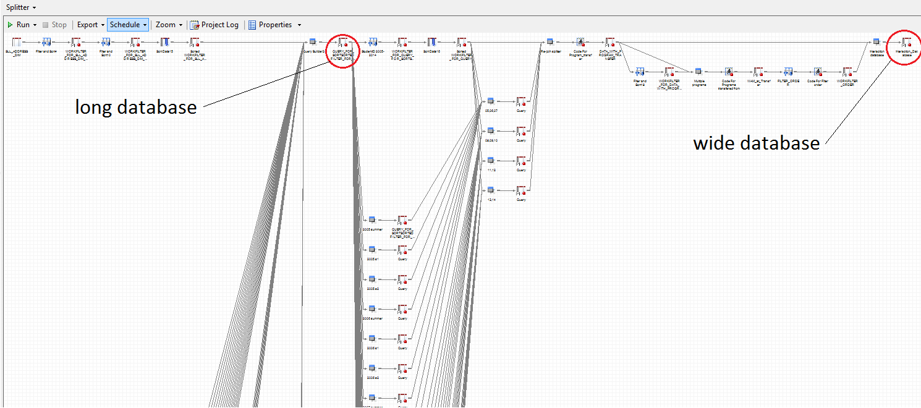
Figure 36: Screenshot indicating database locations in splitter process flow within data source project.

Discussion
This project has sought to unpack the influence of university support initiatives on students through a research intensive, mixed-method study. Specifically, the concern of this project has been to explore how the success of students from low SES backgrounds is impacted by their interaction with the support initiatives offered by SLL at UNSW. A low SES ethnography was identified through the use of mass student data sourced from university records, which were then added to via the self-reported information gathered via questionnaire responses and interview testimonies. These methods captured the demographic, academic and experiential data that were collated and then analysed to inform the project aims. Results and their interpretation are discussed in this section.
Previous support initiative studies have tended to base their analysis on a single method approach. It was the intention of the project team to present a more encompassing account of the subject matter. This was approached by offering an examination that incorporated often-overlooked or out-of-scope methods and analyses. For instance, multi-method investigations have been called for in the literature (Tinto, 2010;Naylor et al., 2013; Gale and Parker, 2014), and the multilevel modelling technique is an underused tool in low SES educational data analyses in the (Australian) support initiative context – despite advantages for its use in scholarship (Pan et al., 2008; Stewart, 2008; Goldstein, 2011), as well as calls for its use (Edwards and McMillan, 2015). McConney and Perry (2010, p439) outline the widely recognised understanding that MLM is ideal for estimating unique associations of student- and faculty-level variables on student performance, while highlighting that the MLM “relies on often unspoken assumptions that relationships among variables under study are linear”. “The approach can thereby result in the unintended consequence that departures from linearity in relationships for particular subgroups of students within the dataset, which may become evident with a finer grained analysis, are masked.” (McConney and Perry, 2010, p439). Thus, the relationship between low SES success and initiative interaction was approached drawing on database information in tandem with the finer-grained methods of purposive questionnaire sampling and interview narrative analysis.
The results of this research indicate that SLL support initiatives contribute in different ways to success. SLL support initiatives vary in their service provision, and as a corollary, required contextual definitions of their success outcomes.
A focus on improved academic performance offered by interaction with TLC and Disability Services allowed these particular services to be assessed by their contribution to academic success. It was found that low SES students had a greater chance at academic success if they interacted with TLC and Disability Services. This was evidenced by the significantly improved grades after interaction (TLC consultation) and significantly higher grades at program completion (TLC consultation, Disability Services) seen among the low SES cohort. These results were corroborated during in-depth interviews, where students described how in various guises the services had contributed to their success.
Careers and UNSW Advantage initiatives operate with the professional development of students in mind. The contribution to success offered by these initiatives is manifold, but in the interest of analysis was assessed as a function of impact on late-stage academic performance (Careers) and development of social capital (UNSW Advantage).
A Careers consultation served to significantly increase low SES student grades at program completion, and attendance at a Careers workshop resulted in students being significantly more likely to be on good academic standing. Student testimonies supported literature that discusses the importance of career clarity on academic performance (Dennis et al., 2005; Evans et al., 2011). Questionnaire data illustrated that low SES students considered Careers consultations significantly more helpful than their high SES peers, while interview data identified that this was in some part due to the socioeconomic context of students’ backgrounds – high SES students tend to possess an encultured understanding about where a university degree might take them, but low SES students are more likely not to (Walpole, 2003; Devlin, 2010; 2013). This resulted in Careers consultations being more beneficial to low SES students.
An interaction with an Advantage program was seen to significantly improve grades after initial interaction as well as result in better grades at program completion. However, students did not directly attribute these interactions to academic success. Students were apt to link their Advantage program experiences with improvements to non-academic areas such as social engagement, professional development and mental health. These benefits are underpinned by their psycho-social construct in a higher education environment (Zhao and Kuh, 2004; Kuh et al., 2008). Harper and Quaye (2014, p4) explain that integration into “social communities on campus lead to higher levels of institutional commitment”, which in turn compels students to succeed. This was hinted to by students in many of their responses through testimony such as:
“When I get to talk to people I feel less stressed, and when you’re less stressed it feels like you’ve got some of the load off you so you can focus back on your work”
“Through being involved in the student bodies, having a community and having friends, I’ve been able to limit the impact of being from a rural area and finding it hard to adjust or being unwell”
“I think it’s important to develop your skills in ways that you might not necessarily come across in your job or in other social settings”
Students simultaneously recognised (in their narrative) and demonstrated (through academic results) that social engagement can be directly linked to academic performance at UNSW. The academic success of low SES students who interacted with Advantage programs supports this.
Conclusions drawn regarding Advantage program interaction would have been different if a single-method approach was used. Academic results point to a direct influence on academic performance, whereas narrative analysis suggests social inclusion and mental wellbeing were success outcomes of this particular support initiative interaction. Both are true. However, these conclusions individually do not tell the whole story. A mixed-method application enabled further unpacking of data to connect what would otherwise remain unconnected, and in doing so bring to the fore a better understanding of the initiative’s influence on low SES students.
Low SES students attending appointments with counsellors at CAPS saw a reduction in academic performance after interaction. However, this may not be a reflection of the interaction, but a function of the severity of the issues faced by interacting students. Interview responses better validate the multifaceted impact a one-on-one appointment with a counsellor can have on attendees (Payton et al., 2000). Success in this regard can be read as perseverance (Harper and Quaye, 2014), and low SES students who interacted with CAPS were not more likely to discontinue than non-interacting students.
ESA interactions were represented by a cohort with a relatively poor academic performance record. Nevertheless, low SES students who interacted with an ESA were significantly more likely to be on good standing after interaction. In addition, questionnaire participants identified as low SES through Part B of the survey found the service significantly more helpful than high SES participants when it came to ‘emotional matters’. However, students may have conflated emotional wellbeing with academic performance and social wellbeing. Pekrun et al. (2002, p102) posit that students experience a rich diversity of emotions in academic settings, such as a university, identifying that “social environments can induce academic emotions in students”. “Gaining a realistic account of students’ academic performance may require taking their emotions into account” (Pekrun et al. 2002, p103). This is not to say that students were wrong in their self-appraisal of the help they had received. On the contrary, it demonstrates the complex links between emotion, sociality and academic performance, and how these are re-produced by one another within the student experience (Pekrun et al., 2002; Kahu, 2013).
Much evidence exists around the impact of emotional support (or lack of) on student success (see for example Johnson, 2016). The support and guidance offered by services such as CAPS and ESAs contribute to the emotional support of students, which in turn can be said to contribute to their success.
Students were asked “Do you think people, including yourself, need support services, programs and/or workshops at UNSW?” All interviewed students replied yes, including:
“Yes, yes I think we do, based upon my experience anyway”
“Yes definitely. They help immensely”
“Yes, I think without them you’d be missing a rather large demographic of the university”
“I think definitely yes. I wouldn’t be here if I hadn’t been supported, that’s for sure. It would just be too hard”
“Yes, I feel like every student should be provided with support services and workshops. And I really do believe our university does a lot”
A common perception among the research participants for this project was that support initiatives had contributed to their success as students. For instance, when asked “Have any of the support and development services that you interacted with impacted on your success?” Responses included:
“Definitely the doctor has helped a lot, and I think the CAPS counsellor supporting me”
“They have. [Disability Services] has defiantly contributed to my success”
“Yes, [Disability Services] has improved my success, if that makes sense. It has made it easier for me to succeed”
“Yes, totally, yeah”
“Yeah, I think ESA was extremely helpful, and CAPS was helpful”
“CAPS has blown my mind with how much it’s helped me”
“I definitely think so. I probably would’ve dropped out of it wasn’t for them, I was considering it”
“I think knowing that the support is there has been helpful in going ‘I’m not alone in doing this’”
Notwithstanding evidence of the influence of interaction on success, interview participants also highlighted barriers to support access, barriers that may have prevented them, or others, from achieving greater success through initiative support. For example, the following students bemoaned the high demand for services and subsequent wait times:
“Well it would be nice if they could have more appointments available. The problem that they face is that the university keeps enrolling more students each year and the services tend to stay the same”
“I know that there’s a lot of wait just for general things and that there is a lot of demand. Even meeting with [Disability Services], it’s got to be planned quite a bit in advance.”
“[It is hard] being able to make time where they have time for you and you have time for them. Just to make appointments, it’s a bit difficult”
“You have to wait a long time to see free [services]”
Other students noted some reluctance to seek help, which can be common (Tones et al., 2009; Naylor et al., 2013):
“I sometimes think I might go there (to a support initiative) and they might be like “it’s not the right thing for you”. I don’t know if want to go through to deal with that”
“it seems if I really wanted to I could go right ahead and look them all up and ask around and all that. But I don’t really want to”
“I frequently feel that I may have any issue, but I wouldn’t need to particularly go and seek out support from a program”
“I’m not saying I don’t need people’s help, [but] I think that if I can deal with it myself then I feel stronger and independent”
This was sometimes a result of not having confidence in the ability of support initiatives to help…
“I’ve seen psychologists before and they’ve never been that helpful, so I was sort of a bit dismissive of [UNSW support initiatives]”
“[There is a gap between] your expectations on what they can help you with compared to the degree that they can actually get you there”
“I guess there still is a bit of a barrier, a sense of trepidation of actually trying to access them because I’m not too sure about how they’re relevant to me personally”
Or a perceived stigma surrounding help-seeking, or admitting to a need for help…
“Stigma is probably is the biggest [issue]. You think if you’re going to CAPS or Disability Services or even the Hub that you’re a person who’s going to need support, and that’s somewhat of an issue”
One student identified a disconnection between their belief about other’s need for support and their own willingness to act on this belief:
“I think most people probably need support, which is sort of contradictory to how I feel about getting support”
Some research participants were inclined to have the attitude that they were not deserving of the services, and that support should be left to more worthy candidates. For instance:
“I’m probably not too likely to access any sort of financial help at uni even if I really needed it, just because I feel like there’s probably other people more deserving”
“I think that probably there are a lot of people that need them [more than me]”
A lack of knowledge with regard to the existence or location of support initiatives was also a common theme among research participants. Such as:
“I know the centres are there because I walk past, but I wouldn’t use [them] because I don’t really know much about [them]“
“sometimes at uni I just don’t know who to approach or what support services are out there if I am in need of help”
“I know there are lots of [services] out there, I just wish that I would be able to find more about them or that [they] be more accessible to students so that we can actually use them”
“Not knowing about things [is a barrier]. CAPS told me about some different services that I could use. I only found the ESA people this year and I think it’s my third year here”
“I know there’s a lot of [support initiatives] out there, it’s just they’re [hard to find, especially] a lot of the ones you don’t see. One of the reasons I went to Student Central and the Hub is cos they’re along the main walkways of uni, so you see them and you’re like “oh there’s that” and then I can go research it. But some of the other ones they’re a bit more tucked away and you don’t really know that they exist”
A large portion of interview participants also spoke of interacting with non-SLL support initiatives. These included interactions with services provided by ARC as well as school and faculty level services. Also, students identified sources of support that contributed to their success from outside the university. External support was accessed in the shape of formal intervention, such as clinical or government, and informal help, including familial or peer support. These non-institutional support networks are often vital to low SES student success (Benson et al., 2009)…as are university support services (Glaser et al., 2006; Harvey and Luckman, 2014).
Fostering a culture of help-seeking among students is important (Karabenick and Newman, 2006). Low SES students have been identified as lacking help-seeking motivation (Tones et al., 2009; Naylor et al., 2013), but seen engaging in help-seeking practices in comparably high rates elsewhere (Gale and Parker 2013). Students develop their help-seeking competence by engaging with SLL support initiatives, which in turn increases their chance at success. In other words, help-seeking fosters help-seeking, especially if the experience was positive (Gulliver et al., 2010). The large majority of interview participants confessed to positive experiences with SLL initiative interactions. This in turn facilitates the re-production of help-seeking behaviours, which is widely agreed upon as critical to low SES student success (Robbins et al., 2009; Tinto, 2010; Devlin et al., 2012; Gale and Parker, 2013; Naylor et al., 2013; Christensen et al., 2016).
All nine support initiatives were found to contribute to low SES student success, albeit in different ways. The project team acknowledge that the success outcomes assessed for individual support initiatives are not exhaustive, and that services may contribute to success in ways that have not been assessed or identified in this report. This also serves to highlight the salience of using multiple methods to gather as much relevant data as possible to inform analyses.
The contribution of methods to answering the project aims could be summarised as follows:
- The database identified the target cohort and participation rates of interacting students as well as their academic outcomes in correlation with support initiative interaction.
- Questionnaire data enabled quantification of the severity of various student issues and the extent to which initiatives helped, or did not help with these.
- Interview testimonies delivered in-depth narrative on the support provided by initiative interaction and elucidated data relevant to the project themes.
This report has identified how and where low SES student success was influenced by SLL support initiatives at UNSW between 2005 and 2014. This was achieved through provision of evidence gathered within a multiple methods framework. The project has also provided a data source from which further work may be undertaken, use of which would elide much of the lengthy data collation and manipulation process inherent in similar research.

Project Limitations, Implications and Future Research
The results of this study have illustrated that interactions with support initiatives can influence the success of low SES students at UNSW. While provision of academic and demographic determinants in combination with service interaction data has given insight into the influence of support initiatives, a definitive account of success as an outcome is yet to be obtained. This section poses some ongoing theoretical and practical challenges for future research as well as some of the limitations of the current study. There were inevitably areas of research out of scope for this project given that certain restrictions apply to an investigation involving the human dimensions of behaviour and experience, as well as the magnitude of factors that could otherwise impact success.
The mixed-methods approach used in this project has expanded understandings of support initiatives at UNSW and their impact on low SES student success. While insights have been provided into how success is influenced by support initiatives, it is understood that many of the forces and influences that act upon (low SES) students are intangible, highly variable and contextually situational.
First, the definition of success is not universal. This was made evident during interviews where student’s offered different takes on what being a successful student meant to them. The somewhat self-evident success indicators of academic performance and retention were considered for the current study. However, the subjective meanings of success imagined amongst the student cohort were something that was overlooked. Incorporating personalised student success into analysis, or taking account of the subjective meaning of success according to research participants, present opportunity for future work.
Further examination of support initiative interaction effect on low SES students is important so that the findings of this research may be corroborated or refuted – in part or in full. Given that this study was undertaken entirely at UNSW, further studies at different higher education institutions are warranted. It would be of particular interest to repeat the study at an institution that has high rates of participation of low SES students. Moreover, other groups may be targeted for investigation – the data source contains identifiers for additional equity groups such as those from regional and remote areas and those from non-English speaking backgrounds. Other studies might also examine the efficacy of faculty support programs and services. Other support initiatives in other areas or other universities may evoke different academic, social, emotional or behavioural outcomes.
The purposive sampling design employed for this project presents a potential limitation of the research methods. This approach was suited to the exploration of project aims, but could be expanded to account for other groups and other voices. In addition, qualitative research methods rely on assertions that have been interpreted from answers that may have been accidentally or intentionally falsified (Dumont, 2010). Some level of uncertainty must be considered when analysing self-reported data (Dumont, 2010). This also applies to SIMS data that was self-reported.
The current study focused on local undergraduate students from 2005 to 2014. Future work could incorporate a longer study period, non-local students and postgraduate students into the appraisal of support initiatives. In particular, the study of postgraduates and alumni present an opportunity to further assess the influence of support initiatives on student success within an extended longitudinal context. A recent study by Li et al. (2016) used the Australian Graduate Survey to assess a range of employment outcomes for disadvantaged groups in terms of probability of employment, qualification-job match, job quality, and earnings. A similar approach could be adopted to extend the current study to include data on student interactions with support initiatives. This would facilitate investigation into relationships between service interaction and graduate success – an area that has received little research attention (Bridgestock, 2011; Shah and Nair, 2011).
Further investigation is warranted at UNSW into students who participate in Advantage programs. The current study looked at the programs offered by SLL as a whole in order to maintain statistical power. However, an examination of individual programs would be of interest as several of the programs offered under SLL were established to facilitate engagement with low SES background students and provide opportunities to develop their social capital. While an investigation into academic success and interaction may not produce statistically significant findings, descriptive statistics on the participation rates of low SES students in each of the programs, as well as student grades and retention information, would allow a better picture of the participants to be developed. This investigation is made easier through use of the data source created in the current study. Further results on this topic may inform how SLL programs are tailored to ensure their optimisation for students from low SES backgrounds.

References
Allen, J., Robbins, S., Casillas, A., and Oh, I., (2008) Third-year college retention and transfer:
effects of academic performance, motivation, and social connectedness. Research in
Higher Education, 49: 647-664.
Andrews, A., and Chong, J., (2011) Exploring the wellbeing of students studying at an
Australian university. Journal of the Australia and New Zealand Student Services
Association, 37: 9-38.
Australian Bureau of Statistics, (2006) Community participation of people with a disability.
http://www.abs.gov.au/AUSSTATS/abs@.nsf/Previousproducts/66A7963E00C12206C
A2571B00010334A?opendocument 27 April, 2015.
Australian Bureau of Statistics, (2011) Population estimates under Australia’s new statistical
geography. http://www.abs.gov.au/ausstats/abs@.nsf/Products/3219.0.55.001~
August+2011~Main+Features~Methodology?OpenDocument 27 April, 2015.
Baik, C., Naylor, R., and Arkoudis, S., (2015) The first year experience in Australian
universities: findings from two decades, 1994-2014. Melbourne University Centre for
the Study of Higher Education, Melbourne.
Belot, M., Canton, E., and Webbink, D., (2007) Does reducing student support affect
scholastic performance? Evidence from a Dutch reform. Empirical Economics, 32:
261-275.
Benson, R., Hewitt, L., Devos, A., Crosling, G., and Heagney, M., (2009) Experiences of
students from diverse backgrounds: the role of academic support. HERDSA, July
2009, Darwin.
Biktimirov, E., and Klassen, K., (2008) Relationship between use of online support materials
and student performance in an introductory finance course. Journal of Education for
Business, 83: 153-158.
Boumelha, P., (2012) Support for inclusion: a New Zealand perspective. Journal of the
Australia and New Zealand Student Services Association, 39: 32-41.
Bradley, D., Noonan, P., Nugent, H., and Scales, B., (2008) Review of Australian higher
education: final report. Department of Education, Employment and Workplace
Relations, Canberra.
Bradley, R., and Corwyn, R., (2002) Socioeconomic status and child development. Annual
Review of Psychology, 53: 371-399.
Bridgestock, R., (2011) Skills for creative industries graduate success. Education and
Training, 53: 9-26.
Burk, D., and Bender, D., (2005) Use and perceived effectiveness of student support services
in a first-year dental student population. Journal of Dental Education, 69: 1148-1160.
Christensen, M., Hudson, J., Oram, M., and Wirihana, L., (2016) A survey of nursing students’
experiences and accessibility to non-educational support services at a regional
university campus. Journal of Nursing Education and Practice, 6: 43-50.
Crosier, D., Purser, L., and Smidt, H., (2007) Trends V: universities shaping the European
higher education area. European University Association, Belgium.
Dawkins, J. 1990. A fair chance for all: Higher education that’s within everyone’s reach.
Canberra, Department of Education Employment and Training.
Denny, K., Doyle, O., McMullin, P., and O’Sullivan V., (2014) Money, mentoring and making
friends: the impact of a multidimensional access program on student performance.
Economics of Education Review, 40: 167-182.
Department of Education, Employment and Workplace Relations, (2009) Measuring the
socio-economic status of higher education students. Australian Government, Canberra.
Devlin, M., (2010a) Improved access needs on-campus support. The Australian, 29
September, 2010. Accessed online: http://www.theaustralian.com.au/higher-
education/opinion/improved-access-needs-on-campus-support/story-e6frgcko-
1225931051379 23 April, 2015.
Devlin, M., (2010b) Non-traditional university student achievement: theory, policy and
practice in Australia. First Year in Higher Education (FYHE) international conference,
June 27–30, Adelaide.
Devlin, M., (2013a) Bridging socio-cultural incongruity: conceptualising the success of
students from low socio-economic status backgrounds in Australian higher education.
Studies in Higher Education, 38: 939-949.
Devlin, M., (2013b) Effective university leadership and management of learning and
teaching in a widening participation context: findings from two national Australian
studies. Tertiary Education and Management, 19: 233-245.
Devlin, M., Kift, S., Nelson, K., Smith, L., and McKay, J., (2012) Effective teaching and support
of students from low socioeconomic status backgrounds: resources for Australian
higher education. Australian Government Office for Learning and Teaching, Sydney.
Devlin, M., and McKay, J., (2014) Reframing ‘the problem’: students from low socio-
economic status backgrounds transitioning to university. In: Brook, H., Fergie, D.,
Maeorg, M., and Michell, D., Universities in transition: foregrounding social contexts of
knowledge in the first year experience. University of Adelaide Press, Adelaide, 97-126.
Devlin, M., and O’Shea, H., (2012) Effective university teaching: views of Australian
university students from low socio-economic status backgrounds. Teaching in Higher
Education, 17: 385-397.
Dockery, A., Seymour, R., and Koshy, P., (2015) Promoting low socio-economic participation
in higher education: a comparison of area-based and individual measures. Studies in
Higher Education, http://www.tandfonline.com/doi/pdf/10.1080/03075079.2015.
1020777, 27 April, 2015.
Dumont, F., (2010) A history of personality psychology: theory, science, and research from
Hellenism to the twenty-first century. Cambridge University Press, Cambridge.
Eisenberg, D., Downs, M., Golberstein, E., and Zivin, K., (2009) Stigma and help seeking for
mental health among college students. Medical Care Research and Review, 66: 522-541.
Edwards, D., and McMillan, J., (2015) Completing university in a growing sector: is equity an
issue? Australian Council for Educational Research, Victoria.
Ene, M., and Leighton, E., Blue, G., and Bell, B., (2015) Multilevel models for categorical data
using SAS PROC GLIMMIX: the basics. University of South Carolina, accessed online:
http://support.sas.com/resources/papers/proceedings15/3430-2015.pdf, 4
January, 2016.
Ensminger, M., and Fothergill, K., (2012) A decade of measuring SES: what it tells us and
where to go from here. In: Bornstein, M., and Bradley, R., Socioeconomic status,
parenting, and child development. Routledge, Oxon, 13-28.
Field, A., (2012) Discovering statistics using IBM SPSS Statistics. 4th edition, SAGE
Publications, London.
Forsyth, A., and Furlong, A., (2003) Access to higher education and disadvantaged young
people. British Educational Research Journal, 29: 205-225.
French, B., Muurlink, O., and Wilson, K., (2014) Access and opportunity: a retention
intervention. Griffith University Centre for Learning Futures, Queensland.
Gale, T., (2012) Towards a southern theory of student equity in Australian higher education:
enlarging the rationale for expansion. International Journal of Sociology and
Education, 1: 238-262.
Gale, T., and Tranter, D., (2011) Social justice in Australian higher education policy: an
historical and conceptual account of student participation. Critical Studies in
Education, 52: 29-46.
Gale, T., and Parker, S., (2013) Widening participation in Australian higher education. CFE
Research, UK.
Gale, T., and Parker, S., (2014) Navigating change: a typology of student transition in
higher education. Studies in Higher Education, 39: 734-753.
Garson, D., (2013) Hierarchical linear modelling: guide and applications. SAGE
Publications, California.
Glaser, N., Hall, R., and Halperin, S., (2006) Students supporting students: the effects of
peer mentoring on the experiences of first year university students. Journal of the
Australian and New Zealand Student Services Association, 27: 4-17.
Goldstein, H., (2011) Multilevel statistical models. John Wiley & Sons, West Sussex.
Green, J., and Thorogood, N., (2004) Qualitative methods for health research. SAGE
Publications, London.
Guest, G., Bunce, A., and Johnson, L., (2006) How many interviews are enough? An
experiment with data saturation and variability. Field Methods, 18: 59-82.
Gulliver, A., Griffiths, K., and Christensen, H., (2010) Perceived barriers and facilitators to
mental health help-seeking in young people: a systematic review. BMC Psychiatry,
10: 1-9.
Hammond, K., Thorogood, J., Jenkins, A., and Faaiuaso, D., (2015) A friendly, destination:
normalising first-year science student help-seeking through an academic literacy
targeted learning session: a practice report. The International Journal of the First Year in
Higher Education, 6: 179-185.
Harper, S., and Quaye, J., (2014) Making engagement equitable for students in U.S. higher
education. In: Quaye, J., and Harper, S., Student engagement in higher education.
Routledge, 2nd edition, New York, 1-14.
Harvey, A., and Luckman, M., (2014) Beyond demographics: predicting student attrition
within the bachelor of arts degree. The International Journal of the First Year in Higher
Education, 5: 19-29.
Hesse-Biber, S., and Leavy, P., (2008) Handbook of emergent methods. The Guilford Press,
New York.
Hesse-Biber, S., and Leavy, P., (2011) The practice of qualitative research. 2nd edition,
SAGE Publications, California.
Hoyne, G., and McNaught, K., (2013) Understand the psychology of seeking support to
increase health science student engagement in academic support services: a practice
report. The International Journal of the First Year in Higher Education, 4: 109-116.
James, R., (2007) Social equity in a mass, globalised higher education environment: the
unresolved issue of widening access to university. Centre for the Study of Higher
Education, Melbourne.
James, R., Bexley, E., Anderson, A., Devlin, M., Garnett, R., Marginson, S., and Maxwell, L.,
(2008) Participation and equity: a review of the participation in higher education of
people from low socioeconomic backgrounds and indigenous people. Centre for the
Study of Higher Education, Melbourne.
James, R., Krause, K., and Jenkins, C., (2010) The first year experience in Australian
universities: findings from 1994 to 2009. Department of Education, Employment and
Workplace Relations, Canberra.
Jerrim, J., Vignoles, A., and Finnie, R., (2012) University access for disadvantaged children: a
comparison across English speaking countries. Department of Quantitative Social
Science, University of London, London.
Johnson, W., (2016) On being a mentor: a guide for higher education faculty. 2nd edition,
Routledge, New York.
Kahu, E., (2013) Framing student engagement in higher education. Studies in Higher
Education, 38: 758-773.
Karabenick, S., (2006) Introduction. In: Karabenick, S., and Newman, R., Help-seeking in
academic settings: goals, groups, and contexts. Lawrence Erlbaum Associates, Inc.,
New Jersey, 1-14.
Karimshah, A., Wyder, M., Henman, P., Tay, D., Capelin, E., and Short, P., (2013) Overcoming
adversity among low SES students. Australian Universities’ Review, 55: 5-14.
Kift, S., and Nelson, K., (2005) Beyond curriculum reform: embedding the transition
experience. In: Brew, A., and Asmar, C., HERDSA, July 2005, Sydney.
Krause, K., (2005) Serious thoughts about dropping out in first year: trends, patterns and
implications for higher education. Studies in Learning, Evaluation Innovation and
Development, 2: 55-68.
Krause, K., (2006) Accommodating diverse approaches to student engagement. Paper
presented at the “Evaluating and Enhancing Student Engagement in Learning”
Conference, September, 2006, Wellington.
Krause, K., and Armitage, L., (2014) Australian student engagement, belonging, retention
and success: a synthesis of the literature. The Higher Education Academy, York.
Kuh, G., Cruce, T., Shoup, R., Kinzie, J., and Gonyea, R., (2008) Unmasking the effects of
student engagement on first-year college grades and persistence. The Journal of Higher
Education, 79: 540-563.
Kyndt, E., and Onghena, P., (2014) Hierarchical linear models for research on professional
learning: relevance and implications. In: Billett, S., Harteis, C., and Gruber, H.,
International handbook of research in professional and practice-based learning.
Springer, Dordrecht, 337-368.
Lawrence, J., (2005) Addressing diversity in higher education: Two models for facilitating
student engagement and mastery. Research and Development in Higher Education,
28: 243-252.
Lesik, S., (2007) Do developmental mathematics programs have a causal impact on student
retention? An application of discrete-time survival and regression-discontinuity analysis.
Research in Higher Education, 48: 583-608.
Li, I., Mahuteau, S., Dockery, A., Junankar, P., and Mavromaras, K., (2016) Labour market
outcomes of Australian university graduates from equity groups. National Centre for
Student Equity in Higher Education, Curtin University, Perth.
Martin, L., (1994). Equity and General Performance Indicators in Higher Education.
Canberra: Australian Government Publishing Service.
McBurnie, J., Campbell, M., and West, J., (2012) Avoiding the second year slump: a
transition framework for students progressing through university. International Journal
of Innovation in Science and Mathematics Education, 20: 14-24.
McConney, A., and Perry, L., (2010) Science and mathematics achievement in Australia: the
role of school socioeconomic composition in educational equity and effectiveness.
International Journal of Science and Mathematics Education, 8: 429-452.
McDowell, L., (2010) Interviewing: fear and liking in the field. In: DeLyser, D., Herbert, S.,
Aitken, S., Crang, M., and McDowell, L., The SAGE handbook of qualitative geography.
SAGE Publications, London, 156-171.
McEwen, C., and Trede, F., (2014) The value of workplace learning in the first year for
university students from under-represented groups. Asia-Pacific Journal of Cooperative
Education, 15: 55-67.
McIntyre, J., Todd, N., Huijser, H., and Tehan, G., (2012) Building pathways to academic
success. A practice report. The International Journal of the First Year in Higher
Education, 3: 109-118.
McLafferty, S., (2010) Conducting questionnaire surveys. In: Clifford, N., and Valintine, G.,
Key methods in geography. 2nd edition, SAGE Publications, London, 77-88.
McNaught, K., and Beal, E., (2012) The NAME four factor model for engaging students in
academic support services. HERDSA, July 2012, Hobart.
Mertens, D., (2011) Publishing mixed methods research. Journal of Mixed Methods
Research, 5: 3-6.
Minichiello, V., Aroni, R., and Hays, T., (2008) In-depth interviewing. 3rd edition, Pearson
Education Australia, Sydney.
Naylor, R., Baik, C., and James, R., (2013) Developing a critical interventions framework for
advancing equity in Australian higher education. The University of Melbourne Centre
for the Study of Higher Education, Melbourne.
Nelson, K., and Goodman, S., (2011) Identifying and lowering student attrition risk: a
counselling interventionist approach. Higher Education Review, 43: 31-49.
Nelson, K., Clark, J., Stoodley, I., and Creagh T., (2014) Establishing a framework for
transforming student engagement, success and retention in higher education
institutions. Australian Government Office for Learning and Teaching, Sydney.
Ng, E., Muntaner, C., Chung, H., and Eaton, W., (2014) Socioeconomic status and mental
illness. In: Cockerham, W., Dingwall, R., and Quah, S., The Wiley Blackwell encyclopedia
of health, illness, behavior, and society. Wiley-Blackwell, New Jersey.
Ostrove, J., Stewart, A., and Curtin, N., (2011) Social class and belonging: implications for
graduate students’ career aspirations. The Journal of Higher Education, 82: 748-774.
Pan, W., Guo, S., Alikonis, C., and Bai, H., (2008) Do intervention programs assist students to
succeed in college?: A multilevel longitudinal study. College Student Journal, 42: 90-98.
Payton, J., Wardlaw, D., Graczyk, P., Bloodworth, M., Tompsett, C., and Weissberg, R.,
(2000) Social and emotional learning: a framework for promoting mental health and
reducing risk behaviour in children and youth. Journal of School Health, 5: 179-185.
Pekrun, R., Goetz, T., Titz, W., and Perry, R., (2002) Academic emotions in students’ self-
regulated learning and achievement: a program of qualitative and quantitative
research. Educational Psychologist, 37: 91-105.
Penalber, E., (2005) The effectiveness of student support services at a research
extensive university in the south. Unpublished PhD thesis, Southeastern Louisiana
University, Louisiana.
Pile, S., (1991) Practising interpretative geography. Transactions of the Institute of British
Geographers, 16: 458-469.
Porter, S., and Umbach, P., (2001) Analyzing faculty workload data using multilevel
modelling. Research in Higher Education, 42: 171-196.
Raudenbush, S., and Bryk, A., (2002) Hierarchical linear models: applications and data
analysis methods. 2nd edition, SAGE Publications, California.
Reavley, N., McCann, T., and Jorm, A., (2012) Mental health literacy in higher education
students. Early Intervention in Psychiatry, 6: 45-52.
Robbins, S., Oh, I., Le, H., and Button, C., (2009) Intervention effects on college performance
and retention as mediated by motivational, emotional, and social control factors:
integrated meta-analytic path analyses. Journal of Applied Psychology, 94: 1163-1184.
Robinson, O., (2014) Sampling in interview-based qualitative research: a theoretical and
practical guide. Qualitative Research in Psychology, 11: 25-41.
Schweitzer, M., Klayich, J., McLean, J., (1995) Suicidal ideation and behaviours among
university students in Australia. Australian and New Zealand Journal of Psychiatry,
29: 473-479.
Scrivener, S., Bloom, D., LeBlanc, A., Paxson, C., Rouse, C., and Sommo, C., (2008) A good
start: two-year effects of a freshman learning community program at Kingsborough
Community College. MDRC, New York.
Secor, A., (2010) Social surveys, interviews, and focus groups. In: Gomez, B., and Jones, J., P.,
Research methods in geography. Blackwell Publishing, West Sussex, p194-205.
Seftor, N., Mamun, A., and Schirm, A., (2009) The impacts of Regular Upward Bound on
postsecondary outcomes 7-9 years after scheduled high school graduation: final report.
Mathematica Policy Research Inc., New Jersey.
Shah, M., and Nair, C., (2011) Renewing quality assurance at a time of turbulence: an
attempt to reenergise quality in Australian higher education. Perspectives: Policy and
Practice in Higher Education, 15: 92-96.
Shaw, W., Goff, J., Brander, R., Walton, T., Roberts, A., and Sherker, S., (2014) Surviving the
surf zone: towards an integrative approach to rip current safety. Applied Geography,
54: 54-62.
Stewart, E., (2008) School structural characteristics, student effort, peer associations, and
parental involvement: the influence of school- and individual-level factors on academic
achievement. Education and Urban Society, 40: 179-204.
Stone, C., (2011) Engaging students across distance and place. Journal of the Australian and
New Zealand Student Services Association, 39: 49-55.
Tabachnick, B., and Fidell, L., (2013) Using multivariate statistics. 6th edition, Pearson
Education, New Jersey.
Tinto, V., (2008) Access without support is not opportunity. Inside Higher Education,
accessed online: https://www.insidehighered.com/views/2008/06/09/tinto, 27
April, 2015.
Tinto, V., (2010) From theory to action: exploring the institutional conditions for student
retention. Higher Education: Handbook of Theory and Research, 25: 51-89.
Tones, M., Fraser, J., Elder R., and White, K., (2009) Supporting mature-age students from a
low socioeconomic background. Higher Education, 58: 505-529.
Twisk, J., (2006) Applied multilevel analysis. Cambridge University Press, Cambridge.
van de Vijver, F., van Hemert, D., and Poortinga, Y., (2008) Multilevel analysis of individuals
and cultures. Lawrence Erlbaum Associates, New York.
Vinson, T., (2007) Dropping off the edge: the distribution of disadvantage in Australia. Jesuit
Social Services, Victoria.
Vivekananda, K., Telley, A., Trethowan, S., (2011) A five year study on psychological distress
within a university counselling population. Journal of the Australia and New Zealand
Student Services Association, 37: 39-57.
Walpole, M., (2003) Socioeconomic status and college: how SES affects college experiences
and outcomes. The Review of Higher Education, 27: 45-73.
White, C., (2011) Access without support is not opportunity…but stop singling them out!
Journal of the Australian and New Zealand Student Services Association, 37: 1-8.
Willems, J., (2010) The equity raw-score matrix – a multiple-dimensional indicator of
potential disadvantage in higher education. Higher Education Research & Development,
29: 603-621.
Wimshurst, K., and Allard, T., (2008) Personal and institutional characteristics of student
failure. Assessment and Evaluation in Higher Education, 33: 687-698.
Winchester, H., and Rofe, M., (2010) Qualitative research and its place in human geography.
In Hay, I., Qualitative research methods in human geography. 2nd edition, Oxford
University Press, Victoria, 3-17.
Wynaden, D., McAllister, M., Tohotoa, J., Al Omari, O., Heslop, K., Duggan, R., Murray, S.,
Happell, B., and Byrne, L., (2014) The silence of mental health issues within university
environments: a quantitative study. Archives of Psychiatric Nursing, 28: 339-344.
Yamaguchi, S., Wu, S., Biswas, M., Yate, M., Aoki, Y., Barley, E., and Thornicroft, G., (2013)
Effects of short-term interventions to reduce mental health-related stigma in university
or college students: a systematic review. Journal of Nervous and Mental Disease,
201: 490-503.
Yeung, A., and McInerney, D., (2005) Students’ school motivation and aspiration over high
school years. Educational Psychology, accessed online: http://www.tandfonline.com
/doi/pdf/10.1080/01443410500046804, 2 February, 2016.
Zhao, C., and Kuh, G., (2004) Adding value: learning communities and student engagement.
Research in Higher Education, 45: 115-138.

Appendices

Appendix 1: Syntax for Coding Multilevel Models in SAS
Multilevel modelling was performed using SAS base code within SAS Enterprise Guide 7.1 (SAS EG). SAS EG permits use of coding through its ‘Program’ function whereby a page is produced for SQL or base code to be input in contrast to the otherwise (sometimes) restrictive graphical user interface features.
The following syntax was employed for modelling general linear multilevel models (MLM) and generalised linear multilevel models (GMLM). The PROC MIXED procedure was utilised for MLM, while the PROC GLIMMIX procedure was utilised for GMLM. The syntax shown below is of what was (usually) the last model in the model building logic order (i.e. model 5).
WAM before and after interaction
proc mixed data = WORK.QUERY_FOR_FILTER_FOR_QUERY__0002
covtest method=ml noclprint;
class STUDENTID;
model CUMULATIV_WAM = INTERACT STAGE / solution ddfm=satterth;
random intercept INTERACT / type=un subject=STUDENTID;
run;

WAM at completion
proc mixed data = WORK.QUERY_FOR_FILTER_FOR_QUERY__0002
covtest method=ml noclprint;
class FACULTY;
model COMP_WAM = INTERACT ATAR / solution ddfm=satterth;
random intercept INTERACT / type=un subject=FACULTY;
run;

Academic Standing before and after interaction
proc glimmix data = WORK.QUERY_FOR_FILTER_FOR_QUERY__0002
method=laplace noclprint;
class STUDENTID;
model STANDING (event=last)=INTERACT STAGE/link=logit
cl dist=binary ddfm=bw solution oddsratio (diff=first label);
random intercept INTERACT/ subject=STUDENTID type=un;
covtest/wald;
run;

Discontinuation
proc glimmix data = WORK.Join_TLC_Cons_Last_Stage
method=laplace noclprint;
class FACULTY;
model DISC(event=last)=INTERACT FIRST_TERM LAST_STAGE ATAR/link=logit cl dist=binary ddfm=bw solution oddsratio (diff=first label);
random intercept INTERACT/ subject=FACULTY type=un;
covtest/wald;
run;

Appendix 2: Multilevel Model Results

TLC Consultation WAM before and after
 | Model 1 | Model 2 | Model 3 | Model 4 | Model 5 #

Fixed Effects
Intercept | 62.31** (0.84) | 57.56** (1.17) | 59.46** (1.85) | 58.51** (2.18) | 58.19** (2.29)
Interact | 2.94* (1.16) | -0.84 (1.3) | 3.75** (0.94) | 3.31* (1.55) | 3.4* (1.66)
Stage |  | 2.95** (0.52) | 0.04 (0.38) | 0.34 (0.31) | 0.5 (0.3)

Random Effects
Intercept |  |  | 172.45** (34.39) | 260.28** (51.02) | 290.38** (56.56)
Interact |  |  |  | 112.51** (25.53) | 132.74** (29.3)
Intercept*Interact |  |  |  |  | -136.82** (35.5)

Model Fit
-2LL | 3640.2 | 3609.2^^ | 3268.4^^ | 3153.1^^ | 3122.5^^

Note: *p<.05 **p<.01; likelihood ratio significance test ^p<.05 ^^p<.01; Values based on SAS PROC MIXED. Entries show parameter estimates with standard errors in parentheses; Estimation Method = Max Likelihood. Covariance structure Model 3 and Model 4 = Variance Components, Model 5 = Unstructured; # Best fitting model.

TLC Consultation WAM at completion
 | Model 1 | Model 2 | Model 3 # | Model 4 | Model 5
Fixed Effects |  |  |  | not positive definite | did not converge
Intercept | 69.23** (0.2) | 35.07** (2.12) | 25.46** (2.48) | x | x
Interact | 0.78 (1.62) | 4.21* (1.7) | 3.49* (1.64) | x | x
ATAR |  | 0.39** (0.02) | 0.5** (0.03) | x | x
Random Effects |  |  |  | x | x
Intercept |  |  | 47.16** (1.86) | x | x
Interact |  |  |  | x | x
Intercept*Interact |  |  |  | x | x
Model Fit |  |  |  | x | x
-2LL | 11845.54 | 8786.7^^ | 8707.72^^ | x | x

Note: *p<.05 **p<.01; likelihood ratio significance test ^p<.05 ^^p<.01; Values based on SAS PROC MIXED. Entries show parameter estimates with standard errors in parentheses; Estimation Method = Max Likelihood. Covariance structure Model 3 and Model 4 = Variance Components, Model 5 = Unstructured; # Best fitting model.

UNSW Advantage WAM before and after
 | Model 1 | Model 2 | Model 3 | Model 4 | Model 5 #

Fixed Effects
Intercept | 70.76** (0.36) | 69.74** (0.57) | 70.09** (0.71) | 70.3** (0.72) | 70.32** (0.74)
Interact | 0.56 (0.51) | -0.34 (0.65) | -1.26** (0.35) | -1.24** (0.41) | -1.27** (0.41)
Stage |  | 0.58* (0.26) | 0.86** (0.14) | 0.79** (0.13) | 0.79** (0.13)

Random Effects
Intercept |  |  | 54.58** (7.11) | 56.73** (7.48) | 60.34** (8.01)
Interact |  |  |  | 7.74** (1.68) | 8.5** (1.79)
Intercept*Interact |  |  |  |  | -8.46** (2.9)

Model Fit
-2LL | 7390.7 | 7385.5^ | 6039.8^^ | 5978.7^^ | 5968.2^^

Note: *p<.05 **p<.01; likelihood ratio significance test ^p<.05 ^^p<.01; Values based on SAS PROC MIXED. Entries show parameter estimates with standard errors in parentheses; Estimation Method = Max Likelihood. Covariance structure Model 3 and Model 4 = Variance Components, Model 5 = Unstructured; # Best fitting model.

UNSW Advantage WAM at completion
 | Model 1 | Model 2 | Model 3 # | Model 4 | Model 5
Fixed Effects |  |  |  | not positive definite | did not converge
Intercept | 68.86** (0.16) | 34.52** (1.8) | 25.21** (2.16) | x | x
Interact | 4.02** (1.1) | 2.59* (1.03) | 2.72** (1) | x | x
ATAR |  | 0.39** (0.02) | 0.5** (0.02) | x | x
Random Effects |  |  |  | x | x
Intercept |  |  | 4.66* (2.52) | x | x
Interact |  |  |  | x | x
Intercept*Interact |  |  |  | x | x
Model Fit |  |  |  | x | x
-2LL | 17172.9 | 12547^^ | 12447.9^^ | x | x

Note: *p<.05 **p<.01; likelihood ratio significance test ^p<.05 ^^p<.01; Values based on SAS PROC MIXED. Entries show parameter estimates with standard errors in parentheses; Estimation Method = Max Likelihood. Covariance structure Model 3 and Model 4 = Variance Components, Model 5 = Unstructured; # Best fitting model.

Careers
Consultation WAM at completion
 | Model 1 | Model 2 | Model 3 # | Model 4 | Model 5
Fixed Effects |  |  |  | not positive definite | did not converge
Intercept | 68.87** (0.19) | 34.97** (1.96) | 25.43** (2.33) | x | x
Interact | 2.16** (0.69) | 2.26** (0.71) | 2.27** (0.69) | x | x
ATAR |  | 0.39** (0.02) | 0.5** (0.03) | x | x
Random Effects |  |  |  | x | x
Intercept |  |  | 4.8* (2.64) | x | x
Interact |  |  |  | x | x
Intercept*Interact |  |  |  | x | x
Model Fit |  |  |  | x | x
-2LL | 13791.8 | 10175.7^^ | 10095.9^^ | x | x

Note: *p<.05 **p<.01; likelihood ratio significance test ^p<.05 ^^p<.01; Values based on SAS PROC MIXED. Entries show parameter estimates with standard errors in parentheses; Estimation Method = Max Likelihood. Covariance structure Model 3 and Model 4 = Variance Components, Model 5 = Unstructured; # Best fitting model.

Careers
Workshop Academic Standing
 | Model 1 | Model 2 | Model 3 | Model 4 | Model 5 #

Fixed Effects
Intercept | -2.15** (0.06) | -1.39** (0.11) | -6.79** (0.47) | -6.52** (0.46) | -7.41** (0.53)
Interact | -0.41** (0.1) | 0.19 (0.12) | -0.2 (0.2) | -3.3** (0.97) | -2.07* (0.82)
Stage |  | -0.5** (0.06) | -0.21* (0.1) | -0.04 (0.11) | -0.03 (0.11)

Random Effects
Intercept |  |  | 31.44** (6.58) | 25.05** (5.09) | 38.65** (8.62)
Interact |  |  |  | 52.46** (21.36) | 90.21** (23.82)
Intercept*Interact |  |  |  |  | -22.36** (7.77)

Model Fit
-2LL | 3269.54 | 3196^^ | 2309.7^^ | 2198.29^^ | 2183.95^^

Note: *p<.05 **p<.01; likelihood ratio significance test ^p<.05 ^^p<.01; Values based on SAS PROC GLIMMIX. Entries show parameter estimates with standard errors in parentheses; Estimation Method = Laplace. Covariance Structure Model 3 and Model 4 = Variance Components, Model 5 = Unstructured; # Best fitting model.

CAPS
Consultation Discontinuation
 | Model 1 | Model 2 | Model 3 | Model 4 | Model 5 #
Fixed Effects |  |  |  | not positive definite | did not converge
Intercept | -2.56** (0.05) | 139.7** (20.06) | 139.78** (19.67) | x | x
Interact | -0.14 (0.21) | 0.32 (0.28) | 0.28 (0.28) | x | x
First semester  interact |  | -0.03** (<0.01) | -0.03** (<0.01) | x | x
Last enrolled stage |  | -1.61** (0.1) | -1.61** (0.1) | x | x
ATAR |  | -0.02** (0.01) | -0.02* (0.01) | x | x
Random Effects |  |  |  | x | x
Intercept |  |  | 0.07 (0) | x | x
Interact |  |  |  | x | x
Intercept*Interact |  |  |  | x | x
Model Fit |  |  |  | x | x
-2LL | 2894.79 | 1514.13^^ | 1507.29^^ | x | x

Note: *p<.05 **p<.01; likelihood ratio significance test ^p<.05 ^^p<.01; Values based on SAS PROC GLIMMIX. Entries show parameter estimates with standard errors in parentheses; Estimation Method = Laplace. Covariance Structure Model 3 and Model 4 = Variance Components, Model 5 = Unstructured; # Best fitting model.

ESA Academic Standing
 | Model 1 | Model 2 | Model 3 | Model 4 | Model 5 #

Fixed Effects
Intercept | -0.71** (0.13) | -0.03 (0.23) | -1.19** (0.43) | -1.73** (0.54) | -1.59** (0.51)
Interact | -0.43* (0.21) | -0.15 (0.23) | -0.17 (0.33) | -6.39** (1.96) | -3.67* (1.57)
Stage |  | -0.46** (0.14) | -0.17 (0.2) | 0.19 (0.25) | 0.15 (0.24)

Random Effects
Intercept |  |  | 3.42** (1.21) | 3.61* (1.65) | 3.04* (1.37)
Interact |  |  |  | 145.15 (112.82) | 54.83 (42.6)
Intercept*Interact |  |  |  |  | 5.64 (3.38)

Model Fit
-2LL | 555.23 | 542.94^^ | 471.18^^ | 451.63^^ | 450.01

Note: *p<.05 **p<.01; likelihood ratio significance test ^p<.05 ^^p<.01; Values based on SAS PROC GLIMMIX. Entries show parameter estimates with standard errors in parentheses; Estimation Method = Laplace. Covariance Structure Model 3 and Model 4 = Variance Components, Model 5 = Unstructured; # Best fitting model.

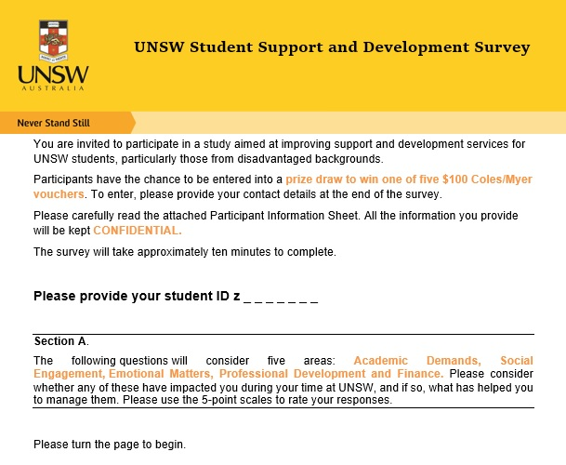
Appendix 3: Student Questionnaire

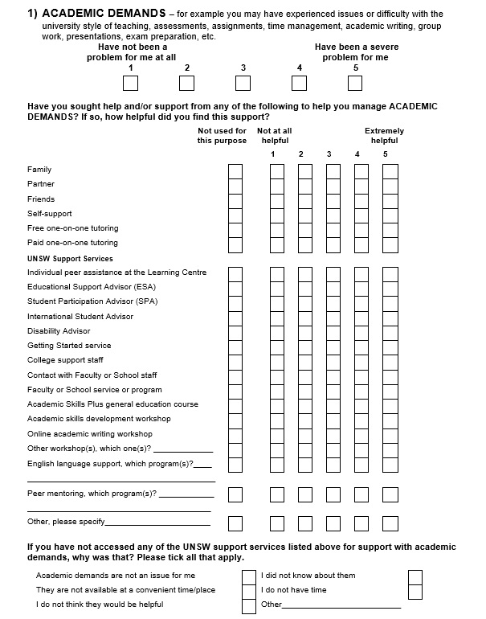
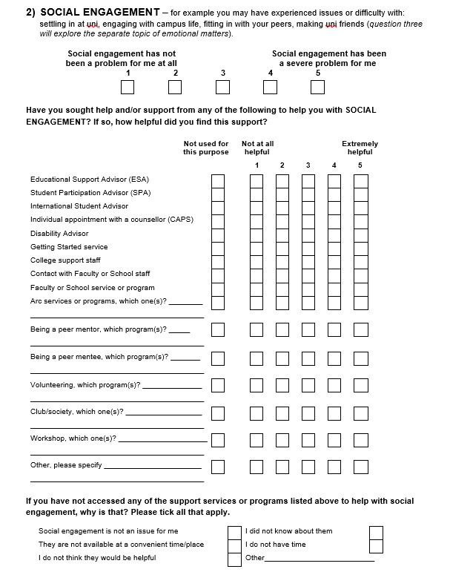
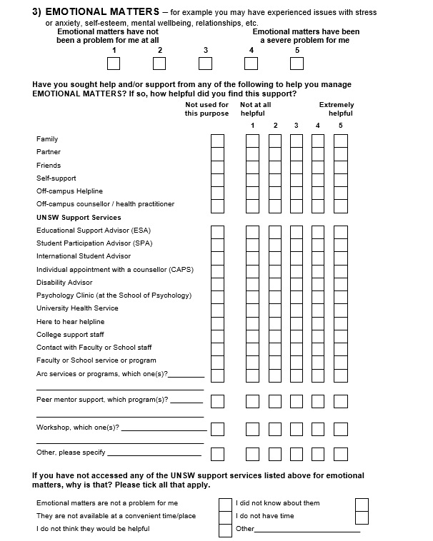
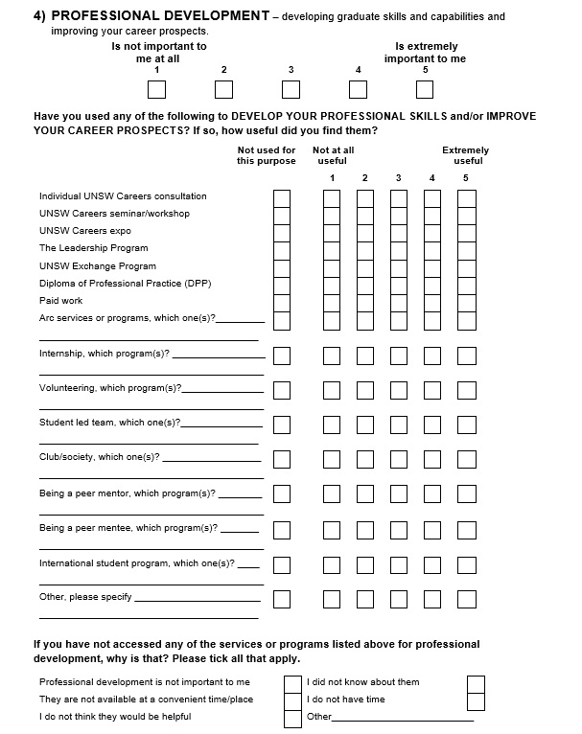
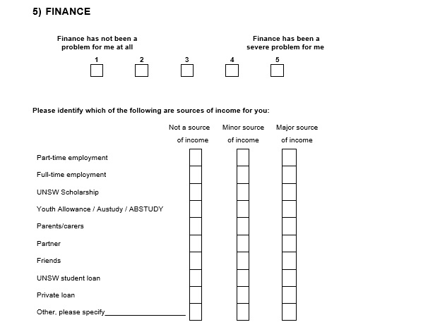
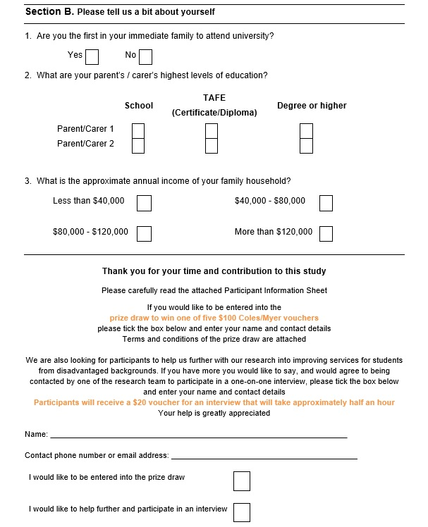

Appendix 4: Questionnaire Participant Information Statement

UNSW Research Study HC reference number: HC15047A ‘Picture of Student Success at UNSW’
What is the research study about?
You are invited to take part in a research project. To participate in this project you must be a current or former student of UNSW and be over the age of 18. The aim of the research is to provide an evidence base that will inform improvements to the design and delivery of support initiatives for students from disadvantaged backgrounds at UNSW. The research outcomes will present a picture of the academic and graduate success of students, the support and development services they interact with, and identify correlations between interaction and success.
Participation in this research study is voluntary. This Participant Information Statement and Consent Form tells you about the research study. Please read this information carefully.
What does participation in this research require?
If you decide to take part, you will complete a questionnaire on the issues you have faced as a UNSW student and the support mechanisms you have accessed to help you with these. The questionnaire will also ask some additional demographic questions about you. We hope to use the information we get from this research study to improve service delivery for students from disadvantaged backgrounds.
Will I be paid to participate in this project?
If you provide your contact details you will go into a draw to win one of five $100 Coles/Myer vouchers.
What will happen to information about me?
By submitting your survey you consent to the research team collecting and using information from the questionnaire you complete. You also permit the research team to access your UNSW student record to compare additional demographic and academic information about you and the support and development services you have accessed. This is solely for the purpose of the research study, and any information obtained that can identify you will remain confidential. In order to ensure your confidentiality and so that you cannot be identified during the study, your student ID will be re-identified using an anonymisation code. All coding will be logged and the log will be stored separately from the data. Neither the data nor the log will be shared outside of the project team, or published in any way. We will store this coded information on a secure UNSW server for a period of seven years, after which it will be erased.
It is anticipated that the results of this research study will be published and/or presented in a variety of forums. In any publication and/or presentation, information will be provided in such a way that you will not be individually identifiable.
How and when will I find out what the results of the research study are?
You have a right to receive feedback about the overall results of this study. You can tell us that you wish to receive feedback by emailing: meryl.james@unsw.edu.au. This feedback will be in the form of a one page summary of the research findings and provision of links to any published results. You will receive this feedback after the study is finished.
What if I want to withdraw from the research study?
Submitting your completed questionnaire is an indication of your consent to participate in the study. You can withdraw your responses any time before you have submitted the questionnaire. Once you have submitted it, your responses cannot be withdrawn.
What should I do if I have further questions about my involvement in the research study?
If you want any further information concerning this project or if you have any problems which may be related to your involvement in the project, you can contact the following member of the research team: Meryl James (phone: +612 9385 3207; email: meryl.james@unsw.edu.au).

If you have complaints about any aspect of the project or the way it is being conducted, then you may contact: Human Research Ethics Coordinator (phone: +612 9385 6222; email: humanethics@unsw.edu.au).
HC reference number: HC15047.

Appendix 5: Interview Schedule

Interview preparation
- Read participant information statement
- Hand over participant consent form
- Setup recording device
- Commence interview

Questions
Demographics
- Name, ID:
- Where is your permanent address, and how long have you lived there?
- How did you hear about the study?

(General) Open-ended interview questions
- What kind of hindrances to study do you believe most commonly impact students? Why do think this?
- Have you encountered any difficulties that have hindered your study or negatively impacted your time at university?
- When did this begin, and how long did it affect you?
- Have you done anything to try to resolve this?
- Which of these (referring to impacts) would you say has most significantly impacted you?
- (If applicable) – for the common hindrances you identified above, why do these not influence you?

(Targeted) Open-ended interview questions
Support Services
- What on/off campus support or services, if any, did you access to help with these issues? (If necessary) prompt for support (workshops, programs, peer groups, services) -why did you access it?
- What were your expectations before accessing the service?
- How close was it (how close were they) to providing what you needed?
- What aspect was most useful for your specific needs?
- Is there anything the support service/program didn’t do or should have done differently to help you more?
- Since using it (them), how likely are you to use another one?
- Any other off campus support, or anyone else that has supported you? How useful/important was this compared to the on-campus support- (if necessary) prompt for support (family, friends, partner)
Development Programs
- Have you accessed any professional development, co-curricular or volunteering services or programs at UNSW?
- Prompt for any other service, program, workshop interactions
- Why did you access it?
- What were your expectations?
- Did it/they provide what you needed?
- What aspect was most useful?
- Anything they should’ve done differently?
- How could they be improved?
- How likely are use another (or go again)?
- Have there been any barriers to you accessing support and development services at UNSW?
- Are there any additional support or development services/programs you would like to see introduced?

Clearing house interview questions
If you don’t mind, we’ll now ask you a bit about your demographic background. The Australian government designates people as low, medium or high socioeconomic status.
- What do you think your status is compared to other UNSW students?
  - how do you think your socioeconomic status has impacted any issues you may have encountered at UNSW?
  - how do you think your socioeconomic status has influenced your interaction with support services, if any?
- Do you think people, including yourself, need support services, programs and/or workshops at UNSW?
- What kind of service is most important and for who?
- What does being a successful student mean to you?
  - What do you think are the indicators of this success?
  - Have any of the issues you have identified impacted on this success?
  - Have any of the support/development services you have interacted with impacted on your success?
  - Have any other factors impacted on your success?
- Is there anything else that you would like to express about support services – about using support services, or support services in general at UNSW?

Appendix 6. Interview Participant Information Sheet and Consent Form

Student Life and Learning
PARTICIPANT INFORMATION STATEMENT AND CONSENT FORM
A Picture of Student Success at UNSW
The study is being carried out by the following researchers:
Role Name Organisation
Chief Investigator Meryl James Student Life and Learning, UNSW
Co-Investigator/s Colin Clark Student Life and Learning, UNSW
Todd Walton Student Life and Learning, UNSW
Research Funder This research is being funded by the Department of Education as part
of the Higher Education Participation and Partnerships Program National Priorities Pool.
What is the research study about?
You are invited to take part in this research study. To participate in this project you must be a current or former student of UNSW. The aim of the research is to provide an evidence base that will inform improvements to the design and delivery of support initiatives for students from disadvantaged backgrounds at UNSW. The research outcomes will present a picture of the academic and graduate success of students, the support and development services they interact with, and identify correlations between interaction and success.
Do I have to take part in this research study?
Participation in this research study is voluntary. If you don’t wish to take part, you don’t have to. Your decision will not affect your relationship with UNSW.
This Participant Information Statement and Consent Form tells you about the research study. It explains the research tasks involved. Knowing what is involved will help you decide if you want to take part in the research.
Please read this information carefully. Ask questions about anything that you don’t understand or want to know more about. Before deciding whether or not to take part, you might want to talk about it with a relative or friend.
If you decide you want to take part in the research study, you will be asked to:
- Sign the consent form;
- Keep a copy of this Participant Information Statement.
What does participation in this research require, and are there any risks involved?
If you decide to take part in the research study, you will be asked to take part in an interview with a member of the research team. The interview will take approximately 30 minutes. During the interview a member of the research team will ask you questions about the support and development services and programs you have accessed during your time at UNSW, and how you feel these have impacted on your success. With your permission we would like to digitally record the interview using an audiotape. The interviews will take place on campus at UNSW, or over the phone.
Aside from giving up your time, we do not expect that there will be any risks or costs associated with taking part in this study.
With your permission we would like to gain access to your UNSW student record to collect demographic and academic information about you.
Will I be paid to participate in this project?
You will be reimbursed with a $20 Coles/Myer voucher as compensation for your time.
What are the possible benefits to participation?
We hope to use the information we get from this research study to improve service delivery for students from disadvantaged backgrounds.
What will happen to information about me?
By signing the consent form you consent to the research team collecting and using information about you for the research study. We will store information about you on a secure UNSW server. We will keep this data for seven years. Your information will only be used for the purpose of this research study and it will only be disclosed with your permission.
It is anticipated that the results of this research study will be published and/or presented in a variety of forums. In any publication and/or presentation, information will be provided in such a way that you will not be individually identifiable in these publications.
You have the right to request access to the information about you that is collected and stored by the research team. You also have the right to request that any information with which you disagree be corrected. You can do this by contacting a member of the research team.
The audiotaped digital recordings are for the purposes of the research study. After the interview we will transcribe and then delete your digital recordings. We will keep the transcribed information for seven years. We will store this information on a secure server. To ensure your confidentiality, the research team will assign each interview a unique code and all identifying information will be removed from the interview transcripts. The key to the code will be stored in an encrypted file on a secure server.
How and when will I find out what the results of the research study are?
You have a right to receive feedback about the overall results of this study. You can tell us that you wish to receive feedback by emailing: meryl.james@unsw.edu.au. This feedback will be in the form of a one page summary of the research findings and provision of links to any published results. You will receive this feedback after the study is finished.

What if I want to withdraw from the research study?
If you do consent to participate, you may withdraw at any time. If you do withdraw, you will be asked to complete and sign the ‘Withdrawal of Consent Form’ which is provided at the end of this document. Alternatively you can ring the research team and tell them you no longer want to participate.
If you decide to leave the research study, the researchers will not collect additional information from you.
You are free to stop the interview at any time. Unless you say that you want us to keep them, any recordings will be erased and the information you have provided in the interview will not be included in the study results. You may also refuse to answer any questions that you do not wish to answer during the interview.
What should I do if I have further questions about my involvement in the research study?
If you want any further information concerning this project or if you have any problems which may be related to your involvement in the project, you can contact the following member of the research team:
Research Team Contact
Name Meryl James
Position Senior Project Officer, Student Life and Learning
Telephone 9385 3207
Email meryl.james@unsw.edu.au
What if I have a complaint or any concerns about the research study?
If you have any complaints about any aspect of the project or the way it is being conducted, then you may contact:
Complaints Contact
Position Human Research Ethics Coordinator
Telephone + 61 2 9385 6222
Email humanethics@unsw.edu.au
HC Reference Number HC 15047

Consent Form – Participant Providing Own Consent
Declaration by the Participant

- I have read the Participant Information Sheet or someone has read it to me in a language that I understand;
- I understand the purposes, study tasks and risks of the research described in the project;
- I have had an opportunity to ask questions and I am satisfied with the answers I have received;
- I freely agree to participate in this research study as described and understand that I am free to withdraw at any time during the project and withdrawal will not affect my relationship with any of the named organisations and/or research team members;
- I understand that I will be given a signed copy of this document to keep;

Participant Signature
Name of Participant (please print) _____________________________________________
Signature of Research Participant _____________________________________________
Date _____________________

Declaration by Researcher*
- I have given a verbal explanation of the research study, its study activities and risks and I believe that the participant has understood that explanation.

Researcher Signature*
Name of Participant (please print) _____________________________________________
Signature of Research Participant _____________________________________________
Date _____________________
*An appropriately qualified member of the research team must provide the explanation of, and information concerning the research study.
Note: All parties signing the consent section must date their own signature.

Form for Withdrawal of Participation

I wish to WITHDRAW my consent to participate in the research proposal described above and understand that such withdrawal WILL NOT affect my relationship with UNSW.

Participant Signature
Name of Participant (please print) _____________________________________________
Signature of Research Participant _____________________________________________
Date _____________________

The section for Withdrawal of Participation should be forwarded to:
CI Name: Meryl James
Email: meryl.james@unsw.edu.au
Phone: 9385 3207
Postal Address: G22, John Goodsell Building, UNSW, High Street, Kensington,
Sydney. 2024.

Appendix 7: Database Results for Low SES Students and All Students
Table 1. Student mean WAM and academic standing before and after initial interaction with support initiatives, ‘n’ = total number of students who recorded a WAM/standing in at least one semester both before and after initial semester of interaction, *significantly different at p < 0.05, **significantly different at p < 0.01.
 |  | WAM  Before | WAM  After | Academic Standing Before | Academic Standing After | n
Low SES students | TLC consultations | 62.3 | 65.3* | 0.87 | 0.93 | 59
 | Counselling consultations | 63.3 | 62.7** | 0.84 | 0.78* | 307
 | ESA consultations | 58.7 | 60.6 | 0.67 | 0.76* | 71
 | Careers consultations | 67.3 | 69.5 | 0.90 | 0.92 | 256
 | Advantage programs | 70.8 | 71.3** | 0.99 | 0.95 | 125
All students | TLC consultations | 64.9 | 67.1** | 0.89 | 0.91 | 602
 | Counselling consultations | 64.3 | 65.0** | 0.85 | 0.82** | 3,085
 | ESA consultations | 60.7 | 62.7 | 0.75 | 0.75 | 507
 | Careers consultations | 67.7 | 69.5** | 0.94 | 0.95** | 2,414
 | Advantage programs | 70.7 | 71.6 | 0.97 | 0.95* | 864

Table 2. Percentage of interacting and non-interacting students discontinuing. ‘n’ = total number of students discontinuing (given in brackets), *significantly different at p < 0.05, **significantly different at p < 0.01.
 |  | % non-interacting students discontinuing (n) | % interacting students discontinuing (n)
Low SES students | TLC consultations | 6.8 (342) | 5.2 (5)
 | Disability Services | 8.0 (20) | 7.4 (6)
 | Counselling consultations | 7.2 (376) | 6.3 (25)
 | ESA consultations | 5.3 (204) | 9.5 (10)
 | Careers consultations | 7.3 (390) | 3.9 (11)
 | Advantage programs | 7.5 (487) | 0.8 (1)
All students | TLC consultations | 5.8 (3,133) | 4.2 (42)
 | Disability Services | 7.0 (193) | 5.5 (53)
 | Counselling consultations | 6.0 (3,493) | 6.5** (247)
 | ESA consultations | 4.7 (1,966) | 7.5** (51)
 | Careers consultations | 6.2 (3,655) | 3.1 (85)
 | Advantage programs | 6.5 (4,757) | 0.8* (7)

Table 3. WAM at completion and ATAR for non-interacting students, interacting students, and students interacting in their first semester. ‘n’ = total number of students completing, and those completing who have a recorded ATAR (‘n’ values given in brackets), *significant at p < 0.05, **significant at p < 0.01.
WAM at completion ATAR
 |  | No int. (n) | Initial int. any sem. (n) | Initial int. first sem. (n) | No int. (n) | Initial int. any sem. (n) | Initial int. first sem. (n)
Low SES students | TLC consultations | 69.2  (1,666) | 70.0*  (25) | 72.3  (9) | 88.3  (1,280) | 84.6  (18) | 85.9  (8)
 | Disability Services | 66.4  (85) | 69.1*  (17) | 75.8**  (9) | 88.8  (55) | 85.1  (10) | 85.5  (7)
 | Counselling consultations | 69.1  (1,819) | 68.2  (154) | 71.0*  (16) | 88.3  (1,388) | 88.0  (116) | 85.8  (12)
 | ESA consultations | 69.7  (1,063) | 63.0  (11) | 65.5  (2) | 88.8  (825) | 80.6  (10) | 81.8  (2)
 | Careers consultations | 68.9  (1,830) | 71.0**  (143) | 74.8  (6) | 88.2  (1,394) | 88.7  (110) | 88.6  (4)
 | Advantage programs | 68.9  (2,396) | 72.9**  (55) | 74.6  (2) | 88.6  (1,802) | 91.7  (50) | 89.8  (2)
All students | TLC consultations | 70.4  (19,702) | 70.9  (335) | 73.7**  (74) | 90.0  (15,287) | 87.8  (204) | 88.0  (40)
 | Disability Services | 68.6  (1,041) | 69.7**  (231) | 71.2**  (130) | 88.0  (665) | 85.8  (147) | 85.6  (94)
 | Counselling consultations | 70.2  (22,301) | 69.7**  (1,491) | 70.7  (164) | 90.0  (17,090) | 89.1  (1,037) | 87.8  (100)
 | ESA consultations | 70.7  (12,473) | 67.8  (98) | 69.8  (8) | 90.2  (9,786) | 88.1  (74) | 84.8  (5)
 | Careers consultations | 70.1  (22,361) | 71.4*  (1,431) | 73.4  (106) | 90.0  (17,003) | 89.7  (1,124) | 89.0  (76)
 | Advantage programs | 70.1  (29,559) | 73.2*  (430) | 71.7  (26) | 90.2 (22,143) | 92.8 (357) | 92.3 (23)

The term ‘student support initiative’ is used throughout this report to describe services, programs and initiatives targeting student engagement, co-curricular learning, development and support.
The term ‘workshop’ is used throughout the report to describe services and programs offered to groups of students. These could be seminars, events, workshops or other group activities.
SA1s are small geographical areas designed to represent areas for specific analysis. There are 54,805 SA1s in Australia, with an average population of 400 with a range between 200 and 800 people.
For example, an address that needed to be corrected might have been missing a space between house number and street name, and the software was unable to read it.
Refer to the following link for a detailed description of undergraduate Academic Standing meaning and designation: https://student.unsw.edu.au/academic-standing-undergrad.
Students who had enrolled in more than one program, and had attended that program for at least one semester, had multiple rows in accordance with the number of programs they had enrolled in.
The overall fit of a model is tested using a chi-square likelihood ratio – the -2LL (negative two log-likelihood) or deviance. The smaller the value, the better the model fit. Significance of model improvement was calculated according to the chi-square distribution table; at 1 df p<.05 = 3.84 and p<.01 = 6.64.
There was no meaningful difference in p-values to two decimal places – the point to which p-vales have been reported in this study.
Increased stage was shown to have a positive effect on both WAM and academic standing, i.e. the further along a student’s academic career, the better the average WAM and higher the likelihood of ‘good standing’.
ATAR (Australian Tertiary Admission Rank) is awarded to students who complete their HSC (Higher School Certificate) in New South Wales. It is a 0 to 99.95 rank based on their HSC grades and is used as the primary criterion for entry into most undergraduate programs at UNSW.
Included as a function for how long a student had to discontinue – the earlier the first semester, the more likely to discontinue. Studies have shown that discontinuation is most likely to occur early in a student’s academic career (for example Krause, 2005; McEwen and Trede, 2014).
Last recorded stage was included as a covariate to account for the bias of students interacting with initiatives later into their program – for example, a student interacting with a Careers consultation was more likely to do so late in their program, and hence have progressed through the risky first year (Krause, 2005; McEwen and Trede, 2014).
Some literatures on MLM building suggest that the first model contain just the level-2 predictor, usually to ascertain the presence of a group/nested effect in the data (Garson, 2013; Ene et al., 2015). However, effect of the level-2 predictors investigated in this research were know prior to the MLM process – i.e. faculty level and individual student differences were known to exist.
http://www.abs.gov.au/AUSSTATS/abs@.nsf/DetailsPage/6523.02013-14?OpenDocument
T-test for Equality of Means p<0.01
T-test for Equality of Means p<0.01
‘First in family’ results were inconsistent. Some students indicated that they were first in family, but had a parent with a degree. For this reason, the First in Family indicator was dropped from analyses.
These two items were frequently conflated by students, so were grouped as one for analysis.
Nura Gili is the Indigenous Programs Unit at UNSW. It provides a range of support services for ATSI students.
Local, undergraduate students with an SA1 of either low, medium or high.
p=0.04, n=59
p=0.63, n=59
p=0.03, n=1,691
p=0.15, n=1,691
p=0.41, n= 96
p=0.54, n=41
p=0.09, n=41
p=0.52, n= 2,171
p=0.71, n=2,171
p=0.46, n=92
p=0.04, n=1,272. Significance resulted from hierarchical multiple regression as unable to perform MLM due to sample size issue.
p<0.01, n=102
Ave. WAM at completion = 68.9
p=0.51, n=81
Using Spearman’s rank-order correlation test, p=0.25, n=52
p=0.37, n=125
p<0.01, n=125
p<0.01, n=2,451
p=0.28, n=2,451
Discontinuation rate for interacting students =0.8%, non-interacting students =7.5% (p=0.71, n=132)
p=0.16, n=256
p=0.11, n=256
p=0.32, n=280
p<0.01, n=1,973
p=0.1, n=1,973
Mann-Whitney U Test, p<0.01, n=97
p=0.01, n=697
p=0.1, n=697
p=0.2, n=794
p=0.95, n=1,973
p=0.41, n=1,973
p<0.01, n=307
p=0.01, n=307
p=0.46, n=1,973
p=0.03, n=1,973
Annie Andrews has been Director of Counselling and Psychological Services (CAPS) at UNSW Australia since 1998.
p=0.31, n=398
p=0.49, n=94
p=0.39, n=94
p=0.2, n=1,973
p=0.42, n=1,973
p=0.65, n=106
p=0.23, n=1,074
p=0.12, n=105
p=0.18, n=71
p=0.02, n=71
Mann-Whitney U Test, p<0.02, n=19
FIRST_SEM_INTERACT is input in place of INTERACT for first semester interaction influence test.

