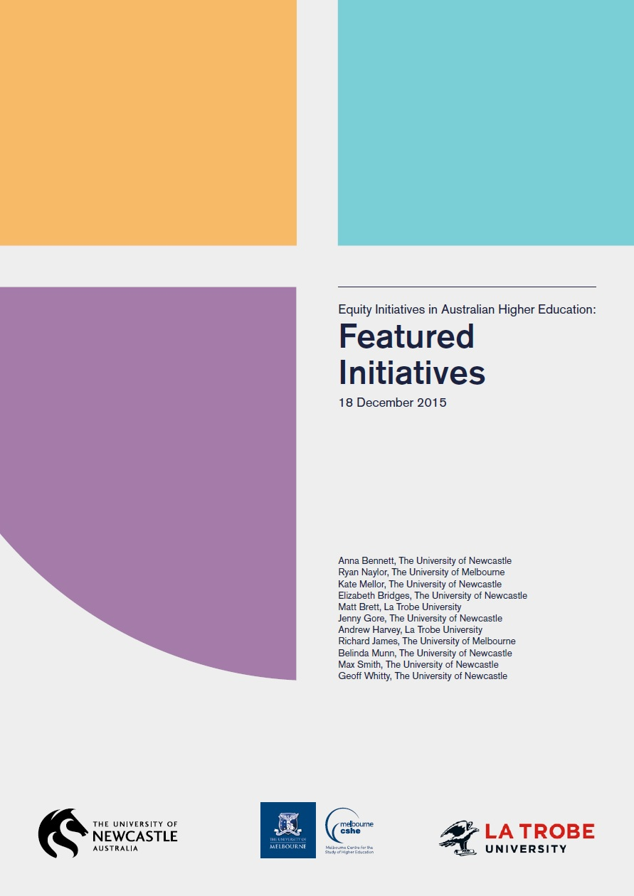

Featured Initiatives

18 December 2015

Anna Bennett, The University of Newcastle
Ryan Naylor, The University of Melbourne
Kate Mellor, The University of Newcastle
Elizabeth Bridges, The University of Newcastle
Matt Brett, La Trobe University
Jenny Gore, The University of Newcastle
Andrew Harvey, La Trobe University
Richard James, The University of Melbourne
Belinda Munn, The University of Newcastle
Max Smith, The University of Newcastle
Geoff Whitty, The University of Newcastle

The project that resulted in the production of this report was funded under a National Priorities Pool (Higher Education Participation and Partnerships Program) grant from the Commonwealth. The recipient of the grant has granted the Commonwealth the right to sub-licence the material in this report. Copyright in the report remains with the original copyright owners.
Except where otherwise indicated, and save for any material protected by a trade mark, the Department of Education and Training, acting on behalf of the Commonwealth, has applied the Creative Commons Attribution 4.0 International Licence.

Modifications: Changed to meet WCAG 2.0 accessibility requirements.
Alternate text inserted for all images. Minor typographical errors corrected.
The Critical Interventions Framework Part Two
Equity Initiatives in Australian Higher Education: Featured Initiatives
The work described in this report was funded by a grant from the Australian Government Department of Education and Training. The grant was made under the Higher Education Participation and Partnerships Program.
With the exception of the University logos, any material protected by a trademark and where otherwise noted, all material presented in this document is provided under Creative Commons Attribution 3.0 Australia (http://creativecommons.org/licenses/by/3.0/au/) licence. The details of the relevant licence conditions are available on the Creative Commons website (accessible using the links provided) as is the full legal code for the Creative Commons Attribution 3.0 licence (http:// creativecommons.org/licenses/by/3.0/au/legalcode).
The document must be attributed as ‘Bennett, A., Naylor, R., Mellor, K., Bridges, E., Brett, M., Gore, J., Harvey, A., Munn, B., James, R., Smith, M., and Whitty, G. (2015). The Critical Interventions Framework Part 2: Featured Initiatives’

Contents
List of Tables 5
List of Figures 5
Introduction 6
Important Features of Effective Equity Initiatives 7
Key Findings 7
1. Pre-Access: Outreach to Schools and Communities 11
Key Points of Pre-Access – Outreach to Schools and Communities Initiatives 11
Digital Divas 12
In2Uni Program 14
Indigenous Youth Sports Program (IYSP) 16
Tertiary Education Experience for Students with Disabilities (TEE) 18
The Young Achievers Program 20
UniCamps 22
UNSW ASPIRE 24
2. Access: Pathways and Admission 28
Key Points of Access – Pathways and Admission Initiatives 28
Centre for Aboriginal Studies – Indigenous Enabling Mentor Program 29
e-Learning Tools 30
Foundation Studies 32
MAPS to Success 34
Scaffolded Assessment 36
Science for Nursing Enabling Course 37
Week Zero 40
3. Participation: Transition and Engagement 44
Key Points of Participation – Transition and Engagement Initiatives 44
Accelerated Nurses Initiative in the Bachelor of Nursing 45
PASSwrite 47
Strategies for Success 50
The Principal Tutor 52
4. Participation: Engagement and Progression 55
Key Points of Participation – Engagement and Progression Initiatives 55
Accessible e-books for Indigenous Students 55
Embedded Library Services 57
Mathematics Learning Centre 60
Mentoring Circles 62
Murdoch ALLY Program 64
5. Attainment and Transition Out 67
Key Points of Attainment and Transition Out Initiatives 67
Lucy Mentoring Programme 67
Professional Development Program 69
Indexes 73
Initiatives by Equity Group 73
Initiatives by Type 75
Initiatives by Program Aims 80
Initiatives by Evaluation Methods 82

List of Tables
Table 1: Counselling and Learning Adviser consults with Open Foundation by
Distance students in first semester, 2011–2013. 41
Table 2: Rates of assignment submission and online tutorial attendance in first
semester, 2012–2013 42
Table 3: Generic skill and PD Program activities for first year students 71

List of Figures
Figure 1: Equity Initiatives Framework 10

Introduction
The Featured Initiatives document has been created as part of the Critical Interventions Framework, Part 2 (CIF Part 2) (2015) national research project funded by the Department of Education and Training. It is intended to showcase effective initiatives that enable access, participation and attainment for students from equity backgrounds in a broad variety of ways. Please refer to the main report The Critical Interventions Framework Part 2: Equity Initiatives in Australian Higher Education: A review of evidence of impact for the full analysis and detail of the features and findings of effective initiatives referred to in the following pages.
In the context of the CIF Part 2 (2015) study, an equity intervention is defined as a program or initiative that is broadly associated with the activities of higher education institutions, individually or collaboratively, which seek to enhance the access, participation and success of students with equity characteristics. Students with equity characteristics in the Australian context are based on the Equity and General Performance Indicator framework (Martin, 1994) these were initially outlined by Dawkins (1990):
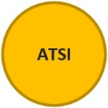 | People who identify as Aboriginal and/or Torres Strait Islander
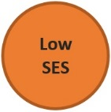 | People who are from low socio-economic status (SES) backgrounds
 | People with a disability
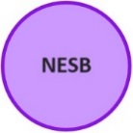 | People from non-English speaking backgrounds
 | People from regional and remote areas
 | Women in non-traditional areas

Equity initiatives correlate strongly with these groups; however, other groups, such as incarcerated populations and students from refugee backgrounds are also targeted by equity interventions. Whilst this review is based on available sector data groupings, we recognise that such categories are complex and contested.
The Important Features of Effective Equity Initiatives and Key Findings detailed below are based on the 76 initiatives identified that had undergone rigorous review and demonstrated evidence of impact. It is likely that effective programs which have not yet been rigorously evaluated share many of the following features.

Important Features of Effective Equity Initiatives
The evidence shows that a more holistic approach is effective and that one single feature does not work alone to produce impact. Multifaceted work is required within any one program. Effective initiatives are also likely to have greater impact if nested within a cohesive institutional equity strategy and national policy framework. The following are interdependent features that have been found to culminate in producing impact across the sector.
- Effective initiatives shift the focus from fitting students into an unchanging higher education system, to developing inclusive higher education programs.
- Inclusive pedagogies, curricula and support are important. This is particularly evident in the effective initiatives that draw on Indigenous knowledges and practices.
- Demystifying university culture and cultivating a sense of belonging for both current and prospective students are important for building and sustaining student engagement and success.
- Initiatives that are responsive, accessible and relatively easy to navigate for all stakeholders are more likely to be sustainable and effective.
- Evaluation of impact is important. From the impact studies and research participants, we found that effective evaluation in the field:
  - is stakeholder-centred, context-specific and iterative
  - is undertaken most frequently through mixed methods approaches that utilise quantitative and qualitative data
  - reports multiple effects and outcomes, including: increased access, retention and performance; improved student experiences, connectedness and engagement; informing aspirations for higher education and awareness of pathways
  - is informed by those with experience in program provision and evaluation.
Collaborations that join program providers’ specialist knowledge with evaluation and research expertise promote rigorous forms of evaluation and high quality provision.

Key Findings
Overall, sector data show that students from equity backgrounds are not substantially less likely to successfully complete their studies than other students. Indigenous students continue to be the exception to this. An increasing number of initiatives demonstrate effectiveness, but sustained effort is required to support the development of work in this area.
- Direct experiences with universities for school students and other groups make an effective contribution to widening participation.
- Mentors and role models can have a significant impact on access and success across all stages of the student life-cycle. Developing student engagement through mentoring takes time, appropriate training and incentives for mentors (forms of recognition and appropriate remuneration).
- Embedding support in the curriculum is more effective and has broader reach than extra-curricular support programs. Many of the studies cite non- engagement with traditional student support services of students from equity groups. Support should be responsive and tailored according to context.
- Well-designed technologies and online resources increase engagement and support for many students. These resources can provide greater reach and flexibility, although there are challenges in accessing good quality technologies and in sustaining engagement in online programs. Technologies are best aligned with robust pedagogies and effective teaching methods.
- Impact studies included in this study that provide details about effective initiatives for Aboriginal and/ or Torres Strait Islander students contain important principles and approaches that may be useful for influencing the design and evaluation of other initiatives.
- Much of the evidence of impact draws on robust theory and research about equity, evaluation and quality program provision.
- Strong collaboration between institutions and communities, and within university environments, is a clear feature of effective programs. A major strength of the Queensland Tertiary Widening Participation Consortium has been state-wide reach and an ability to take a coordinated approach to the collection of data.
- Most studies focus on secondary school outreach programs, pathways programs and first year transition initiatives. Fewer publications evaluate the impact of specific initiatives in early outreach in primary schools and community outreach for adult education. Initiatives during later years of participation, including those relating to completion, transition to employment and postgraduate study, are also less prominent in the literature.
- Regional universities/campuses with high numbers of students from equity backgrounds are well represented in the literature about effective program provision.
- The equity group most targeted is people from low socio-economic status backgrounds, but there is a high degree of overlap in equity group participation, and many of these initiatives also capture people who identify as Aboriginal and/or Torres Strait Islander, people who are first in family to attend university, people from non-English speaking backgrounds, and people from regional and remote areas.
- Less represented in the literature are students with a disability and women in non-traditional areas of work and study.
- The most impact demonstrated by programs in specific areas of work and study is found in the health sciences, particularly nursing.
The ‘key points’ at the start of each section of this document correspond with the findings from each stage of the student life-cycle outlined in the CIF Part 2 main report.
The initiatives highlighted in this document have been selected to represent the diverse range of effective approaches across the Australian higher education sector. The collection is not intended as a comprehensive description of equity programs across the field. Instead, it is a resource that highlights some examples of programs that demonstrate impact. It focuses on evaluation strategies, methodologies, data sources and the challenges faced in evaluating programs, following feedback that specific information in this area would be valuable to the sector. Further information about evaluation is described in Naylor (2015) and further examples of case studies are detailed in Access and Participation in Higher Education (NCSEHE, 2013) and Partnerships in Higher Education (NCSEHE, 2014).
The type of program, target equity group and data sources for evaluation are summarised for quick reference. The initiative ‘types’ and ‘aims’ were selected by survey participants and research staff involved in the literature review and were based on the list provided in the survey and research templates. Participants were also provided with flexibility in choosing ‘other’ to describe programs. Following these short descriptions, more details about the program are provided.
The initiatives are grouped according to where they are offered in the student life-cycle–from pre-access to completion—as shown in the Equity Initiatives Framework (EIF), which was developed as part of the CIF Part 2 (2015) in Figure 1 (page 7). As explained in the CIF Part 2 report, the elements outlined in the EIF are not static or fixed in sequence, and some programs bridge several different phases because equity programs are often multi-targeted and work in different ways at different times. The EIF provides a general snapshot of the student life-cycle, types of initiatives and a flexible and adaptive structure for evaluation and reporting purposes.
Although all efforts have been made to ensure the information included in the following pages is accurate (based on review of the literature, phone interviews and written submissions), we cannot guarantee that this is the case, and we encourage readers to follow-up with institutions and resources listed in the Further Information section. Such conversations build collegial interactions and dissemination of expertise across the sector for the greater benefit of students. Our aim is that this outline of initiatives inspires further connected, creative and agile approaches to the design and evaluation of programs, research and pedagogies.

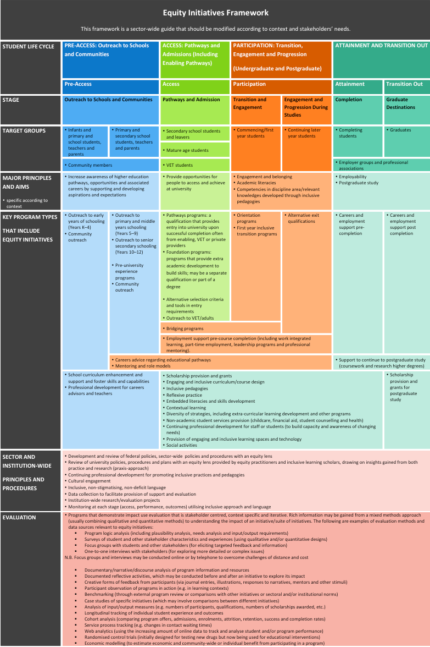
Figure 1: Equity Initiatives Framework

1. Pre-Access: Outreach to Schools and Communities

Key Points of Pre-Access – Outreach to Schools and Communities Initiatives
- Most outreach programs that provide evidence of effectiveness focus on high school.
- The majority of access initiatives are centred on familiarising school students with the university environment, disciplines and people (staff and students); and provision of teaching modules designed for school teachers to use in classrooms.
- Informing aspirations for higher education is a central theme in these programs through providing information and developing awareness about programs, associated careers and university pathways.
- Outreach programs that demonstrate effectiveness involve collaborative partnerships with communities and other stakeholders. This ensures a better understanding of the needs of the community, and increases effectiveness by enabling a tailored approach and community support.
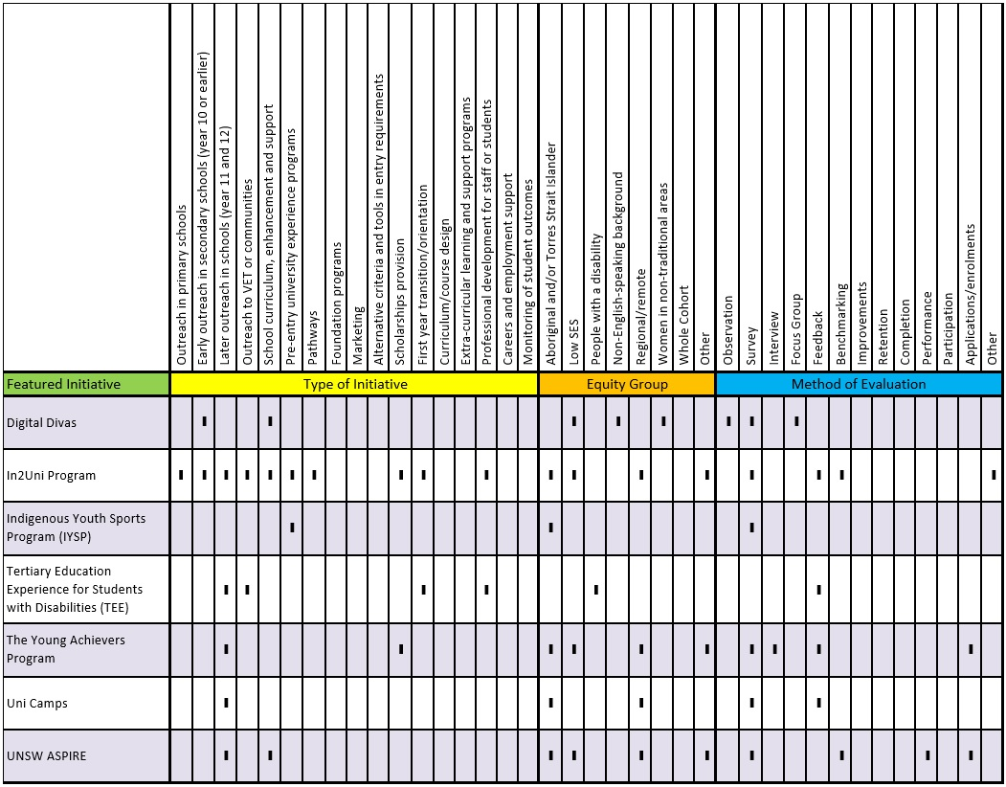
- Programs utilising sustained mentoring have been shown to be effective in familiarising students with university. In particular, high school students have been found to connect and respond to university student role models or mentors from similar backgrounds.

Digital Divas
Monash University, Swinburne University of Technology and Deakin University
Stage of the student life-cycle:
- Outreach to schools and communities

Equity group
Evaluated using | - Observation  - Survey  - Focus group
Source | Report

Keywords
- Access
- Aspirations
- Curriculum Design
- Pedagogy
- Engagement
- Awareness of Pathways

Short Description
Digital Divas is a project aiming to increase girls’ interest and confidence in their ability to study information technology (IT). The initiative was developed in an attempt to influence girls at an early stage in their education about IT and employment pathways.
The evaluators reported that ten schools took part with over 300 students participating in the program that ran for four years. The target group were girls aged between 13–16 years. Many of the schools had diverse cohorts, including a large proportion of students from non-English speaking and low SES backgrounds. The research team developed teaching modules that were delivered in school classrooms by high school teachers and the curriculum was designed to encourage girls to study computing. The program runs over two school terms and has two main components: teaching modules and role models.

Initiative Type
- Early Outreach in secondary schools (Year 10 or earlier)
- School curriculum, enhancement and support

Aims
- Informing aspirations and developing expectations for higher education
- Increasing awareness or understanding of educational pathways

Evaluation and Impact
The research team working on Digital Divas drew on an evidence-based approach to the design of teaching modules and program components. By incorporating factors identified to have a significant impact on girls’ interest in IT, the team devised a program based on research in the field. Examples of how this translated into program actions include: structuring the learning environment as an all-girl space; using collaborative learning; and developing a curriculum with a focus on girls’ interests (Fisher et al., 2015).
Digital Divas was evaluated using surveys and focus groups. The evaluation methodology was designed to explore whether the program was successful in raising girls’ interest and confidence in their ability to study IT. A mixed methods approach was used that included a combination of quantitative and qualitative methods.
The authors argue that longer-term programs like Digital Divas, which run for two school terms, have a more sustained effect on participants (Fisher et al., 2015). An increase in the interest and confidence of participants in their ability to study IT was established.
Digital Divas increased high school participants’ ability to ‘see’ a non-traditional area of work/study in a positive way (women studying and working in IT). Increased confidence with IT was recorded in the program evaluation, with the majority of students (76 per cent) answering the question indicating that their confidence had improved. Overall, results showed an increased interest in IT. The curriculum was also positively evaluated by participants with 87 per cent reporting that they enjoyed it (Fisher et al., 2015).

Key Points
An educational specialist was engaged to help with curriculum design and role models from the community (women working in IT) were invited as guest speakers. Current female IT university students were also employed as ‘expert Divas’. School teachers delivered the program (Fisher et al., 2015).
- The first stage of implementation was the creation of classroom teaching modules to be used bymschool teachers. School teachers were trained in the module delivery during school holidays.
- Each module was designed around the Australian curriculum (i.e. teaching broad knowledge of IT skills) and ran for 4–5 weeks.
- Modules aimed to maximise engagement by focusing on students’ interests and creativity.
- During teaching terms, researchers visited the schools to observe how Digital Divas was received by participants.
- Expert Divas worked with classes once a week, and helped to raise students’ knowledge of IT pathways.

Challenges
When reflecting on the survey design in the Digital Divas project, Fisher et al. acknowledged that ‘in setting up the research instruments a flawed assumption was made that the girls were starting from a negative base’ (2015, p. 13). The fact that some of the girls were already confident using computers before participating in the program was not taken into account. Further iterations need to consider the wider variation in the interests and skills of participants in order to maximise engagement.

Further Information
Fisher, J., Lang, C., Craig, A., & Forgasz, H. (2015). If girls aren’t interested in computers can we change their minds? In European Conference on Information Systems 2015 (paper 45). Retrieved from http://aisel.aisnet.org/?utm_source=aisel. aisnet.org%2Fecis2015_cr%2F45
andutm_ medium=PDFandutm_campaign=PDFCoverPages
Digital Divas: Designing approaches to enthuse girls’ interest in ICT studies and ICT careers Final Report June 2012. Retrieved from http://www.sims.monash.edu.au/staff/jfisher
/Digital%20 Divas%20Final%20Report%202012.pdf
Additional information regarding the modules and project: www.digitaldivasclub.org

In2Uni Program
University of Wollongong, Student Diversity Unit
Stage of the student life-cycle:
- Outreach to schools and communities
- Transition and Engagement

Equity group | - Other  - Mature Age  - First-in-Family
Evaluated using | - Survey  - Feedback  - Benchmarking  - Independent research
Source | CIF Part 2 Survey

Keywords
- Access
- Aspirations
- Transition
- Progression
- Awareness of Pathways

Short Description
The In2Uni Program engages with individuals in targeted schools and communities to build their awareness and aspirations towards higher education and to provide them with the knowledge and skills to get there. The program starts working with students early in Year 1.
It then continues to support them through high school, vocational pathways and higher education. The focus is on lifelong learning and engagement with education, whilst providing tangible outcomes for individuals.
The vision for the program is to:
- Work collaboratively with internal and external stakeholders to develop programs that build capacity and provide tangible opportunities for individuals from all backgrounds
- Increase participation in higher education for individuals from all backgrounds to enrich local communities
- Connect with individuals and communities to foster a culture of lifelong learning through aspiration, access, transition and support programs
The strategic aim of the program is to increase the aspirations, awareness and attainment of students from under-represented backgrounds in higher education through delivering a coherent suite of outreach programs, which offer a clear developmental progression into university. The goal is to increase the access and success of students in higher education.

Initiative Type
- Outreach in primary schools
- Outreach in secondary schools (Year 10 or earlier)
- Later-year outreach in schools (Year 11 and 12)
- Outreach to VET or communities (adults, including parents of students)
- School curriculum enhancement and support
- Pre-entry university experience programs
- Pathways (a qualification that provides entry into university upon successful completion, often from Enabling, VET or private providers)
- Scholarships provision
- First year transition/orientation programs
- Professional development for staff or students (to build capacity or awareness)

Aims
- Informing aspirations and developing expectations for higher education
- Developing academic capacity and/or providing academic support
- Supporting students in dealing with broader issues outside their study
- Increasing awareness or understanding of educational pathways
- Providing tangible pathways for students to access higher education

Evaluation and Impact
The In2Uni Program is underpinned by a strong evaluation framework that includes the utilisation of pre- and post-surveys with all stakeholders in the program (including program staff, university students, participants and key partners), feedback and planning sessions with key partners, benchmarking projects with other universities and internal/ independent research projects undertaken on the impact of the program. The In2Uni Program also undertakes tracking of students regarding their articulation and retention at university level.
Peer mentors undertake significant training and work with students on a weekly basis. Participants are matched with mentors who are graduates of the same school. This allows students to connect with positive role models. The other successful component of the program is strong stakeholder engagement and the mutually beneficial partnerships that have been developed between all levels of the various organisations involved in the program.

Further Information
The Annual Report outlines the impact of the programs that were run over 2013 and 2014: http://www.uow.edu.au/in2uni-myway/ in2uniannualreports/index.html

Indigenous Youth Sports Program (IYSP)
Central Queensland University
Stage of the student life-cycle:
- Outreach to schools and communities

Equity group
Evaluated using | Survey
Source | Peer reviewed journal

Keywords
- Access
- Aspirations
- Engagement
- Awareness of Pathways

Short Description
The Indigenous Youth Sports Program is a university experience program targeting Aboriginal and/or Torres Strait Islander school students (10–15yrs). Over 200 students participate on campus over a 3–5 day period in sporting activities as well as arts/culture and university studies sessions. The distinctive feature of the Indigenous Youth Sports Program is the use of sports clinics as a way to engage high school students and increase interest in university study. The program is innovative in the way it draws on aspects of sport ‘to reinforce training technique, effort and attitude’ (MacGregor et al., 2015, p. 90) and applies this to broader future interests and career goals.

Initiative Type
- Pre-university experience program

Aims
- Informing aspirations and developing expectations for higher education

Evaluation and Impact
Research tools included pre- and post-surveys analysed using SPSS software.
The researchers found a statistically significant effect in attitudinal data. The main impact was increases in participants reporting post-program that ‘My education is the ticket to the job or career I want in my future’ (Cohen’s d = 0.39), and that ‘University is something that I can consider at any time in the future’ (d = 0.38). Agreement with ‘I choose to work hard at school’ and ‘I expect this program will help me learn more about my options after school’ also showed relatively large effect sizes (d = 0.30 for each) (MacGregor et al., 2015, pp.
95–96).
It should be noted, however, that levels of agreement with these statements pre-program were already quite high.
It was noted that raised awareness of programs and approaches in higher education was experienced community-wide, with students showing a marked increase in discussing higher education with family, friends, teachers and community Elders.

Key Points
The Indigenous Youth Sports Program is based on a collaboration between Central Queensland University, community stakeholders (the Inala Community Health Service) and the National Youth Sports Program from the US (a program that the IYSP was modelled on) (MacGregor et al., 2015).
The program was sport-focused for approximately two-thirds of the contact time. Other activities included art, culture (dance and storytelling activities), and education and academic activities (which had no specific Indigenous content). Participants who lived further than 200 km from the different program sites were provided with free accommodation at the residential college, whereas students within the local area were provided with transport to and from the program daily. The researchers claimed this enabled more consistency in participation throughout the weekly program (MacGregor et al., 2015).

Challenges
MacGregor et al. (2015) state that one limitation of the evaluation was not being able to show which of the activities work best within the program. The program was evaluated as a whole, without focusing on the effectiveness of individual activities or a mix.
The Indigenous Youth Sports Program students were nominated to participate if they ‘showed positive attitudes towards learning at school’ (Macgregor et al., 2015, p. 94). The authors state that further investigation needs to be undertaken about whether this kind of program could have a positive effect on students who are experiencing difficulties at school.

Further Information
Macgregor, C., Mann-Yasso, M., Wallace, S., Savage, S., & Signal, T. (2015). Indigenous Youth Sports Program- Widening participation for higher education. Widening Participation and Lifelong Learning, 17(1), 86–102.

Tertiary Education Experience for Students with Disabilities (TEE)
Griffith University
Stage of the student life-cycle:
- Outreach to schools and communities
- Transition and Engagement

Equity group
Evaluated using | Feedback
Source | CIF Part 2 Survey

Keywords
- Access
- Aspirations
- Transition
- Orientation
- Support
- Learning Resources
- Academic Literacies
- Student Experience
- Awareness of Pathways

Short Description
The Tertiary Education Experience Program (TEE) is for high school students with disabilities. Young people with disabilities who have used VET pathways or are re- engaging with studies after a break are also included.
The program aims to enhance the aspirations of these students by demystifying the university experience and engaging students in transition from high school to post compulsory education. TEE involves a number of customised activities held throughout the year/in alternate years:
- Annual experience day for Year 9–11 students
- Annual pre-orientation/transition activity for Year 12 students and young adults transitioning from VET
- Biennial staff Professional Development Day
Parents and teachers are invited to attend. All activities include mentors who are current university students with disabilities. Sponsorship is provided to students, families and teachers travelling from regional and remote areas to offset some of their costs.

Initiative Type
- Later-year outreach in schools (Year 11 and 12)
- Outreach to VET or communities (adults, including parents of students)
- First year transition/orientation programs
- Professional development for staff or students (to build capacity or awareness, etc.)

Aims
- Informing aspirations and developing expectations for higher education
- Developing academic capacity and/or providing academic support
- Establishing inclusive processes
- Increasing awareness or understanding of educational pathways
- Facilitating engagement of future and commencing students with disabilities with the university experience

Evaluation and Impact
The TEE is a targeted/customised activity that has been continuously improved over time with the involvement of current students with disabilities.
The main method for evaluation is through experiential data of students (primarily through written or verbal feedback from participants). Feedback on the program include comments from students and parents.
Parent comment:
- ‘Excellent on every level—many thanks for providing the opportunity’
Student comments:
- [Student’s] first comment was ‘these kids are great, they’re just like me, I think I’m going to like uni’
- ‘The lecture really empowered me and made me feel really empowered and comfortable’
- ‘I loved the amount of disabled people supporting and mentoring in the program today, to hear about their experiences being so positive makes us feel comfortable’
- ‘I think the program was pretty cool, the mentors and lecturers were friendly and gave some decent tips on what to do when you first arrive at university’
The program also attempts to track academic outcomes for some participants (those who enrol at Griffith University, due to difficulties in tracking those at other institutions) and choice of pathways.
The impact of staff professional development programs is measured primarily through verbal feedback, but also through observations of TEE staff and student feedback on university processes and reported classroom behaviour.
Coordinating events to tie into other university events (e.g. Open Days) has been very productive. Obtaining systems support to track program participant outcomes once enrolled at Griffith University, and to help organise data, has been very useful in reducing the burden of evaluation.

Challenges
The program providers explain that it is very important to be flexible in data collection techniques because participants (for example, students and parents) sometimes feel uncomfortable with written surveys, but are happy to provide verbal feedback.

Further Information
https://www.griffith.edu.au/student-equity-services/ outreach-activities/tertiary-education-experience

The Young Achievers Program
The University of Queensland
Stage of the student life-cycle:
- Outreach to schools and communities

Equity group | - Other  - First-in-Family
Evaluated using | - Survey  - Interview  - Feedback  - Application/Enrolment
Source | Peer reviewed journal

Keywords
- Access
- Aspirations
- Transition
- Support
- Mentoring

Short Description
The Young Achievers program supports the aspirations of under-represented secondary school students over a six-year period. The university engages with students, their families and schools during Year 11 and 12. This is followed-up with additional support during four years of university study. Initiative strategies are primarily scholarships, pathway awareness raising and mentoring.
The program aims to facilitate the access, transition and participation of under-represented students. It is distinctive in taking a long term approach to engagement with its participants and communities.

Initiative Type
- Later-year Outreach in schools (Year 11 and 12)
- Scholarship Provision

Aims
- Informing aspirations and developing expectations for higher education
- Supporting students in dealing with broader issues outside their study
- Increasing awareness or understanding of educational pathways

Evaluation and Impact
Cuthill and Jansen’s (2013) study evaluates the pre- access stage of the program.
The data assessed to evaluate the impact of the program so far include:
- Program participant ‘enrolment’ records as of December 2010
- Qualitative data collected at a reflective workshop conducted with Program Mentors in October 2010
- Year 11 Residential Camp feedback collected in February 2011 from Cohort 2 Young Achievers and Cohort 2 Student Mentors
- Semi-structured interview data
- Project team meetings and project officer discussion minutes
- Cohort 2 program marketing materials released in 2010
- Program commencement survey data collected in October 2010 from Cohort 2 participants (Cuthill & Jansen, 2013, p. 13)
The program bridges information gaps about university for secondary school students. Based on evidence collected through interviews and feedback from students, families, teachers and mentors, the authors identified four key themes about impact: ‘recognition’, ‘raised awareness’, ‘relief’, and ‘social connections’ (Cuthill & Jansen, 2013, p. 7):
Recognition –
- Increase in students’ self-esteem, confidence and worth
- Increased family/community/school pride
Raised Awareness –
- Helped to raise awareness of pathways, course options, support services, practical aspects of studying at university for students and their parents/guardians
- Facilitated preparation and transition to university
Relief –
- Relief from financial anxiety for families around the cost of higher education including relocation, accommodation and living allowances costs
- Breaking the cycle of intergenerational poverty
Social Connections –
- Provided a network for Young Achievers to form social connections, shared experiences and information with peers in the program and university student mentors
- Families experienced a sense of ‘back-up’ support from the program
- Schools reported a greater connection between the school and university in the form of access to more resources and opportunities to support their diverse students
So far, the program has been evaluated for impact at the pre-access stage of the EIF student continuum. Further research is being conducted about the experiences of the first and second cohorts entering and progressing through university.

Key Points
Twenty seven schools are involved in The Young Achievers Program. Cuthill and Jansen’s (2013) study draws data from four of the schools. The main activities at the schools include:
- On campus experiences (residential camps)
- Study bursary of $1000/year in Years 11 and 12
- Mentoring by current [higher education] students
- Assistance with study and career planning
- Advice on study options, pathways and applications
- Familiarisation with university, campus and [residential] life
- Scholarship support of $6000/year up to four years for students enrolling at ‘the university’
- A guaranteed place at the [relevant] university (Cuthill & Jansen, 2013, p. 9)
The eligibility requirements mean that targeted groups are Year 11 and 12 secondary students from the following backgrounds: financial hardship, geographic isolation, Indigenous and first in family.

Challenges
It was noted that the program selection process may favour students who already demonstrate ‘aspirations’ for higher education and have a supportive family environment. This may lead to participant selection bias.

Further Information
Cuthill, M., & Jansen, D. (2013). Initial results from a longitudinal impact study focusing on a higher education ‘widening participation’ program in Australia. Widening Participation and Lifelong Learning, 15(1), 7–21.

UniCamps
University of South Australia
Stage of the student life-cycle:
- Outreach to schools and communities

Equity group
Evaluated using | - Survey  - Feedback
Source | Peer reviewed journal

Keywords
- Access
- Aspirations
- Support
- Belonging
- Awareness of Pathways

Short Description
UniCamps is a campus residential program that provides a first-hand experience of university life for Aboriginal and/or Torres Strait Islander students from remote locations. Activities in the program encourage small groups of high school students to develop important skills for navigating their way through study and campus life, as well as providing opportunities for students to engage in academic sessions and recreational experiences. The aim is to build knowledge about educational pathways and options.
The program was developed through strong collaborations between university staff and community members following ‘the Pitjantjatjara concept of “ngapartji” (give and take) [which] provides a model for this two-way exchange process.’ (Thomas et al., 2014, p. 27). The project team gained community support by visiting the remote South Australian Aboriginal community of Mimili and engaging in responsive consultation. This led to a strong understanding of community perceptions and goals for the program.

Initiative Type
- Later-year outreach in schools (Year 11 and 12)

Aims
- Informing aspirations and developing expectations for higher education
- Establishing inclusive processes
- Increasing awareness or understanding of educational pathways

Evaluation and Impact
A mixed methods approach was adopted, with quantitative and qualitative data gathered through surveys and other forms of evaluation.
A study of the UniCamps program reported an increase in participants’ understanding of university study. Feedback showed that students thought more about going to university and studying engineering, teaching and nursing. Thomas et al. (2014) state that ‘there was much discussion with them about their aspirations, what they saw for themselves in the future and what they needed to do to get there’ (p. 28). An increase in students’ confidence was an effect reported by staff who were surveyed.

Key Points
In 2009, University of South Australia staff visited Mimili and participated in community wide conversations about aspirations, pathways and access programs supporting Indigenous students into university. A proposal was developed by the University’s Centre for Regional Engagement. The first UniCamp program was offered in 2010.
Students stay on campus for a week in student accommodation with teacher supervision. They engage in living away from home experiences: shopping, cooking meals and managing their day-to-day living arrangements. Students also learn about regional industries and workplaces. They make contact with university staff, learn how to navigate university services such as the library, and also attend academic skills workshops. They have the opportunity to interact with staff from Engineering, Nursing, Social Work, Nutrition, Business, and Foundation Studies. Students visit community organisations and participate in social activities.
By the end of 2012, eight UniCamps had been held. On average five to eight students from Years 9–12 attend at one time. Students visit multiple times and the program varies on each visit.
Since the first UniCamps, the program has extended from one school (in Mimili, South Australia) to a number of other remote schools.

Challenges
The authors note that more formal evaluation is required to provide a thorough examination of the impact of UniCamps, which drills down further into the program’s strengths and weaknesses. A challenge was that students in this cohort had English as their second language. Providing support with appropriate scaffolding was something that needed to be considered and implemented very carefully.

Further Information
Thomas, K., Ellis, B., & Kirkham, R. (2014). Remote indigenous students: Raising their aspirations and awareness of tertiary pathways. Australian and International Journal of Rural Education, 24(2), 23–35.

UNSW ASPIRE
University of New South Wales, Student Life and Learning Unit
Stage of the student life-cycle:
- Outreach to schools and communities

Equity group | - Other  - First-in-Family  - Refugee background  - Pasifika
Evaluated using | - Survey  - Application/enrolment  - Benchmarking  - Performance
Source | CIF Part 2 Survey

Keywords
- Access
- Aspirations
- Mentoring
- Belonging
- Awareness of Pathways

Short Description
The overall purpose of the University of New South Wales’ ASPIRE program is to increase access to higher education for students from low SES backgrounds who might have thought that university was not for them because of social, cultural and financial barriers. ASPIRE provides an integrated program of workshops for students up to Year 12 and connects them with positive role models in education, including students who volunteer as ASPIRE Ambassadors.
ASPIRE is an intensive, multifaceted, comprehensive program that challenges the perceptions about higher education that reduce participation rates of low SES and Indigenous students. ASPIRE aims to build capacity at student, school and community levels across New South Wales to increase higher education participation rates of under-represented cohorts.
ASPIRE focuses on:
- creating awareness of higher education
- building student aspirations to continue in education
- supporting academic achievement, and
- helping students realise their full potential

Initiative Type
- Later-year outreach in schools (Year 11 and 12)
- School curriculum enhancement and support

Aims
- Informing aspirations and developing expectations for higher education
- Developing academic capacity and/or providing academic support
- Increasing awareness or understanding of educational pathways

Evaluation and Impact
The program has a detailed evaluation strategy in which specific cohort data is able to be extracted from the evaluation tools and age-appropriate outcomes investigated. For example, students in Years 7 and 8 reported an increased awareness of higher education and, after the program, were better able to identify courses offered at university and associated careers.
Post-program, students in Years 9 and 10 reported an increased interest in continuing into higher education and were able to identify a pathway for themselves post-school, which included a post-school training opportunity. Year 11 students also reported stronger aspirations to achieve in school and a commitment to continue into higher education.
Over 264 university offers were made to students who had fully participated in the ASPIRE program in 2013. This figure represents a doubling of 2012 figures and included offers to some of the highest demand courses in the State.
Comparative data analysis was conducted between metropolitan and regional areas, and Indigenous and non-Indigenous groups. Improvements in outcomes among metropolitan students in Years 9 and 10 (81 per cent reported increased aspirations for higher education, and were able to identify a pathway to post- school education for themselves compared to 65 per cent in 2011) is attributed to increased staff support within the program, refining of workshops, improving school relationships and improvements in the training of university student volunteers.
Students in regional areas reported lower levels of interest in higher education at the beginning of the program (both Indigenous and non-Indigenous students). A focus on low levels of initial interest, and strategies to achieve comparable outcomes with those found in the metropolitan program, are said to be a focus for program development moving forward. In evaluating the 2012 outcomes, overall, schools with high levels of engagement in the program showed a higher percentage increase in offers to university than schools with low levels of engagement. This supports the ASPIRE strategy of multiple instances of engagement, as evidenced by the extant research. Evaluation of individual workshops and activities shows that, across the board, learning outcomes are being achieved.

Key Points
The program was developed by drawing on strategies that research shows are effective in fostering greater awareness of university among students who may not have considered a university education before. These strategies are based on:
- Frequent and sustained contact with students from a young age
- Interactions in the classroom
- Bringing students onto a university campus
- Providing access to relevant information
- Creating additional educational opportunities so the students see the relationship between school, university and job options
- Working with the wider school community to develop knowledge about higher education

Further Information
http://www.aspire.unsw.edu.au/
http://issuu.com/aspire8/docs/aspire_2014_annual_ report_online

2. Access: Pathways and Admission

Key Points of Access – Pathways and Admission Initiatives
- Universities recognise the relationship between secondary school academic performance and educational disadvantage through flexible and inclusive admission processes.
- The main aims of pathway and bridging programs are to engage and empower students in learning and to increase preparedness.
- Effective pathway programs include a specific focus on inclusive pedagogies and curricula. This is particularly important in programs targeting Indigenous students, but is valuable regardless of audience.
- Academic skills development is enriched by a holistic approach to student support, with a strong focus on student engagement.
- There are some public concerns about bonus point university entry schemes and similar approaches leading to decreased academic standards. There is no evidence from tracking student performance that these perceptions are valid.

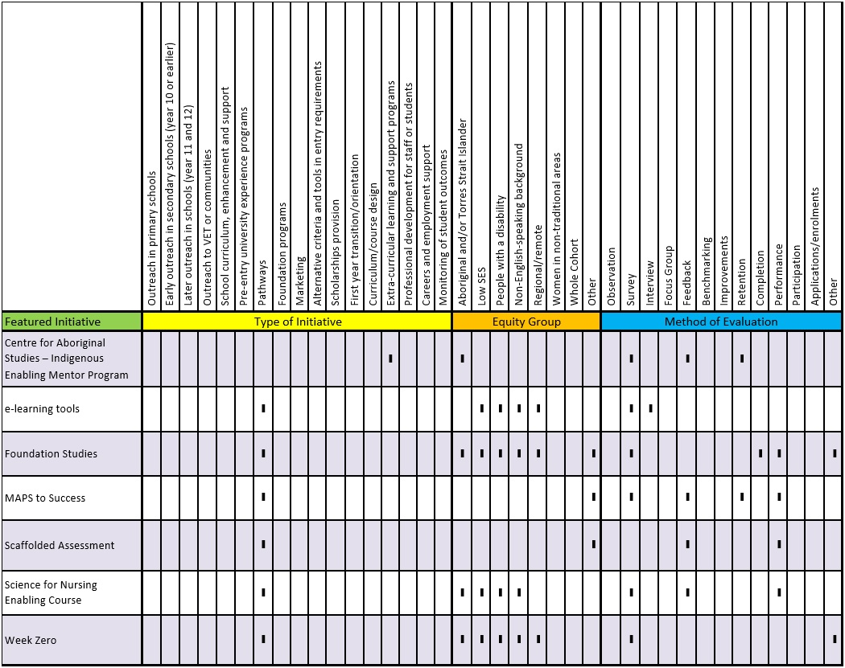

Centre for Aboriginal Studies – Indigenous Enabling Mentor Program
Curtin University of Technology
Stage of the student life-cycle:
- Pathways and Admission

Equity group
Evaluated using | - Survey  - Feedback  - Retention
Source | CIF Part 2 Survey

Keywords
- Retention
- Support
- Mentoring
- Student Experience
- Engagement

Short Description
The Indigenous Enabling Mentor Program is a mentoring program for Enabling Course students. The aim of the program is to increase retention rates of Indigenous Tertiary Enabling Course students by connecting students with Indigenous mentors.
The mentoring program is designed to be delivered in a culturally sensitive manner. It delivers individual support and academic development to enabling program students. Social networks are also created through mentor-organised events once a month, increasing the opportunities for enabling students to develop a supportive network with a broader group of both enabling course and university students.

Initiative Type
- Extra-curricular learning and support programs (outside or in addition to normal classes)

Aims
- Supporting students in dealing with broader issues outside their study
- Providing mentorship to enabling program students

Evaluation and Impact
Participant feedback surveys are collected from both mentors and mentees each semester. Regular informal feedback and ongoing dialogue with mentors and mentees is also valuable for the continuous improvement of the program.
The retention rates of Indigenous students in both the pathway program itself and the broader university provide evidence of impact. Institutional retention data, for example, shows that the retention rates for Indigenous students have increased in the enabling program from 51 per cent in 2012–2013 to 68 per cent in 2013–2014.

Key Points
Indigenous students from the university who are already studying a degree are recruited to mentor Indigenous enabling course students.
Participating students are matched with a mentor who can help the student by providing advice about studies, the university, where to access advice and to improve the student experience through providing regular social events.

Challenges
Engagement has been the main challenge. Students may experience difficulty accessing mentors, managing their studies and attending program events. Initially, the program held one social event per semester and due to feedback received, three social events are now run each semester. Attendance at these social events is highly encouraged, but at times these events have been poorly attended.
Continuing support for the program has been difficult due to ‘soft funding’ and related staff turnover. Better student analytics would substantially increase the ability to track student outcomes and evaluate the program. Accessing data from central systems is not currently supplied as a matter of course, but would be of great value to the program.

Further Information
Curtin University of Technology offers both this program and a broad range of other mentoring programs, including specialty programs for other equity groups.
Full details can be found at http://campaign.curtin.edu.au/mentoring/

e-Learning Tools
Charles Darwin University
Stage of the student life-cycle:
- Pathways and Admission

Equity group
Evaluated using | - Survey  - Interview
Source | Peer reviewed journal

Keywords
- Access
- Pedagogy
- Learning Resources
- Engagement
- Online

Short Description
Three e-learning tools were introduced to approximately 300 students in an online enabling program where 62 per cent of students study via online courses and the majority of the cohort are equity students. Because of a reported need for additional support (due to the online nature of the course, as well as its role as an enabling course), the following tools were developed to assist in the building of academic capacity for participants:
- Video Clips—to introduce students to the course lecturer and general course and assessment requirements
- Online tutorials—to connect students to each other and to the tutor and provide opportunities to discuss course related issues
- Discussion board/groups—to encourage active learning and engagement with course content and assessment

Initiative Type
- Pathways program (a qualification that provides entry into university upon successful completion, often from Enabling, VET or private providers)

Aims
- Developing academic capacity and/or providing academic support

Evaluation and Impact
A mixed methods approach was used, including three anonymous surveys and two in-depth telephone interviews. Surveys were employed to assess the effects of video clips and online tutorials. Additionally, ten students were randomly selected to participate in two 15 minute telephone interviews in which feedback was obtained about the discussion boards. Data showed that the e-tools were perceived by students as ‘a useful resource to support their learning overall’ (Lambrinidis, 2014, p. 264).
Data were collected at five strategic points along the way. This approach was able to capture the complexity and changes in students’ perceptions and needs as they progressed through the course. All five phases focused on different aspects of the e learning tools to ascertain which ones were effective and when they appeared to be most effective.
The study highlights the importance of social connectedness for the engagement and retention of equity students. The largest result recorded was the effect of students feeling more connected to each other and to their tutor through the online tutorials (however, ongoing participation in online tutorials was a challenge, see ‘challenges’ below).
Greater engagement and connection was a reported effect in the use of discussion boards: ‘I really felt we were discussing the subject and felt as though I knew these people’ (Lambrinidis, 2014, p. 265). Use of the discussion boards varied overall, with some courses using them as a means in which to submit assessments, rather than as an opportunity for discussion.
Students were more likely to access the video clips out of all of the e-learning tools.

Key Points
Video clips were used as an introductory tool, introducing new students to lecturers, the learning management system (Learnline) and providing course information.
Tutorials were an opportunity for students to connect with one another, discuss issues and clarify expectations of course work with the lecturers.
The aim of discussion boards was to promote greater engagement with content and ‘through the active involvement of the lecturers in directing and promoting productive discussion of topics by students, students gained a better understanding of the topic and the level of academic input expected’ (Lambrinidis, 2014, p. 259).

Challenges
The fine-detail acquired through data collection revealed a need for greater staff training and support in the online space. Student feedback indicated the desire for more focused and planned online tutorials. Some feedback suggested more staff involvement on discussion boards would make that forum more effective and engaging.
One of the biggest challenges identified was the low rate of students accessing online tutorials (only approximately 33 per cent of the 134 students in the study sample participated in online tutorials). Lambrinidis (2014) described reasons for this as related to time constraints and technical difficulties. These issues require consideration for the design and implementation of tutorials so that the positive effects of engaging in them (including an improvement in performance and experience as reported by those who participated), can be experienced by more students.

Further Information
Lambrinidis, G. (2014). Supporting online, non-traditional students through the introduction of effective e-learning tools in a pre-university tertiary enabling programme. Journal of Higher Education Policy and Management, 36(3), 257–267.

Foundation Studies
University of South Australia, UniSA College
Stage of the student life-cycle:
- Pathways and Admission

Equity group | - Other  - Low ATAR  - Mature age  - First-in-Family  - Refugee background
Evaluated using | - Survey  - Completion  - Performance  - Other  - Student destinations/articulations
Source | CIF Part 2 Survey

Keywords
- Transition
- Curriculum Design
- Academic Literacies
- Belonging
- Engagement

Short Description
Foundation Studies is a one year Commonwealth supported program. Students completing the program earn a GPA for competitive entry to undergraduate programs. The program includes eight units, four of which are compulsory core units and four elective units. The electives chosen are based on the student’s desired undergraduate degree.

Initiative Type
- Pathways (a qualification that provides entry into university upon successful completion, often from Enabling, VET or private providers)

Aims
- Developing academic capacity and/or providing academic support
- Establishing inclusive processes
- Increasing awareness or understanding of educational pathways
- Providing a supported transition to higher education by preparing students with academic literacies and prerequisite knowledge

Evaluation and Impact
The Foundation Studies program commenced in 2011 and since that time, 706 students have gone on to enrol into further University of South Australia degree programs (83.7 per cent articulation rate). Fifty-five students have now graduated from their undergraduate degree. Enrolment numbers in the program continue to grow with current enrolments in 2015 sitting around 750 students (not including the mid-year intake).
Student evaluation data and interviews with previous students, university unit managers and course coordinators have been positive. The program is currently awaiting the results of a large review; however, multiple forms of evidence from the past four years shows that the program is supporting students to transition effectively and successfully into undergraduate studies and beyond.

Key Points
Having a strong teaching and professional staff team who are committed to the equity agenda and supporting the students, as well as creating engaging and innovative content to prepare students for undergraduate studies, has been essential for the positive results.
The goal of the program is to give students a taste of what university is like to inform their aspirations for further study. As a pathway program, attrition is described in ways that may be ‘positive’ for some participants.

Challenges
Tracking and gaining feedback from students who do not complete the program is essential (to find out their reasons for dropping out), but this can be very difficult.
The main challenge for the program has been rapid growth, which is reported to hinder data collection and analysis. Staff time and funding to evaluate the program comprehensively is also a challenge.
A full review of UniSA College is underway to set direction for 2016–2022.

Further Information
http://www.unisa.edu.au/study-at-unisa/unisa-college/ explore-our-programs/foundation-studies/

MAPS to Success
The University of Western Australia
Stage of the student life-cycle:
- Pathways and Admission

Equity group | - Other  - Mature age
Evaluated using | - Survey  - Feedback  - Retention  - Performance
Source | Peer reviewed journal

Keywords
- Access
- Retention
- Support
- Learning Resources
- Diagnostic Testing

Short Description
MAPS to Success is an initiative supporting students in a pathways program called MAPS (Mature Age Access Pathway) where students take four undergraduate units. In MAPS to Success diagnostic exercises are used and learning action plans devised. Pre-semester activities (around orientation time) involve full day workshops, student networking opportunities, study management techniques, learning about study skills and learning about features of university culture like library services, IT systems and student support services.
During semester, ongoing support is offered in the form of one-on-one consultations with students who are academically struggling, and social activities are also held (Christensen & Evamy, 2011).

Initiative Type
- Pathways (a qualification that provides entry into university upon successful completion, often from Enabling, VET or private providers)

Aims
- Developing academic capacity and/or providing academic support
- Supporting students in dealing with broader issues outside their study

Evaluation and Impact
A mixed methods approach was undertaken. Quantitative data was recorded from MAPS student records on retention and performance. Qualitative data was obtained from online student evaluations and was used to provide more depth and detail.
A downward trend in attrition during the students’ first semester was recorded after the initiative was introduced.
Overall, 87 per cent (26/30) of the respondents were either ‘very satisfied’ or ‘mostly satisfied’ with the level of support offered in their first semester, and 77 per cent (23/30) were either ‘very satisfied’ or ‘mostly satisfied’ with respect to their study experience. Typical comments include:
Good to touch base with people who care about your progress. Working full time means you don’t hang around between or after lectures to socialise and experience ‘Uni life’. The early contact with people who appear interested in your wellbeing was reassuring (Christensen & Evamy, 2011, p. 43).
Student feedback showed positive effects around demystifying university culture:
I am especially grateful for the very first information evening when Dr Christensen explained about the ‘invisible’ unit of getting used to the whole new culture. I often reflected on that when I felt I was getting overwhelmed and felt a bit better telling myself it was just the ‘invisible’ unit. (Christensen & Evamy, 2011, p. 44)

Key Points
The MAPS to Success project was developed in 2009 using internal university funding due to a high attrition rate of MAPS students. Staff from different sections of Student Support Services designed the activities of the initiative.
Activities take place pre-semester and during semester. Pre-semester activities include a formal information session (1.5 hours offered in day and evening time slots) with a diagnostic writing exercise. The exercise is used to determine the level of support appropriate to individual students. Learning Action Plans are established for students and students are advised on which activities and level of support would be relevant to them. Learning action plans are also used to assist students with subject choices. Another pre-semester activity includes a one day workshop called MAPs to Success Study Essentials delivered by Learning Skills Advisers. This provides an opportunity for students to network.
During semester activities include one-to-one student consultations, social activities, study groups, and academic workshops. Interviews are conducted with students during the first five weeks of semester to ensure that everyone is aware of all the support services the university has to offer.

Further Information
Christensen, L. & Evamy, S. (2011). MAPs to Success: Improving the First Year Experience of alternative entry mature age students. The International Journal of the First Year in Higher Education, 2(2), 35–48.

Scaffolded Assessment
The University of Notre Dame Australia
Stage of the student life-cycle:
- Pathways and Admission

Equity group | - Other  - Alternative pathways students
Evaluated using | - Feedback  - Performance
Source | Peer reviewed journal

Keywords
- Access
- Progression
- Pedagogy
- Academic Literacies

Short Description
Scaffolded assessment was introduced into an academic writing course within an enabling program. It was introduced as a strategy for students to acquire skills and develop efficacy in academic writing.

Initiative Type
- Pathways (a qualification that provides entry into university upon successful completion, often from Enabling, VET or private providers)

Aims
- Developing academic capacity and/or providing academic support

Evaluation and Impact
Quantitative data was collected through student results compared over three years (comparing pre- and post- initiative cohorts). Academic performance in Semester 1 of the enabling program increased. A benchmark (the grade students need to achieve to qualify for successful completion of this course—65 per cent) was used to compare results and post-initiative results show that a higher number of students achieved the benchmark. Another result showed that students who completed this unit (that is, met the benchmark) also met the benchmarks of their other enabling units (McNaught & Benson, 2015).

Key Points
Before scaffolded assessment was introduced into the academic writing program (pre- 2013) the need to make assessment more supported was identified by teaching staff. Scaffolded assessment breaks assessment tasks into stages and smaller components. For example, essay writing can be daunting for people new to the experience. A scaffolded method included breaking the essay writing task into smaller steps. Formative feedback was provided before students progressed to the final stage of producing a full essay. Drawing on research, the authors make the point that scaffolding helps students transition from teacher-centric school environments to the adult learning environments typical of higher education.

Further Information
McNaught, K., & Benson, S. (2015). Increasing student performance by changing the assessment practices within an academic writing unit in an Enabling Program. The International Journal of the First Year in Higher Education, 6(1), 73–87.

Science for Nursing Enabling Course
The University of Newcastle
Stage of the student life-cycle:
- Pathways and Admission

Equity group
Evaluated using | - Survey  - Feedback  - Performance
Source | Peer reviewed journal conference paper

Keywords
- Access
- Retention
- Curriculum Design
- Progression
- Pedagogy

Short Description
A new enabling course (EPHEALTH) was implemented in 2013 to address the differences in performance in undergraduate nursing between students from enabling programs and school students. The course was developed for mature age enabling students who aim to enter undergraduate nursing. EPHEALTH focuses on building preparedness and confidence in scientific knowledge and skills appropriate for the first year undergraduate nursing program. The course aims to ‘help students develop an analytical approach to their study and focus directly on those skills that will be an essential component of their future work life in the health care environment’ (Burgess & Relf, 2014, p. 106).

Initiative Type
- Pathways (a qualification that provides entry into university upon successful completion, often from Enabling, VET or private providers)

Aims
- Developing academic capacity and/or providing academic support

Evaluation and Impact
EPHEALTH was evaluated formally in 2013 and then restructured in 2014 based on feedback received from the 2013 cohort.
The 2013 evaluation used a mixed methods approach. Data collection tools included an online survey, consisting of 12 questions students rated according to a 1–5 scale of agreement or disagreement. It also contained open-ended questions. Survey participants were students (n=127) who completed the 2013 EPHEALTH course and had progressed to successfully complete semester one of undergraduate nursing.
Students experienced greater preparedness for undergraduate study: ‘Over 92 per cent of the survey respondents agreed or strongly agreed that studying EPHEALTH gave them more confidence to undertake difficult tasks in undergraduate study and helped prepare them for the self-directed learning required in undergraduate study’ (Relf & Burgess, 2014). This is expressed in students’ comments:
This course has been an enormous advantage going into my degree. I had never studied chemistry or biology before EPHEALTH and I was able to achieve a HD for HUBS [Human Bioscience] in my first semester of my degree (Relf & Burgess, 2014).
Student feedback from the survey indicated challenges with the introduction of mathematical and chemistry concepts (65 per cent agreed that EPHEALTH had improved their maths skills but a high proportion disagreed or were undecided), ‘Many students did not see the “buy in” for learning maths and chemistry and how it related to the human body or nursing until much later towards the end of the course’ (Relf & Burgess, 2014). The course was re-designed to address some of the issues identified in feedback.

Key Points
EPHEALTH was developed based on a need to better support and prepare students in enabling science courses for undergraduate study in nursing. Data analysis revealed a gap in performance between enabling students and traditional undergraduate nursing students: ‘It became obvious that the current CLS [Chemistry and Life Sciences] course offering was not suitable for the wide range and number of students who were now using this course to prepare for nursing, and that the course was not targeting the specific skills required in the undergraduate nursing course’ (Burgess & Relf, 2014, p. 106).
A consultative approach was undertaken with discussions between the nursing school, biomedical department and the enabling program academic coordinators, with a focus on best practice for mature age students. ‘UON Nursing Faculty staff highlighted a focus on understanding basic scientific principles and their application to healthcare and the development of literacy and numeracy skills, as applied in the nursing context, as the areas of greatest need in terms of preparation of students.’ (Burgess & Relf, 2014, p. 106).
- EPHEALTH 2013 was designed to deliver content in the context of a healthcare setting
- Content included ‘basic chemical, anatomical and physiological scientific principles that underpin clinical reasoning in nursing’ (Relf & Burgess, 2014) with embedded literacy and numeracy skills
- After reflection and analysis of student feedback EPHEALTH was redesigned in 2014
- Topic order was developed to gradually introduce more complex mathematical and chemical concepts
- The introduction of mathematical concepts was aligned with the relevant topics in the enabling mathematics course that many EPHEALTH students also study, and ‘this allowed students to be introduced to the mathematics concepts in the EPMATH course before they needed to use them in EPHEALTH’ (Relf & Burgess, 2014).

Challenges
A much larger cohort enrolled in EPHEALTH than expected. Over 600 students have enrolled every year since it was first offered.

Further Information
Burgess, C., & Relf, B. (2014). Improving academic outcomes of enabling students in undergraduate nursing. Journal of Institutional Research in South East Asia, 12(1), 98–109.
Relf, B., & Burgess, C., (2014). The challenges of curriculum design in a large enabling pre-nursing open access course. Paper presented at Foundation and Bridging Educators of New Zealand (FABENZ), Tauranga, New Zealand, 4–5 December 2014.

Week Zero
The University of Newcastle
Stage of the student life-cycle:
- Pathways and Admission

Equity group
Evaluated using | - Survey  - Other  - Web analytics
Source | Conference paper

Keywords
- Access
- Orientation
- Support
- Engagement
- Online

Short Description
Week Zero is an orientation initiative offered to all commencing students enrolled in the University’s Open Foundation Online program (approximately 400 students every year). It provides a supported, gradual introduction to the online learning environment for students who may have had little exposure or opportunity to engage in online learning and become familiar with the technology involved. Activities run over five days and focus on creating support networks, engaging students with course content and familiarising students with online learning tools. Activities include discussion boards, video clips and blogs.

Initiative Type
- Pathways (a qualification that provides entry into university upon successful completion, often from Enabling, VET or private providers)

Aims
- Developing academic capacity and/or providing academic support

Evaluation and Impact
Impact data was collected on the program for the 2012 and 2013 cohorts. Data collection tools included tracking ‘students’ access and participation in Blackboard [the learning management system] during the orientation and into Semester 1’, and ‘two surveys were administered: one on Day 5 of Week Zero; and one during the second semester’ (Goode & Clarke, 2013, p. 43).
Program evaluation data shows how Week Zero strategies increased student engagement with their courses online with a significant increase in commencing students accessing Blackboard since the initiative was introduced (from 60 per cent in 2011 to 94 per cent in 2013). It also reveals an impact on student confidence, as one student stated: ‘By only revealing parts of blackboard each day it has been great and not overwhelming’ (Goode, 2013, p. 6).
Week Zero is successful in linking students to support services. A significant increase in students contacting support staff since the program was introduced is shown in Table 1 below. Improving student awareness of support staff was an aim of the program and evidence shows consistent upward trends in this area.

Table 1: Counselling and Learning Adviser consults with Open Foundation by Distance students in first semester, 2011–2013.
2011 | 2012 | 2013
17 | 84 | 126

Introduction videos by course lecturers are received positively resulting in increased connections between students and academic staff and providing reassurance, as shown in student feedback responses:
The most interesting thing has been learning about the lecturers. Understanding that they are just normal people and they are genuinely here to help. Find out a little about who they are really helps to relate to them and make me feel at ease. (Goode, 2013, p. 5).

Key Points
Week Zero was developed and implemented after an internal review of The University of Newcastle’s Open Foundation Online (previously named ‘Open Foundation by Distance’) program. The review recommended that more guidance and support was needed for commencing students on how to access courses and services. It also recommended strategies to encourage students to interact more with each other and their lecturers which would lead to positive effects on student engagement.
Creating engaging and connected learning experiences is an effect recorded in Goode’s (2013) analysis. An online environment can be a challenging space in which to achieve greater connectivity between students, and so Week Zero activities are specifically designed to encourage students to interact with one another. This approach ‘can translate the sense of enthusiasm and anticipation felt by many students at the outset of their academic journeys into the formation of dynamic and supportive communities’ (Goode, 2013, p. 3).
Week Zero is delivered through the Open Foundation Online Blackboard site. It is structured over five days of activities and includes information, resources and videos. The schedule is designed to introduce students to:
- the Enabling administrative staff and how to use key tools in Blackboard such as quizzes and discussion boards (Day 1)
- the range of support services and staff available for OF by D students (Day 2)
- the Enabling Librarian and how to use the university’s online library systems (Day 3)
- and the course lecturers and basic study skills such as critical thinking, academic writing, and using scientific calculators (Days 4/5) (Goode & Clarke, 2013, p. 40).
The approach taken by the program design team is to provide a supported and gradual introduction to the online learning space:
To lead students incrementally into the Blackboard environment, more ‘menu buttons’ became visible across the five days of Week Zero, and Adobe Captivate demonstrations with voice-over instructions were provided to guide students through how to use each new area or tool. Additionally, technical support was also made readily available by phone or email from 9am to 9pm throughout the orientation period. (Goode & Clarke, 2013, p. 41)

Challenges
Due to low tutorial attendance and first assessment submissions across all the 2012 OF by Distance courses, changes were made to online support:
The decision was made to guide students incrementally into their course sites during Week Zero in the same way that they were guided into the program site. It was hoped that this would give students ‘breathing space’ to spend time getting used to the sites without the pressure of weekly coursework, and allow staff the opportunity to highlight important information before the commencement of semester (Goode, 2013, p. 6).
This innovation produced positive effects reflected in 2013 data which show increases in the level of online tutorial participation as well as the number of first assessment submissions (Table 2).

Table 2: Rates of assignment submission and online tutorial attendance in first semester, 2012–2013
 | 2012 | 2013
Rate of first assignment submission | 71% | 81%
Average attendance per online tutorial | 5 students | 11 students

Further Information
Goode, E. (2013). Encouraging engagement and enhancing student experience: Can an online orientation help? Paper presented at National Association of Enabling Educators of Australia, Melbourne, Australia 27–29 November 2013.
Goode, E., & Clark, H. (2013). Week Zero in Open Foundation by Distance: The successes and challenges of embedding an online orientation into an enabling distance program. Create and Collaborate: Proceedings of the Foundation and Bridging Educators New Zealand 2012 Conference (pp. 38–49). Auckland Ako Aotearoa—The National Centre for Tertiary Teaching Excellence.

3. Participation: Transition and Engagement

Key Points of Participation – Transition and Engagement Initiatives
- There are few impact studies on specific equity initiatives beyond the first year of study.
- Equity initiatives are most actively developed and undertaken in health sciences, particularly in nursing. Other programs prominent in the literature include psychology, STEM courses and business/commerce.
- Participation initiatives concentrate on orienting students to the higher education environment, offering various forms of academic learning development, as well as working to foster a sense of belonging for new students.
- Transition initiatives are often not specifically identified as equity initiatives, but target courses and programs with high numbers of equity students.
- Equity initiatives captured in this section recast traditional higher education ‘support’ models from a remedial, externalised service approach to more embedded, early forms of engagement and learning development.
- Studies of effective initiatives demonstrate strong collaboration in the design and implementation of initiatives between institutions and communities, and between university faculties/centres.
- Many of the transition programs are situated in institutions located in low SES or diverse cohort regions.
- The equity group that is targeted most is students from low SES backgrounds, but there is a large degree of overlap showing how these initiatives are also capturing Aboriginal and/or Torres Strait Islander students, first in family and regional and remote students.
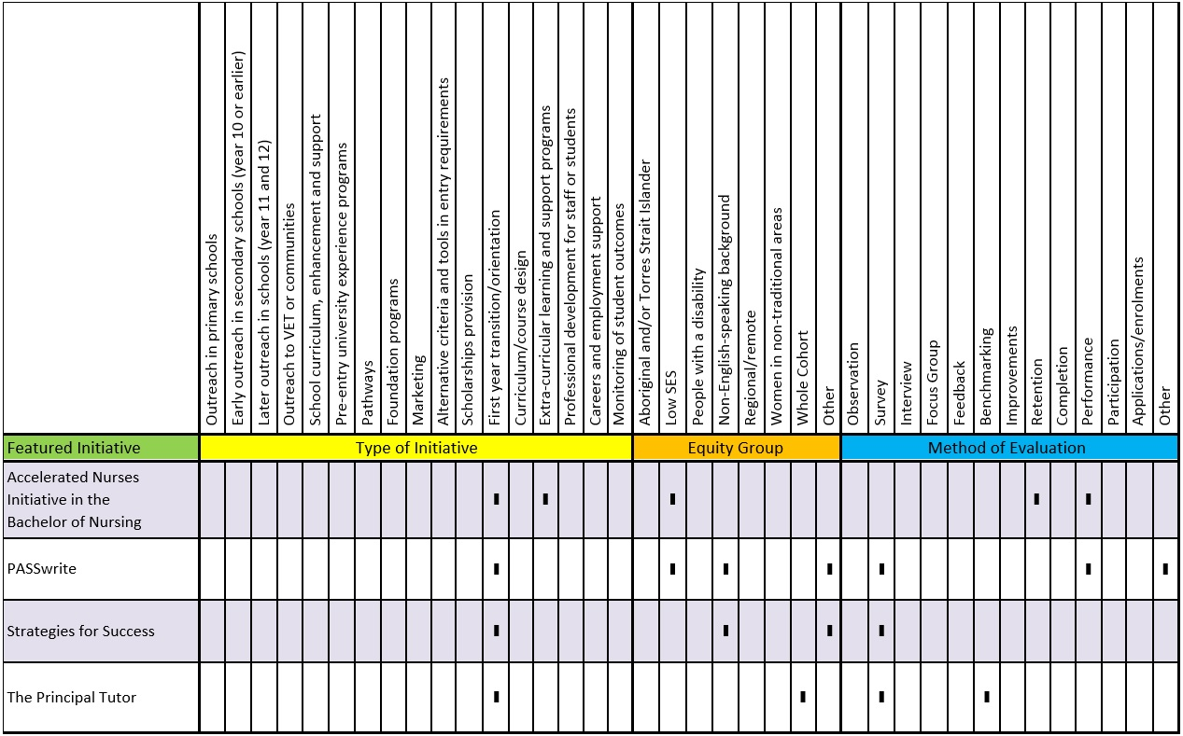

Accelerated Nurses Initiative in the Bachelor of Nursing
Queensland University of Technology
Stage of the student life-cycle:
- Transition and Engagement
- Engagement and Progression

Equity group
Evaluated using | - Retention  - Performance
Source | Peer reviewed journal

Keywords
- Transition
- Retention
- Orientation
- Support
- Learning Resources

Short Description
The Accelerated Nurses Initiative in the Bachelor of Nursing is designed to prepare nurses entering the accelerated nursing program. Students accepted into the program receive recognition of prior learning from a non-university qualification and enter the program in second year. The distinctive feature of this initiative is that it is targeted to a specific group within one program—the Bachelor of Nursing at a small regional campus with a high proportion of students from low SES backgrounds.
Through data that included high attrition rates, it was identified that students in the accelerated program experienced problems adjusting to university. A number of activities were initiated to lower attrition rates of accelerated students in two of the nursing units (bioscience and pharmacology) where up to 50 per cent of students (approximately 70 students) were identified as ‘accelerated’.
The activities included the provision of review lectures, establishment of a community website, an ‘O week’ workshop, and provision of an extra tutor.

Initiative Type
- First year transition/orientation programs
- Extra-curricular learning and support programs

Aims
- Developing academic capacity and providing academic support

Evaluation and Impact
The introduction of the initiative led to approximately a two-thirds reduction in the attrition rate of accelerated students in pharmacology and bioscience courses. Average academic performance in the cohort remained steady alongside the increased retention. (Doggrell & Polkinghorne, 2015, p. 192).

Key Points
The authors searched for an intervention model that would apply to accelerated low SES cohorts and found a study by Yorke and Thomas (2003) based on analysis of six universities in the UK performing above average in completion rates for students from a number of equity groups, including low SES.
Yorke and Thomas (2003) identified factors that make a positive difference to retention and success of low SES students:
- a supportive ‘friendly’ environment which leads to engagement (students develop a relationship with the university)
- first year support (e.g. orientation activities)
- formative assessment (with feedback) in early stage of courses
- the importance of a social aspect to learning (e.g. study groups)
The factors outlined above were integrated into the Bachelor of Nursing accelerated program initiative. The initiative was offered in stages between 2010 and 2011.
Review lectures were delivered to all accelerated students in the nursing program before or at the beginning of the semester. The aim of the lectures was to prepare students in subjects they had not previously studied, so they would be able to cope with the subjects at a more advanced level once the semester commenced.
Doggrell and Polkinghorne (2015) explain that, in addition, ‘A community website for the accelerated students in bioscience and pharmacology was established on Blackboard and all of the students in these units were enrolled. The accompanying email stipulated that the community website was designed for accelerated students, but could serve as a useful refresher for continuing students. All of the components of the program were available on the community website’ (p. 190). In the weeks before the start of semester, a formative website activity (to develop some basic concepts common to the science units) was posted on the community website. These concepts were supported by multiple choice quizzes and feedback for each correct and incorrect answer (Doggrell & Polkinghorne, 2015).
Doggrell and Polkinghorne (2015) also describe how ‘accelerated students were invited to a special workshop in O week. The workshop started with an introduction to why the strategies were set up, followed by a walk-through of the community Blackboard site, and the Blackboard site for the individual units. The second part of the workshop discussed library resources available to the students, and was presented by the campus Academic Skills Adviser. The third part of the workshop focused on study skills for active learning as well as specific advice on studying bioscience and pharmacology. Finally, a previous accelerated nursing student discussed their experiences’ (p. 190).
Extra tutor support was offered ‘using the Blog/ Discussion part of Blackboard to answer queries for weeks 1-3 … It was hoped that the forum would encourage peer learning and remain active after the end of support from the tutor but this did not occur because of lack of continued engagement’ (p. 190).
This program has now been introduced into the larger main campus.

Challenges
The extra tutor activity was not used again after 2011. The purpose of the extra tutor was to support a blog/ discussion on Blackboard. The tutor’s role ceased because students had not engaged sufficiently with the blog/discussion to warrant continuation of this aspect.

Further Information
Doggrell, S., & Polkinghorne, A. (2015). Using the factors that have a positive impact on the retention of low socioeconomic students to prepare accelerated enrolled nurses for the science units of a nursing degree. A Practice Report. The International Journal of the First Year in Higher Education, 6(1), 187–194.
Yorke, M., & Thomas, L. (2003). Improving the retention of students from lower socio-economic groups. Journal of Higher Education Policy and Management, 25(1), 63–74.

PASSwrite
University of Western Sydney and University of Technology, Sydney
Stage of the student life-cycle:
- Transition and Engagement

Equity group | - Other  - Mature age  - First-in-Family
Evaluated using | - Survey  - Performance  - Demographic data
Source | - Peer reviewed journal  - Report

Keywords
- Transition
- Support
- Learning Resources
- Academic Literacies
- Engagement

Short Description
PASSwrite is a peer-led academic literacies program that has been adapted from the well-known and widely applied PASS (Peer Assisted Study Sessions) model. Students practise academic literacy skills in small groups, concentrating on their own field of study to provide specific, authentic training in the relevant academic literacy. A high proportion of participants from equity groups participated in the program.

Initiative Type
- First year transition programs

Aims
- Developing academic capacity and/or providing academic support

Evaluation and Impact
A broad range of research methods and data sources were used to collect information from students and peer facilitators. This included the collection and analysis of:
- demographic data
- student surveys at commencement and completion
- commencement point student writing samples
- registration and attendance data
- session observation records and final reflections for each facilitator
- online posts and discussions among facilitators and team members
- records of meetings with facilitators and project team members.
(Williamson & Goldsmith, 2014, p. 19)
Comparisons between attendees’ and non-attendees’ academic performance was also made. Prior to participation in PASSwrite, students were surveyed and assessed on academic literacy skills. Commencement data showed students’ previous academic literacy practices ‘contributed to a significant level of under preparedness’ (Williamson & Goldsmith, 2014, p. 21). After participation, students’ results data shows that, on average, PASSwrite students who attended three or more sessions per semester did better than the average for the whole unit cohort in marks awarded in the relevant subjects. The difference varied from subject to subject from 3 to 15 percentage points.

Key Points
PASSwrite was offered in humanities and business disciplines. However, Williamson and Goldsmith (2014) explain that the program is scalable, and could be used at a subject, program or discipline level (across different programs).
Weekly 1.5 hour sessions were run from the third to final teaching week across the whole year (2 semesters). The number of attendees was capped at 10 students so that individual feedback could be provided. Student facilitators were recruited from existing PASS program facilitators. Training was conducted through online and face-to-face measures. Highly structured session outlines were provided to the student facilitators so that all students had ‘hands-on’ reading and writing practice, as well as receiving feedback.
Each session had the following structure:
- informal introduction including identifying areas of need (whole group)
- deconstructing and annotating an exemplar of writing in that discipline (pairs or small groups)
- ‘round robin’ of different reading/writing activities selected based on needs of group (e.g. grammar in context, vocabulary, structuring longer pieces of writing, incorporating evidence into paragraphs, supporting arguments from text, analysing essay/ assessment tasks, planning a piece of writing, evaluating sources, etc.) (small groups)
- co-constructing a text in response to the reading (pairs)
- peer-editing and feedback on a piece of writing just produced using a modified form of the marking criteria from units within that discipline (pairs)
- feedback from facilitator on writing undertaken outside the session (takes place while students engage in small group activities) (individual) (Williamson & Goldsmith, 2014, p. 11)
One of the outcomes of the PASSwrite project was the development of a PASSwrite framework and accompanying resources (including evaluation tools), which could be used by other institutions (see link below under ‘Further Information’).

Challenges
Cultivating the awareness of academic staff and students of the purposes, requirements and intended outcomes of PASSwrite was an area of challenge. Students in other disciplines to the ones targeted in the program enrolled, and staff may have been confused about the differences between the more widely known PASS program and PASSwrite.
Williamson and Goldsmith (2014) observed the inconsistent attendance of students, which they argued may be due to students being more used to a ‘just-in- time’ drop-in culture of support, whereas PASSwrite was designed as an ongoing ‘developmental’ approach.
Recording program outcomes was hampered by ‘inconsistency of attendance patterns’ making ‘the measurement of any language and literacy-based progression at the individual level very difficult’ (Williamson & Goldsmith, 2014, p. 13). However, despite this, on average, PASSwrite students who attended three or more sessions per semester did better than the average for the whole unit cohort in marks awarded in the relevant subjects. The difference varied from subject to subject from 3 to 15 percentage points.

Further Information
Williamson, F., & Goldsmith, R. (2013). PASSwrite: Recalibrating student academic literacies development. Journal of University Teaching and Learning Practice, 10(2), 1–11.
Williamson, F. & Goldsmith, R. (2014). PASSwrite. Final report: Prepared for Office for learning and teaching. Retrieved from http://www.olt.gov.au/resource-passwrite, May-2014
The PASSwrite training package and associated resources can be found at: http://uws.edu.au/passwrite

Strategies for Success
Curtin University of Technology and Murdoch University
Stage of the student life-cycle:
- Transition and Engagement

Equity group | - Other
Evaluated using | - Survey
Source | - Report

Keywords
- Transition
- Orientation
- Support
- Student Experience
- Belonging

Short Description
The Strategies for Success program is a two-day program for commencing students from refugee backgrounds. Nine modules of small group and presentation style activities are delivered covering university culture and learning strategies. Students are able to compare educational and learning experiences from their home countries and become more familiar with the expectations of the Australian higher education context.

Initiative Type
- First year transition/orientation programs

Aims
- Developing academic capacity and/or providing academic support
- Establishing inclusive processes
- Supporting students in dealing with broader issues outside their study

Evaluation and Impact
A qualitative research method was used because it was suitable ‘to the development of learning resources based on systematic exploration of the way students from refugee backgrounds make sense of, describe and interpret their experiences of university study’ (Silburn et al., 2010, p. 1).
Data was collected using surveys and evaluations with ratings and open-ended questions.
The main impact was students gaining a better understanding of university culture and how to succeed within it. Building student efficacy was an important aim and outcome of the program (Silburn et al., 2010).
Students identified a number of aspects from the program that helped them form a sense of student identity as well as what they need to do to succeed, including:
- time management and motivation to study
- building-up my self-esteem; confidence in academic writing
- learn to share with others and learn to compare different cultures
- how to prepare … before starting to write or read anything; … be selective and … make reading reasonable and gainful
(Silburn et al., 2010, p. 48)

Key Points
Silburn et al.’s (2010) study on Strategies for Success refers to the use of research and theories in designing the initiative that support the use of peer mentors, highlighting ‘community connections’ and ‘psychosocial support’ (p. 17) as positive effects.
A collaborative inter-university approach was taken in Strategies for Success between Murdoch and Curtin universities. In the design phase of the initiative, the process ‘involved sharing strategies, ideas and resources as appropriate for the differing contexts’ (Silburn et al., 2010, p. 10).
The program modules were delivered by a migrant facilitator who was able to demonstrate empathy, cross cultural awareness and greater understanding of some of the background issues and at every stage of the implementation process, student feedback and suggestions for improvement were sought.
Implementing the initiative involved three main phases:
- Learning needs analysis
- Design and delivery
- Evaluation
Two full day sessions included nine modules based on a relaxed, informal approach to facilitation. The modules covered a range of topics, including setting goals and milestones; time management and planning; preparing for classes; differences between educational systems; identifying supports; and so on.
A DVD was designed and developed as a companion resource for academics and other staff in order ‘to demonstrate how these programs can address the specific socio-cultural and pedagogical needs of first year students from refugee backgrounds’ (Silburn et al., 2010, p. 51).

Challenges
The project team identified the need for more thorough and rigorous evaluation including both quantitative and qualitative aspects of impact.

Further Information
Silburn, J., Earnest, J., De Mori, G., & Butcher, L. (2010). ‘Life’: Learning Interactively for Engagement—Meeting the Pedagogical Needs of Students from Refugee Backgrounds. Final report prepared for Australian Learning and Teaching Council.
Retrieved from http://www.olt.gov.au/resource-library?text=Learning+interactively+for
+engagement%E2%80%93meeting+the+pedagogical+needs+of+students+from+refugee+
backgrounds

The Principal Tutor
Griffith University
Stage of the student life-cycle:
- Transition and Engagement

Equity group | - Other  - A whole cohort initiative with a high proportion of equity students
Evaluated using | - Survey  - Benchmarking
Source | - Peer reviewed journal

Keywords
- Retention
- Support
- Progression
- Learning Resources
- Engagement

Short Description
The Principal Tutor is an initiative offered over first semester in the first year of an undergraduate degree in two core psychology subjects. The central feature is a role called ‘The Principal Tutor’ performed by a staff member responsible for teaching tutorials and following up on assessments. Additionally, the role involved using flexible tutorial times to discuss issues such as course structure and profession-relevant topics. Importantly, discussions were encouraged around career options and relating curriculum to professions so that students could gain a better understanding of the relevancy of theories. These small, but significant changes promoted greater connections between students and the department (Lodge, 2011).

Initiative Type
- First year transition/orientation programs

Aims
- Developing academic capacity and/or providing academic support
- Establishing inclusive processes
- Increasing awareness or understanding of educational pathways

Evaluation and Impact
The study was conducted over two years with two separate cohorts. Data were collected using online student surveys delivered at the end of both years, with specific questions asked about the Principal Tutor and engagement with studies. Retention and enrolment data was also collected, which demonstrated a clear increase in retention after the initiative was introduced.
Student engagement data was benchmarked against national averages reported in the Australasian Student Engagement Report (ACER, 2010). The participant sample exceeded the national average in a number of areas:
- Students working with other students during class
- Students working with other students outside of class (often or very often)
- Students working with a staff member on research projects
  - 22 per cent of students from the project worked on research projects with staff (2 per cent of first year students nationally work on a research project with staff)
- Students discussing career plans with staff
  - 56 per cent of psychology students in the sample discussed careers plans with staff (national average is 39 per cent)

Key Points
Griffith University’s cohort is largely comprised of mature age, low SES and Aboriginal and/or Torres Strait Islander students (Lodge, 2012). The aim of the program was to provide one central point of contact for students in academic, career and administration matters. This strategy was also designed to improve student engagement.
There are three elements to the initiative:
- The program enhanced student engagement. Eighty six per cent of students ‘rated the ability of the practices associated with the psychology subject to make the students feel part of the subject/discipline as quite good or excellent’ (Lodge, 2012, p. 13). A Facebook group was set up to provide a space for students to engage and collaborate with one another. Staff posted news and notifications of social events. Data shows that students utilised the social media resource frequently and that ‘student members of the group quickly rose to over 160 within the first few weeks of the group going live. A number of discussion board topics were started and several students commented in the survey that they used the social networking site to help them get to know other students’ (p. 14).
- The Principal Tutor also followed-up with the lowest performing (10–15 per cent) of students after each assessment item in order to encourage these students ‘to persist and make use of support services’ (Lodge, 2012, p. 12). Improved retention reflects the success of enhanced student support and engagement, ‘there is a clear turnaround between the first year group of 2007 and the first year groups of 2008 and 2009, when this initiative began and on into 2010’ (p. 15).
- The Principal Tutor aimed to increase students’ ‘sense of professional purpose by contextualising the subject curriculum within the degree and the profession’ (Lodge, 2012, p. 11), which the researchers state mitigates many student misconceptions about professions. This was done in tutorials through discussions about ‘professional registration, course structure and options for further study beyond graduation and career opportunities. Students had the choice of working through self- paced exercises or to be involved in discussion of administrative and profession specific topics, which, where possible, related to the theoretical course material covered in the session. In turn, students developed a better understanding of the authenticity and relevance of specific theories’ (p. 11).

Further Information
Lodge, J. (2012). Implementing a Principal Tutor to increase student engagement and retention within the first year of a professional program. The International Journal of the First Year in Higher Education, 3(1), 9–20.

4. Participation: Engagement and Progression

Key Points of Participation – Engagement and Progression Initiatives
- There are fewer published impact studies about equity initiatives beyond first year.
- Rather than targeting students from equity groups specifically, many initiatives provide support to all students. Although general in nature, these initiatives may disproportionately benefit students from equity backgrounds.
- The main feature of both first and later year participation initiatives is the provision of alternative models of support.
- There is a focus on changing conventions in order to introduce improvements for engaging specific equity groups. In particular, the embedding of Indigenous culture in initiatives for Aboriginal and/or Torres Strait Islander students is a strong feature of publications demonstrating effectiveness.
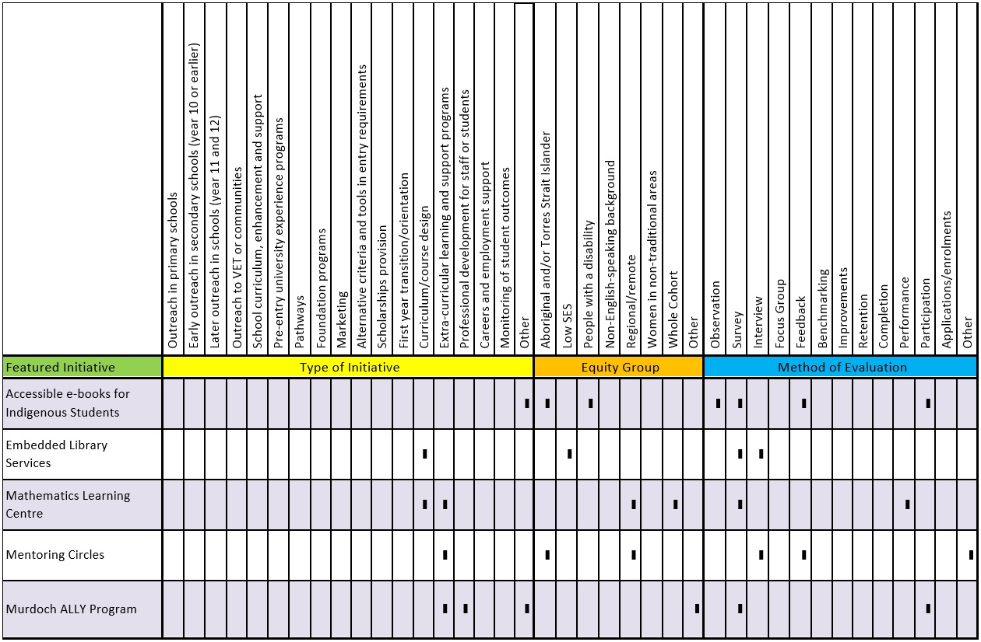
- Technology to better facilitate both on-campus and online learning environments are important aspects of both first and later year initiatives, when used in considered, curriculum specific ways.

Accessible e-books for Indigenous Students
Charles Darwin University, Bachelor Institute of Indigenous Tertiary Education, and Macquarie University
Stage of the student life-cycle:
- Engagement and Progression

Equity group
Evaluated using | - Observation  - Survey  - Feedback  - Participation
Source | Report

Keywords
- Support
- Learning Resources
- Belonging
- Technology
- Flexible Delivery

Short Description
Accessible e-books were designed for a small group of Indigenous students with sensory or learning disabilities. Course content and learning resources were uniquely formatted and uploaded to easy-to-use hand held devices (provided at no cost to the student). No internet access was required for students to use the e-books.
A distinctive feature of this pilot project was the use of technology to enable flexible and accessible delivery of course content. The authors argue that ‘the use of designed-for-purpose software on standalone devices is a first for education in this specific area and it gives direction to further exploration of ways of using these and other emerging educational technologies for the benefit of Indigenous education in Australia’ (Kerr et al., 2014, p. 6).

Initiative Type
- Flexible delivery mode for course content

Aims
- Developing academic capacity and/or providing academic support
- Establishing inclusive processes

Evaluation and Impact
Observations of students using e-books during class activities were conducted by teachers and Macquarie University Accessibility Services staff over a two day period. Students displayed a range of expertise with the devices from novice to expert. However, the researchers found that this enhanced group work, as experienced users shared their knowledge with inexperienced users, and students’ level of skill using the tablets increased very quickly with familiarity.
Survey data was also collected from students and Unit Convenors, which showed that the majority of students Convenors, which showed that the majority of students found the devices helpful to their studies. Unit convenors reported ‘having more freedom in their teaching as students had all their unit material with them on the tablet and did not need to go to a computer lab to access the Internet’, and believed that the devices had had a positive impact on learning outcomes (Kerr et al., 2014, p. 26).

Key Points
Accessible e-books was a pilot project delivered across three campuses and two courses. Curriculum content and learning resources were reformatted (with publishers’ permission) and uploaded to hand-held devices.
The underlying design principles of the project included:
- cultural safety for the students and Indigenous staff
- universal design of curriculum—so that students were not placed in the position of needing to declare disability
- equity of access to the technology for all students and staff to avoid disadvantage
- customised training and support in the use of the technologies and access to the curriculum content
- that all materials were designed to be available without access to the internet that the e-book constituted a totally self-contained learning experience that could be engaged with from remote communities (Kerr et al., 2014, p. 18).
Although no student in the pilot project had a declared disability, the researchers warned that this may be due to reluctance to access services among Indigenous students: ‘In preliminary studies, the project team established that Indigenous students generally did not wish to engage with the bureaucracy surrounding provision of support or perceived discrimination by the adoption of a deficit label of disability.’ (Kerr et al., 2014, p. 18).
Because the e-books were accessible whether or not students had disabilities, participants were better able to engage academically without needing to access more traditional bureaucratic student support services. This was the primary rationale for the project. Students were able to adjust the sizes of font and images, listen to content being read using text-to-speech technology, or access transcripts of the audio/video recordings of course materials.
Extensive consultation (about three weeks) occurred between the project team and course convenors to maintain curriculum integrity.
E-books could be extended to benefit all rural and remote students who may be disadvantaged by unreliable internet access, as well as for students from diverse cultural and linguistic backgrounds.

Further Information
Kerr, S., Booth, J., & Kerr, T. (2014). Impact of accessible eBooks on learning outcomes of Indigenous students. Australian Government: Office for Learning and Teaching.
Retrieved from http://staff.mq.edu.au/teaching/projects/ indigenous_ebooks/

Embedded Library Services
Deakin University
Stage of the student life-cycle:
- Engagement and Progression

Equity group
Evaluated using | - Survey  - Interview
Source | - Peer reviewed journal

Keywords
- Support
- Progression
- Learning Resources
- Student Experience
- Online
- Information Literacy
- Embedded Practice

Short Description
This initiative involved embedding library services within a unit of study and delivered via a learning management system reaching over 150 students. It was concerned with providing better support for disadvantaged students in the online space. The advantages of embedding library support are described as providing the librarian with an ‘insider’ status, by positioning them as part of the teaching team, and therefore increasing the librarian’s opportunity to offer discipline specific support (Horn et al., 2013).

Initiative Type
- Curriculum/course design

Aims
- Developing academic capacity and/or providing academic support

Evaluation and Impact
Based on survey questions regarding non-traditional pathways and postcode data, it was established that 85 per cent of respondents were low SES and had followed non-traditional pathways into university.
Data collected included accounts of practice, observations (from surveys and interviews) and lessons learned and/or intended changes in future practices (Horn et al., 2013). Staff interviews were semi-structured and conducted with the teacher and librarian. They were interviewed twice, at the beginning and end of the trimester. The questions asked participants to ‘reflect on the progress, nature, benefits and challenges of the embedded practice’ (p. 241).
Students reported greater ‘comfort in using library resources and services, awareness of library resources, and satisfaction with the support and resources provided’ (Horn et al., 2013, p. 247). The librarian reported being able to provide more effective support, while the teacher gained more knowledge about library research methods and reported the positive effects of increased student/teacher/librarian discussions around information literacy.
In addition to the evaluation conducted by the research team, the results of a university wide routine satisfaction survey indicated an increase in student satisfaction with library services among participants compared to the previous year’s cohort.

Key Points
The program was embedded within a second-year, undergraduate unit in a health sciences degree which had both internal face-to-face and external (distance) enrolments and a comparatively high percentage of domestic students from low SES backgrounds (Horn et al., 2013, p. 239). Low SES students were targeted in this initiative because of the recognition that many students in this group have prior educational experiences that may not have prepared them for all aspects of university study. Horn et al. (2013) emphasised the role student academic services such as library services have in improving educational outcomes for equity students.
The rationale for the initiative was the rise of LMSs (learning management systems) and that an increase in online (distance enrolment) enrolment can cause difficulties for library services to be ‘visible’ and accessible.
Implementation involved a collaborative approach between teaching staff and support staff. It focused on repositioning support staff as ‘contributor(s) to student learning’ (Horn et al., 2013, p. 246).
Activities included in the initiative:
- development of an online resource guide
- face-to-face presentation at the start of trimester— recorded for online users
- provision of library help objects (LHOs) to assist student navigation and resource seeking
- modelling of appropriate search strategies for a sample assignment topic
- regular engagement with students through a dedicated LMS discussion forum
- delivery of an online session about the use of Endnote, a reference management software
- student initiated one-to-one consultations by email and phone
An important point made in relation to ‘not practice as usual’ was the strategy of ‘pushing information out’ (Horn et al., 2013, p. 244). Instead of waiting to be asked a question the librarian would make information available to all students. This had the added benefit of not marginalising or singling out ‘disadvantaged’ students.
Because this initiative has demonstrated strong elements of initial success, it has also been adopted by other courses with relatively high proportions of low SES students in the participating university.

Challenges
No baseline data were collected, making it difficult to assess the full extent of effects of the initiative. No data were collected on student performance or on overall results, nor were specific data on usage of library services utilised by students (Horn et al., 2013).

Further Information
Horn, A., Maddox, A., Hagel, P., Currie, M., & Owen, S. (2013). Embedded library services: Beyond chance encounters for students from low SES backgrounds. Australian Academic and Research Libraries, 44(4), 235–250.

Mathematics Learning Centre
Central Queensland University
Stage of the student life-cycle:
- Engagement and Progression

Equity group | - Other  - Whole cohort
Evaluated using | - Survey  - Performance
Source | Peer reviewed journal

Keywords
- Retention
- Curriculum Design
- Progression
- Learning Resources
- Diagnostic Testing

Short Description
The Mathematics Learning Centre (MLC) is an academic support centre accessible to all students. It is offered as an additional service that focuses specifically on mathematics. The MLC is an individual entity closely aligned with faculties through collaborations with faculty staff. The MLC aims to address the ‘under preparedness’ of students in mathematics as they undertake pathways programs and undergraduate courses. Students access MLC by self-referral or are referred by teaching staff.
The main aim of the program is to foster independent learning practices. The MLC targets equity students, in particular, regional students and alternative pathways students, and designs support around this. Support includes preparatory courses for alternative pathways students and general undergraduate students on campus through workshops, drop-in sessions, one-on-one sessions, embedding in courses and support through the use of Tablets/PCs for distance students.

Initiative Type
- Curriculum/course design
- Extra-curricular learning and support programs

Aims
- Developing academic capacity and providing academic support

Evaluation and Impact
The effectiveness of MLC resources was evaluated through a survey of students’ experiences. All students surveyed ‘found the MLC useful and would recommend it to other students’, and they reported improved performance in mathematics (Adams et al., 2012, p. 29).
Students confirmed that the dedicated MLC space is an environment conducive to independent learning. The researchers attributed effectiveness to engaged approaches and collaborations with faculties. Having a dedicated space on campus, as well as access for off campus students (phone and email access was noted as being utilised by distance students and students who wished to use the service anonymously) increased the reach and scope of the MLC. Self-assessment tools embedded in undergraduate courses enabled students to develop their learning. The use of sound learning and teaching principles (for example, scaffolding) in the development of study materials was also described as contributing to the overall effectiveness of the centre.

Key Points
The authors observed that in order to prevent attrition, support is required in areas where knowledge gaps exist that critically impede students’ progress (Adams et al., 2012, p. 29).
The MLC at Central Queensland University has been operating since 1984. A timetable is visible for students to see staff availability, but students have access to the room during normal office hours regardless of whether it is staffed or not. Students can access the centre online, attend alone or participate in study groups. The staff at the other two campuses without dedicated spaces book tutorial rooms when a session is requested.
The philosophy of the MLC is to encourage students ‘to develop independent learning habits by providing assistance on an as needed basis’ (Adams et al., 2012, p. 28). The authors observed that student confidence in working independently rises with the availability of tutorial support (p. 28).
Activities provided include:
- Skills audit testing to see the extent of knowledge gaps, which can also be embedded into undergraduate programs
- Providing mathematics resources designed to enable students to close knowledge gaps. Resources are available online as well as from MLC campus centres and can also be embedded into undergraduate programs. The online option has the advantage
- that students can access resources as needed
- Making mathematical concepts and content available via a website relating to a variety of programs (through collaboration between faculty and MLC staff). The content is designed to be self-paced
- Individual assistance via a drop-in service
- Individual assistance for distance students via telephone, email or in person at four regional campuses
- Online services—conducted by MLC staff using tablet PCs which allow provision of handwritten solutions and videos
- Workshops on areas of difficulty—topics are selected through collaboration with faculty, and
- Orientation week workshops—designed to create awareness of services and support available and to introduce students to the mathematics they may experience in undergraduate courses, students are also directed to the online resources of MLC
These activities could be scaled down and included in specific faculties (e.g. Faculties of Engineering) as required.

Challenges
The authors would like to see more extensive sharing of resources (inter-university sharing), and state that intellectual property policies limit the sharing of teaching materials in Australia.

Further Information
Adams, N., Hayes, C., Dekkers, A., Elliott, S., & Atherton, J. (2012). Obtaining learning independence and academic success through self-assessment and referral to a Mathematics Learning Centre. The International Journal of the First Year in Higher Education, 3(2),
21–n/a.

Mentoring Circles
James Cook University
Stage of the student life-cycle:
- Engagement and Progression

Equity group
Evaluated using | - Interview  - Feedback  - Artefacts
Source | Report

Keywords
- Support
- Learning Resources
- Mentoring
- Student Experience
- Belonging

Short Description
A Bachelor of Nursing initiative, Mentoring Circles targeted a small cohort of Torres Strait Islander students at James Cook University. It was implemented by grouping a skilled, experienced mentor with less- experienced students. The initiative enabled students ‘to identify tailored strategies in a safe, culturally appropriate and supportive environment which would make a difference to their lives as nursing students’ (Mills et al., 2014, p. 1138). The initiative was developed to address an urgent need to improve retention (Mills et al., 2014; Felton-Busch, 2013).

Initiative Type
- Extra-curricular learning and support programs (outside or in addition to normal classes)

Aims
- Developing academic capacity and/or providing academic support
- Establishing inclusive processes
- Supporting students in dealing with broader issues outside their study

Evaluation and Impact
The evaluation was conducted using qualitative methodology in an action research study. The participants included students as well as tutors and research team members.
The data-set included ‘facilitator notes from the mentoring circle meetings, outcomes of activities, worksheets, posters, graphic designs for a student shirt, interview transcripts, and minutes from the research team meetings’ (Mills et al., 2014, p. 1140). Artefacts were analysed using NVivo, a computer software program for qualitative data analysis.
The initiative demonstrated impact in two main areas: students’ practical skills and their confidence. A shift in student perspectives from perceiving study as a struggle, to viewing it as problem-solving through supportive networks, was also reported (Mills et al., 2014). The initiative ‘helped students to better negotiate their surroundings and frame the experience as a challenge to meet or a worthwhile goal to achieve’ (Mills et al., 2014, p. 1140).
Some of the skills that students reported developing included: self-analysis; communication with both peers and university staff; ‘making their study needs known to friends, family and workmates; and networking, teamwork and collaboration’ (Felton-Busch et al., 2013, p. 36).

Key Points
Mentoring Circles was designed and implemented using a ‘decolonizing methodology’ (Mills et al., 2014). Aboriginal and/or Torres Strait islander cultural protocols, values and behaviour were built into activities (group support, for example) of the mentoring program, enabling participants to ‘guide the direction of the study according to their present and arising needs’ (Felton-Busch et al., 2013, p. 136).
‘Student participants identified common issues, discussed these within the group, devised strategies for action, implemented these strategies and reflected on the outcomes. They also considered how actions and outcomes from previous mentoring circle meetings impacted on their student experience’ (Mills et al., 2014, p. 1140).
Students met four times each semester for approximately 1–1.5 hours. Mentors planned and delivered activities focusing on discussions, bonding and developing student identities. The structure of the meetings was ‘loose’ and included sharing food. Feedback was included on actions identified at previous mentoring sessions.

Challenges
The research team working on Mentoring Circles recommended incorporating the initiative into a subject (rather than offering it as an extra-curricular activity) as a way to meet the challenge of time restrictions that inhibited students’ ability to fully participate in the program (Mills, et al., 2015).

Further Information
Mills, J., Felton-Busch, C., Park, T., Maza, K., Mills, F., Ghee, M., Hitchins, M., Chamberlain-Salaun, J. & Neuendorf, N. (2014). Supporting Australian Torres Strait Islander and Aboriginal nursing students using mentoring circles: An action research study. Higher Education Research and Development, 33(6), 1136–1149.
Felton-Busch, C., Maza, K., Ghee, M., Mills, F., Mills, J., Hitchins, M. Park, T. & Chamberlain-Salaun, J. (2013). Using mentoring circles to support Aboriginal and Torres Strait Islander nursing students: Guidelines for sharing and learning. Contemporary Nurse: A Journal for the Australian Nursing Profession, 46(1), 135–138.

Murdoch ALLY Program
Murdoch University
Stage of the student life-cycle:
- Engagement and Progression

Equity group | - LGBTIQ
Evaluated using | - Survey  - Participation
Source | CIF Part 2 Survey

Keywords
- Support
- Mentoring
- Student Experience
- Belonging
- Engagement

Short Description
The ALLY Program provides information to students and staff on issues related to sexuality and gender identity, and reducing homophobic incidents across campuses. It also provides a forum for increasing awareness of cultural diversity and difference. The program provides: a ‘safe zone’ to Lesbian, Gay, Bisexual, Transgender, Intersex, Queer (LGBTIQ) staff and students; hosts cross-campus research and information seminars on LGBTIQ issues; and provides training to student mentors and resources and information about LGBTIQ issues to the ALLY community.

Initiative Type
- Supporting LGBTIQ students and staff
- Extra-curricular learning and support programs (outside or in addition to normal classes)
- Professional development for staff or students (to build capacity or awareness, etc.)

Aims
- Establishing inclusive processes

Evaluation and Impact
Since the program was introduced in 2007, over 200 staff have become ALLIES. The program is supported by Murdoch University’s Organisational Capabilities Unit, which coordinates and evaluates the program.
Evaluation of the ALLY training program consistently scales ‘Excellent’ to ‘Very Good’ for presenter competency, program content, transfer of learning, program material and overall assessment. Further evidence of the impact of the program is high attendance at workshops and research seminars that cover topics such as the ‘Developing Inclusive Educational Communities: Supporting Diversity in Gender and Sexuality, Literacy and Use of Technology’, which was attended by professional and academic staff at all levels and included representatives from The University of Western Australia, Curtin University of Technology and Edith Cowan University, as well as Murdoch University’s Acting Vice- Chancellor.
Several factors are reported to have contributed to positive feedback received about the program: the commitment and enthusiasm of the ALLY staff trainers; the expertise of the ALLY trainers and their recent renewal of the ALLY training content that covers new material and resources and a reverse class room model of training; a strong ALLY network; and the commitment of Murdoch University’s Acting Vice Chancellor to the ALLY program.
The ALLY program could be applied as a model for similar awareness raising and capacity building. It could be ‘scaled up’ to reach more people through the development of additional resources, increased training opportunities, increased community outreach and cross-campus programs.
ALLY connects with a range of programs and services in order to provide holistic support. Other programs ALLY connects with include: the UniEdge Student Mentor program; with student mentors undertaking the ALLY training program; Pride Week campus events; and The Student Queer Collective that offers seminars on findings of current research being undertaken by Murdoch University such as the CRC project: Developing Inclusive Educational Communities: Supporting Diversity in Gender and Sexuality, Literacy and Use of Technology.

Challenges
Limited time and resources available to run the program.

Further Information
http://our.murdoch.edu.au/Student-life/Health-and- happiness/Support-for-lesbian-and-gay-students/What- is-an-Ally/

5. Attainment and Transition Out

Key Points of Attainment and Transition Out Initiatives
- There are few studies on equity initiatives that focus on post-graduation outcomes.
- Employability initiatives are evident at participation stages of the student lifecycle.
- Common strategies of work-based learning include mentoring and work placements, professional development of students (to build capability or awareness) and careers support.
- The impact of work-based learning initiatives is increased industry knowledge and raised awareness of the realities of the work environment.
- There is some evidence that early work placements (in first year) have a positive effect on student retention and engagement.
- Some initiatives demonstrate a long-term approach (spanning different stages of the continuum) with long-term benefits, including access to resources that students can utilise after course completion.
- Career development and mentoring programs are scalable and adaptable to different contexts.
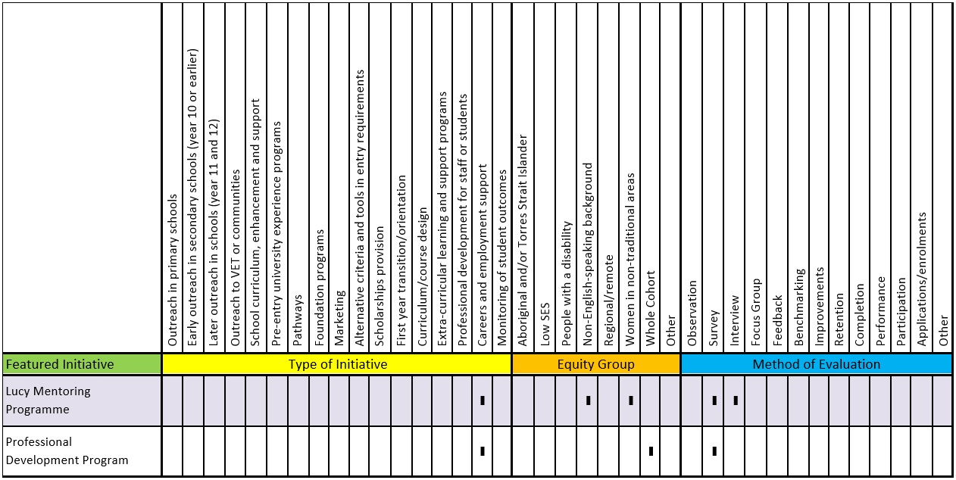

Lucy Mentoring Programme
University of New South Wales, University of New England, The University of Newcastle, and University of Technology, Sydney
Stage of the student life-cycle:
- Attainment and Transition Out

Equity group
Evaluated using | - Survey  - Interview
Source | - Peer reviewed journal

Keywords
- Mentoring
- Student Experience
- Employability

Short Description
The Lucy Mentoring Programme is a work integrated learning mentoring program that targets female business and law students. The program aims ‘to link students with mentors in their potential field of employment to help inspire and educate the students about various career options’ (Smith-Ruig, 2014, p. 770).

Initiative Type
- Careers and employment support (pre- or post-course completion)

Aims
- Improving or measuring graduate outcomes

Evaluation and Impact
The program was evaluated to gain insights into the types of mentoring activities that have developed within the program, as well as evidence of impact and benefits. Evaluation was conducted using qualitative and quantitative methods. Open-ended questionnaires and phone interviews with mentees were undertaken. Data was also analysed using content analysis.
The main benefits of the Lucy Mentoring Programme were improved industry knowledge and understanding of the realities of the work environment (Smith-Ruig, 2014). Career planning and development, coaching advice and building support and knowledge occurred during the mentoring experience, leading to increased confidence, awareness and knowledge about career options for students.
A third of the sample gained employment through participating in the program. The impact of mentoring and career learning are captured in this feedback from a student:
Through Lucy, we had women who were high up in their jobs come and talk to us. I found that great, as it was the time when I was applying for jobs (trying to figure out what to do!) and trying to decide between offers from different Commonwealth Government Departments. Lucy gave me access to their advice and opinions (Respondent 3) (Smith-Ruig, 2014, p. 776).

Key Points
The Lucy Mentoring Programme targets female business and law students and students from a non-English speaking background are encouraged to participate (Smith-Ruig, 2014).
The program highlights ‘contextual learning’ (Smith-Ruig, 2014, p. 778) as an important aspect of work integrated learning because it includes ‘the realities of a workplace and a professional career; [this is] experience that is difficult to incorporate into classroom teaching’ (Smith- Ruig, 2014, p. 778). Lucy mentors are drawn from the ‘public or corporate sector, consulting firms and self- employed mentors’ (p. 771).
Students volunteer for the program. Acceptance into the program is competitive and based on academic performance, extra curricula activities and potential to benefit from participation. Students spend approximately 35 hours with their mentors, and keep a reflective journal during the program. They also take part in an induction and formal closing ceremony.
The Lucy Mentoring Programme (Smith-Ruig, 2014) shows that work integrated learning initiatives are being applied to different contexts, with five universities now participating in the program.

Challenges
Two challenges were identified in the study: some mentors were too busy to engage with mentees and some mentees didn’t bond with their mentor. A students’ feedback comment captures these issues:
My mentor held a senior position at a large law firm which meant that she was subject to a very demanding schedule. The demands of my mentor’s position left her with little time to spend with me. Whilst my mentor was often in the office I did not experience the opportunity to observe her in the workplace nor did I engage with her on a personal level... When I entered the program I was looking forward to getting to know my mentor, how she achieved her success and balancing her career with the personal aspects of life. At the conclusion of the program I had not had one lengthy discussion with my mentor, which disappointed me, particularly after learning that many of the other mentees did enjoy engaging with their mentors on a more personal level. (Respondent 16) (Smith-Ruig, 2014, p. 777).

Further Information
Smith-Ruig, T. (2014). Exploring the links between mentoring and work-integrated learning. Higher Education Research and Development, 33(4), 769–782.

Professional Development Program
Griffith University
Stage of the student life-cycle:
- Attainment and Transition Out

Equity group | - Other  - A whole cohort initiative with a diverse cohort
Evaluated using | - Survey
Source | - Peer reviewed journal

Keywords
- Curriculum Design
- Student Experience
- Employability
- Work Integrated Learning

Short Description
The Professional Development Program is delivered to a large cohort of business degree students at the beginning of each trimester. With a focus on work integrated learning, its purpose is to develop students’ generic workplace skills which increase employability (such as interpersonal and oral communication skills and career and vocational knowledge). Freudenberg et al. (2011) cite literature that shows strong links between increased generic skills and improved employment prospects. The Professional Development Program has a ‘co-curricular’ approach and the program is taken alongside (and is complementary to) the academic curriculum.

Initiative Type
- Careers and employment support (pre- or post-course completion)

Aims
- Improving or measuring graduate outcomes
- Developing workplace skills

Evaluation and Impact
Freudenberg et al.’s (2011) study was based on a longitudinal survey methodology in which two cohorts and a control group were surveyed to measure the impact of the program on first year students. Survey questions were designed to determine students’ generic skills. Sample sizes were large, with 170 students participating from the first cohort and 203 participating from the second.
Students were surveyed first at ‘the start of the university year in Orientation Week in an attempt to capture students prior to their engaging extensively with the university’ (Freudenberg et al., 2011, p. 84). They were surveyed again a year later when they commenced second year to capture their level of development in generic skills. A control group ‘of students in a similar degree’ which doesn’t offer the PD [Professional Development] Program ‘were surveyed at similar times as the primary sample’ (p. 84).
Freudenberg et al.’s study showed an increase in perceived generic skills for both cohorts. The effects seen were not just improvements in skills, but students also valued the skills more than the control group. A reason provided for this was the relevancy of the program to students and ‘industry engagement … which allows the students to more clearly appreciate the link between their academic studies and their future careers, underscoring the value of a genuine WIL [work integrated learning] experience,’ (Freudenberg et al., 2011, p. 90).

Key Points
The program is integrated into a business degree and delivered over three days at the beginning of each trimester. A variety of activities aiming to develop generic skills are offered each trimester. A sample of the program activities is shown in Table 3.

Table 3: Generic skill and PD Program activities for first year students
GENERIC SKILL | PDP #1 | PDP #2 | PDP #3
1. Interpersonal | - Business breakfast (I)  - Pods  - Campus trivia tour | - Networking lunch (I)Interview skills workshop  - Pods | - Dealing with clients (I)  - Pods  - Student industry conference (I)
2. Self-management | - Academic planning  - Personal planning (I)  - Goal setting (I)  - Networking skills (I)  - Time management | - Internship opportunities (I) | - Student industry conference (I)
(Freudenberg et al., 2011, p. 83)
Industry participation is integral to the design and delivery of the program. Industry participants include human resources staff, recent graduates and professional bodies. University academic and non- academic staff also deliver sessions.
In Freudenberg et al.’s (2011) study, the first part of the program (PD#1) was delivered at the beginning of the year before the start of the first trimester:
This was an integrated orientation program with workshops that addressed many of the generic skills required by students as well as the more traditional orientation activities. Additional activities included forming relationships with other new and established students (through Pod activities) and initial networking with industry. In addition to funding, industry assisted in the delivery of a number of sessions in PD#1 for the first year students. The major industry session held in PD#1 was a networking breakfast on the third day, which enabled students and industry (approximately 25 industry members attended) to talk to each other about university and the profession’ (Freudenberg et al., 2011,
pp. 82–83).
PD#2 was delivered at the start of the second trimester (May). It focused on ‘improving first year students’ academic skills and preparing them for the job application and interview process. The major industry session was a networking lunch, followed by “Speed Dating Interviews” which allowed first year students to gain confidence in dealing with industry representatives’ (Freudenberg et al., 2011, p. 83).
PD#3 was offered at the start of the third trimester and ‘focused on further improving first year students’ generic and professional skills and relationships with industry partners’ (Freudenberg et al., 2011, p. 83). Students were also required to ‘present an assignment from one of their courses to an audience of peers, industry representatives and academics. Industry involvement extended to the assessment of student presentations and participation in an awards ceremony for outstanding student presentations’ (Freudenberg et al., 2011, p. 83).

Further Information
Freudenberg, B., Brimble, M. & Cameron, C., (2011). WIL and generic skill development: The development of business students’ generic skills through work-integrated learning. Asia-Pacific Journal of Cooperative Education, 12(2), 79–93.

Indexes

Initiatives by Equity Group

People who are from low SES backgrounds
- Accelerated Nurses Initiative in the Bachelor of Nursing (36)
- Digital Divas (10)
- e-Learning Tools (25) Embedded Library Services (48)
- Foundation Studies (27)
- In2Uni Program (12)
- PASSwrite (38)
- Science for Nursing Enabling Course (30)
- The Young Achievers Program (17)
- UNSW ASPIRE (20)
- Week Zero (32)

People who identify as Aboriginal and/or Torres Strait Islander
- Accessible e-books for Indigenous Students (46)
- Centre for Aboriginal Studies – Indigenous Enabling Mentor Program (24)
- Foundation Studies (27)
- In2Uni Program (12)
- Indigenous Youth Sports Program (IYSP) (14)
- Mentoring Circles (52)
- Science for Nursing Enabling Course (30)
- The Young Achievers Program (17) UniCamps (19)
- UNSW ASPIRE (20)
- Week Zero (32)

People from regional/remote areas
- e-Learning Tools (25)
- Foundation Studies (27)
- In2Uni Program (12)
- Mathematics Learning Centre (50)
- Mentoring Circles (52)
- The Young Achievers Program (17)
- UniCamps (19)
- UNSW ASPIRE (20)
- Week Zero (32)

People with a disability
- Accessible e-books for Indigenous Students (46)
- e-Learning Tools (25)
- Foundation Studies (27)
- Science for Nursing Enabling Course (30)
- Tertiary Education Experience for Students with Disabilities (TEE) (15)
- Week Zero (32)

People from non-English speaking backgrounds
- Digital Divas (10)
- e-Learning Tools (25)
- Foundation Studies (27)
- Lucy Mentoring Programme (57)
- PASSwrite (38)
- Science for Nursing Enabling Course (30)
- Strategies for Success (40)
- Week Zero (32)

Women in non-traditional discipline areas
- Digital Divas (10)
- Lucy Mentoring Programme (57)

Mature age
- In2Uni Program (12)
- MAPS to Success (28)
- Mathematics Learning Centre (50)
- PASSwrite (38)
- The Principal Tutor (42)

First in family
- Foundation Studies (27)
- In2Uni Program (12)
- PASSwrite (38)
- Scaffolded Assessment (29)
- The Young Achievers Program (17)
- UNSW ASPIRE (20)

Refugee background
- Foundation Studies (27)
- Strategies for Success (40)
- UNSW ASPIRE (20)

Pasifika
- UNSW ASPIRE (20)

Low ATAR
- Foundation Studies (27)

Whole cohort
- Mathematics Learning Centre (50)
- Professional Development Program (59)
- The Principal Tutor (42)

Lesbian gay bisexual transgender intersex queer (LGBTIQ)
- Murdoch ALLY Program (54)

Initiatives by Type

Outreach in primary schools
- In2Uni Program (12)

Early outreach in secondary schools (Year 10 or earlier)
- Digital Divas (10)
- In2Uni Program (12)

Later-year outreach in schools (Year 11 and 12)
- In2Uni Program (12)
- Tertiary Education Experience for Students with Disabilities (TEE) (15)
- The Young Achievers Program (17)
- UniCamps (19)
- UNSW ASPIRE (20)

Outreach to VET or communities
- In2Uni Program (12)

School curriculum, enhancement and support
- Digital Divas (10)
- In2Uni Program (12)
- UNSW ASPIRE (20)

Pre-entry university experience programs
- In2Uni Program (12)
- Indigenous Youth Sports Program (IYSP) (14)

Pathways
- Centre for Aboriginal Studies – Indigenous Enabling Mentor Program (24)
- e-Learning Tools (25)
- Foundation Studies (27)
- In2Uni Program (12)
- MAPS to Success (28)
- Scaffolded Assessment (29)
- Science for Nursing Enabling Course (30)
- Week Zero (32)

Scholarships provision
- In2Uni Program (12)
- The Young Achievers Program (17)

First year transition/orientation programs
- Accelerated Nurses Initiative in the Bachelor of Nursing (36)
- In2Uni Program (12)
- PASSwrite (38)
- Strategies for Success (40)
- Tertiary Education Experience for Students with Disabilities (TEE) (15)
- The Principal Tutor (42)

Professional development for staff or students
- In2Uni Program (12)

Curriculum/course design
- Embedded Library Services (48) Mathematics Learning Centre (50)

Flexible delivery mode for course content
- Accessible e-books for Indigenous Students (46)

Extra-curricular learning and support programs
- Accelerated Nurses Initiative in the Bachelor of Nursing (36)
- Mathematics Learning Centre (50)
- Mentoring Circles (52)

Supporting lesbian, gay, bisexual, transgender, intersex, queer (LGBTIQ) students and staff
- Murdoch ALLY Program (54)

Successful completion and graduate employment
- Lucy Mentoring Programme (57)

Careers and employment support (pre- or post-course completion)
- Lucy Mentoring Programme (57)
- Professional Development Program (59)

Academic literacies
- Foundation Studies (27)
- PASSwrite (38)
- Scaffolded Assessment (29)
- Tertiary Education Experience for Students with Disabilities (TEE) (15)

Access
- Digital Divas (10)
- e-Learning Tools (25)
- In2Uni Program (12)
- Indigenous Youth Sports Program (IYSP) (14)
- MAPS to Success (28)
- Scaffolded Assessment (29)
- Science for Nursing Enabling Course (30)
- Tertiary Education Experience for Students with Disabilities (TEE) (15)
- The Young Achievers Program (17)
- UniCamps (19)
- UNSW ASPIRE (20)
- Week Zero (32)

Aspirations
- Digital Divas (10)
- In2Uni Program (12)
- Indigenous Youth Sports Program (IYSP) (14)
- Tertiary Education Experience for Students with Disabilities (TEE) (15)
- The Young Achievers Program (17)
- UniCamps (19)
- UNSW ASPIRE (20)

Awareness of pathways
- Digital Divas (10)
- In2Uni Program (12)
- Indigenous Youth Sports Program (IYSP) (14)
- Tertiary Education Experience for Students with Disabilities (TEE) (15)
- UniCamps (19)
- UNSW ASPIRE (20)

Belonging
- Accessible e-books for Indigenous Students (46)
- Foundation Studies (27)
- Mentoring Circles (52)
- Murdoch ALLY Program (54)
- Strategies for Success (40)
- UniCamps (19)
- UNSW ASPIRE (20)

Curriculum design
- Digital Divas (10)
- Foundation Studies (27)
- Mathematics Learning Centre (50)
- Professional Development Program (59)
- Science for Nursing Enabling Course (30)

Diagnostic testing
- MAPS to Success (28)
- Mathematics Learning Centre (50)

Embedded practice
- Embedded Library Services (48)

Employability
- Lucy Mentoring Programme (57)
- Professional Development Program (59)

Engagement
- Centre for Aboriginal Studies – Indigenous Enabling Mentor Program (24)
- Digital Divas (10)
- e-Learning Tools (25)
- Foundation Studies (27)
- Indigenous Youth Sports Program (IYSP) (14)
- Murdoch ALLY Program (54)
- PASSwrite (38)
- The Principal Tutor (42)
- Week Zero (32)

Flexible delivery
- Accessible e-books for Indigenous Students (46)

Information literacy
- Embedded Library Services (48)

Learning resources
- Accelerated Nurses Initiative in the Bachelor of Nursing (36)
- Accessible e-books for Indigenous Students (46)
- e-Learning Tools (25)
- Embedded Library Services (48)
- MAPS to Success (28)
- Mathematics Learning Centre (50)
- Mentoring Circles (52)
- PASSwrite (38)
- Tertiary Education Experience for Students with Disabilities (TEE) (15)
- The Principal Tutor (42)

Mentoring
- Centre for Aboriginal Studies – Indigenous Enabling Mentor Program (24)
- Lucy Mentoring Programme (57)
- Mentoring Circles (52)
- Murdoch ALLY Program (54)
- The Young Achievers Program (17)
- UNSW ASPIRE (20)

Online/technology
- Accessible e-books for Indigenous Students (46)
- e-Learning Tools (25)
- Embedded Library Services (48)
- Week Zero (32)

Orientation
- Accelerated Nurses Initiative in the Bachelor of Nursing (36)
- Strategies for Success (40)
- Tertiary Education Experience for Students with Disabilities (TEE) (15)
- Week Zero (32)

Pedagogy
- Digital Divas (10)
- e-Learning Tools (25)
- Scaffolded Assessment (29)
- Science for Nursing Enabling Course (30)

Progression
- Embedded Library Services (48)
- In2Uni Program (12)
- Mathematics Learning Centre (50)
- Scaffolded Assessment (29)
- Science for Nursing Enabling Course (30)
- The Principal Tutor (42)

Retention
- Accelerated Nurses Initiative in the Bachelor of Nursing (36)
- Centre for Aboriginal Studies – Indigenous Enabling Mentor Program (24)
- MAPS to Success (28)
- Mathematics Learning Centre (50)
- Science for Nursing Enabling Course (30)
- The Principal Tutor (42)

Student experience
- Centre for Aboriginal Studies – Indigenous Enabling Mentor Program (24)
- Embedded Library Services (48)
- Lucy Mentoring Programme (57)
- Mentoring Circles (52)
- Murdoch ALLY Program (54)
- Professional Development Program (59)
- Strategies for Success (40)
- Tertiary Education Experience for Students with Disabilities (TEE) (15)

Support
- Accelerated Nurses Initiative in the Bachelor of Nursing (36)
- Accessible e-books for Indigenous Students (46)
- Centre for Aboriginal Studies – Indigenous Enabling Mentor Program (24)
- Embedded Library Services (48)
- MAPS to Success (28)
- Mentoring Circles (52)
- Murdoch ALLY Program (54)
- PASSwrite (38)
- Strategies for Success (40)
- Tertiary Education Experience for Students with Disabilities (TEE) (15)
- The Principal Tutor (42)
- The Young Achievers Program (17)
- UniCamps (19)
- Week Zero (32)

Transition
- Accelerated Nurses Initiative in the Bachelor of Nursing (36)
- Foundation Studies (27)
- In2Uni Program (12)
- PASSwrite (38)
- Strategies for Success (40)
- Tertiary Education Experience for Students with Disabilities (TEE) (15)
- The Young Achievers Program (17)

Work integrated learning
- Professional Development Program (59)

Initiatives by Program Aims

Informing aspirations and developing expectations for higher education
- Digital Divas (10)
- In2Uni Program (12)
- Indigenous Youth Sports Program (IYSP) (14)
- Tertiary Education Experience for Students with Disabilities (TEE) (15)
- The Young Achievers Program (17)
- UniCamps (19)
- UNSW ASPIRE (20)

Developing academic capacity and/or providing academic support
- Accelerated Nurses Initiative in the Bachelor of Nursing (36)
- Accessible e-books for Indigenous Students (46)
- e-Learning Tools (25)
- Embedded Library Services (48)
- Foundation Studies (27)
- In2Uni Program (12)
- MAPS to Success (28)
- Mathematics Learning Centre (50)
- Mentoring Circles (52)
- PASSwrite (38)
- Scaffolded Assessment (29)
- Science for Nursing Enabling Course (30)
- Strategies for Success (40)
- Tertiary Education Experience for Students with Disabilities (TEE) (15)
- The Principal Tutor (42)
- UNSW ASPIRE (20)
- Week Zero (32)

Developing workplace skills
- Professional Development Program (59)

Establishing inclusive processes
- Accessible e-books for Indigenous Students (46)
- Foundation Studies (27)
- Mentoring Circles (52)
- Murdoch ALLY Program (54)
- Strategies for Success (40)
- Tertiary Education Experience for Students with Disabilities (TEE) (15)
- The Principal Tutor (42)
- UniCamps (19)

Supporting students in dealing with broader issues outside their study
- In2Uni Program (12)
- Mentoring Circles (52)
- Strategies for Success (40)
- The Young Achievers Program (17)

Improving or measuring graduate outcomes
- Lucy Mentoring Programme (57)
- Professional Development Program (59)

Increasing awareness or understanding of educational pathways
- Digital Divas (10)
- Foundation Studies (27)
- In2Uni Program (12)
- Tertiary Education Experience for Students with Disabilities (TEE) (15)
- The Principal Tutor (42)
- The Young Achievers Program (17)
- UniCamps (19)
- UNSW ASPIRE (20)

Provide tangible pathways for students to access higher education
- In2Uni Program (12)

Facilitating engagement of future and commencing students with disabilities with the university experience
- Tertiary Education Experience for Students with Disabilities (TEE) (15)

Providing a supported transition to higher education by preparing students with academic literacies and prerequisite knowledge
- Foundation Studies (27)

Supporting students in dealing with broader issues outside their study
- Centre for Aboriginal Studies – Indigenous Enabling Mentor Program (24)
- MAPS to Success (28)

Providing mentorship to enabling course students
- Centre for Aboriginal Studies – Indigenous Enabling Mentor Program (24)

Initiatives by Evaluation Methods

Applications/enrolments
- The Young Achievers Program (17)
- UNSW ASPIRE (20)

Artefacts
- Mentoring Circles (52)

Benchmarking
- In2Uni Program (12)
- The Principal Tutor (42)
- UNSW ASPIRE (20)

Demographic data
- PASSwrite (38)

Feedback
- Accessible e-books for Indigenous Students (46)
- Centre for Aboriginal Studies – Indigenous Enabling Mentor Program (24)
- In2Uni Program (12)
- MAPS to Success (28)
- Mentoring Circles (52)
- Scaffolded Assessment (29)
- Science for Nursing Enabling Course (30)
- Tertiary Education Experience for Students with Disabilities (TEE) (15)
- The Young Achievers Program (17)
- UniCamps (19)

Focus group
- Digital Divas (10)

Independent research
- In2Uni Program (12)

Interview
- e-Learning Tools (25)
- Embedded Library Services (48)
- Lucy Mentoring Programme (57)
- Mentoring Circles (52)
- The Young Achievers Program (17)

Observation
- Accessible e-books for Indigenous Students (46)
- Digital Divas (10)

Participation
- Accessible e-books for Indigenous Students (46)
- Murdoch ALLY Program (54)

Performance
- Accelerated Nurses Initiative in the Bachelor of Nursing (36)
- MAPS to Success (28) Mathematics Learning Centre (50)
- PASSwrite (38)
- Scaffolded Assessment (29)
- Science for Nursing Enabling Course (30)
- UNSW ASPIRE (20)

Retention
- Accelerated Nurses Initiative in the Bachelor of Nursing (36)
- Centre for Aboriginal Studies – Indigenous Enabling Mentor Program (24)
- MAPS to Success (28)

Survey
- Accessible e-books for Indigenous Students (46)
- Centre for Aboriginal Studies – Indigenous Enabling Mentor Program (24)
- Digital Divas (10)
- e-Learning Tools (25)
- Embedded Library Services (48)
- In2Uni Program (12)
- Indigenous Youth Sports Program (IYSP) (14)
- Lucy Mentoring Programme (57)
- MAPS to Success (28)
- Mathematics Learning Centre (50)
- Murdoch ALLY Program (54)
- PASSwrite (38)
- Professional Development Program (59)
- Science for Nursing Enabling Course (30)
- Strategies for Success (40)
- The Principal Tutor (42)
- The Young Achievers Program (17)
- UniCamps (19)
- UNSW ASPIRE (20)
- Week Zero (32)

Web analytics
- Week Zero (32)

Martin, L. (1994). Equity and general performance indicators in higher education. Canberra: Australian Government Publishing Service.
Dawkins, J. (1990). A fair chance for all: National and institutional planning for equity in higher education. Canberra: Australian Government Publishing Service.
As discussed in the Introduction to this report, student ‘success’ is a relative concept. Success at university is formally described as having passed a unit of study, but is informally described in terms of grades or degree completion. However other definitions may apply, which are context dependent.
Naylor, R. (2015). Understanding evaluation for equity programs: A guide to effective program evaluation. Bentley, W.A.: National Centre for Student Equity in Higher Education, Curtin University.
NSCEHE (2013). Access and Participation in Higher Education–Outreach, Access, Support, W.A.: National Centre for Student Equity in Higher Education, Curtin University.
NSCEHE (2014). Partnerships in Higher Education, W.A.: National Centre for Student Equity in Higher Education, Curtin University.

