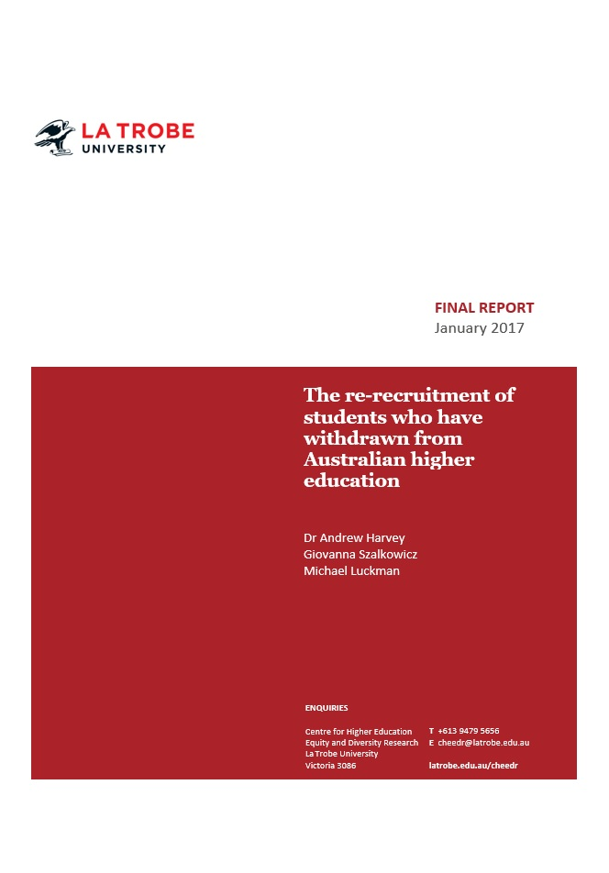

The Re-Recruitment of Students who have Withdrawn from Australian Higher Education
January 2017

Dr Andrew Harvey
Ms Giovanna Szalkowicz
Mr Michael Luckman

The project that resulted in the production of this report was funded under a National Priorities Pool (Higher Education Participation and Partnerships Program) grant from the Commonwealth. The recipient of the grant has granted the Commonwealth the right to sub-licence the material in this report. Copyright in the report remains with the original copyright owners.
Except where otherwise indicated, and save for any material protected by a trade mark, the Department of Education and Training, acting on behalf of the Commonwealth, has applied the Creative Commons Attribution 4.0 International Licence.

Modifications: Changed to meet WCAG 2.0 accessibility requirements.
Alternate text inserted for all images. Minor typographical errors corrected.

Acknowledgements
The authors acknowledge the funding of the Australian Government Department of Education and Training (DET).
The project team comprised:
- Dr Andrew Harvey, Director, Centre for Higher Education Equity and Diversity Research, La Trobe University
- Giovanna Szalkowicz, Research Officer, Centre for Higher Education Equity and Diversity Research, La Trobe University
- Michael Luckman, Senior Research Officer, Centre for Higher Education Equity and Diversity Research, La Trobe University.
We would like to acknowledge the support and assistance provided by:
- Hannah Beattie, Administration Officer, Centre for Higher Education Equity and Diversity Research, La Trobe University
- Lisa Andrewartha, Senior Research Officer, Centre for Higher Education Equity and Diversity Research, La Trobe University.
The authors are thankful for the data provided by:
- Mr Zhengfeng Li, Australian Government Department of Education and Training
- Phil Aungles, Australian Government Department of Education and Training.

The re-recruitment of students who have withdrawn from Australian higher education is published by the Centre for Higher Education Equity and Diversity Research, La Trobe University.
Centre for Higher Education
Equity and Diversity Research
La Trobe University
Melbourne Victoria 3086
Australia
Tel: +61 3 9479 5656
Email: cheedr@latrobe.edu.au
Web: latrobe.edu.au/cheedr
February 2017
ISBN 978-0-9946100-3-4
© Centre for Higher Education Equity and Diversity Research, La Trobe University 2017
Written by Dr Andrew Harvey, Giovanna Szalkowicz, Michael Luckman.
To cite this report: Harvey, A., Szalkowicz, G. & Luckman, M. (2017). The re-recruitment of students who have withdrawn from Australian higher education. Report for the Australian Government Department of Education and Training. Melbourne: Centre for Higher Education Equity and Diversity Research, La Trobe University.

Contents
Acknowledgements 3
List of Figures 5
List of Tables 5
Executive Summary 6
List of Abbreviations 8
Findings 9
Project Background and Report Structure 11
Project Structure 11
Definition of Key Terms 11
Stages of Students who Discontinue University 13
Report Structure 14
Introduction 16
Context 16
Attrition and People from Low Socio-Economic Status (SES) Backgrounds 18
Completion and People from Low Socio-Economic Status (SES) Backgrounds 20
Why Students Withdraw from University 22
Institutional Neglect of Discontinuing Students 22
Re-Engaging with Higher Education 24
Section Summary 26
National Data Analysis 28
Length of Time out of the Higher Education Sector before Re-Enrolment 28
Do Students Return to the Same Institution? 30
How do Australian Re-Recruitment Rates Compare Internationally? 32
Section Summary 34
Survey Findings 35
Participant Characteristics 35
Findings 36
Section Summary 44
Student Interviews 46
Participant Characteristics 46
Findings 47
Student Interviews Summary 57
References 59
Appendices 68
Appendix A: Survey of domestic undergraduate students who had commenced
a degree at the University and subsequently withdrawn from that degree 68
Appendix B: Interview with undergraduate domestic students from low SES
backgrounds who re-enrolled at the pilot university within six years or took a LoA 71
Appendix C: Methodology 73

List of Figures
Figure 1: National retention rates for all domestic students by equity group. 19
Figure 2: Cumulative re-recruitment rate over time for bachelor level students
first reported as absent from higher education in 2006. 28
Figure 3: Cumulative re-recruitment rates of domestic bachelor level students by
length of time after first being reported as absent from higher education; and
by socio-economic status. 29
Figure 4: Proportion of re-recruited students who returned to the same institution
over time and for students who were first reported as absent in 2006. 30
Figure 5: Proportion of re-recruited students who returned to the same institution
over time by socio-economic status. 31
Figure 6: Proportion of returning students who returned to the same institution the following year. 32
Figure 7: Proportion of first year (commencing) students who returned after a one
year break from higher education over time. UK and Australia compared 33
Figure 8: Proportion of students who returned to study at the same institution. UK
and Australia compared. 33
Figure 9: Which of the following statements best describes why you discontinued
your degree at the pilot university? (n = 395 respondents). 37
Figure 10: What was the main reason for discontinuing your degree at the pilot
university? (n = 540 respondents). 37
Figure 11: At the time, do you think there was anything the pilot university could
have done to encourage you to stay? (n = 397). 39
Figure 12: Which best describes how you felt about the pilot university when you
discontinued university? (n = 399). 40
Figure 13: In terms of your career goals, how helpful was the course you
discontinued at the pilot university? (n = 397). 41
Figure 14: What are you doing at present?* (n = 397). 42
Figure 15: Are you enrolled in the same discipline that you previously commenced
at the pilot university at present? (n = 79). 43
Figure 16: Do you think you will return to university in the future? (n = 269). 44

List of Tables
Table 1: Selected re-engagement initiatives offered by institutions in the US 25
Table 2: Summary of participant characteristics (n= 596) 35
Table 3: Contact with the pilot university before and after discontinuing 38
Table 4: Looking back, would you have made same decision of discontinuing
university? (n = 398) 39
Table 5: How likely are you to recommend the pilot university to others? (n = 397) 41
Table 6: Where are you studying at present?* (n = 118) 42
Table 7: Summary of participant characteristics (n=13) 46

Executive Summary
Student attrition within higher education is a growing concern of institutions, governments and prospective students. In an expansive and competitive marketplace, institutions are enrolling students of unprecedented diversity, with differing levels of prior academic achievement. Universities are focussed on student attrition partly because of its rising financial and reputational costs. Resources are allocated to learning analytics, mentoring, and pedagogy, to ensure that any students ‘at risk’ of withdrawing are promptly managed and supported. For governments, the costs of attrition include sectoral reputation and economic inefficiencies. Governments still underpin higher education funding across the Anglo-American world, and their priorities are moving further towards outcomes beyond mere enrolments. Performance-based funding reflects a demand of accountability from institutions for student outcomes, including degree completion and graduate employment rates. Equally, governments are providing sectoral outcome data to prospective students to inform enrolment decisions. Prospective university students are themselves considering this comparative institutional retention data in a context of rising tuition fees and costs of living. As data continues to suggest that what matters is not only commencing, but completing a university degree (Tinto, 2012), relative attrition data is likely to influence student enrolment decisions, especially as retention rates become more embedded within national and international institutional rankings.
Despite the growth in institutional preventative measures, the rise in research and evidence, the public funding incentives, and pressure from prospective students themselves, higher education attrition rates have moved remarkably little over the past decade. At least within Australian public universities, attrition is fairly inelastic, arguably because some of it is inevitable. Understanding this reality is central to developing more effective policies to address the stigmatisation of withdrawal, and to re-recruit students who have previously withdrawn. Unlike attrition, re-recruitment is an area of high elasticity. Many students who withdraw from higher education have the potential to be re-recruited in subsequent years, including students who are initially adamant that they will never return to higher education. Our research has found that, with little institutional effort, around one half of ‘non-completers’ already return to higher education within eight years of their initial withdrawal. It is difficult to prevent many students from withdrawing, but relatively easy to support their re-enrolment.
National data is supported by our qualitative research findings, focussed both on students who had withdrawn from university, and those who had successfully been re-recruited after their initial withdrawal. Consistent with broader international research, we found a broad range of reasons that students depart before completion of their degree. For most survey respondents, personal and course-related reasons were likely to be mutually reinforcing, but few left with hostility towards their university. Indeed, our results indicate that much attrition is inevitable but not final. For low socio-economic status (SES) background students in particular, there are financial, personal, and health-related reasons that are perceived to necessitate withdrawal at a point in time. School leavers and low SES students are also more likely to have made initial course and career choices that were less informed and therefore subject to change or cessation. Some of this attrition is certainly avoidable, and we recommend institutional strategies to support student perseverance and to enable flexibility of pathways and duration. Equally though, we argue that institutions need to rethink the temporality of enrolment, and understand that the causes of attrition are often temporary.
Many of our re-recruited respondents had returned to university despite expressing feelings of defeat, stigma, and even hostility towards their original university experience. In most cases, they returned to study despite little or no follow-up from the university they had first departed. These findings have implications for university recruitment strategies, but also for how the sector reflects the reality of student pathways in definitions, metrics, language, and course design. Pathways are non-linear, with many students already moving in and out of higher education over time. There are few ‘drop-outs’, but many partial completers, stop-outs, alumni and lifelong learners. Our research suggests that universities have much capacity to increase enrolments from their previous students, through better incentives, engagement, and systems to support flexibility and promote re-recruitment.
Universities and governments also have a broader responsibility to reframe the issue of attrition. The existing conception of attrition creates an unhelpful binary notion, by which students are perceived either as actively enrolled, or rejected and ‘othered’. Because low SES and other equity group students are more likely to withdraw from university, inequity is exacerbated by the stigmatised language and assumptions. While sectoral players no longer refer to student attrition as ‘wastage’ (e.g. Gray & Short, 1961; Sanders, 1958), the language of drop-outs and failures remains. Language, metrics and incentives need to adapt to reflect the growing realities of non-linear student pathways, diverse student cohorts, and increasingly partial, part-time, deferred and liminal enrolment status. Prudent universities will view withdrawal from university neither as a symptom of failure nor as a final student decision.

List of Abbreviations
ABS Australian Bureau of Statistics
ACER Australian Council for Educational Research
AIHW Australian Institute of Health and Welfare
ASGS Australian Statistical Geography Standard
ATAR Australian Tertiary Admission Rank
ATSI Aboriginal and Torres Strait Islander
AWOL Absent Without Leave
CHESSN Commonwealth Higher Education Student Support Number
DoE Discontinuation of Enrolment
DET Australian Government Department of Education and Training
DIISRTE Department of Industry, Innovation, Science, Research and Tertiary Education
HESA Higher Education Statistics Agency
IEO Index of Education and Occupation
IRU Innovative Research University
ISSP Indigenous Student Success Programme
LoA Leave of Absence
NESB Non-English Speaking Background
QILT Quality Indicators for Teaching and Learning
SEIFA Socio-economic Index for Areas
SES Socio-economic status
TEQSA Tertiary Education Quality and Standards Agency
UK United Kingdom
US United States (of America)
VET Vocational Education and Training

Findings
- Much of student attrition is either unpredictable or inevitable. Common reasons cited for withdrawal include personal (including mental health), financial and other reasons often beyond institutional control, which may help to explain the relative inelasticity of national attrition data over time.
- A significant proportion of student attrition involves those who are out of the sector for one year only. Many of these students are likely to have taken a formal Leave of Absence, and they return to the institution a year later. The presence of such students within the data is likely to contribute to an overstating of genuine attrition.
- The sector lacks common language and definitions around stages of enrolment, such as deferment, leave of absence, absence without leave, discontinuation of enrolment, withdrawal, and re-enrolment. This opacity is confusing for students and complicates data and policy analysis.
- Students are often unaware of their capacity to take formal leave, or of impending changes to their administrative status, e.g. absent without leave.
- Around half of the students who withdraw from higher education return to the sector within eight years. This return rate exists despite limited efforts by universities to re-recruit students.
- Low SES students are less likely to re-enrol in higher education than their high SES counterparts. This trend helps to explain why national completion rates reveal greater socio-economic disparity than national attrition rates.
- Low SES students are more likely to withdraw from higher education because of choosing the wrong course or career, and more likely to enrol in a different field of education upon their return. This finding has implications for careers advisors in secondary schools, course advisors at university, and those tasked with re-recruiting students.
- National variation in both attrition and re-enrolment rates by socio-economic status is relevant when considering the outcomes-based performance of institutions.
- Institutional completion and re-enrolment data is limited, but could potentially be collected and published through the Higher Education Information Management System and the Quality Indicators for Teaching and Learning.
- There is greater overall attrition among continuing students than commencing students. Many students who withdraw have successfully completed a year or more of higher education, suggesting a need for greater focus on the provision of nested and scaffolded degrees.
- Many students contemplating re-enrolment are unsure of their capacity to obtain formal credit for former university study and recognition of prior learning.
- Students who withdraw often retain positive views of their university, and are relatively likely to return to their original institution. However, since the expansion of the demand-driven system, students are more likely to return to a different institution from their original one.
- Students who withdraw are unlikely to complete an exit interview or survey, unlikely to be contacted personally after their withdrawal, and unlikely to receive tailored re-recruitment advice from their university.
- Students who withdraw may face stigmatised language and attitudes, though students who re-enrol are often positive about the likelihood of completing their course.

Project Background and Report Structure

Project Structure
This study was conducted by La Trobe University, funded through an external research grant provided by the Australian Government Department of Education and Training (DET) through the 2015 National Priorities Pool.
The primary study objectives were to:
- outline the extent to which students from low socio-economic status (SES) backgrounds were withdrawing from higher education study but returning to the sector at a later date;
- explore discontinuing low SES students’ motivations for leaving, and the factors affecting their re-enrolment;
- contribute new insights to inform policies and strategies around communications and marketing, language, scaffolding of qualifications and recognition of prior learning, designed to support students to re-enrol in, and re-engage with, higher education.
Our project adopted a mixed methods approach involving:
- an international literature review of research surrounding attrition and re-enrolment, including specific issues for low SES and other equity group students;
- quantitative analysis of national data on the extent to which students are withdrawing from higher education but returning to study at a later date;
- interviews with undergraduate domestic students from low SES backgrounds who re-enrolled at one Innovative Research University (IRU) multi-campus pilot university, referred to as the University, within six years; and
- a survey of undergraduate domestic students who discontinued their degree at the pilot university between 2009 and 2015, and who were not enrolled at the University in April 2016, with a focus on students from low SES backgrounds.

Definition of Key Terms
The following definitions are adopted for the purposes of this report:
Institutional attrition: Institutional attrition is a measure of the proportion of students who have left an institution prior to completion. It is calculated as the proportion of students who were enrolled in a course in a given year and who neither completed their degree nor returned to study the following year (Department of Education and Training, 2016a). The measure is also known as ‘crude’ attrition, as it includes students as having discontinued if they have simply moved from one institution to another. This measure does not track students if they return to university study at a later date.
Sectoral or adjusted attrition: The adjusted or sectoral attrition rate measures the proportion of students who have left the higher education sector altogether prior to completion. The calculation can track student enrolments across the sector by using the Commonwealth Higher Education Student Support Number (CHESSN) and the Student identifier (Department of Education and Training, 2016a). This measure is more detailed than the institutional attrition measure since it can track students as they move between institutions. However, as with the institutional attrition measure, the sectoral attrition measure does not monitor students who return to study at a later date.
Non-continuation rate: The non-continuation rate is a measure of student withdrawal used by the Higher Education Statistics Agency (HESA) in the United Kingdom (UK) as part of their suite of performance indicators. The non-continuation rate is measured by selecting a cohort of full time bachelor level students who were studying their first degree in a given year and examining their enrolment status the following year. Students who were no longer enrolled in a registered Higher Education provider were deemed to have not continued their study (HESA, 2016b).
Course completion: ‘The successful completion of all the academic requirements of a course of study which includes any required attendance, assignments, examinations, assessments, dissertations, practical experience and work experience in industry’ (Tertiary Education Quality and Standards Agency [TEQSA], 2012, p. 1).
Completion rate: Completion rate is a measure of the proportion of students who successfully complete all the academic requirements of a course within a period of time. Completion can be tracked among particular student cohorts by using the student’s individual student identifier (CHESSN). The CHESSN makes it possible to track the progression of a student cohort for a period of time (Department of Education and Training, 2014, 2015a, 2016d; Edwards & McMillan, 2015).
Re-engagement: Re-engagement is the process by which universities re-establish communication with students who have withdrawn despite not having completed their qualification. Re-engagement is designed to keep discontinued students engaged with the university, typically with a view to re-enrolling the student and preserving broader institutional reputation.
Re-enrolment: Re-enrolment is the process by which students who have withdrawn from their higher education degree return to higher education study at a later date. To measure the extent of re-enrolment, we calculated a re-enrolment rate using customised data provided by the Australian Government Department of Education and Training. The data tracked the subsequent enrolment records of students who were counted as absent from higher education according to the Department’s retention formula (see Appendix C for further details regarding the re-recruitment rate calculation used in this report).
Re-recruitment: This process involves active and successful steps by a university to secure the re-enrolment of a student who had previously withdrawn from higher education.
Socio-economic status (SES) background: SES is a complex construct but can be broadly described as a measure of people’s access to material and social resources that influence their ability to effectively participate in society (Saegert, Adler, Bullock, Cauce, Liu, & Wyche, 2007). SES can be measured in a variety of ways, but in official higher education statistics publications in Australia the SES of students is determined by matching Index of Education and Occupation (IEO) data from the Australian Bureau of Statistics’ 2011 Socio-economic Indexes for Areas (SEIFA) to the postcode of the student’s home residence. Postcodes classified as being in the lowest 25th percentile of the population according to the IEO were classified as low SES, while postcodes in the highest 25th percentile of the population were classified as high SES. Postcodes between the 25th and 75th percentile were classified as medium SES. Low SES background is often compounded by other markers of disadvantage, including geographic location. In Australia, regional and remote students comprise a separate equity group with group membership based on the area of residence. Regional and remote students are more likely to be from low SES backgrounds than their metropolitan counterparts (Burnheim & Harvey, 2016; Edwards & McMillan, 2015; James, Baldwin, Coates, Krause & McInnis, 2004).
Regional background: In countries with sparsely populated regions, such as Australia, long distances and travel times can affect access to crucial services (Australian Institute of Health and Welfare [AIHW], 2004). The measure of regional background is based on the distance required to be travelled to access crucial services such as health and education. The further residents have to travel to access these basic services the more regional or remote the location is judged to be. For our study, the regional status of students was determined by matching Remoteness Area data from the Australian Bureau of Statistics’ 2011 Australian Statistical Geography Standard (ASGS) to the postcode of the student’s home residence.

Stages of Students who Discontinue University
The enrolment status of students can change during different periods of leave. Within the pilot university of this study, students can move through stages including: Deferment, Leave of Absence (LoA), Discontinuation of Enrolment (DoE), and being Absent without Leave (AWOL).

Deferment
Students who have received an offer to study at a university have the option to defer their studies before the census date and begin their course at a later date (e.g. the following semester or year). National statistics published by the Department of Education and Training show that nine per cent of students deferred their offer in 2015, and school leavers and regional students were more than twice as likely as their mature age and urban counterparts to defer their studies (Department of Education and Training, 2015b). Since deferred students are not counted within the Department of Education and Training’s census of enrolled students, and consequently not included in the Department’s retention calculations, deferred students were not included in the immediate scope of this project. Nonetheless, they are clearly a cohort which could be targeted for re-engagement by universities, particularly since there is evidence suggesting that one-third of deferred students do not return to higher education after three years (Polesel & Klatt, 2014).

Leave of Absence (LoA)
Students who would like to discontinue after the census date has passed, or who have completed and obtained results for a subject, can apply for Leave of Absence (LoA) if they are experiencing difficulties in their personal or academic life – be it financial, emotional, medical, employment or study related. As such, students can apply to put their course on hold for them to complete after they have returned from leave. Failure to apply for LoA may result in the cancellation of a student’s enrolment. Every university has its own LoA policy. There is little conclusive research on the specific re-recruitment rates for students who have taken a LoA, but there are signs that many students who take a formal LoA do not return to study at its conclusion (The Victoria Institute, 2013, p. 13).

Discontinuation of Enrolment (DoE)
Students can formally withdraw by completing a Discontinuation of Enrolment (DoE) form. The DoE form collects information regarding the reason students discontinue their degree and includes the following options: medical, financial, employment, dissatisfaction, relocation, family, personal, enrolling at a different institution and other. It also contains a check box to encourage students to seek the advice of course coordinators and academics before confirming their decision. Completion of a DoE form prior to the subject census date is necessary if the student is to avoid incurring a financial liability for the subject. Students who withdraw by following the DoE process are also able to be readmitted to their course, providing they do not have any academic sanctions for unsatisfactory progress.

Absent without Leave (AWOL)
It is relatively common for students simply to let their enrolments lapse without formally discontinuing. These students have their course status set to AWOL and do not provide any information regarding their reasons for discontinuing. Students who have been reported AWOL are required to re-apply for admission to the university if they wish to return to study at a later date.

Stop-Outs and Drop-Outs
These are terms employed predominantly within the US, but also within the literature on student retention in the UK. A ‘stop-out’ is considered a temporary break from higher education study where students return to higher education at a future date, while ‘drop-out’ students are those who permanently withdraw from the sector altogether. While differentiation between the two groups has some value, we argue against the use of negative terms such as ‘drop-outs’ and their implications of permanency, as many students who are labeled ‘drop-outs’ can be re-engaged and re-recruited to higher education.

Report Structure
Our report begins with a context section in which we review the national and international work related to attrition and re-enrolment in higher education. We highlight the growing importance of attrition to institutional reputation, student decision-making, and government funding and outline major causes of attrition. This section also includes analysis of the extent to which attrition disproportionately affects under-represented students.
We then examine national data in which we analyse: the length of time students spend out of the sector; the extent to which students returned to the same institution; the related equity implications; and a comparison of Australian re-recruitment rates with those reported internationally.
Subsequently, we outline the findings of our survey of students who had withdrawn from the pilot university. The survey addressed the initial reasons for student departure and reflections on the process and motivations of departure. Also examined were the cohort’s current status in study or employment and we outline related equity implications of the survey findings.
We then provide an analysis of interviews conducted with students from low SES backgrounds who were successfully re-enrolled, having previously withdrawn from the pilot university. Out interviews addressed previous tertiary education experience; motivations for re-enrolling at university; re-enrolment processes; differences between current and previous university experiences; potential stigma associated with having previously discontinued their university degree; future education plans; and suggestions for improving practices.
Finally, we discuss our major findings and the overall picture emerging from our research.

Introduction

Context
Between 2002 and 2014, Australian institutional attrition rates for domestic commencing bachelor students increased only marginally, from 19.8 to 21.01 per cent (Department of Education and Training, 2016a). Excluding students who transferred between institutions, the ‘adjusted’ or sectoral attrition in 2014 was still around 15.1 per cent (Department of Education and Training, 2016a). Even though the number of students who transfer between institutions is increasing (Norton, 2013a, p.8), the number who withdraw from the sector altogether is still substantial. Attrition rates in higher education have also been a concern in the United Sates (US) and the United Kingdom (UK) (see, for example, Davies & Elias, 2003; Department for Business Innovation and Skills, 2014; Johnston, 1997; Quinn, Thomas, Slack, Casey, Thexton, & Noble, 2005; Rose-Adams, 2012; Tinto, 2012; Walker, Matthew, & Black, 2004).
For institutions and governments, the cost of student attrition runs to hundreds of millions of dollars (Adams, Banks, Davis, & Dickson, 2010; Department of Education and Training, 2016a). For students, there are financial costs as well as broader personal and emotional costs (Long, Ferrier, & Heagney, 2006; Tinto, 2012). Students who withdraw from higher education often receive little financial benefit from their studies (Long et al., 2016, p. xiii; Tinto, 2012, p. 1), and are often demoralised or stigmatised by their experience (Lomax-Smith, Watson, & Webster, 2011, p.76). Indeed, emotional costs may be exacerbated by the fact that ‘attrition is associated with some sense of personal failure’ (Long et al., 2006, p. 161) and that ‘academic failure lowers self-confidence and self-esteem for individuals’ (McInnis, Hartley, Polesel & Teese, 2000, p. 8).
Given the sectoral, institutional and individual costs of attrition, it is perhaps unsurprising that research has focussed on methods of prevention. To strengthen student engagement and commitment to study, universities have employed several techniques, including sophisticated predictive analytics, a range of academic advisers, peer mentors, collaborative pedagogy and assessment, career advisers, support services, and a range of online technologies (e.g. Chickering & Gamson, 1989, 1997; Kift, 2009; Kift, Nelson, & Clarke 2010; Singell & Waddell 2010; Tinto 2012). Many institutional strategies are implemented before classes even start. Universities in Australia lose a substantial number of enrolments from the moment students first accept an offer to the census date many months later (Harvey, Burnheim, Joschko, & Luckman, 2012). This trend, also known as the ‘summer melt’, has been the subject of extensive research within the United States (US) and has led to increasingly early contact with prospective and commencing students (Arnold, Fleming, DeAnda, Castleman, & Wartman, 2009; Castleman & Page, 2013). Many strategies have successfully contributed to reductions in institutional attrition. The Queensland University of Technology (QUT), for example, reduced attrition by implementing a strategy from the First Year Experience Program known as the Student Success Program, which aims to improve the experience of commencing students (Kift, Nelson, & Clarke, 2010, p. 13). Changes to attrition rates are usually minor though, and despite extensive institutional prevention efforts, many students still withdraw from higher education.
The drive to improve student retention rates is also being driven by government priorities, with a trend towards performance-based funding and publication of university outcomes to enable informed decision-making by students. In the US, there has been a movement towards performance-based funding (sometimes referred to as outcomes-based funding). Approximately 35 of the 50 American states have adopted, or are preparing to adopt, performance-based funding in higher education on the grounds that the enrolment-based model ‘does not necessarily provide incentives for institutions to help students successfully complete degree programs’ (National Conference of State Legislatures, 2015). While performance-based models differ across individual states, they typically share the principle of rewarding institutions with financial bonuses based on whether they meet specific performance goals (e.g. graduation rates, retention rates, job placements), that are tied to state priorities.
In Australia, formative moves are being made to introduce performance-based funding in areas such as Indigenous higher education, where attrition rates are notoriously high. The Review of Higher Education Access and Outcomes for Aboriginal and Torres Strait Islander People recommended ‘re-weighting of the Indigenous Support Program formula towards retention and completions to provide a clear incentive to institutions to increase successful course completions by their Aboriginal and Torres Strait Islander students’ (Australian Government, 2012, p. 75). Subsequently, the Indigenous Student Success Programme (ISSP) commenced on 1 January 2017, and is focussed on the improvement of completion rates for Indigenous students (Australian Government, 2016). Universities will be accountable for ensuring that Indigenous students enrol, progress and complete their higher education degree. Furthermore, the Higher Education Standards Panel was commissioned by the Australian Government in late 2016 to investigate trends in student attrition and completion and how institutions can support enrolled students to complete their degree (Department of Education and Training, 2016b). Relatedly, the Quality Indicators for Teaching and Learning (QILT) that were introduced partly to allow students to make side-by-side comparisons of graduate employment outcomes for institutions and disciplines (QILT, 2016a), could potentially publish more detailed information on retention and completion rates by discipline, course and university.
Despite government incentives and institutional strategies to raise retention, many Australians continue to withdraw from higher education before completion of their degree. Approximately one million Australians have an incomplete bachelor level degree (Australian Bureau of Statistics [ABS], 2016). Interestingly, more attrition exists among continuing students – those in the second or further years of their degree – than commencing (i.e. first year) students (Department of Industry, Innovation, Science, Research and Tertiary Education [DIISRTE], 2012). Data suggest that around 46,000 continuing undergraduate domestic students are leaving the sector every year, many of whom have successfully completed one or more years of their undergraduate degree (DIISRTE, 2012) but without any recognition of that achievement. The 46,000 continuing students who discontinue represent 53.9 per cent of the total annual student attrition. Students from low SES backgrounds, regional students, students with a disability, and Indigenous students are over-represented among those who discontinue (Department of Education, 2014a; Edwards & McMillan, 2015; Long et al., 2006; McMillan, 2005, 2015). A cross-national study found that students who discontinued university in fifteen European countries were more likely to gain employment than those who never enrolled in higher education (Schnepf, 20017). There can also be some intergenerational benefit of exposure to higher education even when a parent has commenced but not completed a degree (Pascarella & Terenzine, 2005, p. 590), but the costs of attrition are well-documented (Tinto 2012) and affect under-represented students disproportionately.
While some students who withdraw from higher education never return to study, many do. Indeed, nearly half of the Australian students who withdraw from higher education are subsequently re-enrolled at a university within eight years of their initial departure (see section 2). This striking statistic partly reflects a flaw in our definition of attrition. Many students return to study just one year after their withdrawal, and while they are included as part of the attrition rate, they are often students on a formal Leave of Absence who always intended to return. Such students contribute to formal attrition rates that are arguably exaggerated, and that are unable to accommodate the increasing nuances in enrolment status. Nevertheless, and notwithstanding those with approved leave from their university who fully intend to return, many other students re-enrol after formally or informally withdrawing altogether from university. Our research suggests that the re-enrolment of these students is often due more to changes in their circumstances than institutional re-recruitment strategies. For example, students who discontinue university often leave for personal reasons (Adams, Banks, Davis, & Dickson, 2010; Controller & Auditor General, 2002; QILT, 2016b, p. 24; Long et al., 2006) and are relatively likely to return to the sector in the future when their circumstances change (Long et al., 2006; The Victoria Institute 2013, 64). Students from equity groups, however, may be both more likely to leave higher education and less likely to return.

Attrition and People from Low Socio-Economic Status (SES) Backgrounds
Low socio-economic status (SES) background remains the most prevalent marker of disadvantage in Australian higher education. Socio-economic status is determined by matching data on the occupations and relative levels of education of populations within a geographic area to the postcode of students’ permanent home addresses. Three categories are developed for data purposes: low SES (the lowest quartile of the population); medium SES (the middle quartiles); and high SES (the upper quartile). Students from low SES backgrounds as a cohort are slightly more likely than the overall domestic student population to withdraw from university, while Indigenous student retention rates remain the lowest of the equity groups. Figure 1 shows that the overall retention rate for domestic students between 2009 and 2014 was higher than the retention rate for low SES domestic students, and for regional students, Indigenous students, and those with a disability.
The Australian Tertiary Admissions Rank (ATAR) is a major selection method employed by Australian public universities. The correlation between ATAR and SES is well documented (e.g. Birrell, Calderon, Dobson, & Smith, 2000; Dobson & Skuja, 2005; Lomax-Smith et al., 2011; Martin & Karmel, 2002), partly explaining why students from low SES backgrounds are disproportionately likely to receive low ATARs. Low prior academic achievement rather than SES is the primary factor associated with increased university attrition (Edwards & McMillan, 2015), and low SES students in fact typically ‘outperform’ their ATAR once enrolled at university (Harvey & Burnheim, 2013). Nevertheless, the experiences of students from low SES backgrounds at university have often been conceptualised in a way that implies a deficit (Mills & Gale, 2007).

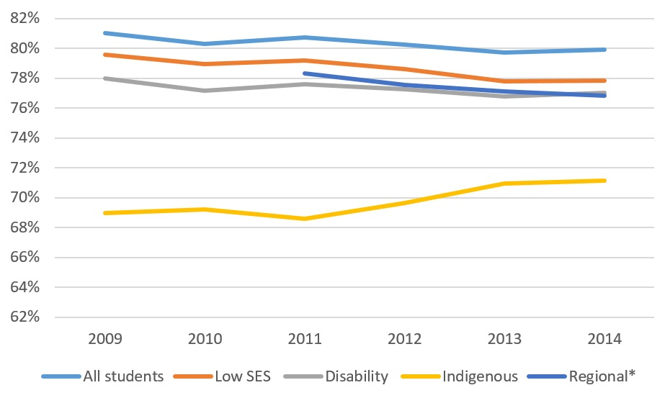
Figure 1: National retention rates for all domestic students by equity group.
Source: Department of Education and Training (2016c)
*As measured by the 2011 ASGS.
An emphasis of this deficit has often been placed on what low SES students lack, namely the cultural capital needed to succeed at university (Harvey, Andrewartha, & Burnheim, 2016, p. 81). Cultural capital can be defined as ‘proficiency in and familiarity with dominant cultural codes and practices – for example, linguistic styles, aesthetic preferences, styles of interaction’ (Aschaffenburg & Mass, 1997, p. 573). The notion of cultural capital has been considered vital to comprehend the experiences of low SES students in higher education (Devlin & McKay, 2014).
Bourdieu and Passeron (1977) argue that the higher education system is biased towards the higher socio-economic class, and reproduces class privileges and social hierarchies. Bourdieu’s theoretical insight has often been used as a way to interpret low social and academic outcomes of socially marginalised groups (Yosso, 2005), and many authors have argued that students from low SES backgrounds are often unfamiliar with the norms and expectations of higher education (e.g. Devlin, 2011; 2010; Greenbank, 2006). Conversely, it is argued that high SES students’ exposure to enriching social experiences have helped them develop a ‘reservoir of cultural and social resources’ and familiarity ‘with particular types of knowledge, ways of speaking, styles, meanings, dispositions and worldviews’ (Margolis, Soldatenko, Acker, & Gair, 2001, p. 8). As a result, some institutions have focussed on ways to assist students from low SES backgrounds in developing the cultural capital required to succeed in higher education. However, once enrolled at university, students from low SES backgrounds typically outperform high SES students with similar ATARs (Harvey & Burnheim, 2013).
One reason for the relative over-achievement of low SES students enrolled in Australian higher education is likely to be their possession of different forms of capital that are rarely defined or acknowledged. For example, Yosso (2005, p. 69) has documented forms of capital that include aspirational, navigational, social, linguistic, familial and resistance capital, each of which can contribute to student identity, achievement and perseverance. A narrow focus on cultural capital contributes to what Bletsas and Michell (2014, p. 77) call ‘classism’ in Australian higher education – ‘the tendency to construct people from low SES backgrounds as inherently deficient according to prevailing normative values’. Bletsas and Michell (2014) argue the need to change the way students from low SES backgrounds are regarded as ‘needier’ when compared to their SES peers. While low SES and other equity group students often possess many alternative forms of student capital, these forms are often unacknowledged or unrewarded by universities, so low SES students may feel marginalised even as they possess qualities essential for perseverance and success. The relevance of student capital requires further research in their own right, but for the purposes of this report we note that low SES attrition is higher than average, but that we must also distinguish academic under-preparedness from socio-economic status itself (Harvey, Andrewartha, & Burnheim, 2016, p. 71).

Other Factors Related to Attrition
Even though low SES background remains the most prevalent marker of disadvantage, it is often compounded by other factors. For example, students from low SES backgrounds often belong to a second equity group. Regional and Indigenous students, for example, are much more likely to be from low SES backgrounds than other Australians (Edwards & McMillan, 2015). Similarly, by looking at patterns of multiple group memberships, James et al. (2004) found that around half of the students from low SES backgrounds also belonged to a second equity group. More recently, customised data requested from the Department of Education and Training shows that, in 2014, 56.4 per cent of domestic undergraduate low SES students were also a member of at least one other equity cohort. The largest crossover was between regional and low SES status, with 38.2 per cent of low SES students also coming from a regional area.
Students from identified equity groups such as those from regional backgrounds, Indigenous students, and students with a disability are also more likely to discontinue their university degree when compared with their peers (Department of Education and Training, 2016c). Figure 1 shows that the retention rate for regional students in 2014 was around three per cent lower than the retention rate for all domestic students. The retention rate for Indigenous students was around 8.7 per cent lower than the retention rate for all domestic students, while the retention rate for students with a disability was around 2.8 per cent lower than average. Findings are consistent with international research highlighting that non-traditional students are more likely to discontinue their studies (Rose-Adams, 2012; Walker, Matthew & Black 2004).

Completion and People from Low Socio-Economic Status (SES) Backgrounds
A small number of national studies have focussed on the analysis of completion rates among different groups of students (e.g. Department of Education and Training, 2014, 2015a, 2016d; Edwards & McMillan, 2015; Mark, 2007; Martin, Maclachlan, & Karmel, 2001). However, most studies of university course completion in Australia draw on administrative data collected by universities (Marks, 2007), and are thus unable to track students who moved between institutions. Recent studies track completion among particular student cohorts by using the student’s individual student identifier, known as the Commonwealth Higher Education Student Support Number (CHESSN). The CHESSN makes it possible track the progression of a student cohort for a period of time (Department of Education and Training, 2014, 2015a, 2016d; Edwards & McMillan, 2015).
One report from the Department of Education and Training (2016d) that tracked completion rates of domestic bachelor students who commenced in 2006 found that almost 73.5 per cent of the 2006 cohort of domestic bachelor students completed a course at a publicly funded university within nine years of commencement. The same study showed that while 67.9 per cent of students from low SES backgrounds had completed their studies by 2014, completion rates for high SES students was 77.8 per cent (Department of Education and Training, 2016d, p. 22). Similarly, Edwards and McMillan (2015) tracked the completions outcomes of a student cohort that commenced their degree in 2005 for a period of nine years, up to 2013. The study found that approximately 69 per cent of domestic bachelor students from low SES backgrounds completed their degree, compared with 78 per cent of students from high SES backgrounds (Edwards & McMillan, 2015). Low SES students were also more likely than their peers to discontinue their degree within the first two years of study. Overall, national data suggests that students from low SES background are less likely than those from high SES backgrounds to complete their higher education degree. Indeed, completion data reveal more striking differences by socio-economic status than attrition data. In this report we argue that the discrepancy is partly explained by the relatively low re-enrolment rates of low SES students.

Other Factors of Disadvantage Related to Completion
Students from identified equity groups such as those from regional and remote backgrounds and Indigenous students are also less likely to complete their degree compared to their peers. A number of studies confirm that regional students tend to record lower completion rates than metropolitan students (Edwards & McMillan, 2015; Martin et al., 2001; McMillan, 2005). National data reveals that 74.7 per cent of students from metropolitan areas of the 2006 cohort of domestic bachelor students completed their studies by 2014, while the equivalent regional and remote rates were 69 per cent and 60.1 per cent respectively (Department of Education and Training, 2016d). Various studies also indicate a substantial difference between the outcomes of Indigenous and non-Indigenous students (e.g. Edwards & McMillan, 2015; Marks, 2007; Martin et al., 2001). National data shows that around 47.3 per cent of the 2006 cohort of domestic Indigenous bachelor students completed their studies by 2014, while the completion rate for non-Indigenous students was 73.9 per cent (Department of Education and Training, 2016d). Moreover, Edwards and McMillan’s (2015) study found that one in five Indigenous students who commenced their degree in 2005 had discontinued their degree before their second year.
Other factors associated with lower likelihood of completion include: an ATAR band below 60 for school leavers (Department of Education and Training, 2015a, 2016d; Edwards & McMillan, 2015; Norton 2013b); being male (Department of Education and Training, 2015a, 2016d; Marks, 2007; Martin, et al., 2001); studying part time or externally (Department of Education and Training, 2015a, 2016d; Martin et al., 2001); being 25 years old or over (Department of Education and Training, 2015a, 2016d; Powdthavee & Vignoles, 2007); being admitted to university through other basis of admission (Department of Education and Training, 2015a, 2016d); enrolment in generalist fields of education (Martin et al., 2001; McMillan, 2005); and undertaking long hours of paid work while studying (McMillan, 2005; Vickers, Lamb, & Hinkley, 2003).

Why Students Withdraw from University
International and national research confirm that students often discontinue study for personal reasons and/or a combination of personal reasons and academic reasons; and are frequently positive about their institution and higher education more broadly (Adams, Banks, Davis, & Dickson, 2010; Department for Business Innovation and Skills, 2014; Halliday-Wynes & Nguyen, 2014; The Victoria Institute, 2013; Shapiro, Dundar, Yuan, Harrell, Wild, & Ziskin, 2014). Similarly, Halliday-Wynes and Nguyen (2014, p. 3) revealed that tertiary students who had considered discontinuing their course ‘cited a variety of reasons such as a lack of interest, work pressures and other personal matters’. An institutional study also noted that students often discontinue because of ‘employment’, ‘health’, ‘distance to travel’, ‘moved away’, ‘needed a break’, and ‘personal reasons’ (The Victoria Institute, 2013, p. 45). Furthermore, some studies (e.g. Leveson, McNeil & Joiner, 2013) have revealed that personal reasons or factors external to the university are outside institutional control. As such, much attrition must be seen as inelastic, if not inevitable. Nevertheless, relatively few studies have addressed the re-engagement and re-enrolment of students.
Compared to their more advantaged peers, students from equity groups are more likely to cite reasons for attrition around finances, family obligations, and ‘getting by’, and less around issues of choice and lifestyle (Edwards & McMillan, 2015, p. vi). Similarly, a report from Universities Australia (2008, p. 40) noted that ‘low SES students experience more financial pressures than high SES students once they reach university’. Research has also shown that having a clear direction and sense of purpose correlates with persistence and adjusting to university (Krause, Hartley, James, & McInnis, 2005; Lizzio & Wilson, 2010). A major national study of students who discontinue their degree found that a change of direction, particularly in regard to careers, was the main reason given by students for discontinuing university (Long et al., 2006). Career decisions are often made at secondary school level, and variable access to university information and pathways may also affect longer term attrition. Our own research has confirmed that low SES and regional students in Year 11 typically have relative low understanding of tertiary application, selection and admission processes (Harvey, Brett, Cardak, Sheridan, Stratford, Tootell, McAllister & Spicer, 2016). Incomplete information may contribute to sub-optimal university course and career choices, and may be a contributor to the subsequent high attrition rates of regional and low SES students. Commencing but not completing a degree, or taking longer to complete a degree due to time away from study, also places an increased financial burden on students from low SES backgrounds.

Institutional Neglect of Discontinuing Students
Institutional strategies appear limited around the point of student departure from university. Formal capture of data from discontinuing students is minimal, with interviews and surveys rarely being conducted with students who are in the process of withdrawing from university. A large-scale national quantitative study found that only four per cent of students who discontinued university were interviewed (Long et al., 2006, p. 22). The study also found that ‘there was an undercurrent in the written comments that students felt that universities did not care about them as individuals’ (Long et al., 2006, p. 174). A national report undertaken by a consultancy body that interviewed and surveyed university students also found that when students notified their institution of their intention to discontinue, most respondents noted that ‘they were simply handed a form and shown the door’ (Hobsons, 2014, p. 6). When the respondents were asked what an institution could have done to encourage them to stay, many said that institutions could have just ‘asked me to stay’ (Hobsons, 2014, p. 6); showing that students generally exit the course rapidly and without institutional follow-up.
Lack of apparent interest may be exacerbated by stigmatised language, by which students who withdraw from university are often marginalised. In particular, there is a common language of failure and marginalisation used to refer to students who discontinue their degree. Frequently used terms referring to discontinuing students include ‘failure’, ‘drop-out’, ‘non-achievement’, ‘non-completer’ and ‘wastage’ (Long et al., 2006, p. 9; Quinn et al., 2005). Historically, the terms ‘student wastage’ and ‘academic wastage’ were even used in Australia to talk about student attrition (e.g. Gray & Short, 1961; Sanders, 1958). Institutional studies have highlighted that these labels have a negative connotation for discontinuing students (e.g. Victoria Institute, 2013). This language reinforces the idea that students are ‘unlikely or even unworthy to return to study’ (Harvey & Szalkowicz, 2015). Indeed, Quinn et al. (2005, p. 14) found that interviewees ‘were well aware how this label could be internalised and also used to position them in the minds of others’. Discontinuing university is also associated with a sense of personal failure, and students’ decisions to discontinue their degree is described ‘as the outcome of a lack of moral fibre and a propensity to quit’ (Quinn et al., 2005, p. 17). Long et al. (2006, p. 161) argue that attrition is linked to a sense of personal failure: ‘at the very least, a student has started out with a goal but not achieved it. At worst, the student has failed and been traumatised in the process’. As traditionally under-represented students such as low SES students, regional students, students with disability and Indigenous students are more likely to discontinue university (Department of Education and Training, 2016c), the impact of attrition falls disproportionately on these students (Department of Education and Training, 2016c).
Students who discontinue university go through different stages such as Deferment, Leave of Absence, Discontinuation of Enrolment, and Absence without Leave (see definitions of key terms). Understanding the different stages of withdrawal is necessary, especially given that in several cases students do not officially withdraw. For example, it is common for students at the pilot university simply to reach a point where the university’s student information system considers them to have left. Historically, students in danger of becoming AWOL typically received a procedural email simply indicating that they would be automatically ‘discontinued’ from their course if they did not re-enrol. Universities are generally aware of the point at which students are about to be registered as AWOL, and could, therefore, contact them systematically and effectively before this point is reached. Providing and extending grants of leave of absence would also seem an effective way to retain many students on the cusp of withdrawal. Under the demand-driven system, most courses enable unlimited enrolments, so a student on leave is typically not preventing any other student from being enrolled. University withdrawal processes may require adaptation to harness the full possibilities of the demand-driven system and to reflect contemporary student life.
The cost of institutional neglect can be significant, particularly given the potential damage to institutional reputation caused by unsatisfied students. Students who discontinue their degree may be unlikely to recommend the university to their colleagues, friends and family (Seidman, 2005). Although relatively few students who discontinue are openly hostile to the university, the reputational impact can still be significant (Reichheld & Sasser, 1990). As such, the advantages of maintaining contact with discontinuing students extend not only to re-recruitment but to reputational preservation (Seidman, 2005). Improving communications with former students is a risk mitigation strategy as well as a recruitment strategy.

Re-Engaging with Higher Education
While attrition literature tends to examine the decision to discontinue university as something permanent (Stratton, O’Toole & Wetzel, 2007), national and international research reveal further study to be a common outcome for discontinuing students (e.g. Long et al., 2006, p. iv; McMillan 2005; Quinn et al., 2005; Rodríguez-Gómez, Meneses, Gairín, Feixas, & Muñoz, 2016; Schnepf, 2014; The Victoria Institute, 2013; Yorke, 1999). Australian national data identified approximately one million Australians who currently hold an incomplete bachelor level degree (ABS, 2016). Among this group, 28 per cent have also completed a different higher education qualification, 32 per cent some sort of vocational education qualification, and 37 per cent hold no post-school qualification (ABS, 2016). Beyond this high level data, and despite the substantial number of partial university completers, little research has been conducted on the destinations of partial completers. While the Graduate Destination Survey and Beyond Graduation Survey both track graduate destinations (Graduate Careers Australia, 2016a, 2016b), there is little equivalent analysis of destinations of those who commence higher education but then withdraw.
One way of addressing the rise of partial completers is to develop nested degrees and steps of accreditation, for example by formally integrating diplomas and associate degrees within longer bachelor degree programs. Disaggregating the degree can particularly assist students whose motivation is wavering, and who are confronting personal challenges that threaten their continuing enrolment. Indeed, many students who withdraw have successfully completed a year or more of higher education. Harvey and Szalkowicz (2016) argue that Australian universities could potentially expand the provision of nested undergraduate courses, where students can exit their degree at multiple points and receive a lesser qualification that formally recognises their achievements or partial course completion.
Moreover, some students are in fact eligible to receive a qualification but have not done so, partly because of institutional transfer issues. This problem is particularly acute in the US, where many students commence at a two-year community college before seeking to transfer to a university that accredits four-year bachelor degrees. In the US, recent data identified approximately four million Americans who had completed two full academic years’ worth of study, yet received no recognition for the study completed (Shapiro et al., 2014, p. 1). These students had enrolled in multiple institutions and had taken multiple ‘stop-outs’ or temporary breaks (Shapiro et al., 2014, p. 6). Failing to provide formal credit for successful completion of a year or more of undergraduate study may often impact upon return to study (Taylor, 2013), and some American states are moving to increase the recognition of prior learning. In particular, the Win-Win project in the US recruited associate degree-granting institutions in nine states to ‘locate former students, no longer enrolled anywhere and never awarded a degree, whose records qualified them for associate’s degrees, and award those degrees retroactively’ (Institute for Higher Education Policy [IHEP], 2015, p.1). Since August 2013, the Win-Win project has identified more than 6,700 students eligible for the retroactive award of the associate’s degree, and more than 4,500 eligible students who have since received this degree (IHEP, 2015). Further, the ‘Credit When It’s Due’ initiative in the US ‘is a multi-state initiative that supports the development and implementation of reverse transfer programs and policies that confer associate’s degrees to transfer students when they complete the degree requirements while en route to the baccalaureate degree’ (Taylor & Bragg, 2015, p. 1). Receiving an associate degree after transferring may contribute to students’ persistence and continuation towards a bachelor’s degree (Taylor, 2013), and therefore the initiative ‘may also contribute to state college completion efforts’ (Taylor & Bragg, 2015, p. 1).
Beyond developing nested degrees and formal accreditation processes to ensure that eligible students receive qualifications they have earned, a range of initiatives are employed to re-engage American students with higher education (see Table 1).

Table 1: Selected re-engagement initiatives offered by institutions in the US
INSTITUTION | INITIATIVE | DESCRIPTION
Walla Walla Community College | ‘Degree Boost’ | Uses a range of data strategies to focus on improved completion. The ‘Degree Estimator Appliance’ analyses students’ transcripts and tracks their progress against program requirements to determine how close they are to completion. The institution also notifies students who are close to earning a credential, including those no longer enrolled.
Western Michigan University | ‘Returning to College: How can I finish my degree?’ | Encourages students who started a degree at the University to return by offering a General University Studies program. This program can help students to complete their studies with a generalised degree.
The University of Utah | ‘Returning to The U Program’ | Assists adult students who left the University close to graduation and now wish to return to complete a bachelor's degree. University College advisors are available to help returning students from readmission to graduation.
University of Colorado, Boulder | ‘CU Complete’ | Helps students who have discontinued university to learn about their options to complete their degree. The University provides academic, financial aid, and career advisors to assist students in returning to CU Boulder.
Source: Information from university websites - www.wwcc.ed, www.wmich.edu, www.advising.utah.edu, www.ce.colorado.edu.
For example, Walla Walla Community College uses a range of data strategies to improve completion. In 2008, 218 students from Walla Walla Community College who were close to completion were invited to meet with professional advisors for review of their degree progress, and since then 78 students have completed their degree. The University of Utah and the University of Colorado, Boulder, implement specific programs for discontinuing students to complete their degree. Students’ reflections on the ‘Returning to the U program’ at the The University of Utah (2017) included how the program helped them access tutors, and therefore achieve good marks. Further, since the ‘CU Complete’ started at the University of Colorado, Boulder, (2017, p.1) in 2009, the institution ‘has worked with over 600 students and graduated over 200’. Western Michigan University (2017, p.1) also offers a General University Studies program to help discontinuing students to complete their degree. One participant highlighted the effectiveness of the program: ‘through the University Studies program, I was able to graduate with a generalized degree. My advisor helped me to realise my goal of becoming the first person in my extended family to graduate from college’. In many cases, institutions now have a targeted online page for students who are contemplating return to study after a previous withdrawal.
International studies (e.g. DesJardins, Ahlburg & McCall, 2006; Porter, 2003; Rodríguez-Gómez et al., 2016; Shapiro et al., 2014; Stratton, O’Toole, & Wetzel, 2008; Yorke, 1999) explore the re-enrolment patterns of students who discontinue their higher education degree. Some studies have focussed on students who transfer from one institution to another (e.g. Adelman, 2006; Peter & Forrest Cataldi, 2005; Tobolowsky & Cox, 2012). Others have explored the multiple ‘stop-outs’ or temporary breaks taken by students (e.g. DesJardins et al., 2006; Shapiro et al., 2014; Stratton et al., 2008). Stratton et al. (2008, p. 9) distinguish between students who temporarily interrupt their college degree – ‘short-term stopouts’ – and those who interrupt it for a long period of time, whom they call ‘long-term dropouts’. The authors argue that differentiating between ‘stopout’ and ‘dropout’ will allow higher education to design better intervention plans (Stratton et al., 2008). DesJardins et al.’s (2006, p. 588) study found that ‘students who experience a stopout are more likely to experience subsequent stopouts’, while Rodríguez-Gómez et al. (2016, p. 824) found that three-quarters of students who discontinue university return during the next year, though ‘the vast majority decide to change their area of knowledge during their second enrolment spell’.
In the UK, the Higher Education Statistics Agency (2016a) compiles ‘non-continuing’ rates, which is the terminological equivalent of Australian ‘attrition’ rates, for domestic students at higher education providers. In the UK, the proportion of students who returned to higher education in 2015 after taking a one year break was around 21 per cent (see section 2), indicating that the British attrition rate may also be overstated and requires viewing within the context of significant re-enrolment patterns. In Europe, a study focussed on 15 countries shows that, on average, 38 per cent of students who discontinued university re-enrolled at a tertiary education institution and achieved a degree (Schnepf, 2014). However, the study reveals a large variation in the percentage of discontinuing students completing tertiary education, from ‘just 6 per cent in Italy to 58 per cent in Denmark and Sweden’ (Schnepf, 2014, p. 12). Such data highlights the substantial variability among tertiary education systems and incentives to re-enrol, and the need for further research.

Section Summary
This section highlighted the growing importance of attrition to institutional reputation, student decision-making, and government funding. The major causes of attrition were outlined, and specific equity implications considered. Internationally, reasons cited for withdrawal from university typically include personal, health, career and other factors not directly related to institutional experience. These reasons help to explain both why attrition rates are relatively inelastic, and why re-recruitment rates could be higher. Completion rates reveal greater socio-economic differences than attrition rates, partly because low SES students who withdraw from higher education are less likely to re-enrol than their high SES counterparts.
The fact that equity group students are more likely to withdraw from university exacerbates subsequent problems of stigmatisation and institutional inertia around re-recruitment. Students who withdraw from higher education are frequently considered drop-outs and failures, and few initiatives exist to re-recruit such students despite frequent evidence of their willingness to return to study. Nonetheless, Australian re-enrolment rates are surprisingly high (nearly 50 per cent), with many students rethinking their original decision despite limited institutional re-recruitment strategies. International evidence provides examples of successful re-enrolment strategies that could be adopted by Australian higher education providers.

National Data Analysis
This section of the project outlines the extent to which domestic bachelor students who discontinue university are subsequently re-enrolling. The purpose of this component was to analyse national data on the extent of re-recruitment overall, and disaggregated by socio-economic status (SES). We include here an analysis of the length of time students spend out of the sector, the extent to which students returned to the same institution, and a comparison of Australian re-recruitment rates with those reported internationally. To measure the extent of re-recruitment, we used customised data provided by the Australian Government Department of Education and Training. The data tracked the subsequent enrolment records of students who were counted as absent from higher education according to the Department’s retention formula (see Appendix C for methodology).

Length of Time out of the Higher Education Sector before Re-Enrolment
We examined the re-recruitment rates of students who had been reported as absent from higher education in 2006, over a period of eight years through to the 2014 enrolment year. Figure 2 shows the cumulative re-recruitment rate for domestic bachelor level students in each year after first being reported as absent from higher education in 2006. Overall, we found that 46.9 per cent of domestic bachelor level students who had been counted as ‘attrition’ by the official retention calculation had returned to higher education within eight years.
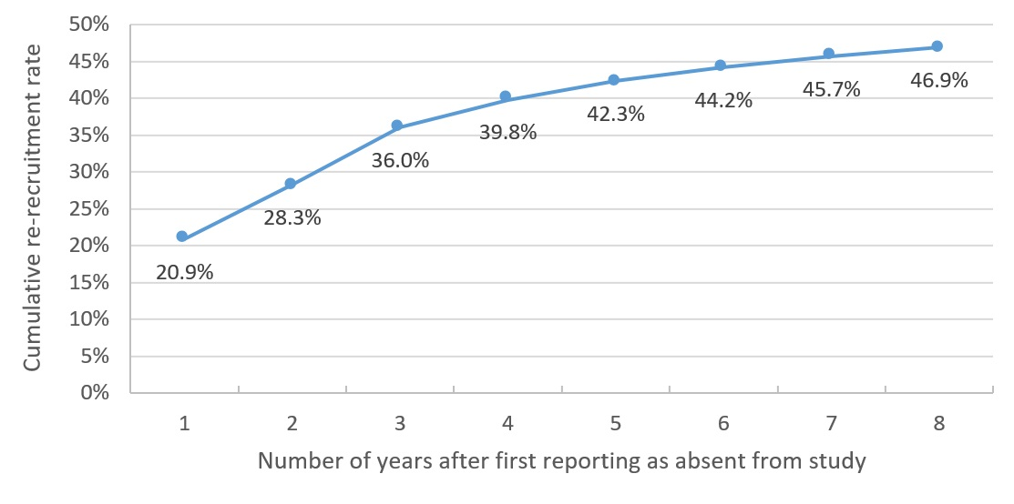

Figure 2: Cumulative re-recruitment rate over time for bachelor level students first reported as
absent from higher education in 2006.

Source: Commonwealth Department of Education and Training customised data request.
The cumulative re-recruitment rate increases fastest over the first three years of the period examined. Figure 2 also shows that 46.6 per cent of the students who returned within the period examined returned the very next year, while 76.8 per cent had returned within three years. The growth of the cumulative re-recruitment rate slows considerably after students have been absent from higher education for more than three years. For instance, the increase in the cumulative re-recruitment rate between seven and eight years after the student was first counted as absent from higher education was only 1.2 percentage points; this suggests that the re-recruitment rate is likely to continue to increase at a relatively slow rate beyond the eight year period examined in this report.
The analysis of re-recruitment rates over time highlight the specificity and technical limitations of the retention rate calculation used by the Department. Using the Department’s official retention calculation, 86.1 per cent of domestic bachelor level students were counted as retained in 2005. If we take into consideration the students who were only absent for one year, many of whom were potentially on an official leave of absence, we find that that the total proportion of students retained increases to 89 per cent. It is even possible to imagine a broader definition of retention, or at least a complementary measure of student persistence. If we broaden the time period to the maximum of eight years and thereby include students who have taken an extended period of absence from education, the ‘retention’ rate increases to 92.6 per cent. These figures include some students re-enrolling at completely different institutions and entirely different courses. Nevertheless, it is notable that fewer than eight per cent of enrolled domestic bachelor students in 2005 had left higher education and not returned to study at a later date.
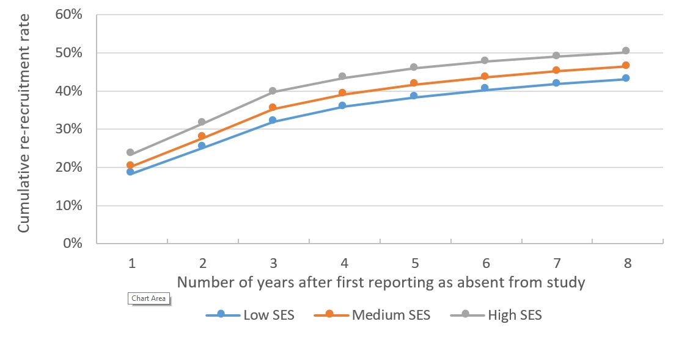
The study also reveals that there is a consistent gap in re-recruitment rates by socio-economic background. Figure 3 shows the cumulative re-recruitment rates for students who were first counted as attrited in 2006 over an eight year period by socio-economic status. The figure shows that low SES students are less likely to be re-recruited than students from both medium and high SES backgrounds.

Figure 3: Cumulative re-recruitment rates of domestic bachelor level students by length of time after first being reported as absent from higher education; and by socio-economic status.
Source: Commonwealth Department of Education and Training customised data request.

To measure the effect size and statistical significance of the differences between students from low and high SES backgrounds, we utilised the ‘relative risk’ ratio as outlined by Altman (1990). The relative risk is calculated by dividing the likelihood of a student from a low SES background returning to study by the likelihood of a student from a high SES background returning to study during the same period. We found that students from high SES backgrounds were 25 per cent more likely than those from low SES backgrounds to be re-recruited into higher education after a two year absence. This gap is reduced somewhat over time but it still remains significant. In 2014, eight years after first being reported as absent from higher education, students from high SES backgrounds were 16.5 per cent more likely than low SES students to have been re-recruited into higher education.
The gap in the re-recruitment rates of students between socio-economic groups provides greater context for the approximately ten percentage point gap in nine year completion rates between students from low and high socio-economic groups identified in the Department of Education and Training’s analysis of completion rates (Department of Education and Training, 2016d). Not only are students from low SES backgrounds slightly more likely to discontinue a university degree than students from high SES backgrounds, but they are also less likely to return to higher education at a later date. It is clear from this analysis that any effort to lift long term completion rates, particularly for students from low SES backgrounds, must include interventions that both encourage students to return but also remove potential barriers to re-recruitment.

Do Students Return to the Same Institution?
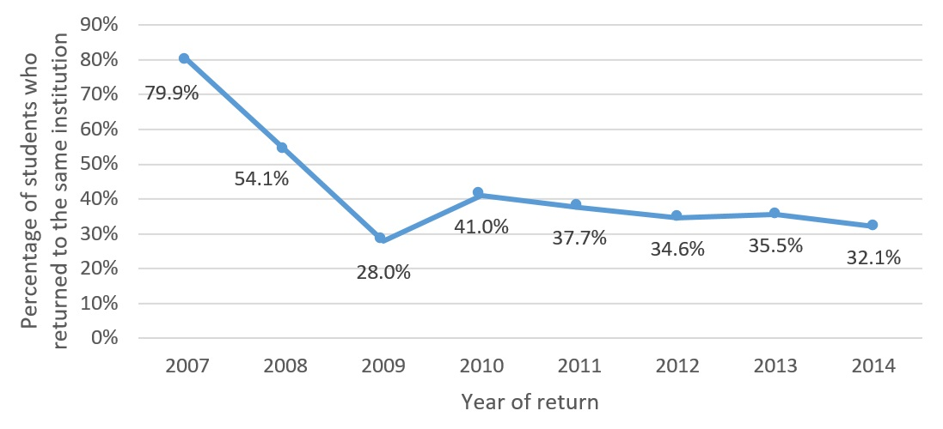
In addition to measuring the overall extent to which students returned to higher education after previously withdrawing from study, we were able to measure the extent to which students returned to the same institution. Figure 4 shows the proportion of re-recruited students who were first reported as absent from higher education in 2006 who returned to the same institution over time.

Figure 4: Proportion of re-recruited students who returned to the same institution over time and for students who were first reported as absent in 2006.

Source: Commonwealth Department of Education and Training customised data request.
It shows that the vast majority (79.9 per cent) of students who were absent from higher education for one year returned to the same institution. As the length of the absence of higher education increases, comparatively fewer students return to the same institution. By 2014, eight years after initially being reported as absent from higher education, only 32.1 per cent of re-recruited students returned to their original institution. Across the entire eight year period examined in our analysis, 57.4 per cent of students who were re-recruited into higher education re-enrolled at the same institution they attended before withdrawing.
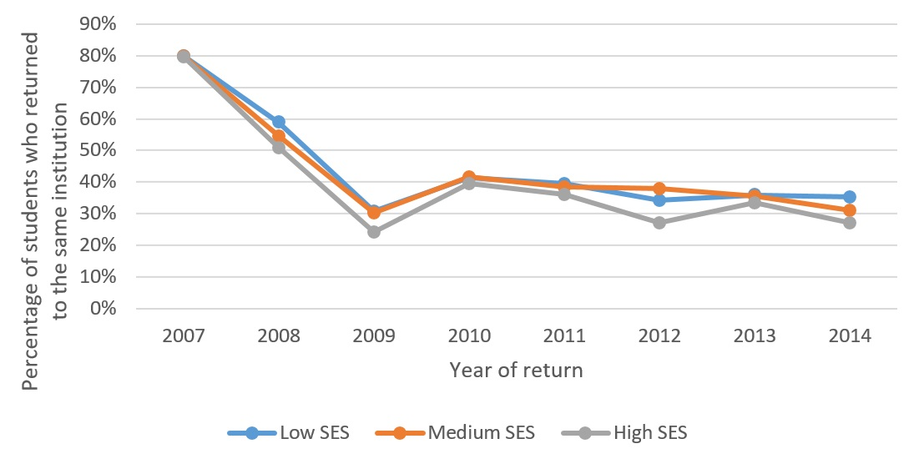
When disaggregated by socio-economic status, we find that all three categories follow a broadly similar pattern, which is highlighted in Figure 5. Using the relative risk method for comparing the likelihood of re-recruited students from low and high SES backgrounds returning to the same institution, we find there was only a statistically significant difference between low and high SES students two and three years after first being reported as absent from higher education. Students from low SES backgrounds were 19.4 per cent more likely than high SES students to be re-recruited to the same institution after two years, and were 9.7 per cent more likely after three years. Over the whole eight year period examined in our analysis, students from low SES backgrounds were found to be 3.5 per cent more likely to enrol at the same institution, but the result was not statistically significant to the 95 per cent level of confidence.

Figure 5: Proportion of re-recruited students who returned to the same institution over time by
socio-economic status.

Source: Commonwealth Department of Education and Training customised data request.
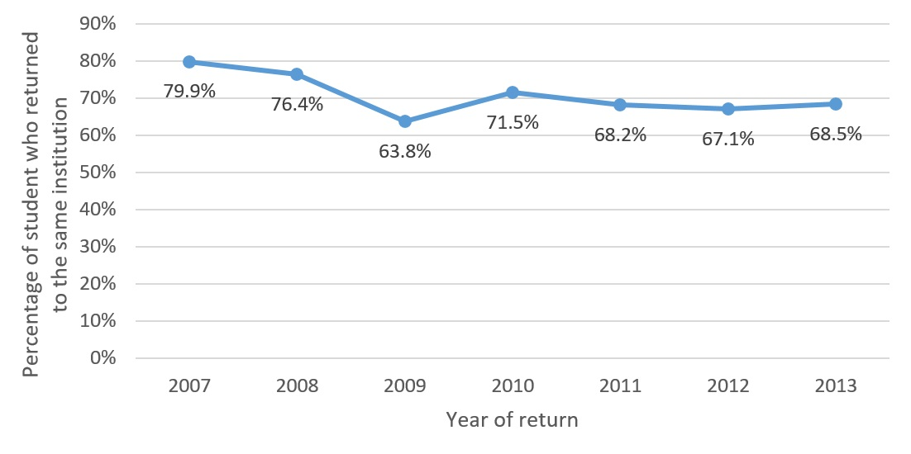
We were also able to examine the change over time of the proportion of re-recruited students who had returned after a one year hiatus. For example, Figure 6 shows that of the students who had taken a one year hiatus and returned in 2007, 79.9 per cent of them returned to their original institution. By contrast, for those who returned in 2009, 63.8 per cent returned to the original institution. The proportion of students who had returned to the same institution after a one year hiatus increased to 71.5 per cent for those who returned in 2010, but decreased slightly to 68.5 per cent for those who returned in 2013.

Figure 6: Proportion of returning students who returned to the same institution the following year.

Source: Commonwealth Department of Education and Training customised data request.
The decline in students returning to the same institution appears to correspond with the introduction of the demand driven system of student funding from 2009 onwards. It is plausible that the increase in flexibility within the demand driven system has made it slightly less likely for students to return to their original institution after discontinuing higher education study.

How do Australian Re-Recruitment Rates Compare Internationally?
It was possible to compare one year re-recruitment rates with data sourced from the United Kingdom. The research team were able to source equivalent data on re-recruitment rates and whether or not students return to the same institution upon return, for commencing domestic first degree students within the UK higher education system. The data is compiled by the Higher Education Statistics Agency (HESA) and examines the proportion of students who return to higher education after taking a one year break.
The results show that the re-recruitment rates for both the UK and Australia were relatively similar. Figure 7 shows that the re-recruitment rate in Australia was approximately four percentage points lower than the return rate in the UK during the period between 2007-2008, but were broadly comparable between 2013-2015 period.
It is interesting to note the improvement in re-recruitment rates in Australia after the introduction of the demand driven system of student funding; and that the decline in the proportion of students returning to study was at its lowest during the 2012/13 academic year in the UK. This is the academic year that coincided with the tripling of course fees and a corresponding decline in enrolments across the sector (Independent Commission of Fees, 2014), although by the 2014/15 academic year the re-recruitment rate had recovered somewhat.

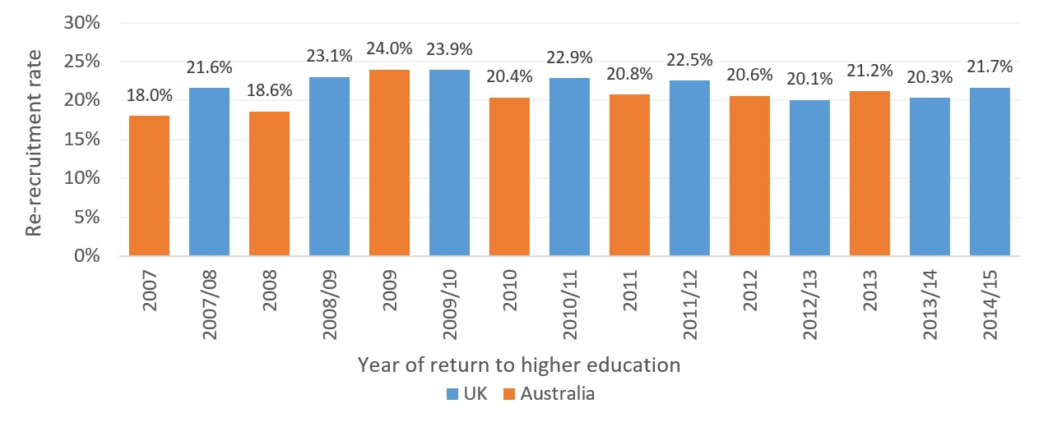
Figure 7: Proportion of first year (commencing) students who returned after a one year break from higher education over time. UK and Australia compared

Source: Commonwealth Department of Education and Training customised data request and Higher Education
Statistics Agency (2016a).
We were also able to compare the proportion of re-recruited students who returned to the same institution they had attended before withdrawing from study. Figure 8 shows that the proportion of re-recruited students who returned to the same institution in the UK remained relatively unchanged at approximately 53 per cent over the period examined. In Australia by contrast, the proportion of students returning to the same institution has changed substantially. Prior to 2009, there was a much stronger pattern of students returning to the same institution they attended before withdrawal, but from 2009 onwards, proportionally more students returned to different institutions. Nevertheless, the majority of commencing domestic students (57.4 per cent) still returned to study after a one year hiatus in 2013.
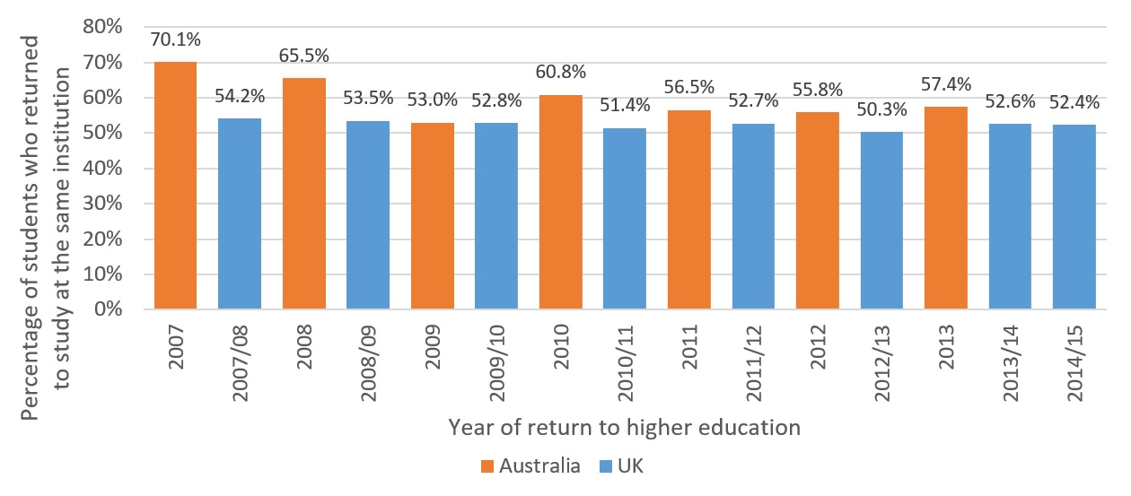

Figure 8: Proportion of students who returned to study at the same institution. UK and Australia compared.

Source: Commonwealth Department of Education and Training customised data request and Higher Education Statistics Agency (2016a).

Section Summary
In examining national data, we find that nearly half of students who have withdrawn from Australian universities are re-enrolled within eight years. This striking statistic carries several implications. First, attrition rates are likely to be overstated. A large number of students return to an institution after only one year of absence. Despite being included within the national attrition statistics, such students are often on a formal Leave of Absence (LoA) from their institution and simply return to their university the following year as intended. Equally though, the data reveal the potential of re-recruitment. Nearly half of the students who withdraw are already returning to the sector despite minimal institutional effort and the erection of several substantial barriers to re-enrolment. Re-recruitment strategies have the potential to attract many former students, particularly those from low SES and other under-represented backgrounds.

Survey Findings
This section of the project explores the experiences of students who have withdrawn from university, with a particular focus on students from low SES backgrounds. The survey of students at an Australian pilot university (also referred to as ‘the University’) aimed to capture the initial reasons for their departure, subsequent reflections on the process and motivations of departure, and their current status in study or employment. The pilot university is a member of the Innovative Research University (IRU) group and includes multiple campuses in both metropolitan and regional areas.
We surveyed domestic undergraduate students who had commenced a degree at the University and subsequently withdrawn from that degree. The survey comprised 48 questions and was administered via the Qualtrics online survey tool (see Appendix A for survey questions). Respondents could only see questions that pertained to them as the survey was customised to each participant by using a display logic. Participants were asked about their experience in commencing a degree at the pilot university and discontinuing this degree, what they were doing when the survey was conducted, and what their plans are for the future. Approximately 5,600 people were invited to participate in June and July 2016. A total of 596 people responded to the survey, representing a 10.6 per cent response rate.

Participant Characteristics
Survey participants were all undergraduate domestic students who withdrew from their degree at the University between 2009 and 2015 and who were not re-enrolled at the institution in April 2016. The summary of the participant characteristics is represented in Table 2.

Table 2: Summary of participant characteristics (n= 596)
 |  | TOTAL
Gender | Male | 197
 | Female | 399
SES category | Low | 91
 | Medium | 332
 | High | 173
Regional category | Metropolitan | 394
 | Regional | 202
Years discontinued | 2-3 | 263
 | 4-5 | 166
 | 6-7 | 167
Course status | Commencing student | 304
 | Continuing student | 292

Findings

Reasons for Discontinuing
A wide range of reasons were provided for withdrawal from university study. Three major findings are notable here. First, most students did not withdraw because of reasons directly related to the University. We have disaggregated reasons broadly into ‘personal’ and ‘university-related’, and this distinction highlights how a majority of the attrition recorded was neither the primary fault of the institution nor within the direct power of the institution to prevent. Figure 9 underlines that more than twice respondents cited personal reasons for their withdrawal compared with university-related reasons, but also that the two factors were often mutually reinforcing.
Other notable findings involve differences around SES. Low SES students were nearly twice as likely as high SES students to leave because of a change in career plans. This statistic highlights earlier problems around inadequate levels of career information and awareness provided to low SES students in schools, which we have documented in an earlier survey of Year 11 students across Victoria and NSW (Harvey et al., 2016). Equally, our survey revealed that high SES students were twice as likely as low SES students to withdraw from the pilot university to enrol at another university, with nearly a third of attrition among high SES respondents explained in this manner. The findings highlight the need for tailored approaches to preventing attrition. In both cases though, there is a need for the pilot university to consider enrolment as a long game, with many commencing students clearly still unsure of their choice of degree, career and/or university.
Also significant is the fact that mental health was cited as a greater reason for withdrawal than academic difficulties. This finding suggests a potential need to re-allocate university resources. While many preventive strategies are employed to tackle academic difficulties, such as tutoring, academic analytics, and bridging mathematics courses, there are often fewer initiatives directed at wellness and mental health. Interestingly, only ten per cent of respondents cited academic difficulties as the primary reason for their departure (see Figure 10).

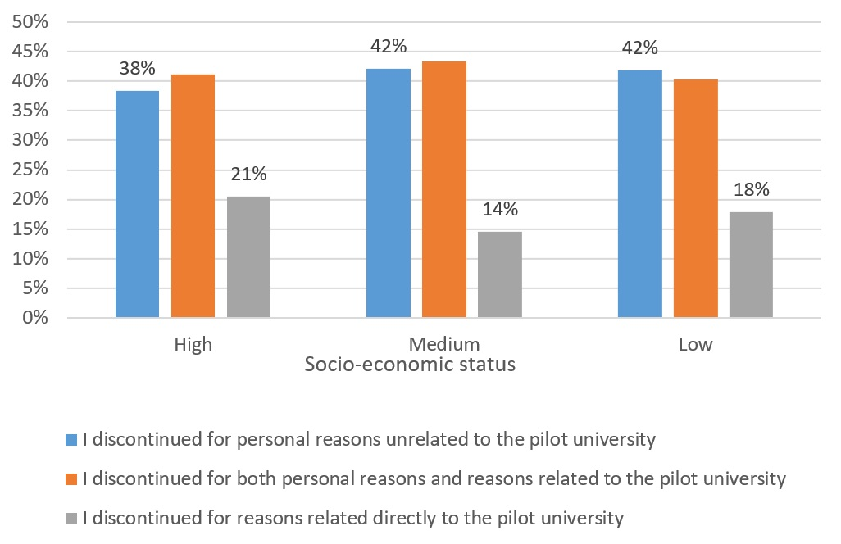

Figure 9: Which of the following statements best describes why you discontinued your degree at
the pilot university? (n = 395 respondents).
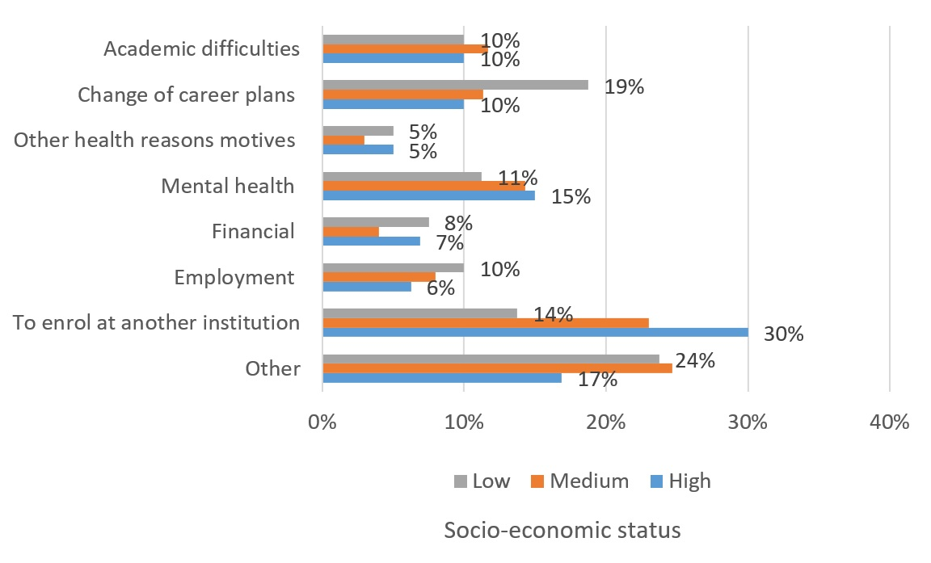

Figure 10: What was the main reason for discontinuing your degree at the pilot university?
(n = 540 respondents).

Contact with the Pilot University before and after Discontinuing
Several survey respondents were reluctant to seek advice from a University staff member. Of greater concern, however, is that very few students were contacted by a University staff member directly before, or after, they withdrew. Table 3 shows that around four in ten participants contacted a pilot university staff member to discuss any concerns before discontinuing their degree. Low SES participants were slightly more likely than those from high SES backgrounds to contact a staff member. Only 17 per cent of survey participants said a pilot university staff member contacted them to discuss any concerns before discontinuing their degree, and only five per cent said they were contacted by the University after their withdrawal. This paucity of follow-up contact is consistent with previous research findings (Long et al., 2006), and is extremely problematic given the manifest potential for re-engagement which is currently unfulfilled.

Table 3: Contact with the pilot university before and after discontinuing
 |  |  | SES
QUESTION | RESPONSE | HIGH | MEDIUM | LOW | TOTAL
Contacted staff member before | Yes | 36% | 38% | 43% | 38%
discontinuing (n = 396) | No | 64% | 62% | 57% | 62%
Contacted by staff member before | Yes | 17% | 14% | 26% | 17%
discontinuing (n = 397) | No | 83% | 86% | 74% | 83%
Contacted by staff member after | Yes | 4% | 5% | 7% | 5%
discontinuing (n = 376) | No | 96% | 95% | 93% | 95%

Interestingly, Figure 11 shows that around 40 per cent of respondents suggested the University could have done something to encourage them to stay, reinforcing the need for more and better contact with students who are about to withdraw. Equally, around 60 per cent of respondents felt there was little that the University could have done to prevent their withdrawal at the time, confirming the inelasticity of much attrition. Results indicate the need for improved processes both leading up to, and following, withdrawal. Some students can be convinced to stay; others can be convinced to return.

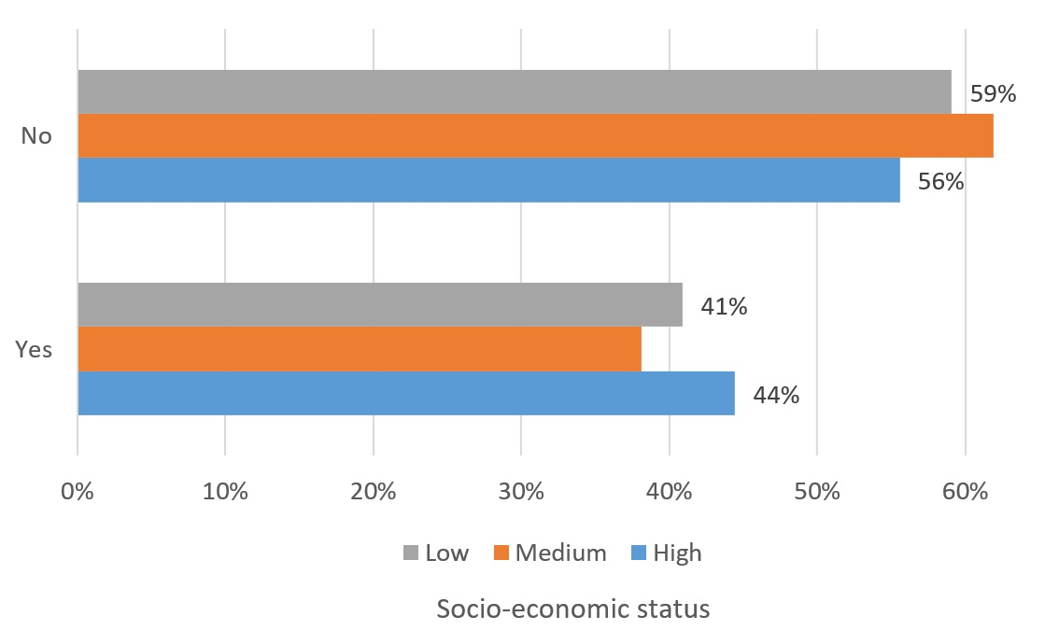
Figure 11: At the time, do you think there was anything the pilot university could have done to
encourage you to stay? (n = 397).
In hindsight, approximately six in ten respondents were extremely or somewhat likely to have made the same decision of discontinuing their degree (see Table 4). People from low SES backgrounds were slightly more likely than high SES students to say they would have made the same decision in hindsight. For all respondents, certainty diminished over time. Respondents who discontinued their degree between two and three years ago were more likely than those who discontinued between four and seven years ago to say they would have made the same decision in retrospect.

Table 4: Looking back, would you have made same decision of discontinuing university?
(n = 398)
 |  | SES
RESPONSE | HIGH | MED | LOW | 2-3 YEARS DISCONT’D | 4-5 YEARS DISCONT’D | 6-7 YEARS DISCONT’D | TOTAL
Extremely or somewhat likely | 49% | 61% | 55% | 67% | 53% | 44% | 57%
Neutral | 24% | 14% | 13% | 13% | 16% | 23% | 17%
Somewhat or extremely unlikely | 27% | 26% | 31% | 20% | 31% | 33% | 27%

Perception about the Course and the Pilot University after Discontinuing
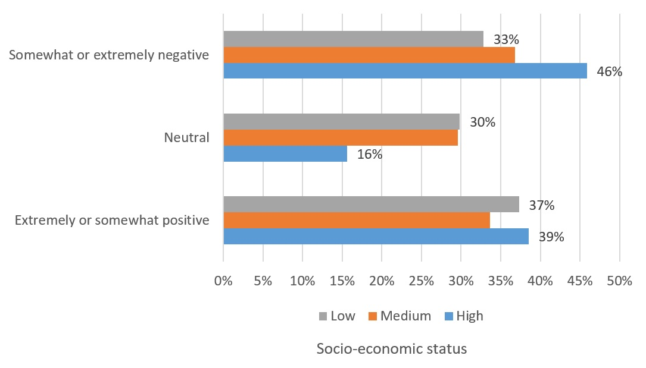
Around six in ten survey respondents felt positive or neutral about the pilot university after discontinuing their degree. However, Figure 12 shows that nearly half of high SES respondents felt somewhat or extremely negative about the University when they withdrew. Although most respondents were neutral or positive overall, the data nevertheless reveal significant levels of dissatisfaction that could potentially have consequences for institutional reputation and re-enrolment.

Figure 12: Which best describes how you felt about the pilot university when you discontinued university?
(n = 399).
Despite discontinuing their degree at the pilot university, nearly half of the survey participants claimed that the course they discontinued was helpful to their career. Only around two in ten participants felt the course was unhelpful. Low SES participants were slightly more likely than those from high SES backgrounds to say that the course they discontinued still helped them in terms of their career goals (see Figure 13). The data reveal that there are some perceived benefits to partial completion, but they also highlight the limitations of incomplete degrees for workforce success.
Table 5 reveals that most survey respondents were likely to recommend the University to others, despite discontinuing their own degree. These findings suggest substantial potential for re-enrolment and reputational growth. Nevertheless, over one fifth of respondents said that they were unlikely to recommend the University to others. This significant minority view may lead to reputational risk beyond the obvious impact on re-enrolment potential. Interestingly, respondents from low SES backgrounds were significantly more likely than high SES students to recommend the University to others. This data may reflect the fact that low SES students are often likely to blame themselves rather than the University for withdrawal. Our own research has confirmed that some students assume responsibility for their own disengagement and withdrawal, and were also reluctant to seek support services (Harvey, Mestan & Luckman, 2012).

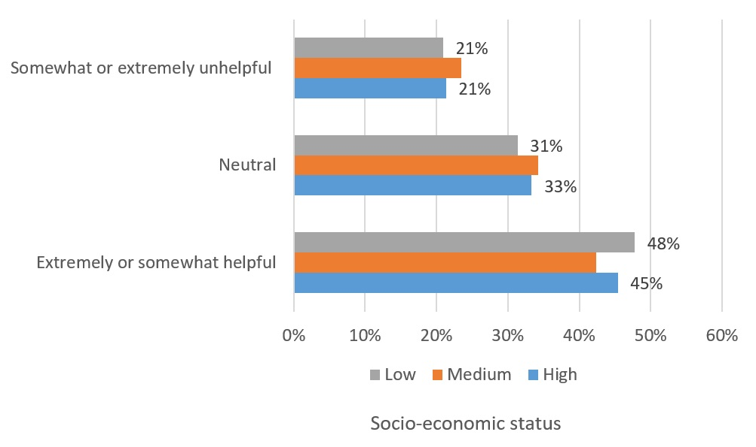
Figure 13: In terms of your career goals, how helpful was the course you discontinued at the pilot university? (n = 397).
Respondents typically became more positive about the University over time. Respondents who had discontinued between six and seven years ago were most likely to recommend the university to others. Those who had withdrawn as commencing students were slightly more likely to recommend the University than those who left as continuing students.

Table 5: How likely are you to recommend the pilot university to others? (n = 397)
 |  |  |  | SES
RESPONSE | COMMENCING STUDENT | CONTINUING STUDENT | HIGH | MED | LOW | 2-3 YRS D’CONT | 4-5 YRS D’CONT | 6-7 YRS D’CONT | TOTAL
Extremely or somewhat likely | 56% | 51% | 54% | 50% | 63% | 52% | 52% | 57% | 53%
Neutral | 21% | 29% | 23% | 27% | 21% | 24% | 28% | 25% | 25%
Somewhat or extremely unlikely | 23% | 20% | 23% | 22% | 16% | 24% | 21% | 18% | 21%

What Were Respondents Doing When the Survey Was Conducted?
The survey found that around three in ten respondents were studying when the survey was conducted (see Figure 14), with the highest rates of re-enrolment being recorded by high SES respondents (38%). Respondents from high and medium SES backgrounds were also more likely than those from low SES backgrounds to be working. Of those who were re-enrolled in tertiary education, around two thirds were enrolled at a university and around one third at a Vocational Education and Training (VET) institution (see Table 6). Consistent with national data, people who discontinued between two and five years ago were more likely than those who discontinued between six and seven years ago to be studying at university.
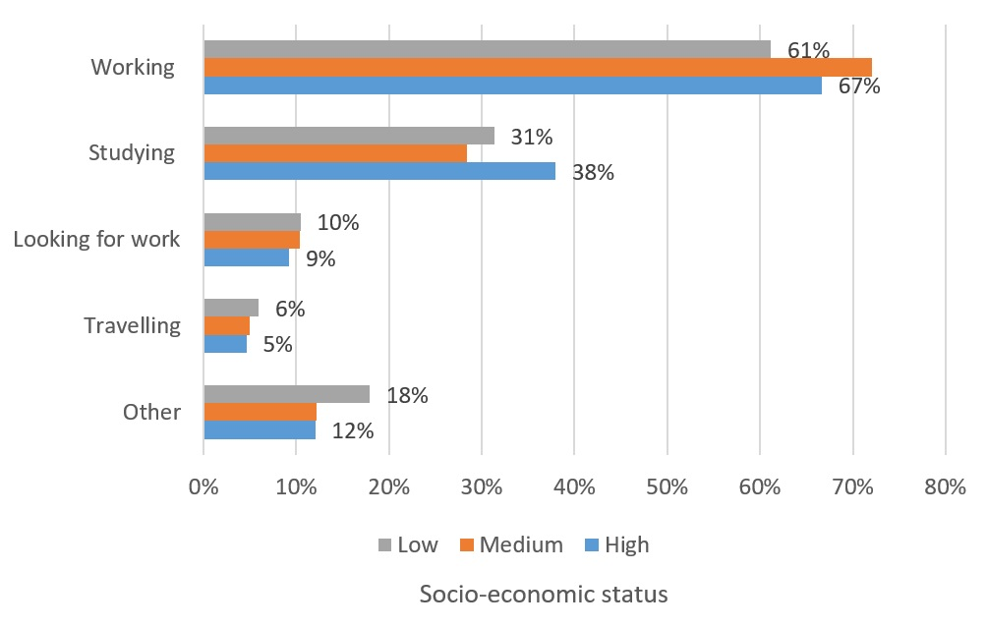
Qualitative feedback from open-ended questions suggested that survey participants’ motivation to re-enrol at university was influenced by a change of career path, career advancement, job opportunities and/or the level of compensation in the field. When respondents were asked what encouraged them to return to university, one noted: ‘discovering what I wanted to do and wanting to earn a higher salary’. Another respondent claimed s/he ‘needed to get a degree to get a decent job’, while a different student explained that, ‘I was unsatisfied in my job … and decided it was time to put my
education first’.

Figure 14: What are you doing at present?* (n = 397).
* Totals do not add up to 100 per cent as students could select more than one option.
* Only respondents who had not enrolled at a different institution after they discontinued from the pilot university were asked this question.

Table 6: Where are you studying at present?* (n = 118)
 |  | SES
RESPONSE | HIGH | MED | LOW | 2-3 YEARS DISCONT’D | 4-5 YEARS DISCONT’D | 6-7 YEARS DISCONT’D | TOTAL
University | 63% | 70% | 63% | 68% | 70% | 61% | 67%
VET | 32% | 23% | 37% | 28% | 23% | 35% | 28%
Other | 5% | 7% | 0% | 5% | 7% | 4% | 5%
* Only respondents who had not enrolled at a different institution after they discontinued from the pilot university and were studying when the survey was conducted were asked this question.
Approximately seven in ten respondents who were studying at university when the survey was conducted, were not enrolled in the same discipline that they previously commenced at the pilot university (see Figure 15). While half of high SES respondents were re-enrolled in the same discipline as their original choice, more than two thirds of low SES respondents were enrolled in a different discipline from their original selection. Again, these findings are likely to reflect unequal access to career and course information at secondary school level, and reinforce the need for universities to consider enrolment as an ongoing process.
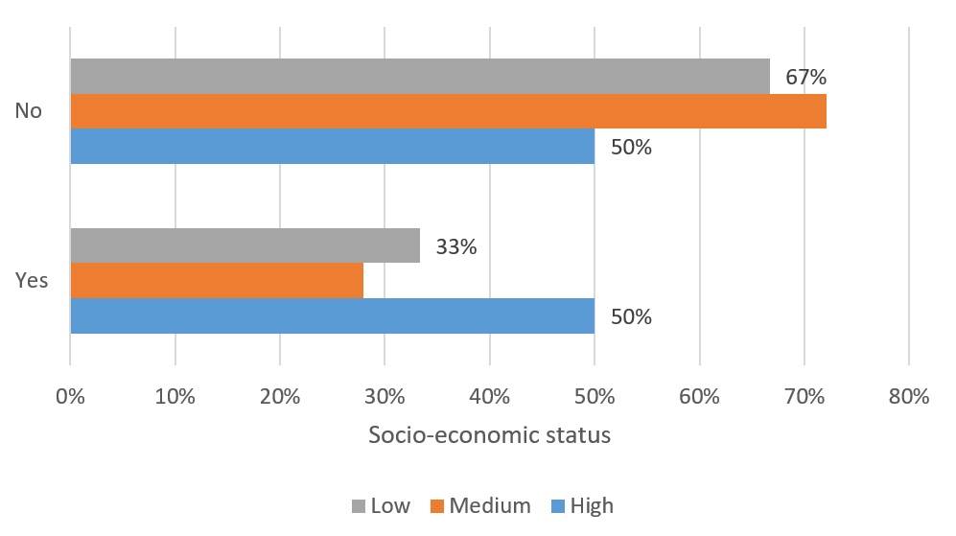

Figure 15: Are you enrolled in the same discipline that you previously commenced at the pilot university at present? (n = 79).
* Only respondents who had not enrolled at a different institution after they discontinued from the pilot university and were studying at university when the survey was conducted were asked this question.

Future Plans
Notably, more than two thirds of those respondents who were not already studying at the time of the survey believed that they would return to higher education in future (see Figure 16). These findings are consistent with the national data confirming that nearly half of discontinuing students re-enrol at university within eight years (see section 2).

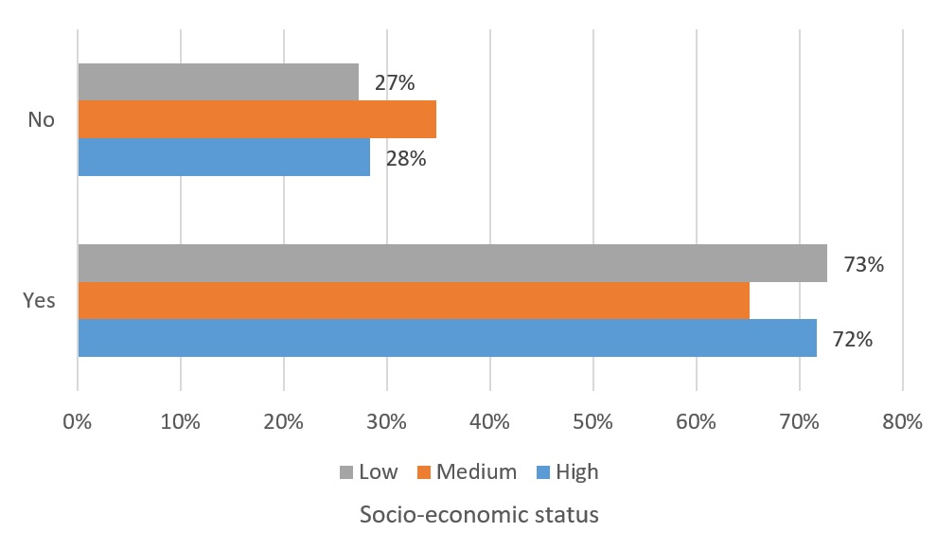
Figure 16: Do you think you will return to university in the future? (n = 269).
* Only respondents who had not enrolled at a different institution after they discontinued from the pilot university and were not studying when the survey was conducted were asked this question.

Section Summary
The survey results revealed several areas of potential improvement and action. Many students withdrew because of personal, financial, work or health reasons unrelated to their course, and their experience of university itself was generally positive. Indeed, many students believed their study experience provided valuable skills and knowledge, despite not completing their chosen degree. Several former students also indicated a desire to re-enrol in higher education at a future point. The general positivity of responses must be seen in the context that the only voices captured were of those willing to respond to the survey.
Despite broad positivity with their experiences, several concerns were highlighted by our survey respondents. Mental health was a common reason cited for withdrawal. This finding is consistent with broader evidence revealing the growth of mental health issues across the sector, reflected in students with a disability being the fastest-growing equity group. Institutional approaches to the mental health of students are likely to be affecting attrition rates and, given the prevalence of stigma around attrition, re-enrolment rates also. Most students also received little or no follow-up communication from the university after their withdrawal, indicating a clear need for more targeted engagement. Notably also, low SES students who had re-enrolled were more likely to be enrolled in a different course from their original choice. This evidence likely reflects the lesser information available to low SES students at secondary school about careers and university courses, as documented in our previous research (Harvey et al., 2016). At the pilot university, low SES students were more likely to withdraw because of a perception that they had chosen the wrong course and/or
career pathway. This perception was subsequently reflected in re-enrolment decisions where relevant, with re-enrolling low SES students often moving into new courses and disciplines.

Student Interviews
This section of the project captured the voices of low SES students who had re-enrolled at the University, having previously either discontinued their degree or taken a formal Leave of Absence (LoA).
Participants responded to 28 open-ended questions about their previous tertiary education experience; motivations for re-enrolling at university; re-enrolment processes; differences between current and previous university experience; the potential stigma associated with having previously discontinued their university degree; future education plans; and suggestions for improving practices. Interviews were digitally recorded, transcribed and analysed for content and themes using NVivo 11 software (QSR International, 2012). An interpretative phenomenological approach to the analysis was applied (Smith, Flowers, & Larkin, 2009). Given the selected interviewees were willing respondents, the primary limitation of the qualitative research is that the population sample is likely to exclude those who had explicitly negative experiences. Full interview questions are located within Appendix B.

Participant Characteristics
A total of thirteen interviews were conducted across the pilot university. The participants were all undergraduate domestic students from low SES backgrounds who had re-enrolled at the University within six years. The summary of the participant characteristics is represented in Table 7.

Table 7: Summary of participant characteristics (n=13)
 |  | TOTAL
Gender | Male | 4
 | Female | 9
Age | 23-25 | 4
 | 26-35 | 6
 | >36 | 3
SES category | Low | 13
Regional category | Yes | 8
 | No | 5
Years discontinued | 5-6 | 3
 | 3-4 | 6
 | 1-2 | 4
Leave of Absence (LoA) | Yes | 4*
 | No | 9
Course in which students re-enrolled | Same | 5
 | Different | 8
College in which students re-enrolled | Science, Health & Engineering | 5
 | Arts, Social Sciences & Commerce | 8
*Several participants who took a LoA had previously enrolled at a different university.

Findings

Major Reason for Discontinuing
Personal reasons featured frequently in interviewees’ explanations for discontinuing their degree. Issues relating to mental health or other health related reasons, lack of motivation, finances, and employment were all prominent specific responses. This finding is consistent with other research showing the importance of personal issues in influencing attrition (Adams, Banks, Davis, & Dickson, 2010; Controller & Auditor General, 2002; Long et al., 2006). Causes of departure featured in the respondents’ explanations also included course-related reasons, including career direction and purpose. However, the general prevalence of personal reasons was consistent with the Australian Student Experience Survey national report that shows the most common reasons for considering discontinuing were not related to course content or the choice of degree. Rather ‘health or stress’, ‘study/life balance’, ‘need to do paid work’, ‘financial difficulties’ and ‘fee difficulties’ were among the main reasons for considering not completing (QILT, 2016b, p. 24).
Amongst personal reasons in general, health issues were specifically most cited as interfering with study. This included both mental and physical health, with one student remarking that: ‘I loved university; my health wasn’t good so I couldn’t keep going with it’ (Interview C). In regard to mental health, often multiple factors undermined students’ psychological well-being and ability to cope. This is illustrated by one person’s account: ‘Stuff at home and for my personal mental state and I couldn’t handle going to school at the same time as dealing with all of that’ (Interview B). A different interviewee expressed how family related reasons were a major factor in discontinuing: ‘I needed to be back here in Melbourne for family and stuff so it was just easier for me if I took a break from studying and came back’ (Interview J).
A group of interviewees reported that uncertainty about career direction and personal reasons can combine to disrupt study, as demonstrated by the following comment:
‘Looking back on it now, I wasn’t in a particularly great mental health and I wasn’t passionate about what I was studying. I went to uni at eighteen because that’s what you’re supposed to do, I followed along because that’s what my family thought I should do. I chose Commerce because that’s what a friend wanted and I kind of did uni because that’s what I was supposed to do, but I never really enjoyed it and I never really got involved in it’ (Interview A).
Another student noted:
‘I didn’t want to do what I was studying and I didn’t know what I wanted to do at all so I just got full time work. My mum got really sick so it wasn’t easy to say well when she’s better I’ll go back’ (Interview H).
A different participant who was not satisfied with the course said: ‘Well it just wasn’t for me… I only tried it because everybody said to me you’d make a great nurse, and I started to doubt – I started to stupidly doubt whether I had the brains to be a psychologist’ (Interview E). The lack of direction felt by some of the participants again confirms the need for universities to consider recruitment as a long game, and to continue focussing on career pathways after students have commenced their course.
Finances and employment were an issue for a minority of the participants. For example, one student said:
‘Basically when I started uni... I was a New Zealand citizen so I had to pay all my fees upfront which made it difficult and so after the first semester I found it very difficult, I couldn’t work, get the grades that I wanted and go to uni so I took a couple of years off’ (Interview D).
Another student noted:
‘I wasn’t in the financial position to go part time so I needed Austudy to get by and if I had of gone to part time I wouldn’t have been eligible and I had a scholarship from an independent organisation because I came from a very, from a disadvantaged family and that was dependent on me being full time as well’ (Interview H).
A different interviewee claimed that the course was not going to lead to ‘any sort of employment’ (Interview L).
Overall, participants often cited external factors for discontinuing their degree. Even though causes of departure vary and include a combination of exogenous and endogenous factors to the university environment, external forces were prominent. Clearly, many students discontinue for reasons that are primarily beyond institutional control.

Assumption of Personal Responsibility
A group of students assumed responsibility for their own disengagement and were also reluctant to seek support services. This trend may partly explain our earlier findings that low SES students who have withdrawn from university are often more positive about the institution than their high SES peers, tending to blame themselves rather than the institution for their withdrawal. When respondents were asked if they discussed any concerns before or after discontinuing their degree, one participant said: ‘I couldn’t handle talking to someone about my problems’ (Interview B). Another interviewee explained:
‘At the time I just thought I couldn’t do it, I wasn’t smart enough and I kind of shut myself off from the university. I shut myself off from my own family, there was, yeah I wasn’t in a great state at that time so I kind of just tried to avoid it as much as possible’ (Interview A).
Another participant said: ‘I just feel I took the easy way out, I didn’t sort of confide in anyone at university’ (Interview M). Uncertainty was another theme, with one student highlighting a lack of career purpose that prevented discussion of concerns with a University staff member:
‘I didn’t really speak to anyone else but my mum about it and because I really didn’t know what it was I wanted to do and I didn’t want to do anything in relation to the current study I was doing’ (Interview H).

Interaction with the Pilot University before and after Discontinuing
When interviewees were asked what the pilot university could have done to encourage them to stay, most respondents said there was not much the institution could ultimately have done. This is illustrated by one person’s account: ‘probably not, I think it was more personal really’ (Interview J). Another student explained: ‘No, my son was born and we had to be able to earn so I went and worked for that time so my wife could look after our children’ (Interview C). These comments show the relative inelasticity of attrition in some cases.
A few interviewees further explained that higher education study was not something they wanted to do at that point in time. As one respondent cited: ‘I think at that point I was ready to move on – I don’t think university was right for me at that point in my life’ (Interview F). Another student noted:
‘…there wasn’t really anything that could have been done for my case to try and persuade me to stay because I did not want to do the content that I was studying and I wasn’t able to just go to part time either’ (Interview H).
These responses highlight the importance of temporality, and explain why many students choose to re-enrol in university study when their life circumstances change.
Several respondents said that they were not contacted by a University staff member before or after discontinuing their degree (Interview A, B, F, G, H, K, M). For example, one participant noted: ‘nobody really contacted me at all, they kind of let me fail out’ (Interview A). This comment reveals that students may expect some contact from the university when they become disengaged and are disappointed when this is absent. Research suggests that actively contacting students and providing them with support is very strongly correlated with increased retention (Australian Council for Educational Research [ACER], 2011, p. 15). Another respondent claimed: ‘I haven't had any conversations or phone calls or emails enquiring as to why I withdrew from my course’ (Interview K).
Some interview participants affirmed that having contact or interaction with the pilot university could have encouraged them to stay. A group of students who discontinued said that they could have potentially been persuaded otherwise with more systematic advice and support. As a respondent who had failed several units explained: ‘I feel it would have been more beneficial if they could have tried to pick up the trigger when I first started failing and had those discussions along the way’ (Interview A).
Another interviewee claimed:
‘If I had someone calling me asking me; how could we help? Could we subsidise the fees or do something? I probably would have most likely stayed but because there was no help – I don’t know I was asking for help but I think I was asking the wrong people for help I guess, I don’t know’ (Interview D).
Even though several interviewees said they usually did not seek out advice from the pilot university, in some instances they retrospectively affirm that such advice could have been beneficial. For example, one interviewee who was not aware that studying part time was an option said knowing that this was a possibility would have made the difference:
‘There probably could’ve been, like I didn’t know that I could do uni part time, so I was, then I kind of regret the fact that I stopped going to uni because if I just dropped two of my subjects then it probably could’ve been easier on me’ (Interview M).
Another student argued: ‘if I’d had contact or interaction I think my likelihood of success would have been greater’ (Interview K). The interviews revealed that many students who are reluctant to seek advice can still benefit from it, and that the decision to withdraw could often have been overturned with strategic institutional intervention.
Nevertheless, most respondents remarked that there was not much the institution could have done when they discontinued. When interviewees were asked if they were fully aware of the deadlines for discontinuing their course, most said yes (Interview C, D, E, G, H, I, J, K, L, M).

Desire to Return to Higher Education after Discontinuing
Several respondents affirmed a desire to return to higher education when they discontinued their degree. As one interviewee explained: ‘I had always intended to come back’ (Interview C). A different student said s/he always intended to re-enrol:
‘My intention was always to return. It was always my plan to go back. I just wanted to work out what I wanted to do, not just because I was good at it and kind of understood it at high school’ (Interview H).
Although several participants wanted to return to higher education, some of them had not planned how to achieve this goal. A participant explained that s/he intended to return to university but was not sure when: ‘I assumed, so due to what I was doing it was one of these things you didn’t know if you were coming back in a month or in a week or in a year’ (Interview I). Another student similarly explained: ‘Yes I was going to save up some money or hopefully, I don’t know, something would change’ (Interview D). These comments indicate that former students could benefit from early follow-up contact and advice from university staff.
By contrast, a group of respondents said they had no intention of returning to higher education when they discontinued. For example, one student said:
‘Well not really to be honest. After I withdrew from uni I decided to take some time out and just go and do some work. I worked at a call centre for a couple of years and basically that gave me the time to figure out what I really wanted to do with my life’ (Interview E).
Another interviewee commented, ‘I had no intention of going back. I hated the idea of university, I hated the idea of study so I wasn’t going back’ (Interview A). A different student explained that s/he could not think about returning to university at that stage: ‘I wasn’t really thinking about my future at that time; I just needed to be alone’ (Interview B). These comments again underline the importance of temporality and the extent to which motivations can change. Many students were not thinking about returning to university when they discontinued, or were even hostile to the idea, yet still found themselves re-enrolled at a subsequent point in time.

Motivation to Re-Enrol
Most respondents’ decision to re-enrol at university was influenced by a combination of factors such as encouragement from family or colleagues, positive experience at work, and career and employment advancement. The following student’s comment is representative:
‘It was a combination, it was those positive experiences working with young people and saying ok I could be a really good teacher and a lot of encouragement and motivation from my partner... So I think a big push there was coming from my girlfriend who is very supportive and going this is something you are capable of doing. And for me to overcome my own mental hurdle of going, ok yes I might have a go at this and I might actually be capable of doing this’ (Interview A).
Another student noted:
‘I talked to a few people. One of my closest friends said to me that I’d make a good psychologist and I’ve always had an interest in medicine… It was actually my dad that suggested… and he said to me you should go back and finish, he said to go back and finish what you started and he said just because one course wasn’t the right course for you doesn’t mean this one will be’ (Interview E).
A different student explained that the decision to re-enrol was influenced by work colleagues: ‘I met two social workers through my work who I admired very much and they both studied at [the pilot university]’ (Interview G).
A group of students outlined that their decision to re-enrol at university was influenced by career and employment advancement. As one student explained, ‘I was sick of my current role, I was a retail store manager and I did a long think about what I did and didn’t enjoy and I came to the conclusion that teaching was something I enjoyed and decided to enrol in that’ (Interview F). When Interviewee F was asked if somebody encouraged her/him to re-enrol, the student noted that a lot of it would be his/her partner. Another student similarly highlighted:
‘I needed a career. When I came to Australia I worked in construction repairs and also in kitchens but I lost my work. So I was working on site and then with the global financial crisis the company I worked for went under so I went and worked in kitchens for a couple of years but the pay in kitchens is terrible. The hours are rubbish and the pay is no good so I needed an actual trade’ (Interview C).
Overall, interviewees’ decision to return to higher education was influenced by career advancement, job opportunities and/or by encouragement from their friends and families. Again, the responses highlight the changing nature of motivations over time, and the effect that subsequent experience in (or out of) the workforce can have on intentions to re-enrol.

Re-Enrolment Process
A group of students interviewed were not interested in having their previous university credits transferred or did not know how the process worked. When respondents were asked if their previously earned credit transfer, one respondent noted that s/he was not interested: ‘I chose to re-do them all again…I wasn’t interested I wanted to do it from scratch’ (Interview F). A different participant similarly explained:
‘I haven’t even looked. It is quite possible I can move some of them across - I honestly haven’t even looked. I’m not interested in that, I’m prepared to spend that bit of extra time to study to learn to do the right thing so that I know that I can come out of this course the best I can be’ (Interview A).
Another student claimed that s/he did not know how the process worked: ‘I’m not sure who to talk to about that, do you know? I’m not sure about that’ (Interview B). A different student highlighted the difficulties of applying for advanced standing:
‘I earned some and I tried to apply for advanced standing this semester but my paperwork got lost… So I haven’t actually had a chance to go and see if I can get advanced standing still but it is something I intend to pursue’ (Interview H).
The paucity of university communication was underlined by a different student who applied for advanced standing:
‘I think that for me was really frustrating because of my mum’s job role. I knew it was available but if I didn’t know, I’m not sure I would have known about it, I wouldn’t have known about it and I wouldn’t have known how to go about it’ (Interview H).
The comments reveal the existing importance of cultural and social capital, particularly in having a network of friends, family or/and colleagues that understand how the system works and can assist and guide students through the re-enrolment process. Further underlined is the need for universities to provide greater transparency and education around processes for acknowledgement of prior credit.

Previous Higher Education Experience
A group of the re-enrolled respondents were positive about their initial experience at the pilot university, and this experience clearly influenced their decision to re-enrol at the same university. Such affirmations by students who do not complete their initial course, and especially those who transfer to another course, are consistent with other research (Long et al., 2006; Wintre, Bowers, Gordner, & Lange, 2006). As one interviewee explained: ‘I really like [the pilot university]. When I was there in 2012 I really liked it, I just couldn’t stay’ (Interview D). Another student highlighted that s/he enjoyed the supportive environment at the pilot university:
‘When I was doing my nursing degree I did enjoy [the pilot university] thoroughly and that’s what made me choose [the pilot university] because of the environment, it’s a much more supportive environment than most of the other universities that I’ve been affiliated with’ (Interview E).
The same interviewee claimed that s/he ‘would highly recommend [the pilot university] to anyone’ (Interview E). A different participant similarly explained that the pilot university provided a comfortable environment: ‘It was the university I used to go to and I had friends that were there and it was a university that I knew so I was comfortable in going back there’ (Interview F). Another participant outlined that the pilot university was the right institution for him/her:
‘I remember [the pilot university] being a really enjoyable social place and I think the reason I went back was that I thought I could feel comfortable there and it would help me overcome some of the feelings I had about the idea of study’ (Interview A).
Interviewee A also noted that s/he wanted to succeed at the pilot university as s/he could not complete his/her degree there previously: ‘I wanted to prove myself wrong. I wanted to show that I could do it’ (Interview A).
Several interviewees felt that studying their previous course was a valuable experience. When respondents were asked if they learnt anything from their first university experience, interviewee A outlined:
‘I had a great social experience, and I met so many different people. Like I met people that had completely different views to me, I met people had different lifestyles to me and I became accepting of that. And I think that really changed who I was because when I walked in I was this 18 year old country boy who had barely been out of my home town in my entire life’ (Interview A).
Another respondent noted that s/he learnt how to use the services offered by the pilot university: ‘learning how best to use what you have available to you in regards to resources I learnt the first time around and it is beneficial this time’ (Interview H). A different student highlighted the importance of seeking help and engaging socially:
‘I learnt that it’s really important to engage socially, I learnt it’s – I was at a really huge institution so I learnt that it’s really easy to get lost, I don’t mean physically lost I mean socially lost yeah… To engage meaningfully with staff – so to be it requires effort to make associations if you are not – it’s not helpful to just be a wallflower’ (Interview K).
A different student explained that previous higher education experience was not wasted:
‘I certainly feel that none of my experience has been wasted and I know that I would not, I wouldn’t have made this choice about study 20 years ago. It wouldn’t have occurred to me to be interested in social work and I wouldn’t have had anything to bring to that whereas now it’s my life experience that will make me really skilled at this’ (Interview G).
Overall, participants did not express grievances about their time studying their previous degree, despite some explaining that they chose the wrong course. As one interviewee who was interested in her/his current course explained, ‘last time it was stuff that I’ve learnt in high school and it was just like a continuation of high school and it didn’t feel like it fit me’ (Interview D). Of course, this finding must be viewed in the context of a selective sample, as all participants were willing respondents and had decided to re-enrol at the pilot university.
The findings do underline, however, that impressions last, and that students are relatively likely to re-enrol at a university if their initial experiences were positive, notwithstanding their ultimate withdrawal from study. Many students withdraw from university with positive memories of the institution and a high proclivity to re-enrol when life circumstances change.

Potential Stigma Associated with Having Previously Discontinued a University Degree
There were mixed responses about the potential stigma attached to re-enrolment. While stigma typically appears for those who have withdrawn from university and not returned, we sought to understand the specific influence of previous study on re-enrolled students, and whether they still felt a stigma despite being successfully re-enrolled. Some respondents felt stigmatised and appeared to place additional pressure on themselves as
re-enrolled students, while several others did not feel any stigma after they had re-enrolled, and perceived that they were viewed no differently by and from other students. The responses highlight that some re-enrolled students do confront specific issues of perception, but that institutional approaches to this issue need to be nuanced.
More than half of the interviewees highlighted that they felt there was not a stigma associated with having previously discontinued their degree (Interview B, C, E, F, H, I, L, M). For example, one respondent remarked that all students were treated the same way: ‘No I don’t think so, no. We’re all treated the same and everything’s normal’ (Interview I). Another participant outlined that a few friends had gone through the same path, and believed there was not a stigma associated with having previously discontinued their degree:
‘For my course, I don’t feel there’s any stigma attached to returning to study as a mature aged student. I’ve never had an issue, some of my friends have done the same thing they’ve gone back to university part time after a break’ (Interview E).
Interviewee E also noted that there may be a stigma associated with having previously discontinued a specific university course: ‘Something like medicine or something of high intelligence – for example someone my age going back to study medicine it would be a bit of ‘okay what are you doing studying medicine it’s going to take you eight years kind of thing’’ (Interview E). A different interviewee claimed that even though there was not a personal stigma, s/he felt a stigma when her/his mother returned to university:
‘Look there may be but I personally haven’t experienced it. My mum was a mature age student and when we were growing up she went back to uni and I think there was a little bit of a stigma in regards to that but for me personally I don’t think so (Interview H).
By contrast, some interviewees highlighted that there was a stigma associated with having previously discontinued a university degree (Interview A, D, G, J, K). As a participant explained:
‘I think there’s an internal stigma about having returned to university - why weren’t you successful first time around… there are demons about returning to university and whether this will be – whether it will be successful or unsuccessful’ (Interview K).
Another respondent similarly highlighted, ‘there’s a lot of questions like why did you come back, but you get those questions but it’s like that’s when I begin to feel uncomfortable because I feel like they’re going to judge me’ (Interview J). A different student remarked that s/he felt uncomfortable for having previously attended university: ‘I do feel a bit embarrassed at having made so many attempts at tertiary study and not having completed any. I guess I feel that people think that I don’t look like I stick with things’ (Interview G).
A participant who had failed a few subjects in the past explained that s/he avoided discussing his/her previous higher education experience, as people were going to think s/he is a ‘failure’:
‘I feel there is a stigma to it, I don’t discuss it with a lot of people, it’s not really talked about at all. So it’s not really known, like, most people that know me don’t know that I dropped out because I failed. I kind of fluff over the fact that I failed and I discuss that I wasn’t interested because I’ve all been worried that if I tell someone that I failed repeatedly that they think that I’m a failure and that I’m not good enough. So I do think that there’s a stigma around that’ (Interview A).

Comparing First University Experience with Current Experience
Most respondents confirmed that their current university experience was very different from their first experience. Students felt more mature, prepared, motivated, focussed and happy with their studies this time. Again, the findings highlighted that a number of withdrawing students are emerging adults and/or facing uncertainty and challenges at the point of their discontinuation. For many, re-enrolment is simply about the attainment of personal growth and greater maturity. When asked to compare the first and current university experience, the following comment was representative:
‘I’m more mature now so I take my studies more seriously I guess. I think it was actually better that I started uni now rather than when I finished high school… I feel more confident in this course. I feel like I’m actually interested in the stuff that I’m learning’ (Interview D).
A different student similarly explained feeling more focussed and motivated: ‘I am definitely more focussed – like I have got a goal and a purpose and a reason to study as opposed to just what society expects, so I am a lot more personally motivated’ (Interview F).
Another participant said:
‘Well probably I was younger and I didn’t know where I wanted to go, so I was probably a little bit lost in that way but this one like I’ve got focussed where I want to be in nursing, so I suppose it’s easier to knuckle down’ (Interview L).
Similarly, a student noted:
‘I think I’m the one that’s changed, I think I’m different… it’s a different course, it’s a different learning style, I’m different, I’m older, I’m more organised, I know what I want to do, I know why I’m at uni, I know it’s for my own benefit not just because I feel I should’ (Interview H).
One interviewee outlined s/he was content with the course and that motivated her/him, ‘I’m doing something I enjoy. When you enjoy something you actually want to do it’ (Interview E). Similarly, when another student was asked what made his/her course feel right this time s/he said:
‘I think possibly that I know myself a bit better. I think I’ve made a good choice in the first place as to what I want to be doing but also my industry experience… I’ve worked really closely with social workers and case workers with Bendigo Hospital and also with the Department of Justice and so when I’m studying everything that I’m doing feels directly appropriate to the work environment. Everything seems to have a practical application’ (Interview G).

Future Plans
Almost all interviewees see themselves finishing their degree this time (Interview A, C, E, F, G, H, I, J, k, L). When participants were asked if they intended to complete their current course, the following comment was typical: ‘Yes, God willing, yes I will’ (Interview J). Another participant said that the course was a really good fit for her/him but would not have been ten years ago: ‘I can really see myself finishing this degree… which sounds a bit terrible but I couldn’t see myself finishing the others but yes this feels right’ (Interview G).
A few respondents also intended to pursue postgraduate study either now or in the future (Interview A, E, F, G, K, L). As one student remarked: ‘definitely hopefully (touch wood) I intend to complete fourth year and masters as well’ (Interview E). Another participant said that s/he would consider postgraduate study in the future: ‘Possibly in the future but I have no plans for that now’ (Interview F). A different interviewee similarly highlighted:
‘I see it as a possibility that I may do further down the track. But I also know that when I finish this course I would like to go back into the workforce and work full time for a period before I come back and do a post grad study’ (Interview A).
By contrast, some participants said they were not planning to continue onto postgraduate study. As one student who does not see a return on pursuing a postgraduate degree explained:
‘I’ve considered it and I’d be quite good at it but I won’t make anything out of it. I need to provide my family with a stable income and research doesn’t do that so there’s no reason to go into it. In honestly doing a masters or a post-doctorate is a luxury that isn’t afford to people with family in my view. Maybe if my wife was really rich’ (Interview C).
Another student illustrated that s/he would like to gain work experience: ‘I haven’t really thought about it but at the moment it’s probably a no, I probably really just want to get out in the workforce and get a taste of what it’s like to work without uni’ (Interview J). Further research would be helpful into the postgraduate aspirations of re-enrolled students. The broader temporal and financial challenges that partly account for low SES under-representation at postgraduate level (Harvey & Andrewartha, 2013) may be further exacerbated among the re-enrolling cohort.

Supporting Discontinuing Students to Re-Engage with, or Re-Enrol at, University
Interviewees suggested that there are a few things that universities could do to support discontinuing students to re-engage with, or re-enrol at, university. Some students noted that the pilot university could develop follow-up communications with discontinuing students. For example, one participant commented that follow-up communication was essential: ‘Honestly I think you guys should contact them, ask them why they’ve discontinued and if you can help them help them’ (Interview D). Another student similarly noted:
‘I think just communication with them, and just email campaign – the course you chose the first time may not have been for you but there’s all these options and it’s never too late to go back and study, I think that’s – a lot of people I speak to at work and things like that they’ll say they’re too old to go back and study, it’s not it’s just a choice they have to make’ (Interview F).
A few participants also remarked that the pilot university could provide more information about transfers and advanced standing, with one student remarking that:
‘I think the only thing that I could suggest is perhaps have more of a discussion about transfers, giving them the options because I had to go and hunt it, I actually had to go and find out for myself what options I had when I was doing my nursing degree and transferring courses was not something that was brought up a lot. I actually was very lucky because the head of the nursing department was actually really good and she was the one that told me about course transfers and things like that. So maybe streamline that process a bit more’ (Interview E).
Another student similarly noted: ‘Maybe to mainly be open and forthcoming about the advanced standing and encourage them to pursue that’ (Interview H). A different student remarked that the re-enrolment process could have been better explained:
‘On reflection I mean the information that I got would have probably remained the same regardless but if it had been explained to me better I think I would have felt more confident and I do think that the worry that I felt about the process would have been enough to put off other people’ (Interview G).
A few students highlighted that universities could better support discontinuing students after they re-enrol. This is illustrated by one person’s account:
‘Maybe perhaps in the first couple of weeks, get someone to call us up and just double check that we’re transitioning okay. If we need to know where things are, if we need anything - who to contact… A student who’s come back and is a little bit clueless about a lot of things and a lot of things have changed’ (Interview J).
Another student noted: ‘I think they should just sort of be more supportive and maybe realise that there are people that are coming back to study, and even maybe organise probably a weekly or monthly sort of catch up just to see how they're going’ (Interview M).
The interviews reveal several gaps in current institutional processes. There is a commonly perceived lack of information provided by the University about processes for re-enrolment, including course transfer and recognition of prior credit. More broadly, there is a lack of specific follow-up communication to encourage discontinued students to re-enrol, despite clear evidence of potential desire and capability to re-enrol among students who have withdrawn. A broader cultural change is required to perceive students who have withdrawn as partial completers and prospective new students, rather than lost to higher education forever.

Student Interviews Summary
Most interview respondents believed there was little that could have prevented their initial withdrawal, confirming the inelasticity of some attrition. At their time of departure, some envisaged returning to study but others were ambivalent or even hostile about the thought of returning. These reflections confirm that many students have the potential to be re-enrolled, including those whose initial experience of university was not positive. The decision of most respondents to re-enrol at university was influenced by a combination of factors such as encouragement from family or colleagues, positive experience at work, and the perceived need for career and employment advancement. Few re-enrolled students were aware of the potential to obtain credit for their prior study, and information and resources provided by the university were limited in this respect. Mixed views existed on the stigma of withdrawal, though once re-enrolled, students felt little discrimination on the basis of their prior experiences. Respondents typically felt more mature and better prepared for their second attempt at university study, and most were confident of completing their degrees in timely fashion.

References
Adams, T., Banks, M., Davis, D., & Dickson, J. (2010). The Hobsons retention project: Context and factor analysis report. Retrieved from http://aiec.idp.com/uploads/pdf/2010_AdamsBanksDaviesDickson_Wed_1100_BGallB_Paper.pdf
Adelman, C. (2006). Toolbox revisited: Paths to degree completion from high school through college. Washington: Department of Education.
Altman, D. G. (1990). Practical statistics for medical research. CRC press.
Arnold, K. D., Fleming, S., DeAnda, M., Castleman, B., & Wartman, K. L. (2009). The summer flood: The invisible gap among low-income students. Thought & Action, 25, 23-34. Retrieved from http://www.nea.org/assets/docs/HE/TA09SummerFlood.pdf
Aschaffenburg, K., & Mass, I. (1997). Cultural and educational careers: The dynamics of social reproduction. American Sociological Review, 62, 573-587.
Australian Bureau of Statistics [ABS]. (2016). Labour Force, Australia - Table 1. Labour force status by sex, Australia - trend, seasonally adjusted and original. Retrieved from http://www.abs.gov.au/AUSSTATS/abs@.nsf/DetailsPage/6202.0Sep%202016?OpenDocument
Australian Bureau of Statistics [ABS]. (2016). Qualifications and work, Australia, 2015. Retrieved from http://abs.gov.au/AUSSTATS/abs@.nsf/DetailsPage/4235.02015?OpenDocument
Australian Council for Educational Research [ACER]. (2011). Research briefing: Australasian Survey of Student Engagement. Melbourne: ACER.
Australian Government. (2012). Review of Higher Education Access and Outcomes for Aboriginal and Torres Strait Islander People: Final Report. Retrieved from https://docs.education.gov.au/system/files/doc/other/heaccessandoutcomesforaboriginalandtorresstraitislanderfinalreport.pdf
Australian Government. (2016). Indigenous Support Programme. Retrieved 5 January 2017 from https://www.dpmc.gov.au/indigenous-affairs/education/indigenous-support-programme
Australian Institute of Health and Welfare [AIHW]. (2004). Rural, regional and remote health: A guide to remoteness classifications. AIHW cat. no. PHE 53. Canberra: AIHW.
Birrell, B., Calderon, A., Dobson, I. R., & Smith, F. T. (2000). Equity in access to higher education revisited. People and Place, 8, 50-60.
Bletsas, A. M., & Michell, D. (2014). Classism on campus? Exploring and extending understandings of social class in the contemporary higher education debate. In H. Brook, D. Fergie, M. Maeorg, & D. Michell (Eds.), Universities in transition: Foregrounding social contexts of knowledge in the first year experience (pp. 77-96). Adelaide: University of Adelaide Press.
Bourdieu, P., & Passeron, J. C. (1977). Reproduction in education, society and culture. Beverly Hills: Sage.
Bradley, D., Noonan, P., Nugent, H., & Scales, B. (2008). Review of Australian higher education, final report. Retrieved from: http://www.voced.edu.au/content/ngv%3A32134
Burnheim, C., & Harvey, A. (2016). Far from the studying crowd? Regional and rural Australians in higher education. In A. Harvey, C. Burnheim, & M. Brett (Eds.), Student Equity in Australian Higher Education: Twenty-five Years of A Fair Chance for All. Singapore: Springer.
Castleman, B. L., & Page, L. C. (2013). A trickle or a torrent? Understanding the extent of summer ‘melt’ among college-intending high school graduates. Social Science Quarterly, 95(1), 202-220.
Chickering, A., & Gamson, Z. (1989). Seven principles for good practice in undergraduate education. Biochemical Education, 17(3), 140-141.
Davies, R., & Elias, P. (2003). Dropping out: A study of early leavers from higher education. Retrieved from http://www2.warwick.ac.uk/fac/soc/ier/publications/2002/davies_and_elias_2002_rr386.pdf
Department for Business Innovation and Skills. (2014). Learning from Futuretrack: Dropout from higher education. Retrieved from http://www.hecsu.ac.uk/assets/assets/documents/Futuretrack_BIS_Learning_from_futuretrack_dropout.pdf
Department of Education and Training. (2014). Completion rates of domestic Bachelor students: A cohort analysis. Retrieved from https://docs.education.gov.au/documents/completion-rates-domestic-bachelor-students-2005-2012-cohort-analysis
Department of Education and Training. (2015a). Completion rates of domestic Bachelor students - A cohort analysis, 2005-2013. Retrieved from https://docs.education.gov.au/node/36817
Department of Education and Training. (2015b). Undergraduate Applications, Offers and Acceptances 2015 Report. Canberra. Retrieved from https://docs.education.gov.au/node/38371
Department of Education and Training. (2016a). Selected Higher Education Statistics 2015: Appendix 4 – Attrition, success and retention. Retrieved from https://docs.education.gov.au/node/41761
Department of Education and Training. (2016b). Release of the Higher Education Standards Panel report on Improving the Transparency of Higher Education Admissions Processes. Retrieved from https://www.education.gov.au/news/release-higher-education-standards-panel-report-improving-transparency-higher-education
Department of Education and Training. (2016c). 2015 Appendix 5- Equity performance data. Retrieved from https://docs.education.gov.au/node/41766
Department of Education and Training. (2016d). Completion rates of domestic Bachelor students - A cohort analysis, 2005-2014. Retrieved from https://docs.education.gov.au/node/41841
Department of Education Employment and Training [DEET]. (1990). A fair chance for all: National and institutional planning for equity in higher education. Canberra: Australian Government Publishing Service.
Department of Industry, Science, Research and Tertiary Education [DIISRTE]. (2012). Retention rates of commencing and continuing domestic bachelor students Australian Government. Unpublished report.
DesJardins, S. L., Ahlburg, D. A., & McCall, B. P. (2006). The effects of interrupted enrollment on graduation from college: Racial, income and ability differences. Economics of Education Review, 25(6), 575-590.
Devlin, M. (2010). Non-traditional student achievement: Theory, policy and practice in Australian higher education. Paper presented at the First Year in Higher Education (FYHE) International Conference, June 27-30, Adelaide. Retrieved from http://www.fyhe.com.au/past_papers/papers10/content/pdf/Marcia_Devlin_keynote_4.pdf
Devlin, M. (2011). Bridging socio-cultural incongruity: Conceptualising the success of students from low socio-economic backgrounds in Australian higher education. Studies in Higher Education, 1-11. doi: 10.1080/03075079.2011.613991
Devlin, M., & McKay, J. (2014). Reframing 'the problem': Students from low socioeconomic status backgrounds transitioning to university. In H. Brook, D. Fergie, M. Maeorg, & D. Michell (Eds.), Universities in transition: foregrounding social contexts of knowledge in the first year experience (pp. 97-125). Adelaide, South Australia: University of Adelaide Press.
Dobson, I., & Skuja, E. (2005). Secondary schooling, tertiary entry ranks and university performance. People and Place, 13(1), 52-62.
Edwards, D., & McMillan, J. (2015). Completing university in a growing sector: is equity an issue? Retrieved from http://research.acer.edu.au/cgi/viewcontent.cgi?article=1045&amp;context=higher_education
Edwards, D., & McMillan, J. (2015). Completing university in Australia: A cohort analysis exploring equity group outcomes. Joining the dots: research briefing, 3(3), Australian Council for Educational Research [ACER]. Retrieved from http://research.acer.edu.au/cgi/viewcontent.cgi?article=1028&amp;context=joining_the_dots
Gale, T., & Parker, S. (2013). Widening participation in Australia in higher education. Retrieved from http://dro.deakin.edu.au/eserv/DU:30064915/gale-wideningparticipation-2013.pdf
General, C. A. (2002). Improving student achievement in English higher education. London: National Audit Office.
Gidley, J. M., Hampson, G. P., Wheeler, L., & Bereded-Samuel, E. (2010). From access to success: An integrated approach to quality higher education informed by social inclusion theory and practice. Higher Education Policy, 23(1), 123-147.
Graduate Careers Australia. (2016a). Australian graduate survey. Retrieved from http://www.graduatecareers.com.au/research/surveys/australiangraduatesurvey/
Graduate Careers Australia. (2016b). Beyond graduation survey. Retrieved from http://www.graduatecareers.com.au/research/surveys/beyondgraduationsurvey/
Gray, G. A., & Short, L. N. (1961). Student progress in the university: The report of the investigation of student failure and wastage and related matters, June 1958-1960. Sydney: University of New South Wales.
Greenbank, P. (2006). Institutional widening participation policy in higher education: Dealing with the "issue of social class". Widening Participation and Lifelong Learning, 8(1), 1-10.
Halliday-Wynes, S., & Nguyen, N. (2014). Does financial stress impact on young people in tertiary study? Adelaide: National Centre for Vocational Education Research (NCVER).
Harvey, A., & Andrewartha, L. (2013). Dr Who? Equity and diversity among university postgraduate and higher degree cohorts. Journal of Higher Education Policy and Management, 35(2), 112-123.
Harvey, A., Andrewartha, L., & Burnheim, C. (2016). Out of reach? University for people from low socio-economic status backgrounds. In A. Harvey, C. Burnheim, & M. Brett (Eds.), Student equity in Australian higher education: Twenty-five years of A Fair Chance for All. Singapore: Springer Publishing.
Harvey, A., Brett, M., Cardak, B., Sheridan, A., Stratford, J., Tootell, N., Spicer, R. (2016). The Adaptation of Tertiary Admissions Practices to Growth and Diversity. Report for the Australian Government Department of Education and Training, Melbourne, La Trobe University. Retrieved from http://www.latrobe.edu.au/__data/assets/pdf_file/0007/720853/La-Trobe-NPP-TAC-Research-Report.pdf
Harvey, A., Burnheim, C., & Brett, M. (2016). Fair chances and missed opportunities. In A. Harvey, C. Burnheim, & M. Brett (Eds.), Student equity in Australian higher education: Twenty-five years of A Fair Chance for All. Singapore: Springer Publishing.
Harvey, A., Burnheim, C., Joschko, L., & Luckman, M. (2012). From aspiration to destination: Understanding the decisions of university applicants in regional Victoria. Peer-refereed paper in Joint International Conference of the Australian Association for Research in Education and the Asia Pacific Educational Research Association, Sydney.
Harvey, A., Mestan, K., & Luckman, M. (2012). Understanding First Year Attrition within the Bachelor of Arts. Access and Achievement Research Unit. Melbourne: La Trobe University.
Harvey, A., & Szalkowicz, G. (2015). From departure to arrival: Re-engaging students who have withdrawn from university. Journal of Further and Higher Education (published online 21 July). doi:10.1080/0309877X.2015.1062852
Harvey, A., & Szalkowicz, G. (2016). Developing multiple exit pathways within undergraduate courses. International Studies in Widening Participation, 3(1), 52-67.
Higher Education Statistics Agency. (2016a). UK Performance Indicators: Non-continuation rates. Retrieved from https://www.hesa.ac.uk/data-and-analysis/performance-indicators/non-continuation
Higher Education Statistics Agency. (2016b). Non-continuation rates - technical details (table series T3). Retrieved from https://www.hesa.ac.uk/data-and-analysis/performance-indicators/non-continuation/technical
Hobsons. (2014). Student engagement and retention. The behavioural and circumstantial factors of student attrition unpacked. Retrieved from https://www.hobsons.com/resources/entry/student-engagement-and-retention
Independent Commission on Fees. (2014). Analysis of trends in higher education applications, admissions, and enrolments. Retrieved from http://www.independentcommissionfees.org.uk/wordpress/wp-content/uploads/2014/08/ICoF-Report-Aug-2014.pdf
Institute for Higher Education Policy [IHEP]. (2015). Project Win-Win. US: IHEP. Retrieved from http://www.ihep.org/research/initiatives/project-win-win
James, R., Baldwin, G., Coates, H., Krause, K., & McInnis, C. (2004). Analysis of equity groups in higher education. Canberra: Commonwealth of Australia.
Johnston, V. (1997). Why do first year students fail to progress to their second year? An academic staff perspective. Paper presented at the British Educational Research Association Annual Conference, University of York.
Kift, S. (2009). Articulating a transition pedagogy to scaffold and to enhance the first year student learning experience in Australian higher education. NSW: Australian Learning and Teaching Council.
Kift, S., Nelson, K., & J., C. (2010). Transition pedagogy: A third generation approach to FYE - A case study of policy and practice for the higher education sector. The International Journal of the First Year in Higher Education, 1(1), 1-20.
Krause, K., Hartley, R., James, R., & McInnis, C. (2005). The first year experience in Australian universities: Findings from a decade of national studies. Canberra: Department of Education Science and Training.
Leveson, L., McNeil, N., & Joiner, T. (2013). Persist or withdraw: The importance of external factors in students’ departure intentions. Higher Education Research & Development, 32(6), 932-945.
Lizzio, A., & Wilson, K. (2010). Strengthening commencing students’ sense of purpose: Integrating theory and practice. Paper presented at the First Year in Higher Education Conference, Adelaide.
lmer, N., Bexley, E., & James, R. (2011). Selection and participation in higher education: University selection in support of student success and diversity of participation Melbourne: Group of Eight, Centre for the Study of Higher Education.
Lomax-Smith, J., Watson, L., & Webster, B. (2011). Higher education base funding review. Canberra: Department of Education, Employment and Workplace Relations.
Long, M., Ferrier, F., & Heagney, M. (2006). Stay, play or give it away? Students continuing, changing or leaving university study in first year. Melbourne: Centre for the Economics of Education & Training, Monash University.
Margolis, E., Soldatenko, M., Acker, S., & Gair, M. (2001). Peekaboo. In E. Margolis (Ed.), The hidden curriculum in higher education. New York: Routledge.
Marks, G. (2007). Completing university: Characteristics and outcomes of completing and non-completing Students (Longitudinal Surveys of Australian Youth, Research Report Number 51). Retrieved from http://research.acer.edu.au/cgi/viewcontent.cgi?article=1054&context=lsay_research
Marrington, A., Nelson, K., & Clarke, J. (2010). An economic case for systematic student monitoring and intervention in the first year in higher education. Paper presented at the 13th Pacific Rim First Year in Higher Education Conference, 27-30 June, Adelaide, SA.
Martin, Y. M., & Karmel, T. (2002). Expansion in higher education during the 1990’s: Effects on access and student quality. Canberra: Department of Education, Science, and Training.
Martin, Y. M., Maclachlan, M., & Karmel, T. (2001) Undergraduate completion rates: An update, (Occasional papers series No. 01/F).
McInnis, C., Hartley, R., Polesel, J., & Teese, R. (2000). Non-completion in Vocational Education and Training and Higher Education Australia. Australia: Department of Education, Training and Youth Affairs (DETYA). Research and Evaluation Branch.
McMillan, J. (2005). Course change and attrition from higher education. Melbourne: Australian Council for Educational Research [ACER].
Mills, C., & Gale, T. (2007). Researching social inequalities in education: Towards a Bourdieuian methodology. International journal of qualitative studies in education, 20(4), 433-447.
National Conference of State Legislatures. (2015). Performance-based funding for higher education. Retrieved from http://www.ncsl.org/research/education/performance-funding.aspx
Norton, A. (2013). Keep the caps off! Student access and choice in higher education. Melbourne: Grattan Institute.
Norton, A. (2013). Mapping Australian higher education. Melbourne: Grattan Institute.
Pascarella, E. T., & Terenzine, P. T. (2005). How college affects students: Volume 2: A third decade of research. San Francisco, CA: Jossey-Bass.
Peter, K., & Forrest Cataldi, E. (2005). The road less traveled: Students who enroll in multiple institutions. Washington, DC: National Center for Education Statistics, U.S. Department of Education. NCES 2005157.
Porter, S. R. (2003). Understanding retention outcomes: Using multiple data sources to distinguish between dropouts, stopouts, and transfer-outs. Journal of College Student Retention, 5(1), 53-70.
Powdthavee, N., & Vignoles, A. (2007). Succeeding in higher education: A widening participation issue. Unpublished Manuscript, Institute of Education, University of London. Retrieved from http://www.powdthavee.co.uk/resources/dropout+paper+27+March.pdf
QSR International. (2012). NVivo qualitative data analysis software. Version 10. Doncaster, Victoria, Australia: QSR.
Quality Indicators for Teaching and Learning [QILT]. (2016a). QILT. Retrieved from https://www.qilt.edu.au/
Quality Indicators for Learning and Teaching [QILT]. (2016b). 2015 student experience survey national report. Retrieved from https://www.qilt.edu.au/docs/default-source/ues-national-report/2015-student-experience-survey-national-report/2015-student-experience-survey-national-report.pdf?sfvrsn=2
Quinn, J., Thomas, L., Slack, K., Casey, L., Thexton, W., & Noble, J. (2005). From life crisis to lifelong learning: Rethinking working-class ‘drop out’ from higher education. York: Joseph Rowntree Foundation.
Reichheld, F. F., & Sasser, W. E. (1990). Zero Defections: Quality Comes to Services. Harvard Business Review, 68(5), 105-111.
Rodríguez-Gómez, D., Meneses, J., Gairín, J., Feixas, M., & Muñoz, J. L. (2016). They have gone, and now what? Understanding re-enrolment patterns in the Catalan public higher education system. Higher Education Research & Development, 35(4), 818-828. doi:10.1080/07294360.2015.1137886
Rose-Adams, J. (2012). Leaving university early: A research report from the back on course project. Milton Keynes: The Open University.
Saegert, S. C., Adler, N. E., Bullock, H. E., Cauce, A. M., Liu, W. M., & Wyche, K. F. (2007). Report of the APA task force on socioeconomic status. Washington: American Psychological Association.
Sanders, C. (1958). Report on academic wastage and failure among university students in Australia and other countries, 1928 to 1958. Perth: Faculty of Education, University of Western Australia.
Schnepf, S. V. (2017). How do Tertiary Dropouts Fare in the Labour Market? A Comparison between EU Countries. Higher Education Quarterly, 71(1), 75-96.
Schnepf, S. V. (2014). Do tertiary dropout students really not succeed in European labour markets? Discussion Paper No. 8015. Retrieved from http://ftp.iza.org/dp8015.pdf
Seidman, A. (2005). A College student retention: Formula for student success. Westport, CT: ACE/Praeger.
Shapiro, D., Dundar, A., Yuan, X., Harrell, A., Wild, J., & Ziskin, M. (2014). Some college, no degree: A national view of students with some college enrollment, but no completion. Signature Report Herndon: National Student Clearinghouse Research Centre.
Smith, J. A., Flowers, P., & Larkin, M. (2009). Interpretative phenomenological analysis: Theory, method, research. London: Sage.
Stratton, L., O’Toole, D., & Wetzel, J. (2007). A multinomial logit model of college stopout and dropout behaviour. Economics of Education Review, 27(3), 319-331.
Stratton, L. S., O’Toole, D. M., & Wetzel, J. N. (2008). A multinomial logit model of college stopout and dropout behavior. Economics of Education Review, 27(3), 319-331.
Taylor, J. (2013). The potential value of a reverse transfer associate degree: Diverse values and perspectives. Retrieved from http://occrl.illinois.edu/articles/the-potential-value-of-a-reverse-transfer-associate-degree-diverse-values-and-perspectives/
Taylor, J. L., & Bragg, D. D. (2015). CWID Data Note: Increasing state associate's degree attainment: The potential of reverse transfer. Retrieved from http://occrl.illinois.edu/docs/librariesprovider4/cwid/cwid-data-note-4.pdf?sfvrsn=5
Tertiary Education Quality and Standards Agency [TEQSA]. (2012). TEQSA Glossary of Terms. Retrieved from http://www.teqsa.gov.au/media-publications/glossary
The University of Utah (2017). Giving Voice to Non-Traditional Students. Retrieved from http://advising.utah.edu/return/giving-voice.php
The Victoria Institute. (2013). The Victoria student attrition report: Comprehensive analysis and recommendations. Melbourne: The Victoria Institute, Victoria University.
Tinto, V. (2012). Completing college: Rethinking institutional action. Chicago: University of Chicago Press.
Tobolowsky, B. F., & Cox, B. E. (2012). Rationalizing neglect: An institutional response to transfer students. The Journal of Higher Education, 83(3), 389-410.
University of Colorado Boulder (2017). CU complete. Retrieved from http://ce.colorado.edu/programs/cu-complete/
Vickers, M., Lamb, S., & Hinkley, J. (2003). Student workers in high school and beyond: The effects of part-time employment on participation in education, training and work. LSAY Research Reports. Longitudinal surveys of Australian youth research report. Retrieved from http://research.acer.edu.au/lsay_research/34
Walker, L., Matthew, B., & Black, F. (2004). Widening access and student non‐completion: An inevitable link? Evaluating the effects of the top‐up programme on student completion. International Journal of Lifelong Education, 23(1), 43-59.
Western Michigan University (2017). University Studies - Complete Your Degree. Retrieved from http://www.wmich.edu/offcampus/program/35-General_University_Studies.html
Wintre, M. G., Bowers, C., Gordner, N., & Lange, L. (2006). Re-evaluating the university attrition statistic. Journal of Adolescent Research, 21(2), 111-132. doi:10.1177/0743558405285658
Yorke, M. (1999). Leaving early: Undergraduate non-completion in higher education. UK: Falmer Press.
Yosso, T. J. (2005). Whose culture has capital? A critical race theory discussion of community cultural wealth. Race Ethnicity and Education, 8(1), 69-91. doi:10.1080/1361332052000341006

Appendices

Appendix A: Survey of domestic undergraduate students who had commenced a degree at the University and subsequently withdrawn from that degree
QUESTION | RESPONSE TYPE

Before you started
Which best describes how you felt about the University before you began the degree you discontinued there? | Extremely positive; Somewhat positive; Neutral; Somewhat negative; Extremely negative

During your studies at the University
How would you describe your experience at the University before discontinuing your degree there? | Extremely positive; Somewhat positive; Neutral; Somewhat negative; Extremely negative
Please respond to the following statements regarding your experience at the University before discontinuing your degree there.  - Feeling prepared for study  - Feeling a sense of belonging at university  - Feeling support from the university to settle into study  - Feeling efficient enrolment and admissions processes  - Feeling the induction/orientation activities were relevant and helpful | Very much; Quite a bit; Some; Very little; Not at all; Not applicable
Overall, how would you rate the quality of the teaching you experienced at the University before discontinuing your degree there? | Excellent; Good; Fair; Poor; Very poor
Overall, how would you rate the quality of your educational experience at the University before discontinuing your degree there? | Excellent; Good; Fair; Poor; Very poor
Before discontinuing your degree at the University, how often did you use university services (e.g. academic or learning advisors, counselling, career advisors) to support your study? | Very often; Often; Sometimes; Rarely; Almost never
Please respond to the following statements regarding the helpfulness of support you received from the University before discontinuing your degree there.  - Administrative staff or systems (e.g. online administrative services, enrolment systems)  - Career advisors  - Academic or learning advisors  - Other support services such as counsellors and financial/legal advisors | Very much; Quite a bit; Some; Very little; Not at all; Not applicable
Before discontinuing your degree at the University, how often were you offered support relevant to your circumstances? | Very often; Often; Sometimes; Rarely; Almost never

Looking back
What was the main reason for discontinuing your degree at the University? | Academic difficulties; Change of career plans; Employment reasons; Financial reasons; Mental health reasons; Other health reasons; To enrol at another institution, which institution; Other, please specify
Which of the following statements best describes why you discontinued your degree at the University? | I discontinued for personal reasons unrelated to the University; I discontinued for both personal reasons and reasons related to the University; I discontinued for reasons related directly to the University
Which best describes how you felt about the University when you discontinued your degree? | Extremely positive; Somewhat positive; Neutral; Somewhat negative; Extremely negative
When did you first start thinking about discontinuing your degree at the University? | As soon as I enrolled in the course; During the first few weeks of commencing my course; During the middle to late part of first semester in my first year; During second semester in my first year; During my second year; During my third year
Did you consider deferring your studies and/or taking a Leave of Absence? | Yes; No
Did you contact a University staff member to discuss any concerns before discontinuing your degree? | Yes; No
Of the following list of university staff who did you contact to discuss any concerns before discontinuing your degree? | Academic staff; Course advisor; Career service staff; Counselling service staff; Admin staff; None of the above
Did a University staff member contact you to discuss any concerns before discontinuing your degree? | Yes; No
Of the following list of University staff who contacted you to discuss any concerns before discontinuing your degree? | Academic staff; Course advisor; Career service staff; Counselling service staff; Admin staff; None of the above
Did a University staff member contact you to discuss any concerns after discontinuing your degree? | Yes; No
Of the following list of University staff who contacted you to discuss any concerns after discontinuing your degree? | Academic staff; Course advisor; Career service staff; Counselling service staff; Admin staff; None of the above
At the time, did you think there was anything the University could have done to encourage you to stay? | Yes; No
What could have the University done to encourage you to stay? | Open text
Do you think you would make the same decision to discontinue your degree? | Yes; No; Unsure

At present
In terms of your educational and career goals, how helpful was the course you discontinued at the University? | Extremely helpful; Somewhat helpful; Neutral; Somewhat unhelpful; Extremely unhelpful
How likely are you to recommend the University to others? | Extremely likely; Somewhat likely; Neutral; Somewhat unlikely; Extremely unlikely
What are you doing at present? Select as many as apply. | Working; Studying; Looking for work; Travelling; Other (please specify)
(If work is selected) Are you working part time or full time? | Part time; Full time
(If studying is selected) Where are you studying at present? | University (please specify institution); Technical and Further Education (TAFE) institute, (please specify institution); Private provider/college (please specify institution); Other (please specify); Unsure
(If university is selected) Are you enrolled in the same discipline that you previously commenced at the University at present? | Yes; No
(If university is selected) What encouraged you to return to university? | Open text
(If university is selected) How satisfied were you with the ease of enrolment and admission process of the university you are studying at present? | Extremely satisfied; Somewhat satisfied; Neutral; Somewhat dissatisfied; Extremely dissatisfied
(If university is selected) Did you have to overcome any barriers when you applied and enrolled at the university you are studying at present? | Yes; No
(if Yes is selected) What barriers did you have to overcome when you applied and enrolled at the university you are studying at present? | Open text
(If TAFE institute and/or Private provider/College are selected) What encouraged you to return to study? | Open text
(If TAFE institute and/or Private provider/College are selected) How satisfied were you with the ease of enrolment and admission process of the institution you are studying at present? | Extremely satisfied; Somewhat satisfied; Neutral; Somewhat dissatisfied; Extremely dissatisfied
(If TAFE institute and/or Private provider/College are selected) Did you experience any type of barriers when you applied and enrolled at the institution you are studying at present? | Yes; No
(if Yes is selected) What barriers did you have to overcome when you applied and enrolled at the institution you are studying at present? | Open text

In the future
(If studying is NOT selected) Do you think you will return to university in the future? | Yes; No
(If Yes is selected) What is the likelihood of returning to university in the next five years? | Extremely likely; Somewhat likely; Neutral; Somewhat unlikely; Extremely unlikely
(If Yes is selected) Would you consider enrolling in the same course that you previously commenced at the University? | Yes; No
(If No is selected) How likely would you be to consider re-applying to study at the University in the future if we offered a course you were interested in studying? | Extremely likely; Somewhat likely; Neutral; Somewhat unlikely; Extremely unlikely
(If Yes is selected) Do you think there is anything universities could do to help your return to study? | Yes; No
What could universities do to help your return to study? | Open text
(if No is selected) Do you think there is anything universities could do to encourage you to return to study? | Yes; No
What could universities do to encourage you to return to study? | Open text
Would you like to receive updates by email about courses, seminars and events offered by the University? | Yes; No
Please make any further comments about your experience at the University here. | Open text

Appendix B: Interview with undergraduate domestic students from low
SES backgrounds who re-enrolled at the pilot university within six years or took a LoA

QUESTION

University experience before re-enrolling in current course

What and where were you studying before you re-enrolled at university?

Are you re-enrolled in the same course that you previously commenced at university?

Overall, what was the main reason for discontinuing your degree?

Were you fully aware of the deadlines for discontinuing from your course?

Did you talk to anyone to discuss any concerns before and/or after discontinuing your degree?

At the time, did you think there was anything the University could have done to encourage you to stay?

If so, what?

When you discontinued your studies did you imagine returning to university?

[If the answer is no] What changed?

Motivation/s to re-enrol at university

What influenced you to re-enrol at university?

Did the University provide any type of support to help you re-enrol? What type of support did the University provide?

Application process

What was the basis of admission to your course?

What was the re-admission and re-enrolment process like? How satisfied were you with the process?

Did all of your previously earned credits transfer?

Current university experience

What course are you re-enrolled in and how far have you progressed in the course?

How do you feel about your course?

What student services offered by the University are you aware of, and which ones, if any, have you used?

First and current university experience

How was your current university experience different from your first experience?

What changed about you and the university?

What did you learn from your first experience at university?

How hard was it to come back as a mature age student?

Were you treated any differently than the students who came straight from secondary school?

Do you think there a stigma associated with having previously discontinued a university degree?

Did you feel any differently starting this course than you did starting the first time?

Work experience

Are you currently working? Where?

How many hours per week do you work?

How do you balance work with study?

Future education plans

Do you intend to complete your current course?

[If the answer is no]

What makes you want to discontinue your current course?

What are your plans?

Do you intend to continue onto postgraduate study either now or in the future?

What do you want to do once you complete your course?

Recommendations

What could universities do to help students who have discontinued their degree to re-enrol at university?

Appendix C: Methodology
The project adopted a mixed method approach involving: 1) a literature review; 2) quantitative analysis of national data on the extent to which students are withdrawing from higher education but returning to study at a later date; 3) interviews with undergraduate domestic students from low SES backgrounds who re-enrolled at one Innovative Research University (IRU) multi-campus pilot university, referred to as the University, within six years; and 4) a survey of undergraduate domestic students who discontinued their degree at the pilot university between 2009 and 2015, and who were not enrolled at the University in April 2016, with a focus on students from low SES backgrounds.
The first stage of the project was an international literature review of research surrounding attrition and re-enrolment, including specific issues for low SES and other equity group students.
The second stage of the project examined the extent to which domestic bachelor students who discontinued their degree at university but subsequently returned to study at a later date. To quantify the extent to which students returned to higher education after a break from studying, we requested customised student data from the Department of Education and Training for domestic bachelor level students. We calculated what we have termed ‘re-recruitment rates’ via a two stage process. Firstly, using the Department’s ‘adjusted’ retention formula, we identified the cohort who were counted as having discontinued university prior to completion. The second stage of the process used the Commonwealth Higher Education Student Support Number (CHESSN) to check if students had been re-enrolled at any institution in each year after they were first reported as being absent from higher education. A student was counted as re-recruited if the CHESSN of a student who discontinued university was matched against an enrolment or completion record in a subsequent enrolment year.
Since the formula used to calculate re-recruitment rates was based on the Department of Education and Training’s retention rate calculation, it retains its shortcomings. For instance, it can only track the status of students who have been allocated a CHESSN and many of those identified as having left the higher education sector may have taken an officially sanctioned leave of absence and always intended to return after a short break. While we are unable to quantify the exact number, it is highly likely that many of the students who were absent from higher education for a one year period before returning to study may have taken an official leave of absence. Re-recruitment rates are also a relatively lagged indicator because they require at least three full years of enrolment data to calculate.
We were able to track re-recruitment rates for students who were counted as discontinued in each year between 2006 through to 2012, which allowed for comparisons in re-recruitment rates over time. We were also able to track students returning to higher education over a period varying from two years for those counted as discontinued in 2012, up to 8 years for students counted as discontinued in 2006. This allows us to examine the re-recruitment patterns by the length of time students remained away from higher education.
To examine the differences between the re-recruitment rates by SES, we contrasted the results for students identified as belonging to the high and low socio-economic groups. Students from low SES backgrounds were identified by their permanent home residence postcode being classified in the lowest quartile according the Index of Education and Occupation (IEO) of the 2011 Socio-economic Index for Areas (SEIFA). Students from high SES backgrounds were identified as having their permanent home residence in a postcode which was classified in the top quartile of the IEO.
We calculated effect sizes and statistical confidence intervals for the differences between students from high and low socio-economic groups by using the relative risk method commonly used in epidemiology (Altman, 1990). The relative risk was used to measure differences between low and high SES students in two ways. Firstly, it was used to measure the differences in re-recruitment rates by calculating the ratio between the probability of a student from a high SES background and the probability of a student from a low SES background returning to study. Secondly, it is used to measure the likelihood of returning to the same institution by calculating the ratio between the probability of a re-recruited student from a low SES background remaining at the same university compared to the probability of a re-recruited student from a high SES background remaining at the same institution.
In addition to examining re-recruitment rates within the Australian higher education sector, we were able to contrast our findings against published re-recruitment statisitcs from the United Kingdom higher education sector (Higher Education Statistics Agency, 2016a). The Higher Education Statistics Agency (HESA) has reported the return rates of students after a one year break since 2002 as part of their suite of university performance measures.
To calculate UK re-recruitment statisitics, the HESA first calculates a ‘non-continuation rate’, which is comparable to the attrition rate calculation used in Australia. Students who were counted as having been absent from the higher education sector according to the non-continuation rate were further examined to see if the student had returned to the higher education sector after a one year break, using a method which is virtually identical to the method used to generate the Australian statistics (Higher Education Statistics Agency, 2016b). The resulting ‘resumption of study after a year out of HE’ figures produced by HESA allow a comparison between the UK and Australian re-recruitment rates after a one year absence from higher education, and identifies whether or not returning students returned to the same institution.
While the statistics on students returning to study after a one year break for Australia and the UK are similar, there are some important differences in the two cohorts which complicate comparisons. Firstly, the academic year in the UK crosses over a two year period from October to June/July the following year, as opposed to the Australian academic year which is based on a calendar year. Secondly, the HESA statistics are for students who are commencing their first degree, while the Australian figures include all commencing bachelor level students regardless of how many degrees they may have studied previously. These differences mean we must be cautious when comparing the statistics from the different systems.
The third stage of the project involved surveying undergraduate domestic students who discontinued their degree at the pilot university between 2009 and 2015 and were not enrolled at the institution in April 2016. The survey compromised 48 questions and was administered via the Qualtrics online survey tool (see Appendix A for survey questions). Respondents could only see questions that pertained to them as the survey was customised to each participant by using a display logic. Participants were asked about their experience in commencing a degree at the pilot university and discontinuing this degree, what they were doing when the survey was conducted, and what their plans are for the future. Invitations to complete the survey were emailed to 5619 people in June and July 2016. A total of 596 people responded to the survey, representing a 10.6 per cent response rate.
Given that the targeted cohort of the survey had discontinued their enrolment at the University between 2009 and 2015, we expected that a relatively high proportion of students would ignore the survey invitation and not participate in the survey. Furthermore, the official University email address for most of the students contacted had been de-activated. As a consequence, the survey invitation was sent to an alternative email address stored within the University’s Student Information System. Many of the email addresses were incorrect, no longer used or had been de-activated. Nonetheless, we were able to achieve a response rate of 10.6 per cent.
The final stage of the project involved interviewing thirteen undergraduate domestic students from low SES backgrounds who re-enrolled at the pilot university within six years or took a LoA. Students at the pilot university were invited to participate in a 30 minute semi-structured interview, conducted over the telephone. Participants were selected based on their SES. All interview data was de-identified.
Participants responded to 28 open-ended questions about their previous tertiary education experience; motivations for re-enrolling at university; re-enrolment process; differences between current and previous university experience; stigma associated with having previously discontinued a university degree; future education plans; and suggestions for improving practices (see Appendix B for interview questions).
Interviews were digitally recorded, transcribed and analysed for content and themes using NVivo 11 software (QSR International, 2012). An interpretative phenomenological approach to the analysis was applied (Smith, Flowers, & Larkin, 2009).

The census date is the date a student is officially reported as enrolled in a subject and is financially liable for the subject’s fees.
Idem.
Idem.
Statistically significant at the 99.9 per cent confidence level.
Statistically significant at the 99.9 per cent confidence level.
Statistically significant at the 99 per cent confidence interval.
Statistically significant at the 99 per cent confidence interval.
The Department’s retention calculation is defined as the number of students who were enrolled in a course in year(x) and continued in year(x+1) at any institution within the sector as a proportion of students who were enrolled in a course in year(x) and did not complete the course in year(x) (Department of Education and Training, 2016a).

