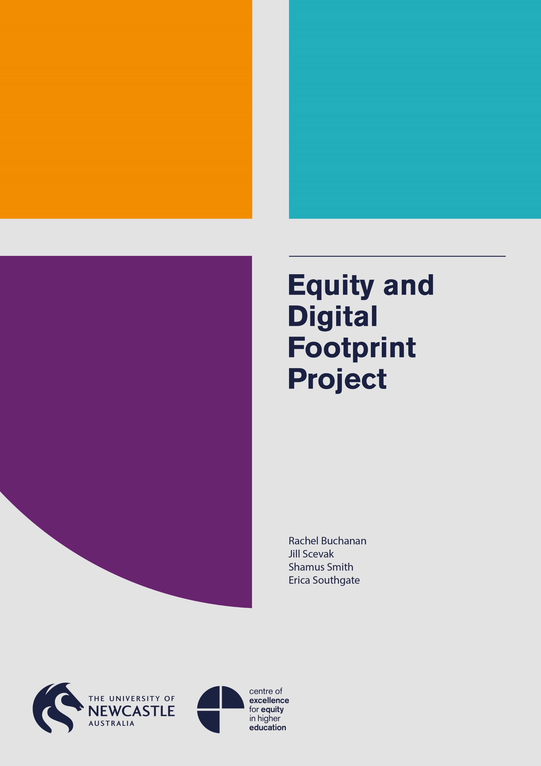

Equity and Digital Footprint Project

January 2015 to December 2015

Dr Rachel Buchanan
Dr Jill Scevak
Dr Shamus Smith
Dr Erica Southgate

The project that resulted in the production of this report was funded under a National Priorities Pool (Higher Education Participation and Partnerships Program) grant from the Commonwealth. The recipient of the grant has granted the Commonwealth the right to sub-licence the material in this report. Copyright in the report remains with the original copyright owners.
Except where otherwise indicated, and save for any material protected by a trade mark, the Department of Education and Training, acting on behalf of the Commonwealth, has applied the Creative Commons Attribution 4.0 International Licence.

Modifications: Changed to meet WCAG 2.0 accessibility requirements.
Alternate text inserted for all images. Minor typographical errors corrected.

Higher Education Participation and Partnerships Programme (HEPPP)

2014 National Priorities Pool FINAL REPORT
Equity and Digital Footprint Project
15 January 2015 to 30 December 2015
Name of university The University of Newcastle, Australia
Name of contact officer Dr Rachel Buchanan*
Position title Senior Lecturer, Education
Email address rachel.buchanan@newcastle.edu.au
Telephone number (02) 4921 6411
In accordance with the Conditions of Grant, you must submit to the Department a Final Report (Clause 6.1 of Part A) and an Acquittal Report (clause 6.4 of Part A).
To meet this obligation, please submit:
- the completed Final Report template, in Word and PDF
- the completed and signed Declaration form, in PDF
- the completed Acquittal Report template, in Excel and PDF.
All documents must be submitted to equity@education.gov.au by 31 March 2016.
If you require additional guidance or clarification please contact equity@education.gov.au.
*Please send a copy of any correspondence regarding this project to:
Ms Belinda Munn
Associate Director
Centre of Excellence for Equity in Higher Education
University of Newcastle
belinda.munn@newcastle.edu.au

Contents
List of Tables 4
1. PROJECT SUMMARY (Conditions of Grant, clause 2.2(a)-(e) of Part A) 5
Objectives 5
Project Activities, Milestones and Key Performance Indicators 5
Highlights and Issues 7
2. OTHER PROJECT MATERIAL (Conditions of Grant, clause 2.2 (b)-(e) of Part A) 10
3. ACQUITTAL REPORT (Conditions of Grant, clause 6.4(e), clause 6.7-8 of Part A) 11
DECLARATION 12
Appendix 1 13
Project Summary 13
Appendix 2 14
AARE Blog Post 14
Appendix 3 17
Presentation 1: Slide Content 17
Appendix 4 23
Presentation 2: Slide Content 23

List of Tables
Table 1: Project objectives 5
Table 2: Project activities, milestones and KPIs 6
Table 3: Additional materials produced over the course of the project 10

1. PROJECT SUMMARY (Conditions of Grant, clause 2.2(a)-(e) of Part A)

Objectives
Indicate the extent to which the Project Objectives specified in clause 3 of Part A of the Conditions of Grant were met. Where obligations established in the Conditions of Grant were not met, please identify these and provide an explanation of circumstances and consequences.

Table 1: Project objectives
IDENTIFIED OBJECTIVE | EXTENT TO WHICH THE OBJECTIVE WAS MET
Overall objective -­‐To build an evidence base for the development of resources and strategies to help students manage and curate their digital footprints. | An evidence base was developed through meeting the various sub-­‐objectives of the project – as detailed below.
-­‐To investigate the digital footprint knowledge and behaviour of students from traditional and non-­‐ traditional backgrounds | This was met through an online survey of 635 university students from 27 universities across Australia and focus groups with 30 students at the University of Newcastle.
-­‐Investigating the approaches of higher education institutions in educating undergraduate students about managing and curating digital footprints for successful personal and professional outcomes | A desktop audit of 45 universities in Australia was performed. This audit examined the digital footprint resources that were publicly available for students’ digital footprint education.
-­‐Identifying examples of evidence informed practice for education of undergraduate students regarding digital footprint management. | A Delphi survey was performed. This survey was of 53 experts in digital technology and education and sought respondents’ expertise on best practice for digital footprint management.

Project Activities, Milestones and Key Performance Indicators
Below, please specify whether:
- all project Activities specified in Schedule 1 of the Conditions of Grant
were completed
- all Project Milestones specified in Schedule 1 of the Conditions of Grant
were completed
- all Key Performance Indicators specified in Schedule 1 of the Conditions of
Grant were met.
Where obligations established in the Conditions of Grant were not met, identify these and provide an explanation of circumstances and consequences.

Table 2: Project activities, milestones and KPIs
TIME FRAME | PLANNED ACTIVITIES AND  MILESTONES | PROJECT ACTIVITIES AND MILESTONES COMPLETED | IDENTIFIED KEY PERFORMANCE INDICATORS | KEY PERFORMANCE  INDICATORS OUTCOME
January – March  2015 | Develop risk assessment and mitigation strategy | Risk assessment and mitigation strategy developed | Risk assessment and mitigation strategy | Risk assessment and mitigation strategy in place
 | Develop communication and dissemination strategy | Communication and dissemination strategy developed | Key conferences and journal identified for publication of results | AARE and GAPS conferences were identified and 3 journals; Journal of Education and Work, Education and Digital Culture, Studies in Higher Education; as being suitable for publication of project results.
 | Establish project website and social media presence | Website (http://dice.newcastle.edu.au/projects.html) developed. Social media presence established | Website hits increase. Number of social media followers grows. | -Website usage is increasing and social media coverage is growing via Twitter and Facebook.
 | Development of student survey and focus group  schedule and submission for ethics approval | Ethics approval granted. Approval  number H-­‐2015-­‐0271 | Instruments developed.  Ethics approval granted. | Met
 | Literature review | Literature review completed | Literature review to be published online on the project website as a freely available downloadable pdf. | Under review for publication as an annotated bibliography
April – June 2015 | Recruitment for student survey and focus groups | Online student survey conducted. Focus groups conducted. | 635 students surveyed. Focus groups  completed with 30 local students | All survey and focus group data collected
 | Survey university career service personnel.  Conduct Delphi survey | University career service personnel surveyed as part of the Delphi survey. Delphi survey completed. | 53 Experts surveyed including university careers service personnel | All Delphi survey data collected.
 | Desktop Audit | Desktop audit completed | 45 universities in  Australia audited | Desktop audit complete
July – September  2015 | Abstracts submitted to national and international conference | Conference papers delivered | Abstracts submitted and accepted | Conference papers delivered at national and international conferences. GAPS Conference, Kuala Lumpar Oct 7, 2016 and AARE conference Dec 7 2016.
 | Analysis of all data | Analysis of all data sets complete | Analysis online students survey, focus group transcripts, Delphi survey and desktop audits | All data sets analysed
October – December  2015 | Implement dissemination strategy | Dissemination strategy enacted | Report to be published on project website. 3  Scholarly papers to be published. Papers presented at 2 conferences | Report in preparation.  3 scholarly papers in preparation. Papers presented at 2 conferences (GAPS and AARE annual conferences).

Highlights and Issues
Provide a summary of highlights and achievements arising from your project (maximum
half page).
- 635 students from 28 universities around Australia were surveyed, plus 30 students from University of Newcastle participated in focus groups.
- There is a difference between how high and low SES students develop their digital footprints, with low SES more likely to develop negative digital footprints.
- Over 75% (n=425) of students claim that their university has provided them with no guidance on how to manage their digital footprints.
- 45 Universities in Australia were desktop audited to determine what resources are given to students – Less than half (n=19) provide accessible information on digital footprint management.
- We surveyed 53 digital experts and university careers service personnel. Respondents in the Delphi survey all agreed that there are equity/social justice issues around digital footprint management as currently not all students are being provided with guidance for the development of positive digital footprints. Students from a low SES background are more likely to have never been given such guidance.
- There is a need for universities to provide guidance to students on the management of their digital footprints. The Delphi experts suggest that a holistic approach be taken, with government, universities, teachers, parents and carers and students all needing to be involved and to be responsible.
- Students’ knowledge of professional social media networks is influenced by their parents’ background (the more prestigious student’s parents occupation is, the more likely a student is to be using professional social networks).
- As first in family and LSES students are not coming to university with the same levels of information regarding professional networking, for the sake of equity, there is an onus on universities to explicitly provide this information.
- 3 universities (James Cook University, Edith Cowan University and Sydney University) contacted us requesting further involvement if the resources are developed to address this issue.
Did the project lead to implementable outcomes? What changes will result at your institution/nationally? Are there activities resulting from this project that will be continued?
The project fulfilled its objective of developing an evidence base for the development of resources and strategies to help students manage and curate their digital footprints. The evidence demonstrates that university students (especially those from non-­‐traditional backgrounds) require guidance for the development of positive digital footprints. Using this evidence the project team aims to develop resources for universities following Dr Rachel Buchanan’s trip to the UK (see below). The project team has faculty funding to build resources and this will be done in the second half of 2016. The project report and information sheets on Digital Footprint management will be produced as freely available downloads from the project website.
Following from this project, the webpage for the project will be further developed. A report will be published online and 3 scholarly journal articles (currently in preparation for Journal of Education and Work, Education and Digital Culture, Studies in Higher Education) will be published.
As a result of this project, the project leader, Dr Rachel Buchanan is going to the UK to meet with leaders in the provision of digital footprint education in higher education in the UK. She will meet with Professor Tristram Hooley at Derby University and the Digital Footprint team at the University of Edinburgh. The information gathered here will help the team develop resources based on best international practice.
Did you undertake an evaluation of your project?
Yes No X
Please summarise the findings and attach the evaluation report

Where applicable, indicate number of the following resulting from this project:
Student contacts | 665
Journal (or other publication) submissions | Three articles in preparation for submission to: Journal of Education and Work, Education and Digital Culture, Studies in Higher Education
Conference Presentations | - ‘Examining the digital footprint awareness of university students: An emerging equity issue for higher education’ Presented at AARE Conference 2015, Fremantle, WA, 29 Nov 2015 -­‐ 03 Dec 2015. Australian Association for Research in Education.  - ‘The importance of digital footprints in achieving equity and excellence in higher education’ Presented at World Congress on Global Access to Post Secondary Education, Kuala Lumpar, 05 Oct 2015 -­‐ 08 Oct 2015. Global Access to Post Secondary Education.
Websites developed | 1 (Website address: http://dice.newcastle.edu.au/projects.html)
Educational or marketing campaigns | N/A
Community organisations engaged | N/A
Schools engaged | While students from 28 universities participated in the online student survey, 3 additional universities engaged in this project by contacting us and asking for information from the project to be sent to them.

Optional - If you included transformational/behavioural change KPIs in your EOI please summarise outcomes here:
E.g. Percentage increase in enrolment | N/A
E.g. Percentage increase in aspiration | N/A

Describe any issues that occurred during the year and any mitigation strategies you implemented.

2. OTHER PROJECT MATERIAL (Conditions of Grant, clause 2.2 (b)-(e) of Part A)
[List the titles of any published reports, pamphlets or other documentation produced in the course of the Project and attach them to this Final Report.]

Table 3: Additional materials produced over the course of the project
TYPE | AUTHOR | DATE OF PUBLICATION | PUBLICATION DETAILS
Blog post on AARE educational research blog | Rachel  Buchanan | 19/01/2015 | ‘Digital Footprint: not everyone is equal and why unis need to teach managing DF as a 21st century skill’ published on the EduResearch Matters website: http://www.aare.edu.au/blog/?p=1291
Conference presentation | Buchanan RA, Dennis J, Noble B, Scevak J, Smith S, Southgate E | 03/12/2015 | ‘Examining the digital footprint awareness of university students: An emerging equity issue for higher education’ Presented at AARE Conference 2015, Fremantle, WA, 29 Nov 2015 -­‐ 03 Dec 2015. Australian Association for Research in Education
Conference presentation | Buchanan RA, Smith S, Scevak J, Southgate, E | 05/10/2015 | ‘The importance of digital footprints in achieving equity and excellence in higher education’ Presented at World Congress on Global Access to Post Secondary Education, Kuala Lumpar, 05 Oct 2015 -­‐ 08 Nov 2015. Global Access to Post Secondary Education.

3. ACQUITTAL REPORT (Conditions of Grant, clause 6.4(e), clause 6.7-8 of Part A)
Have you fully expended the Grant Funds provided under the Conditions of Grant?
Yes No X
[If the answer is No, you must state:
- the amount of the underspend, and
- the reason for the underspend.]
The underspend was because of the following:
- The Research Assistant employed to support the project started working on the Equity and Digital Footprint project in April, rather than January as was budgeted.
- Not all the money budgeted for Teaching Relief was used as some of the CIs teaching commitments shifted and teaching relief was not required.
If the Department allows us to continue to use the unspent funds these would be used to employ a Research Assistant to help finalise the three journal articles currently in preparation for the following journals:
- Journal of Education and Work
- Education and Digital Culture
- Studies in Higher Education
The RA would be employed to help put compile the relevant literature, data and findings, edit and format articles to each journal’s specifications.
[Complete the Acquittal Report template and attach it to this Final Report.]
*IMPORTANT NOTICE - Unspent 2014 HEPPP Partnership Grant Funds
- Grant recipients must fully expend these 2014 National Priorities Pool funds in the project period for which the grant is made and report on this expenditure to the Commonwealth, including the amount of any unspent funds.
- If a provider fails to spend the full amount granted it in respect of a year, the unspent funds may be recovered by the Commonwealth.

DECLARATION
I declare that:
- I am authorised by the university to sign this Declaration on its behalf, and
- to the best of my knowledge, the information that I have provided in the Final Report and Acquittal Report for the HEPPP 2014 National Priorities Pool project Equity and Digital Footprint Project is true, correct and accurate in all particulars.
I understand that:
- The provision of false or misleading information or the making of false or misleading statements to the Commonwealth is a serious offence under the Criminal Code Act 1995 (Cth).
- If any actual or potential conflict of interest arises, I must notify the Commonwealth immediately in writing of the facts giving rise to the actual or potential conflict of interest and to take such steps as the Commonwealth may require so as to resolve or otherwise deal with any conflict of interest that may arise.

Title Professor
Name Andrew Parfitt
Position Deputy Vice-Chancellor (Academic)
Signature

Appendix 1

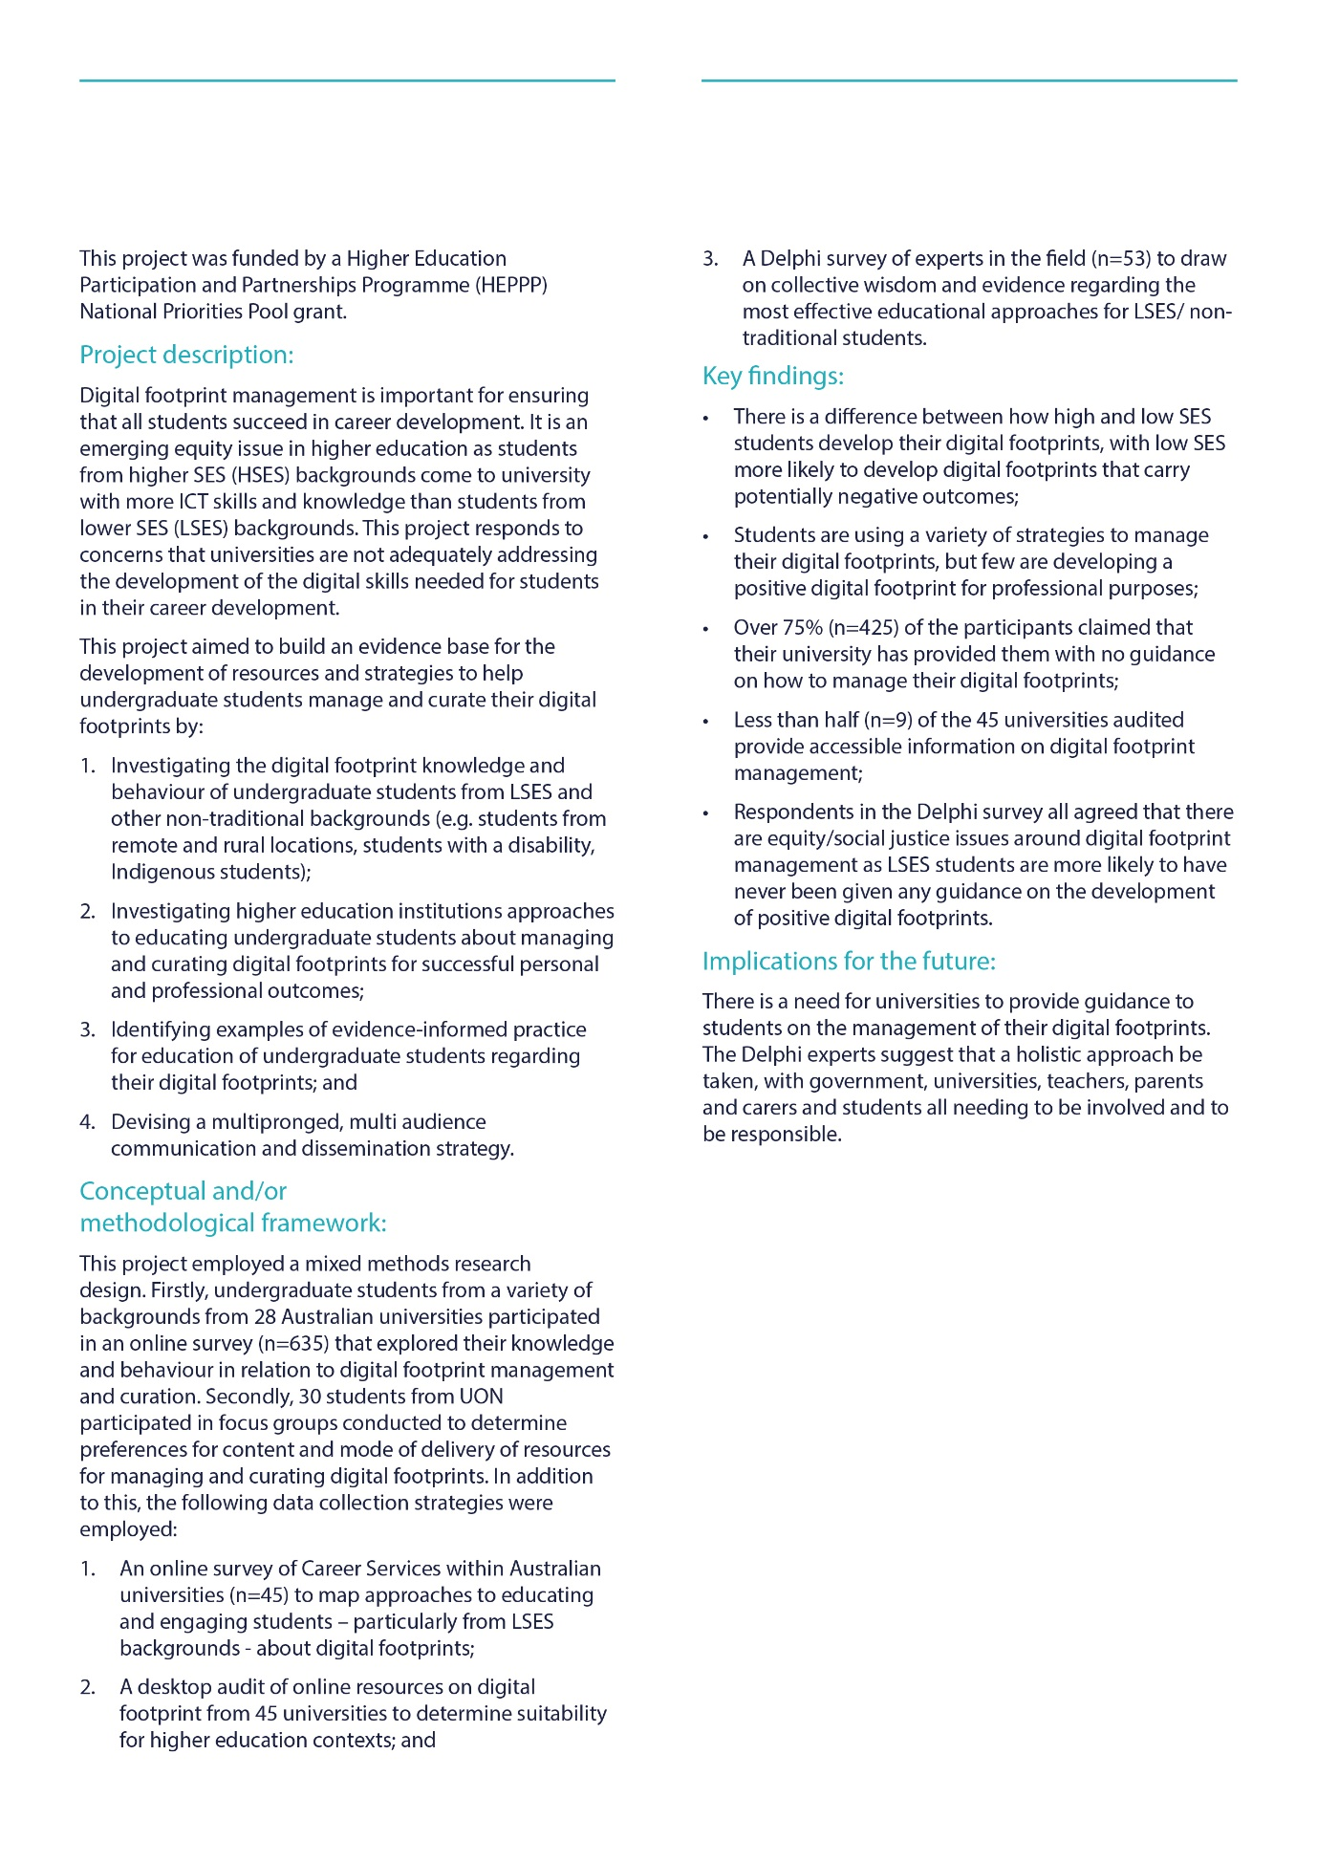
Project Summary

Appendix 2

AARE Blog Post

CATEGORIES
digital footprint, digital footprint and university students, higher education, social media
TAGS
Erica Southgate, Jill Scevak, Rachel Buchanan, Shamus Smith
October.19.2015

Digital Footprint: not everyone is equal and why unis need to teach managing DF as a 21st century skill
By Rachel Buchanan
Australians are among the most digitally connected in the world and young people spend a lot of time online. Most young Australians have an extensive digital footprint, especially university students.
Digital footprints are created through interaction with the internet and social media. Increasingly, digital footprint management is an important career development skill and one that is vital to the professional opportunities of university students.
However, we know very little about what university students know and do, in regards to their digital footprints. This post provides an initial overview of our* investigation into Australian university students’ understanding of their digital footprints. This research and our data collection are still taking place.
ABS data indicates that over 90% of Australians aged 18-40 regularly use the internet. The increase in online activity and social media usage has implications for digital footprints given that 800 000 Australians post videos online, and of the 47% of 16-25 year olds that use platforms such as snapchat, 25% admit to posting material of a sexual nature online.
Digital Footprints
Such social media activities can create a negative, publically accessible digital footprint that can detrimentally impact an individual’s current prospects and future careers.
However, responsible online engagement can create a positive public persona which acts as ongoing résumé of achievement and identity.
Management of digital footprints is a 21st century life skill, a lack of which could have serious social and professional consequences for students. Popular media is full of warnings about the problems caused by poor digital footprint management:
From The Age:
“What if today’s sexting teenager is tomorrow’s prime minister – adult lives can be marred by the digital footprint students are laying down now.”
From the SMH:
“Young ones, your online reputation is, like, forever”
Professional social media platforms, such as LinkedIn, make the professional implications of a badly managed online presence clear:
“Your digital footprint is ruining your job application”
Higher Education, Social Media and Digital Footprints
Yet, with our increased digital connectivity having no online presence can be as detrimental as having a badly managed one. Research tells us that
- Human Resources practitioners are increasingly using social media in recruitment, selection and hiring practices.
- Social Networking awareness is largely absent from the Higher Education curriculum.
- Curation and management of digital footprints is emerging as an essential skill for career development, yet universities are not adequately addressing this.
In regards to university students:
- Students with a high Socio-Economic Status (SES) background are coming to university with more technological knowledge and skills, have more experience with, and positive attitudes towards the use of ICT, than students with a low SES background.
- These students are better placed, than students from other backgrounds, to develop and manage their digital footprints while at university.
- Higher education institutions must help students who are coming to university without the digital education confidence and knowledge develop the required digital skills for success and achievement at university and beyond.
The Equity and Digital Footprint Project
Our project focuses on this emerging equity issue to better understand what undergraduate students from low SES and non-traditional backgrounds know and do in relation to their digital footprints. Information from this research will be used to develop resources to help students build a positive digital footprint.
To achieve this we are currently:
- Reviewing the relevant literature
- Conducting an online survey of university students across Australia to determine their knowledge and behaviour in relation to digital footprint management.
- Running focus groups with University of Newcastle students to speak to students in more depth about their use of professional social media.
- Doing an audit of university online resources on digital footprint to determine how well
- Australian universities are addressing this issue
- Conducting an online survey of ICT educators, policy makers and higher education career service personnel to garner collective wisdom and evidence of which educational approaches would be most effective for students.
Preliminary Findings
While it is very early days, our initial explorations reveal that:
- “Anecdata” abounds – There is lots of anecdotal evidence about the uses and abuses of social media and digital footprints, and media reports of the sensational examples provide only a distorted picture.
- There is conflicting information about the extent to which employees are using digital footprints to vet applicants.
- Students are aware that their internet usage creates a digital footprint, and they employ a variety of strategies to minimize or manage their digital footprints. These strategies range from a refusal to use social media, judicious use of privacy settings, minimal or highly strategic use of their real names when online, through to working from an assumption that privacy does not exist. Most students see their digital footprint as a liability rather than an opportunity.
- While Universities in the United Kingdom are producing some excellent comprehensive resources and services for digital footprint education the approach is very uneven in Australian universities.
Given the emphasis on excellence and equity in Australian universities and the pattern of increased access to universities from students from all backgrounds it is important that universities provide adequate support to all their students. Increased access to university is not an achievement if students are not provided with the resources and skills to participate and succeed in, and beyond, university. Not all students come to university with the necessary digital skills and knowledge.
Given the increased importance of social media management and having a traceable online presence, digital footprint education can provide students with opportunity to turn access and participation in university education into success; a positive online presence acts as an on-going record of identity and achievement.

Dr Rachel Buchanan is a Lecturer in Education at the University of Newcastle. She teaches educational foundations and researches into the equity and social justice implications of education policy and the increased deployment of digital technologies within the education sector. She can be contacted via rachel.buchanan@newcastle.edu.au or found on Twitter: @rayedish.
Rachel is undertaking this research with Dr Jill Scevak, Dr Shamus Smith and Dr Erica Southgate. This project was funded by the Australian Government Department of Education, through a HEPP National Priority Pool grant. More information about our research can be found here

Appendix 3

Presentation 1: Slide Content

Slide 1
Examining the Digital Footprint awareness of university students: An emerging equity issue for Higher Education
Dr Rachel Buchanan * Dr Jill Scevak *
Dr Shamus Smith #
Dr Erica Southgate *
Ms Jessica Dennis +
Ms Brittany Noble *
* School of Education, University of Newcastle

Slide 2
EQUITY AND DIGITAL FOOTPRINT
Acknowledgement
The Equity and Digital Footprint project was funded by the Commonwealth Government’s Higher Education Participation and Partnership Programme National Priorities Pool (HEPPP) in 2015, with support from The Centre of Excellence for Equity in Higher Education at the University of Newcastle.

Slide 3
DIGITAL FOOTPRINTS
Digital footprints are created through interaction with the internet and social media.
Management of digital footprints is a 21st century life skill, a lack of which could have serious social and professional consequences for students.
Research indicates that 90% of Australians aged 18-40 use the internet (ABS, 2014). The increase in online activity and social media usage has implications for digital footprints given that 800 000 Australians post videos online, and of the 47% of 16-25 year olds that use platforms such as snapchat, 25% admit to posting material of a sexual nature online (see http://datafication.com.au/socialvideo/?h=snapchat).

Slide 4
DIGITAL FOOTPRINTS
Mass media is full of warnings about the problems caused by poor digital footprint management:
For example:
http://www.theage.com.au/national/education/tread-very-carefully--youre-leaving-digital- footprints-20150216-13g354.html

"What if today's sexting teenager is tomorrow's prime minister - adult lives can be marred by the digital footprint students are laying down now."
From LinkedIn "Your digital footprint is ruining your job application" https://www.linkedin.com/pulse/20140813131816-321843154-your-digital-footprint-is-ruining-your- job-application

Slide 5
DIGITAL FOOTPRINTS
Such social media activities can create a negative, publically accessible digital footprint that can detrimentally impact an individual’s current prospects and future careers.
However, responsible online engagement can create a positive public persona which acts as ongoing résumé of achievement and identity.
Our project focuses on this emerging equity issue to better understand what undergraduate students from LSES and non-traditional backgrounds know and do in relation to their digital footprints and to develop evidence based engaging strategies for the digital footprint management for all students regardless of family background.

Slide 6
MISMATCH BETWEEN HIGHER EDUCATION AND BUSINESS
- Black and Johnson’s (2010) research shows that Human Resources practitioners are increasingly using social media in recruitment, selection and hiring practices.
- However, Social Networking awareness is largely absent from the Higher Education curriculum (Benson & Filippaios, 2010).

Slide 7
HIGHER EDUCATION AND ICT SKILLS
The Research
Research shows that students with a high socioeconomic status background possess more technological knowledge and skills, and have more experience with, and positive attitudes towards the use of ICT, than students with a low socioeconomic status (LSES) background (Sweeney & Geer, 2010).
These students are better placed, than students from other backgrounds, to develop and manage their digital footprints while at university. Curation and management of digital footprints is emerging as an essential skill for career development, yet universities are not adequately addressing this (Hooley, 2012).

Slide 8
EQUITY AND DIGITAL FOOTPRINT PROJECT
Aims
To build an evidence base for the development of resources and strategies to help students manage and curate their digital footprints. Digital footprint management is important for ensuring that all students succeed in finding careers after university.
This is an emerging equity issue in Higher Education as students from higher SES backgrounds come to university with more ICT skills and knowledge than students from LSES backgrounds.

Slide 9
EQUITY AND DIGITAL FOOTPRINT PROJECT
Methods
- Review of the literature (scholarly and grey literature)
- Survey and Focus groups with University students
  - Online survey of Australian university students from a variety of SES backgrounds to determine their knowledge and behaviour in relation to digital footprint management and curation. This survey will allow for comparative analysis between SES groups.
  - Focus groups undergraduate students conducted to determine preferences for content and mode of delivery of resources for managing and curating digital footprints.
- Desktop audit of online resources on digital footprint to determine suitability for higher education contexts
- Delphi survey of digital experts and higher education career service personnel to garner collective wisdom and evidence of which educational approaches would be most effective for students from LSES and non-traditional backgrounds.

Slide 10
“All my social media is open as I don’t believe that there is any such thing as privacy anymore”
(Engineering undergraduate student)

Slide 11
EQUITY AND DIGITAL FOOTPRINT PROJECT
Initial Findings (n=635 from 28 Australian universities)
Preliminary findings from the university student survey include:
Low SES students are
- more likely to post ill-advised content,
- less likely to have heard of professional social networks,
- less likely to use use any professional social media networks,
- and less likely to create content for professional purposes
High SES students are

- more likely to have higher numbers of Facebook friends,
- more likely to have heard of the various professional social media networks
- and more likely to use LinkedIn

Slide 12
EQUITY AND DIGITAL FOOTPRINT PROJECT
Initial Findings
Over 75% (n=425) of students claim that their university has provided them with no guidance on how to manage their digital footprints.
Over 70% of students (n=445) responded to the question: What would you like to know about your digital footprint?
Typical responses include:
“How to erase, keep private and monitor”;
“How can I create a professional digital footprint? What kind of information should I avoid posting for my digital footprint to look professional?”

Slide 13
DESKTOP AUDIT OF AUSTRALIAN UNIVERSITY
Does the University have content relevant to Digital Footprint?
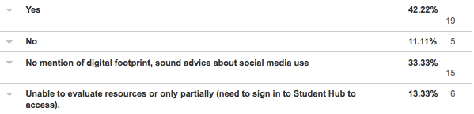

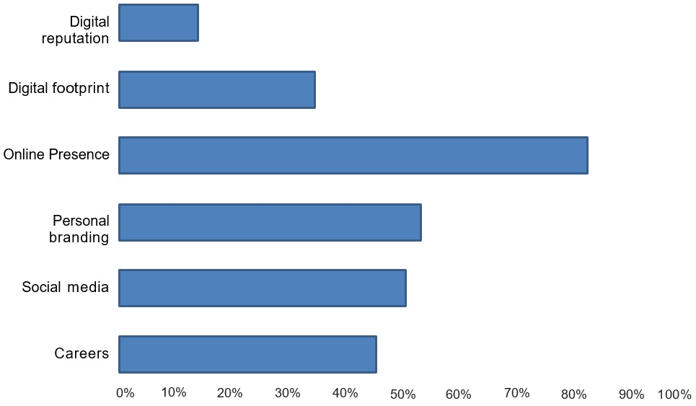
Slide 14

Slide 15
WHERE WAS THE DIGITAL FOOTPRINT INFORMATION FOUND?
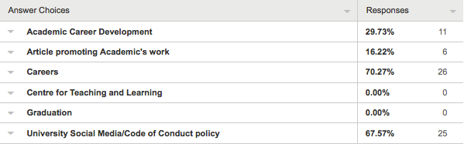

Slide 16
EQUITY AND DIGITAL FOOTPRINT PROJECT
DELPHI SURVEY
Respondents in the Delphi survey all agreed that there are equity/social justice issues around digital footprint management:
“particularly the negative implications of not having or having a poorly representative digital presence, and the advantages afforded those with rich and engaging digital presences to secure social capital, educational and employment opportunities”
Respondents in the Delphi survey thought that there should be shared responsibility for education about digital footprint management. It was considered to be a societal issue, one that needs to be addressed by individuals, government organisations, schools, parents, universities and through careers education.

Slide 17
EQUITY AND DIGITAL FOOTPRINT PROJECT
(INITIAL) IMPLICATIONS
- There is a need for universities to provide guidance to students on the management of their digital footprints.
- Students knowledge of professional social media networks is influenced by their parents’ background (the more prestigious student’s parents occupation is, the more likely a student is to be using professional social networks).
- As first in family and LSES students are not coming to university with the same levels of information regarding professional networking, for the sake of equity, there is an onus on universities to explicitly provide this information.

Slide 18
THE IMPORTANCE OF DIGITAL FOOTPRINTS IN ACHIEVING EQUITY IN HIGHER EDUCATION
Given the increasing importance of the digital aspects of people’s lives equity in higher education needs to mean more than equal opportunity to access university education. Higher education institutions must help students from LSES and other non-traditional backgrounds develop the required digital skills for success and achievement at university and beyond (Devlin, 2012). Universities are ideally situated to understand and address the equity implications of digital footprints and respond to these as part of career development education (Hooley, 2012).

Slide 19
REFERENCES
Black, S. & Johnson, A. (2012). Employers' use of social networking sites in the selection process, The Journal of Social Media in Society, 1(1), 7 -28.
Benson, V., Filippaios, F. (2010): Effects of Digital Footprint on Career Management: Evidence from Social Media in Business Education. In: Lytras, M.D., Ordonez De Pablos, P., Ziderman, A., Roulstone, A., Maurer, H., Imber, J.B. (eds.) Knowledge Management, Information Systems, E-Learning, and Sustainability Research. (pp. 480–
486). Berlin: Springer.
Devlin, M. (2013). Bridging socio-cultural incongruity: conceptualising the success of students from low socio-economic status backgrounds in Australian higher education. Studies in Higher Education, 38, 6. DOI: 0.1080/03075079.2011.613991
Hooley, T. (2012). How the internet changed career: framing the relationship between career development and online technologies. Journal of the National Institute for Career Education and Counselling (NICEC) 29.
Krueger, RA, & Casey, MA. (2009). Focus Groups. A Practical Guide for Applied
Research. Thousand Oaks, California: Sage.
Sweeney, T. & Geer, R. (2010). Student capabilities and attitudes towards ICT in the early years, Australian Educational Computing, 25, 18-24.
Turoff, M. & Linstone, H. (1975). The Delphi Method: Techniques and Applications. Reading, MA: Addison-Wesley Publishing Company.

Slide 20
Thank You
More information: http://dice.newcastle.edu.au/
Twitter: @Dice_Research

Appendix 4

Presentation 2: Slide Content

Slide 1
Rachel Buchanan
Jessica Dennis
Brittany Noble
Jill Scevak
Shamus Smith
Erica Southgate
The importance of digital footprints in achieving equity and excellence in higher education.

Slide 2
EQUITY AND DIGITAL FOOTPRINT
Acknowledgement
The Equity and Digital Footprint project was funded by the Commonwealth Government’s Higher Education Participation and Partnership Programme National Priorities Pool (HEPPP) in 2015, with support from The Centre of Excellence for Equity in Higher Education at the University of Newcastle

Slide 3
DIGITAL FOOTPRINTS
Digital footprints are created through interaction with the internet and social media.
Management of digital footprints is a 21st century life skill, a lack of which could have serious social and professional consequences for students.
Research indicates that 90% of Australians aged 18-40 use the internet (ABS, 2014). The increase in online activity and social media usage has implications for digital footprints given that 800 000 Australians post videos online, and of the 47% of 16-25 year olds that use platforms such as snapchat, 25% admit to posting material of a sexual nature online (see http://datafication.com.au/socialvideo/?h=snapchat).

Slide 4
DIGITAL FOOTPRINTS
Mass media is full of warnings about the problems caused by poor digital footprint management:
For example:
http://www.theage.com.au/national/education/tread-very-carefully--youre-leaving-digital- footprints-20150216-13g354.html

"What if today's sexting teenager is tomorrow's prime minister - adult lives can be marred by the digital footprint students are laying down now."
From LinkedIn "Your digital footprint is ruining your job application" https://www.linkedin.com/pulse/20140813131816-321843154-your-digital-footprint-is-ruining-your- job-application

Slide 5
DIGITAL FOOTPRINTS
Such social media activities can create a negative, publically accessible digital footprint that can detrimentally impact an individual’s current prospects and future careers.
However, responsible online engagement can create a positive public persona which acts as ongoing résumé of achievement and identity.
Our project focuses on this emerging equity issue to better understand what undergraduate students from LSES and non-traditional backgrounds know and do in relation to their digital footprints and to develop evidence based engaging strategies for the digital footprint management for all students regardless of family background.

Slide 6
MISMATCH BETWEEN HIGHER EDUCATION AND BUSINESS
- Black and Johnson’s (2010) research shows that Human Resources practitioners are increasingly using social media in recruitment, selection and hiring practices.
- However, Social Networking awareness is largely absent from the Higher Education curriculum (Benson & Filippaios, 2010).

Slide 7
HIGHER EDUCATION AND ICT SKILLS
The Research
Research shows that students with a high socioeconomic status background possess more technological knowledge and skills, and have more experience with, and positive attitudes towards the use of ICT, than students with a low socioeconomic status (LSES) background (Sweeney & Geer, 2010).
These students are better placed, than students from other backgrounds, to develop and manage their digital footprints while at university. Curation and management of digital footprints is emerging as an essential skill for career development, yet universities are not adequately addressing this (Hooley, 2012).

Slide 8
EQUITY AND DIGITAL FOOTPRINT PROJECT
$107, 287 HEPP funding
Funded by the Australia Government Department of Education, 2014 National Priorities Pool – Higher Education Participation Programme
Supported by University of Newcastle Centre of Excellence for Equity in Higher Education (CEEHE)
Project Team
- Dr Rachel Buchanan
- Jessica Dennis
- Brittany Noble
- Dr Jill Scevak
- Dr Shamus Smith
- Dr Erica Southgate

Slide 9
EQUITY AND DIGITAL FOOTPRINT PROJECT
Aims
To build an evidence base for the development of resources and strategies to help students manage and curate their digital footprints. Digital footprint management is important for ensuring that all students succeed in finding careers after university.
This is an emerging equity issue in Higher Education as students from higher SES backgrounds come to university with more ICT skills and knowledge than students from LSES backgrounds.

Slide 10
EQUITY AND DIGITAL FOOTPRINT PROJECT
Methods
- Review of the literature (scholarly and grey literature)
- Survey and Focus groups with University students
  - Online survey of Australian university students from a variety of SES backgrounds to determine their knowledge and behaviour in relation to digital footprint management and curation. This survey will allow for comparative analysis between SES groups.
  - Focus groups undergraduate students conducted to determine preferences for content and mode of delivery of resources for managing and curating digital footprints.
- Desktop audit of online resources on digital footprint to determine suitability for higher education contexts
- Delphi survey of digital experts and higher education career service personnel to garner collective wisdom and evidence of which educational approaches would be most effective for students from LSES and non-traditional backgrounds.

Slide 11
EQUITY AND DIGITAL FOOTPRINT PROJECT
Initial Findings
While we are still in the process of collecting data, preliminary findings from the university student survey include:
- Of the 264 students who have responded, over 95% have a facebook account
- Most students do not have a professional social network (56%) and most do not use their personal social media accounts for professional purposes (71%)
- Students see digital footprints as a negative, something to be avoided and do not realise that it can be used increase life and professional opportunities

Slide 12
Students are managing their digital footprints:
- Students have a wide variety of strategies for digital footprint management; ranging from avoidance of social media, locking down privacy settings, through to open/public settings.
- Most students have some social media set to private and some set to open or public.
- 86% of students have deleted something or asked (57%) someone to delete something posted on social media about them.

Slide 13
EQUITY AND DIGITAL FOOTPRINT PROJECT
Initial Findings
Over 78% of students claim that their university has provided them with no guidance on how to manage their digital footprints.
Over 67% of students (n=180) responded to the question: What would you like to know about your digital footprint?
Typical responses include:
“how to erase, keep private and monitor”;
“How can I create a professional digital footprint? What kind of information should I avoid posting for my digital footprint to look professional?”

Slide 14
EQUITY AND DIGITAL FOOTPRINT PROJECT
DELPHI SURVEY
Respondents in the Delphi survey all agreed that there are equity/social justice issues around digital footprint management:
“particularly the negative implications of not having or having a poorly representative digital presence, and the advantages afforded those with rich and engaging digital presences to secure social capital, educational and employment opportunities”
Respondents in the Delphi survey thought that there should be shared responsibility for education about digital footprint management. It was considered to be a societal issue, one that needs to be addressed by individuals, government organisations, schools, parents, universities and through careers education.

Slide 15
EQUITY AND DIGITAL FOOTPRINT PROJECT
(INITIAL) IMPLICATIONS
- There is a need for universities to provide guidance to students on the management of their digital footprints.
- Students knowledge of professional social media networks is influenced by their parents’ background (the more prestigious student’s parents occupation is, the more likely a student is to be using professional social networks).
- As first in family and LSES students are not coming to university with the same levels of information regarding professional networking, for the sake of equity, there is an onus on universities to explicitly provide this information.

Slide 16
THE IMPORTANCE OF DIGITAL FOOTPRINTS IN ACHIEVING EQUITY AND EXCELLENCE IN HIGHER EDUCATION
Given the increasing importance of the digital aspects of people’s lives equity in higher education needs to mean more than equal opportunity to access university education. Higher education institutions must help students from LSES and other non-traditional backgrounds develop the required digital skills for success and achievement at university and beyond (Devlin, 2012). Universities are ideally situated to understand and address the equity implications of digital footprints and respond to these as part of career development education (Hooley, 2012).

Slide 17
REFERENCES
Black, S. & Johnson, A. (2012). Employers' use of social networking sites in the selection process, The Journal of Social Media in Society, 1(1), 7 -28.
Benson, V., Filippaios, F. (2010): Effects of Digital Footprint on Career Management: Evidence from Social Media in Business Education. In: Lytras, M.D., Ordonez De Pablos, P., Ziderman, A., Roulstone, A., Maurer, H., Imber, J.B. (eds.) Knowledge Management, Information Systems, E-Learning, and Sustainability Research. (pp. 480–
486). Berlin: Springer.
Devlin, M. (2013). Bridging socio-cultural incongruity: conceptualising the success of students from low socio-economic status backgrounds in Australian higher education. Studies in Higher Education, 38, 6. DOI: 0.1080/03075079.2011.613991
Hooley, T. (2012). How the internet changed career: framing the relationship between career development and online technologies. Journal of the National Institute for Career Education and Counselling (NICEC) 29.
Krueger, RA, & Casey, MA. (2009). Focus Groups. A Practical Guide for Applied
Research. Thousand Oaks, California: Sage.
Sweeney, T. & Geer, R. (2010). Student capabilities and attitudes towards ICT in the early years, Australian Educational Computing, 25, 18-24.
Turoff, M. & Linstone, H. (1975). The Delphi Method: Techniques and Applications. Reading, MA: Addison-Wesley Publishing Company.

Slide 18
Thank You
Questions

