Creative Industries Careers:
Re-imagining Regional and Remote
Students’ Opportunities [HEP1600027]
31 October 2017 to 31 December 2017

Kathryn Grushka, The University of Newcastle

The project that resulted in the production of this report was funded under a National Priorities Pool (Higher Education Participation and Partnerships Program) grant from the Commonwealth. The recipient of the grant has granted the Commonwealth the right to sub-licence the material in this report. Copyright in the report remains with the original copyright owners.
Except where otherwise indicated, and save for any material protected by a trade mark, the Department of Education and Training, acting on behalf of the Commonwealth, has applied the Creative Commons Attribution 4.0 International Licence.

Modifications: Changed to meet WCAG 2.0 accessibility requirements.
Alternate text inserted for all images. Minor typographical errors corrected.

Higher Education Participation and Partnerships Programme (HEPPP)

2016 National Priorities Pool FINAL REPORT
Creative Industries Careers: Re-imagining Regional and Remote Students’ Opportunities [HEP1600027]
31 October 2017 to 31 December 2017
Name of university The University of Newcastle
Name of contact officer Kathryn Grushka
Position title Senior Lecturer
Email address kath.grushka@newcastle.edu.au
Telephone number (02) 4921 6583
In accordance with the Conditions of Grant, you must submit to the Department a Final Report (Clause 6.1 of Part A) and an Acquittal Report (clause 6.4 of Part A).
To meet this obligation, please submit:
- the completed Final Report template, in Word and PDF
- the completed and signed Declaration form, in PDF
- the completed Acquittal Report template, in Excel and PDF.
All documents must be submitted to equity@education.gov.au by 31 December 2017.
If you require additional guidance or clarification, please contact us at equity@education.gov.au.

Contents
List of Tables 3
1. PROJECT SUMMARY (Conditions of Grant, clause 2.2 of Part A) 4
Objectives 4
Project Activities, Milestones and Key Performance Indicators 10
Highlights and Issues 16
2. OTHER PROJECT MATERIAL (Conditions of Grant, clause 2.2 (b)-(e) of Part A) 23
3. ACQUITTAL REPORT (Conditions of Grant, clause 6.4 (a)-(d), clause 6.5 (a)-(b)
of Part A) 26
DECLARATION 27

List of Tables
Table 1: Project objectives 4
Table 2: Project activities, milestones and KPIs 11
Table 3: Additional materials produced over the course of the project 23

1. PROJECT SUMMARY (Conditions of Grant, clause 2.2 of Part A)

Objectives
Indicate the extent to which the Project Objectives specified in clause 3 of Part A of the Conditions of Grant were met. Where obligations established in the Conditions of Grant
were not met, please identify these and provide an explanation of circumstances and consequences.

Table 1: Project objectives
IDENTIFIED OBJECTIVE | EXTENT TO WHICH THE OBJECTIVE WAS MET
a) support regional and remote high school students in farming, mining and manufacturing regions to re-imagine their futures and aspire to work in creative industries; | This objective was achieved by designing a Creative Industries Roadshow rolled out as a staged project targeting three distinct research populations. Firstly remote and regional high school students and their careers advisors and teachers, secondly university students studying the creative industries and finally young Creative Industry innovators who used tertiary education to develop their skills and launch their creative careers.  The Team:  The University of Newcastle research team was led by Dr Kathryn Grushka, School of Education with Dr Miranda Lawry, Dr Susan Kerrigan, and Jane Shadbolt from the School of Creative Industires, A/Prof Maree Grupretta, from the Wollotuka Institute. The research team was supported by three research assistants Kristi Street, Ari Chand and Alice Hope who were employed with the HEPPP funding. Current University students and Alumni were recruited as volunteers.  Regions Targetted:  The research team targeted NSW regional High Schools in the Central West, New England, Mid North Coast and the Hunter regaions. The CI Roadshow was rolled out to these regions, inviting all High School to participate from the following 13 Principal Networks: Hunter, Maitland, Hasting, Mid-northcoast, Macquarie, Western Plains, Orange, Bathurst, Great Lakes, Wollomi, Barwon, Tamworth, Northern Tablelands/Armidale. The design and targeting of these populations in the secondary education environment was led by Dr Kathryn Grushka and Dr Miranda Lawry, with A/Prof Maree Grupretta securing an additional CI Roadshow workshop to the UON Gomeroi Gaaynggal Centre in Tamworth.  Recruited:  - University students as mentors: to tell their personal stories to High School students and teachers to help in the re-imagining of creative industries careers. University students volunteered to be mentors to deliver the CI Roadshow and share their stories about University life and planning a CI career while working with the High School students in the three digial media workshops.  - Alumni, Graduates as young CI Innovator volunteers from University programs, were interviewed for the youtube series, ‘See what you can be’. This allowed each young CI innovator to explain their educational pathway from High School, tertiary study to a CI Career as an animator, filmmakers, digial media producer, artists, website and graphic designers.  Evaluation:  Information sessions and surveys for Careers advisors, teachers and High School students were incorporated into the CI Roadshow so that current understanding of CI could be ascertained to judge any shift in those which might occur due to the Roadshow.  Pilot:  In May a pilot of the CI Roadshow was delivered at Kurri Kurri High School in the Hunter. The pilot proved it was possible for one school to be a Hub and host the CI Roadshow, allowing up to five local High Schools to participate. The benefit of this arrangement was to reduce overall travel time for the students and teachers. This proved to be a great strategy for the more remote rural areas where we had staff and students travelling up to two hours to reach their hub school.  The CI Roadshow:  In August to September we rolled out the CI roadshow to the seven NSW regional areas -Port Macquarie, Taree, Dubbo, Mudgee, Gunnedah, Merriwa, and Tamworth. Tamworth was added as Hub location because as additional funded through the University’s Wollotuka Institute that targeted indigenous students. A website housing all the CI Roadshow content provides a breakdown of the projects deliverables, and all High School Students, Careers advisors and teachers were given the website to access during the roadshow. The website was created by RA Ari Chand.  These activities helped the research team to achieve this objective through the delivery of the CI Roadshows to those regional and remote high school students, careers advisors and teachers in farming, mining and manufacturing regions.
b) deliver a Creative Industry Roadshow to high school students in six remote and regional centres; | 8 x CI Roadshows:  The research team over delivered on this objective by running eight CI Roadshows, we added two more during the project, the pilot for the Hunter and the Indigenous Roadshow for Tamworth. The eight CI Roadshow toured 13 Principal Networks in remote and regional NSW, engaging 40 High Schools and allowed over 602 high school students, Careers Advisors and teachers to learn more about the creative industries through information sessions, discussions and hands on digital media workshops.  National and Globally Open Website  The CI Roadshow became an exhibiton event where 6 University academics that formed the research team with two research assistants and 16 Univeristy Student Mentors provided accurate and up to date information to participants about Creative Industries career options and University life. A globally open access website was made which centrally contains all the material developed by the Project Team will continue to assist careers advisors, teachers and high school students in envisaging their future CI careers.  Career Advisors and Teacher Information sessions:  The CI Roadshow allowed Careers advisors and teachers to participate in an information session about CI Career opportunities, while the High School Students participated in creative skills workshops (2 hours) where short animations, pitches for Virtual Reality and short films were created.  Mobile Technology Creative Industry Workshops:  The digital equipment funded through the HEPP grant allowed these digital workshops to be delivered to groups of 20 students. The University Student Mentors ran the workshops and the wrap up sessions using mobile technologies allowed all the works to be screened. This immediate and engaging feedback was a highlight for boht teachers and students. It also provided an opportunity for the Mentors to tell their stories about how they came to be studying at University. High School students participated in a survey about their understanding of CI, and were given an opportunity to anonymously ask questions about their concerns with tertiary study. These questions were answered in person by the Mentors during the wrap up session and have been collated on the website in the Frequently asked questions (FAQ) section.  Ethics:  Ethical approvals to survey and ask questions of High School Students, Careers Advisors, Indigenous students, university student mentors and young innovators were obtained through three rounds of ethical protocal with University (HRCE), Education department (SERAP), Indigenous (NEAF). Dr Kathryn Grushka the project leader, managed two of these application and A/Prof Maree Gupretta managed the Indigenous application.  Logistical Success:  Delivering the CI Roadshow as planned was a logistical triumph and Research Assistant, Kristi Street, employed by the HEPPP funding did a superb job in inviting schools to participate. Street’s work in organising this Roadshow was overseen by the project led Dr Kathryn Grushka. The detailed breakdown of the 13 Principal Networks and of the tour show how this project objective was successfully met. The following tables provide a breakdown of these details.  Participant Schools List:  Kurri Kurri Pilot Day, Total Number of Students= 65 (35 Females, 30 Males)  Additional students attending information and screening sessions 42  Date: 7th June 2017  Name of Public School NSW Principals Network Distance (Time) Students Male Female  Pilot Hunter HUB SCHOOL Kurri Kurri High School Hunter 45 23 22  Francis Greenway High School Maitland 0:19 Kurri 4 2 2  Maitland Grossmann High School Maitland 0:19 Kurri 4 2 2  Cessnock High School Hunter 0:20 Kurri 4 0 4  Rutherford Technology High School Maitland 0:21 Kurri 4 2 2  Mount View High School Hunter 0:23 Kurri 4 1 3  Port Macquarie Total Number of Students = 66 (29 Female, 37 Male)  Additional students attending information and screening sessions 68  Date: Friday 25th August 2017  Hasting HUB SCHOOL Principals Network Travel Students Male Female  Hastings Secondary College Port Macquarie Campus 54 31 23  Hastings Secondary College Westport Campus Hastings 0:00 Port Combined  Melville High School (South Kempsey) Mid North Coast 0:48 Port 6 3 3  Camden Haven High School Hastings 0:38 Port 6 3 3  Dubbo Total Number of Students = 43 (25 Females, 18 Males)  Date: Monday 28th August 2017  Macquarie HUB SCHOOL Principals Network Travel Students Male Female  Dubbo College Senior Campus (Yrs 11&12) 34 15 19  Dubbo College Delroy Campus (Yrs 7-10) Macquarie 0:00 Dubbo Combined  Dubbo College South Campus (Yrs 7-10) Macquarie 0:00 Dubbo Combined  Gilgandra High School Western Plains 0:46 Dubbo 3 1 2  Molong Central School Orange 1:22 Dubbo 6 2 4  Mudgee Total Number of Students= 52 (21 Females, 31 Males)  Additional students attending information and screening sessions 58  Date: Tuesday 29th August 2017  Macquarie HUB SCHOOL Principals Network Travel Students Males Female  Mudgee High School 36 21 15  Gulgong High School Macquarie 0:29 Mudg 4 2 2  Portland Central School Bathurst 1:22 Mudg 4 4 0  Denison College of Secondary Education Kelso High Campus Bathurst 1:34 Mudg 4 1 3  Blayney High School Bathurst 2:02 Mudg 4 3 1  Taree Total Number of Students= 57 (40 Females, 17 Males)  Date: Thursday 31st August 2017.  Great Lakes HUB SCHOOL Principals Network Travel Students Male Female  Chatham High School 36 8 28  Taree High School Great Lakes 0:00 Taree 9 2 7  Wingham High School Great Lakes 0:13 Taree 4 0 4  Great Lakes College Tuncurry Campus (Yr7-10) Great Lakes 0:35 Taree 4 4 0  Great Lakes College Forster Campus (Yr 7-10) Great Lakes 0:39 Taree 4 3 1  Great Lakes College Senior Campus (Yr 11&12) Great Lakes 0:35 Tar 0 0 0  Gunnedah Total Number of Students = 62 (29 Females, 33 Males)  Date: Wednesday 6th September 2017.  Wollemi HUB SCHOOL Principals Network Travel Students Males Females  Gunnedah High School 51 25 26  St Mary College Private 0:00 Gunn 11 8 3  Moree Secondary College Albert St Campus (Yr10-12) Barwon 2:14 Gunn 0 0 0  Merriwa Total Number of Students= 43 (31 Females, 12 Males)  Date: Thursday 7th September 2017.  Wollemi HUB SCHOOL Principals Network Travel Students Male Female  Merriwa Central School 32 2 30  Scone High School Wollemi 0:54 Merr 3 3 0  Muswellbrook High School Wollemi 1:00 Merr 4 4 0  Coolah Central School Merriwa/Gunnedah Wollemi 1:08 Merr 1 0 1  Dunnedoo Central School Merriwa/Gunnedah Wollemi 1:24 Merr 3 3 0  Tamworth Total Number of Students = 46 (20 Females, 26 Males)  Date: Friday 8th September 2017.  Tamworth HUB Principals Network Travel Students Males Females  Gomeroi Gaaynggal  Centre (UON)  Oxley High School Tamworth 0:00 Tamworth 0 0 0  Calrossy High Scool Private 0:00 Tamworth 12 12 0  Peel High School Tamworth 0:00 Tamworth 13 4 9  Farrer Memorial Agricultural High School Tamworth 0:00 Tamworth 12 5 7  Guyra Central School Northern Tablelands/ Armidale 1:43 Tamworth 9 5 4
c) Provide information about pathways into Creative industries careers through a YouTube series titled “See what you can be: creative industries pathways”; and | Name Film VR Anni Course Work Program 13/06 Kurri Kurri 25/08 Port Mac 28-29/8 Dubbo Mudgee 31/8 Taree 6-8/9 Gunn Merriwa Tam  Callum Foot AFV No Vis Comm Animation A A A  Daniel Smith AFV GRAD Vis Comm A A  Hannah Jordan AFV No Communications A A A  Joyous Colley AVF Course Natural History A A A A  Samantha Bayly AVF Course Natural History A A A A  Natasha Mansfield AFV No Natural History A A A  Emily Jordan FAV No Communications F F F  Ciarin Christie FVA No Communications F F F F  Nicholas Smit FVA No Communications F  Rebecca McKinnon FVA No Communications Film F F F F  Ryan McGrath FVA No Communications F F  Kristen Wunderlich FVA No Communications F F F F  Robert Prosser FVA No Communications F F  Shelby Heath FVA No Communications F  Kasi-Ann Riley VAF No Vis Comm Video V V V  Robert Connell VFA No Fine Art V V V  Sam Ferguson VFA No IT V V V V  William Lentell VFA No Communications V V V V  Daniel Evers VFA Course Communications V V V V  Pathways to the Creative Industries through personal stories:  This objective was achieved by identifying those who could Mentors:  tell stories about their pathway into university and the pathway after graduation and during the transition into a CI Career. We recruited two groups; current UON students and UON Alumni.  Stories of mentors:  Current UON students became the Mentors who travelled with the CI Roadshow, they were able to tell their personal stories about how they decided to come to University, and their High school aspirations. This element of the project was led by Dr Miranda Lawry and assisted by RA, Kristi Street. Profiles of each Mentor have been listed on the project website.  Young Innovator Videos:  The Alunim, made up of recent UON graduates from CI degree programs, (Fine Art, Communication and Design) became the Young Innovators who participated in a filmed interview describing their pathway from high school, to university to a CI Career/ business. This section of the project was led by Dr Susan Kerrigan with assistance by Kristi Street and the whole research team. In total 14 videos were produced, created by 56 Communication students as part of a work intergrated learning (WiL) project in a 2nd year Television Production course. A short and long version of each interview was created with two promotional trailers.  These six filmed interviews became the youtube series ‘See what you can be’, now hosted on a University youtube channel and available on the CI Roadshow website. The videos were screened during the CI roadshow to Careers Advisors, teachers and students to highlight the range and scope of career opporutnities offered in the Creative Industries.  ‘See What You Can Be’ Youtube series  Interviewee Long Video (minutes) Short Video (minutes)  1 Filmmaker Jacob Payne 10 8  2 Video Producer/Director Karen Hopkins 10 6  3 Web/UX Designer Jemimah Irvin 12:30 9  4 Animator Dan Smith 13 10  5 Artist Gillian Bencke 14 10  6 Artist Ben Kenning 14 10  7 Promotional Trailer 6.00 3  Surveys were conducted with the High School students during the CI Roadshow to determine how the mentor information sessions and the ‘See What you can Be’ series changed their understanding around the possibility of a career in CI.  Feedback from Students, Career Advisors and Teachers  Students Comments  Workshop Evaluation  I was impressed with how much people know about the industry. It’s very exciting once you learn something.  I was sort of looking forward to this, but it definitely blew my expectations today was great.  Teacher/Career Teacher Comments  This project let me see that if you have the skill set and the idea, you can pursue this anywhere, however access to resources due to our location maybe challenging.  The future potential for ways of learning, direction of career paths, creativity is in all areas, that I want to start some MOOCS. That i will use these resources for stage 5 & 6 art classes. That my school needs to be aware of this. Who is going to write the syllabus for this way of learning for year 9/10 electives, PBL??? So many questions.  This work shop has shown me the potential of combining creativity with more traditional career paths. It has also provided resources that I can adapt to classroom careers lessons to broaden students perceptions about the importance of creative industries in future employment.
d) provide professional development for teachers and careers advisors about the student skill set required for the new technologies and inform families about the prospects of a Creative Industry career and a university education. | Career Advisors and Teachers Professional Development  This professional development objective was achieved by delivering an information session at the CI Roadshow and by developing an online Higher Education resource for Careers Advisors and Teachers located on the project website: www.creativeindustriesroadshow.com.  During the 8 Roadshows the Careers Advisors and teachers participated in a 2 hour Teacher development session outlining:  - An overview of the key focuses of the CI research project.  - Case Study examples of economic trends toward Creative Industry Economies.  - Overview of new approaches to technology.  - Teacher discussions around regional concerns and key issues.  - How the ‘See what you can be’ youtube series can be used in the classroom.  - Some of the ways they can provide information to parents and school students about creative career options.  The website offers resources for classroom use by Careers Advisors and Teachers and includes:  - Careers Advisors/Teachers section with CI Career pathway information  - Lesson plans to intergrate this material into classroom based on screening the ‘See what you can be series’  - Student Mentor profiles showing experiences of other like minded students  - Background information about VR, animation and filmmaking sectors  - Degree programs offered by the School of Creative Industires at UON

Project Activities, Milestones and Key Performance Indicators
Below, please specify whether:
- all project Activities specified in Schedule 1 of the Conditions of Grant were completed
- all Project Milestones specified in Schedule 1 of the Conditions of Grant were completed
- all Key Performance Indicators specified in Schedule 1 of the Conditions of Grant
were met.
Where obligations established in the Conditions of Grant were not met, identify these and provide an explanation of circumstances and consequences.

Table 2: Project activities, milestones and KPIs
TIME FRAME | PLANNED ACTIVITIES AND MILESTONES | PROJECT ACTIVITIES AND MILESTONES COMPLETED | IDENTIFIED KEY PERFORMANCE INDICATORS | KEY PERFORMANCE INDICATORS OUTCOME
Oct 2016 –Jun 2017 | Stage 1  1.1 Submission of application for ethics approval to the University of Newcastle for Stages 2-4 of the Project. | Ethics submitted and approved, ref. number:  H-2016-0418  Variation submitted by Chief investigator to Human Research Ethics Committee and final approval notification recieved 07-Jun-2017.  Chief investigator submitted ethics application to State Education Research Applications Process (SERAP) on 19/04/2017, Application No: 2017174 with final approval notification received on 20/04/2017, and valid till 08/06/2018. | 1.1 Application for ethics approval submitted in sufficient time for approval to be granted by June 2017. | Complete
Feb 2017 - Jun 2017 | Stage 2  2.1 Production of a YouTube video series, “See what you can be Creative Industries pathways”, by University of Newcastle Creative Industries students. | These interviews were created by 56 University Students as a Work integrated Learning project in the 2nd year Television Production Communication course. These videos are hosted on CEHEE’s youtube channel. | 2.1 Production of 14 videos for inclusion in the Roadshow workshops which showcase the real-life stories of young innovators in the creative industries and their learning and study pathways. | Complete
 | 2.2 Recruitment of Student Mentors to deliver Roadshow workshops (Stage 3) from University of Newcastle students studying Creative Industries. | Student Mentor Interviews were undertaken on Monday the 15th May 2017- with 19 mentors selected by the research team to undertake training for the roadshow delivery.  Mentors were trained over two days:  Monday 5th June:  -A Cultural Training Workshop at Wollotuka Institute run by Facilitators.  -Virtual Reality Training Workshop run by VRXP Studios.  Wednesday the 7th:  -Mentors arepresented with Project overview, objectives and the Project Team,  The website  UoN promotion (ambassador).  -Trained in Filmaking by project Team staff.  -Trained in Animation by Project team staff.  - Comprehensive brief and documentation session. | 2.2 16 Student Mentors are recruited to deliver the Roadshow workshops as part of their Work Integrated Learning (WIL) study outcomes. | Complete
 | 2.3 Roadshow planning and preparation, including:  a. identification of Regional School Centres for delivery of Roadshow activities  b. Establishment of school contacts  c. delivery of the pre-Roadshow online survey to students, teachers and careers advisors  d. Workshop content finalised and training of Student Mentors. | 30th April 2017  Six Regional School Centres confirmed for Dubbo, Mudgee, Merriwa Central, Gunnedah, Taree and Port Macquarie. Two additional centres included were Roadshow pilot in the Hunter and Indigenous in Tamworth.  March/June  School contact list drawn up through out.  February to August  Three ethics approvals completed for surveys, and survey prepared in survey monkey. The time taken here saw the change from a pre-survey to a post Roadshow survey  30th May  Digital equipment purchased for workshops, and workshop content finalised for 20 high school students doing 3 VR, Animation and Fimmaking.  Mentor interview selection completed. | 2.3 Roadshow planning and preparation completed:  - ONE regional school nominated as HUB for each cluster covering 13 Principal networks. Other schools with up to 90 minutes travel radius were invited with between 3 and 6 schools accepting invitations.  - School contact list vital for invitations was established with principals, teachers and careers advisors  - pre-Roadshow online survey was dropped because ethics process was more lengthy than anticipated. This became a post-Roadshow survey.  - 16 Student Mentors interviewed and recruited. Workshop content for hands-on activities with digital technologies tested by 16 mentors. | Complete
 | 2.4 Working with children checks | 7th June 2017.  All Roadshow organisers, mentors and volutneers completed working with Childrens Checks with details uploaded to SERAP for approval. | Applications for Working with Children Checks for all relevant Project personnel are submitted to the NSW Government in sufficient time for clearances to be granted by the end of April 2017. | Complete
 | 2.5 Roadshow workshop piloted at the University of Newcastle. | 5th and 6th June 2017  Roadshop workshops trialed by mentors and academics. Cultural training provided by the Wollotuka Institute. Technology training provided by VRXP Studios and the University of Newcastle. Researchers and student mentors tested and discussed some of the issues that needed to be resolved. | 2.4 Successful Roadshow workshop pilot with Student Mentors completed. Necessary improvements to workshop activities and additional VR material were identified and incorporated in time for Stage 3. | Complete
 | 2.6 Roadshow workshop piloted at Rutherford High School. | 7th June  Roadshow workshop piloted at Kurri Kurri High School  An evaluation of the day was untertaked by Mentors and Project Team in order to adjust and refine workshop delivery and content | 2.5 Roadshow workshop piloted with Student Mentors at Rutherford High School by the end of May 2017. Any necessary improvements to logistics are identified and incorporated in time for Stage 3. | Complete
Jul 2017 - Sept 2017 | Stage 3  3.1 Roadshows delivered at each of the six Regional School Centres. | July/September  Seven regional centres took part in the Roadshow. 40 High Schools and over 602 High School student participated in CI Roadshow delivered Port Macquarie, Taree, Dubbo, Mudgee, Gunnedah, Merriwa and Tamworth- (funded by Wollotuka). | 3.1 Roadshows comprising the delivery of three workshops each day for three days was delivered at each of the six Regional School Centres by the end of September 2017, reaching 400 secondary school students (50-60 per Regional School Centre).  High School students animations, VR pitches and short films were uploaded to website for all to access. | Complete
 | 3.2 Filming of a documentary during the Roadshows. | August/September  Video and photographic documentation was undertaken at all Roadshows delivered in High schools. | 3.2 Roadshow workshops were filmed. Footage and images were backedup and prepared for editing.  Interviews with 4 students participating in the Roadshow, 1 Careers Teacher and 12 Mentor testimonals were captured for documentary | Complete
 | 3.3 Investigation and evaluation, including  delivery of the post-Roadshow online survey to students, teachers, careers advisors and Student Mentors  principal, teacher and careers advisor interviews. | September/October  Post roadshow Survey completed by 34 Teachers/Career Advisors.  Mentor interviews were undertaken throughout the roadshow.  4th October 2017  A focus group interview undertaken with mentors to get feedback and reflections on their Roadshow experience. | 3.3 Investigation and evaluation completed by the conclusion of the Roadshows and the end of September 2017:  a. post-Roadshow online survey delivered to 420 students, 34 teachers and careers advisors  b. Focus groups held for Student Mentors, | Complete
Oct 2017 – Dec 2017 | Stage 4  4.1 Analysis of Project data and outcomes. | 30th November 2017  Anonymous Student Participation Workshop Questionaire:  The Diener and Biswas-Diener validated Satisfaction with Life Scale (SWLS) was used to measure the student’ subjectivity and emotional well-being scale at the conlusion of the Creative industries Roadshow events. The results of n=271 returned questionaires were analysed as self-reporting affective responses. | 4.1 Analysis of all Questionnaire, and preliminary analysis of the qualitative interview material obtained through the filmed interviews and encompassed in the documentary.  Conference presentation at AARE end of November 2017. | Complete
 | 4.2 Finalisation of the Roadshow documentary. | October/November  Video footage sorted by regional hub. Interviews with all filmed participants transcribed.  Video of all High School student workshop outputs were finalised and placed on website site.  3 short videos for each workshop were created and placed on website. | 4.2 The documentary will facilitate understanding around digital skills and expectations to seek further tertiary study in the Creative Industries.  The documentary will showcase the whole project including interviews with High School Students, Career’s teacher and testimonals from student mentors. It will be availale on the website and entered into the Australian Teachers of Media Awards. | Complete
 | 4.3 Delivery of the Final Report and Acquittal Report. |  | 4.3 Final Report and Acquittal Report completed for Department of Education and Training by 31 December 2017. | Complete

Highlights and Issues
Summary of projects highlights and achievements (maximum half page).
The project centered around a complex and successful collaboration between the University Sector and Department of Education Schooling system. It formed strong partnerships with high schools and the ‘Career Advisor Association of NSW and ACT’. It engaged a collaboration and inter-disciplinary approach to delivering impactful and meaningful shifts in the perceptions of regional and remote students. University students, and the key stakeholders in these regional and remote areas. This was done through the successful implementation of the project plan. High School students were able to engage with university students to inspire and help them envisage what it would be like to study and work in creative industries. The community was engaged in a range of media releases and reports that promoted the narrative of the changing career landscapes in Australia.
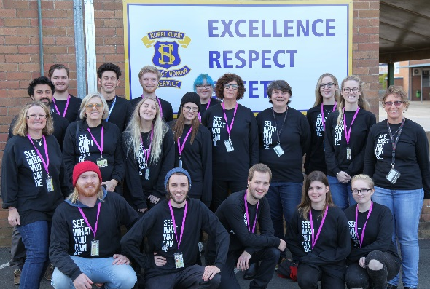
The research project has had widespread
School community impact, developing a
strong narrative of future career possibilities within the creative industries sector in these regional communities. Most schools visited published material in their publications and school network in order to facilitate the discussion around creative industries with parents. The local community engaged in positive media coverage of the events in
order to highlight the important ways Universities impact and effect School students perceptions of career opportunities.
The project presented a holistic and comprehensive approach to understanding the issues facing Schools, Teachers, Career Advisors and High School students in regional and remote when evaluating potential career options. It supported regional and remote High School students facing the prospect of decline in the traditional areas of farming, mining and manufacture to re-imagine their futures and aspire to work in Creative Industries (Rural Councils Victoria, 2014). The project provided students, teachers and careers advisors with information about the skills needed to be successful in the industry, university pathway options, what Creative Industry jobs look like and the benefits a university education can provide if you should aspire to a Creative Industries career.
Mentor Skill Development and life long learning: This project allowed for the opportunity for university students to build their skills through opportunity beyond academic skills attainable in the University. The Work integrated Learning opportunity proved invaluable to the Mentors.
Research Outcomes in Brief: The survey confirmed that the Career Advisors/Teachers gained a better understanding of the types of employment or careers that high school students may seek after university study.
Teacher/Career Teacher Comments
Question: ‘What have you learnt about the Creative Industries from viewing the video series?’
That there is more than one occupation in the creative industries.
This work shop has shown me the potential of combining creativity with more traditional career paths. It has also provided resources that I can adapt to classroom careers lessons to broaden student’s perceptions about the importance of creative industries in future employment.
That there are industry job opportunities that I did not even know existed, such as in Virtual Reality. That students can attend university to enhance learning in areas that they can develop and promote themselves initially, such as animation and filmmaking on Youtube.
The wide range of careers and possible business ideas, the different pathways students take, the trend towards remote self-employed businesses. The need for a range of employability skills.
We found that Career’s teachers have a limited understanding of future workforce needs, particularly in the CI sector and they are underprepared for changes in future workforces. They see TAFE as a pathway into Creative Industries. They acknowledged the challenges faced in rural areas around high speed internet though working remotely ‘from home’ was seen as a possibility. Career’s teachers focused on Creative Arts students– they neglected to see how the STEM disciplines could participate in Creative Industries and it’s entrepreneurial possibilities.
Did the project lead to implementable outcomes?
There is a comprehensive website with open access that embeds :
- Overall research objectives
- Youtube videos, ‘See what you can be’, High School Student films, animations and VR pitches
- Learning outcomes for teachers,
- Educational Material related to filmmaking, animation or Virtual Reality
- Links to the media coverage of the project
- Examples of the creative outcomes of workshops in video, animation and VR.
- Reflections from Student mentors involved in the project.
The website has been visited 786 times, and 2,575 page views as of 21st of November 2017. Below is a screen shot of the entry page for www.creativeindustriesroadshow.com
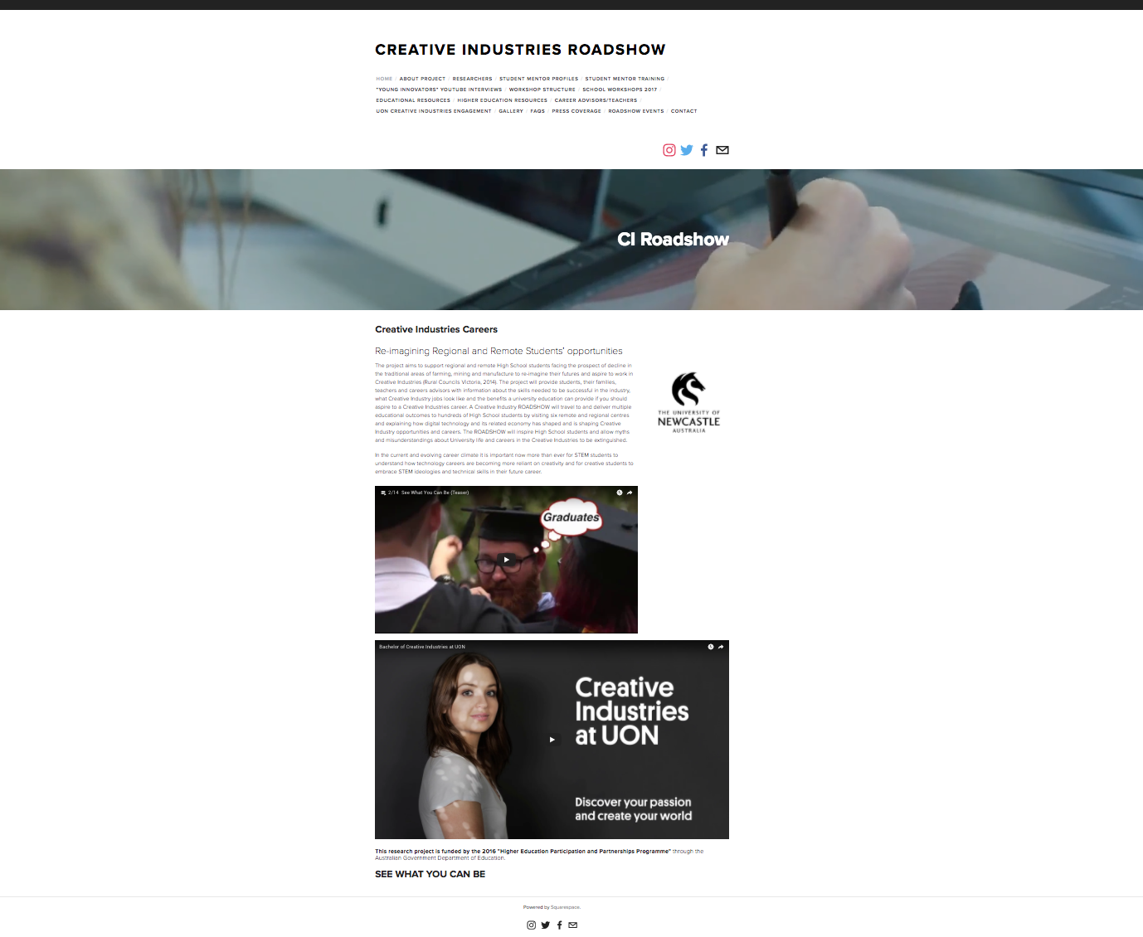
What changes will result at your institution/nationally?
The Creative Industries Roadshow project is defined as a model that can be now rolled nationally to both government and independent schools systems. This project highlights the need for professional development in regional and remote areas that includes visiting the schools and connecting with Teachers/Career Teachers to enable professional development in particular understanding how stem interests are a part of creative industries. The University of Newcastle has committed to provide ongoing support to the project in 2018 through:
- Exploration and support for an externally funded (ie ARC Linkage) grant partnering with other universities nationally. Or directly funded support from the Australian Government through Innovation in Agriculture and Regional Areas: finding to inspire students and the community through digital technologies STEM.
- providing logistical, material resources and staffing for delivery for the CI Roadshow program to independent schools and government schools in the Hunter in 2018.
- Continued provision for work integrated learning (WIL) for university students as mentors and continue the production of new learning materials features creatives from the region on an on going basis. Additional support for 12 months to maintain the global website resource and to continue to upload innovative learning resources. Ongoing access to the website will be dependant on more external funding.
- Support from the university to seed indigenous learning in the creative Industries in the regional centre of Tamworth (Gomeroi Gaaygnggal) University of Newcastle Department of Rural Health, Faculty of Health and Medicine.
- Development of more “See What You Can Be Videos” to be disseminated locally and nationally.
How is research being translated into practice?
The findings indicate that the project has been successful in shifting career advisors and teachers perceptions of the skill sets required for at secondary school level for a pathway into careers in the creative industries eg. Understanding that a computer student can find a pathway into the gaming and film industries not just a CAPA student.
The careers advisors and teachers understanding of the scope of career opportunities in Creative Industries. Previously the career advisors recommended visual arts/music teaching as the main career option for CAPA students or a TAFE Diploma in Design. Career Teachers now feel confident presenting Creative industries options to students. Shifting perceptions beyond the limited service industries (farming and mining jobs) to entrepreneurial, freelance, startups, innovation hubs or small businesses (drones in marketing and real estate).
Before you watched the 'See What You Can Be' series, which area(s) would you have most likely presented to your students as possible career pathways after school?
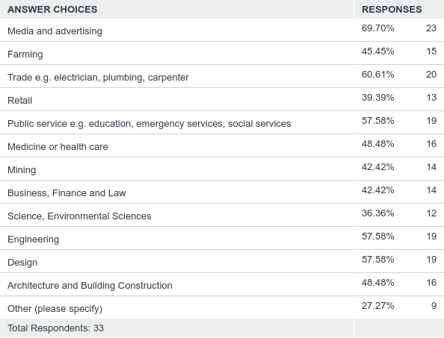
Insights: Before viewing and engaging with the workshop, sessions and videos, Teachers indicate a clear preference toward traditional career trajectories.
After watching the 'See What You Can Be' series, which of the following Creative Industries careers would you recommend as viable career options for your students.
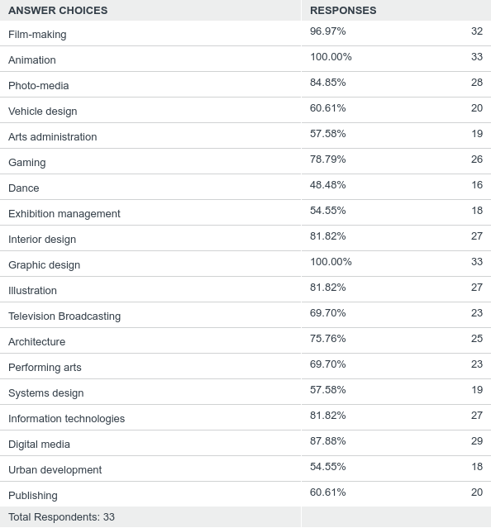
Insights: After viewing, interacting with mentors and academics in workshops and sessions, alongside viewing the video series Teachers indicate a strong shift to recognizing regional and remote students have many options for career possibilities within the creative industries sector.
Are there activities resulting from this project that will be continued?
The following activities from this project are dependant on future funding and support from schools, state and federal Government to provide this quality professional development resources for schools, community and teachers/careers advisors.

The Projects Future:
Option 1: Roll this model out to other educational sectors:
- Newcastle, Lake Macquarie, Port Stephens and Maitland NESA schools
- Hunter Catholic Education
- Hunter and Central Coast Independent Schools
Option 2:
- Directly funded support from the Australian Government through Innovation in Agriculture and Regional Areas: finding to inspire students and the community through digital technologies STEM.
- Industry Linkage options for ARC inviting other educational providers (catholic or DET) to further drive this research about future career prospects.
- Offer CI Roadshow model as a self-funded opportunity to Catholic and Independent educational sectors.
  - Conduct teacher professional development – proficiency level Professional development or beyond. Board of Studies Tertiary Education (BOSTES) Approved element to the CI Roadshow.
Option 3: Piloting an indigenous CI Roadshow model with UON’s Tamworth campus.
Did you undertake an evaluation of your project?
Yes X No

Evaluation Overview:
The project was ethnographically and qualitatively evaluated. The High School students participated in an evaluation of the workshops and information session. See - Students Anonymous - Students Participation Workshop Questionnaire. The Careers Advisors and Teachers completed an evaluation of their professional development session in an online survey see Creative Industries Roadshow Teacher Response Form. The University students participating as Mentors completed Focus Group and video testimonials and some students also completed a report for their WIL coursework see Individual mentor evaluation as part of their WiL example. The Young Innovators who participated in the ‘See what you can be’ YOUTUBE series approved the video interviews. The Research Team undertook anecdotal evaluation collected throughout the project and recorded in meetings and through the project website.
Please summarise the findings and attach the evaluation report.
Attachment 1.

Where applicable, indicate number of the following resulting from this project:
Student contacts | 602 high school students  19 university students
Journal (or other publication) submissions | Book Chapter on CI Education  Preparing Journal Articles for Journal of Creative Industries and Journal of Media Practice and Education
Conference Presentations | 2 – AARE Canberra November 2017.
Websites developed | www.creativeindustriesroadshow.com
Educational or marketing campaigns | 1 Television News Story  1 Radio Story  4 Print/online Newspaper articles  4 Online reports linked to project website.  5 School Newsletters  7 School Facebook pages  Instagram & Facebook: @seewhatyoucanbe
Community organisations engaged | 7
Schools engaged | 56
Parental/family contacts | N/A

The pre-survey data could not be collected before the CI Roadshow because of the time it took to secure ethical approval from three committees – university, indigenous and educational bodies. Hence the specific response rate targets were not able to be achieved as the timeframe for survey was completely altered and instead the pre-survey turned into a post-survey.

2. OTHER PROJECT MATERIAL (Conditions of Grant, clause 2.2 (b)-(e) of Part A)

Table 3: Additional materials produced over the course of the project
TYPE | AUTHOR | DATE OF PUBLICATION | PUBLICATION DETAILS
Pamphlet | Kristi Street
Conference Presentation | Dr Kathyn Grushka, Dr Miranda Lawry, A/Prof Maree Grupetta. | Sunday 26th November 2017 | Australian Association for Research in Educaiton Conference 2017, “The politics of Funding: Re-positioning the Arts- A Creative Industries HEPPP equity initiative case study”, 26th-30th November 2017
Conference Presentation | A/Prof Maree Grupetta. | Thursday 30th November 2017 | Australian Association for Research in Educaiton Conference 2017, “Creating Creative Industries (CI) opportunities with Indigenous secondary school students”, 26th-30th November 2017
Television | Prime 7 Local News | 31st August 2017 | https://au.prime7.yahoo.com/n3/video/-/watch/36909412/creative-industry-careerroadshow-video/
Radio | ABC Central West | 29th August 2017 | Interview of Kristi Street Project Manager
Print | Daily Liberal News, Author: Taylor Jurd | 1st September | http://www.dailyliberal.com.au/story/4895127/creative-careers-on-show-for-students/
Print | Manning River Times, author: Rob Douglas | 1st September 2017 | “Chatham High School hosted University of Newcastle Creative Industries Roadshow”, http://www.manningrivertimes.com.au/story/4892778/choosing-a-creative-career/
Print | Naomi Valley Independent, Author: Ella Smith | 6th September 2017 | “University of Newcastle’s Creative Industries Roadshow stops in Gunnedah”, http://www.nvi.com.au/story/4906042/how-a-student-takes-his-first-roller-coaster-ridefrom-his-own-classroom-video-gallery/
Print | Scone.com.au, author: unclear | 7th September 2017 | “Career Changing Ideas”, http://www.scone.com.au/career-changing-ideas/
Online | Author: CIR | July 2017 | Creative Industries Roadshow, https://www.facebook.com/seewhatyoucanbe/
Online | Ari Chand | August 2017 | ResearchGate, “Creative Industries Roadshow: Re-imaginging Regional and Remote Students’  Opportunities”  https://www.researchgate.net/project/Creative-Industries-Roadshow-Re-imagining-Regional-and-Remote-Students-opportunities
Online | Dr Susan Kerrigan | August 2017 | School of creative industries, Creative Industries Roadshow,  http://www.creativeindustriesnewcastle.org.au/category/creative-industries-roadshow/
Online | Rebecca MacKinnon | 18th September 2017 | Youtube Video, “Creative Industries Roadshow: On the road”  https://www.youtube.com/watch?v=CFyCA-LJY24&t=8s
School Newsletters | Dunedoo Central School | 11th September 2017 | Dunedoo Central School Newsletter, “The University of Newcastle Australia Creative Industries Roadshow”, http://www.dunedoo-c.schools.nsw.edu.au/cmsresources/dunedoo-centralschool/misc/2017/9/week_9_term_3_2017___11th_september__2017_1505104167230.pdf
School Newsletters | Jane Hegarty | 14th September 2017 | Merriwa High School Newsletter, “Secondary Report:Creative Industries Roadshow”,  http://www.merriwa-c.schools.nsw.edu.au/cmsresources/merriwa-centralschool/misc/2017/9/issue_29resize_1505344525717.pdf
School Newsletters | Portland Central School | Term 3 Week 8 2017 | Portland Central School Newsletter, “Portland CS & University of Newcastle Creative Industries Roadshow”,  http://www.portland-c.schools.nsw.edu.au/cmsresources/portland-centralschool/misc/2017/9/newsletter_term_3__week_8_1504847246868.pdf
School Newsletters | Gunnedah High School | Term 3 Week 9 2017 | Gunnedah High School Newsletter, “Creative Industries Roadshow Stops In”, http://www.gunnedah-h.schools.nsw.edu.au/cmsresources/gunnedah-highschool/misc/2017/9/t3w9_newsletter_web_1505280680298.pdf
School Newsletters | Wingham High School | Term 3 Issue 3 2017 | Wingham High School Newsletter, “Creative Industries Roadshow”, http://www.wingham-h.schools.nsw.edu.au/cmsresources/wingham-highschool/misc/2017/9/term_3_issue_3_1_1506048776226.pdf
School Facebook Pages | Heritage College Lake Macquarie | 10th August | https://www.facebook.com/HeritageCollegeLM/?hc_ref=ARQ2qTjGC0DVT1o7ciN06g9JM5gwsdGtV7TW2ENOSx8ruLe_QqJPb9DBfOOytOEiYiQ
School Facebook Pages | Melville High School Careers | 25th August | https://www.facebook.com/amazingcareers/?hc_ref=ARSFRkXEaM_4UUH9T-idx8-M2oIokCDcz_J_N__AFZ6oqoUaGTVAop02HN9INIv-je8 (2 Posts)
School Facebook Pages | Gunnedah High School Official | 29th August, 4th September & 13th September | https://www.facebook.com/gunnedahhighschool/?hc_ref=ARTJaKbAlZhi96szE4A3bF5BKzR8 (3 Posts)
School Facebook Pages | Gulgong High School | 30 August | https://www.facebook.com/gulgonghighschool/?hc_ref=ARTT2SXqzH8mr2PHmInSrZpoNPX
School Facebook Pages | Chatham High School – Official | 31st August | https://www.facebook.com/ChathamHighTareeOfficial/?hc_ref=ARQxIm7iXKIhvQKJYr_BDVo
School Facebook Pages | Moree Secondary College Careers | 7th September | https://www.facebook.com/Moree-Secondary-College-Careers-322498677783482/
School Facebook Pages | Merriwa Central School | 8th September | https://www.facebook.com/MerriwaCentralSchool/?hc_ref=ARSvsdIjKC9x2InXZ3H7m658HT

3. ACQUITTAL REPORT (Conditions of Grant, clause 6.4 (a)-(d), clause 6.5 (a)-(b) of Part A)
Have you fully expended the Grant Funds provided under the Conditions of Grant?
Yes No X
If the answer is No, please specify:
- the amount of funds remaining: $11,152.08
- the reason for this underspend: Underspend in the area of administration.
Ensure that the completed Acquittal Report template is signed by an appropriate university officer and attached to this Final Report.
*IMPORTANT NOTICE - Unspent 2016 National Priorities Pool Grant Funds
- Grant recipients must fully expend these 2016 National Priorities Pool funds in the project period for which the grant is made and report on this expenditure to the Commonwealth, including the amount of any unspent funds.
- If a provider fails to spend the full amount granted it in respect of a year, the unspent funds may be recovered by the Commonwealth.

DECLARATION
I declare that:
- I am authorised by the university to sign this Declaration on its behalf, and
- to the best of my knowledge, the information that I have provided in the Final Report and Acquittal Report for the HEPPP 2016 National Priorities Pool project: Creative Industries Careers: Re-imagining Regional and Remote Students’ Opportunities is true, correct and accurate in all particulars.
I understand that:
- The provision of false or misleading information or the making of false or misleading statements to the Commonwealth is a serious offence under the Criminal Code Act 1995 (Cth).
- If any actual or potential conflict of interest arises, I must notify the Commonwealth immediately in writing of the facts giving rise to the actual or potential conflict of interest and to take such steps as the Commonwealth may require so as to resolve or otherwise deal with any conflict of interest that may arise.
I agree to publication of the Final Report on the Department of Education and Training website, once accepted by the department.

Title Professor
Name Darrell Evans
Position Deputy Vice-Chancellor (Academic)
Signature

The University of Newcastle- Centre of Excellence for Equity in Higher Education (CEEHE) You Tube Chanel (found below): https://www.youtube.com/watch?v=OLEmGjhQUtI&list=PL-XMm0O56R5mqX4ORR-UuHxWAV9X39cUX

