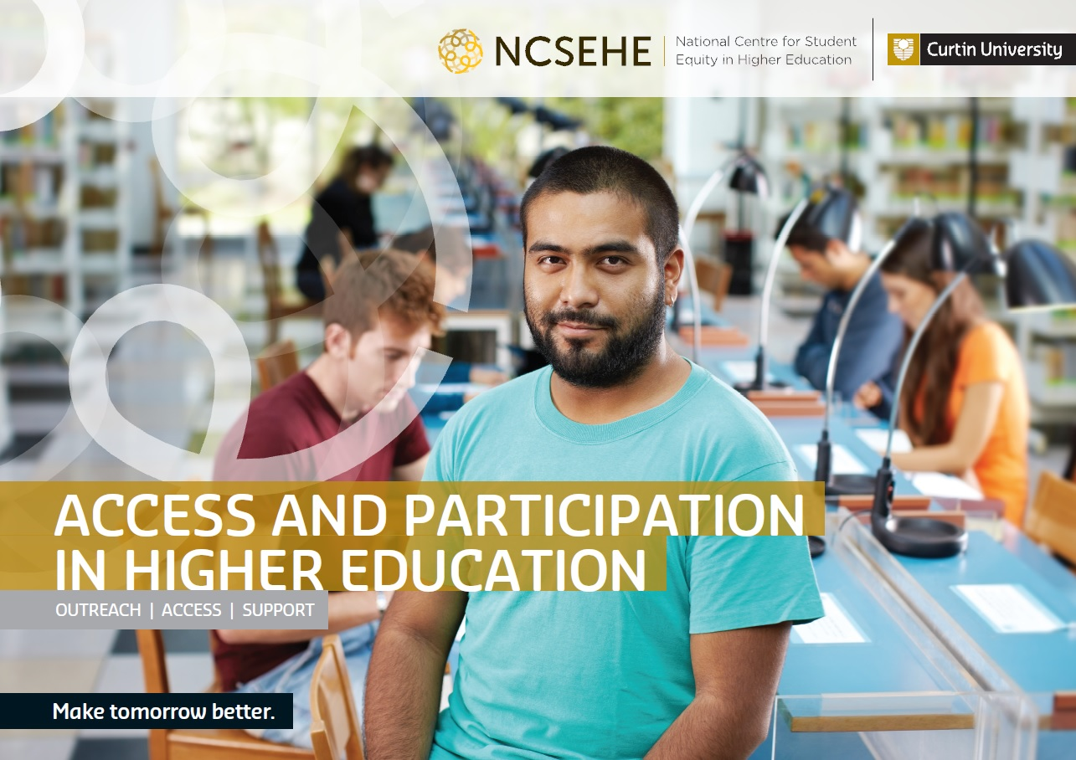

Access and Participation
in Higher Education

National Centre for Student Equity in Higher Education, 2013

ACKNOWLEDGEMENTS
This publication could not be completed without the work of a dedicated team of people and the support of the Australian Government Department of Education.
Sincere thanks go to Louisa Bowman, the Centre’s Web Media & Communications Officer for coordinating the publication, to Kitty Drok of Transmogrify for text editing and to Ken Bowman and Rachael Young of Lodestone Pty Ltd for graphic design.
Thanks must also go to the many people from each university involved in sharing their current practice case studies which we proudly share here with you in this publication and on the web at: ncsehe.edu.au

COPYRIGHT INFORMATION
© Curtin University 2013
Except as permitted by the Copyright Act 1968, this material may not be reproduced, stored or transmitted without the permission of the copyright owner. All enquiries must be directed to Curtin University.
Curtin University is a trademark of Curtin University of Technology
CRICOS Provider Code 00301J (WA), 02637B (NSW)
ISBN 978-0-9923560-0-2 Print
ISBN 978-0-9923560-1-9 Digital
Funded by the Australian Government.

Contents
Preface 4
Meet the Professor 5
ANU Regional Partnerships Program 7
Enquiring Minds 9
Facilitated Distance Education Program 11
Into Uni: Learnline in Colleges 13
Student Success Team 15
StepUp to Curtin 17
Work Placement Program 19
ECU Mates 21
Regional Schools Outreach Program 23
Inspire e-Mentoring 25
Griffith University 27
Get Into Uni 29
Uni Bridges 31
Learn, Experience, Access Professions (LEAP) 33
LEAP Macquarie Mentoring Program 35
Improving Selection for Social Inclusion 37
First Year Advisor Network 39
Robotics@QUT 42
I Belong 44
Southern Cross University 46
Student Support Program 49
Adelaide Compass 51
UC 4 Yourself 53
Telescopes in Schools 55
The First Year Experience Strategy 57
The ASPIRE Program 59
Open Foundation by Distance 61
UQ Young Achievers Program 63
UniSA College 65
Dream Aspire Reach Experience (DARE) 67
Compass — Your Way to Higher Education 69
University Preparation Program 71
U@Uni Summer School Program 73
The Creative Writing Excellence Program 75
Aspire UWA 77
Fast Forward Expansion 79
The In2Uni Program 81
AVID Australia 83
List of Acronyms 85
About the Centre 87
Disclaimer 88

Preface
Professor Sue Trinidad PhD
Director
National Centre for Student Equity in Higher Education
Australian universities have long demonstrated a strong commitment to student equity and to increasing the participation of people from equity backgrounds. This was also a key recommendation from the Bradley Review (2008). The Higher Education Participation and Partnerships Program (HEPPP) was set up to fund a range of university participation and partnership initiatives.
Through HEPPP funding, Australian universities have been able to provide opportunities to students from under-represented backgrounds who have the ability to study at university, to actually do so.
Thirty nine case studies are presented here, demonstrating Australian universities’ commitment to improving the access, participation and success in higher education of students from equity groups. The case studies share current practice used by universities to reach prospective university students (outreach), help get them into university (access), and provide the support once the students commence, improving the retention and completion rates of those students.
The range of case studies featured here illustrate the multiple initiatives and is an opportunity to share current practice that enhance equity students’ awareness, educational aspirations, access to and success in higher education across Australia. Such initiatives inform and expose school students and other prospective university students to the opportunities that higher education can offer. A variety of entry pathways enables those equity students who desire to participate to have the capacity to apply for and successfully enter undergraduate study at university. A range of support services, such as mentoring and tutoring programs, ensure all students have the best chance of succeeding in their studies.
Australian universities have been able to provide opportunities to students from underrepresented backgrounds who have the ability to study at university, to
actually do so.

Meet the Professor
Australian Catholic University
Outreach
ACU is committed to yearly reviews of Meet the Professor, involving both internal and external partners.

Description
Meet the Professor was developed by Australian Catholic University (ACU) for Grade 5 and 6 students. These students are invited to participate in a tour of their local ACU campus, where they can meet staff and students and participate in activities related to university life. They have the opportunity to meet a professor; we ask a senior academic to be part of the day. The professor interacts with the students, talking to them about university and what it entails, its benefits and how you can access university. The students meet with ACU students who lead them in numeracy and literacy exercises, exercise science activities, health school activities, observing paramedicine activities and others.

Objectives
The major objective is for students to experience being on a university campus, participate in educative and interactive activities and speak to students and staff at the university who can inspire then to think about education as an exciting and engaging pursuit.
This achieves our goals of demystifying higher education for target groups, enabling students to reflect on the importance of education and sowing the seed of university as a positive and achievable option for their future.

Funding
This activity is fully funded by HEPPP Component B competitive and base funding. In addition, our partner schools, teachers and parents provide in-kind support.
Before doing the program the majority showed little interest in university, afterwards the majority showed interest.

Measurement
The Equity Pathways team have developed evaluation tools for the program. For primary grades we ask teachers and parents who have attended to fill out an evaluation questionnaire. Students are not directly questioned, more reliance is placed on adult response to the activity. However, we do ask for some student response, represented below.
Of the 1,128 participating primary students in 2013 up to August, findings were:
- Before: the majority showed little interest in university.
- After: the majority showed interest in university.
- Before: very few students understood the requirements for attending university.
- 91% understood what was required to attend university.
Students were asked to either draw or write a response to “MY BIG DREAM IS..........”. Responses include:
“Become an independent woman that finishes all her goals who becomes remembered and gets good grades and goes to Brigidine and tries everything and becomes students council president. Never gives up (has a great education and a great legacy).”
“To be a lawyer or a photographer. If not just work in a shop.”
Being a sportsperson accounted for at least 20 per cent of student responses and being a singer or actor, 10 per cent. Other responses fell into an even range of career categories including teacher, vet, doctor, nurse, policeman, chef, lawyer, engineer, architect, author, artist, pharmacist, pilot, astronaut and zookeeper.

The Future
ACU is committed to yearly reviews of Meet the Professor, involving both internal and external partners. The outcomes of these reviews will determine further program development. Both ACU and its partners will be responsible for fostering the program’s development and continuation.

ANU Regional Partnerships Program
Australian National University
Outreach
Access
90 per cent of the teachers believe that the program has impacted their students aspirations and participation in higher education.

Description
The ANU Regional Partnerships Program commenced in 2009 as a pilot program as an important part of the University’s engagement with its surrounding regions. Fifteen schools in the southeast region of NSW are currently in the program, a region which is relatively close to Canberra but where there is sometimes a perception that university is not relevant or accessible. The ANU Regional Partnerships Program seeks to dispel this perception, primarily through presentations from ANU academics and staff within Halls of residence, and ANU Community Ambassadors who are current students, many from regional areas themselves. These volunteers are trained and supported by our education team; professional staff with a range of discipline backgrounds and teaching experience.
The program consists of a number of school-based programs and ANU campus and residential programs that provide educational enrichment to school students from primary schools through to year 12, community based partnerships, an admission package to support entry to ANU, and transition grants that support the move to Canberra. In 2012, current ANU students also established the Regional, Rural and Remote Students’ Society that helps with the transition to university upon arrival.

Objectives
The ANU Regional Partnerships Program raises awareness about university study, enhances educational outcomes for students from its partnership schools and encourages consideration of university as a post-school option.
Schools appreciate the opportunity to visit the university ‘to see and feel what a university is like’, and the contact with ANU students.

HEPPP Funding
Outreach and on-campus activities are currently supported by the HEPPP. Initially transition grants and support for information and administration for the admissions package were also supported by the HEPPP, but these are now supported by the ANU.

Measurement
In 2012, the ANU Regional Partnerships program had direct contact with over 7,000 regional school students.
- 15% increase of university offers (all University Admissions Centre (UAC) universities) indicated by UAC data from partnership schools
- 24% increase of actual enrolments since the 2010 intake
- 27% increase in offers to the ANU since 2010
- 28% increase in enrolments since 2010
Quantitative and qualitative evaluations are conducted for individual projects and all schools involved have been asked to evaluate the impact of the program on their students. Findings indicate that schools value the partnership highly and appreciate the variety of activities available, the opportunity to visit the ANU ‘to see and feel what a university is like’, and the contact with ANU students.
The program raises awareness about university study, enhances educational outcomes for students from its partnership schools and encourages consideration of university as a post-school option.
Teachers have commented on the positive impact the Community Ambassadors have on their students as role models, and how effective Ambassadors were at delivering information about admission and transition to university.
“As we are dealing with adolescent students, they appreciate the opportunity to discuss learning with people they see as peers, but people they admire and look up to.” — Teacher comment about the effectiveness of Community Ambassadors.

The Future
Whilst the admissions package has now been embedded into the admissions policy of the ANU and transition grants are covered by the ANU endowment, the sustainability of the broad range of on-campus and outreach activities is of concern.

Enquiring Minds
Bridges to Higher Education
University of Technology Sydney
Macquarie University
University of Western Sydney
The University of Sydney
Australian Catholic University
Outreach
Enquiring Minds has already been broadcast to 1.4 million viewers across Greater Western Sydney.

Description
Enquiring Minds is an 11-part television series developed to inspire 7–12 year-olds to think about where their passions and interests could take them in the future. The series was developed by Television Sydney on behalf of Bridges to Higher Education and was launched in March 2013.
The television series is supported by a fully interactive website with teacher curriculum support and an online game for children. The resources for schools have been mapped against the Australian Curriculum and developed alongside primary school teachers to offer downloadable lesson plans for use in the classroom. The website hosts each segment from the TV series online, as well as extras including transcripts, biographies, study pathways, and an online game.
The series features the experiences of 21 primary school students meeting inspirational university students and professionals who have successfully established a career by following their passions.
Enquiring Minds is designed to sit alongside widening participation initiatives and through an enriched learning experience, to give students a real-life picture of how their academic skills, their passion and motivation could frame their future.

Objectives
To inspire young people between the ages of 7 and 12 from communities under-represented in higher education to think about how their passions and interests can be turned into careers through education.
Enquiring Minds is an 11-part television series developed to inspire 7–12 year-olds to think about where their passions and interests could take them in the future.

HEPPP Funding
Enquiring Minds has been funded through the Bridges to Higher Education initiative as part of the HEPPP Partnerships component competitive grant process. The Bridges to Higher Education initiative is funded from December 2011 to December 2014.

Measurement
Enquiring Minds has already been broadcast to 1.4 million viewers across Greater Western Sydney. It will be broadcast to a further 4.5 million viewers across Australia through Australian Community Television Alliance affiliates in Brisbane, Melbourne, Perth and Adelaide.
The launch of the series generated a high volume of local media interest and the website generated in excess of 3,000 hits in the first month. The series has been distributed to over 1,000 schools across NSW to date, as we continue to roll out our distribution plan. The reach and impact of the program are being monitored as part of the Bridges to Higher Education Evaluation Framework.
The television series is supported by a fully interactive website which hosts each segment from the TV series online, with curriculum-mapped resources for schools and an online game for children.
Feedback from schools to date has been extremely positive. To see a short video about how this school used the resources visit: www.bridges.nsw.edu.au/resources
“Matthew and his classmates have been so inspired by this experience we have decided to dedicate our whole Term 2 learning on doing the same idea but for all the students in our class. This has really inspired me as a teacher”. — primary teacher.

The Future
Distribution of the resources to schools and networks will continue, as well as syndication locally, nationally and potentially internationally. Bridges partner universities continue to integrate this program into their widening participation strategies. We welcome the adoption of these tools and resources by colleagues across the tertiary sector.
The Bridges partner universities are:
- Australian Catholic University
- Macquarie University
- University of Sydney
- University of Technology, Sydney
- University of Western Sydney.

Facilitated Distance Education Program
CQUniversity
Support
Students identified the importance of synchronous online sessions to support their learning.

Description
CQUniversity has developed a number of learning and teaching programs in targeted schools/faculties where participation rates of students from low socioeconomic status (LSES) backgrounds is high. These programs assist with the transition to university and provide scaffolded opportunities within the curriculum to improve online engagement, academic literacies, technological skills and access to tailored student support services.
The aim of these projects is to improve participation and retention of undergraduate
students from LSES backgrounds
One example is the Facilitated Distance Education Program, supporting commencing students undertaking a fully distance program of study in the School of Education and the Arts.
The program is characterised by regular two-way communication between academics
and students and active integration with support agencies. There is also a program of professional development for academic staff, ensuring a consistent approach to curriculum implementation, facilitation skills, support strategies and project objectives. This is achieved through regular synchronous online tutorials using the web conferencing tool, Blackboard Collaborate.

Objectives
Attrition of distance students at CQUniversity is high. This is predominantly due to socio-economic and demographic factors that are well known as influences on regional university students. The aim of this program is to provide a model of distance education that is responsive to the needs of the diverse student cohort (situated in regional LSES communities) undertaking a fully online program in their first year of study.
Attrition of distance students was a third of the attrition of the face-to-face cohort.

HEPPP Funding
The academic position of distance facilitator was fully HEPPP funded as a secondment in the School of Education and Arts. The Distance Facilitator’s duties included:
- checking student enrolment patterns, contacting all commencing students by telephone within the first two weeks of term if issues had been identified through a Student Readiness Questionnaire
- contacting commencing students by telephone within the first three weeks of term and establishing a support network
- a series of weekly emails providing staged, just-in-time information, advice and support for students
- a program of peer support through experienced senior student mentors
- development of technological and pedagogical skill in the online synchronous environment for all academics.
Other initiatives, including the design and facilitation of online courses, are ongoing.

Measurement
Student retention in the target cohort was significantly higher than the university average for distance learners.

Retention
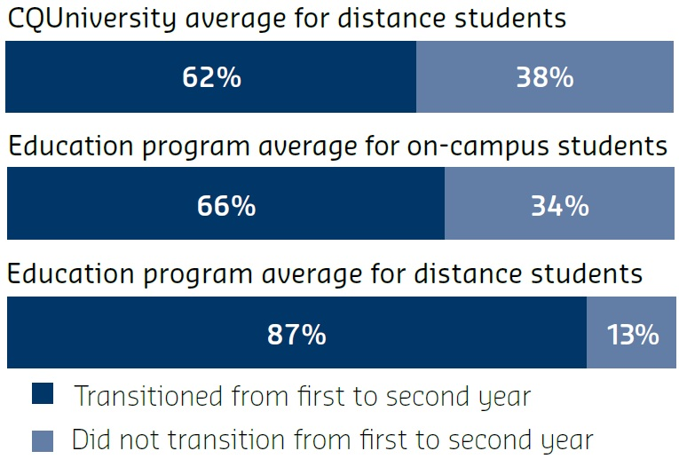
Formal data from students and academics identified the value of synchronous sessions in particular as being highly supportive of their learning in terms of:
- being supportive of diversity and flexibility needs
- developing a sense of belongingness, transition and engagement
- scaffolding of assessment – clarity and task expectations
- self-evaluation and monitoring by benchmarking their progress against that of others
- developing a sense of enjoyment, social and intellectual engagement in their courses.
Embedded assessment in small weekly tasks led to the early identification of students at risk, effective scaffolding of their learning and approach to assessment, higher grade averages on this assessment task, and excellent attendance of weekly synchronous tutorials.
Participation and engagement has been enhanced and improved.

The Future
The program has been successful in enhancing a model of teaching and learning that supports and engages with a diverse range of students who are new to tertiary learning and distance education. This model continues to be implemented in the school. Further research to enhance engagement of students in online learning through constructive alignment of embedded tasks with assessment is under examination.

Into Uni: Learnline in Colleges
Charles Darwin University
Outreach
Thirty curriculum units are live with over 700 students enrolled.

Description
Into Uni is a three-year program at Charles Darwin University (CDU), funded by the HEPPP and run in partnership with Kormilda College in Darwin, and Centralian Senior College (CSC) and Centralian Middle School in Alice Springs (schools with significant numbers of Indigenous students). Into Uni encourages Indigenous students, particularly those from lower socio-economic backgrounds, to complete school and progress into higher studies.
An important part of this encouragement is the removal of systematic barriers. A major feature of higher education is the use of online Learning Management Systems (LMS – CDU’s is called Learnline). Students can find using an LMS daunting, particularly if they have limited previous experience with them. Anecdotal evidence suggests that the LMS is a deterrent to university for people more familiar with traditional face-to-face methods of learning. Even students who do progress to CDU can find using Learnline difficult, sometimes leading to withdrawal from study.
Effective use of an LMS can significantly enhance access to quality content, learning activities, peer interaction, and facilitate more targeted monitoring and support of student progress by academic staff. Almost all higher education units at CDU are supported with Learnline.
One Into Uni project is Learnline in Colleges (LLiC). This project brings Learnline into Kormilda College and CSC, to demystify the technology by introducing it to students in a familiar classroom setting. This is enabled through CDU sharing access to Learnline (including technical and user support) and providing professional development for staff.
Maintaining study can be a challenge for Indigenous students drawn back to their communities for extended periods.

Objectives
There are several objectives to LLiC:
- to assist school students to develop effective study skills using Learnline and associated digital technologies and resources
- to engender in school students a positive view of LMS-enabled learning
- to thereby remove concerns of students and their families about LMS as a barrier to their higher education aspirations
- to facilitate a smooth transition from school into university study.
To achieve these objectives, two collateral objectives are to:
- support schools in improving their teaching design and delivery using Learnline
- improve CDU’s understanding of Learnline through learning from the schools’ experiences.

HEPPP Funding
LLiC is fully funded by the HEPPP, providing licences, continuous helpdesk support, time-release for staff to develop their online units and resources, and professional development.

Measurement
Key input and process measures for LLiC are student and staff satisfaction with Learnline, and the uptake of Learnline in schools.
Key outcome measures for LLiC are:
- changes in attitudes (using focus group methods) towards university study
- tracking the change in the number of Indigenous students who enrol in higher education courses in future years and the retention rate within these courses.
The program is currently 60 per cent complete. As at September 2013, 30 curriculum units are live with over 700 students enrolled. An additional 600 students are enrolled in an orientation unit. Student feedback to date has been very positive, however it is too soon to measure the impact of the project on progression.
- 41% of Northern Territory students identified as Indigenous in 2010
- 47% of Indigenous students progress to year 12, compared with 79% non-Indigenous nationally
Learnline in Colleges demystifies the technology by introducing it to students in the context of a familiar classroom setting.
1,400 secondary students enrolled in at least one Learnline unit in 2013.
120 teachers are receiving professional development in online learning methods and strategies.

The Future
Maintaining study can be a challenge for Indigenous students drawn back to their communities for extended periods. In addition to the core LMS, Learnline includes a range of associated interactive technologies including Learnline Mobile. The next step for LLiC is to explore how these technologies may assist students in maintaining contact with their school and studies while they are not on campus.

Student Success Team
Charles Sturt University
Support
Since 2011 the SST has provided both proactive and reactive support to students from LSES backgrounds.

Description
The Student Success Team (SST) supports students in their first semester at Charles Sturt University (CSU) through proactive contact campaigns.
The SST runs five campaigns each semester including:
- Welcome to CSU
- CSU Check-Up
- Failed Subject
- Risk of Exclusion
- Exit Interview.
The SST is staffed by specially trained (and paid) students from a purpose-built call centre on the Bathurst campus. These students are selected for their communication skills and are representative of the CSU cohort, spanning a variety of disciplines, ages and study modes, including distance education. In each campaign the SST phones students to discuss their situation, provide advice from their unique student perspective, and recommend specific CSU support services that are appropriate for their individual circumstances. Students receive a customised follow-up email with links to the support services discussed. Students who cannot be reached by phone receive a similar email and an SMS message. SST feedback from campaigns is provided to the broader CSU community for further action where appropriate.
Since 2011 the Student Success Team has provided support over the phone to 7,869 students, and emailed a further 6,650 students that could not be contacted via phone.

Objectives
The SST’s main objectives are to:
- assist students from LSES backgrounds make a successful transition into university
- provide support to students who show signs of disengaging from their studies.

HEPPP Funding
The SST has been HEPPP funded since its inception in 2011. Based on the success of the pilot, the SST has also secured Student Services Amenities Fee funding expanding its scope to include enhanced orientation for Distance Education students.

Measurement
The SST has experienced considerable growth since its inception. The number of students it has supported each year is represented below.
CSU recognises that LSES students enter university with diverse socio-cultural capital. Targeted support during the critical transition period assists students to master the role of student and bridge this socio-cultural incongruence.
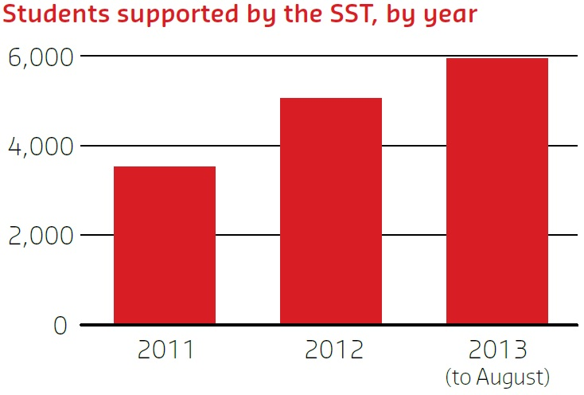
In each campaign the group of students contacted via phone has a reduced rate of withdrawal in the vicinity of 2–9 per cent, compared with the group that the SST could not contact.
Students contacted by the SST by phone exhibit a lower rate of withdrawal and finish the session with a higher average Grade Point Average (GPA) than those students unable to be contacted (on average 3.5 per cent fewer withdrawals and an increase of 0.5 points GPA on a 7-point scale).

The Future
Based on the initial results from the SST, CSU are working towards integrating this project into the CSU learning analytics strategy and ensuring that the work of the SST becomes embedded into organisational practice.
“I was very grateful for the call. Really appreciated, and feel much more comfortable about my upcoming studies. The follow up email was fantastic too. Great information, very helpful and exceptionally welcoming. Thank you.” — CSU student.

StepUp to Curtin
Curtin University
Access
Support

Eighty one per cent of currently enrolled StepUp students are succeeding academically.

Description
StepUp to Curtin is one of many equity initiatives at Curtin University funded by HEPPP working to break down the barriers to higher education. Curtin recognises everyone should have the same opportunities to achieve their true academic potential regardless of their background. StepUp addresses this gap by automatically identifying students from equity target groups and offering them the opportunity for admission into Curtin courses they may otherwise miss out on. StepUp then provides further assistance during the application and admission stage in areas proven to support academic achievement such as housing, scholarships and book grants.
Students who have the potential to succeed at university but who may have experienced adverse circumstances affecting their ability to reach Curtin’s required Australian Tertiary Admission Rank (ATAR) entry level are StepUp’s target group. Since 2010 and the introduction of the program, we have seen a five-fold increase of student offers, acceptance and retention. StepUp has also built partnerships and identified research gaps in reaching eligible students. Ongoing project evaluations have produced deeper understandings of the interaction between successful outcomes, seed funding and existing resources.
Enhancing Curtin’s former Principals Recommendation Program using HEPPP guidelines allowed Curtin to improve on existing relationships and increase community awareness of educational, financial and social opportunities for students from disadvantaged backgrounds. These changes are helping students to access and excel at Curtin, regardless of their background.
Curtin recognises everyone should have the same opportunities to achieve their true academic potential regardless of their background.

Objectives
StepUp’s main objectives are:
- to create an inclusive entry pathway for eligible Australian, NZ, permanent and humanitarian resident applicants with a 60–69.95 ATAR
- to support the achievement of Curtin’s Student Equity Strategy 2010–2014 through participation that recognises and supports students from disadvantaged backgrounds with potential to excel in higher education.

HEPPP Funding
The Social Inclusion Project Coordinator who coordinates StepUp has been fully funded by HEPPP since 2010, along with project costs allowing for outreach, access and retention schemes.

Measurement
The success of StepUp is measured by the number of students enrolling through StepUp and their retention. From 2010 to 2013, 916 students were offered a place at Curtin through StepUp out of which 719 students accepted or deferred their offers. Curtin has since retained 80 per cent of students who gained entry through StepUp and 81 per cent of currently enrolled students are succeeding academically.

Retention
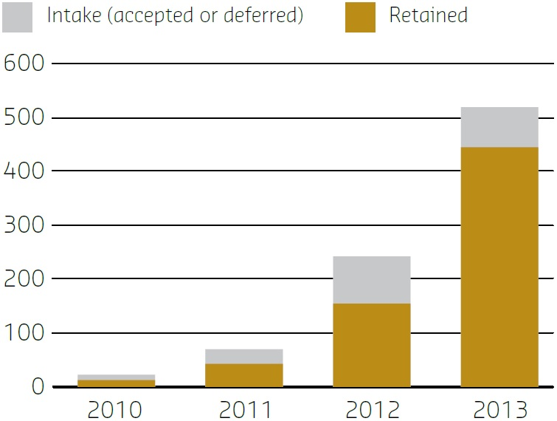
Since 2010 and the introduction of the program, we have seen a five-fold increase of student offers, acceptance and retention.

The Future
Research scoping to further expand the low socio-economic status criteria to reach a wider disadvantaged community has already begun. Curtin will continue to develop cross-platform and cross-sector statistical methods to identify eligible students, partnership structures to increase school awareness of StepUp, and improve academic staff awareness and engagement with the project.
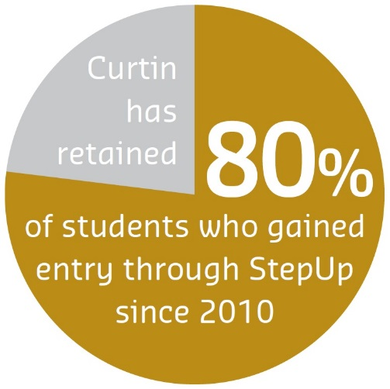

Work Placement Program
Deakin University
Support
Since 2011, over 300 students have benefited from arranged work placements or bursaries.

Description
Deakin University is committed to making higher education accessible to those who may not otherwise have the opportunity, including providing a rich and relevant student experience.
Many students experience challenges in accessing career and CV-building experiences whilst at university, including those from LSES backgrounds. Students may lack awareness of opportunities and appropriate connections and support to access available opportunities. They may also have financial difficulties or be reliant on part-time employment.
The HEPPP has enabled Deakin to develop targeted programs to assist students in finding and undertaking work placements, addressing the specific challenges of income replacement, awareness, application and preparation.
- The Work-Integrated Learning Bursaries program provides financial support for completing compulsory placements that are credited towards a student’s course.
- The Work Placement Program offers students paid, four-week work placements, as well as career planning support.
There are several videos which highlight the benefits of the Work Placement Program available at: deakin.edu.au/equity/work-placement-program.php
The bursaries and placements have enabled participation in CV-building experiences, reduced financial stress and increased career readiness.

Objectives
The main objectives of the programs are to increase tertiary retention and completion rates, and improve graduate outcomes through increasing participation in work experience by students from LSES backgrounds.
The programs aim to develop students’ career planning skills and confidence, as well as their understanding of workplace behaviours, in preparation for graduate employment. They also financially enable students to undertake compulsory placements.

HEPPP Funding
The programs are entirely HEPPP funded, with most of the money spent on bursaries and student wages. Some funding also supports host organisation supervision payments and employing coordinating staff at Deakin.
“This program is a brilliant opportunity for students to experience their desired workplace and decide if they have chosen the right path for their future endeavours. It allows students to achieve their goals and dreams of completing work experience/internships where they choose.” — Nicole Nash, student

Measurement
Over 300 students have benefited from the programs since 2011. Evaluation has shown the positive impact they are having. Bursary recipients have achieved above average grades in their work-integrated learning units. All participants have either graduated or continued with their course, so the program has a 100 per cent retention/completion rate to date. Many students and graduates have secured employment with their host organisation.
Individual feedback from students indicates that the bursaries and placements have enabled participation in CV-building experiences, reduced financial stress and increased career readiness.
For example, the bursary allowed a student to undertake a placement researching sites for a coral restoration program.
The host organisations have also provided positive feedback, with all keen to offer future placements.
The program has a 100 per cent retention/completion rate to date.

The Future
There is great demand for placements and bursaries, and Deakin will expand the programs to enhance retention and completion rates. As more data become available via the Graduate Destination Survey, Deakin will be able to track the impact of the program on graduate outcomes and the longer-term career progress of the target cohort.

ECU Mates
Edith Cowan University
Outreach
Access
The merit and successes of this program have resulted in requests from other schools to join the program.

Description
ECU Mates is an innovative program that trains Edith Cowan University (ECU) students to become ‘mates’ and mentor lower secondary school students from partnership schools in low socio-economic areas. The program provides guidance, friendship and educational support to these students who are currently unlikely to undertake higher education.
In the first year of the program, 50 highly motivated and trained ECU Mates mentored 150 secondary school students from across six schools. Approximately 400 small group sessions were conducted by ECU Mates with students covering:
- advice on school subjects
- homework and study
- handling peer pressure
- practising mock interviews for part-time work
- conducting ‘safe’ science experiments
- learning more about university life.
At the end of the year, all students attend the ECU Mates Day where they tour the university campus, attend ‘fun’ lectures and discover more about university courses that interest them.
ECU Mates is an innovative program that trains ECU students to become ‘mates’
and mentor lower secondary school students from partnership schools in low socio-economic areas.

Objective
The main objectives of ECU Mates are:
- to provide an inclusive mentoring program targeting lower secondary students at educational risk from identified low Index of Community Socio-Educated Advantage schools and who rarely receive funding support
- to provide socio-emotional and educational support, in implementing resilience strategies to promote success at school and later into higher education
- to reinforce both the HEPPP objectives and ECU’s Engaging Minds: Engaging Communities: Towards 2020 document with the long-term goal of ‘facilitating positive contributions to our communities by our students, graduates and staff’.

HEPPP Funding
HEPPP funding has supported a part-time coordinator for the program and other costs including training, delivery and administration. The program has also been supported by substantial volunteering efforts from other ECU staff and the ECU students.
Approximately 400 small group sessions were conducted by ECU mates with students.

Measurement
Co-founders, Dr Deborah Callcott and Dr Judy Esmond, believe the program has exceeded expectations. Preliminary qualitative data is reinforced by positive feedback from students, ECU Mates, school personnel and parents. A letter from a parent to a participating school best sums up the program’s value:
“I would like to express my appreciation. My son has been very fortunate in having access to this program. He has had quite a big adjustment to high school life and has had times when things seemed quite overwhelming for him. Having someone to talk to at school where there are no judgements, just friendship and compassionate communication and understanding has had such a positive influence on him. He looks forward to the days when he is going to see his ‘Mate’. I would like to thank you for enabling such a great program and I hope that this is something that is continued throughout the years.”
Evidence from participating schools has also demonstrated reductions in school absenteeism and behavioural issues. Further, there has been a 75 per cent increase in students now considering university study after attending the program.

The Future
The merit and successes of this program have resulted in requests from other schools to join the program. The goal is to undertake further intensive research and continue to expand, doubling the number of students and ECU Mates who all benefit greatly from the program.
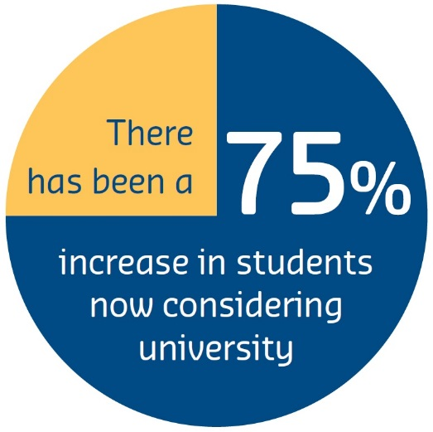

Regional Schools Outreach Program
Federation University Australia
Outreach
A key feature is the involvement of student ambassadors who co-deliver in-school and on-campus sessions.

Description
The Federation University Australia’s Regional Schools Outreach Program (RSOP) works in partnership with 49 regional western Victorian schools, to address the interplay between geographic and socio-economic factors which result in lower rates of access to higher education of regional and remote students, compared to those from metropolitan areas.
Since 2007, the RSOP has developed and expanded its work with school students and their families, delivering a wide range of in-school, on-campus, and more recently online, activities. These activities are age-specific (working across Years 5-12) and respond to the many barriers facing regional, remote and LSES students in completing secondary school and in accessing higher education. A key feature of the RSOP is the involvement of student ambassadors (currently 50 regional Federation University Australia students) who co-deliver the program, providing real points of contact for information and inspiration.
“I am so glad that I have been in this session today. I thought that … university is only for [really smart] students and it costs lots, but now I know that there are ways that I can go if I want.” — student.
Federation University Australia is the amalgamation of the University of Ballarat and Monash Gippsland campus as of 1st January 2014.
Evaluations consistently report the success and relevance of the Regional Schools Outreach Program for the schools it works with, along with a demonstrable change in interest towards higher education.

Objectives
The overarching aim of the RSOP is to increase access to higher education among students from regional/ remote and LSES backgrounds in western Victoria.

HEPPP funding
The RSOP is fully funded by HEPPP (until the end of 2014), as one of 11 HEPPP programs in Australia funded through the first round of the HEPPP Partnership competitive bid process.
“Since the RSOP came and spoke at the school … [university] doesn’t seem as scary as I thought. It would increase my options.” — student.
“I’m more confident to help my daughter now. With our support it will really give her the boost she needs.” — parent.

Measurement
The RSOP conducts annual internal evaluations to measure reported shifts in students’ aspirations, and the effectiveness of programs and activities. These evaluations consistently report the success and relevance of the RSOP for the schools it works with, along with a demonstrable change in interest towards higher education. Student, teacher and parent evaluations are consistently positive about the RSOP’s impact.
“When no-one in the family has gone [to university] before, it’s really hard. This has helped us and students equally as much.” — parent.
“For many of our students the RSOP demystifies university. It creates a new conversation for them.” — teacher.

The Future
The future development and responsiveness of the RSOP will be informed by an external longer-term evaluation currently underway, looking at qualitative data from RSOP students, parents, principals and teachers, and quantitative data on RSOP school students’ applications to higher education, and school retention.
“We had a student who had never contemplated university who now considers it as a possible pathway in the future. If he didn’t experience university through this program he would most likely have lived his entire life without ever setting foot inside one.” — teacher.
There will be further development as outreach activities in the Gippsland region of Victoria come under the banner of the new Federation University Australia in 2014.

Inspire e-Mentoring
Flinders University
Outreach
Access
Participating schools suggest over 70 per cent of students participating in Inspire e-mentoring continue to engage in their education.

Description
Flinders University’s Inspire Mentor Program has been raising the aspirations of children and young people from LSES communities for 10 years. The Inspire e-mentoring program, which commenced in 2011, now extends mentoring relationships to students in rural and regional Australia with the aim of raising aspirations and considering pathways to higher education.
Flinders University partnered with the Department for Education and Child Development (DECD) in the delivery of e-mentoring for secondary students from rural and regional locations in South Australia who have the potential to undertake tertiary studies, but are at risk of disengaging with education. Inspire e-mentoring enables students to explore learning pathways with current undergraduate and post-graduate e-mentors engaged in the tertiary environment. This connection is powerful in developing the understandings and aspirations of students considering their learning and career choices.
Inspire e-mentoring uses Saba Centra 7, an online learning platform, to provide a safe and secure environment for mentors and mentees to communicate. E-mentoring sessions are monitored and supported by DECD project staff, ensuring a safe and productive relationship for mentees and mentors. Inspire e-mentoring culminates annually with a visit to the Flinders University campus for mentees to experience life as a university student, participate in on-campus activities, and meet and interact with their mentors.
Inspire e-mentoring enables students to explore pathways, understandings and aspirations in learning and career choices.

Objectives
Inspire e-mentoring’s main objectives include:
- providing access to academic and social/ emotional support for secondary school students disadvantaged by remoteness and/or distance, including raising aspirations amongst these secondary students to attend university
- working collaboratively with internal and external stakeholders to develop strategies aimed at increasing the number of students from LSES backgrounds studying at university and raising aspirations for participation in higher education.

HEPPP Funding
Inspire e-mentoring is a jointly funded collaboration between Flinders University and the DECD. Funding is via the HEPPP, departmental funding through the DECD Social Inclusion Unit, and through individual participating secondary schools.
Funding is used to support the growth of relationships with the DECD and participating schools, ensure a safe and secure program through comprehensive session monitoring, and provide mentees with an interactive university experience.

Measurement
- The success of Inspire e-mentoring is measured by:
- increases in successful mentor/mentee matches
- increases in participating schools
- retention and continued engagement of mentees with their education.
Inspire e-mentoring was piloted in 2011, consisting of three schools and 30 students. The 2012/13 expansion has seen a:
- 176 per cent increase in student participation
- 166 per cent increase in school participation.
Feedback received from participating schools suggests over 70 per cent of students participating in Inspire e-mentoring continue to engage in their education and are progressing toward their South Australian Certificate of Education.
Inspire e-mentoring culminates annually with the mentees visiting the Flinders University campus to experience life as a university student and meet and interact with their mentors.

The Future
Flinders University will continue to work in partnership with public, Catholic and Independent schools from 2014 supporting LSES, Indigenous and rural and regional students in aspiring to and accessing higher education. Inspire e-mentoring will play a significant role in providing access to mentoring support for students from rural, regional and remote locations, with an expected 750 students benefitting from the program over the next two years.

Griffith University
Griffith University
Outreach
Access
Support
Widening Tertiary Participation Program for Pasifika communities.

Description
This HEPPP-funded initiative encourages the higher education aspirations of students from Pacific Island backgrounds and facilitates the transition, engagement and retention of current Griffith University Pasifika students (Pasifika in this context is a generic group term used to describe Pacific Island and Maori peoples).
The Brisbane-Gold Coast urban conurbation has the largest proportion of Pasifika peoples nationally. The program engages with Pasifika students and families to address the complex legislative, cultural and socioeconomic factors impeding youth engagement and progression with education.
It comprises three intertwined initiatives delivered since 2011:
- Legacy-Education-Achievement-Dream (LEAD), a tiered outreach program for Years 10–12 students, delivered with four partner low socio-economic schools that have large cohorts of Pasifika students
- the Pasifika Cultural Graduation, an annual showcase event for Pasifika students and the wider Pasifika community which honours cultural identity, encourages student progression and promotes success
- the Griffith Pasifika Student Association, which provides various activities supporting the transition, engagement and retention of current Griffith University Pasifika students.
These include participatory action learning projects to create ownership, engagement and authentic learning. The active involvement of school and community personnel of Pacific Island heritage is integral, as are Griffith University Pasifika students as positive ‘role models’.
Many young people – largely, New Zealand citizens of Pacific Island heritage – want to pursue higher education but are HECS-ineligible due to the Trans- Tasman Travel Arrangement (TTTA). This issue appears to affect Griffith University enrolments to a greater extent than any other Australian university, and outcomes from its aspiration and attainment raising work would remain limited if this barrier is not addressed. Consequently a parallel strategy has entailed awareness raising and advocacy with key policy and decision makers.
The program aims to encourage aspirations for university study, build capacity of current and future students, and enhance community engagement with higher education.

Objectives
The program aims to:
- encourage aspirations for university study
- build capacity of current and future students at Griffith University
- enhance community engagement with higher education.
It is a practical, highly visible and successful demonstration of Griffith University’s commitment to social justice and inclusion, strategic priorities of community engagement, building aspiration, retention and supporting learning, and it aligns with the national widening participation reform agenda.

HEPPP Funding
Griffith University’s Pacific Island Liaison Officer and associated operations have been funded by HEPPP since mid-2011. External grant funds enable the delivery of additional activities.

Measurement
An evaluation report capturing LEAD program outcomes (2011+) has been prepared, based on qualitative and quantitative data gathered from participants, parents/caregivers and facilitators. This data verifies the positive and sustained impact of this initiative, and includes school data on engagement, achievement and post-school outcomes for Pasifika students. Other outcomes include student action projects, student-led strategies in school-based programs, and the infusion of professional practice and organisational culture in partner schools and at Griffith University.
An evaluation report capturing program outcomes has been prepared, based on qualitative and quantitative data gathered from participants, parents and facilitators, and verifies the positive and sustained impact of this initiative.

The Future
Insufficient data to accurately gauge the true impact of the TTTA issue on student aspirations to higher education has led to the development of a LEAD-connected research project to collect this data.

Get Into Uni
James Cook University
Outreach
The program is flexible in its approach so that we provide relevant, community-driven and appropriate support and engagement.

Description
James Cook University’s (JCU) Get Into Uni program is a major initiative in regional school and community engagement. It works with approximately 200 secondary and primary schools, and eight community ‘hubs’, to stimulate interest in and awareness of tertiary study. It aims to alleviate potential barriers to access and participation faced by target LSES and Aboriginal and Torres Strait Islander groups. Get Into Uni spans 500,000 km2 of north and far north Queensland, including island communities in the Torres Strait, Gulf and east coast.
JCU acknowledges the distinctive barriers faced by our target groups, and the potential adverse impact on educational access and achievement. The program is flexible so that we provide relevant, community-driven and appropriate support and engagement, which ensures needs are identified and met. The program is commonly tailored to address existing school and community practice and agendas; culture and cultural events or programs; access to university campuses and resources; issues of remoteness and isolation; and background and education levels/experiences.
The program offers a range of activities held at university campuses and in schools and communities. Activities span Years 5/6 to Year 12, and adult and non-school leaver target cohorts. A program of professional development and guidance exists for partners, key stakeholders and key influencers.
Get Into Uni works with approximately 200 secondary and primary schools to stimulate interest in, and raise awareness of, tertiary study.

Objectives
To ensure all students in identified LSES schools, and identified Aboriginal and Torres Strait Islander peoples in identified LSES communities and hubs, have access to tertiary awareness and preparation. The program supports JCU’s strategic intent through meaningful engagement that embraces the diversity of communities we serve, creating opportunities and enduring benefits for our region.

HEPPP Funding
JCU School and Community Engagement teams and associated costs for project and outreach activities have been HEPPP funded since mid-2011.
Through 2012 in partner schools alone, 13,643 participants, 520 activities and 51 schools were engaged. Evaluation revealed 91 per cent average positive feedback.

Measurement
The Get Into Uni program is measured across outputs and outcomes, which indicate engagement and impact across target groups, partners and stakeholders. Quantitative and qualitative data is being collected, and data from other sources such as the Queensland Tertiary Admissions Centre and Next Steps is being collated and analysed under the Queensland Widening Participation Consortium.
Following engagement in activities 2013 year-to-date:
- 83% of school students stated a desire to attend university
- 85% thought it would be possible to access university
In 2012, three Uni Preparation programs were delivered in remote communities, with a total of 15 participants, with 11 subsequent enrolments at university.
Progress includes:
- approximately 14,000 students engaged with the program each year
- 61 learning resources developed
- 23 Indigenous community partnerships brokered
- 120 JCU student ambassadors recruited and trained.
“The student ambassadors have really helped me in deciding what to do after high school.” — year 10 student.
“I’ve never seen anything like it, the change in these students, in all my years of being in different schools and getting involved with different [university] activities, I’ve never seen anything so powerful ... These are students who weren’t thinking of university, and now they’re all planning on going and are really excited about it.” — principal, target school.

The Future
Evaluation, research and partner analyses are ongoing to further understanding about the specific nature of school and community needs and the potential barriers and issues faced by target students. We will also further explore and evidence the nature and extent of outcomes and impact of the Get Into Uni program.

Uni Bridges
La Trobe University
Outreach
Access
Student surveys and focus groups confirm that aspirations and confidence levels of participating students are rising.

Description
La Trobe University received HEPPP funding in 2013 to expand and adapt the successful Curriculum Bridges pilot project, originally funded by the Victorian Government. Curriculum Bridges involves embedding ‘real-world’ context into the Year 10 and Victorian Certificate of Education (VCE) curriculum through engaging and innovative learning tasks designed around a topical social theme. The students re-named the program ‘Uni Bridges’ themselves, and chose the theme of ‘preventing and curing disease’: this theme unites what is studied across a range of subjects, including English and mathematics as well as the sciences. Uni Bridges students who satisfactorily complete VCE and receive a positive recommendation from their school will receive a guaranteed place at La Trobe University via a special entry scheme.
The expanded Uni Bridges program is a collaborative partnership between La Trobe University, The Department of Education and Early Childhood Development (DEECD), the Victorian Curriculum and Assessment Authority, Quantum Victoria, the Koorie Academy of Excellence, and the Centre for Research on Education Systems at the University of Melbourne. See: www.latrobe.edu.au/news/announcements/2013/unibridges-video
Uni Bridges will cover all five public secondary schools in Bendigo in north-west Victoria, and seven schools in northern Melbourne that are members of the Koorie Academy of Excellence and/or LSES. The project targets some of the most resistant and complex profiles of educational disadvantage.
Uni Bridges involves embedding ‘real-world’ context into the Year 10 and VCE curriculum through engaging and innovative learning tasks designed around a topical social theme.

Objectives
The Uni Bridges program is intended to:
- increase Year 10–12 student engagement with science, technology, engineering and mathematics (STEM) disciplines
- improve student achievement in STEM subjects
- provide STEM teachers with additional professional development opportunities
- provide an alternative entry pathway to selected STEM-based courses at La Trobe. Uni Bridges has four key elements:
- Curriculum – a thematic approach to STEM subjects, Professional Development (PD) for teachers, use of technology and science bloggers
- Outreach – curriculum-embedded activities, multiple student–university touchpoints throughout the year
- Admission – entry to selected degrees based on school recommendation, not Australian Tertiary Admission Rank (ATAR)
- Evaluation – evaluation against objectives to be completed in 2013.

HEPPP Funding
The pilot program was primarily funded by DEECD, with additional HEPPP funding to support the appointment of a program coordinator. From 2013, competitive HEPPP funding has been used to expand the program and support:
- teacher release at participating schools to enable curriculum development
- teaching resources to enable La Trobe academic staff to participate in curriculum redesign and teaching classes and workshops
- PD for science teachers to be provided by Quantum Victoria and the Faculty of Science Technology and Engineering.
- facilitated curriculum design workshops with schools
- project evaluation
- dissemination of outcomes.

Measurement
Qualitative evidence suggests that the program is already succeeding in changing student attitudes and teacher capabilities. Student surveys and focus groups confirm that aspirations and confidence levels of participating students are rising. Interviews with teachers and other program stakeholders reveal strong support for the collaborative model and benefits from the PD undertaken. Curriculum reform has been documented and is substantial, with modules to be extended to new schools in the expanded model.
Evidence of transition into higher education will be available from 2014 onward.
The Uni Bridges program is intended to increase Year 10–12 student engagement with STEM disciplines.

The Future
Uni Bridges could potentially have a transformative systemic impact in demonstrating how:
- science and mathematics can be made more relevant and engaging to students through developing cross-disciplinary and cross-sectoral curriculum bridges
- students can be reached, inspired, and supported to examine fulfilling professional careers through university participation
- universities and schools can partner to identify, promote, and support the academic preparedness of students.

Learn, Experience, Access Professions (LEAP)
Learn Experience Access Professions
Outreach
Access
Greater retention and success results when students enter university well informed about how university will assist them to achieve their goals.

Description
Access to the professions through higher education for LSES secondary school students across Victoria is the aim of the Learn, Experience, Access Professions (LEAP) program. LEAP adopts a consortium approach of coordinated outreach activities developed and delivered through a partnership of the Victorian universities, Department of Education and Early Childhood Development, Catholic Education Commission of Victoria and Independent Schools Victoria.
Initially focussing on the design, engineering, health and law professions, LEAP provides applied learning activities and online material to engage students through a learner progression framework comprising two key foci. ‘Understanding the Professions’ (Years 7–9) demystifies the professions and associated careers, illuminating the journey from school experience to a diversity of outcomes within the field. ‘Making it Happen’ (Years 10– 12) builds learner confidence, knowledge and the tools to support LSES students reach their goals for entry to the professions through higher education. All activities are linked to both the AusVELS (Australian Curriculum in Victoria) and Victorian Careers Curriculum Framework to provide learning context.
Schools access the program through a web-based LEAP Portal. The portal will be a sustainable, expandable platform for future outreach activities by participant universities.
LEAP’s main objective is to engage LSES students, Victoria-wide, with universities and professional communities to demystify the links between school, higher education and professional careers.

Objectives
LEAP’s main objective is to engage LSES students, Victoria-wide, with universities and professional communities to demystify the links between school, higher education and professional careers. This involves:
- stimulating students’ interests in particular fields, enabling them to experience and engage with a range of career possibilities
- enhancing students’ and families’ understanding of how to prepare for entry to specific fields, supporting informed decision-making
- challenging and extending students, increasing their confidence and enthusiasm for personal possibilities.
This program seeks to extend the generic aspiration raising offered directly through individual school-university partnerships, enabling partners to draw on more opportunities than would otherwise be possible.

HEPPP Funding
LEAP is the recipient of a HEPPP competitive grant from 2011. Contributions are also made by consortium members. Funding covers operational costs, including the development of targeted, effective and appropriate hands-on activities and web content, along with their delivery to an identified priority group of approximately 250 schools.

Measurement
The success of LEAP is indicated through the formative responses of participants and in the medium term, increased LSES enrolment in higher education. Participation has included over 3,000 students from 125 identified schools.
To date, over 80 per cent of students indicate an increase in their knowledge of careers, and approximately 70 per cent of all students indicate their knowledge of options and pathways into professions had increased. Variations do exist which highlight particular issues for rural/remote students. Our feedback suggests students from regional locations typically have poorer knowledge of the professions prior to participation. They also indicate they are less interested in university prior to participation, with just 38 per cent strongly indicating interest in university compared to 58 per cent of metropolitan students.

The Future
From preliminary findings it appears that regional/ remote students face bigger challenges and hurdles to higher education participation than their metropolitan counterparts. An understanding of these hurdles and a holistic approach from all levels of government and education is required. LEAP will look to embed the program across the Victorian universities and promote participation in higher education as a pathway to the professions.

LEAP partners
- Australian Catholic University
- Catholic Education Commission of Victoria
- Deakin University
- Department of Education and Early Childhood Development
- Independent Schools Victoria
- La Trobe University
- Monash University
- RMIT University
- Swinburne University of Technology
- The University of Ballarat (Federation University Australia)
- The University of Melbourne
- Victoria University.
70% of participating students indicate their knowledge of options and pathways had increased.

LEAP Macquarie Mentoring Program
Macquarie University
Outreach
Access
Mentors work with students from Years 9–12 to bridge the gap between high school and higher education.

Description
The LEAP Macquarie Mentoring program is a needs-based mentoring program that supports high school students from refugee backgrounds in their investigation of higher education and higher education pathways. The program was set up in 2011 by Macquarie University as a widening participation initiative in partnership with the NSW Department of Education and Communities (DEC), and high schools in western and southwestern Sydney. The program recognises the need for ongoing support of people from refugee and humanitarian entrant backgrounds to successfully engage in higher education.
The program runs over an 11 week period each university semester and recruits Macquarie University students, some of whom are from refugee backgrounds themselves, to be Macquarie Mentors. Mentors work with students from Years 9–12 to bridge the gap between high school and higher education, and to support the students to take ownership of their education. As the mentor program is a needs-based program, areas of focus are student-led with the aim of supporting their engagement in education, developing confidence and relevant cultural capital, and broadening their understanding of the Australian higher education system and all the options within it.
The LEAP Macquarie Mentoring program is a needs-based mentoring program that aims to support high school students from refugee backgrounds to participate and succeed in higher education.

Objectives
The program aims to support students to engage in school life, progress in their studies and to plan their transition to higher education. The program specifically aims to:
- develop confidence, resilience and self-belief
- raise aspirations towards further study
- develop social and cultural capital to navigate the tertiary education system
- develop study and research skills
- develop an awareness of school and university cultures and expectations in the Australian context
- increase understanding of tertiary education pathways.

HEPPP Funding
The LEAP Macquarie Mentoring program is largely funded by HEPPP with support from DEC for teacher relief. Funding goes towards training mentors, transporting them to and from the high schools each week, and hosting all the students and their teachers at Macquarie University for one day a semester to experience university life.

Measurement
Due to the needs-based approach that the program takes to mentoring, the impact and outcomes of the program can differ from student to student, and the long-term effect of the program may only be visible years after a student has participated. However, the LEAP Macquarie Mentoring program uses multiple evaluation techniques to record indicators of raised student confidence, increased engagement in education and motivation to continue education.
In recent evaluations:
- 77% of students said their belief in their ability to complete higher education had changed positively
- 44% said they had gained a lot of knowledge about higher education
- 34% said they had gained skills that would help them in the future
- 34% said that they had a greater understanding of their future options
Three students from semester 1, 2011 are now known to be enrolled in university, citing the program as an influence.
“Before I participated in this program, I was thinking about dropping out of school, thinking about what’s the use of going to school if I know that I won’t have enough ATAR to get into uni. Now I know there are many other programs to help me get into uni.” — participating high school student.

The Future
The LEAP Macquarie Mentoring program is responding to requests to expand to new schools, supporting more students from refugee backgrounds to investigate the options that exist for them in higher education, develop their confidence, and engage in their education.

Improving Selection for Social Inclusion
Monash University
Access
Monash has renewed its efforts to more effectively address educational disadvantage in selection.

Description
Monash University recognises that a range of structural and personal factors affect students’ school achievement, and that the Australian Tertiary Admission Rank (ATAR) alone may not reflect students’ academic potential.
Through the Special Entry Admissions Scheme (SEAS), Monash University considers factors including: financial disadvantage, mature age, attending a rural or isolated school or a school under-represented in higher education, Indigenous status, non-English speaking background, difficult personal circumstances and disability or longterm medical condition. Eligible students may receive points in these categories. Points are added to students’ aggregate study score, resulting in an adjusted ATAR.
From 2011, Monash has renewed its efforts to target SEAS more effectively to address educational disadvantage, and to monitor the achievement of SEAS-eligible students admitted to Monash degrees. This involves extensive analysis of Victorian Tertiary Admissions Centre data and Monash University data to determine the impact of SEAS.
Monash has also increased efforts to communicate how SEAS works and encourage more students to apply. The key tool for doing this is the SEAS Calculator (http://monash.edu/seas/) which allows students to self-assess their eligibility for SEAS and model their adjusted ATAR. Monash also works with Victorian Tertiary Admissions Centre to simplify the SEAS form and reduce the amount of information students are required to provide.
The result is a simpler and fairer system of special consideration in admissions.
The weighted average marks of first year students admitted to Monash with
SEAS eligibility are consistently higher than those of other students with the same achieved ATAR.

Objectives
The objectives of improving the SEAS at Monash are to:
- recognise that students who have been disadvantaged will often perform better at university than their school results suggest
- extend opportunity to students who have achieved well in spite of adversity and who could succeed at Monash
- provide a consistent and transparent way of taking into account the nature and extent of disadvantage.

HEPPP Funding
The analysis and policy development to revise SEAS at Monash has been undertaken by staff funded through HEPPP, in collaboration with Monash staff from other organisational units. HEPPP funding was used to develop the SEAS Calculator.
“I have found the SEAS calculator to be an invaluable tool... It is a concrete and functional interactive device that has helped forge a better understanding of the significance of the SEAS application process amongst my students.” — school careers practitioner.

Measurement
The effectiveness of selection for social inclusion at Monash is gauged by the number of applicants benefiting from special consideration through SEAS, and by the success of those students compared to other entrants.
From 2011 to 2012, the number of applicants to Monash who received SEAS bonus points increased from 9,564 to 10,718. In 2012, 47 per cent of SEAS applicants were awarded bonus points. Simpler documentation assisted students to demonstrate their eligibility – for example, 80 per cent more students received points for financial disadvantage.
The weighted average marks (WAM) of first year students admitted to Monash with SEAS eligibility are consistently higher than those of students who were not eligible for SEAS consideration. For example, SEAS-eligible students who achieved an ATAR between 80.00 and 84.99 had a WAM of 65.5 compared to 62.7 for non-SEAS eligible students in the same ATAR band.

The Future
Monash will continue to promote SEAS to all applicants, and to monitor and refine the operation of the program to widen participation and support achievement in Monash degrees.
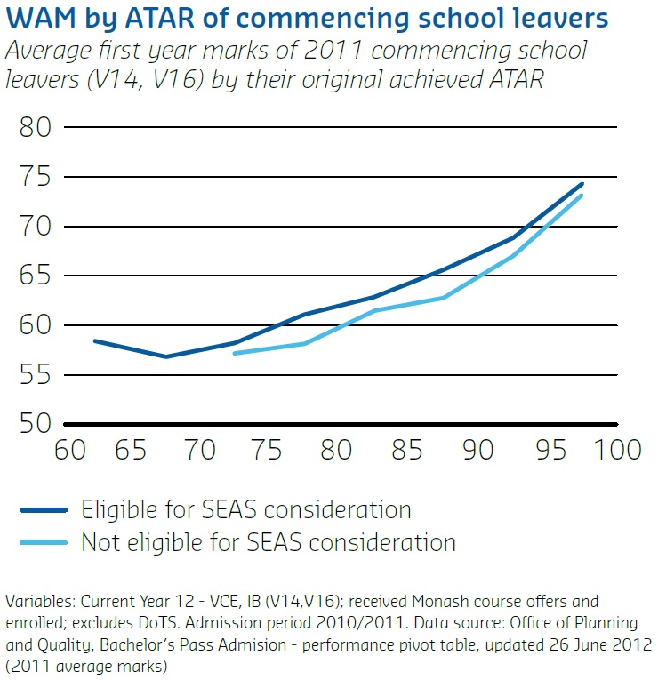

First Year Advisor Network
Murdoch University
Support
At 15 per cent, Murdoch has the largest number of LSES students in the population of the Western Australian universities.

Description
Murdoch University introduced the First Year Advisor Network (FYAN) in January 2011, after an internal university review highlighted the need to develop a formal approach to the first year experience. At 15 per cent, Murdoch has the largest number of LSES students in the population of the Western Australian universities. Additionally Murdoch University has a significant proportion of part-time, external, mature age, and regional students, indicating that the student population of Murdoch is diverse and may require additional support.
The FYAN acts as a generalised support to Murdoch’s diverse first year student cohort and as a hub to accessing specialised support at the university. It provides a range of community building activities and outreach ‘just-in-time’ interventions to all undergraduate first year students at Murdoch University. This university-wide approach has facilitated open channels of communication between the student, the FYAN, and all relevant academic and non-academic support personnel to ensure students receive up-to-date and individualised assistance when required.

Objectives
The FYAN’s key objectives are:
- assisting first year undergraduate students at Murdoch in their transition to university, through both individual and cohort-based initiatives
- providing individualised support and promoting student access to a wide range of university services
- facilitating deeper engagement of first year students.
The First Year Advisor Network acts as a generalised support to Murdoch’s diverse first year student cohort and as a hub to accessing specialised support at the university.

HEPPP Funding
Fifteen full-time positions within the FYAN have been fully funded by the HEPPP since January 2011.

Measurement
The FYAN can be measured in a number of ways, which are directly linked to the objectives of the program.
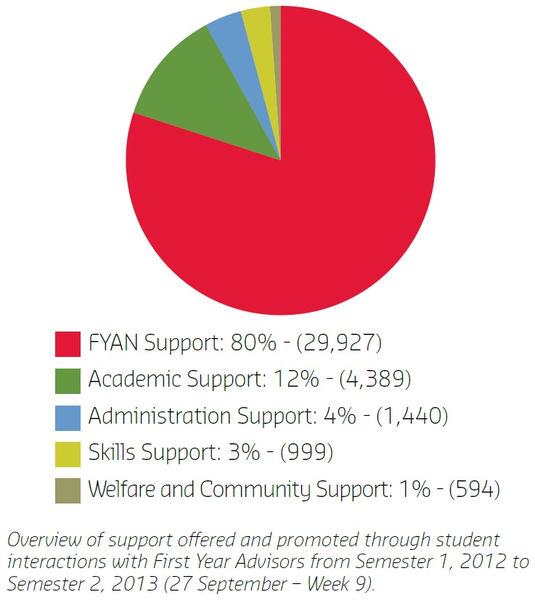
There is a large amount of student contact through the FYAN. Student engagement is generally viewed as a two-way process, which involves both the student and the institution. This active participation by the FYAN and the student demonstrates student engagement.
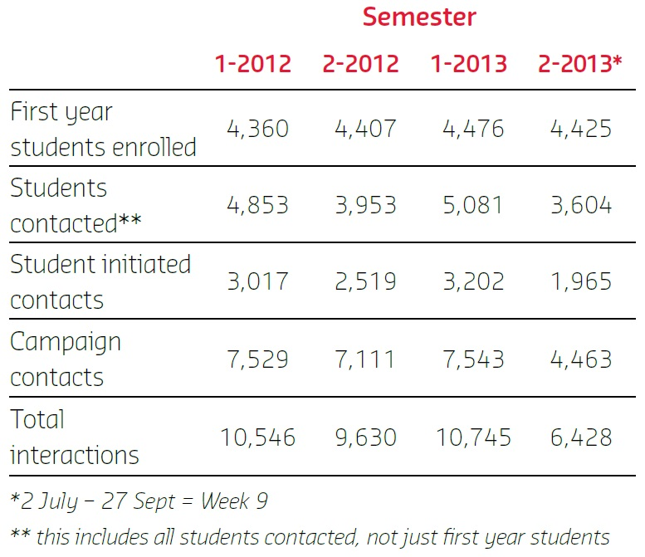
Support offered and promoted through student interactions with their FYAs has reached 29,927 incidents.

The Future
The FYAN recognises the need to be flexible to accommodate the changing needs of the student and staff population. Systematic and data-driven evaluations of FYAN initiatives occur on a regular basis and take into account student and staff feedback, outcomes of student contact, new research in the field, and data surrounding student retention and engagement. This process ensures effective initiatives are sustained or adapted to reflect the changing needs of the student and staff population.
The FYAN intends to use the systems, structures and initiatives already established to develop a suite of retention strategies and retention measurements at Murdoch.

Robotics@QUT
Queensland University of Technology
Outreach
Robotics is a proven tool for engaging and motivating students to participate in Science, Technology, Engineering and Mathematics

Description
Robotics@QUT uses dynamic robotics activities to encourage Science, Technology, Engineering and Mathematics (STEM) literacy, problem solving and collaborative learning in Year 6-12 school students. The program works equally well across a range of age groups and academic abilities, and serves as a hook for building interest across all STEM-related areas and in tertiary study. Teachers appreciate that the program is curriculum-connected, and parents love that it allows for whole family engagement.
Within Queensland University of Technology’s (QUT) Widening Participation (WP) program, the approach to school learning partnerships is to add value to curriculum with hands-on, in-school activities, delivered by tertiary students. The heightened engagement of school students leads to better school completion and achievement; and the tertiary role models and their personal narratives de-mystify university and build aspiration.
LSES Queensland schools have below-average participation and achievement rates in senior STEM subjects. STEM disciplines are key drivers of innovation and the economy, and LSES students need better access to STEM at school and beyond, if they are to have equal participation in society.
Robotics is a proven tool for engaging and motivating students to participate in STEM. Robotics activities provide plenty of fun for children, but also boost their technical and thinking skills. Students of all ages and abilities can participate in activities such as robotic art, robot drag racers, sumo robot wrestlers, solar panel cars, LEGO® building challenges and DUPLO® tower challenges.
Research shows these types of robotics activities contribute to improved literacy in ICT, skills in problem solving, metacognition and group collaborations.

Objectives
Robotics@QUT :
- improves maths literacy, Information Communication Technology (ICT), problem solving, metacognition and group collaboration
- builds interest and aspiration for tertiary study
- enhances the school STEM curriculum
- engages the school community in student learning
- provides pre-service teachers with practical experience in LSES schools.

HEPPP Funding
Started by QUT’s Faculty of Education in 2010, the program has been jointly funded (and significantly scaled up) since 2011.
Current HEPPP funding covers coordination staff and pre-service teachers to deliver the program; free robotics kits for schools; professional development (PD) for teachers, including workshops with researchers from QUT and overseas; school-based robotics fun days for students and parents; and sponsorship to the FIRST® LEGO® League Robotics Competition.

Measurement
Robotics@QUT involves over 30 LSES primary and secondary schools in the Moreton Bay region. Each year over 100 teachers participate in PD and run school-based robotics programs, assisted by pre-service teachers. Hundreds of students and their parents are involved in on-campus robotics challenges and fun days held annually.
Research shows these types of robotics activities contribute to improved literacy in maths and ICT, and increased skills in problem solving, metacognition and group collaborations.
Teachers surveyed report the program’s positive impact in schools.
STEM disciplines are key drivers of innovation and the economy, and LSES students need better access to STEM at school and beyond, if they are to have equal participation in society.

The Future
The research to date about the reasons for STEM-aversion and university-aversion in young working-class people suggests links and overlaps worthy of further investigation. At the level of practice, emerging collaborations between mainstream STEM and WP outreach programs should be encouraged.
Further information: www.qut.edu.au/about/equity/widening-participation

I Belong
RMIT University
Outreach
Access
The I Belong senior years program has a student lifecycle and student cohort focus.

Description
RMIT’s I Belong program addresses barriers of the city as alien and inaccessible to young people from LSES schools and communities, and the impact these have upon access and entry to pathways and professions.
The I Belong middle years program works with secondary schools and students to deliver a distinctive and scaled program, focussed on tertiary ‘tasters’ aligned with city and industry exploration and peer engagement.
The I Belong senior years program builds upon the middle years program with deep, vocationally themed ‘tasters’ and tertiary preparation delivered in the city of Melbourne. These are referenced to the industries, employment and education concentrations of the city.
Over 2013–2015, the I Belong senior years program aims to deliver the program to over 3,000 students across the senior secondary years.
Secondary schools participating in the I Belong program are schools already in partnership with RMIT through the Schools Network Access Program (SNAP), our substantial priority access program across the west, north and southeast of metropolitan Melbourne and East Gippsland.
The I Belong senior years program has a student lifecycle and student cohort focus. The lifecycle focus informs the program focus of:
- tertiary masterclass delivery, unpacking specialised disciplines and industry outcomes aimed at Year 11 and 12 students
- on-campus transition days, study and learning skills enhancement
- peer engagement using current tertiary students enrolled at RMIT through the SNAP partnership.
Secondary schools in partnership for the I Belong senior program include:
- secondary schools across the SNAP partnership footprint with the highest concentrations of disadvantage
- secondary schools across the SNAP partnership aligned with the Australian Indigenous Mentoring Experience
- secondary schools in East Gippsland and part of the SNAP partnership.

Objective
I Belong Senior years will build on the participation of 1,500 middle years students to grow informed aspiration, awareness and opportunity for tertiary outcomes leading to pathways and employment across specialised professions and industries.
I Belong will help to achieve national population parity for Indigenous participation and increased participation of students from LSES backgrounds, underpinned by RMIT’s admission policy and targets for Indigenous and LSES growth.
I Belong senior years will grow cultural awareness and understanding to support Indigenous participation through family, school, and community brokerage and cultural awareness delivered through an identified senior advisor Indigenous participation position.

HEPPP Funding
I Belong senior years is funded through the HEPPP competitive partnership grant, and supplemented by RMIT’s allocation of all partnership funds to support the I Belong middle and senior years programs.
“[Access through] SNAP isn’t just a safety net. It’s an opportunity to engage with passionate individuals who want to test themselves, and I’m quite grateful for that.” — current RMIT tertiary student who was enrolled through SNAP.

Measurement
Measurement of outcomes of the I Belong senior years program cover three core areas:
- participation of students, schools and high priority Indigenous and rural students
- scale, depth and breadth of discipline masterclasses, tertiary transition opportunities and skill enhancement modules
- vocational and professional outcomes through tertiary pathways, inclusive access commitments and Indigenous prioritisation through participation, and engagement and access.
“I Belong was awesome, I didn’t know there were jobs doing what I love (photography and design). I know what I want to do, now.” — Year 11 student.
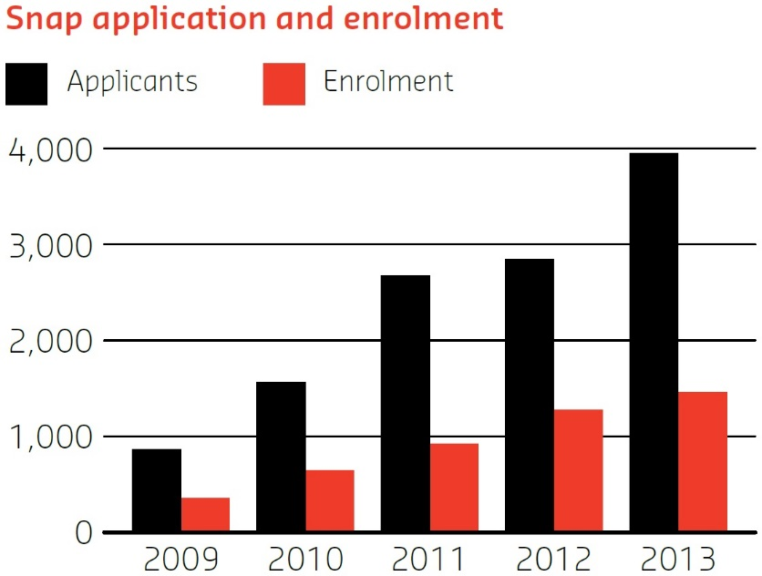

The Future
The HEPPP funding to support the I Belong senior years program is crucial support for Indigenous and rural participation, to grow scale and participation and deepen opportunity. Over 2013–2015, the I Belong senior years program aims to deliver the program to over 3,000 students across the senior secondary years.

Southern Cross University
Southern Cross University
Outreach
The UNI-BOUND program currently partners with 15 high schools, an increase from five in 2007.

Description
Southern Cross University’s (SCU) UNI-BOUND program is one of a number of initiatives which supports the university’s commitment to improving the access, participation and success of students from equity groups. UNI-BOUND has four main components:
Year 7: ‘Uni Opens Up Your World’
Students visit a SCU campus and explore their future aspirations through story-telling and mixed-media presentations. The day provides an introduction to life at university, interaction with university staff and UNI-BOUND Mentors, and an opportunity to explore a university campus.
Year 8: ‘Thinking About Uni’
Students participate in a seminar presented by SCU staff and student mentors at their school. The seminar provides an opportunity to learn more about university and post-school pathways.
Year 9: ‘Going to Uni’
Students visit a SCU campus, attend lectures, investigate career choices and participate in academic study skills seminars. UNI-BOUND Mentors share their stories of getting into and studying at university.
‘Residential School’
Students stay in a residential college on campus and undertake a longer program of events at the university. It is designed to offer not just a selection of activities in different subject areas, but an immersive experience of ‘what being a university student is really like’.
Central School Special Projects (Years 8 and 9)
A three-day program delivered both at participating schools and on-campus; a collaboration between UNIBOUND program staff, teaching areas of the university and high school staff.
In 2012, 1,437 school students participated in UNI-BOUND events and activities, compared to 206 students in 2007.

Objectives
The UNI-BOUND program aims to increase knowledge and understanding of higher education and career options; build confidence and motivation towards higher education; and improve academic attainment for higher education.

HEPPP Funding
The UNI-BOUND Program has been funded by HEPPP since 2010. HEPPP funds have enabled the program to expand to a greater number of regional schools and cohorts of students.
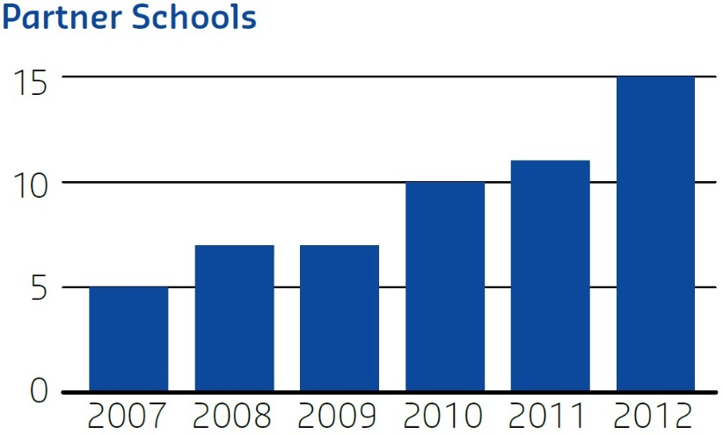

Measurement
In 2012/2013 a Monitoring, Evaluation, Reporting and Improvement Plan was developed and implemented for UNI-BOUND. The success and impact of the program is being measured through:
- student feedback surveys (Years 7, 8, 9 and Central Schools Special Projects)
- pre- and post-event feedback surveys that include questions to gather qualitative and quantitative data on measurable change
- post-event review and evaluation meetings with key stakeholders including UNI-BOUND staff, university and school staff, and school principals and project leaders (Central Schools Special Projects)
- longitudinal tracking of matriculation to university of participants.
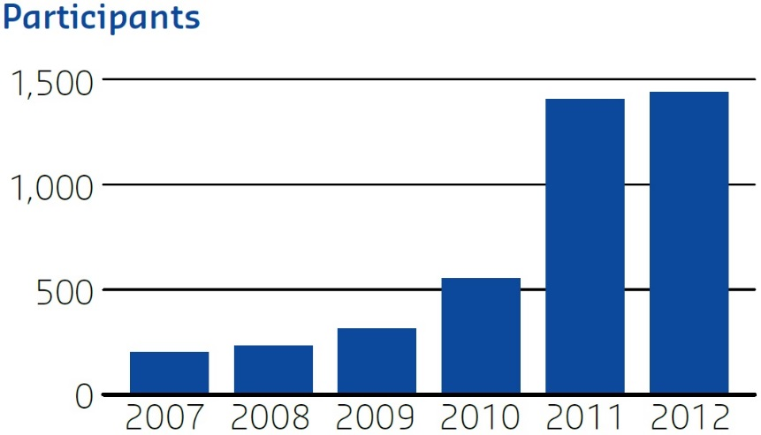
“After nearly 30 years of being a teacher this is the most successful model of any outreach program I have seen. It was a great initiative to engage students at a crucial stage. The door of opportunity has now been opened to them.” — head teacher, English and history.

The Future
UNI-BOUND Program activities will continue to be enhanced and expanded to include additional events and activities and to increase the number of students participating in the program. In addition, an academic support model will be developed and delivered to high school students aimed at increasing confidence, motivation and preparation for higher education.
The UNI-BOUND program aims to increase knowledge and understanding of higher education and career options; build confidence and motivation towards higher education; and improve academic attainment for higher education.

Student Support Program
Swinburne University
Support
Student Equity and Disability Services (SEADS).

Description
The Student Equity and Disability Services (SEADS) Student Support program is one of Swinburne University’s social inclusion plan initiatives funded by the HEPPP. One of the key principles under the Social Inclusion Plan is to provide a range of services to support students within the university.
The program provides assistance with study and living expenses to undergraduate students from LSES backgrounds or those experiencing significant financial disadvantage. Key features of the program are:
- Funding of some equity-related scholarships awarded by Swinburne University. These scholarships include final year undergraduate scholarships, first year rural and regional scholarships, refugee or asylum seekers scholarships and TAFE pathways scholarships.
- SEADS awarding major grants and scholarships in first semester. These include rental assistance scholarships, laptop grants, iPad grants, mobile broadband grants and specialist software grants.
- Funding of small grants distributed via Housing and Finance Officers. These small grants are available throughout the year and include petrol vouchers, book vouchers, public transport grants, and one-off hardship grants.
The number and type of grants and scholarships available have increased since the program’s inception in 2010.
The program provides assistance with study and living expenses to
undergraduate students from LSES backgrounds or those experiencing significant financial disadvantage.

Objectives
The main objective of the program is to increase the retention and completion of LSES students or those experiencing significant financial disadvantage through providing financial assistance in the form of grants and scholarships. Financial assistance is seen as critical in the retention and completion of students from LSES backgrounds or those experiencing significant financial disadvantage.

HEPPP Funding
Activities and staffing costs associated with the SEADS Student Support Program have been HEPPP-funded since 2010.

Measurement
The success of the program is reflected by the number of students assisted and their success, attrition and grade point average rates, in addition to a yearly online survey of grant/scholarship recipients.
Since 2010, 716 students have received a scholarship or grant under the SEADS Student Support program.
The average success rate of SEADS recipients was 3–5 points higher compared to the domestic higher education cohort, and 7–10 points higher compared to the LSES cohort.
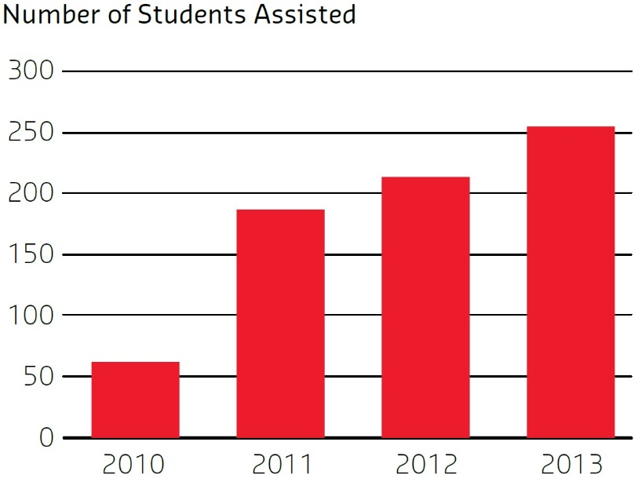
Initial evaluation of the program via a yearly online survey found the grants and scholarships alleviated students’ financial pressure and stress, enabled students to have resources to undertake and complete course requirements, and gave them more time to devote to study.
Since 2010, 716 students in total have received a scholarship or grant under the SEADS Student Support program.

The Future
Further evaluation of the program is being undertaken to determine if and how it is making a difference to the retention and completion of LSES students.

Adelaide Compass
The University of Adelaide
Outreach
Access
Find your way to higher education.

Description
Adelaide Compass, funded by the HEPPP, is an early-intervention initiative designed to show students from LSES backgrounds that university is a viable option for their future. It does this by delivering fun learning activities to students in primary school and early high school, in recognition of the value of early intervention. Adelaide Compass is based on the successful Compass – find your way to higher education program run by the University of Sydney since 2009, and has been tailored to meet the specific needs of South Australian schools and communities.
Many students from LSES backgrounds do not have any family members who have attended university, and for them higher education may not be seen as attainable or even a priority. Adelaide Compass provides these students with university experiences enabling them to engage with university students, campuses, personnel, culture and language.
All Adelaide Compass activities are embedded within the school curriculum, based on effective planning and consultation with the schools involved. A range of methods are used to engage students in cultural learning activities at the university, such as university experience days, programs and activities at schools supported by university students and staff, and homework or study groups led by university students. Activities encompass literacy, mathematics, science, culture and agricultural themes.
While the program targets primary-aged children, there are also positive benefits for those students not directly involved in Adelaide Compass activities, through the promotion of a school-wide culture of engagement and promotion of the relevance of and possibilities available through study.
All Adelaide Compass activities are embedded within the school curriculum, based on effective planning and consultation with the schools involved.

Objectives
Adelaide Compass aims to develop an understanding of university and to change perceptions about its relevance and accessibility. It focusses on building student attainment and aspiration in order to show students from LSES or disadvantaged backgrounds that university study is possible, practical and achievable for them. It aligns with the University of Adelaide’s new strategic plan, Beacon of Enlightenment, which builds upon the university’s founding principles including the key strategic goal of reaching out to a broader student body, especially students from LSES backgrounds, whilst promoting the importance of the university to the community.

HEPPP Funding
Since its inception in 2011, Adelaide Compass has been fully funded by the HEPPP.

Measurement
An independent evaluation of Adelaide Compass is currently being undertaken. Anecdotal evidence from program staff and volunteers indicates that there has been a strong increase in awareness about university and further study opportunities. Since the introduction of the program, enrolments to university from the pilot school have increased by 600 per cent.

The Future
The Journey to Higher Education 2013–2015, which is a successful HEPPP competitive bid by the three public universities in South Australia, will see the development of new tailored outreach activities that use each university’s areas of strength. As part of this, Adelaide Compass will be expanded to schools in new geographic areas through the adaptation of metropolitan activities to a regional context, including a specific Indigenous stream.
Compass focusses on building student attainment and aspiration in order to show students from LSES or disadvantaged backgrounds that university study is possible, practical and achievable for them.
Since the introduction of Adelaide Compass, enrolments to university from the pilot school have increased by 600 per cent.

UC 4 Yourself
University of Canberra
Outreach
The program aims to break down barriers to higher education for students in Years 7–10 from financially disadvantaged backgrounds.

Description
The Aspire UC Schools outreach program is the University of Canberra’s (UC) flagship partnership program funded under the HEPPP. The program aims to break down barriers to higher education for students in Years 7–10 from financially disadvantaged backgrounds. The majority of the students come from rural or regional areas.
The UC 4 Yourself program is a component of the Aspire UC program. UC 4 Yourself provides the opportunity for students to visit UC to experience the campus environment and to see firsthand what it is like to be a UC student for a day through an organised program of activities. The program was initially developed and implemented in 2010 with 10 schools. There are now 30 schools involved and the UC 4 Yourself program has been substantially enhanced in response to student feedback. As a result, the UC 4 Yourself Expo model was introduced in 2013. The Expos include interactive demonstrations, hands on displays and student- and academic-led workshops.
The UC 4 Yourself Expo is offered six times throughout the year and engages multiple school groups in each Expo. To date 1,351 students, primarily from Year 9, have participated in 2013, with an additional 300 participants scheduled for the next UC 4 Yourself experience.
To date 1,351 students, primarily from Year 9, have participated in 2013, with an additional 300 participants scheduled for the next UC 4 Yourself experience.

Objectives
The UC 4 Yourself program is designed to:
- raise the aspirations of students from disadvantaged backgrounds for higher education
- help students to identify and overcome barriers to higher education
- introduce students to a university environment, available courses and potential career paths
- smooth the transition between school and university.

HEPPP Funding
The UC 4 Yourself program, including staffing, transportation, catering and activity expenses is fully HEPPP funded.

Measurement
Pre- and post-test surveys are undertaken to examine students’ intention to go to university and their knowledge and understanding of post-school options. Analysis of the new format UC 4 Yourself program is currently underway. Preliminary results from the surveys indicate that the program enables students to increase their understanding of the range of postschool options available to them, and increases the per centage of students who intend to go to university. Qualitative feedback is overwhelmingly positive, as evidenced by comments from students.
“After going through today’s activities UC seems to me that it is an awesome place. All of the friendly faces, and all the support they give, UC is looking like it’ll play a part in my future.” — high school student.

The Future
The University of Canberra has recently received HEPPP funding for three projects aimed at breaking down barriers to higher education for Indigenous students. The projects will do this through delivery of a specialist Aspire UC program, through the development of a foundation program delivered in school hubs across the region, through support and professional development for teachers, and through a range of initiatives undertaken in partnership with external organisations. Each program will be fully evaluated through a range of methodologies.
“My thoughts on UC is that it is a fun environment and fantastic place to go to uni. Seeing the uni today has made me want to go to a uni in the future.” — high school student.

Telescopes in Schools
The University of Melbourne
Outreach
Special events such as the Transit of Venus and partial solar eclipses have seen whole-school participation.

Description
Telescopes in Schools (TiS) is an outreach program offered by the University of Melbourne in partnership with Quantum Victoria, Museum Victoria, the ARC Centre of Excellence for All-sky Astrophysics and CSIRO, targeting LSES schools in Melbourne metropolitan and Victorian regional areas. To date, research-grade telescopes have been installed at ten schools that now hold regular astronomy and observing sessions attended by students, teachers and university academic staff. Parents have also been involved, learning and collaborating alongside their children. Students observe the night sky, learn about astrophysics and perform astrophotography. After demonstrating their competency in preparing and driving the telescope, students earn their ‘telescope license’. Schools can tailor the program to their particular needs and student cohort while taking advantage of full and ongoing support from the university.
Activities include night-time and day-time observing, talks from astrophysicists, practical exercises and capturing images through the telescopes. These have allowed students and families from diverse cultural backgrounds to meet in a collaborative environment, and special events such as the transit of Venus and partial solar eclipses have seen whole-school participation. Community groups and other local schools have also participated in TiS events.
In 2012, the enrolment rate for physics in Year 11 and 12 doubled for the only participating all-girls school, with the program cited as the main contributing factor.

Objectives
- To bring together students, parents and teachers from LSES schools with academic staff in a collaborative environment, to improve awareness of higher education as a post-school option
- To increase student aspiration for tertiary-level science study through the use of research-grade technical equipment to explore aspects of astronomy and astrophysics
- To provide ongoing support to teachers through regular professional development opportunities and close collaborative relationships with academic staff
- To establish and maintain positive long-term relationships between LSES schools participating in the program and the university.

HEPPP funding
HEPPP funding was used to support program development and administration in addition to seed funding which enabled purchase of the telescopes and accessories. The ongoing running costs of the program are funded by the Laby Foundation.
Over 120 observing sessions have been conducted, with approximately 3,000 students, 445 teachers, 400 parents and 200 astronomers attending.

Measurement
The success of the program is evidenced by the following:
- Program uptake and participation: since commencement in April 2012 over 120 observing sessions have been conducted, with approximately 3,000 students, 445 teachers, 400 parents and 200 astronomers attending.
- Increase in student enrolment in senior school science subjects: in 2012 the enrolment rate for physics in Year 11 and 12 doubled for the only participating all-girls school, with the program cited as the main contributing factor. Similar increases have been observed in other participating schools.
- Publicity and media coverage: the TiS Transit of Venus event was covered on national television news broadcasts. Local newspapers report regularly on other TiS events, broadening the reach of the program to the wider community.
- The TiS website and blog: www.telescopesinschools.wordpress.com had around 100 followers, 10,000 views, and 60 posts by August 2013. The Twitter feed (@scopesinSchools) provides regular updates on the program’s activities and has international followers.

Future
Quantitative and qualitative data are being collected for a longitudinal study exploring the shifts in student motivation and parental influence in choosing Science, Technology, Engineering and Mathematics subjects at secondary school and consequently their pathways into higher education institutions after program participation.

The First Year Experience Strategy
University of New England
Support
The aim is to ensure that students can access additional learning support as required, in purpose-built surroundings.

Description
The First Year Experience Strategy demonstrates the University of New England’s (UNE) approach to managing HEPPP funding to achieve sustainable positive outcomes. UNE’s students strongly represent regional and remote and LSES backgrounds and UNE has extensive experience in providing relevant interventions and programs for its diverse student population. Student transition and success in the critical first year has provided the focus for development of our First Year Experience Strategy, initiated in 2012.

Objectives
The First Year Experience Strategy was designed to support the successful transition from commencing to progressing student, and recognises the factors that impact on students who predominately come from regional and remote and LSES backgrounds. A First Year Experience Committee has guided the development of a number of interlinked activities. This university-wide committee reports to the Academic Board’s Teaching and Learning Committee, and its membership is open to all interested staff. Through this framework a number of interlinked HEPPP-funded programs have been created.
The First Year Experience Strategy is the University of New England’s response to strategically managing the multi-faceted issue of student transition and success in the critical first year.
The three initial projects are:
Informal Learning Spaces
The aim is to ensure that students can access additional learning support as required, in purpose-built surroundings. The spaces are currently under construction and will deliver ‘hang-out’ spaces for first year students, informal and collaborative learning programs, and ‘just-in-time’ assistance for students.
First Year Experience Co-ordinators
This project creates academic roles which foster best practice in First Year Experience Programs. Based in each school, these staff report to the First Year Experience Committee and work together to provide support and co-ordination of first year experience activities. They are collaboratively developing a culture of first year excellence, responding to the needs of rural, remote and LSES students. As the academic face of first year teaching and learning they are instrumental in promoting ideas for first year improvements.
Vice-Chancellor’s Scholars
The Vice-Chancellor’s Scholars program celebrates the achievements of our most academically gifted students and rewards them by providing unique opportunities for academic and professional development. The objective behind this program is to provide a well-publicised incentive to all students to aspire to achieve outstanding academic results. It is a whole-of-university program provisioned to identify high achieving first year students and provide opportunities directed at their needs.

HEPPP Funding
This strategy is fully funded through HEPPP funding.

Measurement
The First Year Experience Strategy is a work in progress. Measurement of its success will be iterative and include:
- measurement of collaboration and the ability of cross-functional areas and disciplines to address the needs of our first year cohorts: early indicators are that this is being achieved
- at a program level, participation data will be used to measure the fitness for purpose of both spaces and student support activities
- instructional design improvements via the First Year Experience Co-ordinators network and a demonstrated emphasis on the science of teaching and learning as it relates to first year students from regional and remote backgrounds will be further measured by student evaluations and tracking of progression rates.
The objective behind the Vice-Chancellor’s Scholars program is to provide a well-publicised incentive to all students to aspire to achieve outstanding academic results.

The Future
The success of strategically using HEPPP funds to change the culture of institution–student interactivity will drive the future deployment of funds at UNE. The First Year Experience Strategy provides a watching brief for sustainable programs and interventions.

The ASPIRE Program
University of New South Wales
Outreach
Access
Using multiple data sources, ASPIRE identifies and targets communities most in need.

Description
The University of New South Wales (UNSW) ASPIRE program (www.aspire.unsw.edu.au) is a multifaceted educational outreach program reaching over 6,000 students every year in 55 partner schools across Sydney and regional NSW. The program aims to address educational disadvantage by widening participation at university by students from LSES backgrounds. It does this by engaging with students from Kindergarten to Year 12. Developed through a learning framework that includes age-appropriate activities in school and on the UNSW campus, ASPIRE works with students longitudinally over a number of years to encourage them to make informed choices about their higher education opportunities.
Students are given multiple opportunities to interact with and experience the university environment from an early age. The use of the learning framework enables the learning to be built upon from year to year, and takes into account key stages of the school curriculum where relevant. The overall ASPIRE program is unique for each school, depending on the context of the school.
Within the primary and early high school years the program works with all students. From Year 9 onwards the program may work with groups of students identified by the school as needing additional support to form their goals or meet their goals of entering higher education.
Engagement with the wider local community, particularly parents, is also part of the overall ASPIRE strategy. The whole community approach to engage with students, and with their wider networks, is designed to build sustainable capital.
ASPIRE works with students longitudinally over a number of years to encourage them to make informed choices about their higher education opportunities.

Objectives
ASPIRE aims to:
- raise the awareness and aspirations of students to participate in higher education
- assist in raising the academic attainment of students
- assist students to make informed decisions on progression to higher education
- address some of the barriers that prevent students from accessing higher education.
Using multiple data sources, ASPIRE identifies and targets communities most in need. This ensures a focus on the espoused aims. This in turn supports the social inclusion agenda of the government, specifically the access target for students from low socioeconomic areas.

HEPPP Funding
ASPIRE is currently supported by HEPPP partnership funds (baseline and competitive bid). It also receives funding from the Citi Foundation and support from UNSW.

Measurement
An evaluation framework using qualitative and quantitative measures has been set up to gauge the impact of ASPIRE. Results so far include:
- an overall decline in negative attitudes to higher education over time, indicating the cumulative effect of ASPIRE
- an overall increase in offers to university from ASPIRE schools which is greater than the increase for a comparable group of schools not engaged in ASPIRE
- schools with high levels of engagement in the program show a higher per centage increase in offers to university than schools with low levels of engagement.
The whole community approach to engage with students, and also with their wider networks, is designed to build sustainable capital.

The Future
For many partner schools ASPIRE represents the first time they have worked closely with a university. To carry on major aspects of the work if current funding sources cease, ASPIRE aims to build ongoing resources for schools to use in the future. These resources will be linked to key stages within the school curriculum.

Open Foundation by Distance
The University of Newcastle
Access
Support
The aims of Week Zero and the full-year regional and online support mechanisms are to increase student engagement.

Description
The University of Newcastle’s off-campus enabling program for mature-aged students, Open Foundation by Distance (OF by D), has been offered since 2003. In 2011, HEPPP funding provided an opportunity to review “almost every aspect of the vision, goals and practices” of the program. A team of academic, professional and teaching staff identified a number of critical concerns relating to student support and engagement, and a substantial redevelopment of the program began.
The six OF by D courses were remodelled from paper-based to fully online delivery, and a five-day online orientation, Week Zero, was designed and implemented for commencing students. A program-level Blackboard site was also established as a centralised online ‘support hub’ and regular guided study sessions were set up in seven regional locations across NSW.
The aims of Week Zero and the full-year regional and online support mechanisms introduced in 2012 directly related to opportunities identified through the review process: increasing student engagement and building a sense of confidence for commencing and current students, many of whom were entering study with disrupted educational backgrounds. Week Zero was a particularly successful initiative, creating a vibrant and supportive ‘learning community’ of OF by D students and staff.
In 2011 HEPPP funding provided an opportunity to review “almost every aspect of the vision, goals and practices” of the Open Foundation by Distance program at the University of Newcastle.

Objectives
The objective of this project was to enhance the experience and engagement of students from diverse backgrounds seeking entry to higher education through Open Foundation by Distance.

HEPPP Funding
This project has been fully HEPPP funded for three years. HEPPP funding has enabled the appointment of key staff, including a distance support coordinator and a team of study advisers. It has also enabled critical staff development and training, and the production of innovative materials and resources.

Measurement
Student feedback, institutional data on retention and transition and software usage statistics have been continually collected and monitored. Continuing evaluative research confirms the success of the changes implemented in response to the HEPPP-funded review. Some measures of student engagement have increased by more than 500 per cent compared to previous years.
Key outcomes include:
- Rates of Blackboard access:
  - 60% by end of Week 2 in 2011
  - 94% in 2012 and 2013
- interaction in online discussion boards: 986 posts in 2011 to 5,878 posts in 2012 and 5,066 in 2013
- access to Counselling and Learning Development: 17 consults in 2011 to 84 consults in 2012 and
- 126 consults to-date in 2013.
“I have been extremely impressed with all the resources available to help you study as well as how much interaction there is between lecturers and students. I am blown away by the support available and am really enjoying my study experience, thank you so much” — OF by D student.

The Future
A culture of reflection, collaboration and continual improvement now drives innovation in OF by D. The introduction of an online orientation and the coordination of online and face-to-face support resources have made a significant positive impact on the quality of student experience and engagement in an online enabling program. Several new online courses are now being developed for future cohorts. Week Zero has been so successful that it will be rolled out across the university’s suite of on-campus enabling courses.

UQ Young Achievers Program
The University of Queensland
Outreach
Access
The UQ Young Achievers program provides a valuable support framework to enable participating students to realise their potential.

Description
The UQ Young Achievers Program (UQYAP) supports the tertiary study and career aspirations of motivated secondary school students from low-income families who might not otherwise have access to university. The program is focused on nurturing and developing the educational ambitions of Year 11 and 12 participants through mentoring; on-campus experiences; information on university study options, pathways and application processes; opportunities for personal growth; and financial assistance in the form of bursaries and scholarships. To date, more than 370 Young Achievers have benefited from the program.
The program is operating in State secondary schools in Ipswich, Logan, the Lockyer Valley, Toowoomba and the Darling Downs, Wide Bay and Far North regions of Queensland.

Objectives
- To raise awareness and interest in tertiary education within educationally disadvantaged communities.
- To increase the number of students from low-income families enrolling in and graduating from university.
- To develop civic-minded student role models willing to assist in raising the tertiary aspirations of others.
The University of Queensland is committed to the long-term sustainability of this initiative and the benefits it will bring, not only to participants, but also to their families, schools and communities.

HEPPP Funding
The program was established in 2009 with financial support from university donors to assist with scholarships and bursaries. HEPPP funding covers all operational costs, including staffing, mentor training and development, residential camps, publications and program tracking.

Measurement
Success of the program is measured through:
- the number of participants who successfully complete Years 11 and 12
- active engagement of participants (and their families) in all program events and activities, including mentoring and completion of school/ community volunteer projects
- feedback from surveys, reflective workshops and interviews (with participants, parents/guardians, mentors and school staff)
- the proportion of participants who apply, receive and accept an offer at a university
- University of Queensland (UQ) completions in future years.
In 2013, nine of our inaugural cohort of Young Achievers, now in their second year at university, joined the UQYAP mentor team and are giving their time to support Year 11 participants, often from their home schools.
Early metrics relating to the number of Young Achievers transitioning to tertiary study are very encouraging. Ninety five per cent of the first cohort (who completed Year 12 in 2011) submitted a Queensland Tertiary Admissions Centre application; 86 per cent of these students received and accepted a tertiary offer (for UQ or elsewhere).
A qualitative study is underway to understand the impact of the program on students, families, schools and communities and assist in its further development. A quantitative study to track the effect the program is having on students’ self-beliefs and intentions to study at university is also in place.
Over the past four years, more than 370 Young Achievers and their families have been welcomed into the program.

The Future
Early outcomes and feedback indicate that the UQ Young Achievers Program is helping to raise educational aspirations of students from low-income families. A strong working model and solid student pipeline is in place and Young Achievers are serving as wonderful role models within their schools, families and communities.
The focus of further program development is on embedding the academic and emotional support systems to optimise retention and graduation rates for Young Achievers at UQ.
The University of Queensland is committed to the long-term sustainability of this initiative and the benefits it will bring, not only to participants, but also to their families, schools and communities.

UniSA College
University of South Australia
Outreach
Access
Participation in outreach activities has increased by over 600 per cent over the last three years.

Description
In January 2011 the University of South Australia established UniSA College. UniSA College is responsible for pre-degree and pathway programs and conducts a range of outreach activities for students who traditionally have not pursued university studies.
Outreach programs use academic expertise to identify current and emerging Science, Technology, Engineering and Mathematics (STEM) ideas to develop interactive experiential programs for secondary school students. Scenario-based problem solving is a key approach in the programs, using specialised equipment and facilities.
UniSA College also partners with community centres and organisations to run programs for members of the public. Collaboration with community centres is designed to encourage their members to re-engage with education. Community programs include the Aboriginal Power Cup, Australian Indigenous Mentoring Experience and Career Awareness Programs.
Academic programs provide more than just entry into university for students with low or no previous qualifications – they equip students with the knowledge and skills to succeed in their chosen degree. Programs include Foundation Studies and Diploma programs. The Diplomas are two-year programs providing a supportive university educational experience. In the first year of the program students build the skills and confidence they need to succeed at university. In the second year, students start the first year of their undergraduate degree, with additional support provided by College staff. Foundation Studies is a one-year program for people with no previous qualifications, preparing students for study at university. On completion of the program students apply for entry into a university degree.
UniSA College aims to increase the number of students from a low socio-economic background enrolled in the university.

Objectives
UniSA College’s role is to implement the University’s Participation Strategy, aimed at increasing the number of students from a low socio-economic background enrolled in the university. Its objectives are to raise awareness, increase access, and support achievement for people who have not previously accessed university studies.

HEPPP Funding
UniSA College was set up in part through funding obtained via the HEPPP. The outreach programs engaging secondary school students and community groups continue to be funded through the HEPPP.

Measurement
The success of UniSA College can be measured by the growth in participation in both outreach and pathway programs. Since 2011, 1,836 students have commenced an academic pathway program at UniSA College. Of those who successfully complete a pathway program, around 85 per cent have been offered a place in a degree program at the University of South Australia. Growth in student numbers over the three years has been significant.
Since 2011, 1,836 students have commenced an academic pathway program at UniSA College.
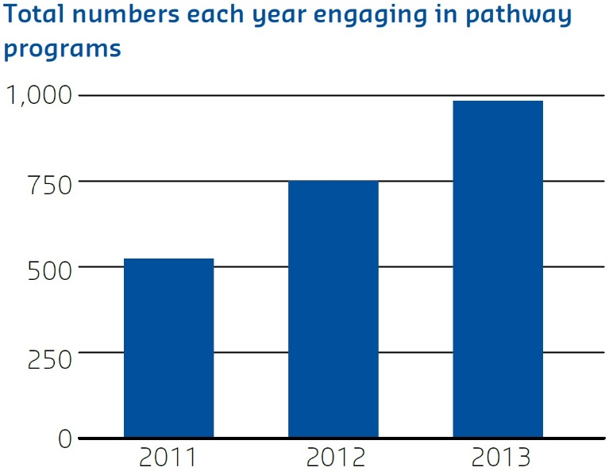
Participation in outreach activities has increased by over 600 per cent over the last three years.
The number of schools and their students involved since 2011:
- 2011: 600 students and six teachers through 30 school interactions
- 2012: 3,063 students and 452 teachers through 156 school interactions
- 2013: 4,030 students and 481 teachers through 198 school interactions.

The Future
Secondary school outreach programs which have focussed predominantly on the northern suburbs of metropolitan Adelaide will be expanded to include schools in the western suburbs from 2014. Enrolment in academic programs will continue to increase with a commitment to expand places to 1,200 students in 2014. Results from activities will continue to be disseminated through relevant outlets.

Dream Aspire Reach Experience (DARE)
University of Southern Queensland
Outreach
Access
Indigenous Secondary School Student Mentoring Program.

Description
The DARE (Dream Aspire Reach Experience) Program aims to address the barriers related to participation in education for Aboriginal and Torres Strait Islander people. The curriculum-based program focuses on building the aspirations of students through face-toface mentoring and engagement with parents, teachers and Indigenous communities. DARE engages with a variety of stakeholders to develop partnerships aimed at supporting school attendance and completion rates and raising students’ awareness of further education opportunities beyond the school gates. The importance of a holistic approach underpinned by Indigenous protocols and knowledge is integral in approaching school engagement, building rapport and trust.
Features of the program include:
- Year 10 secondary school students targeted to coincide with Senior Education and Training Planning
- 16 week program conducted in group settings within schools
- Indigenous and non-Indigenous undergraduate university students, Indigenous elders, Indigenous community leaders, business owners, health service employees, Community Education Counsellors, Queensland Police Officers and Indigenous Liaison Officers engaged as mentors
- Cross-cultural awareness training and ongoing support for mentors
- Cultural understanding, historical awareness and self-identity development incorporated to benefit both mentees and mentors
- DARE Traditional Indigenous Games School Competition
- DARE Leadership Camp involving guest speakers, leadership and motivation workshops, team building, and cultural experiences
- DARE Awards Ceremony to celebrate participation, academic and attendance achievements.
DARE focuses on building the aspirations of Indigenous students through face-to-face mentoring and engagement with parents, teachers and Indigenous communities.

Objectives
The program aims to:
- raise the aspirations of Indigenous students to higher education
- improve secondary school attendance and completion rates of Indigenous students
- improve English literacy and numeracy skills of Indigenous students
- promote healthy and positive lifestyles for Indigenous students to improve their participation in education
- promote and foster cultural respect and understanding
- bridge the gap between schools, communities and universities.
A holistic approach underpinned by Indigenous protocols and knowledge is integral in approaching school engagement, building rapport and trust.

HEPPP Funding
The program is partially HEPPP-funded, supporting leadership camps, traditional game days, and awards evenings. In-kind support from the University of Southern Queensland allows the program to run in 15 secondary schools, with sponsorship from Arrow Energy allowing the provision of scholarships and extension of the program to a further two schools.

Measurement
Success of the program is judged based on school participation, secondary student enrolment patterns and attendance rates, academic improvement records from schools, surveys, focus groups and reflective journals. Early indications are positive:
- 10 secondary schools engaged in 2012, increasing to 15 in 2013
- 25 undergraduate students volunteered as mentors in 2012, increasing to 56 undergraduates and community members acting as mentors in 2013
- 405 secondary school students engaged in 2013
- improved attendance rates, engagement and completion rates
- increased Indigenous Higher Education Pathways Program enrolments at the University of Southern Queensland from DARE engagement initiatives.

The Future
The program is now in its second year of operation, and its impact on the tertiary aspirations and success rates of Indigenous students is only beginning to be seen. Given the program’s success and support from Aboriginal and Torres Strait Islander communities, plans are underway to continue its expansion across the university’s three campuses from 2014.

Compass — Your Way to Higher Education
The University of Sydney
Outreach
Access
‘Compass’ programs are a perfect fit to our school’s goals’.

Description
Compass – your way to higher education (Compass) is an innovative program that supports primary and high school students’ motivation, skills and capacity to pursue higher education opportunities. Compass partners with schools where there are significant populations of communities traditionally underrepresented in higher education.
Compass uses a community development framework: partner schools are involved in the development of activities so that they meet the needs of the school community and complement the National Curriculum Framework. This ensures that there is genuine alignment between the school and the university in the goals and outcomes for each project.
Compass has partnerships with 26 metropolitan schools, with projects delivered both on-campus and in-schools. It also delivers 10 regional projects, primarily in Dubbo and Broken Hill. Together the projects build a program with cumulative messaging and experiential activities to build skills and motivation.
Compass is divided into four stages:
- Discover, Year 3–6, includes museum, theatre and science activities on campus and skills development activities at schools.
- Explore, Year 7–8, introduces a university campus and the opportunity of higher education.
- Inquire, Year 9–10, activities focus on developing critical thinking, independent study and learning skills.
- Experience, Year 11–12, focuses on Higher School Certificate (HSC) and higher education preparation.
The community development framework approach used by Compass ensures there is genuine alignment between the school and the university.

Objectives
Compass’ main objectives are to:
- provide enriched learning experiences and skill development for students
- support teacher skills and capacity
- build student understanding of, and positively influence attitudes towards higher education
- fulfil the university’s social inclusion objectives.

HEPPP Funding
Compass is funded through the Bridges to Higher Education Initiative which is funded by the HEPPP and donations to the University of Sydney.

Measurement
The success of Compass is measured by both qualitative and quantitative data that is collected by the program and further evaluated by external contractors. Since the inception of the program in 2009 the engagement framework has continued to be strengthened and partnerships have been extended to a wider range of schools.
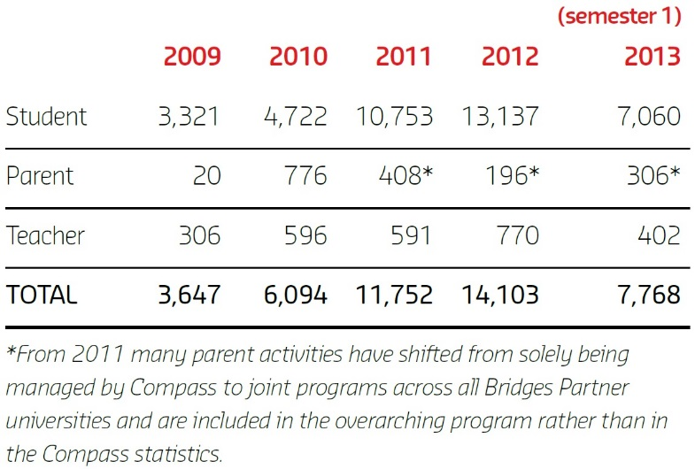
- The number of students, teachers and parents in the program grows each year. To July 2013, Compass has had 43,364 engagements including 38,993 with students, 1,706 with parents and 2,665 with teachers
- Compass has grown to 34 projects, and from 12 partner schools to partnerships with 26 metropolitan and 14 regional schools
- Offers have grown from 57 per cent to 63 per cent for students from Compass partner schools to the university’s E12 Early Offer Admission Pathway since 2012 (first intake year).
“In 2008, only 12 per cent of our students went to university. Two years ago 27 per cent went. In 2011, 44 per cent gained admittance. This is a massive change. I am excited by these results and the teachers are happy and proud. Compass has been a massive part of this change. Its programs are a perfect fit to our school’s goals.” — high school teacher, 2012.

The Future
Compass is currently growing its work with Aboriginal and Torres Strait Islander communities with programs focusing on literacy, skills enhancement and pathways to higher education.

University Preparation Program
University of Tasmania
Access
Support
The University Preparation Program is identified as a key strategy for improving access and pathways into university for all students.

Description
The award-winning University Preparation Program (UPP) is a pre-degree program offered by the University of Tasmania (UTAS). UPP helps to improve access to higher education by providing a pathway for students who do not meet the university’s admission requirements. UPP assists non-traditional students (including those from LSES backgrounds, rural and remote areas, non-English speaking backgrounds, and other students who face barriers to higher education) to build the skills needed for success at the tertiary level.
UPP covers a broad range of skills; including academic writing, mathematics, information technology, communication skills and general study skills. Students may use the course to improve their skills in a specific area and/or to help meet entry requirements for bachelor study.
Since its introduction in the north-west of the state, UPP has expanded to include all three Tasmanian campuses as well as distance delivery. The program has also been incorporated into UTAS’ central admissions system, meaning students not eligible for entry into a bachelor degree may automatically receive an offer into UPP.
UPP helps to improve access to higher education by providing a pathway for students who do not meet the university’s admission requirements.

Objectives
The main objectives of the program are:
- to provide a pathway for students who do not meet general admission requirements or who face barriers to higher education
- to provide students with the necessary skills and knowledge to successfully undertake degree studies
- to familiarise students with academic culture and provide a supported introduction to the university environment.

HEPPP Funding
UPP is partially funded by the HEPPP. This funding contributes towards the overall delivery of the program.
UPP is identified in the UTAS Social Inclusion Plan 2013–2015 as a key strategy for improving access and pathways into university for all students.

Measurement
The success of UPP is measured by the number of students enrolling in the course, the retention of these students, and their success transitioning into degrees.
Awareness of the course within the community has grown significantly in recent years and student numbers have increased by more than 375 per cent from 2010 to 2013.
While enabling programs generally suffer from high attrition, in recent years UPP has averaged retention of almost 60 per cent. Recent figures also show that 85 per cent of UPP students who passed one or more unit in 2012 remained enrolled at UTAS in May 2013. Evaluation is ongoing in order to measure the impacts of the program into the future.

The Future
As the longest-running pre-degree program at UTAS, UPP is identified in the UTAS Social Inclusion Plan 2013–2015 as a key strategy for improving access and pathways into university for all students. Research has identified how key learnings from UPP can be successfully applied in other pre-degree contexts. Previous and ongoing research into the range of medium- to longer-term outcomes from UPP will contribute to the research base on enabling education, and will inform the development of an expanded framework for evaluating the success of alternative pathways to university using a range of qualitative and quantitative measures.

U@Uni Summer School Program
University of Technology Sydney
Outreach
The program targets Year 10 students who need extra motivation or skills in order to aspire to, and gain entry into higher education.

Description
The University of Technology Sydney’s (UTS) U@Uni Summer School Program is a three-year program for students from UTS U@Uni partner schools in the southwest of Sydney. The program targets Year 10 students who need extra motivation or skills in order to aspire to, and gain entry into higher education, or who might be the first in their family to attend university.
UTS staff and academics aim to boost students’ enthusiasm for Higher School Certificate (HSC) study, demystify university, build interpersonal skills and raise personal aspirations by providing them with a range of opportunities including:
- a two-week summer school in areas such as design, engineering, business, health, film and science
- multiple connections with UTS through school visits and follow-up workshops over the three-year period to develop skills that will assist them through Year 11 and 12 including critical thinking, study skills and stress management
- information to assist them make informed decisions about post-high school options including access schemes and other support available for them to attend UTS.
Creating links with teachers and parents is integral to the program and is achieved through the U@Uni Summer School Graduation Ceremony, in which students receive awards in academic robes and share their achievements with parents and teachers; and the development of teaching resources based on content from the program to support the study of science, health and engineering back in schools.
UTS staff and academics aim to boost students’ enthusiasm for HSC study, demystify university, build interpersonal skills and raise personal aspirations.

Objectives
To encourage motivation for university study, well before the point of enrolment, through an integrated suite of programs developed in partnership with targeted schools, TAFEs and communities.

HEPPP Funding
The U@Uni Summer School program is funded by UTS, HEPPP and the Bridges to Higher Education Initiative (www.bridges.nsw.edu.au/). Funding is used to provide student resources, staffing and support to students as they make their way through the three-year program.

Measurement
The U@Uni Summer School program is evidence-based and captures both qualitative and quantitative data for program evaluation. An external evaluation was undertaken in 2013 and the program is included in the Bridges to Higher Education Evaluation Program.
- 53% of program participants who completed high school in 2012, were offered a university place in 2013 (compared to 48 per cent for the general Australian student population)
- 91% said it encouraged them to want to go to university because they became familiar with the campus, interacted with university mentors and gained vital practical information about university entrance
- 80% Almost 80 per cent said they had been motivated to consider careers that need a university degree.

The Future
The U@Uni Summer School program will continue to support students from Year 10 into university, build stronger connections with parents, teachers and communities, and develop the existing engagement with program alumni to mentor participants in the program.

The Creative Writing Excellence Program
University of the Sunshine Coast
Outreach
The Program aims to foster an understanding of universities as appealing and inclusive organisations providing opportunities for all students.

Description
The Creative Writing Excellence Program is a joint initiative between the University of the Sunshine Coast (USC) and schools in the Sunshine Coast region. It is taken into regional schools as an extracurricular excellence program, and aims to raise aspirations and demystify university for students from Years 6–12.
The program entails an eight week course that teaches the basic elements of creative writing to school students who have an interest in the discipline. The teaching model is the short story, with each week’s workshop content focused on a specific element of narrative, giving the students a thorough understanding of how narrative is constructed and the techniques writers apply to create memorable fiction. The program culminates with the students writing a short story which is edited and published in an anthology.
The Creative Writing Excellence Program is taken into regional schools as an extracurricular excellence program, and aims to raise aspirations and demystify university for students from Years 6–12.

Objectives
The program has three core objectives revolving around introducing students to the university experience, with the aim of motivating their educational aspirations and increasing their participation in tertiary education. The program aims to ‘demystify’ the tertiary environment while fostering an understanding of universities as appealing and inclusive organisations providing opportunities for all students.
The program also fosters the development of long-term, mutually productive partnerships between USC and schools, particularly those with a high proportion of disadvantaged students, in the wider Sunshine Coast area. These partnerships are beneficial to the students, teachers and their communities, while also developing and enhancing USC’s reputation throughout the region.
Finally, the program seeks to encourage youth in exploring and developing their creativity, while enhancing their reading, comprehension and analytical skills. As an adjunct to this objective, the program aims to encourage student-writers to explore career opportunities in the creative industries, including in the areas of editing and publishing.

HEPPP Funding
The program is financially supported by both the participating schools and HEPPP funding.

Measurement
Four core aspirational measurement items, as well as an overall question item, sought to measure the impact of the program on students’ current education interest, awareness of tertiary education, likelihood of tertiary education, and career linkage awareness.
In 2012, after the Creative Writing Excellence Program:
- 65% were in general agreement that they became even more interested in their school work
- 88% were in general agreement that their overall awareness of the possibility for further study after high school increased
- 88% were in general agreement that they were more likely to actively pursue further study after high school
- 82% were in general agreement that they increased their understanding that further study after high school will help them get the kind of job they want
- 82% were in general agreement that overall, the Creative Writing Excellence Program increased their desire for further study.

The Future
USC’s Widening Participation programs, such as the Creative Writing Excellence Program, are supported through both University and Commonwealth HEPPP funding and are a long-term commitment with the aim of continuing to build an aspiration for higher education, particularly among those who might not otherwise have the opportunity or awareness.

Aspire UWA
The University of Western Australia
Outreach
Aspire UWA supports students with academic potential, but facing significant challenges, to achieve their higher education goals.

Description
Aspire UWA supports students with academic potential, but facing significant challenges, to achieve their higher education goals. Through formalised partnerships with 21 secondary schools in metropolitan Perth and 31 regional and remote schools across Western Australia, the university and school communities are working together to address traditionally low transfer rates to higher education.
Since commencing with 600 students in 2009, Aspire UWA has grown significantly with over 7,000 students participating in activities in 2013. Hands-on activities, delivered in schools and on campus, immerse middle school students in diverse disciplinary areas and provide insight into the opportunities tertiary studies offer. These messages are reinforced in the later years of high school through study skills, motivational and revision workshops. Residential camps are a significant feature, delivering rich, intensive experiences to over 1,000 metropolitan and regional students since 2009.
Students with an interest in medicine or dentistry receive support through the Choose Medicine Choose Dentistry Rural/Broadway School Leaver Pathways. These programs provide an entry pathway for students from regional and identified metropolitan schools, who are sometimes the first from their school ever to enter into these disciplines.
Specialist support is provided to all Indigenous students by the School of Indigenous Studies’ High School Outreach Program, which offers a wide range of activities aimed specifically at encouraging and supporting these students. Key strengths are the cultural leadership provided by the School of Indigenous Studies’ staff and the strong relationships formed with families, communities and organisations.
Since commencing with 600 students in 2009, Aspire UWA has grown significantly with over 7,000 students participating in activities in 2013.

Objectives
Aspire UWA’s objectives are to work in partnership with schools to raise aspirations for higher education by:
- improving the motivation and attainment of students in LSES communities
- encouraging and supporting Indigenous students in culturally appropriate ways
- supporting school staff through professional development workshops and scholarships
- engaging parents and the wider community.

HEPPP Funding
Aspire UWA is currently funded by a HEPPP Partnerships Competitive Grant that was awarded in 2011. The program also receives significant in-kind support from The University of Western Australia.
82 per cent of partner schools’ leaders agree that Aspire UWA has increased the motivation of students to attend university.

Measurement
A multi-faceted evaluation strategy demonstrates the impact Aspire UWA is achieving. Findings include:
- enrolment data: analysis of enrolments at WA universities in 2013, when the first cohort of students to participate in the program entered university, shows increased enrolments from Aspire schools to three of the four WA public universities, when overall school leaver enrolments decreased at all bar one university
- surveys (with a response rate of 78 per cent yielded very positive results including:
  - 82% of partner schools’ leaders agree that Aspire UWA has increased the motivation of students to attend university
  - 77% agree that they were now more proactive in encouraging their students to consider university as an option
Participant interviews and focus groups have also provided useful information to refine engagement strategies.

The Future
The current grant concludes in 2014 and a sustainability plan is being developed to ensure the program continues at its current level of engagement. Aspire UWA is also investigating the use of online strategies to strengthen the current suite of activities.

Fast Forward Expansion
University of Western Sydney
Outreach
Access
Fast Forward recognises the importance of engaging students with the concept of lifelong learning.

Description
The Fast Forward Program is a partnership between the University of Western Sydney and Greater Western Sydney (GWS) schools which helps students to see the value of continuing their education through to Year 12 and beyond. It began in 2004 and has continued to grow, offering the opportunity for enhanced academic and personal achievement to a large number of GWS students. In 2013 there are 53 partner schools and approximately 2,500 participants involved in the program.
Fast Forward encourages students to strive for their personal best and to see tertiary study as a realistic and viable post-school option.
The program recognises the importance of engaging students with the concept of lifelong learning and the benefits of post-school education as early as possible so that they can more knowledgeably plan their pathways in the senior years of schooling and post-school study.
Fast Forward encourages students to strive for their personal best and to see tertiary study as a realistic and viable post-school option.

Objectives
The main objective in expanding the Fast Forward Program is to increase the number of students from a LSES background who raise their educational aspirations and knowledge of post-high school opportunities and options. This is achieved by:
- increasing the number of schools involved in the program
- growing the number of program offerings available to new and existing students.
- increasing parental/carer involvement by providing opportunities for them to learn about the program and gain an understanding of how they can play a part in raising the aspirations of their child.

HEPPP Funding
The expansion of the Fast Forward Program has been fully funded by HEPPP. These funds have been used to employ project officers, allowing the expansion of program offerings and also funding additional resources for use within the program. Other activities funded by HEPPP include the Year 12 Conference, Higher School Certificate (HSC) Preparation Courses, additional in-school mentoring sessions and workshops, parent information sessions, and the recruitment and training of over 100 university students to be mentors in the program.

Measurement
Each of the 1,900 students involved in the program in 2012 was involved in 7–12 hours of intensive experiential learning activities totalling around 20,000 hours of student engagement.
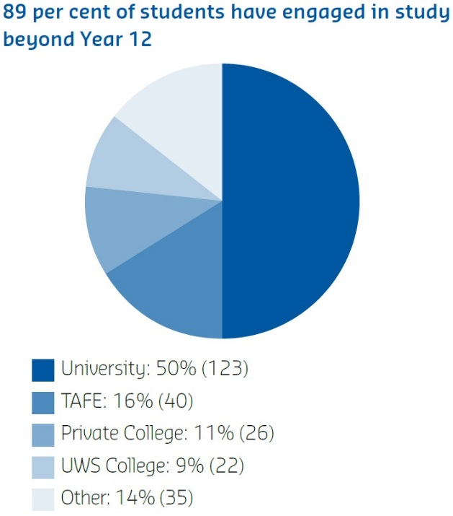
There were 262 Year 12 students in 2012. Destination tracking identified 246 of these students. Of that group, 219 (89 per cent) have engaged in further study in 2013. Others have undertaken apprenticeship/traineeship courses, enrolled in the Defence Forces, or have commenced full time employment.
50 per cent of 2012 Year 12 students were made first round offers to study at a university.
At on-campus events, student responses to evaluation questions indicated that 91per cent of students agreed or strongly agreed that the information presented was interesting, relevant and engaging.

The Future
Further expansion is planned in 2013 with a new program targeting 16 high schools situated in areas with high rates of students from LSES backgrounds. A targeting policy has been developed to select these schools and students in consultation with the Department of Education and Communities and the Catholic Education Office.

The In2Uni Program
University of Wollongong
Outreach
Access
Our partnership with University of Wollongong and the In2Uni Program is about access and equality of opportunity for our students.

Description
The University of Wollongong (UOW) has an embedded commitment to its local community, evidenced by a number of equity initiatives.
The In2Uni Program is a partnership between UOW, Department of Education and Communities (DEC) and the Catholic Education Office (CEO). This partnership demonstrates a whole-of-region commitment to providing students from non-traditional backgrounds with increased opportunities to access higher education.
The In2Uni Program is operated out of UOW’s main and regional campuses, to enhance the aspirations and academic capacity of students from non-traditional backgrounds. The program works with 58 primary and high schools over a 400 km area down the east coast of NSW. Students in Year 6 through to Year 12 engage with on-site campus experiences, mentoring, Higher School Certificate (HSC) study assistance, transition advice and financial assistance to support them through their schooling and make a successful transition to university. The program recognises the importance of providing positive role models for students through the use of trained university mentors in all programs on offer.
In 2013, the program together with the Faculty of Law, Humanities and the Arts at UOW launched Summer Master Classes, an intensive six credit point subject for current Year 12 students. The Summer Master Classes provided students with the opportunity to enrol and study as a university student and has provided a tangible pathway for students from all backgrounds to transition into a UOW degree.
A whole-of-region commitment to providing students from non-traditional backgrounds with increased opportunities to access higher education.

Objectives
The In2Uni Program addresses the partnership component of the HEPPP Funding and
aims to:
- develop, foster and sustain mutually beneficial collaborations and partnerships with key stakeholders
- build aspirations of LSES students toward higher education
- build capacity to successfully navigate pathways to higher education
- strengthen relationships with parents and local school communities to build an awareness and knowledge about higher education.

HEPPP Funding
The human resource and program costs for the In2Uni Program have been primarily funded by HEPPP since 2010, with joint contributions made by UOW, DEC and the CEO to ensure program sustainability.
The number of schools participating in the program has increased from 21 in 2011, to 58 in 2013.

Measurement
The success of the In2Uni Program has been measured by the level of student, parent and teacher participation and engagement with the program.
The number of schools participating in the program has increased from 21 in 2011, to 58 in 2013; with the number of student participants increasing two-fold over three years. Enrolments to UOW from participant schools have increased from 279 in 2011, to 397 in 2012.
The success of the program is also measured by a positive community response, as evidenced by the following example:
“The In2Uni Program is breaking down barriers and showing students’ education options. Our partnership with UOW and the In2Uni Program is about access and equality of opportunity for our students, something I am determined that they will have so they can explore all educational opportunities now and in the future.” —Principal, 2013.

The Future
From 2014, the program will operate under UOW’s broader Student Diversity and Outreach Framework. UOW will continue to develop opportunities for engagement with equity students through embedding outreach strategies at its regional campuses and expanding the scope of the Summer Master Classes on offer.

AVID Australia
Victoria University
The Victoria Institute
Outreach
Access
A systematic approach to university readiness.

Description
The Advancement Via Individual Determination (AVID) Australia project is an innovative university-readiness system that explicitly prepares students from LSES, diverse and disadvantaged backgrounds for tertiary success. The AVID system provides early childhood, primary, secondary and tertiary programs and has been operating in the US for over 30 years. AVID works simultaneously to support students, teachers and school leaders to improve academic, social and emotional aspects for underachieving students.
The AVID Australia program is building strong relationships between schools and universities across Australia and internationally.
AVID works with teachers to help them support disadvantaged students by providing ongoing professional learning focused on delivering collaborative, inquiry-based, high-engagement pedagogies across a whole school. These pedagogies set high academic expectations for underachieving students. The teaching strategies are augmented with AVID-trained undergraduates who act as mentors and tutors to AVID students. AVID students are acculturated into campus life by participating in lectures, learning about courses and careers, and meeting tertiary students who came from backgrounds like themselves.
The AVID Australia project is an innovative university readiness system that explicitly and expressly prepares LSES students for tertiary study.

Objectives
The AVID Australia project has a number of objectives:
- to build stronger school–university partnerships
- to generate whole-school improvement
- to assist teaching and leadership staff to better meet the needs of underachieving students by using explicit teaching pedagogies to build their writing, inquiry, collaboration, organisation and reading skills
- to increase the numbers of LSES, diverse and disadvantaged students aspiring to access and succeed at university and beyond.

HEPPP Funding
AVID Australia is HEPPP-financed and receives in-kind support from AVID Center, and participating schools and universities. The funds are used to provide ongoing professional learning for teachers and school leaders, direct support for students, and facilitates outreach activities including campus visits and accommodation for students from rural and regional areas.

Measurement
An omnibus research design is underway which evaluates both short and longer-term data and tracks whole-school impact, particularly by observing any improvement to student achievement from changes in teachers’ pedagogies. A combination of teacher observations, interviews with stakeholders in the school community, student achievement measures and use of the Effective Lifelong Learning Inventory developed by the University of Bristol are also being employed.
AVID assists teachers in supporting disadvantaged students, generating student success through high support, high expectations and collaborative high-engagement pedagogies.

The Future
The number of AVID sites in Australia has grown from one in 2010 to 19 in 2013. Over 500 teachers in Victoria, NSW and WA have been trained in AVID strategies. The program is scalable and early indications show it is having a very strong, positive effect on whole-school improvement. Its impact will be measured over time with the expectation that the numbers of LSES, diverse and disadvantaged students aspiring to, accessing and succeeding at university will greatly increase in those sites using AVID.

List of Acronyms
ACU Australian Catholic University
ANU Australian National University
ATAR Australian Tertiary Admission Rank
AVID Advancement Via Individual Determination
CDU Charles Darwin University
CEO Catholic Education Office
CQU Central Queensland University
CSC Centralian Senior College
CSU Charles Sturt University
CV curriculum vitae
DARE Dream Aspire Reach Experience
DEC NSW Department of Education and Communities
DECD Department for Education and Child Development
DEECD Victorian Department of Education and Early Childhood Development
ECU Edith Cowan University
FYAN First Year Advisor Network
FYE First Year Experience
GPA Grade Point Average
GWS Greater Western Sydney
HECS Higher Education Contribution Scheme
HEPPP Higher Education Participation and Partnerships Program
HSC Higher School Certificate
ICT Information Communication Technology
JCU James Cook University
LEAD Legacy-Education-Achievement-Dream
LEAP Learn, Experience, Access Professions
LLiC Learnline in Colleges
LMS Learning Management Systems
LSES Low Socio-Economic Status
OF by D Open Foundation by Distance
PD Professional Development
QUT Queensland University of Technology
RMIT Royal Melbourne Institute of Technology
RSOP Regional Schools Outreach Program
SCU Southern Cross University
SEADS Student Equity and Disability Services
SEAS Special Entry Admissions Scheme
SIT Sydney Institute of TAFE
SNAP Schools Network Access Program
SST Student Success Team
STEM Science, Technology, Engineering and Mathematics
SUT Swinburne University of Technology
TAFE Technical and Further Education
TiS Telescopes in Schools
TTTA Trans-Tasman Travel Arrangement
UAC University Admissions Centre
UC University of Canberra
UNE University of New England
UNSW University of New South Wales
UOW University of Wollongong
UPP University Preparation Program
UQ University of Queensland
UQYAP UQ Young Achievers Program
USA University of South Australia
USC University of the Sunshine Coast
USQ University of Southern Queensland
UTAS University of Tasmania
UTS University of Technology Sydney
UWA University of Western Australia
UWS University of Western Sydney
VCE Victorian Certificate of Education
VET Vocational Education and Training
WAM Weighted Average Marks
WP Widening Participation
WPS Widening Participation Strategy

About the Centre
The National Centre for Student Equity in Higher Education began operation in 2008, hosted by the University of South Australia. In May 2013, Curtin University won the bid to take over the Centre and received funding to achieve its aim of informing public policy design and implementation and institutional practice, to improve higher education participation and success for marginalised and disadvantaged people.
The NCSEHE’s objectives are:
- to be at the centre of public policy dialogue about equity in higher education
- to assist in ‘closing the loop’ between equity policy, research and practice by:
  - supporting and informing evaluation of current equity practice, with a particular focus on identifying good practice
  - identifying innovative approaches to equity through existing research and the development of a forward research program to fill gaps in knowledge
  - translating these learnings into practical advice for decision-makers and practitioners alike.
The NCSEHE’s key purpose is “to inform public policy design and implementation, and institutional practice, to improve higher education participation and success for marginalised and disadvantaged people.”
In keeping with its purpose, the NCSEHE is connecting Commonwealth student equity policy with the activities of higher education institutions and national equity outcomes through its input into comparative assessment of institutional strategies, systemic assessments of policy achievements and assessments of national policy-making in view of this evidence. The Centre’s focus is based on three programs of research activity:
- Equity Policy and Program Evaluation
The Centre is providing leadership and support in developing a national approach and resources to evaluate the impact of initiatives to increase participation of people from low SES backgrounds and other equity groups in higher education.
- Equity Policy and Planning Research
The Centre is furthering equity policy and planning in Australia, sharing knowledge and capabilities developed in Australia, and providing evidence on the impact of policy on equity outcomes in the system. By enabling national research and engagement on higher education policy and practice, the Centre ensures its research includes analysis of all student equity groups including people from low SES, Indigenous, regional and remote communities, and people with disability.
- Student Equity Data
The Centre conducts analysis of higher education datasets from a student equity perspective. This encompasses:
  - compiling and analysing national equity data and survey data on student transition to higher education
  - managing a website that presents data on student equity performance in higher education; in particular, the mapping of higher education participation data in Australia
  - providing access to data and data-driven research on equity policy and programs from around Australia and the world.

“Assisting in closing the loop between equity policy, research and practice.”

Disclaimer
Information in this publication is correct at the time of printing but may be subject to change. This material does not purport to constitute legal or professional advice.
Curtin accepts no responsibility for and makes no representations, whether express or implied, as to the accuracy or reliability in any respect of any material in this publication. Except to the extent mandated otherwise by legislation, Curtin University does not accept responsibility for the consequences of any reliance which may be placed on this material by any person.
Curtin will not be liable to you or to any other person for any loss or damage (including direct, consequential or economic loss or damage) however caused and whether by negligence or otherwise which may result directly or indirectly from the use of this publication.

National Centre for Student Equity in Higher Education
Building 100 Curtin University
Kent Street Bentley WA 6102
GPO Box U1987 Perth WA 6845
Tel: +61 8 9266 1573
Fax: +61 8 9266 3658
Email: ncsehe@curtin.edu.au
ncsehe.edu.au

