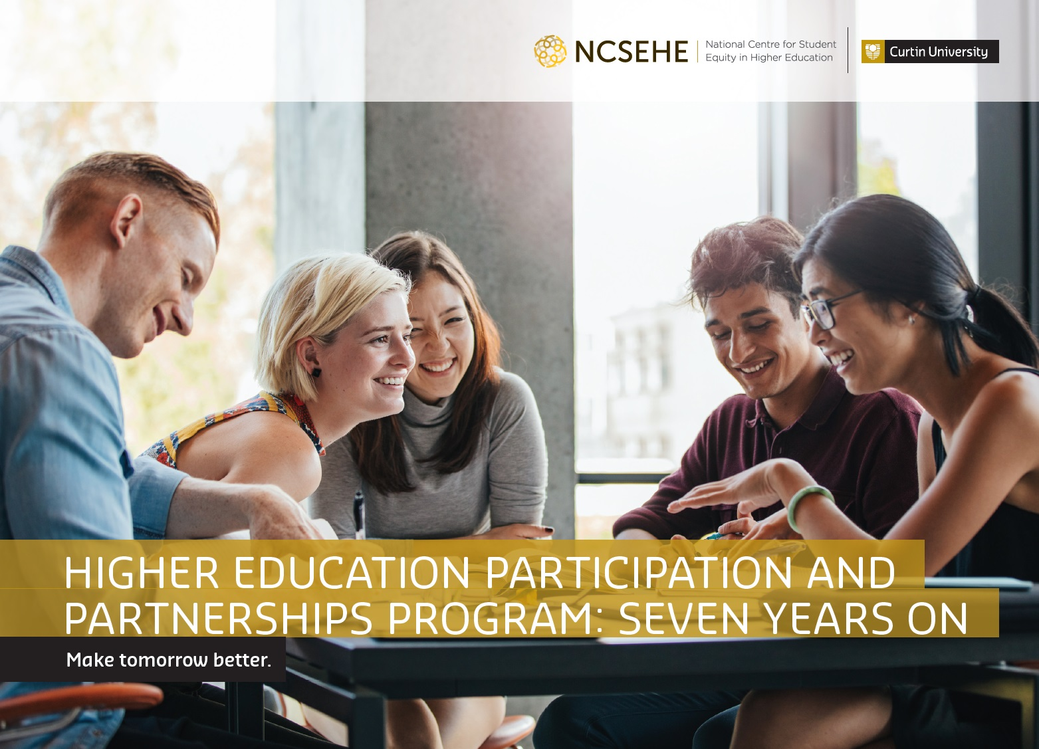

Higher Education Participation and Partnerships Program: Seven Years On

National Centre for Student Equity in Higher Education, 2017

ACKNOWLEDGEMENTS
This publication could not be completed without the work of a dedicated team of people and the support of the Australian Government Department of Education and Training and Curtin University.
Sincere thanks go to Ms Nina Thomas, Miss Marcia Schneider, Dr Kitty Drok and Dr Nadine Zacharias for their input and assistance. Thank you to the many people from each institution involved in sharing their current practice case studies which we proudly share here with you in this publication and on the web at: ncsehe.edu.au

COPYRIGHT INFORMATION
© Curtin University 2017
Except as permitted by the Copyright Act 1968, this material may not be reproduced, stored or transmitted without the permission of the copyright owner. All enquiries must be directed to Curtin University.
CRICOS Provider Code 00301J
ISBN Print 978-0-6480700-2-3
ISBN Digital 978-0-6480700-3-0
Funded by the Australian Government.

Contents
Preface 9
Addressing inequities in educational outcomes 9
HEPPP: Seven Years On 9
A picture of success: diverse, large-scale and sophisticated HEPPP initiatives 9
Seven years of innovative practice 10
ACUgate 11
WCE 14
Future Moves 17
Retention and Return to Study 20
AHEAD 23
ICCB 26
Girls in ICT – Venus 29
Student Futures Program 32
The River Journey 35
Uni-Reach/Uni-Key 38
Get Into Uni 41
School Partnerships Program 44
LEAP 47
Access Monash Mentoring 50
MAP4U 53
Explore Uni 56
I Belong 59
Uni-Bound 62
Strategies for Success 65
Children’s University 68
SSSP 71
SEAMS 74
Live, Learn, Grow 76
Peer Learning Program 79
ASPIRE 82
Young Achievers 85
UniSA Connect 88
Making Career Choices 91
Pathways to Success 93
U@Uni 96
Explore 99
Fairway UWA 102
In2Uni 105
Student Transition Mentors 108
Fast Forward 111
List of Acronyms 114
About the Centre 116
Disclaimer 117

Preface
Professor Sue Trinidad, Director, NCSEHE
Dr Nadine Zacharias, Senior Research Fellow, NCSEHE
Every Australian should have the opportunity to build the best possible future for
themselves, regardless of background or personal circumstances, and education is
widely seen as the basis for realising individual potential. However, many students may
not consider the possibility of higher education, may have difficulty accessing university or may struggle with transitions through it. The reasons are many and varied, but may include remoteness, disability or socioeconomic status, with the most disadvantaged students affected by more than one of these characteristics. The fact that many of these students
do not reach the same level of attainment at school as their non-disadvantaged peers has been widely documented.

Addressing inequities in educational outcomes
Over the last three decades, the Australian Government has developed targeted policy initiatives to address inequities in educational outcomes for young people from six equity target groups, including the Higher Education Participation and Partnerships Program (HEPPP). Introduced in 2010, this comprehensive national equity program provides supplementary funding to universities to build the aspirations and capacity of students
from low socioeconomic status (SES) backgrounds to participate and succeed in higher education. The Government’s commitment to supporting students from disadvantaged backgrounds has been re-articulated in education policy with the Higher Education Reform Package (2017), informed by the findings of the Evaluation of the HEPPP (2017).
Under the HEPPP, Australia’s 37 public universities have designed equity programs
in response to local community circumstances and the nature of their student body. University programs frequently include partnerships with local primary and secondary schools, vocational education and training providers, other universities, State and Territory governments, community groups, and other relevant stakeholders. In addition, there are a variety of programs to support current students in their transition into and through university.

HEPPP: Seven Years On
This case study publication is the third in the NCSEHE series, detailing the successful practices used by universities to reach prospective university students from the target
equity groups (pre-access or outreach), help them get into university (access) and provide support once they commence study (participation), and approach completion (attainment). Following on from Access and Participation in Higher Education: Outreach–Access–Support (2013) and Partnerships in Higher Education (2014), this publication tracks the diverse activities, partnerships, positive outcomes, and sustainable impacts of HEPPP programs over time. This latest review of initiatives to support widening access and participation is a timely contribution to further developing a progressive and equitable higher education system in Australia.

A picture of success: diverse, large-scale and sophisticated HEPPP initiatives
The HEPPP funded programs showcased in this publication illustrate the diversity of institutional responses to HEPPP as well as some clear themes that have been consistent over time. They are a celebration of what has been achieved and a reminder of what remains to be done.

Of the 35 featured case studies, 21 focus on pre-access programs and a further seven
have a pre-access component. This demonstrates the traditional focus of HEPPP funded work on outreach and partnerships with schools, communities and industry partners. The case studies document the longevity, growth and diversification of several flagship outreach programs, with the scale and sophistication of many of these university-led partnerships being truly impressive. Noteworthy differences in program design emerge throughout the case studies. Pre-access programs variably focus on primary/pre-primary students, or those in their final years of high school; on some of the most educationally disadvantaged young people, or on high achievers in disadvantaged schools. Some have a career focus whereas others prioritise academic attainment and teacher professional development. While most engage with their cohort at the school level, other programs have identified sub-groups for highly targeted offers, including Indigenous students, students from refugee or care leaver backgrounds and young women in non-traditional areas.
Collectively, the sector can look back at seven years of significant achievements in positioning higher education as a desirable and achievable post-school pathway. Some
of the case studies document the increases in application rates to universities from their partner schools over time. At the same time, the case studies highlight the often intangible benefits that result from universities’ sustained and mutually beneficial engagement with communities and the difficulties involved in measuring these outcomes. There are case studies of programs that target more than one phase of the student lifecycle, notably pre-access/access; pre-access/participation; and pre-access/access/participation. These provide integrated solutions to some of the barriers identified during the pre-access phase, namely alternative entry pathways and financial support; address the needs of identified target groups; or provide a continuation of support from school to university.
Seven of the case studies have a major access component and are important illustrations of good practice. However, the lack of access-only strategies emphasises the opportunity to increase investment in demonstrably effective access initiatives. This strategic gap has been observed since the early days of HEPPP, by Richard James, Ryan Naylor and Chi Baik in 2012, and confirmed in the 2016 NCSEHE Equity Fellowship project by Nadine Zacharias. Furthermore, there is only one case study reporting on activities in the attainment and transition out phase. This is not surprising given the longitudinal nature of this publication and the fairly recent shift of attention to completion and graduate outcomes of students from low SES backgrounds.
The remaining five case studies highlight participation programs which focus on preparation, transition and peer-support. One case study provides an example of a more personalised approach to retention while another demonstrates the success of efforts to create a more inclusive curriculum which disproportionately benefits students from equity groups. These illustrate the importance of initiatives to support current students in their journey through university but also highlight some of the limitations of attempting to target support offers at particular groups of students.

Seven years of innovative practice
As a collection, the case studies underscore one of the key findings of the above mentioned Equity Fellowship project: that HEPPP has provided universities with the flexibility to develop bespoke equity programs which align with their institutional profile and strategic priorities. Put differently, there is no one best way to develop and implement a HEPPP program; instead, this publication is a celebration of the diversity of successful initiatives undertaken under the banner of HEPPP. HEPPP: Seven Years On illustrates the importance of documenting these successes in comprehensive and rigorous ways as well as the challenges in evaluating programs which show less measurable outcomes.
“Equality is giving everyone a shoe. Equity is giving everyone a shoe that fits.”
– Unknown

ACUgate
Australian Catholic University
Pre-Access
Access

Description
ACUgate is a suite of 16 programs offered by Australian Catholic University (ACU) that span awareness, aspiration raising and access. Of these, the Principal’s Recommendation Program (PRP) and Education Reconnect (ER) focus on university access.
ACU has in excess of 200 secondary partner schools in Australia that are considered low SES. The PRP seeks to offer students who have experienced educational disadvantage an opportunity to access a degree course at ACU. Similarly, ER provides opportunities for people without an Australian Tertiary Admission Rank (ATAR), or who have been out of the education system for a long period. Both programs offer opportunities for the future, realised through educational outcomes.

Objectives
Both programs were created and implemented to assist in pre-tertiary achievement, either at school (PRP) or via an alternative pathway (ER), to enable consideration for access to higher education.

Activities and Progress
The PRP is for Year 12 students from ACU’s low SES partner schools. Principals can recommend eligible students, and students can also self-nominate. The principal’s letter of recommendation outlines the reason for the application, details the student’s suitability, and provides Year 11 and Year 12 academic results.
“Don’t give up on education ... don’t think it is unattainable ... there are ways and means of getting around apparent hurdles ... [and] access resources at unis that are available as I did.”
– ACU student Susan
‘Ben’ was in Year 12 in a low SES suburb of Melbourne.
His principal recommended him as a hardworking student who maximised his academic potential and made significant contribution to the communal life of the school.
However, Ben’s home life was challenging with the passing of one family member and the ill health of another. The family relied on Ben’s time and energy, which impacted significantly on his emotional wellbeing, study commitments and ATAR results.
Through the PRP Ben was offered a place in a B. Arts/B. Laws degree course, even though his ATAR was below requirement. He was supported through his first year of study by the Office of Student Success and the Equity Pathways Officer on campus. Ben is now engaged in his third year of study and moving confidently towards a fulfilling career in law.
“Exam results came out today and I was very happy with the marks I received! From struggling big time I ended up passing both Laws and Marketing.”
– ACU student Ben
In contrast, ER targets people who have not achieved an ATAR, or have achieved an ATAR but have been out of the education system for a long period. Applicants submit a curriculum vitae, academic transcripts of any other courses completed, and nominate three referees. ACU’s Equity Pathways Officer interviews the candidate, their preferred faculty is notified and the application is discussed. If it is considered that the candidate is capable enough, a direct entry offer is made.
‘Susan’ became a mother during Year 12, and did not complete the school year. She eventually began work in a not-for-profit community care organisation. Over time she decided to make a future for herself in nursing.
Susan contacted ACU’s Equity Pathways office, and fitted the ER criteria. She had well-documented references, interviewed well and showed real enthusiasm. It was suggested that she enter ACU through ACUcom, an ACU TAFE provider offering pathways into degree courses.
“This was great for me because it was the first formal education I had had in years ... great way to ease back into education ... hours were good and classes small.”
– ACU student Susan
Susan now studies nursing at ACU and will graduate in 2017.

Outcomes
PRP enrolments at ACU have been stable since 2013, with an increasing proportion of students continuing in study beyond their first year at university.
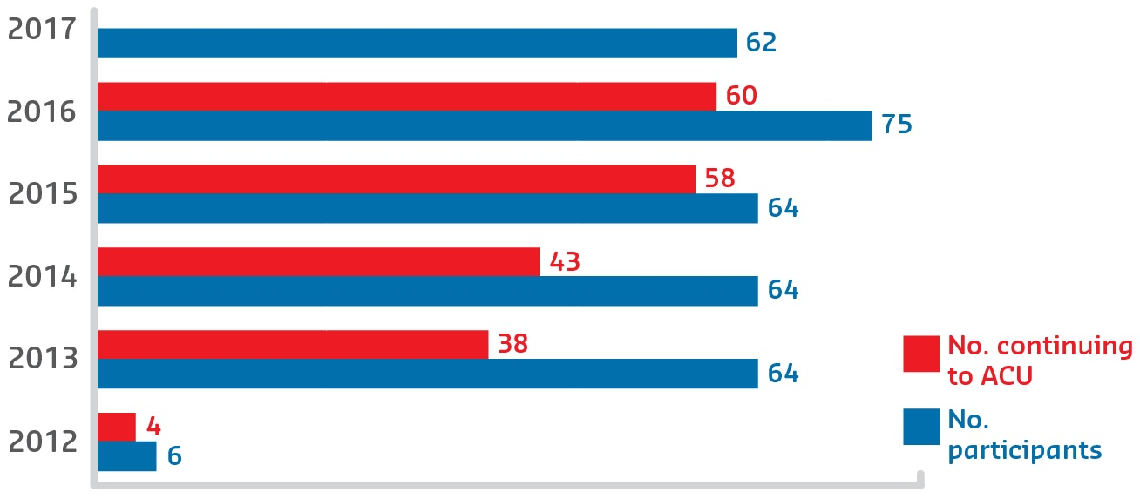
There have been few applicants for ER but it remains part of ACUgate because of the success achieved by the participants to date. It is quietly unique in providing outlier support to students who have come to education ‘after the fact’.

Figure 1: PRP enrolments and continuation at ACU

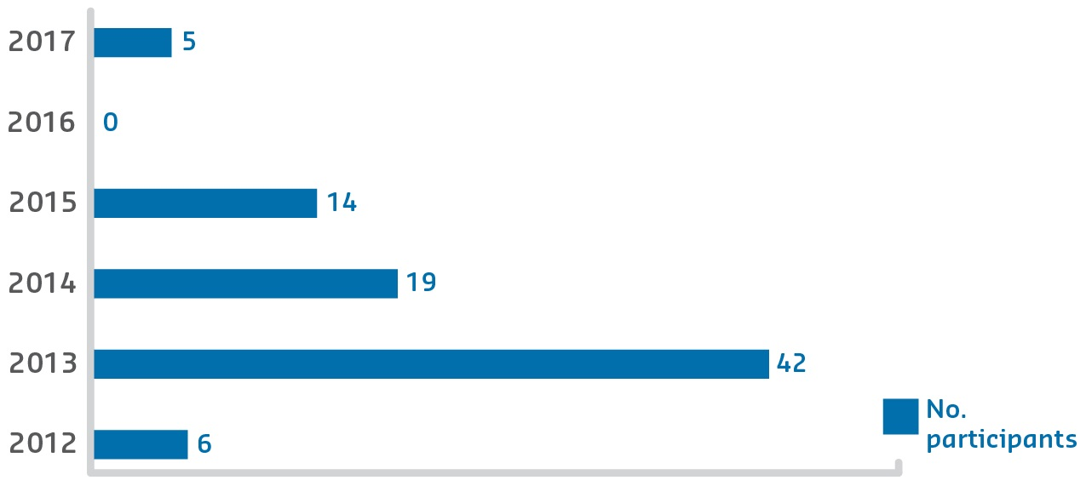
Sustainable Impacts

Figure 2: ER participants
ACU is committed to these HEPPP funded ACUgate access programs, and will continue to develop and streamline them into the future. In general, ACUgate provides a platform from which programs like these can be effectively developed and modified to provide for changing times and needs as they arise. Achieving the programs’ objectives requires close monitoring and documentation of participant opinions and progress, to inform more effective implementation and better outcomes.

WCE
Charles Darwin University
Pre-Access

Description
The Whole of Community Engagement (WCE) initiative commenced in July 2014, led by the Office of the Pro Vice-Chancellor Indigenous Leadership at Charles Darwin University (CDU). WCE aimed to find ways that strengthen pathways into higher education to support the aspiration and expectation of six remote Indigenous communities in the Northern Territory. Using a place-based, Indigenous-led community development approach, the program developed a model which could be applied by agencies engaging with Indigenous communities. Strategy and action was informed by participatory action research and developmental evaluation approaches. Campus-based and remote Indigenous community-based staff worked together to identify needs, priorities and activities from the ground up. A strategic project on Indigenous adult English language literacy and numeracy was put in place in response to emerging Indigenous concerns.
Formalised partnerships included:
- Yirrkala, Galiwin’ku, Maningrida, Gunbalanya, Tennant
- Creek and Yuendumu organisations and communities
- Batchelor Institute of Indigenous Tertiary Education
- Northern Territory Department of Education
- Northern Australian Indigenous Land and Sea
- Management Alliance
- Australian Centre for Indigenous Knowledges and Education
- Service Level Agreements with:
  - Aboriginal Research Practitioners’ Network (ARPNet), West Arnhem
  - Research Institute for the Environment and Livelihoods
  - CDU Research Centre for Health and Wellbeing.
“[It is important that] people on the mainstream side understand the right of Aboriginal people to have a powerful voice in decisions that affect them and their communities — as a principle.”
– Community leader (Galiwin’ku)

Objectives
For Indigenous people living remotely, who often speak English as a second, third or fourth language, the road to higher education is over the horizon, potholed and obstacle strewn, with minimal roadside assistance. The objectives of the WCE were to: explore and engage Indigenous perspectives around higher education, including facilitators of, and barriers to, entry and participation; identify ways to make higher education more culturally relevant and accessible; link Indigenous perspectives and aspiration to action and strategy to catalyse positive systems change; and co-create opportunities for Indigenous communities, researchers and leaders to engage with each other, public policymakers and other stakeholders in mutually beneficial interactions.

Activities and Progress
The WCE team comprised more Indigenous than non-Indigenous staff, and local teams planned and implemented activities together in each community. Although the six implementation sites were remote and geographically dispersed, common attitudes, beliefs and themes around higher education emerged over time. Local teams responded uniquely in each place supporting and delivering a diverse range of locally-driven research, strategies and activities. Activity focus areas included: youth leadership; addressing school bullying; promotion of and entry into higher education; student mentoring and mediation; cultural mentoring for teachers; Indigenous teacher support; strengthening Indigenous leadership in school councils; catalysing community-wide engagement on education; local research capacity building; documenting Indigenous metaphors around higher education; facilitating Honorary appointments; filming Indigenous perspectives and experiences; and research on local educational history.
Progress was informed by an internal evaluator who fed into the team’s reflective cycle. The systems component of the WCE focused primarily on a strategic project on Indigenous adult English language literacy and numeracy. All WCE activities ceased at the end of September 2017.
“Education is viewed holistically by Indigenous participants and includes wellbeing, spirituality and livelihood.”
– WCE coordinator

Outcomes
The WCE model recalibrated power relations, amplified the Indigenous voice, enhanced Indigenous leadership and governance capacity and led to unique outcomes at each site. It contributed to increased: cross-sectoral communication and coordination; interest in schooling and understanding of pathways into higher education; Indigenous researcher capacity and organisation; confidence and capacity of youth leaders; Indigenous role modelling and mentoring within school and community; introduction of cultural content and supporting resources in schools; and contribution to the literature about remote Indigenous perspective and ideas on higher education. Emerging perspectives were shared with each community, at team meetings, conferences, and in publications, including that: Indigenous leadership and governance in remote education is essential; education and higher education are a priority for many Indigenous people; Indigenous cultural knowledge is foundational to other learning; education should be ‘both-ways’; education is viewed holistically by Indigenous participants and includes wellbeing, spirituality and livelihood; and English language, literacy and numeracy is central to progress.

Sustainable Impacts
Funded initially for two and a half years (and extended in part to three), WCE developed a substantial number of strategic relationships and laid a solid foundation for future partnerships between CDU, the six Indigenous communities and other organisations. The WCE also contributed to the furthering of long-term community aspirations and goals.
WCE operated in logistically complex, unpredictable and challenging settings across the Northern Territory. Travel requirements were significant, and the environment and communications were unpredictable. Indigenous people speak multiple languages (54 per cent do not speak English as their primary language), and have diverse cultural identities and strong cultural and community obligations. Establishing trusting relationships, meeting with all stakeholders, communicating the aims of the project and getting people interested and engaged took time. Sustainability was directly impacted by the short timeframe. Sustainable impacts relate strongly to:
- establishing stronger relationships between and within education institutions and remote Indigenous communities
- enabling the generation of a knowledge base about how to make education culturally and physically relevant and accessible as told through the Indigenous lived experience.

Future Moves
Charles Sturt University
Pre-Access

Description
Starting with 10 school partners in 2010, Charles Sturt University (CSU) developed Future Moves to address the underrepresentation of students from low SES areas in higher education. Future Moves has since strengthened to become the university’s mainstream aspiration program, delivered across six campuses and partnering with over 80 primary and secondary schools in regional New South Wales and North East Victoria. Future Moves’s activities encourage students to act on their aspirations in informed ways by raising their awareness of opportunities arising from a university degree and their understanding of how university might be part of their future, making school studies more relevant.
Partners:
- New South Wales Department of Education
- Victorian Department of Education and Early Childhood Development
- National Indigenous Science Education Program
- community partners, Indigenous partners and local councils
- over 80 primary and secondary schools in regional NSW and North East Victoria.

Objectives
Future Moves aims to shift the views of school students and their parents to consider university as a realistic and achievable post-school option. It aims to operationalise aspirations of the targeted cohort and provide information to support families in the processes of choosing higher education. Future Moves’s short-term objectives are to see an immediate positive shift in students’ awareness of, and aspiration to, study at university following Future Moves’s events and activities. In the longer-term, Future Moves aims to maintain students’ aspiration to study at university and to see increased enrolments at university from its partner schools.
“It opened up everything pretty much. I knew what I wanted, I wanted to work with people and help them, but I never knew how, and this helped tell me how to do it.”
– Indigenous Year 10 student

Activities and Progress
Future Moves delivers a structured program of school workshops and on-campus events to students from Years K to 12, aligned with the Australian Blueprint for Career Development.
In-school workshops cover a range of age-appropriate topics including: self-development; higher education awareness; study skills; courses and careers; time management; and pathways to university.
On-campus events introduce students to university and seek to change students’ perceptions of university as an intimidating place for smart people, to a friendly environment accessible through many pathways.
Workshops and on-campus events build awareness of university and encourage students to explore careers. Future Moves’s activities also help students identify appropriate pathways and assist students to identify and overcome real or perceived barriers to tertiary education. Future Moves also engages with parents to encourage and support their understanding of tertiary education, and works collaboratively with partner schools to identify opportunities for teacher professional development.
Since 2014, Future Moves has also run a suite of Indigenous-specific programs called Danygamalanha, meaning ‘to excel’. These include:
- Sky Stories — connecting Indigenous knowledge to science, engineering, technology and mathematics
- Strong Moves mentoring — a four-session on-campus intensive university experience, and Indigenous on-campus overnight camps.

Outcomes
“I asked the students prior to attending the Check it out Day! who was thinking about going to university, only about seven of the 16 students put their hand up. After the day we had a 100 per cent success rate. They all wanted to go and were seriously working out how to they were going to achieve this.”
– Assistant Principal
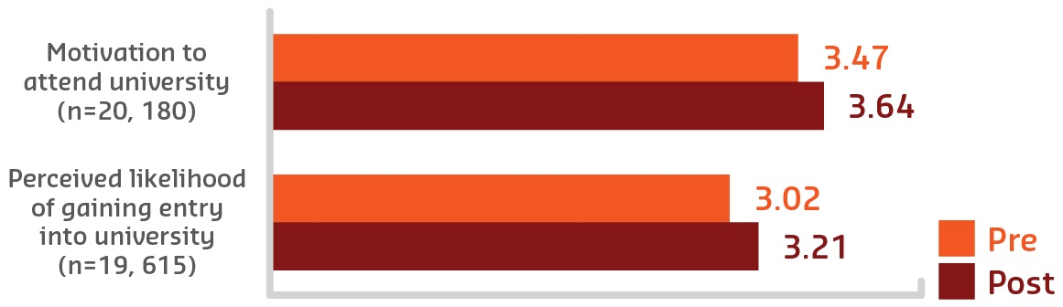
Evaluation shows that Future Moves activities achieve immediate positive shifts in students’ aspiration to attend university and their perceived likelihood of getting into university.

Figure 3: Likelihood and motivation
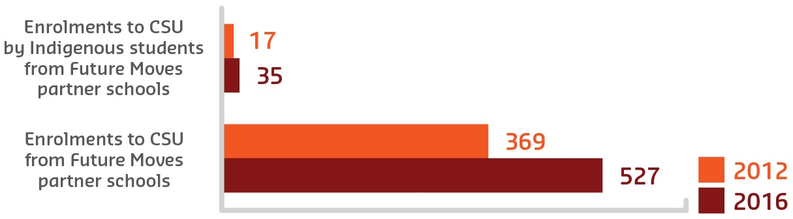
University enrolments from Future Moves partner schools have increased by 70 per cent since 2012, and 106 per cent among Aboriginal and Torres Strait Islander students.

Figure 4: Admissions

Sustainable Impacts
Future Moves impacts on students’ awareness of, and aspiration to, attend university and on university enrolments — evidenced by increased university enrolments to CSU from Future Moves partner schools. Interviews and surveys with teachers and parents show that they perceive Future Moves to have an ongoing impact that extends beyond actual activities and events.
Future Moves has built strong, responsive partnerships with partner schools and volunteer university student Leaders. Schools take an active role in the program, signing yearly agreements that outline mutual responsibilities while university Leaders support program delivery in classrooms and on campus, demonstrating their enthusiasm and knowledge of university life to the school students. Many Future Moves volunteer Leaders were participants in Future Moves while at school. Future Moves is embedded in the Office for Students’ HEPPP funded equity programs at CSU and is working collaboratively within CSU and communities in its footprint to continue to deliver the program.

Retention and Return to Study
CQUniversity
Participation

Description
CQUniversity is a comprehensive regional university with 25 campuses across Australia. Fifty per cent of its domestic undergraduate students are from low SES backgrounds, and 62 per cent are from regional and remote locations. With this proportion of disadvantaged students, CQUniversity experiences relatively high student attrition and low completion rates.
The Retention and Return to Study program was initiated in 2015 to identify the key factors that contribute to attrition and the supports required to improve the retention and success of these students.

Objectives
The program aimed to improve the retention and success of CQUniversity students from low SES backgrounds by:
- identifying the factors that contribute to students withdrawing
- establishing an evidence base to inform the development of a retention strategy
- reconnecting with former students and identifying strategies that could encourage them to return to complete their degree
- providing the supports required to enable former students to return and successfully complete their studies.
“Thank you for your advice and recommendations. I think I am leaning towards just doing one unit for now, as working full-time and only having two full days per week is just not possible to study a recommended 25-hour week uni work load.”
– Returning student

Activities and Progress
The program involved four key stages:
- Preliminary work including: gaining ethics approval; appointing project staff; identifying former students who met the criteria for inclusion; and refining the methodology.
- Semi-structured interviews conducted with former students who left the university over the last five years to identify the factors they believe contributed to them being unable to complete their studies, and what might have helped them to stay. The interviews also provided the opportunity for former students to indicate if they would like support to return to study.
- Following up with those participants who indicated that they would like to return to study, and providing them with the support to navigate the processes required for them to re-enrol in either their original program or an alternative program that might better suit their needs.
- The final stage of the project, due to conclude at the end of 2017, will involve: final analysis of the findings; development of case studies and preparation of good practice guidelines for academics; and final reporting.

Outcomes
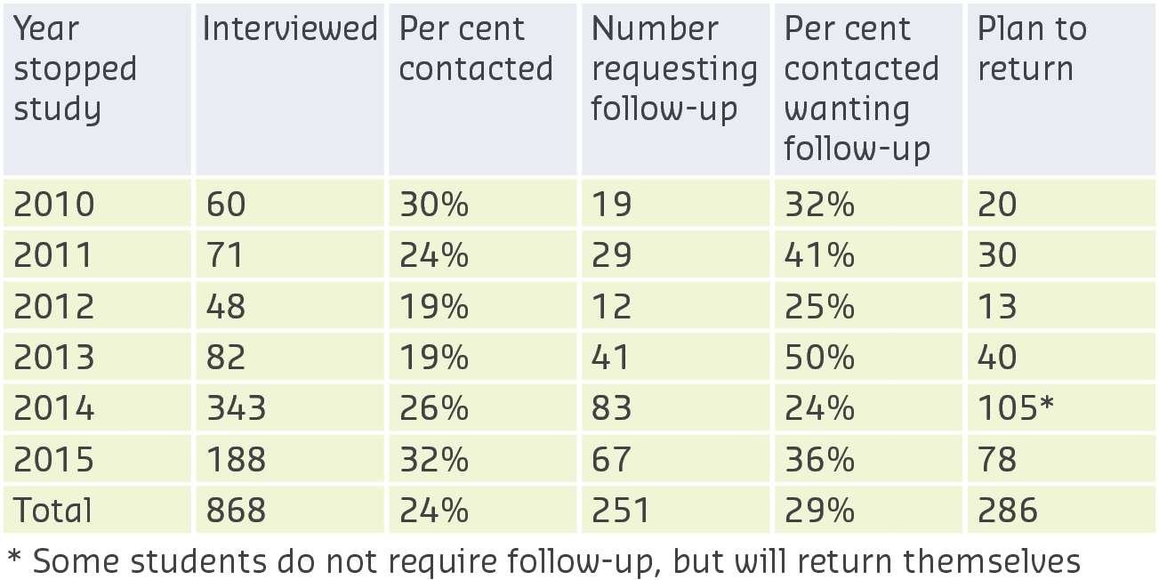
Of the 868 former students interviewed, 251 (29 per cent) requested follow-up with the view to exploring the possibility of returning to study to complete their degree.

Figure 5: Number of students who requested follow up and/or who plan to return

The findings from interviews confirm that the major factors contributing to high levels of student attrition are: personal such as health or family responsibilities; work–study balance; academic; lack of support; now studying at another university; financial; and other.
“CQUniversity experiences relatively high student attrition and low completion rates [among disadvantaged students]. The Retention and Return to Study program was initiated in 2015 to identify the key factors that contribute to attrition and the supports required to improve the retention and success of [disadvantaged] students.”
– Retention and Return to Study coordinator
Many of those interviewed offered suggestions as to how CQUniversity could better support their students and improve retention: 161 suggested more support, follow-up and/or phone calls, and 153 proposed academic-related solutions (for example improving teaching, better recognition of prior learning processes and improved group work assessment processes). Those studying at a distance indicated a preference for a more personal approach, such as a regular phone call.
Program findings suggest that a more personalised approach could improve student retention and success, and demonstrated that even after students have left the university, a phone call to reconnect and encourage them to return can improve completions. Of the 251 former students that requested follow-up with the view to returning to study, 46 returned in Term 1 2017 and 22 are planning to enrol in Term 2, 2017, with the remainder planning to return in 2018 or when their situation improves.
Those returning to study were supported in making informed decisions about the suitability of their chosen programs, and counselled about their workload expectations. As a result, some chose more realistic career pathways and modified their study commitments to ensure that they were not overcommitting to an unrealistic workload.

Sustainable Impacts
Program findings suggest several strategies universities can employ to improve the retention and success of students from low SES backgrounds. These provided the evidence to support the following initiatives at CQUniversity:
- a pilot pre-commencement interview strategy trialled with commencing Bachelor of Nursing students in 2015, which demonstrated the benefits of early intervention to better prepare transitioning students for realistic pathways and work–life–study balance
- a current National Priorities Pool funded project extending the trials of the pre-commencement interview strategy across disciplinary fields and university contexts in 2017
- a CQUniversity funded project trialling a personalised student support approach in which academic and professional staff work as school-based teams providing pre-commencement advice for transitioning students, and ongoing support for students identified as at-risk.

AHEAD
Curtin University
Pre-Access
Access

Description
The Curtin Addressing Higher Education Access Disadvantage (AHEAD) program aims to provide pre-tertiary learning experiences and resources, in collaboration with school and community partners, that facilitate student learning in low SES school and community groups to overcome the challenges to participation in higher education.
AHEAD works with low SES K–12 schools and community groups in three distinct clusters: metro; regional; and remote. AHEAD also partners with organisations that share similar mandates to provide exemplary aspiration-focused learning experiences for people from low SES backgrounds, and to contribute to the development of best practice widening participation initiatives.
AHEAD collaborates with over 80 external school and community groups, as well as local governments, including: Role Models and Leaders Australia; Follow the Dream (the Graham Farmer Foundation); the Department of Corrective Services; Boronia Pre-Release Centre for Women; Women in Leadership Driving Change (WILD’C); Ruah Community Services; The Smith Family; YourTutor; Acacia Prison; and Future Footprints.
“I have been a part of this program since Year 8. If I hadn’t been a part of this, I would not have believed university was a possible option for me.”
– Year 10 student

Objectives
AHEAD focuses on creating and facilitating career development and university readiness learning experiences, designed to raise aspirations and strengthen capability for higher education. With the aim of increasing participation of underrepresented individuals and groups, AHEAD experiences are designed to increase confidence and capacity to make informed choices; expose people to new and enhanced opportunities; and change perceptions and attitudes about higher education. AHEAD is a collaborative and innovative outreach hub that develops the potential of promising underrepresented higher education students. The program harnesses university services and facilities to create unique learning experiences that foster tertiary interest.

Activities and Progress
AHEAD was formed in 2014 by bringing together the platforms and early lessons from several outreach initiatives that focused on secondary school tutoring and tertiary awareness workshops funded through the HEPPP.
Originally a school-focused program, the suite of AHEAD learning opportunities has expanded to include design solutions to educational challenges impacting young people in their communities, those from culturally and linguistically diverse backgrounds, and people seeking education while incarcerated.
AHEAD activities include: in-school, in-community and in-prison workshops; on-campus learning experiences; mentoring; support groups; participation at community events; aspiration through sport; Row AHEAD — introduction to university rowing with current university student mentors (Clontarf Aboriginal College); university aspiration camps; and AHEAD with Confidence (regional Year 12 one-week camps).
AHEAD has achieved significant growth in demand for its services, which has enabled collaboration with more than 60 schools, increased from 11 in 2010.
AHEAD participants have grown from 1,000 in 2010 to over 4,000 in 2016. Over the years, AHEAD has developed engagement strategies to foster progressive learning experiences that build the knowledge and confidence that empowers students and community participants to enter higher education.

Outcomes
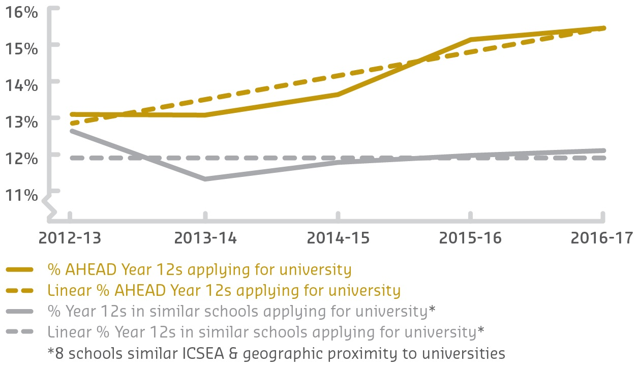
AHEAD’s successful outcomes are represented by strong partnerships, which enable it to engage with and support over 4,000 low SES school and community members a year. Since 2014, AHEAD has supported 1,041 students into university, and 41 prison residents through the Curtin UniReady program, of which 10 have transitioned into university. As AHEAD develops, it is able to work closely with many different areas of the university to create comprehensive and innovative support mechanisms for potential higher education students from low SES backgrounds. Since 2012, 1,678 AHEAD students have applied for university.

Figure 6: Percentage of Year 12 AHEAD students applying
for university versus Year 12s from similar schools

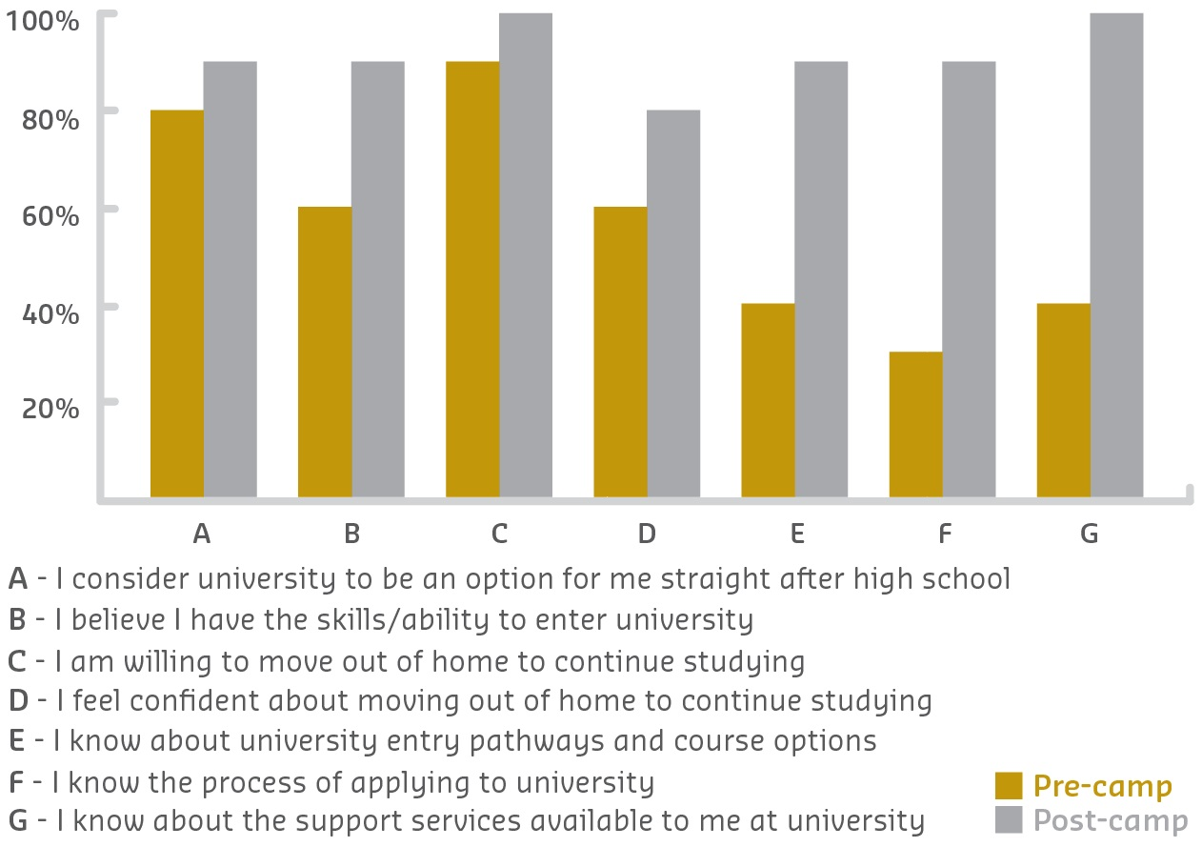
Sustainable Impacts

Figure 7: Pre- versus post-camp attitude of regional camp participants
AHEAD, funded primarily through the HEPPP, is strongly supported by Curtin University.
Its achievements have been recognised and celebrated, having recently won the Vice-Chancellor’s Excellence Award for Professional Staff in 2016 for Engagement and Collaboration. AHEAD is situated within the Learning Futures directorate, as part of
Curtin Learning and Teaching. Learning Futures develops innovative learning strategies, promotes talent development for high potential students and builds strategic partnerships. The inclusion of AHEAD within Learning Futures is fostering the development of new opportunities for AHEAD participants, including blended learning opportunities, processes
for validating and rewarding AHEAD student achievement, and documenting evidence of learning through innovation, creativity and entrepreneurship activities.

ICCB
Dakin University
Participation
Attainment

Description
Deakin University’s Inclusive Curriculum and Capacity Building (ICCB) program has enabled more than 25 projects to transform curriculum and develop a stronger university culture of inclusive teaching and learning over the past three years. The HEPPP funded program has brought together academic and professional staff to work closely on a range of initiatives, each identified by the partners themselves.
Informed by Universal Design for Learning principles, each project has aimed to embed and scaffold inclusive pedagogy and practice, academic skills and literacies, and digital literacy into the curriculum at unit and course level.
Partners:
- internally with all faculties
- Institute of Koorie Education
- Deakin Learning Futures
- Library, Student Academic & Peer Support, Careers Education.

Objectives
The Inclusive Curriculum and Capacity Building program supports students from diverse backgrounds, particularly low SES. It aims to develop awareness and appreciation of diversity as a valuable resource.
Inclusive design, development and delivery of curriculum addresses the learning needs of our diverse student population. The program builds a more inclusive approach to curriculum, and supports staff to manage the challenges and opportunities this presents.
“[The ICCB project] has changed practice and influenced the systems and the way
that this university is doing its business. I think that is significant and we should not underestimate that achievement ... I think that is what is being achieved, one course
at a time.”
– ICCB project participant

Activities and Progress
- Faculty of Health ‘Inclusive Feedback’: The first project formed a community of practice with academics and sessional staff and surveyed students to develop an inclusive feedback model and resources, run professional development workshops, and pilot video feedback. The second project, still underway, surveyed academics and inclusion experts to develop a model of inclusive feedback. The team has also submitted for publication a literature review on video feedback in collaboration with the Centre for Research in Assessment and Digital Learning at Deakin University.
- Faculty of Arts and Education ‘Introduction to University Study’: A team of Equity and Diversity, Faculty, Library, and Academic and Peer Support staff collaboratively redesigned this accredited unit in late 2014. The partners continue to team-teach the unit across three campuses and online to large cohorts of students. An evaluation of the new curriculum was conducted in 2015, and the evidence gathered was used to further improve the unit.
- Faculty of Science, Engineering and Built Environment and Graduate Employment ‘Start Anytime’ Work Integrated Learning units: A team of staff developed online units to support more than 2,000 students each year prepare for and complete work placement. The ‘online flipped classroom’ design streamlines students’ progress and feedback. The fully accessible units include built-in pre- and post-tests to continuously evaluate learning.
- ‘Perspectives’ online role-play: The Library worked with student designers and faculty staff to develop an online role-playing interface and activity. This can be re-used in multiple units with customised content, to help students develop digital literacies using resources and ideas relevant to their discipline in an accessible, engaging and collaborative way. The template has been trialled in two faculties, with further customisations underway for multiple units in the remaining faculties.

Outcomes
An ongoing action research approach is used to ensure that achievements are highlighted, continuously improved and sustained into the future. Student statistics, surveys, web log data, focus groups and interviews are used to identify student impact, successful practices and models, and systemic issues.
For example, the Introduction to University Study retention and success outcomes for the 2015 unit cohort include:
- pass rate increased by 7.5 per cent for all students, 13 per cent for low SES, 10 per cent for Non-English Speaking Background, and six per cent for students with disability
- students had a 10 per cent greater pass rate in other units they studied
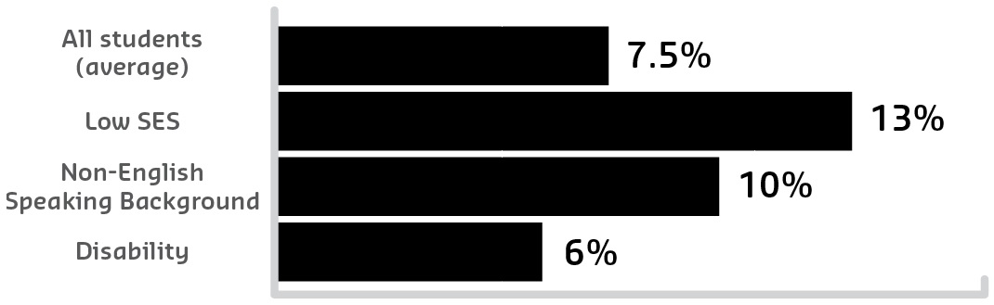
- students had a seven per cent greater retention rate to the end of 2016.

Figure 8: Introduction to University Study program pass rate increase for 2015 cohort
The other successful practices and models have been similarly scrutinised. Most initiatives are ongoing, having been embedded in curriculum and professional development.
Some have attracted further funding. Evaluation suggests that the ICCB program has produced systemic changes. Faculty teaching and learning planning documents are now listing explicit inclusive teaching and learning goals. Several recent program and course redesign documents have included inclusivity goals. At least six staff employed casually for ICCB projects have been retained as permanent staff and continue to apply their knowledge of inclusive design and teaching.
Many project leaders have leveraged their ICCB work to develop inclusive curricula in other units and courses.

Sustainable Impacts
The ICCB program grew out of several independent HEPPP funded projects initiated by faculty and divisional teams beginning in 2011. Equity and Diversity combined these in collaboration with professional staff to create the ICCB program. This has multiplied opportunities to share ideas, resources and evidence around inclusive teaching and learning, and has deepened relationships between academic and professional staff. A major effort is now underway to disseminate learnings, models and exemplars widely:
- Equity and Diversity have just launched a comprehensive ‘Inclusive Teaching and Learning’ website for all Deakin staff, showcasing fully accessible web design and including inclusive teaching tips, exemplars, resources and discussions. This builds on an existing successful university-wide online staff development module.
- The Faculty of Health has published its own Inclusive Learning Series to support its professional development program.
More than 30 journal articles and conference presentations have been written/presented on ICCB initiatives/outcomes.

Girls in ICT – Venus
Edith Cowan University
Pre-Access

Description
The Girls in ICT — Venus project was established to enthuse and inspire female Year 9
and 10 students from low SES areas about careers in the Computer and Security Sciences (C&SS). Currently, females are significantly underrepresented in this industry. This project investigated the prevailing attitudes that Year 9 and 10 female students had towards Computer and Security Sciences. ‘Boring’ has been regularly stated as a school factor associated with low female participation rates in computing classes. However, through the provision of hands-on activity sessions with partnering schools, as well as career seminars at Edith Cowan University (ECU), this project demonstrated positive attitudinal change.
Partners:
- Edith Cowan University
  - School of Science
  - Strategic Relationships Management team
- Department of Education, Western Australia
- three low SES secondary schools in Perth’s central northern corridor, and
one on-campus workshop with Indigenous students from four local Catholic secondary schools.
“Currently there are different perceptions in relation to working in C&SS ... The focus was to raise awareness ... and increase career aspirations towards C&SS.”
– Girls in ICT – Venus coordinator

Objectives
The focus was to raise awareness of non-traditional pathways for students (those from low Index of Community Socio-Educational Advantage [ICSEA] schools) into university, highlight higher educational opportunities in C&SS, and increase career aspirations towards C&SS.
Currently, there are different perceptions in relation to working in C&SS. The project wanted to break down some of these barriers, engender aspirations with regard to careers in this often perceived male-dominated science area, and raise awareness of higher education opportunities in non-traditional female careers.
“The Girls in ICT — Venus project wanted to engender aspirations with regard to careers in the often perceived male-dominated area of Computer and Security
Sciences, and raise awareness of higher education opportunities in non-traditional female careers.”
– Girls in ICT – Venus coordinator

Activities and Progress
Two interactive C&SS experience sessions were conducted with schools — the main objective being to provide information increasing students’ understanding of C&SS. The
first interactive session was focused on ‘engagement’. This involved female Year 9 and 10 students learning about the different skillsets required to work in C&SS. The fun activities specifically exposed the analytical, creative, interpersonal and practical components of C&SS. The focus was to assist the participants in linking their individual strengths to the various C&SS career fields, and therefore increase their knowledge.
The second interactive session was focused on ‘exposure’. This involved mixed Year 9
and 10 students visiting ECU and experiencing career talks. Female role models from the cyber security, computer science and counter terrorism, intelligence and security sciences presented information on their chosen professions. These female role models challenged often held perceptions of women in C&SS. Discussions were held with the students on the presenters’ school experiences, pathways to university and university study options, engendering their aspirations with regard to careers.
“By the end of 2016, over 200 Year 9 and 10 students from local secondary schools ... had taken part in the Girls in ICT — Venus project.”
– Girls in ICT – Venus coordinator

Outcomes
By the end of 2016, over 200 Year 9 and 10 students from local secondary schools (with
low ICSEA scores), had taken part in the Girls in ICT — Venus project. More than 120 of these were female, who now understand and are more knowledgeable about C&SS as a potential career. With this in mind, we hope to see future enrolments of females in our C&SS courses increase. This should commence around 2018 as these students complete school.
Teachers and school deputies who attended the school workshops and university presentations have also been exposed to the different skillsets and careers in C&SS.
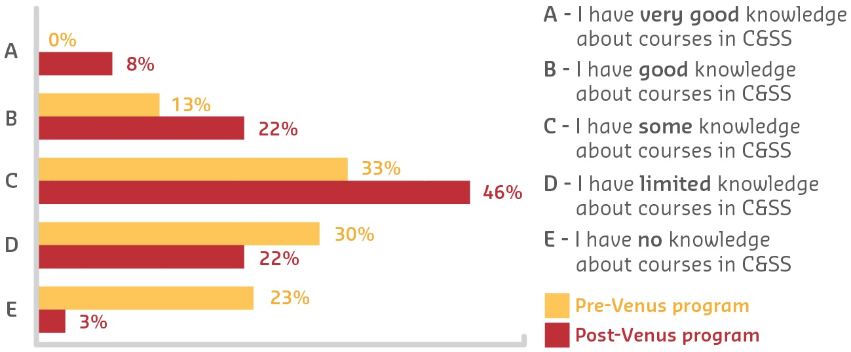
This means that they are in a better position to support students when advising them about career pathways, subject selection and further education.

Figure 9: Pre- versus post-program student perceptions

Sustainable Impacts
The Girls in ICT — Venus project has offered students:
- an opportunity to experience activities that directly relate to the courses and
careers of C&SS
- understanding of the various jobs and the different skills (analytical, creative, interpersonal and practical) required to work in these careers
- perspective on people who are studying or working within this field
- an opportunity to come on campus.
The HEPPP funding has also contributed to the furthering of ECU relationships with local (low ICSEA) schools. Continued engagement has resulted since the Girls in ICT — Venus project, with ECU’s School of Science now offering C&SS activities for students in Years 7
to 11 from different schools.
These hands-on activity sessions expose students to our university, C&SS skills, and higher education pathways. This new project seeks to increase female participation (particularly low ICSEA) rates in C&SS courses and careers.

Student Futures Program
Federation University Australia
Participation

Description
The Student Futures Program (SFP) is a suite of initiatives that supports students through preparation for and transition to university, contributing to student retention and success. SFP is founded on peer support, with a large portion of HEPPP funding allocated to employing students as peer leaders. This means that not only does SFP support students directly, but also enables these student leaders to access convenient, reliable, paid work on their campus or from home to support themselves while studying. With many of these leaders being from equity groups themselves, this has a direct positive impact on their own learning journey.
The SFP is coordinated through the Centre for Learning Innovation and Professional Practice and works collaboratively with areas across the university including Faculties, Library, and Student Connect.

Objectives
As a university with a high proportion of students from non-traditional backgrounds, Federation University Australia (FedUni) made the strategic decision to proactively develop SFP to offer holistic and coordinated academic preparation and learning support for students, and to further provide leadership and employment opportunities to student leaders. Based primarily on a peer support model, the initiative leverages successful students to support new students, creating a positive framework and successful mechanism for student-led support. The SFP challenges the deficit discourse model, focusing on using students’ successes to create a positive environment for student transition.
“What a great start to learning at university ... Now I have an understanding of
what is expected and how things should be presented. It’s a great way to start the learning process.”
– Student

Activities and Progress
In 2013 the SFP brought together a range of existing initiatives and developed new services to ensure students were supported throughout their transition and academic journey. SFP now cohesively combines the following initiatives:
- FedReady — A one-week intensive preparation program that gives commencing students the skills and knowledge they need to succeed in a tertiary environment.
- FedReadyOnline — A facilitated two-week version of the FedReady preparation program.
- Mentoring — Leverages the experience of continuing students to guide new students. Every commencing student is allocated a mentor.
- Peer Assisted Study Sessions (PASS) — Assists commencing students in historically difficult core first year subjects by providing weekly study sessions.
- Academic Skills and Knowledge (ASK) — Acts as a triage point, giving students online, phone and face-to-face access to advice from experienced student leaders.
- YourTutor — Provides out-of-hours online support on assignments and study techniques in an easily accessible manner.
The SFP has grown significantly to see successful rollout at FedUni’s new Churchill campus in 2014 and new Berwick campus in 2017. The SFP is aligned with the University’s Disability Action Plan, Reconciliation Action Plan, Social Inclusion Plan and the Student Retention and Success Plan.

Outcomes
SFP outcomes are clear:
- 100 per cent of the last cohort of FedReady graduate students (those completing the preparation program) would recommend it to their friends.
- Students who attend PASS are less likely to fail, have lower withdrawal rates, and receive a higher than average grade than those who do not attend.
- In 2016, over 1,000 students accessed ASK, with 80 per cent of all enquires resolved without referral.
- In 2016, YourTutor conducted 4,919 live tutorial sessions, and 3,195 essay reviews. Students gave very positive feedback on these interactions.
“... they not only answered my questions but also showed me where to source it for myself should I need it again.”
– Student

Sustainable Impacts
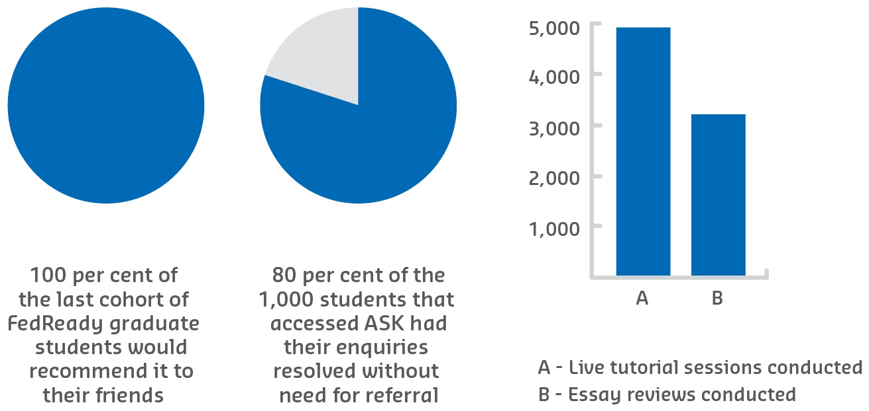
The positive impact of the HEPPP funded SFP stretches beyond the obvious benefits for students accessing the program components. Employing over 180 current, continuing students across all of its services, SFP enables these students to access convenient, reliable, paid work on their campus or from home to support themselves while studying.

Figure 10: 2016 SFP snapshot
Many of these SFP employees are themselves from equity groups, and report that they seek work within the program because of the direct positive impact it has had on their own learning journeys. Facilitation skills and leadership qualities are explicitly taught and developed in student leaders, enhancing their graduate attributes and increasing their graduate employment opportunities.
The SFP is woven into the fabric of FedUni. The Deputy Vice-Chancellor (Learning and Quality) is the University’s champion for this program, ensuring it has the highest level of institutional support.
“[SFP focuses] on using students’ successes to create a positive environment for student transition.”
– SFP coordinator

The River Journey
Flinders University
Pre-Access

Description
Flinders University provides a suite of interventions for prospective university students from low SES backgrounds, raising aspiration and enabling access for participation in higher education.
The River Journey aims to encourage students to explore and map their education and career futures using the metaphor of a winding river, recognising that life journeys do not always progress in a straight line.
Students learn, from upper primary to senior secondary, to consider the benefit of higher education in achieving their career objectives and life goals.
Partners:
- The Department of Education and Child Development
- Catholic Education South Australia
- Association of Independent Schools South Australia
- The Smith Family.
“I think it was a really great look out to what uni could help us with — it was fun.”
– River Journey Student

Objectives
The River Journey was developed after discussion and feedback from primary and secondary educators in low SES areas. This revealed a gap in understanding about what universities were, how they could be accessed and how participation in higher education could benefit their students.
The program is supported financially through HEPPP Partnership allocations and was developed to:
- assist in improving the understanding and awareness of higher education as a viable post-school option
- assist in pre-tertiary achievement, either at school or via an alternative pathway, to enable consideration for access to higher education.
“It gave me more of an understanding about my career and how to go about
getting there.”
– River Journey Student

Activities and Progress
The River Journey commenced in 2012 with the participation of a single primary school in an Adelaide outer southern suburb involving 20 students. The majority of students involved in the pilot had limited knowledge of university or professional career pathways.
The initial presentation aimed to trigger interest in higher education and possible opportunities for further study. From learnings in the pilot, the River Journey has evolved to include age/year level-specific interventions including:
- Encounter (Year 7) — Triggers students’ interest in higher education and possible opportunities.
- Explorer (Year 8) — Helps students remain motivated toward achieving their education/career goals.
- Investigator (Year 9) — Exposes students to new or unknown options for the future and supports their interest.
- Navigator (Year 10) — Examines careers, attainability and employment prospects.
- Senior Presentation (Years 11 and 12) — Examines the modern career landscape, employability and individual directions beyond secondary school.
The River Journey program includes interactive on-campus experiences that enable students to experience life as a university student and learn about courses and access opportunities.
From simple beginnings, the River Journey has evolved to become a comprehensive support program focusing on careers and higher education participation for students from low SES and/or other disadvantaged backgrounds from Year 7 to Year 12. The River Journey has grown from one school and 20 students in 2012 to 52 schools and 5,603 students in 2016.

Outcomes
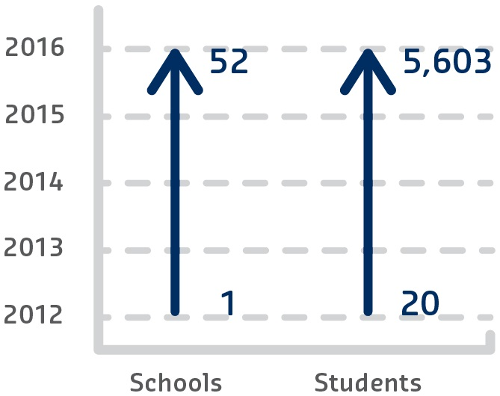

Figure 11: Program growth 2012-16
Since 2012, the River Journey has assisted 9,969 students from low SES backgrounds to learn more about careers and university participation, understand access pathways to university, and consider participation in higher education as an achievable post-school option. Feedback received from school staff involved in the project suggests that students who participate are more engaged in their schooling, talk openly about opportunities to go to university and are generally more motivated for success. This is particularly the case for engagements with upper primary to middle secondary students.
River Journey senior secondary presentations commenced in 2014. A sample of eight participating secondary schools indicated increases between seven per cent and 10 per cent in applications to Flinders University for 2015.

Sustainable Impacts
The Flinders University River Journey program has enabled many disadvantaged students in primary and secondary education across South Australia to consider university participation as an achievable post-school option.
River Journey has proven to be effective, as illustrated in data suggesting increased applications to Flinders University by students from low SES schools and education communities. This benefit is supported by educators and students as evident through increased participation in the program.
Currently the River Journey program relies on HEPPP funding allocations, adding to the comprehensive nature of the program across multiple year levels. Future incarnations of the program may include the voluntary participation of current university students sharing their ‘River Journey’ with prospective university students.

Uni-Reach/Uni-Key
Griffith University
Pre-Access
Access
Participation

Description
Uni-Reach provides students from Years 6 to 12 with scaffolded activities to foster and develop aspirations, career interests, and pathways to university. For Uni-Reach participants and other equity students who enrol at Griffith University, Uni-Key provides a smooth transition and support for first year students with peer mentoring, academic workshops and social support.
Partners:
Uni-Reach’s school and community partners in Griffith’s South East Queensland and northern New South Wales catchment include:
- 22 Queensland secondary schools
- 19 Queensland primary schools
- 3 Queensland adult education centres
- 23 New South Wales primary schools
- 4 TAFE institutes in Queensland and New South Wales.
Uni-Key is supported in both the university curricular and co-curricular space by collaborative partnerships in Learning and Teaching, Student Support and Development services, and other elements supporting student success.

Objectives
Griffith fosters a holistic and whole-of-institution approach to retention and success for students from equity backgrounds, recognising the particular challenges for these cohorts.
Uni-Reach and Uni-Key are complementary programs supporting aspiration, access, participation and success through key points along the student journey. HEPPP has facilitated significant scaling up and increased depth for Uni-Reach with aspiration-building activities, career development and peer mentoring, assisting students to develop their early ideas about capabilities and future careers.
Uni-Key uses paid and trained peer mentors to ease transition into university and improve engagement. The combination of academic and personal co-curricular activities increase learning confidence, create a sense of belonging and improve student success.
“The Uni-Key and Uni-Reach program [were] absolutely sensational. It helped me transition from high school to uni and learn those real key aspects as to how to be a successful uni student.”
– Uni-Reach and Uni-Key participant

Activities and Progress
For over 20 years Uni-Reach has been underpinned by best practice in career development and widening participation. Its strong school partnerships are built on longstanding relationships, and since 2010 have been supported by the Queensland Widening Participation Consortium. The program’s scaffolded activities from Years 6 to 12 feature peer mentors, career practitioners and equity specialists engaging with students, parents, educators and community partners. In-class and on-campus mentor-led programs feature discipline-specific activities to stimulate interest in post-school study and career options. Students are assisted to access university through educational access schemes and equity scholarships which recognise their personal circumstances.
Once enrolled, Uni-Reach students and other equity groups are encouraged to register for Uni-Key. Uni-Key includes a pre-orientation program, regular peer mentoring sessions based on discipline areas, academic skills workshops, online discussion boards and resources, and social activities. These activities are facilitated by experienced, high-achieving peer mentors from similar backgrounds. HEPPP has allowed this program to develop a strong and professional mentor network whose participation in the program not only helps new students to develop a sense of belonging and improved engagement, but contributes to their professional development and graduate attributes.

Outcomes
National research backed by the Queensland Widening Participation Consortium and institutional evaluation has seen strong evidence-based outcomes. A 2011 Australian Learning and Teaching Council award and continuous positive participant and community feedback also confirms program best practice.
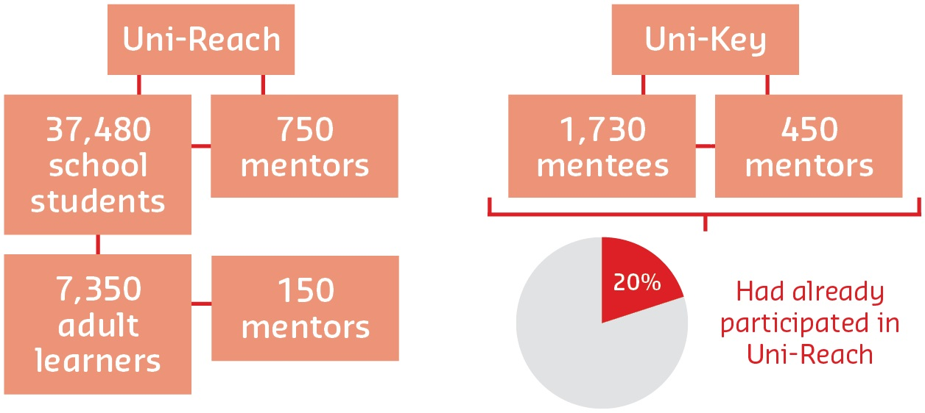
In the last five years over 37,480 school students and 1,100 parents have attended Uni-Reach activities. In the last three years 7,350 adult learners have also been engaged. Around 150 mentors support the program annually. Student perceptions regarding the statement ‘I believe it is possible for me to go to university’ generally increase by 25 per cent after participating in Uni-Reach activities. The transformation of mentees in their first year of university into confident learners has been a key focus of Uni-Key. Around 20 per cent of Uni-Key participants have participated in Uni-Reach. In the last five years 450 mentors have participated in Uni-Key, supporting 1,730 mentees.

Figure 12: Five year overview (2011-16)
Qualitative data consistently illustrates high satisfaction for all participants in the mentoring process and data also shows improved retention outcomes. At the end of the first year many mentees subsequently become mentors to ‘pay it forward’.

Sustainable Impacts
In 2016 Uni-Reach and Uni-Key marked 20 years, providing a chance to reflect on two decades of program evolution and success. Griffith has a strong commitment to these programs, and the HEPPP has enabled them to develop, expand and grow with the changing needs of prospective and current students. The strong evidence base assists in continuous improvement and innovation in a climate where national funding has been reduced.
Unprecedented registrations for Uni-Reach in 2017 means Griffith will continue to work with partners to develop innovative and engaging programs which reflect student need. Mentee registration for Uni-Key in 2017 has already exceeded the previous year, and Griffith’s trimester model requires continuous innovation to meet the changing needs of new students. Targeted extension activities for adult learners, LGBTIQ+ students, and students with disabilities are part of the expansion. Additional training opportunities for mentors also continue to evolve.

Get Into Uni
James Cook University
Pre-Access

Description
James Cook University (JCU)’s Get Into Uni program is a major initiative in regional and remote school and community engagement. It works with targeted primary and secondary schools and community hubs to stimulate interest in, and awareness of, tertiary study.
It aims to alleviate potential barriers to access and participation faced by target low SES and Aboriginal and Torres Strait Islander groups. Get Into Uni delivers in-community and on-campus activities across a region that spans 500,000 km2 of North and Far North Queensland, including island communities in the Torres Strait, Cape York Peninsula and the east coast.
“[Get Into Uni] aims to alleviate potential barriers to access and participation faced by target low SES and Aboriginal and Torres Strait Islander groups.”
– Get Into Uni coordinator

Objectives
The program aims to ensure all students in identified low SES schools, and Aboriginal and Torres Strait Islander peoples in identified low SES communities and hubs, have access to tertiary awareness and preparation. The program supports JCU’s strategic intent through meaningful engagement that embraces the diversity of communities we serve, creating opportunities and enduring benefits for our region. The program is aligned to JCU’s Access, Participation and Success Plan in particular supporting the delivery of activities to address pre-entry and access barriers.

Activities and Progress
Over time we have responded to the needs of our communities, learned from experience and adapted to changing resource parameters to evolve our program offering. Currently the program features in-school (Study Explorer), and on-campus (Campus Explorer) engagements.
Campus Explorer schedules visits to JCU’s Cairns and Townsville campuses for groups of students from Year 6 to Year 10 and engages them in hands-on activities with academic staff, while providing insight into life as a university student.
A team of student ambassadors known as the School Squad delivers a range of engagement activities to students, under the 5As framework developed at JCU to:
- raise Aspirations
- raise Awareness
- raise Achievement
- explore Affordability
- promote action for Access.
Study Explorer provides opportunities for the School Squad and JCU officers to visit regional and remote schools and communities to deliver activities, share authentic experiences and answer questions.

Outcomes
“James Cook University’s Get Into Uni program is a major initiative ... [working] with targeted primary and secondary schools and community hubs to stimulate interest in, and awareness of, tertiary study.”
– Get Into Uni coordinator
During 2016, Study Explorer engaged 3,883 students from 29 participating schools while Campus Explorer attracted 3,149 students from 60 schools; 12 of these school groups travelled over 100 km to participate. Students report high levels of satisfaction with the program, particularly interaction with the School Squad members who share authentic experiences and describe their university journeys.
“Wish to express big eso [thanks] to your team for visiting our school and supporting
our students to explore career options. It was a very successful visit — your activities were very engaging and you have planted the seed with several students to seriously consider tertiary studies or otherwise at least seriously think about their interest,
goals and futures.”
– Community Education Counsellor
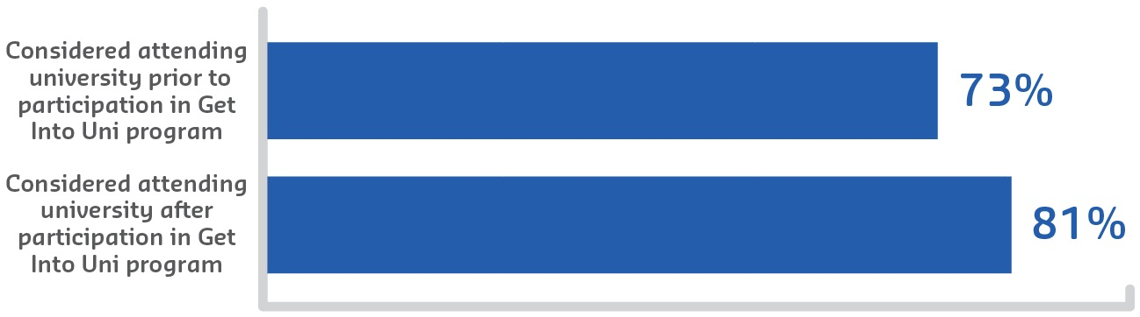
Meeting the needs of regional and remote schools by taking university to them has allowed Get into Uni to influence many students who otherwise would not have the opportunity to engage with tertiary education. In 2016, 22 per cent of this cohort identified as Aboriginal and Torres Strait Islander and 44 per cent were the first in their family to consider tertiary study. The impact of the program is best illustrated by student feedback, which indicates
that in 2016, 73 per cent of students considered university an option prior to participation
in activities, however after participating in the engagement program this increased to 81
per cent.

Figure 13: 2016 university aspirations of program participants

Sustainable Impacts
Building sustainable relationships and delivering a meaningful service over a geographic area twice the size of Victoria is a resource-intensive activity. In recent years, funding constraints have limited the scope of engagement and necessitated an adaption of the delivery model.
Solid relationships have been established with the target secondary schools and these will continue to be nurtured in the future while investing in building links with target primary schools to facilitate engagement with younger students, their parents and the community.
The program is HEPPP funded, however, collaboration with academic teams and other university initiatives, including a partnership with a local secondary school to create a virtual Science, Technology, Engineering and Mathematics (STEM) academy for students in Years 5 to 9, contributes to cost efficiency and greater reach.

School Partnerships Program
La Trobe University
Pre-Access

Description
La Trobe University’s School Partnerships Program is designed to increase the number of students attending university from low SES backgrounds. The University collaborates with 32 low SES schools in metropolitan and regional Victoria to deliver a sequential framework of engagement activities that support the demystification of higher education and provide extra curriculum support, academic preparation, and awareness of university courses and future careers.

Objectives
La Trobe University campuses are situated in regions where several schools record relatively low transition rates of their students to higher education.
The School Partnerships Program addresses this issue by providing students from 32 low SES schools with greater knowledge of higher education and related careers, including through discipline-specific workshops; and increased learner confidence and capacity, allowing students to have more informed aspirations and capabilities around post-secondary education.
“Since [2011] the program has expanded to 32 disadvantaged schools. In 2016 there were over 18,000 student attendances in the program.”
– School Partnerships coordinator
“The program is designed to improve post-secondary education outcomes of students from disadvantaged areas by facilitating a wide range of outreach activities.”
– School Partnerships coordinator

Activities and Progress
In 2011, the School Partnerships Program commenced with 15 low SES schools in regional and metropolitan areas. Since then, the program has expanded to 32 disadvantaged schools. In 2016 there were over 18,000 student attendances in the program.
Activities undertaken include: curriculum-linked workshops or laboratories; university campus tours and engagement activities; and school-based presentations. Through carefully planned events delivered from La Trobe University’s campuses located in Melbourne, Bendigo, Albury Wodonga, Shepparton and Mildura, students participate in interdisciplinary, innovative, challenging and flexible workshops.
In 2016, over 300 events were conducted to stimulate interest in the following disciplines:
- science
- technology
- engineering
- mathematics
- arts
- social sciences
- commerce.
Past workshops have included media studies, videography, creative writing, printmaking, business, biology, chemistry, electronic engineering, information technology and physics.
In response to initial evaluations, participating schools worked with the University to raise teacher expectations of student performance, and to embed knowledge of the program across the entire school. Biennial evaluation, involving surveys of around 6,500 students and 790 staff across the participating schools, has enabled each school to benchmark their performance against other program schools and address specific issues of interest.

Outcomes
Evaluations have found improved post-secondary transition rates for students at participating schools. For example, from 2012–15, La Trobe University’s enrolments from School Partnerships Program schools increased by 38 per cent, compared to 19 per cent for comparator schools.
Evaluations have also identified a measurable increase in student aspiration since the start of the School Partnerships Program. Students reported an improved understanding of the partnership scheme, increased parental support for university study, and were more likely to feel that university study was a good option for themselves and their peers.
“Evaluations have found improved post-secondary transition rates for students at participating schools.”
– School Partnerships coordinator
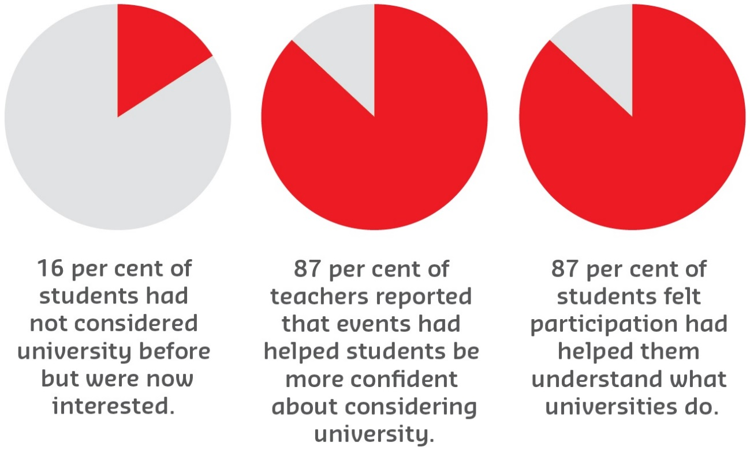
Teachers agreed that students were more likely to aspire to university, were better informed of their post-school options, and that parents were more likely to be knowledgeable of university options.

Figure 14: School Partnerships Program snapshot

Sustainable Impacts
With the support of the HEPPP, the School Partnerships Program is improving access for low SES students, evidenced by increased university enrolments and the endorsement of teachers that the program is contributing to positive change. The program has been regularly evaluated, and the comprehensive biennial surveys have enabled longitudinal data to be collected to inform program expansion and reform.
The program is also now being expanded to further educational sites. Following the University’s research into care leavers in higher education, the program now plans to expand outreach activities to alternative schools and other non-traditional learning sites.
The School Partnerships Program is fully HEPPP funded but is being positioned as an integrated program within La Trobe University’s broader equity strategy.

LEAP
Macquarie University
Pre-Access

Description
Young people from refugee backgrounds face a raft of complex challenges when entering the Australian education system, stemming from common experiences of disrupted prior education and trauma. These students in most cases need additional guidance and encouragement to attend university, as the social and cultural capital needed to navigate education and career pathways is often lacking. Education is key to effective resettlement, leading to better employment and health outcomes, yet schools often struggle to provide resources to fully support this very academically able cohort.
The Learning, Education, Aspiration and Participation (LEAP)–Macquarie Mentoring (Refugee Mentoring) Program at Macquarie University connects students from refugee backgrounds with university student mentors to help them navigate these challenges.
The LEAP program has partnered with 10 schools across the Greater Western Sydney
area since its inception in 2011. The program was set up in consultation with the NSW Department of Education, partner schools and with input from students from refugee backgrounds.
“The LEAP program provides mechanisms to provide sustained, goal-directed support to students for higher education.”
– LEAP program coordinator

Objectives
There is very limited support for students from refugee backgrounds in their transition to higher education. Macquarie University is developing specific strategies and programs to engage students from refugee backgrounds with the aim of increasing student motivation and self-confidence, and to increase their awareness of higher education possibilities.
“Education is not just about intensive studying. It is also about having fun, enjoying your time and contributing to your society.”
– Mentee

Activities and Progress
The LEAP program engages university student mentors, some of whom are from migrant or refugee backgrounds themselves, to mentor students from refugee backgrounds who are between Years 9 and 12 in high school. The program comprises a flexible three-part structure that allows mentors to tailor the program to the individual needs of their mentees.
The program is guided by the structure below:
- Weeks 1–3 — Developing Rapport:
  - establishing ground rules
  - mentor/mentee stories
  - goal setting.
- Weeks 4–6 — Skill Building:
  - study skills
  - time management
  - research skills.
- Weeks 7–11 — Informed Decision Making:
  - career research strategies
  - explore pathways to university
  - university experience day
  - review goals and reflection
  - wrap up and evaluation.
The program:
- develops confidence, resilience and agency
- raises aspirations towards further study
- develops social and cultural capital to navigate the tertiary education system
- develops study and research skills, including Information Communication Technology (ICT) skills
- develops an awareness of school and university cultures and expectations in the Australian context
- develops an understanding of available educational pathways and making decisions regarding appropriate pathways
- increases refugee parents’ and communities’ understanding of tertiary education pathways.

Outcomes
To date, 1,203 secondary school refugee students have benefited from participation in the program, with 86 students now in universities across Australia. From 2013–16 a mixed method approach was used to evaluate the effectiveness of the LEAP program, encompassing three focus groups with 12 mentees in each and paper-based surveys.
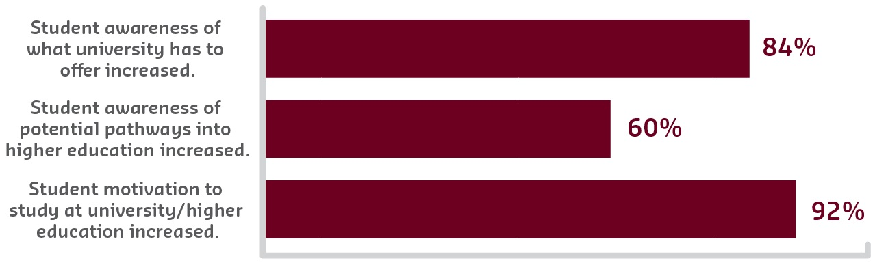
Of the students participating in the evaluation, 84 per cent reported that their awareness of what university has to offer had increased, and 60 per cent also reported an increased awareness of potential pathways into higher education and university. Additionally, 92 per cent of students reported that the program motivated them to study at a university/higher education level. This increased motivation is apparent in the students’ reflections on the impact of the LEAP program.

Figure 15: Evaluation of LEAP 2013-16

Sustainable Impact
The HEPPP funded LEAP program helps develop sustained and meaningful interactions between university students and high school students from refugee backgrounds during the course of the program. The evidence indicates the LEAP program provides mechanisms to provide sustained, goal-directed support to students for higher education. More importantly, the program contributes to the development of educational and social capital for students to develop their confidence, awareness, motivation and perception towards university to widen the participation in higher education of students from refugee backgrounds.
“The program made me a determined person. Therefore, I’m going to be more organised about studies.”
– Mentee

Access Monash Mentoring
Monash University
Pre-Access

Description
The Access Monash Mentoring program was introduced in 2012 to make university study a reality for more young people from low SES communities. The program aims to provide intensive support to inform students’ decision-making and preparation for university and careers by matching them with highly engaged and successful Monash student mentors to work in a one-to-one mentoring relationship over the final two years of their schooling. The student-to-student connections help secondary students from low SES communities to bridge the gap from school to university and encourage them to view higher education as an obtainable goal.
Partners:
Access Monash Mentoring partners with 46 secondary schools across the south-east of Melbourne and Gippsland regions. The program is targeted at underrepresented schools and schools with a high proportion of low SES students.
“Mentoring sessions and activities are designed to help mentees explore and extend their interests and career and study options.”
– Access Monash Mentoring coordinator

Objectives
The program aims to work with students from low SES communities to build their personal and academic capacity, enthusiasm for higher education and understanding of what is needed to succeed. Mentors draw on their own experiences to support mentees in improving their understanding and awareness of higher education as a viable post-school option, and to link them with higher education providers. The two-way benefit ensures:
- mentees are supported in their preparation for university and careers
- mentors develop their leadership and employability skills and experience the value of giving back to the community.
“I wasn’t sure what I wanted to do after high school, but my mentor guided me and helped me discover my options ... [they] showed me that university isn’t just a place
to learn, it’s a place to grow as a person and enjoy yourself.”
– Student

Activities and Progress
Each mentee and mentor agree on a structured mentoring plan based on the mentee’s needs (identified through self-assessment tools). Mentoring sessions and activities are designed to help mentees explore and extend their interests and career and study options, develop future plans based on those options, and build their study techniques, goal-setting, effective communication, motivation and resilience.
Mentoring and enrichment activities include:
- online and face-to-face weekly mentoring sessions during term time
- academic study assistance
- open days, campus visits and tours
- industry experiences — enrichment activities, shadowing experiences, workplace visits, industry forums, workshops and work experience.
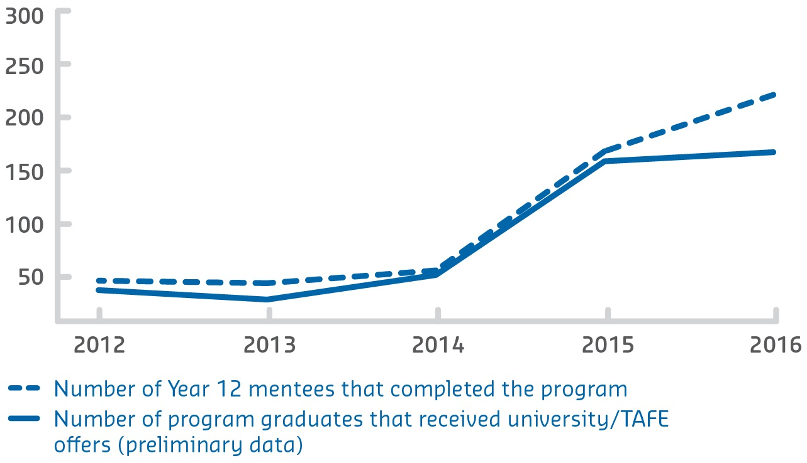
Progress is monitored through mentoring session reports. Mentees complete a self-reflection tool at final sessions to evaluate how they have improved their skills and knowledge as a result of program. Outcomes for mentees include confidence and the capability to progress to higher education equipped with a well-prepared plan for course choice and career development.

Figure 16: Comparison of the number of Year 12s that
completed the program and those who received an offer
An e-mentoring initiative was introduced in 2013 to extend access to students from regional areas. Mentor Leaders were introduced in 2014 to act as advisors to mentors, and take a key role in training, ongoing support, connecting mentors to others outside their field of expertise, collecting feedback and recommending developments to the program for improved outcomes.

Outcomes
Since 2012, Access Monash Mentoring has been successful in increasing the number of students from underrepresented communities continuing to higher education. The program has grown from 94 mentees to 640 in 2017, with the number of mentors increasing from 75 to 343. In that time, 589 mentees have graduated from the program and Monash has been able to track the outcomes of 431. Of those contacted, 93 per cent went on to university study, and four per cent have undertaken other forms of further study (TAFE, for example).

Sustainable Impacts
Monash University’s commitment to support the access and social mobility of students from low SES backgrounds is evidenced in its Widening Participation Strategy 2016–2020. The strategy prioritises mentoring of secondary students and access to high-impact engagement activities for Monash students.
Monash has ambitious plans to ensure disadvantaged students are not only supported in their transition to university, but throughout their degrees and into fulfilling careers. The strategy addresses the whole student life cycle, with plans to grow the program from ‘mentoring for university transition’ to ‘mentoring for lifetime success’.
Monash has begun to recruit business and community leaders, including Monash alumni, who will provide targeted and structured individual mentoring to Mentor Leaders with a focus on industry knowledge, career planning and personal development. Participating in a high-performing structured alumni mentoring program is a way for these students to be supported in navigating the challenging transition from university to work.

MAP4U
Murdoch University
Pre-Access
Access

Description
Murdoch’s Aspirations and Pathways for University (MAP4U) program supported schools and agencies to develop and implement a range of innovative programs designed to increase the participation in higher education of underrepresented students from the south-west corridor of Perth. MAP4U was conceived as applied research, with high accountability for schools in the region through mutually developed key performance indicators and a commitment to co-invest in programs. MAP4U operated from 2012–16 and used surveys, interviews, and observations of school and student data to identify gaps, evaluate processes and analyse set outcomes.
Partners:
Murdoch University; Curtin University; Challenger Institute of Technology (other TAFE/Colleges); Australian Indigenous Mentoring Experience; Department of Education WA; Catholic Education Office; Association of Independent Schools of Western Australia; City Councils — Rockingham, Kwinana, Mandurah and Serpentine-Jarrahdale; Chamber of Commerce and Industry WA; Rockingham Education Development Group; Peel Development Commission; 23 government, independent and Catholic secondary schools; and not-for-profit organisations: Big Picture Education Australia, South Metropolitan Youth Link and Youth Connect.

Objectives
The key project goal was to develop sustainable school-led programs to build aspirations in schools and learning links to university, increasing tertiary participation of local students.
“No one in our family has been to university. I was also the first person to graduate
from high school ... [TLC110] drives me to take those baby steps and keep going ... Degrees aren’t nothing ... So I want to go for something that’s going to be beneficial
for me in the long run.”
– TLC110 student

Activities and Progress
Four programs were implemented, linked to each school through a School–Murdoch Compact that key stakeholders agreed upon and committed to. The Compacts designated both the level of program commitment and specified performance indicators.
The MAP4U programs were:
- Building Academic Aspirations and Achievement: This supported adolescents
to set goals and fulfil their aspirations to transition to higher education. Developed programs included individual pathway plans, scholarships, parents as career partners, and partnership with the Australian Indigenous Mentoring Experience.
- Innovative Curriculum and Pedagogies: This supported innovative curriculum
and pedagogies to engage young people and connect students with university mentors and industry professionals that shared the same interest. Developed
long-term programs included film making, games art design, robotics clubs and English support.
- School Within a School/Big Picture Academy: Students disconnected with existing curriculum accessed Big Picture Education programs that provided alternative models of empowering young people in their learning while linking to university preparation.
- University Enabling Programs: These supported Year 12 students who aspired to go to university but did not study ATAR (for direct entry). An after-school enabling program was developed (Murdoch pathway program TLC110) which complements school achievements and provides an alternative pathway to university.
Over five waves of data collection, 1,429 students participated in a MAP4U survey. The students were from Years 7 to 12, and two-thirds indicated that they desired to go onto university study.

Outcomes
- A four per cent increase in the number of students from the region applying to university.
- Increased engagement with schools across the region to implement sustainable, innovative programs, which encouraged students to aspire to university, totalling 172 programs over the four years.
- Increased community engagement through the development of aspirational academies/curriculum/pedagogy within schools, which increased student expectations to attend university after secondary school.
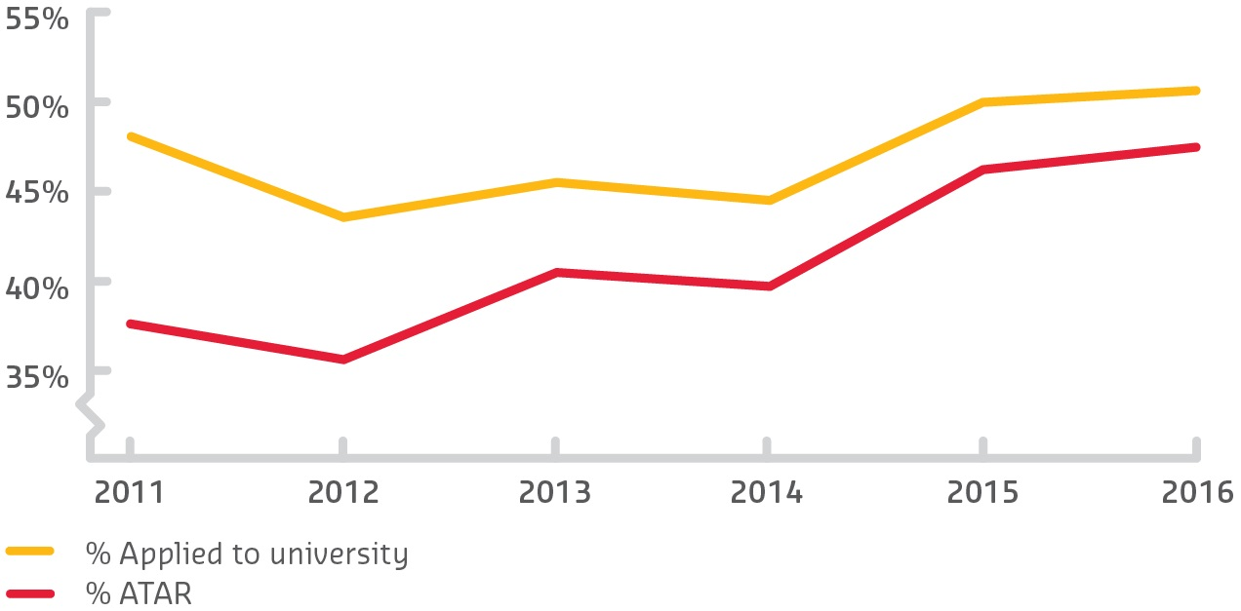
- Identification of a gap for students between their aspirations for a university degree and their perceptions of realising this goal (i.e. expectations).

Figure 17: Percentage of total number of Year 12 students that achieved
an ATAR versus percentage of total number that applied for university

Sustainable Impacts
Increasing the percentage of Year 12 students that study ATAR from the region means schools have developed a culture of higher attainment and challenged staff to build aspirations and deliver improved outcomes with more effective pedagogies. Increased university applications up to 2016, above and beyond the percentage of students completing ATAR pathways, was achieved through nurturing the aspirations of students by providing alternative pathways to higher education, such as studying university enabling programs (for example TLC110), portfolio preparation and entry through TAFE Certificate IV.
Many MAP4U programs are now embedded within schools and curriculum. Robotics and STEM clubs continue to flourish, and robotics forms part of the curriculum. Individual pathway planning and academies have been incorporated within school structures. Murdoch University supported the University Enabling Program TLC110 and scholarships are continuing to be distributed across the schools from a variety of stakeholder contributions. Engagement between stakeholders continues with university staff fulfilling roles on school boards, education and training committees and development commissions. Overall the culture change, to provide opportunities for students from the region to study in higher education, continues.
MAP4U research over the past four years indicates that the students in the south-west corridor of Perth have relatively high aspirations for their academic and professional goals, so it is important to see schools in the region support their students and demand more from their capable and resilient staff and students.

Explore Uni
Queensland University of Technology
Pre-Access

Description
Explore Uni (EU) is Queensland University of Technology (QUT)’s signature Widening Participation (WP) program. It is a scaffolded program of residential camps and on-campus days immersing school students from low SES backgrounds in experiences that aim to: build aspiration for post-school study by building on students’ pre-existing strengths; shatter myths and misunderstandings about tertiary education; and boost students’ confidence by creating what Gale and Sellar have called ‘cultures of possibility’.
These are essential pre-conditions for informed post-school choices. Key program elements include tertiary student ambassadors sharing their personal narratives, an embedded career development component, and dynamic discipline-related workshops which bring future opportunities to life.
Partners:
- 36 QUT primary and secondary partner schools
- all six QUT faculties, Oodgeroo Unit, Library and Careers staff
- The Smith Family, notably Learning for Life program staff.

Objectives
Many students from low SES backgrounds face barriers to tertiary participation due to the effects of intergenerational poverty and racism. Moving from being uninterested to actively interested in tertiary study is a journey, not a single revelatory experience, and involves issues of identity and imagination, not just information. This is why EU, offered to schools with low rates of progression to tertiary education, systematically addresses five conditions which must all be met before low SES students enter tertiary education: awareness; aspiration; achievement; affordability; and access. The program is designed so students experience gradual growth in awareness, aspiration and capability through multiple engagements over time.
“If I hadn’t attended an Explore Uni camp in Year 12 I wouldn’t be at uni today ... Hearing the Ambassadors’ stories made me realise some people had overcome far greater obstacles than mine and made it to uni; therefore I could too.”
– Explore Uni camp attendee

Activities and Progress
HEPPP funding enabled QUT to expand its pre-existing EU program, which was only offered to small numbers of senior students. Whole class cohorts now participate in several on-campus experiences as they progress from Year 6 to Year 12. Approximately 7,000 students from 36 partner schools attend one of 40 EU days or four residential camps annually.
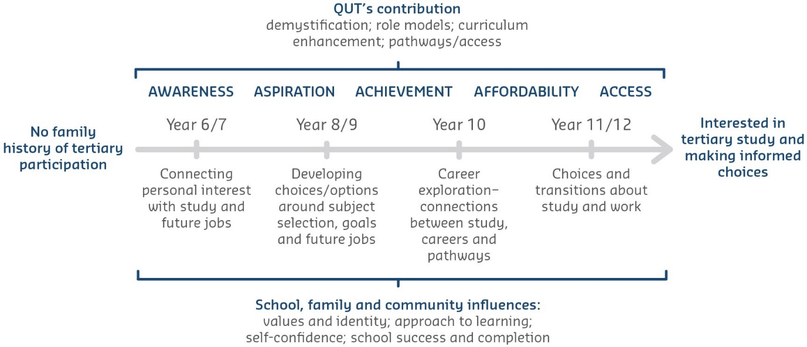
Storytelling by student role models demystifies university and the people who go there. These ambassadors use prevalent myths about tertiary education to frame their personal ‘success’ stories; real students telling real stories incorporating real fears and real solutions. The approximately 70 ambassadors—alumni from low SES schools and equity scholarship recipients—undertake a comprehensive training process which builds capacity, develops skills and enhances their sense of belonging.

Figure 18: The pre-tertiary scaffolded journey for school-age low-income and Indigenous students
These student ambassadors now lead all aspects of the EU program. The program also benefits from faculty staff collaboration. Seventy engaging hands-on, ambassador-led, discipline-related activities have been developed, ranging from engineering to dance, from mock law trials to slam poetry, and from optometry to business entrepreneurship. All are age-appropriate and linked to related study and career opportunities.
The on-campus career development component has more recently been reinforced by in-school activities (in response to teachers’ feedback) to deepen and consolidate learnings. These include the development of pre- and post-EU Career Conversation resources and in-school tertiary admissions and career sessions.

Outcomes
Student and teacher feedback demonstrates that the program debunks myths, particularly the myths that ‘people like me don’t go to university’ and ‘it’s too expensive’, and builds aspiration for post-school study. Students and teachers consider that the program’s success arises from the opportunity to experience the campus first-hand, and the personal contact with student ambassador role models. Queensland Tertiary Admissions Centre (QTAC) applications data indicates that interest in tertiary education is being stimulated. University applications from QUT target schools increased by 20 per cent between 2011 and 2016 (compared with a 15.8 per cent increase across all Queensland schools). In addition, 56.5 per cent of EU camp attendees made tertiary applications via QTAC.

Sustainable Impacts
It is the power of partnerships that maximises the program’s effectiveness. Over the last five years, trusting and respectful relationships have developed across QUT faculties and divisions, and with participating low SES schools. QUT staff have formed a community of practice based on a shared vision. The program has evolved as a result of deepening school, student and university collaboration.
School staff consider the program has positively influenced school culture. It also appears to have a ripple effect with peers and family, as evident when the student quoted above concluded:
“My brothers aged three and four tell me they are going to uni when they are older, just like me!”
Students who attended EU days and camps as school students and were inspired by QUT ambassadors have come full circle and are now the role models, inspiring the next generation of low SES students by visiting their old schools as ambassadors. It is the circular nature of student involvement coupled with strong partnerships and commitment to a shared vision that are the strongest sustainability factors.

I Belong
RMIT University
Pre-Access

Description
I Belong programs address barriers to higher education, careers and professions among regional, low SES and Indigenous secondary school students. Students can explore disciplines and careers through hands-on activities, understand the benefits and opportunities of tertiary education, and develop skills and knowledge to support their
school achievement and successful transition to tertiary studies. Since 2012, over 16,000 secondary students have participated in the program.
Partners:
- Australian Centre for the Moving Image
- BAE Systems
- Capital City Local Learning and Employment Network
- City of Melbourne
- Engineers without Borders
- Equity Practitioners in Higher Education Australasia
- Ganbina
- Koori Heritage Trust
- Lab De Stu
- Learn, Experience, Access Professions
- Melbourne Museum
- National Education Advancement Programs
- Student Youth Network (SYN) Media
- The National Gallery of Victoria
- The National Trust
- The Smith Family
- Victorian Department of Education and Training
- Schools Network Access Program (SNAP) — partnership with over 200 secondary schools focused on growing tertiary access.
“RMIT has given me a clearer view of tertiary education. The overall experience was helpful and allowed me to think about my career path better.”
– Secondary student

Objectives
With its focus on providing students with a positive experience of university and Melbourne, opportunities for career exploration, and accessible information about application processes, I Belong endeavours to address many of the barriers to higher education that students from low SES backgrounds face. Programs are designed to:
- enhance students’ knowledge of entry pathways to university, study and course options and career opportunities
- improve students’ self-confidence
- increase students’ motivation for studies
- increase or affirm students’ enthusiasm about current and future studies
- expand students’ study and career aspirations by addressing perceptions about
the relevance and attainability of tertiary study.
I Belong also has a strong focus on peer role modelling through the involvement of SNAP Champions, who are current RMIT students who studied at SNAP secondary schools.

Activities and Progress
Middle years students undertake applied learning experiences drawing upon key industry partnerships and the opportunities available at an urban university of technology, design
and enterprise. Disciplines explored include marketing, creative industries, crime and justice, media and communications, sustainability, computer science and information technology, engineering, and health and medical sciences. Senior years programs build on students’ discipline and career knowledge, with particular focus on equipping them to succeed in tertiary education. Programs include short, intense master classes in art and design, engineering, study skills, and mathematics and statistics.
Programs encourage participation by regional and Indigenous students through building relationships with schools, organisations and communities, and designing and delivering engaging content responsive to their needs. Melbourne residential camps for Indigenous students include a mix of cultural knowledge from local Elders, university information, and discipline exploration.
A key development since I Belong’s inception has been the increased contribution of
SNAP Champions, in response to student and teacher feedback. SNAP Champions
come from similar backgrounds to participating secondary students, and promote a
positive university experience through delivery of workshops and presentations, sharing
their student experience, and acting as positive role models for secondary students,
parents and teachers.

Outcomes
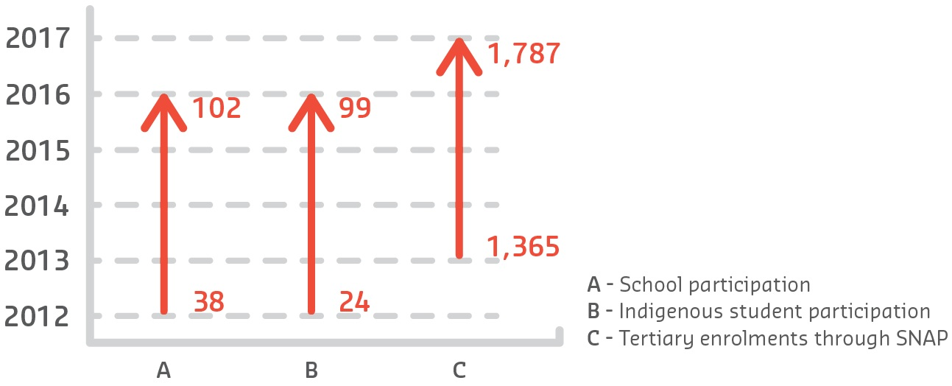
A NCSEHE evaluation of I Belong cited the universally positive responses of attending teachers, the high levels of student engagement, and confirmed that the programs are of very high quality and effectively respond to the issues experienced by low SES, regional
and Indigenous students. In recent program evaluations, 80 per cent of students in middle
years programs indicated that I Belong increased their interest in study options available
at university, while 86 per cent of students in senior years programs reported an increase
in confidence about going to university. Since 2012, over 16,000 secondary students
have participated.

Figure 19: Participation increase 2012-17

Sustainable Impacts
I Belong is currently funded through the HEPPP, enabling the university to build and deepen partnerships with schools and communities and to increase awareness of, and aspiration to, tertiary study among underrepresented students. Without HEPPP funding, the sustainability of I Belong programs is not yet resolved. In 2016 RMIT was successful in securing funding through the HEPPP National Priorities Pool to expand beyond I Belong’s existing model of on-campus, city-based engagement programs. RMIT will deliver targeted digital content and workshops that can be accessed by regional students from low SES backgrounds, parents and carers. These new resources will make it possible for regional students to engage with RMIT students, teaching staff and facilities, increase their understanding of university life, and develop study skills that will assist them should they choose to enrol in tertiary study.

Uni-Bound
Southern Cross University
Pre-Access

Description
Southern Cross University (SCU)’s Uni-Bound program supports the University’s commitment to improving access, participation and success of students from equity groups.
Uni-Bound currently works with 17 secondary schools, three central schools and 19 primary schools in the Mid North Coast, Northern Rivers, southern Gold Coast and Tweed regions. Schools in these regions have high concentrations of low SES communities and high Aboriginal and Torres Strait Islander enrolments.
There has been significant growth in the number of students participating in Uni-Bound with the broadening of our engagement to primary schools, enabling greater capacity building and partnership within our regions of focus. Cohort-specific activities and embedded career education provide a connected learning framework with resources developed to support teachers, family and community.

Objectives
Uni-Bound’s scaffolded tailored programs deliver inspiring educational experiences
designed to:
- inspire imagination and curiosity and encourage lifelong learning
- increase knowledge and understanding of higher education and career options
- build confidence and motivation towards higher education
- improve readiness for higher education
- support teachers, families and community to assist students to reach their potential for higher education.
“An extremely positive experience for all students, a welcoming, supportive environment that engaged and inspired them to expand their interests.”
– Primary school teacher

Activities and Progress
Uni-Bound’s outreach scope has expanded to include primary schools in addition to secondary schools, and now offers experiences for students in Years 5 to 9.
- Year 5: Dreaming About Your Future — A special presentation on campus designed to inspire students to dream about their future careers and harness the power of their imaginations. Students get to experience the physical environment of the university and meet current SCU students.
- Year 6: Believe in Your Potential — Delivered in schools, students gain a greater understanding of university career pathways through fun activities reflecting a range of academic disciplines. Identifying personal strengths and exploring teamwork and problem solving in the context of career pathways is a key focus.
- Year 7: Recipe for Success — Delivered in schools as workshops designed to help students identify and develop skills such as resilience, positive peer culture, motivation to learn, goal setting and decision making.
- Year 8: Thinking About Uni — Delivered in schools, these workshops pose more detailed questions about why people choose to study at university. These are discussed and presented through the shared experiences of university students via mixed media, interactive activities and games. Students gain an understanding of the differences between school and university.
- Year 9: Going to Uni — An on-campus visit to one of three university campuses comprising sessions on identifying personal strengths and interests, career pathways, 21st century skills and an exploration of discipline areas providing hands-on, engaging and interactive experiences.
“[Uni-Bound] enhances the strong programs we have at school in guiding students
in their future pathways ... It increases student confidence in their potential to [pursue] university study.”
– Secondary school teacher
“[Uni-Bound provides] scaffolded, tailored programs that deliver inspiring and educational experiences.”
– Uni-Bound coordinator

Outcomes

Figure 20: Program growth 2012-16
Uni-Bound has more than doubled its capacity to reach students in SCU’s low SES communities.
It is valued and acknowledged as a worthwhile, engaging and informative program. Our evaluations show that for more than 80 per cent of participants, Uni-Bound:
- increases confidence in their potential to undertake university study
- promotes conversation and curiosity about future study choices
- enhances knowledge about course options and university pathways.
“It opened my mind to university and gave me a wider understanding.”
– Year 9 student

Sustainable Impacts
Uni-Bound continues to use its monitoring and evaluation framework to make ongoing improvements to the program, including identifying which student cohorts benefit most and in what ways they are impacted by the program. Longer-term measures of transition to university are still being explored.
As a fully funded HEPPP program, there has been uncertainty in the year to year allocation model. However, Uni-Bound has established a sustainable model of delivery and known minimum resource requirements, enabling a flexible and responsive approach to its delivery. Assured funding for the future is vital for maintaining these established school partnerships and a continued commitment to low SES communities in our university footprint.

Strategies for Success
Swinburne University
Participation

Description
The Strategies for Success (SFS) program at Swinburne University of Technology is a flagship activity in Swinburne’s overall orientation and transition strategy. The week-long program, held two weeks before the commencement of semester, aims to facilitate students’ academic transition to the university, as well as build important social connections among students. The program is open to all new and current students, with targeted attendance by low SES and ‘at risk’ students. Analysis of academic results at semester’s end suggests the program acts as a significant confidence booster for students, leading to demonstrably positive effects on academic performance, including for disadvantaged students.

Objectives
The SFS program was developed in the context of growing diversification of student cohorts at Swinburne, along with concerns about rising rates of student attrition, especially among disadvantaged students. Internal research showed that the chief factors contributing to attrition were students’ lack of familiarity with academic requirements at tertiary level, as well as a limited sense of belonging to the institution.
SFS was developed to address this situation, aiming to:
- facilitate students’ transition to university through a comprehensive understanding of the ‘student experience’, including an introduction to key academic skills relevant to study in their particular faculty
- introduce students to support services in the university
- develop strong social connections among students, along with their sense of belonging.
“The week-long program ... aims to facilitate students’ academic transition to the university, as well as build important social connections among students.”
– SFS coordinator

Activities and Progress
The program commenced in 2014 under the auspices of the University’s newly-formed Student Engagement unit.
The program is open to all new students, with some targeting of disadvantaged student cohorts. Later-year students who fall into ‘at risk of failure’ categories are also strongly encouraged to attend. The program is held each semester, two weeks before the formal commencement of classes. The topics covered in the program include: the transition to university; motivation; goal setting; time management and procrastination issues; the balance between study, paid work, family and leisure time; getting the most out of lectures and tutorials/labs/studios; planning and writing essays and reports; and preparing for class oral presentations and formal exams.
A key innovation in the development of the five-day program has been to shift from a generic program to a faculty-based one — students in each of Swinburne’s three faculties attend separate, parallel programs ensuring that content is targeted to the specific study requirements of the broad areas of study: STEM, business, or social and health sciences/design.
Along with helping develop key academic and transition skills, the program is designed to be the first point of contact for a suite of support services including: academic development consultation services; language and academic skills support; student mentor activities; and careers guidance.
“The [Strategies for Success program] was invaluable and will greatly impact my first year and beyond.”
– Student

Outcomes
Participation has progressively increased over the three years the program has run. In Semester 1 2016, 1,290 students attended, representing over 30 per cent of the undergraduate intake.
We estimate 20 per cent of these participants fell into low or near-low SES categories. This represents more than 50 per cent uptake for newly-enrolled students in these lower categories. The main measure of program performance has been students’ subsequent academic performance.
In 2016, students who attended SFS achieved significantly higher marks at the end of Semester 1 than those who did not attend. In Semester 2, there was a smaller, but still significant difference between students who had attended the initial SFS and those who had not. This suggests that the program acts as a significant confidence booster for students, supporting adaptation to the demands and requirements of their study.
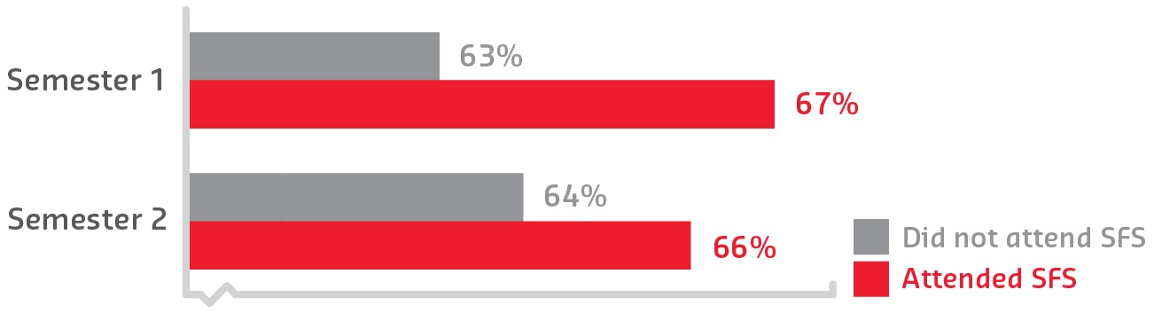
Significantly, the analysis also found this overall positive effect for those students falling into low SES categories.
“Participation has progressively increased over the three years the program has run.
In Semester 1 2016, 1,290 students attended, representing over 30 per cent of the undergraduate intake.”
– SFS coordinator

Figure 21: 2016 academic performance of SFS versus non-SFS attendees (GPA %)

Sustainable Impacts
The SFS program has become a key and ongoing component of Swinburne’s transition strategies. Development and deployment of the program has been largely HEPPP funded over the last three years. This funding has enabled the program to grow significantly, including being able to offer targeted faculty-specific versions of the program.
One area for development is to maximise attendance of low SES and other disadvantaged students. Our evaluation processes have found that a factor preventing some students from participating has been work commitments, as the program is currently only provided on campus during the day, before semester commences. Continued funding will enable adaptation of the program for online delivery, thus ensuring expanded access to disadvantaged cohorts.

Children’s University
The University of Adelaide
Pre-Access

Description
The University of Adelaide is the national license holder for the Children’s University program in Australia. Children’s University Australia (CUA) provides validated, extra-curricular learning opportunities for children aged 7–14 years, and volunteering opportunities for 15–18-year-olds.
CUA engages children in learning in the broadest sense, providing the scaffolding to develop self-efficacy, confidence and aspirations. There is a strong emphasis on exploration and experience as learning tools, with participants encouraged to pursue their passions. CUA is at the forefront in cultivating a love of learning and raising aspirations among young people who may otherwise be disengaged from education.
Partners:
CUA currently partners with 117 schools and 137 ‘Learning Destinations’ across Australia, including many local councils, libraries and art galleries, and this continues to grow. Major partners include:
- South Australian Museum
- Zoos SA
- Bunnings
- WOMADelaide
- Questacon — the National Science and Technology Centre
- Mobile Science Education
- Port Arthur Historic Site
- Government House Tasmania
- Bass Strait Maritime Centre
- Central Coast Marine Discovery Centre
- Hunter Medical Research Institute.
“CUA encourages children to explore new ideas, concepts and experiences via public
or school-based ‘Learning Destinations’, engaging in a new way of learning that sits outside their normal school experience.”
– CUA coordinator

Objectives
CUA offers superior educational experiences for young people through extra-curricular activities and recognises their achievements through the award of formal certificates and graduations. CUA encourages children to explore new ideas, concepts and experiences
via public or school-based Learning Destinations, engaging in a new way of learning that
sits outside their normal school experience. CUA leverages local educational and learning activity providers including sports clubs, museums, galleries and school clubs, reinforcing that learning is something that can happen in a wide range of places and contexts. This is especially valuable in families and communities with a history of disengagement with education.

Activities and Progress
Activities take place in Learning Destinations which have been validated and quality-assured through the CUA accredited Planning for Learning program. Learning Destinations can range from a museum to a farm to an airport or even a business, provided the activity connects with clear learning outcomes and has credible links to future study opportunities.
Participants are issued with a ‘Passport to Learning’ to record their learning journey. For every hour of activity, they receive a stamp in their passport. When they reach the hours needed to graduate from CUA, they participate in formal graduation ceremonies at high-profile locations like The University of Adelaide’s Bonython Hall. In response to feedback from older students a ‘Passport to Volunteering’ was created which provides 15–18-year-olds with opportunities to assist with running CUA activities, while developing leadership skills and graduate attributes. Older students can use this activity to count towards the Duke of Edinburgh Award scheme and the South Australian Certificate of Education. From 2016, CUA has also begun partnering with government and other organisations to provide opportunities for young people to shadow senior state executives, opening their eyes to
new possibilities for their own futures.

Outcomes
CUA was launched at The University of Adelaide in 2013. It was piloted with one school, 45 participants and nine Learning Destinations. It is now operating nationally, partnering with the University of Tasmania, The University of Newcastle, and Charles Darwin University, with plans to expand further. Currently around 10,500 CUA Passports to Learning have been issued and nearly 2,500 children have graduated.
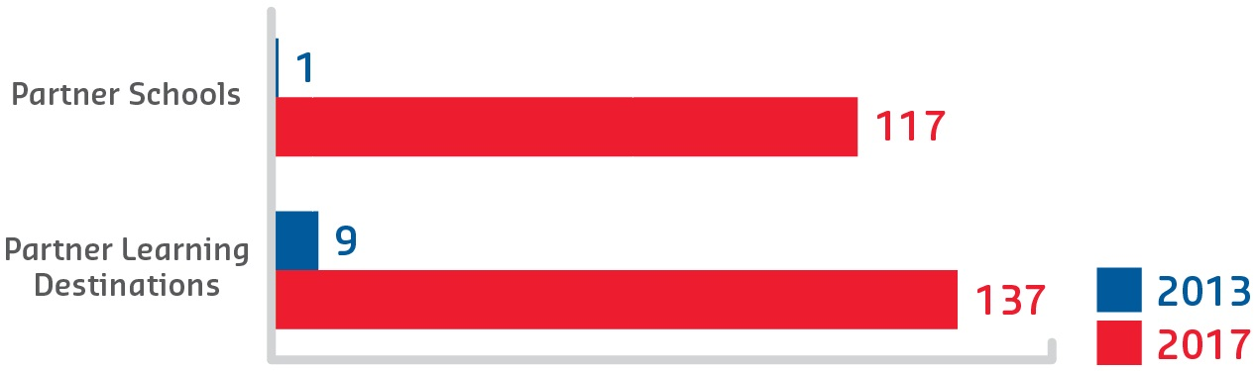
Part of the effectiveness of CUA is that it disrupts normal assumptions about education and engagement, not just for participants but also for families and communities who are able to see the value and impact for their children. Evaluations of CUA demonstrate the impact that the program has on students and their communities. A National Centre for Vocational Education Research report in 2016 noted that parents and teachers agreed that CUA was very positive for the school and community and that participants enjoyed school more, had improved self-confidence and had greater engagement with learning.

Figure 22: Program evaluation

Sustainable Impacts
CUA is already well-established in three states and expansion into the remaining states is planned within the next few years. New schools and Learning Destinations are continually signing up for the program and this growth is expected to continue to grow exponentially. Though funded through the HEPPP, CUA also generates a small amount of income through sales of memberships/passports and merchandise. This income goes back into the program to help provide transport and subsidise, or otherwise reduce, costs of participation for low SES students. It is expected that CUA activities will continue to be funded through the HEPPP as a flagship outreach program for Adelaide and the partner universities. CUA is also seeking state funding, philanthropic donations and corporate sponsorship to ensure diversity of funding and sustainability.
“CUA was very positive for the school and community ... Participants enjoyed school more, had improved self-confidence and had greater engagement with learning.”
– CUA coordinator

SSSP
University of Canberra
Pre-Access

Description
The Stronger Smarter Schools Program (SSSP) is a University of Canberra (UC) partnership program designed to break down barriers to higher education for students from low SES, regional and remote, and Aboriginal and Torres Strait Islander backgrounds. It works with teachers and school leaders to build leadership capacity and enact transformational change within schools. Participating schools generally have an ongoing relationship with UC’s flagship schools outreach program, Aspire UC. By delivering professional development to teachers and other educational professionals, the SSSP complements the partnerships formed between schools and UC, and extends the capacity of schools to raise the aspirations and expectations of students from equity backgrounds.
Partners:
UC partners with the Stronger Smarter Institute to deliver the SSSP to schools in the ACT and regional NSW. Outside of this partnership, the Institute itself has delivered its flagship professional development program to over 2,500 teachers across 720 schools, with approximately 45,000 Aboriginal and Torres Strait Islander students enrolled in those schools since the program began in 2006.
“[SSSP] works with teachers and school leaders to build leadership capacity and enact transformational change within schools.”
– SSSP coordinator
“The SSSP challenged my long-held but still supple views of the world; and invited me to do some ‘unlearning’. But it did so in a way that introduced me to a powerful and very respectful approach to leading; learning and changing.”
– SSSP coordinator

Objectives
The SSSP aims to:
- build leadership capacity in school staff, particularly for schools already involved in UC’s schools outreach programs
- provide support and resources for schools to develop projects and resources to influence student self-belief and aspirations for the future
- provide support and resources to establish a network of schools in the ACT and southern NSW engaged in delivering the Stronger Smarter approach in their schools and classrooms
- provide support and resources to schools to design and evaluate their own improvement projects.

Activities and Progress
The SSSP delivered four professional learning programs to over 89 staff from 31 schools in the ACT and regional NSW between 2014 and 2016. The majority of participating schools have an ongoing relationship with UC through existing schools outreach projects. Through this professional development program, schools were able to complement the existing outreach work focusing on students, with additional support for teachers working with students from equity backgrounds. With a recent project extension, the SSSP is delivering another two professional learning programs in 2017. The SSSP is delivered via two intensive face-to-face programs; the first being five days’ and the second two days’ duration.

Figure 23: Professional learning program summary 2014-16

Outcomes
Participants rated the program exceptionally highly on both personal and professional measures. As a feature of the program, participants nominated a challenge to focus on in their workplace.
These projects reflect the diversity of schools and the varying challenges faced by educators, and were broadly focused on four main themes:
- concentrating on high-expectations classrooms: pedagogy and activities to introduce students to future-oriented goals, including university study
- creating high expectations and an excellence-oriented whole school culture
- developing innovative approaches to engaging community in schools
- cultivating high-expectations relationships with students and community members.
These projects ranged in scale and scope from altering individual classroom practices, to improving relationships with staff, to making changes to the physical school environment.
Workplace projects provided over 50 examples of activities designed to improve student engagement in the classroom; over 70 examples of activities focused on staff relationships, such as professional learning, building networks and cultural action plans; and 25 specific examples of resources created to implement within the school or community. Some projects focused on improving relationships between schools and their communities such as revitalising National Aboriginal and Islander Day Observance Committee (NAIDOC) Week celebrations, and creating additional opportunities for meaningful community involvement in school programs.
Many participants reported significant positive changes in their school, including reports of improved relationships between colleagues, within the classroom, and throughout the school as a whole.

Sustainable Impacts
The SSSP has already worked directly with 89 participants in 31 schools. A number
of participants reported that the support, collegiality and communication among cohorts
were a large source of encouragement, unlike that which has been experienced in other professional learning programs. Participants have organised visits to neighbouring
schools and towns to share practice and resources extending beyond the involvement
or coordination of UC or the Stronger Smarter Institute. The mentoring, sharing of practice and positive changes embedded by these dedicated educational professionals creates the ripples of change that spread slowly throughout classrooms, schools and communities, creating increased opportunities for students and improving educational outcomes in
the future.
“... the SSSP has captured the essence of respectful, insightful, strength-based personal and professional enrichment that does indeed help me to be better.”
– SSSP participant

SEAMS
The University of Melbourne/Monash University
Pre-Access

Description
Strengthening Engagement and Achievement in Mathematics and Science (SEAMS) is a partnership program between Monash University and the University of Melbourne that began in 2014. The program grew from a shared commitment to increasing the participation of low SES and Indigenous students in science and maths-related degrees at university.
The universities collaborate to deliver a series of activities designed to improve students’ achievement in and engagement with maths and science, and help them explore related study and career options. The program’s aim is to deliver an academic and social program that has a long-term positive impact on young people’s educational outcomes in maths and science.
Partners:
- Monash University
- The University of Melbourne
- John Monash Science School
- Elizabeth Blackburn School of Sciences.

Objectives
SEAMS aims to strategically increase the participation and attainment of low SES and Indigenous students in STEM in higher education.
By enhancing the engagement and academic achievement of low SES and Indigenous students in senior secondary mathematics and science, SEAMS facilitates increased access to a range of university courses in the STEM areas.
The program meets the following HEPPP objectives:
- assist in improving the understanding and awareness of higher education as a viable post-school option
- assist in achievement at school, to enable consideration for access to higher education
- support students in linking with higher education providers.
“The benefit is introducing students to concepts in advance of classroom experiences, allowing them to focus more effectively on what will help them learn. This increases students’ confidence and skill through preparing them for learning experiences.”
– SEAMS coordinator

Activities and Progress
SEAMS focuses on improving Year 11 and 12 students’ knowledge and skills in mathematic methods, chemistry and physics. Three-day camps are held in January and July, with one year level attending at Monash and the other year level at the University of Melbourne. The groups swap locations for the second camp, ensuring each student experiences both universities. Academic sessions are run by leading teachers who provide insight into key concepts the students will learn during their Victorian Certificate of Education studies. The activities are designed to strengthen students’ conceptual understanding of mathematics and science, and increase their fluency and resilience as learners through increasing levels of challenge.
The key benefit is introducing students to concepts in advance of classroom experiences, allowing them to focus more effectively on what will help them learn. This increases students’ confidence and skill through preparing them for learning experiences, rather than using a deficiency model (involving revision or remediation).
During term time, students have access to SEAMS resources, activities and networking through an online learning platform. The program creates a cohort of motivated learners who may otherwise be isolated in their mathematics and science study, and uses peer and university student mentors to assist students’ learning.

Outcomes
From 2014–17, 314 students graduated from the SEAMS program, of which 275 students were contactable. Of those, 269 (98 per cent) received a university offer.
Of the contactable students:
- 38 per cent are studying at Monash University and 21.6 per cent at the University of Melbourne
- 89.7 per cent are studying in STEM-related fields
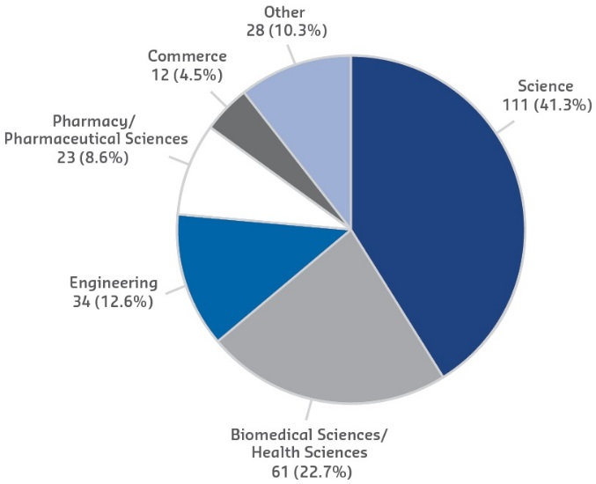
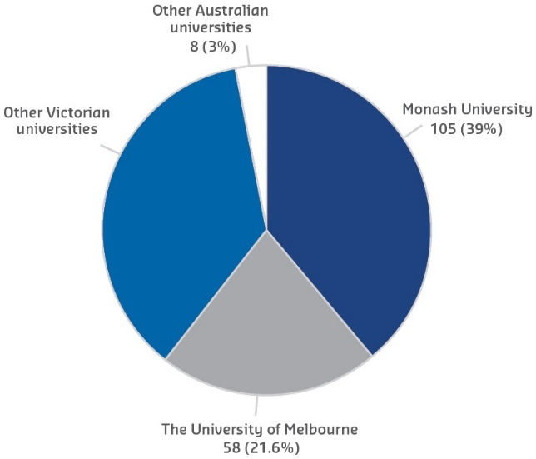
- 30 per cent received an ATAR of 90+, 28 per cent 80–89.9 and 21 per cent 70–79.9.

Figure 24: University destination
of SEAMS 2014-16 graduates

Figure 25: Field of post-secondary
study of SEAMS 2014-16 graduates

Sustainable Impacts
The SEAMS program was fully HEPPP funded until December 2016. Due to the demonstrated success of the program, Monash University and the University of Melbourne have committed funding until December 2018.
In 2017 the program introduced a SEAMS e-mentoring program for Year 12 students. Students have the opportunity to be paired with a university student mentor to work in a one-on-one mentoring relationship throughout Year 12.
The SEAMS program is also working in partnership with the John Monash Science School to develop an online program that can be accessed through the Emerging Sciences Victoria program into the future.

Live, Learn, Grow
The University of Newcastle
Pre-Access
Participation

Description
The University of Newcastle (UON)’s innovative program Live, Learn, Grow seeks to overcome the known barriers preventing students from a care experience—such as foster or residential care—engaging with higher education. The program is the first of its kind to provide care leavers with a range of tailored support services including subsidised on-campus accommodation, supported employment and academic/social support.
Partners:
The program was developed by UON’s Centre of Excellence for Equity in Higher Education (CEEHE) in consultation with stakeholders across the Out of Home Care (OOHC) sector:
- Allambi Care
- Connecting Carers NSW
- NSW Department of Family and Community Services
- Family Action Centre
- Next Step
- Premier Youthworks
- Settlement Services International
- Wandiyali
- Wesley Mission.
“The program addresses the key factors driving care leavers’ lack of engagement in higher education, to give ... young people the best chance at reaching their potential.”
– Live, Learn, Grow coordinator

Objectives
Over 40,000 children and young people are in OOHC across Australia, and the limited data available reveals young people exiting the care system are significantly less likely to commence and complete tertiary education than other school leavers. Live, Learn, Grow encourages young people in OOHC to transition to higher education from secondary school and assists care leavers to succeed once they are on campus.
The program addresses the key factors driving care leavers’ lack of engagement in higher education, to give this group of young people the best chance at reaching their potential.
“Live, Learn, Grow is the first program to provide students from foster or residential care with a range of tailored support services as they transition into university.”
– Live, Learn, Grow coordinator

Activities and Progress
The program was the first of its kind to be offered in Australia and internationally. In addition to the launch of tailored on-campus support in 2016, UON now provides regular on-campus experiences for Year 10, 11 and 12 students in OOHC so they can experience university life.
On-campus development days are also held for educators and case workers, to provide the most up-to-date theories and practical applications for working with young people in care —this is an attempt to address the research and data gap that exists for this cohort.
Throughout the pilot, a number of key revelations were made. Firstly, the dedicated support role that was created to assist students was proven invaluable. Every 2016 participant indicated that they would have left university within the first four weeks without the assistance of their supporter.
Secondly, systemic issues that emerged as potential barriers for participants, such as difficult online enrolment processes, were assessed and changed as a result of the program. Finally, the collaborative community process has contributed to improved practices within the OOHC sector, driven by caseworkers and organisations involved with Live, Learn, Grow.

Outcomes
Nine students participated in the program pilot in 2016, with seven successfully completing a full year of study. In 2017 the program welcomed another nine participants.
“This program has given me confidence and also encouraged me to do some things
out of my comfort zone which can be challenging but so worth it. Most of all it has been great to have that extra support at a time with so much change going on. I’ve also had the opportunity to participate in research discussions with people in the out-of-home-care community about why such a low percentage of people in care come to university and how this can be improved.”
– Live, Learn, Grow pilot participant
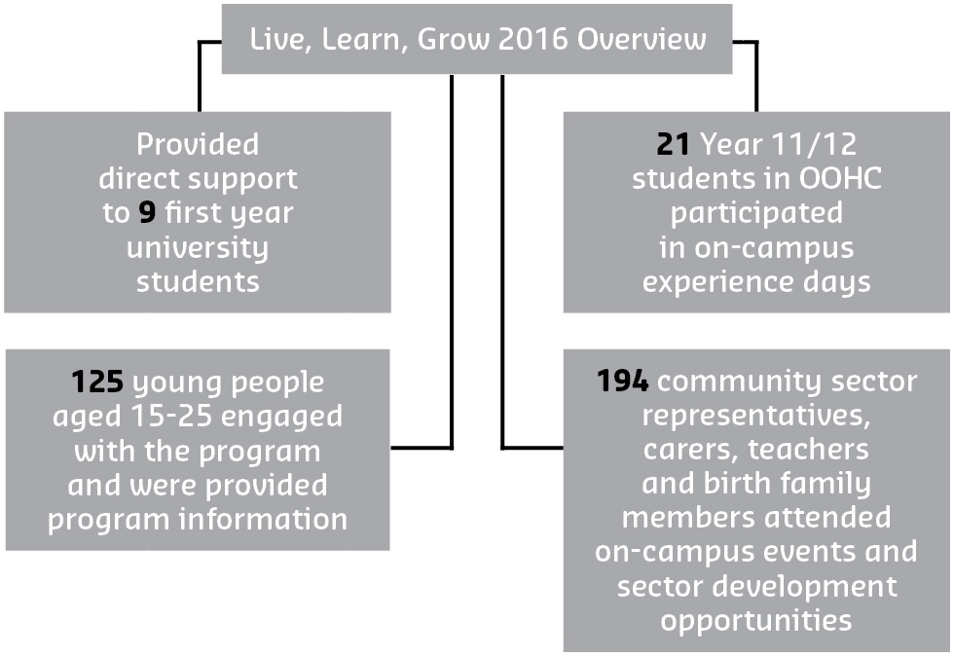

Figure 26: Live, Learn, Grow 2016 overview

The program’s flexible structure allowed for several intakes throughout the year if necessary. To date, the program has also directly connected with almost 300 young people (both in and out of secondary school) plus 365 case workers and 137 carers.

Sustainable Impacts
The program team are working to inform a research agenda that can effect broader systemic changes across policy and other universities. The program model has the potential to be adapted for other groups in the community who may also have lower transition rates into higher education. Live, Learn, Grow was established under a 2015 HEPPP National Priorities Pool grant and is now fully supported by the CEEHE and the UON with the intention of continuing the program annually. Key learnings from these early stages will help shape a possible expansion of the program’s delivery processes into the future.

Peer Learning Program
University of New England
Participation

Description
The University of New England (UNE) Peer Learning Program, established in 2015, builds on our previous science Peer Assisted Study Sessions Program (HEPPP 2012–14). It offers a suite of student-led individual and group learning opportunities for all students. Peer learning is a robust, powerful method of learning; it is not a single undifferentiated educational strategy.
To capture the potential of peer learning for our diverse student population, the context, discipline and characteristics of students were considered in shaping the activities offered by each project:
- Peer Assisted Study Sessions (PASS): sciences and arts
- Peer-to-Peer Help: business and law
- Peer-Writing: multidisciplinary.

Objectives
The program aims to:
- establish university-wide collaborative peer learning networks • support students to develop a sense of student identity and belonging to the university community
- provide an inclusive environment for students to confidently engage with trusted peers in group and individual settings to develop critical academic and learning skills
- promote engagement and success through the development of self-efficacy, particularly for students who may have experienced educational disadvantage and those yet to develop the social and cultural capital associated with successful transition to university.
“The program develops self-efficacy, particularly for students who may have experienced educational disadvantage and those yet to develop the social and
cultural capital associated with successful transition to university.”
– Peer Learning Program coordinator

Activities and Progress
PASS and Peer-to-Peer Help provide scheduled weekly peer-led study groups in 21 first year units known to be challenging and most likely to impede student progression. A number of the units supported are in UNE’s Tracks and Pathways enabling programs, for students proceeding to degrees in sciences, business and law.
The study groups are led by highly successful senior students within the discipline who are trained in group facilitation techniques and mentoring. In each session, the Leaders guide students to collaboratively review notes, discuss concepts, work examples and share organisational and study strategies within the context of the unit.
Where possible, study groups meet in discipline teaching/research areas. The accessibility of the program was increased by offering evening sessions in the residential college precinct and using web conferencing software within unit Learning Management Systems to reach our large online cohorts in business and law.
These strategies promote a sense of inclusion within the discipline and signal peer learning as a normal process for new students.
Peer-Writing, a new initiative conducted centrally in the UNE library, addresses the core writing support needs of students across disciplines and units. Peer-Writing Tutors provide 162 individual online sessions and face-to-face help and are available on the weekend as well as during the week.

Outcomes
As a mainstream program, the UNE Peer Learning Program provides safe, welcoming and informal socially constructed learning spaces that encourage participation by students in underrepresented groups. Learning communities provide encouragement to students:
The program is regularly evaluated through administrative data, by end of trimester survey, and comparative academic outcomes.
“... I found working with other students the most help and also realising I wasn’t
the only student who didn’t grasp some topics made me feel encouraged to strive
harder together.”
– Program participant

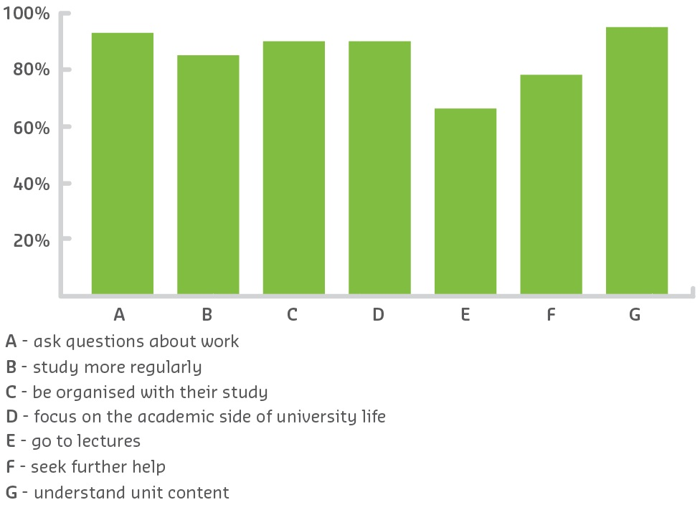
Sustainable Impacts

Figure 27: Student respondents agreed the program helped them to:
The success of the program has been acknowledged by students in their enthusiastic decision to fund the program through their Student and Services and Amenities Fee. This, together with the financial support of some schools and the Office of the Pro Vice-Chancellor (Academic), has seen the growth and further integration of the program. Peer learning opportunities are now an expectation of students and staff as a mainstream learning activity at the University of New England. In 2017, 28 units will be supported by up to 50 PASS and Peer-to-Peer Help sessions across the university in both on-campus and online mode.
Further research has been funded through the HEPPP in 2017 to underpin ongoing development and inform the future direction of the program. Some initiatives in this area include centralisation of the program and the development of a web presence, making the program accessible to students studying online.
“Peer learning opportunities are now an expectation of students and staff as a mainstream learning activity at UNE.”
– Peer Learning Program coordinator

ASPIRE
University of New South Wales
Pre-Access

Description
ASPIRE is a multifaceted outreach program working with 56 partner schools in educationally disadvantaged communities in Sydney and regional and remote NSW. The program provides age-appropriate educational activities within a scaffolded learning framework, both in school and at the University of New South Wales (UNSW), to facilitate learning about university and the benefits of a university education. Activities address barriers faced by students from low SES backgrounds in accessing university education. Integral to the program is the involvement of UNSW students as ASPIRE Ambassadors, acting as role models for school students.

Objectives
ASPIRE aims to:
- raise awareness and enable aspirations of students to participate in higher education
- assist in raising the academic attainment of students
- assist students to make informed decisions that are right for them for their progression to higher education
- address some of the barriers that prevent students from accessing higher education.
“[ASPIRE] assists students to make informed decisions that are right for them for their progression to higher education.”
– ASPIRE coordinator
The program raises aspirations and builds capacity of people from low SES backgrounds by developing activities in partnership with primary and secondary schools and thereby complies with the Partnerships component of the HEPPP.
“[ASPIRE] was really invaluable for me as a student. I had a misconception that I needed to study medicine to be a medical researcher. But it was by talking to the ASPIRE Ambassadors that I learned I could do a science degree.”
– Student from ASPIRE partner school
“There were ... events where we got to go to the university and explore the campus, and see what students and researchers do on a daily basis.”
– Student from ASPIRE partner school

Activities and Progress
ASPIRE takes an innovative approach to addressing inequity of access to university.
- It is multifaceted and multidimensional, addressing significant barriers in a way relevant to the communities in which it works. The program is not a ‘one-size-fits-all’ and regularly introduces new elements depending on the context of the particular schools, for example the Homework Centre in Condobolin which operates two nights per week.
- It undertakes a practice-led and practice-informed research approach including: embedding ASPIRE officers in communities and providing online reading mentors for remote Kindergarten to Year 3 students; online mentoring for middle secondary school students; and STEM development for teachers. Ethics approved research undertaken as part of the program has been introduced to inform both ASPIRE and sector-wide programs.
- It uses both traditional face-to-face engagement methods, and other methods such as online initiatives to reach remote communities more often and address the barriers of distance. The program is currently experimenting with augmented and virtual reality.
- It engages longitudinally with the same communities over a number of years. The whole school is engaged, with scaffolded activities in class for every age group from Kindergarten to Year 12. At key points students are brought on campus and into Sydney for residential experiences.

Outcomes
Since 2010, ASPIRE has engaged with over 45,000 students. Offer rates for students from ASPIRE’s schools to university have increased by over 120 per cent from 2010–16. Data from this same period shows that university offers are being made to students from ASPIRE schools that had very low offer rates prior to ASPIRE’s involvement in 2010. Schools that had a higher number of students receiving offers have significantly increased their offer rates by up to 90 per cent and in one case offers increased threefold.
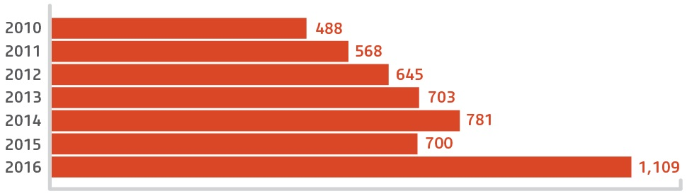
There has also been a 50 per cent increase in the range of universities making offers to students from ASPIRE schools as well as in the range of degree programs offered. This suggests that students have greater awareness of the range of university programs available and are obtaining the entry requirements for a broader range of institutions.

Figure 28: Offers to higher education institutions for students from ASPIRE partner schools

Sustainable Impacts
The multifaceted, longitudinal approach working with the same group of schools over a number of years has enabled the program to:
- build strong and lasting relationships within communities
- engage multiple times with students
- ensure that the workshops and interactions are tailored to address barriers and provide students with targeted information to make informed decisions about their future, particularly in the later senior years.
Successful longitudinal engagement requires the commitment of government, the institution and buy-in from the communities. Through working with the same schools over an extended period of time, ASPIRE has been able to build trust and buy-in within communities. As a result, schools have chosen to remain part of ASPIRE and are very willing to pilot new aspects of the program. Contact with ASPIRE Ambassadors (current university students) has contributed to overcoming barriers to entering higher education and to students beginning to see themselves at university.

Young Achievers
The University of Queensland
Pre-Access
Access

Description
The University of Queensland (UQ)’s Young Achievers Program (UQYAP) supports the tertiary study and career aspirations of motivated secondary school students from low-income families who might not otherwise have access to university. The program nurtures and develops the educational ambitions of Year 11 and 12 participants through mentoring; on-campus experiences; information on university study options, pathways and application processes; opportunities for personal growth; and financial assistance in the form of bursaries and scholarships. The program operates in state secondary schools in Ipswich, Logan, the Lockyer Valley, Toowoomba and the Darling Downs, Wide Bay and Central Queensland.

Objectives
UQYAP aims to:
- raise awareness and interest in tertiary education within educationally disadvantaged communities
- increase the number of students from low-income families enrolling in, and graduating from, university
- develop civic-minded student role models willing to assist in raising the tertiary aspirations of others.
“To me, it is not just a scholarship, it is an opportunity. An opportunity that has inspired me not only to create change for my future but also for the community around me.”
– UQ Young Achiever
“The impact this program makes on the lives of the mentees is incredible. It has driven students to reach higher than they ever thought imaginable.”
– UQYAP mentor

Activities and Progress
The program was established in 2009 with financial support from university donors to
assist with scholarships and bursaries. HEPPP funding covers all operational costs, including staffing, mentor training and development, residential camps, publications and program tracking.
In 2016, 19 former Young Achievers joined the UQYAP Student Mentor Team, giving their time to support Year 11 and Year 12 participants, often from their home schools. Almost 800 Young Achievers have benefited from the program, with eight cohorts of Young Achievers completing the in-school component of the program to date. As the ninth cohort of students enters the program in 2017, an increasing number of earlier Young Achievers are graduating from university. Since the first cohort of students commenced at UQ in 2012, the total number of Young Achievers who have graduated has now reached 50.

Outcomes
Success of the program is measured through:
- the number of participants who successfully complete Years 11 and 12
- active engagement of participants (and their families) in all program events and activities
- feedback from surveys, reflective workshops and interviews (with participants, parents/guardians, mentors and school staff)
- the proportion of participants who apply, receive and accept an offer at a university
- UQ completion and graduations.
One hundred per cent of the eighth cohort submitted a QTAC application; 99 per cent of these students received and accepted a tertiary offer.
An impact research study commissioned in 2010 investigated the experiences of a sample cohort of students through Years 11 and 12 and their first two years after school, including tertiary study.
Findings indicate that:
- Young Achievers extend their knowledge about university pathways, study options and application processes
- the program contributes to building student confidence and helps students through the critical Year 12 decision-making period
- the program facilitates Young Achievers’ access to tertiary study
- family stress is eased by the financial assistance provided, as well as the support network of mentors, other Young Achievers and program staff.
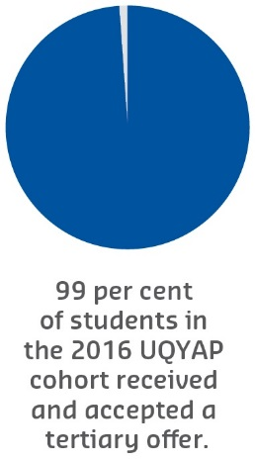

Figure 29: UQYAP cohort that received and accepted a tertiary offer

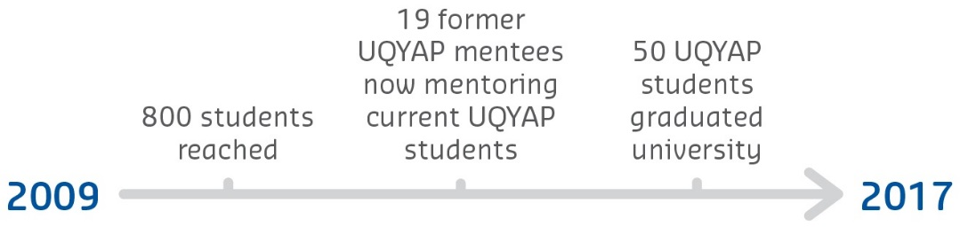

Figure 30: Involvement in UQYAP between 2009 and 2017
Stakeholders also reported the benefit of information provision via multiple channels, and support during ‘critical’ times, such as when submitting tertiary applications.

Sustainable Impacts
A strong working model and solid student pipeline is in place and Young Achievers are serving as key role models within their schools, families and communities. Outcomes and feedback indicate that the UQ Young Achievers Program is helping to raise educational aspirations of students from low-income families.
The focus of further program development is based upon embedding the academic and emotional support systems in order to optimise retention and graduation rates for Young Achievers at UQ.
We continue to seek regular feedback from Young Achievers and their families, mentors and secondary school staff, to inform the future development of the program.
“School staff reported observable effects from program involvement within schools:
in particular, peer information sharing and encouragement about university and considering or persisting with the goal of tertiary study.”
– UQYAP coordinator
UQ is committed to the long-term sustainability of this program and the benefits it will bring, not only to participants, but also to their families, schools and communities.

UniSA Connect
University of South Australia
Pre-Access

Description
University of South Australia (UniSA) Connect curriculum enrichment programs involve over 8,000 senior secondary students annually, enhancing their STEM skills. The programs inspire further STEM study, educational attainment, and understanding of STEM career pathways. UniSA Connect’s strong equity focus targets students that historically have been less engaged with STEM, such as girls and Indigenous students, and fosters consultative and collaborative secondary school partnerships across the low SES areas of Adelaide and regional and remote South Australia.
Partners:
- University of South Australia
  - Division of Information Technology, Engineering and the Environment
  - Division of Health Sciences
  - Division of Education, Arts and Social Sciences
- Over 100 secondary schools
- Port Adelaide Football Club
- South Australian Aboriginal Sports Training Academy
- The Smith Family.
“UniSA Connect curriculum enrichment programs involve over 8,000 senior secondary students annually, enhancing their STEM skills.”
– UniSA Connect coordinator

Objectives
UniSA Connect programs address the decline in secondary school students—particularly those from low SES backgrounds—studying STEM subjects. Inquiry-based learning focuses on engaging students in their learning while supporting them to develop their confidence, improve their STEM skills and raise achievement. Teacher Professional Learning programs complement this and support sustainability by focusing on new technologies, emerging scientific knowledge, and engaging and interactive pedagogical approaches to science and mathematics learning. A Career Awareness program links students’ learning with relevant secondary subjects enabling students to achieve their goals, make informed decisions and pursue STEM learning and career options.
“I have seen Year 9 students involved in Connect programs reach Year 12 this year. Connect has been an important contributor to an increase in the number of students studying STEM subjects in Year 12.”
– Participating school principal

Activities and Progress
UniSA Connect programs are often designed in partnership with secondary schools to inspire and engage students in STEM study and to integrate with, enhance and deepen concept knowledge of school STEM curriculum. Growing from a few two-hour programs,
the range of programs available to secondary schools has expanded to full-day programs, including:
- STEM Enrichment Programs, immersing students in deep STEM learning, while providing authentic learning links to the Australian Curriculum, Reporting and Assessment Authority and South Australian Certificate in Education (SACE) curriculum
- STEM Student Networks and STEM Girls, enabling like-minded students to learn together
- Career Awareness Programs linked to the SACE Personal Learning Plan subject
- STEM School and Cluster Programs, meeting the needs of each school’s STEM strategy by linking to their STEM curriculum improvement agenda
- STEM Teacher Professional Learning Programs
- STEM Innovation Experience, promoting STEM and career pathways to the community
- University Experience Days, enabling students to participate in career awareness and experiential STEM programs on campus.
A partnership with the South Australian Aboriginal Sports Training Academy is also providing new approaches to learning, including culturally appropriate STEM subject options. The consultative model of program development, review and refinement ensures programs are responsive to client needs and that ownership is shared. Issues such as low student achievement or engagement are framed as challenges that can be addressed through the reform of curriculum and pedagogy, rather than remediating individual student deficits of learning capacity or interest in education.

Outcomes
UniSA Connect programs commenced in 2011, with six schools and 600 students engaged. With the injection of HEPPP funds these numbers have increased. In 2016, 101 schools statewide were engaged, and 8,700 students attended Connect programs. Growth has resulted from the consultative model used to develop programs and the satisfaction level of student and teacher participants.
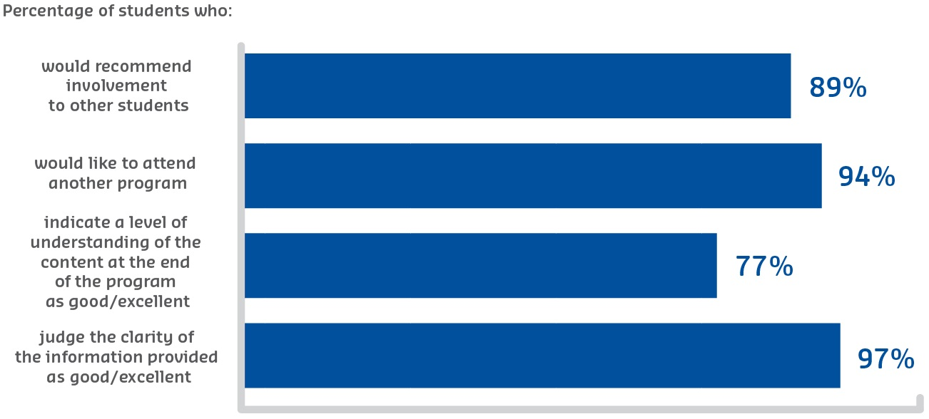
An analysis of nine metropolitan secondary schools involved in UniSA Connect since 2012 showed (from 2012 onwards) a 19 per cent increase in student first preferences to UniSA, and a 31 per cent increase in acceptances of offers to UniSA.

Figure 31: Participant attitudes towards the program

Sustainable Impacts
HEPPP funding has provided the impetus for UniSA Connect to build capacity within low SES school communities. University funding supplements the HEPPP funds, enabling UniSA Connect programs to go well beyond experience programs and ‘taster’ days that target individuals as potential students.
Our whole cohort model will continue to develop sustainable collaborative partnerships and, to borrow from Behrendt et al., “unlock capacity and empower choices”.

Making Career Choices
University of Southern Queensland
Pre-Access

Description
The University of Southern Queensland (USQ)’s Making Career Choices program works collaboratively with individuals, schools and communities across the southern and western regions of Queensland. Using career and community development frameworks of practice, this outreach service delivers a range of tailored supports to secondary school and TAFE students, teachers, parents, community organisations and their clients in order to build career decision-making skills which may inform future study choices, develop or enhance awareness and understanding of pathways into higher education and, for some regional and remote students, provide a unique university experience through participation in its annual Beyond Year 10 camps.
Partners:
- Marketing & Student Attraction USQ
- 25 partner schools
- 20 partner community organisations.

Objectives
Making Career Choices’s primary goal is to contribute to widening regional participation in higher education through the provision of career outreach services. Focusing upon building individual, school and community capacity, the project seeks to enable secondary and TAFE students, and others from low SES communities, to make informed decisions about career possibilities.
“For some regional and remote students, Making Career Choices provides a unique university experience through participation in its annual Beyond Year 10 camps.”
– Making Career Choices coordinator

Activities and Progress
Making Career Choices is the current iteration of USQ’s HEPPP funded career outreach initiative which began in 2013 with the Choices and Opening Doors programs. It is increasingly viewed as an important component of USQ’s suite of career development services, serving as a conduit through which to strengthen links between USQ and the communities it serves from Brisbane to Charleville and beyond.
The program provides tailored services to develop career decision-making skills, and increasing participants’ knowledge concerning pathways to higher education through workshops and individual career counselling opportunities. Students from regional and remote communities also gain exposure to university life through subsidised career-focused residential camps.
“Making Career Choices’s primary goal is to contribute to widening regional participation in higher education through the provision of career outreach services.”
– Making Career Choices coordinator
The scope of career development services has recently been further expanded to include individual scholarships to enhance the opportunities for low SES students otherwise unable to gain industry experience as a consequence of their financial circumstances. This has proved highly successful, as has the ongoing expansion of industry linking and partnership activities, to deliver a continuum of career services from aspiration to graduate employment. Program practices have been refined over time to ensure optimal collaboration with, and leveraging from, other internal and external stakeholder programs. In this way resources are maximised, enabling services which better meet the diverse needs of unique target cohorts across a broad geographic footprint, to the highest quality standards.

Outcomes
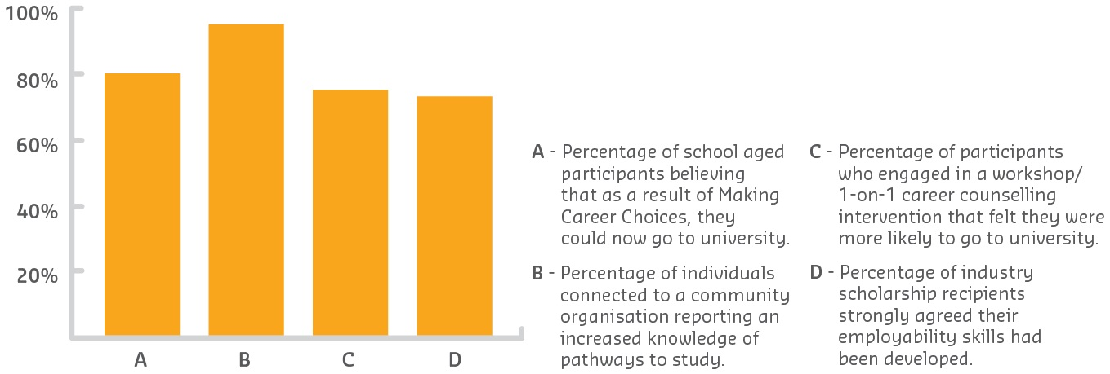
Since 2014, USQ’s career development outreach activities have delivered 357 career development workshops, seminars, expos and campus experiences, and 363 individual career counselling sessions, with a total of 10,572 incidents of participation (to 31 May 2017). In 2016, Making Career Choices successfully demonstrated it had reached its objectives of increasing aspirations and knowledge of pathways to higher education through the combination of career and community development with examples of impact.

Figure 32: Career and community development – examples of impact

Sustainable Impacts
Like many aspiration and awareness raising programs, the impact for some Making Career Choices project participants is distal. It may be several years before a participant from a non-English speaking background has developed the language competency necessary to pursue their higher education dream.
“The knowledge of pathways to higher education gained by thousands of project participants will have a sustained impact.”
– Making Career Choices coordinator
A Beyond Year 10 participant from remote Queensland may wrestle with the barriers of distance, technology, economic capacity and social apprehension before enrolling several years later in higher education which may take them far from home. Yet, we know this project has already had a lasting effect for many. The positive relationships developed, the professional development opportunities facilitated and the knowledge of pathways to higher education gained by thousands of project participants will have a sustained impact reaching beyond the boundaries of current HEPPP funding. In recognising its value and benefit, USQ has now cemented its future commitment to Making Career Choices through elevation to program status.

Pathways to Success
University of Tasmania
Pre-Access

Description
The Pathways to Success program aimed to increase participation in higher education for Aboriginal and low SES students through initiatives enabling future students, families and communities to engage with career possibilities aligned with Tasmania’s industries of the future in food, advanced manufacturing, tourism and health.
The program delivered 83 cultural and regional initiatives, partnered with 55 Tasmanian schools and 134 industry/community partners and involved the participation of 8,366 Tasmanian students and adult learners. These were drawn from regions which included over 83 per cent of Tasmania’s communities living in disadvantaged circumstances and 87 per cent of Indigenous Tasmanians.
Partners:
- 55 Tasmanian schools
- 134 industry and community partners.

Objectives
The Pathways to Success program aimed to:
- inform, lift aspirations and increase understanding of the value of higher education
- increase participation in higher education through activities which inform and build aspiration, provide smooth transitions and enable targeted groups to engage with career possibilities aligned with future industries
- improve rates of transition to industry-relevant higher education courses.
Sixteen core programs were piloted, mapped to the Australian curriculum, to assist teachers and students to develop links between the school curriculum, industry engagement and tertiary education in four Tasmanian Department of State Growth priority economic sectors: advanced manufacturing, food, health, and tourism.
“Why this program matters, is that we are all in education together — this program
offers a rare glimpse at how a coordinated effort and approach to aspiration, raising awareness and imparting information realistically and creatively, can make an impact.”
– Pathways to Success stakeholder

Activities and Progress
The program offered a wide range of activities that included work in four broad program areas: What’s After High School; Look in at Jobs; Skills for Professionals; and the TasTAFE–UTAS awareness program.
Activities offered covered events linked to the four industry cluster areas and included: Tech Sense; Harbouring Careers; Farm to Feast; Healthy Futures; Your Future Tasmania; Industry Tours; Career Conversations; Designed by Me; Creating My Career; Cruise into a Career; and 24 Carrot Jobs. The various program foci and activities offered were guided by industry and education partners.
Extension of the Creating My Career initiative has continued in 2017. Working with the Department of Education My Education team, this program has been expanded from the 2016 model to run state-wide and will involve approximately 3,000 students across Burnie, Launceston and Hobart. This involves partnership between the University of Tasmania, TasTAFE and Rotary Tasmania and provides the opportunity for Year 8 and 9 students to explore 19 different career clusters. Professional development activities for Tasmanian educators are also being continued through partnership with My Education, providing teacher and career planners with ongoing information about university pathways and industry and career links.

Outcomes
The implementation of the Pathways to Success project exceeded its original objectives. In total, 83 programs and initiatives were delivered, tailored to the student lifecycle from aspiration formation to further education and career pathways. Of these, 16 were core, fully-piloted curriculum-mapped programs.
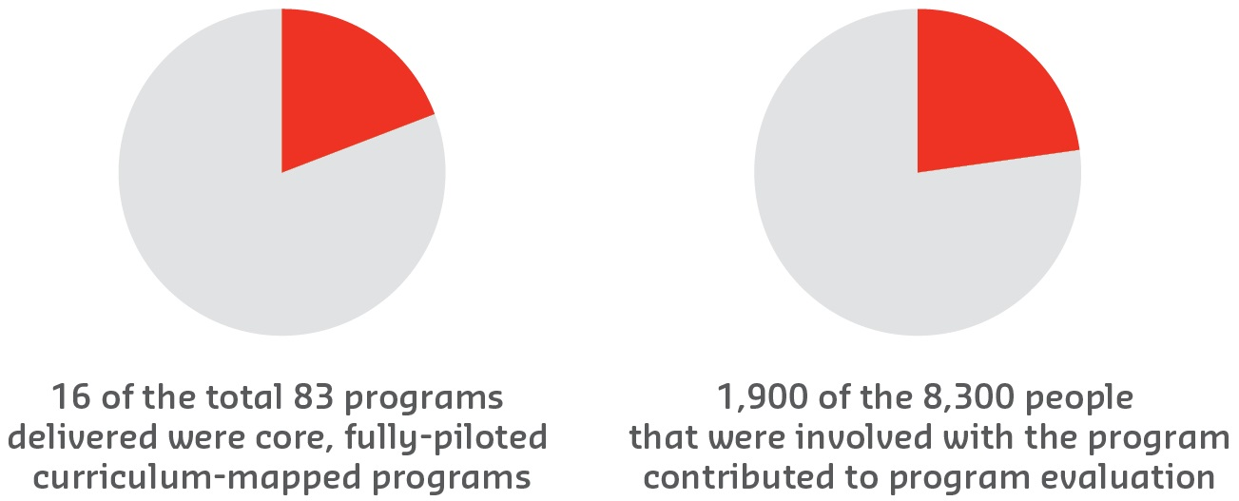
More than 8,300 students and adult learners, including Aboriginal Tasmanians, participated in program events and activities. Over 1,900 participating students, teachers, career advisors, schools and organisational stakeholders contributed to program evaluation. One of the greatest strengths were the project partnerships; 55 schools and 134 industries and organisations were engaged across Tasmania. Stakeholders were overwhelmingly positive about their involvement and links have continued with partners.

Figure 33: Pathways to Success snapshot

Sustainable Impacts
In late 2016, the University of Tasmania (UTAS) appointed its first Pro Vice-Chancellor (Schools Engagement). The position seeks to implement a more strategic, coordinated and meaningful engagement with Tasmanian schools and further education providers to encourage participation in, and articulation to, higher education.
“One of the greatest strengths were the project partnerships; 55 schools and 134 industries and organisations were engaged across Tasmania.”
– Pathways to Success coordinator
A new Schools Engagement Strategy has been approved following extensive consultation with internal and external stakeholders. The strategy draws on learnings from Pathways to Success and in particular the development of coordination in activities, internally and externally, and the importance of evaluation in informing future developments.
A significant outcome of this program was the need to continue involvement in, and development of, aspiration informing and transition programs and initiatives modelled on successful programs within Pathways to Success. Project outcomes, partnerships and ongoing initiatives of Pathways to Success are taken forward in the strategy’s strategic themes of aspirations, building pathways and supporting transition to tertiary education.

U@Uni
University of Technology Sydney
Pre-Access

Description
The University of Technology Sydney (UTS) Widening Participation Strategy delivers a whole-of-university approach to increasing the number of students from underrepresented equity groups accessing and completing university study, in particular students from low SES backgrounds and Indigenous students. The UTS U@Uni program is a key component of the strategy, focusing on outreach to schools and communities. The program includes two-week summer schools and shorter workshops on campus, school-based tutorials delivered by UTS students, and teacher professional learning and networking involving UTS academics. This integrated set of evidence-based activities aims to holistically and responsively address the needs of target students in their secondary school years.
Partners:
- Department of Education NSW and 20 south-western Sydney high schools
- The Smith Family, Public Education Foundation, NSW
- Industry partners including: Cisco Systems Australia; Google Australia; and the Australian Broadcasting Corporation.
“I gained an insight of what uni life is like and [summer school] has provided me with more lifelong friends.”
– Student
“The program aims to encourage student aspiration for university study, and support academic achievement well before the point of enrolment, through an integrated suite
of activities.”
– U@Uni coordinator

Objectives
The program aims to encourage student aspiration for university study, and support academic achievement well before the point of enrolment, through an integrated suite of activities developed in partnership with targeted schools, TAFEs and communities.
The program works with and through its partners to:
- improve students’ academic preparedness and outcomes
- increase students’ awareness, confidence and motivation toward higher education
- build teacher, school and community capacity
- broaden students’ family knowledge about higher education
- develop and sustain effective community and stakeholder partnerships.

Activities and Progress
Commencing in 2009 as a one-week program for 30 low SES students, U@Uni has expanded to include four strands of activity that reach approximately 4,000 secondary school students, 630 parents and 150 teachers annually, while engaging over 100 UTS students as mentors and tutors in its delivery. While the extent and reach of the program has changed over time, the objective and approach continues to reflect UTS’s student-centred approach to learning. On-campus time for secondary school students sees them engaged in actively learning skills and content, and the ability to work within a group to solve authentic real-life issues, while demystifying university and increasing their confidence and motivation to attend university.
The current U@Uni program includes four strands of activities:
- Summer School: A two-week on-campus learning experience in which students take part in one of six summer schools in the areas of design, media and communications, business, science, engineering and information technology, and health.
- HSC Tutorial Scheme: School-based tutorial sessions delivered by UTS students to assist Year 11 and 12 students.
- On-campus workshops: Hands-on, interactive experiences working with
UTS academics, students and resources as well as industry experts for Years
10, 11 and 12.
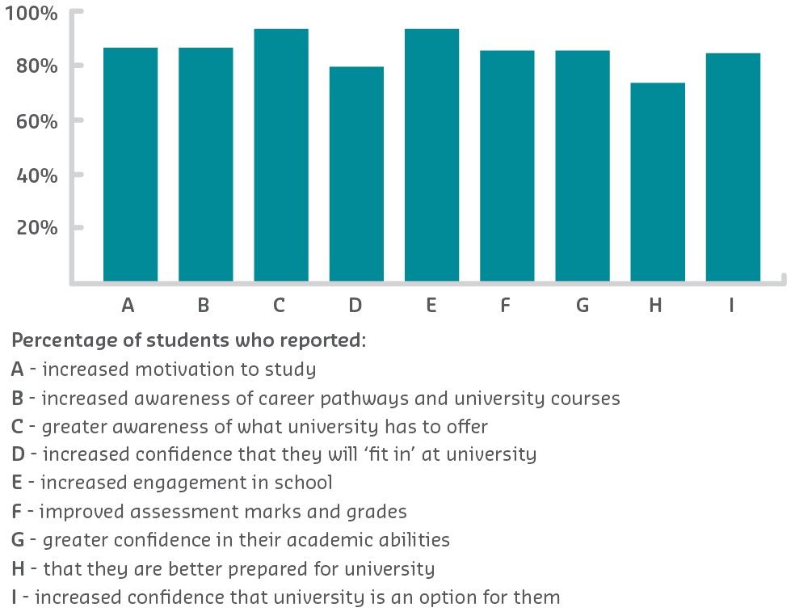
- Teacher professional learning builds teacher capacity and creates a community of practice inclusive of UTS academics.

Figure 34: U@Uni participant outcomes

Outcomes
Program impact is measured in the form of student and teacher surveys, interviews, focus groups, direct observation and informal feedback. Students are surveyed before participating in a U@Uni activity, immediately after, and on exiting the program.
Both quantitative and qualitative evaluation data demonstrate that U@Uni is contributing to positive outcomes for students.

Sustainable Impacts
Social justice is a critical part of UTS’s strategic plan and institutional culture, with the actions of staff and students reflecting the role it aims to play in increasing public good, increasing social mobility and equity, and in supporting the creation of enabling environments for communities to thrive.
To strengthen its focus on social justice, UTS is developing a Social Impact Framework to demonstrate its current collective impact and to guide future sustainability. UTS’s Widening Participation Strategy is a crucial component of that framework, with the U@Uni program a key intervention supporting the both wider participation outcomes and broader university aims.
In the foreseeable future U@Uni will continue to focus on south-western Sydney, while expanding to support UTS’s Social Impact Framework by also engaging with the schools and communities within the UTS local precinct.

Explore
University of the Sunshine Coast
Pre-Access

Description
The University of the Sunshine Coast (USC) Explore program offers a creative approach to developing children’s career aspirations during their upper primary years to improve their understanding and awareness of higher education as a viable post-school option.
The program offers a scaffolded suite of online lessons for Years 4, 5 and 6 which are based on the themes of adventure and discovery. Students are invited to take a journey to a deserted island and use their imagination to build their ideal community. In doing so, they develop an awareness of their own skills and interests while discovering which skills are necessary for a range of different jobs.
Year 5 students are also invited to attend a career expo at their local university to provide direct hands-on experiences of different types of jobs and information about a range of career pathways.
Partners:
Participating partner schools in low SES regions:
- whole of cohort, Years 4, 5 and 6
- parents/carers
- teaching staff.
The expo highlights partnerships with a number of community stakeholders:
- Vocational and Educational Training sector (TAFE)
- employers in the local community
- university academics.
“Explore is a sustainable program for building career aspirations in primary schools, with a strong emphasis on early intervention and continuing engagement.”
– Explore coordinator

Objectives
USC has a long-term commitment to the delivery of aspiration building programs within the community. Between 2011 and 2016, USC delivered several awareness building career development programs targeting primary students. These included the USQ Smart Steps program for Year 5 and the USC MyTED program for Years 4 and 6, both of which combined in-class lessons with an immersive expo. A review in 2015 identified that these programs could be consolidated into one streamlined program which used existing good practice and ensured a stronger alignment with the six HEPPP guiding principles. The new program emphasises early intervention and continuing engagement while offering an integrated and multi-layered approach.

Activities and Progress
The Explore program team comprised two curriculum developers, staff involved in the delivery of existing primary programs (Smart Steps and MyTED), school stakeholders, and an accessibility officer. Program development commenced with a review of existing programs to build on early learnings and identify key components of good practice. Examples of these components included the immersive expos (which formed part of both existing programs), and MyTED’s use of a story to engage students in the lesson activities.
Explore was developed as an online program with the option of paper resources being available to schools with limited internet access. The program was designed as a series of scaffolded lessons for Years 4, 5 and 6 and an immersive expo on campus for students in Year 5. The online resources include lesson plans linked to the Australian Curriculum, activity sheets and video clips.
The lessons were piloted in a participating school to ensure they were effective and engaging for the students prior to the Explore website being launched in early 2017.

Outcomes
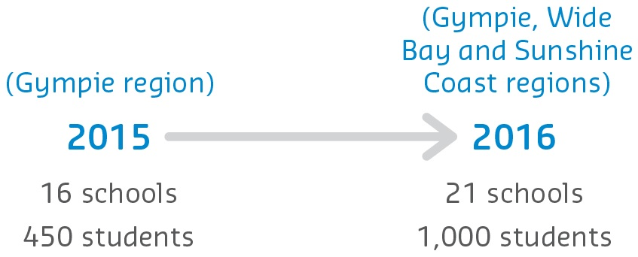
On average, across all participating schools involved in the Smart Steps program, 85 per cent of students either agreed or strongly agreed that the program raised their awareness of further study. Ninety-one per cent either agreed or strongly agreed that they would like to go to university or TAFE.

Figure 35: Engagement with Smart Steps

Over the last three years:
- 2015: 16 schools and 450 students reached via Smart Steps in the Gympie region.
- 2016: 21 schools and 1,000 students engaged via Smart Steps in the Gympie, Wide Bay and Sunshine Coast regions.
- 2016: Development of the scaffolded online career suite, Explore.
Preliminary findings from the Explore pilot indicate it successfully engaged students and encouraged them to consider a range of career pathways.

Sustainable Impacts
The program is fully HEPPP funded and is available online, providing schools and other institutions with a suite of lessons for Years 4, 5 and 6, online teaching resources and a model for delivering the on-campus events in a way that provides the opportunity for the package to be embedded within other institutions’ footprints.
Due to the accessibility of the online lesson plans and resources, Explore is a cost-effective sustainable package that will lend itself to further development of a secondary school program to ensure continuity and long-term engagement with low SES communities.
USC is committed to long-term engagement when delivering outreach programs and is exploring future opportunities to collaborate with school staff, students and parents to diversify the resources, focusing on an interactive approach and the possible development of an app linked to the package.
“Great for students to link careers with strengths and weaknesses, to recognise skills needed and develop these.”
– Year 4 teacher

Fairway UWA
The University of Western Australia
Access
Participation

Description
The University of Western Australia (UWA) has an integrated suite of equity outreach programs ranging from broad-based, early intervention outreach programs and access pathways to more intensive, targeted individual support programs.
Fairway UWA is an alternative entry pathway to UWA for students completing Year 12
under difficult circumstances. Open to WA students who face challenging circumstances in demonstrating their academic potential, the program offers support with Western Australian Certificate of Education studies and university aspirations. Students who complete the program are eligible for a placement offer up to 10 points below UWA’s usual admission
cut-off.

Objectives
Fairway UWA aims to build both the academic capacity and motivation of students facing significant challenges in attaining their higher education goals. The program provides multifaceted support responsive to the individual and their circumstances, through their journey from Year 12 until the completion of their studies at UWA.
“It’s all thanks to Fairway that I am at university now. It’s a dream come true.”
– Fairway UWA student volunteer
All reasonable costs associated with attending Fairway UWA events are covered by the program, ensuring the additional support remains accessible to students.
“Fairway is making a difference in the lives of others and motivating them to strive for the best. To me it means giving back for everything they did for me.”
– Fairway UWA student volunteer

Activities and Progress
In 2012, the Fairway UWA program commenced with 42 students from 16 schools. In 2013, the program doubled in size, accepting 97 metropolitan and regional students. Currently, the program supports over 100 Year 12 students each year.
To complete the program, students are required to complete three assessment tasks, four online modules and attend on-campus events. The academic tasks are designed to develop students’ English language and research skills, enhancing their likelihood of receiving a university offer and preparing them for tertiary studies.
Fairway UWA students originally attended only one on-campus event: a two-day residential Summer School in January. However, feedback from participants identified that maintaining motivation in the face of constant stress was a common challenge, and that building a sense of cohort was critical to sustaining motivation. As a result, a Master Class in April and a four-day Winter School in July were added to the program, and the Summer School was extended to four days. Students also have access to a wealth of online resources and are encouraged to attend additional English classes on Saturdays.
For students who enrol at UWA, Fairway UWA maintains ongoing contact and provides financial, academic and social support, and career counselling. Peer Study Groups are also available for first year core units. Many senior Fairway UWA students subsequently join the program as ambassadors, mentoring Year 12 students and tutoring commencing university students.

Outcomes
“Fairway has inspired many students from disadvantaged backgrounds to achieve their full potential and dreams of higher education (myself included). This support has been made available to Fairway students after Year 12 and thus many of us feel more at ease about attending UWA because of the family feeling of Fairway.”
– Fairway UWA student.

From 2012–16, 376 students successfully completed the program, with 361 receiving offers from universities in WA (96 per cent success rate).
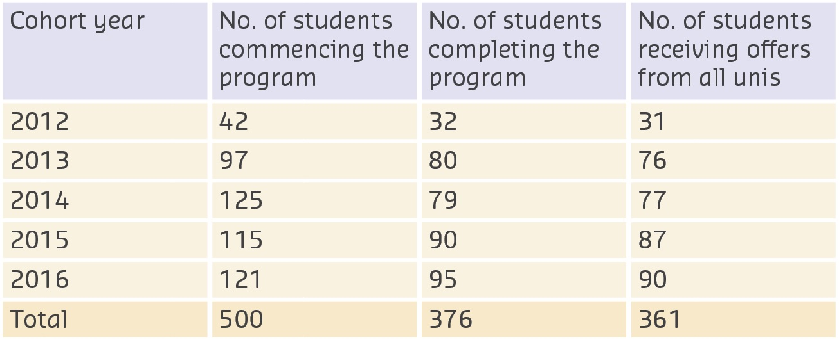
Since the end of 2012, 143 Fairway UWA students have received offers from UWA. Of these, 131 are currently enrolled (above 91 per cent retention), an outstanding result when considering the challenges faced by this cohort. These students have also performed well academically, with 75 per cent achieving average to above average standards and 15 per cent achieving a Weighted Average Mark of 70 or higher. There is strong student satisfaction with the overall program, including delivery of activities and intended outcomes.

Figure 36: Program involvement

Sustainable Impacts
Fairway UWA is making a real difference in improving access and success for disadvantaged students, evidenced by increased university enrolments for low SES students, positive retention data and the endorsement of parents and teachers that Fairway UWA is contributing to long-term positive change.
With the support of HEPPP funding, Fairway UWA is now positioned as an integrated program within the broader equity outreach strategy at UWA.
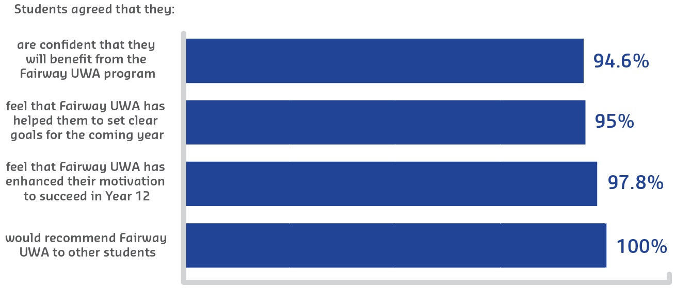
Ongoing collaboration within the institution, its alumni, and the larger university community will underpin the sustainability and continued success of this program, building upon available funding to continue delivering positive outcomes.

Figure 37: Student attitudes after participating in Fairway UWA

In2Uni
University of Wollongong
Pre-Access
Access

Description
The University of Wollongong (UOW) offers a number of outreach activities to raise the aspirations, attainment, awareness and access to higher education for individuals from underrepresented backgrounds. The In2Uni program is one such activity, which fosters engagement with students from Years 6–12 in UOW’s communities with a high representation of low SES students through on-campus visits, study skills programs, workshops, master classes and a university preparation program.
Partners:
- NSW Department of Education
- Catholic Education Office (Wollongong and Canberra/Goulburn Diocese).
“My daughter just completed the Year 12 Summer Master Class … what impressed me
most was how openly she speaks now about wanting to work harder in a general sense. This is a really well put together program, and I’m so impressed with the effect that it has had on a very disengaged and critical learner. She has gone back to her high school saying nothing but good about university.”
– Parent of student participant

Objectives
In2Uni aims to foster and develop collaborative partnerships that:
- connect positively with individuals from underrepresented backgrounds to build their aspirations and capacity towards higher education
- work collaboratively with stakeholders to develop programs that engage individuals from underrepresented backgrounds and provide tangible bridges to access higher education
- increase the number of students from low SES, Indigenous and regional/remote backgrounds accessing higher education to enrich UOW’s local communities.
“Overall I enjoyed my university experience and was not looking forward to going home. I met some fabulous people and I’m now excited for university more than anything! Mentors and staff were just as great as the experience also.”
– School student

Activities and Progress
UOW has a long history of undertaking school outreach activities in the local community. In 2010, the HEPPP provided a vehicle to establish an institution-wide approach to school outreach, and the In2Uni Program was launched with five secondary schools and five primary schools in the region.
In2Uni is underpinned by a research-driven learner progression approach and benchmarked against the Design and Evaluation Matrix for Outreach. Since 2011, it has expanded to include over 80 primary schools and 45 secondary schools in 2017, engaging with over 10,000 students across a 430 km coastline of southern NSW.
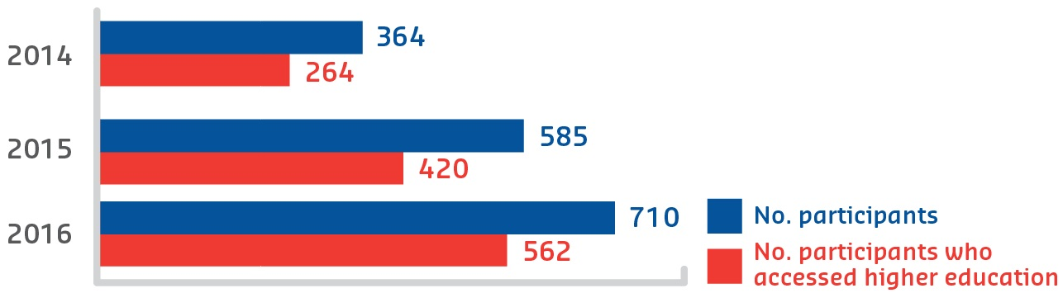
The program initially commenced with on-campus visits for Year 6 and Year 10 students, study skills programs for Year 11 students, and curriculum-based projects for Year 7 and Year 8 students. These programs have been refined each year, based on survey data and stakeholder feedback, to now include teacher professional development activities and curriculum for teachers to deliver in the classroom, and workshops that encourage students and parents working together in their learning journey. Pivotal additions to the In2Uni program were the launches of the Year 12 Summer Master Classes and the Year 12 University Preparation Program in 2014. These programs provide a student-centred approach to learning and supporting students with diverse needs, while extending the school curriculum and enhancing student preparedness for higher education.

Figure 38: Program transitions to higher education
In2Uni has been benchmarked against other widening participation programs and been
the subject of two internal evaluations by an independent research team. These reviews, combined with substantial collaboration and feedback with In2Uni’s partners, have led to continuous improvement and significant growth of the program over the last seven years.

Outcomes
The Year 12 Summer Master Classes and Year 12 University Preparation Program have demonstrated the most significant impact, with an increasing number of students engaged in both programs. The University Preparation Program students provide evidence (upon entry) that they do not have sufficient academic attainment to access higher education. As a result of participating in the program, more students each year increase their academic attainment and access a place at university.

Sustainable Impacts
The focus of In2Uni has been to develop multi-layered, sustainable and collaborative partnerships between UOW and the Department of Education and Catholic Education
Office in the Illawarra South East Region, at all levels of the organisation, to ensure the ongoing sustainability of the program. These range from MoUs between organisations, to collaborative development of content between teachers and university staff, to positive mentoring relationships established between university and school students.
Underpinned by a continuous improvement planning cycle, In2Uni activities are continuously refined to ensure that the activities are aligned with HEPPP objectives, as well as meeting the evolving needs of students participating in the program. 2017 will see In2Uni expand its reach into South Western Sydney, with a pilot program being launched in 10 schools
in the region.
“In2Uni engages with over 10,000 students from over 125 schools across the 430 km coastline of southern NSW.”
– In2Uni coordinator

Student Transition Mentors
Victoria University
Participation

Description
Victoria University (VU)’s Student Transition Mentors (STM) program was established to provide peer support to first year and commencing (pathways) students during their transition into university. VU students come from diverse backgrounds including a large proportion from key equity groups. Through specific engagement and retention interventions, STMs who are employed as ‘Students as Staff’, work within VU’s retention program (Student Link) to engage with students who have been identified through data analytics as at-risk of attrition.
The STM program is informed by pedagogy and provides students with numerous ‘on-the-job’ learning opportunities to develop and strengthen graduate capabilities.

Objectives
The goal of the STM program is to engage, guide and support students during the adjustment period of navigating university systems, processes and information to ease anxiety, enhance engagement and positively impact university retention. The program builds connection to the university, provides students timely and relevant support and advice, positive experiences, and potential STM job opportunities.
STMs are provided with support and guidance in developing presentation, public speaking, communication, leadership and teamwork skills by the program coordinator. STMs are consulted on aspects of the program, providing opportunities to make real change, increase confidence, and contribute to lifelong learning practices.
“The program builds connection to the university, provides students with timely and relevant support and advice, positive experiences and potential STM job opportunities.”
– STM coordinator

Activities and Progress
STMs undertake biannual training to effectively support and guide their peers through face-to-face interactions at Orientation and College events, during semester drop-in sessions, and one-on-one on-campus appointments.
STMs also engage students through ‘check in’ phone calls to answer any questions or address and refer concerns to the appropriate area or person.
With VU’s student population incorporating a high equity group profile, the STM program is able to provide the initial and timely support necessary to ensure a smooth and successful transition into the University.
With the recent addition of a customer response management system (RightNow), STMs are able to accurately document details of conversations and provide a case-management approach when speaking with students. This closely aligns with research that shows that students are more likely to be engaged, successful and satisfied with their learning if support is tailored to their individual needs.

Outcomes
“[My STM] was great, he answered all my course and staff-related questions ...
There are so many other things that [he] assisted with but importantly he made me
feel welcomed.”
– STM student

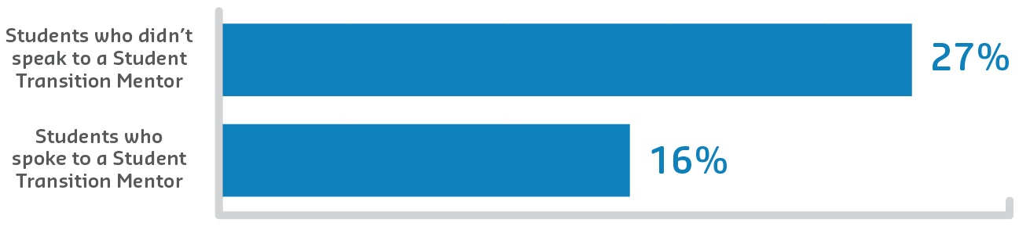
The STM program currently employs 25 Students as Staff from diverse backgrounds and equity groups, and has employed 47 since implementation. 2016 reporting shows that students who spoke to a STM have a lower risk of attrition (16 per cent) between Semester
1 and 2 as opposed to those not who did not (27 per cent).

Figure 39: 2016 attrition rates of students between Semesters 1 and 2
Anonymous program evaluations completed by STMs highlight some aspects of the program:
“Making a difference in another student’s experience in VU.”
“The breadth of students you face is staggering at times, it really demonstrates VU’s student diversity.”
“Being able to engage with students from a plethora of backgrounds. Helping students solve their problems ...”
Some student comments on the STM program include:
“[My STM] was great, he answered all my course and staff-related questions ... There are so many other things that [he] assisted with but importantly he made me feel welcomed ...”
“... [student] told me that our conversation had been by far the most useful he had had at uni and he was very grateful to have someone to talk to.”

Sustainable Impacts
In less than two years since inception, the STM program has seen growth and support from VU staff and students. Further enhancements to the existing STM Facebook page, increased visibility on the VU website and widened collaboration will contribute to the overall sustainability of the program.
The program, which is fully funded through the HEPPP, has shown to effectively engage students and provide timely support when student stresses and anxiety are high.
STM work done within Student Link provides a real student voice and helps to normalise common feelings of confusion, frustration and anxiety when commencing university.
STMs have also recently been involved in the Early-Uni Pathways (EUP) program at VU. Work is currently being done in this space to employ, train and develop former EUP students (who have taken up undergraduate studies at VU) to become STMs who will then support new EUP students coming to VU.
“The breadth of students you face is staggering at times, it really demonstrates VU’s student diversity.”
– Student Transition Mentor

Fast Forward
Western Sydney University
Pre-Access

Description
Fast Forward works in partnership with 64 secondary schools across western Sydney to encourage students’ participation in higher education. Through raising awareness of the many different pathways to higher education, and supporting students with activities designed to increase their aspirations towards continuing education, the Fast Forward program improves educational outcomes.
Former Fast Forward students currently studying at Western Sydney University (WSU) mentor and encourage secondary school students to strive for their personal best and to see tertiary study as a realistic and viable post-school option by fostering familiarity with the university environment.

Objectives
Fast Forward supports secondary school students from underrepresented backgrounds across the western Sydney region with activities designed to increase their aspirations towards continuing their education after Year 12 and to raise their awareness of pathway options to higher education.
“Expansions during 2012, 2013 and 2016 saw Fast Forward reaching 64
secondary school partners across western Sydney with student numbers increasing
to 3,346 in 2016.”
– Fast Forward coordinator

Fast Forward facilitates the personal, academic and professional development of students, and is a partnership where all participants—secondary school students, schools and teachers, parents and carers and the university community—unite to secure the success of our future generations.
“Fast Forward is making a genuine difference to the lives of secondary school
students in western Sydney, by improving their access and success in higher
education particularly among students who would typically be underrepresented.”
– Fast Forward coordinator

Activities and Progress
The Fast Forward program commenced as a pilot study in 2004 to link students from schools in western Sydney to their local university (WSU) and to encourage students and their families to see tertiary study as a genuine post-school option. A major program expansion in 2011 saw 17 new schools added to Fast Forward, followed by further expansions during 2012, 2013 and 2016 to now reach 64 secondary school partners across western Sydney. Fast Forward student numbers have increased from 1,912 in 2012 to 3,346 in 2016.
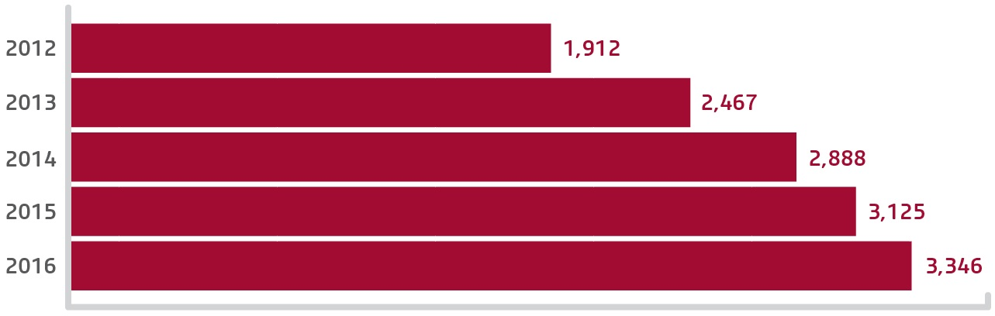
New programs were developed in WSU’s Office of Widening Participation to complement and support the increasing demand for Fast Forward. In 2013, First Foot Forward was established out of a need to engage with students earlier on their educational journey to maximise opportunities for aspiration building. First Foot Forward originally partnered with
11 primary schools, and after several expansions reached 3,296 students across 35 schools in 2016.

Figure 40: Program participation growth
STEPS (Strive Towards Educational Participation and Success) was developed in 2014 to meet the increased demand for many other schools in western Sydney to be part of a secondary school aspiration building program. Providing on-campus and in-school learning sessions for Years 9 and 10 students, STEPS commenced working with 14 schools, expanding to 20 schools in 2015, and in 2016 worked with 2,543 secondary school students.

Outcomes
“I dreamed about becoming a lawyer and going to university but it seemed to be a foreign and alien experience and unreachable for a little kid from western Sydney ... I decided to study hard and applied for WSU’s Academic Excellence Scholarship which I had the privilege to win, enabling me to pursue my dream ... I would never have realised my desired career path if it was not for the Fast Forward Program.”
– Fast Forward Western Sydney University student
From 2012–16, 2,616 Fast Forward students completed Year 12 with 1,595 receiving offers to university (61 per cent success rate). Of these, 946 received offers to WSU.
“... All participants—secondary school students, schools and teachers, parents and carers and the university community—come together to secure the success of our
future generations..”
– Fast Forward coordinator

Feedback from students, teachers and parents alike demonstrate the resounding success of Fast Forward:
- 86 per cent of students attending a Year 9 university day reported greater confidence in making decisions about their future educational pathway
- 85 per cent of students attending a Year 11 university day reported a better understanding about what further education can offer them.

Sustainable Impacts
Fast Forward is funded by the HEPPP, and 2017 is its 14th year of operation. Fast Forward is making a genuine difference to the lives of high school students in western Sydney by improving their access and success in higher education, particularly among students who would typically be underrepresented. This can be evidenced through increased offers to university between 2012–16 among Fast Forward students, a broader reach of students participating in the program, the success of the newly developed primary school and secondary school programs that support and meet the additional demand from Fast Forward, and the positive endorsements of parents, teachers and students alike.
With the provision of HEPPP funding, Fast Forward is positioned as an integral part of the Securing Success strategic plan at WSU. It is an exciting time for the program and we look forward to the continued success of Fast Forward in 2017 and beyond.

List of Acronyms
ACT Australian Capital Territory
ACU Australian Catholic University
AHEAD Addressing Higher Education Access Disadvantage
ARPNet Aboriginal Research Practitioners’ Network
ASK Academic Skills and Knowledge
ATAR Australian Tertiary Admission Rank
B. Arts Bachelor of Arts
B. Laws Bachelor of Laws
C&SS Computer and Security Services
CDU Charles Darwin University
CEEHE Centre of Excellence for Equity in Higher Education
CQU Central Queensland University
CSU Charles Sturt University
CUA Children’s University Australia
ECU Edith Cowan University
ER Education Reconnect
EU Explore Uni
EUP Early-Uni Pathways
FedUni Federation University Australia
HEPPP Higher Education Participation and Partnerships Program
HSC Higher School Certificate
ICCB Inclusive Curriculum and Capacity Building
ICSEA Index of Community Socio-Educational Advantage
ICT Information Computer Technology
JCU James Cook University
LEAP Learning, Education, Aspiration and Participation
LGBTIQ+ Lesbian, Gay, Bisexual, Transgender, Intersex or Queer
MoU Memorandum of Understanding
MAP4U Murdoch Aspirations and Pathways for University
MyTed My Tertiary Education Day
NAIDOC National Aboriginal and Islander Day Observance Committee
NCSEHE National Centre for Student Equity in Higher Education
NSW New South Wales
OOHC Out of Home Care
PASS Peer Assisted Study Sessions
PRP Principal’s Recommendation Program
QTAC Queensland Tertiary Admissions Centre
QUT Queensland University of Technology
RMIT Royal Melbourne Institute of Technology
SA South Australia
SACE South Australian Certificate of Education
SCU Southern Cross University
SEAMS Strengthening Engagement and Achievement in Maths and Science
SES Socioeconomic Status
SFP Student Futures Program
SFS Strategies for Success
SNAP Schools Network Access Program
SSSP Stronger Smarter Schools Program
STEM Science, Technology, Engineering and Mathematics
STEPS Strive Towards Educational Participation and Success
STM Student Transition Mentors
SYN Student Youth Network
TAFE Technical and Further Education
UC University of Canberra
UNE University of New England
UniSA University of South Australia
UNSW University of New South Wales
UON The University of Newcastle
UOW University of Wollongong
UQ The University of Queensland
UQYAP University of Queensland Young Achievers Program
USC University of the Sunshine Coast
USQ University of Southern Queensland
UTAS University of Tasmania
UTS University of Technology Sydney
UWA The University of Western Australia
VU Victoria University
WA Western Australia
WCE Whole of Community Engagement
WILD’C Women in Leadership Driving Change
WP Widening Participation
WSU Western Sydney University

About the Centre
The National Centre for Student Equity in Higher Education began operation in 2008, hosted by the University of South Australia. In May 2013, Curtin University won the bid to take over the Centre and received funding to achieve its aim of informing public policy design and implementation and institutional practice, to improve higher education participation and success for marginalised and disadvantaged people.
The NCSEHE’s objectives are:
- to be at the centre of public policy dialogue about equity in higher education
- to assist in ‘closing the loop’ between equity policy, research and practice by:
  - supporting and informing evaluation of current equity practice, with a particular focus on identifying good practice
  - identifying innovative approaches to equity through existing research and the development of a forward research program to fill gaps in knowledge
  - translating these learnings into practical advice for decision-makers and practitioners alike.
The NCSEHE’s key purpose is “to inform public policy design and implementation, and institutional practice, to improve higher education participation and success for marginalised and disadvantaged people.”
In keeping with its purpose, the NCSEHE is connecting Commonwealth student equity policy with the activities of higher education institutions and national equity outcomes through its input into comparative assessment of institutional strategies, systemic assessments of policy achievements and assessments of national policy-making in view of this evidence. The Centre’s focus is based on three programs of research activity:
- Equity Policy and Program Evaluation
The Centre is providing leadership and support in developing a national approach and resources to evaluate the impact of initiatives to increase participation of people from low SES backgrounds and other equity groups in higher education.
- Equity Policy and Planning Research
The Centre is furthering equity policy and planning in Australia, sharing knowledge and capabilities developed in Australia, and providing evidence on the impact of policy on equity outcomes in the system. By enabling national research and engagement on higher education policy and practice, the Centre ensures its research includes analysis of all student equity groups including people from low SES, Indigenous, regional and remote communities, and people with disability.
- Student Equity Data
The Centre conducts analysis of higher education datasets from a student equity perspective. This encompasses:
  - compiling and analysing national equity data and survey data on student transition to higher education
  - managing a website that presents data on student equity performance in higher education; in particular, the mapping of higher education participation data in Australia
  - providing access to data and data-driven research on equity policy and programs from around Australia and the world.

“Assisting in closing the loop between equity policy, research and practice.”

Disclaimer
Information in this publication is correct at the time of printing but may be subject to change. This material does not purport to constitute legal or professional advice.
Curtin accepts no responsibility for and makes no representations, whether express or implied, as to the accuracy or reliability in any respect of any material in this publication. Except to the extent mandated otherwise by legislation, Curtin University does not accept responsibility for the consequences of any reliance which may be placed on this material by any person.
Curtin will not be liable to you or to any other person for any loss or damage (including direct, consequential or economic loss or damage) however caused and whether by negligence or otherwise which may result directly or indirectly from the use of this publication.

National Centre for Student Equity in Higher Education
Building 100 Curtin University
Kent Street Bentley WA 6102
GPO Box U1987 Perth WA 6845
Tel: +61 8 9266 1573
Fax: +61 8 9266 3658
Email: ncsehe@curtin.edu.au
ncsehe.edu.au

