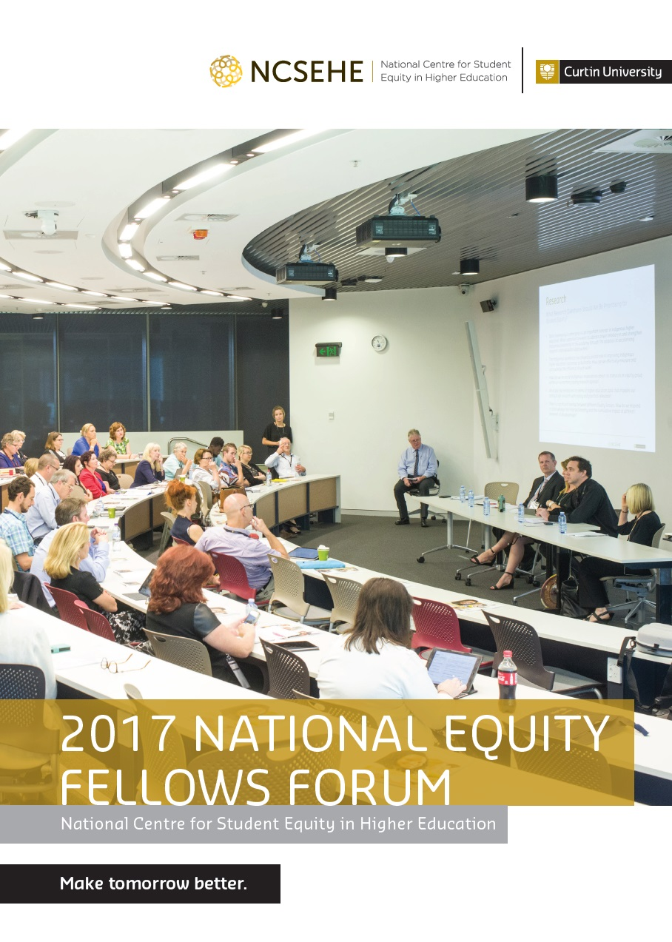

2017 National Equity Fellows Forum

National Centre for Student Equity in Higher Education

November 2017

ACKNOWLEDGEMENTS
This publication could not be completed without the work of a dedicated team of people and the support of the Australian Government Department of Education and Training and Curtin University.
Sincere thanks go out to all of the delegates of the 2017 Equity Fellows Forum for their contributions to the establishment of these key strategic directions for equity policymakers, researchers and practitioners.
This publication is available to view and download on the NCSEHE website ncsehe.edu.au

COPYRIGHT INFORMATION
© Curtin University 2017
Except as permitted by the Copyright Act 1968, this material may not be reproduced, stored or transmitted without the permission of the copyright owner. All enquiries must be directed to Curtin University.
CRICOS Provider Code 00301J
Funded by the Australian Government

National Equity Fellows Forum

On 20 November 2017 the National Centre for Student Equity in Higher Education (NCSEHE) staged the second National Equity Fellows Forum at Queensland University of Technology in Brisbane.
The Forum presented and promoted the current projects of the 2017 Equity Fellows, Matt Brett, Louise Pollard and James Smith. Perhaps more significantly, by examining the commonalities and synergies of those projects, critical issues for equity in higher education were raised through an interactive session with experts in equity. Through this discussion, key strategic directions for equity policymakers, researchers and practitioners were established.
The strategic directions section of the Forum was titled Shaping the Future of Australian Higher Education Equity Policy, and was facilitated by Robert Latta, Manager of the Quality and Access Branch in the Higher Education Group in the Department of Education and Training (DET).
This communiqué sets out the questions raised by the three 2017 Equity Fellows, each of which selected key issues in three themes that need to be addressed by the equity and higher education sectors.
Each Fellow introduced a theme and posed a series of critical questions. The three themes were:
- Research – what questions should we be prioritising for student equity? (James Smith)
- Policy – What is the relevance of student equity for tertiary education policy reform? (Matt Brett)
- Practice – how can we ensure the value and impact of student equity practice? (Louise Pollard)
The questions raised by the Equity Fellows were strongly informed by their projects:
- James Smith – Strengthening evaluation within Indigenous higher education contexts in Australia
- Matt Brett – Equity, performance and accountability
- Louise Pollard – Remote student university success: an analysis of policy and practice
PowerPoints, audio recordings and transcripts of the presentations and discussion at the Forum are available at https://www.ncsehe.edu.au/ncsehe-national-equity-fellows-forum-2017-wrap-up/
The 2017 Equity Fellows Forum was a great success in generating fresh insights into equity challenges and the responses to them. Importantly, this was achieved in a collective and collaborative way through discussion and debate among invited delegates who were experts in equity in higher education and engaged in policy, research and practice.
I would like to thank all of the delegates to the 2017 Equity Fellows Forum for participating in the gathering and for the constructive way they combined to advance the equity agenda in Australian higher education.
Sue Trinidad
Director
National Centre for Student Equity in Higher Education

Equity Fellows Program

The Equity Fellows Program has supported Fellows to undertake strategic, high-impact, high-profile leadership projects targeted, sector-wide, at improving the access, participation and success in higher education of students from disadvantaged backgrounds.
As part of their Fellowships, Fellows spend a period of time working in, and with, the Australian Government Department of Education and Training (DET) in Canberra facilitating mutually beneficial engagement between the Department and the sector as a way of exchange and leadership opportunities.
Bringing together Higher Education research practitioners with Higher Education policymakers and administrators is an innovative and creative feature of the Equity Fellowships, enabling us to learn from each other and to share our different perspectives on student equity.
The first cohort of Equity Fellows have had direct influence and impact on equity in the higher education sector through:
- identification of equity issues that affect the Australian higher education system, and the development and facilitation of approaches to address these issues
- sector-wide leadership in promoting, enhancing and developing good practice in improving access, participation and success in higher education for students from disadvantaged backgrounds
- the development of a collaborative arrangement for the ongoing exchange of knowledge between the sector and the Department to inform the delivery of government programs and policy concerned with equity in higher education.
Projects have also:
- raised the profile in higher education institutions of efforts to widen participation among students from disadvantaged backgrounds
- established and built on national and international partnerships and collaboration in widening participation.

Impacts and Outcomes
Since its inception just over a year ago, the Equity Fellows Program has already had a big impact on higher education in two major areas: through the dissemination and adoption of advice to researchers, policymakers and practitioners; and by developing capacity and leadership within the equity field. Because of their lasting impacts, the cumulative effects of the contributions of the Equity Fellows Program will continue to grow and shape the future of higher education.
The 2016 Equity Fellows have already made a major impact, conducting numerous presentations, workshops and seminars, and promoting their findings nationally and internationally through interviews, institutional visits and professional networking. The final reports and associated resources have been accessed widely, recording almost 8,000 downloads through the NCSEHE website:
- Dr Cathy Stone (5,365 downloads) Opportunity Through Online Learning: Improving Student Access, Participation and Success in Online Higher Education.
- Dr Nadine Zacharias (1,003 downloads) The Australian Student Equity Program and Institutional Change: Paradigm Shift or Business As Usual?
- Dr Erica Southgate (1,368 downloads) Fair Connection to professional Careers: Understanding Social Difference and Disadvantage, Institutional Dynamics and Technological Opportunities.
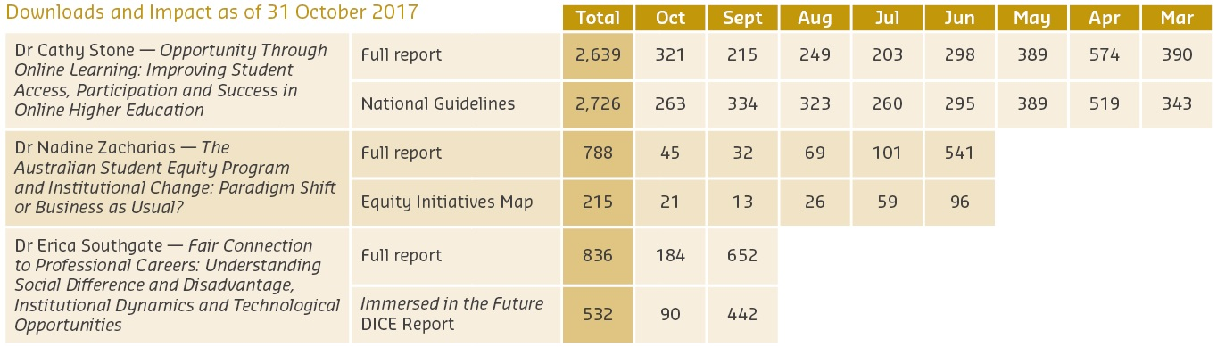
The 2017 Equity Fellows, announced in November 2016, are now well into their Fellowships and have already presented their work so far on an international scale. Given the areas of critical importance to equity in which all three Fellows are working, we look forward to significant further outcomes from their work.

2017 Equity Fellows’ Projects

Mr Matthew Brett

Equity, Performance and Accountability
Growth of public investment in Australian higher education has sharpened the focus of policymakers on issues of performance and accountability. This Fellowship explores the distribution of accountabilities for student equity objectives across the higher education system, and how these objectives are defined and progressed across policy instruments, policy processes, and institutional planning systems. The perspectives of system stakeholders have also been surfaced through surveys and interviews. The Fellowship has found that the Australian higher education system has a strong, broadly distributed, and deeply embedded commitment to student equity. There is no crisis of accountability. There are, however, opportunities for strengthening equity performance and accountability systems. These opportunities are described in an Equity Performance and Accountability Framework, refined though application to specific policy and institutional settings. The framework will be stress tested by application within higher education policy reform processes and institutional settings. The Fellowship has provided an opportunity to explore issues of system importance, and through a secondment to the Department of Education and Training, Matt has developed a deeper understanding of the passion and commitment of those at the heart of policy design.

Ms Louise Pollard

Remote Student University Participation and Success: An Analysis of Policy and Practice
This 2017 Equity Fellowship focuses on remote students’ participation in higher education, exploring issues relevant to these students and identifying ways in which they can be supported more effectively by the higher education sector and Australian Government.
Good practice examples from across the sector have been examined and the Fellowship was informed by a study tour to Canadian universities and a secondment to the Department of Education and Training. The Fellowship involves analysis of national datasets that have focused attention on the cohort of remote students in higher education in a new and innovative way. This includes the development of a comprehensive summary of remote students engaged in university. The demographic profile may challenge assumptions made about the cohort previously and will help the sector, and governments, to refine and target strategies to support remote students in accessing and succeeding in higher education. The good practice case studies include interviews with students from remote Australia and staff engaged in the delivery of programs and curriculum. They will provide insights into the extent to which existing practice addresses the unique challenges and needs of the remote student cohort.

Associate Professor James A. Smith

Strengthening Evaluation within Indigenous Higher Education Contexts in Australia
Enhancing Indigenous pathways and transitions into higher education is a key equity priority in Australia. To do this effectively we need robust evidence assessing the process, impact and outcomes of Indigenous higher education policies and programs. This Fellowship investigates ways of strengthening evaluation in Indigenous higher education contexts in Australia. Key research questions address: the quality and utility of evaluation; the current challenges and opportunities associated with planning and undertaking evaluation; the enablers and barriers associated with using evaluation evidence to inform policy and program development and reform to support Indigenous participation and achievement; and strategies might be useful for strengthening evaluation. The multifaceted project has involved a scoping review of what is known about evaluation in Indigenous higher education contexts in Australia. Additionally, primary research interviews have been conducted with 24 Indigenous scholars and thinkers working in Indigenous higher education contexts across all states and territories; and 15 policymakers working in Indigenous or equity-related higher education policy contexts within the Australian Government. This work has also involved consultation with key national stakeholders including the National Aboriginal and Torres Strait Islander Higher Education Consortium and Universities Australia, resulting in the development of a conceptual model and accompanying evidence base to frame future strategies in this space. In particular, the Fellowship provides important baseline data to respond to multiple calls to Government and Australian universities to work towards the co-development of an Indigenous higher education performance, monitoring and/or evaluation framework.

Synthesis of Group Discussion

A collation of the directions for equity raised by Forum delegates, this summary provides insights that can be developed to further support students from disadvantaged backgrounds to access, participate and achieve successful outcomes in higher education.

Research

The Challenges
What research questions should we be prioritising for student equity?
- Data sovereignty is emerging as an important concept in Indigenous higher education. What opportunities exist to address power imbalances and strengthen Indigenous leadership in the academy through the adoption of decolonising research and evaluation approaches?
- The Indigenous workforce has played a pivotal role in improving Indigenous higher education outcomes in Australia. How can we effectively measure and acknowledge the influence of such work?
- How can we reconcile Indigenous reservations about its status as an equity group within an overarching equity research agenda?
- What are the limitations in terms of higher education data that impedes our ability to do research with policy and practical relevance?
- There is significant overlap between different equity groups. How do we respond or acknowledge this intersectionality and the cumulative impact of different elements of disadvantage?

The Responses
Coordinating and disseminating research findings:
- Informed networks to promote knowledge of current and proposed research, and dialogue on research direction.
- Produce more publications that synthesise research into narratives.
Producing better informed research:
- Improve linkages between quantitative and qualitative research methods.
- Rethink research design and the identification of research gaps.
- Obtain feedback on further outcomes from projects.
- Map research to an equity development framework.
Re-examining research in the light of the review into equity groups:
- Broad equity groups can be inconsistent/restrictive; focus on smaller groups and selected issues.
- Use the individual as the fundamental unit of research and link individuals to characteristics.
Better tracking of individuals for more informed research and a better knowledge base:
- Track individuals from preschool to employment.
- Track all qualifications, including VET, to better understand changes in post-school education and skills development.
Accessing and applying the data available to inform all equity stakeholders:
- Focus on data linkage from many different sources and make more data available.
Justifying research to avoid research budget cuts:
- Focus research on productive outcomes and constructive recommendations.
- Focus on social inclusion and poverty in a broader sense, not just equity in higher education.
- Better value the importance of equity in education for communities.

Policy

The Challenges
What is the relevance of student equity for tertiary education policy reform?
- How will future increases in tertiary participation be accommodated and financed? What equity implications arise if reform remains elusive?
- Do we have sufficient valid data on equity in tertiary education that can inform the direction of tertiary education policy reform?
- How can we design accountability frameworks to foster collaborations between tertiary providers and governments to drive better equity outcomes?
- What strategies work best to ensure that recommendations from comprehensive and sector-wide evaluation and review processes are integrated in policy reform?
- How do we ensure that policy consultation processes engage with, understand and respond to the educational needs of different groups, be they large or small, mainstream of marginalised?

The Responses
Drawing out the implications for equity more broadly from focused research:
- Communicate research more effectively to targeted stakeholders to inform national educational and economic debates.
- Look to influence policy outside of education.
The future of higher education shaping equity:
- Be abreast of rapid changes in the economy to evolve demand for skills and education.
- Understand the VET sector and its linkages to higher education e.g. nested qualifications and pathways between the two sectors.
Focusing on policy outcomes and understanding the costs and benefits of equity:
- Embed the equity story in an economic narrative and look at transfer payments and the real costs and benefits of equity and education.
- Leverage government interest in data linkages across education, tax and welfare systems to support an equity policy agenda.
- Link state and national education systems and outcomes (this may require improved reporting and incentives to produce positive outcomes at both levels).
The higher education sector working with government and industry on changing needs for qualifications:
- Strengthen networks on the evolution of education-skills-employment trends to inform stakeholders of changes in coordinated policy responses by all stakeholders.
- Develop data tracking individuals from an early age through to employment outcomes and incomes to inform the networks to improve outcomes from tertiary education that are more relevant to an evolving economy.

Practice

The Challenges
How can we ensure the value and impact of student equity practice?
- How do we best meet the needs of diverse populations, geographies and operating contexts in Australian higher education within a Commonwealth funded public university system?
- How can we best measure concepts of nature, quality and effectiveness in Indigenous and/or equity focused higher education work?
- What capacity building across the higher education sector needs to occur to enhance evaluation (and subsequent accountability) in Indigenous and/ or equity higher education spaces?
- How do we better surface and respond to the perspectives and needs of students and communities in equity practice in higher education?

The Responses
Is practice informed by research and policy or is it a different world?
- Improve two-way dialogue between the research and practitioner communities; this necessitates strengthening networks and linkages.
- Synthesise research findings and focus on developing practical recommendations.
- Communicate this information clearly and succinctly to practitioners.
- Practitioners could convey more information to researchers, including qualitative findings of practice and feedback from practitioner conferences and fora.
- Circulate this information effectively among the research community.
Sustaining practice skills at a time of vulnerability to budget cuts:
- Better convey the positive ‘equity narrative’ and tell success stories from institutions concerning equity in higher education.
- Embed the importance of equity into higher education and beyond so that practice is not vulnerable to funding cuts.
Coordinating practice ideas:
- There are many good equity practices being developed; coordinating and presenting good ideas informs others of good practice.

Delegates

While not all Forum delegates will be unanimous in agreement on all the key challenges, as set out by the Equity Fellows, or the key responses that emerged from the group discussion, there was a high degree of consensus on future directions. The NCSEHE would like to thank the delegates for their contribution to developing these future directions for equity in higher education.

Peter Anderson WIRA; Queensland University of Technology
Anna Bennett University of Newcastle
Matt Brett NCSEHE Equity Fellow; La Trobe University
Penny Jane Burke CEEHE, University of Newcastle
Buly Cardak NCSEHE Advisory Board; La Trobe University
Joanne Chivers Department of Education and Training
Paul Corcoran Department of Education and Training
Diane Costello NCSEHE; Curtin University
Nicole Crawford University of Tasmania
Ian Cunninghame NCSEHE; Curtin University
Marcia Devlin RMIT University
Daniel Edwards Australian Council for Educational Research
Paul Farnhill NCSEHE; Curtin University
Michele Fleming NCSEHE Advisory Committee; Flinders University
Kate Flynn Queensland University of Technology
Anthony Gartner Disability (ATEND)
Cheryl Godwell NATSIHEC; Charles Darwin University
John Guenther NCSEHE Advisory Committe; Flinders University
Andrew Harvey La Trobe University
Jane Hawkeswood Australian Disability Clearing House on Education and
Training (ADCET)
Renee Hindmarsh Australian Technology Network of Universities
Leanne Holt Macquarie University
Sarah Imtiaz University of Western Australia
Mary Kelly Queensland University of Technology
Sally Kift James Cook University
Paul Koshy NCSEHE; Curtin University
Kerri-Lee Krause NCSEHE Advisory Board; La Trobe University
Robert Latta NCSEHE Advisory Board; Australian Government Department of
Education and Training
Ian Li University of Western Australia
Elisa McGowan University of Western Australia
Helen McKenzie NCSEHE; Curtin University
Rebecca McKenzie NCSEHE; Curtin University
Darlene McLennon Australian Disability Clearing House on Education and
Training (ADCET)
Julie McMillan Australian Council for Educational Research
Geoffrey Mitchell Queensland Department of Education and Training
Aileen Moreton-Robinson NIRAKN; Queensland University of Technology
Melinda Mann CQ University
Belinda Munn CEEHE, University of Newcastle
Karen Nelson University of the Sunshine Coast
Paul Nichols NCSEHE Advisory Board; Curtin University
Andrew Norton Grattan Institute
Gabrielle O’Brien Equity Practitioners in Higher Education Australasia (EPHEA)
Caroline Perkins Regional Universities Network
John Phillimore NCSEHE; Curtin University
Louise Pollard NCSEHE Equity Fellow; University of Western Australia
Maria Raciti University of the Sunshine Coast
Boni Robertson WINHEC: Griffith University
Kim Robertson Charles Darwin University
Marcia Schneider NCSEHE; Curtin University
Fiona Shalley Charles Darwin University
Judy Skene University of Western Australia
James Smith NCSEHE Equity Fellow; Charles Darwin University
Ann Stewart NCSEHE Adjunct Fellow
Cathy Stone NCSEHE Visiting Fellow
Wotjek Tomaszewski University of Queensland
Mike Teece Universities Australia
Nina-Marie Thomas NCSEHE; Curtin University
Karen Treloar Tertiary Education Quality Standards Agency (TEQSA)
Sue Trinidad NCSEHE; Curtin University
Grady Venville University of Western Australia
Lynette Vernon NCSEHE; Curtin University
Louise Watson NCSEHE Advisory Board; Canberra University
Mark Western University of Queensland
Nadine Zacharias NCSEHE; Curtin University

The Forum would not have been possible without the work of a dedicated group of people and the support of the Australian Government Department of Education and Training and Curtin University.
We would like to extend our gratitude to our speakers the 2017 NCSEHE Equity Fellows, Associate Professor James Smith, Mr Matt Brett and Ms Louise Pollard; the NCSEHE Advisory Board; the NCSEHE Advisory Committee; and Equity Fellows Program Selection and Reference Committee, all of whom volunteer their time to assist us in achieving our goals. We would also like to thank Gabrielle O’Brien (President, EPHEA) and the staff from Queensland University of Technology who provided continued support in conducting this successful event.

Speakers

Mr Matthew Brett
Prior to his appointment as an Equity Fellow, Matt was Senior Manager of Higher Education Policy at La Trobe University where he provided policy advice to the University Executive and supported La Trobe’s engagement with public policy processes. Matt has extensive experience in higher education across a variety of roles including policy adviser, services manager, practitioner and researcher. Matt is also a PhD Candidate at the Centre for the Study of Higher Education at the University of Melbourne.

Ms Louise Pollard
Prior to her appointment as an Equity Fellow, Ms Pollard was the Manager of Aspire UWA, a nationally recognised widening participation program. Preceding this, Louise was a teacher and Student Services coordinator at a WA Department of Education secondary school. She is a member of the Equity Practitioners in Higher Education Australasia Executive
Committee and was previously the peak body’s representative on the NCSEHE Advisory Board. She has extensive community development and education program management experience, having worked and volunteered in a range of international contexts.

Associate Professor James A. Smith
Prior to commencing his Equity Fellowship, James was the Program Manager of the multi-award winning Whole of Community Engagement initiative led through Charles Darwin University (CDU). This built on over a decade of experience working in senior strategic roles in Indigenous health and education contexts in NT and SA. He is a Fellow of the Australian Health Promotion Association, Co-Lead of the Indigenous Leadership Research and Evaluation Network at CDU, and holds multiple adjunct research positions. He has led numerous Indigenous higher education research projects and recently co-edited Indigenous pathways, transitions and participation in higher education published by Springer.

Professor Sue Trinidad
Professor Sue Trinidad is the Director of the National Centre for Student Equity in Higher Education. An established scholar in the areas of higher education pedagogy and change management, the use of technology and student learning, Sue’s research covers higher education and leadership including the use of technology for regional and remote areas to provide equity access to all students regardless of their geographical location. Prior to becoming the NCSEHE’s Director, Sue was Deputy PVC and Dean of Teaching and Learning in the Faculty of Humanities at Curtin during 2007-12.

Mr Robert Latta
Mr Robert Latta manages the Governance, Quality and Access Branch in the Higher Education Group within the Australian Government Department of Education and Training. In this role, he manages equity and access programs, governance and system design. Mr Latta has held various positions in the department, including Parliamentary coordination, business improvement, the management of financial and corporate systems and international education. Earlier employment includes various roles in the private sector (largely IT focussed) and the higher education sector (with a particular focus on international education).

About the Centre

The National Centre for Student Equity in Higher Education began operation in 2008, hosted by the University of South Australia. In May 2013, Curtin University won the bid to take over the Centre and received funding to achieve its aim of informing public policy design and implementation and institutional practice, to improve higher education participation and success for marginalised and disadvantaged people.
The NCSEHE’s objectives are:
- to be at the centre of public policy dialogue about equity in higher education
- to assist in closing the loop between equity policy, research and practice by:
  - supporting and informing evaluation of current equity practice, with a particular focus on identifying good practice
  - identifying innovative approaches to equity through existing research and the development of a forward research program to fill gaps in knowledge
  - translating these learnings into practical advice for decision-makers and practitioners alike.

Student Equity and Participation
The NCSEHE’s key purpose is “to inform public policy design and implementation, and institutional practice, to improve higher education participation and success for marginalised and disadvantaged people.”
In keeping with its purpose, the NCSEHE is connecting Commonwealth student equity policy with the activities of higher education institutions and national equity outcomes through its input into comparative assessment of institutional strategies, systemic assessments of policy achievements and assessments of national policy-making in view of this evidence. The Centre’s focus is based on three programs of research activity.
1. Equity Policy and Program Evaluation
The Centre is providing leadership and support in developing a national approach and resources to evaluate the impact of initiatives to increase participation of people from low SES backgrounds and other equity groups in higher education.
2. Equity Policy and Planning Research
The Centre is furthering equity policy and planning in Australia, sharing knowledge and capabilities developed in Australia, and providing evidence on the impact of policy on equity outcomes in the system. By enabling national research and engagement on higher education policy and practice, the Centre ensures its research includes analysis of all student equity groups, including people from low SES, Indigenous, regional and remote communities, and people with disability.
3. Student Equity Data
The Centre conducts analysis of higher education datasets from a student equity perspective. This encompasses:
- compiling and analysing national equity data and survey data on student transition to higher education
- managing a website that presents data on student equity performance in higher education; in particular, the mapping of higher education participation data in Australia
- providing access to sources for data and data-driven research on equity policy and programs from around Australia and the world.

“Assisting in closing the loop between equity policy, research and practice.”

Disclaimer

Information in this publication is correct at the time of printing but may be subject to change. This material does not purport to constitute legal or professional advice.
Curtin accepts no responsibility for and makes no representations, whether express or implied, as to the accuracy or reliability in any respect of any material in this publication. Except to the extent mandated otherwise by legislation, Curtin University does not accept responsibility for the consequences of any reliance which may be placed on this material by any person.
Curtin will not be liable to you or to any other person for any loss or damage (including direct, consequential or economic loss or damage) however caused and whether by negligence or otherwise which may result directly or indirectly from the use of this publication.

National Centre for Student Equity in Higher Education
Building 100 Curtin University
Kent Street Bentley WA 6102
GPO Box U1987 Perth WA 6845
Tel: +61 8 9266 1573
Email: ncsehe@curtin.edu.au
ncsehe.edu.au

